An easy to parameterise physics-informed battery model and its application towards lithium-ion battery cell design, diagnosis and degradation

*Yu Merlaa\*, Billy Wub, Vladimir Yufitc, Ricardo F. Martinez-Botasa and Gregory J. Offera,c*

a Department of Mechanical Engineering, Imperial College London, London, SW7 2AZ, UK

b Dyson School of Design Engineering, Imperial College London, London, SW7 2AZ, UK

c Department of Earth Science and Engineering, Imperial College London, London, SW7 2AZ, UK

\* e-mail of corresponding author: [yu.merla09@imperial.ac.uk](mailto:yu.merla09@imperial.ac.uk)

# Abstract

Accurate diagnosis of the state-of-health (SOH) of lithium ion batteries is of a significant value for many applications, to improve performance, extend life and increase safety. However, in-situ or in-operando diagnosis of SOH often requires robust models. There are many models available however these often require expensive-to-measure ex-situ parameters and/or contain unmeasurable parameters that were fitted/assumed without solid scientific basis. In this work, we have developed a new empirically parametrised physics-informed equivalent circuit model. Its modular construction and low-cost parametrisation requirements allow end users to parametrise cells quickly and easily. The model is accurate to 19.6mV for dynamic loads without any global fitting/optimisation, only that of the individual elements. The consequences of various degradation mechanisms are simulated, and the impact of a degraded cell on pack performance is explored, validated by comparison with experiment. Results show that an aged cell in a parallel pack does not have a noticeable effect on the available capacity of other cells in the pack. The model shows that cells perform better when electrodes are more porous towards the separator and have a uniform particle size distribution, validated by comparison with published data. The model is provided with this publication for readers to use.

# Highlight

* Physics based model that can be empirically parametrised
* Modular model allows various cell configurations and new features
* Effect of particle size explored, uniform distribution is best
* Model can be fitted to degraded cells for diagnosis purposes
* Model was used to predict the effect of damaged cell in a pack

# Keyword

* Lithium ion battery
* Modelling
* Empirical
* Parametrization
* Physics model
* Degradation

# Corresponding Author Details:

* Yu Merla (at all stages of refereeing and publication)
* Email: yu.merla09@imperial.ac.uk
* Postal address: Department of Mechanical Engineering

Exhibition Road

Imperial College London

South Kensington Campus

London SW7 2AZ

United Kingdom

# Author E-mail Address

Yu Merla - yu.merla09@imperial.ac.uk

Billy Wu - billy.wu@imperial.ac.uk

Vladimir Yufit - v.yufit@imperial.ac.uk

Ricardo F. Martinez-Botas - r.botas@imperial.ac.uk

Gregory J. Offer - gregory.offer@imperial.ac.uk

# List of symbols

|  |  |  |
| --- | --- | --- |
| Symbol | Unit | Description |
| *a* |  | Anode |
| *c* |  | Cathode |
| *r* | m | Radius |
| *sep* |  | Separator |
| *Cdl* | F | Double layer capacitance |
| *Csei* | F | Solid electrolyte interphase capacitance |
| *E* |  | Voltage source |
| *I* | A | Current |
| *Lwire* | H | Wire inductance |
| *Rcc* | Ω | Current collector resistance |
| *Rct* | Ω | Charge transfer resistance |
| *Rs* | Ω | Series resistance |
| *Rsei* | Ω | Solid electrolyte interphase resistance |
| *Rtot* | Ω | Total resistance |
| *Rele* | Ω | Electrolyte resistance |
| *Rdiff* | Ω | Diffusion resistance |
| *Rp2p* | Ω | Particle-to-particle contact resistance |
| *Rp2cc* | Ω | Particle-to-current-collector contact resistance |
| *V* | V | Voltage |

# Introduction

Lithium ion batteries in modern application are expected to last hundreds if not thousands of cycles under various and sometimes aggressive conditions. Ageing in these cells is complicated with many different degradation mechanisms [1–4] which are in need of further understanding. In order to maximise the lifetime and performance of a battery in real applications, it is beneficial to understand what is happening inside without disassembly. This requires a low-cost, practical yet detailed in-situ diagnosis/prognosis technique with easy-to-measure parameters. The industrial standard “capacity fade” and “power fade” definitions of degradation are limited and do not offer any insight into why the cell has degraded and if it is still safe to use. There are a few promising in-situ methods out there which might be suitable for in-operando application such as those using incremental capacity analysis [5,6], differential voltage analysis [7,8], electrochemical impedance spectroscopy (EIS) [9,10], and differential thermal voltammetry (DTV) [11,12]. However, in order to use any of these techniques, the diagnosis results must be compared with a robust battery model that can provide the insight into the internal states of the cell that cannot be measured directly, so that the battery management system (BMS) can improve performance, prolong lifetime and mitigate rapid degradation or failure.

There are numerous models already available and many show significant potential for future applications especially in the field of research [13–17]. The disadvantage of many of these models is the high computational power requirements, which makes many unsuitable to embed on-board a BMS. State-of-the-art reduced order models simplify the computational tasks for this matter [18,19] however for the models to be combined with a diagnostic technique, they need to include degradation models for various likely mechanisms such as solid electrolyte interphase(SEI) growth [20,21], lithium plating [22,23] and metal dissolution [24].

The critical issue with all these models is the parametrisation process. It almost always consists of assumed and/or fitted parameters such as electrode/separator thickness, porosity and volume fraction, initial and maximum lithium concentration and reaction rate constant to name a few [25–29]. These parameters have limited accuracy and may work fine for a specific cell however re-parametrisation is necessary for end users who might have different cells for various applications. This is especially likely with the range of different cell chemistries, microstructures and form factors now available. Conductivity of electrolyte is an example parameter where there are many fitted equations out there for specific cells [30–34] giving different values sometimes with an order of magnitude difference.

Even if the parameters can be measured this is often difficult requiring numerous ex-situ experiments and expensive testing equipment [35,36]. Ecker et al. represents the state-of-the-art in parameterisation [30] making a more physically accurate model. However, this was for one cell, and repeating this process for a new cell will take a long time and effort. Hence, there is a need for a multi-purpose flexible model with simple low-cost parametrisation with minimal assumed and fitted parameters.

In this work, a model was created that will fit as many cells as possible in real applications with varying modelling and simulation requirements. For this purpose, the model needed to be easily parametrised and modular so that the end-users can effectively configure this model for their own cells in application while minimising the cost for external expertise and equipment. One application may require a simple single particle approximation and another may require a more complex multi-particle core-shell approximation with inhomogeneous particle size distribution, effective porosity and various degradation mechanisms. In order to achieve this, we have developed a physics based model inspired by Newman style porous electrode theory models, where the physics is discretised and represented as circuit elements in a network [37]. The model is implemented in Simulink for ease-of-use, and easy reconfiguration, i.e. addition of more/less particles, dimensions, level of discretisation, etc. The individual elements are fitted according to empirical data, yet have an intended physical meaning and can be used to observe internal parameters that cannot be measured directly.

# Model structure

The model presented here was constructed in MATLAB R2016b using Simulink (v8.8) with the Simscape toolbox (v4.1). One of the key ideas of this model was to create an expanded network of equivalent circuits where every circuit element represents a real internal phenomenon in a battery including double layer capacitance: a concept inherited from the physical model made by Von Srbik et al. [38]. This allows for the observation and variation of individual decoupled internal parameters in detail.

The model is aimed for commercial BMS systems with relatively low computational and memory capabilities. This meant that the model should minimise the use of complex equations to solve. Solid-state lithium concentration in the electrodes is represented by the capacity of particle layers and never directly calculated. The model uses a variable time step solver to achieve more stable and efficient simulations.

The battery model contains one or more anode/cathode particle subsystems (depending on user requirements) and resistance parameters for the electrolyte (*R*ele), current collector (*R*cc), particle-to-current collector contact (*R*p2cc) and inter-particle contact (*R*p2p) (only for multi-particle configuration). See Figure 1a and 1b for illustration.

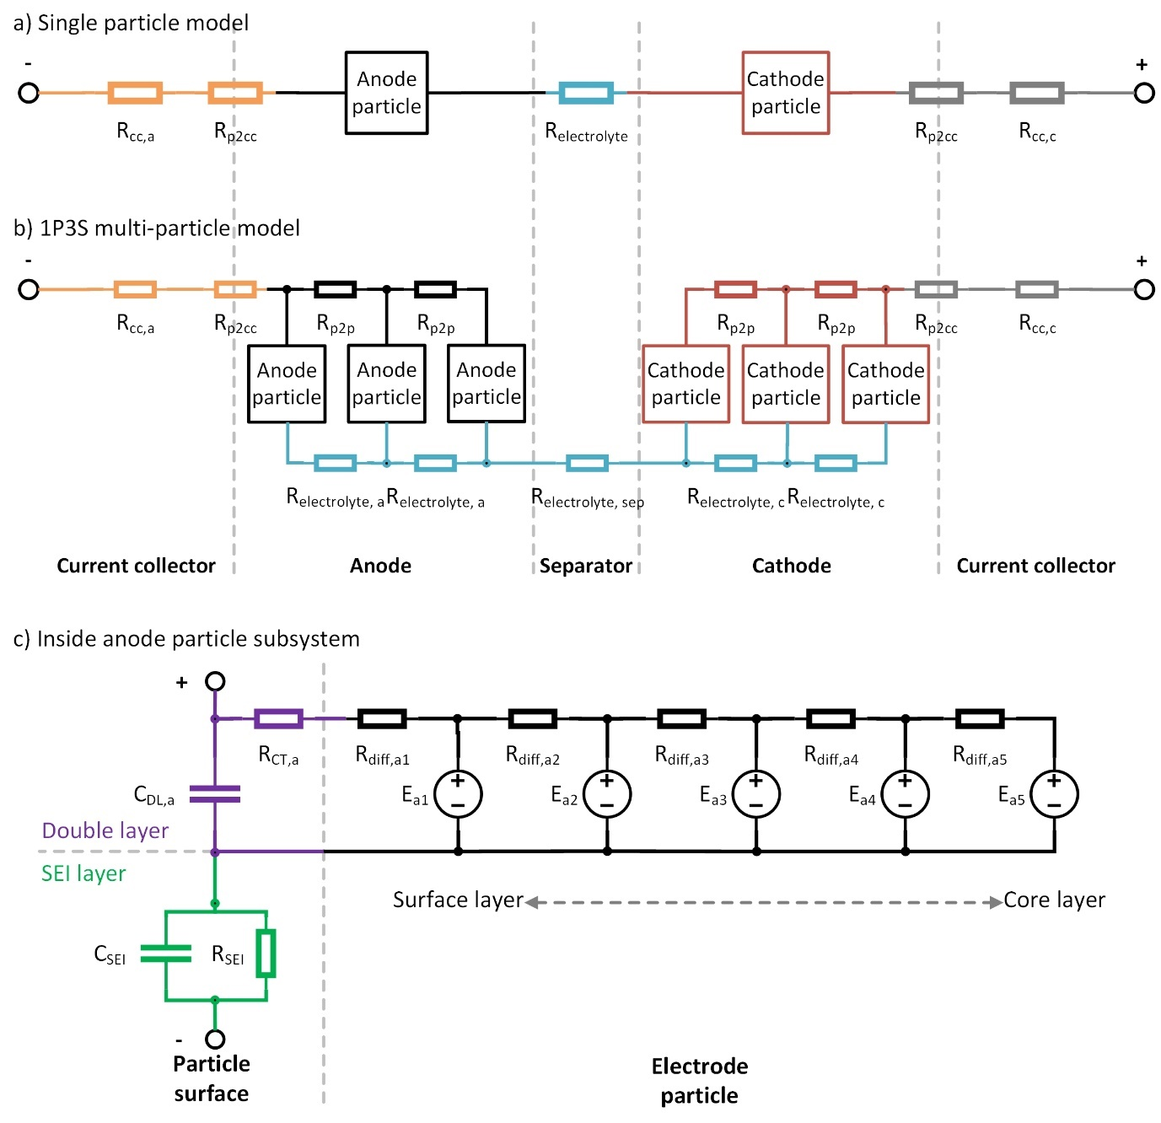

Figure 1. Cell level model schematics for (a) single particle model and (b) 1P3S multi-particle model. Inside the anode particle subsystem (c). 5 particle layers in this example. Particle core to the right and particle surface to the left.

The particle configuration can be easily modified due to the modular nature of the model components. More particles will allow the users to see the effect of concentration gradients within the electrodes, which are more important at high operating current densities as well as emulating a porous electrode by having the electrolyte resistance inside the electrode. The electrode particle subsystems can simply be duplicated or deleted to increase/decrease the number of particles. It can be placed to represent separate volumes of particles in the thickness dimension or in parallel to represent separate regions across the plane of the current collector. The two electrodes do not necessarily have to have the same configuration.

Anode and cathode particle subsystems have the same internal structure with individual parameter values (Figure 1c). The electrode particle is separated into multiple layers from surface to core. This allows for the observation of concentration gradients within the particle as well as defining separate parameters for each layer. This would be particularly useful to emulate core-shell particles seen in Si-C electrodes [39–41] and carbon coated lithium iron phosphate (LFP) electrodes [42–44] as well as gradient Ni-rich NMC cathodes [45].

The subsystem also consists of a double layer capacitance (*C*dl), charge transfer resistance (*R*ct) and (in this case) five pairs of particle layer voltage source (*E*) and associated diffusion resistance (*R*diff). The anode particle subsystem also contains an RC pair for the frequency response representing the SEI layer (*R*sei & *C*sei). The outermost *R*diff is connected in series with the *R*ct. This is because the particle layer voltage sources represent the capacity of the cell i.e. lithium and they are approximated to be at the radial midpoint of the particle layer. The lithium must therefore diffuse to the surface before it can be (de)intercalated.

The particle layer voltage source contains a controlled voltage source which defines the thermodynamic potential of the particle layer through a 1D look-up table as a function of accumulated charge calculated through coulomb counting. The current sensor tracks the current going through this layer, counts the coulombs and looks up the corresponding particle layer potential. The lookup table is auto-calibrated in the model algorithm for the number of layers and particles defined by the user.

In this work, the layers are made iso-volumetric, hence iso-capacity, meaning that each layer will have a different radial distance as well as surface area. This affects the diffusion resistance which is also calculated at the particle layer accordingly and used to define the parameter value. It should be noted that the layers may be configured differently to suit user requirements such as iso-radial distance or iso-diffusion resistance.

The electrolyte potential is arbitrarily set to 2V at open circuit. This is simply to offset the electrode potential from the electrolyte potential by a user defined constant which applies to every particle layer. This is set so that the voltages across the double layer capacitors at open circuit are roughly the same for both electrodes. The model is not sensitive to this offset as changing it does not affect any of the results and it can be changed if desired without affecting the performance of the model. However, an accurate/meaningful value of electrolyte potential may become important once various degradation mechanisms have been included.

The charge transfer resistance and the double layer capacitance are placed at the surface of the electrode particle. The charge transfer resistance is generated through a 2D look-up table as a function of current across the resistor and voltage of the particle surface. Double layer capacitance is assumed constant [22,46]. The SEI resistance and capacitance are also assumed to be independent of current and SOC.

In a multi-particle model, it is also possible to define the particle size distribution by specifying the ratio of the particle radii. The particle parameters are auto-scaled accordingly for example in smaller particles, the effective SEI resistance of an electrode volume will decrease as the total surface area of the active materials in a volume is larger assuming same SEI thickness and resistivity.

The present model is highly modular and allows easy changes such as the number of particles, configuration, particle layer properties, particle size distribution etc. This also permits easy addition of features such as a degradation and/or voltage hysteresis effects. In addition, the battery model can be multiplied and connected in series and parallel to simulate a battery pack. In this case, it will be necessary to place a finite inter-connection resistance between each cell connection to simulate a real pack application [47].

# Parameterisation

In this work, a commercial 5Ah pouch cell by Dow Kokam (model SLPB11543140H5) with carbon graphite anode and nickel manganese cobalt dioxide (NMC) cathode was used to parametrise the battery model.

A Bio-Logic BCS-815 was used for all *in-situ* characterisations mentioned here as well as a Binder KB-23 incubator to maintain the cells at 20 °C.

The physical model presented in [38] requires parameters that are very difficult and expensive, if not impossible, to measure. Hence, the said model uses the parameter values and fitted equations from a total of 14 different publications in the literature assuming these will match the specific cell. It should be noted that some of these parameters were assumptions to begin with. This model may have worked for that particular cell but will not be useful to end users if they cannot use it for their cells in application. This new model makes parametrisation simpler through direct empirical measurements based on relatively low-cost *in-situ* experiments rather than *ex-situ* experiments and/or physical derivation from first principles requiring assumed and fitted parameters.

The model parametrisation only requires 3 types of *in-situ* experiments: slow discharge to determine the open circuit voltage (OCV) curve for the anode and cathode; pulse discharge to find the diffusion resistance; and electrochemical impedance spectroscopy (EIS) under various loads to obtain the remaining resistance and capacitance values. Figure 2 summarises the parametrisation process used in this paper. The model parameters are then separated into individual particles and layers as described later in detail. It should be noted that the full cell OCV can also be obtained by the pulse discharge experiment through interpolating between the equilibrium points suggesting that only 2 types of experiments are required however there may be loss of information between the interpolated points.

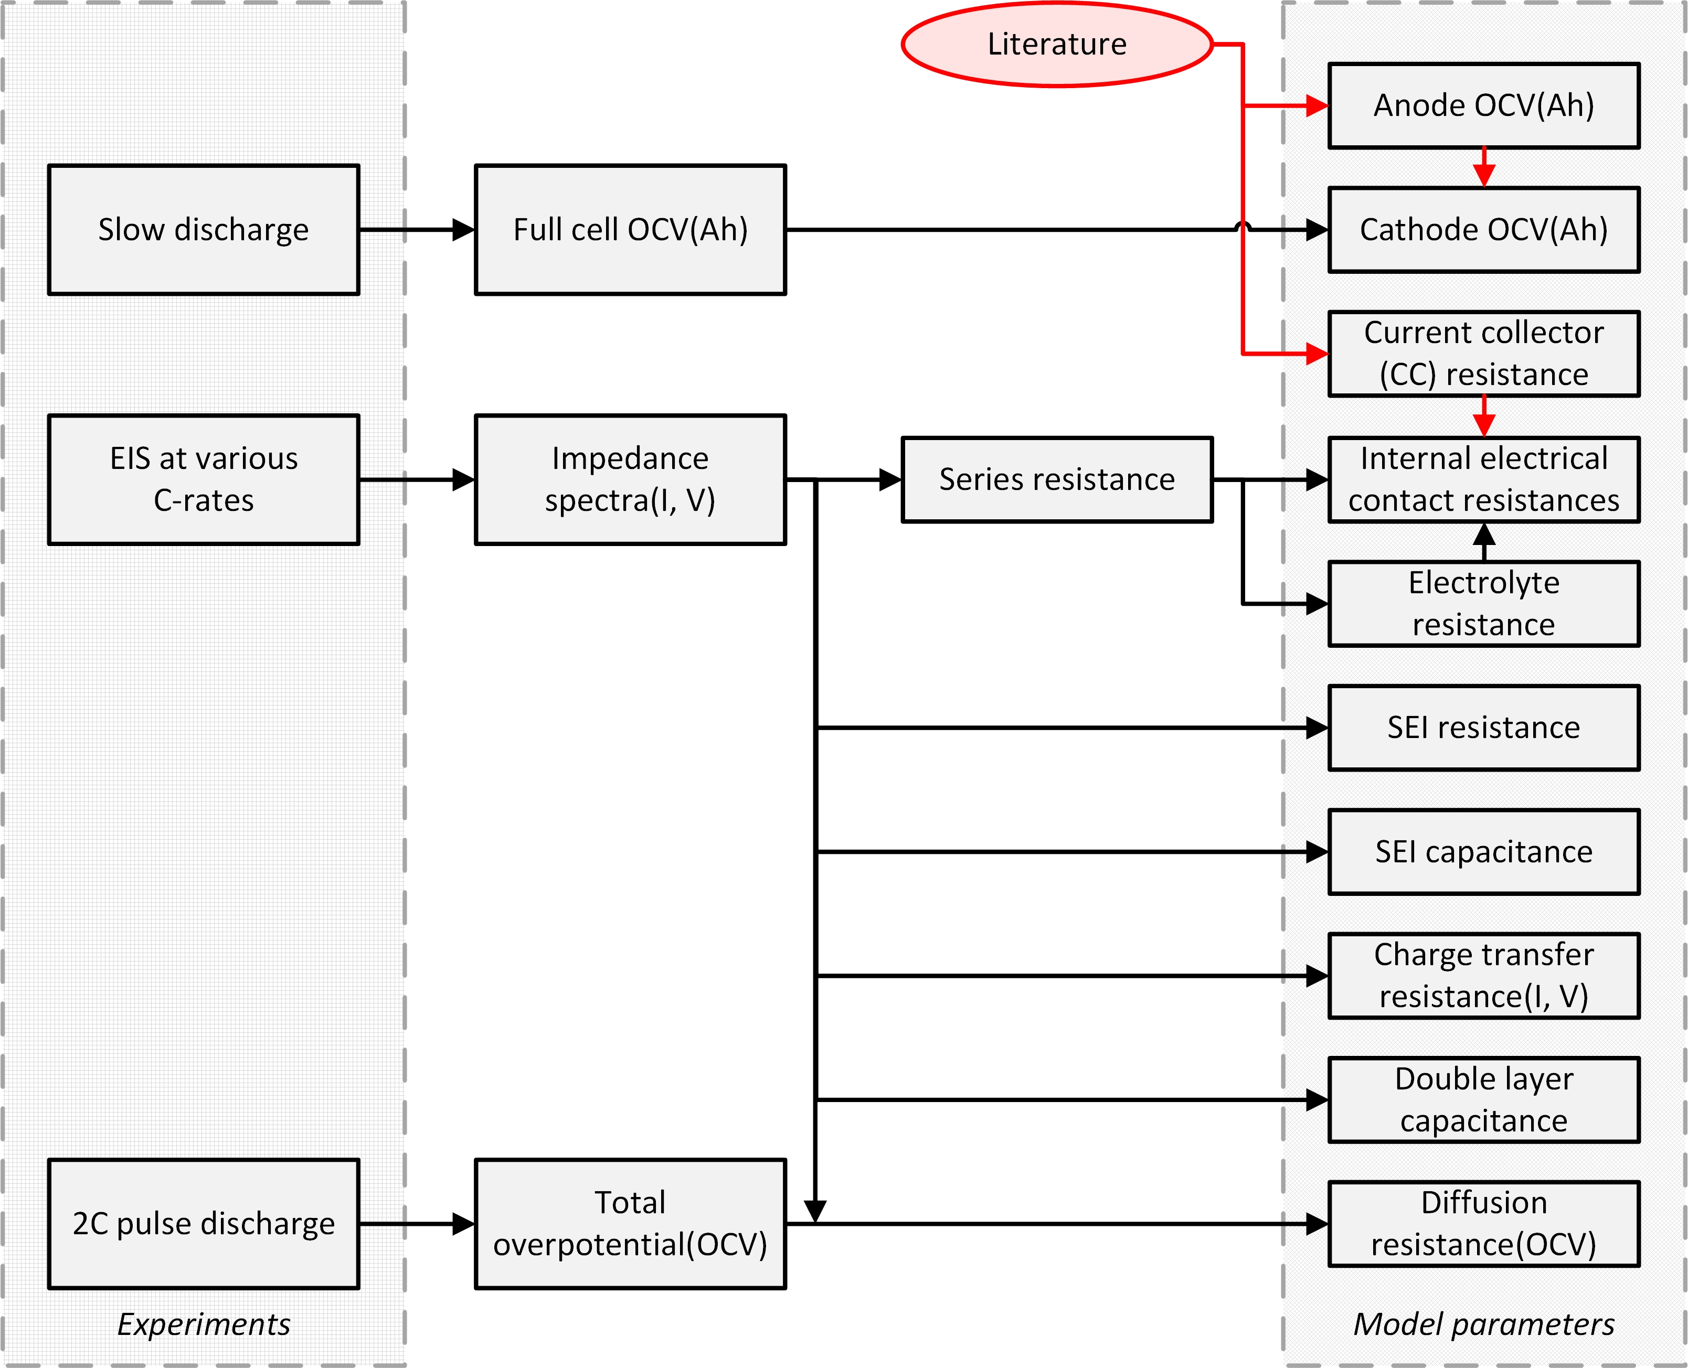

Figure 2. Summary of parametrisation process used in this paper. 3 types of in-situ experiments and minimal literature to parametrise all model parameters. Model parameters are then divided into individual particles and layers accordingly.

Summary of the model parameters are presented in Table 1.

Table 1. Summary of model parameters.

|  |  |  |  |  |  |  |  |
| --- | --- | --- | --- | --- | --- | --- | --- |
|  | Symbol | Unit | Dependency | Value | Electrode value | Method of parametrisation | Multiparticle recalibration |
| Anode voltage | *E*a | V | Coulomb counting | Taken from [14] | - | Literature | Calibrate Ah in lookup table |
| Cathode voltage | *E*c | V | Coulomb counting | Full cell OCV – anode OCV | - | Slow CC charging and literature | Calibrate Ah in lookup table |
| Current collector resistance | *R*cc | Ω | Constant | a = 23.8e-6  c = 89.8e-6 | Calculated individually | Equations 5, 6 | Equation 38 |
| Electrolyte resistance | *R*ele | Ω | Constant | 1.80e-3 | Calculated individually | EIS and equations 2-4 | Equation 37 |
| Particle to particle contact resistance | *R*p2p | Ω | Constant | 0.40e-3\* | Calculated individually | EIS and equations 8 | Equation 37 |
| Particle to current collector contact resistance | *R*p2cc | Ω | Constant | Divided equally | EIS and equations 8 | Equation 37 |
| SEI resistance | *R*sei | Ω | Constant | 1.00e-3 | Only to anode particle surface | EIS | Equation 35 |
| Charge transfer resistance | *R*ct | Ω | Voltage and current | Figure 4a | Divided according to [48] | EIS | Equation 35 |
| Diffusion resistance | *R*diff | Ω | Voltage | Figure 4b | Divided according to [48] | Pulse discharge and equations 21, 27 | Equation 35 |
| SEI capacitance | *C*sei | F | Constant | 1.24 | Only to anode particle surface | EIS | Equation 36 |
| Double layer capacitance | *C*dl | F | Constant | 5.73 | Divided equally | EIS | Equation 36 |

*\*for a single particle model.*

## Voltage sources

The voltages of the electrode particle layers are generated through a 1D lookup table against the accumulated charge counted at the layer. In order to parametrise this lookup table, two half-cell OCV data are required with respect to the electrode stoichiometry.

The OCV data for the full cell was obtained by a slow C-rate discharge from 100% state of charge (SOC) in this case C/100. This data is sometimes provided by the cell manufacturer. The carbon graphite half-cell OCV data was taken from literature which used the same cell model of smaller capacity [14], therefore we have assumed the materials are the same. The stoichiometric alignment of the two electrodes was also taken from that paper. The NMC half-cell OCV data was generated by subtracting the graphite half-cell OCV from the full cell OCV data. In practice, making two half-cell measurements would be preferred, requiring no assumptions or manipulations.

The coulomb counting for determining the particle layer voltage is adjusted for the number of electrode particles and layers within. In this paper, the capacities between electrodes and its layers were kept the same but this can be easily modified by allocating different fraction of the total capacity to individual particles/layers to emulate various internal scenarios such as high capacity core of a gradient nickel rich NMC cathode.

## Resistances

There are seven different resistance terms in this model: *R*cc, *R*ct, *R*sei, *R*ele, *R*diff, *R*p2p & *R*p2cc. These terms are then further separated into anode and cathode parameters which are either divided equally or split according to theory.

A galvanostatic EIS under load was carried out at various SOCs to determine the series resistance (*R*s), *R*sei and *R*ct. EIS was carried out at rest, and under load at 0.4 C, 1 C, 1.6 C and 2 C for both charge and discharge. The characterisation cycle was done every 0.167 Ah providing 30 EIS spectra per cycle. The frequency range was set from 1 kHz to 3 Hz with 6 measurements per decade to capture sufficient impedance characteristics to determine the three resistance terms with minimal measurement time (hence SOC drift) during the EIS. The current sine wave amplitude was 200 mA and the drift correction function provided by Bio-logic was turned on.

The impedance spectra were then fitted onto a 2 RC-pair ECM (Figure 3a and 3b) using ZView (version 3.3e) to determine the high and mid frequency resistance and capacitance terms. A resistor and inductor were connected in series to represent the series resistance and wire inductance respectively.

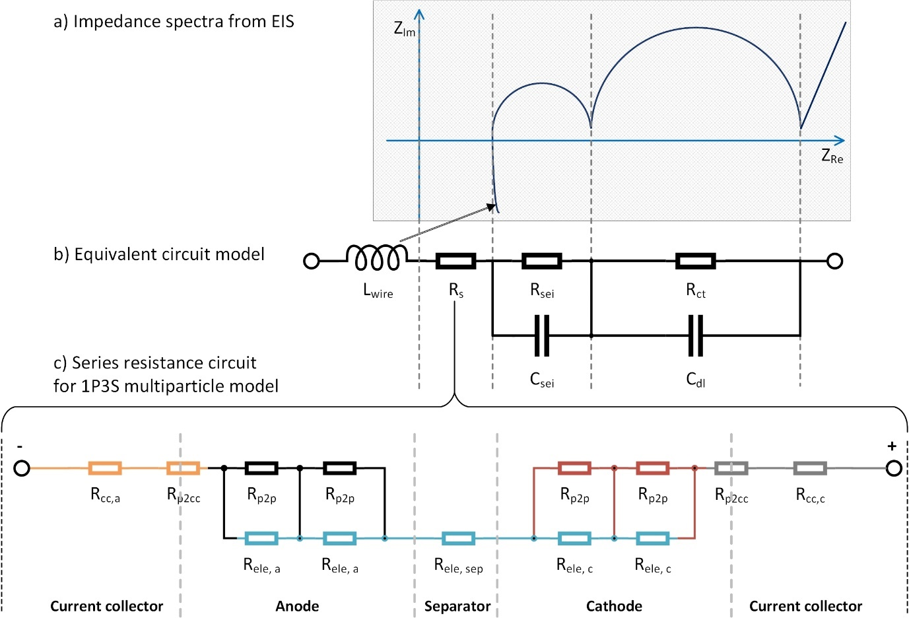

Figure 3. (a) Typical impedance spectra for lithium-ion cells. (b) Equivalent circuit model used to parametrise impedance spectra from EIS results. High frequency RC pair is often associated with the anode SEI and mid frequency to the charge transfer resistance and double layer capacitance. Inductor element represents the wire inductance during the experiment. (c) Series resistance circuit for 1P3S multiparticle model. Consists of Rcc, Rele, Rp2p & Rp2cc.

### Series resistances

The series resistance, *R*s, of the cell model was assumed to be independent of SOC and current. The average of the values taken at various SOCs at rest was taken as the parameter value. This resistance was then split into *R*cc, *R*ele, *R*p2p & *R*p2cc:

The electrolyte resistance, *R*ele, is said to account for the majority of the series resistance [49,50]. In order to obtain the electrolyte resistance fraction, *k*ele, the theoretical *R*ele was calculated using the conductivity of electrolyte equation presented by Northrop et al. [31] and compared to the *R*s found experimentally. Parameters used for the calculation are summarised in Table 2.

$$\begin{aligned}R_{ele,i}=\frac{l_{z,i}}{A_{xy}κ_{eff,i}}\#\left(2\right)\end{aligned}$$

$$\begin{aligned}κ_{eff,i}=ε_{i}^{p_{i}}\left(\begin{matrix}4.1253×{10}^{-2}+5.007×{10}^{-4}c-4.7212×{10}^{-7}c^{2} \\ +1.5094×{10}^{-10}c^{3}-1.6018×{10}^{-14}c^{4}\end{matrix}\right)\#\left(3\right)\end{aligned}$$

$$\begin{aligned}k_{ele}=\frac{R_{ele,a}+R_{ele,sep}{+R}_{ele,c}}{R_{s}}=\frac{1.797mΩ}{2.201mΩ}=0.8168\#\left(4\right)\end{aligned}$$

Where *l*z is the thickness of a single component *i* which may be may be anode (*a*), separator (*sep*), or cathode (*c*) layer, *A*xy is the total active surface area of the electrode, *κ*eff is the effective conductivity of the electrolyte phase, *ε* is the electrolyte volume fraction, *p* is the Bruggeman porosity exponent and *c* is the electrolyte concentration. For the sake of simplicity, the average electrolyte concentration was used as a constant for *c* as the electrolyte resistance has relatively a small impact on the overall resistance of the fresh cell.

The electrolyte resistance can be estimated from the series resistance using Equation 4 kif the parameters required for Equations 2 – 3 are unavailable.

The current collector resistances for each of the electrodes, *R*cc, were derived from the conductivity of aluminium and copper [31], and the geometric properties of the cell [38]:

$$\begin{aligned}R_{cc_{a}}= \frac{l_{x}}{A_{yz}σ_{Cu}}\#\left(5\right)\end{aligned}$$

$$\begin{aligned}R_{cc_{c}}= \frac{l_{x}}{A_{yz}σ_{Al}}\#\left(6\right)\end{aligned}$$

Where *l*x is the length of the pouch cell in the x-direction, *A*yz is the total surface area of the current collector per electrode normal to the length of the cell and *σ* is the electrical conductivity. *A*yz is calculated by the following equation:

$$\begin{aligned}A_{yz}=l_{y}×l_{z,cc,i}×N_{cc,i}, i=a,c\#\left(7\right)\end{aligned}$$

Where *l*y is the length of the cell in the y-direction, *l*z,cc,i is the thickness for a single current collector and *N*cc,i is the total number of current collector layers. The values used for this cell are listed in Table 2. These parameters, if not known or provided by the manufacturer, require dismantling of the cell. In such cases, it is possible to simply find the combined *R*cc and *R*p2cc values during the following method without the need for these internal parameters.

Table 2. Parameter values used to calculate current collector and electrolyte resistances. N.B. these values are not required by end-users if information is unavailable for their cell.

|  |  |  |  |  |  |
| --- | --- | --- | --- | --- | --- |
|  | Symbol | Unit | Value | Reference | Used in equation(s) |
| Domain thickness per layer | *l*z | m | a = 40e-6  c = 29.12e-6  sep = 20.32e-6  a. current collector = 48.1e-6  c. current collector = 21.0e-6 | [38] | 2, 7, 9, 10 |
| Active surface area | *A*xy | m2 | 0.84 | Internal\* | 2 |
| Average electrolyte concentration | *c* | molm3 | 1200 | [38] | 3 |
| Bruggeman porosity exponent | *p* | - | 1.5 | [38] | 3 |
| Electrolyte volume fraction | *ε* | - | a = 0.385  c = 0.485  sep = 0.724 | [31] | 3 |
| Conductivity of copper | *σ*Cu | S/m | 5.96e7 | [31] | 5 |
| Conductivity of aluminium | *σ*Al | S/m | 3.55e7 | [31] | 6 |
| x-direction length of cell | *lx* | m | 0.14 | [38] | 5, 6 |
| y-direction length of cell | *ly* | m | 0.041 | [38] | 7 |
| Number of current collector layers | *Ncc* | - | a = 50  c = 51 | Internal\* | 7 |

*\*Information from dismantling of the cell carried out within the research team prior to this work.*

In a single particle configuration, the ratio of these resistances does not matter as they are all connected in series. In a multiparticle configuration such as the 1P3S model in Figure 1b, the series resistance circuitry is equated to a single effective resistance i.e. *R*s (as illustrated in Figure 3c) and the remaining contact resistance values, *R*p2p and *R*p2cc, are calculated.

$$\begin{aligned}R_{cc,a}+R_{p2cc}+2\frac{R_{p2p,a}R_{ele,a}}{R_{p2p,a}+R_{ele,a}}+R_{ele,s}+2\frac{R_{p2p,c}R_{ele,c}}{R_{p2p,c}+R_{ele,c}}+R_{p2cc}+R_{cc,c}=R_{s}\#\left(8\right)\end{aligned}$$

Where,

$$\begin{aligned}R_{ele,i}=k_{ele}\frac{l_{i}}{l_{a+s+c}}R_{s}\#\left(9\right)\end{aligned}$$

$$\begin{aligned}R_{p2p,i}=k_{contact}\frac{l_{i}}{l_{a+c}}R_{s}\#\left(10\right)\end{aligned}$$

$$\begin{aligned}R_{p2cc}=k_{contact}R_{s}\#\left(11\right)\end{aligned}$$

The three resistances, *R*ele, *R*p2p and *R*p2cc, are defined as a fraction of the effective *R*s multiplied by the thickness fraction. The subscript *i* represents the section of the battery such as the anode, cathode and the separator. The only unknown parameter, *k*contact, can be solved by plugging the three substitutions into Equation 8.

### SEI resistance

The SEI resistance, *R*sei, was also treated as independent of current and SOC in the same way as the series resistance where the value was taken from the average of the measured values of the high frequency resistance term from the ECM.

*R*sei was directly used for the model parameter. In this case, we have allocated all of this resistance to the anode particle surface as the electrode surface resistive film usually forms mostly on the anode particle [20]. However, it can be separated between the two electrodes as desired.

In a multi-particle configuration, it is possible to define the particle size distribution which will have a direct effect on this resistance. The model algorithm is written to automatically calibrate such resistances according to the defined particle size distribution. Smaller particles will have smaller surface area per particle so the *R*sei per particle, *Rsei,p*, is expected to be higher. The electrical resistance, *R*, is described as follows:

$$\begin{aligned}R=\frac{ρl}{A}\#\left(12\right)\end{aligned}$$

Where *ρ* is the resistivity, *l* is the length or the thickness of the SEI in this case, and *A* is the surface area of the SEI. Assuming the SEI resistivity and thickness to be independent of particle size, the following approximation can be made:

$$\begin{aligned}R_{sei,p}=f\left(\frac{1}{A}\right)=f\left(\frac{1}{r^{2}}\right)\#\left(13\right)\end{aligned}$$

In this model, each electrode “particle” in the equivalent circuit represents a volume of active electrode material i.e. a collection of many actual particles. It is necessary to consider that the number of particles, *np*, per volume of active electrode material, *Vmat*, changes as the particle size is altered hence the current per particle, *Ip*, is changing for a given total current going through the volume, *Ivol*.

Note that the volume of the active material is also represented as a sphere. Assuming homogeneity between the particles in the volume, the following relationship is derived for the effective *Rsei* of the volume, *Rsei,vol*

This suggests that using smaller particles will decrease the effective SEI resistance of a volume and vice versa.

### Charge transfer resistance

The charge transfer resistance, *R*ct, is a function of SOC and current (as well as temperature) as described by the Butler-Volmer equation [51]. The values for the *R*ct are taken directly from the mid frequency EIS results as described in Figure 3b and placed inside a 2D look-up table which takes voltage of the particle surface and current going through the resistance as inputs. Figure 4a illustrates the 2D look-up table.

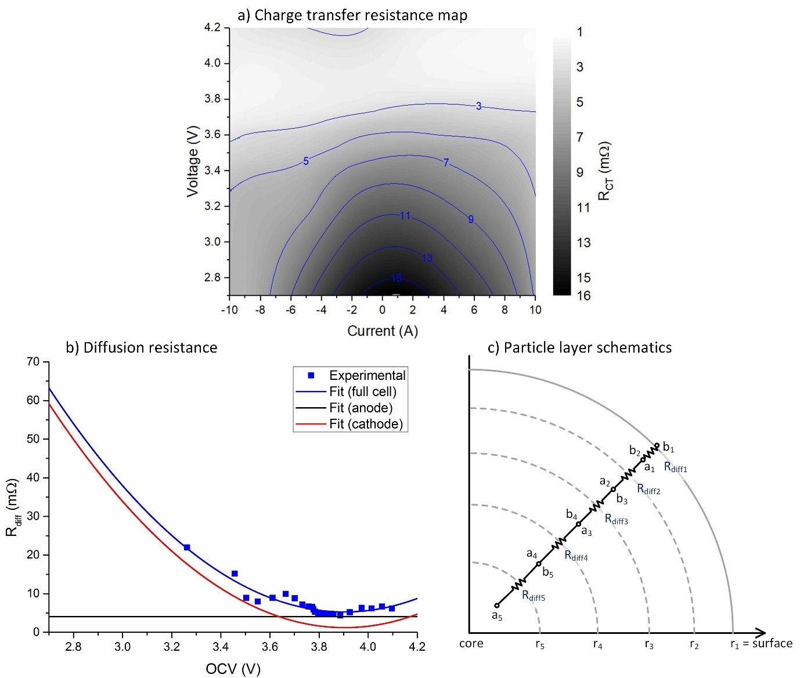

Figure 4. (a) 3D colourmap of total charge transfer resistance (Ω) as a function of current and voltage. Experimental results of EIS under load presented with both interpolation and extrapolation. (b) Diffusion resistance plot. Full cell Rdiff was separated into individual electrodes using the ratio of electrode diffusion coefficients presented in [52]. (c) Particle layer schematics. Particle is divided into five iso-volumetric layers containing equally divided capacity. The diffusion resistance of lithium to travel from one layer to the next is proportional to the distance of the two radial midpoints, ai and bi.

It is known that the charge transfer resistance varies between the two electrodes and as this resistance has a significant contribution to the overall resistance it cannot simply be divided equally. The charge transfer coefficient profiles for individual electrodes were previously simulated by Wu [48] for the exact same cell. The quantitative ratio between the two profiles were taken and applied to the total *R*ct of this model, *Rct,tot*, to separate it into the two electrodes.

$$\begin{aligned}R_{ct,c}\left(V,I\right)=R_{ct, tot}\left(4.2,I\right)×\left(0.341V-0.876\right)\#\left(19\right)\end{aligned}$$

$$\begin{aligned}R_{ct,a}\left(V,I\right)=R_{ct, tot}\left(V,I\right)-R_{ct,c}\left(V,I\right)\#\left(20\right)\end{aligned}$$

The particle size will also affect the value of *R*ct. This can be treated in a similar way to the *R*sei discussed earlier assuming that the charge transfer is occurring in the Helmholtz layer (a finite thin layer of ions above the particle surface) which can be regarded as a spherical shell. Smaller particles have higher particle surface area per volume of active materials hence lower resistance and vice versa.

### Diffusion resistance

The diffusion resistance, *R*diff, was determined by subtracting the above resistance terms from the total resistance found through a 2C pulse discharge.

$$\begin{aligned}R_{diff}=R_{tot}-R_{s}-R_{SEI}-R_{ct}\#\left(21\right)\end{aligned}$$

Where,

$$\begin{aligned}R_{tot}=\frac{dV}{I}\#\left(22\right)\end{aligned}$$

*dV* is the potential drop after the pulse loading also known as the overpotential and *I* is the current. The pulse loading was carried out by 60 seconds of 2 C charge followed by 3 hours of rest from 4.2 V to 2.7 V.

In this work, *R*diff, was considered a function of SOC (hence voltage) only and independent of current. This should be a reasonable assumption below 2 C (for a cell rated up to 30 C) according to Tafel’s approximation [51]. The experimental results of *R*diff(OCV) were then fitted onto a 2nd order polynomial for quick interpolation and extrapolation.

Similar to *R*ct, the total *R*diff is separated into individual electrodes following the quantitative ratio of the electrode diffusion coefficients given in [48] using the same cell. Figure 4b illustrates the results.

It should be noted that the diffusion resistance in this version of the model is only for the solid phase and does not include the electrolyte phase.

The electrode diffusion resistance is then split accordingly to the different particles. This may be equal division or not depending on the homogeneity of particle sizes in the electrode. This is done in the same manner as Equation 12. As expected, smaller particles have smaller diffusion resistances as lithium has less radial distance to travel to the particle surface.

Once the diffusion resistance per particle is determined, it is necessary to divide this further into particle layers. In this case, the radial distance of each shell is different as the layers were set to be iso-volumetric. The radius of each layer can be worked out by equating the volume of a sphere and spherical shells.

$$\begin{aligned}\frac{V_{sphere}}{n}=\frac{4}{3}πr_{n}^{3}=\frac{4}{3}π{(r}_{n-1}^{3}-r_{n}^{3})=\frac{4}{3}π{(r}_{1}^{3}-r_{2}^{3})\#\left(23\right)\end{aligned}$$

$$\begin{aligned}r_{i}^{3}=(n+1-i)×\frac{r_{tot}^{3}}{n}\#\left(24\right)\end{aligned}$$

Where *V*sphere is the volume, *r*i is the radius of the particle layer *i* and *n* is the total number of layers in a particle. *r*1 (= *r*tot) is the radius of the whole particle (outer radius of the surface shell) and *r*n would be the radius of the core sphere. Figure 4c illustrates the particle layer system.

The electrical resistance of a spherical shell is defined as [52]:

$$\begin{aligned}R_{hollow sphere}=\frac{ρ\left(b-a\right)}{4πab}\#\left(25\right)\end{aligned}$$

Where *ρ* is the resistivity, *a* is the inner radius and *b* is the outer radius. *ρ* is assumed a constant giving Equation 17. Particle layers place the layer diffusion resistances in series as lithium diffuses in the radial direction. Hence the layer diffusion resistance can be determined as a fraction of the particle diffusion layer.

$$\begin{aligned}R_{diff,layer }\left(OCV\right)=f\left(\frac{b-a}{ab}\right)\#\left(26\right)\end{aligned}$$

$$\begin{aligned}R_{diff,layer j}\left(OCV\right)=\frac{\left(\frac{b_{j}-a_{j}}{a_{j}b_{j}}\right)}{\sum_{i=1}^{n}{\left(\frac{b_{i}-a_{i}}{a_{i}b_{i}}\right)}}×R_{diff,particle}\left(OCV\right)\#\left(27\right)\end{aligned}$$

The capacity hence the lithium is assumed to be stored at mid-point of the radial distance of the layer i.e. ${{(r}_{i}-r_{i+1})}/2$. When the lithium is to diffuse from one layer to the adjacent layer, the diffusion path is from the radial mid-point of the initial layer to the radial mid-point of the next layer. The surface layer is an exception where the lithium only needs to diffuse from the radial midpoint of the layer to the layer surface. Hence the inner and outer radii for the layer diffusion resistances can be obtained by the following equations:

$$\begin{aligned}a_{i≠n}={{(r}_{i}-r_{i+1})}/2\#\left(28\right)\end{aligned}$$

$$\begin{aligned}b_{i≠1}={{(r}_{i-1}-r_{i})}/2\#\left(29\right)\end{aligned}$$

$$\begin{aligned}a_{i=n}={r_{n}}/2\#\left(30\right)\end{aligned}$$

$$\begin{aligned}b_{i=1}=r_{1}\#\left(31\right)\end{aligned}$$

Inside the model, the layer diffusion resistance is determined as a function of the layer voltage at each time step using the following steps:

1. Calculate the equivalent full cell OCV from the layer voltage through a 1D lookup table.
2. The effective *R*diff of the full cell is generated through the fitted 2nd order polynomial equation as presented on Figure 4b.
3. The effective *R*diff of the electrode is calculated by separating the full cell value by the ratio of diffusion coefficients provided in [48].
4. The effective *R*diff of the particle is calculated by dividing the above value by the number of particles taking into account its particle size distribution using Equation 22.
5. The *R*diff of the particle layer is calculated using Equations 17,19 and 20.

## Capacitance

The two capacitance terms, *C*sei and *C*dl, were both taken from the parametrised ECM of experimental EIS results. In this model, the capacitances were assumed to be independent of SOC and current and the mean of the results at 0 C were taken as constant values.

*C*sei was allocated to the anode surface only whereas *C*dl was divided equally between the two electrodes.

The dependency of these two capacitances on particle size is the inverse to the resistances. The capacitance between two concentric spheres is defined as:

$$\begin{aligned}C_{concentric spheres}=\frac{4πεab}{b-a}\#\left(32\right)\end{aligned}$$

$$\begin{aligned}C_{particle}=f\left(ab\right)≈f\left(r^{2}\right)\#\left(33\right)\end{aligned}$$

$$\begin{aligned}C_{sei,eff or dl,eff}=f\left(\frac{1}{r}\right)\#\left(34\right)\end{aligned}$$

Where ε is the permittivity, *a* is the outer radius of the inner sphere and *b* is the inner radius of the outer sphere. Assuming the distance between *a* and *b* to be much smaller than *a* and independent of particle size, the same approximation can be made in Equation 21. The dependency is essentially the inverse of resistance meaning smaller particles give larger capacitances per volume of active materials.

## Upscaling to multi-particles

When changing the model to a new multiparticle configuration, such as 2P5S, it is required to recalculate the effective parameter values accordingly. This is done automatically in the model. In a *x*P*y*S configuration, the *y* number of electrode particles along the thickness of the cell are actually connected in parallel to each other and the *x* number of parallel strips perform essentially the same with negligible electrochemical interaction between them (explained through results in Section 4.3). Hence, taking particle charge transfer resistance and double layer capacitance as examples, the recalculated values are as follows:

$$\begin{aligned}R_{ct,xPyS}=xyR_{ct,total}\#(35)\end{aligned}$$

$$\begin{aligned}C_{dl,xPyS}=\frac{1}{xy}C_{dl,total}\#\left(36\right)\end{aligned}$$

The above two equations also apply to particle *R*diff, *R*SEI and *C*SEI. The series resistance terms will be calculated as follows as initially introduced in an example for 1P3S in Equation 8:

$$\begin{aligned}R_{cc,a}+R_{p2cc}+\left(y-1\right)\frac{R_{p2p,a}R_{ele,a}}{R_{p2p,a}+R_{ele,a}}+R_{ele,s}+\left(y-1\right)\frac{R_{p2p,c}R_{ele,c}}{R_{p2p,c}+R_{ele,c}}+R_{p2cc}+R_{cc,c}={xR}_{s,total}\#\left(37\right)\end{aligned}$$

Current collector resistances are recalculated similar to Equation 35 however are unaffected by the number of particles along the thickness of the cell as the number of *R*cc components does not change.

$$\begin{aligned}R_{cc,xPyS}=xR_{cc,total}\#\left(38\right)\end{aligned}$$

As for the voltage sources, the Ah values in the lookup table is divided according to the fractional electrode capacity of the particle.

# Results and discussion

## Model outputs and validation

Due to the structure of the model, it is possible to view the potential, current and resistance components of each electrode, particle and particle layer individually as desired. This provides much insight to the cell analysis and opportunities to look at decoupled performances according to various cell configurations.

The model is validated against different pulse cycle data consisting of charge and discharge pulses at various C-rates (max. 2 C) across the entire battery SOC for both the single and multiparticle (1P3S) models to check for their voltage responses. The model is able to simulate 2 hours of operation in just a few minutes using the multiparticle model and under a minute with the single particle model.

Figure 5 demonstrate some of the outputs the multiparticle model is capable of producing.

*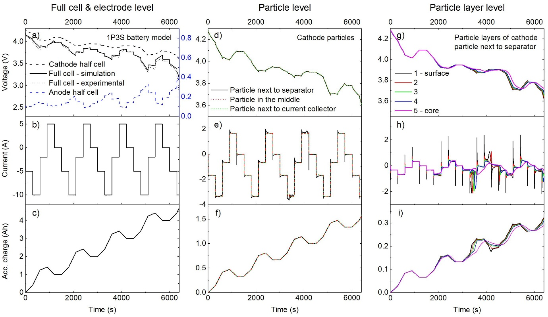*

Figure 5. (Left) model output on a “full cell” and “electrode” level for a multi-pulse loading on a 1P3S multi-particle model. Simulation, experimental, and electrode voltages vs. Li (a), current (b), and accumulated charge (c). (Middle) model output on a particle level for the same simulation. Cathode particle potentials vs. Li (d), current (e), and accumulated charge (f). (Right) Model output on a “particle layer” level for the same multi-pulse loading. This example is for a cathode particle closest to the separator with five iso-capacity particle layers. Particle layer potential vs. Li (g), current (h), and accumulated charge (i). Notice how the surface layer has the most transient response whereas the core layer has the smoothest response.

In each case, the error between the simulation and the experiment is measured by looking at the median of absolute deviations of the full cell voltage. As illustrated in Figure 5a, the validation results demonstrate high accuracy at 16.5mV and 19.6mV for single and multiparticle models respectively. It should be noted that the model has NOT had any parameter fitting or optimisation process after the initial parametrisation process described in the previous section.

In Figure 5e, it can be observed that the particles closer to the separator have a more transient response as they have a shorter electrolyte distance to travel hence smaller path of resistance. However, the performance between the three particles is very similar as although the inter-particle contact resistance is much smaller than the electrolyte resistance in the electrode, they are both much smaller than the charge transfer and diffusion resistance which therefore dominate the behavior of this cell under these conditions. This effect can also be seen in Figure 5g to 5i, where for one particle the surface layer has a much more transient response than the inner layers as the lithium ion needs time to diffuse through the layers to and from the surface.

## Quantitative estimation of degradation mechanisms

As the model components represent real internal components of a battery, it is possible to simulate various degradation mechanisms together with the knowledge of their effects by changing parameters in the model.

* Capacity loss by decreasing the available Ah in the electrode(s)
* SEI layer growth by increasing the SEI resistance
* Electrolyte leakage and/or loss of lithium inventory in the electrolyte by increasing the electrolyte resistance
* Mechanical fracture of the electrode by increasing particle-to-particle contact resistance and/or solid diffusion resistance
* Island formation by isolating a particle from the circuit
* Electrode delamination by increasing or cutting the circuitry at the particle-to-current-collector resistance
* Metal dissolution by decreasing cathode particle capacity and diffusion resistance
* Current collector corrosion by increasing current collector resistance
* Oxidation of conductive agents or binder decomposition by increasing particle-to-particle resistance
* Stoichiometric drift by shifting the electrode stoichiometry alignment

This method can therefore be used to quantitatively estimate the degradation mechanisms of an aged cell with respect to the cell which was used to initially parametrise the model. The model presented here is parametrised for a fresh cell. As a demonstration, another cell from the same batch (Dow Kokam model SLPB11543140H5) was aged in a controlled environment and its degradation mechanisms were quantitatively estimated by fitting the model to data from a dynamic discharge.

The aged cell was cycled at 2C inside an incubator at 55°C for 32 days. The cycling profile is purely constant current charge/discharge without constant voltage or relaxation phases. From literature and experimental characterisation of such cell [3], the expected dominating degradation mechanisms are SEI layer growth at the anode surface as the cycling lithium-ions continuously reveal fresh electrode surfaces and electrolyte decomposition as a result of high temperature operation. These mechanisms were expected to result in loss of capacity and increase in electrolyte, SEI and charge transfer resistances.

Degradation factors (i.e. % change) for these 4 parameters (capacity, *R*s, *R*sei, *R*ct) were estimated from single pulse experimental data using the parameter estimation toolbox in Simulink, i.e. the toolbox estimates % change in parameter values compared to the fresh cell parameters to fit the voltage data of the aged cell. The pulse data consisted of a 1C pulse discharge phase for 10s and then a rest phase for 10s starting from 4.2V (100% SOC) continued to 2.7V (0% SOC). It should be noted that no prior knowledge about the ageing history is assumed hence the initial degradation factors, i.e. percentage change in the parameter, was set to 0% for all four parameters, i.e. there was no initial guess. The aged cell was then separately characterised using the same procedure as the new cell. In Table 3, the results of the estimation are compared to the characterisation measurements.

Table 3. Quantitative degradation estimation of an aged cell. Simulation vs. experimental measurements.

|  |  |  |  |  |
| --- | --- | --- | --- | --- |
| **Degradation** | **Thermodynamic capacity** | ***R*s** | ***R*SEI** | ***Rct (@~100%SOC)*** |
| **Model estimation** | 7.14% loss | 62.3% increase | 145% increase | 31.4% increase |
| **Experimental results (GEIS at 1C)** | 7.48% loss | 63.8% increase | 112% increase | 29.2% increase |
| **Expected dominating mechanisms** | Loss of lithium inventory and loss of active material | Electrolyte decomposition | SEI layer growth at the anode particle surface | Combination of all listed |

The model estimation shows close correlation to the experimentally measured degradation. The difference between the values could be due to the other degradation effects which were not considered here such as increase in diffusion resistance. This result demonstrates the ability for the model to simulate and estimate various degradation effects hence support the hypotheses for their mechanisms. In addition, this model estimation could be a complimentary method to the EIS and other measurement of degradation which usually require special equipment. In particular if the model can be embedded in a BMS with enough computing power to run parameter estimation algorithms, then this could be used for in-situ and even in-operando diagnosis of specific degradation mechanisms and their consequences.

## Pack performance simulation

As a second demonstration, the cell model is multiplied and used to simulate a battery pack. Taking the same approach as one of our previous papers [11], 4 cell models were connected in parallel where one cell was artificially aged in the same manner as the previous section. Interconnection resistances are placed representing cell tab to bus bar electrical contacts which were measured to be between 200 to 325µΩ. The pack is discharged at 2C hence 40A where Figure 6 shows individual current performances.

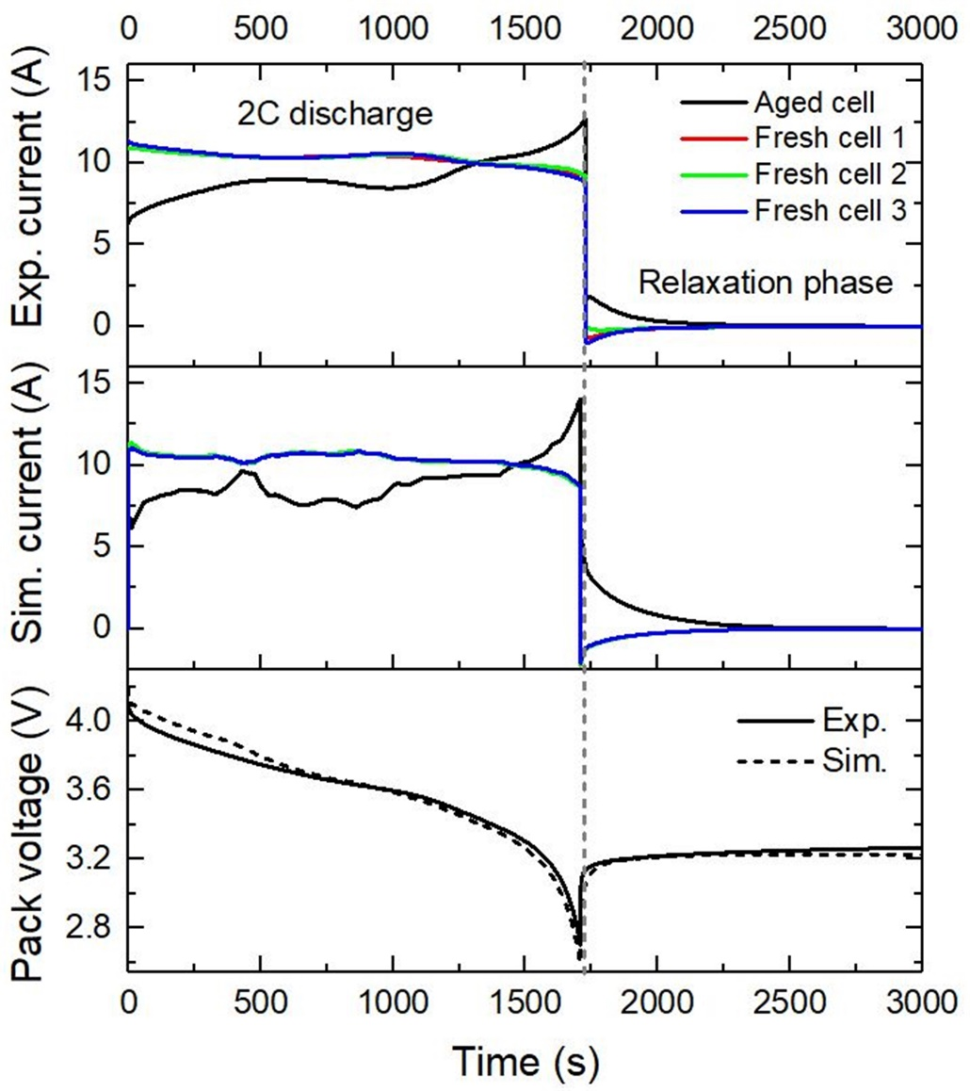

Figure 6. Experimental and simulated cell currents in a parallel battery pack (top & middle). Pack voltage (bottom). 2C discharge followed by a relaxation phase. One cell was artificially aged prior to the discharge. Experimental results taken from [11].

The simulated cell current performance closely resembles that of the experiment where the aged cell initially does not contribute as much power as the fresh cells due to its higher overpotential. However, as the diffusion resistances of the fresh cells increase towards the end of the discharge, the aged cell begins to provide more power and cell balancing continues as the load is turned off. The impact of having an aged cell in a battery pack on pack capacity is analysed both experimentally and through simulation (Table 4).

Table 4. Simulation and experimental results on sum of individual cell capacities vs. pack capacity. Experimental results taken from [11].

|  |  |  |  |  |  |  |
| --- | --- | --- | --- | --- | --- | --- |
| **2C discharge (Ah)** | **Aged cell** | **Fresh cell 1** | **Fresh cell 2** | **Fresh cell 3** | **Sum of individual capacities** | **Pack capacity** |
| **Model simulation** | 4.34 | 4.87 | 4.87 | 4.87 | 18.94 | 18.83 |
| **Experimental results** | 4.39 | 4.83 | 4.83 | 4.82 | 18.70 | 18.99 |

It can be seen from the results that the difference between pack capacity and sum of individual cell capacities is approximately 1%. It is expected that pack performance is lower due to the presence of interconnection resistances however the experimental results show an opposite effect. This may be because the cells become hotter when combined as a pack from the proximity to the other cells also generating heat. Higher temperature means smaller impedance hence the cells are able to discharge more until they reach the voltage cut-off. The results demonstrate that there is no significant loss in pack capacity in the presence of an aged cell compared to the sum of individual cell capacities. However, it should be noted that the higher peak currents at different stages of the discharge suggests accelerated aging of all cells and thus the aged cell should be identified and replaced as soon as possible.

## Sensitivity analysis of particle size distribution

As an example demonstration for the multi-particle model, a performance analysis is carried out by simulating gradient particle size distributions. In this sensitivity analysis, the particle radii of the electrode particles in a 1P3S multi-particle model are unevenly distributed and the accessible energy and capacity of the full cell is observed. The radii are distributed while maintaining the same overall particle-to-electrolyte interfacial area.

As described in the parametrisation section, the particle radii affect the resistances (*Rsei, Rct, Rdiff*) and capacitances (*Csei, Cdl*) of the particles and their surfaces accordingly. In reality, particle radius will also affect electrode porosity hence effective electrolyte resistance however this dependency is not explored in this current version of the model. The sensitivity analysis of gradient effective electrolyte resistance in an electrode is explored in the next section. Figure 7a describes the results.

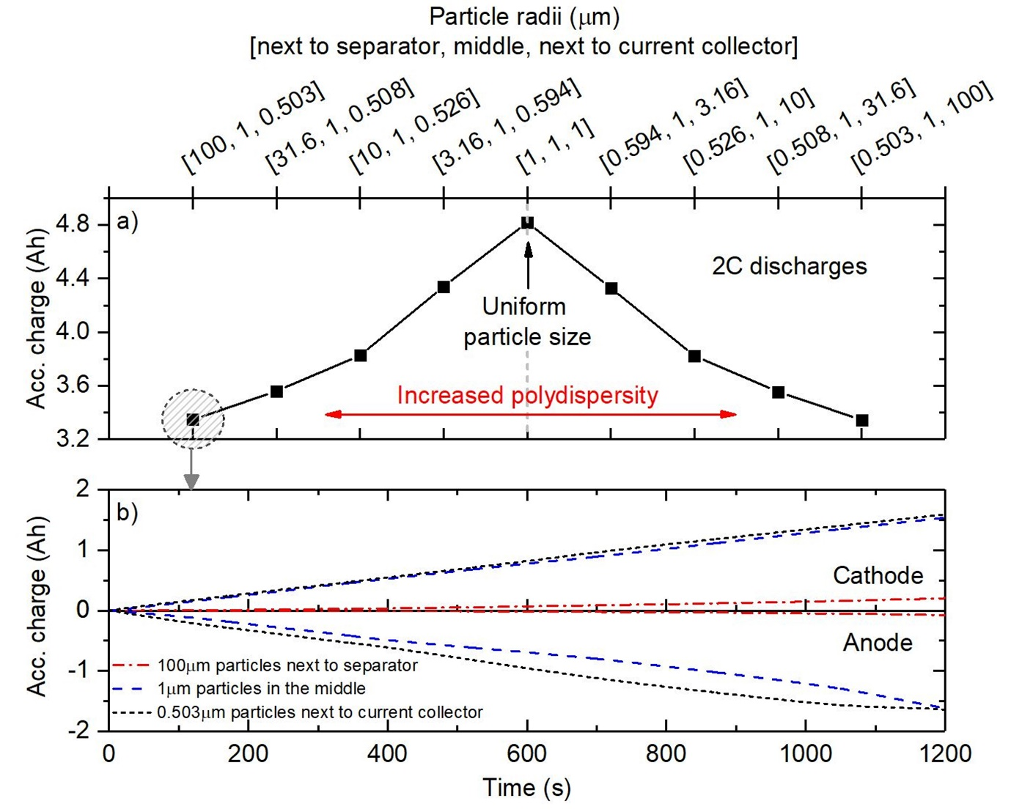

Figure 7. (a) Accessible charge for a 2C discharge from 4.2V to 3.0V for various particle size polydispersity with the same total particle-to-electrolyte interfacial area. Simulated on a 1P3S configuration. Notice how the cell performance drops with increased polydispersity. (b) Anode and cathode accumulated charge for a cell with particle radii of [100, 1, 0.503] (µm). i.e. particles closer to the separator are larger and closer to the current collector are smaller. Notice how the smaller particles (de)intercalates faster despite being further away from the separator. The large particles have significantly less contribution due to their large resistances.

It can be seen in the results that there is lower available capacity and energy with increasing particle size dispersity regardless of their locations with respect to the separator/current collector. Electrodes with uniform particle size distribution performs the best which matches the results presented in [25]. This is due to the presence of the larger particles limiting the overall performance of the electrode with its slow kinetics and larger diffusion resistance.

Particle size has a direct influence on particle resistances as it is dependent on the radial distance/area of the particle. As a result, the smaller particles should experience a higher and faster lithium intercalation whereas the larger particles see the opposite effect. In Figure 7b it can be clearly observed that the electrode region with the smaller particles have faster (de)intercalation despite it being further away from the separator. This is validated by an X-ray tomography analysis of an LiMn2O4 battery presented in [53].

## Sensitivity analysis of gradient effective electrolyte resistance

As a last example, a performance analysis is carried out by simulating various gradient electrolyte resistances through the thickness in the two electrodes. Porosity has a direct correlation to the effective electrolyte resistance as defined by the conductivity of electrolyte equation [31]. This sensitivity analysis could be correlated to the effect on the effective ionic conductivity of the electrolyte due to variations in electrode porosity. This is simulated by altering the electrolyte resistance components between the electrode particles while maintaining the total effective electrolyte resistance of the electrode the same. Accessible energy and power are calculated for a 2 C discharge from 4.2 V to 3.0 V.

C:\Users\ym1309\AppData\Local\Microsoft\Windows\INetCache\Content.Word\R_ele_test1.tif

Figure 8. Accessible energy and charge for a 2C discharge from 4.2V to 3.0V for various effective electrode porosity gradient.

Simulation results in Figure 8 show that having a higher porosity closer to the separator interface provides a slightly higher useable capacity for the same effective electrolyte resistance. This result matches with the graded electrode analysis provided by Qi et al. [54]. This can be explained by the fact that the electrode particles closer to the separator interface having a lower path of resistance. This allows these particles to be discharged further with smaller overpotentials hence reaching the voltage cut-off at a later point.

However, it can also be argued that this gradient has negligible impact on the performance as the difference seen in this result is less than 0.2%. This is because all the particles need to be (de)lithiated in order to fully discharge the cell so the presence of a gradient is negligible as long as the overall effective electrolyte resistance in the electrode is the same.

# Conclusion

In this work a new physics based model, inspired by Newman style porous electrode theory models, where the physics is discretised and represented as circuit elements in a network, was developed, parametrised and tested. The model, written in Simulink, consists of components that represent real internal components of a battery allowing for flexible and modular applications to fit many scenarios and requirements. The key advantage of this model is that it is easy to parametrise requiring only 3 low-cost in-situ experiments: slow discharge, pulse discharge and EIS under load. The model showed an accuracy of 19.6mV compared to multi C-rate pulse loading experiments.

The model’s capability was demonstrated through a number of different simulation configurations validated by literature and lab experiments. Demonstrated results include:

* Model can simulate and estimate various aging mechanisms proving to be a complimentary method to experimental measurements such as EIS.
* No significant impact on pack capacity is observed in the presence of an aged cell with respect to sum of individual cell capacities.
* Cells perform better in uniform electrode particle size distribution for the same total electrode-to-electrolyte interfacial area.
* Cells perform marginally better when the electrode is more porous towards the separator for the same total effective electrolyte resistance.

The model and initialisation MATLAB script are provided for readers to use for their own application.

# Acknowledgement

The authors would also like to acknowledge Innovate UK for funding this work for Yu Merla as well as the EPSRC through the Career Acceleration Fellowship for Gregory Offer (EP/I00422X/1), the EPSRC Energy Storage for Low Carbon Grids Project (EP/K002252/1) and the EPSRC Joint UK India Centre for Clean Energy (EP/P003605/1) for Billy Wu, the ESRN Energy Storage Research Network project for Vladimir Yufit and the FUTURE vehicles project (EP/I038586/1).

# References

[1] J. Vetter, P. Novák, M.R. Wagner, C. Veit, K.-C. Möller, J.O. Besenhard, M. Winter, M. Wohlfahrt-Mehrens, C. Vogler, a. Hammouche, Ageing mechanisms in lithium-ion batteries, J. Power Sources. 147 (2005) 269–281. doi:10.1016/j.jpowsour.2005.01.006.

[2] S. Krueger, R. Kloepsch, J. Li, S. Nowak, S. Passerini, M. Winter, How Do Reactions at the Anode/Electrolyte Interface Determine the Cathode Performance in Lithium-Ion Batteries?, J. Electrochem. Soc. 160 (2013) A542–A548. doi:10.1149/2.022304jes.

[3] Y. Merla, B. Wu, V. Yufit, N.P. Brandon, R.F. Martinez-Botas, G.J. Offer, Novel application of differential thermal voltammetry as an in-depth state-of-health diagnosis method for lithium-ion batteries, J. Power Sources. 307 (2016) 308–319. doi:10.1016/j.jpowsour.2015.12.122.

[4] A. Barré, B. Deguilhem, S. Grolleau, M. Gérard, F. Suard, D. Riu, A review on lithium-ion battery ageing mechanisms and estimations for automotive applications, J. Power Sources. 241 (2013) 680–689. doi:10.1016/j.jpowsour.2013.05.040.

[5] M. Dubarry, C. Truchot, B.Y. Liaw, Cell degradation in commercial LiFePO4 cells with high-power and high-energy designs, J. Power Sources. 258 (2014) 408–419. doi:10.1016/j.jpowsour.2014.02.052.

[6] C. Weng, X. Feng, J. Sun, H. Peng, State-of-health monitoring of lithium-ion battery modules and packs via incremental capacity peak tracking, Appl. Energy. 180 (2016) 360–368. doi:10.1016/j.apenergy.2016.07.126.

[7] M. Berecibar, M. Garmendia, I. Gandiaga, J. Crego, I. Villarreal, State of health estimation algorithm of LiFePO4 battery packs based on differential voltage curves for battery management system application, Energy. 103 (2016) 784–796. doi:10.1016/j.energy.2016.02.163.

[8] M. Berecibar, F. Devriendt, M. Dubarry, I. Villarreal, N. Omar, W. Verbeke, J. Van Mierlo, Online state of health estimation on NMC cells based on predictive analytics, J. Power Sources. 320 (2016) 239–250. doi:10.1016/j.jpowsour.2016.04.109.

[9] B. Stiaszny, J.C. Ziegler, E.E. Krauß, M. Zhang, J.P. Schmidt, E. Ivers-Tiffée, Electrochemical characterization and post-mortem analysis of aged LiMn 2O4-NMC/graphite lithium ion batteries part II: Calendar aging, J. Power Sources. 258 (2014) 61–75. doi:10.1016/j.jpowsour.2014.02.019.

[10] D. Andre, M. Meiler, K. Steiner, H. Walz, T. Soczka-guth, D.U. Sauer, Characterization of high-power lithium-ion batteries by electrochemical impedance spectroscopy . II : Modelling, J. Power Sources. 196 (2011) 5349–5356. doi:10.1016/j.jpowsour.2010.07.071.

[11] Y. Merla, B. Wu, V. Yu, N.P. Brandon, R.F. Martinez-botas, G.J. Offer, Extending battery life : A low-cost practical diagnostic technique for lithium-ion batteries, 331 (2016) 224–231. doi:10.1016/j.jpowsour.2016.09.008.

[12] B. Wu, V. Yufit, Y.Y. Merla, R.F.R.F. Martinez-botas, N.P.N.P. Brandon, G.J.G.J. Offer, Differential thermal voltammetry for tracking of degradation in lithium-ion batteries, J. Power Sources. 273 (2015) 495–501. doi:10.1016/j.jpowsour.2014.09.127.

[13] J. Christensen, J. Newman, A Mathematical Model for the Lithium-Ion Negative Electrode Solid Electrolyte Interphase, J. Electrochem. Soc. 151 (2004) A1977. doi:10.1149/1.1804812.

[14] C.R. Birkl, E. McTurk, M.R. Roberts, P.G. Bruce, D.A. Howey, A Parametric Open Circuit Voltage Model for Lithium Ion Batteries, J. Electrochem. Soc. 162 (2015) A2271–A2280. doi:10.1149/2.0331512jes.

[15] B. Wu, V. Yufit, M. Marinescu, G.J. Offer, R.F. Martinez-Botas, N.P. Brandon, Coupled thermal–electrochemical modelling of uneven heat generation in lithium-ion battery packs, J. Power Sources. 243 (2013) 544–554. doi:10.1016/j.jpowsour.2013.05.164.

[16] C. Kupper, W.G. Bessler, Multi-Scale Thermo-Electrochemical Modeling of Performance and Aging of a LiFePO 4 /Graphite Lithium-Ion Cell, J. Electrochem. Soc. 164 (2017) A304–A320. doi:10.1149/2.0761702jes.

[17] M.B. Pinson, M.Z. Bazant, Theory of SEI Formation in Rechargeable Batteries: Capacity Fade, Accelerated Aging and Lifetime Prediction, J. Electrochem. Soc. 160 (2012) A243–A250. doi:10.1149/2.044302jes.

[18] K.D. Stetzel, L.L. Aldrich, M.S. Trimboli, G.L. Plett, Electrochemical state and internal variables estimation using a reduced-order physics-based model of a lithium-ion cell and an extended Kalman filter, J. Power Sources. 278 (2015) 490–505. doi:10.1016/j.jpowsour.2014.11.135.

[19] J.L. Lee, L.L. Aldrich, K.D. Stetzel, G.L. Plett, Extended operating range for reduced-order model of lithium-ion cells, J. Power Sources. 255 (2014) 85–100. doi:10.1016/j.jpowsour.2013.12.134.

[20] M.B. Pinson, M.Z. Bazant, Theory of SEI Formation in Rechargeable Batteries: Capacity Fade, Accelerated Aging and Lifetime Prediction, J. Electrochem. Soc. 160 (2012) A243–A250. doi:10.1149/2.044302jes.

[21] I. Laresgoiti, Modelling Mechanical Degradation in Lithium Ion Batteries during Cycling: SEI Fracture, in: ModVal 12, 2015.

[22] S. Tippmann, D. Walper, L. Balboa, B. Spier, W.G. Bessler, Low-temperature charging of lithium-ion cells part I: Electrochemical modeling and experimental investigation of degradation behavior, J. Power Sources. 252 (2014) 305–316. doi:10.1016/j.jpowsour.2013.12.022.

[23] N. Legrand, B. Knosp, P. Desprez, F. Lapicque, S. Raël, Physical characterization of the charging process of a Li-ion battery and prediction of Li plating by electrochemical modelling, J. Power Sources. 245 (2014) 208–216. doi:10.1016/j.jpowsour.2013.06.130.

[24] X. Lin, J. Park, L. Liu, Y. Lee, a. M. Sastry, W. Lu, A Comprehensive Capacity Fade Model and Analysis for Li-Ion Batteries, J. Electrochem. Soc. 160 (2013) A1701–A1710. doi:10.1149/2.040310jes.

[25] R. Darling, J. Newman, Modeling a Porous Intercalation Electrode with Two Characteristic Particle Sizes, J. Electrochem. Soc. 144 (1997) 4201–4208. doi:10.1149/1.1838166.

[26] P. Ramadass, B. Haran, R. White, B.N. Popov, Mathematical modeling of the capacity fade of Li-ion cells, J. Power Sources. 123 (2003) 230–240. doi:10.1016/S0378-7753(03)00531-7.

[27] R. Klein, N.A. Chaturvedi, J. Christensen, J. Ahmed, R. Findeisen, A. Kojic, Electrochemical model based observer design for a lithium-ion battery, IEEE Trans. Control Syst. Technol. 21 (2013) 289–301. doi:10.1109/TCST.2011.2178604.

[28] M. Guo, G.H. Kim, R.E. White, A three-dimensional multi-physics model for a Li-ion battery, J. Power Sources. 240 (2013) 80–94. doi:10.1016/j.jpowsour.2013.03.170.

[29] D.E. Stephenson, E.M. Hartman, J.N. Harb, D.R. Wheeler, Modeling of Particle-Particle Interactions in Porous Cathodes for Lithium-Ion Batteries, J. Electrochem. Soc. 154 (2007) A1146. doi:10.1149/1.2783772.

[30] M. Ecker, K. Dung, P. Dechent, K. Stefan, Parameterization of a Physico-Chemical Model of a Lithium-Ion Battery I . Determination of Parameters, 162 (2015) 1836–1848. doi:10.1149/2.0551509jes.

[31] P.W.C. Northrop, V. Ramadesigan, S. De, V.R. Subramanian, Coordinate Transformation , Orthogonal Collocation , Model Reformulation and Simulation of Electrochemical-Thermal Behavior of Lithium-Ion Battery Stacks, 158 (2011). doi:10.1149/2.058112jes.

[32] K. Smith, C.-Y. Wang, Power and thermal characterization of a lithium-ion battery pack for hybrid-electric vehicles, J. Power Sources. 160 (2006) 662–673. doi:10.1016/j.jpowsour.2006.01.038.

[33] K. Smith, Electrochemical Modeling, Estimation and Control of Lithium Ion Batteries, The Pennsylvania State University, 2006.

[34] K. Smith, C.Y. Wang, Solid-state diffusion limitations on pulse operation of a lithium ion cell for hybrid electric vehicles, J. Power Sources. 161 (2006) 628–639. doi:10.1016/j.jpowsour.2006.03.050.

[35] Y. Ji, Y. Zhang, C.-Y. Wang, Li-Ion Cell Operation at Low Temperatures, J. Electrochem. Soc. 160 (2013) A636–A649. doi:10.1149/2.047304jes.

[36] E. Prada, D. Di Domenico, Y. Creff, J. Bernard, V. Sauvant-Moynot, F. Huet, Simplified Electrochemical and Thermal Model of LiFePO4-Graphite Li-Ion Batteries for Fast Charge Applications, J. Electrochem. Soc. 159 (2012) A1508–A1519. doi:10.1149/2.064209jes.

[37] J. Newman, Optimization of Porosity and Thickness of a Battery Electrode by Means of a Reaction-Zone Model, J. Electrochem. Soc. 142 (1995) 97. doi:10.1149/1.2043956.

[38] M. Von Srbik, M. Marinescu, R.F. Martinez-botas, G.J. Offer, A physically meaningful equivalent circuit network model of a lithium-ion battery accounting for local electrochemical and thermal behaviour , variable double layer capacitance and degradation, J. Power Sources. 325 (2016) 171–184. doi:10.1016/j.jpowsour.2016.05.051.

[39] N. Liu, Z. Lu, J. Zhao, M.T. McDowell, H.-W. Lee, W. Zhao, Y. Cui, A pomegranate-inspired nanoscale design for large-volume-change lithium battery anodes., Nat. Nanotechnol. 9 (2014) 187–92. doi:10.1038/nnano.2014.6.

[40] N. Dimov, S. Kugino, M. Yoshio, Carbon-coated silicon as anode material for lithium ion batteries: advantages and limitations, Electrochim. Acta. 48 (2003) 1579–1587. doi:10.1016/S0013-4686(03)00030-6.

[41] F. Tariq, V. Yufit, D.S.S. Eastwood, Y. Merla, M. Biton, B. Wu, Z. Chen, K. Freedman, G. Offer, E. Peled, P.D.D. Lee, D. Golodnitsky, N. Brandon, In-Operando X-ray Tomography Study of Lithiation Induced Delamination of Si Based Anodes for Lithium-Ion Batteries, ECS Electrochem. Lett. 3 (2014) A76–A78. doi:10.1149/2.0081407eel.

[42] Z.R. Chang, H.J. Lv, H.W. Tang, H.J. Li, X.Z. Yuan, H. Wang, Synthesis and characterization of high-density LiFePO4/C composites as cathode materials for lithium-ion batteries, Electrochim. Acta. 54 (2009) 4595–4599. doi:10.1016/j.electacta.2009.03.063.

[43] C.Z. Lu, G.T.K. Fey, H.M. Kao, Study of LiFePO4 cathode materials coated with high surface area carbon, J. Power Sources. 189 (2009) 155–162. doi:10.1016/j.jpowsour.2008.10.015.

[44] H. Joachin, T.D. Kaun, K. Zaghib, J. Prakash, Electrochemical and Thermal Studies of Carbon-Coated LiFePO4 Cathode, J. Electrochem. Soc. 156 (2009) A401. doi:10.1149/1.3106121.

[45] G.M. Koenig, I. Belharouak, H. Deng, Y. Sun, K. Amine, Composition-Tailored Synthesis of Gradient Transition Metal Precursor Particles for Lithium-Ion Battery Cathode Materials, (2011) 1954–1963.

[46] W. Waag, S. Käbitz, D.U. Sauer, Experimental investigation of the lithium-ion battery impedance characteristic at various conditions and aging states and its influence on the application, Appl. Energy. 102 (2013) 885–897. doi:10.1016/j.apenergy.2012.09.030.

[47] G.J. Offer, V. Yufit, D. a. Howey, B. Wu, N.P. Brandon, Module design and fault diagnosis in electric vehicle batteries, J. Power Sources. 206 (2012) 383–392. doi:10.1016/j.jpowsour.2012.01.087.

[48] B. Wu, Fuel cell hybrid electric vehicle powertrain modelling and testing, Imperial College London, 2014.

[49] a. Eddahech, O. Briat, E. Woirgard, J.M. Vinassa, Remaining useful life prediction of lithium batteries in calendar ageing for automotive applications, Microelectron. Reliab. 52 (2012) 2438–2442. doi:10.1016/j.microrel.2012.06.085.

[50] D.P. Abraham, E.M. Reynolds, P.L. Schultz, a. N. Jansen, D.W. Dees, Temperature Dependence of Capacity and Impedance Data from Fresh and Aged High-Power Lithium-Ion Cells, J. Electrochem. Soc. 153 (2006) A1610. doi:10.1149/1.2210668.

[51] L.R. Faulkner, A.J. Bard, Electrochemical Methods: Fundamentals and Applications, 2nd ed., John Wiley & Sons, Inc., 2001.

[52] S. Hughes, Current, Continuity Equation, Resistance, Ohm’s law., in: Massachusetts Inst. Technol. Dep. Phys., Spring 200, Massachusetts, 2005: pp. 63–71. http://web.mit.edu/sahughes/www/8.022/.

[53] D. Chung, P.R. Shearing, N.P. Brandon, S.J. Harris, R.E. Garc, Particle Size Polydispersity in Li-Ion Batteries, 161 (2014) 422–430. doi:10.1149/2.097403jes.

[54] Y. Qi, T. Jang, V. Ramadesigan, D.T. Schwartz, V.R. Subramanian, Benefit Analysis of Employing Graded Electrodes in Lithium-Ion Batteries, J. Electrochem. Soc. 164 (2017) A3196–A3207. doi:10.1149/2.1051713jes.