Fission Gas in Thoria

Navaratnarajah Kuganathan1, Partha S. Ghosh2, Conor O. T. Galvin1, Ashok K. Arya2, Bijon K. Dutta3, Gautam K. Dey2 and Robin W. Grimes1

1Department of Materials, Faculty of Engineering, Imperial College, London, SW7 2AZ, UK

2Material Science Division, Bhabha Atomic Research Centre, Trombay, Mumbai 400 085, India

3Homi Bhabha National Institute, Trombay, Mumbai 400 094, India

**__________________________________________________________________________________________**

**Abstract**

The fission gases Xe and Kr, formed during normal reactor operation, are known to degrade fuel performance, particularly at high burn-up. Using first-principles density functional theory together with a dispersion correction (DFT+D), in ThO2 we calculate the energetics of neutral and charged point defects, the di-vacancy (DV), different neutral tri-vacancies (NTV), the charged tetravacancy (CTV) defect cluster geometries and their interaction with Xe and Kr. The most favourable incorporation point defect site for Xe or Kr in defective ThO2 is the fully charged thorium vacancy. The lowest energy NTV in larger supercells of ThO2 is NTV3, however, a single Xe atom is most stable when accommodated within a NTV1. The di-vacancy (DV) is a significantly less favoured incorporation site than the NTV1 but the CTV offers about the same incorporation energy. Incorporation of a second gas atom in a NTV is a high energy process and more unfavourable than accommodation within an existing Th vacancy. The bi-NTV (BNTV) cluster geometry studied will accommodate one or two gas atoms with low incorporation energies but the addition of a third gas atom incurs a high energy penalty. The tri-NTV cluster (TNTV) forms a larger space which accommodates three gas atoms but again there is a penalty to accommodate a fourth gas atom. By considering the energy to form the defect sites, solution energies were generated showing that in ThO2-x the most favourable solution equilibrium site is the NTV1 while in ThO2 it is the DV.

**Keywords:** Thoria; DFT; Defects; Xenon; Krypton; Nuclear fuel

**1. Introduction**

There is considerable interest in finding an alternative to urania fuel (UO2), which remains the main fissile component in nuclear reactors. Materials that can replace UO2 should have low cost, high abundance, high proliferation resistance and be able to facilitate high burn-up **[1]**. Thoria (ThO2) has been identified as a possible alternative, partly because spent ThO2 fuels give rise to considerably smaller inventories of minor actinides, especially Pu. Further, ThO2 is a highly stable oxide, and exhibits higher thermal conductivity, higher melting temperature, higher corrosion resistance and lower thermal expansion compared to UO2 **[2].**

The fission product inert gases Xe and Kr, are estimated to be 15% of the total fission yield **[3]** but are insoluble in the fuel matrix. At high fuel temperatures, gas atoms migrate and are accommodated at point defect sites in the fuel matrix. Over time some of these aggregate into bubbles. Formation of bubbles is important as it leads to swelling and degrades mechanical properties of the material. Some gas atoms make their way to the fuel clad gap, which leads to an increase in the temperature in the fuel matrix due to a decrease in thermal conductivity across the fuel clad gap. This also increases the internal rod pressure. In order to understand fuel performance, it is necessary to understand the interaction of gas atoms with point defects.

Considerable work has already been carried out on gas atoms in UO2. It is, for example, energetically unfavourable for the large Xe or Kr gas atoms to occupy interstitial sites in UO2 (and ThO2) **[3-6].** Thus, the formation of defect clusters can be favoured. The smallest, charge neutral group of vacancies in UO2 or ThO2 consists of one uranium and two oxygen vacancies (the neutral tri-vacancy NTV), **[7]** which offers a greater volume than an interstitial or a single point defect to accommodate a large gas atom. Simulations predict that the incorporation of noble gas atoms in a UO2 NTV is favourable because of the strain relief introduced by this defect [**5, 6, 8**]. Using high energy resolution X-ray absorption spectroscopy, Bes *et al****.*[9]** have reported experimental evidence for the presence of Xe incorporated in a UO2 NTV**.** Using molecular dynamics simulations, Murphy *et al.***[5]**reported thatthemost favourable trap site for a Xe atom is a NTV in UO2 and this defect has little or no effect on the free energy of incorporation up to 1050 K**.** In order to accommodate gas clusters or bubbles in the fuel matrix, a number of NTVs are thought necessary to create larger space.

While a significant body of experimental and theoretical data have been reported on the defect chemistry and incorporation of Xe in UO2, fewer studies have been reported for ThO2. Using density functional theory (DFT), Lu *et al.* **[10]** calculated defect formation energies in ThO2 and concluded that the most favourable disorder process is oxygen Frenkel [consisting of an unoccupied oxygen lattice site (ie. a vacancy) and an interstitial O2- ion]**.** The reaction energy order (O Frenkel < Schottky < Th Frenkel) found in their study is in agreement with other DFT and empirical studies **[10-13].** Yun *et al.* **[14]** performed DFT total energy calculations to establish defect energies and Xe diffusion in UO2 and ThO2. They suggested that formation and migration energies of vacancy defects for ThO2 were much higher than for UO2 because of the restricted oxidation state of Th and stronger bonds between thorium and oxygen ions. Incorporation of fission products incuding Xe has been considered in ThO2 and CeO2 using DFT within the local density approximation, where all vacancy and interstitial defects were treated as neutral **[4]**. In ionic materials, however, defects should also be considered with appropriate full ionic charge.

In this study, we have used DFT simulations to carry out a detailed survey of the relative energetics for the formation of intrinsic defects with appropriate charges and the incorporation of Xe and Kr atoms in defect structures of ThO2. DFT calculations, in addition to giving structural information, predict electronic structure and electronic properties of the defects containing noble gas atoms.

**2. Computational Methods**

The calculations were carried out using the spin-polarized mode of DFT as implemented in the VASP package **[15,16].** The exchange-correlation term was modelled using the generalized gradient approximation (GGA) parameterized by Perdew, Burke, and Ernzerhof (PBE) **[17].** The standard projected augmented wave (PAW) potentials **[18]** were employed and a plane-wave basis set with a cut off value of 500 eV was used in all calculations. The valence electronic configurations treated for Th, Xe, Kr and O were 6s2 6p6 6d2 7s2, 4s2 4p6, 5s2 5p6 and 2s2 2p4 respectively. In order to describe the behaviour of the localized Th *f* states we included the orbital-dependent, Coulomb potential (Hubbard *U*) and the exchange parameter *J* within the DFT+U calculations, as formulated by Liechtenstein *et al.* **[19].** We applied the values of U = 4.5 eV and J = 0.5 eV to the localized *f* states of Th. Charged defects interact with their next periodic images in all three directions. To compensate, we applied the Madelung correction **[20]** as described by Leslie and Gillan **[21]** using the experimental dielectric constant of 18.9 reported by Axe *et al.* **[22].**

For bulk Th metal, we used an 8×8×8 Monkhorst-Pack **[23]** *k*-point mesh, which yielded 35 k points in the irreducible part of the Brillouin-zone and for bulk ThO2, a 4×4×4 Monkhorst-Pack *k*-point mesh, which yielded 10 k points. A 2×2×2 supercell containing 96 atoms was used for the defect calculations. For defect clusters consisting of multiple NTV units, we used a 3×3×3 supercell containing 324 atoms. Structural optimizations were performed using a conjugate gradient algorithm **[24]** and the forces on the atoms were obtained from the Hellman-Feymann theorem including Pulay corrections. In all optimized structures, forces on the atoms were smaller than 0.001 eV/Å and the stress tensor was less than 0.002 GPa.

The inclusion of van der Waals (vdW) interactions is particularly important for the incorporation of highly polarizable noble gas atoms into ThO2. In this work, dispersion has been included by using the pair-wise force field as implemented by Grimme *et al*. **[25]** in the VASP package.

**3. Results and discussion**

***3.1. Calculations on bulk Th and ThO2***

Single point calculations were performed on bulk Th and ThO2 structures to obtain the equilibrium lattice constants and bulk modulus, thereby enabling an assessment (through comparison with experimental values) of the quality of the pseudopotentials and basis set used for Th and O. The unit cell volume was varied within ±5% of the equilibrium volume and a cohesive curve was plotted by fitting values of the calculated energy to the Murnaghan equation of state **[26]** (see Figure 1). The calculated equilibrium lattice constants and bulk modulus, derived from the Murnaghan fit, are in excellent agreement with the experimental values and with the results of other plane wave calculations (see Table 1).

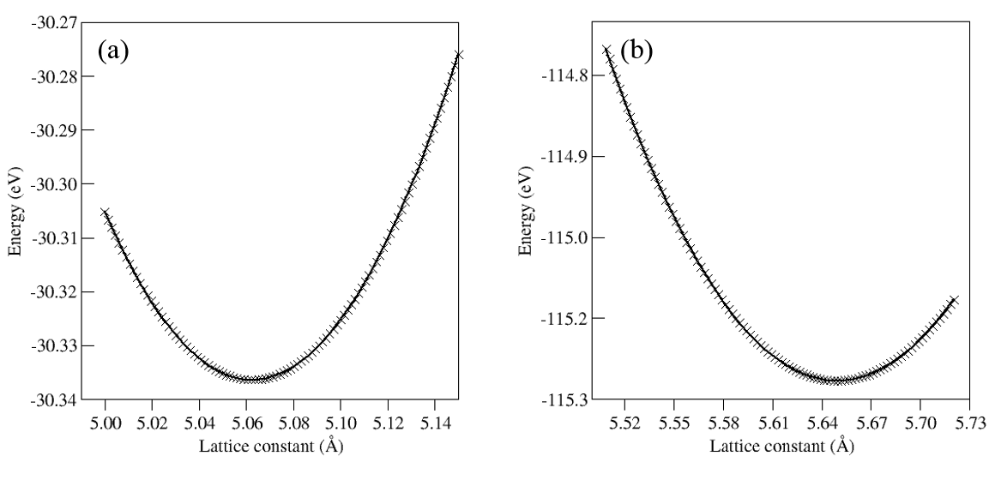

**Figure 1**. Plot of total energy versus lattice constant for (a) bulk Th and (b) bulk ThO2. Black crosses are the points obtained by calculation; the line represents the Murnaghan fit.

**Table 1.** Calculated and experimental lattice constants, bulk modulus, bond distances, band gaps and cohesive energies of bulk Th and ThO2.

|  |  |  |  |  |
| --- | --- | --- | --- | --- |
| **Parameter** | **Th** | | **ThO2** | |
| ***calc*** | ***expt*** | ***calc*** | ***expt*** |
| a = b = c (Å) | 5.07 | 5.07 **[28]** | 5.64 | 5.60 **[27]** |
| α = β = γ (°) | 90.00 | 90.00 | 90.00 | 90.00 |
| Bulk modulus (GPa) | 55.87 | 58.00 **[29]** | 189.92 | 193.23 **[30]** |
| Th – Th /O (Å) | 3.58 | 3.59 | 2.44 | 2.43 |
| Egap (eV) | 0.00 | 0.00 | 4.72 | 5.75 **[31]** |
| Ecoh (eV) | 6.79 | 6.23 **[32]** | 24.92 | 23.66 **[33]** |

ThO2 is a typical insulator. The band gap energy calculated here for ThO2 is 4.72 eV, which underestimates the experimental band gap value of 5.75 eV **[31]** but is consistent with other DFT calculations **[11, 14].** The underestimation of the band gap is due to the use of the exchange-correlation approximation **[34].**

***3.2. Intrinsic point defects and clusters***

A series of isolated point defect (vacancy and interstitial) energies were calculated and combined to determine the formation energies for Frenkel and Schottky disorder. Calculated formation energies for all point defects and clusters together with the methodology used in this study are reported in the electronic supplementary information (ESI). Our calculations suggest that the most favourable charge state for a point defect (vacancy or interstitial) is that with the full ionic charge. The oxygen interstitial defect (O2–) exhibits a negative formation energy, meaning that O2– can be easily incorporated with the release of 0.65 eV (this is because O2- is not a stable isolated species) **[35]**. Lu *et al.* reported that the Th interstitial with +4 charge has the lowest and negative formation energy **[10].** The study by Murphy *et al*. shows that Th vacancy with –4 charge is the most favourable point defect **[11].** Defect formation energies calculated using different methodologies, particularly in the case of charged defects, are difficult to compare. However, Schottky and Frenkel energies (i.e. complete disorder processes) calculated by combining corresponding point defects can be compared.

Point defects in a highly ionic material might be expected to be in their fully ionic charge states. The following equations represent the reactions involving these defects with full ionic charge (though we will also consider partial and neutral process below) as written using Kröger-Vink notation **[36].**

Th Frenkel:  (1)

O Frenkel:  (2)

Schottky:  (3)

The formation energy of a Frenkel pair (FPx) was calculated combining the formation energies of a vacancy and a corresponding interstitial, that is:

 (4)

In order to calculate the formation energy for a Schottky defect the following equation was used:



(5)

where N is the number of atoms contained in the supercell considered.

Table 2 lists the intrinsic defect process energies, derived by combining the calculated energies of point defects and lattice energies. In all cases the total reaction energy is normalized per defect formed (i.e. by 2 for Frenkel and 3 by Schottky) so that they can be compared. For each we compare our results with those derived by Murphy *et al.* **[11]** and by Lu *et al*. **[10].** For each reaction the most favourable corresponds to fully charged defects. Comparing the most favourable Frenkel and Schottky reactions, the order is O Frenkel < Schottky << Th Frenkel)**.** There is excellent agreement overall with Murphy *et al.* **[11]** and for neutral defects with those by Lu *et al.* **[10]**. The difference in the energetics for charged defect process compared to Lu *et al.* **[10]** is due to different methodologies used to correct for periodic charged defects. The current study and that by Murphy *et al*. **[11]** used the methodology implemented by Leslie and Gillan **[21]**, whilst Lu *et al*. **[10]** used a potential alignment correction based on macroscopic average techniques **[37, 38].** In particular, in this study we used the experimental dielectric constant of ThO2, 18.9 in the correction whereas Lu *et al***. [10]** have not mentioned the exact value of the dielectric constant value in the potential alignment correction. Thus, the formation energies for charged defects calculated by Lu *et al*. **[10]** may differ from our calculated values.

**Table 2.** Normalised formation energies of intrinsic defects in ThO2.

|  |  |  |  |  |
| --- | --- | --- | --- | --- |
| **Defect** | **Equation** | **Formation energy per defect(eV)** | | |
| This study | Murphy *et al.11* | Lu *et al.10* |
| Th Frenkel | ${Th}_{Th}^{X}$ → $V_{Th}^{''''}$ + ${Th}_{i}^{⦁⦁⦁⦁}$ | 6.79 | 6.86 | 8.36 |
|  | ${Th}_{Th}^{X}$ → $V_{Th}^{'''}$ + ${Th}_{i}^{⦁⦁⦁}$ | 7.64 | 7.68 | 9.41 |
|  | ${Th}_{Th}^{X}$ → $V_{Th}^{''}$ + ${Th}_{i}^{⦁⦁}$ | 8.89 | 9.00 | 10.59 |
|  | ${Th}_{Th}^{X}$ → $V_{Th}^{'}$ + ${Th}_{i}^{⦁}$ | 10.46 | 10.69 | 12.25 |
|  | ${Th}_{Th}^{X}$ → $V_{Th}^{0}$ + ${Th}_{i}^{0}$ | 12.31 | 12.68 | 12.22 |
| O Frenkel | $O_{O}^{X}$ → $V_{O}^{⦁⦁}$ + $O_{i}^{''}$ | 2.31 | 2.49 | 3.42 |
|  | $O_{O}^{X}$ → $V_{O}^{⦁}$ + $O_{i}^{'}$ | 3.00 | 3.36 | 3.98 |
|  | $O_{O}^{X}$ → $V_{O}^{0}$ + $O_{i}^{0}$ | 4.54 | 4.66 | 4.66 |
| Schottky | ${Th}_{Th}^{X}+2O_{O}^{X}$ → $V_{Th}^{''''}+2V_{O}^{⦁⦁}+{ThO}_{2}$ | 2.98 | 2.68 | 2.74 |
|  | ${Th}_{Th}^{X}+2O_{O}^{X}$ → $V_{Th}^{''}+2V_{O}^{⦁}+{ThO}_{2}$ | 4.39 | 4.24 | 4.18 |
|  | ${Th}_{Th}^{X}+2O_{O}^{X}$ → $V_{Th}^{0}+2V_{O}^{0}+{ThO}_{2}$ | 6.69 | 6.69 | 6.49 |

The first cluster considered was the simple di-vacancy (DV) consisting of a thorium vacancy adjacent to a nearest neighbour oxygen vacancy (i.e. there is one possible geometry). The full charge of this cluster is -2 reflecting the association of VO(+2) and VTh(-4). We also considered the formation of a DV with charge -1 reflecting the association of Vo(+1) and VTh(-2) and finally the neutral cluster reflecting the association of Vo(0) and VTh(0). The formation energies of the clusters are 5.20 eV, 8.89 eV and 14.37 eV respectively, again indicating that the fully charged defect is the most stable.

We then calculated the NTV defects resulting from associating a single Th vacancy and two O vacancies. There are three different near neighbour NTV defect configurations possible in the fluorite structure and they are shown in Figure 2. Our calculations predict that the NTV2 defect exhibits the lowest energy in the 2×2×2 supercell. Using classical effective potential simulation, Cooper *et al*. **[12]** found that the NTV3 defect is the most stable for all supercell sizes**.** We have considered all three defects in a 3×3×3 supercell and found that the energy difference between NTV2 and NTV3 defects is very small. Thus, the NTV cluster geometry preference is supercell size dependent. Murphy *et al.* **[11]** have recently calculated NTV energies in ThO2 using the DFT+GGA method and found the same trend as identified here. Thompson *et al***.[39]** have also seen this trend in their NTV calculations using the DFT+GGA+U method in a 2×2×2 UO2 supercell.

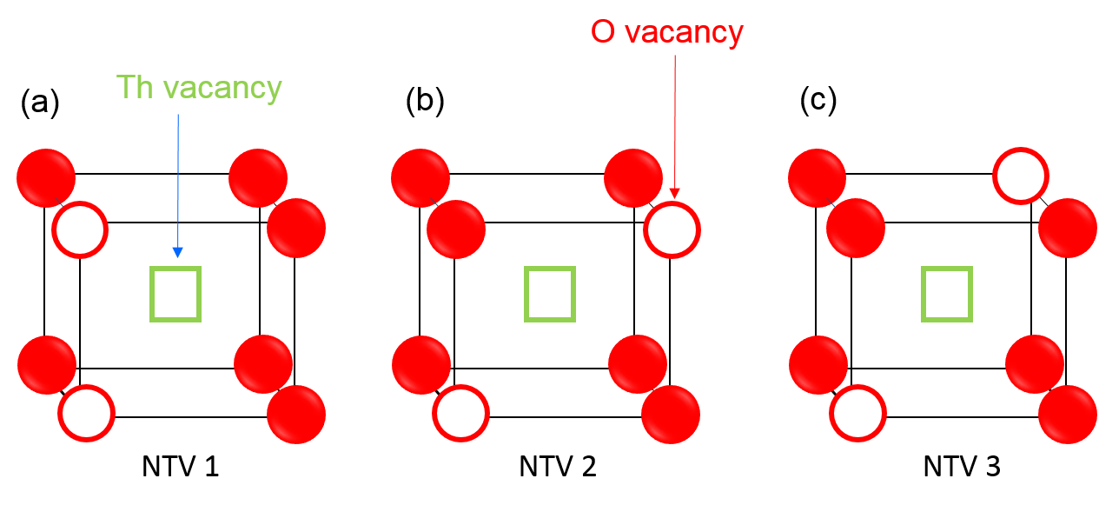

**Figure 2.** The three different possible configurations of NTV defects in ThO2.

The next cluster that has previously been modelled in fission gas simulations is the charged tetravacancy (CTV) **[7]**. This consisits of two thorium vacancies and two oxygen vacancies. Given the result for the VTh and DV cluster, here only the fully (-4) charge state was considered. The CTV is often considered as a NTV1 cluster which has trapped a thorium vacancy in the same plane as the other three vacancies. The binding energy of the VTh to the NTV1 cluster is 2.55 eV.

Contributions of two and three NTVs were also considered as traps for gas atoms. Their geometries are described later.

***3.3. Incorpoation of single fission gas atom at interstitial and single point defects***

In order to study the confinement of fission gases in ThO2, three different single site positions were initially considered. The first is an octahedral interstitial site in defect-free ThO2. The other two were oxygen and thorium vacancy defect sites with different charge states, including fully ionic charges. The incorporation energy of a gas atom in the octahedral interstitial site was calculated using the following equation:

(7)

where  is the energy of a Xe atom incorporated into a ThO2 supercell,  is the total energy of the defect-free ThO2 supercell and  is the energy of a single Xe gas atom. The incorporation energy of a Xe atom at a defect site, for example Xe at an oxygen vacancy site, is given by,

 (8)

where  is the total energy of the supercell containing a Xe atom at an oxygen vacancy and

 is the total energy of the cell containing an unoccupied oxygen vacancy.

An incorporation energy (see Table 3) is the energy to trap a fission product atom, initially assumed to be at infinity, at a pre-existing defect site (in the charge state specified). Thus, we assume that the trap site is available for occupation. Such a situation is most applicable if the number of gas atoms is small compared to the concentration of the trap site. The results show that, the accommodation of Xe or Kr at an interstitial site in ThO2 is unfavourable (high positive energy) indicating both gas atoms are highly insoluble in the defect-free ThO2 matrix. Further, both Xe and Kr are much more readily accommodated at a pre-existing neutral thorium vacancy but not at a neutral oxygen vacancy. This agrees with the DFT calculations by Xiao *et al.* **[4]** who also found that a single Xe atom is more favourably accommodated at a neutral thorium vacancy than a neutral oxygen vacancy or an octahedral interstitial site.

Next we consider how incorporation energies of Xe and Kr differ between vacancies of different charge. In the case of the oxygen vacancy, the highest charged vacancy has the lowest incorporation energy. The is due in part to the induced dipole attraction between the positive charge in the cell and the electrons in the complete outer shells of Xe and Kr. Also, because the relaxation outwards of surrounding ions is greater for a higher charged defect this provides a larger defect site space to accommodate the large gas atom. Further, in the case of the oxygen vacancy, Kr has a more favourable incorporation energy than Xe due to its smaller atomic radius. In the case of the thorium vacancy, the trend is reversed. Incorporation is less favoured at the thorium vacancy with -4 charge. This is because of the strong repulsion between the negative charge and the complete electron outer shells of Xe and Kr. This is demonstrated by the significant Bader charge on Xe (see Table 3), which forms because Xe transfers charge (polarizes) to balance the lack of Th4+ cation. Once the negative charges are introduced [i.e. from VTh (0) to VTh(-4)] the value of the positive Bader charge decreases gradually to zero. Kr is less favourable than Xe to incorporate in the VTh (0) and VTh(-1) vacancies because it is harder to transfer charge from Kr and thus the corresponding Bader charges are smaller (i.e. it is less polarizable than Xe, see Table 3). However, incorporation of Kr into VTh(-3) and VTh(-4) is more favourable than for Xe because the polarization contribution is less significant and the size effect (which favours Kr) becomes the dominant determining factor. Charge density and density of states plotted for the Xe and Kr complexed with neutral and fully charged vacancies are presented in the ESI.

We can also use incorporation energies to investigate if the occupation of a given defect (i.e. a Th or O vacancy) by a gas atom will alter its most stable (preferred) charged state. This is achieved by reconstituting the incorporation energy relationship by adding the energy to change the charge of the vacancy from its most stable {i.e. VTh(-4) or VO(+2)} to the alternate charge. Relative incorporation energies are important because electronic charge is transported through the lattice much more rapidly than gas atoms. Here, for example, the relative incorporation of Xe at an oxygen vacancy with +1 charge was calculated using the following equation:

 (9)

where  is the incorporation energy of Xe with respect to an oxygen vacancy with +2 charge (i.e. the most favourable unoccupied charge state for an oxygen vacancy),  is the incorporation energy of Xe,  and  are the formation energies of oxygen vacancies with +1 and +2 charges respectively.

Relative incorporation energies (see Table 3) show that for both oxygen and thorium vacancies the most stable charge state is that with the full charge; that is, whether the vacancy is occupied by a gas atom or unoccupied, the preference is for the fully charged state. Nevertheless, association of charge to the XeTh defect has now been shown to have an induced polarization energy term that has not previously been identified. This may have a consequence for understanding the transport of Xe through the lattice.

**Table 3**. Incorporation energies with (i.e. relative) and without respect to fully chaged defects, Bader charges on fission gases and magnetic moments of the composites: Int; an octahedral interstitial. VO ; an oxygen vacancy and VTh ; a thorium vacancy in the lattice.

|  |  |  |  |  |  |  |  |  |  |  |
| --- | --- | --- | --- | --- | --- | --- | --- | --- | --- | --- |
| Properties |  | Int. | $$V_{O}^{X}$$ | $$V_{O}^{•}$$ | $$V_{O}^{••}$$ | $$V_{Th}^{X}$$ | $$V_{Th}^{'}$$ | $$V_{Th}^{''}$$ | $$V_{Th}^{'''}$$ | $$V_{Th}^{''''}$$ |
| Incorporation energy (eV) | Xe | 10.19 | 10.04 | 9.12 | 7.50 | 0.01 | 0.66 | 1.76 | 2.82 | 3.74 |
| Kr | 6.96 | 7.21 | 6.57 | 4.84 | 1.19 | 1.49 | 1.83 | 2.25 | 2.64 |
| Relative incorporation energy, with respect to fully charged defect (eV) | Xe | 10.19 | 11.47 | 9.38 | 7.50 | 8.33 | 6.50 | 5.47 | 4.32 | 3.74 |
| Kr | 6.96 | 8.64 | 6.83 | 4.84 | 9.51 | 7.33 | 5.54 | 3.75 | 2.64 |
| Bader charge (|e|) | Xe | +0.24 | +0.10 | +0.10 | +0.12 | +1.22 | +0.97 | +0.67 | +0.35 | +0.01 |
| Kr | +0.05 | −0.04 | +0.04 | −0.07 | +0.50 | +0.41 | +0.27 | +0.16 | −0.05 |
| Magnetic moment (µB) | ---- | 0.00 | 0.00 | 1.00 | 0.00 | 3.78 | 2.87 | 1.89 | 0.87 | 0.00 |
| Xe | 0.00 | 1.85 | 0.00 | 0.00 | 2.00 | 3.00 | 2.00 | 1.00 | 0.00 |
| Kr | 0.00 | 2.00 | 0.00 | 0.00 | 3.28 | 0.64 | 0.00 | 0.25 | 0.00 |

Finally, we calculated the magnetic moment before and after gas atom incorporation. Vacancy defects with full charge and the octahedral interstitial defect have no magnetc moment before and after incorporation, so incorporation does not change magnetization. Thorium vacancy defects, except with full charge, exhibit a magnetic moment and the incorporation changes the amount of magnetic character due to the distortion in the electronic configurations of Xe and Kr as shown in the Bader charge (see Table 3).

***3.4. Incorporation of single and multiple fission gas atoms in single defect clusters***

As octahedral interstitial sites and single vacancy defects offer limited space for the incorporation of Xe and Kr gas atoms, we next considered defect clusters. The incorporation energies for Xe and Kr into the three different charge states of the DV are reported in Table 4. This shows that for both Xe and Kr, as with the thorium vacancy, incorporation is most favoured to the neutral cluster, although the Bader charge for Xe incorporation is smaller reflecting a reduced polarisation. This explains why the incroporation energy is higher for Xe into DV(0) than VTh(0). However, again once the relative incorporation energies are calculated with respect to the most stable DV charge state; then it is the fully charged defect cluster that has the lowest relative incorporation energy for both gas atoms. Relative incorporation energies assume charge has redistributed to the trap sites.

**Table 4**. Incorporation energies, Bader charges on fission gases and magnetic moments of the composites calculated for di-vacancy cluster with different charge states.

|  |  |  |  |  |
| --- | --- | --- | --- | --- |
| Properties |  | $$V_{ThO}^{X}$$ | $$V_{ThO}^{'}$$ | $$V_{ThO}^{''}$$ |
| Incorporation energy (eV) | Xe | 0.77 | 1.33 | 1.50 |
| Kr | 0.88 | 1.00 | 1.12 |
| Relative incorporation energy with respect to fully charged defect (eV) | Xe | 9.94 | 5.02 | 1.50 |
| Kr | 10.05 | 4.69 | 1.12 |
| Bader charge (|e|) | Xe | +0.59 | +0.23 | +0.06 |
| Kr | +0.02 | +0.01 | 0.00 |
| Magnetic moment (µB) | ---- | 1.89 | 0.96 | 0.00 |
| Xe | 2.00 | 0.93 | 0.00 |
| Kr | 1.63 | 0.89 | 0.00 |

Following the divacancy, we investigated the incorporation of Xe and Kr in all three (neutral) NTV defects and found that a single Xe or Kr is incorporated more favourably in the NTV1 cluster than in the other two NTV defects. Figure 3 shows the DFT optimized structures for a single Xe incorporated in the three different NTV defects.

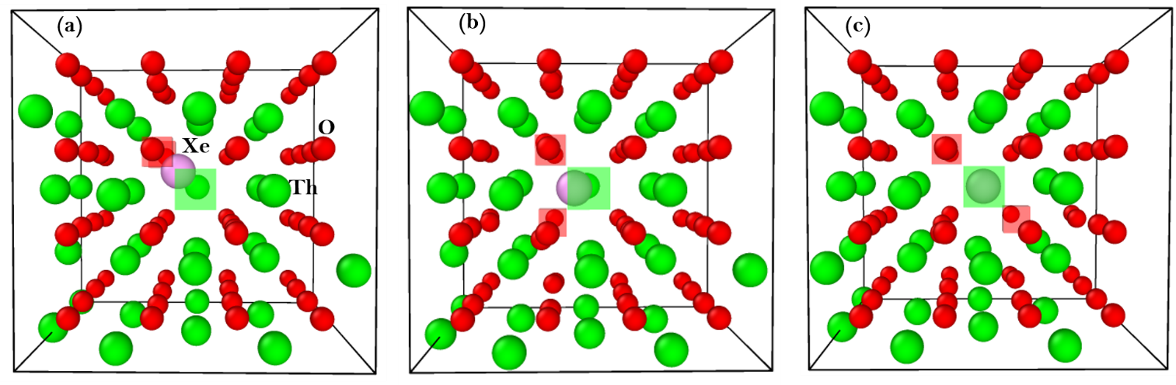

**Figure 3.** DFT optimised structures for a single Xe atom incorporated in (a) NTV1, (b) NTV2 and (c) NTV3 defects in ThO2. The Th vacancy is indicated by a green square, oxygen vacancy by a red square.

The NTV1 cluster geometry is more accommodating of a spherical atom than the other two NTV clusters. That is, the NTV1, offers a more effective volume. In the other two NTV clusters, the oxygen vacancies are further apart and the NTV geometry is elongated. The degree to which the sites can accommodate Xe is reflected in the relative energies of the defect clusters shown in table 5. Similar results are observed for Kr but with slightly more favourable incorporation energies due to its smaller atomic radius. In all cases, charges on the gas atoms are small, indicating that there is little charge transfer/polarisation of the type seen with accommodation at a neutral VTh site (Table 3). Also the complexes formed by incorporation are non-magnetic.

Table 5 also shows the relative incorporation energies for Xe and Kr in NTVs with respect to the most stable unoccupied NTV2 geometry found in the 2×2×2 supercell. This takes account of the requirement to reorient NTV1 and NTV3 from NTV2 for gas atom incorporation. The penalty for reorientation is then reflected in the second row of energy values in Table 5, which shows that NTV3 and NTV1 defect clusters are peanalised respectively by 0.20 eV and 0.62 eV to reorient into the NTV2 defect cluster. These energies assume local Vo re-orientation can occur more quickly than transport of gas atoms, which is well established in fluorite oxides. Despite the penalty for reorientation, the relative incorporation energy for Xe in a NTV1 (0.94 eV) is decidedly lower than that in a DV (1.50 eV) (and the same for Kr).

Incorporation energies of gas atoms were next determined into the fully charged (-4) CTV cluster. Values for Xe and Kr were 0.12 eV and 0.17 eV respectively. These values are similar to those for incorporation in an NTV1 but, lower once account has been made for rearrangement form NTV3. Similar to incorporation in NTV clusters, a very small amount of charge was observed on gas atoms in a CTV with overall zero-magnetic moment

**Table 5**. Incorporation energies, Bader charges on fission gases and magnetic moments of the cluster formed between a gas atom and NTV defects.

|  |  |  |  |  |  |  |
| --- | --- | --- | --- | --- | --- | --- |
| Properties | Xe:NTV1 | Xe:NTV2 | Xe:NTV3 | Kr:NTV1 | Kr:NTV2 | Kr:NTV3 |
| Incorporation energy (eV) | 0.32 | 1.43 | 2.28 | 0.11 | 0.98 | 1.44 |
| Incorporation energy with respect to the most stable NTV geometry | 0.94 | 1.43 | 2.48 | 0.73 | 0.98 | 1.64 |
| Bader charge (|e|) | +0.05 | +0.03 | +0.02 | +0.01 | −0.02 | −0.04 |
| Magnetic moment (µB) | 0.00 | 0.00 | 0.00 | 0.00 | 0.00 | 0.00 |

The next satge of this study was to consider incorporating an additional Xe or Kr atom in a pre-existing single NTV cluster already occupied by a single Xe or Kr. Table 6 reports the incorporation energies calculated for the second Xe or Kr atom into the three different NTV defects, Bader charges on gas atoms in the structures, net magnetic moments on all three clusters and the separation between the two gas atoms. Thisshows that there is a large energy penalty against the incorporation of the second Xe or Kr in a NTV1 containing a single gas atom. While incorporation of the second gas atom in a NTV2 is also unfavourable it is less unfavourable than in NTV1. Similarly, incorporation of a second gas atom into a NTV3 is less unfavourable again. DFT optimized structures of two Xe atoms in all three NTV clusters are shown in Figure 4.

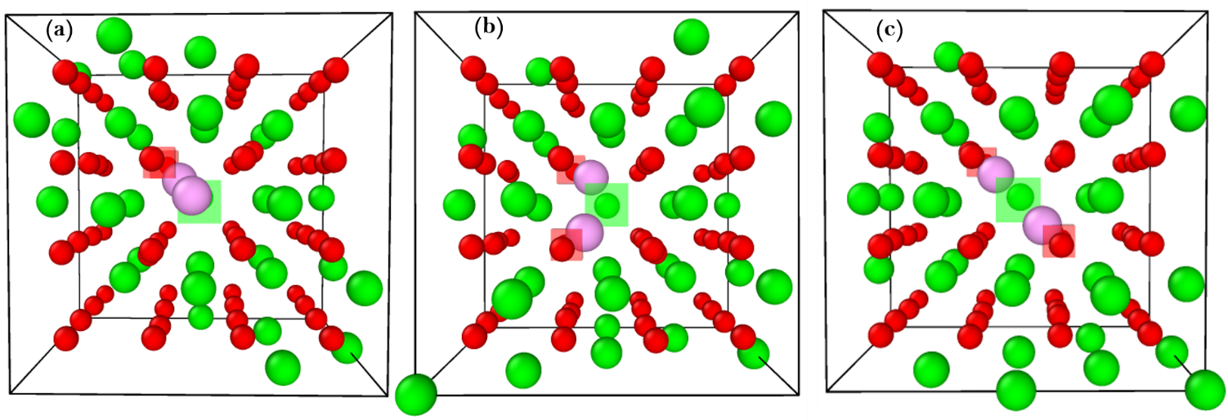

**Figure 4.** DFT relaxed structures of two Xe incorporated into (a) NTV1, (b) NTV2 and (c) NTV3 clusters.

The stability of the double gas atom complexes is reflected in the interaction of gas atoms with oxygen vacancy defects. The distribution of the oxygen vacancies in the NTV3 facilitates the two Xe atoms aligning along <100>. In the NTV2 cluster, the geometry means the two Xe atoms are much close together. In the NTV1, Xe atoms prefer the formation of a non-symmetric structure with oxygen vacancies, leading to the least stable complex and the closest proximity of gas atoms (see Table 6). Similar relaxed configurations were observed for Kr atoms with slightly shorter Kr-Kr separations.

The incorporation energies in Table 6 show that the energy to associate the second gas atom in a NTV is always high. Thus, if an unoccupied NTV were available (i.e. the concentration of NTV clusters is higher than gas atoms), the second gas atom would much more readily occupy an unoccupied NTV. However, if only singly occupied NTVs were available then it could be energetically preferable for double occupation. For example, the incorporation energy for a second Xe atom to occupy NTV3 is 2.79 eV but 3.74 eV for it to be incorporated in the most favourable Th vacancy (see Table 3) (i.e. ~ 1.0 eV benefit). However, the energy to rearrange the XeNTV1 to a XeNTV3 is ~2 eV, which is greater and so, given the fast rearrangement of oxygen vacancies in a fluorite structure, overall the second gas atom will remain in a Th vacancy. A comparison of values in Tables 3 and 5 show equivalent results for Kr.

**Table 6**. Incorporation energies for a second gas atom, Bader charges on fission gases, net magnetic moments of the clusters and separation between gas atoms in all three NTV defects.

|  |  |  |  |  |  |  |
| --- | --- | --- | --- | --- | --- | --- |
| Properties | Xe:XeNTV1 | Xe:XeNTV2 | Xe:XeNTV3 | Kr:KrNTV1 | Kr:KrNTV2 | Kr:KrNTV3 |
| Incorporation energy (eV) | 6.47 | 4.39 | 2.79 | 3.89 | 2.10 | 1.25 |
| Bader charge (|e|) | +0.05,+0.07 | +0.06,+0.06 | +0.06,+0.07 | 0.00,-0.01 | 0.00,+0.01 | 0.00,+0.01 |
| Magnetic moment (µB) | 0.00 | 0.00 | 0.00 | 0.00 | 0.00 | 0.00 |
| X-X separation (*d*) (X= Xe or Kr) | 3.04 | 2.95 | 3.07 | 2.83 | 2.81 | 2.96 |

Since a single NTV doesn't gather two gas atoms, we next considered adding a second gas atom to a CTV already occupied by a single gas atom. The incorporation energy for the second Xe atom is 3.77 eV and 2.30 eV for Kr. This shows that there is a reduction in the penalty to incorporate the second Xe atom compared to a NTV1 but they are more similar to second gas atom incorporation into NTV2 and NTV3. This indicates that the addition of a second VTh is not sufficient to accommodate a second gas atom. Thus we next consider multiple NTV clusters as incorporation sites.

***3.5. Incorporation of single and multiple gas atoms in multiple NTV defect clusters***

In order to offer more space to accommodate multiple gas atoms, two NTV1 defects were associated {a Bi-NTV cluster (BNTV)}, as shown in Figure 5 (a). There are too many different possible BNTV configurations to calculate all in this study. Here, as an example, we consider a BNTV with two adjacent NTV1s forming a larger more spherical like space. Occupation by a single Xe atom and a Kr atom were considered initially and favourable incorporation energies identified of –0.26 eV and –0.30 eV respectively (see Table 7). The negative energies are a result of the van der Waals interaction.

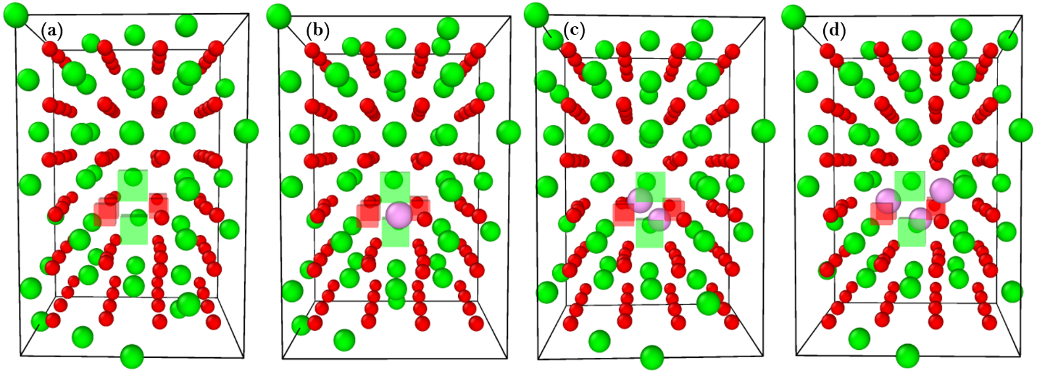

**Figure 5.** Structure of a BNTV considered in this study (a), relaxed structures of Xe:BNTV (b), 2Xe:BNTV (c) and 3Xe:BNTV (d)

The energies for additional gas atoms to be incorporated in the BNTV are reported in Table 7 and the structures are shown in Figures 5c and 5d. The incorporation energy for the second Xe (0.56 eV), though positive is much lower than incorporation in a VTh or a second Xe in a NTV or in a CTV. Furthermore, the incorporation of two Xe atoms into the BNTV has a combined energy of 0.30 eV, which is slightly less than two separate Xe atoms in two separate NTV clusters (i.e. 2x 0.32 eV). Thus, there is an energy gain to combine two Xe:NTV clusters. The energy to incorporate a third Xe atom to form a trimer cluster is, however, highly unfavourable and the same holds for Kr atoms. Furthermore, the incorporation energies for the third gas atoms are larger than those for incorporation in a VTh so there is no driving force to associate that third gas atom.

**Table 7.** Incorporation energies, Bader charges on fission gases, net magnetic moment of the composites calculated for the consequent addition of gas atoms in a BNTV defect,

|  |  |  |  |  |  |  |
| --- | --- | --- | --- | --- | --- | --- |
| Properties | Xe:BNTV | Xe:XeBNTV | Xe:2XeBNTV | Kr:BNTV | Kr:KrBNTV | Kr:2KrBNTV |
| Incorporation energy (eV) | -0.26 | 0.56 | 4.91 | -0.30 | 0.11 | 2.99 |
| Bader charge (|e|) | +0.03 | +0.04, +0.04 | +0.03, +0.06, +0.04 | -0.01 | -0.06, -0.05 | -0.01, +0.01, 0.00 |
| Magnetic moment (µB) | 0.00 | 0.00 | 0.00 | 0.00 | 0.00 | 0.00 |

The Bader charges on each of the gas atoms in the BNTV (see Table 7) are very small implying that gas atoms are not involved in any interaction involving charge re-arrangement. In all cases, the clusters exhibit no magnetic moment.

In order to increase the cavity size, we introduced one more NTV1 to create a tri-NTV cluster (TNTV) as shown in Figure 6 (a). Three Xe atoms were introduced, one by one, into the defect; figures 6 b, c and d show the DFT optimized structures. The values reported in Table 8 shows that incorporation energies of the first and second are negative. While the incorporation of the third gas atom is positive (for both Xe and Kr) it is much smaller than for incorporation into a VTh and as such the third gas atom will enter the TNTV cluster. The sum of incorporation for all three gas atoms is also smaller than incorporation into three separate NTV clusters indicating the strong association of Xe:NTV to form a 3Xe:TNTV.

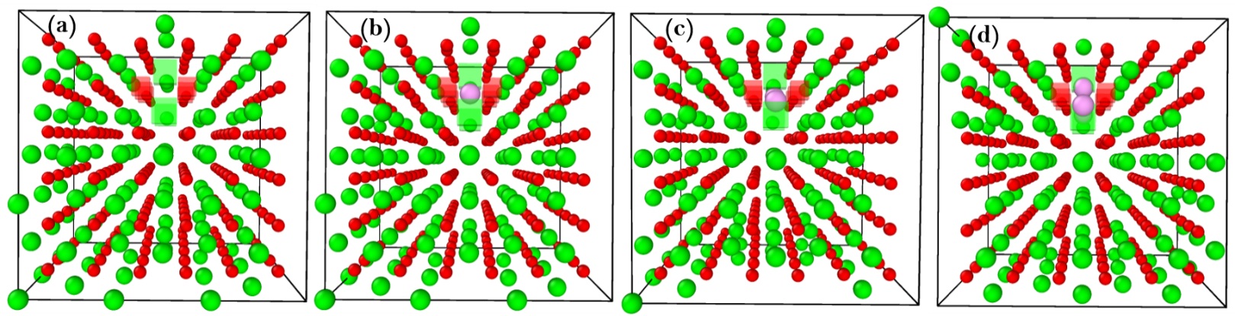

**Figure 6.** Structure of a TNTV considered in this study (a), relaxed structures of Xe:TNTV (b), 2Xe:TNTV (c) and 3Xe:TNTV (d).

**Table 8.** Incorporation energies, Bader charges on gas atoms and the net magnetic moment of the clusters calculated for the consecutive addition of Xe atoms in a TNTV.

|  |  |  |  |  |  |  |
| --- | --- | --- | --- | --- | --- | --- |
|  | Xe:TNTV | Xe:XeTNTV | Xe:2XeTNTV | Kr:TNTV | Kr:KrTNTV | Kr:2KrTNTV |
| Incorporation energy (eV) | -0.37 | –0.77 | 1.89 | -0.40 | -0.58 | 0.98 |
| Bader charge (|e|) | +0.02 | +0.03,+0.02 | 0.00,+0.02,+0.03 | -0.02 | 0.00,-0.02 | 0.00, +0.02, +0.03 |
| Magnetic moment (µB) | 0.00 | 0.00 | 0.00 | 0.00 | 0.00 | 0.00 |

***3.6. Mixed gases in BNTV clusters of ThO2***

Finally, the incorporation of mixed gases in the BNTV cluster was considered to ensure there was no unanticipated mixed gas effect. As a BNTV can readily accommodate two gas atoms, we considered the addition of a second Xe atom to a Kr:BNTV, which has a positive incorporation energy of 0.35 eV and the addition of a second Kr atom to a Xe:BNTV, which has a positive incorporation energy of 0.38 eV. Thus, there is little difference in incorporation energy and indeed these values are similar (and between) those for addition of Xe to a Xe:BNTV (0.56 eV) or Kr to a Kr:BNTV (0.11 eV) as reported in Table 6.

***3.7. Solution energies***

Incorporation energies assume that there are more sites available at which the gas atom can be trapped than gas atoms. Once the concentration of gas atoms exceeds this criteria trap sites must be formed in order to accommodate the gas atoms. This means we are now considering the solution energy of gas into the lattice. For example, the solution energy for a Xe atom at the oxygen vacancy site with +2 charge can be calculated using the following equation:

 (10)

where  is the incorporation of energy of a Xe atom at the charged oxygen vacancy site and  is the defect formation energy of the charged oxygen vacancy. For ThO2,  is equal to half the oxygen Frenkel energy while in ThO2-x it is zero as we assume  defects are already available in excess of the gas concentration due to the nonstoichiometry. Equilibrium formation energy values for defects sites (point defects and custers) are reported in suplimentary information and follow the equations reported by Grimes and Catlow **[7]**.

Here we calculate solution energies for the most favourable trap site of each type. Table 9 reports the solution energies calculated for Xe and Kr. All values are large and positive, indicating that both Xe and Kr are highly insoluble in thoria. Taking first stoichiometric ThO2, for Xe solution at the DV and NTV1 are energetically equal and most preferable. The same holds true for Kr although solution at a is not so much less favourable and even the site is not for behind. In ThO2-x the NTV1 is the most favourable solution site for Xe while for Kr it is clearly the .

It is interesting to compare the current solution energies for Xe in ThO2 and ThO2-x with values calculated previously for Xe in UO2 and UO2-x by Grimes and Catlow **[7].** In particular, while the values in UO2 are ~50% are higher, the preference for solution site is identical; DV and NTV1 for UO2 and NTV1 for UO2-x.

**Table 9**. Solution energies of fission gases at defect sites in ThO2 and ThO2-x.

|  |  |  |  |  |  |  |
| --- | --- | --- | --- | --- | --- | --- |
|  | Solution Energies (eV) in ThO2 | | | | | |
|  | Int |  |  | (DV) | NTV1 | CTV |
| Xe | 10.19 | 9.81 | 8.06 | 6.70 | 6.71 | 8.59 |
| Kr | 6.96 | 7.15 | 6.96 | 6.32 | 6.50 | 8.76 |
|  | Solution Energies (eV) in ThO2-x | | | | | |
|  |  |  |  |  |  |  |
| Xe | 10.19 | 7.50 | 12.68 | 9.01 | 6.71 | 13.33 |
| Kr | 6.96 | 4.84 | 11.58 | 8.63 | 6.50 | 13.38 |

***3.8. The approach to bubble formation***

There is a strong driving force for gas atoms to move from interstitial positions to VO and then to VTh sites. The solution energy is, however, still high and there is a large energy gain to associate a VO to a XeTh forming Xe:DV. There is further energy gain to associate a second VO to Xe:DV to form a Xe:NTV1. The energy to associate a VTh to Xe:NTV1 forming a Xe:CTV is 2.38 eV (note this is almost the same as the energy to associate a VTh to an unoccupied NTV1). While there is an energy gain to associate a XeTh to Xe:NTV1 to form 2Xe:CTV this results in a cluster that is strongly attractive to VO to form 2Xe:BNTV. This cluster will then bind to a Xe:NTV to form a 3Xe:TNTV although the energy to associate the third Xe is still slightly positive. Thus, while we have not quite arrived at the point where N gas atoms neatly reside in clusters consisting of N x NTV clusters this point is fast approaching.

**4. Conclusions**

DFT based simulations have been used to investigate the energetics of intrinsic defect and defect cluster formation in ThO2 and then the incorporation of Xe and Kr atoms. The main results are:

1. The simulations show good reproduction of the experimentally observed lattice parameter of ThO2,the bulk modulus, cohesive energy and band gap, establishing the quality of the pseudopotentials and basis sets used.
2. The most favourable intrinsic disorder type is the oxygen Frenkel defect. The reaction energy order (O Frenkel < Schottky << Th Frenkel) is in agreement with previous simulations.
3. The most favorable point defect incorporation site for Xe or Kr is the thorium vacancy. The oxygen vacancy site exhibits a higher incorporation energy and the value for the octahedral interstitial site is still much high. In all cases incorporation of Kr is slightly more favoured (because of its smaller atomic radius). The lowest incorporation energies for Xe and Kr are into neutral Th vacancies. The energy penalty to form a neutral v’s a fully charged vacancy is, however, substantially greater than the benefit in energy in accommodating a gas atom at a neutral v’s a fully charged vacancy. Therefore, gas atoms will occupy fully charged vacancy sites.
4. Of the three NTV cluster geometries, a single Xe or Kr atom is energetically most favourably accommodated within a NTV1 geometry as this cluster has a more effective volume to accommodate a large spherical gas atom. Incorporation of a second gas atom is not energetically preferred compared to its accommodation within an isolated Th vacancy.
5. The di-vacancy is a less favoured incorporation site than the NTV.
6. The CTV offers a lower incorporation energy than does the most favourable NTV configuration but a similar incorporation to the NTV1 cluster.
7. The BNTV defect can accommodate two gas atoms with a small energy gain compared to two separate Xe:NTV clusters. There is a substantial energy penalty to accommodate a third gas atom.

(8) The TNTV defect offers a larger volume and readily accommodates three gas atoms.There is a small

driving force to associate three Xe:NYV1 clusters into a single 3Xe:TNTV cluster.

1. Finally, by considering the energy required to form the incorporation sites, equilibrium solution energies were constructed. These showed that for Xe, the DV and NTV1 are energetically the most favourable solution sites in ThO2 while in ThO2-x it is the NTV1. For Kr the situation is similar for ThO2 but in ThO2-x the most favoured situation site is the  reflecting the smaller size of the Kr atom.

**Acknowledgement:** We thank the EPSRC for funding as part of the INDO-UK project (grant code EP/K00817X/1). Dr. Samuel Murphy is acknowledged for helpful discussions. Computational facilities and support were provided by High Performance Computing Centre at Imperial College London.

**References**

1. Thorium Fuel Cycle-Potential Benefits and Challenges IAEA-TECDOC-1450 International Atomic Energy Agency, Austria, May 2005.

2. C.-F. Chen, J. Kelly, Ø. Asphjell, P.A. Papin, R.T. Forsyth, D.R. Guidry, D.J. Safarik, A. Llobet, Journal of the American

Ceramic Society 97 (2014) 3062.

3. R.W. Grimes, Simulating the behaviour of inert gases in UO2,: S. E. Donnelly and J. H. Evans (Ed.), Fundamental aspects of inert gases in solids, Plenum Press, New York, 1991.

4. H.Y. Xiao, Y. Zhang, W.J. Weber, Journal of Nuclear Materials 414 (2011) 464.

5. S.T. Murphy, A. Chartier, L. Van Brutzel, J. P. Crocombette, Physical Review B 85 (2012) 144102.

6. A.E. Thompson, C. Wolverton, Physical Review B, 84 (2011) 134111.

7. R.W. Grimes, C.R.A. Catlow, Philosophical Transactions of the Royal Society of London A: Mathematical, Physical and

Engineering Sciences 335 (1991) 609.

8. A. Chartier, L. van Brutzel, and M. Freyss, Physical Review B, 81 (2010) 174111.

9. R. Bès, P. Martin, E. Vathonne, R. Delorme, C. Sabathier, M. Freyss, M. Bertolus, P. Glatzel, Applied Physics Letters

106 (2015) 114102.

10. Y. Lu, Y. Yang, P. Zhang, Journal of Physics: Condensed Matter 24 (2012) 225801.

11. S.T. Murphy, M.W.D. Cooper, R.W. Grimes, Point defects and non-stoichiometry in thoria, Solid State Ionics, 267

(2014) 80.

12. M. W. D. Cooper , M. J. D. Rushton, R. W. Grimes, J. Phys. Condens. Matter 26 (2014) 105401.

13. R. K. Behera , C. S. Deo, J. Phys. Condens. Matter 24 (2012) 215405.

14. Y. Yun, P.M. Oppeneer, H. Kim, K. Park, Acta Materialia 57 (2009) 1655.

15. G. Kresse, J. Furthmüller, Physical Review B 54 (1996) 11169.

16. G. Kresse, D. Joubert, Physical Review B 59 (1999) 1758.

17. J.P. Perdew, K. Burke, M. Ernzerhof, Physical Review Letters 77 (1996) 3865.

18. P.E. Blöchl, Physical Review B 50 (1994) 17953.

19. A.I. Liechtenstein, V.I. Anisimov, J. Zaanen, Physical Review B 52 (1995) R5467.

20. Madelung E (1918). *Phys. Zs.* **XIX**: 524.

21. M. Leslie, N.J. Gillan, Journal of Physics C: Solid State Physics 18 (1985) 973.

22. J. D. Axe, G.D. Pettit, Physical Review 151 (1966) 676

23. H.J. Monkhorst, J.D. Pack, Physical Review B 13 (1976) 5188.

24. Press, W. H., Flannery, B. P., Teukolsky, S. A., & Vetterling, W. T. (1986). Numerical recipes: the art of scientific

computing, 818 pp.

25. S. Grimme, J. Antony, S. Ehrlich, H. Krieg, The Journal of Chemical Physics 132 (2010) 154104.

26. F.D. Murnaghan, Proceedings of the National Academy of Sciences of the United States of America 30 (1944) 244.

27. H.D. Leigh, E.R. McCartney, Journal of the American Ceramic Society 57 (1974) 192.

28. W.J. James, M.E. Straumanis, Lattice parameter and coefficient of thermal expansion of thorium, Acta Crystallographica, 9 (1956) 376.

29. [G.](http://www.newworldencyclopedia.org/entry/Thorium) Bellussi, U. Benedict and W. B. Holzapfel, High pressure X-ray diffraction of thorium to 30 GPa, Journal of the Less Common Metals, 78 (1981) 147.

30. P.M. Macedo, W. Capps, J.O. Wachtman, Elastic Constants of Single Crystal Tho2 at 25°C, Journal of the American Ceramic Society, 47 (1964) 651.

31. E.T. Rodine, P.L. Land, Electronic Defect Structure of Single-Crystal ThO2 by Thermoluminescence, Physical Review B, 4 (1971) 2701.

32. Charles Kittel. Introduction to Soilid State Physics, 8th edition. Hoboken, NJ: JohnWiley & Sons, Inc, 2005

33. P.J. Kelly, M.S.S. Brooks, Electronic structure and ground-state properties of the actinide dioxides, Journal of the Chemical Society, Faraday Transactions 2: Molecular and Chemical Physics, 83 (1987) 1189..

34. W. Kohn, L.J. Sham, Self-Consistent Equations Including Exchange and Correlation Effects, Physical Review, 140 (1965) 1133.

35. R.W. Grimes, Molecular Simulation 5 (1990) 9.

36. F.A. Kröger, H.J. Vink, Relations between the Concentrations of Imperfections in Crystalline Solids, in: S. Frederick, T. David (Eds.) Solid State Physics, Academic Press, 1956, pp. 307.

37. A. Baldereschi, S. Baroni and R. Resta, Physical Review Letters, 61 (1988) 734.

38. M. Pressi, N. Binggeli and A. Baldereschi, Journal of Physics D: Applied Physics, 31 (1998) 1273.

39. A.E. Thompson, C. Wolverton, Pathway and energetics of xenon migration in uranium dioxide, Physical Review B, 87 (2013) 104105.