**A new estimate of the yarn-on-yarn friction coefficient**

**Roger E Hobbs** FICE (Emeritus Professor of Structural Engineering, Dept. of Civil and Environmental Engineering, Imperial College London, London SW7 2BU) (corresponding author: 01342 822383, [r.hobbs@imperial.ac.uk](mailto:r.hobbs@imperial.ac.uk)) and

**Dr Isabel M L Ridge** FIMechE (Director, Tension Technology International Testing Ltd, Hithercroft Road, Wallingford OX10 9DG, 07846 236035, [ridge@tensiontech.com](mailto:ridge@tensiontech.com) )

**Abstract**

The value of the yarn-on-yarn friction coefficient is an important parameter in analyses of the behaviour of fibre ropes and textiles. The standard method for calculating this friction coefficient for rope yarns relies on an analysis of the measured forces in a simple plait as a yarn is pulled over itself through the plait. Unfortunately, this analysis includes some ambiguities that have made their way into an ASTM standard and some worrying approximations. These issues are addressed here, and then an improved analysis developed. Sample calculations indicate that differences of up to 40% in the calculated friction coefficient can be expected, with significant effects on any subsequent rope analysis.

**Keywords**

Yarn friction coefficient rope calculation model

(Wordcount: 3221)

**1 INTRODUCTION**

Goksoy (**1**), Flory et al. (**2**) developed a test machine to determine the cycles to failure of fibre yarns abrading against themselves in a simple braid or plait. The loading arrangement is particularly relevant to the rope manufacturing industry, where this type of degradation is found in fibre ropes both within and between strands. The machine was designed as a table mounted apparatus and permits the quick and economical assessment of different types of yarns with different yarn finishes in both wet and dry conditions. A typical machine is shown in Fig. 1. This example is a four station machine, with the stations conveniently arranged around, and driven by, a single motor with a cam. The test specimen passes from the cam over a pulley at the corner of the apparatus and over a second pulley before entering the braid. Leaving the braid the yarn passes round the bottom pulley and re-enters the braid before passing over a final pulley to a weight that provides the tension. A length of 50 mm of yarn is typically drawn back and forth through the inter-wrapped yarn section (Fig. 2) each cycle.

Sets of experiments, usually at least eight, may be conducted with the same weight or with a series of different weights hung on the free end of the sample. The Cordage Institute standards give guidance as to how to conduct the experiments (**3**), and for performance requirements for marine grade nylon and polyester fibres (**4, 5**).

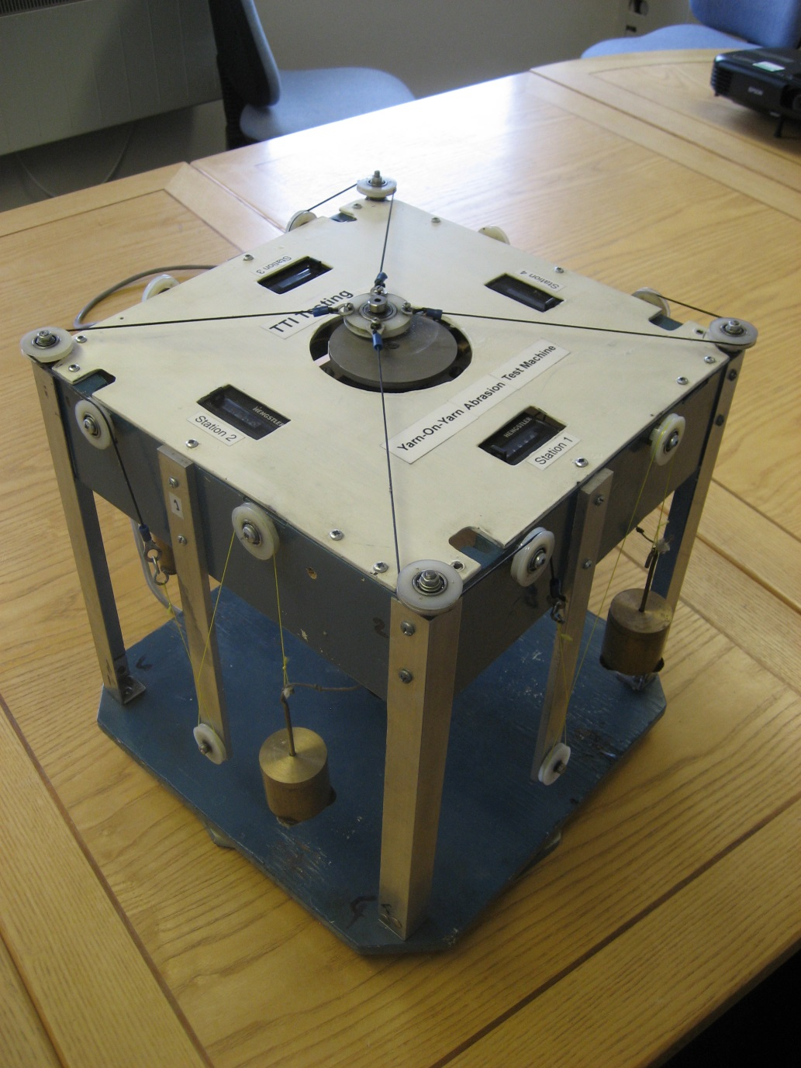

Fig. 1 General arrangement of a yarn-on-yarn testing machine.

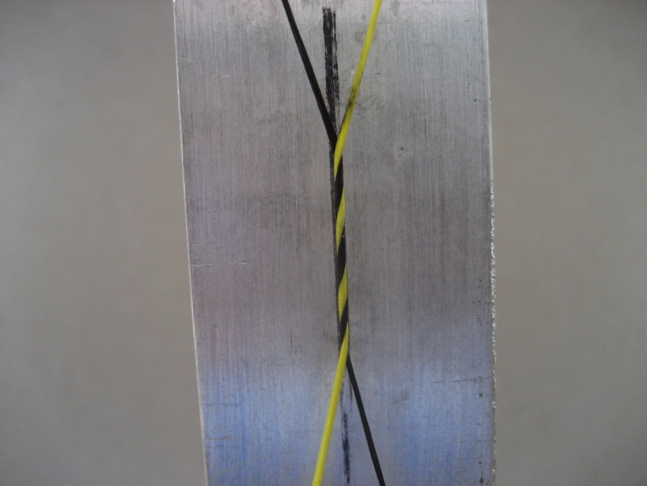

Fig. 2 Detailed view on yarn-on-yarn testing machine showing the plait. Note that half of the yarn has been dyed black to aid clarity.

The arrangement of the stations is not critical. It may be as shown in Fig. 1, alternatively other instrument manufacturers have designed equipment with the stations in line. What is important is the diameter and arrangement of the three guide pulleys which largely define the angle between the yarns where they come together at the top of the sample.

In addition to being used to assess the abrasion resistance of the test yarn, by measuring the yarn forces, T1 and T2 and the included angle between the two parts of the yarn, γ, Fig. 3, it is also possible to estimate the yarn-on-yarn friction coefficient, μ, from a simple analysis based on statics and the geometry of the test arrangement. A version of the resulting formula is included in an ASTM standard (**6**). Its derivation bears clear similarities to that of the classical Euler-Eytelwein formula for the frictional behaviour of a rope wrapped around a bollard. These similarities have tempted some engineers to describe the braid in terms of the number of wraps around a notional bollard in a rather ambiguous way. Unfortunately, there is further ambiguity in the way the length of yarn in contact with itself is defined. These ambiguities can introduce an unwanted factor of two into the calculated value of μ.

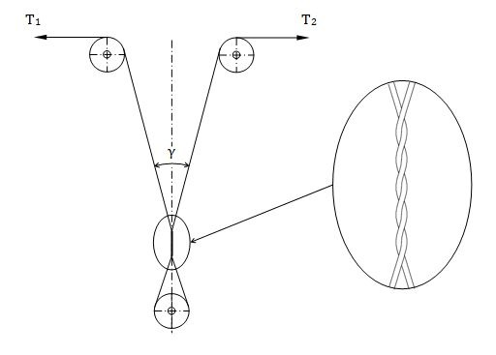

Fig. 3 Yarn forces in an abrasion test set-up

The value of the friction coefficient is a key parameter in any analysis of the complex behaviour of fibre ropes (**7**). While there is a very substantial body of prior work on the frictional behaviour of fibres and textiles, much of it is concerned with the behaviour of smaller yarns and higher displacement speeds than occur in fibre ropes. A large number of different tests have been proposed (**8**), and the recent volume production of carbon fibre reinforced composites has led to test work on carbon fibre tows (filament bundles). It has also led to a greater understanding of the fundamental aspects of friction in fibres, including its sensitivity to yarn-to-yarn orientation and direction of relative movement, and indeed to the contact pressure between the yarns (**9,**10) by introducing the concept of the real contact area between fibres.. At a larger scale, it is possible to measure the friction coefficient between strands or sub-ropes by measuring the force needed to extract a cut strand from a rope and the radial pressure exerted on the strand by its neighbours using a piezo-electric sensor (**11**).However, in practice the yarn-on-yarn test shown in Fig. 3 is simple and cheap, and as it closely models the conditions within a typical fibre rope carrying varying axial or bending load it is easy to see why it has become a standard test. Thus it is sensible to make the best possible use of that test by optimising its analysis.

To that end this paper next restates and refines the Goksoy analysis (**1, 6**), resolving the ambiguities that have developed with the passage of time, and identifies a number of troubling approximations that are inherent in that analysis. An improved analysis with fewer approximations is then presented, yielding a practical formula that is as simple as the classical one, and sample calculations produced that suggest that increases of up to 40% can be expected in the predicted value of μ. Clearly, analytical rope modelling will be improved by using a better estimate of μ as input.

**2 RESTATEMENT OF THE GOKSOY ANALYSIS**

Referring to Fig. 3, the limiting yarn tensions at the onset of slip are respectively T1 and T2 with T1 > T2. The distribution of tension T within the plait, T(x), say, and the distributed friction generated as a result are both of interest.

The angle between the two yarns, γ, was assumed by Goksoy (**1**) to be symmetrically divided by the axis of the plait. Further, the two yarns were assumed to be symmetrically disposed about the axis of the plait. With a yarn diameter d and radius r = d/2, the centreline of each yarn forms a helix with radius r (Fig. 3) and the contact line between the yarns is thus, working a distance r inwards from the yarn centre line to any contact point, simply the straight line coincident with the axis of the plait. Noting that ropemakers would refer to the angle between the yarn and the axis of the plait here as the “lay angle”, the lay angle of both helices was assumed to be γ/2 everywhere, so that by the standard result for a helix the radius of curvature of the yarn centreline at any point is then

$r_{c}=r/\sin^{2}\left(γ/2\right)$…(1)

and the inward “pressure” (or more strictly the contact force per unit length in newtons per mm run) between the two parts of the yarn, p, is

$p=T/{r_{c}}=T\sin^{2}(γ/{2)/r}$…(2)

where T is the local tension T(x) in the yarn. This pressure is clearly a constant times the local tension T(x), say kT(x), and the distributed friction force per unit length acting to resist slip is then given by μ times the pressure or μkT(x). Combining the two constants into a single value c = μk, the friction force per unit length of the yarn is cT(x) where

$c=μ\sin^{2}\left(γ/2\right)/r$…(3)

Turning to the distribution T(x) itself, consider the equilibrium of an element of yarn dx long, Fig. 4, in an approach familiar from the Euler-Eytelwein bollard analysis, giving dT = cTdx, or

$cdx=dT/T$…(4)

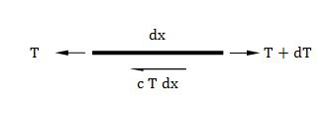

Fig. 4 Equilibrium of yarn element with friction force c T dx

Integrating both sides of equation (4) with appropriate limits,

$cL=ln({{T_{1}}/{T_{2})}}$…(5)

The length L is the total fretted length of yarn in the plait, that is, the length from the start of the plait at tension T1 down to the lower pulley plus the length from the lower pulley to the exit from the plait at tension T2. While this length could be measured experimentally, for consistency its relationship with the lay angle of the helices, γ/2, and their “lay length”, where the lay length is the pitch of the helix denoted by LL , was used by Goksoy (**1**). The lay length is given by $L_{L}={2πr}/{\tan{{(γ}/{2)}}}$…(6)

The number of lay lengths in the total fretted length L is most simply derived from the number of times, NC, the yarns appear to cross in Fig. 3. With NC = 3, the two yarns will each have completed a single lay length, giving a total of two lay lengths to form the total fretted length. A further crossing implies an additional half lay length for each yarn, adding one lay length to the total fretted length. In general, for NC crossings, the total fretted length will be given by

$L=\left(N_{C}-1\right)L_{L}={2πr\left(N_{C}-1\right)}/{\tan\left(γ/2\right)}$…(7)

Combining equations (3), (5) and (7), and rearranging to give the friction coefficient yields

$μ=\frac{ln⁡({T_{1}}/{T_{2}).tan⁡(γ/2)}}{2π({N_{C}-1)sin}^{2}(γ/2)}$…(8)

Equation (8) can be used to find a value of μ from experimental readings of T1, T2 and γ. For small γ, of course, it can be approximated by taking tan (γ/2) = sin (γ/2) = γ/2 but with modern spreadsheets this is hardly worthwhile.

**3 COMPARISON WITH ASTM D3412M-13 (6)**

Equation (2) in the ASTM standard includes an allowance for pulley friction, and also interchanges the notations T1 and T2. Otherwise it reads

$μ=\frac{ln⁡({T_{1}}/{T_{2})}}{2πn_{α}}$…(9)

nα is a mistake that appeared in the previous version of the standard (**12**) where it was perhaps clearer that n times α was meant. In the current version of the standard (**6**) nα is explicitly defined as “the number of wraps” and μ is then apparently independent of the included angle α between the two parts of the strand at the head of the braid, i.e. independent of γ in the notation of this paper. Clearly for nα in equation (9) the reader should understand n.α, but this kind of ambiguity is unhelpful.

Turning to the value of n itself, the standard gives a value of 2.5 in parentheses, and Fig. 1 in the standard shows a plait with six crossings, or NC = 6 in the notation of the present paper. Substituting NC = 6 in equation (8), and using the approximations for small γ/2, finally confirms equation (2) in the standard if nα is replaced by n.α. The value of n = 2.5 is further explained in section 9.2.2 of the standard.

**4 AN IMPROVED ANALYSIS**

There are two striking approximations in the Goksoy (**1**) analysis. The first is the assumption that the angle γ between the two parts of the yarn is symmetrical about the axis of the plait. Given that the tension T1 is larger than the tension T2 the assumption violates static equilibrium just above the plait, and it is better to calculate (or even measure experimentally) the two angles α and β (Fig. 5).

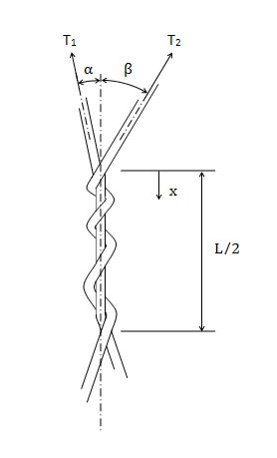

Fig. 5 Unequal angles α and β

The second approximation is the assumption that the contact line between the two parts of the yarn is a straight line, so that the yarn curvature is the same everywhere (equation (1)). This violates equilibrium at any general point within the plait, because by definition the tension is higher in one leg of the yarn (the T1 side of the plait) than in the other leg (the T2 side of the plait), and hence (equation (2)) the pressure exerted by the first yarn on the other is apparently greater than the pressure exerted by the second yarn on the first.

This contradictory result is clearly unsatisfactory, and in what follows the two approximations identified here are resolved and an improvement on equation (8) is proposed.

**4.1 Equilibrium of the two yarns above the plait**

Resolving perpendicularly to the axis of the plait

$T_{1}\sin{α=T_{2}\sin{β}}$…(10)

(i.e. β > α). As α + β = γ, after some manipulation the two angles can be shown to be

$α=\tan^{-1}\left({\sin{γ}}/{\left(\cos{γ+{T_{1}}/{T_{2}}}\right)}\right)$…(11)

and

$β=γ-α$…(12)

**4.2 Equilibrium of pressures within the braid**

As noted above, the assumption of uniform yarn curvature is inconsistent with equilibrium within the braid. To achieve equilibrium, the radius of curvature and indeed the lay angle must change from point to point within the braid. In particular the helix radius must be smaller within that part of the braid that carries a higher tension, and larger in the more lightly loaded part of the braid.

Defining a general position x from the start of the braid (Fig. 5) by a suffix x, and denoting the tension, lay angle α and helix radius in the part of the braid carrying T1 at its upper end by a suffix 1, and the tension, lay angle β and helix radius in the other part by a suffix 2, pressure equilibrium is defined by

$\frac{T_{1x}\sin^{2}α_{x}}{r_{1x}}=\frac{T_{2x}\sin^{2}β_{x}}{r_{2x}}$, $0≤x≤L/2$…(13)

As equation (13) is true for all values of x, it must be true for any particular value of x, including x = 0, and the pressure must be the same everywhere, a constant value K, say. (Alternatively, suppose that the pressure falls monotonically from the start of the braid at x = 0 to the exit from the braid with tension T2. But for equilibrium the pressure at x must equal that at (L/2 – x) in the other part of the braid, contradicting our supposition that the pressure falls monotonically. Or suppose, unlikely though that seems, that the pressure rises monotonically from the start of the braid to the exit: this assumption leads to the same contradiction. Hence as the pressure neither rises nor falls, it can only have a constant value, taken as K here.)

At x = 0, then

$K=\frac{T_{1}\sin^{2}α}{r_{1}}=\frac{T_{2}\sin^{2}β}{r_{2}}$…(14)

For compatibility the sum of the helix radii must be 2r, where r is the yarn radius, or

$r_{1}+r_{2}=2r$…(15)

Solving equations (14) and (15) for r1

…(16)

and hence the uniform pressure

$K=\frac{\left(T_{1}\sin^{2}α+T_{2}\sin^{2}β\right)}{2r}$…(17)

Turning again to the axial equilibrium of an element, this now has the simpler form

$dT=μKdx$…(18)

and again integrating over the total fretted length L of the braid

$T_{1}-T_{2}=μKL$…(19)

or

$μ={\left(T_{1}-T_{2}\right)}/{KL}$…(20)

The total fretted length L is to a close approximation unchanged from its value in the Goksoy analysis, equation (7). Substituting for K from equation (17) and for L from equation (7) in equation (20), the friction coefficient μ is finally given by

$μ=\frac{\left(T_{1}-T_{2}\right)\tan\left(γ/2\right)}{π\left(N_{C}-1\right)\left(T_{1}\sin^{2}α-T_{2}\sin^{2}β\right)}$…(21)

Hence experimental datasets for NC, T1, T2 and γ can be reduced by finding α and β from equations (11) and (12), and then μ from equation (21). This procedure is simple to implement in a spreadsheet. It is worth noting that the calculated value of μ is again independent of the yarn radius r.

**5 RESULTS**

This section concentrates on the results of numerical experimentation comparing the calculated values of μ obtained from equations (8) and (21). While it is well recognised that yarn testing produces data with plenty of scatter, it would be worth making the best use of that data by employing the more realistic analysis, particularly as there are significant differences between the two formulae.

Comparing equations (21) and (8), the ratio between the new and original values of μ is

$\frac{μ}{μ_{G}}=\frac{2\left(T_{1}-T_{2}\right)\sin^{2}\left(γ/2\right)}{\left(T_{1}\sin^{2}α+T_{2}\sin^{2}β\right)ln\left({T_{1}}/{T_{2}}\right)}$…(22)

where the subscript G denotes the value from equation (8). This ratio is clearly dependent on T1/T2 and on the angle γ at the head of the plait, but independent of the yarn radius r and the crossing count NC, although the latter will, of course, strongly influence the T1/T2 ratio in a given test regime.

Fig. 6 summarises the effects of γ and T1/T2 on the μ/μG ratio.

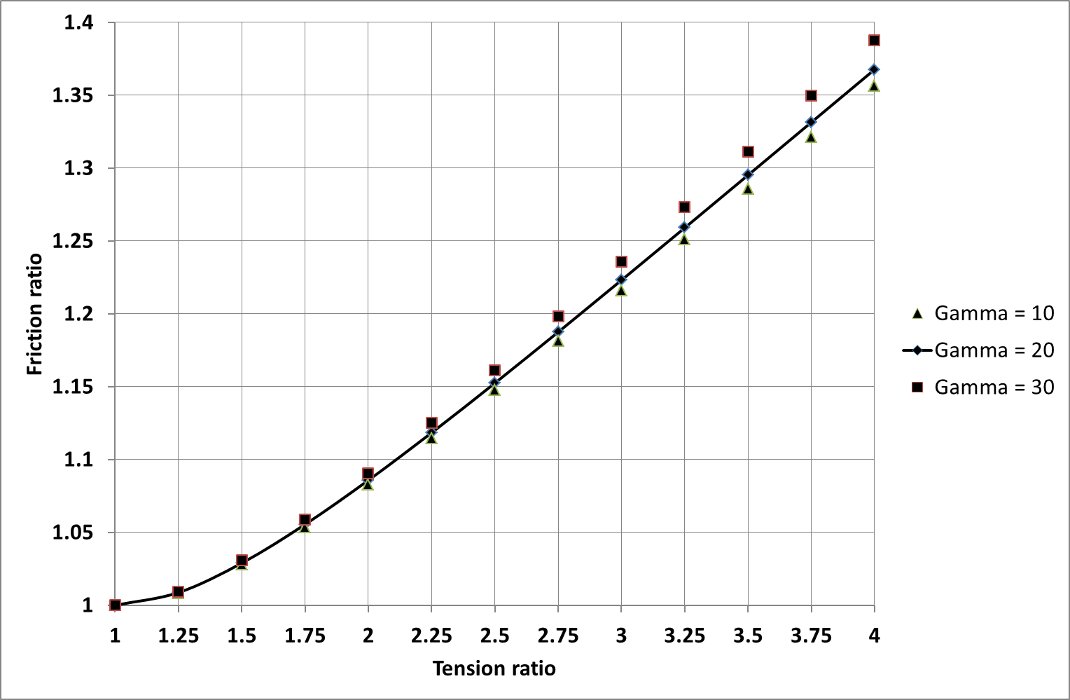

Fig. 6 Friction ratio μ/μG as a function of the tension ratio T1/T2 for various values of γ (degrees)

It can be seen that while γ has only a modest effect on the friction ratio, significant differences occur for practical values of the tension ratio T1/T2 (values between 3 and 4 are frequently observed). This suggests that it will be worth using equation (21) in practice when computing μ from test data, particularly for larger values of the tension ratio.

**6 CONCLUSIONS**

This paper has reworked the Goksoy analysis (**1**) for yarn-on-yarn friction coefficient, and clarified the calculation of the total fretted length as a function of the yarn crossing count, NC. In particular, the implementation of this analysis in the ASTM standard (**6**) has been re-examined and an error identified.

An alternative analysis with fewer approximations has been developed. This analysis respects equilibrium in two areas that the earlier work did not, and is as easy to implement in a spreadsheet format. Further, it is apparent that significantly larger values of the friction coefficient are obtained by the new method, particularly for larger values of the tension ratio.

**REFERENCES**

**1 Goksoy, M.** A study of yarn-on-yarn abrasion. PhD thesis, UMIST, 1986

**2 Flory, J.F., Goksoy, M., and Hearle, J. W. S.** Yarn-on-yarn abrasion testing of rope yarns. Part 1: The test method. *J Textile Institute* 79(3) 417-431 1988

**3** CI 1503-09 Cordage Institute International Standard Test method for Yarn-on-Yarn abrasion wet and dry, Cordage Institute, Wayne, PA19087, USA, October 2009.

**4** CI 2009N-13 Cordage Institute International Guideline Performance Requirements for Marine Grade Nylon Yarn For Fibre Rope, Cordage Institute, Wayne, PA19087, USA, June 2013.

**5** CI 2009P-10 Cordage Institute International Guideline Performance Requirements for Marine Grade Polyester Yarn For Fibre Rope, Cordage Institute, Wayne, PA19087, USA, October 2010.

**6**  ASTM D3412/D3412M-13. Standard test method for coefficient of friction, yarn to yarn. ASTM, West Conshohocken, 2013

**7 Leech, C. M.** The modelling and analysis of the mechanics of ropes. Springer 2014 (Solid mechanics and its applications, Vol.209)

**8** **Howell, H. G.** Friction in textiles. Butterworths Scientific Publications 1959

**9 Mulvihill, D. M., Smerdova, O., and Sutcliffe, M. P. F.** Friction of carbon fibre tows *Composites Part A* 93, 185-198 2017

**10 Chadlakar, N. D., Mandal, P., and Potlori, P.** Effects of inter-tow angle and tow size on carbon fibre friction *Composites Part A* 65 115-124 2014

**11 Hobbs, R. E.** Pressure sensitive “yarns” and in-rope friction measurements. *J Textile* *Institute* 81(4) 549-560 1990

**12**  ASTM D3412/D3412M-07. Standard test method for coefficient of friction, yarn to yarn. ASTM, West Conshohocken, 2007 (superseded)

**APPENDIX 1**

**Notation**

c a constant

d yarn diameter

k, K constants

L total fretted length of yarn

LL lay length in helix

n,nα number of “wraps” (2)

NC crossing number

P “pressure” i.e. yarn contact force per unit length

r yarn radius = d/2

r1,r2 helix radii

T, T(x) yarn tension at general position

T1,T2 yarn tension leaving, entering plait

x coordinate along plait

Subscript

x general position

G Goksoy

Lower case Greek

α angle between T1 and plait centreline

β angle between T2 and plait centreline

γ angle between T1 and T2

μ friction coefficient