**Incidence of Secondary Primary Malignancies (SPMs) in patients with multiple myeloma included in the Prospective Collaboration to Collect Autologous Transplant Outcome in Lymphoma and Myeloma (CALM) Study, On Behalf of the Plasma Cell Disorders Subcommittee of the EBMT Chronic Malignancies Working Party**

Firoozeh Sahebi1, Simona Iacobelli2, Giulia Sbianchi 2 , Linda Koster3, Didier Blaise4, Péter Reményi5, Nigel H. Russell6, Per Ljungman7, Guido Kobbe8, Jane Apperley9, Marek Trneny10, Jiri Mayer11, Wieslaw Wiktor-Jedrzejczak12, James F. Sanchez1, Michel Schaap13, Cecilia Isaksson14, Stig Lenhoff15, Paul Browne16, Christof Scheid17, Keith M.O. Wilson18, Ibrahim Yakoub-Agha19, Soledad González Muñiz20, Stefan Schönland21, Curly Morris22, Laurent Garderet23, Nicolaus Kröger24

1City of Hope, Duarte, US.

2Rome University Tor Vergata, Rome, Italy.

3EBMT Data Office Leiden, Leiden, The Netherlands.

4Institut Paoli Calmettes, Marseille, France.

5St. István & St. Laszlo Hospital, Budapest, Hungary.

6Nottingham University, Nottingham, UK.

7Karolinska University Hospital, Stockholm , Sweden.

8Heinrich Heine Universität, Düsseldorf, Germany.

9Hammersmith Hospital, London, UK.

10Charles University Hospital, Prague, Czech Republic.

11University Hospital Brno, Brno, Czech Republic.

12Central Clinical Hospital, Warsaw, Poland.

13Radboud University - Nijmegen Medical Centre, Nijmegen, The Netherlands.

14Umea University Hospital, Umeå, Sweden.

15Skanes University Hospital, Lund, Sweden.

16Hope Directorate, Dublin, Ireland.

17University of Cologne, Cologne, Germany.

18University Hospital of Wales, Cardiff Wales, UK.

19Hôpital HURIEZ, Lille, France.

20Hospital Universitario Central de Asturias, Oviedo Asturias, Spain.

21University of Heidelberg, Heidelberg, Germany.

22Queens University of Belfast, Belfast, Northern Ireland.

23Hospital Saint Antoine, Paris, France.

24University Hospital Eppendorf, Hamburg, Germany.

**Abstract**

We examined the incidence of secondary primary malignancies (SPM) in multiple myeloma (MM) patients who were enrolled in the prospective observational Collaboration to Collect Autologous Transplant outcome in Lymphoma and Myeloma (CALM) study.

**Patients and methods**: Between 2008 and 2012, 3204 patients with MM underwent a first autologous hematopoietic stem cell transplantation.Induction regimens included immunomodulatory drugs, proteasome inhibitors, and dexamethasone, with or without alkylating agents. Plerixafor was used as a mobilizing agent for patients with poor stem cell mobilization as defined by the respective centers.

**Results:** 135 patients developed SPM, with a cumulative incidence of 5.3% (95% CI: 4.4-6.3) at 72 months. Ninety-four patients developed solid tumors, 30 developed hematologic malignancies, and 11 developed SPM of an unknown type. Cumulative incidence of known hematologic and solid malignancies were 1.4% and 3.6%, respectively, at 72 months. The median time to development of SPM was 33 months, with 75% occurring in the first 50 months. Overall survival for the whole group was 65.3% at 5 years post HSCT and 37.5% at 5 years post-SPM in patients who developed SPM. In a univariate analysis, gender, use of radiotherapy, type of induction regimen, , poor mobilizer status, plerixafor use, and hematopoietic stem cell dose did not influence the cumulative incidence of SPM. Only age over 65 was statistically associated with an increased incidence of SPM (Gray test, p value= 0.01).

**Conclusion**: The incidence of SPM, in this large prospective observational study, was 5.3% at 72 months and was comparable to earlier estimations of SPM in multiple myeloma. Novel induction therapies, radiation use, and plerixafor did not increase the cumulative incidence of SPM.

**Introduction**

Although multiple myeloma (MM) remains an incurable disease for the vast majority of patients, the introduction of novel agents including proteasome inhibitors (PIs) and immunomodulatory agents (IMiDs) has significantly improved patient outcomes, with a median overall survival improving from 5 to 8 years over the last decade [[1](#_ENREF_1" \o "Kumar, 2014 #60), [2](#_ENREF_2" \o "Pulte, 2011 #208)]. Further improvements in outcome are expected with the advent of new treatments such as the monoclonal antibodies and the rapidly expanding immune modulating therapeutic approaches. As patients live longer, the development of long-term complications, particularly second primary malignancies (SPM) are emerging and gaining increased attention. Clinical trials have reported an incidence of 1-12% SPM of [[3-5](#_ENREF_3" \o "Pratt, 2014 #209)]. The incidence of SPM can be under-reported in retrospective, post hoc studies when they are not specifically tracked, and they may be over-reported in prospective studies if SPM is expected or screening tools are used. Well-designed registry-based population studies with a long follow up are a more effective mean to determine the true incidence of SPM. Table 1 outlines the population based studies evaluating the incidence of SPMs in multiple myeloma patients. Many of these population-based studies included both transplanted and non-transplanted patients, and they extended from the years 1958 to 2012, when a dramatic shift in treatment, from prolonged used of alkylating agents to autologous stem cell transplantation (ASCT),immunomodulatory drugs (IMiDs) and proteasome inhibitors (PIs) based regimens, occurred. Therefore, the earlier results may not entirely illuminate the risk of SPM in the era of novel agents.

We examined the incidence of SPM in MM patients who were registered in the European societyfor Blood and Marrow Transplantation (EBMT) data base .The data were collected as part of an observational non-interventional study: the so called CALM (Collaboration to Collect Autologous Transplant outcome in Lymphoma and Myeloma) study.

**Patients and methods**

TheCALM Study, is a non-interventional prospective study of the EBMT registry enrolling patients with a diagnosis of lymphoma or multiple myeloma who underwent a first upfront autologous hematopoietic stem cell transplant (HSCT) between 2008-2012. The details of the data collection and the study design were reported previously(<https://www.ebmt.org/Contents/Research/EBMTStudies/CurrentResearch>). The data were collected in the EBMT registry database and the study conducted by the Plasma Cell Disorders (PCD) subcommittee of the EBMT Chronic Malignancies Working Party . The current study is limited to patients with a newly diagnosed multiple myeloma who underwent an upfront autologous stem cell transplantation between 2008- 2012. Patients received an induction treatment per standard practice in Europe. Plerixafor was administered to those with poor mobilization, as defined by the center. The primary objective of the study was to estimate the rate of SPM in patients receiving plerixafor to overcome poor mobilization status. The secondary objectives were to evaluate the cumulative incidence of SPM among all patients and according to age, gender, induction treatment, radiation use, and CD34+ cell dose. We also analyzed the rate of overall survival in patients who developed SPM. Patients who developed SPM within 2 months of transplant were excluded to rule out the possibility of previous synchronous malignancies (PSM).

**Statistical Analysis**

General patients’ characteristics were shown using descriptive statistics. Frequencies and percentages were reported for categorical variables and the median with range for continuous variables. Overall Survival (OS) was defined as the time from ASCTto death from any cause, and patients who were still alive at the last follow up were considered as censored observations. The probabilities of OS were computed using the Kaplan-Meier estimator, and the univariate comparisons were performed by applying the Log-Rank test. The same methods were used to determine the overall survival post SPM. The incidence of SPM was analysed in the competing risk framework. SPM occurrence was considered as the event of interest: death without prior SPM was considered as the competing risk and patients who did not develop an event were censored at their last follow up. The probabilities of SPM occurrence and death without prior SPM were calculated using the proper non- parametric estimator for outcomes with competing risk and compared by Gray’s test. These methods were applied to perform the analysis of the incidence of SPM by type, considering separately solid and haematological tumors. All p-values shown were from two-sided tests, and the reported confidence intervals (CI) refered to 95% boundaries.

**Results**

**Patient characteristics**

A total of 3204 patients with multiple myeloma were enrolled and underwent first ASCTbetween 2008-2012. Patient characteristics are shown in Tables 2-3. The median age was 59 (19-77), and the male/female ratio was 1858/1346. The immunoglobulin subtypes were as follows for the 2409 patients with known data: IgG, 1749 (72.6%); IgA, 607 (25.2%); IgD, 31 (1.3%); IgM, 20 (0.8 %); IgE, 2 (0.1%). 2567 patients (80.1%) underwent a first ASCT within 12 months from the diagnosis, and 637 patients (19.9%) had their first transplant beyond 12 months. Among the 2714 patients with reported data, the induction regimen included: a combination of PIs and IMiDs with no alkylating agents, in 445 patients (16.4%); an alkylating agents with no PIs or IMiDs in 275 (10.1%); an alkylating agents in combination with PIs only in 413 (15.2%); an alkylating agents with IMiDs only in 518 (19.1%); an alkylating agents in combination with both IMiDs and PIs in 192(7.1%); an IMiDs only in 201 (7.4 %); PIs only in 516 (19%); and other regimens in 154 (5 %). 1771 out of 2717 patients with known data (65.2%) received their transplant after one line of therapy, 649 (23.9%) after 2 lines, and 297 (10.9 %) after more than 2 lines of treatment. A total of 537 out of 2717 patients (19.8%) had radiation therapy for bone lesions prior to ASCT;. “Poor stem cell mobilization” as defined by the respective centers was reported in 507 out of 3204 patients (15.8%), and 217 of those (42.8% of poor mobilizers) received plerixafor as a mobilizing agent. The conditioning regimen prior to stem cell transplant was high dose melphalan in 3133 (97.9%) patients. Only 67 patients (2.1%) received melphalan with another chemotherapy agent. In 209 out of 1806 patients (11.6%), the collected CD34+ cell dose was <3 x 106, in 346 (19.2%) patients from 3 to 510 6 cells, and in 1251 (69.3%) >5x106 cells. The infused CD34+ cell were <3 x 106 cells in 678 out of 2330 patients (29.1%), 3-5 x 106 cells in 940 patients (40.3%), and >5 x106 cells in 712 patients (30.6%).

**Incidence of secondary primary malignancies**

The median follow was 58.6 months (range: 0.53-105 months). A total of 135 SPM were identified with a cumulative incidence of 4.3% (95% CI: 3.5-5.1%) at 60 months and 5.3% at 72 months (95% CI: 4.4-6.3%). Ninety four patients developed solid SPM, and 30 patients developed hematologic SPM (Table 4). We observed a cumulative SPM incidence of 5.3% at 72 months, with a cumulative incidence of hematologic SPM of 1.4% and solid SPM of 3.4% at 72 months. The SPM type was not documented in 11 patients. The median time to SPM was 33 months (range: 2.1-86.5) with 75% occurring in the first 50 months. By Kaplan Meier analysis, the OS for the whole group was 65.3% (95% CI: 63.4-67.2%) at 60 months (Supplemental Figure 1a). Overall survival post development of SPM was 37.5% at 60 months (95% CI: 23.6-51.5 %) (Figure 1a), 15.2 % (95% CI: 0-32.5%) for those who developed hematologic malignancies, and 58% at 36 months (95% CI: 46.8–70.0%) for those who developed solid SPM (Figures 1b,c).

We analyzed the impact of induction treatment (alkylating alone; IMiDs alone or in combination with alkylating; proteasome inhibitors alone or combination regimens or other treatments), radiation use, mobilization status, and CD34+ cell dose on the incidence of SPM and OS. We also studied the effect of plerixafor use in patients who were considered to be poor mobilizers. A univariate analysis revealed a higher incidence of SPM in patients receiving alkylating agents alone or IMiDs alone as induction therapy, compared with the lower incidence with proteasome inhibitor therapy; however, these values did not reach statistical significance (Gray test, p=0.621) (Supplemental Figure 2a). The use of prior radiotherapy, CD34+ cell dose, Karnofsky score, disease status at transplantation, mobilization status, and use of plerixafor did not have any statistically significant influence on the incidence of SPM. (Supplemental Figures 2b, 3, and 4). Only age >65 was associated with a higher incidence of SPM (Gray test, p=0.012); no association by gender was noted (Supplemental Figure 5). In a univariate analysis, prior radiation (p=0.022), Karnofsky score of less than?? (p=0.01), disease status at transplant less than a partial remission (p=0.xx??) and age over ?? (p=0.005) were associated with lower OS. The type of induction regimen, CD34+ cell dose, poor mobilzation status, and use of plerixafor did not have any impact on OS. We also analyzed the probability of death. After developing a SPM, it was7.0% as compared to 61.0%% from causes other than SPM, indicating that the risk of SPM was very small compared to other causes of death (Figure 2).

**Discussion**

While patients with multiple myeloma live longer, the risk of late complications, including secondary malignancies, are becoming more apparent. Data from the Surveillance, Epidemiology, and End Results (SEER) Program reported a cumulative SPM incidence of 1-10% in MM, comparable to the incidence of cancer per life-year in the general population [[5](#_ENREF_5" \o "Howlader,  #211)]. Other large population based studies have reported incidence rates in the range of 1.9-12% (Table 1, 25-29). The CALM study was a large prospective observational population based study of 3204 patients who underwent single autologous stem cell transplant between 2008-2012, reflecting the modern era of treatment. Our results align well with earlier investigations of SPM incidence in MM patients and indicate that shifts in treatment practice, while extending survival, have not increased the risk of developing SPM. Furthermore, as shown in Figure 2, the cumulative probability of SPM is markedly lower than the probability of death from any other cause than secondary cancer. A similar observation was reported by other groups [5,6]. This finding is indicative that, although SPM is of a concern requiring attention, controlling disease should remain a priority.

The association between alkylating agents and development of myelodysplastic syndrome (MDS) and acute myeloid leukemia (AML) has long been known [[7-12](#_ENREF_8" \o "Bergsagel, 1979 #218)]. Among the new antimyeloma therapies, especially the immunomodulatory agents, lenalidomide, has been linked to the development of SPM. The association was particularly observed when a prolonged course of lenalidomide was used as a maintenance therapy in both transplant and non-transplant settings. Two maintenance studies, using lenalidomide post single autologous stem cell transplantation, reported an increased incidence of SPM (7-8%) as compared to placebo (3-5%) [[13](#_ENREF_13" \o "Attal, 2012 #212), [14](#_ENREF_14" \o "McCarthy, 2012 #213)]. Similarly, in another randomized study of nontransplanted patients, an increased SPM in the maintenance lenalidomide arm was observed [[15](#_ENREF_15" \o "Jones, 2016 #232)]. Furthermore, a meta-analysis of randomized controlled trials using lenalidomide as first line therapy reported an increased SPM in newly diagnosed patients using lenalidomide. A 6.9% (95% CI: 5.3-8.5) cumulative incidence of SPM was reported in patients who received lenalidomide vs. 3.8% (95%CI: 2.7-4.9) in those who did not [[16](#_ENREF_16" \o "Palumbo, 2014 #214)]. Co-administration of lenalidomide and oral melphalan significantly increased the risk of secondary hematologic SPM. In this study, we observed a similar trend for a higher incidence of SPM in patients having an induction therapy which included an alkylating agents and an IMiDs compared to the relatively lower risk with proteasome inhibitors without the co-use of an IMiDs and alkylating agents. However, these differences did not reach statistical significance. This study could not assess the effect of maintenance therapy as the data on post transplant maintenance treatment wasnot captured. Nevertheless, maintenance lenalidomide became standard practice in Europe, outside of clinical trials, only very recently. We did not find any association between the use of radiotherapy and the development of SPM, in accordance with US Connect MM registry data [[11](#_ENREF_11" \o "Rifkin, 2016 #221)]. This finding may be related to the relatively lower dose of palliative radiation used for pain control in myeloma patients. Use of plerixafor forpoor mobilizers, the poor mobilizer status, and the CD34+ cell dose collected did not have any statistical influence in SPM risk. Although we did not observe any relationship between the use of plerixafor and the incidence of SPM, further validation is required with a larger set of patients. Unlike previous reports where an association between male gender and malignancies was reported, we did not find a similarcorrelation. Only age older than 65 years was associated with a significant increased risk of SPM. This finding is consistent with previous observations of increasing risk of malignancies in older age [[17-19](#_ENREF_17" \o "Miller, 1994 #278)]. Lastly, we observed an early onset of SPM in this study, with 75% of cancer occurring within the first 50 months.

In conclusion, this large observational study highlights that the incidence of SPM remains low in multiple myeloma patients receiving therapy in the current era. However, as the number of durably surviving patients with myeloma rises, early detection and intervention for SPM should become part of long term care for such patients.

Legends to figures

Figure 1: a) Overall survival post SPM, b) overall survival post hematological SPM, c) overall survival post solid SPM

**Figure 2.** Cumulative incidence rate of developing SPM versus death from all causes without occurrence of SPM.

|  |  |  |  |  |  |  |  |  |
| --- | --- | --- | --- | --- | --- | --- | --- | --- |
| **Authors** | **Type** | **Period** | **# of pts and overall SPM%** | **Hematological**  **SPM** | **Solid SPM** | **Time from MM to SPM** | **Hematological SPM SIR (Ob/Exp) (95% CI)** | **Solid SPM SIR (95% CI)** |
| Dong et al. (24) | Population based | 1958-1996 | 8656 (5.5%) | 1.0% | 4.5% | 2.9 yr | 2.19 | 0.81 |
| Mailankody et al. (25) | Population based | 1986-2005 | 8740 (6.6%) | 0.8% | 5.8% | 45.3 mo | 2.04 | 1.19 |
| Youlden et al. (26) | Population based | 1982-2001 | 2174 (0.6%) | NR | NR | NR | NR | NR |
| Razavi et al. (28) | Population based | 1973-2008 | 36,491 (5.5%) | 0.7% | 4.7% | 5.2 yr | 1.63 | 0.92 |
| Tzeng et al. (33) | Population based | 1997-2009 | 3970 (1.8%) | 0.9% | 0.9% | 1.9 yr | 13 | 0.57 |
| Rifkin et al. (29) | US MM registry | 2009-2012 | 1493 (5.1%, invasive 3.5%) | 1% | 2.6% | NR | Len: 0.17*, No Len: 0.47** | Len: 0.67*,  No Len: 0.68** |
| Englhardt et al. (6) | Freiburg university registry study | 1997-2011 | 744 (6.6%) | 2.3% | 4.3% | NR | NR | NR |

**Table 1.** SPM incidence in MM patients. Abbreviations: MM, multiple myeloma; NR, not reported; SPM, secondary primary malignancy. *Incidence per 100/person-year in 977 patients. **Incidence per 100/person-year in 466 patients.

|  |  |
| --- | --- |
| **Variable** | **Median (range) or N (%)\*** |
| **Age** | 59 (19-77) |
| **Male/Female** | 1858/1346 |
| **MM Subtype** |  |
| IgG | 1749 (72.6%) |
| IgA | 607 (25.2%) |
| IgD | 31 (1.3%) |
| IgM | 20 (0.8%) |
| IgE | 2 (0.1%) |
| **Interval from diagnosis** |  |
| < 12 | 2567 (80.1%) |
| > 12 | 637 (19.9%) |
| **Induction regimen** |  |
| Alkylating alone | 275 (10.1%) |
| Alkylating + PI | 413 (15.2%) |
| Alkalyting + IMiD | 518 (19.1%) |
| Alkylating + PI+ IMiD | 192 (7.1%) |
| PI only | 516 (19.0%) |
| IMiD only | 201 (7.4%) |
| PI + IMiD | 445 (16.4%) |
| other | 154 (5.7%) |
| **Line of therapy prior to HSCT** |  |
| 1 | 1771 (65.2%) |
| 2 | 649 (23.9%) |
| > 2 | 297 (10.9%) |
| **Prior Radiation** |  |
| no | 2180 (80.2%) |
| yes | 537 (19.8%) |

**Table 2.** **Patient characteristics**. Abbreviations: IMiD: immunomodulatory agent; PI: proteasome inhibitor; HSCT: hematopoietic stem cell transplantation. *Percentages based on patients with available data in each category. Number of patients with MM subtype data available: N=2409; number of patients with induction regimen data available: N=2714; number of patients with line of therapy prior to PSCT data available: N=2717; number of patients with prior radiation data available: N=2717. Patient gender and interval from diagnosis data were available for all 3204 patients.

|  |  |
| --- | --- |
| **Variable** | **N (%)\*** |
| **Disease status at HSCT** |  |
| CR | 1416 (45.0%) |
| PR | 1487 (47.2%) |
| <PR | 245 (7.8%) |
| **Poor mobilization** |  |
| Yes | 507 (15.8%) |
| No | 2697(84.2%) |
| **Plerixafor** |  |
| Yes | 217 (6.8 %) |
| No | 2987 (93.2 %) |
| **Conditioning regimen** |  |
| Melphalan (Mel) | 3133(97.9%) |
| Mel + other | 67 (2.1%) |
| **CD34 collected** |  |
| <3 x 106 | 209 (11.6%) |
| 3-5 x 106 | 346 (19.2%) |
| >5 x 106 | 1251 (69.3%) |
| **CD34 infused** |  |
| <3 x 106 | 678 (29.1%) |
| 3-5 x 106 | 940 (40.3%) |
| >5 x 106 | 712 (30.6%) |

**Table 3.** Transplantation data. Abbreviations: PSCT, peripheral stem cell transplantation; CR, complete response; PR, partial response. *Percentages based on patients with available data in each category. Number of patients with disease status at HSCT data available: N=3148; Number of patients with mobilization data available: N=3204; Number of patients with plerixafor data available: N=3204; Number of patients with conditioning regimen data available: N=3204; Number of patients with CD34 collection data available: N=1806; Number of patients with CD34+ cell infusion data available: N=2330;

|  |  |
| --- | --- |
| Variable | N |
| **Hematological malignancy** | 30 |
| **Lymphoma** | 11 |
| **MDS/MPN** | 10 |
| **Acute leukemia** | 8 |
| **Chronic leukemia** | 1 |
| **Solid tumor** | 94 |
| **Breast** | 15 |
| **Prostate** | 11 |
| **Skin tumor** | 10 |
| **Gastrointestinal** | 9 |
| **Lung** | 5 |
| **Pancreas** | 4 |
| **Kidney tumor, including renal cell** | 4 |
| **Adenocarcinoma** | 4 |
| **Glioblastoma** | 1 |
| **Central nervous system** | 1 |
| **Melanoma** | 1 |
| **Angiosarcoma** | 1 |
| **Hepatobiliary** | 1 |
| **Uterine** | 1 |
| **Undifferentiated carcinoma** | 1 |
| **Other** | 17 |
| **Unknown** | 8 |

**Table 4.** Secondary primary malignancy by type.

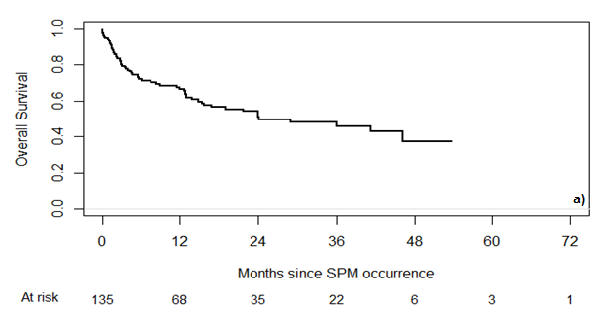

**Figure 1 a**

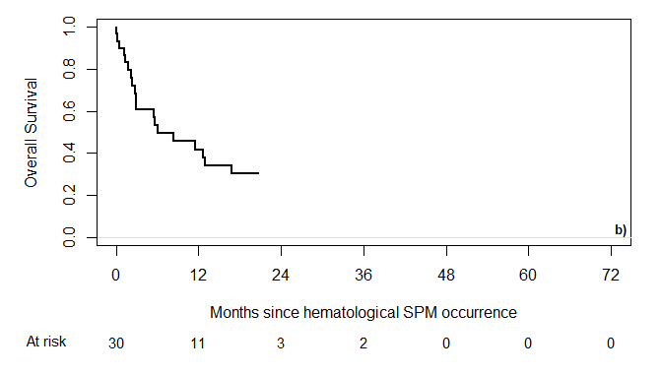

**b)**

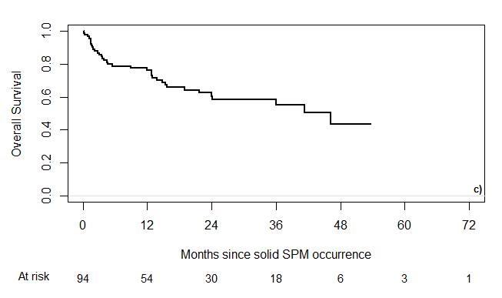

**c)**

Figure 2

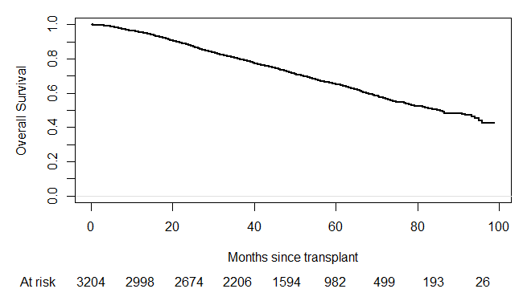

**Supplemental Figure 1.** Overall survival.

**a)**

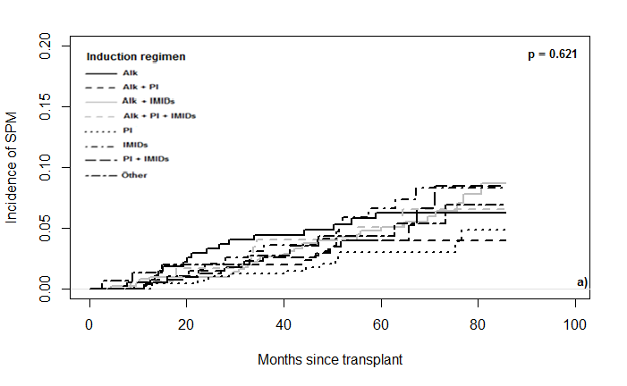

**b)**

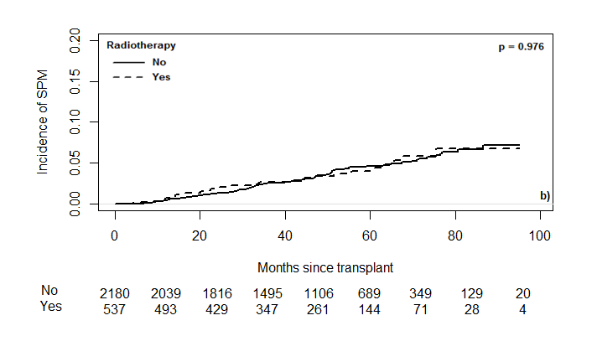

**Supplemental Figure 2a) SPM incidence by induction regimen, b) SPM incidence according to prior radiotherapy**

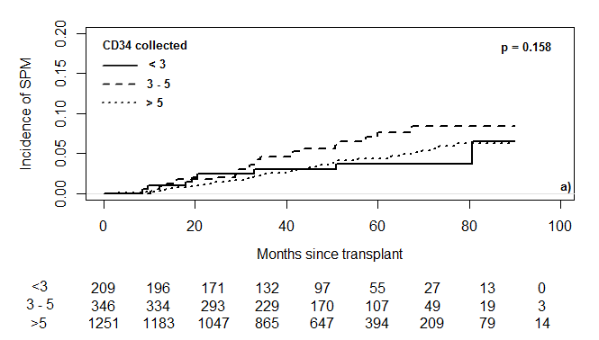

**a)**

**b)**

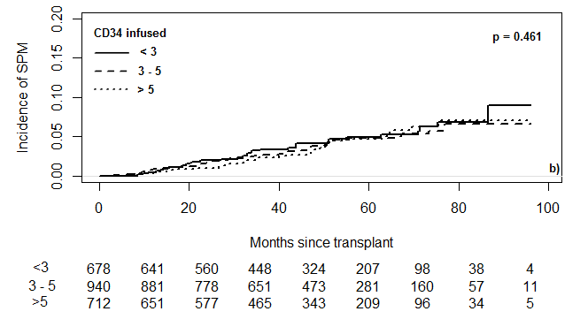

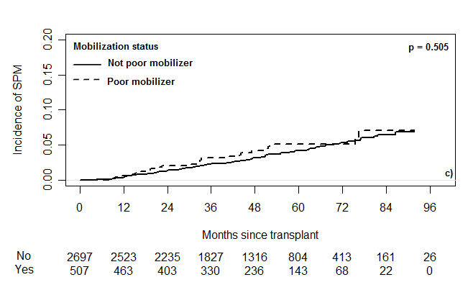

**c)**

**Supplemental Figure 3a) SPM incidence by CD34+ cell dose collected, b) SPM incidence by CD34+ cell dose infused, c) incidence of SPM by mobilization status**

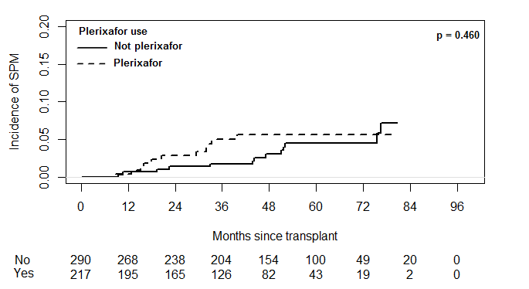

**Supplemental Figure 4 Incidence of SPM by plerixafor use**

**a)**

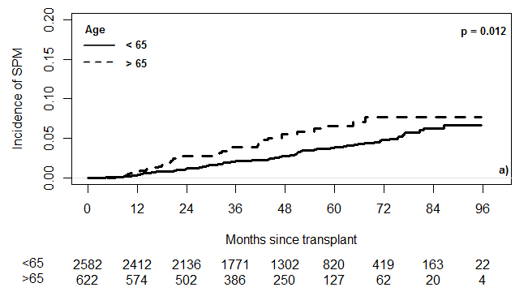

**b)**

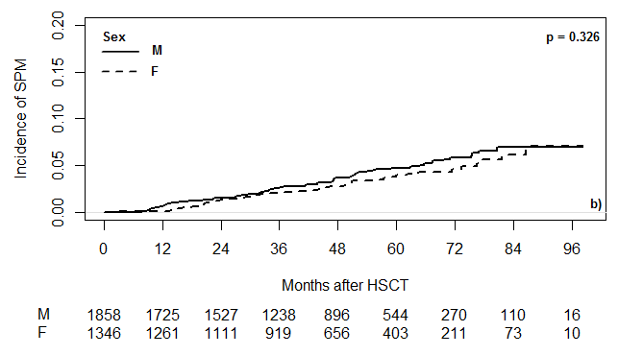

**Supplemental Figure 5a. SPM incidence by age. B. SPM incidence by sex.**

**References**

1. Kumar, S.K., et al., *Continued improvement in survival in multiple myeloma: changes in early mortality and outcomes in older patients.* Leukemia, 2014. **28**(5): p. 1122-8.

2. Pulte, D., A. Gondos, and H. Brenner, *Improvement in survival of older adults with multiple myeloma: results of an updated period analysis of SEER data.* Oncologist, 2011. **16**(11): p. 16003.

3. Pratt, G., *Lenalidomide and second malignancies in myeloma patients.* Lancet Oncol, 2014. **15**(3): p. 253-4.

4. Thomas, A., et al., *Second malignancies after multiple myeloma: from 1960s to 2010s.* Blood, 2012. **119**(12): p. 2731-7.

5. Howlader, N., et al., *SEER Cancer Statistics Review, 1975-2013, National Cancer Institute. Bethesda, MD,* [*http://seer.cancer.gov/csr/1975_2013/*](http://seer.cancer.gov/csr/1975_2013/)*, based on November 2015 SEER data submission, posted to the SEER web site, April 2016.*

6. Engelhardt, M., et al., *Large registry analysis to accurately define second malignancy rates and risks in a well-characterized cohort of 744 consecutive multiple myeloma patients followed-up for 25 years.* Haematologica, 2015. **100**(10): p. 1340-9.

7. Kyle, R.A., R.V. Pierre, and E.D. Bayrd, *Multiple myeloma and acute myelomonocytic leukemia.* N Engl J Med, 1970. **283**(21): p. 1121-5.

8. Bergsagel, D.E., et al., *The chemotherapy on plasma-cell myeloma and the incidence of acute leukemia.* N Engl J Med, 1979. **301**(14): p. 743-8.

9. Cuzick, J., et al., *A comparison of the incidence of the myelodysplastic syndrome and acute myeloid leukaemia following melphalan and cyclophosphamide treatment for myelomatosis. A report to the Medical Research Council's working party on leukaemia in adults.* Br J Cancer, 1987. **55**(5): p. 523-9.

10. Reddi, D.M., et al., *Myeloid neoplasms secondary to plasma cell myeloma: an intrinsic predisposition or therapy-related phenomenon? A clinicopathologic study of 41 cases and correlation of cytogenetic features with treatment regimens.* Am J Clin Pathol, 2012. **138**(6): p. 855-66.

11. Rifkin, R.M., et al., *Connect MM(R) - the Multiple Myeloma Disease Registry: incidence of second primary malignancies in patients treated with lenalidomide.* Leuk Lymphoma, 2016. **57**(9): p. 2228-31.

12. Areethamsirikul, N. and D.E. Reece, *The risk of secondary primary malignancies after therapy for multiple myeloma.* Leuk Lymphoma, 2015. **56**(11): p. 3012-21.

13. Attal, M., et al., *Lenalidomide maintenance after stem-cell transplantation for multiple myeloma.* N Engl J Med, 2012. **366**(19): p. 1782-91.

14. McCarthy, P.L., et al., *Lenalidomide after stem-cell transplantation for multiple myeloma.* N Engl J Med, 2012. 366(19): p. 1770-81.

# 15. Plaumbo A., Hajek R., Delforge M. Continuous Lenalidomide Treatment for Newly Diagnosed Multiple Myeloma, N Engl J Med 2012, 366 (19): p 1759

16. Palumbo, A., et al., *Second primary malignancies with lenalidomide therapy for newly diagnosed myeloma: a meta-analysis of individual patient data.* Lancet Oncol, 2014. **15**(3): p. 333-42.

17. Miller, J.S., et al., *Myelodysplastic syndrome after autologous bone marrow transplantation: an additional late complication of curative cancer therapy.* Blood, 1994. **83**(12): p. 3780-6.

18. Pedersen-Bjergaard, J., M.K. Andersen, and D.H. Christiansen, *Therapy-related acute myeloid leukemia and myelodysplasia after high-dose chemotherapy and autologous stem cell transplantation.* Blood, 2000. **95**(11): p. 3273-9.

19. Mahindra, A., et al., *New cancers after autotransplantations for multiple myeloma.* Biol Blood Marrow Transplant, 2015. **21**(4): p. 738-45.

20. Jones, J.R., et al., *Second malignancies in the context of lenalidomide treatment: an analysis of 2732 myeloma patients enrolled to the Myeloma XI trial.* Blood Cancer J, 2016. **6**(12): p. e506.

# 21. Landgren, O., A. Thomas, and S. Mailankody, *Myeloma and second primary cancers.* N Engl J Med, 2011. 365(23): p. 2241-2.

22. Munker R., Shi R. Nair R. The Shreveport Myeloma Experience: Survival, Risk Factors and Other Malignancies in the Age of Stem Cell Transplantation,, Acta Haemato, 2016, 135(3), 146-55.

23. Nuchan A., Reece D. The risk of secondary maligancies after thera[y for multiple myeloma Leu & Lymphoma, 2015; 56(11);3012-3021. same ref as number 12

24.Dong C, Hemminki K. Second primary neoplasms among 53 159 haematolymphoproliferative malignancy patients in Sweden, 1958-1996: a search for common mechanisms, *Br J Cancer,* 2001; 85: 997–1005.

25. Mailankody S , Pfeiffer RM, KristinssonSY et al.   Risk of acute myeloid leukemia and myelodysplastic syndromes after multiple myeloma and its precursor disease (MGUS). *Blood* 2011; 118: 4086–4092.

26. YouldenDR, BaadePD.The relative risk of second primary cancers in Queensland, Australia: a retrospective cohort study. *BMC Cancer*2011:1: 83.

27. Chakraborty S , HaukeRJ BonthuN, Tarantol SR. Increased incidence of a second lymphoproliferative malignancy in patients with multiple myeloma—a SEER based study. *Anticancer Res*, 2012; 32: 4507–4515.

28. Razavi p.  Rand K, Cozen W, et al.   Patterns of second primary malignancy risk in multiple myeloma patients before and after the introduction of novel therapeuticS. *Blood Cancer J* 2013.

29. Rifki RM , Abonour R, Shah JJ et al.   Connect MM®—the multiple myeloma (MM) disease registry: incidence of second primary malignancies (SPM). *Leuk Lymphoma* 2016; : 2228–2231 e121. same as ref 11

30. Miller JS, Arthur D, Litz CE et al.   Myelodysplastic syndrome after autologous bone marrow transplantation: an additional late complication of curative cancer therapy. *Blood*, 1994; 83: 3780–3786.

31. Pedersen-BjergaardJ, AndersenMK, ChristiansenDH. Therapy-related acute myeloid leukemia and myelodysplasia after high-dose chemotherapy and autologous stem cell transplantat. *Blood*, 2000; 95: 3273–3279.

32. Mahindr A\, Rav G, Mehta P et al.   New cancers after autotransplantations for multiple myeloma. *Biol Blood Marrow Transplant* 2015; 21: 738–745.