**Supplementary information**

**Film defect formation**

After the PLD LSC8020 film deposition the high vacuum chamber is filled with oxygen and the sample is cooled down with a cooling rate of 5 ⁰C/min to minimize the thermal induced defect formation. Silicon substrate and LSC material have two very different thermal expansion coefficient: 2.7·10-6 ⁰K-1 [1] and 19.1·10-6 ⁰K-1 [2] respectively. During the cooling, due to the large difference in thermal expansions, the LSC film contracts faster than the silicon substrate Fig.1S.

**Fig.1S (a,b)| AFM surface profile of a LSC/Si sample.** Afm surface analysis of a LSC/Si sample grown at 600 ⁰C. The line marked one corresponds to a line profile (1a). The bright lines on the surface are corrugation of the film surface of around 3 nm high as can be observed by the profile in (1b).

Because of these forces local deformations appear all over the film surface. The density of these defects is inversely proportional to the PLD deposition temperature as shown in Fig.2 (main text). From the AFM analysis profiling Fig.1S (a,b) it is clear that the defects are deformed material (surface corrugations) and not open surface-cracks. In some cases when the cooling rate is too fast the surface corrugations can break in real cracks as shown in Fig.2S (LSC8020/SiO2sub sample).All the samples employed on the IEDP experiments have been first screened by AFM to exclude the presence of open-cracks that could strongly affect the isotopic exchange results. When possible, for the sample synthetized at lower temperature, the FIB-SIMS analysis after the isotopic exchange step has been performed inside a free of defects area; see for example the LSC/SiO2 sample shown in Fig.2S. For the film with higher defect density as the one prepared at 750 ⁰C, it was impossible to avoid the corrugated area since the SIMS analysis area has been always maintained 15·15 m2.

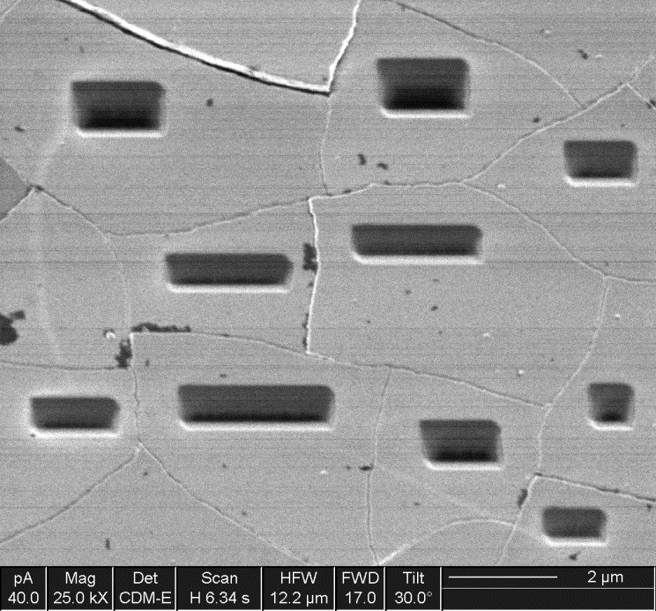

**Fig.2S| SE image of LSC/SiO2 sample surface after FIB-SIMS analysis.** SEM image performed on a cracked LSC film after the depth profile analysis by FIB-SIMS. The analysis has been performed in areas crack-free.

**X-ray-reflectivity (XRR) measurement**

Two samples, one amorphous grown at 400 ⁰C and one crystalline grown at 550 ⁰C, have been analysed by XRR technique. The PANAlytical software package has been employed to calculate the 300 nm film densities. In Fig.3S the two analysis have been presented.

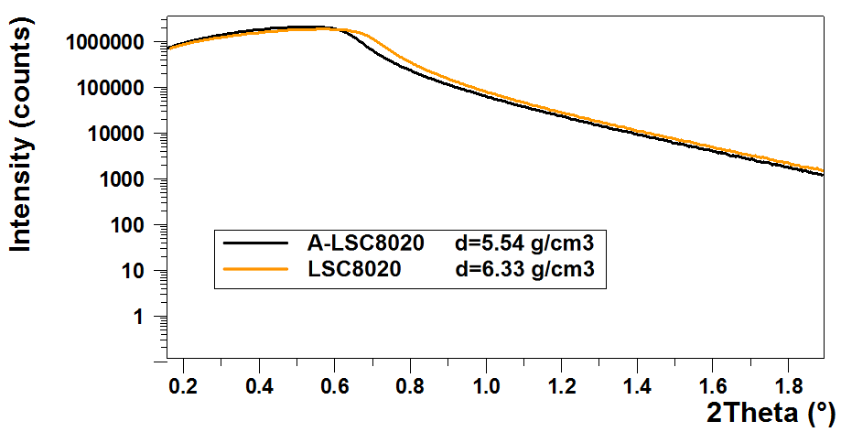**Fig.3S| XRD analysis of 300nm LSC crystalline and amorphous films.** In orange is represented the crystalline sample and in black the amorphous respectively. The critical angle value (ӨC) is higher for the crystalline sample indicating a higher density.

The critical angle Өc can be defined as the angle beyond which the condition for the total reflection is not any more valid.

**Low Energy Ion scattering**

LEIS high vacuum chamber has an operating pressure of 10-8 mbar produced by the noble gas flux during LEIS experiments. Three noble gas sources are available: helium, argon and neon. The choice of the primary ion is conditioned by the mass of the chemical species to be analysed. Helium for example is used when the presence of light mass contaminants on the sample surface like carbon or sodium are also important for the investigation. The selected noble gas is ionized, mass selected, focused and rastered on the sample surface. Primary ions are incident normal to the target surface. Only the primary ions scattered by the sample surface through 145⁰ are accepted by the Qtac100 analyser (a double toroidal electrostatic analyser -DTA). The very large acceptance solid angle together with parallel energy detection offers 3000 times higher sensitivity than conventional ion scattering spectrometers. In case of insulating samples, to prevent any charging effects, low-energy electrons (10 eV) are flooded over the sample during the measurement. The secondary argon ion sputtering gun (energy 500 eV) is oriented at 59⁰ with respect to the analysed surface. It is generally used alternating with the analysis beam to obtain a complete 3D-depth-profiling chemical map of the sample. The sputtered area was double the size of the analysed area. For this study the 4He primary ion source with energy of 3 keV has been employed, the analyser pass energy has been maintained at 3000 eV in all the experiments. In a typical LEIS spectrum each peak is produced by the binary collision between the primary ions and the atomic species at the sample surface. The energy peak position can be calculated according to the laws of conservation of energy and momentum knowing the solid angle of the analyser and the incident primary ion energy [3]. The element signal intensity is directly related to the amount of that particular atomic species on the analysed sample surface. Generally, LEIS technique does not suffer of matrix effect nevertheless the ion yield corresponding to the interaction of the primary ion with the different chemical species could be different for each pair and a direct compositional quantification is not possible. To fit the LEIS surface scattering gaussian peaks a complex function that takes into account the very particular LEIS spectra background is employed. To do so ION-TOF has developed a dedicated software. When the peak-background intensity ratio decreases, the residual error correlated to the fitting process increases proportionally and should be taken into account in the total error quantification. In the depth profiling mode the pause between analysis and sputtering is maintained of one second to avoid that the carbon contaminants that are present in the instrument chamber despite the high vacuum would redeposit on the sample surface. In Fig. 4S the cobalt, strontium and lanthanum normalized intensities for four LSC samples prepared at 400, 500, 600 and 750⁰C by PLD have been presented.

**Figure 4S** | **LEIS analysis of the 300 nm LSC films.** Each of the different cation species intensity, cobalt, strontium and lanthanum from left to right, has been represented for LSC film deposited at different temperatures. Each intensity has been normalized by the sum of all cations.

For each species, the element concentration has been calculated assuming that the normalized intensity at the plateau (marked with a circle) has the stoichiometry material composition. The second important assumption we have done is the absence of preferential sputtering of the argon ions.

**DC-resistivity measure**

Fig. 5S shows the conductivity measurements obtained in a Van Der Pauw configuration for five different LSC-8020 samples on silicon substrates. Each film has a thickness of 300 nm and it has been grown by PLD in the temperature range of 200⁰C-750⁰C.

**Figure 5S** | **DC conductivity of different LSC films prepared at different deposition temperature.** The amorphous LSC films (400 ⁰C and 200 ⁰C) present a sharp reduction of the electronic conductivity compared with the crystalline ones.

A Linkam chamber with four probes has been used for the analysis. The chamber has a little round furnace and the sample is sit on top of it. The temperature presented in the DC conductivity plot has been measured after the analysis on the sample surface by a thermocouple. Due to the large difference between the nominal chamber temperature and real one the maximum analysis temperature has been around 260 ⁰C. Whereas Van Der Pauw configuration is very sensitive to material defects, the values here presented will be used only for qualitative reasoning. The amorphous films (400 ⁰C and 200 ⁰C) clearly show a major decrease of the LSC8020 material conductivity with respect to the crystalline ones. It is worth points out how the film with higher defect density (750 ⁰C) presents an intermediate conductivity value related to the presence of the defects themselves.

**Isotope exchange of Amorphous-cathodes thin films**

Once the samples have been isotopically exchanged, depth profiles have been performed in a dynamic FIB-SIMS. The calculated oxygen-18 isotopic fraction has been fit with the sheet solution to the Fick’s diffusion equation to calculate the values of D* and k*. For each sample the analysis has been repeated between 6 and 8 times. To analyse this large amount of data we employed Tracex, a software developed to run in Matlab environment. An example of the fit for ALSC8020, ALSC6040, ALSC214 and ALSMC have been presented in Fig. 6S.



**Figure 6S** | **Oxygen-18** **isotopic fraction diffusion profiles analysed by Tracex.** One single analysis for each of the different cathode samples have been here presented. The film surface is on the left side and the interface between the cathode film and the Si crystal is on the right where the oxygen fraction (blue dots) drops.

Blue dots are the original data, in red is represented the sheet solution fitting and in green the residual. The standard error for D* and k* calculated from the different measurements on a single sample vary from 1-3% for the D* and 4-9% for the k*. Due to the large dot size employed in the main text figure the errors have not been included. We also identified an extra experimental error source affecting the oxygen self-diffusion constants calculation in the residual gas of the SIMS chamber that could be different from session to session. This error could cause an underestimation of the real constant values and it has been estimated in a maximum of 10%.

**Symmetric Amorphous-LSC cell characterization**

PLD-LSC8020 300 nm films have been deposited at room temperature on both sides of an YSZ commercial substrate (230 m).The voltage applied during the AC-impedance analysis has been maintained at 10 mV. To avoid any positive catalytic contribution from the current collector material, a gold mesh has been employed. In all spectra collected in the range of 338 ⁰C-415 ⁰C, four different arcs are recognizable Fig. 7S. Each semi-circle is depressed and differs from the expected perfect semi-circle shape. This could be related to the reduced electronic conductivity of the LSC8020 amorphous films join with the use of a mesh gold current collector (mesh size 1 mm2). The increase of the sheet resistance can provoke therefore an inhomogeneous electrical field over the sample during the AC measures. The impedance complex plane Nyquist plot is described by four different features: a high frequency arc attributed to the YSZ electrolyte grain resistance, a middle-high frequency arc attributed to the YSZ grain boundary resistance, a middle-low frequency arc corresponding to YSZ/LSC interface resistance (Ri) and the low frequency arc related to the cathodic resistance (Rp). The capacitors associated with each resistance have been replaced by the more general constant phase elements CPE.

$$Z_{CPE}=\frac{1}{Q∙{(i∙ω)}^{n}}$$

For fitting the experimental impedance curve the model described by Baumann *et al.* [4] for a dense perovskite mixed conductor’s film on YSZ electrolyte has been chosen. The relative permittivity ε' of YSZ has been estimated to be 30 as reported in [5]. Using this value it is possible to calculate the expected area specific bulk capacitance for the 230 m thick YSZ electrolyte according to Eq.1

$$∁ = \frac{ε^{'}∙ε_{0}}{l}$$

Where ε0 is the permittivity of free space 8.854·10-14 F/cm and l is the thickness of the YSZ substrate. The calculated capacitance is in the order of 1.15·10-10 F/cm2 consistent with the experimental value of the first arch reported in table 1S (2·10-10 F/cm2). The experimental grain boundaries capacitance 5.8·10-7 F/cm2 is also consistent with value reported in the literature [6]. The interface resistance Ri, corresponds to the phenomena of O2−transfer across the LSC-electrode/YSZ interface. The related capacitance CPEi, is generally described as a double layer capacitance produced by the block of electronic charges at the interface with the electrolyte. The experimental interface capacitance, table 1s, is around 40 F/cm2 measured at 365 ⁰C in the same order of magnitude of the capacitance reported by Baumann for a LSCF film at 500 ⁰C.



**Figure 7S EIS analysis of a symmetric cell ALSC/YSZ/ALSC sample.** The sample has been measured under 10mV at 365 ⁰C and 22% of p(O2).

As concluded by Baumman *et al.* this value is too high to be related only to an electrostatic double capacitance and a chemical change at the interface should be responsible for it. Finally, the dominant resistive process Rp observed at low frequency is associated with the oxygen exchanged at the surface of the electrode. The large capacitance called chemical capacitance (CPEchem) is associated to oxygen stoichiometry changes in the bulk of the electrode [7].

The CPEs values in table 1S have been converted to pure capacitances using the following equation:

$$C={(R^{1-n}∙Q)}^{1/n}$$

Where R is the resistance, Q is the constant phase element (CPE) and n is the parameter that determines how close the constant phase is to a pure capacitance (n=1).

**Table 1S Capacitances measured by EIS analysis performed at 365 ⁰C and pO2 22%**

|  |  |  |  |  |
| --- | --- | --- | --- | --- |
| Conditions | YSZ-Grain Interior | YSZ-Grain Boundaries | LSC-YSZ Interface | Rp |
| T=365⁰C | Arc I (C F/cm2) | Arc II(C F/cm2) | Arc III (C F/cm2) | Arc IV (C F/cm2) |
| PO2=22% | 2.00E-10 | 5.81E-7 | 4E-5 | 0.022 |

The critical length value Lc defined as D*/k* will determine if the cathodic resistance is mainly dominated by the cathode surface (when Lc<< cathode thickness) and any oxygen bulk diffusion limitations can be ignored. Employing the D* andk* experimental values(table 1 main text) the critical length in the exchange conditions used is Lc=243 nm. The film thickness is around 300 nm so very close to the Lc; bulk diffusion limitation cannot be dismissed a *priori*. In Fig. 8S (a) the activation energies calculated for the four different resistive processes measured by AC impedance in pO2 22% have been presented.

**Figure 8S | EIS activation energy and pO2 dependence studies.** a) The activation energies for the YSZ-bulk YSZ-grain boundaries, Ri and Rp have been calculated. (b,c) The pO2 dependence (m) have been obtained for Ri and Rp at 338 ⁰C and 415 ⁰C. A decrease of m with the increasing measure temperature has been observed.

The activation energy for the bulk and YSZ grain boundaries are in agreement with the values reported in the literature. The cathodic resistance Rp displays an activation energy of 1.3 eV similar to the one calculated for Co-rich MIECs materials (≈1.3 eV) [4]. The conductivity dependence of the interface resistance Ri with the pO2, Fig.8S (b), is very low (0.03) as expected. The dependence of the Rp with the pO2 instead is changing with the temperature going from m=0.23 (~1/4) at 338 ⁰C to m=1.11 at 415 ⁰C (~1/8).

**Gold grid deposited on the ALSC cathode**

For the fuel cell test of Ni-YSZ/YSZ/ALSC a Pt collector has been used on the thick porous anode while a gold grid has been sputtered on the side of the dense 300 nm amorphous cathode. Gold, when in bulk, has not oxygen reduction catalytic properties. The optical image after the analysis Fig. 9S, has been used to calculate the free ALSC cathode surface.



**Figure 9S | Optical microscope image of the gold grid on ALSC cathode.** The cathode free surface represents roughly the 25% of the total cathode surface.

**References**

[1] Y. Okada, Y. Tokumaru. Precise determination of lattice parameter and thermal expansion coefficient of silicon between 300 and 1500 K. *Journal of Applied Physics* 56, 314 (1984).

[2] F. Tietz, I. Arul Raj, M. Zahid, D. Sto ̈ver. Electrical conductivity and thermal expansion of La0.8Sr0.2(Mn,Fe,Co)O3-y Perovskites. *Solid State Ionics* 177, 1753 – 1756 (2006).

[3] H. Niehus, W. Heiland, E. Taglauer. Low-energy Ion Scattering at Surfaces. *Surf. Sci. Rep.* 17, 213–303 (1993).

[4] F.S. Baumann, J. Maier, J. Fleig. The polarization resistance of mixed conducting SOFC cathodes: A comparative study using thin film model electrodes. *Solid State Ionics* 179, 1198–1204 (2008).

[5] F.E.G. Henn, R.M. Buchanan, N. Jiang, D.A. Stevenson. Permittivity and AC conductivity in yttria-stabilized zirconia. *Appl. Phys. A* 60, 515 (1995).

[6] J. Nielsen, J. Hjelm. Impedance of SOFC electrodes: A review and a comprehensive case study on the impedance of LSM:YSZ cathodes. *Electrochimica Acta* 115, 31– 45 (2014).

[7] F.S. Baumann, J. Fleig, H.U. Habermeier, J. Maier. Impedance spectroscopic study on well-defined (La,Sr)(Co,Fe)O3−δ model electrodes. *Solid State Ionics* 177, 1071–1081 (2006).