Effects of Microstructure on Surface Segregation: Role of Grain Boundaries

H. Téllezª, J. Druceª, T. Ishiharaª and J. A. Kilner^{a,b}

ª International Institute for Carbon-Neutral Energy research (wpi-I²CNER), Kyushu University, Fukuoka, 819-0395, Japan
^{b} Department of Materials, Imperial College London, London SW7 2AZ, United Kingdom

The effects of microstructure on the kinetics of strontium segregation in La_{0.6}Sr_{0.4}CoO_{3-δ} ceramic samples are investigated. A faster segregation of the Sr cations towards the surface was observed after annealing for 1 h at 600 °C in dry oxygen (pO₂= 200 mbar) as the density of grain boundaries at the surface increases (i.e. with a decrease of the grain size). The presence of surface impurities, such as Na, partially inhibits the Sr segregation towards the surface. Optical micrographs and ToF-SIMS chemical imaging showed that the segregation and precipitation of Sr starts at the grain boundaries, with an apparent enrichment of the surface around the grain boundary via Sr surface diffusion.

Introduction

Cation segregation is a common phenomenon occurring at high and intermediate temperatures in the perovskite materials often used as oxygen electrodes in solid oxide fuel cells and electrolyzers (SOFC/SOEC) . Most of these perovskite oxides, with the general formula ABO₃, are doped in the A-site and often also the B-site lattice positions in order to tailor their stability, electronic conductivity and ionic transport properties. For instance, LaCoO₃ perovskites are typically doped with Sr cations at the A-site in order to increase the oxygen vacancy concentration, and hence improve the catalytic activity of the material for oxygen reduction/evolution reactions, as well as the ionic conductivity.

Nevertheless, at the typical processing and operation temperatures for SOFC/SOEC applications, aliovalent doping of A⁺³B⁺³O⁻²₃ perovskites results in surface segregation due to elastic and electrostatic interactions within the host lattice . This leads to a compositional gradient at the near- and outer surface of the oxide electrode, showing a full SrO-perovskite surface termination and, in the longer term, to the precipitation of secondary phases . Recent studies applying low-energy ion scattering (LEIS) spectroscopy have shown that this segregation occurs in a short time-scale and at relatively low temperatures . For instance, Sr segregation occurs even during the fabrication of dense polycrystalline thin films of La_{0.6}Sr_{0.4}CoO_{3-δ} (LSC) by pulsed laser deposition . The Sr cations which segregate during the deposition of the film and its subsequent cooling can be removed by rinsing in deionized water - indicating that some water-soluble Sr secondary phases are formed. However, when the LSC thin films are subjected to further annealing in oxygen at temperatures higher than 400°C, segregation of the divalent dopant takes place again, indicating this is the equilibrium surface termination at the high temperature .

Recently, Kubicek et al. reported that at device operating temperatures, the diffusion of Sr through the grain boundaries in LSC nanostructured thin films is three orders of magnitude faster than through the bulk of the grains . Given the detrimental effect of Sr segregation on the electrochemical performance of the electrode (e.g. by increasing the electrode surface resistance), the impact of faster cation diffusion through the grain boundaries should be considered when optimizing the microstructure of the electrode material.

On the other hand, an increase in the oxygen exchange kinetics has recently been obtained in Sr-doped A⁺³B⁺³O⁻²₃ perovskite materials by tailoring the grain size and orientation of polycrystalline thin films prepared by pulsed laser deposition (PLD) . The enhanced rate for the surface exchange process was attributed to the high density of grain boundaries exhibiting high surface exchange and diffusion coefficients. For instance, in the case of La_{0.8}Sr_{0.2}MnO₃ thin films, the oxygen surface exchange and diffusion coefficients are also three orders of magnitude higher at the grain boundaries compared to the bulk . A possible strategy to enhance the behavior of electrode materials exhibiting a limited mixed ionic-electronic conducting character has been proposed by tailoring the microstructure of the electrode material through increasing the grain boundary density and orientation of the grains .

From the point of view of cation segregation, although decreasing the grain size may improve performance, it could also accelerate degradation. Therefore, such microstructural engineering approaches should aim to optimize the trade-off in terms of the density of grain boundaries at the surface to improve the mass transport properties while assuring the long-term chemical stability. The purpose of this work is to study the effects of the microstructure on the kinetics of cation segregation in LSC ceramic materials and to understand the mechanism of this process at earlier stages.

Experimental

Sample Preparation

Ceramic pellets of La_{0.6}Sr_{0.4}CoO_{3-δ} (LSC) were prepared via solid state reaction from high purity oxide precursors to ensure low levels of impurities. Stoichiometric amounts of La₂O₃ (Kishida Chemical Co., Japan, 99.99%), SrCO₃ (Kishida Chemical Co., Japan, 99.99%) and Co₃O₄ (Sigma-Aldrich, 99.995%) were weighed, mixed and calcined at 1200°C for 6h. Prior to weighing, the La₂O₃ and SrCO₃ powders were calcined at 400°C for 2 hours to decompose any hydroxides formed by reaction with the atmosphere. X-ray diffraction analysis of the calcined powder was performed in Bragg-Brentano geometry (Rigaku X-ray diffractometer, RINT 2500 HLR, Rigaku Co., Japan) confirming the phase purity corresponding to a rhombohedral unit cell, with no detectable secondary phases formed.

The calcined powder was milled in a planetary ball mill (300 r.p.m. for 1 h) to obtain a homogeneous fine particle size. After drying, the LSC powders were pressed into pellets by uniaxial pressing (5 MPa) and then compacted by cold isostatic pressing (300 MPa for 30 min). Several batches with different microstructures were prepared by sintering in air at different temperatures and times to obtain a range of grain sizes ranging between approximately 5 and 50 μm. The pellets were ground using SiC paper and then polished using water-based diamond suspensions to a mirror finish (final particle size ¼ μm) to obtain a fresh flat surface. The residues from the polishing process were removed by ultrasonic cleaning in acetone, ethanol and finally de-ionised water.

The ceramic pellets were annealed in pure oxygen at a pO₂ of 200 mbar at 600°C for different times (1h, 4h, 8h and 16h) in a dedicated rig. Prior to the annealing process, the silica tube containing the samples was pumped down to a vacuum < 2 x 10⁻⁷ mbar to minimize the presence of moisture, CO₂ and other atmospheric gases that might react with the segregated species. In addition, one of the ceramic pellets for each batch was thermally etched in air (1000°C for 2 h) to reveal the grain structure.

Surface Characterisation

Low Energy Ion Scattering. The chemical composition of the outermost surface was analysed by means of Low-Energy Ion Scattering (LEIS) (Qtac¹⁰⁰ LEIS spectrometer, IonToF GmbH., Germany). Due to the sensitivity of the technique to the outermost atomic layer, a cleaning step was required after introduction of the samples in the ultra-high vacuum LEIS instrument in order to remove any organic contamination and other adsorbed species on the sample surface. These species were removed by oxidation with activated oxygen atoms extracted from a plasma source. Unlike other surface cleaning methodologies based on ion sputtering or thermal treatments, the use of reactive oxygen avoids surface damage and cation segregation processes as the kinetic energy of the activated O atoms is low and the cleaning occurs by chemical reaction with the organic contaminants to form volatile species. This cleaning methodology has been described elsewhere .

The surface characterization was performed using two different noble gas ion beams to obtain complementary information about the light elements or impurities, and good sensitivity and mass resolution power for heavier species present at the surface (by using 3 keV He⁺ and 6 keV Ne⁺ beams, respectively). The primary ion beam is produced in a high brightness plasma and accelerated to energies ranging from 1 to 8 keV. The primary ion beam is directed at normal incidence to the sample surface, while the back scattered ions at 145º were collected through the whole scattering azimuth. The kinetic energy distribution of the backscattered ions is then analysed to provide information of the first atomic layer composition. Surface spectra are collected from a large area (typically 1 mm²) in order to limit the ion fluence irradiated on the surface to below the static limit (e.g. 2 x 10¹³ ions/cm²), and hence minimise surface damage during the analysis. Each sample was analysed in three different areas in order to assure the reproducibility of the measurements and obtain a representative measurement of the segregation process.

Time-of-Flight Secondary Ion Mass Spectrometry (ToF-SIMS). High resolution chemical imaging was performed by means of Time-of-Flight Secondary Ion Mass Spectrometry (ToF-SIMS V, IonToF GmbH., Germany) fitted with a 30 keV Bi⁺ source at 45 degrees to the sample surface. The Bi⁺ source can achieve lateral resolution of the order of 200 nm for typical imaging analysis of the ceramic surface and, due to the excellent sensitivity of the technique, chemical information of the spatial distribution of the species of interest. Although the limits of detection and lateral resolution of ToF-SIMS are better than LEIS, the surface specificity is slightly lower as the secondary ions are typically emitted from the first 2-3 atomic layers. Therefore, the combination of both techniques provides complementary information to understand compositional changes in the surface and near-surface regions of the electrode material .

Results and Discussion
Microstructure and grain size

The role of grain boundaries on cation diffusion and oxygen transport in electrode materials have been previously studied in dense thin films deposited by pulsed laser deposition (PLD), in which the grain boundary density (via the grain size) is tailored by the deposition temperature or by the morphology of a buffer layer grown at the film-substrate interface . Although these approaches provide control of the electrode microstructure, they require high temperature for the deposition of the thin film which leads to cation segregation and atomic rearrangements during the deposition itself with the formation of secondary phases at the outer and near-surface regions .

Another path to control the microstructure while avoiding a segregated surface is the use of ceramic pellets. Ceramic materials are typically subjected to high temperature during the sintering process, typically above 1000°C, which also results on surface segregation of divalent dopants (A’⁺²) in (A⁺³_{(1-x)}A’⁺²_{x}B⁺³O_{3-δ}) perovskites, showing a full A’O-terminated surface after a short period of time (e.g. 12 h) . However, a fresh surface representative of the bulk composition of the material can be easily produced by grinding the pellet surface.

In the present work, the grain boundary density and grain size is controlled by the temperature and duration of the sintering treatment. A better homogeneity in the grain size was found for LSC powders that were planetary ball milled to obtain a fine particle mixture, increasing also the density of the material. The sintering conditions were chosen to provide a wide variety of large grains, above an average size of 1 μm. A summary of the sintering conditions and the resulting densities and grain size are shown in Table I. A large range of grain sizes were obtained for the different batches, from a few microns to around 55 μm.

TABLE I. Sintering conditions, relative density and average grain size of the LSC64 ceramic samples used in this study.
Batch | Sintering |  | Relative Density (%) | Approximate Grain Size (µm)
Batch | Temperature (°C) | Time (h) | Relative Density (%) | Approximate Grain Size (µm)
A | 1350 | 18 | 95.0 ± 0.6 | 55
B | 1350 | 12 | 93.9 ± 0.1 | 35
C | 1350 | 6 | 93.9 ± 0.2 | 30
D | 1200 | 6 | 90.2 ± 1.2 | 5

Figure 1 shows optical micrographs of thermally-etched LSC samples for the different batches prepared for this study. As observed in the micrographs, the different sintering treatments produced significant differences in the microstructure (e.g. grain size). All the samples showed a homogeneous grain size with low porosity and no evidence of cracks. Interestingly, the thermal etching treatments in air led to the decoration of the grain boundaries with precipitates, with the exception of the smallest grain size sample (D), where the grain boundaries were not easily distinguished by optical microscopy. In addition to the decorated grain boundaries for samples A, B and C, the formation of small precipitates on the grain surfaces could also be observed. The density of precipitates formed on the surface is larger as the average grain size decreases (from A to C).

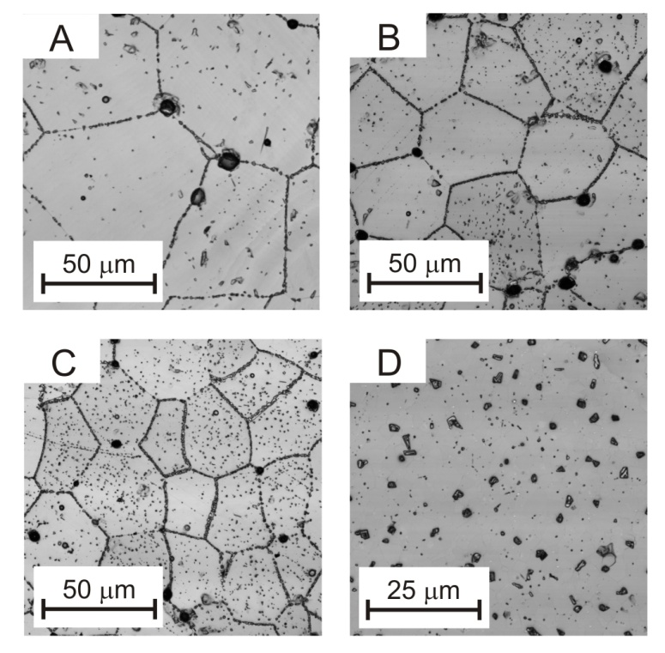
Figure 1. Optical micrographs of the LSC ceramic samples after thermal etch in air at 1000°C for 2 h.

The microstructure of sample D can be observed in the SEM image in Figure 2, showing an approximate grain size of 5 µm (one order of magnitude smaller than in sample A). Sample D was sintered at lower temperature (1200°C) than samples A-C, resulting in a relative density of around 90% and a large degree of residual porosity at the surface. For this sample, the formation of precipitates was observed along the grain boundaries (solid arrows in Figure 2). Large irregular polyhedral precipitates were also observed, especially at the triple points between several grains (dotted arrows in Figure 2). The larger size (1-2 µm) of these precipitates compared to those observed for samples A-C is a first indication of the faster segregation through the grain boundaries. These particles are formed by the segregated Sr clustering at the triple points of the grains giving rise to the large irregular particles across the surface.

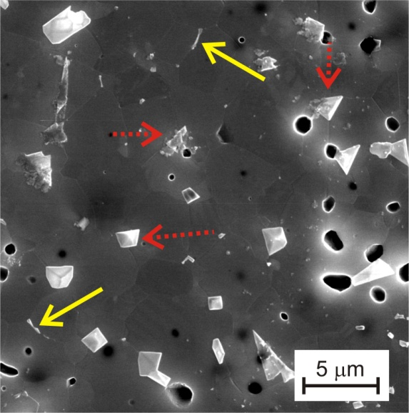
Figure 2. SEM micrographs of sample D (5 µm) after the thermal etch in air at 1000°C for 2h.

These images seem to be at odds with results reported by Oh et al. , where the precipitation of Sr particles in La_{0.6}Sr_{0.4}Co_{0.2}Fe_{0.8}O_{3-δ} (LSCF) was observed at the grain surfaces, leaving clean grain boundaries. Although the treatments performed by Oh et al. were at high temperatures (600°C - 900°C), the annealing treatments were longer (i.e. 50 and 100h). In our case, the thermal etching was performed in air at 1000°C for two hours, showing an earlier stage of the Sr segregation process. The lower the grain boundary density at the sample surface (i.e. sample A, 55 µm grain size), the lower the number of precipitates observed at the grain surface. These images suggest that, at initial stages of the thermal treatments, the precipitation of secondary phases is initiated at the grain boundaries. Similar precipitation at the grain boundaries of LSCF ceramics have been also observed at the earlier stages of the annealing process by Niania et al. . In addition, for the smaller grain size (sample D), large particles were observed at the surface.

On the other hand, it is also interesting to point out that the distribution of precipitates is not uniform over all the grains within the field of view. For instance, samples B and C show some grains with a very high density of precipitates, while some other regions are poorly decorated. No relationship between grain size and areal density of surface particles is observed in the micrographs, implying that the origin of this difference may lie in elsewhere. For example, this variation may well depend on the orientation of the underlying grain.

Kinetics of Sr Segregation

The surface composition of the ceramic LSC samples was analysed using LEIS spectrometry in order to investigate the effects of the grain boundary density on the kinetics of the Sr segregation. Note that given the large analysis area used for the LEIS analyses (1 mm²), a random distribution of grain orientations is included within the probed surface. Figure 3 shows the composition of the polished surfaces for the different samples. Prior to the annealing treatments, the LSC samples showed the presence of all the constituent cations at the surface, corresponding to the bulk composition expected for the polished surfaces. The high energy onsets for each of the species at the surface are indicated by arrows in the spectra. The He⁺ spectrum for the smaller grain LSC sample (batch D), reveals the presence of a Na impurity at the surface, whereas samples A-C showed a clean surface. The Na impurity might be attributed to a contamination during sample processing, as all the batches were prepared from the same high purity precursors. Due to this impurity, the peak areas (proportional to the cation surface coverage) for the rest of the constituent cations are smaller for sample D compared to the rest of the LSC samples.

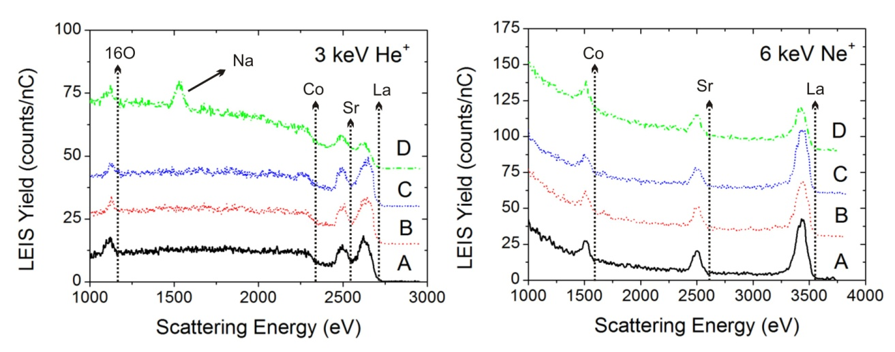
Figure 3. Surface LEIS spectra obtained for the as polished LSC samples (A: 55 µm, B: 35 µm, C: 30 µm, D: 5 µm). Left: 3 keV He⁺ spectra, right: 6 keV Ne⁺ spectra) Spectra are offset for clarity.

LEIS spectra were also acquired using a 6 keV Ne⁺ primary beam, which provides better sensitivity and resolution power for the analysis of the heavier elements. As observed in the Ne⁺ spectra, all the polished surfaces samples, except sample D, show similar intensities for La, Sr and Co peaks. These values were taken as a reference to represent the bulk composition of the LSC ceramic samples. In the case of sample D, a significant decrease of the La and Sr coverage was observed due to the presence of the Na impurity for this set of samples. This result suggests that the Na impurity is incorporated into the perovskite structure forming a solid solution by substituting onto the A-site .

The effect of the grain size and grain boundary density on the kinetics of the Sr segregation can be observed in Figure 4. In this figure, the surface composition of samples A (55 µm) and C (30 µm) after annealing at 600°C in a pO₂ of 200 mbar for 1h are compared. After this short thermal treatment at intermediate temperature, a clear increase on the Sr surface coverage is observed in comparison with the spectra obtained for the bulk composition (i.e. the Sr peak areas for the bulk composition of the “as polished” surfaces are smaller than after annealing for 1h, as shown in Figure 3). The fast kinetics of the segregation process for acceptor-doped perovskites (A⁺³_{(1-x)}A’⁺²_{x}B⁺³O_{3-δ}) has been previously reported in other similar perovskite materials . For instance, Druce et al. reported a significant Sr surface enrichment on the surface of LSCF after annealing for 8h in oxygen at 400°C and almost a full SrO-surface coverage when the annealing was performed at 600°C for the same time . Kubicek et al. also observed Sr segregation in LSC thin films prepared by PLD deposition and annealed at 600°C . Recently, we also showed that the segregation of Sr can take place during PLD deposition at high temperatures of thin films with nanometric columnar grains (~50 nm in diameter), leading to the formation of a water-soluble Sr phases on the surface . In that case, the thin films were rinsed with water to remove the segregated phase formed during the PLD deposition. Subsequent annealing of the water-rinsed LSC thin films in a pO₂ of 200 mbar for 45 min at 600°C was sufficient to obtain a Sr-segregated surface with almost no Co cations detected at the outer surface. Further annealing at longer times did not significantly increase the Sr surface coverage, indicating that the surface had reached an equilibrium state.

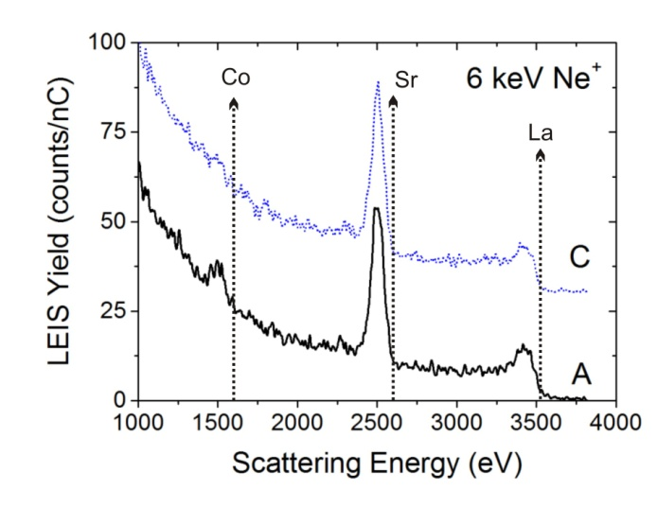
Figure 4. LEIS surface spectra obtained using 6 keV Ne⁺ primary ions for samples A (55 µm) and C (30 µm) annealed at 600°C for 1 h in a pO₂ of 200 mbar. Spectra are offset for clarity.

In the present work, the grain boundary density at the surface of the ceramic pellets is decreased considerably compared to the PLD thin films reported in as the grain sizes are 2 - 3 orders of magnitude larger. As observed, the Sr segregation becomes faster as the grain size is reduced from 55 µm (sample A) to 30 µm (sample C). For a high areal grain boundary density (sample C), the Sr surface coverage increases at the expense of Co and La surface coverage, with no transition metal detected at the outer surface (similar to previous results obtained for nanocolumnar LSC thin films ).

A comparison of the evolution of the surface composition with annealing time for all the sets of samples is shown in Figure 5, depicting the cation surface fractions taking as a reference for the bulk stoichiometry the composition of the “as polished” samples. As observed previously in the comparison for samples A and C in Figure 3, a direct relationship between the density of the grain boundaries and the larger Sr coverage at the surface is also shown after 1 h of annealing, with the exception of sample D (5 µm). Similarly, this is reflected in a decrease of the Co coverage with the grain size. On the other hand, the La coverage decreases very quickly after 1 h of annealing and remains rather constant for further annealing at longer times.
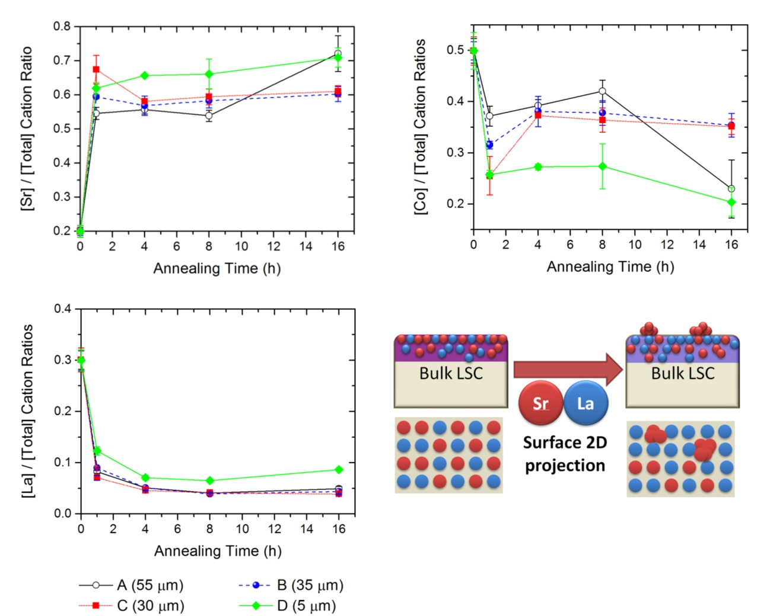

Figure 5. Evolution of the cation surface coverage as a function of annealing time at 600°C in pO₂ = 200 mbar. The cation ratios for the “as polished” surface was used as a reference of the bulk stoichiometry. Error bars correspond to the standard deviation for three difference measurements on each sample. Schematic of the clustering process and the 2-dimensional surface projection observed by LEIS.

The different behavior observed for sample D could be attributed to the presence of the Na impurity incorporated into the perovskite structure . Cation segregation in acceptor-doped perovskites (A⁺³_{(1-x)}A’⁺²_{x}B⁺³O_{3-δ}) is driven by electrostatic and misfit strain interactions with the host lattice . In these perovskite oxides, the atomic layers of the parent structure are not charge-neutral, but consisting of alternating [(A⁺³O⁻²)]⁺¹ and [(B⁺³O₂⁻²)]⁻¹ charged sheets. As pointed out by Tasker , this leads to a net dipole moment converging towards the surface that makes it unstable. In the presence of an acceptor dopant, such as A’ = Sr, the crystal can be stabilized by the segregation of the dopant towards the surface to obtain a charge neutral termination [(A’⁺²O⁻²)]⁰.

The same driving forces for the segregation of the Na impurity exist. For instance, the ionic radii of both cations in the 12-fold A-site coordination are very similar (i.e. R (Na⁺)_{XII}=1.39 Å and R (Sr⁺²)_{XII}=1.44 Å) . Furthermore, in the presence of Na impurities, surface charge neutrality can be obtained by a [(La⁺³_{(1-x)/2}Sr⁺²_{x}Na⁺¹_{(1-x)/2}O⁻²)]⁰ surface termination. This is clearly reflected in the cation surface fractions in Figure 5. After annealing for 1h, sample D shows a lower degree of Sr segregation that would be initially expected from the trend observed for samples A-C. Since sample D has the smallest grain size (and larger grain boundary density at the surface), the Sr coverage was expected to be higher (similarly to what was found for nanograined LSC thin films ). However, the presence of the Na impurity seems to inhibit the segregation of Sr towards the surface, with a lower (Sr/total cation) surface ratio. Note that the Sr surface coverage is indeed smaller in a [(La⁺³_{(1-x)/2}Sr⁺²_{x}Na⁺¹_{(1-x)/2}O⁻²))]⁰ surface than in a [(Sr⁺²O⁻²)]⁰ surface. Further evidence of the formation of the charge-neutral [(La⁺³_{(1-x)/2}Sr⁺²_{x}Na⁺¹_{(1-x)/2}O⁻²)]⁰ is the behavior observed for La and Co. While the Co surface ratio decreases accordingly to the expected trend observed for samples A-C (i.e. the higher number of grain boundaries at the surface, the lower Co surface coverages), the La surface coverage in sample D is larger compared to samples A-C, indicating that La is present at the outer surface even after long annealing times (16 h). Similar effects of alkaline and alkaline earth cations on the segregation of aliovalent dopants have also been observed in PrBaCo₂O_{5+δ} double perovskites .

The evolution of the surface chemistry for longer annealing times in samples A-C, shows an apparent decrease on the Sr surface coverage after 4 h of annealing. We attribute such a decrease to the clustering of Sr into precipitates at the surface, which exposes the Co cations at the surface surrounding the precipitates (and also reflected an increase in the (Co/total cation) fractions. Since LEIS spectra are representative of a 2D projection of a 3D topography, clustering of the Sr particles at the surface will be reflected by a decrease of the Sr peak area (see sketch in Figure 5). The same particle-clustering effect was observed previously on (La,Sr)₂CoO_{4+δ} epitaxial thin films with increasing the annealing temperature . The lack of a significant change on the (La/total cation ratio) suggests that, after 4 h of annealing, the competition to occupy the outermost surface layer is established between the acceptor dopant (Sr) and the transition metal (Co) located at the near-surface regions. For longer annealing times, the trend of increasing the Sr surface coverage while decreasing the Co coverage is observed.

In order to obtain further information of the distribution of the cations at the surface, the samples were also analysed by ToF-SIMS imaging . Although ToF-SIMS is also a surface-sensitive technique, the information for static measurements (i.e. with low ion doses to minimize the surface damage) comes from the first 2-3 atomic layers. However, the better lateral resolution of ToF-SIMS enables high resolution chemical mapping of the distribution of the segregated species at the near-surface. Figure 6 shows the distribution of Sr⁺ and LaO⁺ secondary ions at the surface of sample A (55 µm) after annealing at 600°C for 8 h (top maps). Note that the intensities of Sr⁺ and LaO⁺ ions are normalized to the total secondary ions intensity (SI⁺) in order to account for differences in the sputtering rates on the different orientations of the grains included in the field of view. The dotted boxes on the chemical maps indicate the regions from where the intensity profiles shown in the figure were extracted.

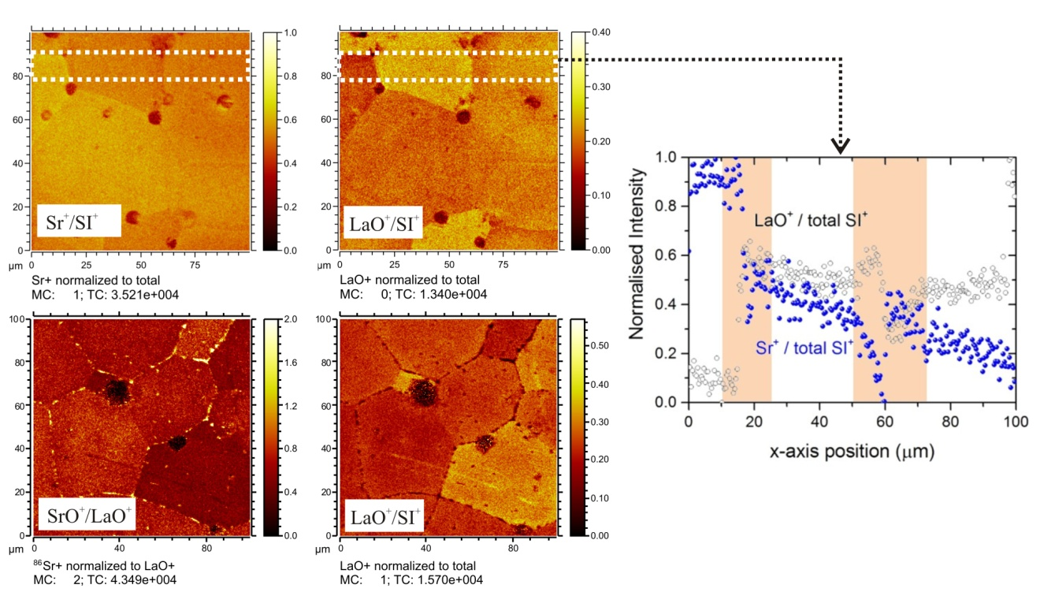
Figure 6. ToF-SIMS chemical maps obtained for sample A (55 μm) after annealing for 8h (top row) and after thermal etch (bottom row). The white dotted boxes on the chemical maps of the sample annealed for 8h show the regions from which the intensity profiles were extracted. The shadowed boxes in the profiles highlight the grain boundary regions.

As observed, the chemical maps obtained for (LaO⁺/SI⁺) and (SrO⁺/SI⁺) are complementary and the intensities are not homogeneous for the different grains, which suggests that the grain orientation does affect the segregation of Sr as well. This was also suggested by the optical micrographs in Figure 1, where the distribution of precipitates for the different grains in samples B and C was not uniform. Furthermore, a gradual change of the (LaO⁺/SI⁺) and (SrO⁺/SI⁺) intensities can be observed next to the grain boundaries, suggesting that Sr surface diffusion from the grain boundary region to the grain surface takes place. This can be observed clearly in the intensity profiles at the right, with the grain boundary regions highlighted with coloured boxes, showing complementary profiles for LaO⁺ and Sr⁺ at the surroundings of the grains. The apparent diffusion fronts extending from the grain boundaries may partly explain the seemingly orientation-related contrast between different grains in the (LaO⁺/SI⁺) and (SrO⁺/SI⁺) images for the 600 °C annealed samples. It is conceivable that the degree of Sr enrichment seen in these images depends on the anisotropy of surface diffusion of Sr, although further studies are needed to obtain a firm conclusion about this anisotropic effect. Figure 6 also shows the (SrO⁺/LaO⁺) fraction maps for the thermally etched samples. In this case, the grain boundaries show high intensity for (SrO⁺/LaO⁺) fractions and a depletion at these regions for the (LaO⁺/SI⁺) intensity maps. For the thermal-etched samples, some Sr precipitates can be also observed at the grain surfaces. The images obtained for the thermally-etched samples seem to suggest that the segregation and precipitation of Sr particles is preferentially taking place at the grain boundaries at initial stages of the heating treatments.

Conclusions

In this work, the relationship between microstructure (in particular with the grain boundary density) and the kinetics of Sr segregation has been studied. We have observed that the segregation of Sr takes place more rapidly as the grain size is decreased (i.e. as the grain boundary density at the surface increases). Furthermore, ToF-SIMS imaging suggested that surface diffusion of Sr from the grain boundaries might take place, and a certain degree of anisotropy is also observed for the different grain orientations. The surface segregation is a fast, dynamic and complex process depending on a large number of experimental variables, including annealing atmosphere , surface microstructure , presence of impurities , among others. All these factors further complicate our understanding of the segregation process, which is based on static snapshots reported in the literature that are, quite often, carried out in different experimental conditions.

Furthermore, the fast kinetics of the Sr segregation observed and, in particular, its relationship with the grain boundary density, has important implications to be considered when optimizing the microstructure of the electrode materials, giving the detrimental effect of Sr segregation for the oxygen surface exchange process. Recent studies have suggested that the rate of oxygen exchange at the surface of perovskite materials can be enhanced by engineering the microstructure of the electrode (i.e. through an increment of the grain boundary density at the surface) . Nevertheless, the higher density of the grain boundaries might also facilitate the segregation of Sr and impurities towards the surface, with the performance and chemical stability of the material threatened in the long term by the depletion of Sr at the bulk (leading to a decrease in the concentration of oxygen vacancies, formation of passivating precipitates at the surface, volatile species, etc). Therefore, further studies on the dependence of cation segregation, materials microstructure, and electrochemical performance are required in order to establish the practical viability of this approach to improve the long-term behavior of the electrode materials.

Acknowledgments

The authors acknowledge the support of the International Institute for Carbon Neutral Energy Research (wpi-I²CNER), funded by the World Premier Research Centre of the Ministry of Education, Culture, Sports, Science and Technology (MEXT) of the Japanese Government.

References

1. J. Druce, H. Tellez, M. Burriel, M. D. Sharp, L. J. Fawcett, S. N. Cook, D. S. McPhail, T. Ishihara, H. H. Brongersma and J. A. Kilner, Energy & Environmental Science, 7, 3593 (2014).
2. N. Y. Y. Teraoka, T. Seiyama, Journal of the Surface Science Society of Japan, 9, 153 (1988).
3. E. J. Crumlin, E. Mutoro, Z. Liu, M. E. Grass, M. D. Biegalski, Y.-L. Lee, D. Morgan, H. M. Christen, H. Bluhm and Y. Shao-Horn, Energy & Environmental Science, 5, 6081 (2012).
4. M. Kubicek, G. M. Rupp, S. Huber, A. Penn, A. K. Opitz, J. Bernardi, M. Stoger-Pollach, H. Hutter and J. Fleig, Physical Chemistry Chemical Physics, 16, 2715 (2014).
5. W. Lee, J. W. Han, Y. Chen, Z. Cai and B. Yildiz, Journal of the American Chemical Society, 135, 7909 (2013).
6. G. M. Rupp, H. Téllez, J. Druce, A. Limbeck, T. Ishihara, J. Kilner and J. Fleig, J. Mater. Chem. A, 3, 22759 (2015).
7. J. Druce, T. Ishihara and J. Kilner, Solid State Ionics, 262, 893 (2014).
8. H. Téllez, J. Druce, Y.-W. Ju, J. Kilner and T. Ishihara, International Journal of Hydrogen Energy, 39, 20856 (2014).
9. A. M. Saranya, D. Pla, A. Morata, A. Cavallaro, J. Canales-Vázquez, J. A. Kilner, M. Burriel and A. Tarancón, Advanced Energy Materials, n/a (2015).
10. K. Develos-Bagarinao, H. Kishimoto, J. De Vero, K. Yamaji and T. Horita, Solid State Ionics).
11. E. Navickas, T. M. Huber, Y. Chen, W. Hetaba, G. Holzlechner, G. Rupp, M. Stoger-Pollach, G. Friedbacher, H. Hutter, B. Yildiz and J. Fleig, Physical chemistry chemical physics : PCCP, 17, 7659 (2015).
12. M. de Ridder, R. G. van Welzenis and H. H. Brongersma, Surface and Interface Analysis, 33, 309 (2002).
13. H. Tellez, A. Aguadero, J. Druce, M. Burriel, S. Fearn, T. Ishihara, D. S. McPhail and J. A. Kilner, Journal of Analytical Atomic Spectrometry, 29, 1361 (2014).
14. G. M. Rupp, A. Limbeck, M. Kubicek, A. Penn, M. Stoger-Pollach, G. Friedbacher and J. Fleig, Journal of Materials Chemistry A, 2, 7099 (2014).
15. Y. Chen, H. Téllez, M. Burriel, F. Yang, N. Tsvetkov, Z. Cai, D. W. McComb, J. A. Kilner and B. Yildiz, Chemistry of Materials, 27, 5436 (2015).
16. D. Oh, D. Gostovic and E. D. Wachsman, Journal of Materials Research, 27, 1992 (2012).
17. M. Niania, R. Podor, S. J. Skinner and J. A. Kilner, ECS Transactions, 68, 665 (2015).
18. T. He, J. Chen, T. G. Calvarese and M. A. Subramanian, Solid State Sciences, 8, 467 (2006).
19. J. Druce, H. Tellez, T. Ishihara and J. A. Kilner, ECS Transactions, 66, 61 (2015).
20. Z. Cai, M. Kubicek, J. Fleig and B. Yildiz, Chemistry of Materials, 24, 1116 (2012).
21. P. W. Tasker, Journal of Physics C: Solid State Physics, 12, 4977 (1979).
22. R. Shannon, Acta Crystallographica Section A, 32, 751 (1976).
23. K. V. Hansen, K. Norrman and M. Mogensen, Surface and Interface Analysis, 38, 911 (2006).

