**Formation of V-grooves in SrRuO3 Epitaxial Film**

Guiju Liua, Honglei Fenga, Bin Liua, Yiqian Wanga,*, Wei Liub, Bin Zoub, Neil McN. Alfordb, and Peter K. Petrovb

*a College of Physics & The Cultivation Base for State Key Laboratory, Qingdao University, No.308 Ningxia Road, Qingdao, 266071, P.R. China*

*b Department of Materials, Imperial College London, London, SW7 2AZ United Kingdom*

**Abstract**

SrRuO3 thin films were epitaxially grown on a (001) SrTiO3 substrate using pulsed laser deposition technique. Various defects such as V-grooves, threading dislocations and dislocation dipoles are observed in the SrRuO3 epitaxial film. It is found that the sidewalls of most V-grooves are {101} facets, and the dominant angle between the sidewalls is 90o. Some threading dislocations end at the apexes of the V-grooves while the others penetrate the entire film. The threading dislocations and V-grooves can partially relieve the strain in the epitaxial SrRuO3 film. During the relaxation process, a two-dimensional growth mode transforms into a three-dimensional one, along with the formation of mesa-like islands separated by V-grooves. The dimensions and distributions of V-grooves are associated with the growth conditions. The control of growth mechanism and surface morphology are very important for the fabrication of novel perovskite oxide devices.

**Keywords:** A1. Surface structure; A1. Line defects; A1. Transmission electron microscopy; A1. Growth models; B1. Perovskites; B1. SrRuO3 epitaxial films

* Corresponding author, email address: yqwang@qdu.edu.cn, Te. No.:+86-532-83780318

**1. Introduction**

SrRuO3 (SRO) epitaxial thin films have attracted considerable attention because of their special physical properties such as high resistance to chemical corrosion [[1]], high thermal conductivity [[2]] and stability [[3]-[4][5]], which make them useful for electrodes, junctions and buffer layers in perovskite oxide-based devices [[6],[7]].However, the properties of these perovskite oxide devices are sensitive to the growth mode, surface morphology and microstructure of thin films. Hence, it is necessary to investigate the growth mechanism, surface morphology and microstructure of SRO films.

In the past decades, high-quality SRO thin films were grown on various single crystalline substrates such as SrTiO3 (STO) [[8]], LaAlO3 [[9]], MgO [[10]] and Si [[11]]. In these heteroepitaxial systems, strain energy strongly influences the surface morphology and determines the growth mode. However, even if the surface energy favors a flat surface, sometimes the strain relaxation favors island formation [[12]]. Three growth modes namely Frank-van der Merwe (FM), Volmer-Weber (VW), and Stranski-Krastanov (SK), have been introduced to describe the surface configuration and formation of dislocations in heteroepitaxial systems [12]. The FM mode corresponds to a two dimensional (2D) layer-by-layer growth mode, the VW mode corresponds to a three dimensional (3D) growth, and the SK mode corresponds to 2D growth of a few monolayers followed by 3D island formation. The latter two non-planar growth modes could easily generate defective surfaces and pits [[13]]. For instance, Jiang and Pan [[14]] investigated the microstructure and growth mechanism of SRO thin films grown on (001) LaAlO3 substrates, and found that the film has a rough surface due to an effect of lattice mismatch and its island-like growth process. In SRO/STO systems many studies have reported that the step-flow growth mode is achieved after an initial 2D layer-by-layer [[15]-[16][17]] or 3D island growth mechanism [[18],[19]]. Once the substrate surface is covered by a continuous SRO film, the growth mode will be transformed into a step-flow growth, and the film shows large terraces which are separated by small steps. [16] However, the V-groove structures have been scarcely observed on the surface of the SRO/STO films.

In this paper, we report a detailed investigation of the surface morphology and dislocations in SRO films epitaxially grown on (001) STO substrates using high-resolution transmission electron microscopy (HRTEM). The aim of this work is to investigate the formation mechanism of V-grooves and threading dislocations.

**2. Experimental Procedures**

The 200-nm-thick epitaxial SRO films were grown on a 5 × 5 mm2 (001) STO substrates by pulsed laser deposition (PLD) technique using a KrF excimer laser (λ = 248 nm). The films were deposited from 20 mm diameter stoichiometric SRO target in a high vacuum chamber (base pressure: ~ 8x10-6 Torr) with an oxygen partial pressure of 75 mTorr. The energy density of the laser spot was ~1 J/cm2. During the entire process of the deposition, the substrate holder temperature was maintained at 700 ºC, while the target was kept rotating. The thickness of the resulted film was determined by the ablation time together with the number of pulses shot on the target. Once the deposition was over, the samples were annealed for 20 min in an oxygen rich environment (700 Torr) in order to reduce the oxygen vacancies, and then slowly cooled down to room temperature at a rate of about 10 ºC/min.

For transmission electron microscopy (TEM) examinations, the samples were prepared in a cross-sectional orientation ([010] zone-axis for STO substrate) using traditional techniques of mechanical polishing and ion thinning. The ion thinning was performed using a Gatan Model 691 precision ion polishing System (PIPS, Pleasanton, CA). The bright field (BF) imaging, high-resolution TEM (HRTEM) and selected-area electron diffraction (SAED) examinations were carried out using a JEOL JEM 2100F transmission electron microscope operated at 200 kV.

**3. Results and discussions**

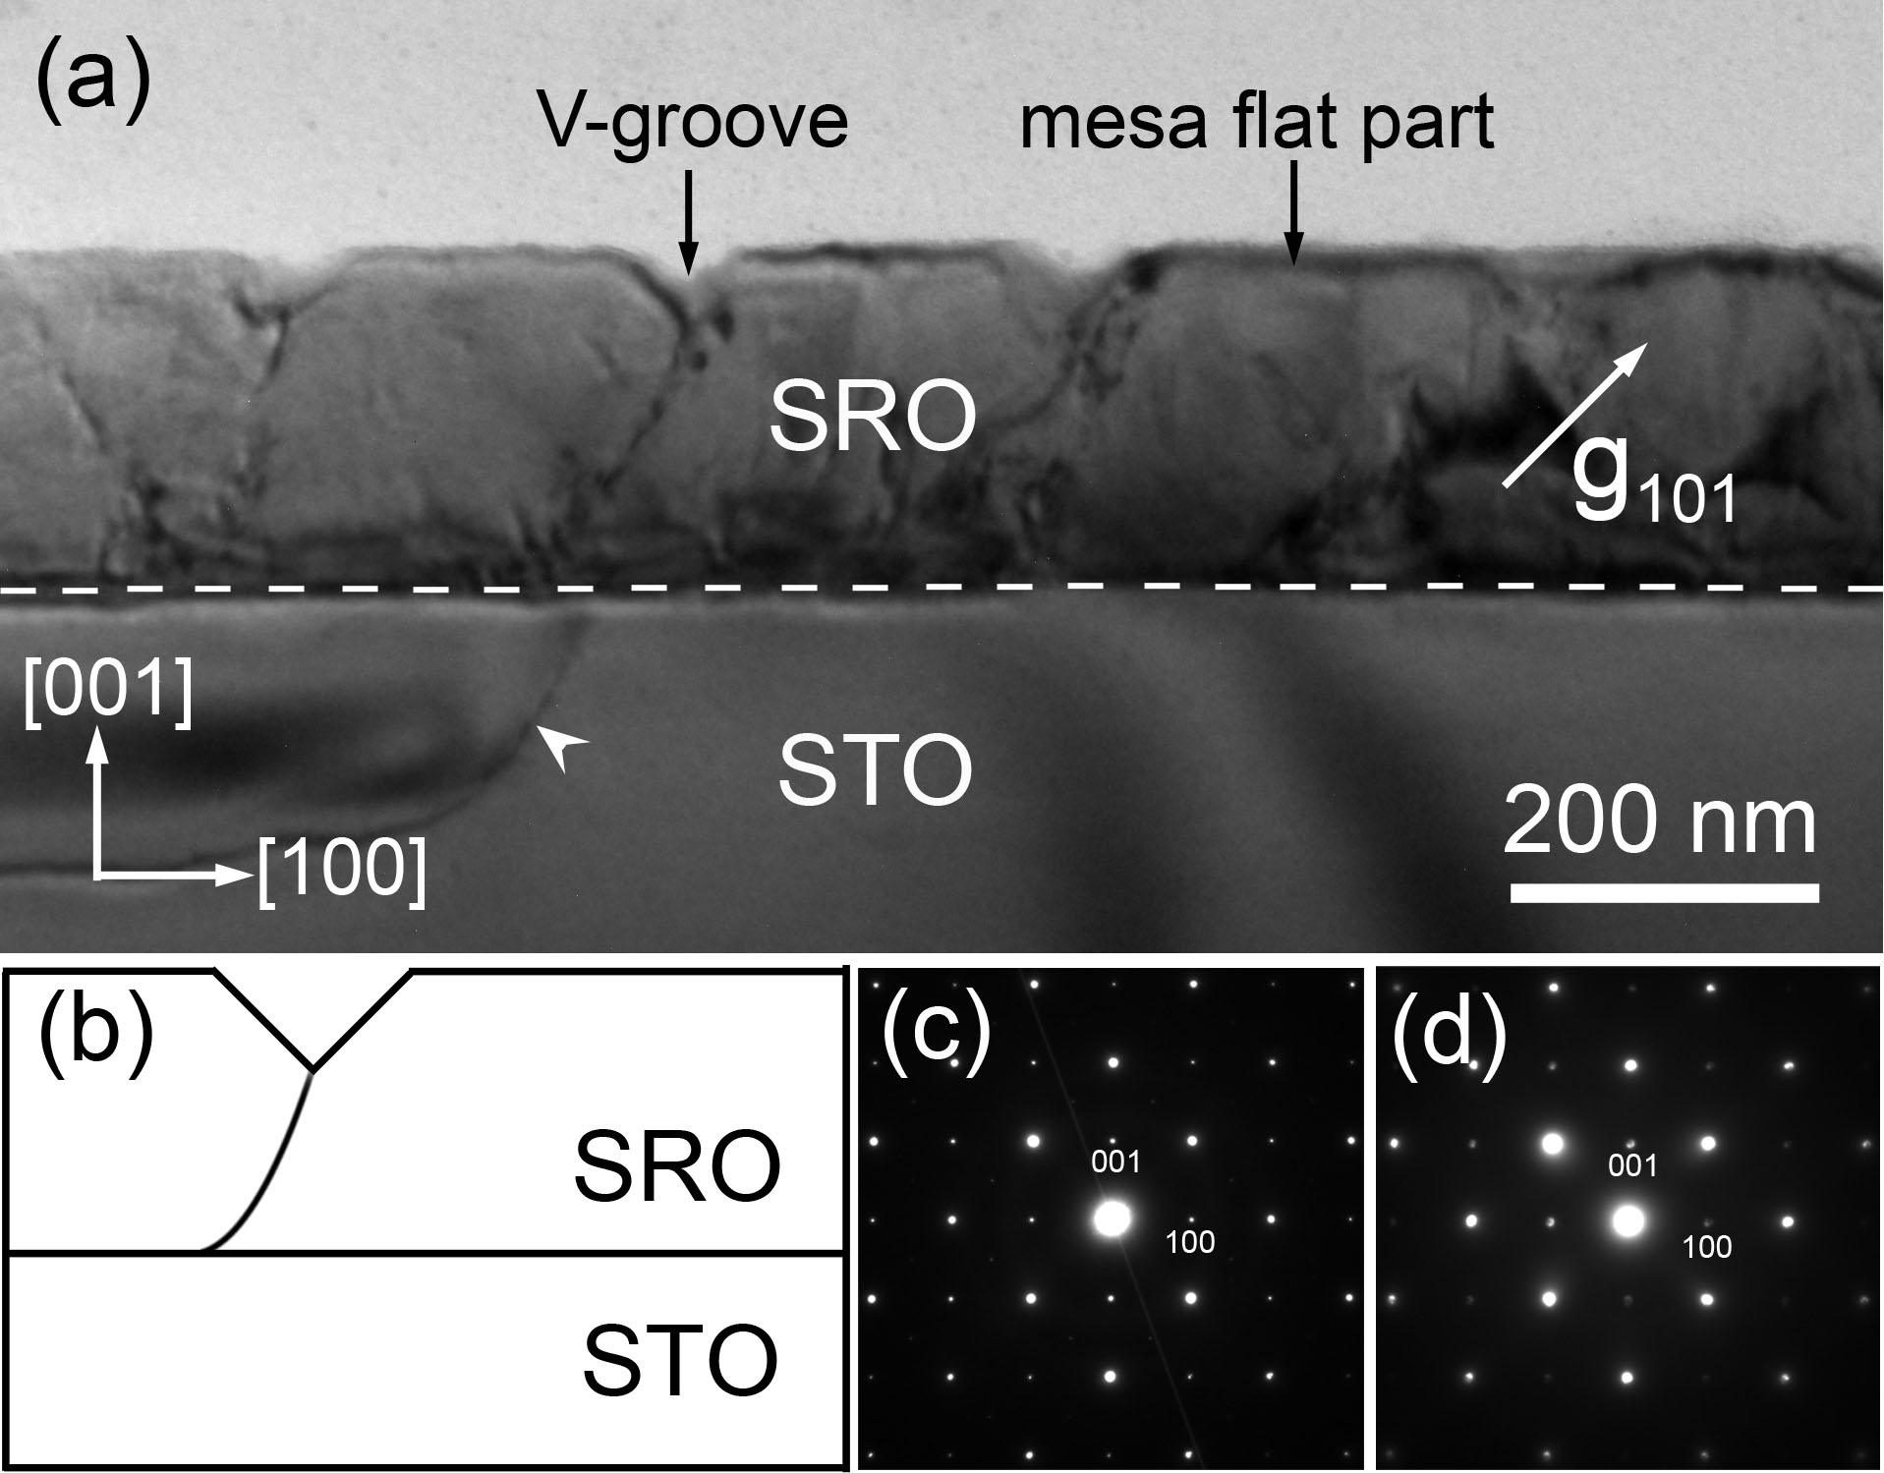

**Fig. 1.** (a) Cross-sectional BF TEM image of SRO/STO taken near the [010] zone-axis with a diffraction vector of **g** = 101; (b) Schematic diagram of groove with triangular shape and threading dislocation; Typical [010] zone-axis SAED patterns taken from the epitaxial film (c) and substrate (d), respectively.

Fig. 1(a) is a typical BF TEM image of a cross-sectional SRO/STO sample where the dashed lines indicate the interface between the substrate and film. This image was taken under a two-beam condition with **g** = 101. As can be seen from Fig. 1(a), the free surface of the epitaxial film is not smooth, and several trenches are unevenly distributed on the flat surface. Along the [010] direction, these trenches are projected as V-shaped grooves with various depths and widths spreading on the film surface. It is measured from cross-sectional TEM image that the depths of the grooves vary from 17 nm to 55 nm. The total thickness of the SRO film is around 200 nm, so the V-grooves do not penetrate through the whole film. Such morphological features are similar to those observed in (Al,Ga)N/GaN heterostructures [[20]-[21][22]], however, in SRO/STO systems this morphology is scarcely reported. He *et al.* [[23]]observed two kinds of grooves in SZO/SRO/STO heterostructure, one being trapezoidal, the other being triangular. However, in our SRO films only triangular-shaped grooves were observed. Usually, when SRO films are grown on (001) STO substrates, they exhibit (001) flat surfaces. The PLD process is far from thermodynamic equilibrium. Therefore, the interaction between the highly energetic species (forming the laser plume) and the sample surface influences the film growth mode and could modify the crystalline shape and promote the formation of V-grooves. In addition, cross-sectional TEM observations indicate that threading dislocations emerge both below the V-grooves apex and below the mesa flat parts. Fig. 1(b) sketches the configuration of triangular-shaped grooves with a threading dislocation. The grooves configuration and dislocations may be related to the growth mechanism of SRO films. Fig. 1(c) is a typical SAED pattern taken from the epitaxial film region, which corresponds to a [010] zone-axis SAED pattern of SRO. From the SAED pattern, it proves that the epitaxial film is a good single crystal and the growth direction of the film is along [001]. Fig. 1(d) is a typical SAED pattern taken from the substrate region. From Figs. 1(c) and (d), it can be seen that the film and substrate have a good epitaxial orientation relationship of [010]SRO//[010]STO and (001)SRO//(001)STO.

F:\刘桂菊\SRO\fenxi\新建文件夹\图\Fig.2.tif

**Fig. 2.** (a) Cross-sectional BF TEM image of SRO/STO taken near the [010] zone-axis with a diffraction vector of **g** = 101; (b) Typical [010] zone-axis HRTEM image and SAED pattern of an individual V-groove; (c) Typical [010] zone-axis HRTEM images of regions I in (a), respectively; (d) and (e) An enlarged HRTEM image and Fourier-filtered lattice image of enclosed region III and IV in (c).

Fig. 2(a) shows the BF TEM image of a cross-sectional SRO/STO sample with some V-grooves on the surface. It was taken under a two-beam condition with **g** = 101. It can be seen that most V-grooves have a dominant angle of 90ºbetween the sidewalls because they were viewed end-on ([010] direction). However, a few V-grooves show a sidewall angle shallower than 90o, and a shadow image can be observed in between the sidewalls, which might be due to inclined nature of the V-grooves with respect to the view direction. One example is labelled II in Fig. 2(a). A clearer image of V-groove is shown in Fig. 2(b), and the inset is a typical SAED pattern taken from this region, which corresponds to a [010] zone-axis diffraction pattern of SRO. The two sidewalls of the V-groove are indicated by red lines and green lines, respectively. The planes of these sidewalls are indicated in the corresponding SAED image. It is clearly seen that the facets of sidewalls are all {101} planes which have an angle of 45o with respect to the (001) surface. This means that the angle between the two sidewalls of this V-groove is 90o. The strain in the SRO film is easy to be relieved at the sidewalls of the V-grooves. Cheng *et al.* [21] found that the formation of the V-grooves, which leads to a larger surface area and a partial elastic relaxation, is a way to reduce the total strain inside the film. In the case of SRO films on STO substrates, we come to a conclusion that the formation of the V-grooves is an effective way to stabilize the surface and to relieve strain in the epitaxial SRO films.

Extensive TEM examinations of the SRO epitaxial film show that the V-grooves preferentially form over the threading dislocations, as shown in Fig. 2(a). In InGaN/GaN multiple quantum wells [[24],[25]], the threading dislocation, which is associated with V-defects, was also found. Fig. 2(c) is a typical HRTEM image of a SRO film corresponding to region I in Fig. 2(a), showing that five edge-dislocation dipole pairs emerging at the bottom of the V-groove. The dislocation dipoles are indicated by D1 to D10, respectively. The extra half atomic plane, which is a characteristic of a pure edge dislocation, is indicated by dashed lines in Fig. 2(c). To show the extra half atomic planes more clearly, an enlarged HRTEM image and one dimensional Fourier-filtered lattice image of the dislocation dipoles are shown in Figs. 2(d) and (e). It can be seen that two extra half planes are inserted from the direction parallel to [10 $\overline{1}$], confirming that they are pure edge dislocations. For D1, D3, D5, D7and D9 the extra half atom planes are inserted from [10 $\overline{1}$], while for D2, D4, D6, D8 and D10 the extra half atom planes are inserted from [$\overline{1}$ 01]. Thus D1, D3, D5, D7 and D9 are regarded as positive dislocations, and the others are considered to be negative dislocations. The dislocation line directions for D1 to D10 are along [010]. To determine the Burgers vectors, Burgers circuits are drawn for D1 and D2, as shown in Fig. 2(d). From Fig. 2(d), we can clearly see the gaps between the starting and ending points of the Burgers circuits, as indicated by red arrows. The Burgers vectors of the two dislocations are determined to be **b** = $\frac{1}{2}$ <101>, which is a characteristic Burgers vector for a partial dislocation.

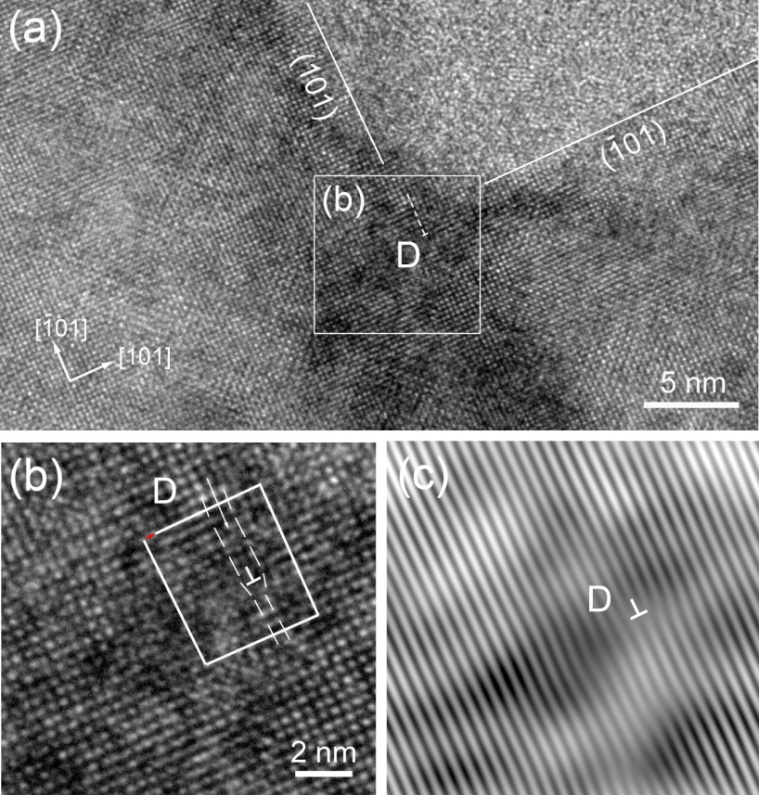

**Fig. 3.** (a) HRTEM of V-groove; (b) An enlarged HRTEM image of enclosed region in (a), and Burgers circuit for D; (c) Fourier-filtered lattice image of (b) along [10 $\overline{1}$].

Below the apex of V-grooves, several edge dislocations emerge. Fig. 3(a) is a typical HRTEM image of the V-groove together with a pure edge dislocation in SRO film. Two perpendicular white lines mark the sidewalls of this V-groove. The dislocation is indicated by D and the extra half atomic plane of this dislocation is indicated by dashed lines in Fig. 3(a). To show the extra half atomic plane more clearly, an enlarged HRTEM image of the rectangular area in Fig. 3(a) is shown in Fig. 3(b). Fig. 3(c) shows the one dimensional Fourier-filtered lattice image of Fig. 3(b) with the lattice plane parallel to [10 $\overline{1}$]. The Burgers circuit for D is drawn in Fig. 3(b). The Burgers vector for this dislocation is determined to be **b** = $\frac{1}{2}$ <101>, which can be regarded as a partial dislocation.

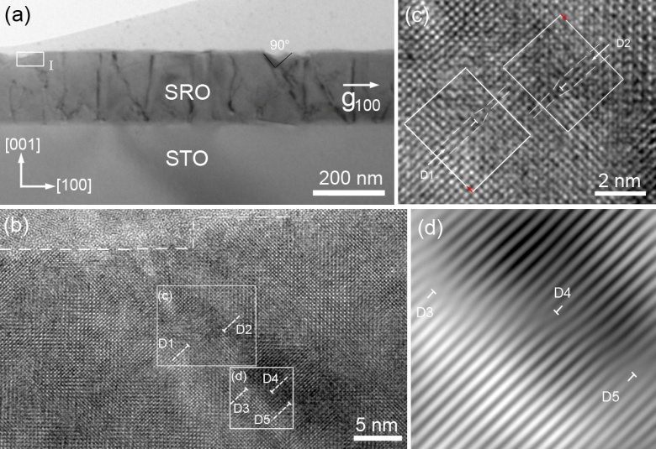

**Fig. 4.** (a) Cross-sectional BF TEM image of SRO/STO; (b) HRTEM image of enclosed region I in (a); (c) An enlarged HRTEM image of enclosed region in (b); (d) Fourier-filtered lattice image of (b) along [101].

It is easy to find that threading dislocations are widely distributed in the film. Except for those emerging at the bottom of the V-grooves, some dislocations exist below the mesa flat parts, as shown in Fig. 4(a). Fig. 4(a) is the BF TEM image of cross-sectional SRO/STO sample which was taken under a two-beam condition with **g** = 100. It shows that some threading dislocations emerge below the flat surface. Oh *et al.* [[26]] has reported that the existence of threading dislocations can reduce the flatness of film at the intersection with film surface and disturb 2D growth of films. Fig. 4(b) shows a terrace which is separated by a step of eight to ten atoms in height on the film surface. The undulations of the surface are accompanied by the appearance of threading dislocations. Similarly, we also observe the edge dislocation dipoles which are indicated by D1 to D5, and the extra half atomic planes of these dislocations are indicated by tilted dashed lines in Fig. 4(b). In order to show the extra half atomic plane more clearly, an enlarged HRTEM image and one dimensional Fourier-filtered lattice image of the dislocation dipoles are shown in Fig. 4(c) and Fig. 4(d), respectively. Two Burgers circuits for D1 and D2 are drawn in Fig. 4(c). It can be clearly seen that there is a gap between the starting and ending points of the Burgers circuits which is indicated by an arrow, and the Burgers vectors for D1 and D2 are determined to be **b** = $\frac{1}{2}$ <10 $\overline{1}$ >. In Fig. 4(d), for D3 and D5, two extra half planes are inserted from the direction of [101], while for D4, the extra half plane is inserted from the direction of [$\overline{1}$ 0 $\overline{1}$], confirming that they are pure edge dislocations. The Burgers vectors for D3, D4 and D5 are **b** = $\frac{1}{2}$ <10 $\overline{1}$ >, too. Therefore, all the dislocation dipoles in SRO film are partial dislocations.

From Fig. 1(a), Fig. 2(a) and Fig. 4(a), it is easy to find that apart from those ending at the surface of the films or at the apex of the V-grooves, some dislocations terminate at the middle of the film. This can happen when some point defects or impurities exist inside the film. When the dislocations permeate them, the threading dislocations will pin over there instead of climbing. The sources of threading dislocations are various. Because the purchased STO substrate is not a perfect single crystal, several dislocations exist in it. When the film grows on the substrate, the dislocations in the substrate easily extend into the growing film. With the increase of the film thickness, dislocations gradually climb or slip inside the film. Because of the effect of the strain mechanism (the in-plane stress limits the moving direction of the dislocations), the dislocation is hard to slip along the slip direction in the film and can only climb up to the surface of the film. Eventually, the threading dislocation will form. It is found that several threading dislocations in Fig. 1(a) are connected to pre-existing dislocations in the substrate. This indicates that the dislocations in the substrate act as an effective source for the generation of threading dislocations. The dislocations density in commercial single crystalline STO (001) substrate is known to be in the order of 103-104 /cm2 [[27]], while in SRO films, it is estimated to be about 1010/cm2. Obviously, the pre-existing dislocations in the substrate are too few in number to generate sufficient threading dislocations. Thus the threading dislocations also originate from other mechanisms. It is universally acknowledged that threading dislocations are formed by the extension of misfit dislocations [23]. In a 3D island growth mode prevailed for the growth of SRO, the introduction of threading dislocations through the boundaries of the islands would be an additional source during the coalescence stage. Thus the potential sources for the formation of threading dislocations contain the pre-existing dislocations in the substrate, the misfit dislocations and the coalescence of islands.

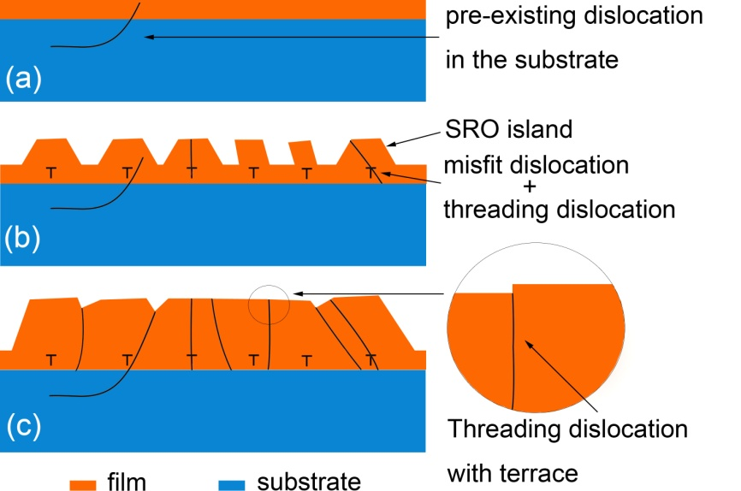

**Fig. 5.** Schematic growth mechanism of SRO film: (a) Initial growth on the SRO substrate showing smooth morphology; (b) Isolated islands and dislocations growing on the flat surface; (c) Coalescence of islands leading to formation of extra threading dislocations and V-grooves.

To understand the evolution of threading dislocations and formation process of V-grooves, we proposed a 2D-3D growth mode for the SRO/STO films, as shown in Fig. 5. Black lines indicate the threading dislocations, and “┬” indicates the misfit dislocations. In the initial growth stage, since the SRO film thickness is below the critical thickness, due to the small lattice mismatch (≈ -0.6%), the lattice between SRO films and STO substrates matches very well, and the film may show a 2D layer-by-layer growth, as shown in Fig. 5(a). The strain caused by the lattice mismatch can be accommodated by elastic deformation. So misfit dislocations won’t form at the interfacial region, and only some pre-existing dislocations in the substrate will penetrate into the film. When the epitaxial film grows thicker than critical thickness, the strain is accumulated. The strain begins to be relieved according to the introduction of misfit dislocations in the film [denoted as “┬” in Fig. 5(b)]. With further growth, because the non-uniform distribution of stress along the film surface, the dislocation regions become new nucleus, and the truncated pyramidal islands and pillar-like islands preferentially form above a portion of dislocations [Fig. 5(b)]. Because the plane with lower surface energy is more stable, the free surface of the islands consists of (001), {101} and {111} facets [[28]]. And the film growth mode will transform from 2D layer-by-layer mode into 3D island mode. As time goes by, the islands gradually grow into big ones, threading dislocations and V-grooves will form at the islands coalescence regions, as shown in Fig. 5(c). In addition, the threading dislocations with step-terrace structure will emerge at coalescence regions of pillar-like islands, as shown in the enlarged region in Fig. 5(c). Oh *et al.* [26] reported that as the deposition temperature increased, the surface transformed from undulated to step-terrace structure. The dimensions or distribution of V-grooves also depend on the growth condition of the films. Furthermore, because the misfit dislocations can’t completely relieve strain, some misfit dislocations eventually expand into threading dislocations, as shown in Fig. 5(b). However, the presence of a high density of threading dislocations and slip bands leads to strain-instability of the film [26]. In order to relax the stress and reduce the surface energy, the atoms on the film surface will transport from the high-energy regions to the low-energy regions through surface diffusion process. Thus, small steps will appear in the surface where threading dislocations exist, which are shown in Fig. 4(b). The 2D-3D growth stage is closely related to strain relaxation and causes roughening of the film surface. The formation of threading dislocations and V-grooves on the surface will completely reduce the strain energy in the film.

**4. Conclusions**

V-grooves and threading dislocations are observed in the SRO/STO epitaxial films. The 90o V-grooves have various width and depth, and don’t extend to the SRO/STO interface. About threading dislocations, some penetrate to the apexes of the V-grooves, some penetrate through the entire film and the others terminate at the middle of the film. The sources of the threading dislocations include the pre-existing dislocations in the substrate, misfit dislocations and the coalescence of islands. A 2D-3D growth mode was proposed to explain the formation process of V-grooves on the film surface and the threading dislocations in the films. The formation of V-grooves and threading dislocations can all relieve the local strain in SRO epitaxial film. Our results can shed light on the formation of V-groove structures in other epitaxial film systems.

**Acknowledgements**

We would like to thank the financial support from the National Key Basic Research Development Program of China (Grant no.: 2012CB722705), and High-end Foreign Experts Recruitment Program (Grant nos.: GDW20143500163, GDW20133400112). Y. Q. Wang would also like to thank the financial support from the Top-notch Innovative Talent Program of Qingdao City (Grant no.: 13-CX-08), and the Taishan Scholar Program of Shandong Province, China.

**References**

1. [] L. Klein, J.S. Dodge, T.H. Geballe, A. Kapitulnik, A.F. Marshall, L. Antognazza, K. Char, Perpendicular magnetic anisotropy and strong magneto-optic properties of SrRuO3 epitaxial films, Appl. Phys. Lett. 66 (1995) 2427-2429.
2. [] N. Keawprak, R. Tu, T. Goto, Thermoelectric properties of Sr-Ru-O compounds prepared by spark plasma sintering, Mater. Trans. 49 (2008) 600-604.
3. [] J.-M. Albina, M. Mrovec, B. Meyer, C. Elsässer, Structure, stability, and electronic properties of SrTiO3/LaAlO3 and SrTiO3/SrRuO3 interfaces, Phys. Rev. B 76(2007) 165103.
4. [] S. Ito, K. Takahashi, S. Okamoto, I.P. Koutsaroff, A. Cervin-Lawry, J. Sakai, N. Ito, H. Funakubo, Thermal stability of epitaxial SrRuO3 bottom electrodes and their contribution to the characteristics of (Ba0.5Sr0.5)TiO3 films grown on them, Integra. Ferroelectr. 77 (2005) 3-11.
5. [] J. Shin, S.V. Kalinin, H.N. Lee, H.M. Christen, R.G. Moore, E.W. Plummer, A.P. Baddorf, Surface stability of epitaxial SrRuO3 films, Surf. Sci.581 (2005) 118-132.
6. [] Y.B. Lin, Z.B. Yan, X.B. Lu, Z.X. Lu, M. Zeng, Y. Chen, X.S. Gao, J.G. Wan, J.Y. Dai, J.M. Liu, Temperature-dependent and polarization-tuned resistive switching in Au/BiFeO3/SrRuO3 junctions, Appl. Phys. Lett. 104 (2014) 143503.
7. [] J.G. Wu, S. Qiao, C.H. Pu, D.Q. Xiao, J. Wang, J.G. Zhu, Effect of bilayer structure and a SrRuO3 buffer layer on ferroelectric properties of BiFeO3 thin films, Appl. Phys. A 109 (2012) 57-61.
8. [] Y.Z. Yoo, O. Chmaissem, S. Kolesnik, B. Dabrowski, M. Maxwell, C.W. Kimball, L. McAnelly, M. Haji-Sheikh, A.P. Genis, Contribution of oxygen partial pressures investigated over a wide range to SrRuO3 thin-film properties in laser deposition processing, J. Appl. Phys. 97 (2005) 103525.
9. [] Z.Q. Liu, Y. Ming, W.M. Lu, Z. Huang, X. Wang, B.M. Zhang, C.J. Li, K. Gopinadhan, S.W. Zeng, A. Annadi, Y.P. Feng, T. Venkatesan, Ariando, Tailoring the electronic properties of SrRuO3 films in SrRuO3/LaAlO3 superlattices, Appl. Phys. Lett. 101 (2012) 223105.
10. [] B. Zou, P.K. Petrov, N.M. Alford, SrRuO3 thin films grown on MgO substrates at different oxygen partial pressures, J. Mater. Res. 28 (2013) 702-707.
11. [] T. Higuchi, Y.X. Chen, J. Koike, S. Iwashita, M. Ishida, T. Shimoda, Epitaxial Growth of SrRuO3 thin film electrode on Si by pulsed laser deposition, Jpn. J. Appl. Phys. 41 (2002) 6867-6872.
12. [] H. Katsuno, M. Uwaha, Y. Saito, Heteroepitaxial growth modes with dislocations in a two-dimensional elastic lattice model, Surf. Sci. 602 (2008) 3461-3466.
13. [] F.H. Kaatz, W.R. Graham, J. Van der Spiegel, Modification of the microstructure in epitaxial erbium silicide, Appl. Phys. Lett. 62 (1993) 1748-1750.
14. [] J.C. Jiang, X.Q. Pan, Microstructure and growth mechanism of epitaxial SrRuO3 thin films on (001) LaAlO3 substrates, J. Appl. Phys. 89(2001) 6365-6369.
15. [] J. Choi, C.B. Eom, G. Rijnders, H. Rogalla, D.H.A. Blank, Growth mode transition from layer by layer to step flow during the growth of heteroepitaxial SrRuO3 on (001) SrTiO3, Appl. Phys. Lett.79 (2001)1447-1449.
16. [] R.A. Rao, Q. Gan, C.B. Eom, Growth mechanisms of epitaxial metallic oxide SrRuO3 thin films studied by scanning tunneling microscopy, Appl. Phys. Lett. 71 (1997) 1171-1173.
17. [] G. Rijnders, D.H.A. Blank, J. Choi, C.B. Eom, Enhanced surface diffusion through termination conversion during epitaxial SrRuO3 growth, Appl. Phys. Lett.84(2004)505-507.
18. [] G. Herranz, B. Martínez, J. Fontcuberta, F. Sánchez, M.V. García-Cuenca, C. Ferrater, M. Varela, Impact of microstructure on transport properties of nanometric epitaxial SrRuO3 films, Appl. Phys. Lett. 82(2003)85-87.
19. [] F. Sánchez, M.V. García-Cuenca, C. Ferrater, M. Varela, G. Herranz, B. Martinez, J. Fontcuberta, Transition from three- to two-dimensional growth in strained SrRuO3 films on SrTiO3 (001), Appl. Phys. Lett. 83 (2003) 902-904.
20. [] P. Vennéguès, Z. Bougrioua, J.M. Bethoux, M. Azize, O. Tottereau, Relaxation mechanisms in metal-organic vapor phase epitaxy grown Al-rich (Al,Ga)N/GaN heterostructures, J. Appl. Phys. 97(2005) 024912.
21. [] K. Cheng, M. Leys, S. Degroote, H. Bender, P. Favia, G. Borghs, M. Germain, Formation of V-grooves on the (Al,Ga)N surface as means of tensile stress relaxation, J. Cryst. Growth 353 (2012) 88-94.
22. [] Z. Bougrioua, I. Moerman, L. Nistor, B. Van Daele, E. Monroy, T. Palacios, F. Calle, M. Leroux, Engineering of an insulating buffer and use of AlN interlayers: two optimizations for AlGaN-GaN HEMT-like structures, Phys. Stat. Sol. A 195(2003) 93-100.
23. [] J.Q. He, R. Dittmann, S. Karthӓuser, E. Vasco, Geometric shadowing from rippled SrRuO3/SrTiO3 surface templates induces self-organization of epitaxial SrZrO3 nanowires, Phys. Rev. B 74 (2006), 205410.
24. [] X.H. Wu, C.R. Elsass, A. Abare, M. Mack, S. Keller, P.M. Petroff, S.P. DenBaars, J.S. Speck, S.J. Rosner, Structural origin of V-defects and correlation with localized excitonic centers in InGaN/GaN multiple quantum wells, Appl. Phys. Lett. 72 (1998) 692-694.
25. [] C.J. Sun, M.Z. Anwar, Q. Chen, J.W. Yang, M.A. Khan, M.S. Shur, A.D. Bykhovski, Z. Liliental-Weber, C. Kisielowski, M. Smith, J.Y. Lin, H.X. Xiang, Quantum shift of band-edge stimulated emission in InGaN-GaN multiple quantum well light-emitting diodes, Appl. Phys. Lett. 70 (1997) 2978-2980.
26. [] S.H. Oh, C.G. Park, Surface evolution of strained SrRuO3 films deposited at various temperatures on SrTiO3 (001) substrates, J. Mater. Res. 21(2006) 1550-1560.
27. [] J. Yamanaka, Distribution of dislocations in SrTiO3 single crystals, Mater. Trans. JIM. 40 (1999) 915-918.
28. [] Y. Saito, Three-dimensional elastic lattice model of heteroepitaxy, Surf. Sci. 586 (2005) 83-95.