**Can solute segregation in ceramic materials be reduced by lattice strain?**

George F. Harrington1\*¶, Stephen J. Skinner1, and John A. Kilner1,2

*1Department of Materials, Imperial College London, London, SW7 2AZ, UK*

*2International Institute for Carbon-Neutral Energy Research (WPI-I2CNER), Kyushu University, Fukuoka, Japan*

*\*E-mail: harrington.frederick.george.302@m.kyushu-u.ac.jp*

*¶Present address: Center for Co-Evolutional Social Systems, Kyushu University, Fukuoka, 819-0395, Japan, and Department of Materials Science and Engineering, Massachusetts Institute of Technology, Cambridge, MA 02139, USA.*

Abstract

Lattice strain is a relatively unexplored route to modify the degradation effects in functional oxides for high temperature electrochemical devices. In this paper, we present results on the segregation of Gd to the surface of strained Gd0.1Ce0.9O2-δ films using low energy ion scattering to assess the surface composition. The potential for strain-modified segregation is discussed as well as the challenges in studying and implementing it.

1. Introduction

Cation segregation to the surfaces and the interfaces of complex metal oxide materials often occurs at elevated temperatures and is undesirable for many technological applications such as solid oxide fuel cell (SOFC) or electrolyser cell devices. Currently, one of the biggest barriers to widespread commercialisation of these devices is degradation during long-term operation, caused in part by cation segregation. Although cation segregation in oxides is well established, recently, there has been growing interest in studying the surface segregation in materials for SOFCs, and in particular candidates for the cathode, where cation segregation has been shown to reduce the kinetics of the oxygen reduction reaction.1–5

Over the last decade interest has grown in an alternative approach to materials development for high temperature electrochemical devices, where the application of lattice strain has been suggested to improve ionic transport. Lattice strain may occur during operation in such devices due to thermal and chemical gradients, and also has the potential to be engineered in composites with enhanced functional properties. Promising results have been reported for mixed ionic-electronic conductors6, but despite extensive research in electrolyte materials such as yttria-stabilised zirconia (YSZ) and rare earth substituted ceria, this approach has resulted in limited success with some studies reporting orders of magnitude enhancements in the conductivity7, 8, and others observing a negligible effect in nominally similar systems9–11. Despite great interest in both cation segregation and the effects of lattice strain on complex oxides, little to no work has been carried out to assess the effects of externally applied strain on the rate, or extent of, surface segregation, to the best of the authors’ knowledge. However, this may be a feasible route to develop more stable materials that are less susceptible to degradation at elevated temperature.

In addition, cation segregation has previously been studied in bulk ceramic materials12–14 or single crystal systems15, whose thermal history incudes elongated periods close to the sintering temperature. However, since the proliferation of thin film fabrication techniques such as pulsed laser deposition (PLD), magnetron sputtering, and molecular beam epitaxy, there is widespread interest in the properties of thin film complex oxides for thin films applications including micro-SOFCs, memristors, or ferroelectric and multiferroic devices. These films have often been fabricated at elevated temperatures (500-900°C), but still at substantially lower temperatures than traditionally processed ceramics. Hence, it is instructive to investigate the cation segregation occurring in these materials and the temperature and rate over which it occurs.

In this paper, we will briefly review the established model for cation segregation and discuss the expected role of an externally applied lattice strain. Next, we will present our work on cation segregation to the surface of strained films of 10 mol.% Gd-substituted CeO2 (CGO) as a model system for study. Finally, we will discuss the potential of using lattice strain as a viable route to suppress the effects of solute segregation, and the challenges faced when studying it.

1. Theoretical Considerations

The surface of the crystal provides a different elastic and electrostatic environment to that of the bulk. Surfaces are able to relax to a greater extent than the bulk, and therefore it is often favourable for substitutional cations with an ionic radius mismatch to migrate to the surface where the strain energy is minimised. Hence, there should be a free energy difference between the energy associated with defects, such as cation substitutionals, in the bulk and the surface.

A useful description of surface segregation is in the form of a segregation isotherm. For the time being we may ignore the anion sub-lattice and treat a doped-binary oxide (such as CGO) as a two component system consisting of the host cation lattice (species 1) and the cation substitutionals (species 2). At equilibrium, the ratio of the two species at the surface is given by the following Arrhenius-Langmuir expression16, 17:

[1]

where $X_{i}^{bulk}$ is the concentration of species $i$ in the bulk, $∆S_{seg}$ is the change in entropy, and ${∆H}_{seg}$ is the coverage independent heat of segregation. Clearly, at very high temperatures the surface concentration is equal to the bulk, however at lower temperature the driving force for segregation increases. Positive or negative values of ${∆H}_{seg}$ lead to either an accumulation or depletion of species 2 at the surface respectively. It should be noted that this model is based on dilute systems, and also assumes one set of surface sites and one set of bulk sites. As a further approximation, we will assume that the entropy contribution to Eq. 1, is minimal compared to the enthalpy contribution, which has been shown to be the case for Ca segregation in MgO18.

In alloys it has been shown that a good approximation of the enthalpy of segregation is given by19

[2]

where $∆H_{int}$ is the interfacial energy contribution, given by

$∆H_{int}=\left(λ_{2}-λ_{1}\right)A$ [3]

Here $λ_{1}$ and $λ_{2}$ are the specific surface energy of phases 1 and 2 respectively, and *A* is the area per atom on the surface. $∆H_{bin}$ is the binary interactions contribution, which for infinite dilution and high temperature may be expressed as20

[4]

where ${ΔH}_{mix}$ is the change in enthalpy for mixing a binary solution, and $α$ is a geometric constant dependant on the crystallographic orientation of the surface. A positive value for ${ΔH}_{mix}$ will favour phase separation and increased segregation, whereas a negative value will favour atomic ordering and segregation will be suppressed. $∆H_{ϵ}$ is the solute strain contribution and takes the form21

[5]

where $G$ is the shear modulus, $Y$ is the bulk modulus, and $r_{1}$ and $r_{2}$ are the ionic radii of species 1 and 2 respectively. Here in Eq. 2, we have ignored any segregation stemming from surface charge. Ionic materials differ from metals in that their surfaces may be charged due to the electrostatic nature of the terminating planes22 or as a result of the accumulation of charged defects. One might expect an additional term

$∆H_{C}=q_{i}ϕ(0)$ [6]

where $ϕ(0)$ is the charge at the surface and $q_{i}$ is the charge of the *i*th species. It should be noted that this model was originally proposed for covalently bonded metallic systems and is based on binary interactions due to nearest neighbour bond formalisation. For the case of ionic materials, coulombic interactions act over much larger distances, and hence questions remain over the extent to which this model can be applied to ceramic systems17.

To a first approximation, one would expect that the solute strain contribution to the enthalpy of segregation would be dependent upon lattice strain, while the other contributions would remain relatively independent. Eq. 5 approximates the solute ion as a sphere of radius $r_{2}$ positioned in a spherical hole of radius $r_{1}$ (the ionic radius of the host atom) inside a matrix of a continuous, isotropic and elastic medium. If the matrix is isotropically strained by $ϵ$, the radius of the hole will be modified by

$r_{1}^{'}={ϵ r}_{1}$ [7]

Fig. 1a shows the solute strain contribution to the enthalpy of segregation, according to Eq. 5, plotted as a function of lattice strain for Ce0.9Gd0.1O1.95, using values of $Y$ =215 GPa, $G$ =82 GPa, $r_{Gd}$ =1.05 Å, and $r_{Ce}$ =0.97 Å taken from the literature23, 24. Fig. 1b shows the predicted isotherm. Clearly a tensile strain (positive $ϵ$) leads to a reduction in $∆H_{ϵ}$ which should reduce the driving force for segregation, whereas a compressive strain causes an increase in $∆H_{ϵ}$, increasing the driving force for segregation. If the substitute cation was smaller, then the effect of strain on $∆H_{ϵ}$ would be reversed, and tensile strain would lead to an increase in driving force for segregation.

Eq. 1 describes the equilibrium segregation to a surface, but for this condition to be reached, diffusion must take place. For many oxide materials, cation diffusion only takes place over reasonable timescale at elevated temperatures. Therefore it is necessary to take into account the diffusivity of the species and time over which diffusion has taken place when calculating the surface species fraction. Diffusivity of ions is described by an Arrhenius expression

$D=D_{0}\exp{\frac{∆G_{mig}}{kT}}$ [8]

where ${∆G}_{mig}$ is the free migration energy, and $D_{0}$ contains the concentration of the diffusing species, jump frequency and geometric factors. The ratio of species 2 at the surface at time $t$, $X_{2}^{int}(t)$, to that at equilibrium, $X_{2}^{int}(∞)$, is expressed as25

[9]

where $d$ is the width of the segregated layer, usually taken to be the width of a lattice spacing, and $β$ is

$β=\frac{X_{2}^{int}(∞)}{X_{2}^{bulk}}$ [10]

Eq. 9 is substituted into Eq. 1, and plotted in Fig. 2, along with $D$ and Eq. 1 using reasonable values. It can be seen that for isochronal studies the concentration of the segregated species observes a maximum at certain temperatures dependent upon the driving force for segregation and the diffusivity.

The cation diffusivity has been shown to be dependent upon both the concentration26 and the ionic radii mismatch27, 28 of the solute in the doped-fluorite systems. In addition, grain boundaries and one-dimensional defects such as dislocations have also been shown to provide a fast diffusion pathway26, 29 for cations. When considering the role of applied lattice strain on cation segregation, one must also consider the role of the strain on the diffusivity of the segregating cations. It has been predicted that lattice strain should alter the oxygen vacancy migration barriers for anion diffusivity in materials such as the doped fluorites CeO2 and ZrO230, and substantial effort has been directed towards experimentally verifying these effects31. Cations are also thought to migrate via a vacancy mechanism in acceptor-doped CeO232 and therefore one might also expect that the migration barrier for cation migration to be sensitive to applied strain, or the formation energy for vacancies *via* Frenkel or Schottky disorder.

When studying segregation it is important to distinguish between equilibrium and non-equilibrium segregation33. Equilibrium segregation is determined entirely by the properties of the material, and described by the equilibrium conditions as in Eq. 1. Non-equilibrium segregation is also a function of the thermal and experimental history of the material. This is exemplified in Fig. 2, where at lower temperatures the surface concentration changes as a function of segregation time. The longer the time over which the segregation may take place, the lower the temperature at which equilibrium segregation can be obtained.

Equilibrium segregation has been studied in a limited number of single crystal systems such as Ca segregation in MgO20, and Y and Ca segregation in α-Al2O320, 34 where linear isotherms according to Eq. 1 have been used to describe the behaviour. Since, Mackrodt and Tasker showed that coverage dependant heats of segregation could also be used to explain linear Arrhenius type behaviour in segregation isotherms.17 Lee *et. al.*, showed that the segregation to the surface of doped-LaMnO3 was dependent upon the size of the cation dopant, as expected according to Eq. 5, although the increasing dopant coverage with increasing temperature suggests that the samples had not reached the equilibrium segregation regime.35

In this work we study the effects of lattice strain on the dopant segregation to the surface of CGO. CGO represents a model system for a number of reasons. Nominally, the valence state, and hence the ionic radii and charge, of the constituent cations remains fixed for the pO2 and temperature conditions used in this study. In addition, CGO is cubic at all dopant concentrations up to the solubility limit, which is very high at approximately 50%.36 Finally, Gd segregation in CGO has previously been established in bulk polycrystalline form.12 We have grown highly textured CGO films on a range of substrates allowing for manipulation of the strain via interfacial mismatch and varying the thickness. We have then employed low energy ion scattering (LEIS) to quantifiably probe the composition at the outer-most surface, in order to assess the influence of lattice strain.

1. Experimental Procedure

3.1 Sample preparation and structural characterisation: pulsed laser deposition, X-ray diffraction, and thermal annealing

CGO films were fabricated using pulsed laser deposition (PLD) onto (001) oriented SrTiO3 (STO), (001) oriented LaAlO3 (LAO) (Pi-Kem Ltd, UK) and (0001) oriented Al2O3 (MaTeck Material Technologie & Kristalle GmbH, Germany). The target was prepared from commercially available 10 mol.% CGO (NexTech Materials, USA) by uniaxial pressing followed by sintering at 1500°C for 10 hours. The density of the target was >95% from geometric measurements. An X-ray diffraction (XRD) pattern was recorded from the target (X'Pert Pro MRD, PANalytical, The Netherlands) and refined using the Le Bail method in the FullProf software, and is shown in the Supplementary Information. The structure was found to be cubic, as expected, and the lattice parameter calculated to be 0.5418 nm.

Prior to deposition, the substrates were cleaned in an ultrasonic bath for three minutes in acetone, followed by isopropanol, and then ultra-pure Milli-QTM water. The substrates were mounted on a heater plate inside the PLD chamber using Ag paste to ensure good thermal contact, and a N2 gas gun was used to remove any surface dust. During the PLD growth the substrate was held at a nominal temperature of 700°C for films grown on STO and LAO and 600°C for films grown on Al2O3, at a pressure of 3 O2 mbar. A UV KrF excimer laser was used to ablate the target (λ=248 nm, Lambda Physik, COMPex 201), set to an energy of approximately 444 mJ with a repetition rate of 5 Hz. The laser energy inside the chamber was measured to be approximately 145 mJ and focused to an area of 6 mm2, corresponding to a fluence of 2.4 J cm-2. The thickness of the films was varied by changing the number of pulses used during deposition, and estimated from transmission electron microscopy imaging of a CGO film grown under identical conditions (not shown). After deposition, the films were cooled to room temperature under an O2 atmosphere of 600 mbar, at a rate of 10 °C min-1.

XRD was used to assess the crystalline quality and lattice strain in the films. $\text{2θ/ω}$ scans were carried out on a diffractometer (X'Pert Pro MRD, PANalytical, The Netherlands), using parallel beam optics, line focus, Cu- ${\text{K}}_{\text{α}}$ radiation (λ = 0.1518 nm) a Ni-β and a secondary graphite monochromator. XRD pole figures were taken to assess the in-plane orientation of the films using a similar diffractometer but utilising point-focus conditions and without a monochromator.

To allow segregation to take place, heat treatments were performed on the as-grown films in a tubular furnace, in a clean alumina tube under static laboratory air. The furnace was heated to the desired temperature at a rate of 10°C min-1, then held for two hours, after which the samples were quickly removed and quenched back to room temperature in order to freeze in the surface segregation. After the heat treatment the samples were cleaned for five minutes in an ultrasonic bath in acetone, followed by ethanol and then ultra-pure Milli-QTM water. Next the films were quickly dried using ash-free paper and loaded directly into the LEIS instrument.

3.2 Surface composition: Low energy ion scattering

The surface composition of the films was assessed using LEIS (Qtac100, ION-TOF GmbH, Germany). The base pressure of the instrument was in the low 10-10 mbar range. Primary ions were produced from either a mixed or pure gas, mass selected, and focused onto the sample surface. The energies of the scattered ions were detected using a double toroidal electrostatic analyser at 145° to the sample surface. The energy of a scattered ion is directly related to the mass of the species it scattered from and can be determined by considering the conservation of momentum. Thus, from the obtained energy spectrum, the surface composition can be inferred. The primary advantage of LEIS over other surface analysis techniques is that only the signal coming from the outer-most atomic layer can be identified. This is due to the fact that if ions scatter from a sub-surface layer the probability that they will be neutralised and therefore not detected by the analyser can be assumed as one. A secondary Ar sputter gun with an energy of 500 eV oriented at 59° to the sample surface was used to remove surface material and obtain compositional information as a function of sputtered depth. To prevent surface charging effects, charge compensation was provided by flooding the surface with low-energy electrons at 500 eV.

In this study, the samples were cleaned *in-situ* using atomic oxygen to remove hydrocarbon contamination from the laboratory air while periodically analysing the surface using 3 keV 4He+ primary ions rastered over a 1000 × 1000 μm area to monitor the surface species. 4He+ primary ions show greater sensitivity to the light elements, but poorer mass resolution for heavier ones. Once the LEIS spectra showed minimal improvement with further cleaning the primary ions were switched to 20Ne+ to resolve the Ce and Gd masses. Next a pristine region of the sample surface was analysed as a function of depth using 5 keV 20Ne+ ions rastered over an area of 1500 × 1500 μm, and the Ar ion sputter gun over an area of 2000 × 2000 μm to remove material between analyses. The dose per cycle was kept to $\text{1.1×}{\text{10}}^{\text{13}}$ ions/cm2 for the 20Ne+ analysis gun which is below the static limit and assumes that the surface does not display any measurable change during analysis. The dose per cycle for the Ar sputter gun was 4.7 ion/cm2 to ensure that a much higher proportion of the sputtering is carried out by the low energy sputter gun to allow for a reasonable depth calibration and to minimise intermixing from the higher energy 20Ne+ projectiles.

1. Results

4.1 Film orientation and strain

Fig. 3 shows representative XRD $\text{2θ/ω}$ scans taken from 330 nm films grown on STO, LAO and Al2O3. Well-defined peaks are observed for the films suggesting highly crystalline layers and a single orientation is observed for each film. CGO layers grown on LAO and STO are oriented in the (100) direction out-of-plane, and for Al2O3 the layers are oriented in the (111) orientation out-of-plane. XRD pole figures of the (111) Bragg reflection for CGO are also shown for films grown on each substrate in Fig. 3. For the films on STO and LAO, four maxima equally spaced in the azimuth direction at $ψ=45°$ are observed, implying a single in-plane orientation of the films. For the film grown on Al2O3, one maxima is observed at $ψ=0°$ and three equally spaced maxima at $ψ=70.5°$, also inferring a single in-plane orientation.

The pole figures taken from the substrate reflections are shown next to those taken from the films in the Supplementary Information. From the relative orientation of the two sets of pole figures the orientation relationships can be inferred, as listed in Table 1. From the orientation relationships and the position of the cations and anions in each crystal structure, the theoretical lattice mismatch at the interface for each of the substrates can be calculated according to

$f_{sub,CGO}=\frac{d_{sub, [hkl]}-d_{CGO, [hkl]}}{d_{CGO, [hkl]}}$ [11]

The values are shown in Table 1. From the calculated mismatch, the STO substrate should induce a tensile in-plane strain on the CGO, and the LAO should induce a compressive in-plane strain on the CGO. It should be noted that this assumes the interfaces are coherent due to the small lattice mismatch and that the density of dislocations along the interface is low. It should also be noted that although LAO possesses a slight rhombohedral distortion it can be effectively treated as cubic for the purpose of this study. For Al2O3 substrates the mismatch is much larger, and hence a high density of misfit dislocations along the interface is expected.

Fig. 4 shows the (111) or (200) peaks of the CGO films from the $\text{2θ/ω}$ scans, for films grown at each thickness. The peaks are fitted with either a pseudo-Voigt function or a Cu $K_{α}$ doublet peak. It may be seen that for films grown on Al2O3 and LAO, as the thickness of the films decrease, the peak position shifts to a lower $\text{2θ}$ angle. The case is the opposite for films grown on STO, where the thinner films display a shift to high $\text{2θ}$ angle. The out-of-plane lattice parameters calculated from the fitted peak positions in the $\text{2θ/ω}$ scans are plotted in Fig. 5 as a function of film thickness. The lattice parameter obtained from the CGO target used for PLD deposition is also displayed as a reference. The errors have been calculated assuming an uncertainty in the Bragg peak position of twice the distance between measurement points. For the thickest films grown on STO and LAO, the lattice parameters agree very well with those expected for bulk CGO. Films of the same thickness grown on Al2O3 showed a slight expansion corresponding to a strain of approximately 0.2%. As the thickness of the films was decreased, the out-of-plane lattice parameter increased for films grown on LAO and Al2O3. For the CGO/LAO system, this is consistent with an in-plane compressive lattice strain due to the film-substrate mismatch and an out-of-plane Poisson relaxation (approximately 0.3 for 10 mol.% CGO 37). For the CGO/Al2O3 films, a coherent interface is implausible, however from the increase in the lattice parameter with decreasing thickness, a certain degree of compressive bi-axial strain at the film-substrate interface seems likely. The films grown on STO show the opposite effect, with a reduction of the out-of-plane lattice parameter with film thickness. This suggests in-plane tensile strain from the theoretical mismatch and out-of-plane Poisson relaxation. Thus, this would imply an overall decrease in the unit cell volume for thin films grown on LAO and Al2O3, and an overall expansion of the unit cell volume for films grown on STO.

To ensure that the lattice strain in the films did not completely relax during the heat treatments, the films grown on STO and LAO were measured by XRD after annealing for 2 hours at 800°C. The peak position of the film peaks did not change after the high temperature anneal, as shown in Fig. S3 of the Supplementary Information. Hence, it will be assumed hereon that the films retain their original strain state after annealing at temperatures of up to at least 800°C.

4.2 LEIS spectra

4He+ spectra of the CGO surface after heat treatment and atomic oxygen cleaning show strong peaks assigned to F, Na, and Ca (as seen in Fig. S4a in the Supplementary Information). After the film was cleaned using the solvent procedure described in Section 3.1, these peaks were significantly reduced (Fig. S4b), and the O and Ce+Gd peaks became much stronger. It is not clear if these contaminating species originate from the film or substrate during the annealing step or are contamination from the laboratory environment. Due to the much-improved signal-to-noise ratio achieved for the Gd+Ce peak after sample cleaning all samples discussed from here on have undergone solvent cleaning. Although it has recently been found that Sr segregation at the surface of LSC films is water soluble and can be etched using water, restoring the original surface chemistry after heat treatment4, here a dramatic enrichment of Gd to the surface of CGO is still observed (as discussed below) and hence it has been assumed that the solvent treatment does not alter the surface composition of CGO.

Fig. 6 shows a typical 20Ne+ spectra of the surface of a CGO film after heat treatment, where the Ce and Gd peaks can be clearly resolved. The energy window was selected to maximise the signal-to-noise ratio of the regions of interest in the spectra whist keeping the ion dose below the static limit. The peaks have been fitted using Gaussian functions in the SurfaceLab software38. The plateau on the lower energy side of the Ce peak is attributed to primary ions that have been scattered off Ce or Gd below the outer atomic surface and have undergone re-ionisation whist scattering out of the surface. This feature of the spectrum was fitted with a Gaussian error function. The centre of the error function was confined to be 15-20 eV less than the centroid of the Ce peak, as the charge changing cycle of the projectile from positive to neutral to positive costs approximately 20 eV39. The peak at an energy of ~3250 eV is most likely due to a double collision with the Gd cations on the surface or is part of the secondary ion sputtered background and was not included in the fitting. A small contribution to the Gd peak from double scattering off the Ce cations is also possible, but could not be isolated from the spectra.

Fig. 6b shows a 20Ne+ spectrum obtained after a single sputter cycle and Fig. 6c shows a 20Ne+ spectrum obtained after 30 sputter cycles. Clearly the height of the Ce and Gd peaks increases significantly after sputtering has taken place. This is thought to be due to the removal of surface hydrocarbon adsorbates remaining, despite the atomic oxygen cleaning and the remaining F and Ca present at the surface seen in Fig. S4b in the Supplementary Information. In addition a dramatic change in the relative ratio of the Ce and Gd peaks is seen as more of the surface is sputtered away. This demonstrates that substantial segregation has taken place at the CGO surface during heat treatment.

In theory, the absolute quantification of the LEIS signal for each species is possible, but requires detailed knowledge of the ion beam current, surface roughness, screening from neighbouring atoms, scattering cross sections, neutralisation probabilities, and instrumental factors. Therefore it is common practice to use references in the form of either elemental standards or the signal from the sample after substantial sputtering has taken place and bulk stoichiometry can be assumed. In this work we take the latter approach, and the calculations and assumptions used are explained in detail in the Supplementary Information. It should be noted that due to the preferential sputtering of the oxygen anion sub-lattice, the absolute stoichiometry of the films could not be determined and instead only the normalised cation fraction was calculated such that

${N'}_{Gd}=\frac{N_{Gd}}{N_{Ce}+N_{Gd}}$ [12]

where $N_{Gd}$ and $N_{Ce}$ represents the surface coverage of Gd and Ce respectively, and that $N_{Gd}^{'}$ is 0.10 for the bulk composition used.

4.3 Temperature dependence of surface segregation

To study the effect of temperature on the Gd segregation to the surface of CGO, 83 nm thick films grown on STO were analysed by LEIS for as-grown films, and after heat treatments of 2 hours at 600°C, 800°C, and 1000°C. The normalised Gd cation coverages are plotted in Fig. 7 as a function of sputter dose. Unfortunately, for these profiles a lower sputter dose was used between each analysis, and therefore the depth could not be estimated from a sputter rate calculated from the SRIM software40. However, all the depth profiles in Fig. 7 were taken using the same ratio between the sputter and analysis dose, and therefore the relative lengths of the profiles may be compared.

The first point of note is that dopant segregation occurs during PLD growth without any additional thermal treatment. A surface Gd cation fraction of 0.17 is observed in the as-grown film, representing an increase in the Gd concentration of 70% compared to the bulk. After annealing at 600°C, the Gd fraction increases to 0.21 but showed no noticeable change in the width of the segregated region. A thermal treatment at 800°C, led to an increase in the surface Gd cation fraction of 0.39 and a substantial increase in the width of the Gd enriched region. Finally, after annealing at 1000°C, the surface fraction of Gd increased further to 0.42 and the further increase in the width of the segregated region was observed. The inset of Fig. 7 shows the fractional surface Gd concentration, ${X_{Gd}^{int}}/{X_{Ce}^{int}}$, plotted as a function of temperature in the form of an Arrhenius diagram. As discussed in Section 2, the slope obtained should yield the enthalpy of segregation, providing the surface has reached equilibrium. A value of 11.6 kJ/mol is calculated from the fitted slope. The implications of this will be discussed in Section 5.

4.4 Lattice strain dependence of surface segregation

To assess the effect of lattice strain on Gd surface segregation in CGO, films grown on STO, LAO, and Al2O3, at different thicknesses and therefore different strain states, were annealed in identical conditions for 2 hours at 800°C and analysed by LEIS. The depth profiles of the normalised Gd cation fraction for each film is displayed in the Supplementary Information. No substantial difference in the width of the segregation region was observed for any of the samples.

Fig. 8a shows the normalised Gd ratio at the outermost surface calculated for the films as a function of out-of-plane lattice parameter. The normalised cation fractions of the surface were calculated using the same set of values for the bulk Gd and Ce signals in order to prevent introducing additional errors from different measurements of the scattering rates in the bulk. All samples displayed a significant enrichment in the surface Gd fraction from 0.1 in the bulk to between 0.28 and 0.45 at the surface. In the thickest CGO (100) oriented films grown on STO and LAO, which displayed the same lattice parameter, the same Gd fraction of 0.42 is observed. As the lattice parameter decreased for the thinner films on STO, the Gd fraction increased to 0.45, whereas for the films grown on LAO a decrease in the Gd fraction to 0.37 for the thinnest film with the largest lattice parameter. However, as can be seen, the trend is not completely clear for all films analysed, with the films of intermediate strain showing a lower amount of Gd segregation than the relaxed films. The (111) oriented films grown on Al2O3 consistently showed a lower fraction of Gd at the surface than the films grown on STO and LAO, which was observed to decrease further for the thinnest films with an expanded out-of-plane lattice parameter.

As can be seen in Fig. 6, the signal-to-noise ratio of the first surface spectrum is low, due to other species present on the surface, but is greatly improved for the second spectrum recorded after a single sputter cycle. Therefore, the Gd fractions calculated from the second spectra are plotted as a function of lattice parameter in Fig. 8b. Caution must be taken here, as the Gd fraction reduces quickly as a function of sputter dose, and therefore a slight variation in the dose density per sputter cycle could introduce significant errors. Here the sputter dose per cycle was kept between $0.44-0.47×{10}^{15}$ ions/cm2 for the films grown on STO and LAO, and between $0.40-0.47×{10}^{15}$ ions/cm2 for the films grown on Al2O3. Here, the effect of lattice strain on the Gd segregation in the films grown on each substrate is clearer. However an offset between the relaxed films grown on STO and LAO has been introduced, with them no longer displaying the same Gd fraction.

Depending on the freedom of the fitting parameters used when calculating the peak areas, significant differences in the value for the normalised Gd fraction can be obtained. Often, statistically better fits can be obtained using physically unrealistic peak shapes and positions. We acknowledge that there is significant uncertainty in the absolute values reported here, however great care has been taken when carrying out the analysis to ensure consistency across these data and hence the relative uncertainty is much smaller. However, it is non-trivial to quantify the relative uncertainty in the normalised Gd fraction, and so in Fig. 8 we have taken it to be 5%.

1. Discussion

All the films analysed showed Gd segregation to the surface, as well as evidence for Na, Ca, and F impurities. The Gd fraction was observed to rise from 0.1 in the bulk to 0.42 at the surface after annealing for 2 hours at 1000°C, which is very similar to the value reported by Scanlon *et al.*12 for CGO polycrystalline pellets annealed at 1300°C to 1600°C and measured by LEIS. The solubility limit of Gd in CeO2 is approximately 0.536 and although the values reported in this work are below that value, the formation of a new Gd-rich phase cannot be ruled out. Na and Ca are common impurities in the fluorite oxides, and have been previously reported to segregate to the surface from YSZ and CGO polycrystals12, 14, 41, and YSZ single crystals42 after high temperature thermal treatment. Surprisingly, in this study it was found that these impurities could be almost completely eliminated by ultrasonic cleaning in acetone, ethanol and ultra-pure Milli-QTM water.

The Gd fraction observed at the surface of the films represents significant segregation of Gd cations, over a distance of approximately 1-2 nm, from the estimated depths of the profiles (see Fig. S7-S9). The diffusion length, defined as $2\sqrt{Dt}$, provides a good measure of how far a concentration change can propagate in a given time, $t$, and diffusivity, $D$. The bulk diffusivity of Gd into CeO2 has previously been measured in the form of a diffusion couple, using energy-dispersive x-ray spectroscopy in a transmission electron microscope, avoiding the grain boundary contributions to give an activation energy of 2.29 eV.43 Using these values for $D$, the calculated diffusion length is < 0.07 nm for 2 hours at 800°C, and therefore is too low to describe the segregation observed in this work. Much higher cation diffusivities have been measured for Gd0.22Ce0.78O1.89 nanocrystalline films from grain coarsening experiments, yielding an activation energy of 1.32 eV, which was attributed to grain boundary diffusion.44 These experiments yield diffusivity values over 4 order of magnitude larger at 800°C and a diffusion length of ~12 nm after 2 hours. The films in the present study have been shown to have a single orientation by XRD, and therefore a high density of high-angle grain boundaries are not present in the CGO. However, a high density of low-angle grain boundaries and misfit dislocations may well be present in the films and play a role in the Gd diffusion kinetics.

As seen in Fig. 8, for films displaying an overall expansive strain an increase in the Gd fraction at the surface was seen, whereas for films with an overall compressive lattice strain, a decrease in the Gd segregation was observed. From the considerations discussed in Section 2, tensile strain should lead to a reduction in the thermodynamic driving force for segregation for solute cations with a radius larger than that of the host lattice (as in the case for CGO), but the opposite trend is observed in this study. However, as emphasised in Fig. 2, Eq. 1 is only valid for systems in thermodynamic equilibrium, and if this has not been reached the surface composition will be a function of both the driving force for segregation and the kinetics of cation transport.

From the temperature dependence of the Gd surface fraction in the inset of Fig. 7, one may calculate a positive activation energy of 11.6 kJ/mol. If the system had reached equilibrium, then this would represent the segregation enthalpy, ${∆H}_{S}$ according to Eq. 1. For YSZ, which has the same crystal structure and larger substitutional cations, ${∆H}_{S}$ has been calculated to be -12.3 kJ/mol 15 and experimentally measured as -21 $±$ 3 kJ/mol 41. Although positive segregation enthalpies have been previously reported experimentally for YSZ15, a more likely explanation is that the system has not reached equilibrium due to the relatively short annealing time in this work.

Thus, if the Gd segregation observed in this work is a function of both the thermodynamic driving force for segregation and the kinetics of the cation sub-lattice in CGO, the observed dependence of Gd segregation with lattice strain would be consistent with an increase in the Gd mobility. In principle, this could possibly stem from a lowering of the migration barrier, or from an increase in the number of cation vacancies due to a reduction in the free energy for cation vacancy formation. Although these results show that lattice strain may be a promising route to control segregation in ceramic materials, this work highlights some of the challenges involved when studying the effects of strain on the segregation. These challenges are discussed below.

Firstly, it is clearly important for the system to have reached thermodynamic equilibrium to study the driving forces for segregation. In recent segregation studies, the thermal annealing often is for relatively short amounts of time at low temperature, as in the case of this study. In these cases, when surface analysis is performed on the system, only a snapshot of the dynamic segregation process is observed and changes in the driving force for segregation cannot be isolated. This presents more challenges when studying the effect of lattice strain. In thin films, lattice strain will relax during exposure to high temperatures over a long period of time, as often misfit dislocations form in the film. This leads to the question of whether the thermodynamic equilibrium of a thin film material can be observed while strain is maintained. In fact, in bulk rare earth substituted ceramics, slight changes in the lattice parameter are measured after annealing at 1600°C for extended time (days).45 These have been attributed to defect complexes requiring cation diffusion to take place in order for them to form. This implies that even in bulk materials equilibrium is not achieved even after extremely long times certainly not probed by the vast majority of studies into these materials.

Thin films have many advantages over bulk polycrystals for studying segregation processes, such as low temperature fabrication, and the ability to select a single surface orientation. However, there are also a number of disadvantages that must be considered which will complicate comparisons to bulk materials. Depending upon the growth technique and conditions used, changes in the anion and cation non-stoichiometry46 can occur, as well as additional sources of strain originating from a number of processes such as thermal mismatch, grain boundary effects47, 48, and reduction of the substrate,49 all of which may be expected to change at elevated temperatures.

As discussed above, grain boundaries in CGO may provide a fast path for cation diffusion as well as in other fluorite-26, 29 and perovskite-structured50 systems. This phenomena has been used to explain Sr segregation in La0.6Sr0.4CoO3-δ at lower temperatures than expected due to bulk diffusion kinetics,51 whereby segregation is expected to occur via grain boundaries and across the surface of grains.52 Therefore, controlling the presence of grain boundaries is another significant challenge. Dislocations and low-angle grain boundaries are common in films grown by physical vapour deposition technique and are often a mechanism for relieving strain. The presence of these in the current study may be the cause for the scatter in the Gd concentration at the surface when growing on different substrates. Single crystals would make better candidates to study the fundamentals of cation segregation, but are unfortunately not available for many of the technologically relevant materials.

Our discussion of the expected change in the solute strain enthalpy in Section 2 is clearly limited as it assumes isotropic strain in an isotropic and elastic system. A more accurate picture would be obtained through computational modelling of the solute strain enthalpy in the crystal structure as a function of bi-axial strain. In addition, from an experimental point of view, the lattice strain in the films should ideally be measured both in-plane and out-of-plane and as a function of distance from the substrate interface and the surface.

Finally, we have also neglected any change in the valence state of the cations. Although, nominally for CGO under the conditions used, the Ce and Gd should remain as 4+ and 3+ respectively, studies on Sm substituted CeO2 have shown significant enhancement of Ce to 3+ on the outer surface53. When Ce reduces from 4+ to 3+ the ionic radius increases from 0.97Å to 1.143Å24, which may alter the driving force for Gd to segregate to the surface. Lattice strain may also alter the free energies of reduction, which may alter the solute strain and electrostatic driving forces for segregation.

To summarise, to isolate the thermodynamic driving forces for segregation is a particularly challenging subject experimentally. Even the considerably simpler system of Ca impurity segregation in MgO single crystals, is not fully understood despite the substantial number of studies into it.17, 20, 54–56 The problem becomes even more complex when introducing the question of lattice strain, and future studies on this topic will have to be both highly systematic and controlled.

1. Conclusions

From considerations of the thermodynamic driving force for solute segregation, it is expected that segregation will be dependent upon applied lattice strain. To test this hypothesis, CGO films were grown on a range of substrates and at various thicknesses, thereby controlling the strain. After thermal annealing, the films were analysed by LEIS where it was found that the tensile strained films displayed an increase in the Gd surface fraction and the compressively strained films showed a decrease in the Gd segregation. Further analysis of the temperature dependence of segregation suggested that the films had not reached thermodynamic equilibrium, and therefore the segregation observed was a function of both the driving force and the kinetics of the system. This study shows that lattice strain may be a promising route to control segregation in ceramic materials, but also serves to highlight the challenges in isolating changes in the driving force for segregation.

Acknowledgments

The authors acknowledge funding from the EPSRC for the award of a DTA (GFH) and for support from grant EP/H006060/1. JAK acknowledges support from WPI-I2CNER, sponsored by MEXT, Japan.

References

1 Jung, W. and Tuller, H.L., Investigation of surface Sr segregation in model thin film solid oxide fuel cell perovskite electrodes, *Energy Environ. Sci.*, 2012;5:5370–5378.

2 Cai, Z., Kubicek, M., Fleig, J., and Yildiz, B., Chemical Heterogeneities on La0. 6Sr0. 4CoO3− δ Thin Films - Correlations to Cathode Surface Activity and Stability, *Chem. Mater.*, 2012;24:1116–1127.

3 Chen, Y., Jung, W., Cai, Z., Kim, J.J., Tuller, H.L., and Yildiz, B., Impact of Sr segregation on the electronic structure and oxygen reduction activity of SrTi1−xFexO3 surfaces, *Energy Environ. Sci.*, 2012;5:7979–7988.

4 Rupp, G.M., Limbeck, A., Kubicek, M., Penn, A., Stöger-Pollach, M., Friedbacher, G., and Fleig, J., Correlating surface cation composition and thin film microstructure with the electrochemical performance of lanthanum strontium cobaltite (LSC) electrodes, *J. Mater. Chem. A*., 2014;2:7099–7108.

5 Rupp, G.M., Opitz, A.K., Nenning, A., Limbeck, A., and Fleig, J., Real-time impedance monitoring of oxygen reduction during surface modification of thin film cathodes, *Nat. Mater.*, 2017;16:640–645.

6 Kubicek, M., Cai, Z., Ma, W., Yildiz, B., Hutter, H., and Fleig, J., Tensile lattice strain accelerates oxygen surface exchange and diffusion in La1-xSrxCoO3-δ thin films, *ACS Nano*., 2013;7:3276–3286.

7 Kosacki, I., Rouleau, C.M., Becher, P.F., Bentley, J., and Lowndes, D.H., Nanoscale effects on the ionic conductivity in highly textured YSZ thin films, *Solid State Ionics*., 2005;176:1319–1326.

8 Sillassen, M., Eklund, P., Pryds, N., Johnson, E., Helmersson, U., and Bøttiger, J., Low-temperature superionic conductivity in strained yttria-stabilized zirconia, *Adv. Funct. Mater.*, 2010;20:2071–2076.

9 Guo, X., Vasco, E., Mi, S., Szot, K., Wachsman, E., and Waser, R., Ionic conduction in zirconia films of nanometer thickness, *Acta Mater.*, 2005;53:5161–5166.

10 Gerstl, M., Friedbacher, G., Kubel, F., Hutter, H., and Fleig, J., The relevance of interfaces for oxide ion transport in yttria stabilized zirconia (YSZ) thin films., *Phys. Chem. Chem. Phys.*, 2013;15:1097–1107.

11 Harrington, G.F., Cavallaro, A., McComb, D.W., Skinner, S.J., and Kilner, J.A., The effects of lattice strain, dislocations, and microstructure on the transport properties of YSZ films, *Phys. Chem. Chem. Phys.*, 2017;19:14319–14336.

12 Scanlon, P., Surface composition of ceramic CeGd–oxide, *Solid State Ionics*., 1998;112:123–130.

13 de Ridder, M., van Welzenis, R.G., and Brongersma, H.H., Surface cleaning and characterization of yttria-stabilized zirconia, *Surf. Interface Anal.*, 2002;33:309–317.

14 de Ridder, M., van Welzenis, R.G., Brongersma, H.H., Wulff, S., Chu, W.-F., and Weppner, W., Discovery of the rate limiting step in solid oxide fuel cells by LEIS, *Nucl. Instruments Methods Phys. Res. Sect. B Beam Interact. with Mater. Atoms*., 2002;190:732–735.

15 Hughes, A.E., Segregation in Single Crystal Fully Stabilized Yttria Zirconia, *J. Am. Ceram. Soc.*, 1995;78:369–378.

16 Mclean, D., *Grain boundaries in metals*. Clarendon Press, Oxford, 1957.

17 MacKrodt, W.C. and Tasker, P.W., Segregation isotherms at the surfaces of oxides, *J. Am. Ceram. Soc.*, 1989;72:1576–1583.

18 Masri, P., Tasker, P.W., Hoare, J.P., and Harding, J.H., Entropy of segregation of isovalent impurity cations at the surface of an ionic crystal: MgO(100)Ca2+, *Surf. Sci.*, 1986;173:439–454.

19 Wynblatt, P. and Ku, R.C., Surface energy and solute strain energy effects in surface segregation, *Surf. Sci.*, 1977;65:511–531.

20 McCune, R.C. and Wynblatt, P., Calcium Segregation to a Magnesium Oxide (100) Surface, *J. Am. Ceram. Soc.*, 1983;66:111–117.

21 Friedel, J., Electronic structure of primary solid solutions in metals, *Adv. Phys.*, 1954;3:446–507.

22 Tasker, P.W., The stability of ionic crystal surfaces, *J. Phys. C Solid State Phys.*, 2001;12:4977–4984.

23 Selçuk, A. and Atkinson, A., Elastic properties of ceramic oxides used in solid oxide fuel cells (SOFC), *J. Eur. Ceram. Soc.*, 1997;17:1523–1532.

24 Shannon, R.D. and Prewitt, C.T., Effective ionic radii in oxides and fluorides, *Acta Crystallogr. Sect. B Struct. Crystallogr. Cryst. Chem.*, 1969;25:925–946.

25 Lea, C. and Seah, M.P., Kinetics of surface segregation, *Philos. Mag.*, 1977;35:213–228.

26 Kilo, M., Taylor, M.A., Argirusis, C., *et al.*, Cation self-diffusion of 44Ca, 88Y, and 96Zr in single-crystalline calcia- and yttria-doped zirconia, *J. Appl. Phys.*, 2003;94:7547–7552.

27 Kilo, M., Taylor, M.A., Argirusis, C., Borchardt, G., Weber, S., Scherrer, H., and Jackson, R. a., Lanthanide transport in stabilized zirconias: Interrelation between ionic radius and diffusion coefficient, *J. Chem. Phys.*, 2004;121:5482–5487.

28 Taylor, M.A., Argirusis, C., Kilo, M., Borchardt, G., Luther, K.D., and Assmus, W., Correlation between ionic radius and cation diffusion in stabilised zirconia, *Solid State Ionics*., 2004;173:51–56.

29 Drings, H., Brossmann, U., Carstanjen, H.D., Szökefalvi-Nagy, Á., Noll, C., and Schaefer, H.E., Enhanced 95Zr diffusion in grain boundaries of nano-crystalline ZrO 2 ·9.5 mol% Y 2O 3, *Phys. Status Solidi Appl. Mater. Sci.*, 2009;206:54–58.

30 Korte, C., Schichtel, N., Hesse, D., and Janek, J., Influence of interface structure on mass transport in phase boundaries between different ionic materials : EExperimental studies and formal considerations, *Monatshefte fur Chemie*., 2009;140:1069–1080.

31 Korte, C., Keppner, J., Peters, A., Schichtel, N., Aydin, H., and Janek, J., Coherency strain and its effect on ionic conductivity and diffusion in solid electrolytes – an improved model for nanocrystalline thin films and a review of experimental data, *Phys. Chem. Chem. Phys.*, 2014;16:24575–24591.

32 Beschnitt, S., Zacherle, T., and De Souza, R.A., Computational Study of Cation Diffusion in Ceria, *J. Phys. Chem. C*., 2015;119:27307–27315.

33 Nowotny, J., Sorrell, C.C., and Bak, T., Segregation in zirconia: Equilibrium versus non-equilibrium segregation, *Surf. Interface Anal.*, 2005;37:316–324.

34 Baik, S., Fowler, D.E., Blakely, J.M., and Raj, R., Segregation of Mg to the (0001) Surface of Doped Sapphire, *J. Am. Ceram. Soc.*, 1985;68:281–286.

35 Lee, W., Han, J.W., Chen, Y., Cai, Z., and Yildiz, B., Cation Size Mismatch and Charge Interactions Drive Dopant Segregation at the Surfaces of Manganite Perovskites, *J. Am. Chem. Soc.*, 2013;135:7909–7925.

36 Kudo, T. and Obayashi, H., Oxygen Ion Conduction of the Fluorite‐Type Ce1 − x Ln x O 2 − x / 2 ( Ln = Lanthanoid Element ), *J. Electrochem. Soc.*, 1975;122:142–147.

37 Atkinson, A. and Selçuk, A., Mechanical behaviour of ceramic oxygen ion-conducting membranes, *Solid State Ionics*., 2000;134:59–66.

38 ION-TOF, *SurfaceLab*, 2012;

39 Brongersma, H.H., Draxler, M., de Ridder, M., and Bauer, P., Surface composition analysis by low-energy ion scattering, *Surf. Sci. Rep.*, 2007;62:63–109.

40 Ziegler, J.F., *SRIM - The Stopping and Range of Ions in Solids*, 2013;

41 de Ridder, M., van Welzenis, R.G., van Der Gon, a. W.D., Brongersma, H.H., Wulff, S., Chu, W.F., and Weppner, W., Subsurface segregation of yttria in yttria stabilized zirconia, *J. Appl. Phys.*, 2002;92:3056–3064.

42 Pietrowski, M.J., De Souza, R.A., Fartmann, M., Ter Veen, R., and Martin, M., Oxygen isotope transport properties of yttria-stabilized zirconia (YSZ) in O2- and H2O-containing atmospheres, *Fuel Cells*., 2013;13:673–681.

43 Rockenhäuser, C., Butz, B., Schichtel, N., Janek, J., Oberacker, R., Hoffmann, M.J., and Gerthsen, D., Microstructure evolution and cation interdiffusion in thin Gd2O3 films on CeO2 substrates, *J. Eur. Ceram. Soc.*, 2014;34:1235–1242.

44 Rupp, J.L.M., Infortuna, A., and Gauckler, L.J., Microstrain and self-limited grain growth in nanocrystalline ceria ceramics, *Acta Mater.*, 2006;54:1721–1730.

45 Bevan, D.J.M. and Summerville, E., Chapter 28 - Mixed Rare Earth Oxides; Edited by K.A. Gschneidner, Jr and L. Eyring. *Handbook on the Physics and Chemistry of Rare Earths*. North-Holland Publishing Company, Amsterdam, 1979. pp. 401–524.

46 Wicklein, S., Sambri, A., Amoruso, S., Wang, X., Bruzzese, R., Koehl, A., and Dittmann, R., Pulsed laser ablation of complex oxides: The role of congruent ablation and preferential scattering for the film stoichiometry, *Appl. Phys. Lett.*, 2012;101:131601.

47 Chason, E. and Guduru, P.R., Tutorial: Understanding residual stress in polycrystalline thin films through real-time measurements and physical models, *J. Appl. Phys.*, 2016;119:191101.

48 Chason, E., A kinetic analysis of residual stress evolution in polycrystalline thin films, *Thin Solid Films*., 2012;526:1–14.

49 Stender, D., Cook, S., Kilner, J.A., Döbeli, M., Conder, K., Lippert, T., and Wokaun, A., SIMS of thin films grown by pulsed laser deposition on isotopically labeled substrates, *Solid State Ionics*., 2013;249–250:56–62.

50 Kubicek, M., Rupp, G.M., Huber, S., *et al.*, Cation diffusion in La0.6Sr0.4CoO3−δ below 800 °C and its relevance for Sr segregation, *Phys. Chem. Chem. Phys.*, 2014;16:2715–2726.

51 Rupp, G.M., Téllez, H., Druce, J., Limbeck, A., Ishihara, T., Kilner, J., and Fleig, J., Surface chemistry of La 0.6 Sr 0.4 CoO 3−δ thin films and its impact on the oxygen surface exchange resistance, *J. Mater. Chem. A*., 2015;22759–22769.

52 Tellez, H., Druce, J., Ishihara, T., and Kilner, J.A., Effects of Microstructure on Surface Segregation: Role of Grain Boundaries, *ECS Trans.*, 2016;72:57–69.

53 Chueh, W.C., McDaniel, A.H., Grass, M.E., *et al.*, Highly Enhanced Concentration and Stability of Reactive Ce3+ on Doped CeO2 Surface Revealed In Operando, *Chem. Mater.*, 2012;24:1876–1882.

54 Souda, R., Hwang, Y., Aizawa, T., Hayami, W., Oyoshi, K., and Hishita, S., Ca segregation at the MgO(001) surface studied by ion scattering spectroscopy, *Surf. Sci.*, 1997;387:136–141.

55 Yan, Y., Chisholm, M.F., Pennycook, S.J., and Pantelides, S.T., Structures of pure and Ca-segregated MgO ( 001 ) surfaces, *Surf. Sci.*, 1999;442:251–255.

56 Robach, O., Renaud, G., and Barbier, A., Very-high-quality MgO(001) surfaces: roughness, rumpling and relaxation, *Surf. Sci.*, 1998;401:227–235.

C:\Users\George\AppData\Local\Microsoft\Windows\INetCache\Content.Word\Fig_1.tif

Figure 1 - (a) The solute strain contribution to the segregation enthalpy as a function of applied lattice strain according to Eq.5 and Eq.7 (b) Expected segregation isotherms due solute strain as a function of applied lattice strain.

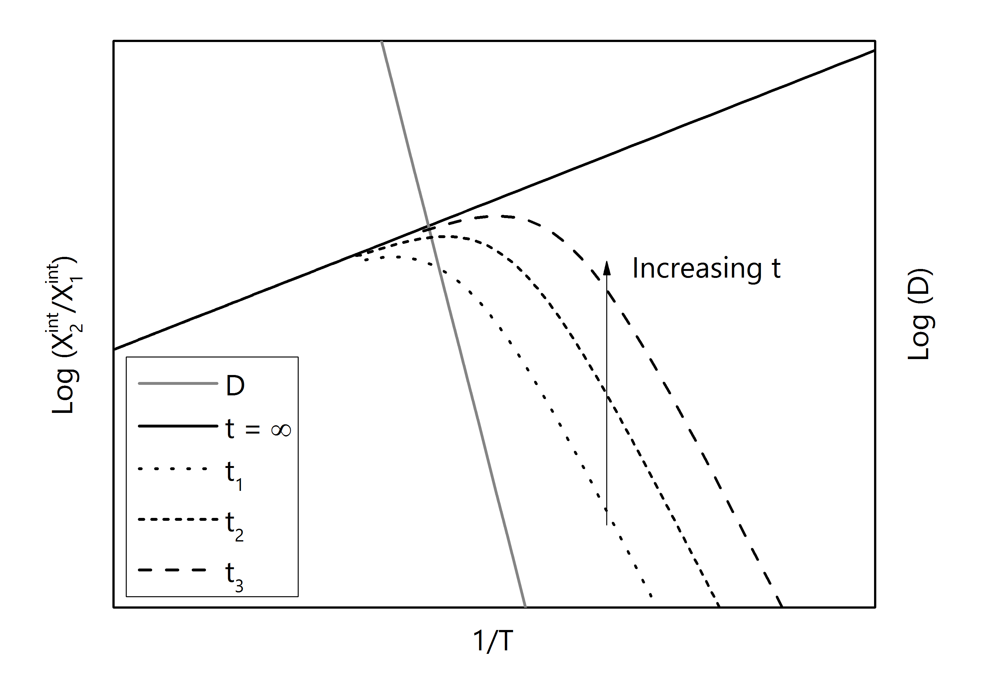

Figure 2: Segregation and diffusivity as a function of reciprocal temperature. The black line represents the surface concentration at t= $∞$ given by Eq. 1, and the dashed lines represent the surface concentration for given diffusion times such that t1<t2<t3 according to Eq. 9.

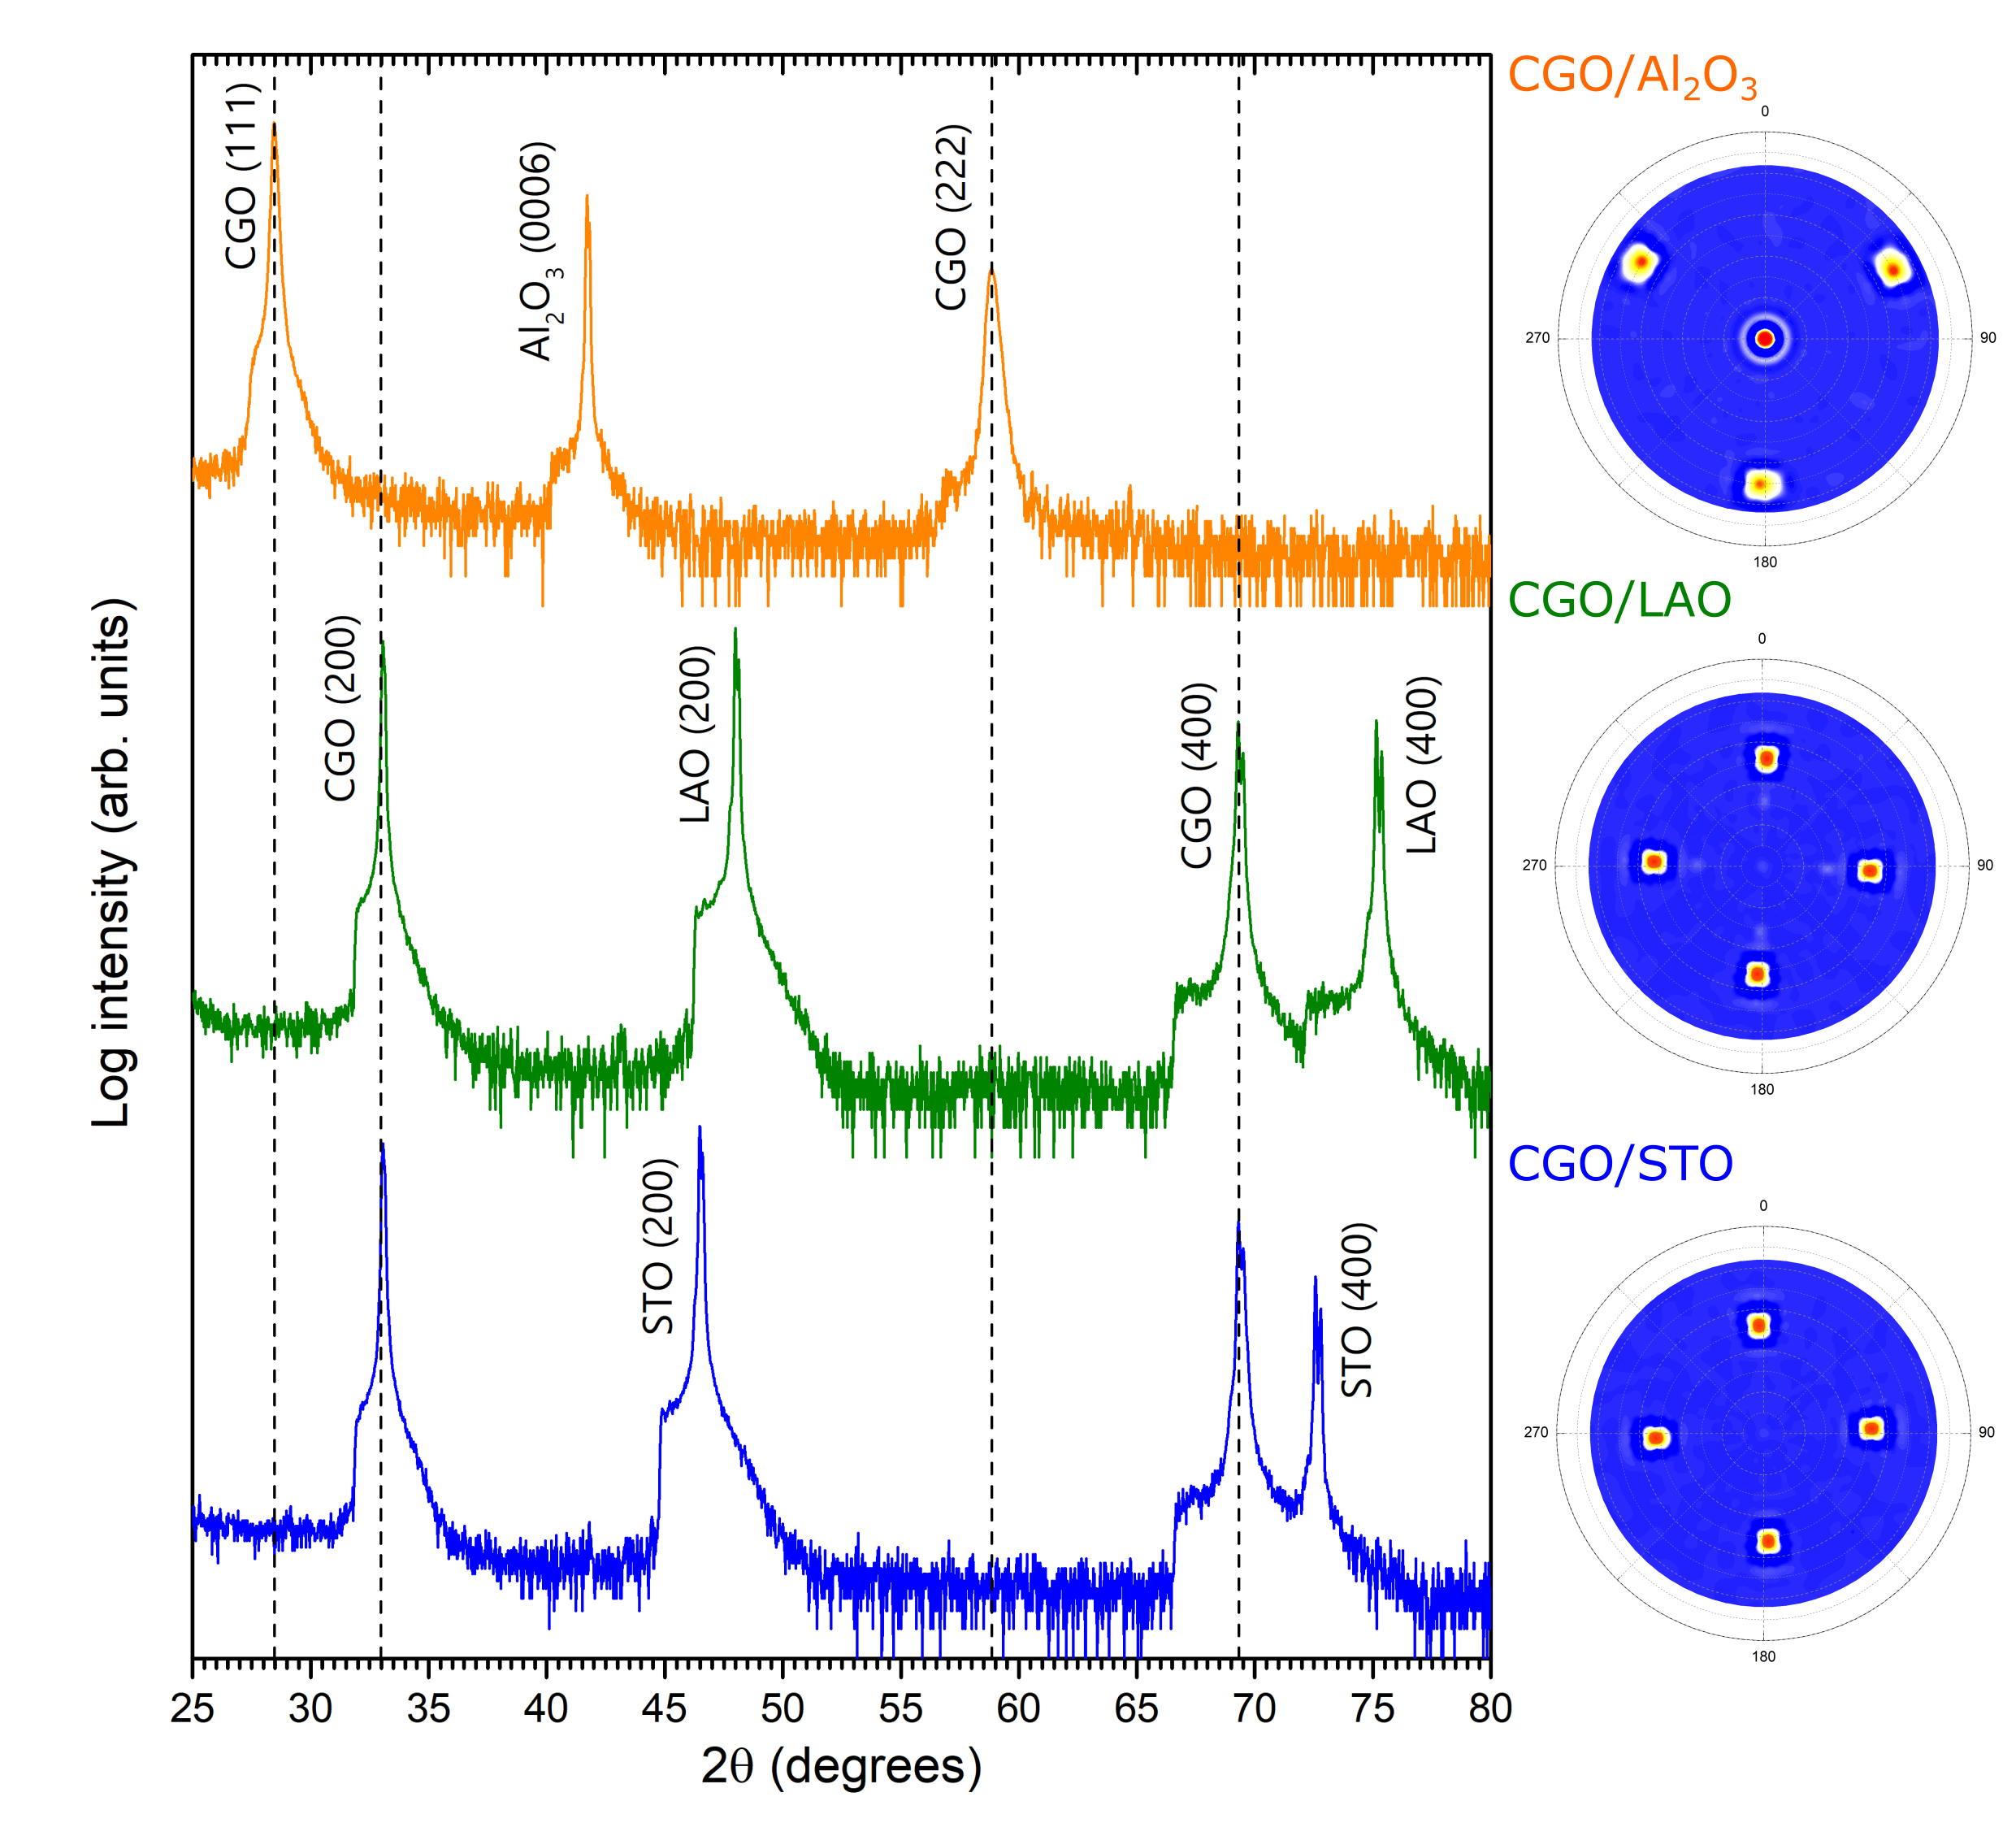

Figure 3 – XRD $\text{2θ/ω}$ scans for 330 nm films grown on STO, LAO and Al2O3 substrates. Also shown are the pole figures corresponding to the CGO (111) reflection of the films grown on each substrate, and are plotted on a $\tan\left(ψ/2\right)$ radial axis.

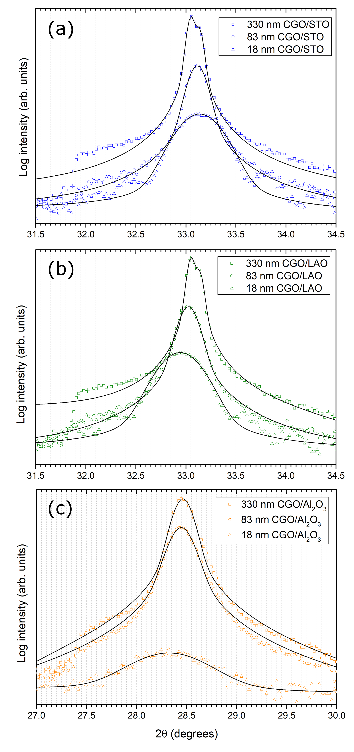

Figure 4 - (a) (111) and (b, c) (200) CGO peaks in the XRD $\text{2θ/ω}$ spectra for a range of film thicknesses grown on (a) STO, (b) LAO and (c) Al2O3 substrates.

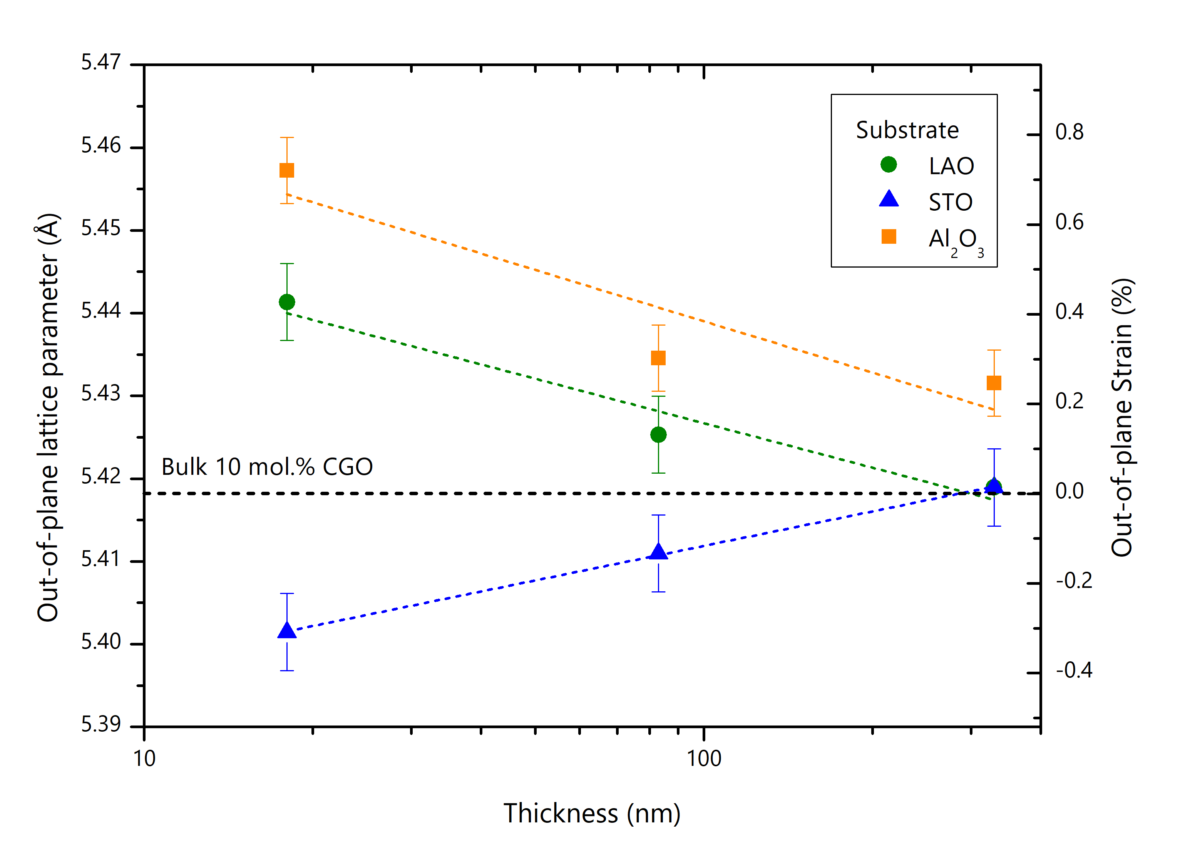

Figure 5 - Lattice parameters of the CGO films grown on each substrate as a function of thickness. The lines only act as a guide to the eye and do not represent any fitting.

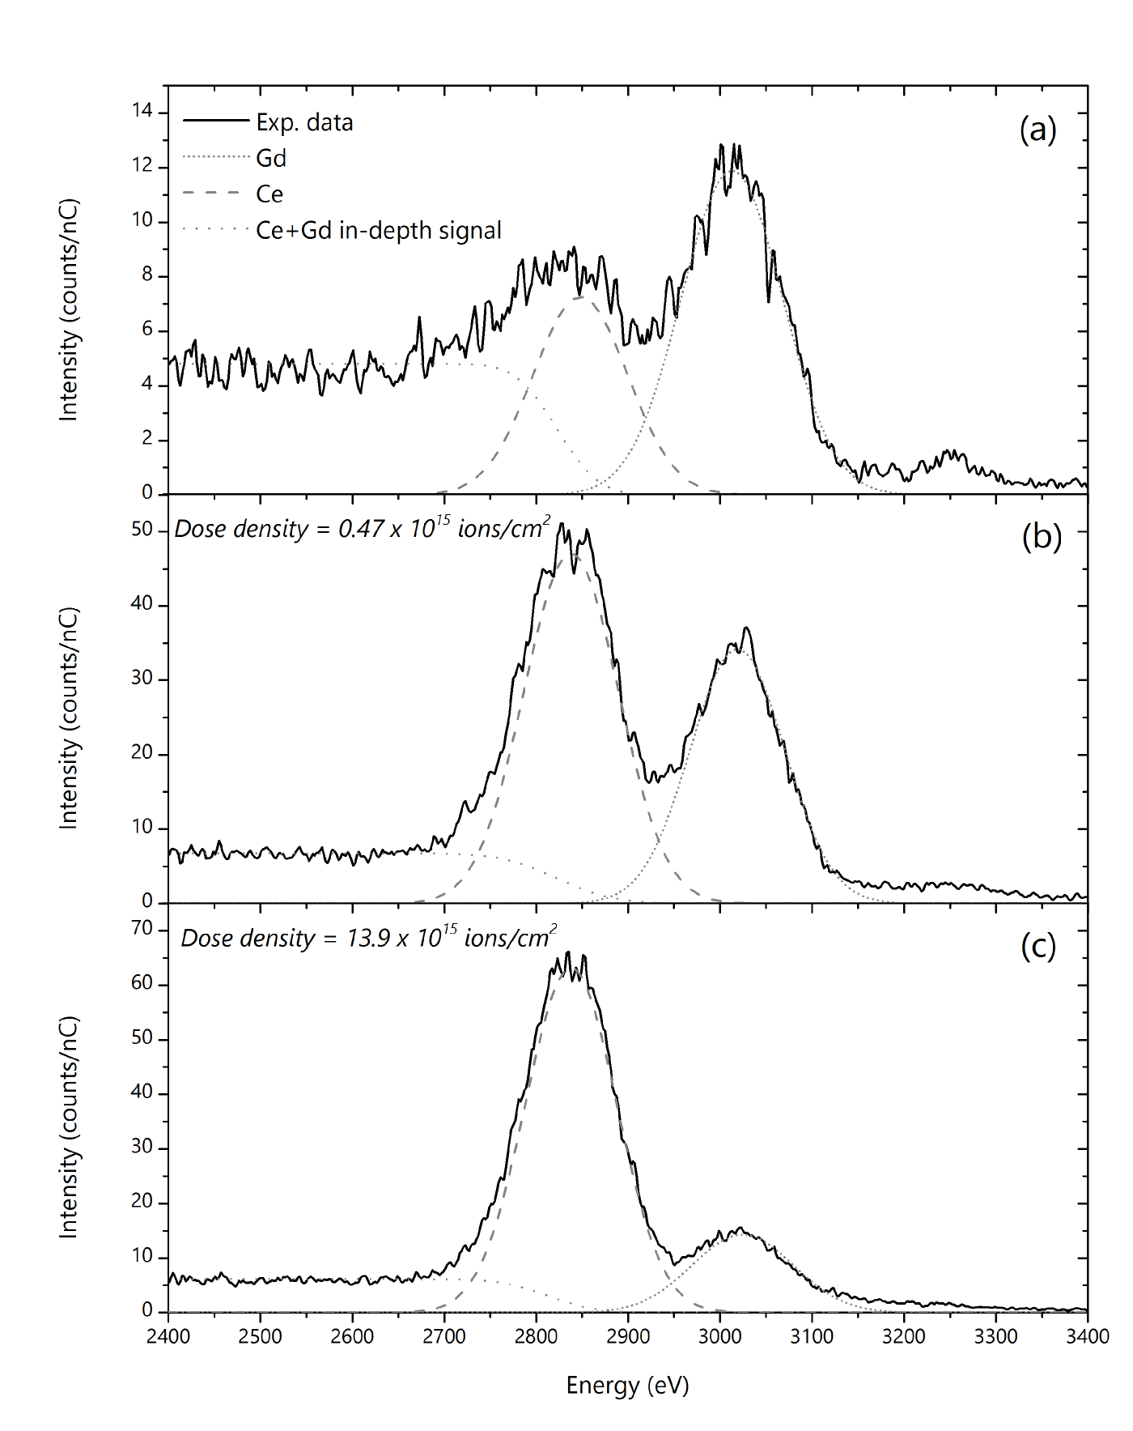

Figure 6 – Typical 5 KeV 20Ne+ spectra of the surface of a CGO film after heat treatment (a) of the out-most surface, and after a sputter dose of (b) 0.47 $×{10}^{15}$ ions/cm2 and (c) 13.9 ions/cm2.

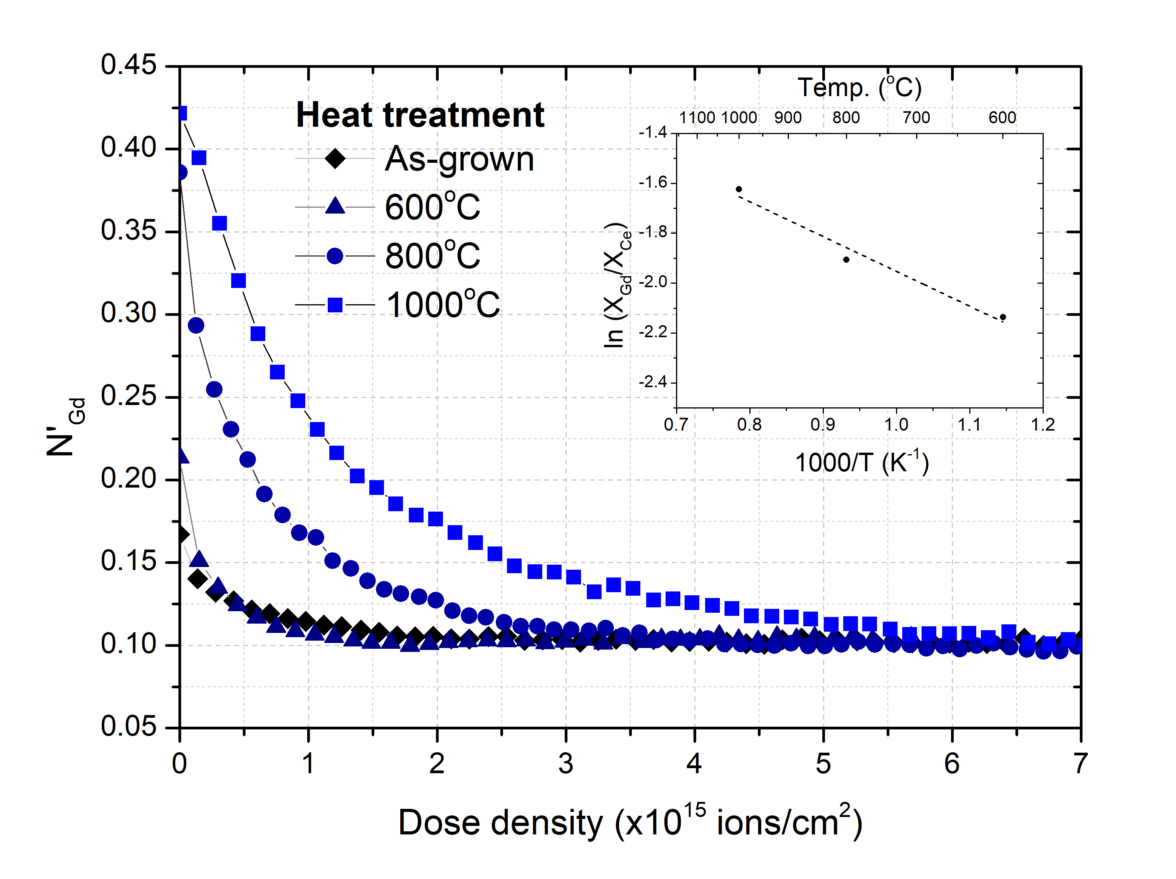

Figure 7 – Normalised Gd fraction as a function of sputter dose for CGO films grown on STO after thermal annealing. The inset displays an Arrhenius plot for the surface cation ratio against reciprocol temperature. The calcluted activation energy from the fitted slope is 11.6 kJ/mol.

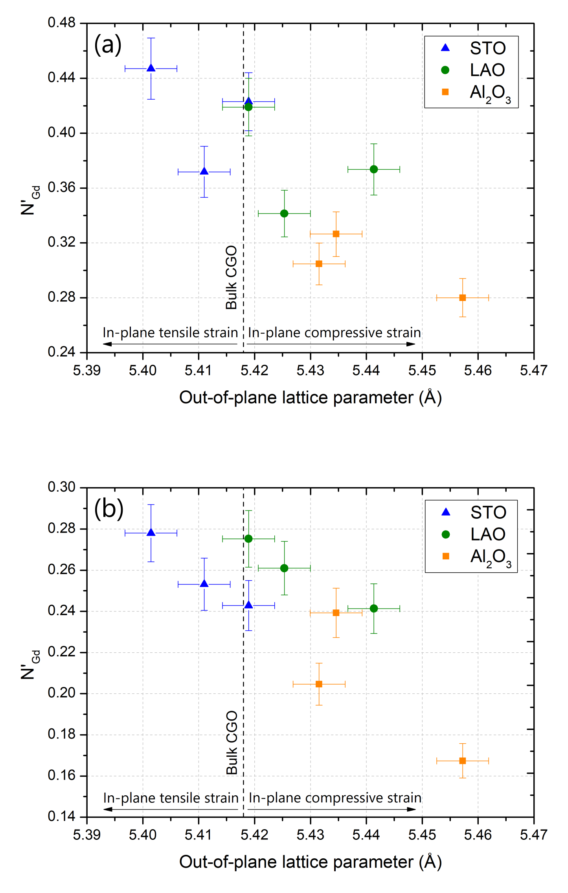

Figure 8 – Normalised Gd ratio as a function of out-of-plane lattice parameter. The ${N'}_{Gd}$ ratios are taken from (a) the outer-most surface spectra and (b) the sub-surface spectra obtained in a single sputter cylcle of $0.40-0.47×{10}^{15}$ ions/cm2.

|  |  |  |
| --- | --- | --- |
| Substrate | Orientation relationship | Theoretical mismatch |
| STO |  | 1.66% |
| LAO |  | -1.05% |
| Al2O3 |  | 24.09%  -58.64% |

Table 1 - Orientation relationships and theoretical mismatches for the CGO films grown on each substrate.