Figure Legends
Figure 1: Virtual environment (basketball court lines and basket were created manually) and skeleton matching (Case 4).
Figure 2: Matching procedure for calculating the lengths of the two key ligaments (Case 1).
Figure 3: Ankle kinematics and ligament strain for four cases of ankle inversion injury
Figure 1
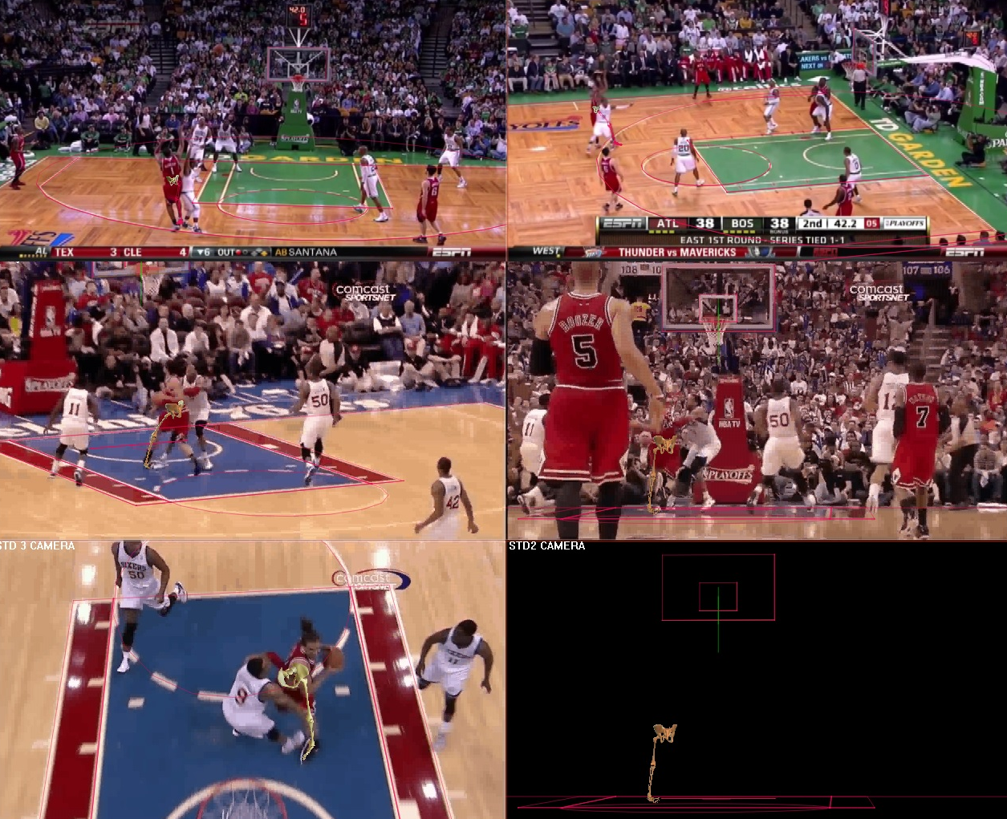
Figure 2
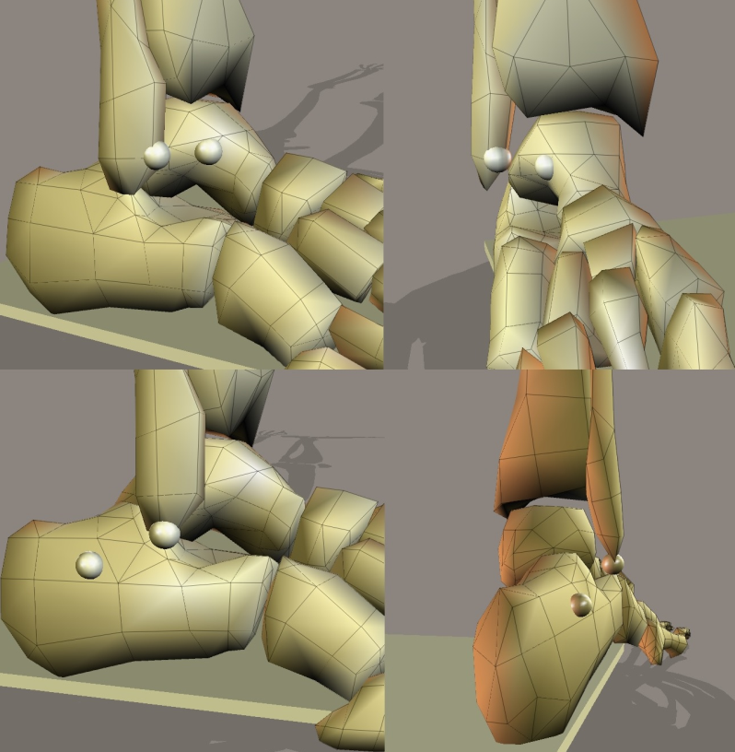

Figure 3

