A 4-NODE CO-ROTATIONAL QUADRILATERAL COMPOSITE SHELL ELEMENT

Z.X. LI^{1*}, T. ZHENG¹, L. VU-QUOC² and B.A. IZZUDDIN³

¹Department of Civil Engineering, Zhejiang University, Hangzhou 310058, China.
²Department of Mechanical and Aerospace Engineering, University of Florida, Gainesville FL 32611, USA.
³Department of Civil and Environmental Engineering, Imperial College, London SW7 2AZ, U.K.
*lizx19993@zju.edu.cn

A 4-node co-rotational quadrilateral composite shell element is presented. The local coordinate system of the element is a co-rotational framework defined by the two bisectors of the diagonal vectors generated from the four corner nodes and their cross product. Thus, the element rigid-body rotations are excluded in calculating the local nodal variables from the global nodal variables. Compared with other existing co-rotational finite-element formulations, the present element has two features: 1) The two smallest components of the mid-surface normal vector at each node are defined as the rotational variables, leading to the desired additive property for all nodal variables in a nonlinear incremental solution procedure; 2) both element tangent stiffness matrices in the local and global coordinate systems are symmetric owing to the commutativity of the nodal variables in calculating the second derivatives of strain energy with respect to the local nodal variables and, through chain differentiation with respect to the global nodal variables. In the modeling of composite structures, the first-order shear deformable laminated plate theory is adopted in the local element formulation, where both the thickness deformation and the normal stress in the direction of the shell thickness are ignored, and an assumed strain method is employed to alleviate the membrane and shear locking phenomena. Several examples involving composite plates and shells with large displacements and large rotations are presented to testify to the reliability and convergence of the present formulation.
Keywords: 4-node quadrilateral shell element; composite; co-rotational approach; vectorial rotational variable; assumed strain method; additive rotational variable
1. Introduction
Composite materials have been widely used in industry due to their appealing characteristics of high strength and stiffness to weight ratios, excellent resistance to corrosion, low thermal expansion, excellent damage tolerance and superior fatigue response characteristics, and the flexibility to tailor to different structural needs, plus the evolution of their technology. ¹⁻³ Composite structures are generally orthotropic in nature, often show unique response even under simple loading conditions and geometric configurations, and thus present challenging technical problems in their modeling. ^{2,4-11}
Computational theories for the modeling of composite shells can be categorized as: (1) classical laminated plate theory; ¹²⁻¹⁴ (2) first-order shear deformation laminated plate theory; ^{9,15-20} (3) higher-order shear deformation laminated plate theories; ^{2,21-25} (4) layer-wise theories^{2,26} and (5) Zig-Zag theories.²⁷⁻³⁰ The number of unknown variables employed in the first three theories are independent from the number of constitutive layers, thus they belong to equivalent single-layer theories.²⁷ These theories have been widely used in solving composite structure problems.
Based on classical laminate plate theories, Hwang & Park¹² presented a four-node quadrilateral plate bending element with one electrical degree of freedom; Suleman & Venkayya¹³ presented a four-node quadrilateral shell elements formulation for a composite plate with laminated piezoelectric layers. Based on a refined plate theory having strong similarity with the classical plate theory, Thai & Choi¹⁴ developed a four-node quadrilateral plate element accounting for shear deformation effect and all couplings from the material anisotropy for laminated composite plates.
Within the frameworks of first-order shear-deformation laminated theories, Kim et al.⁹ presented a four-node co-rotational composite shell element combining an enhanced assumed strain in the membrane strains and assumed natural strains in the shear strains; Auricchio & Sacco¹⁵ obtained a four-node finite element for the analysis of laminated composite plates through a mixed-enhanced approach; Chun et al.¹⁶ proposed a four-node laminated shell element with drilling degrees of freedom, where assumed stress and enhanced strain techniques are adopted to prevent locking problems; Daghia et al.¹⁷ developed a quadrilateral four-node finite element from a hybrid stress formulation involving compatible displacements and element-wise equilibrated stress resultants as primary variables; Vu-Quoc and his coworkers¹⁸⁻²⁰ developed a class of geometrically-exact multilayer shell formulation that can account for large deformation and large overall motion.
Using higher-order shear deformation theories, Balah & Al-Ghamedy² proposed a four-node iso-parametric laminated shell element based on a cubic displacement field over the shell thickness. Using Reddy’s third order theory for composite plates and the discrete Kirchhoff technique, Kulkarni & Kapuria²³ developed a four-node quadrilateral element with seven degrees of freedom per node. To investigate the large deflection behavior of composite plates, Singh et al.²⁴ developed a four-node rectangular finite element based on a higher-order theory allowing parabolic variation of transverse shear strains with zero value at the top and bottom surface of the plate. Lo SH et al.²⁵ proposed a four-node quadrilateral plate element based on the global-local higher order theory to study laminated composite plates subject to a variation in temperature and moisture concentrations, where a displacement function satisfying C₀ continuity is constructed by using the refined element method, and the discrete Kirchhoff quadrilateral thin plate element DKQ is employed for satisfying the requirement of C₁ continuity.
Basar et al.²⁶ developed a four-node iso-parametric shell elements by coupling the single layer theory with a multi-layer concept to deal with complex through-thickness stress distributions in composite laminates. By assuming a zig-zag variation of displacement field through the thickness and using the first-order shear-deformation theory in each layer, Brank & Carrera³⁰ developed a 4-node isoparametric element.
In this paper, a four-node co-rotational quadrilateral composite shell element is presented, its local formulation is based on the first-order shear deformable laminated plate theory. Different from other co-rotational finite element formulations, the proposed co-rotational element formulation employs vectorial rotational variables, and all nodal variables are additive in an incremental nonlinear solution procedure, resulting symmetric element tangent stiffness matrices in both the local and global coordinate systems, making it efficient in solving dynamic problems.³¹⁻³² The versatile vectorial rotational variables had also been employed in a 4-node co-rotational flat quadrilateral shell element with hierarchic freedoms,³³ two co-rotational beam element formulations,³⁴⁻³⁵ and co-rotational triangular and quadrilateral shell element formulations.³⁶⁻³⁹ To overcome locking problems, the assumed membrane strains and transverse shear strains in the present 4-node co-rotational quadrilateral shell element are interpolated respectively by using ANS methods.⁴⁰⁻⁴¹
The outline of the paper is arranged as follows. Section 2 presents the co-rotational framework defined for the four-node quadrilateral composite shell element, and describes the element kinematics. Section 3 includes the local element response and the assumed strain procedure used to alleviate the locking problems. Section 4 presents the transformation matrix between the local and global systems, and the element formulations in global coordinate system. In Section 5, several elastic composite plate/shell problems are solved to demonstrate the reliability and convergence of the proposed four-node co-rotational quadrilateral composite shell element formulation. Some concluding remarks are drawn in Section 6.

2. Co-rotational framework and kinematics of the element
The global coordinate system O-X-Y-Z and the local coordinate system o-x-y-z of the element are presented in Fig. 1. The local coordinate system is a co-rotational framework, and rotates rigidly with the element, but does not deform with the element. The initial triad vectors ($e_{x0}$,$e_{y0}$,$e_{z0}$) of the local co-rotational system are defined by the two bisectors of the diagonal vectors generated from the four corner nodes of the element and their cross product, and determined by:³³
$e_{x0}=\frac{c_{\text{130}}−c_{\text{240}}}{\left|c_{\text{130}}−c_{\text{240}}\right|}$, $e_{y0}=\frac{c_{\text{130}}+c_{\text{240}}}{\left|c_{\text{130}}+c_{\text{240}}\right|}$, $e_{z0}=e_{x0}×e_{y0}$, (1a,b,c)
where c₁₃₀ and c₂₄₀ are respectively the corresponding normalized unit vectors of the element diagonal vectors ($v_{\text{130}}$,$v_{\text{240}}$), and are defined by:
$c_{\text{130}}=\frac{v_{\text{130}}}{\left|v_{\text{130}}\right|}$, $c_{\text{240}}=\frac{v_{\text{240}}}{\left|v_{\text{240}}\right|}$. (2a,b)
The element diagonal vectors $v_{\text{130}}$ and $v_{\text{240}}$ are calculated by
$v_{\text{130}}=X_{\text{30}}−X_{\text{10}}$, $v_{\text{240}}=X_{\text{40}}−X_{\text{20}}$, (3a,b)
where $X_{i0}$ is the global co-ordinates of Node i in the initial configuration, which is indicated by the second subscript “0”.
Fig. 1. Definition of the co-rotational framework
(Note: The vectors t₃, r₂ and r₂₀ are associated with the local coordinate system o-x-y-z, whereas the vectors d₃, p₂₀, p₂, v₁₃₀, v₁₃, v₂₄₀, v₂₄, e_{x0}, e_{y0}, e_{z0}, e_{x}, e_{y} and e_{z} are associated with the global coordinate system O-X-Y-Z.)
Similarly, the triad vectors (e_{x}, e_{y}, e_{z}) of the local coordinate system in the deformed configuration is defined by
$e_{x}=\frac{c_{\text{13}}−c_{\text{24}}}{\left|c_{\text{13}}−c_{\text{24}}\right|}$, $e_{y}=\frac{c_{\text{13}}+c_{\text{24}}}{\left|c_{\text{13}}+c_{\text{24}}\right|}$, $e_{z}=e_{x}×e_{y}$, (4)
where c₁₃ and c₁₄ are the corresponding normalized unit vectors of v₁₃ and v₁₄, and are calculated, respectively, from
$c_{\text{13}}=\frac{v_{\text{13}}}{\left|v_{\text{13}}\right|}$, $c_{\text{24}}=\frac{v_{\text{24}}}{\left|v_{\text{24}}\right|}$, (5)
with the element diagonal vectors v₁₃ and v₁₄ in the deformed configuration defined as
$v_{\text{13}}=X_{3}−X_{1}=v_{\text{13}}^{0}+d_{3}−d_{1}$, $v_{\text{24}}=v_{\text{240}}+d_{4}−d_{2}$, (6)
where $d_{i}$ is the translational displacement vector of Node $i$ in the global coordinate system, with $d_{i}^{T}=\left\lfloor \begin{matrix}U_{i} & V_{i} & W_{i}\end{matrix}\right\rfloor$.
In the global system, the element has 20 degrees of freedom:
$u_{g}^{T}=\left\lfloor \begin{matrix}U_{1} & V_{1} & W_{1} & p_{n_{1}} & p_{m_{1}} & ⋯ & U_{4} & V_{4} & W_{4} & p_{n_{4}} & p_{m_{4}}\end{matrix}\right\rfloor$, (7)
where (U_{i}, V_{i}, W_{i}) are global nodal translational freedoms and ($p_{n_{i}}$,$p_{m_{i}}$) are the two smallest global components of the nodal normal vector $p_{i}$ used as rotational degrees of freedom.³³
In the local coordinate system, the element also has 20 degrees of freedom:
$u_{L}^{T}=\left\lfloor \begin{matrix}u_{1} & υ_{1} & w_{1} & r_{1,x} & r_{1,y} & ⋯ & u_{4} & υ_{4} & w_{4} & r_{4,x} & r_{4,y}\end{matrix}\right\rfloor$, (8)
where, $t_{i}^{T}=\left\lfloor \begin{matrix}u_{i} & υ_{i} & w_{i}\end{matrix}\right\rfloor$ is the translational displacement vector of Node i in the local system, and $θ_{i}^{T}=\left\lfloor \begin{matrix}r_{i,x} & r_{i,y}\end{matrix}\right\rfloor$ represents the two local components of the nodal normal vector $p_{i}$ along the local $x$- and $y$-axes, respectively.
The relationships between the local nodal variables and the global nodal variables are given by
$t_{i}=R\left(d_{i}+v_{i0}\right)−R_{0}v_{i0}$, (9a)
$θ_{i0}=R_{h0}p_{i0}$, (9b)
$θ_{i}=R_{h}p_{i}$, i=1,2,…,4, (9c)
where the matrices R, R_{h0}, R_{h} are defined respectively as follows, $R^{T}=\left[\begin{matrix}e_{x} & e_{y} & e_{z}\end{matrix}\right]$; $R_{h0}^{T}=\left[\begin{matrix}e_{x0} & e_{y0}\end{matrix}\right]$; $R_{h}^{T}=\left[\begin{matrix}e_{x} & e_{y}\end{matrix}\right]$; $θ_{i}$and $θ_{i0}$ are respectively the sub-vectors of the deformed and the initial mid-surface normal vectors $r_{i}$ and $r_{i0}$at Node i in the local coordinate system, i.e., $θ_{i}^{T}=\left\lfloor \begin{matrix}r_{i,x} & r_{i,y}\end{matrix}\right\rfloor$ and $θ_{i0}^{T}=\left\lfloor \begin{matrix}r_{i0,x} & r_{i0,y}\end{matrix}\right\rfloor$; $p_{i}$ and $p_{i0}$ are respectively the deformed and the initial mid-surface normal vectors at Node i in the global coordinate system. In Eq. (9a), the vectors $R_{0}v_{i0}$ and $R\left(d_{i}+v_{i0}\right)$ are respectively the local coordinates of Node i in the initial and deformed configurations, with
$v_{i0}=X_{i0}−X_{\text{10}}$, $i=1,2,⋯,4$, (10)
representing a vector oriented from Node 1 to Node i.
In transforming the global nodal displacements to local nodal displacements according to (9a), the initial local reference system (oriented by e_{x0}, e_{y0} and e_{z0} in the initial configuration) is first rotated about Node 1 to the same orientation of the current reference system (oriented by e_{x}, e_{y} and e_{z} in the rigidly rotated configuration and the deformed configuration), though the center of rotation is actually unimportant, and the local translations excluding rigid body rotation are measured from the initially rotated configuration, as illustrated in Fig. 1.
With the two smallest global components of the normal vector $p_{i}$ used as vectorial rotational degrees of freedom at Node i, the remaining component is obtained from:
$p_{l_{i}}=s_{1}\sqrt{1−p_{n_{i}}^{2}−p_{m_{i}}^{2}}$, $i=1,2,⋯,9$, (11)
where takes the same sign as used for at the previous iteration in a nonlinear incremental solution procedure, and () represent the two smallest components of $p_{i}$ used as global rotational degrees of freedom at Node i.
Bilinear Lagrangian interpolation functions are adopted to describe the geometry and the displacement field of the quadrilateral shell element, leading to an isoparametric formulation:
$\left\{\begin{matrix}x \\ y \\ z\end{matrix}\right\}=\sum_{i=1}^{4}{N_{i}(ξ,η)\left\{\begin{matrix}x_{i0} \\ y_{i0} \\ z_{i0}\end{matrix}\right\}}$, (12a)
$t=\sum_{i=1}^{4}{N_{i}(ξ,η)t_{i}}$, (12b)
${\bar{r}}_{h}=\sum_{i=1}^{4}{N_{i}(ξ,η)θ_{i}}$, i=1,2,3,4, (12c)
where $N_{i}\left(ξ,η\right)$ (i=1,2,3,4) is the Lagrangian interpolation function at Node i; $x^{T}=\left\lfloor \begin{matrix}x & y & z\end{matrix}\right\rfloor$ represents the local coordinate vector at any point on the element mid-surface; $t^{T}=\left\lfloor \begin{matrix}u & v & w\end{matrix}\right\rfloor$ the vector containing the local translational fields; ${\bar{r}}_{h}^{T}=\left\lfloor \begin{matrix}r_{x} & r_{y}\end{matrix}\right\rfloor$ the vector containing the local rotational fields; $x_{i0}^{T}=\left\lfloor \begin{matrix}x_{i0} & y_{i0} & z_{i0}\end{matrix}\right\rfloor$ is the local coordinate vector of Node $i$, obtained from the corresponding nodal coordinates in the global coordinate system as:
$x_{i0}=R_{0}v_{i0}$. (13)
The global components of the initial normal vector at Node i of the element are obtained from the cross-product of the mid-surface tangent lines corresponding to independent variation in the two natural coordinates:
${\bar{p}}_{i0}=\frac{∂X_{0}}{∂ξ}×\frac{∂X_{0}}{∂η}|_{\left(ξ_{i},η_{i}\right)}$, $i=1,2,3,4$, (14)
where
$X_{0}=\sum_{j=1}^{4}{N_{j}\left(ξ,η\right)X_{j0}}$, (15)
with $X_{j0}$ representing the global co-ordinates of Node j.
To minimize the discontinuity between the slopes of adjacent elements at Node $i$, the mean value of the normal vectors from the surrounding elements is adopted:
$p_{i0}=\frac{\sum{{\bar{p}}_{i0}\left|{\bar{p}}_{i0}\right|}}{\left|\sum{{\bar{p}}_{i0}\left|{\bar{p}}_{i0}\right|}\right|}$, $i=1,2,⋯,4$. (16)
The Green-Lagrange strains specialized for the shallow shell⁴² are used. For convenience, the in-plane strain vector $ε$ is split into two parts, $ε_{m}$ and $z_{l}χ$, representing the membrane and bending strains, respectively, i.e.,
$ε=ε_{m}+z_{l}χ$, $z_{l}=\frac{1}{2}ζh$, (17a)
$ε_{m}=\begin{aligned}\left\{ε_{\text{xx}} | \right\}\left\{ε_{\text{yy}} | \right\}\end{aligned}\left\{\right\}=\begin{aligned}\left\{\frac{∂u}{∂x}+\frac{1}{2}{\left[\frac{∂\left(w+z\right)}{∂x}\right]}^{2}−\frac{1}{2}{\left(\frac{∂z}{∂x}\right)}^{2} | \right\}\left\{\frac{∂v}{∂y}+\frac{1}{2}{\left[\frac{∂\left(w+z\right)}{∂y}\right]}^{2}−\frac{1}{2}{\left(\frac{∂z}{∂y}\right)}^{2} | \right\}\end{aligned}\left\{\right\}$ , (17b)
$χ={\left\lfloor \begin{matrix}\frac{∂\left(r_{x}−r_{x0}\right)}{∂x} & \frac{∂\left(r_{y}−r_{y0}\right)}{∂y} & \frac{∂\left(r_{x}−r_{x0}\right)}{∂y}+\frac{∂\left(r_{y}−r_{y0}\right)}{∂x}\end{matrix}\right\rfloor }^{T}$, (17c)
$γ={\left\lfloor \begin{matrix}γ_{\text{xz}} & γ_{\text{yz}}\end{matrix}\right\rfloor }^{T}={\left\lfloor \begin{matrix}r_{x}−r_{x0}+\frac{∂w}{∂x} & r_{y}−r_{y0}+\frac{∂w}{∂y}\end{matrix}\right\rfloor }^{T}$, (17d)
where $γ$ is the transverse shear strain vector, $z_{l}$the distance of the material point from the cross-section centroid, h the thickness of the element, and
$r_{x0}=\sum_{i=1}^{4}{N_{i}r_{i0,x}}$, $r_{x}=\sum_{i=1}^{4}{N_{i}r_{i,x}}$, $r_{y0}=\sum_{i=1}^{4}{N_{i}r_{i0,y}}$, $r_{y}=\sum_{i=1}^{4}{N_{i}r_{i,y}}$. (18a,b,c,d)

3. Element formulation in the local coordinate system
3.1 Conforming element formulation
The total potential energy of the 4-node quadrilateral composite shell element is calculated from
$Π=\frac{1}{2}\int_{V}{{\left\{\begin{matrix}ε_{m}+z_{l}χ \\ γ\end{matrix}\right\}}^{T}D_{c}\left\{\begin{matrix}ε_{m}+z_{l}χ \\ γ\end{matrix}\right\}\text{dV}}−W_{e}$, (19)
where V is the volume of the element, W_{e} the work done by external forces f_{ext}, and D_{c} the material elastic matrix of the composite shell.
By enforcing the stationarity condition to the potential energy of the element
$δΠ=\int_{V}{{\left\{\begin{matrix}ε_{m}+z_{l}χ \\ γ\end{matrix}\right\}}^{T}D_{c}\left[\begin{matrix}B_{m}+z_{l}B_{b} \\ B_{s}\end{matrix}\right]{δu}_{L}\text{dV}}−f{}_{\text{ext}}^{T}{}{δu}_{L}=0$, (20)
the internal force vector $f$ is obtained by
$f=f_{\text{ext}}=\int_{V}{{\left[\begin{matrix}B_{m}+z_{l}B_{b} \\ B_{s}\end{matrix}\right]}^{T}D_{c}\left\{\begin{matrix}ε_{m}+z_{l}χ \\ γ\end{matrix}\right\}\text{dV}}$, (21)
where $B_{m}$,$B_{b}$and$B_{s}$ are respectively the first derivatives of the membrane strains $ε_{m}$, the bending strains $χ$, and the transverse shear strains $γ$ with respect to local nodal variables.
By differentiating the internal force vector with respect to local nodal variables, the tangent stiffness matrix of the 4-node quadrilateral composite shell element is determined as
$k_{T}=\int_{V}{{\left[\begin{matrix}B_{m}+z_{l}B_{b} \\ B_{s}\end{matrix}\right]}^{T}D_{c}\left[\begin{matrix}B_{m}+z_{l}B_{b} \\ B_{s}\end{matrix}\right]\text{dV}}+\int_{V}{{\left[\begin{matrix}\frac{∂B_{m}}{∂u_{L}^{T}} \\ 0\end{matrix}\right]}^{T}D_{c}\left\{\begin{matrix}ε_{m}+z_{l}χ \\ γ\end{matrix}\right\}\text{dV}}$. (22)
In Eq.(22), the first term is symmetric. Due to the commutativity of local nodal variables in calculating the second derivatives $\frac{∂B_{m}}{∂u_{L}^{T}}$of the membrane strains with respect to these local nodal variables, the second term is also symmetric. As a result, we have a symmetric element tangent stiffness matrix k_{T}. Eqs.(21) and (22) are the conforming element formulations in the local coordinate system.
After an analytical integration through the thickness of the composite shell element, Eqs.(21) and (22) can be rewritten as
$$f=\frac{h}{2}\int_{A}{{\left[\begin{matrix}B_{m} \\ B_{s}\end{matrix}\right]}^{T}D_{\text{eq}1}\left\{\begin{matrix}ε_{m} \\ γ\end{matrix}\right\}dA}+\frac{h^{3}}{\text{24}}\int_{A}{{\left[\begin{matrix}B_{b} \\ 0\end{matrix}\right]}^{T}D_{\text{eq}2}\left\{\begin{matrix}χ \\ 0\end{matrix}\right\}dA}$$
$+\frac{h^{2}}{8}\int_{A}{\left({\left[\begin{matrix}B_{m} \\ B_{s}\end{matrix}\right]}^{T}D_{\text{eq}3}\left\{\begin{matrix}χ \\ 0\end{matrix}\right\}+{\left[\begin{matrix}B_{b} \\ 0\end{matrix}\right]}^{T}D_{\text{eq}3}\left\{\begin{matrix}ε_{m} \\ γ\end{matrix}\right\}\right)dA}$, (23)
$$k_{T}=\frac{h}{2}\int_{A}{{\left[\begin{matrix}B_{m} \\ B_{s}\end{matrix}\right]}^{T}D_{\text{eq}1}\left[\begin{matrix}B_{m} \\ B_{s}\end{matrix}\right]dA}+\frac{h^{3}}{\text{24}}\int_{A}{{\left[\begin{matrix}B_{b} \\ 0\end{matrix}\right]}^{T}D_{\text{eq}2}\left[\begin{matrix}B_{b} \\ 0\end{matrix}\right]dA}$$
$$+\frac{h^{2}}{8}\int_{A}{\left({\left[\begin{matrix}B_{m} \\ B_{s}\end{matrix}\right]}^{T}D_{\text{eq}3}\left[\begin{matrix}B_{b} \\ 0\end{matrix}\right]+{\left[\begin{matrix}B_{b} \\ 0\end{matrix}\right]}^{T}D_{\text{eq}3}\left[\begin{matrix}B_{m} \\ B_{s}\end{matrix}\right]\right)dA}$$
$+\frac{h}{2}\int_{A}{{\left[\begin{matrix}\frac{∂B_{m}}{∂u_{L}^{T}} \\ 0\end{matrix}\right]}^{T}D_{\text{eq}1}\left\{\begin{matrix}ε_{m} \\ γ\end{matrix}\right\}dA}+\frac{h^{2}}{8}\int_{A}{{\left[\begin{matrix}\frac{∂B_{m}}{∂u_{L}^{T}} \\ 0\end{matrix}\right]}^{T}D_{\text{eq}3}\left\{\begin{matrix}χ \\ 0\end{matrix}\right\}dA}$, (24)
where D_{eq1}, D_{eq2 ,} and D_{eq3} are equivalent elastic matrices given by
$D_{\text{eq}1}=\sum_{i=1}^{n}{\left(ζ_{i+1}−ζ_{i}\right)D_{\text{ci}}}$, (25a)
$D_{\text{eq}2}=\sum_{i=1}^{n}{\left(ζ_{i+1}^{3}−ζ_{i}^{3}\right)D_{\text{ci}}}$, (25b)
$D_{\text{eq}3}=\sum_{i=1}^{n}{\left(ζ_{i+1}^{2}−ζ_{i}^{2}\right)D_{\text{ci}}}$, (25c)
with $ζ_{i}$ being the dimensionless coordinate of the interface between Layer i-1 and Layer i relative to the mid-surface
$ζ_{i}=−1\text{.}0+\frac{2}{n}\left(i−1\right)$， i=1,2,…,n, (26)
D_{ci} is the elastic matrix of Layer i lamina
$D_{\text{ci}}=T_{i^{T}}C_{i}T_{i}$, (27)
where T_{i} is the transformation matrix between the strains in the material coordinate system of the ith layer lamina and the local coordinate system of element, and C_{i} the material stiffness matrix in the material coordinate system.
A composite shell made of orthotropic fibre-reinforced material is identified with a layered structure with the reinforcement fibres in each lamina parallel to the shell mid-surface. Assuming that the transverse material properties are isotropic and the normal vector of the shell mid-surface is inextensible, then the constitutive matrix C_{i} is given as follows
$C_{i}=\left[\begin{matrix}\frac{E_{1}}{1−μ_{\text{12}}μ_{\text{21}}} & \frac{μ_{\text{12}}E_{2}}{1−μ_{\text{12}}μ_{\text{21}}} & 0 & 0 & 0 \\ \frac{μ_{\text{12}}E_{2}}{1−μ_{\text{12}}μ_{\text{21}}} & \frac{E_{2}}{1−μ_{\text{12}}μ_{\text{21}}} & 0 & 0 & 0 \\ 0 & 0 & G_{\text{12}} & & 0 \\ 0 & 0 & 0 & G_{\text{13}} & 0 \\ 0 & 0 & 0 & 0 & G_{\text{23}}\end{matrix}\right]$, (28)
where$μ_{\text{12}}$and$μ_{\text{21}}$are the Poisson’s ratios, E₁ and E₂ the elastic moduli, G₁₂, G₂₃ and G₃₁ the shear moduli of materials.^{21,43}
The transformation matrix T_{i} of stress and strain vectors between the material coordinate system and the local coordinate system of element can be calculated as follows
$T_{i}=\left[\begin{matrix}{\text{cos}}^{2}φ_{i} & {\text{sin}}^{2}φ_{i} & \frac{1}{2}\text{sin}2φ_{i} & 0 & 0 \\ {\text{sin}}^{2}φ_{i} & {\text{cos}}^{2}φ_{i} & −\frac{1}{2}\text{sin}2φ_{i} & 0 & 0 \\ −\text{sin}2φ_{i} & \text{sin}2φ_{i} & \text{cos}2φ_{i} & 0 & 0 \\ 0 & 0 & 0 & \text{cos}φ_{i} & \text{sin}φ_{i} \\ 0 & 0 & 0 & −\text{sin}φ_{i} & \text{cos}φ_{i}\end{matrix}\right]$, (29)
where $φ_{i}$ is the ply orientation angle measured between the reinforcement fiber of Layer i lamina and the local coordinate system of element.
3.2 Strategies for overcoming locking problems
Equations (23) and (24) represent the conforming element formulation for the 4-node quadrilateral composite shell element in the local coordinate system. In solving thin shell problems, membrane and shear locking phenomena could lead to deterioration in the computational efficiency and accuracy of the conforming element. Therefore, to improve the performance of the quadrilateral element, the membrane and out-of-plane shear strains are replaced respectively with corresponding assumed strains ,⁴⁰⁻⁴¹ accordingly, the modified element formulations are given as:
$$f=\frac{h}{2}\int_{A}{{\left[\begin{matrix}{\tilde{B}}_{m} \\ {\tilde{B}}_{s}\end{matrix}\right]}^{T}D_{\text{eq1}}\left\{\begin{matrix}{\tilde{ε}}_{m} \\ \tilde{γ}\end{matrix}\right\}\text{dA}}+\frac{h^{3}}{\text{24}}\int_{A}{\left({\left[\begin{matrix}B_{b} \\ 0\end{matrix}\right]}^{T}D_{\text{eq2}}\left\{\begin{matrix}χ \\ 0\end{matrix}\right\}\right)dA}$$
$+\frac{h^{2}}{8}\int_{A}{\left({\left[\begin{matrix}{\tilde{B}}_{m} \\ {\tilde{B}}_{s}\end{matrix}\right]}^{T}D_{\text{eq3}}\left\{\begin{matrix}χ \\ 0\end{matrix}\right\}+{\left[\begin{matrix}B_{b} \\ 0\end{matrix}\right]}^{T}D_{\text{eq3}}\left\{\begin{matrix}{\tilde{ε}}_{m} \\ \tilde{γ}\end{matrix}\right\}\right)dA}$, (30)
$$k_{T}=\frac{h}{2}\int_{A}{{\left[\begin{matrix}{\tilde{B}}_{m} \\ {\tilde{B}}_{s}\end{matrix}\right]}^{T}D_{\text{eq1}}\left[\begin{matrix}{\tilde{B}}_{m} \\ {\tilde{B}}_{s}\end{matrix}\right]dA}+\frac{h^{3}}{\text{24}}\int_{A}{{\left[\begin{matrix}B_{b} \\ 0\end{matrix}\right]}^{T}D_{\text{eq2}}\left[\begin{matrix}B_{b} \\ 0\end{matrix}\right]dA}$$
$$+\frac{h^{2}}{8}\int_{A}{\left({\left[\begin{matrix}{\tilde{B}}_{m} \\ {\tilde{B}}_{s}\end{matrix}\right]}^{T}D_{\text{eq3}}\left[\begin{matrix}B_{b} \\ 0\end{matrix}\right]+{\left[\begin{matrix}B_{b} \\ 0\end{matrix}\right]}^{T}D_{\text{eq3}}\left[\begin{matrix}{\tilde{B}}_{m} \\ {\tilde{B}}_{s}\end{matrix}\right]\right)dA}$$
$+\frac{h}{2}\int_{A}{{\left[\begin{matrix}\frac{∂{\tilde{B}}_{m}}{∂u_{L}^{T}} \\ 0\end{matrix}\right]}^{T}D_{\text{eq1}}\left\{\begin{matrix}{\tilde{ε}}_{m} \\ \tilde{γ}\end{matrix}\right\}dA}+\frac{h^{2}}{8}\int_{A}{{\left[\begin{matrix}\frac{∂{\tilde{B}}_{m}}{∂u_{L}^{T}} \\ 0\end{matrix}\right]}^{T}D_{\text{eq3}}\left\{\begin{matrix}χ \\ 0\end{matrix}\right\}dA}$, (31)
where the assumed membrane strains inside the element are interpolated by conforming membrane strains at five tying points of A,B,C,D and O(see Fig. 2), i.e.,
${\tilde{ε}}_{\text{xx}}=\frac{1}{2}\left(1−η\right)ε_{\text{xx}}^{B}+\frac{1}{2}\left(1+η\right)ε_{\text{xx}}^{D}$, (32)
${\tilde{ε}}_{\text{yy}}=\frac{1}{2}\left(1−ξ\right)ε_{\text{yy}}^{A}+\frac{1}{2}\left(1+ξ\right)ε_{\text{yy}}^{C}$, (33)
${\tilde{γ}}_{\text{xy}}=γ_{\text{xy}}^{O}$, (34)
and the assumed shear strains are calculated as
${\tilde{ε}}_{\text{xz}}=\frac{1}{2}\left(1−η\right)ε_{\text{xz}}^{B}+\frac{1}{2}\left(1+η\right)ε_{\text{xz}}^{D}$, (35)
${\tilde{ε}}_{\text{yz}}=\frac{1}{2}\left(1−ξ\right)ε_{\text{yz}}^{A}+\frac{1}{2}\left(1+ξ\right)ε_{\text{xz}}^{C}$. (36)
The first and the second derivatives of assumed membrane strains and shear strains with respect to local nodal variables in Eqs.(30) and (31) are also interpolated by the first and the second derivatives of the corresponding conforming membrane strains and shear strains with respect to local nodal variables at these tying points.
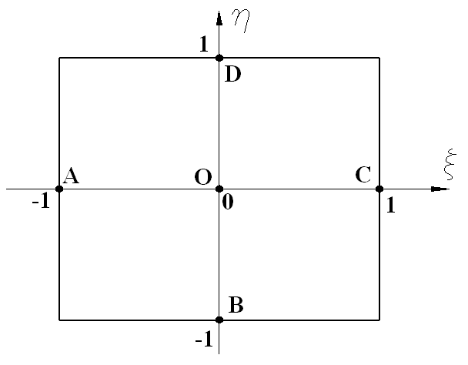
Fig. 2. Positions of five tying points for assumed strains
After introducing the assumed strains, the resulting local element tangent stiffness matrix (see Eq. (31)) is still symmetric.

4. Transformation of local to global response
The global nodal forces $f_{g}$of the 4-node quadrilateral composite shell element can be obtained as a transformation of the local nodal forces according to:
$f_{g}=T^{T}f$. (37)
where $T$ is a $\text{20}×\text{20}$ transformation matrix consisting of first derivative of local with respect to global nodal variables, which can be readily determined from (9a) and (9c).
For convenience, the local nodal variables and the global nodal variables are rewritten as
$u_{L}^{T}=\left\lfloor \begin{matrix}t_{1}^{T} & θ_{1}^{T} & t_{2}^{T} & θ_{2}^{T} & t_{3}^{T} & θ_{3}^{T} & t_{4}^{T} & θ_{4}^{T}\end{matrix}\right\rfloor$, (38)
$u_{G}^{T}=\left\lfloor \begin{matrix}d_{1}^{T} & n_{g1}^{T} & d_{2}^{T} & n_{g2}^{T} & d_{3}^{T} & n_{g3}^{T} & d_{4}^{T} & n_{g4}^{T}\end{matrix}\right\rfloor$, (39)
where $θ_{i}^{T}=\left\lfloor \begin{matrix}r_{i,x} & r_{i,y}\end{matrix}\right\rfloor$(i=1,2,3,4) represents the two local vectorial rotational variables at Node i in the local coordinate system, and $n_{\text{gi}}^{T}=\left\lfloor \begin{matrix}p_{n_{i}} & p_{m_{i}}\end{matrix}\right\rfloor$ (i=1,2,3,4) denotes the two global vectorial rotational components. Accordingly, the transformation matrix is expressed as:
$T=\frac{∂u_{L}}{∂u_{G}^{T}}=\left[\begin{matrix}\frac{∂t_{1}}{∂d_{1}^{T}} & 0 & ⋯ & \frac{∂t_{1}}{∂d_{4}^{T}} & 0 \\ \frac{∂θ_{1}}{∂d_{1}^{T}} & \frac{∂θ_{1}}{∂n_{g1}^{T}} & ⋯ & \frac{∂θ_{1}}{∂d_{4}^{T}} & \frac{∂θ_{1}}{∂n_{g4}^{T}} \\ ⋮ & ⋮ & ⋮ & ⋮ & ⋮ \\ \frac{∂t_{4}}{∂d_{1}^{T}} & 0 & ⋯ & \frac{∂t_{4}}{∂d_{4}^{T}} & 0 \\ \frac{∂θ_{4}}{∂d_{1}^{T}} & \frac{∂θ_{4}}{∂n_{g1}^{T}} & ⋯ & \frac{∂θ_{4}}{∂d_{4}^{T}} & \frac{∂θ_{4}}{∂n_{g4}^{T}}\end{matrix}\right]$, (40)
where the sub-matrices of $T$ are the same as those in [39].
The element tangent stiffness matrix $k_{\text{TG}}$ in the global coordinate system can now be obtained as follows:
$k_{\text{TG}}=T^{T}k_{T}T+\frac{∂T^{T}}{∂u_{G}^{T}}f$, (41)
with
$\frac{∂T}{∂u_{G}^{T}}=\left[\frac{∂^{2}u_{Li}}{∂u_{Gj}∂u_{Gk}}\right]=\left[\begin{matrix}\frac{∂^{2}t_{1}}{∂d_{1}^{T}∂u_{G}^{T}} & 0 & ⋯ & \frac{∂^{2}t_{1}}{∂d_{4}^{T}∂u_{G}^{T}} & 0 \\ \frac{∂^{2}θ_{1}}{∂d_{1}^{T}∂u_{G}^{T}} & \frac{∂^{2}θ_{1}}{∂n_{g1}^{T}∂u_{G}^{T}} & ⋯ & \frac{∂^{2}θ_{1}}{∂d_{4}^{T}∂u_{G}^{T}} & \frac{∂^{2}θ_{1}}{∂n_{g4}^{T}∂u_{G}^{T}} \\ ⋮ & ⋮ & ⋮ & ⋮ & ⋮ \\ \frac{∂^{2}t_{4}}{∂d_{1}^{T}∂u_{G}^{T}} & 0 & ⋯ & \frac{∂^{2}t_{4}}{∂d_{4}^{T}∂u_{G}^{T}} & 0 \\ \frac{∂^{2}θ_{4}}{∂d_{1}^{T}∂u_{G}^{T}} & \frac{∂^{2}θ_{4}}{∂n_{g1}^{T}∂u_{G}^{T}} & ⋯ & \frac{∂^{2}θ_{4}}{∂d_{4}^{T}∂u_{G}^{T}} & \frac{∂^{2}θ_{4}}{∂n_{g4}^{T}∂u_{G}^{T}}\end{matrix}\right]$, (42)
where the various second derivatives in Eq. (42) are the same as those in [39]. Considering Eqs. (41) and (42), and the symmetry of the local tangent stiffness matrix k_{T}, it is clear that the global tangent stiffness matrix is also symmetric.

5. Numerical examples
In this newly developed 4-node co-rotational quadrilateral composite shell element (identified below as the A4QC element), we employ assumed membrane strains and assumed shear strains using an ANS method³⁶⁻³⁷ to alleviate membrane and shear locking problems. To demonstrate the reliability of the A4QC element, a series of laminated plate/shell problems, some of which involving finite/large rotations, are solved using the present A4QC element, with comparisons made against the results from other researchers. ^{9,43-47} The reliability and convergence of this new A4QC element are checked systematically. Four Gauss points over the element domain are adopted in numerical integration for all examples.

5.1. A simply supported laminated strip
Consider a simply supported asymmetric laminate strip (0º/90º) (where, one lamina is at 0 degrees, followed by one lamina at 90 degrees, the “0º” direction is along the span direction of the laminated strip, and the “90º” direction is along its width direction) with geometry parameters and material properties given in Table 1 and Table 2, respectively. The composite strip is subjected to uniformly distributed load as shown in Fig. 3.

Table 1. Geometry parameters of the laminated strip
Length | Width | Thickness
a=9.0 in | b=1.5 in | h=0.04 in

Table 2. Material properties of the laminated strip
Young’s moduli | Shear moduli | Poisson’s ratio
E₁=2.0×10⁷psi E₂=1.4×10⁶psi | G₁₂=G₁₃=G₂₃=7.0×10⁵psi | μ=0.3

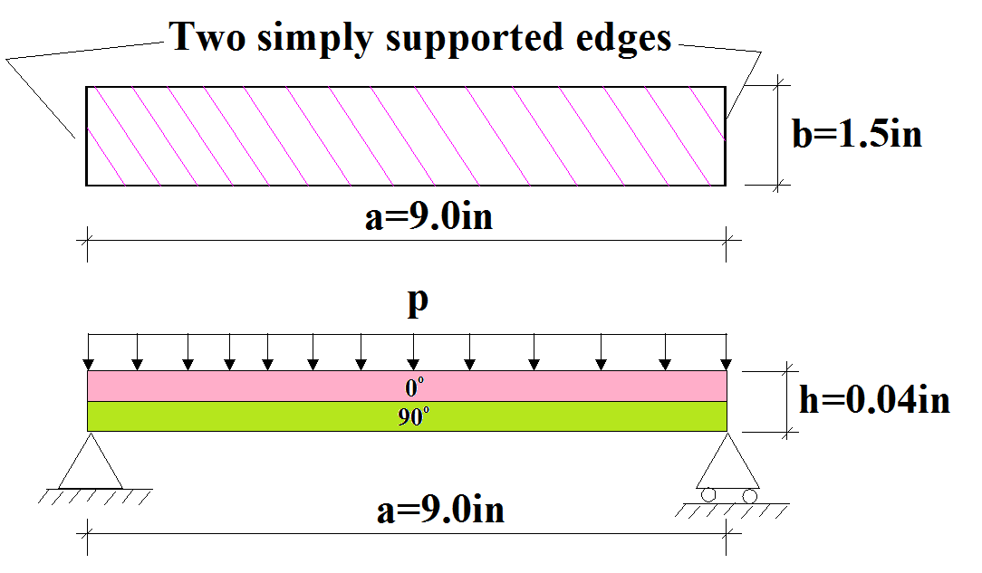
Fig. 3. A simply supported laminated strip subject to uniformly distributed load

For symmetry reason, a quarter of the plate is modeled with 6×1, 12×2 and 24×4 A4QC elements, respectively. The load-deflection curves at mid-span of the strip are depicted in Fig. 4. For comparison, the results from Kreja & Schmidt using 9 LRT56 elements (isoparametric eight-node Serendipity-type shell elements with reduced integration),⁴³ Basar et al. using 32×1 RT7-IAS4 elements (4-node isoparametric assumed strain elements) ⁴⁴ and Kim et al. using 9 EAS-ANS elements (non-linear 4-node shell element based on the EAS and ANS methods) ⁹ are also presented in this Figure. The results from 12×2 and 24×4 A4QC elements agree well with those from Kreja & Schmidt, ⁴³ Basar et al. ⁴⁴ and Kim et al. ⁹

Fig. 4. Load-deflection curve at mid-span of the composite strip

To demonstrate the reliability and convergence of the A4QC element, the results obtained by using respectively 6×1, 12×2, 24×4 and 48×8 A4QC elements (also named as AM+AS element below) are compared against those obtained by the corresponding 4-node co-rotational quadrilateral composite shell elements using respectively conforming membrane strains and conforming shear strains (CM+CS), assumed membrane strains and conforming shear strains (AM+CS), conforming membrane strains and assumed shear strains(CM+AS), and those from Kreja & Schmidt, ⁴³ Basar et al. ⁴⁴ and Kim et al. ⁹ (see Table 3).

Table 3. Normalized central deflection w/h at mid-span of the composite strip under p=5psi
Element type | Normalized central deflection w/h
Element type | 6×1 | 12×2 | 24×4 | 48×8
CM+CS | 7.8906 (-90.85%) | 27.8568 (-67.69%) | 61.1615 (-29.07%) | 78.8524 (-8.55%)
AM+CS | 7.8906 (-90.85%) | 27.8569 (-67.69%) | 61.1618 (-29.07%) | 78.8530 (-8.55%)
CM+AS | 87.8266 (1.85%) | 86.3860 (0.18%) | 86.2556 (0.03%) | 86.2273 (0.00%)
AM+AS (A4QC) | 87.5071 (1.48%) | 86.3781 (0.17%) | 86.2570 (0.03%) | 86.2286 (--)
LRT56 ⁴³ | 86.5269(0.35%)
RT7-IAS4 ⁴⁴ | 86.5672(0.39%)
EAS-ANS ⁹ | 86.2843(0.06%)
Note: “6×1”, “12×2”, “24×4” and “48×8” denote the element meshes employed; Values in the parentheses are the relative errors between the simulation results and the solution obtained using fine mesh of 48×8 A4QC (AM+AS) elements.
It is shown that employing assumed shear strain can alleviate locking problems in CM+AS and AM+AS elements effectively, while employing assumed membrane strain has little effect on the computational accuracy of these elements, thus, shear locking exists in the corresponding CM+CS and AM+CS elements, and membrane locking can be ignored in CM+CS and CM+AS elements.

5.2. Clamped laminated shallow arch
A circular laminated shallow arch subjected to a point load at the center is clamped at its two ends as shown in Fig. 5. Its geometry parameters are presented in Table 4. The arch is made of a two layer (0º/90º) (where, the “0º” direction is along the circumferential direction of the shallow arch, and the “90º” direction is along its width direction) laminated composite, with each layer having the same thickness 1 in. The material properties are given as Table 5.
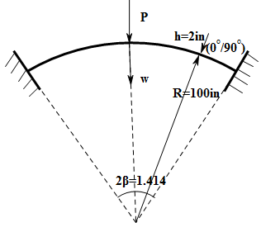
Fig. 5. Clamped laminated shallow arch subject to a central point load

Table 4. Geometry parameters of the laminated shallow arch
Radius | Width | Thickness | Subtending angle
R=100 in | b=1 in | h=2 in | 2β=1.414

Table 5. Material properties of the laminated shallow arch
Young’s moduli | Shear moduli | Poisson’s ratio
E₁=2.5×10⁷psi E₂=1.0×10⁶psi | G₁₂=5.0×10⁵psi G₁₃=5.0×10⁵psi G₂₃=2.0×10⁵psi | μ=0.3

Due to symmetry, only half of the arch is modeled using 10×1, 20×1 and 30×1 A4QC elements, respectively. The load-deflection curves at the central point of the arch are reported in Fig. 6. For comparison purpose, the results from Kreja & Schmidt using 5 LRT56 elements (isoparametric eight-node Serendipity-type shell elements with reduced integration)⁴³ are also reported in this figure.
Fig. 6. Load-deflection curves at mid-span of the laminated shallow arch (0º/90º)

To demonstrate the reliability, computational accuracy and convergence of the present A4QC element, deflections at the center of the laminated shallow arch (0º/90º) subject to a point load p=10000lb obtained respectively from 10×1, 20×1 and 30×1 A4QC elements, and 5 LRT56 elements⁴³ are presented in Table 6.

Table 6. Deflection at mid-span of the laminated shallow arch (0º/90º) under 10000lb
Element type | Deflection (in)
Element type | 10×1 | 20×1 | 30×1
A4QC | 40.5499(0.38%) | 40.4198(0.06%) | 40.3951(--)
LRT56 ⁴³ | 40.8265(1.07%)
Note: Values in the parentheses are the relative errors with respect to the results obtained using fine mesh of 30×1 A4QC elements.

5.3. Hinged laminated cylindrical shells
We consider a laminated composite shell subjected to a point load at the center point; the shell is simply supported along its two straight edges and free along its other two curved edges (Fig. 7). The geometry parameters of the shell are listed in Table 7. The lamination consists of 48 layers, arranged in the manner of (0º₆/90º₆/0º₆/90º₆)_{s} (where, “0º₆/90º₆/…” means that 6 laminas at 0 degrees, followed by 6 laminas at 90 degrees, etc.; the “0º” direction is along the circumferential direction of the cylinder, and the “90º” direction is along the axis of the cylinder; the subscript “s” represents that 48 laminas are arranged symmetrically with respect to the mid-surface of the composite shell). The material properties are given in Table 8.
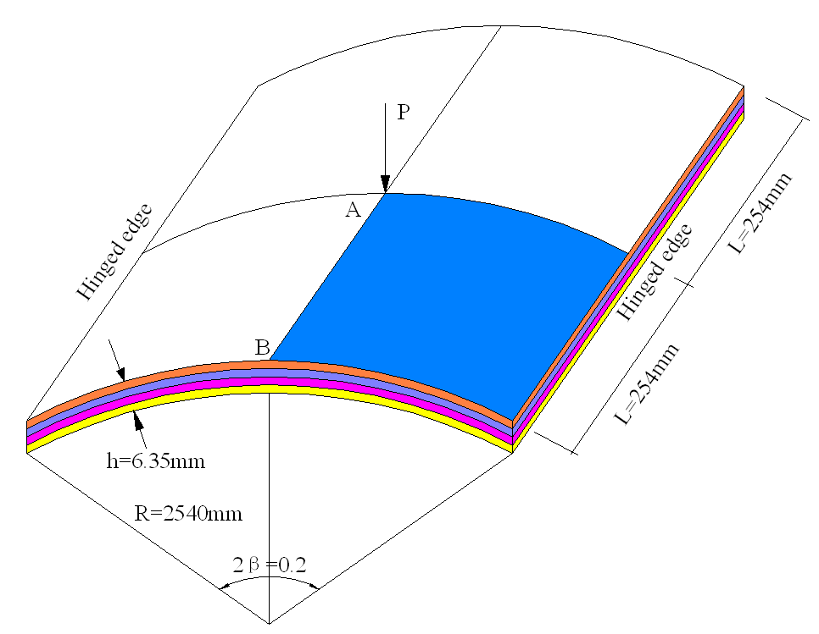
Fig. 7. Hinged laminated cylindrical shell subject to a point load

Table 7. Geometry parameters of the laminated cylindrical shell
Radius | Length | Thickness | Subtending angle
R = 2540 mm | 2L = 508 mm | h = 6.35 mm | 2β = 0.2 rad

Table 8. Material properties of the laminated cylindrical shell
Young’s moduli | Shear moduli |  | Poisson’s ratio
E₁ = 150.0Gpa E₂ = 10.0GPa | G₁₂ = G₁₃ = 6.0Gpa G₂₃=4.0GPa | μ₁₂=μ₂₃=μ₁₃=0.25

Due to symmetry, only a quarter of the laminated cylindrical shell (Fig. 7) is analyzed with discretizations using 12×12 and 24×24 A4QC elements, respectively. The load-displacement curves at Points A are given in Fig. 8. For comparison, the results from Gal & Levy⁴⁵ using 10×10×2 flat triangular shell elements (with 6 degrees of freedom per node) built from the linear membrane constant strain triangle and the DKT flat triangular plate element, and Argyris et al.⁴⁶ using 8×8 TRIC flat triangular shell elements (based on the natural mode finite element method) are also reported in this figure.

Fig. 8. Laminated cylindrical shell (0₆/90₆/0₆/90₆)_{s}: Load-deflection curves at Point A

To illuminate the reliability, computational accuracy and convergence of the present A4QC element, deflections at Point A and B of the laminated cylindrical shell (0₆/90₆/0₆/90₆)_{s} subject to a point load P=15KN obtained respectively from 12×12 and 24×24 A4QC elements, and Gal & Levy⁴⁵ are presented in Table 9.

Table 9. Deflections at Points A and B of the laminated cylindrical shell under P=15KN
Element type | Deflection at Points A |  | Deflection at Points B
Element type | 12×12 | 24×24 | 12×12 | 24×24
A4QC | 30.2874(-0.32%) | 30.3839(--) | 24.0514(-0.48%) | 24.1678(--)
Gal & Levy⁴⁵ | 30.1349(-0.82%) |  | --
Note: Values in the parentheses are the relative errors with respect to the results obtained using fine mesh of 24×24 A4QC elements.

We also analyze two other laminated shells with 12 layers, arranged as (0º₄/90º₄/0º₄) and (90º₄/0º₄/90º₄) (where, the “0º” direction is along the circumferential direction of the cylinder, and the “90º” direction is along the axis of the cylinder), respectively. The material properties are given in Table 10. Here we use meshes with 12×12 and 24×24 A4QC elements, respectively.

Table 10. Material properties of the laminated cylindrical shell
Young’s moduli | Shear moduli |  | Poisson’s ratio
E₁=3.3×10⁹Pa E₂=E₃=1.1×10⁹Pa | G₁₂=G₁₃=G₂₃= 6.6×10⁸Pa | μ₁₂=μ₂₃=μ₁₃=0.25

The load-displacement curves at Points A and B of the laminated cylindrical shell (0º₄/90º₄/0º₄) are presented respectively in Figs. 9 and 10. The results agree well with those from Gal & Levy using 10×10×2 flat triangular shell elements built from the linear membrane constant strain triangle and the DKT flat triangular plate element.⁴⁵

Fig. 9. Laminated cylindrical shell (0₄/90₄/0₄): Load-deflection curves at Point A
Fig. 10. Laminated cylindrical shell (0₄/90₄/0₄): Load-deflection curves at Point B

To illuminate the reliability, computational accuracy and convergence of the present A4QC element, deflections at Point A and B of the laminated cylindrical shell (0º₄/90º₄/0º₄) subject to a point load P=0.8KN obtained respectively from 12×12 and 24×24 A4QC elements, and Gal & Levy⁴⁵ are presented in Table 11.

Table 11. Deflections of the Laminated cylindrical shell (0₄/90₄/0₄) under P=0.8KN
Element type | Deflection at Points A |  | Deflection at Points B
Element type | 12×12 | 24×24 | 12×12 | 24×24
A4QC | 31.9654(-0.36%) | 32.0797(--) | 25.3021(-0.25%) | 25.3663(--)
Gal & Levy ⁴⁵ | 32.2471(0.52%) |  | 25.4530(0.34%)
Note: Values in the parentheses are the relative errors with respect to the results obtained using fine mesh of 24×24 A4QC elements.

The load-displacement curves at Points A and B of the laminated cylindrical shell (90º₄/0º₄/90º₄) are presented respectively in Figs. 11 and 12. The results agree well with those from Gal & Levy using 10×10×2 flat triangular shell elements built from the linear membrane constant strain triangle and the DKT flat triangular plate element.⁴⁵
Fig. 11. Laminated cylindrical shell (90₄/0₄/90₄): Load-deflection curves at Point A

Fig. 12. Laminated cylindrical shell (90₄/0₄/90₄): Load-deflection curves at Point B

Deflections at Point A and B of the laminated cylindrical shell (90º₄/0º₄/90º₄) subject to a point load P=0.3KN obtained respectively from 12×12 and 24×24 A4QC elements, and Gal & Levy ⁴⁵ are presented in Table 12 to demonstrate the reliability, computational accuracy and convergence of the present A4QC element.

Table 12. Deflection of the Laminated cylindrical shell (90₄/0₄/90₄) under P=0.3KN
Element type | Deflection at Points A |  | Deflection at Points B
Element type | 12×12 | 24×24 | 12×12 | 24×24
A4QC | 29.2159(-0.077%) | 29.2383(--) | 25.9695(-2.045%) | 26.5116(--)
Gal & Levy ⁴⁵ | 29.3117(0.251%) |  | 26.0876(-1.599%)
Note: Values in the parentheses are the relative errors with respect to the results obtained using fine mesh of 24×24 A4QC elements.

5.4. Stretched laminated cylinder under point load
Consider a laminated cylinder (90º/0º) (where, the “0º” direction is along the axis of the cylinder, and the “90º” direction is along its circumferential direction) subjected to two opposite point loads (Fig. 13), its geometry parameters and material properties are given in Table 13 and Table 14, respectively.

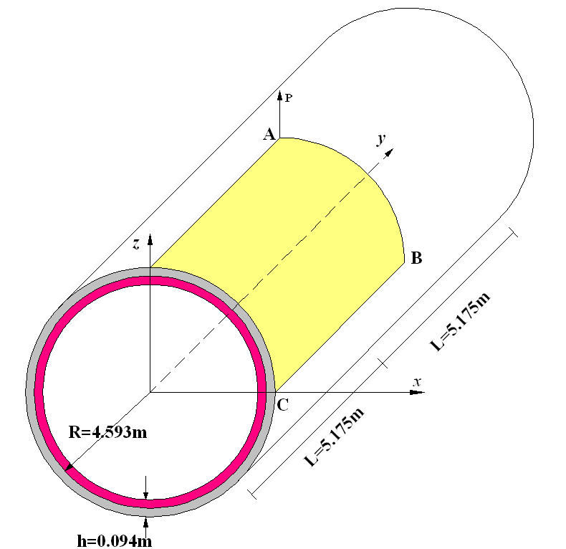
Fig. 13. Stretched laminated cylinder under point load

Table 13. Geometry parameters of the laminated cylinder
Radius | Length | Thickness
R=4.953 | 2L=10.35 | h=0.094

Table 14. Material properties of the laminated cylinder
Young’s moduli | Shear moduli | Poisson’s ratio
E₁=3.05×10⁷Pa E₂= E₃=1.05×10⁷Pa | G₁₂=G₁₃=G₂₃= 4.0×10⁶Pa | μ₁₂=μ₂₃=μ₁₃=0.3125

Due to symmetry, only one octant of the cylinder is modeled using meshes with 32×16 and 48×24 A4QC elements, respectively. The load-displacement curves at Point A of the cylinder are presented in Fig. 14. The results show good agreement with those obtained by Kreja and Schmidt ⁴³ using 24×15 LRT56 elements (isoparametric eight-node Serendipity-type shell elements with reduced integration).

Fig. 14. Laminated cylinder (90º/0º): Load-deflection curve at Points A

Deflections at Point A, B and C of the laminated cylinder subject to a point load P=4×10⁴KN obtained respectively from 32×16 and 48×24 A4QC elements, and Kreja and Schmidt ⁴³ are presented in Table 15 to illuminate the reliability, computational accuracy and convergence of the present A4QC element.

Table 15. Deflections at Points A, B and C of the laminated cylinder under P=4×10⁴lb
Element type | Deflections (in)
Element type | Point A | Point B | Point C
A4QC-32×16 | 2.6951(0.11%) | 4.4358(0.32%) | 3.1565(-0.72%)
A4QC-48×24 | 2.6922(--) | 4.4218(--) | 3.1795(--)
LRT56 ⁴³ | 2.6623(-1.11%) | 4.3766(-1.02%) | 3.2597(2.52%)
Note: Values in the parentheses are the relative errors with respect to the results obtained using fine mesh of 48×24 A4QC elements.

The (0º/90º) arrangement of the laminated cylinder is then used, while employing the same A4QC element meshes, to obtain the load-deflection curves at Points A shown in Fig. 15, with good agreement with Kreja and Schmidt ⁴³ using 24×15 LRT56 elements (isoparametric eight-node Serendipity-type shell elements with reduced integration).

Fig. 15. Laminated cylinder (0º/90º): Load-deflection curve at Points A

Deflections at Point A, B and C of the laminated cylinder subject to a point load P=4×10⁴KN obtained respectively from 32×16 and 48×24 A4QC elements, and Kreja and Schmidt ⁴³ are presented in Table 16.

Table 16. Deflections at Points A, B and C of the Laminated cylinder under P=4×10⁴lb
 | Point A | Point B | Point C
A4QC-32×16 | 2.6751(0.28%) | 4.4140(0.51%) | 3.1984(-1.05%)
A4QC-48×24 | 2.6677 (--) | 4.3915(--) | 3.2322(--)
LRT56 | 2.7013(1.26%) | 4.4546(1.44%) | 3.1818(-1.56%)
Note: Values in the parentheses are the relative errors with respect to the results obtained using fine mesh of 48×24 A4QC elements.

5.5. Clamped laminated cylindrical shell under point load
A deep laminated cylindrical shell (0º/90º/90º/0º) (where, the “0º” direction is along the axis of the cylindrical shell, and the “90º” direction is along its circumferential direction) is clamped along its two straight edges (Fig. 16), and subjected to a point load at the center point. The geometry parameters and material properties of the cylindrical shell are given in Table 17 and Table 18, respectively.

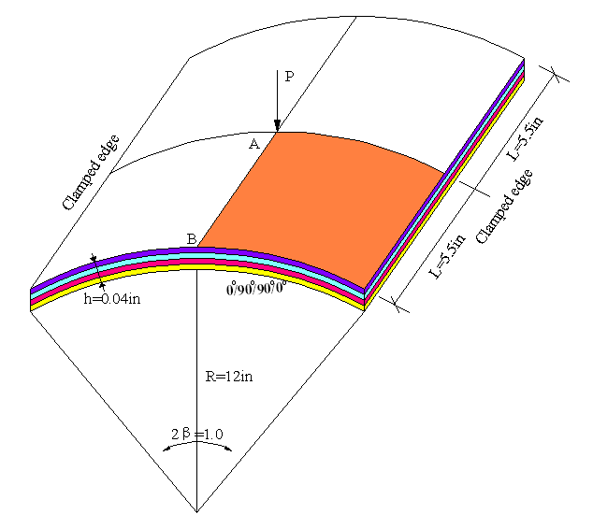
Fig. 16. Clamped laminated cylindrical shell subject to a point load

Table 17. Geometry parameters of the laminated cylindrical shell
Radius | Length | Thickness | Subtending angle
R = 12 in | 2L = 11 in | h = 0.04 in | 2β=1.0

Table 18. Material properties of the laminated cylindrical shell
Young’s moduli | Shear moduli | Poisson’s ratio
E₁=2.046×10⁷psi  E₂=4.092×10⁶psi | G₁₂=G₁₃=2.53704×10⁶psi  G₂₃=1.26852×10⁶psi | μ₁₂=μ₂₃=μ₁₃=0.313

Due to symmetry, a quarter of the laminated cylindrical shell is modeled using 12×12 and 24×24 A4QC element meshes, respectively. The load-deflection curves at the center point of the laminated shell are given in Fig. 17. For comparison, the results from Kreja ⁴⁷ using 4×4 LRT56 elements (isoparametric eight-node Serendipity-type shell elements with reduced integration) and Kim et al.⁹ using 6×6 EAS-ANS elements (non-linear 4-node shell element based on the EAS and ANS methods) are also presented in this figure.

Fig. 17. Load-deflection curves at the center point of the laminated cylindrical shell

Deflections at Point A of the laminated cylindrical shell subject to a point load P=160lb obtained by using respectively 12×12, 24×24 and 48×48 A4QC elements (also named as AM+AS element below) are compared against those obtained by the corresponding 4-node co-rotational quadrilateral composite shell elements using respectively conforming membrane strains and conforming shear strains (CM+CS), assumed membrane strains and conforming shear strains (AM+CS), conforming membrane strains and assumed shear strains(CM+AS), and those from Kreja ⁴⁷ and Kim et al.⁹ (see Table 19). It is shown that serious locking phenomena exist in the CM+CS, AM+CS elements, and employing assumed shear strain can alleviate locking problems in CM+AS and AM+AS (A4QC) elements effectively, while employing assumed membrane strain has little effect on the computational accuracy of the AM+CS element.

Table 19. Deflections at Point A of the laminated cylindrical shell under P=160lb
Element type | Deflection at the center point of the laminated cylindrical shell
Element type | 12×12 | 24×24 | 48×48
CM+CS | 0.0223(-99.14%) | 0.0735(-97.16%) | 0.2734(-89.43%)
AM+CS | 0.0220(-99.15%) | 0.0734(-97.16%) | 0.2745(-89.39%)
CM+AS | 2.5903(0.12%) | 2.5882(0.04%) | 2.5873(0.01%)
AM+AS (A4QC) | 2.5915(0.17%) | 2.5882(0.04%) | 2.5871(--)
LRT56 | 2.6005(0.52%)
EAS-ANS | 2.6015(0.56%)
Note: Values in the parentheses are the relative errors with respect to the results obtained using fine mesh of 48×48 A4QC elements.

6. Conclusions
A 4-node co-rotational quadrilateral composite shell element is presented in this paper. The present line of formulation differs from other co-rotational formulations, as it employs vectorial rotational variables, thus, all nodal variables are additive in an incremental solution procedure, and the element tangent stiffness matrices in both the local and global coordinate systems are symmetric, leading to computational efficiency and economy in computer storage, and advantages in solving dynamic problems. Due to the adopted co-rotational framework, the proposed 4-node quadrilateral composite shell element can be employed to solve large displacement and large rotation problems. By using an assumed strain method, the locking phenomena are alleviated effectively in the present composite shell element, and its reliability and convergence are illustrated with a number of examples of composite shells undergoing moderate/large displacements and rotations.
Acknowledgments This work is financed by the support program of the National Twelfth Five-Year-Plan for Science & Technology (2012BAJ13B04).

References
1. L. G. Andrade, A. M. Awruch, I. B. Morsch, Geometrically nonlinear analysis of laminate composite plates and shells using the eight-node hexahedral element with one-point integration, Compos. Struct. 79(4) (2007) 571–580.
2. M. Balah, H. N. Al-Ghamedy, Finite element formulation of a third order laminated finite rotation shell element, Comput. Struct. 80(26) (2002) 1975–1990.
3. A. Aboshio, S. Green, J.Q. Ye, Structural performance of a woven-fabric reinforced composite as applied in construction of inflatable offshore fender barrier structures, Int. J. Str. Stab. Dyn. 15(1) (2015) 1450036.
4. A. Hayatdavoodi, N.E. Shanmugam, Web buckling and ultimate strength of composite plate girders subjected to shear and bending, Int. J. Str. Stab. Dyn. 15(2) (2015) 1450047.
5. S. Singh, J. Singh, K.K. Shula, Buckling of laminated composite and sandwich plates using radial basis function collocations, Int. J. Str. Stab. Dyn. 15(1) (2015) 1540002.
6. I. Trendalova, R. Palazzetti, A. Zucchelli, Delamination assessment in structures made of composites based on general signal correlation, Int. J. Str. Stab. Dyn. 14(8) (2014) SI 1440022.
7. A. Masud, M. Panahandeh, Finite-element formulation for analysis of laminated composites, J. Eng. Mech. ASCE 125(10) (1999) 1115–1124.
8. A. Masud, C. L. Tham, W. K. Liu, A stabilized 3-D co-rotational formulation for geometrically nonlinear analysis of multi-layered composite shells, Comput. Mech. 26(1) (2000) 1-12.
9. K. D. Kim, S. C. Han, S. Suthasupradit, Geometrically non-linear analysis of laminated composite structures using a 4-node co-rotational shell element with enhanced strains, Int. J. Nonlin. Mech. 42(6) (2007) 864-881
10. X. G. Tan, L. Vu-Quoc, Efficient and accurate multilayer solid-shell element: Non-linear materials at finite strain, Int. J. Numer. Methods Eng. 63(15) (2005) 2124-2170.
11. X. G. Tan, L. Vu-Quoc, Optimal solid shell element for large deformable composite structures with piezoelectric layers and active vibration control, Int. J. Numer. Methods Eng. 64(15) (2005) 1981-2013.
12. W. S. Hwang, H. C. Park Finite-element modeling of piezoelectric sensors and actuators, AIAA J. 31(5) (1993) 930-937.
13. A. Suleman, V. B. Venkayya, A simple finite element formulation for a laminated composite plate with piezoelectric layers, J. Intel. Mat. Syst. Str. 6(6) (1995) 776-782.
14. H. T. Thai, D. H. Choi, Finite element formulation of a refined plate theory for laminated composite plates, J. Compos. Mater. 48(28) (2014) 3521-3538.
15. F. Auricchio, E. Sacco. A mixed-enhanced finite-element for the analysis of laminated composite plates, Int. J. Numer. Methods Eng. 44(10), (1999) 1481-1504.
16. K. S. Chun, S. K. Kassegne, B. K. Wondimu, Hybrid/mixed assumed stress element for anisotropic laminated elliptical and parabolic shells, Finite Elem. Anal. Des. 45(11) (2009) 766-781.
17. F. Daghia, S. de Miranda, F. Ubertini, E. Viola, A hybrid stress approach for laminated composite plates within the first-order shear deformation theory, Int. J. Solids Struct. 45(6) (2008) 1766-1787.
18. L. Vu-Quoc, I. K. Ebcioglu, Multilayer shells: Geometrically-exact formulation of equations of motion, Int. J. Solids Struct. 37(45) (2000) 6705-6737.
19. L. Vu-Quoc, H. Deng, X. G. Tan, Geometrically-exact sandwich shells: The static case, Comput. Methods Appl. Mech. Eng. 189(1) (2000) 167-203
20. L. Vu-Quoc, H. Deng, X. G. Tan, Geometrically-exact sandwich shells: The dynamic case, Comput. Methods Appl. Mech. Eng. 190(22-23) (2001) 2825-2873.
21. J. N. Reddy. Mechanics of Laminated Composite Plates and Shells Theory and Analysis (Second Edition) 2004; CRC Press: New York.
22. A. J. M. Ferreira, C. M. C. Roque, R. M. N. Jorge, Modelling cross-ply laminated elastic shells by a higher-order theory and multi-quadrics, Comput. Struct. 84(19-20) (2006) 1288-1299.
23. S. D. Kulkarni, S. Kapuria, A new discrete Kirchhoff quadrilateral element based on the third-order theory for composite plates, Comput. Mech. 39(3) (2007) 237-246.
24. G. Singh, G. V. Rao, N. G. R. Iyengar, Large deflection of shear deformable composite plates using a simple higher-order theory, Compos. Eng. 3(6) (1993) 507-525.
25. S. H. Lo, W. Zhen, Y. K. Cheung, W. J. Chen, Hygrothermal effects on multilayered composite plates using a refined higher order theory, Compos. Struct. 92(3) (2010) 633-646.
26. Y. Basar, M. Itskov, A. Eckstein, Composite laminates: nonlinear interlaminar stress analysis by multi-layer shell elements, Comput. Methods Appl. Mech. Eng. 185(2-4) (2000) 367-397.
27. E. Carrera, S. Brischetto, A Survey With Numerical Assessment of Classical and Refined Theories for the Analysis of Sandwich Plates, Appl. Mech. Rev. 62(1) (2009) 010803-1~17.
28. E. Carrera, Theories and finite elements for multilayered, anisotropic, composite plates and shells, Arch. Comput. Method E. 9(2) (2002) 87-140.
29. E. Carrera, Historical review of Zig-Zag theories for multilayered plates and shells, Appl. Mech. Rev. 56(3) (2003) 287-308.
30. B. Brank, E. Carrera, Multilayered shell finite element with interlaminar continuous sheer stresses: a refinement of the Reissner-Mindlin formulation, Int. J. Numer. Methods Eng. 48(6) (2000) 843-874.
31. J. C. Simo, N. Tarnow, A new energy and momentum conserving algorithm for the non-linear dynamics of shells, Int. J. Numer. Methods Eng. 37(15) (1994) 2527-2549.
32. J. C. Simo, M. S. Rifai, D. D. Fox, On a stress resultant geometrically exact shell-model .6. Conserving algorithms for nonlinear dynamics, Int. J. Numer. Methods Eng. 34 (1) (1992) 117-164.
33. B. A. Izzuddin, An enhanced co-rotational approach for large displacement analysis of plates, Int. J. Numer. Methods Eng. 64(10) (2005) 1350-1374
34. Z. X. Li, A co-rotational formulation for 3D beam element using vectorial rotational variables, Comput. Mech. 39(3) (2007) 309-322
35. Z. X. Li, L. Vu-Quoc, A mixed co-rotational 3D beam element formulation for arbitrarily large rotations, Adv. Steel Constr. 6(2) (2010) 767-787.
36. Z. X. Li, L. Vu-Quoc, An efficient co-rotational formulation for curved triangular shell element, Int. J. Numer. Methods Eng. 72(9) (2007) 1029-1062.
37. Z. X. Li, B. A. Izzuddin, L. Vu-Quoc, A 9-node co-rotational quadrilateral shell element, Comput. Mech. 42(6) (2008) 873-884.
38. Z. X. Li, Y. F. Liu, B. A. Izzuddin, L. Vu-Quoc, A stabilized co-rotational curved quadrilateral composite shell element, Int. J. Numer. Methods Eng. 86(8) (2011) 975-999.
39. Z. X. Li, X. Zhuo, L. Vu-Quoc, B. A. Izzuddin, H. Y. Wei, A 4-node co-rotational quadrilateral elasto-plastic shell element using vectorial rotational variables, Int. J. Numer. Methods Eng. 95(3) (2013) 181-211.
40. G. M. Kulikov, S. V. Plotnikova, A family of ANS four-node exact geometry shell elements in general convected curvilinear coordinates, Int. J. Numer. Methods Eng. 83(10) (2010) 1376–1406.
41. K. J. Bathe, E. N. Dvorkin, A formulation of general shell elements-the use of mixed interpolation of tensorial components, Int. J. Numer. Methods Eng. 22(3) (1986) 697–722.
42. M. A. Crisfield, Nonlinear Finite Element Analysis of Solid and Structures. Vol1: Essentials Wiley: Chichester, 1991.
43. I. Kreja, R. Schmidt, Large rotations in first-order shear deformation FE analysis of laminated shells, Int. J. Nonlin. Mech. 41(1) (2006) 101-123.
44. Y. Basar, Y. H. Ding, R. Schultz. Refined shear-deformation models for composite laminates with finite rotations, Int. J. Solids Struct. 30(19) (1993) 2611-2638.
45. E. Gal, R. Levy, The geometric stiffness of triangular composite-materials shell elements, Comput. Struct. 83(28-30) (2005) 2318-2333.
46. J. Argyris, L. Tenek, M. Papadrakakis, C. Apostolopoulou, Postbuckling performance of the TRIC natural mode triangular element for isotropic and laminated composite shells, Comput. Methods Appl. Mech. Eng. 166(3-4) (1998) 211-231.
47. I. Kreja, Critical examination of benchmark problems for large rotation analysis of laminated shells. 8th Conference on Shell Structures, Theory and Applications. In: Shell Structures: Theory and Applications. Pietraszkiewicz & Szymczak (eds). Jurata, Poland 2005; 481-485.

