Supporting Information
for
A-site order-disorder in the NdBaMn₂O_{5+δ} SOFC electrode material monitored in-situ by neutron diffraction under hydrogen flow

Florent Tonus¹, Mona Bahout^{2*}, Vincent Dorcet², Rakesh K. Sharma³, Elisabeth Djurado³
Serge Paofai², Ronald I. Smith⁴, and Stephen J. Skinner^{1*}
¹ Department of Materials, Imperial College London, Exhibition Road, London SW7 2AZ, United Kingdom.
²Institut des Sciences Chimiques de Rennes, UMR CNRS 6226, Université de Rennes 1, 263 Avenue du Général Leclerc, 35042 Rennes, France.
³ Univ. Grenoble Alpes, CNRS, G-INP, LEPMI, F-38000, Grenoble, France.
⁴The ISIS Facility, STFC Rutherford Appleton Laboratory, Harwell Campus, Didcot, OX11 0QX, UK.

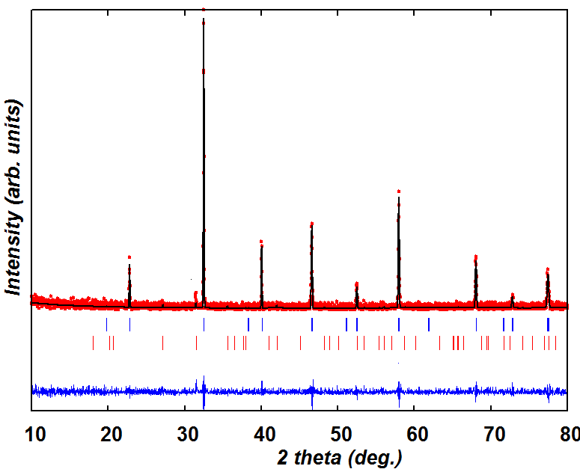
Fig. S.I. 1. Fitted room temperature X-ray diffraction pattern of Nd_{0.5}Ba_{0.5}MnO_{3-δ} phase indexed in Imma (upper markers); lower markers correspond to BaMnO₃ secondary phase (~ 8 wt %) indexed in P6₃/mmc.

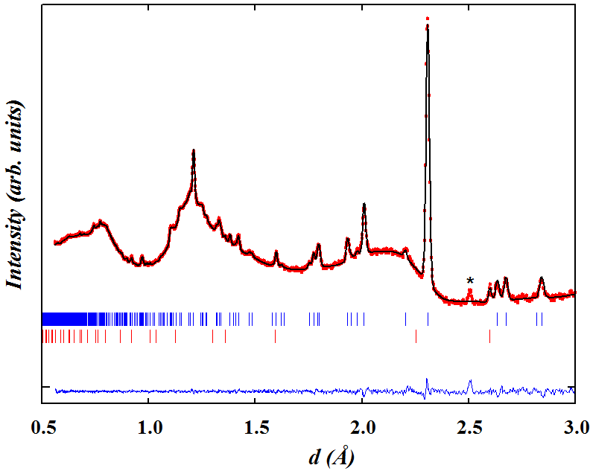.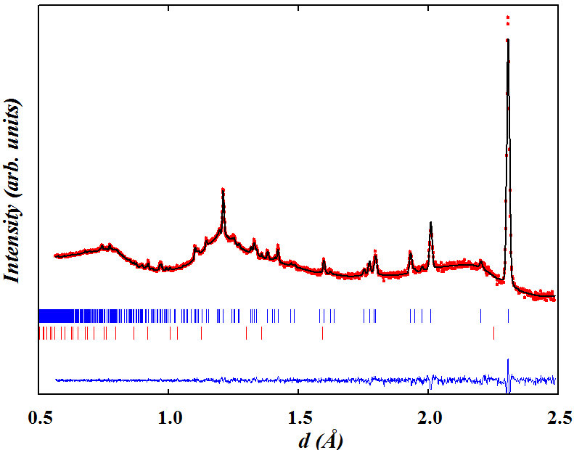Fig. S.I. 2. Rietveld fits to data collected at 900 °C for 2 hours from the (left) 90 ° detector bank and (right) backscattering-bank. Bragg peaks correspond to NdBaMn₂O₅ P4/mmm (upper markers) and MnO Fdm (lower markers). The unindexed peak at d ~ 2.5 Å is labelled (*).

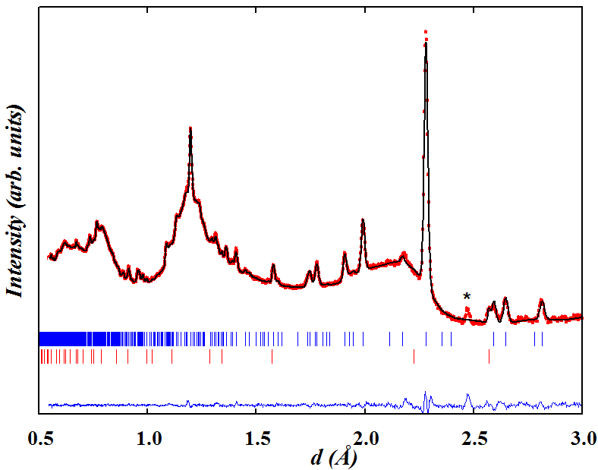
Fig. S.I. 3. Rietveld fit to the data collected for 2 h in the 90° detectors after cooling to 65 °C. Bragg peaks correspond to NdBaMn₂O₅, S.G. P4/nmm (upper markers) and MnO, S.G. Fdm (lower markers). The additional peak likely to arise from crystallization of SiO₂ from the quartz tube is labelled (*).

Table S.I. 1. Refined lattice parameters and isotropic atomic displacement parameter (B_{iso}) for Nd_{0.5}Ba_{0.5}MnO_{3.00} (S.G. Imma) at 20 °C with atoms in the following positions: (Nd,Ba), 4e (0, 1/4, z); Mn, 4b(0, 0, 1/2); O1, 4e(0, 1/4, z); O2, 8g (1/4, y, 01/4), a = 5.503(1) Å, b = 7.7962(4) Å, c = 5.502(1) Å, V_{p} = 59.01(2) Å³, χ² ~ 1.92, R_{B} ~ 1.98 %, R_{f} ~ 4.45%.

Atom | z or y | B_{iso} (Å²)
Nd, Ba | 0.0 | 0.56(2)
Mn |  | 0.62(3)
O1 | 0.470(2) | 2.1(2)
O2 | 0.512(1) | 2.5(1)

Table S.I. 2. Refined structural parameters and anisotropic thermal vibration parameters B_{ii} for Nd_{0.5}Ba_{0.5}MnO_{2.5} (S.G. Pmm) at T ~ 700 °C 700 °C with atoms in the following positions: Nd,Ba, 1a (0, 0, 0); Mn, 1b (1/2, 1/2, 1/2); O, 3c (0, 1/2, 1/2).
Atom | B₁₁, B₂₂, B₃₃ (× 10³)
Nd, Ba | 44(1), 44(1) 44(1)
Mn | 29(1), 29(1), 29(1)
O | 39(2), 154(2), 154(2)

Table S.I. 3. Refined structural parameters ~and anisotropic thermal vibration parameters B_{ii} at 800 °C for NdBaMn₂O₅ in space group P4/mmm with atoms in the following positions: Nd, 1a (0, 0, 0); Ba, 1b (0, 0, 1/2); Mn, 2h (1/2, 1/2, z); O1, 1d (1/2, 1/2, 1/2); O2, 4i (1/2, 0, z); a ~ 4.0066(5) Å, c ~ 7.889(1) Å, χ² ~ 1.0, R_{B} ~ 4 %, R_{F} ~ 8 %.
Atom | B₁₁, B₂₂, B₃₃ (× 10³)
Nd | 22(2), 22(2) 5(1)
Ba | 27(3), 27(2), 4(1)
Mn | 25(2), 25(2), 8(1)
O1 | 106(6), 106(6), 4(1)
O2 | 41(3), 31(2), 27(1)

Table S.I. 4. Refined structural parameters and isotropic thermal vibration parameters B_{iso} at 65 °C for NdBaMn₂O₅ in space group P4/nmm with atoms in the following positions: Nd, 2b (3/4, 1/4, 1/2); Ba, 2a (3/4, 1/4, 0); Mn1(Mn²⁺), 2c (1/4, 1/4, z); Mn2(Mn³⁺), 2c (1/4, 1/4, z); O1, 2c (1/4, 1/4, z); O3, 8j (x, x, z); O3, 2c (1/4, 1/4, 1/2). B_{iso} for Mn1 and Mn2 were constrained to be equal.
Atom | a (Å) | 5.6251(4)
 | c (Å) | 7.7717(7)
Nd | B_{iso} (Å²) | 0.47(4)
Ba | B_{iso} (Å²) | 0.56(7)
Mn1 | z | 0.258(2)
 | B_{iso} (Å²) | 0.31(6)
Mn2 | z | 0.756(1)
O1 | z | 0.002(3)
O2 | x | 0.500(2)
 | z | 0.3077(2)
 | B_{iso} (Å²) | 1.38(4)
 | χ² | 2.11
 | R_{B} % | 5.42

