Hydrogen Activation Using A Novel Tribenzyltin Lewis Acid
Robert T. Cooper, Joshua S. Sapsford, Roland C. Turnell-Ritson, Dong-Hun Hyon, Andrew J. P. White and Andrew E. Ashley*
Department of Chemistry, Imperial College London, South Kensington Campus, London SW7 2AZ, UK. (ORCID ID: 0000-0002-5575-7866)
Keywords: Frustrated Lewis Pairs, Hydrogenation, Tin, Lewis Acids, Hydrogen Activation.

Summary
*Author for correspondence: Andrew E. Ashley (a.ashley@imperial.ac.uk)

Over the last decade there has been an explosion in the reactivity and applications of frustrated Lewis pair (FLP) chemistry. Despite this, the Lewis acids (LAs) in these transformations are often boranes, with heavier p-block elements receiving surprisingly little attention. The novel LA Bn₃SnOTf (1) has been synthesised from simple, inexpensive starting materials and has been spectroscopically and structurally characterised. Subtle modulation of the electronics at the tin centre has led to an increase in its Lewis acidity in comparison with previously reported R₃SnOTf LAs, and has facilitated low temperature hydrogen activation and imine hydrogenation. Deactivation pathways of the R₃Sn⁺ Lewis acid core have also been investigated.

1. Introduction
Since the concept of ‘frustrated Lewis pairs’ (FLPs) was formalised a decade ago,[1] there has been a rapid increase in interest and activity in this area of chemistry.[2–4] The combination of a Lewis acid and base (LA and LB, respectively), which are prevented from forming a strong classical adduct by steric and/or electronic factors,[3] can possess unquenched reactivity that has been shown to allow activation of a range of small molecules. Following initial observations of the heterolytic cleavage of H₂ [5–7] (which had traditionally only been achieved using transition metals), subsequent application to metal-free catalytic hydrogenation has brought great interest, with the scope progressing from imines, aziridines and protected nitriles substrates,[8,9] to activated alkenes,[10] and most recently, aldehydes and ketones.[11,12]
To date the vast majority of the focus in this diverse, rapidly expanding field of chemistry has been directed towards the use of boron-centred LAs; [13] by comparison equivalent FLP chemistry with heavy p-block elements has received far less attention.[14–17] Nevertheless, our current interest has been drawn to the use of stannylium ion R₃Sn⁺ (R = alkyl) based LAs, which possess several properties very similar to the most commonly used LA in FLP chemistry, B(C₆F₅)₃.[13] In particular these LAs are isoelectronic, isolobal, and have been calculated to have comparable hydride ion affinities (ΔG_{H−} = 65.83 and 64.95 kcal mol⁻¹ for ^{n}Bu₃Sn-H and [(C₆F₅)₃B-H]⁻ respectively),[18] indicating that these species could show analogous reactivity in H₂ activation and hydrogenation chemistry. Accordingly, we recently described the use of ^{i}Pr₃SnOTf (a surrogate for ^{i}Pr₃Sn⁺; OTf = CF₃SO₃) in FLP-mediated H₂ activation chemistry when partnered with amine/pyridine LBs. Furthermore ^{i}Pr₃SnOTf could successfully be employed in the catalytic hydrogenation of a variety of functional groups (C=C, C=N and C=O bonds), and demonstrated an unparalleled tolerance to moisture for FLP catalysis.[14] Nevertheless, we noted that one factor limiting the rate of some catalytic hydrogenations using ^{i}Pr₃SnOTf as a LA was the ease of H₂ activation. In this respect, it is notable that earlier work by Manners and co-workers showed similar FLP systems based on ^{n}Bu₃SnOTf were unreactive towards H₂, although they were capable of dehydrogenating amine-boranes. We proposed that this resulted from an overly strong interaction between the less bulky R₃Sn⁺ and TfO– moieties, which would result in significant quenching of the Lewis acidity at Sn;[15] this hypothesis drove us to pursue the synthesis of the more sterically encumbered, yet electronically similar ^{i}Pr analogue. These results clearly indicate that the reactivity of R₃Sn⁺-based FLPs can be highly sensitive to the identity of R, and clearly there exists scope for further modification and optimisation of such Sn(IV) LAs, which are appealing given their relative ease of synthesis, and the abundance and low cost of Sn.[14]
Previously, computational calculations have reported that the successful activation of H₂ is strongly correlated to the cumulative proton and hydride affinities of LB and LA, respectively,[19] for which pK_{a} values of [LB-H]⁺ and Lewis acidity measurements (e.g. Gutmann-Beckett method) can be used as guiding experimental proxies. With this in mind, we speculated that increasing the Lewis acidity of R₃Sn⁺ via the use of a more electron-withdrawing R group would facilitate faster FLP-mediated H₂ activation and hence improved catalytic hydrogenation kinetics. Herein we report the targeted high yielding synthesis and characterisation of the new LA Bn₃SnOTf (Bn = PhCH₂; 1) which, by virtue of the greater inductive electron-withdrawing effect of the sp²-hybridised phenyl C atom vs an sp³-alkyl substituent, displays an enhanced Lewis acidity over ^{i}Pr₃SnOTf. Furthermore, we show that 1 displays facile H₂ activation at lower temperatures than its ^{i}Pr analogue under comparable conditions, and examine its activity for the catalytic hydrogenation of an imine substrate.

2. Experimental details

(a) General Considerations
Unless otherwise stated, all reactions were conducted under an inert atmosphere of dinitrogen using standard Schlenk techniques on a dual-vacuum-inlet gas manifold or MBraun DP Labmaster glovebox. All glassware was heated to 180 °C overnight prior to use. All solvents were dried and degassed before use: pentane was dried using an Innovative Technology Pure Solv™ SPS-400 and stored over K; Et₂O was distilled from Na/fluorenone and stored over K; CHCl₃ was dried and stored over 3 Å molecular sieves; C₆D₆ and CDCl₃/CD₂Cl₂ were freeze-pump-thaw degassed and dried over a K mirror and 3 Å molecular sieves, respectively. H₂ was purchased from BOC (research grade) and dried by passage through a Matheson Tri-Gas Weldassure™ Purifier drying column. 2,4,6-Collidine (hereafter referred to as collidine) and Ph(H)C=NPh were purchased from major suppliers, degassed and dried over 4 Å molecular sieves before use. Bn₃SnCl was purchased from Alfa Aesar and dried under vacuum. Benzyl chloride (BnCl), SnCl₄, Mg, LiAlH₄, I₂ and trifluoromethanesulfonic acid (TfOH) were purchased from major suppliers and used as received.

(b) Analytical measurements
NMR spectra were recorded on Bruker AV-400 MHz and DRX-400 spectrometers. ¹H and ¹³C spectra were referenced internally to the residual solvent signals and reported in parts per million (ppm). ¹⁹F, ³¹P and ¹¹⁹Sn spectra were referenced externally to CFCl₃, 85% H₃PO_{4(aq)} and Me₄Sn respectively. High resolution mass spectrometry was recorded using a Micromass Autospec Premier (EI mode) by Dr Lisa Haigh at Imperial College London. Single crystal X-ray diffraction data were collected and refined by Dr Andrew White (full details can be found in the Electronic Supplementary Information). Elemental microanalysis was conducted by Stephen Boyer at London Metropolitan University.

(c) Synthesis

(i) Tetrabenzylstannane (Bn₄Sn)
A modified procedure of Kipping[20] and Huber et. al.[21] was employed: SnCl₄ (6.70 g, 25.71 mmol) was added slowly to Et₂O (100 ml) at 0 °C to give a milky-white suspension. Mg powder (2.50 g, 102.84 mmol) was added, followed by a single crystal of I₂ (0.05 g, 0.20 mmol). Benzyl chloride (13.02 g, 102.84 mmol) in Et₂O (80 ml) was added dropwise over a period of 90 minutes at 0 °C. Following addition, the reaction was heated to reflux for 3 hours followed by further stirring at room temperature for 24 hours. The reaction was carefully quenched with water and the aqueous phase extracted with CHCl₃. The remaining work-up was performed under air: the combined organic phases were dried over Na₂SO₄ and filtered, and the volatiles removed under reduced pressure resulting in an oil. Bn₄Sn was crystallised from a slow cooled pentane solution at −45 °C, affording 8.50 g (17.59 mmol) of a white crystalline solid in 68.4% yield.
¹H NMR (400 MHz, CDCl₃) δ: 2.22 [8H, s, ²J(^{119,117}Sn-¹H) = 58.3 Hz, CH₂], 6.74 [8H, m, Ph], 7.01 [4H, m, Ph], 7.16 [8H, m, Ph]. ¹¹⁹Sn{¹H} NMR (149 Hz, CDCl₃) δ: −37.1 (s); these values are consistent with those previously reported.[22]

(ii) Tribenzyltin triflate (Bn₃SnOTf), (1)
Trifluoromethanesulfonic acid (TfOH, 0.63 g, 4.21 mmol) was added dropwise to a solution of Bn₄Sn (2.14 g, 4.43 mmol) in CHCl₃ (50 ml), causing the mixture to immediately become turbid. The reaction was stirred at room temperature for 18 hours before the solvent was removed in vacuo and the solid subjected to a dynamic vacuum for 6 hours. The solid was subsequently washed with pentane (4 x 15 ml) to furnish pure Bn₃SnOTf as a white solid (2.01 g, 3.71 mmol) in 88% yield.
¹H NMR (400 MHz, CDCl₃) δ: 2.92 [6H, s, ²J(^{117,119}Sn-¹H) = 66.02 Hz, CH₂], 6.79 [6H, m, Ph], 7.12 [3H, m, Ph], 7.20 [6H, m, Ph]. ¹³C{¹H} NMR (101 MHz, CDCl₃) δ: 26.8 [s, ¹J(¹¹⁷Sn-¹H) = 258.4 Hz, ¹J(¹¹⁹Sn-¹H) = 271.2 Hz, CH₂], 118.9 [q, ¹J(¹⁹F-¹³C) = 317.2 Hz, CF₃], 125.9 [s, ⁵J(^{117,119}Sn-¹³C) = 21.6 Hz, Ph], 128.1 [s, ³J(^{117,119}Sn-¹³C) = 33.4 Hz, Ph], 129.4 [s, ⁴J(^{117,119}Sn-¹³C) = 18.2 Hz, Ph], 135.9 [s, Ph]. ¹⁹F NMR (376 MHz, CDCl₃) δ: −77.0. ¹¹⁹Sn{¹H} NMR (149 Hz, CDCl₃) δ: 87.4 [br s, Δν½ = 48.4 Hz]. Elemental analysis found (calculated) for C₂₂H₂₁O₃F₃SSn: C 48.69 (48.83), H 4.01 (3.91). HRMS (EI): m/z found (calculated) for C₂₂H₂₁O₃F₃SSn: 542.0202 (542.0186).

(iii) Tribenzyltin hydride (Bn₃SnH), (2)
A modified procedure of Miura et. al.[23] was employed for the independent synthesis of Bn₃SnH (2): Bn₃SnCl (1.00 g, 2.34 mmol) was added to LiAlH₄ (0.08 g, 2.13 mmol) in Et₂O (20 ml) at 0 °C and stirred for 30 minutes. The suspension was filtered via cannula before the volatiles were removed in vacuo. The solid was extracted into pentane (3 x 10 ml) and filtered. The volatiles were removed under reduced pressure to furnish 0.294 g (0.75 mmol) of 2, as a viscous oil in 37% yield, which solidified upon cooling to −20 °C in a glovebox freezer for storage.
¹H NMR (400 MHz, C₆D₆) δ: 2.17 [6H, d, J = 1.5 Hz, ²J(^{117,119}Sn-¹H) = 61.5 Hz, CH₂], 5.71 [1H, sept, J = 1.5 Hz, ¹J(¹¹⁷Sn-¹H) = 1693.8 Hz, ¹J(¹¹⁹Sn-¹H) = 1773.1 Hz], 6.79 [6H, m, Ph], 6.94 [3H, m, Ph], 7.09 [6H, m, Ph]. ¹³C{¹H} NMR (101 MHz, C₆D₆) δ: 17.9 [s, ¹J(¹¹⁷Sn-¹H) = 277.0 Hz, ¹J(¹¹⁹Sn-¹H) = 289.5 Hz, CH₂], 124.2 [s, ⁵J(^{117,119}Sn-¹³C) = 16.1 Hz, Ph], 127.9 [s, Ph], 128.9 [s, ⁴J(^{117,119}Sn-¹³C) = 13.6 Hz, Ph], 142.1 [s, ²J(^{117,119}Sn-¹³C) = 39.6 Hz, Ph]. ¹¹⁹Sn{¹H} NMR (149 Hz, C₆D₆) δ: −85.4 (s); these values are consistent with those previously reported.[23]

(d) Gutmann-Beckett Lewis acidity measurements[24]
Et₃PO (3.6 mg, 0.02 mmol) and Bn₃SnOTf (32.4 mg, 0.06 mmol) were dissolved in CD₂Cl₂ (0.4 ml) and added to a NMR tube with a capillary insert containing 1 M Et₃PO in CD₂Cl₂. Based on the ³¹P{¹H} chemical shift of the resulting Et₃PO adduct relative to the insert, the acceptor number (AN) was calculated using the formula of Beckett et al.[25,26] AN = [(δ(sample) − 41.0] x [100/(86.14 − 41.0)]. ³¹P{¹H} NMR, δ_{adduct} = 74.41 ppm gave an acceptor number of 74.0.

(e) H₂ activation procedure using Bn₃SnOTf, (1) and collidine
Inside a glovebox 1 (16.2 mg, 0.03 mmol) and collidine (3.6 mg, 0.03 mmol) were combined in C₆D₆ (0.4 ml) and transferred into a NMR tube fitted with a Young’s valve. The solution was freeze-pump-thaw degassed and H₂ (1 bar) was admitted whilst the solution was at −196 °C (which equates to a pressure of approximately 4 bar at room temperature) and the reaction was analysed by ¹H, ¹⁹F and ¹¹⁹Sn spectroscopy. The reaction was then heated in an oil bath to 50 °C for 2 hours, after which it was reanalysed by NMR techniques. This revealed the formation of 2 by the diagnostic Sn-H septet resonance at δ = 5.71 ppm accompanied by ^{117/119}Sn-¹H satellites and the ¹¹⁹Sn resonance at δ = −85.4 ppm.

(f) Investigations into PhCH₂/H scrambling and deactivation routes

(i) Thermal stability of Bn₃SnOTf, (1)
A sample of 1 (16.2 mg, 0.03 mmol) was dissolved in C₆D₆ (0.4 ml) and transferred into a NMR tube fitted with a Young’s valve. The reaction was followed by ¹H and ¹¹⁹Sn{¹H} NMR spectroscopy but no reaction was observed, even after heating to 70 °C for 72 hours.

(ii) Thermal stability of Bn₃SnOTf (1) and collidine
A NMR tube was loaded with 1 (16.2 mg, 0.03 mmol), collidine (3.6 mg, 0.03 mmol) and C₆D₆ (0.4 ml), which led to the formation of an adduct by ¹¹⁹Sn{¹H} NMR spectroscopy. However, no further change was observed by ¹H and ¹¹⁹Sn{¹H} NMR spectroscopy, even after heating to 70 °C for 72 hours.

(iii) Thermal stability of Bn₃SnOTf (1) and Bn₃SnH (2)
Inside a glovebox 1 (16.2 mg, 0.03 mmol) and 2 (11.8 mg, 0.03 mmol) were combined in C₆D₆ (0.4 ml) and transferred into a NMR tube fitted with a Young’s valve. The mixture was monitored by ¹H and ¹¹⁹Sn{¹H} NMR spectroscopy at regular intervals for 60 hours at RT. Complete decomposition of 1 and 2 was observed with concomitant formation of Bn₄Sn (¹¹⁹Sn{¹H} NMR δ = −37.5 ppm), along with the formation of an intractable precipitate, after this time. An analogous reaction conducted with heating to 50 °C for 5 hours gave identical results.

(iv) Thermal stability of Bn₃SnOTf (1), Bn₃SnH (2), and collidine
1 (8.1 mg, 0.015 mmol), 2 (5.9 mg, 0.015 mmol) and collidine (3.6 mg, 0.03 mmol) were combined in C₆D₆ (0.4 ml) and transferred into a NMR tube fitted with a Young’s valve. The mixture was monitored by ¹H and ¹¹⁹Sn{¹H} NMR spectroscopy at regular intervals over the course of 60 hours at RT, during which partial decomposition of 1 and 2 to Bn₄Sn was observed (¹¹⁹Sn{¹H} NMR δ = −37.5 ppm). An analogous reaction conducted with heating to 50 °C for 5 hours showed complete decomposition.

(g) Imine hydrogenation procedure using Bn₃SnOTf (1) and collidine
Inside a glovebox 1 (10.8 mg, 0.02 mmol), collidine (2.4 mg, 0.02 mmol) and Ph(H)C=NPh (3) (36.2 mg, 0.20 mmol) were dissolved in C₆D₆ (0.4 ml) and transferred into a Wilmad high pressure NMR tube fitted with a PV-ANV PTFE valve. H₂ was admitted to a pressure of 10 bar (at room temperature) and analysed by ¹H, ¹⁹F and ¹¹⁹Sn NMR spectroscopy. The reaction was heated in an oil bath to 50 °C without active mixing and monitored at regular intervals. The conversion (%) was determined by relative integration of ¹H resonances belonging to the amine product [PhCH₂-NHPh, (4)], residual starting material [Ph(H)C=NPh, (3)]. This procedure was repeated at 70 °C and room temperature.

3. Results and discussion

(a) Synthesis and characterisation of Bn₃SnOTf (1)
The target compound Bn₃SnOTf (1) was synthesised by the facile proteodealkylation of Bn₄Sn (synthesised by a modified procedure of Kipping[20] and Huber et al.[21]) with TfOH (Figure 1). Subsequent work-up yielded 1 as a white solid in excellent yield (88%). 1 has been characterised by ¹H, ¹³C, ¹⁹F and ¹¹⁹Sn NMR spectroscopy, elemental analysis, HRMS (EI) and X-ray crystallography. Single crystals were grown from a cooled (–20°C) saturated Et₂O solution under an inert atmosphere, for which X-ray diffraction data were collected and refined, and the structure is shown in Figure 2.

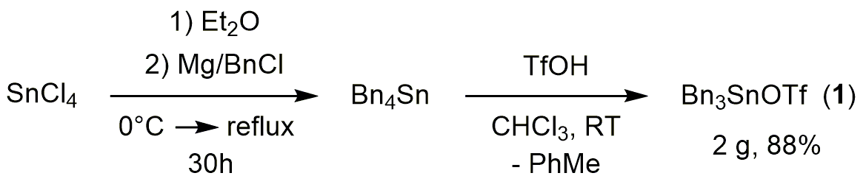
Figure 1: Synthesis of 1.

1 crystallises in the chiral space group P2₁ and contains four independent molecules (molecules 1a-d; see Table 1 for more details) in the asymmetric unit, which are geometrically closely related. Each independent molecule forms its own unique extended polymer structure along the b axis, in which the TfO moieties bridge two separate Bn₃Sn centres. The ligands are coordinated in a distorted trigonal bipyramidal arrangement around Sn, with the three benzyl groups occupying the equatorial positions and oxygens from the bridging triflate moieties occupying the axial positions. The degree of distortion from an idealised trigonal bipyramidal structure can be quantified using the parameter τ;[27] the range 0.94-0.96 obtained for the four independent molecules in 1 indicates a near perfect trigonal bipyramidal geometry (idealised τ = 1, vs. τ = 0 for square-based-pyramidal).

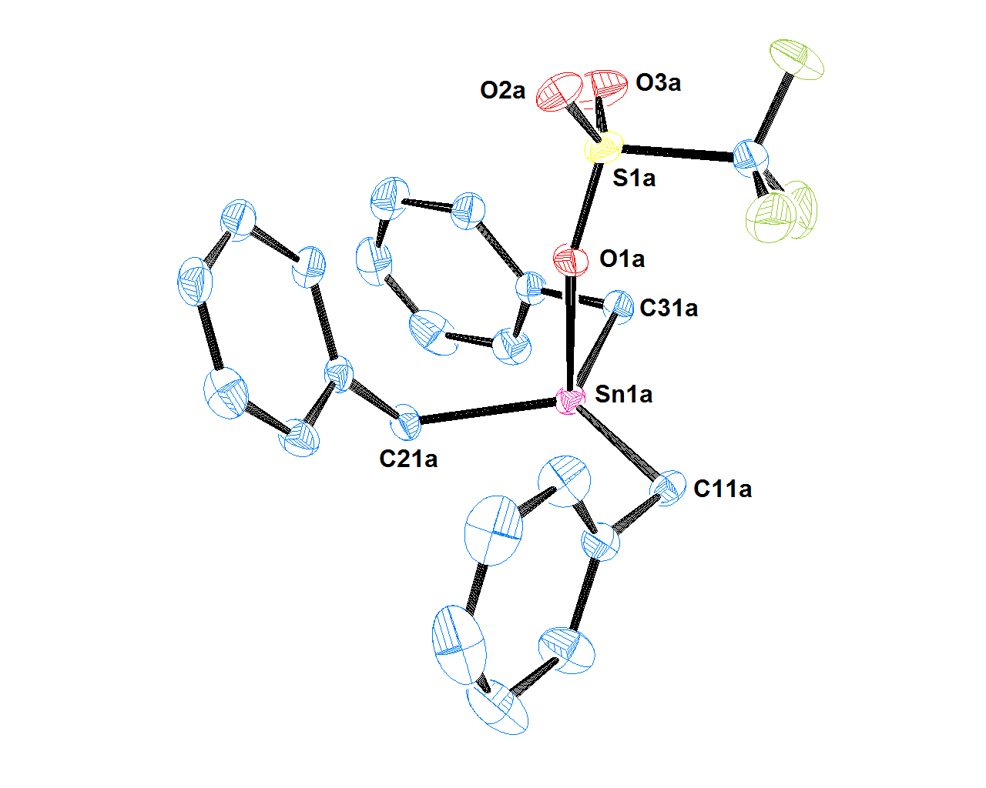
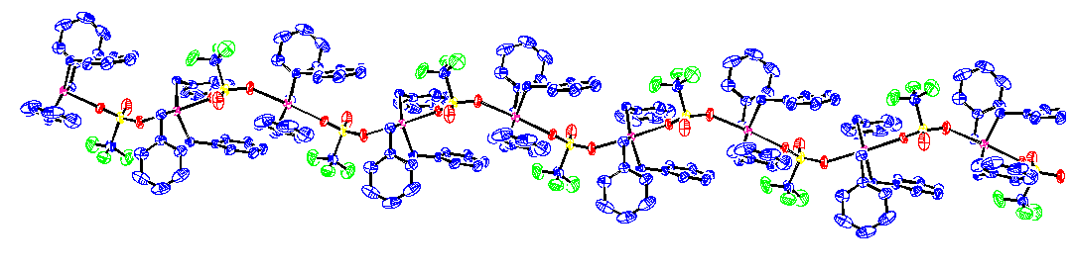
Figure 2: Molecular structure of 1 (molecule 1a). Ellipsoids shown at 50% probability, H-atoms omitted for clarity (C atoms blue, O atoms red, F atoms green, S atoms yellow, Sn atoms pink). Top: view of one independent Bn₃SnOTf fragment in the asymmetric unit. Bottom: extended view of the polymeric structure generated from the independent fragment along the b axis (all four independent molecules form similar polymeric chains).

1 is isostructural with Ph₃SnOTf,[28] one of only two triorganotin triflates that have previously been structurally characterised, the other being the molecular species [(Me₃Si)₂CH]₃SnOTf[29]. These structural variations are likely attributed to the differing steric bulk of the R groups around Sn, with the very large [(Me₃Si)₂CH] substituents favouring a distorted tetrahedral geometry over a polymer which necessitates higher coordination numbers. For Ph and Bn, the substituents are small enough for the Lewis acid Sn centres to bond in a hypervalent manner, resulting in the polymeric 5-coordinate geometry. The Sn-C and Sn-O bond lengths within 1 and Ph₃SnOTf are almost identical within experimental error.[28] However, the latter are considerably longer than those observed in [(Me₃Si)₂CH]₃SnOTf (2.139(4) Å),[29] presumably because the lower coordination number enables closer approach of the triflate moiety, compared to the more sterically congested 5-coordinate species.

Table 1: Selected bond lengths and angles for isomorphic 1 and Ph₃SnOTf.[28] ESDs are given in parentheses.
***BONDLENGTH TABLE HERE***

1 is highly soluble in polar halogenated solvents, displays appreciable solubility in benzene, yet is completely insoluble in aliphatic hydrocarbon solvents. The solution-phase room temperature ¹H NMR spectrum in the non-donor solvent CDCl₃ reveals a notably downfield shift of the methylene resonance (δ = 2.92 ppm; CDCl₃) compared to Bn₄Sn (δ = 2.22 ppm; CDCl₃), with the same trend observable for the methylene carbon resonances (¹³C NMR: δ = 26.8 and 18.9 ppm respectively), which reflects the enhanced electron deficiency upon substituting the benzyl for a weakly coordinating triflate ligand. This might be expected to result in significant stannylium ion character in 1, which is usually typified by a strongly downfield ¹¹⁹Sn NMR chemical shift. However, the single broad resonance seen for 1 in the ¹¹⁹Sn{¹H} NMR spectrum (δ = 87.4 ppm; Δν½ = 48.4 Hz) is considerably upfield relative to the value reported for [^{n}Bu₃Sn][CB₁₁Me₁₂] (δ = 454 ppm), which exhibits the least coordinated trialkylstannylium core reported to date,[30] and the related trialkyltin triflates R₃SnOTf (R = ^{n}Bu [31], ^{i}Pr [14]; δ = 168 and 156 ppm, respectively). These data, in combination with the ¹J(¹³C-¹¹⁹Sn) values for the R₃SnOTf compounds (R = ^{n}Bu 383; ^{i}Pr 316; Bn 258 Hz) where higher values are proposed to be an indicator of increasing stannylium character,[31] might imply that 1 should be the weakest LA of the R₃SnOTf series. However, the ¹¹⁹Sn NMR chemical shift is not a direct correlation to Lewis acidity and can be highly dependent on solvent, degree of aggregation in solution, and the substituents of the stannyl core;[32] in this instance it may be conceived that the propensity to aggregate within the solution-phase (in the absence of external strong donor species) is enhanced due to a more electron-deficient Sn core. A more rigorous, quantitative method was developed by Gutmann and Beckett which uses the change in ³¹P NMR chemical shift of Et₃P=O upon coordination to a LA to provide an acceptor number (AN) value, the magnitude of which positively correlates with Lewis acidity; this is a more reliable indicator of Lewis acidity since it is expected that the nucleophilic O atom in Et₃P⁺–O– is competent at displacing bridging OTf interactions, thus providing a valid assessment of the Lewis acidity of the Bn₃SnOTf monomer. The AN value of 1 was experimentally determined to be 74.0, and indicates that Bn₃SnOTf is significantly more Lewis acidic than the related R₃SnOTf (R = ^{n}Bu, ^{i}Pr; AN = 64.2 and 68.0, respectively),[14] albeit less so than the commonly used FLP LA B(C₆F₅)₃ (AN = 78.1). This indicates, as intended by design, that 1 is the strongest Lewis acid in the R₃SnOTf series and a strong candidate for improved heterolytic H₂ activation and subsequent reactivity.

(b) Hydrogen activation studies of Bn₃SnOTf (1)
Combination of 1 and collidine in a 1:1 ratio in C₆D₆ led to an upfield shift in the ¹¹⁹Sn{¹H} resonance from δ = 74.9 to 33.6 ppm (br), concomitant with a slight shift of the ¹H NMR resonances of 1, consistent with a donor-acceptor interaction. Nevertheless, it is well known that certain ordinary Lewis pair adducts can exhibit FLP reactivity, as exemplified by the classical adduct between lutidine and B(C₆F₅)₃ which generates the free FLP upon heating which subsequently cleaves H₂;[33] furthermore strongly bound adducts such as the silylium/phosphine species [^{i}Pr₃Si-P^{t}Bu₃]⁺ (for which no stable FLP counterpart can exist) can also engage in H₂ heterolysis. [34,35] With this in mind, admission of H₂ (4 bar, 50 °C, 2 h) led to the appearance of resonances in the ¹H NMR [5.72 ppm, SnH, ¹J(^{117/119}Sn-¹H) = 1693/1773 Hz; 13.13 ppm, NH] and ¹¹⁹Sn{¹H} NMR (−84.8 ppm) spectra, which are consistent with formation of Bn₃SnH (2) and [col-H]⁺[TfO] ⁻, formed through H₂ activation by the 1/collidine Lewis pair (Figure 3). These resonances were verified by comparison with literature values,[23] and the independent synthesis of 2. Significantly, this is only the second reported example of H₂ activation using a Sn(IV) based LA.

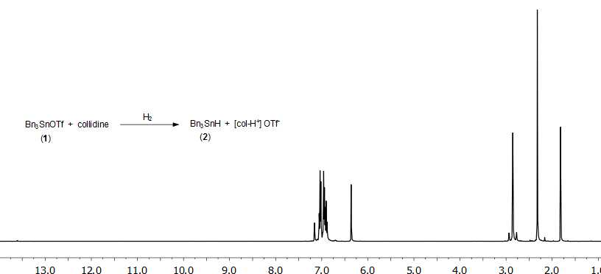
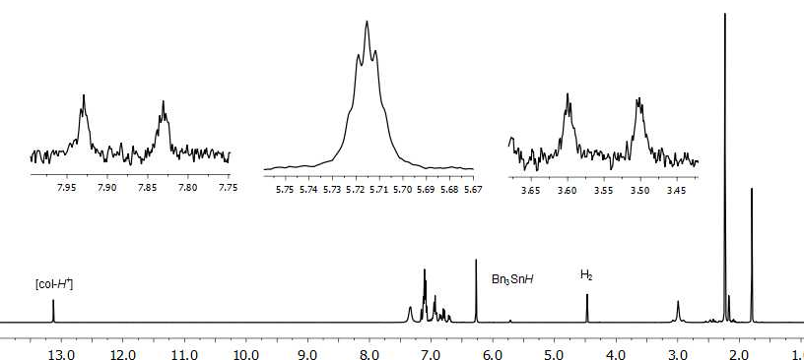

Figure 3: ¹H NMR spectra of 1 and collidine in C₆D₆ before, (a), and after, (b), admission of H₂ (4 bar). Insets show Sn-H resonance and ¹J(^{117/119}Sn-¹H) satellites.

It is interesting to note that the equivalent H₂ activation by ^{i}Pr₃SnOTf and collidine required higher pressure (10 bar) and longer times (20 h).[14] Similarly, no H₂ activation was reported with ^{n}Bu₃SnOTf in combination with the stronger amine base 2,2,6,6-tetramethylpiperidine (TMP),[15] even with prolonged heating (18 hours, 50 °C), which is consistent with the suggestion from our Gutmann-Beckett measurements that 1 is the strongest LA in the R₃SnOTf series (R = ^{n}Bu, ^{i}Pr, Bn).
Inspection of ¹H NMR integrals revealed incomplete conversion of 1 to 2 (17 % as ascertained by ¹H NMR using a 2,5-dimethylfuran insert), which contrasts with the outcome of similar reactions using B(C₆F₅)₃ whose H₂ activation reactions have been reported to proceed to completion when using similarly strong LBs,[19,33] along with a downfield shift and concomitant broadening of the CH₂Ph resonances in 1. However, similar observations were reported for ^{i}Pr₃SnOTf, which is nonetheless catalytically active for a variety of C=X (X = C, N, O) bond hydrogenations.[14] It was noted that alongside appreciable H₂ activation at 50 °C, several other new resonances were observed in the ¹H and ¹¹⁹Sn{¹H} NMR spectra (such peaks had not been observed during earlier investigations using ^{i}Pr₃SnOTf). These were postulated to result from deactivation/decomposition pathways operating within the system, which could provide one explanation for the incomplete conversion of 1 to 2. As such, the origin of these resonances was investigated further.

(c) Investigations into potential Bn₃SnX (X = H, TfO) deactivation pathways
On closer inspection of the hydrogen cleavage experiments the diagnostic chemical shifts of Bn₄Sn were noted in the ¹H and ¹¹⁹Sn{¹H} NMR spectra (δ = 2.17 and −37.5 ppm respectively; C₆D₆). This, in combination with the incomplete conversion of 1 to 2, led us to conclude that additional side-reactions must also be operating. The thermal stability of 1 was established with and without the presence of collidine; samples remained stable (no change observed by ¹H and ¹¹⁹Sn{¹H} NMR) even at temperatures above those used for H₂ activation (70 vs 50 °C). Our initial suspicion related to decomposition of the hydride 2; although 2 has been demonstrated to be an effective reagent in many organic transformations,[23] it is known to be unstable at elevated temperatures,[36] converting smoothly to hexabenzyldistannane (Bn₃SnSnBn₃) with concomitant evolution of H₂.[37] However, at no time was this distannane observed by NMR spectroscopy, indicating that 2 does not decompose via this pathway.
The mutual compatibility of 1 and 2 were subsequently probed (1:1, C₆D₆) which led to an instant interaction as evidenced by the broadening of both sets of resonances (most notably methylene) in the ¹H NMR spectrum [Figure S6(a)]. After 30 minutes at RT there were distinctive resonances indicating the formation of Bn₄Sn and after a further hour, broad resonances at δ = 9.01 and 5.28 ppm appeared (albeit in low intensity), the latter being identical to that previously reported for Bn₂SnH_{2.}[38] Interestingly, the diagnostic downfield resonance is almost identical to the related diorganotin hydride species, Bu₂SnHOTf (δ = 8.99 ppm; C₆D₆)[39], strongly indicating the possibility that a benzyl-substituted analogue might be transiently formed. The resonances for Bn₄Sn steadily grew in intensity at room temperature, whilst those for 1 and 2 decreased, until after 60 hours the dominant species present was Bn₄Sn; when this reaction mixture was heated to 50 °C from the start rapid conversion of 1 and 2 to Bn₄Sn is seen; in both instances a solid material precipitated which proved to be intractable in all non-reacting solvents tested. The same conditions were then applied to a sample of 1 and 2 with collidine also present. After 30 minutes at RT no change was noted except the expected formation of the 1-collidine adduct, as witnessed in section 3(b); whilst Bn₄Sn was similarly observed to appear and grow in intensity concomitant with the decrease of 1 and 2, this was at an appreciably retarded rate in comparison with the results in the absence of collidine. After 60 hours at RT the predominant species in the ¹H and ¹¹⁹Sn{¹H} NMR spectra were 1 and 2; only after heating at 50 °C for a further 5 hours did Bn₄Sn become the predominant species. Interestingly, the resonance at δ = 5.28 ppm attributed to Bn₂SnH₂ was again present, and a characteristic resonance attributed to [col-H⁺] had appeared in significant intensity (δ = 13.38 ppm), upon heating.
Based on the observations above and the lack of any formation of Bn₃SnSnBn₃ or dibenzyl (Bn₂), a proposed mechanism which rationalises the incomplete 1/collidine-mediated H₂ heterolysis reaction, and observed decomposition products, is outlined in Figure 4 (top).

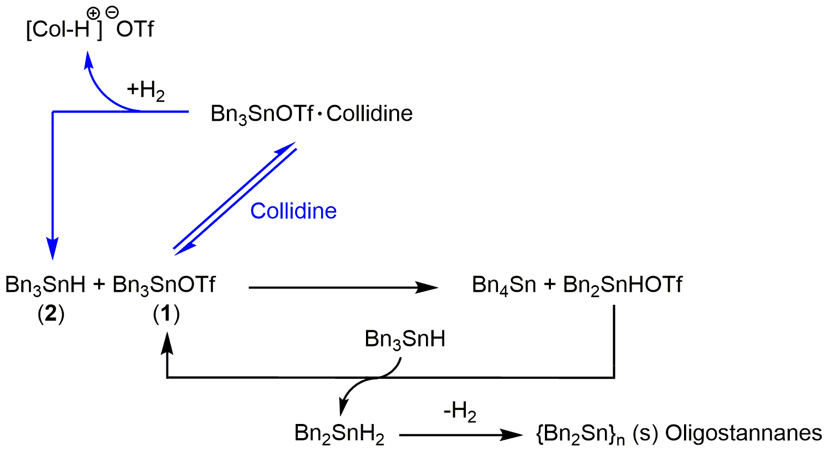
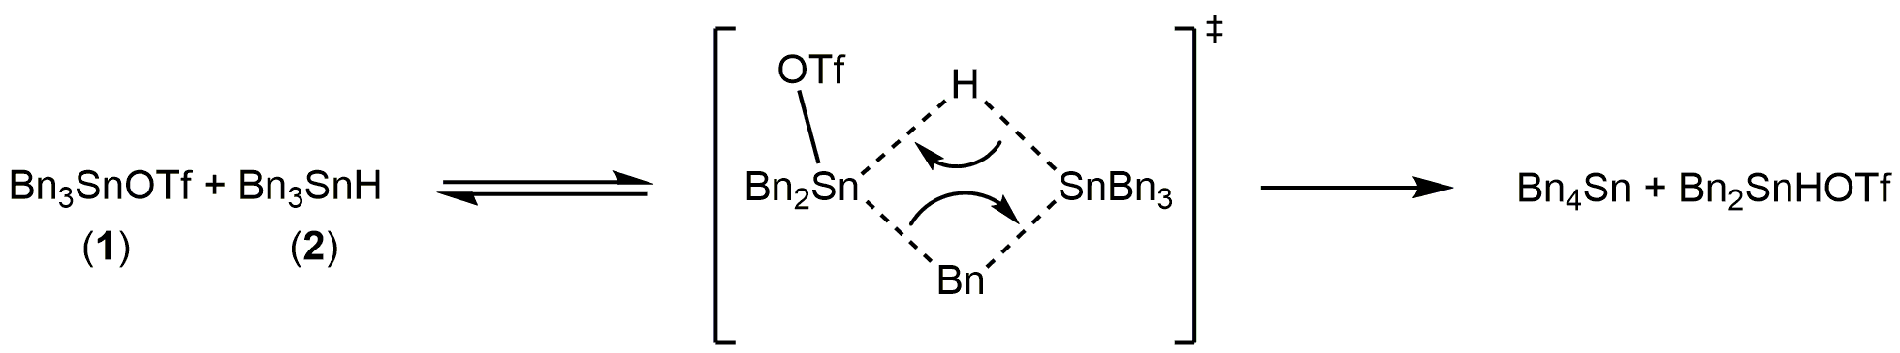
Figure 4: Proposed deactivation pathways for Bn₃SnX (X = H, TfO; 1, 2) during H₂ heterolysis reactions.

It is postulated that the combination of 1 and 2 leads to formation of a binuclear complex (Figure 4, bottom), as evidenced by a broadening of resonances in the ¹H NMR spectrum. Rearrangement of this intermediate through PhCH₂/H exchange between Sn centres could then lead to formation of the observed Bn₄Sn and Bn₂Sn(H)OTf (corresponding to the δ = 9.01 ppm resonance in the ¹H NMR spectrum). Bn₂Sn(H)OTf is expected to be highly reactive by analogy with its ^{n}Bu analogue (hence its low steady-state intensity). Subsequently Bn₂Sn(H)OTf reacts with the more powerful hydride donor 2, which reforms 1 and accordingly produces the observed Bn₂SnH₂ (¹H NMR: δ = 5.28 ppm). R₂SnH₂, especially those containing R groups of a low steric threshold (e.g. ^{n}Bu, Bn) are also highly reactive compounds which are prone to decomposition via a radical chain mechanism, forming H₂ and complex mixtures of oligo/polystannanes {R₂Sn}_{n}, which for Ph-rich species can display poor solubility, especially when cross-branching occurs [from dehydrocoupling with (PhCH₂)₃SnH];[40] the latter explains the observation of a precipitate and overall loss of ¹H NMR signal intensity during the reaction, as the PhCH₂ groups are sequestered from solution.
The stabilising effect when collidine is present may thus be explained by its ability to form a 1-collidine adduct which competes with, and effectively retards, the formation of the complex between 1 and 2, thereby inhibiting the rate of decomposition; this result corroborates the idea that facile formation of the binuclear complex is key to the deactivation mechanism. It should also be emphasised that the presence of [col-H]⁺ in this reaction can be rationalised from the 1/collidine-mediated cleavage of H₂, the latter formed from decomposition of Bn₂SnH₂, which leads to 2 (which re-enters the cycle) and the build-up of [col-H⁺], as observed. It is hence plausible that this constant syphoning of 2 from the system via ligand scrambling and subsequent decomposition may explain the incomplete conversion of 1 to 2 during the normal H₂ activation reaction by 1/collidine under a H₂ atmosphere [Section 3(b)]. Finally, H₂ activation by the incipiently formed Bn₄Sn, in conjunction with collidine, can be discounted since an independent experiment of this combination under H₂ failed to show any reaction; this observation is in line with the poor Lewis acidity of tetralkyltin compounds.

(d) Imine hydrogenations
Despite the observation of subsequent decomposition, the successful activation of H₂ encouraged us to proceed to investigate the use of 1 in FLP hydrogenation reactions. It was hoped that, although 2 may exist only transiently in the presence of a suitable unsaturated substrate, the rate of reduction might exceed the rate of any undesirable side-reactions. Thus, as an attempted proof-of-principle, initial attention was focused on the imine Ph(H)C=NPh, (3), which is an archetypal substrate for FLP-mediated catalytic hydrogenations. When H₂ (10 bar) was added to a solution of imine 3 and 1/collidine (10 mol%) in C₆D₆ and the solution subsequently heated to 50 °C, hydrogenation was indeed observed, with formation of amine PhCH₂NHPh (4) (13.9 % conversion after 128 h; Table 2, entry 2); it is of note that imine hydrogenation using ^{i}Pr₃SnOTf required significantly higher temperatures (120 °C) for any reaction under analogous conditions.[14]

Table 2: 1-catalysed hydrogenation of Ph(H)C=NPh
***TABLE 2 IN HERE***

Unfortunately only low conversion is observed, with that the rate of conversion decreasing as a function of time (5 h 6%; 21 h 10.1%; 66 h 13.3% and 128 h 13.9%), concomitant with the formation of resonances attributable to Bn₄Sn, and hence with decomposition of 1/2 (vide supra). Nevertheless, this is still one of a very small number of examples of FLP-type hydrogenation using a p-block LA catalyst based on an element other than boron.[14,41,42]
Attempts to increase the rate of reaction and percentage of imine conversion by raising the temperature to 70 °C led to no more than minor improvements in rate (Table 2), and resulted in the complete decomposition of 1 (via 1/2) to Bn₄Sn (as observed by ¹H and ¹¹⁹Sn{¹H} NMR spectroscopy). Conversely, at ambient temperatures decomposition was observed to a much lesser extent, but at the expense of even poorer conversion (4.3% after 128 hours); nonetheless this result does demonstrate that H₂ activation occurs even at room temperature for the 1/collidine system. Ultimately, however, it seems clear that the potential for 1 to engage in useful FLP hydrogenation catalysis is unfortunately limited by the reduced chemical stability of the Bn₃Sn core (relative to ^{i}Pr₃Sn, for example).

4. Conclusion
The Sn-based LA, Bn₃SnOTf, has been synthesised in excellent yield and fully characterised in both the solution and solid state. X-ray crystallography reveals an extended polymeric structure with triflate anions bridging two Bn₃Sn cores and a 5-coordinate, trigonal bipyramidal, geometry around the Sn centre; this is a rare example of a structurally characterised triorganotin triflate. Subtle modulation of the electronics at the Sn centre by incorporating benzyl instead of the more common alkyl ligands on the R₃Sn core has allowed for a successful increase in R₃SnOTf Lewis acidity, as evidenced by the comparison of AN values calculated from the Gutmann-Beckett spectroscopic method. This increase in Lewis acidity was further corroborated by the lower temperature and pressure at which Bn₃SnOTf activates hydrogen in comparison with previously reported alkylated analogues. Competing decomposition/deactivation pathways preclude stable H₂ activation for use in catalysis at elevated temperatures, however; these were probed and it was posited that a binuclear complex forming between Bn₃SnOTf and the product of H₂ activation, Bn₃SnH, leads to ligand scrambling and ultimately deactivation to Bn₄Sn. Future efforts are focused on the synthesis of new triorganotin Lewis acids which display enhanced Lewis acidity to mediate rapid H₂ activation, yet retain a high degree of thermal stability, for use as FLP hydrogenation catalysis.

Additional Information
Information on the following should be included wherever relevant.

Data Accessibility
Additional data supporting this article have been uploaded as part of the Electronic Supplementary Material. Crystallography data of 1 has been deposited in the CCDC, number 1534626. They are available online.

Authors' Contributions
R.T.C., J.S.S. (PhD student) and R.C.T-R. (PhD student) carried out the majority of the experiments and characterisation, interpreting the results and writing the manuscript. D-H.H. (undergrad student) contributed to the experimental data and characterisation studies. A.J.P.W collected and processed X-ray crystallography data. A.E.A. conceived and designed the study with R.T.C.. All authors read and approved the manuscript.

Competing Interests
The authors declare that they have no competing interests.
Funding Statement
We greatly acknowledge funding for this work from the Royal Society for a University Research Fellowship (A.E. A; UF110061), the EPSRC for R.T.C. (EP/N026004/1), and Imperial College for a President’s PhD Scholarship (R.C.T-R).

Acknowledgments
We would like to thank Pete Haycock, Imperial College London, for NMR spectroscopic measurements.

References

1 J. S. J. McCahill, G. C. Welch and D. W. Stephan. 2007. Reactivity of ‘frustrated Lewis pairs’: Three-component reactions of phosphines, a borane, and olefins. Angew. Chemie - Int. Ed. 46, 4968–4971. (doi:10.1002/anie.200701215)
2 D. W. Stephan. 2016. The broadening reach of frustrated Lewis pair chemistry. Science (80-. ). 354, 1248. (doi:10.1126/science.aaf7229)
3 D. W. Stephan and G. Erker. 2015. Frustrated Lewis pair chemistry: Development and perspectives. Angew. Chemie - Int. Ed. 54, 6400–6441. (doi:10.1002/anie.201409800)
4 D. W. Stephan. 2015. Frustrated lewis Pairs. J. Am. Chem. Soc. 137, 10018–10032. (doi:10.1021/jacs.5b06794)
5 G. C. Welch, R. R. S. Juan, J. D. Masuda and D. W. Stephan. 2006. Reversible, Metal-Free Hydrogen Activation. Science (80-. ). 314, 1124–1126. (doi:10.1126/science.1134230)
6 G. C. Welch and D. W. Stephan. 2007. Facile heterolytic cleavage of dihydrogen by phosphines and boranes. J. Am. Chem. Soc. 129, 1880–1881. (doi:10.1021/ja067961j)
7 P. Spies, G. Erker, G. Kehr, K. Bergander, R. Fröhlich, S. Grimme and D. W. Stephan. 2007. Rapid intramolecular heterolytic dihydrogen activation by a four-membered heterocyclic phosphane–borane adduct. Chem. Commun. 2, 5072. (doi:10.1039/b710475h)
8 P. A. Chase, G. C. Welch, T. Jurca and D. W. Stephan. 2007. Metal-free catalytic hydrogenation. Angew. Chemie - Int. Ed. 46, 8050–8053. (doi:10.1002/anie.200702908)
9 P. A. Chase, T. Jurca and D. W. Stephan. 2008. Lewis acid-catalyzed hydrogenation: B(C6F5)3-mediated reduction of imines and nitriles with H2. Chem. Commun. 2, 1701–1703. (doi:10.1039/b718598g)
10 L. J. Hounjet, C. Bannwarth, C. N. Garon, C. B. Caputo, S. Grimme and D. W. Stephan. 2013. Combinations of ethers and B(C6F5)3 function as hydrogenation catalysts. Angew. Chemie - Int. Ed. 52, 7492–7495. (doi:10.1002/anie.201303166)
11 D. J. Scott, M. J. Fuchter and A. E. Ashley. 2014. Nonmetal catalyzed hydrogenation of carbonyl compounds. J. Am. Chem. Soc. 136, 15813–15816. (doi:10.1021/ja5088979)
12 T. Mahdi and D. W. Stephan. 2014. Enabling catalytic ketone hydrogenation by frustrated lewis pairs. J. Am. Chem. Soc. 136, 15809–15812. (doi:10.1021/ja508829x)
13 D. W. Stephan. 2015. Frustrated Lewis pairs: From concept to catalysis. Acc. Chem. Res. 48, 306–316. (doi:10.1021/ar500375j)
14 D. J. Scott, N. A. Phillips, J. S. Sapsford, A. C. Deacy, M. J. Fuchter and A. E. Ashley. 2016. Versatile Catalytic Hydrogenation Using A Simple Tin(IV) Lewis Acid. Angew. Chemie - Int. Ed. 55, 14738–14742. (doi:10.1002/anie.201606639)
15 G. R. Whittell, E. I. Balmond, A. P. M. Robertson, S. K. Patra, M. F. Haddow and I. Manners. 2010. Reactions of Amine- and Phosphane-Borane Adducts with Frustrated Lewis Pair Combinations of Group 14 Triflates and Sterically Hindered Nitrogen Bases. Eur. J. Inorg. Chem. 2010, 3967–3975. (doi:10.1002/ejic.201000515)
16 Y. Yu, J. Li, W. Liu, Q. Ye and H. Zhu. 2016. Amino group combined P/Ge and P/Sn Lewis pairs: synthesis and dipolar addition reactions to alkyne and aldehyde molecules. Dalt. Trans. 45, 6259–6268. (doi:10.1039/C5DT03873A)
17 D. Tofan and F. P. Gabbaï. 2016. Fluorinated antimony(v) derivatives: strong Lewis acidic properties and application to the complexation of formaldehyde in aqueous solutions. Chem. Sci. 7, 6768–6778. (doi:10.1039/C6SC02558G)
18 Z. M. Heiden and A. P. Lathem. 2015. Establishing the hydride donor abilities of main group hydrides. Organometallics 34, 1818–1827. (doi:10.1021/om5011512)
19 T. A. Rokob, A. Hamza and I. Pápai. 2009. Rationalizing the Reactivity of Frustrated Lewis Pairs: Thermodynamics of H2 Activation and the Role of Acid−Base Properties. J. Am. Chem. Soc. 131, 10701–10710. (doi:10.1021/ja903878z)
20 T. A. Smith and F. S. Kipping. 1912. CCLXV.—A study of some organic derivatives of tin as regards their relation to the corresponding silicon compounds. J. Chem. Soc., Trans. 101, 2553–2563. (doi:10.1039/CT9120102553)
21 M. Schürmann, A. Silvestri, G. Ruisi, M. A. Girasolo, A. B. Paulsen, F. Huber and R. Barbieri. 1999. The structure and dynamics of Cl-substituted tetraphenyl- and tetrabenzyl-tin(IV). J. Organomet. Chem. 584, 293–300. (doi:10.1016/S0022-328X(99)00166-7)
22 V. S. Petrosyan. 1977. NMR Spectra and structures of organotin compounds. Prog. Nucl. Magn. Reson. Spectrosc. 11, 115–148. (doi:10.1016/0079-6565(77)80005-8)
23 T. Yamakawa, H. Kinoshita and K. Miura. 2013. Synthetic utility of tribenzyltin hydride and its derivatives as easily accessible, removable, and decomposable organotin reagents. J. Organomet. Chem. 724, 129–134. (doi:10.1016/j.jorganchem.2012.11.007)
24 G. C. Welch, L. Cabrera, P. A. Chase, E. Hollink, J. D. Masuda, P. Wei and D. W. Stephan. 2007. Tuning Lewis acidity using the reactivity of ‘frustrated Lewis pairs’: facile formation of phosphine-boranes and cationic phosphonium-boranes. Dalt. Trans. 9226, 3407–3414. (doi:10.1039/b704417h)
25 U. Mayer, V. Gutmann and W. Gerger. 1975. The acceptor number - A quantitative empirical parameter for the electrophilic properties of solvents. Monatsh. Chem. 106, 1235–1257. (doi:10.1007/BF00913599)
26 M. A. Beckett, G. C. Strickland, J. R. Holland and K. S. Varma. 1996. A convenient n.m.r. method for the measurement of Lewis acidity at boron centres: Correlation of reaction rates of Lewis acid initiated epoxide polymerizations with Lewis acidity. Polymer (Guildf). 37, 4629–4631. (doi:10.1016/0032-3861(96)00323-0)
27 A. W. Addison, T. N. Rao, J. Reedijk, J. van Rijn and G. C. Verschoor. 1984. Synthesis, structure, and spectroscopic properties of copper(II) compounds containing nitrogen–sulphur donor ligands; the crystal and molecular structure of aqua[1,7-bis(N-methylbenzimidazol-2′-yl)-2,6-dithiaheptane]copper(II) perchlorate. J. Chem. Soc., Dalt. Trans. 251, 1349–1356. (doi:10.1039/DT9840001349)
28 J. Beckmann, E. Lork and O. Mallow. 2012. Crystal structure of polymeric triphenyltin triflate. Main Gr. Met. Chem. 35, 183–185. (doi:10.1515/mgmc-2012-0056)
29 M. Westerhausen and W. Schwarz. 1997. SYNTHESIS AND MOLECULAR STRUCTURES OF TRIS [ BIS (TRIMETHYLSiLYL ) METHYL ] STANNANE AND THE CORRESPONDING STANNYL TRIFLATE. Main Gr. Met. Chem. 20, 351–360. (doi:10.1515/mgmc.1997.20.6.351)
30 I. Zharov, B. T. King, Z. Havlas, A. Pardi and J. Michl. 2000. Crystal Structure of n-Bu3Sn+ CB11Me12-. J. Am. Chem. Soc. 122, 10253–10254. (doi:10.1021/ja001374v)
31 D. Farah, K. Swami and H. G. Kuivila. 1992. Synthesis and spectral characterization of medium ring distannacycloalkanes and their Lewis acid derivatives. J. Organomet. Chem. 429, 311–334. (doi:10.1016/0022-328X(92)83182-H)
32 A. G. Davies. Organotin Chemistry, Wiley, 2nd edn., 2004
33 S. J. Geier and D. W. Stephan. 2009. Lutidine/B(C6F5)3: At the Boundary of Classical and Frustrated Lewis Pair Reactivity. J. Am. Chem. Soc. 131, 3476–3477. (doi:10.1021/ja900572x)
34 T. J. Herrington, B. J. Ward, L. R. Doyle, J. McDermott, A. J. P. White, P. A. Hunt and A. E. Ashley. 2014. Bypassing a highly unstable frustrated Lewis pair: dihydrogen cleavage by a thermally robust silylium-phosphine adduct. Chem. Commun. (Camb). 50, 12753–6. (doi:10.1039/c4cc05905k)
35 . Note: that in our previous studies the iPr3SnOTf/DABCO (DABCO = 1,4-diazabicyclo[2.2.2]octane) Lewis pair was found to activate H2 despite evidence for similar adduct formation.[14].
36 A. Khan, R. A. Gossage and D. A. Foucher. 2010. A convenient route to distannanes, oligostannanes, and polystannanes. Can. J. Chem. 88, 1046–1052. (doi:10.1139/V10-130)
37 H. Puff, B. Breuer, G. Gehrke-Brinkmann, P. Kind, H. Reuter, W. Schuh, W. Wald and G. Weidenbrück. 1989. Bindungsabstände zwischen organylsubstituierten Zinnatomen. J. Organomet. Chem. 363, 265–280. (doi:10.1016/0022-328X(89)87114-1)
38 T. Birchall and A. R. Pereira. 1975. Nuclear magnetic resonance and Mössbauer spectra of some organotin anions. J. Chem. Soc., Dalt. Trans. 1087–1092. (doi:10.1039/DT9750001087)
39 K. Miura, D. Wang, Y. Matsumoto and A. Hosomi. 2005. Highly regio- and stereoselective hydrostannylation of alkynols with a new Lewis acidic hydrostannane. Org. Lett. 7, 503–505. (doi:10.1021/ol0474397)
40 A. G. Davies, M. Gielen, K. H. Pannell and E. R. T. Tiekink. Tin Chemistry: Fundamentals, Frontiers, and Applications, John Wiley & Sons, Ltd, Chichester, UK, 2008
41 J. A. Hatnean, J. W. Thomson, P. A. Chase and D. W. Stephan. 2014. Imine hydrogenation by alkylaluminum catalysts. Chem. Commun. 50, 301–303. (doi:10.1039/C3CC47889K)
42 T. Vom Stein, M. Peréz, R. Dobrovetsky, D. Winkelhaus, C. B. Caputo and D. W. Stephan. 2015. Electrophilic Fluorophosphonium Cations in Frustrated Lewis Pair Hydrogen Activation and Catalytic Hydrogenation of Olefins. Angew. Chemie - Int. Ed. 54, 10178–10182. (doi:10.1002/anie.201504109)

Tables

Table 1: Selected bond lengths and angles for isomorphic 1 and Ph₃SnOTf.[28] ESDs are given in parentheses.
 | 1a | 1b | 1c | 1d | Ph₃SnOTf
Sn-R length (Å) | 2.141(6)  2.147(7)  2.154(7) | 2.141(7)  2.151(6)  2.152(7) | 2.147(7)  2.157(7)  2.164(6) | 2.141(8)  2.143(7)  2.146(7) | 2.104(6)  2.117(6)  2.118(5)
Sn-O length (Å) | 2.310(4)  2.345(5) | 2.288(5)  2.351(5) | 2.317(5)  2.352(5) | 2.306(6)  2.337(5) | 2.310(4)  2.375(4)
O-Sn-O angle (°) | 177.7(2) | 177.66(18) | 176.83(19) | 176.1(2) | 175.6(1)
R-Sn-R angle (°) | 113.4(3)  118.0(3)  128.3(3) | 115.2(3)  117.7(3)  126.4(3) | 114.4(3)  117.0(3)  128.3(3) | 114.4(3)  115.9(3)  129.5(3) | 116.2(2)  117.4(2)  126.3(2)

Table 2: 1-catalysed hydrogenation of Ph(H)C=NPh
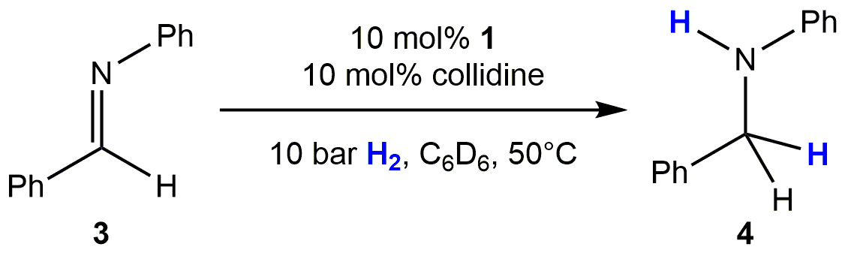
Entry | Temperature (°C) | Time (hours) | Conversion (%)
1 | 25 | 128 | 4.3
2 | 50 | 128 | 13.9
3 | 70 | 49 | 13.2

Figure and table captions
Figure 1: Synthesis of 1.
Figure 2: Molecular structure of 1 (molecule a). Ellipsoids shown at 50% probability, H-atoms omitted for clarity (C atoms blue, O atoms red, F atoms green, S atoms yellow, Sn atoms pink). Top: view of one independent Bn₃SnOTf fragment in the asymmetric unit. Bottom: extended view of the polymeric structure generated from the independent fragment along the b axis (all four independent molecules form similar polymeric chains).
Figure 3: ¹H NMR spectra of 1 and collidine in C₆D₆ before, (a) and after, (b) admission of H₂ (4 bar). Insets show Sn-H resonance and ¹J(^{117/119}Sn-¹H) satellites.
Figure 4: Proposed deactivation pathways for Bn₃SnX (X = H, TfO; 1, 2) during H₂ heterolysis reactions.

Table 1: Selected bond lengths and angles for isomorphic 1 and Ph₃SnOTf[28]. ESDs are given in parentheses.
Table 2: 1-catalysed hydrogenation of Ph(H)C=NPh

Supplementary material
Electronic Supplementary Material has been supplied in an accompanying word document.

