**A novel essential work of fracture experimental methodology for highly dissipative materials**

**C. G. Skamniotisᵃ, M. A. Kamaludinᵃ, M. Elliottᵇ, M. N. Charalambidesᵃ**

a Department of Mechanical Engineering, Imperial College London

London SW7 2AZ, United Kingdom

ᵇ Mars Petcare UK, Leicester, UK

E-mail: [c.skamniotis13@imperial.ac.uk](mailto:c.skamniotis13@imperial.ac.uk); [m.charalambides@imperial.ac.uk](mailto:m.charalambides@imperial.ac.uk)

**Keywords:** EWF, polymer**,** strain rate, remote dissipation, crack speed, crack tip blunting

**Abstract**

Determining fracture toughness for soft, highly dissipative, solids has been a challenge for several decades. Amongst the limited experimental options for such materials is the essential work of fracture (EWF) method. However, EWF data are known to be strongly influenced by specimen size and test speed. In contrast to time-consuming imaging techniques that have been suggested to address such issues, a simple and reproducible method is proposed. The method accounts for diffuse dissipation in the specimen while ensuring consistent strain rates by scaling both the sample size and testing speed with ligament length. We compare this new method to current practice for two polymers: a starch based food and a polyethylene (PE) tape. Our new method gives a size independent and more conservative fracture toughness. It provides key-data, essential in numerical models of the evolution of structure breakdown in soft solids as seen for example during oral processing of foods.

# 1 Introduction

Natural and synthetic polymers are ubiquitous in everyday life (1). Research into their deformation and fracture mechanisms has been an ongoing topic for several decades concerning scientists from diverse backgrounds and disciplines including Mechanical Engineering (2, 3), Chemistry (4, 5), Biology (6, 7) and Medicine (8, 9). Amongst their numerous applications, the food sector has recently received much attention (7, 10). Humans breakdown their food to reduce the intake into smaller pieces suitable for swallowing and digestion (7, 8, 11). This oral process and the associated sensory perception largely depends on both the food raw ingredients used and the processing parameters employed during production (12, 13). Features affecting texture and palatability can be described using mechanical properties–amongst them fracture toughness (7, 12), which describes the energy required to create new surfaces, as experienced during chewing. Therefore fracture toughness data are desirable, not at least as a key input parameter in mastication Finite Element models for predicting sensory related attributes (12, 14, 15), such as chewing force (7) and breakdown speed (10). However, various numerical methods for modelling fracture, such a cohesive traction separation law (15-19) and the element stiffness degradation framework (10, 14), are based on energy consumption strictly in the process zone at the vicinity of the crack tip (20), such that the true fracture toughness parameter is required for accurate simulations (10).

Concerns over the fracture characteristics of polymers also extend to film applications such as paint coatings (21, 22) and adhesive tapes (23, 24). The latter is investigated in this study in addition to a food product. Adhesive tapes involve pressure-sensitive adhesives (PSA) supported on thin film polymeric substrates. Example applications include labels, packaging tapes (19), transdermal patches (18) and surgical skin adhesives (23). Consequently, there is an increasing need to understand and optimise not only the interfacial (peeling) behaviour, but also the film’s fracture properties. Convenient tests for determining fracture toughness values serve either in product development through correlations to molecular structure or mass (23, 25), or in establishing engineering limits for a given application.

The fracture characteristics of soft solid polymers are nevertheless often difficult to obtain (10, 16). Both the food and the adhesion tape examples mentioned above do not obey the Linear Elastic Fracture Mechanics (LEFM) assumptions and thus the corresponding established test methods are rendered invalid (2, 10, 26). This is due to their strong time dependence, high compliance, and other dissipative phenomena such as stress softening (10). These attributes contribute to the complexity surrounding the calculation of the stored energy available for crack propagation (2, 10, 27). Test methodologies established in literature so far include the “trouser tear” test for soft bio-materials (28), wire cutting in cheese (17) and gelatine gels (16) and recently orthogonal cutting (29, 30), which was “borrowed” from work on metals (31) and lately applied to polymers (27) and other soft solids (10, 32).

Post Yielding Fracture Mechanics (PYFM) theory is seen as a viable alternative to LEFM for such materials as it describes fracture through material that has already yielded (33-35). The Essential Work of Fracture (EWF) method has proven popular in particular as it results in a single, fundamental parameter to describe stable crack growth (36, 37). Initially developed as an alternative to “J integral” tests (38, 39) due to the difficulty in performing the latter owing to severe blunting during crack growth, the method is simple in that it separates the total energy distinctly into that used for fracture, and for other dissipative processes nonessential to fracture (36). While originally used to obtain the plane stress fracture toughness of thin sheets, recent work has extended the method to thicker specimens (plane strain) (40-43) as well as viscoelastic materials (10, 44).

However, the EWF method has not yet led to a published test standard (36, 45), as round-robin tests have highlighted the effect of factors such as specimen size (10, 46, 47), thickness (41, 48, 49), speed (50, 51) and notching procedure (36, 52, 53) on the derived data, although the notching problem is a common concern across much of polymer testing (54). Concerns have also been reported (27, 44) regarding the potential variation in the stress state local to the crack tip affecting the fracture process when different ligament lengths are used (see section 2 for a description of the classic EWF method). Specifically Rink et al (38) demonstrated that a true toughness value at crack initiation may be determined only when full yielding occurs in all the ligament lengths. More importantly, the EWF method as it currently exists does not adequately account for the contribution of the specimen arms (denoted as region $V_{e}$,in Figure 1) to the total energy (34, 36). It assumes that energy is dissipated only within a limited region, $V_{p}$, (see Figure 1), local to the yielded ligament. This led to various corrections being proposed (34, 44, 47). The recommendation is that using a gauge length, *g*, equal to the ligament length, *l,* (see Figure 1(c)) to measure the energy input gives more accurate results (38, 47) as opposed to measuring the deflection across the whole specimen length, *L*, (10). Drozdov et al (33) quantified the inelastic energy dissipated remotely and subtracted the amount from the total energy to derive the energy essential to fracture. Recently, Hossain et al (23) used the in- situ digital image correlation (DIC) technique to obtain full-field 2D strain distributions in the specimen and directly partition the total energy. In both of the latter two studies (34, 44), independent tensile tests were necessary in evaluating the constitutive strain energy density associated with uniaxial deformation, and Hossain et al acknowledged that an error is likely in these calculations since the stress state near the crack tip is multi-axial. Apart from the inability of DIC to track very high strain levels (34, 55), it is further argued here that such techniques may be further complicated in rate dependent polymers, which display rate dependent stress-strain curves. To summarise, current efforts to compensate for viscoelastic effects require optical, (e.g. DIC), or extensometer measurements (for gauge deflections), which can be time and cost inefficient, as well as difficult to reproduce in different labs. Finally, no study so far has considered the potential error due to the inconsistent true strain rates being applied when the ligament length is varied.

This work addresses these issues by proposing a novel modification to the EWF method so that it can account for diffuse dissipation throughout the effective specimen volume, whilst vanishing the need for correction methods such as the independent measurement of the gauge length deflection. As will be discussed, the new method ensures a common crack tip deformation state and it also corrects the inconsistency which arises when strain rates vary with the ligament length. The proposed method is validated using a starch based food product, known for its strong rate dependence and dissipative behaviour (10), as well as on a polyethylene (PE) film, with a well characterised time-dependent behaviour and high extensibility (56, 57) which magnifies the remote dissipation effects and the associated error. Starch is largely used by the food industry and the need for a robust test that determines its fracture characteristics is ever increasing (10). PE film is commonly utilized in packaging applications as well as in adhesive tape products where it is used as the substrate for pressure sensitive adhesives (18).

The outline of the paper is as follows. Firstly, a detailed analysis of the classic EWF test along with the novel EWF approach is provided, followed by the description of the materials used and the experimental procedures adopted. Thereafter, the experimental results are presented and the two methods are compared. Finally, the merits of the novel EWF approach are discussed.

# 2 Background

## 2.1 Classic EWF method

The EWF test analysis provides a fundamental material property, the specific essential work of fracture, *we*, also known as the fracture toughness, which is the energy per unit area required to create new crack faces. This energy is essentially dissipated locally at the process zone surrounding the crack tip (36). The method uses the Double Edge Notched tension (DENT) geometry shown in Figure 1. Upon loading, it is assumed that the system can be partitioned into three distinct regions that dissipate energy: the ligament section, $A_{f}$, a plastic zone surrounding the ligament, $V_{p}$, and the remaining part of the specimen, (34). The ligament area is the fracture process zone where the essential work of fracture, $W_{e},$ is dissipated to form the fracture surfaces (36). The plastic zone, $V_{p}$, is the volume that consumes the non-essential energy, $W_{p}$, due to plastic deformation (37) or other dissipative mechanisms (21). Importantly, the remaining part of the body, $V_{e}$, is assumed to deform elastically, such that it reverses its stored energy during tearing (36). The EWF method postulates that the essential work of fracture is the dissipation per unit fractured area on average over the entire crack propagation in the ligament, such that the following two assumptions are made:

a) $W_{e }$ is proportional to the ligament area, such that the specific parameter, $w_{e},$ is introduced as shown below:

$$W_{e }=w_{e}Bl (1)$$

Note that, *we*, has units of kJ/m2 and is the true fracture toughness of the material to be determined from the tests, and

b) $W_{p }$ is proportional to the volume of the plastic zone, $V_{p}$, and the shape factor, $β$, is used to give:

Figure 1. DENT configuration. a) Short specimen - high $V_{p}$/ $V_{e}$ ratio, b) Short ligament length - low $V_{p}$/ $V_{e}$ ratio, c) partitioning of the external work into the three regions: $A_{f}$, $V_{p}$, $V_{e}$- specimen dimensions and other symbols: sample length, $L$, width, $W$, gauge length, $g$, crack, $a$, ligament length, $l$, speed, $\dot{δ}$. d) illustration of the novel approach based on the three constant ratios, $S_{L}$, $S_{w}$, and, $S_{\dot{δ}}$ (see Equations 8 and 9 for definitions).

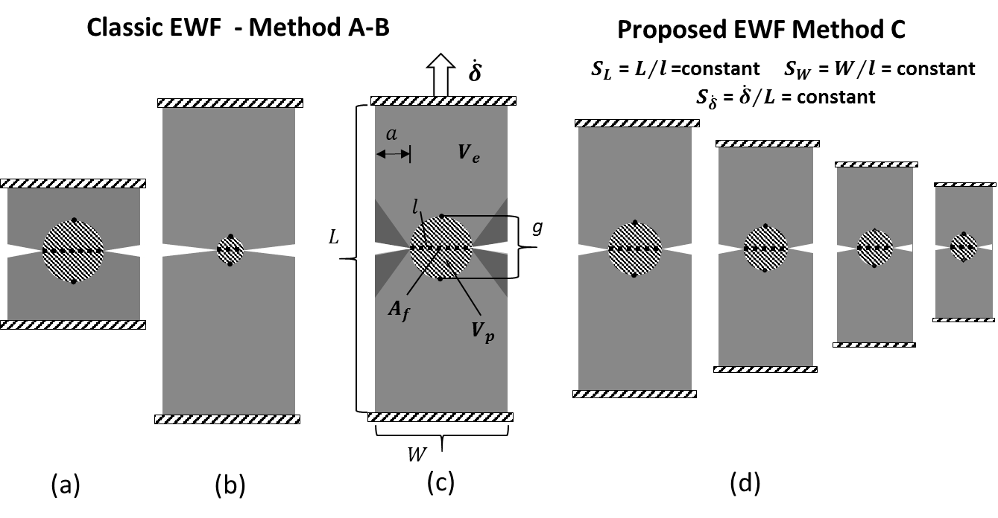

where, $B$, is the sample thickness (out of plane sample dimension in Figure 1), $l$, the ligament length, $β$, the plastic zone shape factor and the parameters $w_{e}$ and $w_{p}$ indicate the energy consumed per unit fractured area (specific essential work of fracture) and the energy dissipated per unit plastic/inelastic volume (specific plastic work of fracture), respectively (36). The term $β$ is a material dependent parameter, related to the shape of the plastic zone (26, 33, 49, 58). For simplicity, a circular plastic zone shape is commonly considered, giving a $β$ value of $π/4$, although several studies have reported a parabolic plastic zone shape between elliptical and diamond geometries (49, 58, 59). Using the energy conservation principle (36), the energy equation shown below is normalized over the ligament, to deduce:

$${W_{f}=\int_{0}^{δ}{P}dδ=W_{e }+W_{p} \underset{⇒}{\left(1\right)\&(2)} w}_{f}={W_{f}}/{Bl}{=w}_{e}+w_{p}βl (3)$$

where, $W_{f}$, is the external work, $w_{f}$, is the specific external work, $P$, the load and, $δ$, the displacement applied remotely on the sample. The parameters, $w_{e},$ and, $βw_{p}$, are determined by linear regression on specific work, $w_{f}$, test data for different ligament lengths, $l$.

## 2.2 Considerations for highly dissipative materials

The traditional EWF assumptions are valid for elastic-plastic mediums, which challenges the applicability of the method to a wider range of materials such as viscoelastic materials (10). Several studies have identified inelastic deformations often occurring in the remote region, $V_{e}$, leading to a potentially significant error in the extrapolation procedure outlined above. Therefore, the fracture parameter derived is not accurate (10, 34, 44, 47).

Specifically, higher total work, $W_{f}$, data are expected since the remote deformations are likely inelastic and do not recover instantly on unloading but are relieved slowly after the test, embodying an additional dissipation component in Equation 3. The effect tends to increase with specimen size, since more material experiences delayed recovery resulting into specimen size dependent total work data. However, it has been argued that although the extrapolation slope, $w_{p}β$, increases due to the additional contribution of bulk dissipation, yet the intercept, *we*, is preserved due to the concept of the extrapolation itself (21). It is argued here however that the bulk inelastic contribution to the total energy consumed may vary between ligaments non-proportionally, due to the common practice of keeping the specimen length, $L$, constant whilst the ligament length, $l$, is varied. Therefore, for varying ligaments and thus different plastic zone sizes, the ratio of the inelastic volume to the plastic zone volume also varies (e.g. compare $V_{p}$*/ $V_{e}$* ratio in Figures 1(b), 1(c)). This means that the error is not proportional to the ligament length, along the extrapolation line, decreasing the slope and hence providing higher intercepts. In order to correct for this potential error, the suggested practice of measuring elongation based on a gauge length, $g$, scaled with respect to the ligament length, , (10, 38, 47), is found to ensure a proportional error such that a consistent intercept is deduced, independent of specimen length, $L$.

Yet, it is argued here even when such corrections are applied, the test parameters do not guarantee consistent strain rates surrounding different ligaments, which raises further concerns in the case of strongly time dependent material behaviours. As will be discussed below, higher strain rates are encountered surrounding shorter ligaments, introducing an additional source of error which further decreases the extrapolation slope whilst also affecting the intercept of the $w_{f}$ versus $l$ line. The novel approach described below is therefore put forward.

## 2.3 Novel EWF approach

Correction against all the above potential errors necessitates a remote inelastic dissipation, $W_{in}$, which is proportional to $l$, as well as a common strain rate field history, across the ligaments tested. The method is here generalized to the case of diffuse dissipation in the whole of the specimen volume, $V$, which may also incorporate a plastic process zone such that:

$$W_{in }=W_{p }+ W_{remote } (4)$$

where $W_{remote }$ refers to the dissipative component in the volume, $V_{e }$, i.e outside the plastic zone, $V_{p}$. Similar to $w_{p}$, it can be deduced that:

$W_{in }=w_{in}V (5$)

where $w_{in}$ is the dissipation per unit plastic/inelastic volume on average over the entire sample volume, $V$. For such conditions, it is still possible to adopt the energy extrapolation scheme (Equation 3), only if the sample volume, $V$, is adjusted with regards to the ligament length, $l$, according to:

$$V=\check{β}Bl^{2} (6)$$

where $\check{β}$ is a proportionality factor with similar functionality as the plastic zone shape factor, $β$. However $\check{β}$ now relates the specimen volume to the term $Bl^{2}$ and can be defined as:

$\check{β}= S_{w}S_{L} (7$)

where $S_{w}$ and $S_{L}$ are the ratios of the specimen width, $W$, and specimen length, $L$, over the ligament length, $l$, respectively:

$$S_{w}=W/l=constant , S_{L}=L/l=constant (8)$$

Note that it is essential to keep $S_{w}$ and $S_{L}$ constant such that the extrapolation procedure using $w_{f}$ versus $l$ data is appropriate. Similar to the traditional method, Equation 6 denotes that the volume of the body is also a function of $l^{2},$ while the thickness, *B*, is preserved, implying that the method is valid for either plane stress or plane strain conditions. The fracture parameters can be similarly determined by tests on varying ligament, $l$, but also width, $W$, and total length, $L$, such that the aspect ratios, $S_{w}$, and, $S_{L}$, are preserved. Consistency in strain rates also postulates varying speed, $\dot{δ}$, with specimen length, $L$, such that:

$$S_{\dot{δ}}={\dot{δ}}/L=constant (9)$$

The ratio, $S_{\dot{δ}}$, is here called as the “strain rate constant”. In specific terms it can be now deduced that:

$$w_{f}{=w}_{e}+w_{in}\check{β}l (10)$$

which replaces the usual EWF Equation (3). Notably $W_{in}$ in the diffuse dissipation case depends on the specimen length, $L$, between the grips, for a given ligament length, $l$. However, the extrapolation intercept, $w_{e},$ is clearly not influenced, since the inelastic contribution is proportionally applied for different ligaments. Note that the new method represented by Equation 10 eliminates the need to measure deformation over a gauge length, $g$; it therefore offers a faster and more efficient way for measuring the material’s fracture toughness. Equation 8, and especially the factor, $S_{w}$, also promotes consistent stress states between ligaments, implying a common deformation state local to the crack tip (38).

The following sections compare the current EWF methods, with the novel EWF scheme represented by Equation 10. For clarity, the three methods in comparison are referenced throughout by the letters, *A*, *B,* and *C,* as outlined below:

Method *A*: Classic EWF method based on grip displacement data,

Method *B*: The method *A* results are corrected by using gauge elongation instead of grip displacement,

Method *C*: Novel EWF scheme (based on grip displacement data).

# 3 Experimental

## 3.1 Materials

**Starch based food:**

Starch samples were provided in the form of extruded sheets by Mars Petcare, Leicester, UK, from which 120 specimens were prepared for the EWF tests, using 6 specimen length/speed parameters, 5 ligament lengths per parameter and 4 repeats per parameter and ligament length. An additional 25 samples enabled uniaxial tensile tests. The samples consisted of an amorphous bio-polymer of gelatinised starch with a protein content of 3-4% w/w, and had 5 mm and 30 mm average thickness, $B$, and width, *W*, respectively. The extrudates were sealed immediately upon production to preserve the water content (10). At long timescales, re-crystallisation is known to alter the mechanical properties of such products (60); however, this was not considered presently and all the tests were conducted on two consecutive days, one week after production.

**PE:**

An adhesive tape was obtained from Klimapartner von der Heidt GmbH, in the form of 0.6 mm and 50 mm nominal thickness and width, respectively. The adhesive tape consisted of the PE substrate, the PSA and a release liner. For the EWF experiments, 90 specimens were tested, using 6 specimen length/speed parameters, 5 ligament lengths per parameter and 3 repeats per parameter and ligament length. Tensile tests were also conducted on 20 specimens. The release liner was removed prior to testing. The effect of the PSA on the measured forces was assumed to be negligible, on the basis of low modulus values reported in (18) for similar materials.

## 3.2 Uniaxial Tension

The uniaxial tensile tests aimed in characterising the constitutive response of the materials used, focusing on the dissipative behaviour due to plasticity, rate dependency and stress softening effects. Note however that such tests are not required with any of the EWF methods discussed here. A universal Zwick/Roell testing machine with a 1 kN load cell was used for all the tests. Sandpaper was glued on the grips to eliminate slippage effects on the displacement data, while a grip length of 100 and 50 mm was used for starch and PE, respectively. Specimen dies were used to obtain standard dumbbell specimens (61). Gauge lengths of 40 and 20 mm and specimen widths of 12 and 5 mm were used for starch and PE, respectively. The gauge length, $g_{o},$ was referenced by marking two dots on the sample surface; these were optically tracked during testing by a Logitech HD Pro webcam C920, at 30 frames per second, and a resolution of 1920x1080 pixels, followed by an analysis in Matlab 2016a (62) to calculate the deformed length, (10). Starch was found to be approximately incompressible in previous work (10), such that:

$$g_{i}A_{i}=g_{o}A_{o} (11)$$

where, $A_{o}$, and $, A_{i}$, are the original and current cross-sectional areas, respectively. The Hencky strain, $ε$, and true stress, $σ$, were calculated as follows:

$$ε=\ln\left(g_{i}/g_{o}\right) \left(12\right)$$

$$σ=F/A_{i}=Fg_{i}/A_{o}g_{o} (13)$$

where, $F,$ is the applied force. Similarly, the Poisson’s ratio of the tape was assumed to be 0.5, for simplicity (45). The strain rate dependency was assessed by performing monotonic tests until ultimate failure at 0.01 1/s, 0.1 1/s and 1.0 1/s constant strain rates on starch and at 10, 100, 1000 mm/min crosshead speeds on PE; these speeds corresponded to average strain rates of 0.0014 1/s, 0.014 1/s and 0.14 1/s during the test. Note that the large extensions of PE in combination with the speed limit of the screw driven machine did not allow for testing PE at rates as high as 1.0 1/s; therefore a different strain rate range than starch was used in PE. Further investigation involved stress relaxation tests, at the strain levels of 0.03, 0.06, 0.08 (10 min hold time) in starch and 0.1, 0.3, 0.8 strains in polyethylene (20 min hold time). Cyclic tests followed with the additional time of 30 sec given between unloading and reloading to observe the viscoelastic recovery. These tests were applied at maximum strains of 0.06, 0.3, and 0.9 in PE whereas in starch only one strain of 0.1 was tested. To further investigate progressive softening behaviour in starch, ten consecutive loading reloading cycles were applied at maximum strains of 0.05 and 0.15.

## 3.3 EWF preparation

**Starch based food:**

The DENT sample configuration was obtained using a surgical scalpel. Notching involved pushing razor blades held in a manual press, which facilitates a fine displacement control. A new razor was used for each cut. Method *B* (see end of section 2.3) was employed by marking two dots across the ligament (see Fig 1(c)), while the gauge elongation, $δ_{g}$, as well as crack tip propagation data were optically monitored using the same optical set up as in the uniaxial tests (section 3.2) (10). A line drawn across the sample width was used to align the blade, while the specimen was held by a drill vice to ensure notch alignment (40, 52). Thereafter, the razor sliding technique was used to create a notch tip of sufficient acuity (21, 52). Data from samples of misaligned cracks were discarded (10, 21, 36). Five nominal ligament lengths of 6, 8, 10, 12, 14 mm were tested using four replicates per condition (36, 63). The rest of the specimen details are given in Table 1. The ligament range was chosen to satisfy the commonly used plane strain criterion of, (10, 21, 33, 36), as well as the less conservative criterion against high deformations in the sample arms, (21, 41). Table 1 summarizes specimen dimensions, test parameters and results from all the EWF tests. The latter are discussed in section 4.

Table 1. Summary of EWF test specifications and results for starch and PE. The bold underlined data are used in the plots of Figure 9.

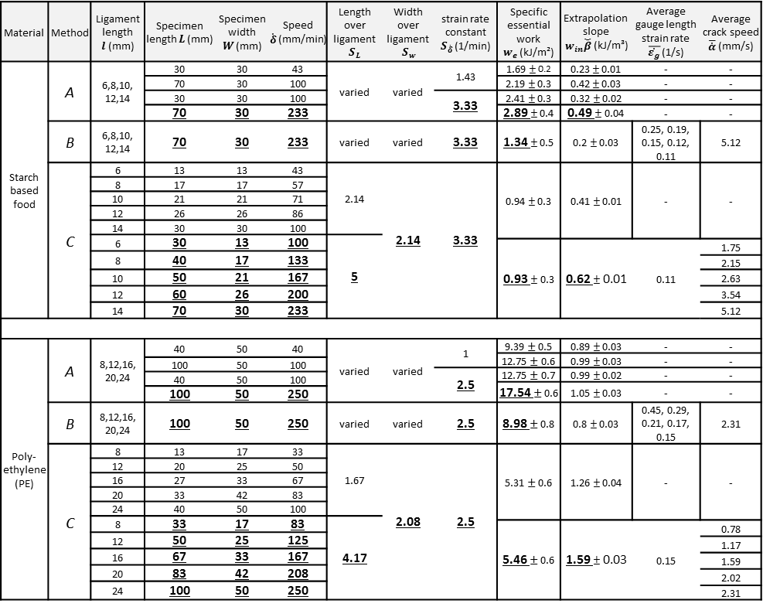

**PE:**

A surgical scalpel was used to cut the required samples from the roll of tape. The release liner was first removed prior to notching, except for within the grip lengths. The notches were then created using a razor through the sample thickness, with the aid of a reference line for parallelism. Similar to starch, method *B* was enabled by marking two dots across the ligament (see Fig 1(c)). Five nominal ligament lengths of 8, 12, 16, 20, 24 mm were tested, while three repetitions were used due to the high repeatability observed in the force displacement results, compared to starch. Test details are shown in Table 1. In contrast to the thick starch samples, the geometry was such that, $l>5B$, implying plane stress conditions (33, 36). Similar to starch, the criterion of, $l≤W/2$ was also considered.

## 3.4 EWF test parameters

The materials were initially tested according to method *A*, such that the errors discussed in section 2.2 can be quantified, as well as to allow for comparison with results from methods *B* and *C*. The strain rate effect was assessed by comparing results between specimens of the same length, $L$, tested at different speeds, $\dot{δ}$. The remote dissipation effect was highlighted by comparing different specimen lengths tested with the same rate constant, $S_{\dot{δ}}$, (Equation 9). In starch, a 30 mm specimen length was tested at two crosshead speeds of 43 and 100 mm/min, giving $S_{\dot{δ}}$ of 1.43, and 3.33 1/min, respectively, and a 70 mm length was tested at 100 and 233 mm/min speeds, giving 1.43 and 3.33 1/min, respective rate constants (see Table 1). In PE, a 40 mm specimen length was tested at 40 and 100 mm/min speeds, giving $S_{\dot{δ}}$ of 1 and 2.5 1/min, as well as a length of 100 mm at 100 mm/min and 250 mm/min speeds, implying corresponding $S_{\dot{δ}}$ of 1 and 2.5 1/min. (Table 1). The specimen design depicted in Figure 1(d) was then adopted to implement method *C* and enable a comparison with methods *A*, *B*. Two specimen to ligament length ratios, $S_{L}$, were tested for the same $S_{\dot{δ}}$ in order to investigate whether specimen length still influences the derived fracture toughness. The $S_{L}$ ratios of 2.14 and 5.00 were used in starch, whereas ratios of 1.67 and 4.17 were applied in PE. The specimen length, $L$, width, $W$, and crosshead speed, $\dot{δ}$, varied with ligament length, $l$, as Equations 8 and 9 require. Table 1 summarizes the test parameters.

# 4 Results and discussion

## 4.1 Constitutive response

**Starch based food:**

The monotonic and stress relaxation tests revealed nonlinear time dependent constitutive behaviour in starch (Figures 2(a),(b),(c)) (10). The non-linear time dependency was confirmed through plotting the relaxation modulus, $M$, versus time for each of the three constant strain levels applied in the relaxation tests (Figure 2(c)); apparently the $M$ plots do not coincide, implying non-linear rate dependency (22). More importantly, Figure 2(a) shows that the stress level increased with rate while the existence of a distinct yield point is not obvious. Little or no remaining deformations were observed when the fractured pieces were put together after a five minutes time period given to allow recovery of the viscoelastic strains. Indeed, Figure 2(d) shows very little plastic strain (0.003) while significant viscoelastic recovery is apparent. Upon unloading, hysteresis is shown while the reloading path provides strong evidence of stress softening (Figure 2(d)). Therefore, dissipation is attributed to the synergistic effect of viscoelasticity and damage (10). The latter is also highlighted in Figure 2(e), which indicates a progressively decreasing stress with increasing number of cycles, reflecting an irreversible dissipative process.

**PE:**

Similar energy loss processes were found in PE which undergoes large strains (Figure 3(a)) accompanied by remarkable plasticity (see Figure 3(b)). At low strains, a time independent linear regime is found, with an elastic modulus, $E$, of 38 MPa, followed by a rate dependent onset yield stress, ranging from 1.12 MPa to 2.13 MPa for the speed range tested; these values were calculated via the 2% strain offset method. Figure 3(c) shows the stress relaxation behaviour, whereas Figure 3(b) reveals a large amount of hysteresis upon unloading, even at the low strain of 0.06. Noticeable viscous strains are relieved during recovery at 0.3 applied strain, giving a remaining plastic strain of 0.06, as opposed to a 0.52 plastic strain when unloading from a 0.9 strain. In contrast to starch, the plastic energy dissipation is significant for PE.

Figure 2. Uniaxial tensile starch data. (a) Monotonic response for various strain rates, (b) Stress relaxation at 0.03, 0.06 and 0.08 strain levels (10 min hold time),(c) Corresponding relaxation modulus plots for these strain levels, (d) Cyclic response with added 30 sec recovery time, (e) Repetitive 10 cycles at 0.05, 0.15 strains.

Figure 3. Uniaxial tensile PE results. (a) Stress-strain curves for average strain rates of 0.0014, 0.014 and 0.14 1/s. (b) Cyclic tests at maximum strains of 0.06, 0.3 and 0.9 with added 30 sec recovery time. (c) Stress relaxation behaviour for strains of 0.1, 0.3 and 0.8, held constant for 20 min.

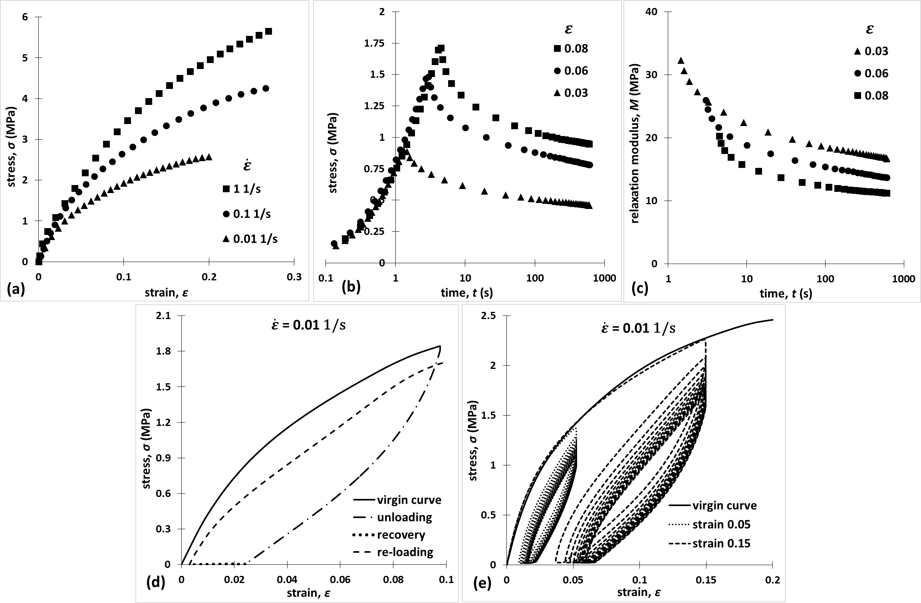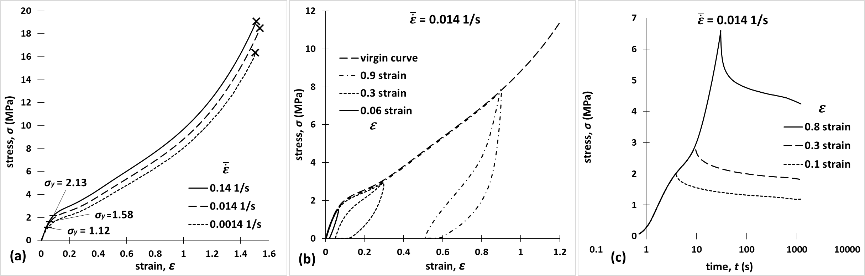

## 4.2 Force displacement behaviour

Figures 4(a) and 4(b) report averaged load, $P$, normalized by the sample thickness, $B$ (5 mm for starch and 0.6 mm for PE) versus displacement data, $δ$, using method *A*, for the maximum ligaments, 14 mm and 24 mm for starch and PE, respectively. The values of $L$ and $\dot{δ}$ are given in the Figure, whereas $W$ was 30 mm for starch and 50 mm for PE. Since the tests were designed for the plane strain and plane stress regime correspondingly for starch and PE, the results were considered thickness independent (10, 40). Therefore $P/B$ is plotted against $δ$ as it better represents a material specific behavior. However, note that the plane strain assumption in starch (see section 3.3) requires further validation. This owes to the well-known peculiar behavior of starch (10), for which the validity of the commonly used EWF plane strain requirement ($l<3B$) has not yet been investigated. The parameters used here provided the best possible practice for the scope of this study. Clearly, the loads increase with speed (Figures 4(a), 4(b)). For the same speeds, the failure displacement increases for longer $L$. However, the maximum loads are common for different sample lengths which were tested at the same $S_{\dot{δ}}$. This is due to the associated strain rates applied, which are deemed to be the same for the different values of $L$. A similar behavior was found in all the ligaments tested using method *A* (results not shown).

Figure 4. Method A. Averaged normalized forces against displacement traces between four sets of speeds and specimen lengths, (a) Starch, (b) PE.

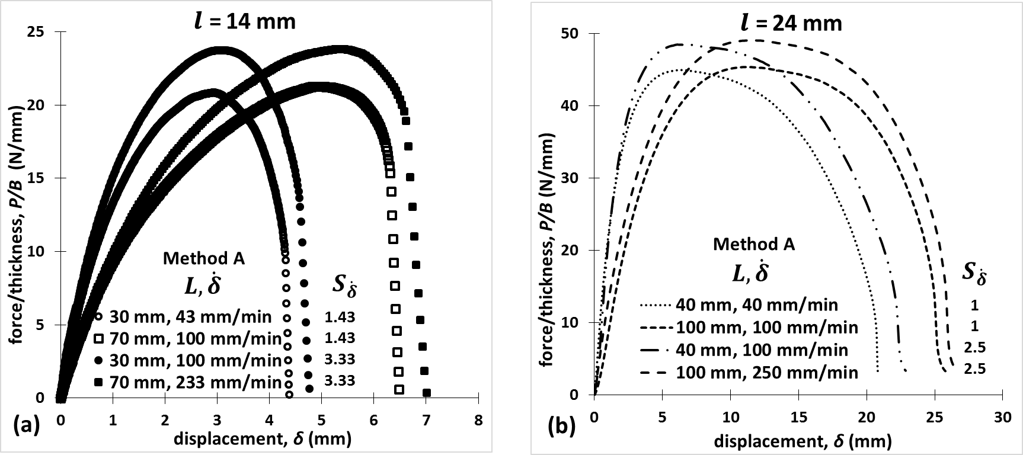

Figures 5(a), 5(b) report $P/B$ against $δ$ data for method *A*, while Figures 5(c), 5(d) report the same data for method *C*. Overall, the curves demonstrate the self-similarity concept (21, 45, 64) among the ligaments tested in both materials; self-similar curves were also apparent for method *B* (shown later in Figure 6). Except for the data corresponding to the maximum ligament, which were common for the two methods (see Table 1), the curves show lower $P/B$ values in method *C* compared to method *A,* particularly for the short ligament lengths, $l$. This is attributed to the higher strain rates expected with decreasing $l$ in method *A*.

Figure 5. Averaged normalized load versus displacement among all the ligaments: (a) method A in starch, (b) method A in PE, (c) method C in starch, (d) method C in PE. The self-similarity criterion is met.

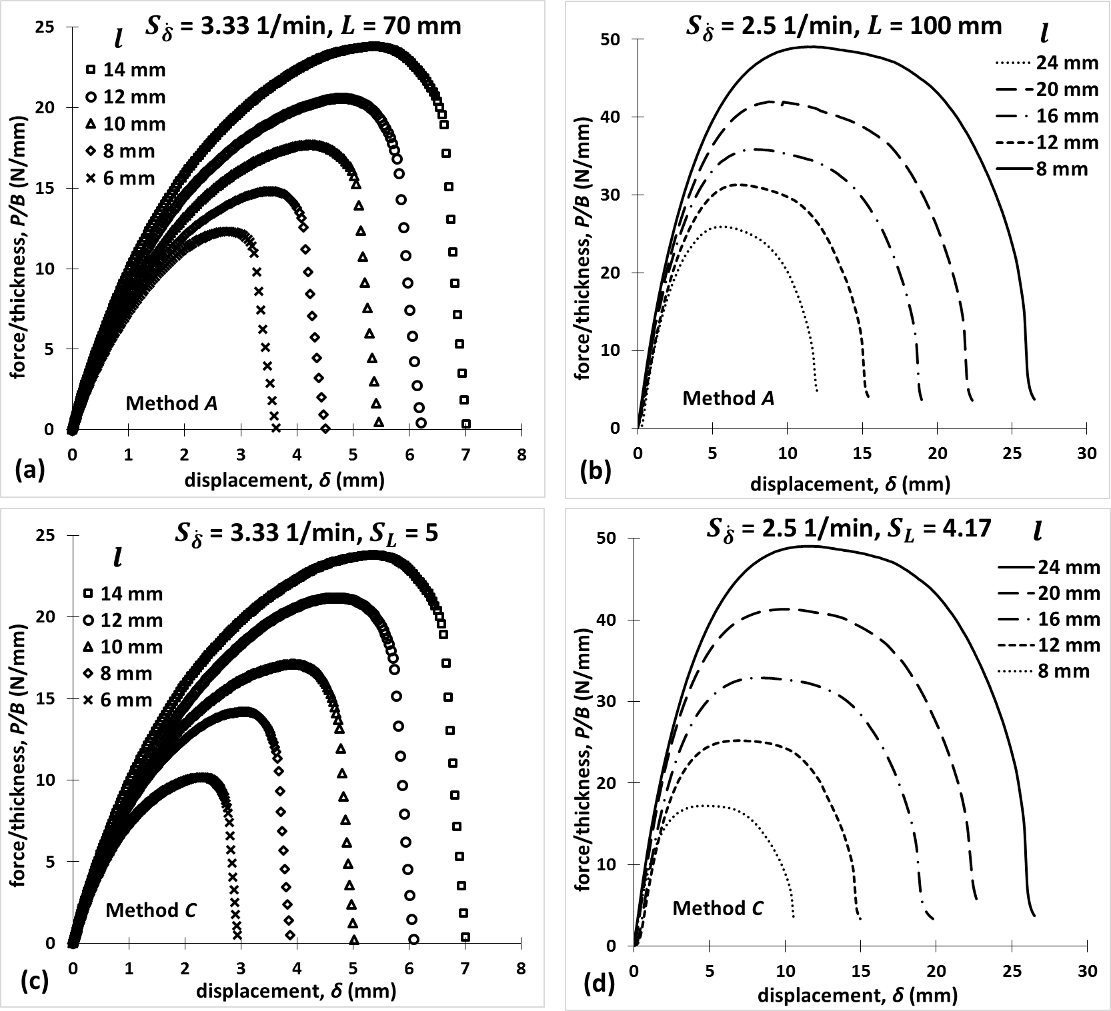

Figures 6(a) and 6(b) illustrate normalised load, $P/B$, versus gauge elongation, $δ_{g}$, data along with four distinct stages throughout the tests and their corresponding video frames for the maximum ligament in each material, for method *B*. The sample wrinkling/out of plane bending, visible in Figure 6(b), is a typical behaviour of thin sheets during stretching, attributed to the boundary conditions applied by the tensile clamps (65). Large length/thickness ratios are expected to promote such phenomena (37), which were eliminated in (66) by using special tensile grip fixtures. However, in contrast to the specimens of $L$ = 100 mm, no wrinkling occurred in the short PE specimens of $L$ = 40 mm, while both lengths gave consistent maximum force data, for common $S_{\dot{δ}}$, as Figure 4(b) denotes. This quantitative evidence suggested that the observed wrinkling in this case does not disturb the comparison of the EWF methods *A*, *B* and *C*; thus the special fixtures proposed in (66) was not judged necessary. It should be also noted that practical limitations may also apply in using these fixtures in method *C,* due to the sample size being varied. Interestingly, both materials demonstrate crack initiation ($I$) well before the maximum load is encountered () (38). Stage $III$ refers to unstable crack growth in starch and load drop in PE while stage $IV$ corresponds to final sample separation. Unstable crack paths were observed in starch, in agreement with previous studies (10), while significant crack tip blunting is apparent in the PE samples (42, 58). It is important to note that the optical means enabled identifying crack initiation with an accuracy of 21 pixels/mm. Specifically, the two opposite crack tip displacement subsequent measurements were used to determine the associated reduction on the ligament length, such that the crack length data were free of crack tip rigid body motion. On the other hand, it was impossible to optically identify yielding in PE or damage in starch (starch does not yield). Note that the data shown of Figures 4-6 as well as the rest of the data from the tests listed in Table 1 were repeatable with a typical variability in the area computed under the curves being less than 5% for starch and 2% for PE.

## 4.3 EWF methods

Figure 6. Method B. Normalized load versus gauge elongation curves across ligaments. Four stages during tearing along with synchronized video frames: (I) Initiation, (II) Maximum load, (III) Instability (starch)/load drop (PE), (IV) separation, (a) Starch sample of $L$, 70 mm, (b) PE specimen of $L$, 100 mm.

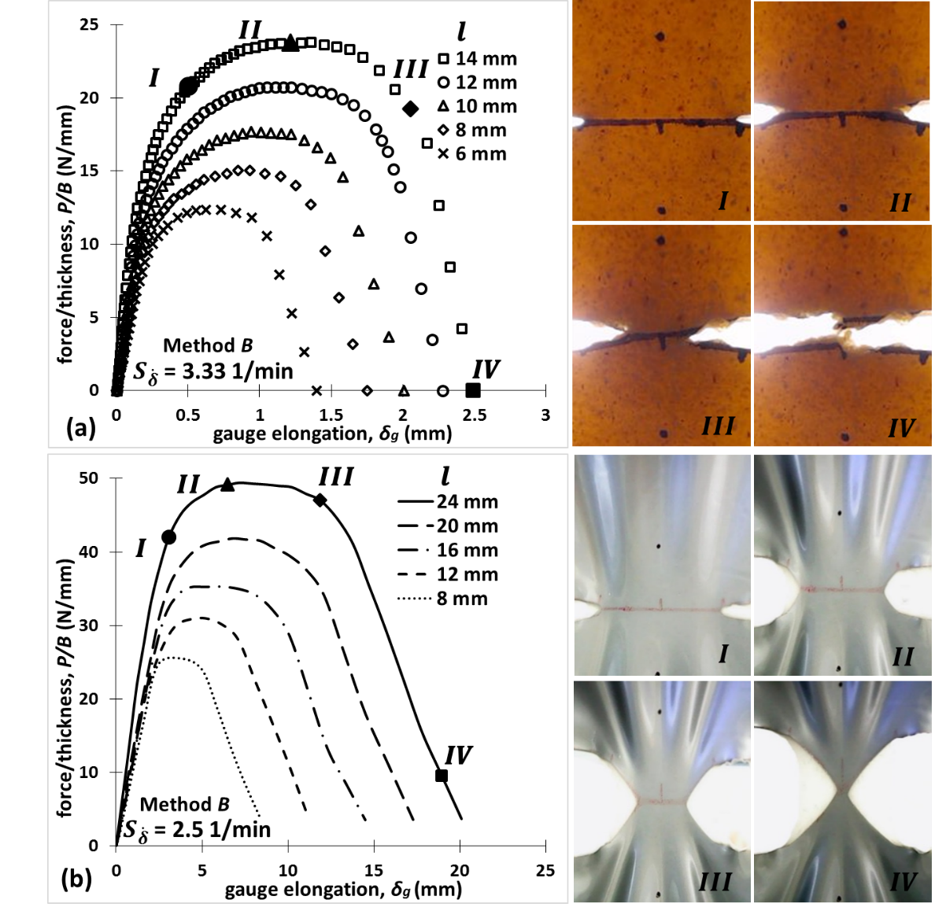

The data presented in section 4.2 are utilized here to perform the EWF extrapolation procedure according to methods *A*, *B* and *C*. The comparison of these methods is addressed as such: firstly the shortcomings of method *A* are highlighted in Figure 7 and discussed; thereafter, the merits of method *C* are depicted in Figure 8; finally in Figure 9 all the methods (methods *A*, *B* and *C*) are compared with special focus on the merits of method *C* over the currently accepted best practice of EWF testing, method *B.*

To start with, Figures 7(a), 7(b) depict the method *A* results for the four combinations of specimen length, $L$, and speed, $\dot{δ}$, for starch and PE, respectively. The speed effect is revealed by comparing specimens of the same $L$, tested at different $\dot{δ}$, whereas the specimen size effect is isolated by comparing samples with different $L$, tested at the same strain rate constants, $S_{\dot{δ}}$, (see Table 1). Overall, both materials show a common trend in terms of increasing essential work, $w_{e}$, (intercept of lines) with increasing $\dot{δ}$ and $L$ (the latter at the same $S_{\dot{δ}}$), attributed to material rate dependency (10) and remote dissipation, respectively. No significant effect of speed, $\dot{δ}$, on the inelastic work (slope of lines) is apparent. As explained in section 2.2, bulk inelastic deformations contribute non-proportionally to the specific work, $w_{f}$, data with varying ligament length, $l$, such that a higher intercept, with increasing specimen length, $L$, is expected. Indeed, starch demonstrates this effect, with a noticeable increase in the essential work, $w_{e}$, result. Interestingly, the phenomenon is more severe in PE as it gives a remarkably higher $w_{e}$ while the slope increases very little. It is argued here that the observed speed effect on the derived $w_{e}$ is a real effect since it arises due to the material’s rate dependent constitutive behaviour. In contrast, the specimen length parameter, $L$, affects the true $w_{e}$ calculation leading to a sample size dependent result which of course is not correct. In addition, when both effects are occurring simultaneously, as in the present study, the EWF results between specimens with different $L$, tested at the same $\dot{δ}$, will lead to different values of $w_{e}$. This is because varying $L$ whilst leaving $\dot{δ}$ unchanged implies different strain rates.

Figure 7. Method A data for the four sets of parameters: specimen length, $L$, speed, $\dot{δ}$. The speed effect is investigated for 30, 70 mm and 40, 100 mm specimen lengths in starch and PE, respectively, for two speeds. The specimen length effect is studied for two speed to rate constants, $S_{\dot{δ}}$; 1.43, 1.33 1/min and 1, 2.5 1/min in starch and PE, respectively, (a) Starch, (b) PE.

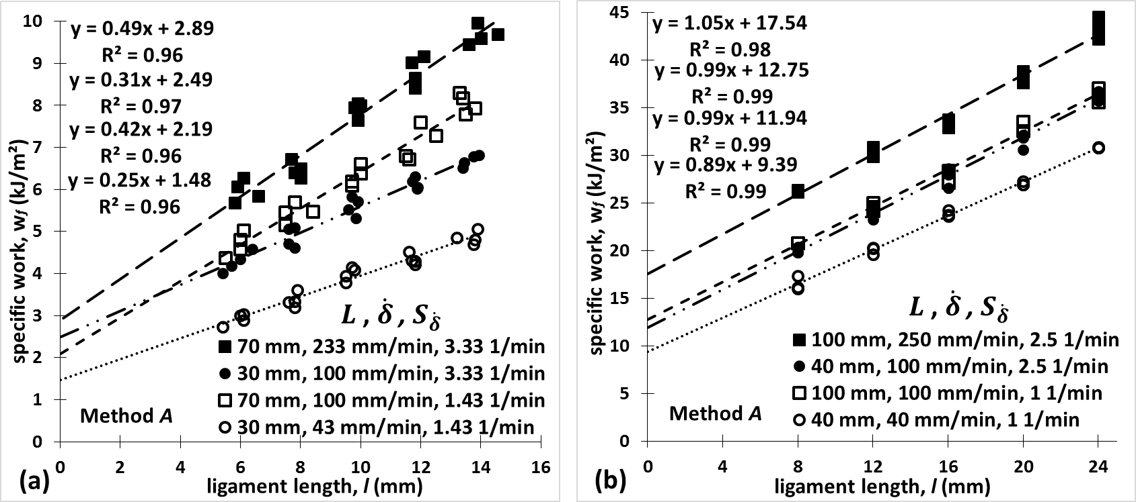

Figures 8(a), 8(b) report the method *C* data for two specimen configurations and associated parameters; $S_{\dot{δ}}$ = 3.33 1/min, $S_{W}$ = 2.14, $S_{L}$ = 5, 2.14 for starch and $S_{\dot{δ}}$ = 2.5 1/min, $S_{W}$ = 2.08, $S_{L}$ = 4.17, 1.67 for PE. In contrast to the discrepancies associated with Method *A* discussed above, different specimen configurations yield practically the same essential work, $w_{e}$, for both materials. This is strong evidence that a true fracture toughness value is determined, independent of specimen dimensions (67), such that it can be deemed crack tip specific (2).

Figure 8. Method C results for two specimen length to ligament length ratios ( $S_{L}$ ratios) and related parameters; $S_{\dot{δ}}$ = 3.33 1/min, $S_{W}$ = 2.14, $S_{L}$ = 5, 2.14 and $S_{\dot{δ}}$ = 2.5 1/min, $S_{W}$ = 2.08, $S_{L}$ = 4.17, 1.67, for starch and PE, respectively, (a) Starch, (b) PE.

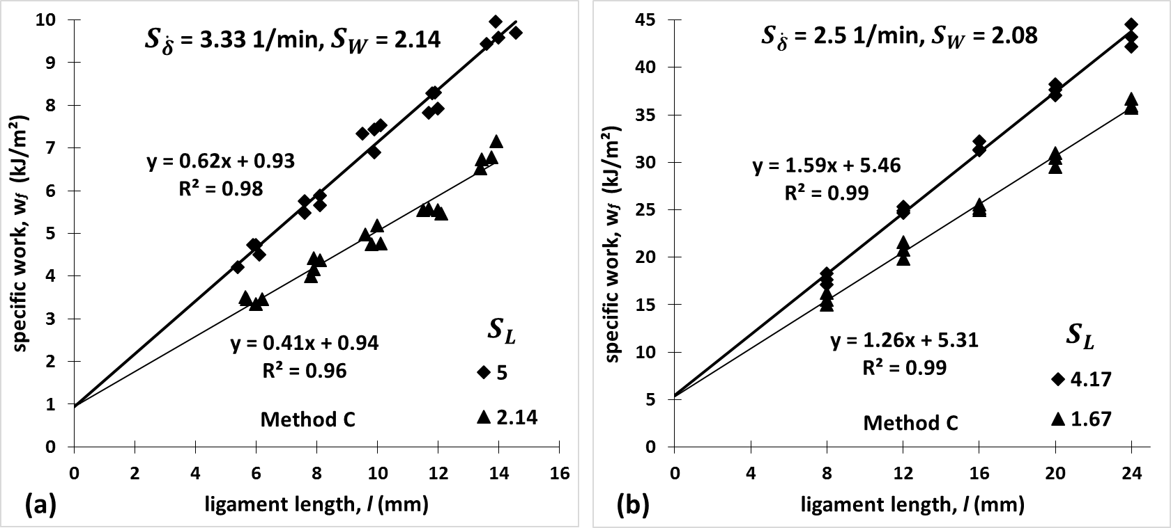

Using all the data corresponding to $S_{\dot{δ}}$ = 3.33 1/min, for starch and 2.5 1/min, for PE (see Table 1) comparisons can now be made between all three methods *A*, *B* and *C* as shown in Figure 9. The data used in this plot are underlined in Table 1 for clarity. The comparison reveals a large discrepancy between methods *A* and *C* ( $w_{e}$ values of 2.89 kJ/m² and 0.93 kJ/m² respectively for starch and 17.54 kJ/m², 5.46 kJ/m² for PE), as opposed to method *B* which deduces essential work, $w_{e}$, values (1.34 KJ/m² for starch and 8.98 KJ/m² for PE) which are closer to the ones of method *C*. The latter is in agreement with previous studies, which suggest the use of extensometers to measure elongation across a gauge length, $g$, as an accurate technique for eliminating the effect of the bulk energy dissipation on the derived fracture toughness (method *B*) (10, 38, 47). The $w_{e}$ value of method B also falls close to results of our previous investigation (10) in a similar starch recipe. Yet, the novel scheme proposed here (method *C*) yields a more conservative $w_{e}$ value consistently in both materials. It is suggested that the deviation is mainly due to the different strain rates applied on the samples of varying ligament lengths. Specifically, in method *B*, higher strain rates occur locally at the crack tip in shorter ligaments. In rate dependent materials, such as the materials in hand, this leads to overestimated specific external total work, $w_{f}$, with decreasing ligament, $l$, and hence a further drop in the extrapolation slope, giving higher $w_{e}$ intercepts. The strain rate effect is further discussed in the following section.

Figure 9. Comparison between methods A, B and C, (a) Starch, (b) PE.

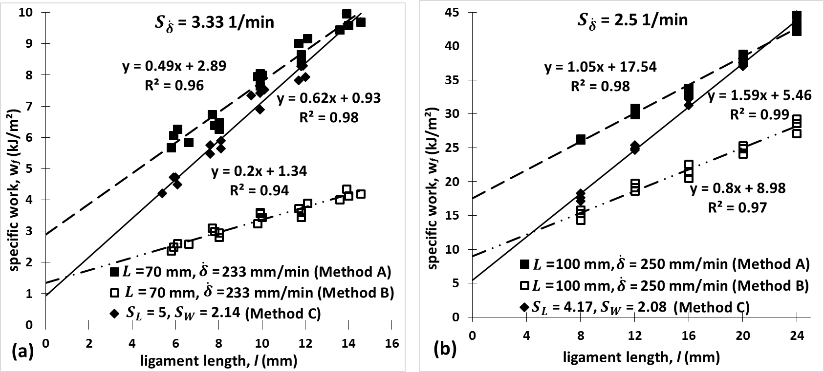

## 4.4 Strain rates between ligaments

To gain further understanding of the strain rate inconsistency affiliated with methods *A* and *B*, the optically derived crack propagation data were related to the gauge elongation recordings. Since method *B* is only a correction applied on the method *A* data, both methods *A* and *B* are represented by the same strain rates and crack speeds, referenced as method ‘*A-B*’ results; these are compared to the method *C* data. The measured gauge elongation in Method *B* was divided by the original gauge length, $g$, such that the concept of ‘gauge strain’, $ε_{g}$, could be adopted to describe the order of the strains applied in the confined region surrounding the ligament in the volume, $V_{p}$. Figures 10a and 10b depict averaged crack length (method *A-B*) and gauge strain versus time (method *B*), respectively, among all the ligaments for starch. Figures 10c and 10d illustrate the respective curves for method *C*.

The data are presented in the same order for PE in Figures 11a, 11b for method *A-B* and method *B* respectively and Figures 11c, 11d for method *C*. The intercepts between the dashed lines and the plotted curves in Figures 10(b),(d) and 11(b),(d), indicate the approximate crack initiation points, which are discussed in the following section. The propagation data of the two cracks either side of each DENT sample were averaged to compute a single crack length–time curve (10, 38). Thereafter the averages between four and three replicates for each ligament in starch and PE were evaluated, respectively. The incremental crack speeds were calculated by time differentiation and the mean speed values over the whole time range were considered. In agreement with a previous study (10), starch showed a significant number of negative crack speed increments owing to crack bifurcation mechanisms occurring. These negative increments were ‘corrected’ by applying a five-point mean smoothing function to the raw crack speed data, using Matlab (62).

Figure 11. Optical data for all ligament lengths in PE synchronized with testing machine recordings, (a) Methods A-B, crack length histories, common average crack speed, $\overline{\dot{a}}$ = 2.31 mm/s, (b) Method B, gauge strain against time, varying rates, (c) Method C, crack length versus time, varying speeds, (d) Method C, gauge strain histories, common average gauge strain rate, $\overline{\dot{ε_{g}}}$ = 0.15 1/s. Intercepts of dashed lines denote the approximate crack initiation points.

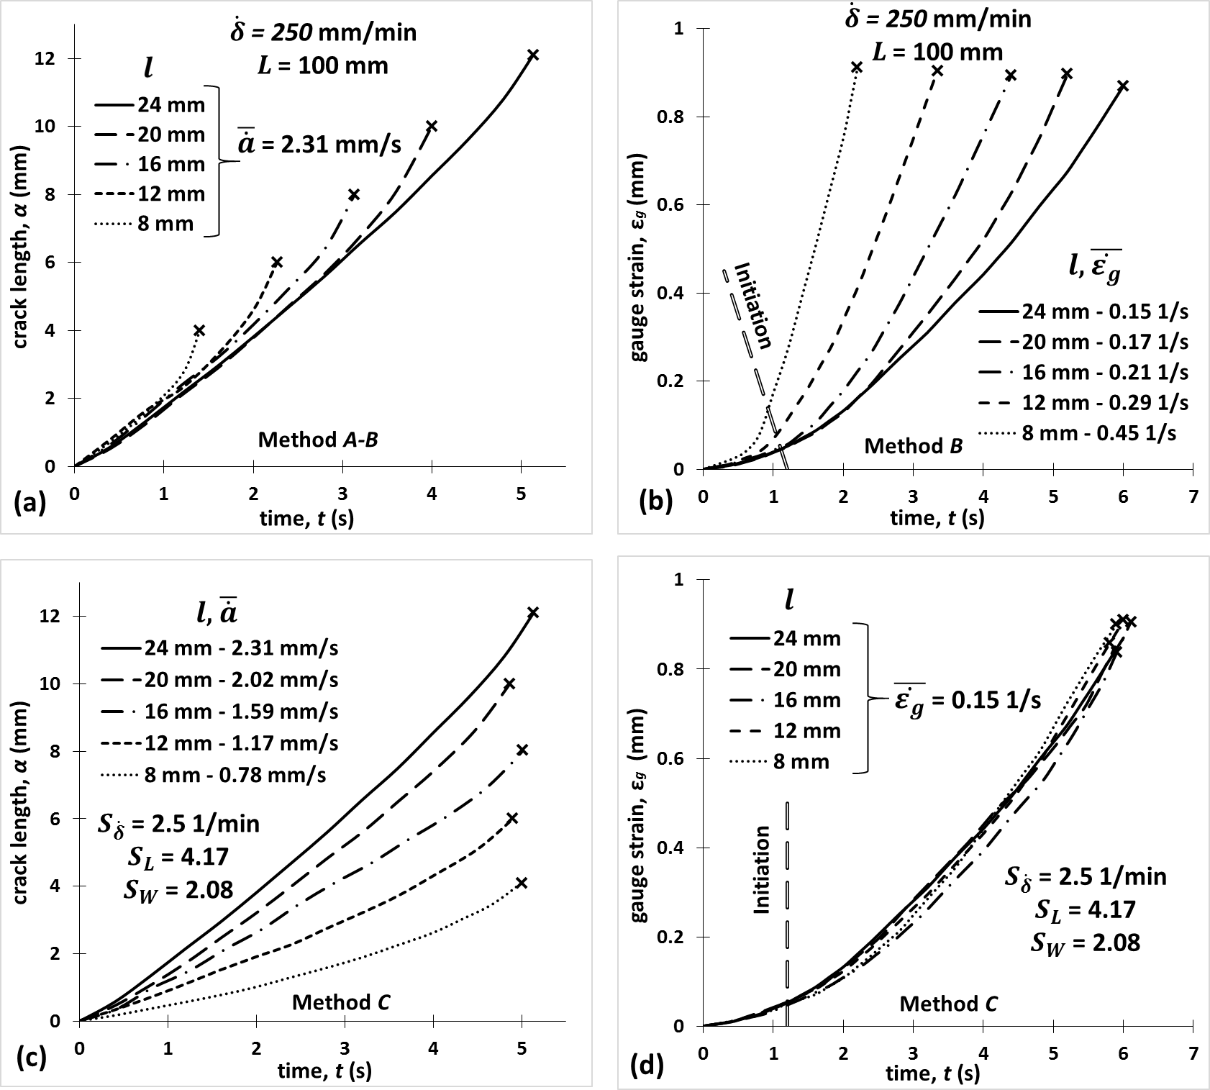

Figure 10. Optical data for all ligaments in starch synchronized with testing machine recordings, (a) Methods A-B, crack length versus time, common average crack speed, $\overline{\dot{a}}$ = 5.12 mm/s, (b) Method B, gauge strain histories, varying rates, (c) Method C, crack length histories, varying speeds, (d) Method C, gauge strain against time, common average gauge strain rate, $\overline{\dot{ε_{g}}}$ = 5.12 1/s. Intercepts of dashed lines denote the approximate crack initiation points.

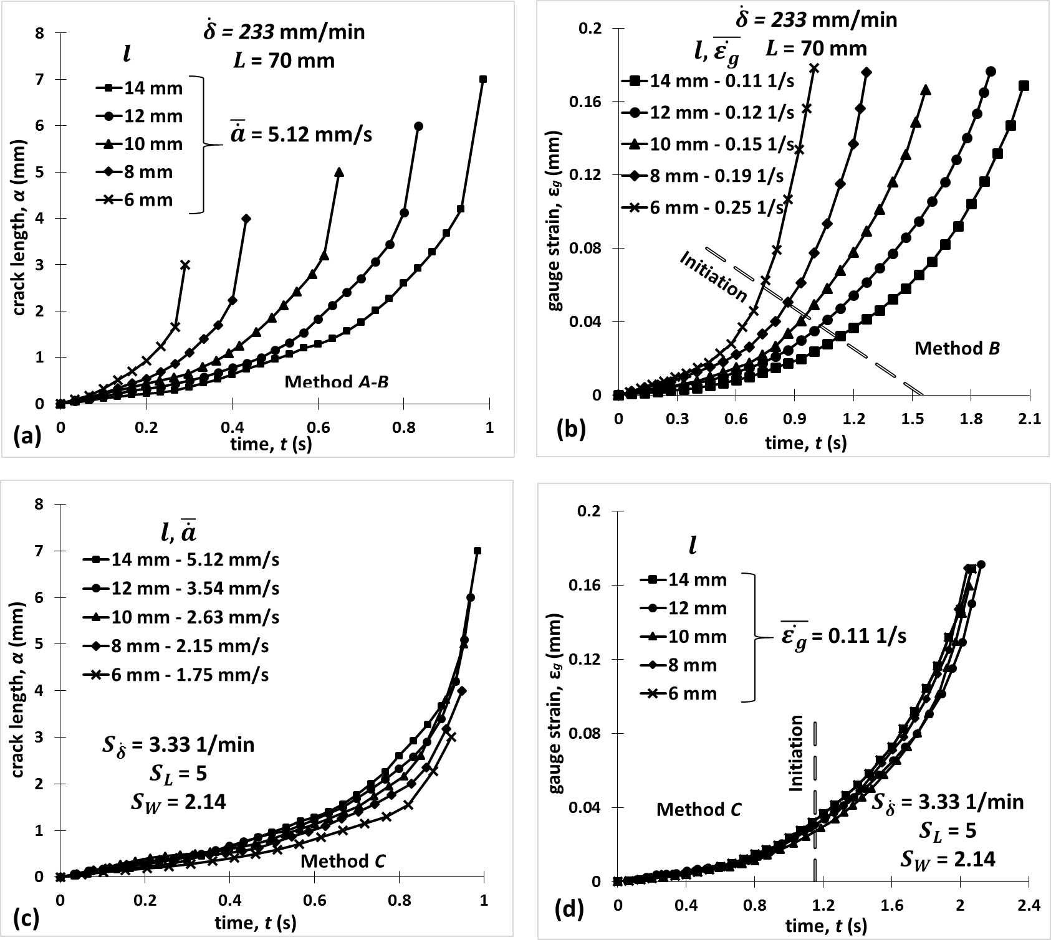

In both materials, method *A-B* gives crack length traces which are self-similar between ligaments, but also common average incremental crack speeds, $\overline{\dot{a}}$, (equal to 5.12 mm/s in Figure 10a and 2.31 mm/s in Figure11a). The latter is in agreement with our previous study on starch (10). It is apparent that for starch, the crack propagates at an increasing rate, followed by a steep rise associated with unstable crack growth (2). In contrast, PE showed an approximately constant speed during crack propagation.

As opposed to method *A-B*, method *C* causes the average crack speeds to drop with decreasing ligament, $l$, in both materials (Figures 10c, 11c). In starch for example, $\overline{\dot{a}}$ decreases from 5.12 mm/s to 1.75 mm/s when $l$ is decreased from 14 mm to 6 mm (Figure 10(c)). Apparently, the time until complete ligament fracture is now common for all the ligaments, implying that lower speeds are indeed expected when shorter ligaments are being torn. It is found that the latter is associated with consistent gauge strain rates, $\overline{\dot{ε_{g}}}$. Specifically, Figures 10b and 11b demonstrate different $\overline{\dot{ε_{g}}}$ versus time curves in starch and PE respectively associated with method *A-B*, whereas in Figures 10d and 11d the $\overline{\dot{ε_{g}}}$ versus time curves coincide as a result of the method *C* design. All these plots highlight common gauge strains, $ε_{g}$, at total separation between ligaments, which verifies a consistent stress field local to the crack tip (38).

**4.5 Stress states between ligaments**

It is underlined that the EWF extrapolation described by Equation 3 or 10, determines the energy required to create new crack faces on average over the entire tearing process (10). The terms, $w_{e}$, and, $w_{in}$, are assumed to be constant since they are deduced as energy normalized over the entire ligament, performing an average between the initiation and propagation processes (38). This may be valid only when the material ahead of the crack tip is always in the same deformation state, such that the external energy required per unit crack propagation is constant throughout the fracture process. In the case of elastic-plastic materials this theoretically requires a uniform stress distribution in the ligament section i.e fully yielded ligament before crack initiation (33, 38).

In order to examine whether the latter condition was met, the two requirements proposed by Williams and Rink (36) were implemented. The first criterion postulates that the theoretical value of the maximum stress on the ligament, $l$, should relate to the uniaxial tensile yield stress, $σ_{y}$, as such:

$$σ_{max}=1.15σ_{y} (14)$$

The second, less restrictive version of the criterion requires that the maximum stresses, $σ_{max}\left(l\right)$, calculated for different, $l$, should fall within 10% of the average maximum value, $\overline{σ_{max}}$, such that:

$$0.9\overline{σ_{max}}<σ_{max}\left(l\right)<1.1\overline{σ_{max}} (15)$$

For maximum force, $F_{max}$, ligament original sectional area, $A_{l},$ and number of repeats, $n$, the $σ_{max}\left(l\right)$ and ${\overline{σ}}_{max}$ are expressed as:

$$σ_{max}\left(l\right)=\frac{F_{max}}{A_{l}} \left(16\right)$$

$$\overline{σ_{max}}=\left[\sum_{l=i}^{n}{σ_{max}\left(l_{i}\right)}\right]/n \left(17\right)$$

Figures 12(a) and 12(b) illustrate the two criteria (Equations 14 and 15) between the method *A-B* and method *C* for starch and PE, respectively. The parallel lines denote the *0.9 $\overline{σ_{max}}$* and *1.1 $\overline{σ_{max}}$* limits for method *A-B* only, as for method *C* the $σ_{max}\left(l\right)$ values do not vary with $l$, thus the criterion is comfortably met. In Figure 12(b), the *1.15 $σ_{y}$* value of the first criterion (Equation 14) is also shown for PE. In method *C* the stresses are slightly higher than *1.15 $σ_{y}$* which may be attributed to the maximum force during the tests occurring after crack initiation (see Figure 6(b)), suggesting that full ligament yielding follows initiation (38). In addition, deviations from this theoretical value have been widely reported in polymers (21, 68, 69). Also note that $σ_{y}$ was approximated from the data plotted in Figure 3(a), by matching the strain rates of the tensile tests to the gauge strain rate at crack initiation, which was derived from the data used in Figure 11(d). Note that due to the absence of yielding behaviour in starch (see section 4.1) the first criterion was not applicable in starch.

Figure 12. Full ligament yielding criteria between method A-B and method C. (a) Starch, (b) PE.

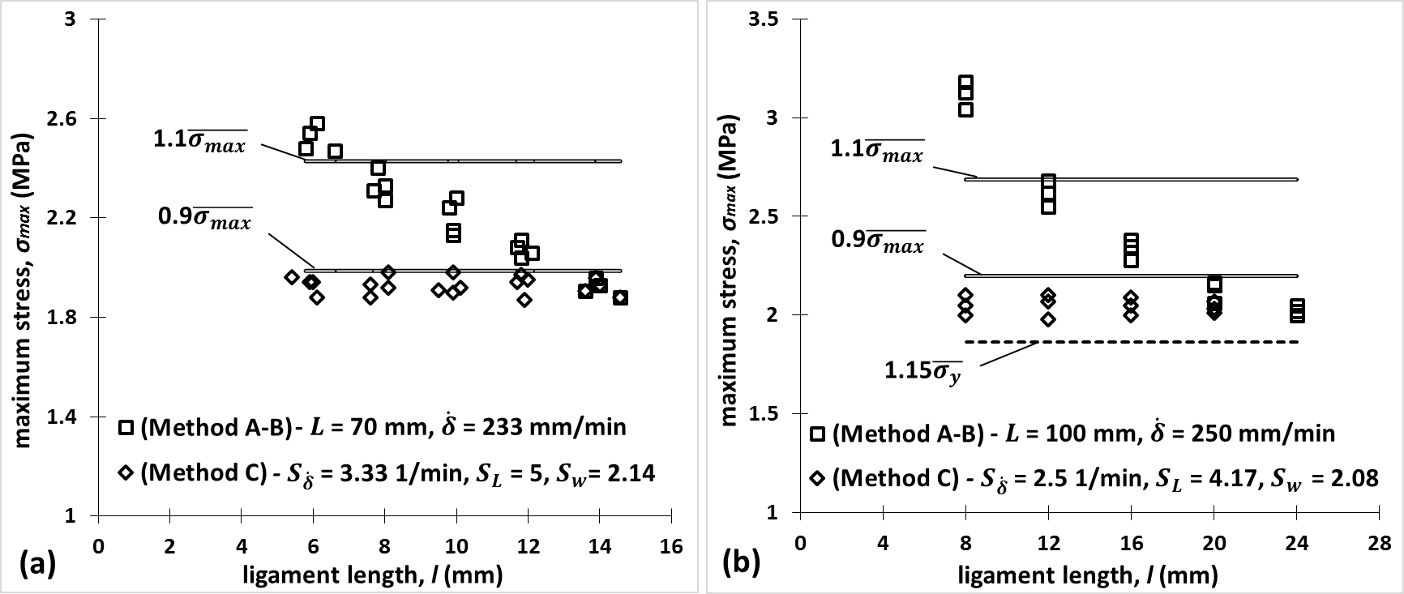

From the results presented in Figure 12, it is once again shown that method *C* is superior to methods *A-B* in terms of a consistent stress state during the whole crack propagation process. The data from methods *A-B* imply that for the shorter and longer ligament lengths, the accuracy of the results may be compromised.

**4.6 Comparison of methods**

Although the evaluation of crack speeds and strain rates as discussed above offers a great insight into the fracture characteristics of the material under investigation, it imposes unfavourable cost and time implications. Here, these optical measurements served in deep understanding of the relation between test parameters and the essential work result. However, such a lengthy data analysis can be prohibitive in cases where the effect of several parameters such as testing speed, temperature, humidity and molecular structure, on the fracture toughness of polymers is studied. Although method *A* is simple practically, this study confirms invalidity for a wide range of polymers, giving incorrectly high values of toughness. On the other hand, method *B* was the best established alternative so far against such errors, yet this study reveals that further corrections are needed to establish true fracture toughness values. Furthermore, method *B* is judged time and cost consuming as it requires optical apparatus and subsequent data analysis. Further limitations can be imposed when the optical field of view is limited in cases where environmental chambers are needed to investigate temperature and humidity effects (70). In contrast, the newly developed method *C* has a design as simple as method *A*’s, whilst leading to more accurate results than ever before. The latter is because it ensures common strain rates and crack geometries, by scaling the specimen size and testing speed while keeping the specimen geometry unchanged. The latter also suggests that a wider ligament range can be used reducing the likeliness of common problems i.e fully yielded ligament for short ligament lengths, $l$, but partly yielded ligament for large (38).

# 5 Conclusions

This study addresses the need for determining accurate values for fracture toughness of complex polymers, such as starch food polymeric composites and soft adhesive polyethylene tapes, using the concept of the EWF methodology. Such work is important for two reasons:

(i) firstly, it provides essential parameters needed in constitutive models incorporating progressive damage and fracture in ductile viscoelastic/viscoplastic soft solids, and

(ii) provides the means for establishing correlations between polymer molecular structure and fracture resistance. The study also reflects industry needs for a convenient and reliable method of measuring toughness towards product quality control and optimization.

Although solutions have been found to the traditional EWF limitations for viscoelastic materials, little work has been reported on quantifying the non-local dissipation effects on EWF results and no study has considered the strain rate parameter involved in tearing different ligament lengths. This work calculates, for the first time, the error induced from such effects and proves that a more conservative determination of true fracture toughness is possible, by adjusting both the specimen size and testing speed simultaneously, with respect to the ligament length. A starch based food and a Polyethylene (PE) tape were considered, for which uniaxial tensile tests indicated a strain rate dependent, highly dissipative behaviour. Interestingly, in both plane strain (starch based food) and plane stress (PE) conditions, the new design (method *C*) deduced consistent fracture toughness values between two extreme specimen lengths, compared to the traditional method (*A*) in which the result is heavily size dependent and much less conservative. The markedly lower toughness values of 0.93 kJ/m² for starch and 5.46 kJ/m² for PE (method *C*), compared to the respective 2.89 kJ/m² and 17.54 kJ/m² (method *A*), suggest that the new design should be considered in polymer studies. Furthermore, the popular gauge length/extensometer technique (method *B*), is still found to induce an error in the extrapolation curve, leading to toughness results of 1.34 kJ/m² and 8.98 kJ/m², which are 44% and 64% less conservative than method *C* in starch and PE, respectively. Such an error is attributed to different strain rates as well as crack geometries occurring in specimens of varying ligament, $l$, for a constant sample length, $L$.

As with any new test method, the recommendations need to be further validated by testing on a wide range of polymeric systems. Nevertheless, our results suggest that the novel method *C* is superior over the EWF methodologies used so far (methods *A*-*B*). This is because method *C* is simple to perform and it raises potential for the true fracture toughness determination in dissipative systems which do not necessarily obey the elastic-plastic behaviour, while classic EWF limitations (method *A*) related to remote deformations in the arms, as well as the effect of specimen size, are no longer a concern. Gauge length corrections (method *B)* or other optical techniques are not as convenient solutions, due to the associated error especially for highly dissipative, viscoelastic materials, complicated test set up as well as the associated significant amount of data processing. Yet this study confirms that the application of such techniques (method *B*) provides reasonably accurate toughness values, compared to method *A* which is strictly invalid when remote specimen dissipation takes place. Our novel test procedure is far more attractive to the current EWF practice. It can lead to real advancement in the various emerging areas of polymer science and technology, allowing for more accurate correlations to be drawn between microscopic characteristics and macro-scale fracture response.

# Acknowledgements

The authors would like to acknowledge Mars Petcare for the financial support and for providing the samples, and Eva Bourbaki, who helped with the ImageJ ligament calculations. In addition, Professor Gordon Williams is acknowledged for useful discussions.

# References

1. Painter PC, Coleman MM. Fundamentals of polymer science: an introductory text. Lancaster, Pa.: Technomic Pub. Co. 1997.

2. Williams JG. Fracture mechanics of polymers. Ellis Horwood Limited, Market Cross House, Cooper St, Chichester, West Sussex, PO 19, 1 EB, UK, 1984 302. 1984.

3. Kamaludin M, Patel Y, Blackman B, Williams J. Fracture mechanics testing for environmental stress cracking in thermoplastics. Procedia Structural Integrity. 2016;2:227-34.

4. Kinloch AJ. Fracture behaviour of polymers: Springer Science & Business Media; 2013.

5. Hedrick JL, Yilgör I, Wilkes GL, McGrath JE. Chemical modification of matrix Resin networks with engineering thermoplastics. Polymer Bulletin. 1985;13(3):201-8.

6. Sanson G. Cutting food in terrestrial carnivores and herbivores. Interface focus. 2016;6(3):20150109.

7. Berthaume MA. Food mechanical properties and dietary ecology. American journal of physical anthropology. 2016;159(S61):79-104.

8. Williams J, Atkins A, Charalambides M, Lucas P. Cutting science in biology and engineering. Royal Society; 2016.

9. Leibinger A, Oldfield MJ, y Baena FR. Minimally disruptive needle insertion: a biologically inspired solution. Interface focus. 2016;6(3):20150107.

10. Skamniotis C, Patel Y, Charalambides M, Elliott M. Fracture investigation in starch-based foods. Interface focus. 2016;6(3):20160005.

11. Harrison SM, Eyres G, Cleary PW, Sinnott MD, Delahunty C, Lundin L. Computational modeling of food oral breakdown using smoothed particle hydrodynamics. Journal of Texture Studies. 2014;45(2):97-109.

12. Goh SM. An engineering approach to food texture studies: Imperial College London; 2002.

13. Moscicki L, Mitrus M, Wojtowicz A, Oniszczuk T, Rejak A. Extrusion-Cooking of Starch2013 2013-07-31.

14. Mohammed I, Charalambides M, Williams J, Rasburn J. Modelling the microstructural evolution and fracture of a brittle confectionery wafer in compression. Innovative Food Science & Emerging Technologies. 2014;24:48-60.

15. Mohammed MAP, Tarleton E, Charalambides MN, Williams J. Mechanical characterization and micromechanical modeling of bread dough. Journal of Rheology (1978-present). 2013;57(1):249-72.

16. Gamonpilas C, Charalambides M, Williams J. Determination of large deformation and fracture behaviour of starch gels from conventional and wire cutting experiments. Journal of materials science. 2009;44(18):4976-86.

17. Goh S, Charalambides M, Williams J. On the mechanics of wire cutting of cheese. Engineering fracture mechanics. 2005;72(6):931-46.

18. Mohammed I, Charalambides M, Kinloch A. Modelling the interfacial peeling of pressure-sensitive adhesives. Journal of Non-Newtonian Fluid Mechanics. 2015;222:141-50.

19. Mohammed I, Charalambides M, Kinloch A. Modeling the effect of rate and geometry on peeling and tack of pressure-sensitive adhesives. Journal of Non-Newtonian Fluid Mechanics. 2016;233:85-94.

20. Simulia AV. 6.13 Documentation. Dassault systemes. 2013.

21. Giannakopoulos I, Taylor A. An essential work of fracture study of the toughness of thermoset polyester coatings. Progress in Organic Coatings. 2015;78:265-74.

22. Hagan EW. The viscoelastic properties of latex artist paints: Imperial College London; 2009.

23. Crosby AJ, Shull KR. Adhesive failure analysis of pressure‐sensitive adhesives. Journal of Polymer Science Part B: Polymer Physics. 1999;37(24):3455-72.

24. Biel A, Alfredsson KS, Carlberger T. Adhesive Tapes; Cohesive Laws for a Soft Layer. Procedia Materials Science. 2014;3:1389-93.

25. Karger-Kocsis J, Moskala E. Molecular dependence of the essential and non-essential work of fracture of amorphous films of poly (ethylene-2, 6-naphthalate)(PEN). Polymer. 2000;41(16):6301-10.

26. Choi B-H, Demirors M, Patel RM, Willem deGroot A, Anderson KW, Juarez V. Evaluation of the tear properties of polyethylene blown films using the essential work of fracture concept. Polymer. 2010;51(12):2732-9.

27. Williams J, Patel Y. Fundamentals of cutting. Interface focus. 2016;6(3):20150108.

28. Horgan CO, Smayda MG. The trousers test for tearing of soft biomaterials. International Journal of Solids and Structures. 2012;49(1):161-9.

29. Patel Y, Blackman B, Williams J. Determining fracture toughness from cutting tests on polymers. Engineering Fracture Mechanics. 2009;76(18):2711-30.

30. Atkins A. Toughness and cutting: a new way of simultaneously determining ductile fracture toughness and strength. Engineering fracture mechanics. 2005;72(6):849-60.

31. Atkins A. Modelling metal cutting using modern ductile fracture mechanics: quantitative explanations for some longstanding problems. International Journal of Mechanical Sciences. 2003;45(2):373-96.

32. Atkins A, Xu X. Slicing of soft flexible solids with industrial applications. International journal of mechanical sciences. 2005;47(4):479-92.

33. Martinez A, Gamez-Perez J, Sanchez-Soto M, Velasco J, Santana O, Maspoch ML. The essential work of fracture (EWF) method–analyzing the post-yielding fracture mechanics of polymers. Engineering failure analysis. 2009;16(8):2604-17.

34. Hossain MM, Lee C-F, Fiscus DM, Sue H-J. Physical assessment of essential work of fracture parameters based on m-LLDPE blown films. Polymer. 2016;96:104-11.

35. Chan W, Williams J. Determination of the fracture toughness of polymeric films by the essential work method. Polymer. 1994;35(8):1666-72.

36. Williams J, Rink M. The standardisation of the EWF test. Engineering fracture mechanics. 2007;74(7):1009-17.

37. Cotterell B, Reddel J. The essential work of plane stress ductile fracture. International journal of fracture. 1977;13(3):267-77.

38. Rink M, Andena L, Marano C. The essential work of fracture in relation to J-integral. Engineering Fracture Mechanics. 2014;127:46-55.

39. Mai YW, Powell P. Essential work of fracture and j‐integral measurements for ductile polymers. Journal of Polymer Science Part B: Polymer Physics. 1991;29(7):785-93.

40. Saleemi A, Nairn J. The plane‐strain essential work of fracture as a measure of the fracture toughness of ductile polymers. Polymer Engineering & Science. 1990;30(4):211-8.

41. Levita G, Parisi L, Marchetti A, Bartolommei L. Effects of thickness on the specific essential work of fracture of rigid PVC. Polymer engineering & science. 1996;36(20):2534-41.

42. Kwon H, Jar P-Y. New energy partitioning approach to the measurement of plane-strain fracture toughness of high-density polyethylene based on the concept of essential work of fracture. Engineering Fracture Mechanics. 2007;74(16):2471-80.

43. Karger-Kocsis J, Ferrer-Balas D. On the plane-strain essential work of fracture of polymer sheets. Polymer Bulletin. 2001;46(6):507-12.

44. Drozdov A, Clyens S, Christiansen J. Essential work of fracture and viscoplastic response of a carbon black-filled thermoplastic elastomer. Engineering Fracture Mechanics. 2009;76(13):1977-95.

45. Clutton E. ESIS TC4 experience with the essential work of fracture method. European Structural Integrity Society. 2000;27:187-99.

46. Korsunsky AM, Nguyen GD, Kim K. The analysis of deformation size effects using multiple gauge length extensometry and the essential work of rupture concept. Materials Science and Engineering: A. 2006;423(1):192-8.

47. Gamez-Perez J, Santana O, Martinez A, Maspoch ML. Use of extensometers on essential work of fracture (EWF) tests. Polymer Testing. 2008;27(4):491-7.

48. Hashemi S. Fracture of polybutylene terephthalate (PBT) film. Polymer. 2002;43(14):4033-41.

49. Maspoch ML, Gamez-Perez J, Gordillo A, Sánchez-Soto M, Velasco J. Characterisation of injected EPBC plaques using the essential work of fracture (EWF) method. Polymer. 2002;43(15):4177-83.

50. Grein C, Plummer C, Germain Y, Kausch HH, Beguelin P. Essential work of fracture of polypropylene and polypropylene blends over a wide range of test speeds. Polymer Engineering & Science. 2003;43(1):223-33.

51. Chen H, Karger-Kocsis J, Wu J. Effects of molecular structure on the essential work of fracture of amorphous copolyesters at various deformation rates. Polymer. 2004;45(18):6375-82.

52. Pegoretti A, Castellani L, Franchini L, Mariani P, Penati A. On the essential work of fracture of linear low-density-polyethylene. I. Precision of the testing method. Engineering Fracture Mechanics. 2009;76(18):2788-98.

53. Martinez A, Segovia A, Gamez-Perez J, Maspoch ML. Influence of femtolaser notch sharpening technique in the determination of essential work of fracture (EWF) parameters. Engineering Fracture Mechanics. 2009;76(9):1247-54.

54. Leevers P, Horsfall I, Rager A, Major Z, Moore D, Pavan A, et al. High rate fracture toughness testing of thermoplastics. Polymer Testing. 2014;33:79-87.

55. Clocksin WF, da Fonseca JQ, Withers P, Torr PH, editors. Image processing issues in digital strain mapping. International Symposium on Optical Science and Technology; 2002: International Society for Optics and Photonics.

56. Casellas J, Frontini P, Carella J. Fracture characterization of low‐density polyethylenes by the essential work of fracture: Changes induced by thermal treatments and testing temperature. Journal of applied polymer science. 1999;74(4):781-96.

57. He G, Li J, Zhang F, Lei F, Guo S. A quantitative analysis of the effect of interface delamination on the fracture behavior and toughness of multilayered propylene–ethylene copolymer/low density polyethylene films by the essential work of fracture (EWF). Polymer. 2014;55(6):1583-92.

58. Karger-Kocsis J, Czigány T, Moskala EJ. Deformation rate dependence of the essential and non-essential work of fracture parameters in an amorphous copolyester. Polymer. 1998;39(17):3939-44.

59. Hashemi S. Work of fracture of PBT/PC blend: effect of specimen size, geometry, and rate of testing. Polymer Engineering & Science. 1997;37(5):912-21.

60. Moscicki L. Extrusion-cooking techniques: applications, theory and sustainability: John Wiley & Sons; 2011.

61. Astm D. 638 Standard Test Method for Tensile Properties of Plastics. ASTM, West Conshohocken, PA. 2003.

62. Manual M. the MathWorks. Inc, Natick, MA. 1995.

63. Marchal Y, Walhin J-F, Delannay F. Statistical procedure for improving the precision of the measurement of the essential work of fracture of thin sheets. International Journal of Fracture. 1997;87(2):189-99.

64. Clutton E. Essential work of fracture. Fracture Mechanics testing methods for polymers, adhesives and composites. 2001;28:177-95.

65. Cerda E, Mahadevan L. Geometry and physics of wrinkling. Physical review letters. 2003;90(7):074302.

66. Lee C-F, Sue H-J, Fiscus DM. Refined fixture design for effective essential work of fracture toughness characterization of m-LLDPE thin films. Polymer Testing. 2013;32(2):256-64.

67. Mai Y, Cotterell B. Effect of specimen geometry on the essential work of plane stress ductile fracture. Engineering fracture mechanics. 1985;21(1):123-8.

68. Arkhireyeva A, Hashemi S. Effect of temperature on fracture properties of an amorphous poly (ethylene terephthalate)(PET) film. Journal of materials science. 2002;37(17):3675-83.

69. Wu J, Mai YW. The essential fracture work concept for toughness measurement of ductile polymers. Polymer Engineering & Science. 1996;36(18):2275-88.

70. Jerabek M, Major Z, Lang R. Strain determination of polymeric materials using digital image correlation. Polymer Testing. 2010;29(3):407-16.