Peer reviewed version of the manuscript published in final form at DOI: 10.1073/pnas.1403139111

**Biologically-active laminin-111 fragment that modulates the epithelial-to-mesenchymal transition in embryonic stem cells**

Christine-Maria Horejsa,b,c, Andrea Serioa,b,c, Alan Purvisd, Adam J. Gormleya,b,c, Sergio Bertazzoa, Anna Poliniewicza,b,c, Alex J. Wanga,b,c, Peter DiMaggioe, Erhard Hohenesterd, and Molly M. Stevensa,b,c

Departments of aMaterials, bBioengineering, dLife Sciences, and eChemical Engineering, and cInstitute for Biomedical Engineering, Imperial College London, London SW7 2AZ, United Kingdom

**Abstract**

The dynamic interplay between the extracellular matrix and embryonic stem cells (ESCs) constitutes one of the key steps in understanding stem cell differentiation in vitro. Here we report a biologically-active laminin-111 fragment generated by matrix metalloproteinase 2 (MMP2) processing, which is highly up-regulated during differentiation. We show that the β1-chain–derived fragment interacts via α3β1-integrins, thereby triggering the down-regulation of MMP2 in mouse and human ESCs. Additionally, the expression of MMP9 and E-cadherin is up-regulated in mouse ESCs—key players in the epithelial-to-mesenchymal transition. We also demonstrate that the fragment acts through the α3β1-integrin/extracellular matrix metalloproteinase inducer complex. This study reveals a previously unidentified role of laminin-111 in early stem cell differentiation that goes far beyond basement membrane assembly and a mechanism by which an MMP2-cleaved laminin fragment regulates the expression of E-cadherin, MMP2, and MMP9.

Laminin-111, together with laminin-511, is among the first extracellular matrix (ECM) proteins expressed during early embryogenesis. Members of the laminin family are highly conserved between different species and are critical constituents of basement membranes in the early blastocyst as well as a variety of other tissues (1). The expression of the three laminin-111 chains—α1, β1, and γ1—is initiated as early as at the two-cell stage (2⇓–4). Laminin-111—together with collagen IV, nidogen, perlecan, and other proteins—is assembled into the basement membrane (5), where it provides not only physical support, but also the capacity to modulate ECM function when modified by other proteins (6⇓–8).

The interactions between matrix metalloproteinases (MMPs) and ECM proteins have been extensively studied over the past decades (9, 10). The cellular expression of MMPs is precisely regulated such that ECM molecules are processed at different cell stages (11). It has been shown that laminin-111 can be processed by different MMPs and a variety of other enzymes and that such modifications are mainly related to cell migration because cleavage of laminin results in a loosened basement membrane (6, 8, 12, 13). Recent insights into the existence of “cryptic” ECM interaction sites—sequences usually hidden within the tertiary structure of the protein or within the assembly of the ECM—have enabled a greater understanding of how cells interact with the ECM and of the astonishingly complex interaction between cells and ECM proteins (14). The ECM can no longer be thought of as just a passive scaffold and physical support for cells in vivo or as a more-or-less adequate cell culture substrate in vitro; the ECM and its modification is now known to act as one of the key constituents in cell regulation. Therefore, to successfully model development in vitro by using pluripotent stem cells, it is imperative to give careful consideration to cell–ECM interactions.

In this work, we address the question of whether MMP2 (15⇓–17) modifies laminin-111 and whether such modifications act to regulate cell behavior such as the epithelial-to-mesenchymal transition (EMT). The EMT is an essential process in a variety of different cellular changes such as phenotype and migratory capacity, but, most importantly, it is fundamental for early embryonic development. During the EMT, cells that are initially attached to each other by tight cell–cell junctions and to the basement membrane via their basal surface (epithelial-type), start to detach and migrate out of the dense cellular layer and adapt a mesenchymal phenotype (18, 19). As the embryo develops, the EMT is regulated by an extensive cross-talk of different regulatory signaling pathways and cellular changes, leading to common endpoints such as cadherin switching, MMP2 and MMP9 up-regulation, snai1 and snai2 up-regulation, accumulation of β-catenin in the nucleus leading to Wnt signaling activation, and up-regulation of twist and vimentin (20⇓⇓⇓–24). Interactions with the ECM as well as secreted soluble growth factors play a role in the regulation of the EMT, and integrin signaling feeds into EMT-regulating pathways (25, 26)—e.g., the exposition of cryptic sites in fibronectin due to mechanical strain and subsequent integrin binding triggers changes in the EMT (27, 28). Although much attention has been dedicated to understanding the mechanism of the EMT, there are many open questions concerning the roles of certain ECM proteins in the EMT signaling cascade. In this work, we have identified a biologically-active laminin-111 fragment, derived from MMP2 cleavage of the β1-chain, which modulates pluripotent stem cell behavior and EMT signals through the α3β1-integrin/ECM metalloproteinase inducer (EMMPRIN) complex. These findings reveal a previously unidentified mechanism in the important interplay between a cryptic site of laminin-111 and the EMT in early differentiation.

**Results**

**MMP2 Cleaves the β1-Chain of Laminin-111.**

Remodeling of the ECM to facilitate pluripotent cell migration is highly dependent on the expression of MMPs. It is assumed that there is developmental regulation of MMP expression, and it has been suggested that only a few MMPs are actually expressed during the early stages of preimplantation development (29, 30). Here we started by investigating the expression profile of MMP2, one of the main extracellular enzymes enabling embryonic implantation (15⇓–17). Fig. 1 shows the time-dependent expression and activity of MMP2 in mouse (Fig. 1 A and B) and human (Fig. 1 C and D) embryonic stem cells (ESCs) during differentiation into embryoid bodies (EBs) for 5 and 14 d, respectively. Only negligible amounts of MMP2 are present at the pluripotent stage, whereas MMP2 expression and activity is significantly up-regulated during the first days of spontaneous EB differentiation. To elucidate how MMP2 processes laminin-111, mouse laminin-111 was incubated with active MMP2, and the resulting protein fragments were analyzed by gel electrophoresis. We observed a distinct band at ∼60 kDa corresponding to a unique fragment released by MMP2 on both the native (Fig. 1 E, lane 3) and denaturing (Fig. 1 E, lane 5) gels. Subsequent digestion of the 60-kDa band and nano-liquid chromatography–tandem mass spectrometry (nanoLC-MS/MS) analysis of the resulting peptides identified the fragment as derived from the N terminus of the β1-chain of laminin-111 (Fig. S1). The peptides were searched against a protein database containing all laminin chains, and the best match and sequence coverage was obtained with the β1-chain. The N-terminal region of the β1-chain (β1–LN–LE1-4) is composed of one LN (laminin N-terminal) domain and four LE (laminin-type epidermal growth factor-like) domains (Fig. 1F). The N-terminal regions of the three short arms of laminin-111 are responsible for the formation of the laminin network (31) and have the same domain architecture, but the sequence identity between the short arms of the α1-, β1-, and γ1-chains is only ∼30%. MMP2 cleavage of the short arm of the β1-chain is predicted to disassemble the laminin network. Indeed, degradation of laminin-111 coatings on tissue culture plastic was observed after 3 h of MMP2 treatment by immunofluorescence, with complete removal after 12 h (Fig. 1G). This observation was confirmed by immunogold staining of laminin-111 before and after treatment with MMP2 (Fig. 1H). These results indicate that the up-regulation of MMP2 during differentiation leads to the degradation of laminin-111 and therefore the basement membrane. The resulting β1–LN–LE1-4 fragment can be recombinantly produced as a stable protein (32), indicating that it can either be released as a soluble factor or may remain within the ECM through noncovalent or covalent interactions. It has been shown that the release of cryptic sites of ECM proteins can trigger cell responses by revealing new binding sites for receptors previously hidden within the protein tertiary structure (27, 28). Biologically-active laminin-111 fragments that are able to function as soluble signaling molecules, however, have not yet been reported. Therefore, to investigate whether the cleavage of laminin-111 by MMP2 has further biological consequences beyond the modification of the basement membrane, the response of human and mouse ESCs to the fragment was examined.

**Laminin β1–LN–LE1-4 Fragment Mediates Cell Adhesion Through α3β1-Integrin.**

Basement membrane substitutes such as Matrigel—containing laminin-111 as a major component—as well as recombinant laminin heterotrimers and some of their fragments have been widely used for culturing stem cells and have been shown to support adhesion and expansion, and some isoforms can also serve as a reliable alternative to feeder-based cultures (33⇓⇓⇓–37). Various binding partners have been identified for laminins, among which integrins feature prominently (38). Most receptor-binding sites are located within the C-terminal region of the α-chain (Fig. 1F) (5). Additional integrin-binding sites have been mapped to the N-terminal region of the α1-chain (39), whereas no integrin receptor-binding sites have been identified in the N-terminal parts of the β1- and γ1-chains. Adhesion and integrin-blocking assays were performed by using mouse and human ESCs plated on the recombinant β1–LN–LE1-4 fragment (32) and on full-length laminin-111. Mouse ESCs adhering to the fragment showed a similar morphology as on full-length laminin-111 and were able to be passaged and kept in a pluripotent state (Fig. 2 A and B), whereas human ESCs did not attach to the fragment compared with laminin-111 (Fig. 2 C and D). To quantify adhesion and to compare attachment on the two other short arm fragments, α1–LN–LE1-4 and γ1–LN–LE1-4, mouse ESCs were seeded on plates coated with different concentrations of the respective fragments and full-length laminin-111. Although slightly more cells attached to full-length laminin-111 than to the β1–LN–LE1-4 fragment, the concentration-dependent attachment profiles were very similar. In sharp contrast, very few cells attached to the γ1–LN–LE1-4 fragment. As expected, cells also attached to the α1–LN–LE1-4, which is known to contain one or more integrin-binding sites (39) (Fig. 2E). From these experiments, we therefore conclude that the laminin β1–LN–LE1-4 fragment contains one or more cell receptor-binding sites for mouse ESCs.

To identify the nature of these receptor–ligand interactions, we used antibodies against all integrin subunits that have been reported for adhesion to laminin-111 (38). Cell attachment to the β1–LN–LE1-4 fragment was reduced by ∼30% using an antibody against β1-integrin subunits, a component of some of the main receptors of pluripotent cells (40). Attachment was also reduced (∼40%) when the α3-integrin subunit was blocked. When a combination of both blocking antibodies was tested, the greatest reduction of attachment (∼50%) was observed (Fig. 2F). The blocking of integrin subunits α1, α2, α6, and α7, as well as combinations of these antibodies with the anti–β1-integrin antibody, did not show any reduction in cell attachment, allowing for the assumption that the β1–LN–LE1-4 fragment contains a previously unidentified binding site for α3- and β1-integrin. The α3β1-integrin constitutes one of the main basement membrane receptors and can form complexes with a variety of different ligands, triggering different signaling cascades, and is involved in maintaining cell–cell junctions, assembling the cytoskeleton, facilitating cell migration due to interactions with tetraspanin proteins, and MMP regulation via the EMMPRIN (CD147) protein (25, 41⇓⇓⇓⇓–46). Consistent with the presence of α3β1-integrin in a variety of different cell and tissue types, fluorescently labeled β1–LN–LE1-4 fragment was observed to accumulate in various regions of the EBs derived from human and mouse cells (Fig. 2 G and H), where the quantification of bound β1–LN–LE1-4 fragment was similar in mouse and human EBs (Fig. S2). The collective data suggest that the β1–LN–LE1-4 fragment has further biological functions resulting from its interaction with α3β1-integrin, where the presence of this integrin is sufficient to provide attachment of mouse ESCs, but not of human ESCs. It has been shown that the attachment of human ESCs to laminin-111 is mainly mediated by α6β1-integrin (36, 47⇓–49). Thus, it is not surprising that they attach less to the fragment than to full-length laminin-111 because the β1–LN–LE1-4 fragment does not possess binding sites for α6β1-integrin. However, the binding of the fragment to both mouse and human EBs, as assessed by confocal microscopy (Fig. 2 G and H), allows for the assumption that the fragment can interact with both mouse and human differentiated cells.

**Laminin β1–LN–LE1-4 Fragment Decreases Expression and Activity of MMP2.**

MMP2 expression is regulated by different mechanisms inside and outside the cell. Besides regulation on a transcriptional level, MMP2 can be inhibited by tissue inhibitors of metalloproteinases (TIMPs) and activated by other MMPs once exported to the plasma membrane (11, 15). The effects of the β1–LN–LE1-4 fragment on the expression and activity of MMP2 produced by human and mouse EBs was evaluated (Fig. 3). When the β1–LN–LE1-4 fragment was added to the medium—hypothesizing that the fragment might be released as a fully soluble fragment by MMP2—a significant down-regulation of MMP2 expression was observed compared with control samples (Fig. 3 A and B). This effect was specific because it was not observed with the structurally related α1- and γ1-chain fragments (Fig. 3D). During EB differentiation, MMP2 is usually up-regulated as part of the differentiation process, particularly during the EMT, representing the very onset of stem cell differentiation. As part of the EMT, MMPs are up-regulated to enable the cells to move out of the dense surrounding basement membrane and to remodel the ECM. It was observed here that an excess of the β1–LN–LE1-4 fragment triggers a down-regulation of MMP2, which seems to provide a negative-feedback mechanism on MMP2 regulation by the product of MMP2 itself. This down-regulation due to the β1–LN–LE1-4 fragment was matched by a decrease in MMP2 activity in the medium of both mouse and human samples (Fig. 3C). In addition, differences in the expression of two inhibitors of MMP2, TIMP1 and TIMP2, were observed (Fig. 3 A and B). Thus, not only MMP2 expression, but also TIMP regulation, are influenced by the MMP2-cleaved fragment, which allows for the assumption that the β1–LN–LE1-4 fragment actually triggers cell responses and is not only cleaved for the purpose of basement membrane remodeling. Given that MMP2 plays a crucial role during the EMT—and that the β1–LN–LE1-4 fragment specifically down-regulates MMP2—the impact of β1–LN–LE1-4 fragment on EMT-related gene expression was tested.

**Laminin β1–LN–LE1-4 Fragment Triggers Changes in the Expression of EMT-Related Genes.**

One of the key events during the EMT is the detachment of epithelial-type cells triggered by the degradation of the basement membrane (18). Fig. 1 shows that the up-regulation of MMP2 causes such degradation. It has been reported that the revelation of cryptic α3β1-integrin–binding sites in fibronectin—triggered by the stretching of only a few nanometers due to mechanical force—plays a strong EMT-inhibitory role (27). In addition, α3β1-integrins are involved in MMP regulation and are thought to coordinate cross-talk between β-catenin and Smad signaling pathways, thereby regulating responses to TGF-β1 activation (45, 46). To determine whether the processing of laminin-111 by MMP2 acts beyond providing a negative-feedback mechanism, the expression of the most prominent EMT-related genes was monitored in the presence of the β1–LN–LE1-4 fragment. We examined EMT gene expression, both with the medium supplemented with β1–LN–LE1-4 fragment (i.e., assuming that the fragment acts as a soluble factor) and with mouse ESCs attached to immobilized fragment as in the adhesion assay (i.e., assuming that the fragment acts as part of a modified ECM). Developmental EMT can be monitored by following the expression of E-cadherin, N-cadherin, snai1 (snail), snai2 (slug), and MMP9. As expected for ESCs undergoing EMT, E-cadherin is down-regulated, and N-cadherin, MMP2, MMP9, snai1, and snai2 are up-regulated in our cells (Fig. S3A). The expression of the same genes, but with β1–LN–LE1-4 fragment added to the medium, was then evaluated. When the fragment was provided as a soluble factor, we observed no difference in the expression of N-cadherin, snai1, and snai2 in mouse ESCs after 5 d of differentiation, but there was a significant up-regulation of E-cadherin compared with the control (Fig. 4A). The experiment was repeated using mouse and human EBs, where we could observe the same changes in E-cadherin expression for mouse EBs, but not for human EBs (Figs. S3 B and C and S4 show human ESCs during EB and monolayer differentiation). The up-regulation of E-cadherin also held true on a protein level (Fig. 4B). Interestingly, when mouse ESCs were cultured on tissue culture plastic coated with β1–LN–LE1-4 fragment, we observed not only a significant up-regulation of E-cadherin on both the gene and protein levels, but also a significant up-regulation of MMP9 compared with cells attached to full-length laminin-111 (Fig. 4 C and D). Additionally, snai1 and snai2, transcriptional inhibitors of E-cadherin, were significantly down-regulated. These data suggest that, in mouse ESCs, the β1–LN–LE1-4 fragment affects the EMT by the regulation of E-cadherin, MMP2, and MMP9 expression, plausibly by α3β1-integrin–dependent pathways. The effect of the β1–LN–LE1-4 fragment was even enhanced when cells were directly attached to the fragment. Notably, there was no change in EMT regulation when cells were exposed to full-length laminin-111, indicating that the released fragment had different activities from its parent molecule.

Blocking of EMMPRIN/CD147 Reverses Effect of β1–LN–LE1-4 Fragment on MMP2, MMP9, and E-Cadherin Expression in Mouse ESCs.

α3β1-integrin has been linked to E-cadherin and cytoskeleton organization in a variety of cell types (25, 44). It has also been shown that a relationship exists between E-cadherin signaling and MMP2 and MMP9 regulation in mouse embryos during implantation (23). Moreover, it has been shown that EMMPRIN (CD147) (50) can complex with α3β1-integrins (43), thereby feeding into the regulatory pathway of MMP2 and MMP9 (29, 51). To investigate whether the observed changes in E-cadherin, MMP2, and MMP9 expression in mouse ESCs due to the β1–LN–LE1-4 fragment are mediated by the α3β1-integrin/EMMPRIN complex, EMMPRIN was blocked by using a function-blocking antibody (52). When EMMPRIN was blocked, the β1–LN–LE1-4 fragment no longer caused an up-regulation of E-cadherin after 5 d of differentiation (Fig. 5). Interestingly, EMMPRIN blockage also impacted the regulation of MMP2 and MMP9. When EMMPRIN was blocked, MMP2 was no longer down-regulated by the β1–LN–LE1-4 fragment but, rather, significantly up-regulated. Equally, the effect on MMP9 expression was reversed by blocking EMMPRIN. In contrast, N-cadherin, snai1, and snai2 expression were not affected by blocking of EMMPRIN. The collective data suggest that the laminin β1–LN–LE1-4 fragment acts via the α3β1-integrin/EMMPRIN complex to regulate the expression of MMP2, MMP9, and E-cadherin.

**Discussion**

Understanding the dynamic interactions between the ECM and cells is necessary to successfully model different phases of development in vitro. Indeed, most paracrine and autocrine signaling processes are triggered or modulated by changes within ECM components. Laminin-111 is one of the first ECM proteins expressed during embryonic development, and its relevance and importance in the assembly and stability of the basement membrane has been demonstrated in a variety of different studies over the past decade (3, 53). It is because of radical changes in the structure of the basement membrane that cells are allowed to migrate within the early embryo, differentiate into different cell types, and ultimately form different districts and organs from an originally unspecialized homogeneous pool of progenitors. At the onset of these events, the EMT represents one of the most important processes that the field is still seeking to fully understand, and our results suggest that this process is tightly linked to the state of the early ECM by a feedback mechanism. The multifunctionality of laminins has been shown by unveiling the role of single domains of the protein spanning from basement membrane assembly (32) to cell adhesion (54) to maintaining pluripotency (35, 36). Here, we report a biological activity of a laminin fragment, β1–LN–LE1-4, that is released through MMP2 processing and that goes beyond cell adhesion and migration. We show that the fragment interacts with mouse ESCs in an α3β1-integrin–dependent fashion, thereby enabling ESCs to adhere in a similar way as to full-length laminin-111. The β1–LN–LE1-4 fragment triggers the down-regulation of MMP2 in human and mouse ESCs, as well as the up-regulation of E-cadherin and MMP9 in mouse ESCs during spontaneous differentiation. Interestingly, the fragment acts on EMT genes in a similar way when added to the medium as a soluble factor and when cells are directly attached to it. Apparently, the β1–LN–LE1-4 fragment can only exhibit its biological function once cleaved from laminin-111, because when cells are attached to full-length laminin-111, the EMT is not affected at all. Thus, the release of the β1–LN–LE1-4 fragment appears to be required for this particular biological activity.

These data show a clear link between laminin-111 and pathways relevant in the EMT. The down-regulation of MMP2 seems to be a feedback mechanism that is conserved in both human and mouse cells. One can imagine this fragment as an indicator for the amount of basement membrane that is cleaved by MMP2. Once a certain amount of laminin has undergone cleavage, MMP2 is down-regulated, and the rate of basement membrane degradation is decreased. This result was observed for both human and mouse ESCs. In mouse ESCs, the β1–LN–LE1-4 fragment also has a significant impact on the expression of EMT-relevant proteins. It causes a significant up-regulation of E-cadherin and MMP9 during differentiation of mouse ESCs. α3β1-integrin has been suggested to be linked to E-cadherin function. These data provide strong evidence that the interaction of the fragment with α3β1-integrin is linked to the regulation of MMP2, MMP9, and E-cadherin. It is also shown that this link is provided by the type I transmembrane glycoprotein EMMPRIN (CD147). EMMPRIN was blocked in mouse ESCs by using a function-blocking antibody (52). The blocking of EMMPRIN affects the signaling elicited by the β1–LN–LE1-4 fragment, reversing its effect. Hence, it can be concluded that one possible link between α3β1-integrin and the regulation of MMP2, MMP9, and E-cadherin is established by the interaction with EMMPRIN. To our knowledge, here we show for the first time that there is a link between the processing of laminin-111 and the regulation of MMP2 during spontaneous differentiation of human and mouse ESCs.

Re-creating the different cellular components that are involved in the phases of development—particularly at the pluripotent stage and the early embryonic development—has granted and will continue to grant invaluable insights for both fundamental studies and when developing new applications and disease-modeling platforms. It is also important to consider, however, that these developmental processes take place in the context of a complex and dynamic cross-talk between the cells and the ECM, which first needs to be understood and ultimately incorporated into those in vitro models. Understanding the role of MMP–ECM interactions in stem cell differentiation will lead to a more precise use of the ECM in possible applications and a deeper knowledge of the early onset of embryonic development.

**Materials and Methods**

Details of mouse D3 and human H9 embryonic stem cell culture techniques, cleavage of laminin-111, western blots, mass spectrometry sample preparation, NanoLC-MS/MS, EMMPRIN blocking, quantitative PCR and primer sequences, cell adhesion and integrin assay, fluorescent labeling and confocal microscopy, immunogold/SEM, and MMP2 activity are available in SI Materials and Methods.

**Acknowledgments**

We thank Aaron Borg, Birgit Leitinger, Manuel Mazo, and Jean-Philippe St. Pierre for help and advice. C.-M.H. is supported by a Federation of European Biochemical Societies long-term fellowship; S.B. is supported by the Imperial College London Junior Research Fellowship; A.J.W. is supported by the Fulbright-Imperial Postgraduate Award; P.D. is supported by Imperial College London; E.H. is supported by a Wellcome Trust Senior Research Fellowship; and M.M.S. is supported by the Medical Research Council UK Regenerative Medicine Platform Hub “Acellular Approaches for Therapeutic Delivery” (MR/K026682/1) and Wellcome Trust Senior Investigator Grant 098411/Z/12/Z.

**Figures**

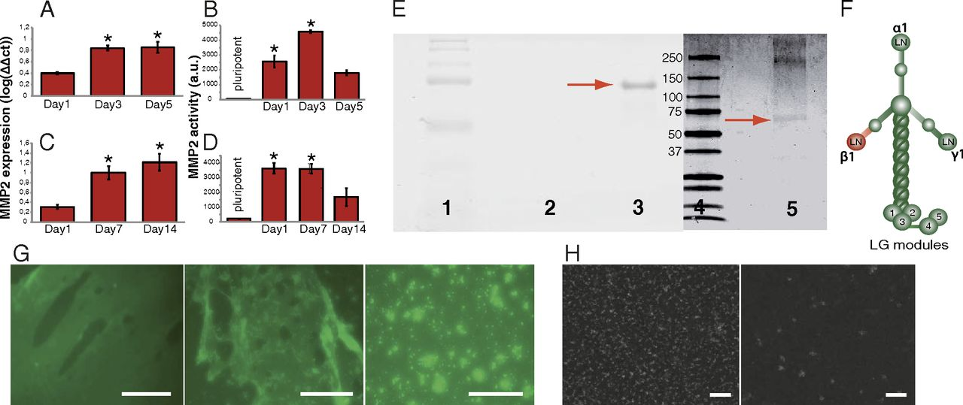

Fig. 1. MMP2 cleaves laminin-111 within the β1-chain. (A–D) Expression [log scale relative to pluripotent cells (= 0)] (A and C) and activity of MMP2 (B and D) in mouse (A and B) and human (C and D) ESCs during differentiation for 5 and 14 d, respectively. Data are shown as mean ± SD. *P < 0.05, significant to pluripotent cells. (E) Native (lanes 1–3) and denaturing (lanes 4 and 5) SDS-PAGE (Coomassie blue-stained) after processing of laminin-111 with MMP2. A distinct band at ∼60 kDa can be detected (red arrow). Lanes 1 and 4 show molecular-mass markers; lane 2 shows unprocessed laminin-111, where no bands can be seen because the 800-kDa protein does not enter the 12% gel; and lane 5 shows three bands, where the two upper bands result from the α1- (400 kDa), β1- (200 kDa), and γ1- (200 kDa) chain. (F) Schematic presentation of the laminin-111 heterotrimer. The β1–LN–LE1-4 fragment, released by MMP2, is indicated in red. (G) MMP2 treatment of a laminin-111 layer leads to the break-up of the protein layer. Immunostainings of a laminin layer before processing, 3 and 12 h after treatment with MMP2. (Scale bars: 100 μm.) (H) MMP2-processing of a laminin-111 layer; before and 3 h after treatment with MMP2. Laminin proteins were stained with immunogold and detected by SEM. (Scale bars: 200 nm.)

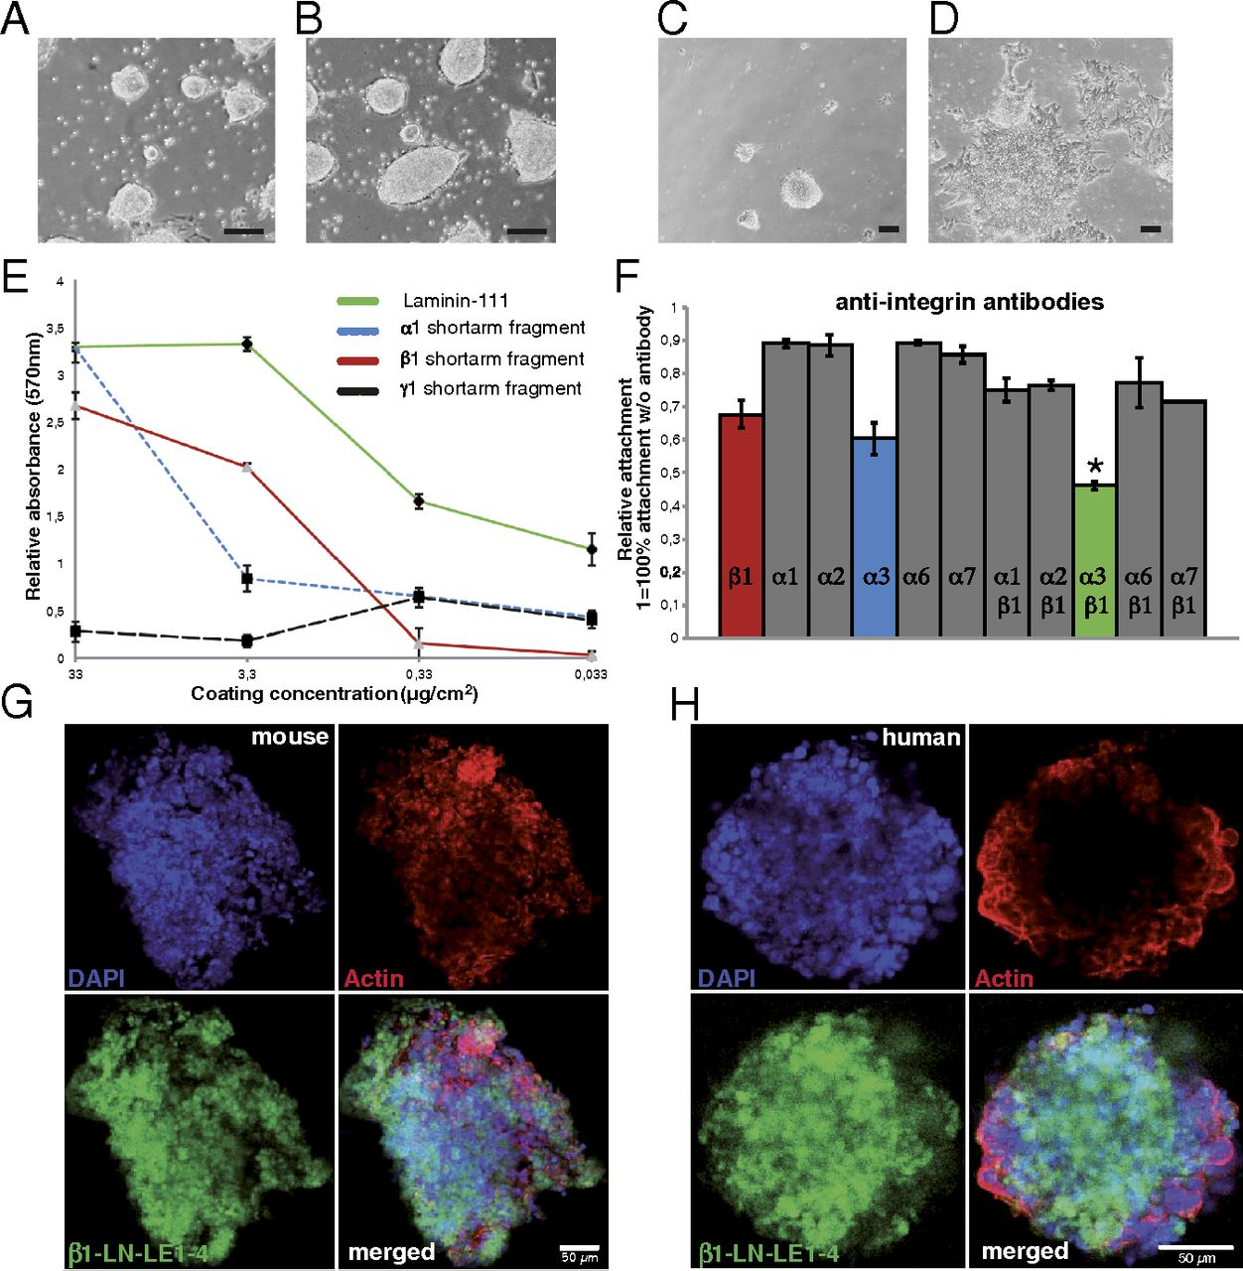

Fig. 2. Receptor-binding sites on β1–LN–LE1-4 fragment. (A and B) Mouse ESCs adhere to the β1–LN–LE1-4 fragment (A) showing a similar morphology as on full-length laminin-111 (B). (C and D) Human ESCs do not attach to the fragment and hence do not form colonies (C), but attach and proliferate on full-length laminin-111 (D). (Scale bars: 100 μm.) (E) Quantification of the adhesion of mouse ESCs on full-length laminin-111 and on the α1-, β1-, and γ1-short arm fragment. (F) Identification of integrin-binding sites on the β1–LN–LE1-4 fragment. Integrin receptors were blocked and attached cells were quantified by using crystal violet staining. Data are shown relative to cells that were not incubated with blocking antibodies (= 100% attachment). Data are shown as ± SD; *P < 0.05. (G and H) Staining of mouse (G) and human (H) EBs with Alexa 633-labeled β1–LN–LE1-4 fragment (green), DAPI (blue), and Phalloidin (red). ESCs were differentiated into EBs for 5 d (mouse) and 10 d (human). (Scale bars: 50 μm.).

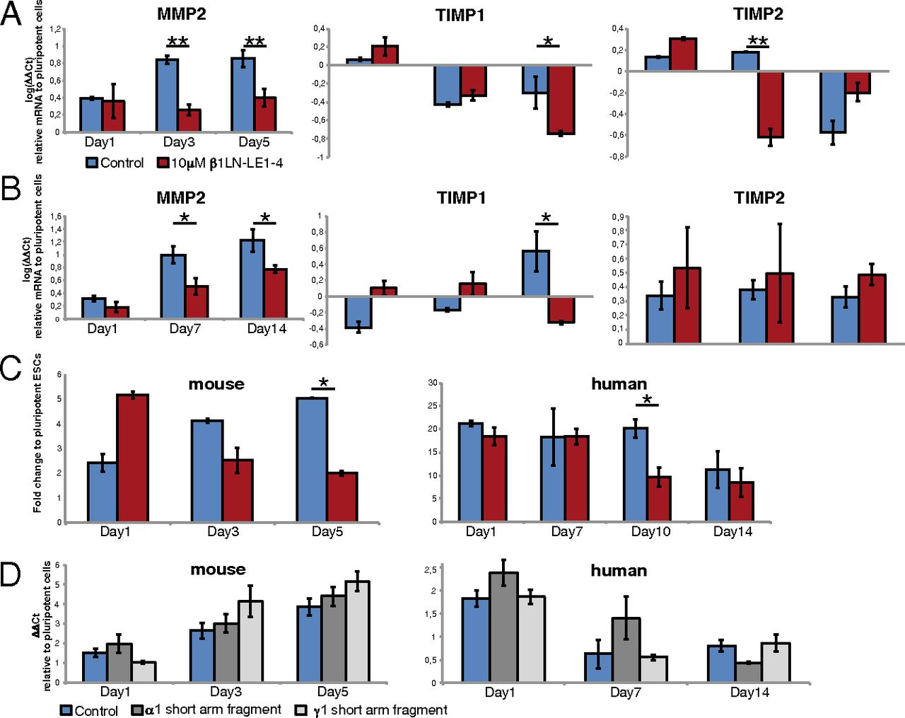

Fig. 3. The binding of β1–LN–LE1-4 fragment impacts expression of MMP2, TIMP1, and TIMP2. (A and B) Expression levels of MMP2 (Left), TIMP1 (Center), and TIMP2 (Right) in mouse (A) and human (B) ESCs after 5 and 14 d of differentiation. Data are shown as log(ΔΔct) relative to pluripotent cells. The medium was complemented with 10 μM β1–LN–LE1-4 fragment (red) compared with a control, where no fragment was added to the medium (blue). (C) Quantification of active MMP2 in the medium corresponding to samples shown in A and B. When β1–LN–LE1-4 fragment is added to the medium (red), significantly less active MMP2 is produced by mouse (Left) and human (Right) ESCs during differentiation. Data are shown as mean ± SD. *P < 0.05; **P < 0.005. (D) Expression of MMP2 in mouse (Left) and human (Right) ESCs after 5 and 14 d of differentiation, when medium is complemented with 10 μM α1–LN–LE1-4 fragment and 10 μM γ1–LN–LE1-4 fragment compared with a control, where no fragment was added to the medium (blue).

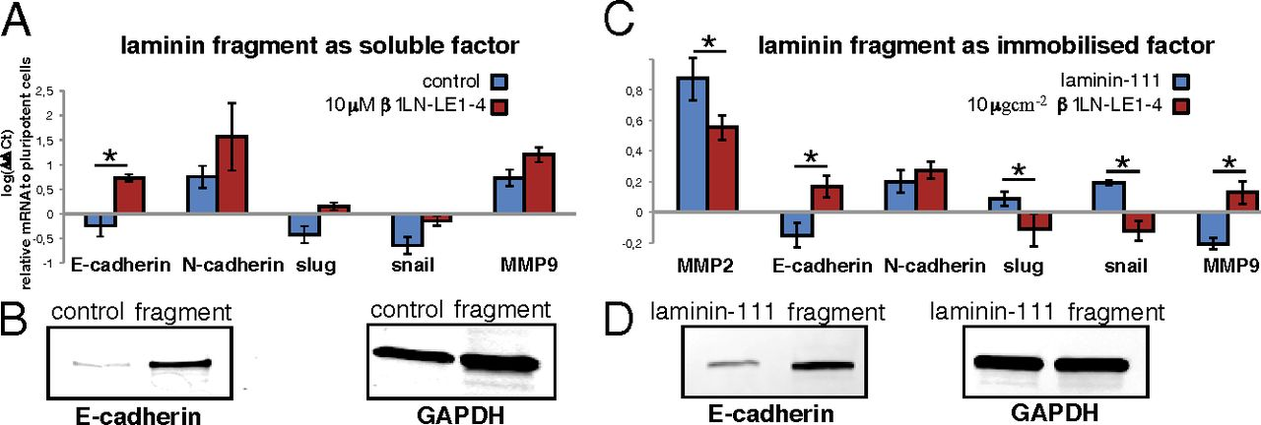

Fig. 4. Changes in EMT gene expression due to β1–LN–LE1-4 fragment. (A) qPCR of mouse ESCs during differentiation in monolayer culture after 5 d with the fragment added as a soluble factor to the medium. E-cadherin is significantly up-regulated during differentiation due to the fragment. Blue, control; red, addition of 10 μM β1–LN–LE1-4 fragment. (B) Western blots of mouse ESCs after 5 d of differentiation. More E-cadherin is expressed when the fragment is added as soluble factor. (C) qPCR of mouse ESCs during differentiation after 5 d, with the cells cultured on β1–LN–LE1-4 fragment vs. laminin-111. MMP-2, E-cadherin, and MMP-9 are up-regulated. Slug and snail, both inhibitors of E-cadherin, are down-regulated. Blue, laminin-111; red, 10 μg/cm2 β1–LN–LE1-4 fragment. (D) Western blots of mouse ESCs after 5 d of differentiation with cells cultured on β1–LN–LE1-4 fragment vs. laminin-111. More E-cadherin can be detected when the cells are differentiated on the fragment. All PCR data are shown as log(ΔΔct) relative to pluripotent cells and as mean ± SD. *P < 0.05.

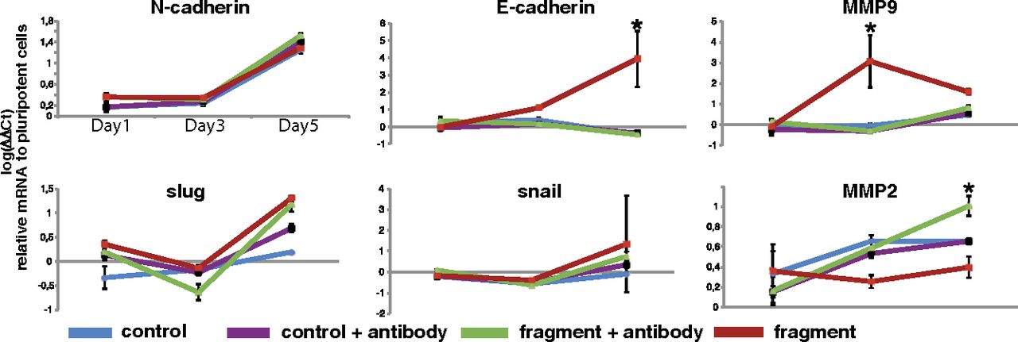

Fig. 5. Blocking of EMMPRIN reveals signal pathway via α3- and β1-integrin. Shown is expression of EMT-relevant genes in mouse ESCs with 10 μM β1–LN–LE1-4 fragment added to the medium without blocking of EMMPRIN (red), when EMMPRIN is blocked (green) as opposed to a control without fragment (blue, no EMMPRIN blocking; black, EMMPRIN blocked). For E-cadherin, MMP2, and MMP9, the effect of the β1–LN–LE1-4 fragment is reversed when EMMPRIN is blocked. Data are shown as mean ± SD. *P < 0.05.

**References**

1. Aumailley M (2013) The laminin family. Cell Adhes Migr 7(1):48–55.
2. Ekblom P, Lonai P, Talts JF (2003) Expression and biological role of laminin-1. Matrix Biol 22(1):35–47.
3. Li S, Edgar D, Fässler R, Wadsworth W, Yurchenco PD (2003) The role of laminin in embryonic cell polarization and tissue organization. Dev Cell 4(5):613–624.
4. Miner JH, Yurchenco PD (2004) Laminin functions in tissue morphogenesis. Annu Rev Cell Dev Biol 20(1):255–284.
5. Hohenester E, Yurchenco PD (2013) Laminins in basement membrane assembly. Cell Adhes Migr 7(1):56–63.
6. Giannelli G, Falk-Marzillier J, Schiraldi O, Stetler-Stevenson WG, Quaranta V (1997) Induction of cell migration by matrix metalloprotease-2 cleavage of laminin-5. Science 277(5323):225–228.
7. Lah TT, et al. (1989) Degradation of laminin by human tumor cathepsin B. Clin Exp Metastasis 7(4):461–468.
8. Mydel P, et al. (2008) Neutrophil elastase cleaves laminin-332 (laminin-5) generating peptides that are chemotactic for neutrophils. J Biol Chem 283(15):9513–9522.
9. Shapiro SD (1998) Matrix metalloproteinase degradation of extracellular matrix: Biological consequences. Curr Opin Cell Biol 10(5):602–608.
10. Mott JD, Werb Z (2004) Regulation of matrix biology by matrix metalloproteinases. Curr Opin Cell Biol 16(5):558–564.
11. Clark IM, Swingler TE, Sampieri CL, Edwards DR (2008) The regulation of matrix metalloproteinases and their inhibitors. Int J Biochem Cell Biol 40(6-7):1362–1378.
12. Faisal Khan KM, Laurie GW, McCaffrey TA, Falcone DJ (2002) Exposure of cryptic domains in the α 1-chain of laminin-1 by elastase stimulates macrophages urokinase and matrix metalloproteinase-9 expression. J Biol Chem 277(16):13778–13786.
13. Koshikawa N, Giannelli G, Cirulli V, Miyazaki K, Quaranta V (2000) Role of cell surface metalloprotease MT1-MMP in epithelial cell migration over laminin-5. J Cell Biol 148(3):615–624.
14. Schenk S, Quaranta V (2003) Tales from the crypt[ic] sites of the extracellular matrix. Trends Cell Biol 13(7):366–375.
15. Kinoh H, et al. (1996) MT-MMP, the cell surface activator of proMMP-2 (pro-gelatinase A), is expressed with its substrate in mouse tissue during embryogenesis. J Cell Sci 109(Pt 5):953–959.
16. Wartenberg M, et al. (2003) Inhibition of tumor-induced angiogenesis and matrix-metalloproteinase expression in confrontation cultures of embryoid bodies and tumor spheroids by plant ingredients used in traditional Chinese medicine. Lab Invest 83(1):87–98.
17. Spencer HL, et al. (2007) E-cadherin inhibits cell surface localization of the pro-migratory 5T4 oncofetal antigen in mouse embryonic stem cells. Mol Biol Cell 18(8):2838–2851.
18. Thiery JP, Acloque H, Huang RYJ, Nieto MA (2009) Epithelial-mesenchymal transitions in development and disease. Cell 139(5):871–890.
19. Lee JM, Dedhar S, Kalluri R, Thompson EW (2006) The epithelial-mesenchymal transition: New insights in signaling, development, and disease. J Cell Biol 172(7):973–981.
20. Thiery JP, Sleeman JP (2006) Complex networks orchestrate epithelial-mesenchymal transitions. Nat Rev Mol Cell Biol 7(2):131–142.
21. Eastham AM, et al. (2007) Epithelial-mesenchymal transition events during human embryonic stem cell differentiation. Cancer Res 67(23):11254–11262.
22. Wheelock MJ, Shintani Y, Maeda M, Fukumoto Y, Johnson KR (2008) Cadherin switching. J Cell Sci 121(Pt 6):727–735.
23. Liu G, et al. (2006) Effects of E-cadherin on mouse embryo implantation and expression of matrix metalloproteinase-2 and -9. Biochem Biophys Res Commun 343(3):832–838.
24. Ullmann U, et al. (2007) Epithelial-mesenchymal transition process in human embryonic stem cells cultured in feeder-free conditions. Mol Hum Reprod 13(1):21–32.
25. Wang Z, et al. (1999) (Alpha)3(beta)1 integrin regulates epithelial cytoskeletal organization. J Cell Sci 112(Pt 17):2925–2935.
26. Markowski MC, Brown AC, Barker TH (2012) Directing epithelial to mesenchymal transition through engineered microenvironments displaying orthogonal adhesive and mechanical cues. J Biomed Mater Res A 100(8):2119–2127.
27. Altroff H, et al. (2004) Interdomain tilt angle determines integrin-dependent function of the ninth and tenth FIII domains of human fibronectin. J Biol Chem 279(53):55995–56003.
28. Brown AC, Rowe JA, Barker TH (2011) Guiding epithelial cell phenotypes with engineered integrin-specific recombinant fibronectin fragments. Tissue Eng Part A 17(1-2):139–150.
29. Chen L, Nakai M, Belton RJ Jr., Nowak RA (2007) Expression of extracellular matrix metalloproteinase inducer and matrix metalloproteinases during mouse embryonic development. Reproduction 133(2):405–414.
30. Lemaître V, D’Armiento J (2006) Matrix metalloproteinases in development and disease. Birth Defects Res C Embryo Today 78(1):1–10.
31. Yurchenco PD, Cheng YS (1993) Self-assembly and calcium-binding sites in laminin. A three-arm interaction model. J Biol Chem 268(23):17286–17299.
32. Purvis A, Hohenester E (2012) Laminin network formation studied by reconstitution of ternary nodes in solution. J Biol Chem 287(53):44270–44277.
33. Rodin S, et al. (2010) Long-term self-renewal of human pluripotent stem cells on human recombinant laminin-511. Nat Biotechnol 28(6):611–615.
34. Domogatskaya A, Rodin S, Boutaud A, Tryggvason K (2008) Laminin-511 but not -332, -111, or -411 enables mouse embryonic stem cell self-renewal in vitro. Stem Cells 26(11):2800–2809.
35. Miyazaki T, et al. (2012) Laminin E8 fragments support efficient adhesion and expansion of dissociated human pluripotent stem cells. Nat Commun 3:1236.
36. Miyazaki T, et al. (2008) Recombinant human laminin isoforms can support the undifferentiated growth of human embryonic stem cells. Biochem Biophys Res Commun 375(1):27–32.
37. Hall PE, Lathia JD, Caldwell MA, Ffrench-Constant C (2008) Laminin enhances the growth of human neural stem cells in defined culture media. BMC Neurosci 9(1):71.
38. Nishiuchi R, et al. (2006) Ligand-binding specificities of laminin-binding integrins: A comprehensive survey of laminin-integrin interactions using recombinant α3β1, α6β1, α7β1 and α6β4 integrins. Matrix Biol 25(3):189–197.
39. Colognato-Pyke H, et al. (1995) Mapping of network-forming, heparin-binding, and alpha 1 beta 1 integrin-recognition sites within the alpha-chain short arm of laminin-1. J Biol Chem 270(16):9398–9406.
40. Prowse ABJ, Chong F, Gray PP, Munro TP (2011) Stem cell integrins: implications for ex-vivo culture and cellular therapies. Stem Cell Res (Amst) 6(1):1–12.
41. Kreidberg JA (2000) Functions of α3β1 integrin. Curr Opin Cell Biol 12(5):548–553.
42. Bökel C, Brown NH (2002) Integrins in development: Moving on, responding to, and sticking to the extracellular matrix. Dev Cell 3(3):311–321.
43. Berditchevski F, Chang S, Bodorova J, Hemler ME (1997) Generation of monoclonal antibodies to integrin-associated proteins. Evidence that α3β1 complexes with EMMPRIN/basigin/OX47/M6. J Biol Chem 272(46):29174–29180.
44. Zhang F, et al. (2003) Distinct ligand binding sites in integrin α3β1 regulate matrix adhesion and cell-cell contact. J Cell Biol 163(1):177–188.
45. Iyer V, Pumiglia K, DiPersio CM (2005) α3β1 integrin regulates MMP-9 mRNA stability in immortalized keratinocytes: A novel mechanism of integrin-mediated MMP gene expression. J Cell Sci 118(Pt 6):1185–1195.
46. Kim Y, et al. (2009) Integrin α3β1-dependent β-catenin phosphorylation links epithelial Smad signaling to cell contacts. J Cell Biol 184(2):309–322.
47. Takayama K, et al. (2013) Long-term self-renewal of human ES/iPS-derived hepatoblast-like cells on human laminin 111-coated dishes. Stem Cell Rev 1(4):322–335.
48. Meng Y, et al. (2010) Characterization of integrin engagement during defined human embryonic stem cell culture. FASEB J 24(4):1056–1065.
49. Braam SR, et al. (2008) Recombinant vitronectin is a functionally defined substrate that supports human embryonic stem cell self-renewal via alphavbeta5 integrin. Stem Cells 26(9):2257–2265.
50. Biswas C, et al. (1995) The human tumor cell-derived collagenase stimulatory factor (renamed EMMPRIN) is a member of the immunoglobulin superfamily. Cancer Res 55(2):434–439.
51. Kubota S, Ito H, Ishibashi Y, Seyama Y (1997) Anti-α3 integrin antibody induces the activated form of matrix metalloprotease-2 (MMP-2) with concomitant stimulation of invasion through matrigel by human rhabdomyosarcoma cells. Int J Cancer 70(1):106–111.
52. Agrawal SM, Silva C, Tourtellotte WW, Yong VW (2011) EMMPRIN: A novel regulator of leukocyte transmigration into the CNS in multiple sclerosis and experimental autoimmune encephalomyelitis. J Neurosci 31(2):669–677.
53. Sasaki T, Fässler R, Hohenester E (2004) Laminin: The crux of basement membrane assembly. J Cell Biol 164(7):959–963.
54. McKee KK, Harrison D, Capizzi S, Yurchenco PD (2007) Role of laminin terminal globular domains in basement membrane assembly. J Biol Chem 282(29):21437–21447.