**Supporting Information**

**Elucidating the Relationship between Crystallo-Chemistry and Optical properties of CIGS Nanocrystals**

*Mahshid Ahmadi1, Stevin S. Pramana2,3, Chris Boothroyd4, Yeng Ming Lam1\**

*1Nanyang Technological University, School of Materials Science and Engineering, 50 Nanyang Avenue, 639798, Singapore. Fax: +65 6790 9081*

*2Facility for Analysis, Characterization, Testing and Simulation, Nanyang Technological University, 50 Nanyang Avenue, 639798, Singapore*

*3Department of Materials, Imperial College London, Exhibition Road, London SW7 2AZ, United Kingdom*

*4Ernst Ruska-Centrum und Peter Grünberg Institut, Forschungszentrum Jülich, D-52425 Jülich, Germany*

* CORRESPONDING AUTHOR, E-mail: [ymlam@ntu.edu.sg](mailto:ymlam@ntu.edu.sg) (Y.M. Lam).

M. Ahmadi and S. S. Pramana contributed equally to this work

**Table S1.** Unit cell parameters and reliability factors from Rietveld refinement of the X-ray diffraction pattern of the different composition of CuIn*x*Ga1-*x*Se2 NCs. (The criteria for the fit used in TOPAS is described as Rwp , Rb and GOF was previously explained in [1])

|  |  |  |  |  |  |  |  |  |
| --- | --- | --- | --- | --- | --- | --- | --- | --- |
| *x* | *a* (Å) | *c* (Å) | Volume (Å3) | *c*/2*a* | Crystallite size (nm) | *Rb* | *Rwp* | GOF |
| 0 | 5.6113±0.0007 | 11.044±0.002 | 347.7±0.1 | 0.984 | 17.3±0.4 | 0.014 | 0.152 | 1.27 |
| 0.77 | 5.634±0.005 | 11.251±0.013 | 357.1±0.7 | 0.998 | 20±3 | 0.055 | 0.273 | 1.13 |
| 0.49 | 5.681±0.005 | 11.462±0.012 | 369.9±0.8 | 1.009 | 11.3±0.9 | 0.080 | 0.380 | 1.04 |
| 0.25 | 5.738±0.001 | 11.464±0.003 | 377.4±0.1 | 0.999 | 32±3 | 0.017 | 0.174 | 1.06 |
| 1 | 5.806±0.002 | 11.561±0.004 | 389.7±0.3 | 0.996 | 20.3±0.9 | 0.074 | 0.321 | 1.12 |

**Table S2.** Acomparison of the theoretical, optical and electrochemical band gaps of different composition of CuIn*x*Ga1-*x*Se2 NCs. The oxidation and reduction potential determined by CV and the electrochemical energy band gap calculated from the difference of the conduction and valence band of different compositions.

|  |  |  |  |  |  |  |  |
| --- | --- | --- | --- | --- | --- | --- | --- |
| Composition | *Eg* eV (Theoretical) | *Eg* eV (optical) | *Ered* (V) | *Eox* (V) | Conduction band | Valence band | *Eg*eV (electrochemical) |
| CuInSe2 | 1.01 | 1.04 | -0.20 | 0.70 | -4.20 | -5.30 | 1.1 |
| CuIn0.77Ga0.23Se2 | 1.12 | 1.09 | -0.34 | 0.90 | -4.06 | -5.30 | 1.24 |
| CuIn0.49Ga0.51Se2 | 1.29 | 1.20 | -0.42 | 0.92 | -3.98 | -5.32 | 1.34 |
| CuIn0.25Ga0.75Se2 | 1.45 | 1.43 | -0.48 | 0.94 | -3.92 | -5.34 | 1.42 |
| CuGaSe2 | 1.64 | 1.62 |  |  | _ | _ | _ |

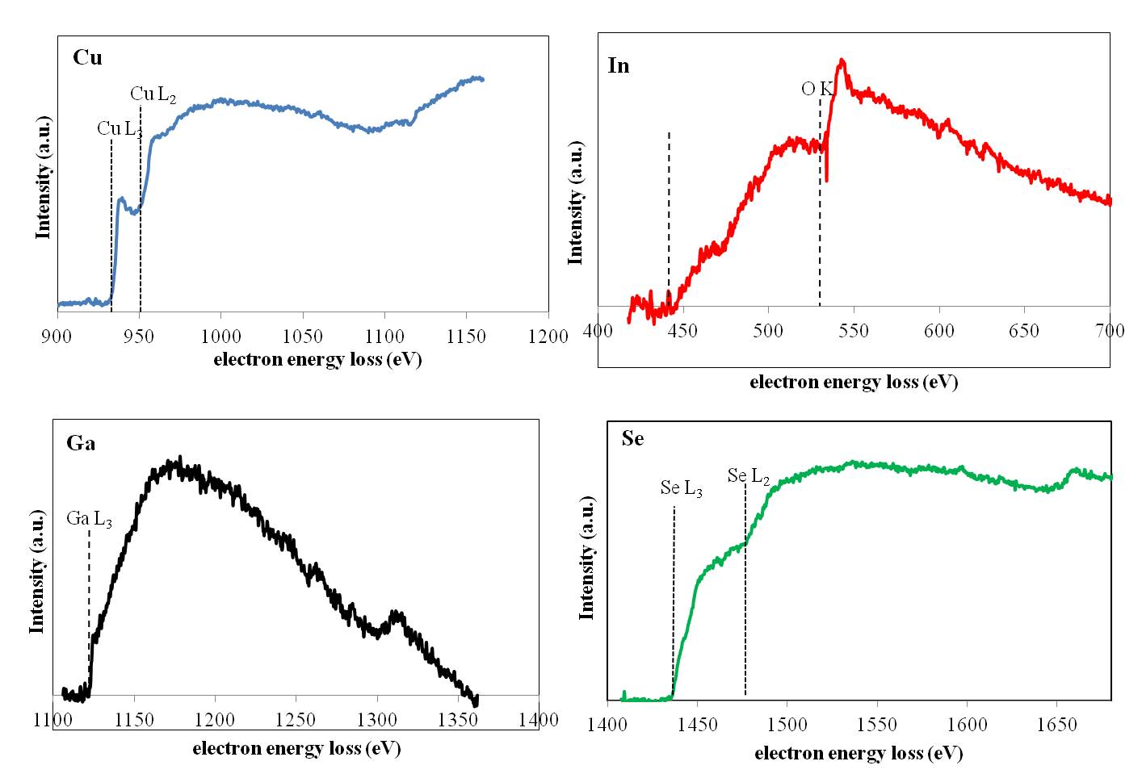

In M4,5

|  |
| --- |
| **Figure S1**. The EELS of CuIn0.49Ga0.51Se2 NCs after background subtraction showing the Cu, In, Ga and Se edges. |

**Figure S2.** Raman spectra of CuInSe2 NCs.

**Figure S3**. Raman spectra of CuIn0.49Ga0.51Se2 NCs.

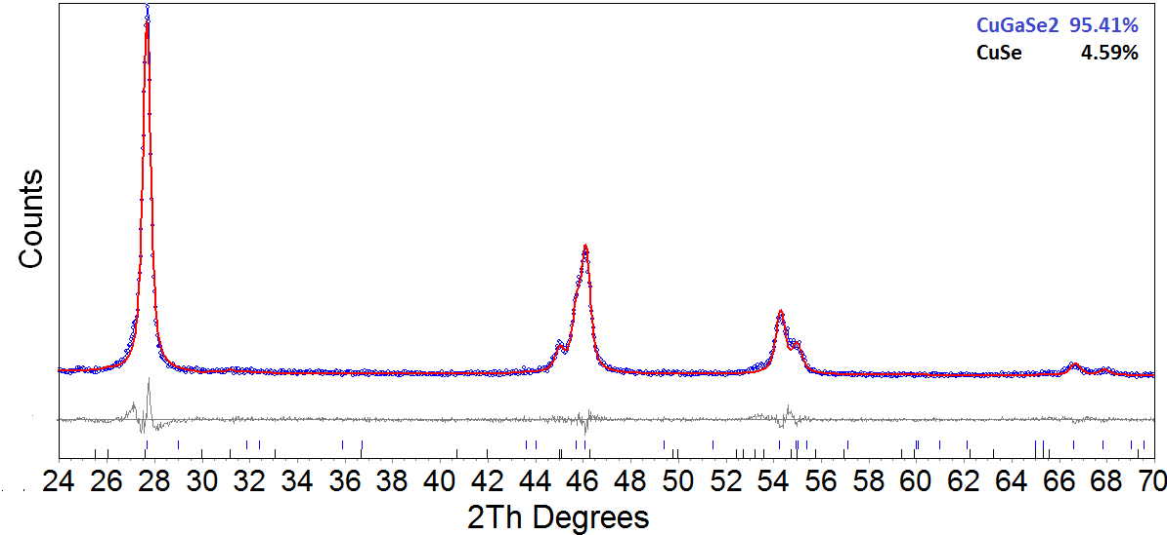

**Figure S4.** X-ray diffraction pattern and Rietveld refinement of CuGaSe2 NCs. Vertical lines show the positions of Bragg peaks and the Bragg markers from top to bottom (a) CuGaSe2 and (b) CuSe. The grey line is the difference between the calculated and experimental intensities. The blue dots correspond to experimental and the red line corresponds to calculated intensities.

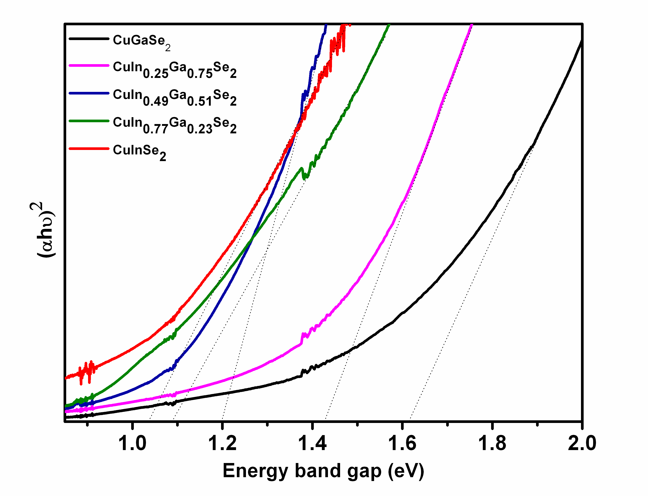

**Figure S5.** An extrapolation of the UV-Vis absorption spectra to identify the band gap of the CuIn*x*Ga1-*x*Se2 NCs. The energy band gap estimated from plotting the squared absorbance vs. energy and extrapolating to zero. The energy band gap increased with increasing Ga content.

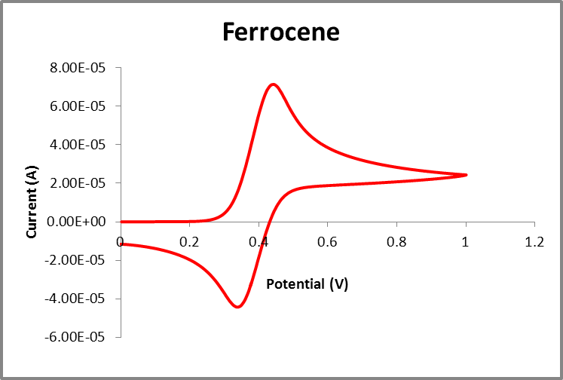

**Figure S6.** The cyclic voltammogram of the oxidation potential of Ferrocene as the internal standard in order to calibrate the measurements. From the oxidation scan the onset of the curve shows the oxidation potential of Ferrocene to be 0.3V.

**Reference:**

[1] M. Ahmadi, S. S. Pramana, S. K. Batabyal, C. Boothroyd, S. G. Mhaisalkar, and Y. M. Lam, "Synthesis of Cu2SnSe3 Nanocrystals for Solution Processable Photovoltaic Cells," *Inorganic Chemistry,* vol. 52, pp. 1722-1728, 2013/02/18 2013.