Elucidating the Relationship between Crystallo-Chemistry and Optical properties of CIGS Nanocrystals

Mahshid Ahmadi¹, Stevin S. Pramana^{2,3}, Chris Boothroyd^{1,4}, Yeng Ming Lam^{1*}

¹Nanyang Technological University, School of Materials Science and Engineering, 50 Nanyang Avenue, 639798, Singapore. Fax: +65 6790 9081
²Facility for Analysis, Characterization, Testing and Simulation, Nanyang Technological University, 50 Nanyang Avenue, 639798, Singapore
³Department of Materials, Imperial College London, Exhibition Road, London SW7 2AZ, United Kingdom
⁴Ernst Ruska-Centrum und Peter Grünberg Institut, Forschungszentrum Jülich, D-52425 Jülich, Germany
KEYWORDS: CIGS, Nanocrystals, Hot injection synthesis, Crystal structure, Raman spectroscopy, Electron probe microanalysis

ABSTRACT
The performances of solar cell fabricated using Cu(In,Ga)(S,Se)₂ nanocrystal (NC) inks synthesized using the hot injection method have yielded efficiencies up to 12 % recently. Efficiencies of these devices are highly dependent on the NC chemical composition and crystallographic quality. The latter is extensively discussed as it can be easily correlated to the optical properties of the film but detailed crystallographic information of these NCs is scarcely discussed. Crystallographic information can result in changes to the optical and also electrical properties. Hence both chemical composition and crystallographic information should be explored for these NC in order for this material to be further developed for thin film solar cells application. In this work, a thorough investigation of the composition and crystal structures of CuIn_{x}Ga_{1-x}Se₂ NCs synthesized using the hot injection method over the entire composition range (0 ≤ x ≤ 1) has been conducted. Raman spectroscopy of the NCs complemented the information derived from X-ray diffraction (XRD) and electron probe microanalysis (EPMA). EPMA, which was carried out for the first time, indicates good controllability of the NC Ga/(In+Ga) ratio using this synthesis method. Raman spectroscopy reviews that CuInSe₂ NCs are a mixture of chalcopyrite and sphalerite with disordered cations whereas CuGaSe₂ NCs are purely chalcopyrite. The lattice parameters determined from XRD was found to deviate from the parameters calculated using Vegard’s law for all compositions. Hence, it can be deduced that the lattice is distorted in the crystal. The optical and electrochemical band gap of CuIn_{x}Ga_{1-x}Se₂ NCs increases as the Ga content increases. The energy band gap deviates from the theoretical values, which could be related to the contribution from the cation disordering and strain. These results help to tailor the opto-electrical properties of semiconductors which inherently depends on the crystalline quality, strain and composition.

1. Introduction
The fundamental physical/electrical properties of CuIn_{x}Ga_{1-x}Se₂ made it uniquely suited for solar cell applications¹. To date the maximum efficiency achieved for CuIn_{x}Ga_{1−x}Se₂ thin film solar cells is 22.6% ². Current manufacturing processes for these thin film solar cells involve the use of vacuum deposition, which makes the cost of commercial production of this type of solar cell relatively high. Therefore, a solution to tackle this issue has to be found.
The hot injection method has been successfully adopted to the synthesis of a wide range of semiconducting chalcogenide nanocrystals (NCs) for low cost solution processable solar cells³. Recently the device performances of solar cells made using Cu(In,Ga)(S,Se)₂ (abbreviated as CIGS and CIGSe for sulfur the and selenium anions, respectively) NCs from nanocrystal inks have yielded efficiencies up to 12 %⁴. However, this field is still at its early stage of research and further improvement is needed. One of the major problems in the development of solution-processed inks is the ability to obtain CIGSe films with uniform and well-controlled composition profiles over large areas. Because of the complexity of CIGSe, device performance can be significantly affected by the local composition, non-uniformity and impurity phases. Other than that, grain boundaries are active recombination centers for photo-generated carriers and CIGSe films must exhibit either large or passivated grains in order to achieve attractive device performance for commercial applications (>10%)⁴. Although considerable progress has been made in the development of bulk ternary and quaternary CuIn_{x}Ga_{1-x}Se₂ systems, the crystallo-chemical understanding of this system, in particular in NC form, is still required to understand how to optimize the properties for solar cells applications.
The fundamental chemical and physical properties of quaternary CuIn_{x}Ga_{1-x}Se₂ materials can be tuned over a significant range using both chemical substitutions and structural modifications. For instance, compositional control in these quaternary semiconductors offers the possibility to tune the energy band gap and hence the opto-electrical properties of these materials. This ability to change the band gap through composition variation is highly beneficial for their application in solar cells. Bearing in mind that the composition is very important for its application in solar cells, the precise control and accurate determination of the elemental composition of CuIn_{x}Ga_{1-x}Se₂ is essential. On top of this, the crystallography of the NCs, such as phase, strain, defects, etc., will also affect the properties of the final films and ought to be studied in tandem with the composition evaluation.
In this paper, we presented the use of electron probe microanalysis (EPMA) for the precise determination of the stoichiometry and the use of X-ray with raman spectroscopy to determine the crystallographic information. The accuracy in EPMA comes from better probe current control coupled with calibration standards. This analysis is conventionally more commonly used for the quantification of bulk samples due to the large X-ray interaction volume (a few hundred nm to µm). It is possible to extend this technique to thin film and/or nanoparticle investigations because of the possibility of accurately determining the film thickness or the nanoparticle size using other methods and hence provide the possibility of offsetting this large interaction volume. CuIn_{x}Ga_{1-x}Se₂ NCs with a range of Ga to In ratios were prepared using the hot injection method.
Stoichiometric CuInSe₂ exists in various crystal structures and it commonly crystallizes as chalcopyrite, which is the stable phase at room temperature¹. This phase is body centered tetragonal (space group$I\overset{}{4}2d$, c ≈ 2a) with Cu at 0, 0, 0, In at 0, 0, 0.5 and Se at 0.227, 0.25, 0.125. When Ga is introduced into CuIn_{x}Ga_{1-x}Se₂, it shares the same lattice site as In ie 0, 0, 0.5. Each Se is coordinated by two Cu and two In/Ga atoms and each Cu and In/Ga is coordinated by four Se atoms. Random distribution of the cations leads to the formation of sphalerite (space group $F\overset{}{4}3m$)⁶ with …ABCABC… stacking and wurtzite (space group P6₃mc)⁷, with …ABABAB… close-packed stacking (Figure 1) both of which are thermodynamically unstable at room temperature. Nanocrystals synthesized via the solution route may exhibit mixed structures due to the numerous inherent metastable processes involved, which can have profound effects on the properties. As the major Bragg peaks of chalcopyrite and sphalerite occur at similar scattering angles (2θ), X-ray diffraction (XRD) alone is insufficient to determine the existence of mixed phases. Shirakata et al.⁸ reported using Raman spectroscopy as a complementary characterization tool for phase determination and the observed Raman active modes of CuInSe₂ at 182 cm⁻¹ coexisting with 175 cm⁻¹ are attributed to sphalerite with disordered cation atoms and chalcopyrite structures, respectively.
Despite many studies of this material, the systematic knowledge of the crystal structure and micro-strain induced in the lattice in NCs is still limited. These structural variations and the crystal lattice distortion can alter the properties of the materials and hence a systematic characterization accompanied with optical studies of the NCs is very important. Herein we report a detailed investigation of the composition and crystal structure of CuIn_{x}Ga_{1-x}Se₂ NCs synthesized using the hot coordinating solvent method over the entire composition range (0 ≤ x ≤ 1) by XRD, Raman scattering, EPMA, transmission electron microscopy (TEM), electron energy loss spectroscopy (EELS), UV-Visible spectroscopy and cyclic voltammetry (CV) and discuss the effect of structural variations on the optoelectronic properties.

2. Experimental details

2.1. Synthesis of wide stoichiometry CuIn_{x}Ga_{1-x}Se₂ NCs
Quaternary CuIn_{x}Ga_{1-x}Se₂ NCs (0 ≤ x ≤ 1) were synthesized by reacting metal-hexadecylamine (HDA) complexes with a Se-HDA suspension. A typical synthesis of CuIn_{0.5}Ga_{0.5}Se₂ NCs has been described in detail in our previous work⁹. A typical synthesis procedure for synthesis of CuIn_{0.5}Ga_{0.5}Se₂ NCs start with heating a stoichiometric mixture of 0.2 mmol CuCl (Sigma-Aldrich, 99.995%), 0.1 mmol InCl₃ (Sigma-Aldrich, 99.999%) and 0.1 mmol gallium (III) acetylacetonate (Ga(acac)₃, Sigma-Aldrich, anhydrous ≥99.999%) and 6.5g of n-Hexadecylamine (HDA, Sigma-Aldrich, 95%) in a 50 mL three-neck flask in an oxygen free environment to 80°C and degassed for 1h. The complete dissolution of cation precursors at around 130°C was confirmed by a change in the color of the solution from blue to yellow. A suspension of 0.4 mmol selenium powder (Se, Kanto Chemical Co. Inc., 99.0%) in 4g of HDA was heated to 50°C and injected into the reaction flask at 130°C under constant stirring and nitrogen flow. The mixture was further heated to 240 °C and held for an hour. After the reaction was completed, the mixture was cooled down to 60 °C. Toluene and methanol were added to the solution and sonicated for 10 mins to remove residual ligands and also the unreacted precursors. The solution was then centrifuged at 9000 rpm for 20 mins, followed by 7000 rpm for 10 mins. The supernatant was discarded for each centrifugation and the NCs were redispersed in toluene before the next centrifugation.
By varying the precursor ratio, the required CuIn_{x}Ga_{1-x}Se₂ NCs compositions were synthesized using the same routes described for x = 0.5.

2.2. Materials Characterization
The compositions of the as-prepared CuIn_{x}Ga_{1-x}Se₂ NCs were quantitatively determined using energy probe microanalysis (EPMA) equipped with five wavelength dispersive spectrometers (WDS). Drop cast samples were deposited on a Si substrate followed by carbon coating. The analysis was carried out at 12 keV with a beam current of 20 nA employing Cu metal, InSb, GaAs and Bi₂Se₃ as the standards for Cu, In, Ga and Se respectively. The ratio of the X-ray intensities collected from the sample and those from the standard at the same accelerating voltage (k-ratio) was calculated. This was used to calculate the weight percentage of the various components using the Bastin and Packwood correction for thin films¹⁰, given a known nano particle size. For each composition the average of a few areas of drop cast samples was taken. The phase and crystallographic structure of the NCs were characterized using grazing incidence X-ray diffraction (GIXRD) performed using a Bruker D8 Advance with a fixed θ of 0.5°, scanning rate of 0.2° min⁻¹, step size of 0.02° and 2θ range from 10 to 80°, using CuK_{α} radiation (λ_{ave}=1.54Å) at 40 kV and 40 mA. The starting Rietveld refinement model used CIF files of CuInSe₂¹¹, CuGaSe₂¹² and CuIn_{0.52}Ga_{0.48}Se₂¹³. The fundamental parameters peak-shape profile was used; a five-coefficient Chebychev polynomial and 1/x background, zero error, scale factors, unit cell parameters and crystal size were sequentially refined using the TOPAS V4 program¹⁴. The weight percentage of each phase was calculated based on quantitative phase analysis using the Rietveld method¹⁵:
$$W_{α}=\frac{S_{α}(\text{ZMV})_{α}}{\sum{(S_{i}(\text{ZMV})_{i})}}$$ | (1)
where W_{α} is the weight fraction of phase α, S is the Rietveld scale factor, Z is the number of formula units in a unit cell, M is the molecular mass for a formula unit and V is the unit cell volume. The micro-Raman spectra were recorded from 50 to 600 cm⁻¹ by using an XY Dilor–Jobin Yvon–Spex spectrometer attached to an Olympus microscope, equipped with a double monochromator and a multi-channel detection system. The 632.8 nm He–Ne laser line was used as an irradiator source with a power density of 20 mW and an Olympus ×100 objective. Spot size was estimated to be around 1µm based on laser spot diameter = 1.22 λ/NA where λ is the wavelength of the laser, and NA is the numerical aperture of the microscope objective being used. Laser power density was controlled by a neutral variable density filters incorporated before the microscope optics. The size and morphology of the NCs was characterized using transmission electron microscopy (TEM). Samples for TEM were prepared by dropping NCs dispersed in toluene onto lacey carbon-coated copper grids. TEM studies were carried out using a JEOL 2100F microscope at an acceleration voltage of 200kV. To identify the oxidation state of the samples, electron energy loss spectra (EELS) were collected with a Gatan imaging filter (GIF) on a Philips CM 300 TEM. For optical characterization, the NCs were dispersed in toluene. The ultraviolet-visible/near infra-red (UV-Vis/NIR) absorption spectrum of the NCs was obtained using a UV-VIS/NIR PerkinElmer Lambda 900 spectrophotometer at room temperature and under ambient conditions with wavelengths ranging from 300 to 1300 nm (step size of 0.5 nm).
Cyclic voltammetry (CV) measurements were performed on an Autolab PG302N electrochemical workstation. Carbon and gold electrodes were used as working and counter electrodes respectively. The reference electrode was a Ag/AgCl electrode with 0.1 M tetrabutylammonium hexafluorophosphate (TBAPF₆) dissolved in acetonitrile as the supporting electrolyte. The ferrocene/ferrocenium couple was utilized as an internal standard¹⁶. A few drops of diluted NCs in chloroform were deposited onto the surface of the working electrode to form a NC film. The scan rate was set at 100 mV/s and during all the measurements, the electrolyte solution was deoxygenated by bubbling N₂ gas through it for 10 min. In this measurement, a treatment with hydrazine was used to remove the ligands by soaking the working electrode (coated with CuIn_{x}Ga_{1-x}Se₂ NCs) in 0.1 M solution of hydrazine in acetonitrile for 30 seconds leading to an improvement in the electrochemical measurements.

3. Results and discussion

3.1. Morphological and compositional study of CuIn_{x}Ga_{1-x}Se₂ nanocrystals
Table 1 shows a comparison of the measured values of x in CuIn_{x}Ga_{1-x}Se₂ using EPMA with the nominal values (according to the stoichiometry of the starting reaction). A value for the thickness comparable to the interaction volume of the NCs was used in calculating the composition from EPMA. The Cu:Se ratio was found to be within 1 standard deviation of the molar ratio, 1:2, while the Ga:(In+Ga) ratio deviates from the starting precursor ratio. This indicates that the NCs stoichiometry is controlled well using this synthesis method. The morphologies of the synthesized CuIn_{x}Ga_{1-x}Se₂ NCs were investigated using TEM. As shown in Figure 2 across the whole composition range, the NCs size distribution is relatively narrow with a nearly spherical morphology. TEM images suggest that the average particle size for all the CuIn_{x}Ga_{1-x}Se₂ NCs synthesized using this hot coordination route was around 20 nm and the change in composition did not change the size of the NCs. This indicates that even though the decomposition temperature and reactivity of the In and Ga precursors are different¹⁷, the presence of HDA in the precursors made the reactivity comparable as precursor complexes are created and the reaction occurred at lower temperature¹⁸. This helps achieve a narrow size and shape distribution with a range of composition. Identical reaction parameters were used throughout the whole series, which makes composition control in the hot coordination method simple compared to other synthesis methods.
EEL spectra (Figure S1, supporting information) of the CuIn_{0.49}Ga_{0.51}Se₂ compound confirmed that all the four elements are present with their expected oxidation states (Cu⁺, In³⁺, Ga³⁺, Se²⁻). From the In EEL spectrum in Figure S1, the edge at around 532 eV is indicative of the presence of oxygen, for which there are many possible sources. Since there are no distinct crystalline oxides present as seen from the X-ray diffraction pattern, the oxygen could be present in the CuIn_{0.49}Ga_{0.51}Se₂ compound in other forms, e.g. substituting for Se as a surface oxide in the form of Cu-O or In-O (most probably amorphous). This was compared with reported EELS of In₂O₃ nanowires and it was found to be very similar¹⁹. From a comparison of CuO and Cu₂O EELS²⁰ with the Cu edge in as synthesized Cu₂Se and CuIn_{0.5}Ga_{0.5}Se₂ NCs (Figure 3), it can be concluded that the presence of oxygen in these NCs did not have a major effect on the shape of the Cu edge. Therefore, there might be only some traces of amorphous In₂O₃ in the sample as it was not observed in the XRD pattern.

3.2. Microstructural study of CuIn_{x}Ga_{1-x}Se₂ nanocrystals using Raman spectroscopy and X-ray diffraction analysis
The major Bragg peaks in the XRD patterns of both chalcopyrite and sphalerite CuInSe₂ occur at similar 2θ values. Hence to detect the presence of the chalcopyrite phase, the weak 211 and 301 reflections must be present. However, it is nearly impossible to de-convolute these two phases if they coexist in the samples. In addition, the presence of micro-strain and preferred orientations of the NCs often perturbs the relative intensity of the XRD patterns, complicating any attempt to distinguish the structures.
Previous studies have shown that through the use of Raman spectroscopy, structural variations (sphalerite and chalcopyrite) in CuInSe₂ thin films can be detected when XRD fails to do so⁸. Raman spectroscopy also provides information on the crystalline quality, strain and compositional variation in semiconducting materials which will in turn affect the opto-electrical properties. In the present work, Raman spectroscopy was carried out to determine the crystal structures present in CIGSe NCs. This study was conducted for the first time on CuIn_{x}Ga_{1-x}Se₂ NCs with a range of compositions.
Raman spectra from the CuIn_{x}Ga_{1-x}Se₂ compositions used here are shown in Figure 4 and illustrate the various phonon modes of the CuIn_{x}Ga_{1-x}Se₂ chalcopyrite structure. The most intense peak occurs in between 175 cm⁻¹ and 188 cm⁻¹ for all CuIn_{x}Ga_{1-x}Se₂, compositions and this corresponds to the A₁ optical phonon mode of the symmetric vibration of Se atoms in the c-plane, which is in agreement with previous studies²¹.
The A₁ mode Raman peak from the CuIn_{x}Ga_{1-x}Se₂ chalcopyrite structure¹¹ was reported to be at 174-175 cm⁻¹ for x = 1^{8a}, and its Raman shift increases according to the equation: Raman shift (cm⁻¹) = -13x + 188²². Another Raman peak observed at 183.4 cm⁻¹ for x = 1 is not related to the chalcopyrite active mode but to a phonon mode related to the sphalerite lattice with disordered cations^{8a}. This cation disordering of the Cu⁺, In³⁺ and Ga³⁺ ions at the 4a Wyckoff site (0, 0, 0) in CuIn_{x}Ga_{1-x}Se₂ causes anti-site defects, creating both donors and acceptors.
The majority of the peaks in the Raman spectra matched those for chalcopyrite. In addition, only the spectrum for CuInSe₂ shows a clear and sharp S peak, while for the rest of the samples, the presence of S is indicated by a shoulder, and from the increasing A₁ area compared to S area, it is possible to deduce that the chalcopyrite phase has increased as the Ga content increases. This shows that the crystal structure is mainly chalcopyrite although some parts of the cations are disordered (i.e sphalerite). To the best of our knowledge, there is no report of Raman spectra from single-phase sphalerite since this is the high temperature phase and thermodynamically the chalcopyrite phase is favored at room temperature. Figure 5 illustrates the gradual shift of the A₁ and S peaks from CuInSe₂ to CuGaSe₂ as the Ga content increases. The increase of the A₁ mode frequency as the Ga content increases is postulated to be due to mass reduction in the system since the mass of Ga is 61% of that in In^{21b}. With increasing In content (x), the fitted linear equations are:
Raman shift (cm⁻¹) = -9.598x + 183.5 (R² = 0.899) for the A₁ mode | (2)
Raman shift (cm⁻¹) = -8.251x + 190.9 (R² = 0.957) for the S mode | (3)
Table 2 shows that the ratio of the area under the curve for the A₁ and S modes decreases with increasing x, which is proportional to the atomic ratio of chalcopyrite to sphalerite, with the CuGaSe₂ showing pure chalcopyrite phase. The fitted quadratic equation is:
$\frac{{\text{Area}}_{A_{1}}}{{\text{Area}}_{S}}=7\text{.}\text{239}x^{2}−\text{14}\text{.}\text{73}x+9\text{.}\text{663}$ (R² = 0.993) | (4)
Hence, for the characterization of the cation disordering in CuIn_{x}Ga_{1-x}Se₂ NCs the Raman measurements are superior to powder XRD.
This study also confirmed that it is possible to monitor the stoichiometric changes since the Raman peaks shift away from the CuInSe₂ peak position to the CuGaSe₂ position when Ga replaces In by making use of the linear relationship between the A₁ peak position and intensity (Figure 5).
Besides the A₁ peak, multiple peaks between 212 and 273 cm⁻¹ correspond to either the B₂ or E modes or a combination of both B₂ and E modes²²⁻²³. Peak broadening can be attributed to disorder in the NC structure^{8a}. Previous studies of thin film CuIn_{x}Ga_{1-x}Se₂ reported that the peak at 260 cm⁻¹ is attributed to the Cu rich phase. The peaks between 212 and 273 cm⁻¹ were labeled for CuInSe₂ NC in Figure S2. In the present study, this peak is attributed to the B₂+E mode of CuIn_{x}Ga_{1-x}Se₂ NCs and also systematically shift with the composition, similar to observations in earlier reports²²⁻²³. The Raman spectra from CuIn_{0.49}Ga_{0.51}Se₂ NCs in Figure 4 also show that there are peaks between 100 cm⁻¹ and 160 cm⁻¹ which are labeled in Figure S3. Some of these peaks, such as the one at 124 cm⁻¹, are attributed to the B₁ mode of CuIn_{x}Ga_{1-x}Se₂^{23a} while others are still unidentified. Since these peaks may not correspond to the CuIn_{x}Ga_{1-x}Se₂ Raman phonon modes, based on previous studies, it was suggested that these peaks indicate the presence of ordered vacancy compounds (OVC), which are mainly related to Cu vacancies. A previous study indicated that the peak at 155 cm⁻¹ corresponds to the vibrational mode of the localized phonon due to a defective structure of the chalcopyrite phase with Cu-poor OVC, in Cu(In, Ga)₃Se₅ single crystal which was not detected by EPMA. The OVC peak is more prominent in CuIn_{0.49}Ga_{0.51}Se₂ NCs. Lastly, a strong vibrational peak was discovered in the Raman spectra of CuGaSe₂ near 274 cm⁻¹ (B₂ mode of this composition) and the second order of this mode can be seen at 540 cm^{-1 21b}. The peak at 263 cm⁻¹ matches the Cu_{2-x}Se impurity present in this compound (Figure 4).
It is worth to mention that in principal, sphalerite is a high temperature meta stable phase of bulk CIGS. However, it was shown that NCs of the meta stable sphalerite phase of CIS can be synthesized via hot injection method by specific reaction controls . In general, it is believed that adding the Se precursor at low temperature and gradual temperature rise prevents large supersaturation and allows the atoms to form the thermodynamically preferred chalcopyrite structure ²⁷ in agreement with our results. Besides, it was demonstrated that amine coordination to the metal cations has a kinetic effect on structure determination ²⁸. In addition to amine, the use of specific selenium source is necessary for the production of sphalerite NCs ²⁸. Therefore, we believe it is unlikely that temperature change during irradiation with laser during Raman measurements to result in phase transition in the synthesized CIGS NCs.
XRD patterns from CuIn_{x}Ga_{1-x}Se₂ NCs with (0 ≤ x ≤ 1) are shown in Figure 6 and all diffraction peaks show a systematic shift to higher 2θ angles with increasing Ga content. The shift can be attributed to the substitution of smaller Ga ions into larger In lattice sites (the ionic radii of tetrahedrally coordinated In³⁺ and Ga³⁺ are 0.62 and 0.47Å, respectively²⁹). The unit cell parameters and reliability factors from Rietveld refinement of the diffraction patterns for CuIn_{x}Ga_{1-x}Se₂ NCs of the diffraction compositions are tabulated in Table S1. As mentioned in the introduction, it was difficult to model both chalcopyrite and sphalerite structures so only the former phase of CuIn_{x}Ga_{1-x}Se₂ was used and the accuracy of the results was confirmed by the good refinement fits as indicated in Table S1. The lattice parameters for the chalcopyrite phase derived from XRD patterns together with the idealized lattice parameters assuming a solid solution using Vegard’s law are plotted in Figure 7. Although the volume of the unit cell follows Vegard’s law very closely the unit cell parameter, c, deviates from that predicted using Vegard’s law. The unit cell parameter, a, was expected to be smaller than that predicted to compensate for c. For x = 0.25 and 0.77, the c/2a ratio is close to unity, which metrically corresponds to cubic sphalerite. However from Raman spectroscopy, the clear peaks at 182.3 for x = 0.25 and 176.4 for x = 0.77, cannot be unambiguously assigned to the chalcopyrite A1 mode suggesting that although they are metrically cubic, the cations have an orderly arrangement leading to the doubling of c. More studies are required to understand and determine the structure properly. In CuGaSe₂, approximately 4 wt.% of Cu_{2-x}Se impurity was observed (Figure S4) and this is consistent with the Raman peaks observed at 263 cm⁻¹.

3.3. Energy levels of CuIn_{x}Ga_{1-x}Se₂ nanocrystals (optical and electrochemical studies)
Figure 8 shows the optical absorption spectra of synthesized CuIn_{x}Ga_{1-x}Se₂ NCs as a function of the stoichiometry, x. It can be observed that the absorption edge is in the visible region and there is a long absorption tail in the infrared region. Also, this tail is shorter when Ga is present. This observation is in line with the absorption spectra of bulk CuIn_{x}Ga_{1-x}Se₂³⁰. The absorption onset for CuIn_{x}Ga_{1-x}Se₂ NCs is blue-shifted with increasing Ga content. As CuIn_{x}Ga_{1-x}Se₂ is a typical direct band gap semiconductor, the estimated optical energy band gap can be obtained from the absorption spectra by extrapolation as shown in Figure S5 and there is a gradual increase of E_{g} with x. The band gaps of CuInSe₂ and CuGaSe₂ obtained from Figure S5 were 1.05 eV and 1.62 eV respectively and these values are consistent with the reported bulk band gaps of 1.01 eV and 1.64 eV that can be derived from the following equation³¹:
E_{g} = 1.010 + 0.626(1-x)-0.167x(1-x)=1.636-0.793x+0.167x² | (5)
A plot of the change in band gap with composition x can be seen in Figure 9. It is reported that the energy band gap of chalcopyrite crystals is lower than sphalerite as the different chemical nature of the Cu, In and Ga ions results in different bonding environments between each of these and their neighboring Se ions resulting in very different ionic character and bond lengths¹. This bond length change reduces the band gap energy of the compound in the case of chalcopyrite structure compared to the sphalerite structure with identical chemical composition, because the latter has a disordered cation sub-lattice¹. Therefore, the difference between the theoretical and experimental energy band gap in figure 9 may be attributed to this contribution from crystals with disordered cations (sphalerite phase). The energy band gap of quaternary chalcopyrite CuIn_{x}Ga_{1-x}Se₂ compounds exhibits a quadratic dependence on the composition. The constant before x² is referred to as the bowing factor, which is understood to be a result of bond alteration in the lattice³². Our experiments showed that the variation is nonlinear for the band gap versus composition of the as synthesized NCs. The experimental optical energy band gap has a downward bowing with a value of 0.463 and this lies beyond the 0-0.25 range¹. Bowing factors that are beyond this range may be an indication of the presence of disorder in the crystal structure as the theoretical bowing factor is calculated for an ordered chalcopyrite structure. The calculated energy band gap in Figure 9 is derived using the following equation:
E_{g} = 0.463x² - 1.059x + 1.632 | (6)
To further validate the energy band gap of the synthesized NCs, the electrochemical energy band gap is also calculated from the difference between the estimated oxidation and reduction potential of NCs as measured using cyclic voltammetry (CV). The oxidation process is related to the injection of a hole into the HOMO level of organic molecules or the valence band of inorganic semiconductors, and the reduction process is related to the injection of an electron into the LUMO level or conduction band of inorganic semiconductors. When ferrocene is used as the reference (a typical CV curve for ferrocene is shown in the supporting information, Figure S6), the valence and conduction bands of the inorganic semiconductors can be calculated using the following equation¹⁶.
E_{HOMO/LUMO} = [(E_{ox/red} – E_{FC}) + 4.7]eV | (7)
CV curves for CuIn_{x}Ga_{1-x}Se₂ NCs are shown in Figure 10. There is a prominent oxidation peak and a relatively weak reduction peak, probably due to the difficulty of charge injection from the electrode to the p-type semiconductor NCs. The oxidation and reduction onsets are shown in Table S2. According to Shafarman and Stolt³³, the bulk band gap for CuInSe₂ is 1.02 eV with valance and conduction bands at ca. -5.6 and -4.6 eV respectively and for bulk CuIn_{0.5}Ga_{0.5}Se₂ the energy band gap is 1.2 eV with valance and conduction bands at ca. -5.2 and -4.0 eV respectively. With increasing Ga ratio, the valence band maximum decreases slightly while an increase in the conduction band is prominent³⁴. Although the calculated electrochemical conduction and valence band of the NCs differs slightly from those reported, there is a systematic shift in the onset potentials of oxidation and reduction of the NCs as the Ga ratio increases (Table S2).
The optical and electrochemical energy band gaps calculated from the absorption edges and the CV measurements (Figure 9 and Table S2) were compared to those predicted by equation 5. Although both optically and electrochemically measured band gaps fall within the range of the theoretical band gaps of CuIn_{x}Ga_{1-x}Se₂ ranging from 1.01 eV to 1.64 eV, with increasing Ga content, there are slight discrepancies in the values. This could be due to the size of the synthesized NCs, as particle size decreases, the quantum confinement effect comes into play and this will increase the band gap. There is also the contribution from defects caused by micro-strain and crystal disordering.
The presence of local disorder causes defect bands at the valence and conduction bands and hence shifts the electronic bands³⁵. Therefore the first oxidation onset seen in the CV curves which is very close to zero can be attributed to these defects as well as the OVCs. The band gap of CuIn_{x}Ga_{1-x}Se₂ NCs can be readily tuned by adjusting the ratio of Ga to In, resulting in band gaps ranging from 1.13 eV to 1.42 eV corresponding to compounds ranging from CuInSe₂ to CuIn_{0.25}Ga_{0.75}Se₂. There is a gradual increase in the band gap as the Ga content increases, which agrees with previous findings.

4. Conclusion
A detailed crystallo-chemical study of CuIn_{x}Ga_{1-x}Se₂ NCs with a wide range of composition synthesized using the hot injection method has been presented. In this study, quantitative analysis of the CuIn_{x}Ga_{1-x}Se₂ NC composition was performed using EPMA. Even though EPMA has been rarely used for measuring nanoparticle compositions, we have used this method for the first time for our compositional study of CIGS NCs and the results are close to the nominal values. In general, XRD is a good technique for lattice parameter determination and phase analysis. In this study, Raman spectroscopy was performed as a complementary characterization tool to determine the different phases in the synthesized NCs.
From the CuIn_{x}Ga_{1-x}Se₂ NC Raman spectra, we can observe the coexistence of the chalcopyrite A₁ mode and the sphalerite S mode with disordered cations. This analysis shows that the crystal structure is mainly chalcopyrite although some parts of the cations are disordered. Raman analysis complements XRD as cation disordering in CuIn_{x}Ga_{1-x}Se₂ NCs can be detected using the latter technique. With increasing substitution of In with Ga, the Raman peaks shift away from the CuInSe₂ peak position to the CuGaSe₂ position, which is an indication of a variation in the stoichiometry of the synthesized NCs. The broadening of the Raman modes can also be attributed to the strain in the sample due to the presence of the OVCs. The crystal lattice distortion was further confirmed by a systematic X-ray diffraction analysis of the crystal lattice parameters a, c, V and c/2a compared to the idealized solid solution trend. CuIn_{0.49}Ga_{0.51}Se₂ NCs showed the maximum distortion amongst the range of compositions explored. UV-Visible spectroscopy and CV measurements indicates that while the energy band gap of NCs is within the range of the theoretical energy band gap for bulk CuIn_{x}Ga_{1-x}Se₂, there is a slight shift which can be attributed to the presence of defects caused by strain and the lattice distortion in the crystal structure of the NCs.

Supporting Information. (1) Refined unit cell parameters of CuIn_{x}Ga_{1-x}Se₂ NCs, (2) A comparison of the theoretical, optical and electrochemical band gaps of CuIn_{x}Ga_{1-x}Se₂ NCs, (3) Background subtracted EELS of the Cu, In, Ga and Se edges of CuIn_{0.49}Ga_{0.51}Se₂ NCs, (4) labeled Raman peaks of CuInSe₂ and CuIn_{0.49}Ga_{0.51}Se₂ NCs, (5) X-ray diffraction pattern and Rietveld refinement of CuGaSe₂ NCs, (6) An extrapolation of the UV-Vis spectra of CuIn_{x}Ga_{1-x}Se₂ NCs, and (7) The cyclic voltammogram of the oxidation potential of Ferrocene. This material is available free of charge via the Internet at http://pubs.acs.org.
Corresponding Author
* Y.M. Lam, E-mail: ymlam@ntu.edu.sg.
Author Contributions
The manuscript was written through contributions of all authors. All authors have given approval to the final version of the manuscript. M. Ahmadi and S.S. Pramana contributed equally to this work.
Funding Sources
This work was funded by Agency for Science, Technology and Research (A*STAR-Singapore) and supported by Energy Research Institute at Nanyang Technological University.

5. References
1. Stanbery, B. J., Copper Indium Selenides and Related Materials for Photovoltaic Devices. Critical Reviews in Solid State & Materials Science 2002, 27 (2), 73.
2. Jackson, P.; Wuerz, R.; Hariskos, D.; Lotter, E.; Witte, W.; Powalla, M., Effects of heavy alkali elements in Cu(In,Ga)Se2 solar cells with efficiencies up to 22.6%. physica status solidi (RRL) – Rapid Research Letters 2016, 10 (8), 583-586.
3. (a) Peng, X., Mechanisms for the Shape-Control and Shape-Evolution of Colloidal Semiconductor Nanocrystals. Adv Mater 2003, 15 (5), 459-463; (b) Akhavan, V. A.; Goodfellow, B. W.; Panthani, M. G.; Reid, D. K.; Hellebusch, D. J.; Adachi, T.; Korgel, B. A., Spray-deposited CuInSe2 nanocrystal photovoltaics. Energy & Environmental Science 2010, 3 (10); (c) Murray, C. B.; Norris, D. J.; Bawendi, M. G., Synthesis and characterization of nearly monodisperse CdE (E = sulfur, selenium, tellurium) semiconductor nanocrystallites. Journal of the American Chemical Society 1993, 115 (19), 8706-8715; (d) Huynh, W. U.; Dittmer, J. J.; Alivisatos, A. P., Hybrid Nanorod-Polymer Solar Cells. Science 2002, 295 (5564), 2425-2427.
4. Guo, Q.; Ford, G. M.; Agrawal, R.; Hillhouse, H. W., Ink formulation and low-temperature incorporation of sodium to yield 12% efficient Cu(In,Ga)(S,Se)2 solar cells from sulfide nanocrystal inks. Progress in Photovoltaics: Research and Applications 2013, 21 (1), 64-71.
5. Jung, S.; Ahn, S.; Yun, J. H.; Gwak, J.; Kim, D.; Yoon, K., Effects of Ga contents on properties of CIGS thin films and solar cells fabricated by co-evaporation technique. Current Applied Physics 2010, 10 (4), 990-996.
6. Merino, J. M.; Michiel, M. D.; Leon, M., Structural analysis of CuInSe₂ and CuIn₃Se₅ at different temperatures with synchrotron radiation. J. Phys. Chem. Solids 2003, 64, 1649-1652.
7. Norako, M. E.; Brutchey, R. L., Synthesis of Metastable Wurtzite CuInSe2 Nanocrystals. Chemistry of Materials 2010, 22 (5), 1613-1615.
8. (a) Shirakata, S.; Kubo, H.; Hamaguchi, C.; Isomura, S., Raman Spectra of CuInSe2 Thin Films Prepared by Chemical Spray Pyrolysis. Japanese Journal of Applied Physics 1997, 36 (Part 2, No. 10B), L1394- L1396; (b) Shirakata, S.; Murakami, T.; Kariya, T.; Isomura, S., Preparation of CuInSe2 Thin Films by Chemical Spray Pyrolysis. Japanese Journal of Applied Physics 1996, 35 (Part 1, No. 1A), 191-199.
9. Ahmadi, M.; Pramana, S. S.; Xi, L.; Boothroyd, C.; Lam, Y. M.; Mhaisalkar, S., Evolution Pathway of CIGSe Nanocrystals for Solar Cell Applications. The Journal of Physical Chemistry C 2012, 116 (14), 8202-8209.
10. (a) Bastin, G. F.; Heijligers, H. J. M.; van Loo, F. J. J., A Further Improvement in the Gaussian ϕ(ϱ) Approach for Matrix Correction in Quantitative Electron Probe Microanalysis. Scanning 1986, 8 (2), 45-67; (b) Packwood, R. H.; Brown, J. D., A Gaussian expression to describe ϕ(ρz) curves for quantitative electron probe microanalysis. X-Ray Spectrometry 1981, 10 (3), 138-146.
11. Schorr, S.; Geandier, G., In-situ investigation of the temperature dependent structural phase transition in CuInSe2 by synchrotron radiation. Crystal Research and Technology 2006, 41 (5), 450-457.
12. Mandel, L.; Tomlinson, R. D.; Hampshire, M. J., Crystal data for CuGaSe2. Journal of Applied Crystallography 1977, 10 (2), 130-131.
13. Souilah, M.; Rocquefelte, X.; Lafond, A.; Guillot-Deudon, C.; Morniroli, J. P.; Kessler, J., Crystal structure re-investigation in wide band gap CIGSe compounds. Thin Solid Films 2009, 517 (7), 2145-2148.
14. Bruker, TOPAS, Version 4. Bruker AXS Inc. Madison, Wisconsin, USA 2008.
15. Hill, R. J.; Howard, C. J., Quantitative phase analysis from neutron powder diffraction data using the Rietveld method. Journal of Applied Crystallography 1987, 20 (6), 467-474.
16. Bard, A. J.; Faulkner, L. R., Electrochemical methods : fundamentals and applications. Wiley: New York, 1980; p xviii, 718 p.
17. Pan, D.; Wang, X.; Zhou, Z. H.; Chen, W.; Xu, C.; Lu, Y., Synthesis of Quaternary Semiconductor Nanocrystals with Tunable Band Gaps. Chemistry of Materials 2009, 21 (12), 2489-2493.
18. (a) de Mello Donegá, C.; Hickey, S. G.; Wuister, S. F.; Vanmaekelbergh, D.; Meijerink, A., Single-Step Synthesis to Control the Photoluminescence Quantum Yield and Size Dispersion of CdSe Nanocrystals. The Journal of Physical Chemistry B 2002, 107 (2), 489-496; (b) Pan, D.; An, L.; Sun, Z.; Hou, W.; Yang, Y.; Yang, Z.; Lu, Y., Synthesis of Cu−In−S Ternary Nanocrystals with Tunable Structure and Composition. Journal of the American Chemical Society 2008, 130 (17), 5620-5621; (c) Qu, L.; Peng, X., Control of Photoluminescence Properties of CdSe Nanocrystals in Growth. Journal of the American Chemical Society 2002, 124 (9), 2049-2055; (d) Talapin, D. V.; Rogach, A. L.; Kornowski, A.; Haase, M.; Weller, H., Highly Luminescent Monodisperse CdSe and CdSe/ZnS Nanocrystals Synthesized in a Hexadecylamine−Trioctylphosphine Oxide−Trioctylphospine Mixture. Nano Letters 2001, 1 (4), 207-211.
19. Cheng, G.; Stern, E.; Guthrie, S.; Reed, M. A.; Klie, R.; Hao, Y.; Meng, G.; Zhang, L., Indium oxide nanostructures. Appl. Phys. A 2006, 85 (3), 233-240.
20. Semiconductor Research Corporation, C. U.
21. (a) Roy, S.; Guha, P.; Kundu, S. N.; Hanzawa, H.; Chaudhuri, S.; Pal, A. K., Characterization of Cu(In,Ga)Se2 films by Raman scattering. Materials Chemistry and Physics 2002, 73, 24-30; (b) Olejníček, J.; Kamler, C. A.; Mirasano, A.; Martinez-Skinner, A. L.; Ingersoll, M. A.; Exstrom, C. L.; Darveau, S. A.; Huguenin-Love, J. L.; Diaz, M.; Ianno, N. J.; Soukup, R. J., A non-vacuum process for preparing nanocrystalline CuIn1−xGaxSe2 materials involving an open-air solvothermal reaction. Solar Energy Materials and Solar Cells 2010, 94, 8-11.
22. Choi, I.-H., Raman spectroscopy of CuIn1&#xa0;−&#xa0;xGaxSe2 for in-situ monitoring of the composition ratio. Thin Solid Films 2011, 519 (13), 4390-4393.
23. (a) Rincon, C.; Ramirez, F. J., Lattice vibrations of CuInSe[sub 2] and CuGaSe[sub 2] by Raman microspectrometry. Journal of Applied Physics 1992, 72 (9), 4321-4324; (b) Deepa, K. G.; Vijayakumar, K. P.; Sudhakartha, C., Lattice vibrations of sequentially evaporated CuInSe2 by Raman microspectrometry. Materials Science in Semiconductor Processing (0).
24. Witte, W.; Kniese, R.; Powalla, M., Raman investigations of Cu(In,Ga)Se2 thin films with various copper contents. Thin Solid Films 2008, 517 (2), 867-869.
25. Yen-Pei, F.; Rui-Wei, Y.; Lew, K. K., CuIn1-xGaxSe2 Absorber Layer Fabricated by Pulse-Reverse Electrodeposition Technique for Thin Films Solar Cell. Journal of the Electrochemical Society 2009, 156 (12), D553.
26. Fontane, X.; Izquierdo-Roca, V.; Calvo-Barrio, L.; Perez-Rodriguez, A.; Morante, J. R.; Guettler, D.; Eicke, A.; Tiwari, A. N., Investigation of compositional inhomogeneities in complex polycrystalline Cu(In,Ga)Se[sub 2] layers for solar cells. Applied Physics Letters 2009, 95 (26), 261912-3.
27. Guo, Q.; Kim, S. J.; Kar, M.; Shafarman, W. N.; Birkmire, R. W.; Stach, E. A.; Agrawal, R.; Hillhouse, H. W., Development of CuInSe2 Nanocrystal and Nanoring Inks for Low-Cost Solar Cells. Nano Letters 2008, 8 (9), 2982-2987.
28. Norako, M. E.; Greaney, M. J.; Brutchey, R. L., Synthesis and Characterization of Wurtzite-Phase Copper Tin Selenide Nanocrystals. Journal of the American Chemical Society 2011, 134 (1), 23-26.
29. Shannon, R. D., Revised Effective Ionic Radii and Systematic Studies of Interatomie Distances in Halides and Chaleogenides. Acta Cryst. 1976, A32, 751-767.
30. Venkatachalam, M.; Kannan, M. D.; Muthukumarasamy, N.; Prasanna, S.; Jayakumar, S.; Balasundaraprabhu, R.; Saroja, M., Investigations on electron beam evaporated Cu(In0.85Ga0.15)Se2 thin film solar cells. Solar Energy 2009, 83, 1652-1655.
31. Alonso, M. I.; Garriga, M.; Rincón, C. A. D.; Hernández, E.; León, M., Optical functions of chalcopyrite CuGa_{x}In_{1-x}Se₂ alloys. Appl. Phys. A-Mater. 2002, 74 (5), 659-664.
32. Zunger, A.; Jaffe, J. E., Structural Origin of Optical Bowing in Semiconductor Alloys. Physical Review Letters 1983, 51 (8), 662-665.
33. Shafarman, W. N.; Stolt, L., Cu(InGa)Se2 Solar Cells. In Handbook of Photovoltaic Science and Engineering, John Wiley & Sons, Ltd: 2005; pp 567-616.
34. Wei, S.-H.; Zhang, S. B.; Zunger, A., Effects of Ga addition to CuInSe[sub 2] on its electronic, structural, and defect properties. Applied Physics Letters 1998, 72 (24), 3199-3201.
35. Luque, A.; Hegedus, S., Handbook of photovoltaic science and engineering. Wiley: Hoboken, NJ, 2003; p xxvii, 1138 p.

Table Captions
Table 1: Composition of CuIn_{x}Ga_{1-x}Se₂ NCs measured using EPMA. The lateral interaction volume is approximately 1-5 µm.
Table 2: Shift in the A₁ and S modes and the parameter (area of A₁ mode)/(area of S mode) representing the degree of disorder from the chalcopyrite structure as a function of the composition x in CuIn_{x}Ga_{1-x}Se₂ NCs.
Figure Captions
Figure 1: a) Chalcopyrite, b) sphalerite and c) wurtzite crystal structures of CuIn_{0.5}Ga_{0.5}Se₂ viewed along the close- packed direction.
Figure 2: TEM images of chalcopyrite CuIn_{x}Ga_{1-x}Se₂ NCs with x a) 1, b) 0.77, c) 0.49, d) 0.25 and f) 0.
Figure 3: Background subtracted Cu L edge EEL spectra from CuIn_{0.49}Ga_{0.51}Se₂ NCs (solid line) and Cu₂Se (dotted line).
Figure 4: Raman spectra from CuIn_{x}Ga_{1-x}Se₂ NCs with a range of Ga/(Ga+In) ratios showing the shift in the A₁ mode of chalcopyrite CuIn_{x}Ga_{1-x}Se₂ and also a deconvolution of the A₁ and the S mode. The peak marked * corresponds to the Cu_{2-x}Se impurity present in CuGaSe₂.
Figure 5: Change in the A₁ and S Raman peak positions from CuIn_{x}Ga_{1-x}Se₂ NCs as a function of x.
Figure 6: XRD patterns from CuIn_{x}Ga_{1-x}Se₂ NCs with a range of Ga/(Ga+In) ratios. A systematic shift of the diffraction peaks to higher 2θ is due to the decreased lattice spacing as smaller Ga atoms are substituted for larger In atoms. Indices are shown on the CuInSe₂ NCs XRD pattern. The indices are similar for the other XRD patterns.
Figure 7: Unit cell parameters, (a) a, (b) c, and (c) unit cell volume. The dotted line represents Vegard’s law. (d) Tetragonal distortion η=c/2a as a function of x.
Figure 8: UV-Vis absorption spectra from CuIn_{x}Ga_{1-x}Se₂ NCs as a function of composition, x.
Figure 9: Comparison of the theoretical with the measured optical and electrochemical energy band gaps.
Figure 10: Cyclic voltammetry of CuIn_{x}Ga_{1-x}Se₂ NCs showing the oxidation and reduction onsets.
Table 1
Nominal x | Measured x
0.00 | 0.00
0.30 | 0.25(4)
0.50 | 0.49(6)
0.70 | 0.77(7)
1.00 | 1.00

Table 2
x | A₁ | S | Area of A₁ mode/ area of S mode
0 | 183.6 | 191.7 | ~
0.25 | 182.3 | 188.5 | 6.5
0.49 | 176.6 | 186.1 | 4.0
0.77 | 176.4 | 184.3 | 2.8
1 | 174.4 | 183.4 | 2.1

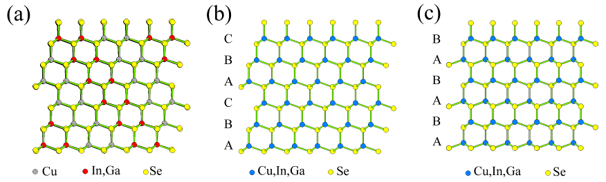

Figure 1
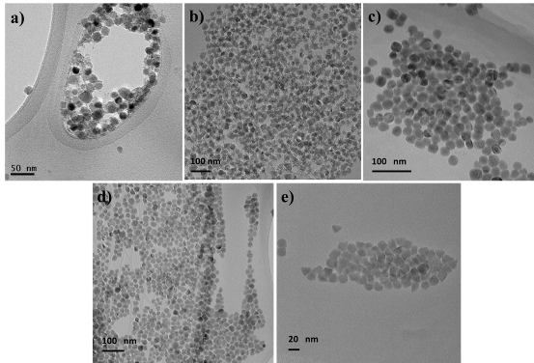

Figure 2

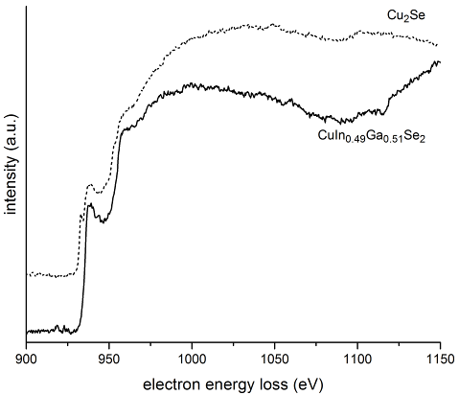
Figure 3

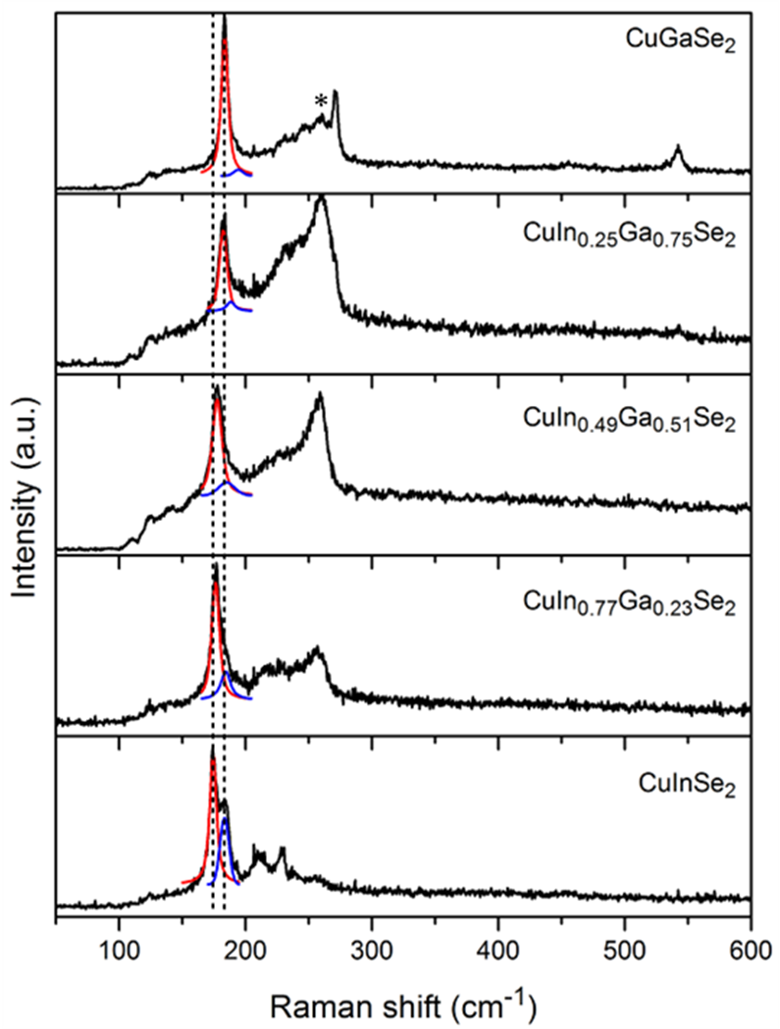
Figure 4

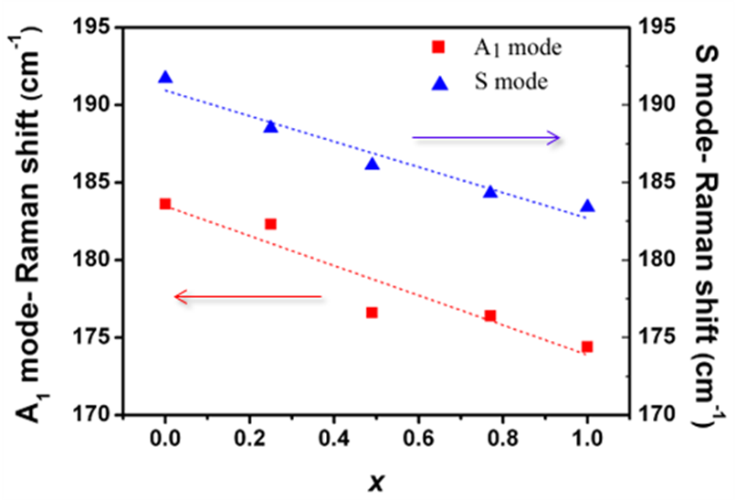
Figure 5

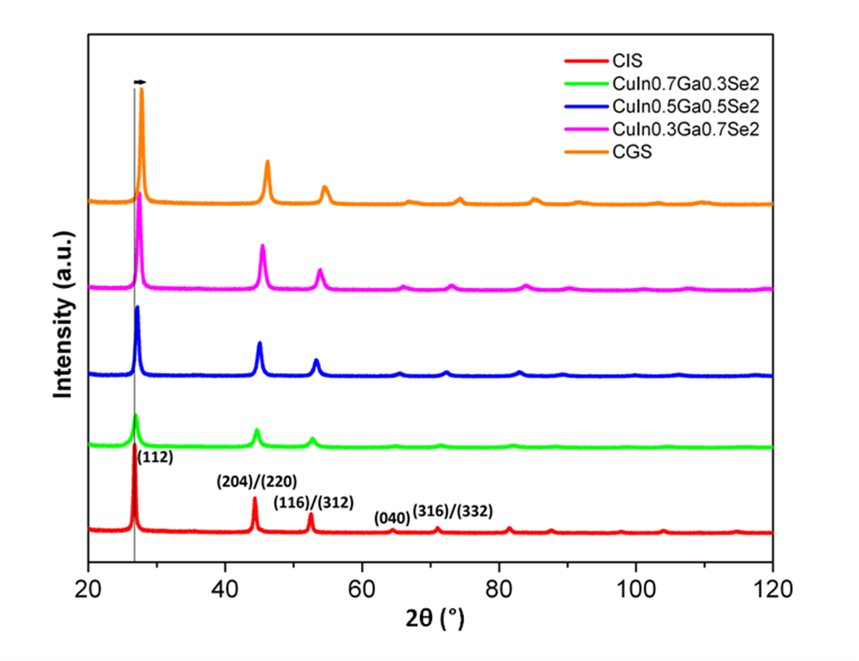
Figure 6
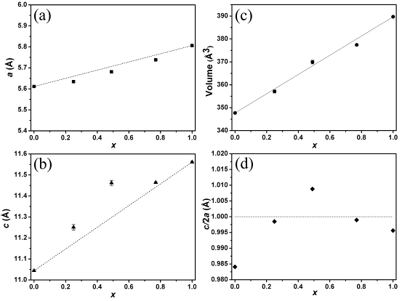
Figure 7
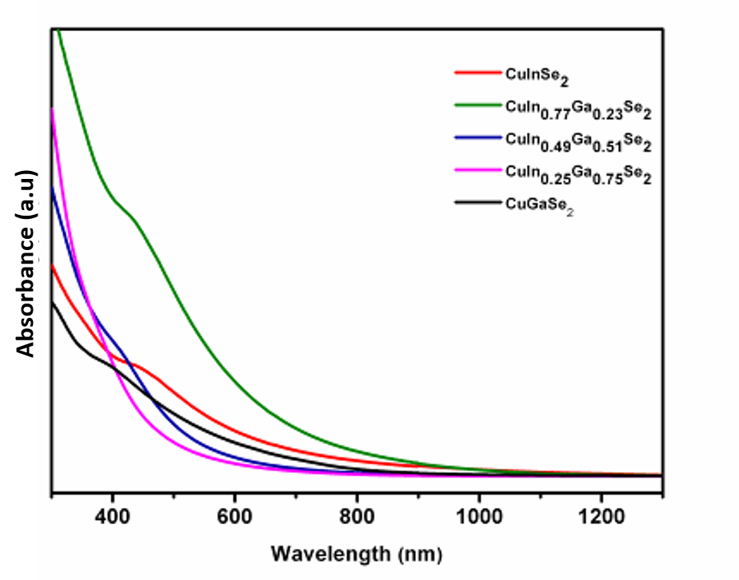
Figure 8

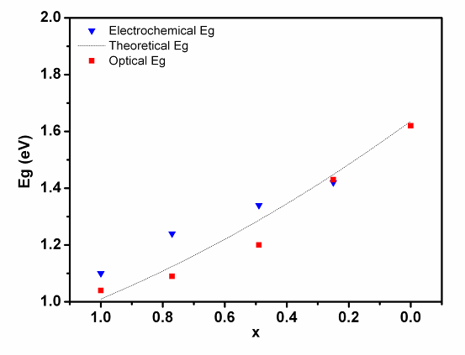
Figure 9

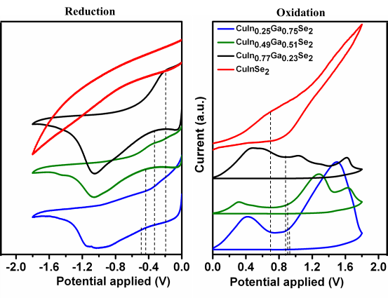
Figure 10

Table of Content
In this work, a thorough investigation of the composition and crystal structures of CuInxGa_{1-x}Se₂ NCs synthesized using the hot injection method over the entire composition range (0 ≤ x ≤ 1) has been conducted. EPMA, which was carried out for the first time, indicates good controllability of the NC Ga/(In+Ga) ratio. These results help to tailor the opto-electrical properties of semiconductors which inherently depends on the crystalline quality, strain and composition.

