High latitude circulation in giant planet magnetospheres

D. J. Southwood 1,2 and E. Chané 2

1Physics Department, Imperial College, London, UK

2 Centre for mathematical Plasma Astrophysics, KULeuven, Belgium

Corresponding author: David Southwood ([d.southwood@imperial.ac.uk)](mailto:d.southwood@imperial.ac.uk))

Key Points:

* Implications of the high invariant latitude Dungey cycle are described
* Midday equatorial flow blocking by heavy material causes reconnection preferentially before noon.
* Solar wind entry particles are lost each rotation by a downtail wind flanking the plasma sheet.

Doi: 10.1002/2015JA022310

Abstract

We follow up the proposal by Cowley et al. [2004] that the plasma circulation in the magnetospheres of the giant planets is a combination of two cycles or circulation systems. The Vasyliunas cycle transports heavy material ionised deep within the magnetosphere eventually to loss in the magnetotail. The second cycle is driven by magnetic reconnection between the planetary and the solar wind magnetic fields (the Dungey cycle) and is found on flux tubes poleward of those of the Vasyliunas cycle. We examine features of the Dungey system, particularly what occurs out of the equatorial plane. The Dungey cycle requires reconnection on the dayside and we suggest that at the giant planets the dayside reconnection occurs preferentially in the morning sector. Secondly, we suggest that that most of the solar wind material that enters through reconnection on to open flux tubes on the dayside never gets trapped on closed field lines but makes less than one circuit of the planet and exits down tail. In its passage to the nightside, the streaming ex-solar wind material is accelerated centrifugally by the planetary rotation primarily along the field, thus in the tail it will appear very like a planetary wind. The escaping wind will be found on the edges of the tail plasma sheet and reports of light ion streams in the tail are likely due to this source. The paper concludes with a discussion of high latitude circulation in the absence of reconnection between the solar wind and planetary field.

1 Introduction

Both Jupiter and Saturn have fast rotating magnetospheres and both have strong internal sources of material from moons deep within the system. Nevertheless, both planets are embedded in the solar wind and there is doubtless momentum, energy and mass exchange with the solar environment. Cowley et al. [2004] proposed that the Kronian magnetospheric circulation was composed of two separate systems which were labelled the Vasyliunas cycle and the Dungey cycle. A point we emphasise here but not raised by Cowley et al. [2004] is that the basic composition of the two systems is fundamentally different. The Vasyliunas cycle [Vasyliunas, 1983] takes place on the closed field lines and is the transport system that brings (heavy) ionised material from the deep magnetospheric interior (from Io at Jupiter, Enceladus at Saturn, etc.) to eventual loss, mainly down the tail. The Dungey cycle introduced by Cowley et al. [2004] takes place on flux tubes at higher invariant latitude than the Vasyliunas cycle. The cycle is the giant planet counterpart of the Dungey circulation system that is the basis for understanding solar-terrestrial coupling [Dungey, 1961]. Flux tubes at high latitude are magnetically connected to the solar magnetic field and the primary source of material in the Dungey cycle regime would be the light material of the solar wind. A major consequence of making specific allowance for the compositional difference in the Cowley et al. [2004] two-cycle model of fast rotating magnetospheres of the giant planets is that the heavy material of the Vasyliunas cycle is largely confined to the equatorial regions of the flux tubes, whereas the light material of the Dungey cycle is not. The sources of the ionisation deep in the magnetosphere are in the equatorial region and as material moves outward, centrifugal forces keep the plasma in the equatorial plane. The entry of the solar wind particles that make up the Dungey system is likely to be near the dayside cusps at high latitude and has been detected [Jasinski et al., 2014]. Accordingly, the distribution of the light Dungey material will be much more extended along the field and off the equator. Of course, diffusion processes across the boundary could lead to mixing but in this paper we shall not study such effects.

The primary transport process in the Vasyliunas system is diffusion radially. Deep within the magnetosphere where the magnetic field is completely dominant the motion is by an overturning interchange motion [Southwood and Kivelson, 1989] where less dense flux tubes move radially inward and denser tubes move out. Once plasma pressure is comparable to the field pressure, flux tubes become distended radially (or balloon) [Kivelson and Southwood, 2005]. Eventually material is lost down tail by magnetic reconnection breaking the distended field lines. It has long been known that in a fast rotating magnetosphere the centrifugal acceleration causes the distension and the plasma escape will occur once the dynamic pressure associated with rotation is comparable with the Alfvén speed [Kennel and Coroniti, 1975]. The radial distance where this occurs is sometimes called the Alfvén point [Mestel, 1968].

Material is released in a plasmoid [see e.g. Jia et al., 2012; Chané et al., 2013; Jackman et al., 2011, 2014]. The newly empty or much less dense closed tubes will naturally diffuse inward and then refill in the deep magnetosphere. The larger overall mass density of the Vasyliunas cycle material means that as the material diffuses outward the planetary rotation is only partially imposed from the feet of the flux tubes. Typically in the outer regions at both giant planets the angular speed is about 50% of the planetary speed [Richardson, 1986; McAndrews et al., 2009; Wilson et al., 2009; Thomsen et al., 2010; Arridge et al., 2011]. It follows that it is hard to envisage that the release of plasmoids occurs faster than once per rotation (i.e. around two planetary rotations). Indeed, observations [Woch et al., 2002; Grodent et al, 2004; Vogt et al., 2010; Jackman et al., 2011] and simulations [Zieger et al., 2010; Jia et al., 2012; Chané et al. 2013] appear to show it is longer.

The Vasyliunas cycle only directly involves flux tubes that spend most of their time closed, that is with both ends in the planetary ionosphere. The flux tubes break or undergo reconnection only in the release process where the plasmoid forms. The flux tubes with invariant latitude beyond the magnetic shell, which could be identified with the polar cap, take no obvious part in the circulation as reconnection only occurs on the nightside and the polar cap flux never changes overall. If there were only the Vasyliunas cycle, the polar cap flux would form a fairly tenuously populated bundle of flux forming the lobes of the magnetotail and then extending eventually into the interplanetary medium with the flux tubes aligned with the solar wind. Eventually, the solar wind would doubtless diffuse into the regime. However, throughout the tail one would expect the flux to rotate with the planet, not necessarily at precise co-rotation speed. Southwood and Cowley [2014] showed that the each rotating polar cap ionosphere would emit a large scale Alfvén waves to transmit the rotation outwards from the planet. The waves themselves would be ultimately absorbed as they transmitted angular momentum to the solar wind. Southwood and Cowley [2014] point out that the waves are the likely explanation of the 10.7-hour oscillations that appear to originate from the polar ionospheres of Saturn. The offset of the planetary dipole makes identification at Jupiter harder.

Magnetic reconnection only enters the Vasyliunas system in the tail loss process. In the Dungey system, reconnection between the planetary field and the interplanetary field occurs twice, on the dayside and by night. The giant planet Dungey cycle is the primary topic of this paper. The flow in the cycle is driven by the transfer of solar wind momentum to the magnetosphere through the connection of planetary flux tubes to the interplanetary field. A combination of this stress and the rotation imposed from the flux tube feet in the planetary ionosphere transports flux from day to night and then the cycle is completed by a return of flux on closed field lines from night to day.

We will suggest that fast rotation of the giant planet systems introduces important effect. In addition to anti-solar flow in the polar cap, rotation will be imposed both on the polar cap plasma and the return flow to a greater or lesser degree [Isbell et al., 1984; Milan et al., 2005].

A theoretical rationale for the considering Dungey and Vasyliunas cycles separately can be based on the difference in inertia. The denser more massive Vasyliunas regime is inherently slower moving than the much more tenuous and lighter Dungey regime. Moreover, the speed of the reconnection process in a current sheet is typically scaled by the Alfvén speed (based on the net magnetic field discontinuity across the sheet) [Levy et al., 1964; Yang and Sonnerup, 1977; Paschmann et al., 1979]. Accordingly, it is reasonable to assume that in the Dungey regime, reconnection and the resulting overall circulation takes place substantially faster than in the Vasyliunas regime, perhaps with a cycle time comparable with the planetary rotation.

Accordingly, it is reasonable to assume that in the Dungey regime, reconnection and the resulting overall circulation takes place substantially faster than in the Vasyliunas regime, perhaps with a cycle time comparable with the planetary rotation.

By pointing out that plasma conditions near the Kronian magnetopause, in particular the plasma/magnetic pressure ratio, β, often look unfavourable to magnetic reconnection, Masters et al. [2012] have apparently drawn into doubt the likelihood of significant low latitude dayside reconnection. The model presented here does not contradict this notion. In the model dayside reconnection is restricted to high latitude morning side magnetospheric flux tubes with strongly depleted density returning from the nightside. There is a direct observational result from Cassini spacecraft measurements at Saturn to give confidence that our starting point of separating the cycles is reasonable. In our scenario, the faster Dungey cycle would not experience much mixing with the slow Vasyliunas cycle and is confined to flux tubes at invariant latitudes beyond it. The work of Gurnett et al. [2010, 2011] has identified that in the Saturn system there is a boundary detected on flux tubes at invariant latitudes around 71-74° which they call the plasmapause. The name is taken by analogy with the terrestrial situation. The terrestrial plasmapause is an idealised boundary inside which in steady state the plasma motion is a rotation about the Earth and flux tubes are permanently closed. Beyond the plasmapause the flux tubes encounter the magnetopause where they undergo reconnection. The resulting open tubes move over the poles and then return from the nightside after further reconnection in the tail. In other words at Earth, the plasmapause marks the notional inner boundary of the Dungey cycle in steady state. We accept Gurnett et al.’s [2010] proposal and regard the inner edge of the Dungey cycle as what has been identified as the plasmapause at Saturn. Although inspired in this respect by experimental results from high latitude at Saturn, we feel it is likely that many of our considerations apply to the fast rotating magnetosphere of Jupiter as well as Saturn.

## 2 The ionospheric pattern of the Dungey circulation

Simple order of magnitude arguments suggest rotation is a secondary effect at Earth whereas it is unavoidably important in the giant planet magnetospheres, [Milan et al., 2005]. A schematic relationship of a minimally mixed giant planet magnetosphere with separate Dungey and Vasyliunas circulation systems is shown in Figure 1. The sketch is similar to that presented in Cowley et al. [2004]. However we distinguish three regimes. At the lowest invariant latitudes the flux tubes are closed and contain the heavy material of the Vasyliunas cycle. Beyond the high invariant latitude boundary of the Vasyliunas cycle, one comes to flux tubes which are sometimes open and sometimes closed. These constitute the Dungey cycle. We also include explicitly a third regime of permanently open flux discussed below.

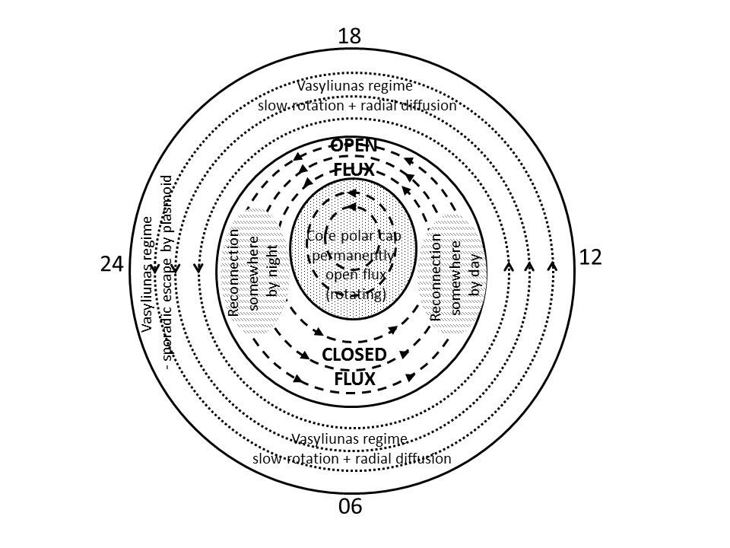

**Figure 1**. Notional sketch in the ionosphere of the regimes of a fast rotating magnetosphere. At lowest latitudes the flux tubes contain the heavy material of the Vasyliunas cycle whose inertia means that it is rotating considerably slower than the planet. At the highest latitudes around the pole, there is the core polar cap of flux tubes which are permanently open and containing very tenuous plasma. Separating the two regimes on flux tubes poleward of the heavy material and equatorward of the core polar cap is the Dungey regime that is the primary focus of this paper. Flux tubes here periodically open and close by reconnection. In a fast rotating magnetosphere, the open tailward motion will be on the afternoon flank and closed flux tube return will be on the morning side.

No allowance in Figure 1 has been made for planetary dipole offset which is in fact important at Jupiter.

As indicated in previous models [e.g. Cowley et al., 2004], it is expected that the Dungey cycle plasma takes place on flux tubes poleward of the Vasyliunas cycle closed field lines. Somewhere on the dayside of the planetary magnetopause reconnection opens planetary flux to link with the solar wind flux. This allows solar wind entry to take place and the open tubes will move toward the nightside. This motion is not directly in the anti-solar direction over the pole; the rotation and the centripetal effect imposed from the ionosphere on the open tubes means that there is a competition between the rotation imposed from below and anti-solar flow imposed from the solar wind. The Dungey tubes are unlikely to move directly over the pole but to move faster on the afternoon side where the two effects add and more slowly on the morning side where rotation and the Dungey return flow are opposed.

The schematic in Figure 1 includes a third region poleward of the Dungey cycle, the tenuous core polar cap where field lines are permanently open. This should be present as long as rotation and solar wind effects are comparable. Such a separate identifiable faster rotating region in the central polar cap has been identified by Stallard et al. [2007] and is seen present about 2/3 of the time. As mentioned earlier, in a pure Vasyliunas cycle (i.e. with no solar wind coupling) the flux in the polar cap takes no part in the magnetospheric circulation and the third regime would occupy the entire polar cap. It would rotate as it would be forced into rotation by the polar ionosphere. In the regime situation outlined here, a core of permanently open flux just rotate around the pole. Far away from the planet the tube will eventually merge with the solar wind as plasma diffuses into it. However there is no a priori reason for any solar wind plasma to make its way back to the planet. Accordingly, it would contain a very tenuous plasma probably mostly of ionospheric origin. Its low mass density and closeness to the rotation axis would likely mean it will move at a speed closer to corotation than elsewhere. As long as this third regime is present, the open tube part of the Dungey flow mapping in the ionosphere equatorward of the polar empty regime, moves down the afternoon side and the return flow which will be on closed flux tubes completes the circuit on the morning side. It should be noted that simulations [Jia et al., 2012] do not show the third region. It should be noted that in some MHD simulations [e.g. Jia et al., 2012] the polar caps do not rotate, which is in contradiction with our theory as well as with observations by Stallard et al. [2007]. Some theoretical work [e.g. Cowley et al., 2004] also predict that the giant planet polar caps should strongly sub-rotate, while others [e.g. Isbell et al., 1984] predict that it should almost rigidly corotate. In fact, in these models, the amount of sub-corotation strongly depends on the conductivity of the ionosphere (which is not very well constrained at Saturn). In addition, these theoretical works [Isbell et al., 1984; Cowley et al., 2004] only consider flow where the solar wind on the tubes is close enough to interact directly with the ionosphere, i.e. where a quasi-static current system can be set up between the solar wind material and the ionosphere, i.e. where the travel time for Alfvén waves bounce back and forth along the field is much lower than the travel time of the solar wind across the polar cap.  On the permanently open tubes, Alfvén waves conveying angular momentum from the ionosphere will in contrast radiate outwards away from the planet, as envisaged for example by Southwood and Cowley [2014].

## 3 Dungey cycle flux tube motion on the dusk side

Once a dayside planetary flux tube has undergone reconnection, it separates into distinct northern and southern open tubes. The force driving the motion of the high altitude end of the flux tubes (where the newly entered plasma is) will be the resultant of the an anti-solar force from the solar wind, an eastward force from the rotation and any residual impulse received by the entering plasma during reconnection. From the feet of flux tubes, ionospheric rotation should be communicated to the new open flux tubes within a few Alfvén bounce times back and forth between the new plasma and the ionosphere. The intervening regime is likely populated by only tenuous plasma and the Alfvén speed will be much higher than in the neighboring Vasyliunas regime closed field lines. On the outermost tubes of the Vasyliunas cycle, the magnetic field is just able to hold the material against centrifugal effects [see e.g. Kivelson and Southwood, 2005]. An immediate consequence is that the Alfvén travel time along the field in the outermost Vasyliunas regime is comparable to the rotation time. In contrast, on an open tube in the Dungey system, the communication of the overall stresses back and forth along the field will be rapid compared with the planetary rotation time. As we see from the estimates in the next section on the order of an hour would seem a reasonable estimate for the thermal bounce time and the Alfvén travel time is likely to be similar or smaller.

Once the tubes are in the afternoon any impulse from reconnection, and the forces at the feet and high latitude (from the solar wind) are moving the tube tailwards. Indeed, the overall tailward flow in the high latitudes parts of the flux tubes could even be faster than corotation through the afternoon side. Overall the solar wind momentum, any pressure force form the magnetopause currents and the sense of corotation all point anti-sunward.

At least until just before dusk, the flux tube feet will experience a component of motion polewards from the solar wind stress. Any departure from strict corotation (super or sub) at the feet will result in a current system on the open tubes. The flow channel made in the ionosphere by the open tubes will be marked by a pair of sheets of field aligned current, upward and downward on each flank. In regions of upward current there will be aurorae. Note that the flank on which the upward current is found switches as flow goes from sub to super corotation. This could be an explanation for changes in the aurora across noon called bifurcations [Radioti et al., 2011]. If the dayside reconnection process is not time-stationary, then the flows, current and auroral structure is likely to reflect any time signature.

A large difference with respect to the terrestrial situation is that on the afternoon side the day to night motion of the open flux tubes is not simply due to the solar wind stress, the rotation is carrying the feet of the tubes tailward also. Indeed even with no force from the solar wind within hours the flux tube feet will be beyond dusk. Once the flux tube feet are somewhere past dusk (perhaps 20-21 LT), the solar wind stress and the planetary stress along the field will start competing with each other. At high latitudes, the anti-sunward flow can continue stretching the flux tube down-tail. The feet however are constrained to rotate eastward. The flux tubes will be bent as the stress from the ionospheric rotation increases.

## 4 The motion of solar wind entry particles.

How will the particles that entered have moved by mid-evening? Taking the solar wind speed as a guide ~ 450kms-1 and the point of entry as 15 RS (RS~ 6×104 km) from the rotation axis (for Saturn) and perhaps 70 RJ (RJ~ 7×104 km) for Jupiter gives *v*SW ~ = ~230 RJ/TJand ~300 RS/TS where TJand TS are the planetary rotation periods (~10h and 10.7h, respectively). In a half of a planetary rotation, a particle of solar wind speed has travelled ~115 RJ at Jupiter and ~150 RS at Saturn. In either case, one expects the particle to be deep in the tail. Moreover, the motion is primarily along the field. In particular, as long as the field remains connected, there is a continuous centripetal acceleration primarily along the field at any non-equatorial point. Thus even though entry may take place from the magnetosheath at a bulk speed below the unperturbed solar wind speed, the centripetal acceleration will set up strong streaming along the field. As is shown later, this acceleration alone can produce speeds comparable to the solar wind speed by the time the particles are on the night side.

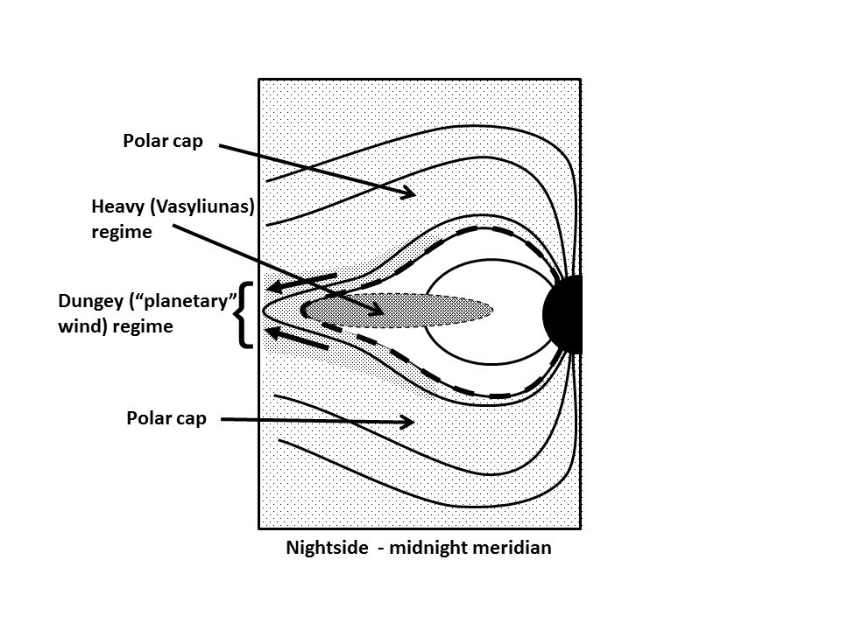

**Figure 2** Schematic (not drawn to scale) of a mid-tail meridian illustrating the Vasyliunas heavy material confined to an equator-spanning sheet on flux tubes at lower magnetic latitudes, At high latitudes are the permanently open core polar cap field lines. The material of the Dungey cycle, having entered by day is undergoing centripetal acceleration along the field and is largely streaming along the field down tail on the flux tubes at the outer edge of the plasma sheet giving the appearance of something like a planetary wind.

In the centre of the tail nightside one expects a distended field holding in the rotating heavy material of the Vasyliunas cycle. However, on the outer most field lines of the plasma sheet, there will be a stream of light ions moving away from the planet. The sketch in Figure 2 outlines our idea schematically. It is labelled in the sketch as a “planetary” wind for that is what it will appear to be. The name would not be entirely unjust as the parallel acceleration will have come from the planet’s rotation. It is suggested that at Saturn this could be an explanation of the streaming light ions seen in the magnetotail [Mitchell et al., 2009].

## 5 The Dungey cycle return flow

The flow speeds in the previous section are high enough that they are likely to exceed the capacity of the central tail field to prevent plasma escape. Thus we suggest that in the giant planet magnetospheres, most of entering solar wind material escapes down tail. Nevertheless, once flux has been opened there must be a route for flux return to the dayside.

A schematic of the return of the Dungey circulation in the equatorial plane is shown in Figure 3. An X-line is shown. Reconnection has to take place somewhere on the dawn side as the closed flux tubes must return along the dawn side of the magnetosphere. In the sketch it is shown at the outer edge of the heavy region and extending towards dawn. However, this is about the closest to the planet one may conceive the X-line. In fact, the distance down tail of the line is fairly immaterial except that because the solar wind material is rotating the X-line does not cross the whole tail and it must be beyond the outer edge of the heavy material so that the solar wind material can make it to the central plane.

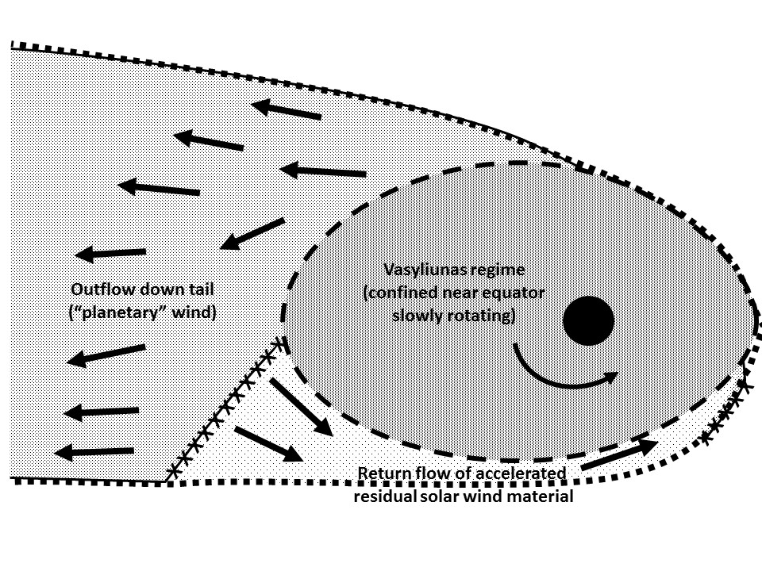

**Figure 3** Equatorial plane view of the Dungey cycle (to be compared subsequently with Figure 4). The material injected on the dayside by reconnection is not present in the equatorial plane on the afternoon side. After dayside reconnection the material only reaches the equatorial plane in the evening sector beyond the outer boundary of the Vasyliunas cycle. Most of the material that has entered on the dayside exits down tail. Reconnection in the early morning sector then accelerates residual material back towards the dayside and to reconnection in the morning to complete the cycle.

If the bulk of the plasma that enters by day streams down tail, the newly created closed tubes will contain a low density plasma. With both ends attached to the planetary ionosphere which is rotating, the new tube will be rapidly accelerated towards the East and it would eventually catch up with corotation. The high speed will be maintained through the night side. However, once the tubes pass through the dawn meridian they find themselves moving into a volume which is decreasing as the tube moves sunward. The closed low density tubes of this part of the Dungey cycle are bounded in the equatorial plane at higher radial distance by the magnetopause and at lower distance by the closed flux tubes of the heavy material of the Vasyliunas cycle. At Jupiter this corresponds to the cushion region well-known in the morning sector [see e.g. Kivelson and Southwood, 2005].

There is less evidence of a depleted morning side region at Saturn than at Jupiter [Went et al., 2011] but the magnetic field in the early morning dayside is commonly very distended azimuthally and the Cassini high inclination passes show a corresponding strongly distorted azimuthal field suggesting that the high altitude plasma is indeed also being prevented from smoothly corotating. The difference between the two planets suggests that at Jupiter flux tubes in the Dungey cycle are more effectively emptied by the escaping wind downstream that at Saturn. Relatively incomplete evacuation at Saturn would lead one to conclude that centrifugal acceleration is less efficient and that the wind is less efficient at blowing open the magnetic field downstream (i.e. the ballooning effect described by Kivelson and Southwood [2005]). This would mean that the coupling to the ionosphere is less effective at Saturn.

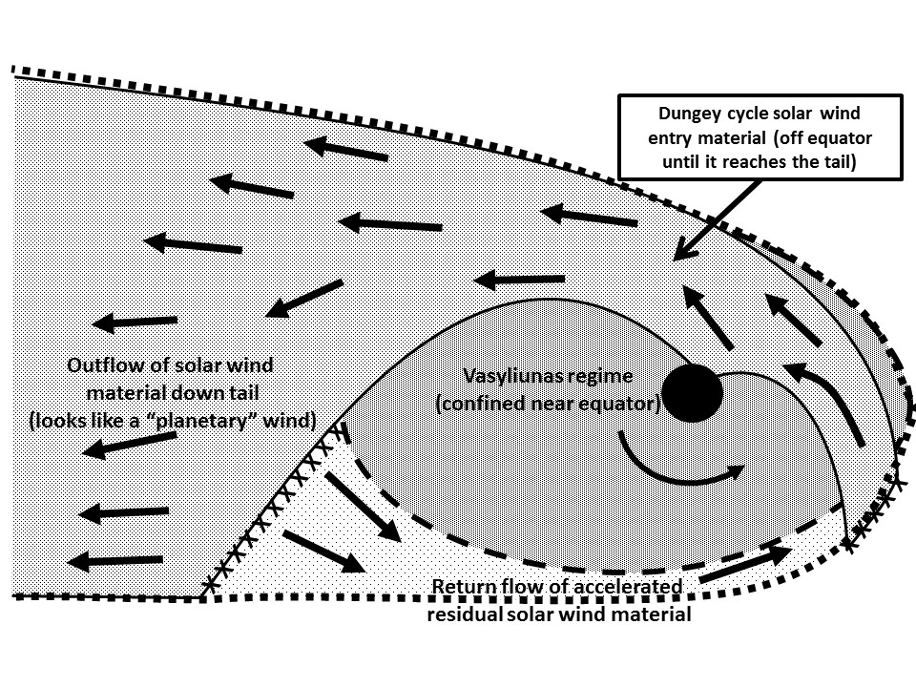

**Figure 4** Schematic of the Dungey circulation: Polar view. This is a projection showing the entire Dungey flow. The Figure can be compared with Figure 3 which represents only the equatorial plane. The cycle begins with pre-noon reconnection. Newly open tubes containing solar wind plasma move out of the plane to convey material from the morning reconnection site over/under the Vasyliunas cycle heavy material. The afternoon Dungey flow is not present in the equatorial plane on the afternoon side. The Dungey cycle material reaches the equatorial plane on the nightside once beyond the outer boundary of the Vasyliunas regime. Reconnection somewhere in the post midnight sector leads to injection of closed field lines containing a tenuous but high speed plasma into the morning side. The cycle repeats with reconnection on the pre-noon sector.

6 Midday blockage

In the noon sector the effect of the solar wind pressure is greatest. The magnetospheric field is compressed. In the morning the tenuously populated closed flux tubes of the Dungey cycle returning from the nightside find themselves squeezed by increasing transverse pressure on each side. The return low pressure Dungey flow will experience a pressure blockage in the equatorial plane made by the combination of the compressed field and the heavy material on flux tubes at lower magnetic latitudes and the pressure of the sheath/solar wind on its outer flank. Accordingly, we suggest that the Dungey cycle closed tubes cannot rotate as far as noon. In simulations a similar effect has been seen in the morning sector. The solar wind pressure at noon, the denser tubes closer to the planet and the resulting flow blockage lead to the plasma in the returning Dungey flow being pushed along the field away from the equator. Reconnection then takes place off the equator. After reconnection, the equatorial pressure blockage no longer prevents motion in the Dungey flow and flux tube feet will move past noon. Material entering from the solar wind will thus enter at high latitude. Indeed, the material on the open flux tubes will stay off the equator until it reaches the night side. Figure 4 shows a polar projection of the overall flow and can be directly compared with Figure 3 giving the equatorial plane view.

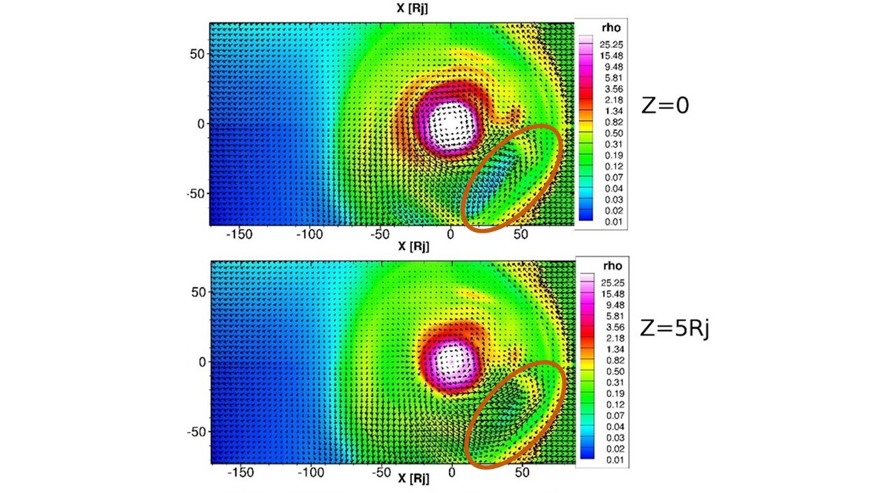

**Figure 5** Fluid simulation of magnetospheric circulation. The view is from the north. The data for the images come from the MPI-AMRVAC full simulation but which does not contain mass discrimination [see Chané et al., 2013 for more details]. Nevertheless, the plots exhibit the two features mentioned in the text as due to the blocking pressure in the circulating material at lower magnetic L-shell once near the nose. The plots show plasma density with relative scale on the right of the plots. The top panel is from the equatorial plane and the bottom panel 5 planetary radii above. The velocity field is represented by arrows. The outward flow in the late morning regime is evident in the lower right hand sector of the two plots and is highlighted. We attribute this to evidence of reconnection occurring in the sector. The density is higher at the higher latitudes in the lower plot due to the squeezing of plasma along the field.

Figure 5 illustrates the two effects described above in a fluid simulation of a fast rotating magnetosphere. Our interest in both plots is in the outer portion of the flow in the +X, -Y quarter. The top panel shows the equatorial plane and the bottom panel 5 planetary radii above. Ellipses highlight the morning sector of interest. The density is higher at the higher latitudes in the bottom plot than in the equatorial top plot due to the squeezing of plasma along the field as described above. The outward flow represented by arrows in the late morning regime corresponding to outward moving magnetic flux is evident in the two plots. This radial component of the flow means that there must be reconnection taking place on the magnetopause somewhere in the morning sector. As the material does not reappear in the afternoon sector, we conclude that once open, tubes are free to move over/under the blockage at the nose.

It is reasonable to assume that reconnection (the key for the Dungey cycle material to pass the blockage) occurs off the equator in the lighter material. Where plasma β (ratio of gas to magnetic pressure) is lower, reconnection is easier to sustain [see e.g. Paschmann et al., 1986; Masters et al., 2012]. Once reconnection has occurred, newly open tubes connecting to northern and southern ionospheres can no longer be blocked by the heavy material near the nose. Once open, the tubes can move through noon by contracting and passing over the equatorially confined heavy material.

In conclusion, in our review of the likely form of the Dungey cycle two important conclusions have emerged about the location and consequences of reconnection. At night, reconnection initiating the Dungey return flow around through dawn is likely to start after midnight in the early morning sector. This gives rise to a depleted plasma regime in the return flow on the outermost closed field lines in the morning. This is very evident at Jupiter in the presence of the “cushion” region in the outer magnetosphere.

On the dayside, we suggest that the Dungey cycle dayside reconnection occurs preferentially off the equator. Moreover, it must take place before noon in the mid to late morning sector. We thus predict substantial changes in flow, ionospheric currents and potentially in auroral morphology across the noon meridian for both giant planets.

7 High latitude circulation in absence of reconnection

The final issue we address is the possibility that reconnection does not occur at all and so there is no component of magnetospheric circulation driven by solar wind-planetary magnetic flux linkage. Because the energy source associated with the planetary rotation is comparable to either the energy available from the reconnection process or the energy in the incoming solar wind itself, the absence of reconnection is not so dramatic overall. However, we will identify observational criteria for distinguishing whether high latitude reconnection is significant.

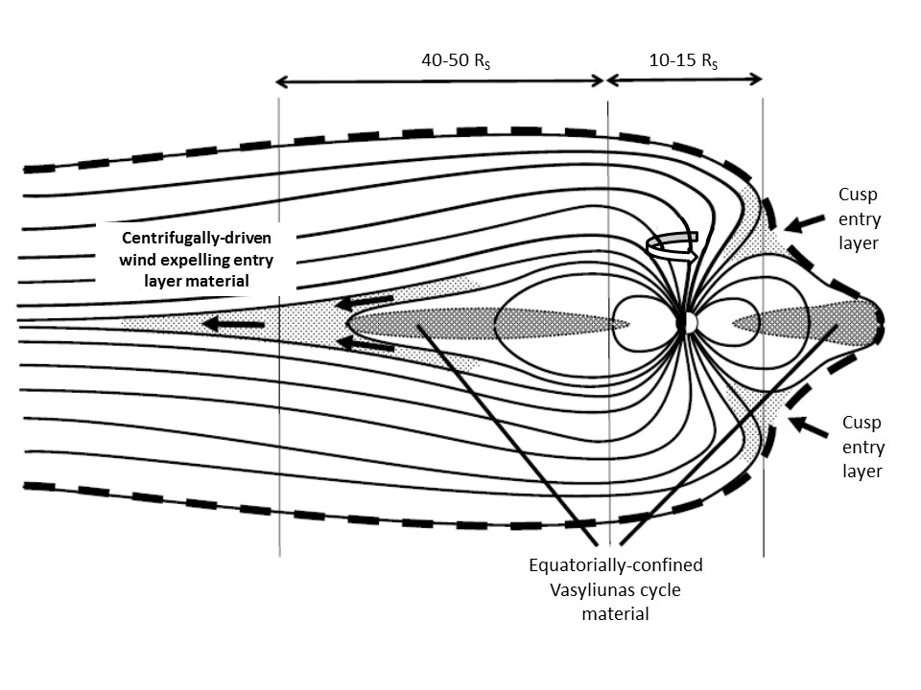

**Figure 6** Sketch illustrating the noon-midnight meridian of a giant planet magnetosphere where there is no significant solar wind-planetary magnetic flux linkage through reconnection. Magnetosheath plasma will have access near the weak field region on the magnetopause at the boundary between closed field lines and field lines extending into the tail. This is marked as the cusp entry layer. Once on magnetospheric flux tubes, plasma will rotate around the afternoon side and within half a rotation will be in the tail. During that time the centrifugal acceleration will have raised the speed parallel to the field to of order the solar wind speed and created an anti-solar stream resembling a planetary wind on the northern and southern flanks of the plasma sheet. The open flux tube feet will continue rotating to the dayside and the process of entry acceleration and loss down tail will repeat.

The basis for a “no reconnection” high latitude cycle associated with solar wind entry is shown in the sketch in Figure 6. The polar cap as a whole would be in the “permanently open” field line state described for the high latitude third regime in Figure 1. Nevertheless, on the edge of the open polar cap field lines plasma would still enter on the dayside. Without reconnection, the weak field regions at the northern and southern polar cusps should still allow dayside entry at high latitude [see e.g. the review of the terrestrial cusp by Russell, 2000]. What would happen to this material? The lower inertia of material that arrives on the closed field lines on flux tubes equatorward of the cusp means that this component of the entry material will pick up the slow rotational motion of the heavy material there and effectively enter into the Vasyliunas cycle. It will eventually be lost, as is the Vasyliunas material in a plasmoid at night. However, cusp entry of material will also result in the arrival of some solar wind material on the otherwise tenuously populated polar cap field lines where they will likely dominate the inertia in an entry layer. The material will nonetheless, pick up a faster rotation speed and subsequent motion of the particles in the layer would resemble that of the Dungey cycle described above except that with no morning side tail reconnection the field would be stretched and dragged around the morning side while far away the solar wind material streamed out along the open field down tail. The tube would eventually refill with material of solar wind origin as it moved through the dayside cusp once again.

What the scenario lacks are two features that are seen at the giant planets and for this reason we would argue that normally the high latitude Dungey circulation does involve both dayside and nightside reconnection. The first feature that is missing and well recorded at Jupiter is the “cushion” region of closed but relatively empty flux tubes detected by all spacecraft in the outermost dawn side Jovian magnetosphere [see e.g. Kivelson and Southwood, 2005]. These tenuously populated indubitably closed flux tubes are a natural feature of the Dungey cycle where magnetotail reconnection results in the escape of almost all plasma downstream. At Saturn, where the morning cushion region is not seen, a strong argument remains for reconnection occurring at high latitude in the regular injection of high energy particles described as resembling a terrestrial substorm by Mitchell et al. [2005]. An efficiency of solar wind reconnection that is around 15% at Saturn would yield a voltage along the neutral line of order 150 kV, of the right order to provide the energisations seen. These events occur on the dawn side and are roughly periodic with the planetary rotation, thus occurring faster than plasmoid formation that is viewed as the primary Vasyliunas cycle loss process [Jackman et al., 2011].

It seems likely that high latitude plasma circulation in both giant planet magnetospheres is facilitated by magnetic reconnection.

8 Concluding remarks

We have analysed a two cycle scenario for the magnetic flux tubes circulation systems of the giant planet (Jupiter and Saturn) magnetospheres. The Vasyliunas cycle takes place in the inner and middle magnetosphere and serves to transport heavy plasma originating near the equatorial plane deep within the magnetosphere to eventual escape down the magnetotail. Reconnection takes place in this cycle only in the tail and serves to release heavy material downtail, likely in plasmoids. We have assumed that this cycle takes place on a time scale long compared with the planetary rotation (10-11h). The second cycle is the high latitude Dungey cycle where reconnection occurs by day and by night and time scales are likely to be faster than the Vasyliunas cycle. We suggest that solar wind particles which enter the Dungey cycle on open tubes by day will receive centrifugal acceleration along the field. This leads to a light ion wind flowing away from the planet on the nightside. This nightside radial outflow would resemble in all respects except the particle origin a centrifugally driven planetary wind much as conceived as a possibility in early discussion of the Jovian magnetosphere [e.g. Kennel and Coroniti, 1975]. The fast rotation of the giant planet magnetospheres also causes the tailward open field lines of the Dungey cycle to be found on the afternoon side with the return of closed flux takes place in the morning.

Although the nightside reconnection that creates the return flow of closed flux will inject high energy particles, the overall density on the tubes returning to the dayside will be depleted. In particular we have argued that the combination of solar wind pressure and the presence of the Vasyliunas cycle plasma will both squeeze material off the equatorial plane and also block the flow of closed tubes past noon. The equatorial blockage is circumvented by morning-side reconnection; once reconnected, open tubes can flow past noon passing over/under the material of the Vasyliunas cycle.

We have argued that allowing for a distinct difference in mass density between the Vasyliunas (internally sourced) circulation and the Dungey (solar wind driven) circulation regimes in the giant planet magnetospheres the density depletion of the Dungey return flow on the morning side and the reconnection at high latitude counters the doubts thrown by Masters et al. [2012] on the likelihood of dayside reconnection the giant planets. Although dayside reconnection rates are likely to be low where heavy material is confined near the equator, high latitude dayside reconnection is likely the basis for there being Dungey cycle, the cycle itself being largely populated by lighter material whose source is the solar wind. Due to dayside blocking of flow near noon, reconnection occurs off-equator and preferentially in the morning. However, we have pointed out that some but not all major features of the scheme presented here are retained in a model allowing for dayside cusp entry and then loss down tail along the field by the centrifugal effect without reconnection between the planetary field and the solar wind.

Acknowledgments

DJS’s work was supported in part by UK STFC Grant ST/K001051/1. EC is funded by the Research Foundation-Flanders (grant FWO 441 12M0115N). EC. would like to acknowledge the ISSI (International Space Science Institute) team "Coordinated Numerical Modeling of the Global Jovian and Saturnian Systems" for useful discussions. This is a purely theoretical paper; no data sets have been directly analysed. The MPI-AMRVAC full simulation referred to is described in Chané et al., [2013].

References

Arridge, C. S., N. André, C. L. Bertucci, P. Garnier, C. M. Jackman, Z. Németh, A. M. Rymer, N. Sergis, K. Szego, A. J. Coates, and F. J. Crary (2011), Upstream of Saturn and Titan, Space. Sci. Rev., 162, 25-83.

Chané, E., J. Saur, and S. Poedts (2013), Modeling Jupiter's magnetosphere: Influence of the internal sources, , *J. Geophys. Res.,* 118, 2157–2172, doi:10.1002/jgra.50258.

Cowley, S.W.H., E. J. Bunce, and R. Prangé (2004), Saturn’s polar ionospheric flows and their relation to the main auroral oval, Annales Geophysicae 22: 1379–1394

Dungey, J.W. (1961), Interplanetary magnetic field and the auroral zones, Phys. Rev. Lett., 6, 47-48.

Grodent, D., J.-C. Gérard, J. T. Clarke, G. R. Gladstone, and J. H. Waite (2004), A possible auroral signature of a magnetotail reconnection process on Jupiter, J. Geophys. Res., 109, A05201, doi:[10.1029/2003JA010341](http://dx.doi.org/10.1029/2003JA010341" \t "_blank" \o "Link to external resource: 10.1029/2003JA010341).

Gurnett, D.A., A. M. Persoon, A. J. Kopf, W. S. Kurth, M. W. Morooka, J.‐E. Wahlund, K. K. Khurana, M. K. Dougherty, D. G. Mitchell, S. M. Krimigis, and N. Krupp (2010), A plasmapause‐like density boundary at high latitudes in Saturn’s magnetosphere, Geophys. Res.Lett., 37, L16806, doi:10.1029/2010GL044466.

Gurnett, D. A., A. M. Persoon, J. B. Groene, W. S. Kurth, M. Morooka, J.-E. Wahlund, and J. D. Nichols (2011), The rotation of the plasmapause-like boundary at high latitudes in Saturn’s magnetosphere and its relation to the eccentric rotation of the northern and southern auroral ovals, Geophys. Res. Lett., 38, L21203, doi:10.1029/2011GL049547.

Isbell, J., A.J. Dessler, and J. H. Waite, Jr. (1984), Magnetospheric energization by interaction between planetary spin and the solar wind, 89, 10716-10722 doi: 10.1029/JA089iA12p10716.

Jackman, C. M., J. A. Slavin, and S. W. H. Cowley (2011), Cassini observations of plasmoid structure and dynamics: Implications for the role of magnetic reconnection in magnetospheric circulation at Saturn, J. Geophys. Res., 116, A10212, doi:[10.1029/2011JA016682](http://dx.doi.org/10.1029/2011JA016682" \t "_blank" \o "Link to external resource: 10.1029/2011JA016682).

Jackman, C. M., C. M., J. A. Slavin, M. G. Kivelson, D. J. Southwood, N. Achilleos, M. F. Thomsen, G. A. DiBraccio, J. P. Eastwood, M. P. Freeman, M. K. Dougherty, and M. F. Vogt (2014), Saturn's dynamic magnetotail: A comprehensive magnetic field and plasma survey of plasmoids and traveling compression regions and their role in global magnetospheric dynamics, J. Geophys. Res. Space Physics, 119, 5465–5494.

Jasinski, J. M., et al. (2014), Cusp observation at Saturn's high-latitude magnetosphere by the Cassini spacecraft, Geophys. Res. Lett., 41, 1382–1388, doi:[10.1002/2014GL059319](http://dx.doi.org/10.1002/2014GL059319" \t "_blank" \o "Link to external resource: 10.1002/2014GL059319).

Jia, X., K. C. Hansen, T. I. Gombosi, M. G. Kivelson, G. Tóth, D. L. DeZeeuw, and A. J. Ridley (2012), Magnetospheric configuration and dynamics of Saturn's magnetosphere: A global MHD simulation, J. Geophys. Res., 117, A05225, doi:10.1029/2012JA017575.

Kennel, C. F. and F. V. Coroniti (1975), Is Jupiter’s magnetosphere like a pulsar’s or Earth’s? Space Science Reviews, 17 (1975) 857-883.

Kivelson, M. G., and D. J. Southwood (2005), Dynamical consequences of two modes of centrifugal instability in Jupiter's outer magnetosphere, J. Geophys. Res., 110, A12209, doi:10.1029/2005JA011176.

Levy, R. H., H. E. Petschek, and G. L. Siscoe (1964), Aerodynamic aspects of the magnetospheric flow, AIAA Journal, Vol. 2, No. 12, pp. 2065-2076. doi: 10.2514/3.2745.

Masters, A., J. P. Eastwood, M. Swisdak, M. F., Thomsen, C. T. Russell, N. Sergis, F. J. Crary, M. K. Dougherty, A. J. Coates, and S. M. Krimigis (2012), The importance of plasma  conditions for magnetic reconnection at Saturn’s magnetopause, Geophys. Res. Lett., 39, L08103, doi:10.1029/2012GL051372.

McAndrews, H.J., M.F.Thomsen, C.S.Arridge, C.M.Jackman, R.J.Wilson, M.G.Henderson, R.L. Tokar, K.K.Khurana, E.C.Sittler, A.J.Coates, M.K.Dougherty (2009), Plasma in Saturn’s nightside magnetosphere and the implications for global circulation, *Planet. Space Science, 57*, 1714–1722.

Mestel, L. (1968), Magnetic Braking by a Stellar Wind, Mon. Not. R. astr. Soc., 138, 359-391.

Milan, S. E., E. J. Bunce, S. W. H. Cowley, and C. M. Jackman (2005), Implications of rapid planetary rotation for the Dungey magnetotail of Saturn, *J. Geophys. Res., 110*, A03209, doi:10.1029/2004JA010716.

Mitchell, D. G., P. C. Brandt, E. C. Roelof, J. Dandouras, S. M. Krimigis, B. H. Mauk, C. P. Paranicas, N. Krupp, D. C. Hamilton, W. S. Kurth, P. Zarka, M. K. Dougherty, E. J. Bunce, and D. E. Shemansky (2005), Energetic ion acceleration in Saturn’s magnetotail: Substorms at Saturn?, Geophys. Res. Lett., 32, L20S01, doi:10.1029/2005GL022647.

Mitchell, D. G., W. S. Kurth, G. B. Hospodarsky, N. Krupp, J. Saur, B. H. Mauk, J. F. Carbary, S. M. Krimigis, M. K. Dougherty, and D. C. Hamilton (2009), Ion conics and electron beams associated with auroral processes on Saturn, J. Geophys. Res., 114, A02212, doi:10.1029/2008JA013621.

Paschmann, G., I. Papamastorakis, N. Sckopke, G. Haerendel, B.U.O. Sonnerup, S.J. Bame, J.R. Asbridge, J.T. Gosling, C.T. Russel, R.C. Elphic (1979), Plasma acceleration at the earth’s magnetopause—evidence for reconnection. Nature **282**, 243–246, doi:[10.​1038/​282243a0](http://dx.doi.org/10.1038/282243a0).

Paschmann, G., I. Papamastorakis, W. Baumjohann, N. Sckopke, C. W. Carlson, B. U. Sonnerup, and H. Lühr (1986), The magnetopause for large magnetic shear: AMPTE/IRM observations, J. Geophys. Res., 91(A10), 11099–11115, doi:[10.1029/JA091iA10p11099](http://dx.doi.org/10.1029/JA091iA10p11099" \t "_blank" \o "Link to external resource: 10.1029/JA091iA10p11099).

Radioti, A., D. Grodent, J.‐C. Gérard, S. E. Milan, B. Bonfond, J. Gustin, and W. Pryor (2011), Bifurcations of the main auroral ring at Saturn: ionospheric signatures of consecutive reconnection events at the magnetopause, J. Geophys. Res., 116, A11209, doi:10.1029/2011JA016661.

Richardson, J. D. (1986), Thermal ions at Saturn: Plasma parameters and implications, *J. Geophys. Res., 91(A2)*, 1381-1389, doi:10.1029/JA091iA02p01381.

Russell, C. T. (2000), The polar cusp, Adv. Space Res., 25, 1413–1424, doi:10.1016/S0273-1177(99)00653-5.

Southwood, D.J., and M.G. Kivelson (1989), Magnetospheric interchange motions, J. Geophys. Res., 94, 299-308.

Southwood, D. J., and S. W. H. Cowley (2014), The origin of Saturn's magnetic periodicities: Northern and southern current systems, J. Geophys. Res. Space Physics, 119, doi:[10.1002/2013JA019632](http://dx.doi.org/10.1002/2013JA019632" \o "Link to external resource: 10.1002/2013JA019632).

Stallard, T. S., Miller, S., Melin, H., Lystrup, M. K., Dougherty, M., & Achilleos, N. (2007). Saturn's auroral/polar H+ 3 infrared emission: I. General morphology and ion velocity structure. Icarus, 189(1), 1-13 [doi:10.1016/j.icarus.2006.12.027](http://dx.doi.org/10.1016/j.icarus.2006.12.027)

Thomsen, M. F., D. B. Reisenfeld, D. M. Delapp, R. L. Tokar, D. T. Young, F. J. Crary, E. C. Sittler, M. A. McGraw, and J. D. Williams (2010), Survey of ion plasma parameters in Saturn’s magnetosphere, *J. Geophys. Res., 115*, A10220, doi:10.1029/2010JA015267.

Vasyliunas, V. M. (1983), Plasma distribution and flow, in *Physics of the Jovian Magnetosphere*, edited by A. J. Dessler, pp. 395– 453, Cambridge Univ. Press, New York.

Vogt, M. F., M. G. Kivelson, K. K. Khurana, S. P. Joy, and R. J. Walker (2010), Reconnection and flows in the Jovian magnetotail as inferred from magnetometer observations, J. Geophys. Res., 115, A06219, doi:[10.1029/2009JA015098](http://dx.doi.org/10.1029/2009JA015098" \t "_blank" \o "Link to external resource: 10.1029/2009JA015098).

Went, D. R., M. G. Kivelson, N. Achilleos, C. S. Arridge, and M. K. Dougherty (2011), Outer magnetospheric structure: Jupiter and Saturn compared, J. Geophys. Res., 116, A04224, doi:10.1029/2010JA016045

Wilson, R. J., R. L. Tokar, and M. G. Henderson (2009), Thermal ion flow in Saturn’s inner magnetosphere measured by the Cassini plasma spectrometer: A signature of the Enceladus torus? *Geophys. Res. Lett*., 36, L23104, doi:10.1029/ 2009GL040225.

Woch, J., N. Krupp, and A. Lagg, Particle bursts in the Jovian magnetosphere: Evidence for a near-Jupiter neutral line, Geophys. Res. Lett., 29(7), doi:[10.1029/2001GL014080](http://dx.doi.org/10.1029/2001GL014080), 2002.

Yang, C. K., & Sonnerup, B. U. (1977). Compressible magnetopause reconnection. Journal of Geophysical Research, 82(4), 699-703.

Zieger, B., K. C. Hansen, T. I. Gombosi, and D. L. De Zeeuw (2010), Periodic plasma escape from the mass-loaded Kronian magnetosphere, J. Geophys. Res., 115, A08208, doi:[10.1029/2009JA014951](http://dx.doi.org/10.1029/2009JA014951).