Peer reviewed version of the manuscript published in final form at DOI: 10.1002/adhm.201500338

Extracellular stiffness modulates the expression of functional proteins and growth factors in endothelial cells

Authors: Livia Santos*^{1,2,3}, Gregor Fuhrmann^{1,2,3}, Maya Juenet^{1,2,3}, Nadav Amdursky^{1,2,3}, Christine-Maria Horejs^{1,2,3,4}, Paola Campagnolo^{1,2,3}, Molly M. Stevens*†^{1,2,3}

Affiliations:
¹Department of Materials, Imperial College London SW7 2AZ, United Kingdom
²Department of Bioengineering, Imperial College London SW7 2AZ, United Kingdom
³Institute of Biomedical Engineering, Imperial College London SW7 2AZ, United Kingdom
⁴Current address: Department of Medical Biochemistry and Biophysics, Division of Biomaterials and Regenerative Medicine, Karolinska Institutet, Scheeles Väg 2, 17165 Stockholm, Sweden

*Corresponding authors: M. M. Stevens (m.stevens@imperial.ac.uk) and L.J. Santos (livia.santos15@yahoo.com)

†Additional information:
Molly M. Stevens
Address: Room 208, Royal School of Mines, South Kensington Campus, Prince Consort Road, London SW7 2AZ, United Kingdom
Telephone: +44 (0)20 7594 6804
Fax: +44 (0)20 7594 6757
Email: m.stevens@imperial.ac.uk
Website: www.stevensgroup.org

Keywords: angiogenesis, bone regeneration, extracellular rigidity, Young’s modulus, endothelial cells

Abstract text
Angiogenesis, the formation of blood vessels from pre-existing ones, is of vital importance during the early stages of bone healing. Extracellular stiffness plays an important role in regulating endothelial cell behavior and angiogenesis, but how this mechanical cue affects proliferation kinetics, gene regulation, and the expression of proteins implicated in angiogenesis and bone regeneration remains unclear. Using collagen-coated polyacrylamide (PAAm) hydrogels, human umbilical vein endothelial cells (HUVECs) are exposed to an environment that mimics the elastic properties of collagenous bone, and cellular proliferation and gene and protein expressions are assessed. The proliferation and gene expression of HUVECs are not differentially affected by culture on 3 or 30 kPa PAAm hydrogels, henceforth referred to as low and high stiffness gels, respectively. Although the proliferation and gene transcript levels remain unchanged, significant differences are found in the expressions of functional proteins and growth factors implicated both in the angiogenic and osteogenic processes. The down-regulation of the vascular endothelial growth factor receptor-2 protein with concomitant over-expression of caveolin-1, wingless-type 2, bone morphogenic protein 2, and basic fibroblast growth factor on the high stiffness PAAm hydrogel suggests that rigidity has a pro-angiogenic effect with inherent benefits for bone regeneration.
1. Introduction
Bone has an innate regeneration capability supported by the interplay between osteogenesis and angiogenesis, with blood vessels providing conduits for nutrient exchange and paracrine factors, and bone cells supplying angiogenic growth factors to endothelial cells.[1] However, certain clinical circumstances, particularly ageing, trauma, or osteoporosis, may undermine its natural healing capacity resulting in delayed or nonunion of the bone fracture.[2] A significant body of evidence coupling osteogenesis and angiogenesis suggests that pro-angiogenic strategies are absolutely fundamental to overcome impaired bone regeneration.[3-8]

Angiogenesis is a well-orchestrated, multistep process involving the migration of endothelial cells, the release of paracrine factors and lytic enzymes, and vessel formation.[9] This process is tightly coordinated by biochemical factors such as the vascular endothelial growth factor A (VEGF-A).[10] Angiogenesis is also regulated by mechanical cues such as shear stress, which is generated by blood flow and the stiffness of the extracellular matrix (ECM).[11-14]

Mechanical cues are detected by cells through an array of mechanosensitive receptors and then transformed into a biochemical response through mechanotransduction pathways.[15] Shear stress is of particular importance in stimulating angiogenesis through the activation of the expression of vascular endothelial growth factor receptor-2 (VEGFR-2), vascular endothelial specific cadherin (VE-cadherin), platelet endothelial cell adhesion molecule 1 (PECAM-1), and β-catenin.[11] Stiffness is regarded as a powerful mechanical stimulus capable of modulating stem cell fate. A seminal study conducted by Engler et al. revealed that exposure of mesenchymal stem cells to materials of low, intermediate, and high stiffness directed cell commitment into adipogenic, myogenic, and osteogenic lineages, respectively.[16] In other studies, Gilbert et al. showed that rigidity cues enhance endothelial marker expression and survival in cardiosphere-derived cells,[17] while Kshitiz et al. showed that self-renewal of skeletal muscle stem cells is enhanced by substrates with an elastic modulus matching muscle stiffness.[18] With regard to angiogenesis, a number of studies have demonstrated that stiffening of the ECM enhances endothelial cell monolayer disruption,[12] permeability, and leukocyte transmigration,[13] and encourages endothelial cell sprouting, which in turn affects angiogenesis.[14]

Extracellular stiffness has a pivotal role in regulating endothelial cell behavior and angiogenesis; however, it remains unknown how this mechanical cue affects proliferation kinetics, gene regulation, and the expression of functional proteins and paracrine factors implicated in bone regeneration. With the purpose of obtaining this missing piece of information, we exposed human umbilical vein endothelial cells (HUVECs) to a matrix mimicking the elastic properties of collagenous bone,[16] using for that end polyacrylamide (PAAm) hydrogels, a standard material used in mechanobiology studies. These hydrogels were characterized in terms of roughness, topography, and stiffness by atomic force microscopy (AFM) in liquid. We then assessed how the substrate characteristics affected cell proliferation and the regulation of genes and proteins related to angiogenesis and bone regeneration.
2. Results
2.1. PAAm hydrogels of different stiffness display distinct topography and roughness
PAAm hydrogels were prepared with different ratios of acrylamide and bis-acrylamide to produce substrates of different stiffness and the Young's modulus was determined by AFM. The PAAm hydrogel prepared with an acrylamide/bis-acrylamide ratio of 2:0.24 (v/v) presented a Young's modulus of 2.9 ± 0.4 kPa (≈3 kPa) and the one prepared with 2:2.4 (v/v), presented a Young's modulus of 30.1 ± 2.1 kPa (≈30 kPa) (Figure 1A, Supporting Information).
Topography and roughness of PAAm hydrogels were probed by AFM. As shown in Figure 1B,C (Supporting Information), the gel surfaces displayed distinct topographical differences between the low and high stiffness substrate. The roughness was significantly different from each other, with the high stiffness PAAm hydrogel having a root mean square height (Sq) of 4.40 ± 0.29 nm and the low stiffness substrate of 15.40 ± 0.30 nm (p < 0.05).
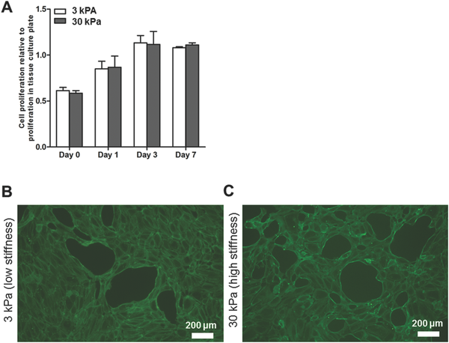
Figure 1. HUVECs exposed to PAAm hydrogels of different stiffness show no differences in proliferation. A) Proliferation kinetics. Morphology of HUVECs exposed to B) 3 kPa (low stiffness) and C) 30 kPa (high stiffness) PAAm hydrogels at day 3 of culture. Data shown as mean ± SEM, n = 3–4 for (A).

2.2. Proliferation kinetics and gene expression are not affected by extracellular rigidity
After probing the PAAm hydrogel surfaces by AFM, the proliferation kinetics were assessed by the alamarBlue metabolic assay. Our results showed that HUVECs exposed to different rigidities maintain the same level of proliferative activity (Figure 1A). Microscopic observation shows that PAAm hydrogels of both rigidities support the formation of tube-like structures and confirms the presence of the cell–cell adhesion protein VE-cadherin (showed in green) (Figure 1B,C).

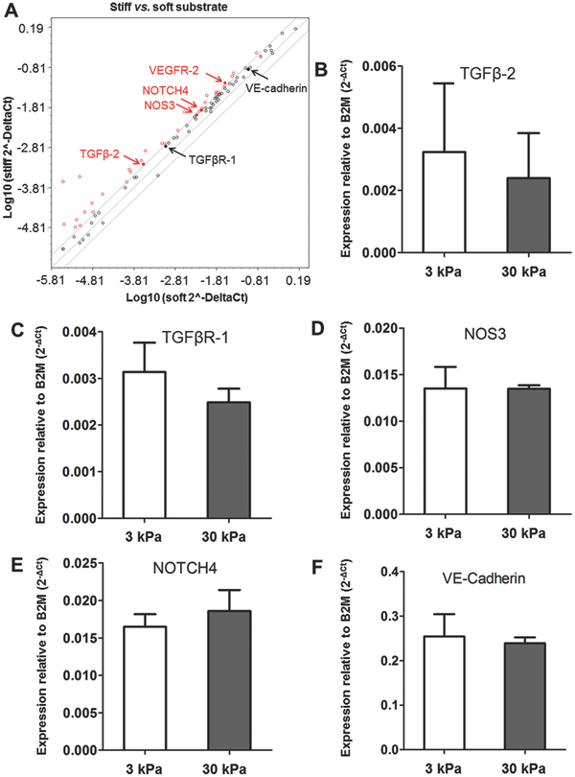

Figure 2. HUVECs exposed to gels with different stiffness values do not present statistical differences at the mRNA level. A) Scatter plot of HUVECs cultured in 3kPa (control group, X axis) versus 30 kPa PAAm hydrogels (Y axis); B) gene expression analysis of TGFβ-2; C) TGFβR-1; D) NOS3; E) NOTCH4; and F) VE-cadherin on HUVECs exposed to 3 kPa (low stiffness) and 30 kPa (high stiffness) PAAm hydrogels. Data shown as mean ± SEM, n = 3.

The effect of hydrogel stiffness on the expression of 84 key genes related to angiogenesis was analyzed by polymerase chain reaction (PCR) array. A scatter plot was built with the purpose of finding up-regulated genes from a set of 84 key genes related to human angiogenesis. Genes were considered potentially up-regulated when exhibiting a fold-change of two and above after being normalized to the control group. This threshold of two-fold is represented in the plot by the superior diagonal line. In a similar way, genes were considered potentially down-regulated when exhibiting a two-fold decrease compared to the control, and this threshold is represented by the inferior diagonal line. The scatter plot (Figure 2A) displaying the Ct log values of HUVECs in the 3 kPa (X axis) versus the 30 kPa (Y axis) substratum reveals that most points fall within the diagonal lines showing equivalent mRNA levels between groups, and 24 points fall above the superior diagonal line (red dots) suggestive of an up-regulation. The green dot means that up-regulation is precisely two-fold. To calculate the statistical significance, we utilized reverse transcription quantitative polymerize chain reaction (RT-qPCR) and analyzed five genes of interest, namely, transforming growth factor β-2 (TGFβ-2), nitric oxide synthase 3 (NOS3), NOTCH4, transforming growth factor β receptor-1 (TGFβR-1), and VE-cadherin. TGFβ-2, NOS3, and NOTCH4 are implicated in mechanotransduction signaling and were found to be up-regulated in the array. TGFβR-1 and VE-cadherin although less dramatically up-regulated are important mediators of the mechanosensing machinery.[11, 19] To keep consistency between the PCR array and traditional RT-qPCR studies, the housekeeping gene was β2 microglobulin in both. RT-qPCR of TGFβ-2 (Figure 2B), TGFβR-1 (Figure 2C), NOS3 (Figure 2D), NOTCH4 (Figure 2E), and VE-cadherin (Figure 2F) did not indicate statistical differences between HUVECs exposed to PAAm of different stiffnesses.
Together, the metabolic assay, PCR array, and RT-qPCR experiments indicate that proliferation and gene expression on HUVECs were unchanged by the exposure to different stiffness substrates.
2.3. Extracellular rigidity modulates expression of VEGFR-2, Caveolin-1, and β-catenin
VEGFR-2 is the main VEGF-A receptor and a key mediator of angiogenesis.[10] When VEGF-A binds to VEGFR-2, this receptor undergoes auto-phosphorylation leading to its internalization and further activation of downstream angiogenesis-related signaling cascades such as the protein kinase B/phosphatidylinositol 3-kinase (AKT/PI3K) pathway, which is involved in protein synthesis.[20] Due to the importance of VEGFR-2 in angiogenesis, we investigated the effect of stiffness in gene and protein expression by RT-qPCR and in-cell Western, respectively. Gene expression analysis revealed no statistically significant differences between HUVECs exposed to low and high stiffness substrates (Figure 3A). By contrast, at a protein level, VEGFR-2 protein expression was diminished in HUVECs exposed to the high stiffness PAAm hydrogel at day 7 of culture (p < 0.05) (Figure 3B). We hypothesized that different levels of VEGFR-2 could be due to VEGFR-2 degradation. As we see no differences in the phosphorylation levels between both conditions (Figure 3C), the mechanism of VEGFR-2 protein reduction may be different.
The recycling of VEGFR-2 from the cell membrane is dependent on caveolae formation: upon overexpression of the caveolae-forming protein caveolin-1 the protein expression of VEGFR-2 is known to be reduced.[21, 22] Indeed, as shown in Figure 3D caveolin-1 was significantly up-regulated by higher stiffness substrates, indicating its potential contribution to VEGFR-2 decrease.
The WNT/β-catenin pathway is implicated in cell differentiation, organogenesis, and angiogenesis.[23, 24] β-catenin is a key effector of the canonical Wnt pathway, which plays a dual role in endothelial cell function. When inactive, β-catenin complexes with the transmembrane protein VE-cadherin acting as an adaptor to transmit mechanical stimuli and stabilize tight junctions. Upon activation of the Wnt pathway, β-catenin translocates to the nucleus where it mediates transcriptional processes.[25-27] In-cell Western results showed that total β-catenin at day 1 (Figure 3E), as well as active β-catenin at all-time points (Figure 3F) were up-regulated on high stiffness gels (p < 0.05). Extracellular stiffness is thus shown to modulate the expression of three proteins involved in the angiogenic process: VEGFR-2, caveolin-1, and β-catenin.

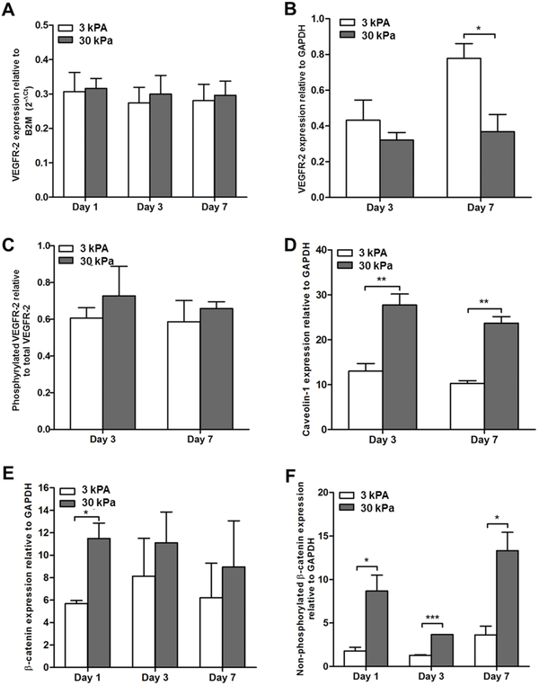

Figure 3. Extracellular stiffness modulates VEGFR-2, caveolin-1, and β-catenin protein expression. A) VEGFR-2 mRNA expression; B) VEGFR-2 protein expression; C) phosphorylated VEGFR-2 protein expression; D) caveolin-1 protein expression; E) β-catenin protein expression; and F) active β-catenin protein expression of HUVECs cultured on PAAm hydrogels with Young's moduli of 3 kPa (low stiffness) and 30 kPa (high stiffness). Data shown as mean ± SEM, n = 3, *p < 0.05, **p < 0.01.
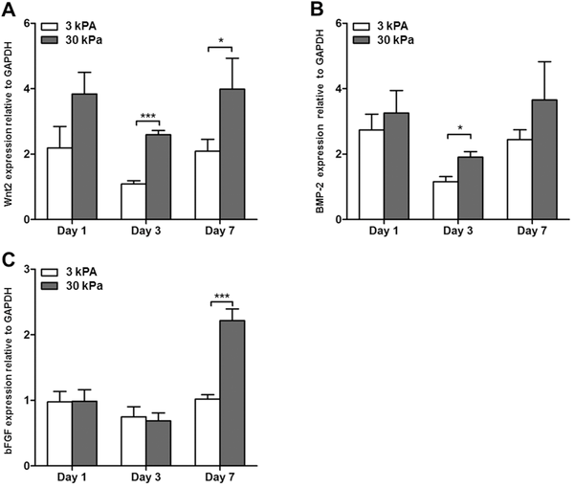

Figure 4. Growth factors are sensitive to stiffness at specific time points. Protein expression of A) Wnt2, B) BMP-2, C) bFGF on substrates of different stiffness. Data shown as mean ± SEM, n = 3–4, *p < 0.05, ***p < 0.001.
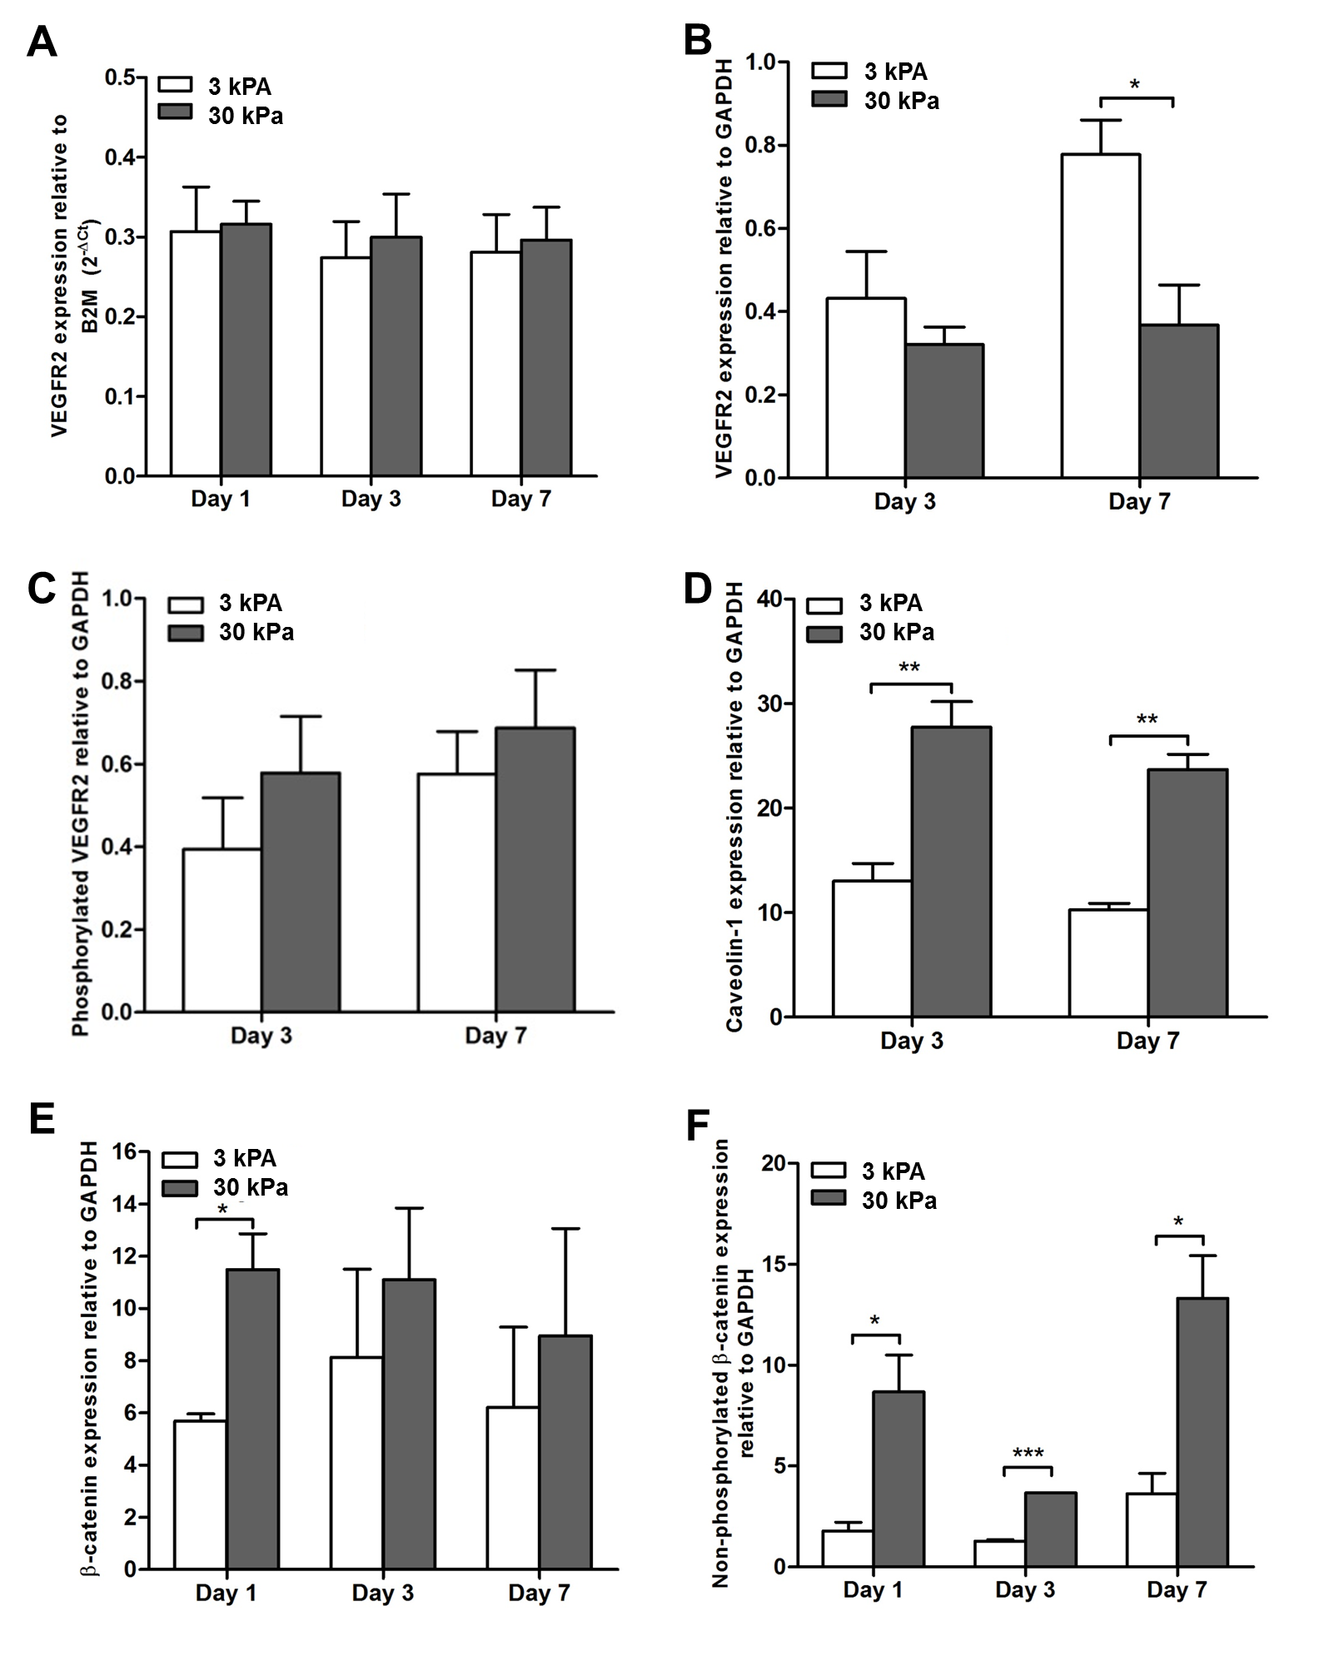Figure 5. Extracellular stiffness modulates VEGFR-2, caveolin-1 and β-catenin protein expression. (A) VEGFR-2 mRNA expression; (B) VEGFR-2 protein expression (C) Phosphorylated VEGFR-2 protein expression (D) Caveolin-1 protein expression (E) β-catenin protein expression and (F) active β-catenin protein expression of HUVECs cultured in PAAm hydrogels of 3 kPa (low stiffness) and 30 kPa (high stiffness) stiffness. Data shown as mean ± SEM, n = 3, *p<0.05, **p<0.01.

2.4. Expression of growth factors implicated in bone regeneration is increased by a relatively stiffer environment
We also investigated the expression of proteins implicated in angiogenesis and osteogenenesis, wingless type 2 (Wnt2), bone morphogenic protein-2 (BMP-2), and basic fibroblast growth factor (bFGF). These were selected based on their autocrine and paracrine role during bone regeneration[28-34] and responsiveness to mechanical forces. Indeed, BMP-2 is up-regulated in cells exposed to mechanical loading,[34] whereas bFGF is influenced by cyclic mechanical strain and shear stress.[36, 37]

In the previous section we confirmed that VEGFR-2 protein expression was down-regulated in endothelial cells exposed to the 30 kPa high stiffness substrates on account of caveolin-1 over-expression, an event described to activate angiogenic signaling cascades via the AKT/PI3K pathway. Here we found other possible interactions, e.g., between β-catenin and Wnt2. Wnt2 is an important key mediator of the canonical WNT/β-catenin pathway via the AKT/PI3K signaling pathway[38] and our results show that Wnt2 and active β-catenin were both up-regulated at day 3 and day 7 (p < 0.001) in endothelial cells exposed to the 30 kPa PAAm high stiffness hydrogel (Figures 3F and 4A, respectively). The immunofluorescence images (Figure 2, Supporting Information) illustrate the over-expression of Wnt2 in response to high stiffness substrates.
Next, we investigated the response of BMP-2 and bFGF growth factors to stiffness. Our results show that BMP-2 (Figure 4B) and bFGF (Figure 4C) protein expression levels were significantly up-regulated on high stiffness substrates at day 3 and day 7 (p < 0.05 and p < 0.0001, respectively) suggesting sensitivity to extracellular rigidity. This result could be linked with the WNT/β-catenin signaling pathway given that they crosstalk in many different ways. BMP-2 modulates β-catenin signaling via the AKT/PI3K signaling pathway inducing differentiation of stem cells into osteoblasts.[39] On the other hand, BMP-2 is a growth factor known to be activated upstream by the Wnt/β-catenin pathway, and these results tie in well with the concomitant observed activation of β-catenin and Wnt2. The bFGF cross talks with the Wnt/β-catenin pathway as well, and can regulate β-catenin either directly or indirectly.[40] It has been previously reported that the knockdown of bFGF results in decreased protein expression of β-catenin, whereas exogenous bFGF treatment increases the β-catenin presence at the cytoplasm and nucleus.[40] Therefore, these pathways are deeply intertwined and the AKT/PI3K at least to some extent appears to be the common denominator. Nonetheless, we believe that a deeper understanding of the impact of stiffness on the regulation of proteins and the cross talk between WNT/β-catenin, BMP and FGF signaling pathways is likely to contribute to open new and vibrant directions in bone regeneration.
3. Conclusion
*
Extracellular stiffness influences numerous aspects of angiogenesis but how it affects proliferation, gene regulation, and the expression of functional proteins and growth factors remains largely unknown. Here, we demonstrate that exposure of HUVECs to different extracellular elasticity modulated the expression of important angiogenesis mediators (i.e., VEGFR-2, caveolin-1, and β-catenin) as well as growth factors involved in bone regeneration (i.e., BMP-2, bFGF, and Wnt2).

PAAm hydrogels are standard materials in mechanobiology studies and were introduced by Wang and Pelham, Jr.[41] in 1998. Since then, they have been routinely employed due to the possibility of tuning stiffness with different ratios of acrylamide and bis-acrylamide without substantially changing the chemical composition of the material. For this reason PAAm hydrogels were utilized to prepare substrates of distinct physiological stiffness. The elastic properties of both substrates were probed by AFM as described elsewhere[42] and confirmed that the hydrogel prepared with an acrylamide/bis-acrylamide ratio of 2:2.4 (v/v) presented a Young's modulus of 30 kPa, a value that falls within 25 and 40 kPa, the elasticity range of collagenous bone[16, 42] and the one prepared with 2:0.24 (v/v), presented a Young's modulus of 3 kPa, mimicking the microenvironment of a soft tissue. Next, we investigated the effect of these substrates on endothelial cell proliferation and the expression of key angiogenesis genes. We observed that both low and high stiffness hydrogels support tube-like structure formation and can therefore be considered to support the angiogenic capacity of endothelial cells. Our data revealed that proliferation and gene expression on HUVECs were unchanged by the exposure to different stiffness substrates. It was previously reported that stiffer matrices elicited fibroblast proliferation due to an increased actomyosin-based contractility and that soft matrices suppressed proliferation because of insufficient actomyosin-based contractility.[43] However, it has been shown that actomyosin contractility is not predictive of endothelial cell proliferation,[44] a finding corroborated by our data. With regards to gene expression, such apparent “insensibility” at a transcriptional level might be due to mechanotransduction operating mostly at a protein level as mechanotransduction changes do not always involve the nucleus.[45]

Gene expression of the key endothelial cell receptor VEGFR-2 was not altered by substrate stiffness. A study conducted by Mammoto and colleagues demonstrated that VEGFR-2 mRNA levels in microvascular endothelial cells are significantly higher on 4000 Pa PAAm hydrogels when compared to hydrogels of 150 Pa.[46] In this study, we worked with a different physiological range, between 3 and 30 kPa, and it is possible that within it, the VEGFR-2 mRNA levels were stabilized. VEGFR-2 protein expression however was found to be significantly down-regulated on the 30 kPa high stiffness PAAm hydrogel. In addition caveolin-1, a protein that negatively regulates VEGFR-2[21, 22] was significantly up-regulated on the 30 kPa high stiffness substrate. These findings corroborate the hypothesis that mechanotransduction although not evidenced at a transcriptional level is indeed occurring at a protein level.

The protein expression studies also demonstrated altered levels of the Wnt pathway protein β-catenin, another important functional angiogenesis protein, which was activated consistently on the 30 kPa high stiffness substrate. It is possible that such increased levels of active β-catenin could be related with the activation of the Rho/ROCK pathway on the stiffer substrate, which is known to increase the actomyosin-mediated cellular tension and triggers β-catenin activation.[47] Further experiments are needed to test this hypothesis.

Mechanotransduction underlies a certain timescale with sensing taking seconds or minutes, signaling between minutes and hours and proliferation as well as other cellular events, from days up to several weeks.[48] Since bone angiogenesis is one of the first events after a bone fracture we analyzed the expression of genes and proteins up to 7 days. While proliferation and transcription of a number of genes of interest remained unchanged, protein expression of in particular active β-catenin and Wnt2 were over-expressed during the entire course of the experiment on the high stiffness PAAm hydrogel, a fact supporting the involvement of this pathway in angiogenesis. BMP-2 and bFGF were also found to be over-expressed in endothelial cells exposed to the stiffer PAAm hydrogel. As for BMP-2 expression, this was significant at day 3 but not day 7, while FGF was over-expressed at day 7 but not day 3, suggesting time-specific roles for these growth factors.

Overall this study suggests that substrate stiffness stimulates endothelial cells to produce pro-angiogenic and osteogenic factors at specific time points, an insight that might prove vital for the development of novel and better bone regeneration therapies.

4. Experimental Section
Cell culture
Cells were plated and cultured according to a well-established protocol.[49] HUVECs (Lonza C2517A) were expanded in fully supplemented endothelial growth factor medium EGM 2 Bulletkit (Lonza, CC-3156 & CC-4176) and incubated at 37°C and 5% CO2. The medium was changed every 2 days. The formation of tube-like structures was confirmed by microscopic observation (Olympus, IX51). Cells between passage 3 and 5 were used.
Preparation of polyacrylamide hydrogels of different stiffnesses coated with collagen type I
In this study we employed “high stiffness” PAAm hydrogels with a Young's modulus of ≈30 kPa coated with collagen I to mimic the initial microenvironment of a healing bone fracture, which is mainly dictated by collagen I.[50] This microenvironment is also associated with the initial angiogenic phase occurring early during bone regeneration. As a lower stiffness control, we chose a 3 kPa PAAm hydrogel coated with collagen I, matching the stiffness of adipose tissue. PAAm hydrogels were prepared according to published protocols.[51]
Very briefly, the solutions were prepared with 8% (v/v) acrylamide, and with 0.048% (v/v) and 0.48% (v/v) of bis-acrylamide for the low and high stiffness hydrogel, respectively. The PAAm solutions were polymerized between 0.75 mm spaced glasses, detached from the glasses, and punched out with the desired diameter. The hydrogels gels were cross-linked with the heterobifunctional linker Sulfo-SANPAH (Thermo Scientific Pierce, 22589) at a concentration of 0.2 mg mL−1 for 15 minutes under ultraviolet radiation. Afterwards the cross-linker solution was aspirated, the gels were washed with 50 × 10−3 m pH 8.5 HEPES buffer and then coated with a 0.1 mg mL−1 concentration of tail-derived collagen type I solution (BD Biosciences, 354236) overnight. Before cell seeding, the collagen solution was aspirated and the hydrogel was washed twice with phosphate buffered saline (PBS). With this method a thin layer of collagen I was covalently attached to the PAAm hydrogels. This layer serves as an anchoring point for cells but it is thin enough for cells to sense the hydrogel substrate.

Topography and roughness
An Agilent 5500 AFM system was used to characterize the topography and roughness of the hydrogel. Measurements were acquired within a liquid cell, where the hydrogel sample was immersed in a PBS solution and left to stabilize for several hours before the measurement. For topography measurements, the AFM scan was done in a contact mode, in which a constant ≈5 nN force was applied on the surface by the AFM tip (SiNi tip by BudgetSensors with a force constant of 0.27 N m−1). The images were processed with the PicoImage software. The surface roughness was calculated according to ISO 25178 for an area of 7 × 7 μm2. The Young's modulus of PAAm hydrogels was probed by indentation using the MFP-3D-Bio (Asylum Research) atomic force microscope by Prof A. Engler's laboratory at UCSD and was kindly provided to us. Silicone nitride (SiN) cantilevers attached to pyramid shape tips (PNP-TR; NanoWorld) with nominal spring constants of 50 pN nm−1 were indented into the hydrogels at a velocity of 2 μm s−1 until a trigger of 2 nN was detected.[42] Roughness and image acquisition was made with PAAm hydrogels coated with collagen I. Determination of the Young's modulus was performed with the surfaces uncoated in order to avoid interference from the collagen coating and extract only the mechanical information from the PAAm hydrogels.
Metabolic assay alamarBlue®
HUVEC proliferation in low and high stiffness PAAm hydrogels was estimated by the metabolic assay alamarBlue (Invitrogen DAL110), according to the manufacturer instructions. This experiment was carried out for 7 days, with time points at day 0, 1, 3, and 7. After the reagent was added, HUVECs were incubated for 1 hour at 37 °C with 5% CO2. The fluorescence intensity was measured in a plate reader (Molecular Devices, Spectramax M5), with excitation/emission wavelengths of 530 and 590 nm, respectively. Results were normalized to the signal obtained from cells cultured in tissue culture plastic at day 0.
qPCR and PCR array
VEGFR-2 mRNA levels were evaluated over 7 days with time points at day 1, 3, and 7, by RT-qPCR. RNA was extracted using the RNeasy kit (Qiagen, 74106) and quality assessed in the Nanodrop 2000c spectrophotometer (Thermo Scientific). cDNA was synthesized in the LifePro thermal cycler (BIOER) using the Quantitect Reverse Transcription Kit (Qiagen, 205314). RT-qPCR was performed in the Rotorgene 6000 thermo cycler (Corbett Research) using the QuantiTect SYBR Green PCR Kit (Qiagen, 204145). VEGFR-2 mRNA levels were normalized to human β2 microglobulin (using the 2(-ΔΔCt) formula.[52] Human VEGFR-2 and β2 microglobulin primers were purchased from Invitrogen (Table 1, Supporting Information).

The human angiogenesis PCR array was used to study regulation and clustering of 84 key genes related to angiogenesis (Sabiosciences, PAHS-024Z). Day 3 was chosen as the timepoint because this was the time at which cells assemble into tube-like structures. RNA was extracted using the RNeasy kit (Qiagen, 74106) and the extract digested with the RNase-Free DNase Set (Qiagen, 79254) prior to cDNA synthesis. RNA quality was evaluated in the Nanodrop 2000c spectrophotometer (Thermo Scientific). cDNA synthesis was carried out in the LifePro thermal cycler (BIOER) using the RT2 First strand kit (Qiagen, 330401). Reverse transcription was made in the Rotorgene-Q (Qiagen) thermo cycler using the RT2 SYBRGreen ROX FAST Mastermix (Qiagen, 330620). Data were normalized against the housekeeping gene β2 microglobulin and analyzed using the RT2 Profiler PCR Array analysis software using an arithmetic mean (Sabiosciences). Five genes of interest were further analyzed using the same chemistry as for the PCR array and primers (Table 1, Supporting Information).
In-cell Western
Protein expression was estimated by in-cell Western. The experiments was carried out for 7 days with time points at day 3 and 7 for VEGFR-2 and caveolin-1 and at day 1, 3, and 7 for β-catenin, Wnt2, bFGF, and BMP-2. At these time points, HUVECs were fixed with 3.7% (v/v) formalin in PBS for 15 minutes at room temperature, and washed and permeabilized with 0.25% (v/v) triton-X-100 in PBS for 3 minutes also at room temperature. After removing the permeabilizing solution, cells were blocked with 3% (w/v) BSA in PBS supplemented with 0.1% (v/v) Tween-20 at room temperature for 1 hour. After that period, the blocking solution was discarded and the cells were incubated with the primary antibody at 4 °C overnight. Following this period, the primary antibody was removed and the cells washed and incubated with the respective secondary infra-red antibody for 1 hour at room temperature and in the dark. The secondary antibody was removed and the cells were washed before scanning. The fluorescence intensity was measured in the infrared imaging system (LI-COR, Odyssey CLx) using two channels at the same time (680 and 800 nm). The antibodies were used according to manufacturer instructions (list can be consulted on Table 2, Supporting Information). Data were normalized to GAPDH.
Immunostaining
HUVECs were fixed with 3.7% (v/v) formalin in PBS for 15 minutes at room temperature, and washed and permeabilized with 0.25% (v/v) triton-X-100 in PBS for 3 minutes also at room temperature. After removing the permeabilizing solution, cells were blocked with 3% (w/v) BSA in PBS with 0.1% (v/v) Tween-20 at room temperature for 1 hour. After that period, the blocking buffer was discarded and the cells were incubated with the primary antibody at 4 °C overnight. Following this period, the primary antibody was removed and the cells were washed. HUVECs were incubated with the secondary antibody for 1 hour at room temperature. In this protocol, anti-Wnt2 primary antibody (Table 2, Supporting Information) and antirabbit secondary antibody Alexa Fluor 594 (Life Technologies, A21442) were used following manufacturer's instructions. After removing the secondary antibody, cells were washed, mounted with the antifade agent ProLong Gold Antifade Reagent with DAPI (Molecular Probes P36935), and observed under the inverted microscope (Olympus, IX51). Images were obtained at day 3 using the same time of exposure for all materials.
Statistical analysis
Data are presented as the mean ± standard error of the mean (SEM). The statistical significance between experimental groups was assessed through the unpaired Student's t-test using GraphPad Prism software with 95% of confidence level. *p < 0.05, **p < 0.01, and ***p < 0.001.
Supporting Information
Supporting Information is available from the Wiley Online Library or from the author.

Acknowledgments
L. Santos was supported by Marie Curie actions FP7 through the Intra-European Marie Curie Fellowship Vascular Bone. G. Fuhrmann acknowledges financial support through the FP7 Marie Curie actions (Intra-European Marie Curie Fellowship) and the German Academic Exchange Service (Postdoctoral Fellowship). The authors thank Benjamin Pierce and Panagiotis Papathanasiou for critically reading the manuscript, Silva Goldoni and Vincent Leonardo for the helpful discussions, and Prof. Adam Engler and Jessica Wen at UCSD for measuring the Young's modulus of the PAAm hydrogels utilized in this study.
Competing interests
No competing financial interests exist.

Author contributions
L.J. Santos designed and wrote the article, optimized and carried out the cell culture and qPCR and PCR arrays experiments, immunostaining and microscopy. G. Fuhrmann performed cell culture and in-cell Western experiments, prepared the PAAm hydrogel samples for AFM analysis and revised the manuscript. M. Juenet participated in the cell culture and in-cell Western experiments and performed the statistical analysis. N. Amdursky performed the AFM measurements. C.-M. Horejs and P. Campagnolo participated in the protein expression study and provided ideas. M.M. Stevens designed and supervised the present work, and revised the manuscript. All authors discussed the results and commented on the manuscript.

Reference List
1 D. A. Towler, Curr. Osteoporos. Rep. 2008, 6, 67.
2 R. Gruber, H. Koch, B. A. Doll, F. Tegtmeier, T. A. Einhorn, J. O. Hollinger, Exp. Gerontol. 2006, 41, 1080.
3 F. Villars, B. Guillotin, T. Amedee, S. Dutoya, L. Bordenave, R. Bareille, J. Amedee, Am. J. Physiol. Cell Physiol. 2002, 282, C775.
4 A. P. Kusumbe, S. K. Ramasamy, R. H. Adams, Nature 2014, 507, 323.
5 S. K. Ramasamy, A. P. Kusumbe, L. Wang, R. H. Adams, Nature 2014, 507, 376.
6 J. M. Kanczler, R. O. Oreffo, Eur. Cell Mater. 2008, 15, 100.
7 Y. Wang, C. Wan, L. F. Deng, X. M. Liu, X. M. Cao, S. R. Gilbert, M. L. Bouxsein, M. C. Faugere, R. E. Guldberg, L. C. Gerstenfeld, V. H. Haase, R. S. Johnson, E. Schipani, T. L. Clemens, J. Clinical Invest. 2007, 117, 1616.
9 R. A. Carano, E. H. Filvaroff, Drug Discov. Today 2003, 8, 980.
10 P. Carmeliet, Nat. Med. 2003, 9, 653.
11 A. Hoeben, B. Landuyt, M. S. Highley, H. Wildiers, A. T. Van Oosterom, E. A. De Bruijn, Pharmacol. Rev. 2004, 56, 549.
12 E. Tzima, M. Irani-Tehrani, W. B. Kiosses, E. Dejana, D. A. Schultz, B. Engelhardt, G. Cao, H. DeLisser, M. A. Schwartz, Nature 2005, 437, 426.
13 R. Krishnan, D. D. Klumpers, C. Y. Park, K. Rajendran, X. Trepat, B. J. van, V. W. van Hinsbergh, C. V. Carman, J. D. Brain, J. J. Fredberg, J. P. Butler, G. P. van Nieuw Amerongen, Am. J. Physiol. Cell Physiol. 2011, 300, C146.
14 J. Huynh, N. Nishimura, K. Rana, J. M. Peloquin, J. P. Califano, C. R. Montague, M. R. King, C. B. Schaffer, C. A. Reinhart-King, Sci. Transl. Med. 2011, 3, 112ra122.
15 P. F. Lee, Y. Bai, R. L. Smith, K. J. Bayless, A. T. Yeh, Acta Biomater. 2013, 9, 7178.
16 D. E. Ingber, Faseb J. 2006, 20, 811.
17 A. J. Engler, H. L. Sweeney, D. E. Discher, J. E. Schwarzbauer, J. Musculoskelet. Neuronal. Interact. 2007, 7, 335.
18 P. M. Gilbert, K. L. Havenstrite, K. E. Magnusson, A. Sacco, N. A. Leonardi, P. Kraft, N. K. Nguyen, S. Thrun, M. P. Lutolf, H. M. Blau, Science 2010, 329, 1078.
19 Kshitiz, M. E. Hubbi, E. H. Ahn, J. Downey, J. Afzal, D. H. Kim, S. Rey, C. Chang, A. Kundu, G. L. Semenza, R. M. Abraham, A. Levchenko, Sci. Signal. 2012, 5, ra41.
20 T. E. Walshe, N. G. dela Paz, P. A. D'Amore, Arterioscler Thromb Vasc. Biol. 2013, 33, 2608.
21 M. T. Dellinger, R. A. Brekken, PLoS One 2011, 6, e28947.
22 S. A. Tahir, S. Park, T. C. Thompson, Cancer Biol. Ther. 2009, 8, 2286.
23 L. Labrecque, I. Royal, D. S. Surprenant, C. Patterson, D. Gingras, R. Beliveau, Mol. Biol. Cell 2003, 14, 334.
24 T. P. Rao, M. Kühl, Circulation Res. 2010, 106, 1798.
25 M. Corada, D. Nyqvist, F. Orsenigo, A. Caprini, C. Giampietro, M. M. Taketo, M. L. Iruela-Arispe, R. H. Adams, E. Dejana, Develop. Cell 2010, 18, 938.
26 B. T. MacDonald, K. Tamai, X. He, Develop. Cell 2009, 17, 9.
27 K. M. Cadigan, Curr. Biol. 2008, 18, R943.
28 T. N. Masckauchan, C. J. Shawber, Y. Funahashi, C. M. Li, J. Kitajewski, Angiogenesis 2005, 8, 43.
29 E. Biver, C. Thouverey, D. Magne, J. Caverzasio, Mol. Cell. Endocrinol. 2014, 382, 120.
30 Z. Lin, J. S. Wang, L. Lin, J. Zhang, Y. Liu, M. Shuai, Q. Li, Exp. Ther. Med. 2014, 7, 625.
31 H. Matsubara, D. E. Hogan, E. F. Morgan, D. P. Mortlock, T. A. Einhorn, L. C. Gerstenfeld, Bone 2012, 51, 168.
32 W. Yang, D. Guo, M. A. Harris, Y. Cui, J. Gluhak-Heinrich, J. Wu, X. D. Chen, C. Skinner, J. S. Nyman, J. R. Edwards, G. R. Mundy, A. Lichtler, B. E. Kream, D. W. Rowe, I. Kalajzic, V. David, D. L. Quarles, D. Villareal, G. Scott, M. Ray, S. Liu, J. F. Martin, Y. Mishina, S. E. Harris, J. Cell Sci. 2013, 126, 4085.
33 J. P. Marie, in Mechanosensing Biology (Ed: M. Noda), SpringerLink, 2010.
34 B. S. Ding, D. J. Nolan, P. Guo, A. O. Babazadeh, Z. Cao, Z. Rosenwaks, R. G. Crystal, M. Simons, T. N. Sato, S. Worgall, K. Shido, S. Y. Rabbany, S. Rafii, Cell 2011, 147, 539.
35 B. S. Ding, D. J. Nolan, J. M. Butler, D. James, A. O. Babazadeh, Z. Rosenwaks, V. Mittal, H. Kobayashi, K. Shido, D. Lyden, T. N. Sato, S. Y. Rabbany, S. Rafii, Nature 2010, 468, 310.
36 Y. F. Rui, P. P. Lui, M. Ni, L. S. Chan, Y. W. Lee, K. M. Chan, J. Orthop Res. 2011, 29, 390.
37 T. P. Quinn, M. Shluter, S. J. Soifer, J. A. Gutierrez, Am. J. Physiol. Lung Cell Mol. Physiol. 2002, 282, L897.
38 C. F. Li, M. Hughes-Fulford, J. Bone Miner. Res. 2006, 21, 946.
39 P. Pu, Z. Zhang, C. Kang, R. Jiang, Z. Jia, G. Wang, H. Jiang, Cancer Gene Therapy 2009, 16, 351.
40 J.-H. Lee, B.-G. Kim, J.-M. Ahn, H.-J. Park, S.-K. Park, J.-S. Yoo, J. R. YatesIII, J.-Y. Cho, Bone 2010, 46, 1522.
41 Y. Fei, L. Xiao, T. Doetschman, D. J. Coffin, M. M. Hurley, J. Biol. Chem. 2011, 286, 40575.
42 Y. L. Wang, R. J. Pelham Jr., Methods Enzymol. 1998, 298, 489.
43 J. H. Wen, L. J. Vicent, A. Fuhrmann, Y. S. Choi, K. C. Hribar, H. Taylor-Weiner, S. Chen, A. J. Engler, Nat. Mater. 2014, 13, 979.
44 J. D. Mih, A. Marinkovic, F. Liu, A. S. Sharif, D. J. Tschumperlin, J. Cell Sci. 2012, 125, 5974.
45 P. Roca-Cusachs, J. Alcaraz, R. Sunyer, J. Samitier, R. Farre, D. Navajas, Biophys. J. 2008, 94, 4984.
46 N. J. Sniadecki, Endocrinology 2010, 151, 451.
47 A. Mammoto, K. M. Connor, T. Mammoto, C. W. Yung, D. Huh, C. M. Aderman, G. Mostoslavsky, L. E. Smith, D. E. Ingber, Nature 2009, 457, 1103.
48 M. S. Samuel, J. I. Lopez, E. J. McGhee, D. R. Croft, D. Strachan, P. Timpson, J. Munro, E. Schroder, J. Zhou, V. G. Brunton, N. Barker, H. Clevers, O. J. Sansom, K. I. Anderson, V. M. Weaver, M. F. Olson, Cancer Cell 2011, 19, 776.
49 T. Iskratsch, H. Wolfenson, M. P. Sheetz, Nat. Rev. Mol. Cell Biol. 2014, 15, 825.
50 I. Arnaoutova, H. K. Kleinman, Nat. Protoc. 2010, 5, 628.
51 A. J. Engler, S. Sen, H. L. Sweeney, D. E. Discher, Cell 2006, 126, 677.
52 J. R. Tse, A. J. Engler, Curr. Protoc. Cell Biol. 2010, 47, 10.16.1.
53 M. W. Pfaffl, Nucl. Acids Res. 2001, 29, e45.

Table of contents entry
Stiffness can influence the activation of endothelial cells and the expression of growth factors implicated in bone regeneration. Human umbilical vein endothelial cells were cultured on polyacrylamide gels of 3 and 30 kPa. Subsequently, their cellular proliferation, the expression of genes and proteins as well as the production of growth factors implicated in bone regeneration was assessed.

Keyword: Extracellular stiffness

Authors: Livia J. Santos*^{1,2,3}, Gregor Fuhrmann^{1,2,3}, Maya Juenet^{1,2,3,4}, Nadav Amdursky^{1,2,3}, Christine-Maria Horejs^{1,2,3,5}, Paola Campagnolo^{1,2,3}, Molly M. Stevens*†^{1,2,3}
Extracellular stiffness modulates the expression of functional proteins and growth factors in endothelial cells

TOC Figure
OR
