**A MACRO-MODEL WITH NONLINEAR SPRINGS FOR SEISMIC ANALYSIS OF URM BUILDINGS**

Giovanni Rinaldin1, Claudio Amadio2, Lorenzo Macorini3

1 Research fellow, Department of Engineering and Architecture, University of Trieste, Piazzale Europa 1, 34127 Trieste, Italy, Email: grinaldin@units.it

2 Professor of Structural Engineering, Department of Engineering and Architecture, University of Trieste, Piazzale Europa 1, 34127 Trieste, Italy, Email: amadio@units.it

3 Lecturer, Department of Civil and Environmental Engineering, Imperial College London, South Kensington Campus, London SW7 2AZ, UK, Email: l.macorini@imperial.ac.uk

**Abstract:** Seismic assessment of existing unreinforced masonry buildings represents a current challenge in structural engineering. Many historical masonry buildings in earthquake regions were not designed to withstand seismic loading, thus these structures often do not meet the basic safety requirements recommended by current seismic codes and need to be strengthened considering the results from realistic structural analysis. This paper presents an efficient modelling strategy for representing the nonlinear response of unreinforced masonry components under in-plane cyclic loading which can be used for practical and accurate seismic assessment of masonry buildings. According to the proposed strategy, a generic masonry perforated walls is modelled using an equivalent frame approach, where each masonry component is described utilising multi-spring nonlinear elements connected by rigid links. When modelling piers and spandrels, nonlinear springs are placed at the two ends of the masonry element for describing the flexural behaviour, and in the middle for representing the response in shear. Specific hysteretic rules allowing for degradation of stiffness and strength are then used for modelling the member response under cyclic loading. The accuracy and the significant potential of the proposed modelling approach are shown in several numerical examples, including comparisons against experimental results and the nonlinear dynamic analysis of a building structure.

**Keywords:** Seismic analysis, unreinforced masonry, equivalent frame approach, nonlinear springs.

1. **Introduction**

Unreinforced masonry (URM) buildings represent a significant portion of existing structures in seismic regions which need to be assessed, and if necessary strengthened to comply with current safety requirements. For this reason, in the last few decades, significant research has been devoted to developing practical and efficient numerical models for predicting the response of URM buildings under earthquake loading [1−18]. It is well known that a realistic representation of the behaviour of URM structures up to collapse requires the use of sophisticated modelling approaches [19]. These should account for the intrinsic complexity and heterogeneity of masonry, which is an assemblage of brick/block units and mortar joints. In this respect, the finite element method is widely employed to model the nonlinear response of masonry components and structures, as it enables a detailed description of the geometry of any masonry structural system including buildings, bridges and historical monuments [20]. When using finite element models for assessing the response of URM components up to collapse, different approaches based on micro- or macro-modelling can be employed [19]. According to macroscale strategies, URM is generally assumed as a homogeneous material and specific damage or plasticity-based formulations are utilised to account for material nonlinearity [19,21]. Conversely when using micro- or mesoscale models [19,22,23], masonry intrinsic anisotropy is directly taken into account using specific nonlinear material relationships for mortar, brick-mortar joints and masonry units which are modelled separately. While this enables an accurate prediction of the masonry response under different loading conditions, it is impractical in the analysis of realistic URM structures because of the excessive computational effort required, especially when using 3D modelling to represent masonry components with a complex bond or the interaction between the in-plane and out-of-plane behaviour [23]. To overcome this intrinsic limit of micro-models for URM, previous research has suggested to couple detailed models representing masonry heterogeneity with homogenisation techniques [24-28] the multi-scale approach [29] or partitioned modelling strategies [30] to allow for computational efficiency. Such advanced modelling approaches are currently employed in research or to investigate heritage structures, but not ordinary buildings. Conversely, more efficient numerical models based upon simplified kinematic and material descriptions have been recently developed [14,15] and implemented in specific software packages for seismic design and assessment of URM buildings. In general, when the floor systems can resist and distribute the seismic forces to the shear walls preventing large out-of-plane displacements along the masonry panels, the seismic performance of URM buildings is governed by the in-plane resistance of the URM walls [31]. In many cases these are perforated walls, whose strength and stiffness are influenced by the coupling between piers and spandrels. In the past 40 years different practical numerical strategies for the seismic assessment of URM masonry buildings have been developed. In the late 1970s and early 1980s the first simple nonlinear models accounting for the nonlinear response of masonry panels loaded in their plane were proposed [1,2] and extensively used for the analysis and rehabilitation of URM building structures damaged by earthquakes. These early models were based upon crude assumptions for describing the ultimate behaviour of masonry walls. According to the POR model [1], damage in perforated walls subjected to in-plane horizontal loading is caused only by the shear forces in the masonry piers, while the masonry spandrels and the nodal regions are considered rigid and fully resistant. This simple numerical description provides a satisfactory seismic assessment only when applied to the analysis of URM buildings with weak piers and strong spandrel. The PORFLEX model was developed as an enhancement of the POR approach allowing for the flexural resistance of masonry piers [2] and the limited strength of masonry coupling beams [3], which, as in the POR description, are assumed to be rigid. Although these methods have had a widespread success among practitioners thanks to their practicality and easiness of use, they generally provide only an approximate evaluation of the seismic performance of URM buildings, as they do not take into account the actual interaction between piers and spandrels and utilise simplified elasto-plastic relationships to describe material nonlinearity in masonry. Other more accurate but still simple nonlinear models [4,6-13,15-18] based on the equivalent frame approach have been proposed more lately. According to this strategy, a perforated masonry wall is modelled using an assembly of vertical and horizontal 1D elements with specific stiffness and strength values for describing piers and spandrels, and rigid links to represent the nodal regions formed by the intersection between the vertical and horizontal masonry components. Damage and failure in the piers and spandrels are modelled using plastic hinges [12] or elastic-plastic elements [9,10,16]. Different relationships for shear and flexural resistance allowing for the influence of compressive stresses on the shear and flexural capacity of URM panels are usually employed. Thus far, most of the equivalent frame models have been developed for the nonlinear static (pushover) analysis of URM buildings under earthquake loading [13]. On the other hand, only very few models [16] accounting for the dissipation of hysteretic plastic energy and the degradation of strength and stiffness in the masonry components can be employed in nonlinear dynamic analysis to represent the response of URM buildings under dynamic earthquake loading.

In this paper, a simple and effective modelling strategy, which can be used in nonlinear analysis of URM buildings under monotonic and cyclic loading, is presented. It is based on the equivalent frame approach and employs nonlinear zero-length multi-spring elements connected by rigid links to model the nonlinear response of URM components. Phenomenological mechanical relationships, calibrated against the results from experimental tests on masonry piers and spandrels under cyclic loading [32,33], are used to represent material nonlinearity. In the following, after describing the proposed numerical model, the results from numerical-experimental comparisons and nonlinear static and dynamic analysis of masonry walls and a URM building are presented and critically discussed.

1. **Numerical description for URM perforated walls**

The frame approach adopted within the proposed numerical modelling strategy for URM walls is discussed below. This is followed by the presentation of the main characteristics of the specific nonlinear spring elements utilised to model the elasto-plastic flexural and shear behaviour of URM piers and spandrels under cyclic loading.

*2.1 Equivalent frame model*

An equivalent frame model (EFM) is used for describing the response of perforated URM walls subjected to in-plane cyclic loading. Masonry piers and spandrels are modelled using macro-elements which are connected by rigid links representing nodal regions to form a frame (Fig. 1).

The strategy proposed in [7] is adopted to define the effective deformable length *Heff* of each pier which is given by the expression:

 (1)

where *H* is the height of the pier corresponding to the distance between the horizontal centroidal axis of the spandrels in two consecutive floors or from the bottom of the perforated wall to the spandrel at the first floor,  is a conventional height obtained by the intersection between the vertical centroidal axis of each pier with the lines from the corners of the openings adjacent to the pier and forming a 30° angle with the horizontal direction (Fig. 1), and *L* is the length of the pier. On the other hand the adopted deformable length of URM spandrels corresponds to the average width of the openings above and below the masonry coupling beam (Fig. 1). According to [7], the use of eq. (1) in a frame description for URM perforated walls allows the consideration of the deformability of the nodal regions given by the geometrical intersection between piers and spandrels. The same effective height expression was also suggested in previous research [3] to take into account the deformability of masonry spandrels in simplified models with deformable piers and rigid spandrels.

As shown in Fig. 2, the proposed macro-elements for piers and spandrels are made up of rigid links connecting nonlinear springs. Specific phenomenological relationships are used for each spring to represent the nonlinear behaviour of a masonry component subjected to in-plane bending, shear and axial forces.

*2.2 Nonlinear spring elements*

According to the proposed strategy, two zero-length multi-spring elements are placed at the two ends of each URM component to model the flexural behaviour and a shear multi-spring element in the middle of each macro-element (Fig. 2) to represent the response in shear allowing for the contribution of the axial force. Each of the multi-spring elements considers two active local displacements, where the shear multi-spring elements account for the axial *u1* and transverse *u2* displacements (Fig. 3) and the flexural multi-spring elements consider *u1* and the in-plane rotation *φ* (Fig. 3). Moreover rigid links are used in parallel to the multi-springs to tie the degree of freedoms not connected by these elements (e.g. *u2* for the flexural springs and *φ* for the shear springs).

A diagonal elastic stiffness matrix ***ke*** is used to calculate the elastic force vector ***fe***for the generic multi-spring element:

 (2)

 (3)

where ***u*** collects the local displacement components, thus it corresponds to ***u****={u1, u2}T* for the shear multi-spring elements and to ***u****={u1, φ}T* for the flexural multi-spring elements (Fig. 2). In the same way the elastic force vector is ***fe****={N, V}eT* for the shear multi-spring elements and ***fe****={N, M}eT* for the flexural elements, where *N* represents the axial force, *V* the shear force and *M* the bending moment.

The coefficient *k1* in (3) for both multi-spring elements is associated with the axial response and it is given by:

 (4)

where *h* is the element length (*h* = *Heff* for masonry piers), *A* the cross section area and *E* the Young’s modulus for masonry. On the other hand, different *k2* values are adopted for flexural and shear multi-springs. In the first case *k2* represents a rotational stiffness:

 (5)

while in case of shear multi-springs:

 (6)

where *EJ* is the flexural rigidity and *GA* the shear rigidityof the URM rectangular cross section.

Concerning the resistance of piers and spandrels, the shear multi-spring elements take into account the shear sliding and diagonal cracking failure mechanisms [34], while the flexural multi-spring elements consider potential rocking failure [34]. Specific material relationships are adopted for representing flexural and shear capacity and hysteretic rules to describe the degradation of strength and stiffness under cyclic loading.

*2.3 Shear and flexural resistance of URM piers and spandrels*

Current codes of practice [34−37] provide simple capacity models for shear and bending resistance of piers and spandrels, which have been derived by the analysis of experimental tests on URM components. Such formulations, which account for the frictional behaviour in shear and neglect masonry tensile strength, have been employed in the proposed modelling approach.

*2.3.1 Masonry piers*

The moment resistance of a pier *Mp* associated with rocking is calculated considering that failure at either end of the masonry component is due to crushing at the compressed part of the panel cross section. A stress block distribution in compression is assumed and the moment resistance is calculated using basic equilibrium considerations as a function of the axial compression force *N* as:

 (7)

where *b* is the panel length, *t* the thickness, *fcm* the masonry compressive strength and  the stress block coefficient taken as =0.85.

The shear resistance of a pier *Vp* is calculated as the lesser of two resistance values related to two different failure mechanisms associated with shear sliding *Vp,1* or diagonal cracking *Vp,2*.

 (8)

Failure due to shear sliding usually occurs in stocky piers (e.g. height < length) when the compression force is low. In these conditions, cracks develop along horizontal bed joints causing sliding of the upper part of the panel. As discussed in previous research [38], failure mechanism due to shear sliding can be represented considering a Coulomb frictional model, where masonry shear strength *fvm* can be calculated as:

 (9)

where *fvm0* is the shear strength under zero compressive stress, *μ* is a frictional coefficient taken as *μ* = 0.4 [39] and *σv* the mean compressive stress (e.g. *σv=N/bt*). Moreover it is assumed that only the part of the pier cross section subjected to compressive stresses can resist shear, thus leading to the shear resistance:

 (10)

where  is the depth of the compressed part of the pier. This can be calculated assuming a linear distribution of compressive stresses as:

 (11)

where *e* is the load eccentricity given by:

 (12)

where *h0* is the distance from the contraflexure point, where the bending moment due to external loading is *M* = 0. In the numerical model, such value is evaluated as the ratio between the in-plane bending moment and in-plane shear in the flexural springs for each load increment.

Substituting eqs (9), (11) and (12) into (10), the resistance to shear sliding can be expressed as [38]:

 (13)

To calculate the shear capacity associated with the development of diagonal cracking, the expression proposed by Turnsek and Sheppard [40] is adopted. This was derived analysing the results from experimental tests on masonry walls subjected to in-plane horizontal forces. It is assumed that shear failure is attained when the principal tensile stress in the masonry panel reaches the masonry diagonal tensile strength *ftm*. This leads to the expression:

 (14)

where  is a coefficient related to the panel shape factor [41].

*2.3.2 Masonry spandrels*

As opposed to masonry piers, spandrels are usually subjected to negligible axial force. Besides, they are not connected to masonry piers by continuous mortar joints, thus interlocking between adjacent units influences the flexural resistance. In this respect, the relationships proposed by FEMA 306 manual [37] are used to calculate flexural and shear capacity. More specifically, the moment capacity of uncracked spandrels *Ms* is obtained considering an elastic stress distribution at the end of the spandrel. The tension and compression resultant forces are derived from the mortar shear strength allowing for the cohesion *fv0* and the frictional contribution due to compressive stresses in the mortar bed joints. Thus the adopted expression for *Ms* is given by:

 (15)

where *d’* represents the spandrel depth, *t* is the spandrel thickness, *beff* the effective interlocking length, ** is a coefficient equal to  with *fteq* the equivalent tensile resistance due to interlocking which is given by:

, (16)

where *bh* is the thickness of a brick plus a mortar joint, *p* corresponds to the vertical compressive stress in the adjacent pier and ** is a reduction factor taken as ** = 0.65.

The shear capacity of masonry spandrels  associated with the development of diagonal cracking is determined using the expression provided by FEMA 306 manual [37]. This corresponds to eq. (14), where b is substituted with d’ and  with 1/**. Thus  can be obtained as:

 with  (17)

where *h* is the horizontal compressive stress, assumed as zero, and *ftm* is the tensile diagonal strength, which according to FEMA 273 [36] corresponds to the cohesive strength of mortar bed joints (*fv0*).

## *2.4 Hysteresis descriptions*

An essential feature of the proposed modelling approach is the use of specific hysteretic rules for determining energy dissipation, strength and stiffness degradation in URM panels under cyclic loading. In this respect, different models are used for shear and flexural multi-spring elements.

## *2.4.1 Shear spring*

To model the cyclic behaviour of URM piers in shear and spandrels in shear and bending, the formulation provided in [42] is employed. It has been derived from an accurate analysis of several experimental tests on masonry piers. Such phenomenological model is based upon the use of a three-linear symmetric backbone curve, which is characterised by an elastic part followed by hardening and softening branches (Figure 4). The skeleton curve can be fully defined by the coordinates of three points: the elastic limit (point A), the point at maximum shear (point B) and the point at maximum displacement (point C). Considering the response in shear, the maximum shear force before the onset of softening is associated with the shear resistance given by eq. (8) for masonry piers and eq. (17) for spandrels. Moreover it is assumed that:

* the force at the elastic limit *Vcr* is 70% of the shear resistance, e.g. *Vcr*=0.7*Vmax*;
* the residual strength at the failure is 80% of the maximum force, e.g. *Vu*=0.8*Vmax*;
* the maximum displacement *u2,u*is proportional to the masonry component length: *u2,u*=0.004*h* [36];
* the displacement at maximum shear is *u2,Vmax*=0.5*u2,u.*

In the case of unloading, the model accounts for stiffness degradation from a displacement larger than the value at first cracking u2cr (Fig. 5).

The reduced stiffness is related to the maximum displacement along the main loading curve reached in previous steps (e.g. u2,1 and u2,2 in Fig. 5). In particular when the maximum displacement on the backbone curve is included in the interval eq. (18) is adopted:

 (18)

*CK* is a stiffness degradation parameter given by:

 (19)

where *Ku* is the unloading stiffness associated with the displacement at maximum shear *u2,u*:

 (20)

where ** is an input (material) parameter.

On the other hand, for unloading paths starting from the third branch of the backbone curve, e.g. , eq. (21) is adopted:

 (21)

When unloading, the stiffness *K’(u2)* calculated using eq. (18) or (21) is considered until reaching a specific shear force reduction which is defined by the input parameter ** Then a pinching branch follows (Fig. 5). Its stiffness can be determined geometrically, considering the inclination of the line intersecting the point symmetric to the point on the skeleton curve at the onset of the unloading branch (e.g. points 1 and 1' in Fig. 5).

The model also accounts for strength degradation (Fig. 6). When reloading, the intersection with the skeleton curve is determined by the displacement increment u2:

 (22)

where ** is a strength degradation coefficient assumed as a material parameter (e.g. **=0.06 as suggested in [42]) and represents the amount of hysteretic energy dissipated in a whole cycle (Fig. 6).

## *2.4.2 Flexural spring*

Different hysteretic rules are employed for describing the nonlinear flexural behaviour (e.g. rocking) of piers. Specific relationships have been developed considering the dissipation characteristics of slender URM walls under in-plane bending as shown in previous experimental tests, e.g. [38]. In the proposed model, the mechanical law for the flexural spring is expressed in terms of in-plane rotation ** and bending moment *M*. A bi-linear symmetric backbone curve with limited ductility is employed for representing the nonlinear response under monotonic loading (Fig. 7). This is defined by the maximum bending moment *Mmax*, which is given by the bending capacity values in eq. (7), the moment at first cracking *Mcr*=0.7*Mmax* and the ultimate displacement *2,u*=0.008*h*.

When unloading after the elastic limit, a three-branch piecewise linear curve is followed. Two degradation coefficients (input parameters), namely ** and **, are used to determine the stiffness of the first two unloading branches. In particular, the first branch starting from the skeleton curve is characterised by a stiffness *K1*, while the second by a stiffness *K2*, where *K1* and *K2* correspond to the elastic and plastic stiffness for the bi-linear backbone curve (Fig. 7). Finally, the third unloading branch connects to the point representing the elastic limit for reversed loading. The length of the first and second part of the unloading curve is defined by specific force reduction factors *1* and *2*, as shown in Figure 7.

## *Interaction with axial force*

In multi-spring elements for URM piers shear and flexural capacities are calculated as functions of the axial force *N*. In the proposed modelling approach, it is assumed that within the incremental procedure adopted to solve the nonlinear problem the shear and flexural resistance values at the current step *i* are calculated as a function of the axial force *Ni-1*at convergence in the step *i-1*. This is schematically shown is Fig. 8, where the transition from the backbone curve at step *i-1* to the curve at step *i* is depicted. It can be noted that both curves feature the same characteristic displacements (e.g. *u2,cr*, *u2,max* and *u2,u*), while the resistance values (e.g. *Vmax,i-1* and*Vmax,i*) are different, as they depend upon the axial force which varies in the nonlinear simulation at each time/load step.

On the other hand, the resistance values for the multi-spring elements representing masonry spandrels do not allow for the variation of the axial force in the adjacent piers. The spandrel flexural resistance (15) is calculated considering the compressive stresses in the piers due to the gravity loading evaluated at the beginning of the analysis.

1. **Numerical validation**

The proposed model with nonlinear multi-spring elements has been implemented into a User Subroutine linked to the finite element code ABAQUS [43]. Nonlinear numerical simulations have been performed to investigate the model accuracy, where numerical predictions have been compared against experimental results on the response of individual piers, a spandrel and a perforated masonry wall under static loading.

## *3.1 Masonry piers and spandrels*

The experimental results on URM piers presented in [38] have been considered for numerical-experimental comparisons. These refer to two different URM panels built with brick units which were tested by applying a constant vertical load of 150 kN (9.5% of the compressive strength of the wall) and then varying cyclically the horizontal top displacements. The two-wythes clay-brick masonry specimens named Low Wall (LW) and High Wall (HW) are characterised by the same 1.0×0.25 m2 cross section and different height, where LW specimen has 1.35 m height and HW wall a height of 2.0 m. The height/length ratios of the walls are 1.35 and 2.0, respectively. The experimental results pointed out the influence of the height-to-width ratio on the response of URM piers. The stocky specimen (LW) exhibited brittle failure due to the development of diagonal cracking, while the more slender wall (HW) showed a rocking (bending) response with large horizontal cracks at the two ends of the wall. The development of two distinct failure mechanisms gave rise to different cyclic response, where the behaviour of LW is characterised by wide hysteresis cycles with significant dissipative capacity which, conversely, is more limited in the case of HW.

The proposed numerical description has been adopted to simulate the cyclic behaviour of the two piers. One macro-element has been used to represent each pier with the properties in Table 1 which were determined in material tests [38] and the degradation parameters * *  and * *  for the HW specimen and * *  and **   for the LW specimen, obtained through model calibration.

Table 1 – Mean mechanical characteristics of masonry for LW, HW and URM building system

|  |  |
| --- | --- |
| Young modulus E | 1900 MPa |
| Shear modulus G | 570 MPa |
| Mass density | 1900 kg/m3 |
| Compressive strength fm | 6.3 MPa |
| Initial shear strength fv0m | 0.23 MPa |
| Diagonal tensile strength ftm | 0.345 MPa |

Figure 9a displays the numerical-experimental comparison for LW. The numerical curve is very close to the experimental response; the proposed model provides a good estimate of the shear capacity and the adopted hysteretic description leads to an accurate representation of the physical response of the wall under cyclic loading. Similar good results have been found for HW specimen. Figure 9b shows the numerical experimental comparison, where, as in the previous example, the numerical prediction is very close to the experimental behaviour.

Additional numerical simulations have been carried out to investigate the effects of the variation of the degradation parameters ** and ** for predicting the response of HW. As discussed before, these parameters are associated with the developed hysteresis description for flexural springs to be used to model the cyclic response due to rocking in URM piers. In particular, the parameter ** determines the amplitude of each hysteresis cycle, as it defines the moment at the end of the first unloading branch. On the other hand, ** defines the slope of the second unloading curve. The sensitivity analysis has been conducted by varying * * within the interval 0 ≤*  * ≤ 0.8 and * * in the interval 0.5 ≤*  * ≤ 2.0. Figure 10 compares the energy dissipated at the end of the physical test against the numerical total energy values expressed as functions of the two model parameters. It can be seen that only a correct choice of these material parameters (e.g. * *  and * *  provides a good prediction of the experimental behaviour.

Table 2 – Mean mechanical characteristics of the masonry spandrel [33]

|  |  |
| --- | --- |
| Young modulus E | 4820 MPa |
| Shear modulus G | 1870 MPa |
| Mass density | 1900 kg/m3 |
| Compressive strength fm | 6.2 MPa |
| Initial shear strength fv0 | 0.19 MPa |
| Diagonal tensile strength ftm | 0.28 MPa |

Further numerical-experimental comparisons have been carried out to investigate the physical response of an URM spandrel subjected to cyclic loading. The experimental tests described in [33] have been considered. In particular, a three-wythes clay-brick masonry spandrel specimen consisting of a URM coupling beam connected to two identical portions of URM piers forming an H-shape specimen has been analysed. The spandrel is 1.0 m long and it is characterised by a cross section of 1.0×0.36 m2. In the test, a maximum shear force of 70 kN was reached when flexural cracks formed at the ends of the coupling beam where it connects to the piers. Then large diagonal cracks developed leading to the collapse of the specimen [33]. The cyclic response is characterised by degradation of strength and stiffness for large transverse displacements.

Following the proposed numerical strategy, the H-shaped specimen was modelled by using distinct macro-elements for the two piers and the spandrel with the masonry properties obtained in material tests [33] and listed in Table 2 and the degradation parameters * *  and **   obtained through model calibration. According to the physical test, the numerical results show that the pier elements remain elastic and the nonlinear response is associated with damage in the spandrel. Figure 11 illustrates the numerical and experimental curves. Also in this case initial stiffness, spandrel capacity (15) and degradation of stiffness and strength are well represented by the proposed modelling approach with nonlinear springs.

As in the previous example, a sensitivity analysis has been conducted by varying *  *and *  *parameters used within the proposed hysteresis description for modelling the shear and flexural cyclic behaviour. The results obtained are shown in Figure 12, where it can be noticed that only one parameter (e.g. * * determines the energy dissipation characteristics of the analysed URM coupling beam, where **   provides an accurate prediction of the total dissipated energy.

## *3.2 Perforated URM wall*

The accuracy of the proposed modelling approach has been also checked in the analysis of a full scale perforated URM wall, named Wall D [44]. It corresponds to a wall with doors and windows of a two-storey URM building which was tested at the University of Pavia [44]. Figure 13 shows the geometrical characteristics of the analysed wall and a sketch with the position of the nonlinear springs for piers and spandrels.

In the test [44], a constant vertical load was applied at each storey and then the wall was subjected to cyclic horizontal in-plane displacements at the two floor levels.

The masonry characteristics are the same as those for the pier specimens in Table 1. As in the previous cases, the material properties have been used to calculate the initial stiffness and maximum strength for the nonlinear springs representing piers and spandrels. Table 3 reports the vertical loads applied at the top of the six URM piers and the ratio between the initial vertical stresses on each pier and the compressive strength.

Figure 14 shows the numerical-experimental comparison on the cyclic response of the wall; the numerical results are very close to the experimental values, confirming the effectiveness in using the proposed hysteretic models for describing damage evolution in URM masonry components which causes degradation of the wall stiffness under cyclic loading.

Table 3 – Vertical loads applied to Wall D

|  |  |  |  |
| --- | --- | --- | --- |
| Pier | Variable load [kN] | Total load [kN] | Compression ratio |
| PD1 | 35.64 | 57.14 | 6.2% |
| PD2 | 60.72 | 95.98 | 6.6% |
| PD3 | 35.64 | 57.14 | 6.2% |
| PD4 | 35.64 | 55.34 | 3.1% |
| PD5 | 60.72 | 93.47 | 3.3% |
| PD6 | 35.64 | 55.34 | 3.1% |

1. **Dynamic analyses**

To show the potential of the proposed modelling strategy, parametric dynamic analyses have been conducted considering the previously analysed perforated wall (Wall D) and a URM building.

## *4.1 Incremental Dynamic Analysis of Wall D*

Incremental Dynamic Analysis (IDA) has been performed to obtain a dynamic characterization of the seismic performance of Wall D. Three artificial ground motion acceleration records (e.g. ACC14, ACC15 and ACC16) obtained with SIMQKE [45] and consistent with the elastic spectrum provided by Eurocode [35] for soil class A [34] were considered (Figure 15b). Figure 15a shows the results of the numerical simulations, where the IDA points are compared against two nonlinear curves obtained from nonlinear static analyses of the wall subjected to two different in-plane horizontal force distributions, e.g. a distribution proportional to floor masses (uniform distribution) and a modal distribution derived from the first mode shape of the structure (modal distribution). Each IDA point represents the maximum top displacement and base shear force for a given record and peak ground acceleration *ag*. The IDA curve is close to the lower pushover curve; this is in good agreement with what already observed in the cyclic pushover (Figure 14) in which the strength degradation is not significant.

As shown in Fig. 15a, the analysed wall remains elastic for the first two levels of ground accelerations (e.g. 0.1g and 0.15g). When the earthquake loading increases (e.g. 0.21g and 0.31g) several springs become plastic and the results are close to the uniform distribution pushover curve. The results for an acceleration of 0.47g are closer to the modal pushover curve due to the stiffness and strength degradation developed during the cycles. This is confirmed in Fig. 16, where base shear force and top displacement cycles for low (0.15g) and high (0.47g) maximum peak acceleration are compared. It can be noticed that the perforated wall remains almost elastic for *ag* = 0.15g, while notable nonlinear behaviour with limited strength degradation characterises the response for *ag* = 0.47g.

## *4.2 3D dynamic analysis of an URM building*

To show the effectiveness of proposed modelling approach in represening the seismic response of URM buildings, the 3D building structure analysed in physical tests in [44] has been considered. The two-storey structure has been modelled adopting the proposed equivalent frame approach as depicted in Figure 17. The structure encompasses four walls: Wall D analysed previously (Fig. 13a), two solid walls (Wall A and Wall C) and Wall B shown in Figure 17b. Kinematic constraints have been used to represent the rigid diaphragms at each floor level. The base of each pier has been restrained with fixed supports along the in-plane direction, and simple supports out-of-plane. The applied loads are reported in Table 4, while the masonry characteristics are the same employed in the Wall D analysis and listed in Table 1.

Table 4 – Load and masses for the two-storey URM building

|  |  |  |  |  |  |  |
| --- | --- | --- | --- | --- | --- | --- |
|  | Area of influence [m2] | Variable load [kN] | Piers weight [kN] | Strips weight [kN] | Total load [kN] | Masses [kN/g] |
| B-Pier 1&4 | 12.1 | 121 | 4.86 | 3 | 131.10 | 13.36 |
| B-Pier 2&3 | 12.1 | 121 | 6.84 | 12 | 142.34 | 14.51 |
| D-Piers 1&3 | 12.1 | 121 | 12.56 | 3 | 140.01 | 14.27 |
| D-Pier 2 | 12.1 | 121 | 15.56 | 6 | 146.18 | 14.90 |
| Piers A&C | 1 | 10 | 56.77 | 0 | 73.80 | 7.52 |

Initially, nonlinear static (pushover) analyses have been performed considering, as in the previous case, uniform and modal distributions of horizontal forces which were increased up to collapse. A maximum shear force of 400kN has been obtained at 0.135m top displacement, when a URM pier at the base reached its ultimate displacement. Subsequently, IDA was carried out adopting a natural acceleration record (El Centro N-S 1940 ground motion).

The numerical results are presented in Figure 18, where it can be seen that the IDA points follow the pushover curve for a distribution of horizontal forces proportional to floor masses.

In Figures 19a,b, the cyclic curves of the rotational spring at the base of pier PD3 and the shear spring in spandrel SD1 obtained from the dynamic nonlinear analysis with *ag* = 0.35g are shown. The moment-rotation response of the pier is characterised by an irregular shape due to the interaction between the moment capacity and the axial force in the pier which varies at each time step leading to a change in the bending resistance to rocking. On the other hand the curve showing the degradation of the shear response in the spandrel is smoother. In this case, the axial force in the spandrel is negligible because of the kinematic constraint at floor level (rigid floor assumption) thus it does not contribute to the spandrel shear resistance, e.g. *h*=0 in eq. (17).

The use of the proposed modelling approach for URM buildings allows the prediction of the development of cracking and failure in the piers and spandrels of URM perforated walls. This is shown in Figure 20, where the activated failure mechanisms in the components of Wall B and Wall D found by the pushover analysis with uniform distribution of horizontal forces at 10mm top displacement (Fig. 20a) and the nonlinear dynamic analysis with *ag*=0.35g (Fig. 20b) are depicted together with the crack pattern observed in the test (Fig. 20c). It can be noticed that the two different nonlinear simulations determine not only the same value of maximum base shear (Fig. 18), but also the same predicted failure mechanism which is due to the attainment of the maximum deformation for flexural cracking in the piers at the base of the two perforated walls. On the other hand, the predicted level of damage in the other URM components is slightly different. The nonlinear dynamic simulation predicts significant shear damage (near to collapse) in spandrels SD1 and SD2, while the pushover analysis finds only the onset of cracking in the same components. Similar inconsistencies have been found in piers PD4, PD5, PB5 and PB6, where the dynamic analysis determines flexural and shear cracking while nonlinear static analysis only flexural cracking. These different results are mainly due to the influence of the degradation of strength and stiffness and the interaction with the axial force which are properly accounted for in the nonlinear dynamic simulations but not in the pushover analysis. Comparing the numerical damage patterns and the distribution of cracks observed in the test [44] (Fig. 20c), it can be seen that shear failure of the spandrel is correctly predicted by the model, as well as flexural cracking in the piers, except for pier PD2, where the flexural failure predicted by the model is not in agreement with the shear cracks observed in the test.

1. **Conclusions**

In the paper an efficient modelling approach for nonlinear static and dynamic analysis of URM buildings has been presented. It is based on the use of multi-spring elements for describing the nonlinear response of URM components. The relationships proposed by current codes of practice are employed to calculate flexural and shear capacities of piers and spandrels, while specific hysteresis models are considered to represent degradation of stiffness and strength and the actual energy dissipation capacity under cyclic loading. The proposed modelling strategy has been validated in numerical-experimental comparisons, where the cyclic responses of piers, spandrels and a full scale perforated masonry wall have been considered. The potential of this numerical approach has been shown in pushover and nonlinear dynamic analyses on a perforated walls and a 3D URM building. IDAs were conducted on the same structures and the IDA points have been compared against the nonlinear curves obtained in nonlinear static simulations assuming different distributions of horizontal forces. It has been found that while the nonlinear static analysis with a uniform distribution of horizontal forces generally provides accurate global results (e.g. top displacements, maximum base shear forces) it enables only an approximate prediction of damage. Finally it should be pointed out that, as the degradation rules adopted to represent the cyclic behaviour of piers and spandrels is phenomenological in nature, a more extensive calibration of the most critical model parameters is required to improve the model accuracy when analysing generic URM components and structures subjected to seismic loading.

**REFERENCES**

1. Tomazevic M. The computer program POR. *ZRMK Research Report*, Ljubljana, Slovenia, 1978, in Slovene.
2. Braga F, Dolce M. A method for the analysis of antiseismic masonry multistory buildings. *Proceedings of Sixth International Brick Masonry Conference*, Rome, May 1982: 1088–1099.
3. Dolce M. Schematizzazione e modellazione degli edifici in muratura soggetti ad azioni sismiche, L’Industria delle Costruzioni, L’Industria delle Costruzioni, 1991, in Italian.
4. Calderoni B, Marone P, Pagano M. Modelli per la verifica statica degli edifici in muratura in zona sismica. *Ingegneria sismica*, 1987; **3**: 19–27.
5. Brencich A, Lagomarsino S. Un modello a macroelementi per l’analisi ciclica di pareti murarie. *Proceedings of 8th Italian Conference ANIDIS*, 1997, Taormina, Italy, in Italian.
6. Magenes G, Della Fontana A. Simplified non-linear seismic analysis of masonry buildings. *Proceedings of the British Masonry Society*, 1998; **8**:190–195.
7. Magenes G. A method for pushover analysis in seismic assessment of masonry buildings. *Proceedings of the 12th World Conference on Earthquake Engineering*, 2000, Auckland, New Zealand.
8. Kappos AJ, Penelis GG, Drakopoulos CG. Evaluation of simplified models for lateral load analysis of unreinforced masonry buildings. *Journal of structural Engineering*, 2002; **128**(7): 890–897.
9. Roca P, Molins C, Marì AR. Strength Capacity of Masonry Wall Structures by the Equivalent Frame Method. *Journal of Structural Engineering*, 2005; **131**(10): 1601–1610.
10. Chen SY, Moon FL, Yi T. A macroelement for the nonlinear analysis of in-plane unreinforced masonry piers. *Engineering Structures*, 2008; **30** (8): 2242–2252.
11. Belmouden Y, Lestuzzi P. An equivalent frame model for seismic analysis of masonry and reinforced concrete buildings. *Construction and Building Materials* 23, 2009; **1**: 40–53.
12. Pasticier L, Amadio C, Fragiacomo M. Non-linear seismic analysis and vulnerability evaluation of a masonry building by means of the SAP2000 v.10 Code. *Earthquake Engineering and Structural Dynamics*, 2008; **37**: 467–485.
13. Rizzano G, Sabatino R. Non-linear static analysis of masonry structures by means of equivalent frames simplified approach. *Proceedings of the 8th International Masonry Conference*, Dresden, 2010.
14. Caliò I, Marletta M, Pantò B. A new discrete element model for the evaluation of the seismic behaviour of unreinforced masonry buildings, Engineering Structures, 2012; **40**: 327–338.
15. Lagomarsino S, Penna A, Galasco A, Cattari S. TREMURI Program: An equivalent frame model for the seismic analysis of URM structures, Engineering Structures, 2013; **56**:1787–1799.
16. Penna A, Lagomarsino S, Galasco A. A nonlinear macroelement model for the seismic analysis of masonry buildings. *Earthquake Engineering & Structural Dynamics*, 2014; **43** (2): 159–179.
17. Addessi D, Liberatore D, Masiani, R. Force-Based Beam Finite Element (FE) for the Pushover Analysis of Masonry Buildings. *International Journal of Architectural Heritage*, 2015; **9**(3): 231–243.
18. Raka E, Spacone E, Sepe V, Camata G. Advanced frame element for seismic analysis of masonry structures: model formulation and validation. *Earthquake Engineering & Structural Dynamics*, 2015; **44**(14): 2489–2506.
19. Lourenco PB. Computational strategy for masonry structures. *PhD Thesis*, Delft University of Technology, Delft, the Netherlands, 1996.
20. Lourenco PB, Krakowiak K, Fernandes F, Ramos L. Failure analysis of Monastery of Jeronimos, Lisbon: How to learn from sophisticated numerical models, *Engineering Failure Analysis*, 2007;**14** (2): 280–300.
21. Gambarotta L, Lagomarsino S. Damage models for the seismic response of brick masonry shear walls. Part II: The continuum model and its applications, *Earthquake Eng. Struct. Dynam.*, 1997; **26**(4): 23-439.
22. Shieh-Beygi B, Pietruszczak S. Numerical analysis of structural masonry: mesoscale approach. *Computers and Structures,* 2008; **86**: 1958–1973.
23. Macorini L, Izzuddin BA. A non-linear interface element for 3D mesoscale analysis of brick-masonry structures. *International Journal for Numerical Methods in Engineering*, 2011; **85**: 1584–1608.
24. Anthoine A. Derivation of the in-plane elastic characteristics of masonry through homogenization theory. *International Journal of Solids and Structures*, 1995; **32** (2): 137–163.
25. Milani G, Lourenço PB, Tralli A. Homogenised limit analysis of masonry walls, Part II: Structural examples. *Computers & Structures*, 2006; **84** (3-4): 181–195.
26. Milani G, Lourenço PB, Tralli A. 3D homogenized limit analysis of masonry buildings under horizontal loads. *Engineering Structures*, 2007; **29** (11): 3134–3148.
27. Sacco E. A nonlinear homogenization procedure for periodic masonry. *European Journal of Mechanics - A/Solids*, 2009; **28**: 209–222.
28. Kawa M, Pietruszczak S, Shieh-Beygi B. Limit states for brick masonry based on homogenization approach. *International Journal of Solids and Structures*, 2008; **45**: 998–1016.
29. Massart TJ, Peerlings RHJ, Geers MGD. An enhanced multi-scale approach for masonry wall computations with localization of damage. *International journal for numerical methods in engineering*, 2007; **69** (5): 1022–1059.
30. Macorini L, Izzuddin BA. Nonlinear analysis of masonry structures using mesoscale partitioned modelling. Advances in engineering software, 2013; **60-61**: 58-59.
31. Gattesco N, Macorini L. In-plane stiffening techniques with nail plates or CFRP strips for timber floors in historical masonry buildings. *Construction and Building Materials*, 2014, **58**: 64–76.
32. Anthoine A, Magonette G, Magenes G. Shear-compression testing and analysis of brick masonry walls. *Proceedings of the 10th European Conference on Earthquake Engineering*, Duma, 1995.
33. Gattesco N, Macorini L, Dudine A. Experimental Response of Brick-Masonry Spandrels under In-Plane Cyclic Loading, *Journal of Structural Engineering ASCE*, 2015; 10.1061/(ASCE)ST.1943-541X.0001418, 04015146.
34. Italian Code for Structural Design (Norme tecniche per le costruzioni - NTC). D.M. 14/01/2008, *Official Bullettin no. 29 of February 4th*, 2008, In Italian.
35. CEN. EN 1998-3 - Eurocode 8 - Design of Structures for Earthquake Resistance - Part 3: Assessment and Retrofitting of Buildings. European Committee for Standardization, Brussels, Belgium, 2005.
36. ATC. NEHRP Guidelines for the seismic rehabilitation of buildings (FEMA 273). Washington, D.C., USA, 1997.
37. ATC. FEMA 306: Evaluation of earthquake damage concrete and masonry wall buildings, Basic procedures manual. ATC, Redwood City, CA, USA, 1998.
38. Magenes G, Calvi GM. In-plane seismic response of brick-masonry walls. Earthquake Engineering and Structural Dynamics, 1997, **26**: 1091–112.
39. CEN. EN 1996-1-1 - Eurocode 6 - Design of Masonry Structures - Part 1: General rules for reinforced and unreinforced masonry structures. European Committee for Standardization, Brussels, Belgium, 2005.
40. Turnsek V, Sheppard P. The shear and flexural resistance of masonry walls. *Proc. International Research Conference on Earthquake Engineering, Skopje*, 1980; 517–573.
41. Benedetti D, Tomazevic M. Seismic assessment of masonry constructions. *Ingegneria Sismica*, 1984, vol. I, **0**: 9-16 (in Italian).
42. Tomazevic M, Lutman M. Seismic behavior of masonry walls - Modeling of hysteretic rules, *Journal of Structural Engineering*, 1996, **122** (9): 1048–1054.
43. Dassault Systemes Simulia Corporation, ABAQUS Analysis User’s manual. 2008, Providence, RI, USA.
44. Calvi GM, Magenes G. Experimental research on response of URM building systems. *Technical Report of US National Center for Earthquake Engineering Research*, 1994; 41–57.
45. Vanmarcke EH, Cornell CA, Gasparini DA, Hou S. SIMQKE: A program for artificial motion generation. Document 94720-1710, Civil Engineering Department, Massachusetts Institute of Technology, 1976.

**FIGURES**

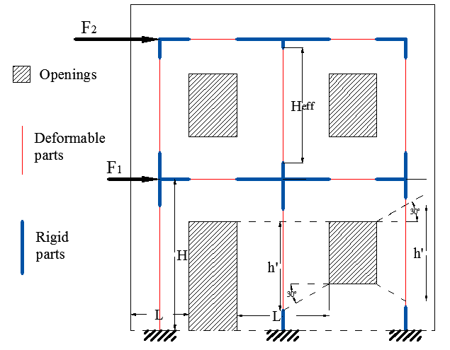

Figure 1. Schematic equivalent frame description for a perforated URM wall under in-plane horizontal forces

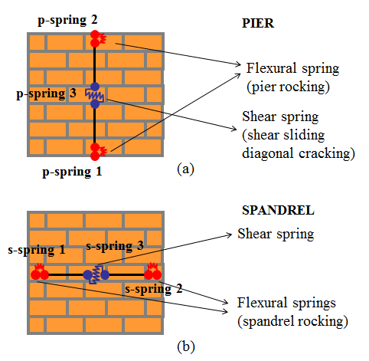

**Figure 2**. Macro-elements with nonlinear springs for piers (a) and spandrels (b)

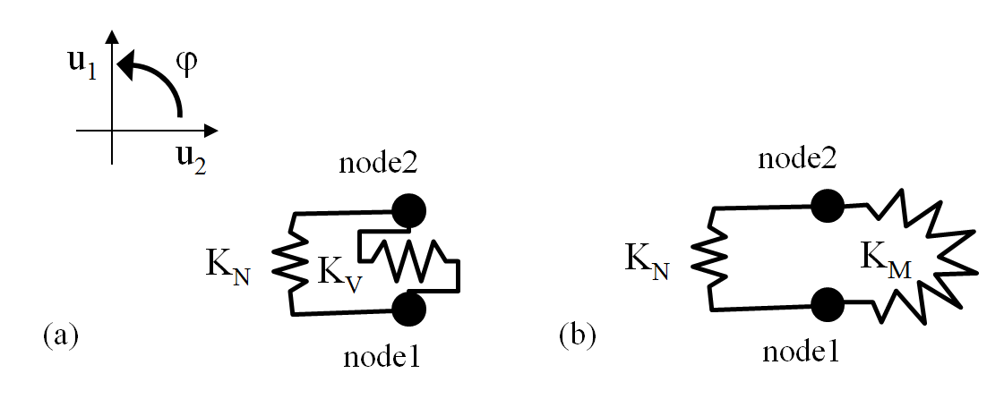

**Figure 3.** (a) Shear and (b) flexural multi-spring elements

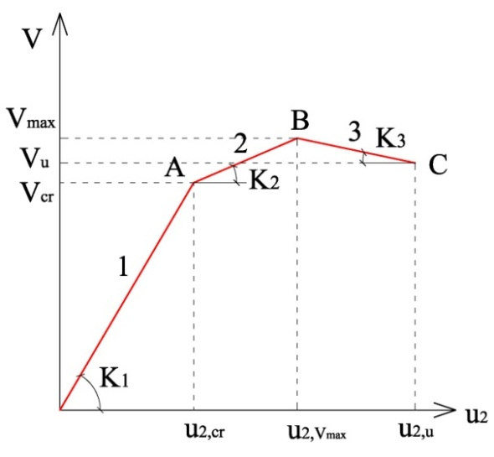

**Figure 4.** Skeleton curve for shear nonlinear spring

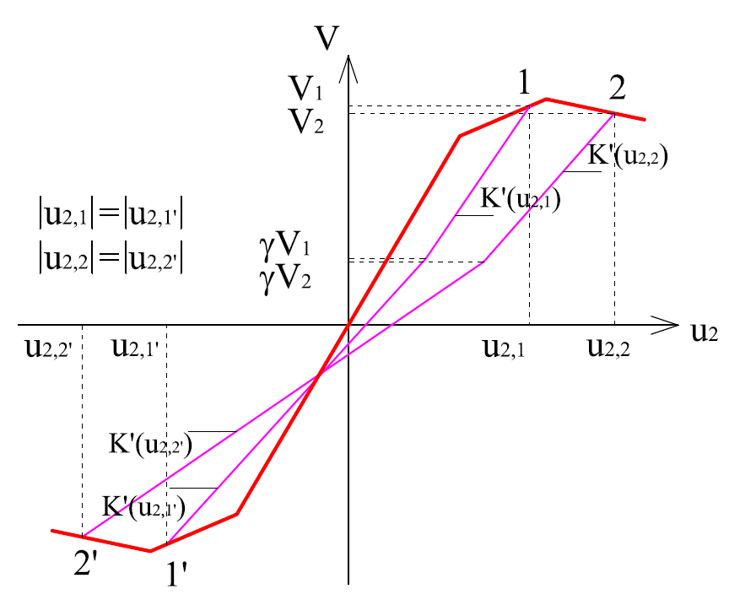

**Figure 5.** Stiffness degradation for unloading branch

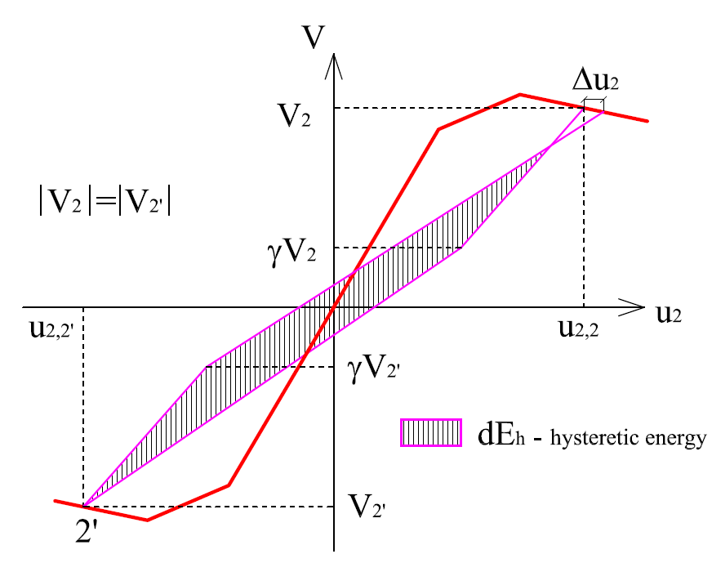

**Figure 6.** Strength degradation when reloading

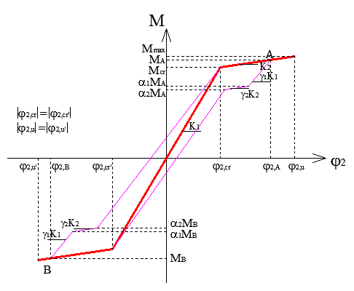

**Figure 7.** Hysteretic behaviour for the flexural spring

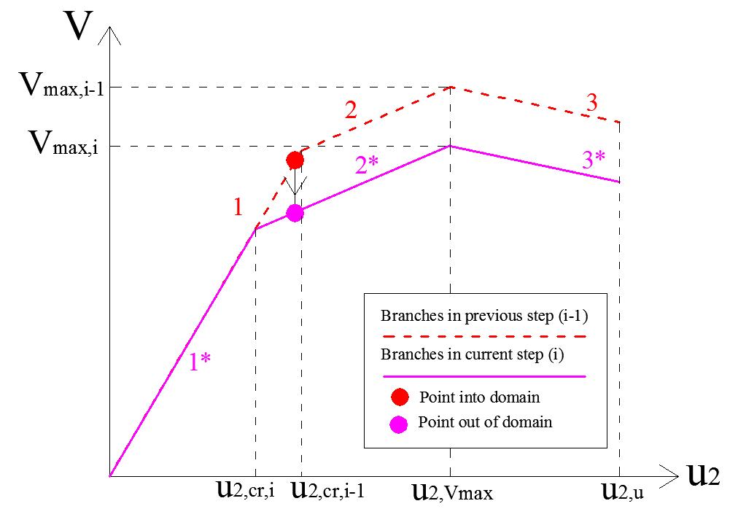

**Figure 8.** Backbone changes due to axial force interaction

|  |  |
| --- | --- |
| maschio tozzo mod2 sens 2 LAST  (a) | maschio snello mod2  (b) |

**Figure 9.** Experimental-numerical comparisons on the cyclic behaviour of URM piers: (a) wall LW and (b) wall HW

|  |
| --- |
| snello alpha1 e gamma2 |

**Figure 10.** Model sensibility to *1* and *2* in the prediction of the cyclic response of HW

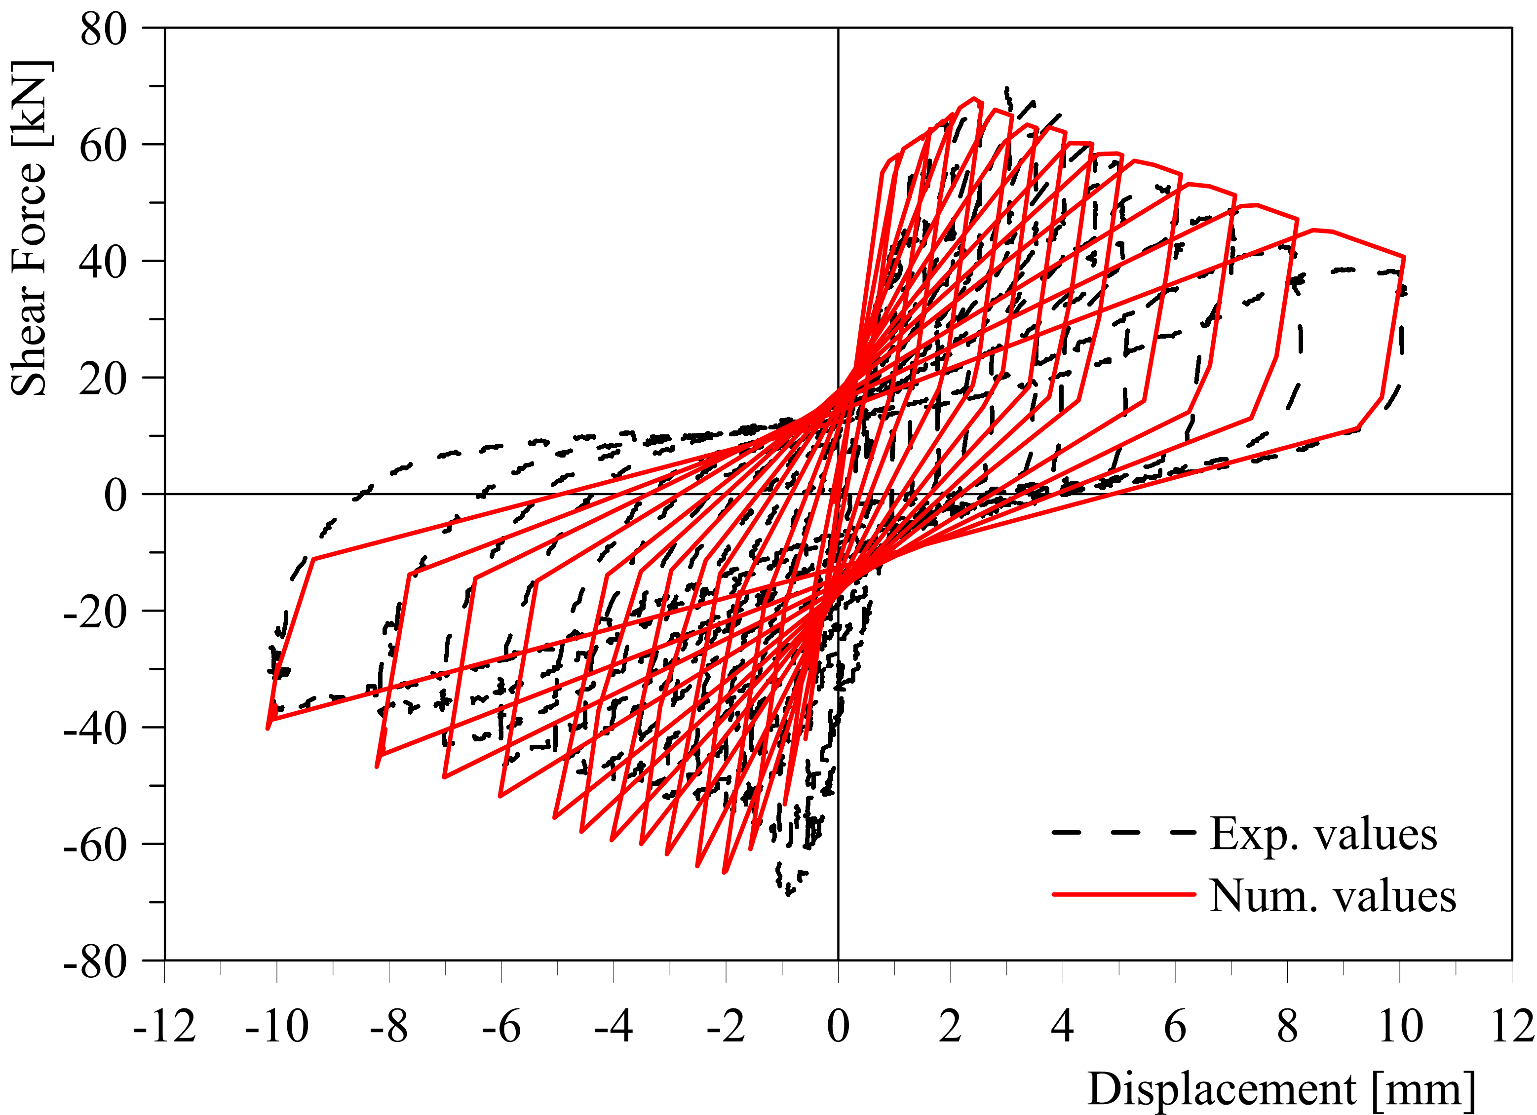

**Figure 11.** Experimental-numerical comparisons on the cyclic behaviour of a masonry spandrel [33]

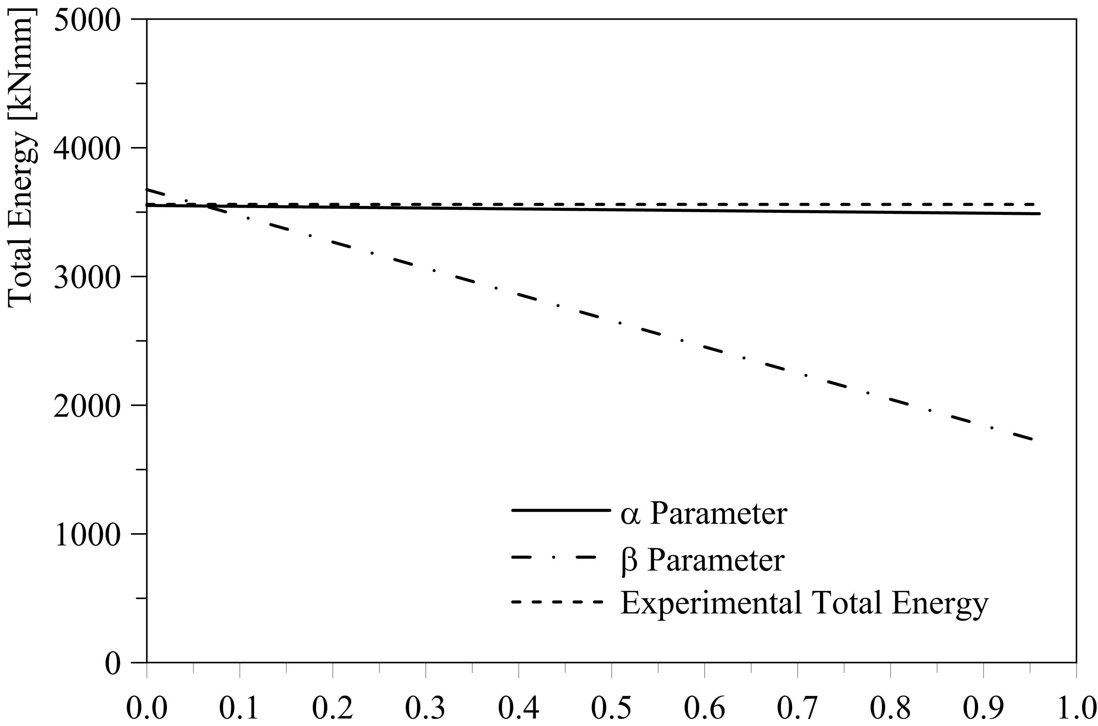

**Figure 12.** Model sensibility to ** and ** in the prediction of the cyclic response of the URM spandrel

|  |  |
| --- | --- |
| (a) | (b) |

**Figure 13.** Perforated URM wall: (a) geometric characteristics [m] and (b) nonlinear springs arrangement for piers and spandrels

**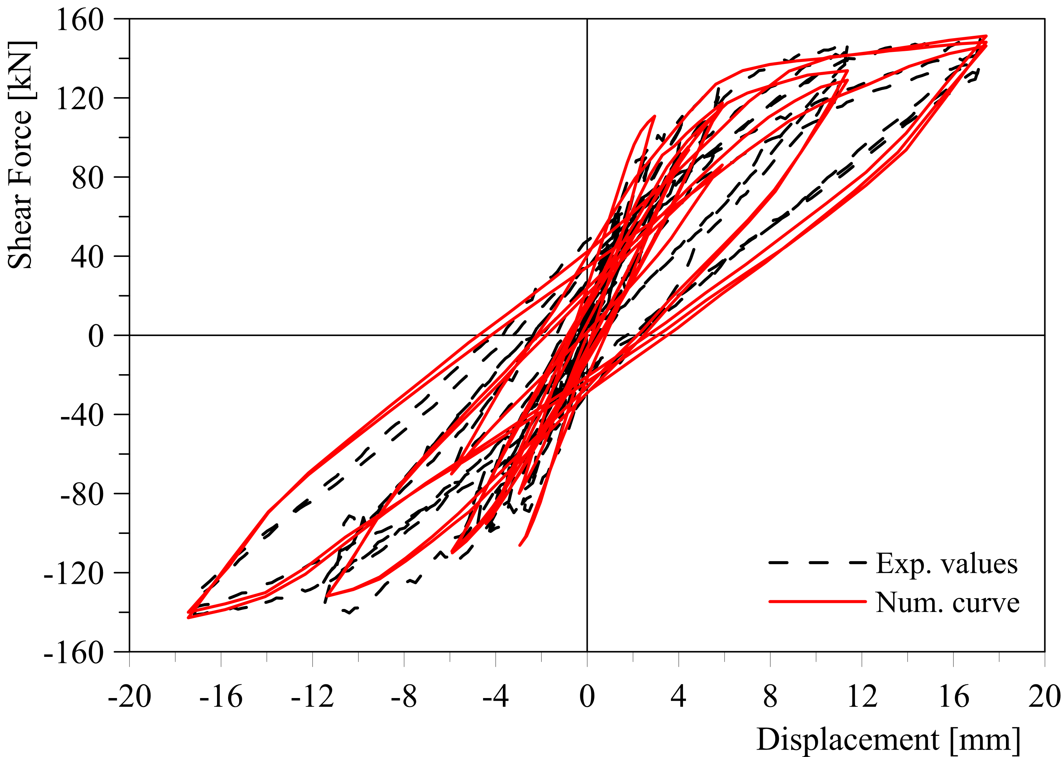**

**Figure 14.** Experimental-numerical comparison under cyclic loading condition

|  |  |
| --- | --- |
| IDA WallD  (a) |  |
|  |
| (b) |

**Figure 15.** (a) IDA curves for Wall D and (b) acceleration spectra of the artificial records

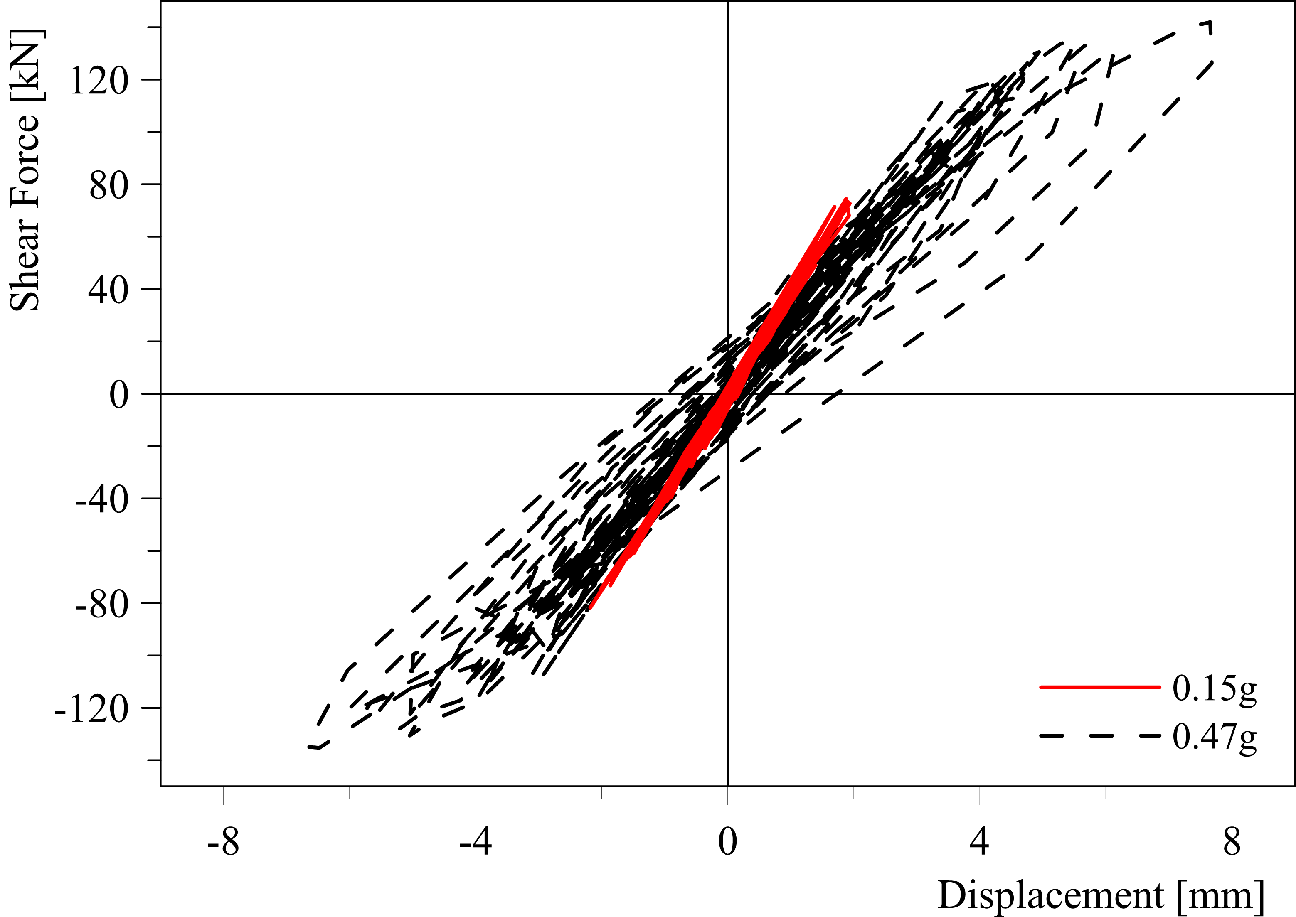

**Figure 16.** Base shear vs. top displacement for dynamic analyses at 0.15g and 0.47g

|  |  |
| --- | --- |
| (a) | Wall B  (b) |

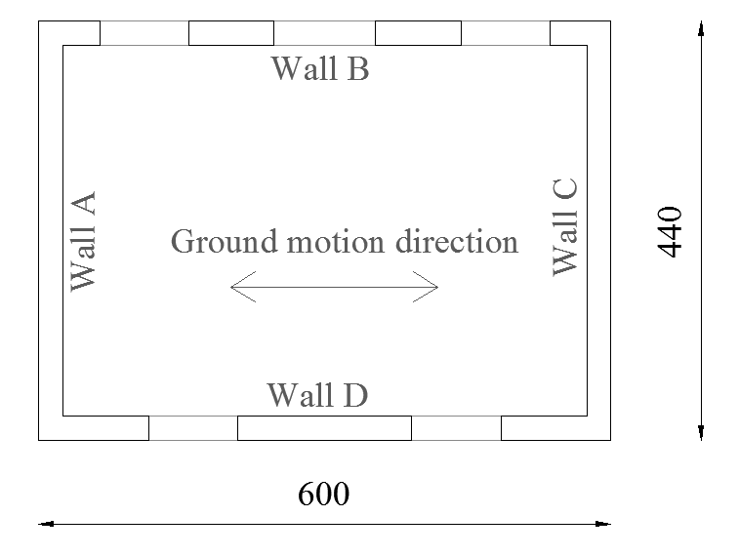

(c)

**Figure 17.** (a) View of the two-storey URM building, (b) Wall B characteristics and (c) plan view

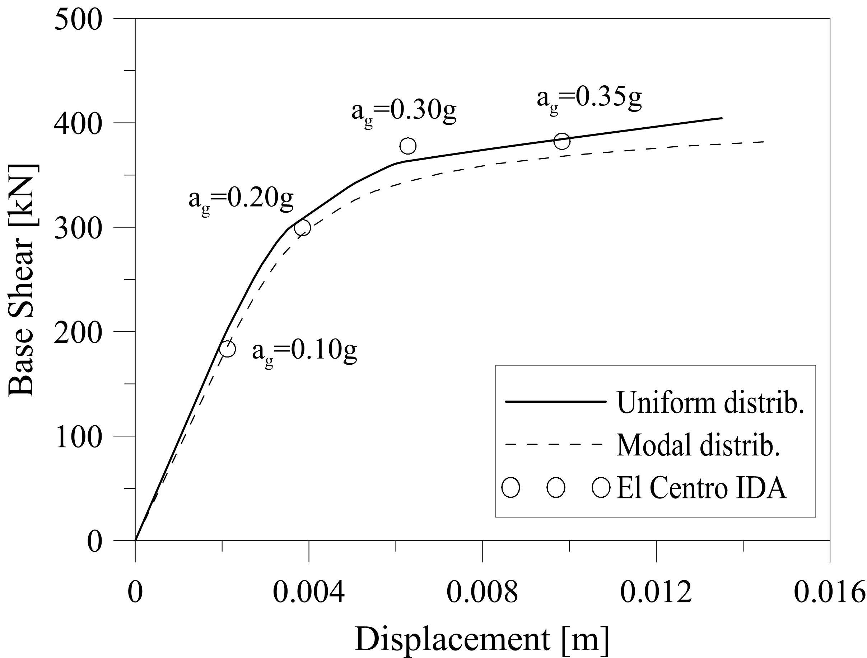

**Figure 18.** Pushover curves and IDA points for the 2-storey URM building

|  |  |
| --- | --- |
| C:\Users\s133674\Desktop\Articoli\articolo molle\disegni\figure edificio\rot03g.gif  (a) | C:\Users\s133674\Desktop\Articoli\articolo molle\disegni\figure edificio\tag03_NEW.gif  (b) |

**Figure 19.** Time-history of (a) bending moment vs rotation at the base of pier PD3 and (b) shear force vs transverse displacement in spandrel SD1

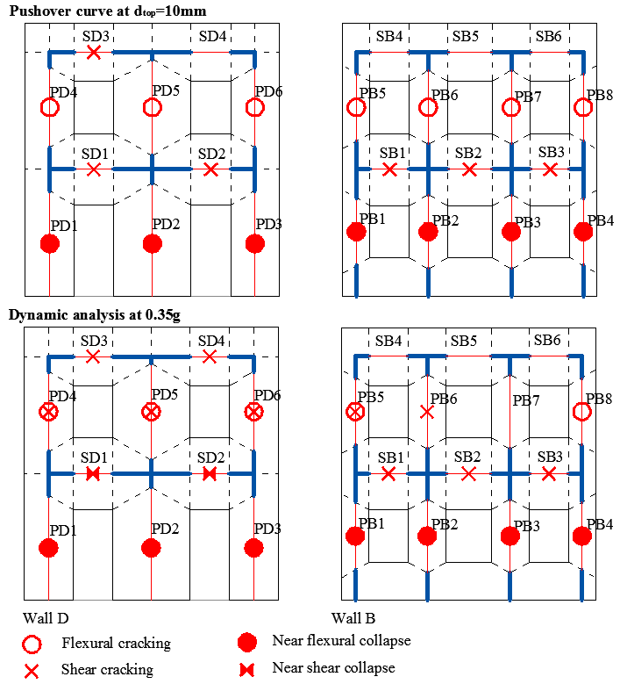

(b)

(a)

(c) 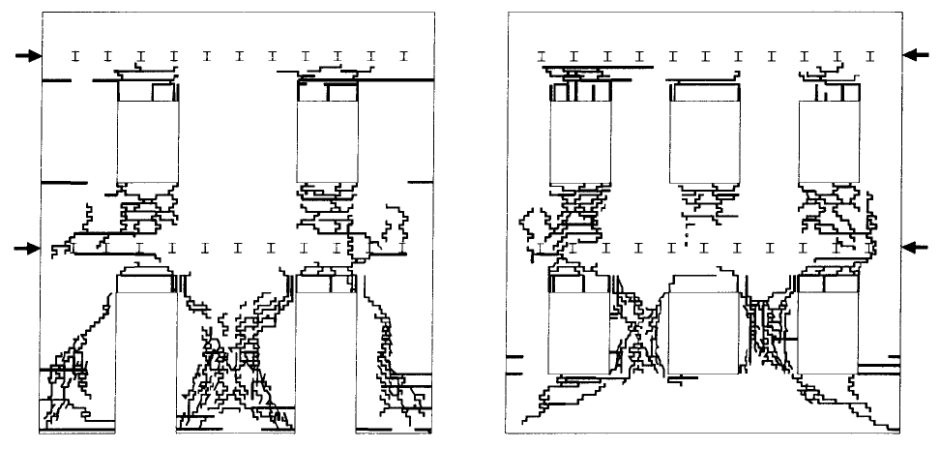

Wall D Wall B

**Figure 20.** Damage representation in the URM components of Wall B and Wall D found by (a) a nonlinear static (pushover) analysis at 10mm top displacement, (b) a nonlinear dynamic analysis with ag=0.35g and (c) observed crack patterns at the end of the experimental test, from [44]