**Supplementary Information:**

**BET isotherm and BJH pore size distribution of catalysts**

The instrument used was a Micromeritics TriStar 3000 surface area and porosity analyser. The adsorbent was N2, the temperature was 77.2K. The best region for the linear fit was determined by the Rouquerol method. The surface area was determined by the BET method. The molecular cross sectional area for nitrogen is 0.1620 nm2. Microporous and external surface area were determined with the t-plot using the the Broekhoff-DeBoer thickness equation. The pore size distribution was determined by the BJH method form the desorption branch of the isotherm.

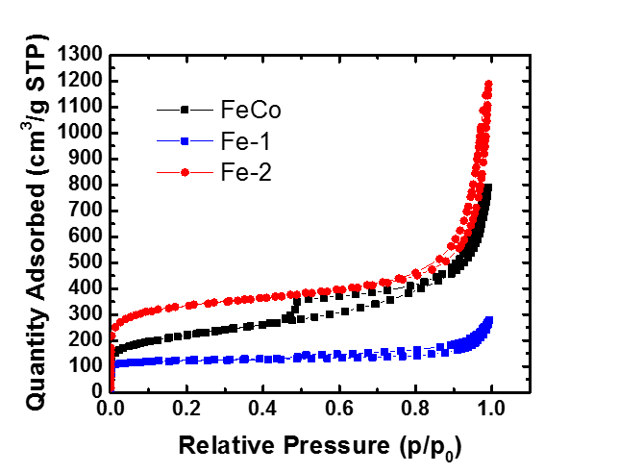

**S 1:** Nitrogen adsorption isotherm @ 77.2K

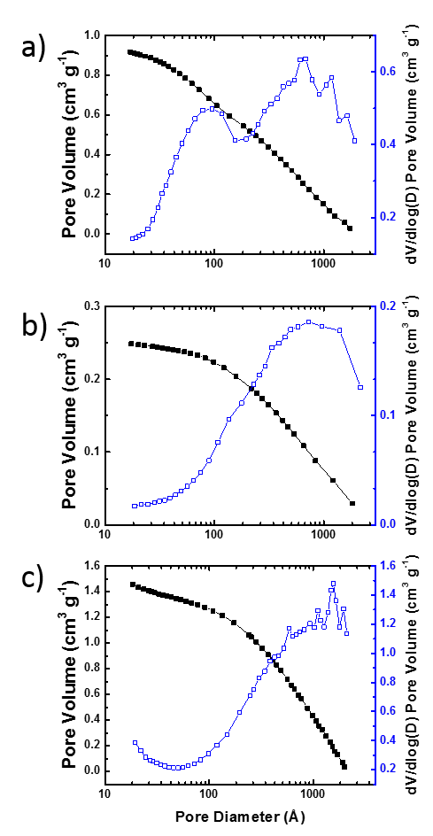

**S 2:** Pore size distribution, as determined by the BJH method from the desorption branch of the above isotherm

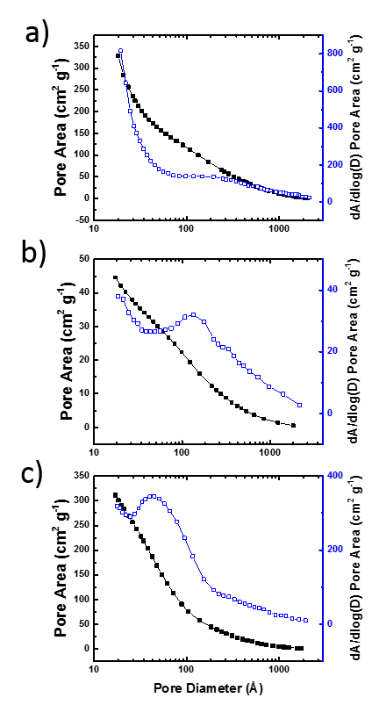

**S 3:** Pore size distribution, as determined by the BJH method from the desorption branch of the above isotherm

**Bode magnitude plots H2/Ar**

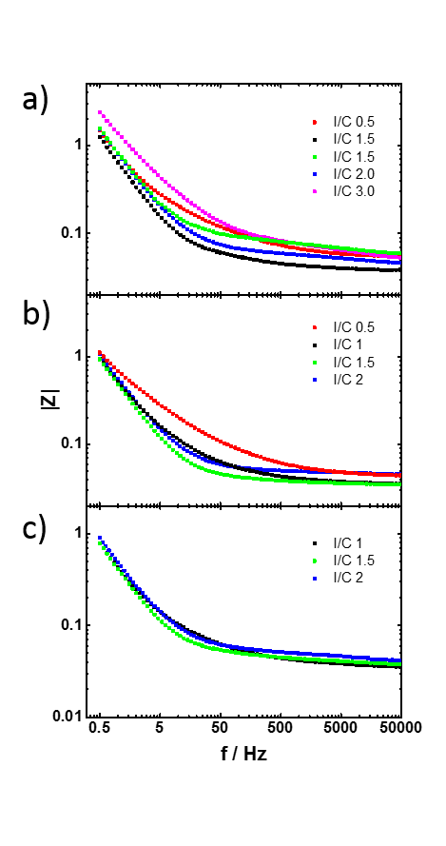

**S 4:** Bode Magnitude plots corresponding to measurements shown in **Figure 3** for catalysts **a) FeCo b) Fe-1 c) Fe-2**

**Bode magnitude plots H2/O2 low current**

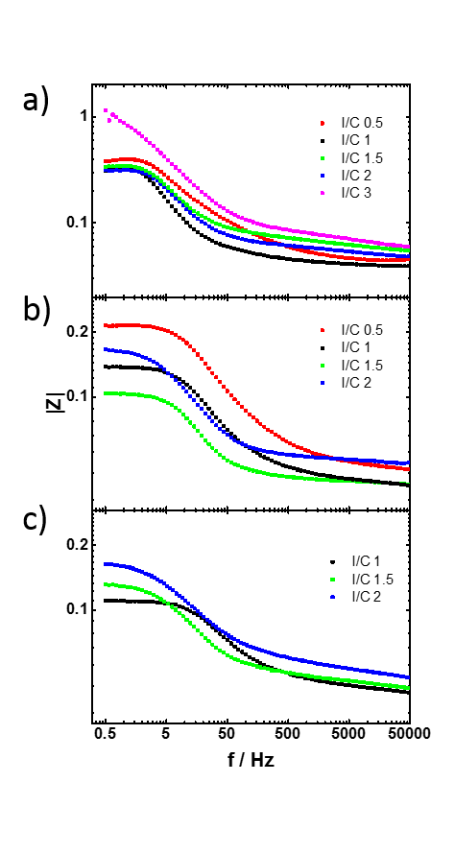

**S 5:** Bode Magnitude plots corresponding to measurements shown in **Figure 5** for catalysts **a) FeCo b) Fe-1 c) Fe-2**

**Bode Magnitude plots high current**

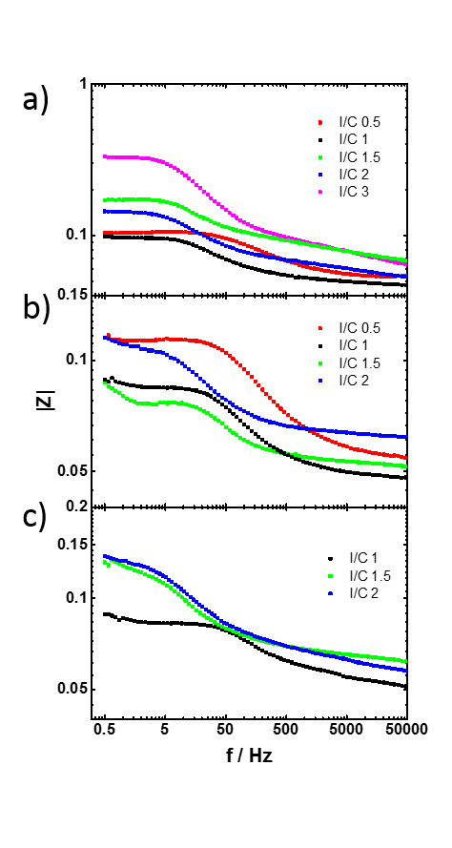

**S 6:** Bode Magnitude plots corresponding to measurements shown in **Figure 7** for catalysts **a) FeCo b) Fe-1 c) Fe-2**

**Performance of FeCo electrode at different thickness**

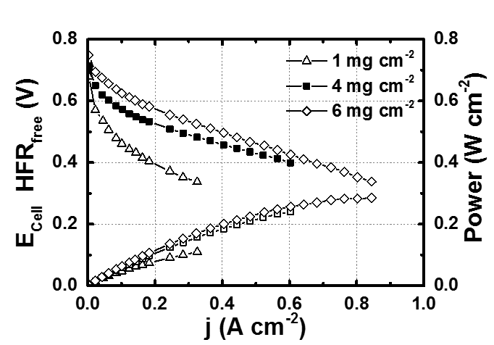

**S 7:** Galvanostatic polarisation curves for single cells with different catalyst loadings at the cathode, Anode: H2, 160 sccm, 2 bar back pressure (gage), 100% RH, Johnson Matthey Hydrogen reformate electrode 0.4 mgPt­/cm2, Cathode: O2, 550 sccm, 2 bar back pressure (gage), 100% RH, 4mgcatalyst/cm2; Cell temperature: 80 oC

**Bode plots H2/Ar at different thickness**

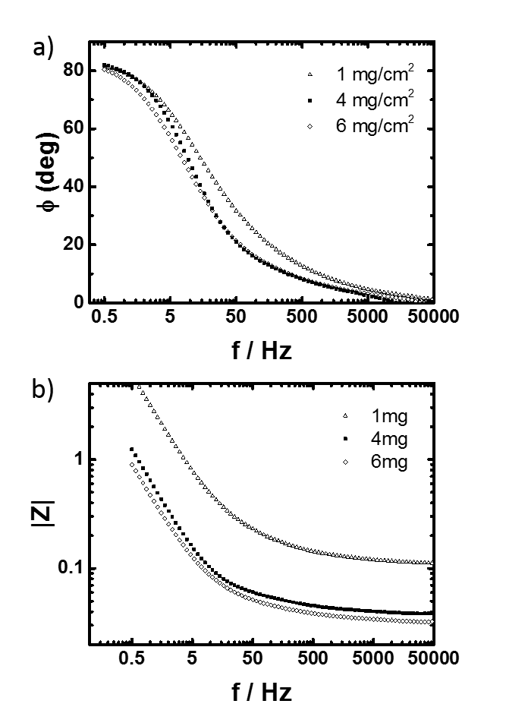

**S 8:** Bode **a)** phase angle and **b)** magnitude plots corresponding to measurements shown in **Figure 8**

**Impedance of H2/Ar with and without backpressure**

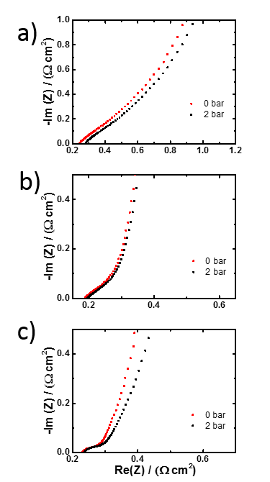

**S 9:** H2/Ar Nyquist plots for catalyst **FeCo** with and without backpressure at I/C ratio **a)** 0.5 **b)** 1.0 **c)** 2.0

**S10-12: Original SEM of FeCo catalyst with different ionomer loading as shown in main text**

C:\Users\vhs\Desktop\Paper on IC ratio\SEM\originals\S12.tif

C:\Users\vhs\Desktop\Paper on IC ratio\SEM\originals\S13.tif

S10: original SEM micrograph of the FeCo catalyst with I/C 0.5

C:\Users\vhs\Desktop\Paper on IC ratio\SEM\originals\S10.tifC:\Users\vhs\Desktop\Paper on IC ratio\SEM\originals\S11.tif

S11; original SEM micrograph of the FeCo catalyst with I/C 1

C:\Users\vhs\Desktop\Paper on IC ratio\SEM\originals\S15.tif

C:\Users\vhs\Desktop\Paper on IC ratio\SEM\originals\S14.tif

S12: original SEM micrograph of the FeCo catalyst with I/C 2

**S13: SEM of Fe-1 catalyst**

C:\Users\vhs\Desktop\Paper on IC ratio\SEM\originals\FEO\S16-2.tif

C:\Users\vhs\Desktop\Paper on IC ratio\SEM\originals\FEO\S16-1.tif

S13: original SEM micrograph of the Fe-1 catalyst with I/C 1.5

**S14: SEM of Fe-2 catalyst**

C:\Users\vhs\Desktop\Paper on IC ratio\SEM\originals\MGO\S17-2.tif

C:\Users\vhs\Desktop\Paper on IC ratio\SEM\originals\MGO\S17-1.tif

S14: original SEM micrograph of the Fe-2 catalyst with I/C 1