Defective SIRT1 increases T_{h}2 cytokine expression via acetylation of GATA-3 in severe asthma

Thomas Colley (PhD), Christopher Brightling (MD)2, Nicolas Mercado (PhD)¹, Yuichi Kunori (PhD), Pankaj K. Bhavsar (PhD)1, Peter J. Barnes (FRS)1 and Kazuhiro Ito (PhD)1

¹Airway Disease Section, National Heart and Lung Institute, Imperial College London, London, United Kingdom; ² Respiratory Medicine, Glenfield Hospital, University of Leicester, Leicester, United Kingdom.

Corresponding author: Kazuhiro Ito, Ph.D., Airway Disease Section, National Heart and Lung Institute, Imperial College London, Guy Scadding Building, Royal Brompton Campus, Dovehouse Street, London SW3 6LY, UK. E-mail: k.ito@imperial.ac.uk. Tel: +44-207-352-8121. Fax: +44-207-351-8126.

Finance Disclosure:
TC was funded by Asthma UK (WHRD_P31768), London, UK. PJB and KI received grants from Asthma UK for this work. CB……………………………………………. The funding sources played no role in study design, data collection and analysis, decision to publish or preparation of the manuscript.

Disclosure of potential conflict of interest: TC and KI are currently employees of Pulmocide Ltd and have honorary contracts with Imperial College. PB has served on Scientific Advisory Boards of AstraZeneca, Boehringer-Ingelheim, Chiesi, Daiichi-Sankyo, GlaxoSmithKline, Novartis, Nycomed, Pfizer, RespiVert, Teva and UCB and has received research funding from Aquinox Pharmaceutiocals, AstraZeneca, Boehringer-Ingelheim, Chiesi, Daiichi-Sankyo, GlaxoSmithKline, Novartis, Nycomed, Pfizer, and Prosonix. CB………………………..The other authors have declared that no competing interests exist for this research.

Abstract

Background: High levels of T_{h}2 cytokines are seen in severe asthma, but the molecular mechanism responsible is yet to be elucidated. GATA-3, a transcription factor critical for the regulation of T_{h}2 cytokine production, is a known acetylated protein with its acetylation level controlled by a protein deacetylase.

Objective: The aim of this study is to investigate the expression of the NAD⁺-dependent Class III protein deacetylase SIRT1 in severe asthma and to determine its role in T_{h}2 cytokine production.

Methods: SIRT1 mRNA, protein expression and activity were evaluated in PBMCs from healthy subjects and severe asthma patients by qRT-PCR, western blotting and fluorescent substrate activity assay. The impact of sirtuin inhibition by sirtinol or cambinol on T_{h}2 cytokine production was also evaluated in cord blood cells, HUT78 and HEK293 stably transfected with GATA-3.

Results: SIRT1 protein expression and activity was observed to be significantly and selectively reduced in PBMCs from patients with severe asthma. Treatment of PBMCs from healthy subjects with sirtuin inhibitors, followed by stimulation with anti-CD3/28 and PMA/ionomycin, led to increased mRNA expression of the T_{h}2 cytokines IL-4 and IL-13 but not the T_{h}1 cytokine IFNγ. Moreover, sirtuin inhibition enhanced differentiation of naïve T_{h} cells into T_{h}2 cells. It was also observed that sirtuin inhibition in the HUT78 T-cell line increased GATA-3 acetylation and its associated activity.

Conclusion: Deficiency of SIRT1, as seen in severe asthma, causes GATA-3 hyper-acetylation, leading to hyper-production of T_{h}2 cytokines and enhanced T_{h}2 cell differentiation.

Clinical implications
The high level of T_{h}2 cytokines associated with worsening symptoms in severe asthma is found to a consequence of SIRT1 deficiency in severe asthma.

Capsule summary
SIRT1, a NAD⁺ dependent protein deacetylase, regulates T_{h}2 cytokine expression via GATA-3 deacetylation, and its reduction causes hyper-production of T_{h}2 cytokines as seen in severe asthma .

Keywords
Severe asthma, SIRT1, GATA-3, IL-4, IL-5, T_{h}1, T_{h}2, acetylation

Abbreviations
FEV₁: forced exhaled volume in1 second, HDAC: histone deacetylase, IP: immunoprecipitate, NAD: nicotinamide adenine dinucleotide, SIRT1 : sirtuin 1, PBMC: peripheral blood mononuclear cell.

Introduction

The treatment of asthma is an ever-increasing burden upon international health services in modern times, with severe asthmatics disproportionally consuming more than 50% of asthma-associated health care expenditure (1). In contrast to mild and moderate patients, severe asthmatics are largely unresponsive to currently available asthma therapies, including high-dose inhaled and systemic corticosteroids. Severe asthmatics exhibit increased neutrophil and eosinophil numbers, involvement of the small airways and extensive airway remodeling, resulting in the observed progressive decline in lung function (2-5).
The relationship between type 2 T helper cell (T_{h}2) development and severe asthma has been well characterised. For example, increased activation of CD4⁺ T-cells and increased production of IL-4, IL-5 and IL-13 is correlated with asthma severity and sensitivity to corticosteroids (6-9). The expression of the T_{h}2 transcription factor GATA-3 is observed to be increased in the airways of asthmatic subjects (10). GATA-3 is known to be an acetylated protein, suggesting deacetylases regulate its function, and histone deacetylase (HDAC) 3 and 5 are reported to be associated with GATA-3 (11;12). The HDAC family comprises four classes of proteins with related function and DNA sequence similarity (13). HDACs are largely responsible for silencing of DNA transcription via the removal of acetyl groups from histones, resulting in altered gene expression. In addition, HDACs regulate the acetylation of non-histone proteins controlling their function. Inhibition of class I HDAC has been shown to increase IL-4 protein expression and promote a T_{h}2-like phenotype in human T-cells, while class I HDAC activity has been demonstrated to correlate with corticosteroid sensitivity (14-16). We recently found that SIRT1, a NAD⁺-dependent Class III HDAC highly homologous to the anti-aging protein Sir2 from S. cerevisae (17), is selectively reduced in lung tissue obtained from patients with chronic obstructive pulmonary disease, a treatment refractory airway inflammatory disease similar to severe asthma (18). SIRT1 influences many non-histone targets and regulates a wide variety of potentially inflammatory pathways including apoptosis, cell survival, DNA-repair, transcription and T-cell activation. SIRT1 is known to deacetylate NF-κB, FOXO3a and p53 influencing the stress-response and regulating oxidative stress-induced apoptosis, a contributory factor in asthma pathogenesis (19-22). Recently it has been shown that SIRT1 is involved in the regulation of T_{h}2 responses in OVA-sensitised mice (23-25). However, the data is currently inconclusive as to the role of SIRT1 in human cells.

Methods

Patients
Severe asthmatics were characterised according to the American Thoracic Society criteria and the severity was defined based on the Global Initiative for Asthma (GINA) criteria. The baseline characteristics of the patients are summarised in Tables E1 and E2. All patients and healthy volunteers were non-smokers. A 50-ml blood sample from each patient or volunteer was collected into anticoagulant-containing syringes. This study was approved by the ethics committee of the Royal Brompton and Harefield Hospitals, National Health Service Trust, Ethics committee in Leicester Univ and all subjects gave written informed consent.
Cells
The human T-cell line HUT78 and human epithelial kidney cell line HEK293 were obtained from the American Type Culture Collection (Manassas, VA) and cultured according to their guidelines. Media for HEK293 culture was supplemented with 200 µg/ml G418 when cells were stably transfected. Human peripheral blood mononuclear cells (PBMCs) were isolated from peripheral blood by density-gradient separation using Ficoll-Paque™ Plus (GE Healthcare) and cultured in RPMI-1640 containing 10% FBS and 15 mM L-glutamine. Cord blood isolated CD4⁺CD45RA⁺ T-cells were obtained from STEMCELL Technologies (Grenoble, France) and cultured in RPMI-1640 containing 10% FBS and 15 mM L-glutamine.
Cell Lysis, Immunoprecipiation, and Western Blotting
Whole and nuclear cell protein extracts were prepared using methods described previously (18). Immunoprecipitation was conducted with an anti-GATA-3 antibody (Santa Cruz Biotechnology, Texas, USA). Cell lysates or immunoprecipitates were analyzed by SDS-PAGE (Invitrogen Ltd, Paisley, UK) and detected with western blot analysis by chemiluminescence (ECL Plus; GE Healthcare, Chalfont St. Giles, UK).
Quantitative Real-time PCR (qRT-PCR)
Total RNA was extracted using the RNeasy kit (Qiagen, West Sussex, UK), and cDNA was prepared using the M-MLV RT kit (Invitrogen, Carlsbad, CA). Gene transcript levels of human SIRT1, IL-4, IL-13, IFNγ, GATA-3, T-bet, GAPDH and GNB2L1 were quantified by qRT-PCR using commercially available TaqMan primers and probes (Applied Biosystems, Warrington, UK) on a Rotor-Gene 3000 (Qiagen, West Sussex, UK).
SIRT1 Activity
SIRT1 activity was measured using the Fluor-de-lys® SIRT1 fluorometric drug discovery assay kit (Enzo Life Sciences, Exeter, UK). Briefly, total activity and non-specific activity in the presence of a high concentration of nicotinamide (1 mM), were determined. Actual SIRT1 activity was calculated as total activity minus nonspecific activity, and the activity was shown as micromolar standard equivalent per microgram of protein (unit).
GATA-3 activity
GATA-3 activity was measured using the TransAM™ GATA Transcription factor ELISA kit (Active Motif, Rixensart, Belgium). Results were normalised against total GATA-3 expression as determined by western blotting.
Acetylated GATA-3 ELISA
GATA-3 acetylation levels were determined by a sandwich ELISA developed in-house. Protein was captured using an immobilised GATA-3 antibody (Santa Cruz Biotechnology, Texas, USA). Acetylation of GATA-3 was observed using an anti-acetylated lysine antibody (New England Biolabs, Hitchin UK). Results were normalised against total GATA-3 expression as determined by western blotting.
Overexpression of GATA-3
Plasmids containing the human GATA-3 gene were prepared using the pcDNA3.1 TOPO directional cloning system (Invitrogen, Carlsbad, CA). HEK293 cells were transfected with plasmid using Lipofectamine 2000 (Invitrogen, Carlsbad, CA), according to the manufacturer’s instructions. Successful transformants were isolated and cultured.
T-cell stimulation
PBMCs were pre-treated with increasing concentrations of vehicle, sirtinol or cambinol for 20 minutes. Cells were transferred to media containing immobilised anti-CD3 (5 μg/ml) and anti-CD28 (0.5 µg/ml) and incubated at 37°C and 5% CO₂ for 24 hours. Subsequently, cells were transferred to media containing PMA (10 ng/ml) and ionomycin (0.5 μM) for four hours.

T_{h}-cell differentiation
Cord blood CD4⁺CD45RA⁺ T-cells were differentiated into T_{h}1 and T_{h}2 subsets according to a protocol described by Cousins et al (26). Briefly, cell suspensions were transferred to 6-well plates containing a combination of immobilised anti-CD3 (1 μg/ml) and anti-CD28 (2 μg/ml). To generate T_{h}1 cells, human recombinant IL-12 (2.5 ng/ml) and IL-2 (10 ng/ml), and an antibody specific for IL-4 (5 μg/ml) were added to the media. To generate T_{h}2 cells, human recombinant IL-2 (10 ng/ml) and IL-4 (12.5 ng/ml), and antibodies specific for IL-10 (5 μg/ml) and IFNγ (5 μg/ml) were added to the media. After 4 days incubation, cells were washed and re-suspended in fresh media containing cytokines and antibody combinations for T_{h}1 and T_{h}2 differentiation, a process that was repeated every 7 days. When required, cells were washed and re-suspended in fresh media containing PMA (5 ng/ml) and ionomycin (500 ng/ml) for four hours.
Reagents
Antibodies used for detection of protein in western blots and ELISA were anti-SIRT1 (H-300; Santa Cruz, CA), anti-GATA-3 (D-16; Santa Cruz, CA), anti-acetylated lysine (9441; New England Biolabs, Hitchin UK) and anti-β-actin (Abcam, Cambridge, UK). The antibody used for immunoprecipitation was anti-GATA-3 (HG3-31; Santa Cruz, CA). To differentiate T_{h} cells, antibodies specific for IL-4 (BD, Oxford, UK), IFNγ (Invitrogen, Carlsbad, CA), IL-10 (Invitrogen, Carlsbad, CA), CD3 (BD, Oxford, UK) and CD28 (BD, Oxford, UK) were obtained. PMA, ionomycin, cambinol, sirtinol and G418 were obtained from Sigma Aldrich (Dorset, UK); recombinant human IL-4, IL-12 and IL-2 were supplied by R&D (Minneapolis, MN). RPMI-1640, DMEM, FBS, L-glutamine and sodium pyruvate were obtained from Invitrogen (Carlsbad, CA).
Statistical analysis
The results were expressed as the mean ± SEM. Statistical analysis between healthy, mild asthma and severe asthma groups was conducted using analysis of variance (ANOVA) with Kruskal-Wallis analysis, and when significant, comparisons were made by Dunns Multiple Comparison test using GraphPad Prism® (GraphPad Software, San Diego, CA). Correlation coefficients were calculated with the use of Spearman’s rank method. One-way ANOVA, Freidman test and student t-test were also used when applicable.
Results

SIRT1 protein expression and activity is reduced in severe asthma
Severe asthmatics were characterised according to the NHLBI GINA guidelines (5) and recruited from The Royal Brompton Hospital and University Hospitals of Leicester. In the first cohort of patients recruited (Table E1), no change was observed between different groups expression of SIRT1 mRNA transcripts, as quantified by qRT-PCR (Figure 1A). To further investigate SIRT1’s function in subject groups, its deacetylase activity was quantified using a fluorophore-conjugated acetylated peptide of the SIRT1 target p53. Patients with severe asthma showed decreased SIRT1 activity (0.19 ± 0.04 µM standard equivalent/ µg protein) when compared to healthy individuals (0.38 ± 0.06; p=0.015; Figure 1B). In comparison, mild asthmatics showed no such decrease (0.34 ± 0.09). Decreased SIRT1 activity was also shown to be positively correlated with decreased FEV₁ (forced expiratory volume at 1 second) suggesting reduced SIRT1 is associated with poorer lung function (Figure 1C). In addition, data from a second separate cohort (Table E2) showed that the expression of SIRT1 protein was seen to be significantly decreased in severe asthmatics (0.14 ± 0.05; p=0.03) when compared to healthy individuals (0.79 ± 0.36; Figure 1D & 1E). This was in contrast to the expression of other sirtuin members (SIRT2, 3, 6 and 7) which showed no change between groups (Figure 1E & E1).

SIRT1 reduction causes T_{h}2 cytokine production
Retrospective analysis of cytokine mRNA expression in patient samples demonstrated a very strong negative correlation between SIRT1 activity and expression of IL-4 transcripts (Figure 2A). A preliminary study designed to observe the effect of endogenous sirtuin inhibition on cytokine expression in PBMCs from healthy individuals using semi-quantitative cytokine array analysis, indicated that the sirtuin inhibitor sirtinol up-regulated the expression of T_{h}2 associated cytokines, but had no effect on the expression of T_{h}1 cytokines and IL-17 related cytokines (Figure E2). In order to investigate this phenomenon further, the impact of sirtuin inhibition on mRNA expression of the cytokines IL-4, IL-13 and IFNγ was quantified by real-time quantitative PCR. In healthy PBMCs activated by anti-CD3, anti-CD28, PMA and ionomycin, sirtuin inhibition by sirtinol at 10 µM significantly (p<0.05) increased the expression of IL-4 and IL-13 (IL-4: 0.00038 ± 0.0001 (sirtinol 10 µM) vs 0.00024 ± 0.000064 (control), IL-13: 0.049 ± 0.012 (sirtinol 10 µM) vs 0.036 ± 0.018 (control); n=5; Figure 2B & C), whilst specific SIRT1/2 inhibition by cambinol at 50 µM also increased IL-4 and IL-13 expression (IL-4: 0.0016 ± 0.00088 (cambinol) vs 0.00063 ± 0.00033 (control), p<0.05; IL-13: 0.0045 ± 0.0022 (cambinol) vs 0.0022 ± 0.0011(control); p<0.01: n=3; Figure 2E & F). Conversely, mRNA expression of the T_{h}1 cytokine IFNγ showed no change with either inhibitor (Figure 2D & 2G). To further investigate the relationship a model of T-cell differentiation was utilised, whereby CD4⁺CD45RA⁺ T-cells from cord blood were induced to differentiate into T_{h}1 and T_{h}2 subsets. T_{h}1 cells pre-incubated with sirtinol demonstrated no significant change in the ratio of IFNγ to IL-4 and T-bet to GATA-3, when normalised against GAPDH (data not shown). However, there was a highly significant increase in the ratio of IL-4 to IFNγ in T_{h}2 cells (Figure 2H). This was accompanied by a borderline significant (p=0.06) increase in the ratio of GATA-3 to T-bet (Figure 2I).

SIRT1 reduction causes hyperacetylation of GATA-3
To examine the mechanism of sirtuin inhibition induced elevation of T_{h}2 differentiation, the effect of sirtinol on the acetylation of GATA-3 was examined. HUT78 cells were treated with sirtinol and the acetylation of GATA-3 within nuclear protein was quantified by ELISA and normalised against total GATA3 expression as determined by western blot. Sirtuin inhibition by 30 µM sirtinol resulted in increased acetylation of GATA-3 (99 ± 37% over baseline; p<0.05; Figure 3A). In addition, immunoprecipitated GATA-3 was confirmed to be highly acetylated when sirtuins were inhibited (Figure 3B). To determine whether increased acetylation of GATA-3 directly impacted upon its activity, GATA3-DNA-binding was quantified. Binding of GATA-3 to its response element was enhanced when sirtuin activity was inhibited by sirtinol at 30 µM (199 ± 64% over baseline; p<0.05; Figure 3C). To directly assess the role of sirtuins in mediating the function of GATA-3, a plasmid coding for GATA-3 was overexpressed in the largely GATA-3-deficient cell line, HEK293. Sirtuin inhibition in un-transfected cells had no impact on IL-4 mRNA expression, while GATA-3 over-expression increased IL-4 mRNA expression by 3-fold (Figure 3D). However, GATA-3 over-expression coupled with sirtuin inhibition significantly raised the transcription of IL-4 above that of GATA-3 over-expression alone.

Discussion

This manuscript provides novel evidence for SIRT1 reduction in severe asthma, contributing to the T_{h}2 cytokine hyper-production characteristic of the disease (6-9;27). The expression of the NAD⁺-dependent Class III HDAC, SIRT1, is known to be reduced in lung tissue and PBMCs from patients with COPD, however SIRT1 expression has yet to be evaluated in asthma (18). Therefore, in this manuscript, Class III HDAC expression and activity were observed in PBMCs from patients with severe asthma initially. As shown in Figure 1A, there was no difference in the expression of SIRT1 mRNA transcripts, as quantified by qRT-PCR, between healthy, mild asthma and severe asthma. In contrast, SIRT1 deacetylase activity in nuclear extracts from PBMCs, which was quantified using a fluorophore-conjugated acetylated peptide of the SIRT1 target p53, was significantly reduced in severe asthma (Figure 1B). Decreased SIRT1 activity was also positively correlated with decreased lung function shown as FEV₁, suggesting reduced SIRT1 is associated with poorer lung function (Figure 1C). Further protein analysis revealed that SIRT1 is selectively reduced in severe asthma compared with other sirtuins, although SIRT4 and SIRT5 expression could not be evaluated due to poor antibody specificity (Figure 1D and E). While both SIRT1 protein and activity were reduced in severe asthma, mRNA expression remained unchanged (Figure 1), suggesting that reduction of SIRT1 is not due to reduced gene transcription. Abnormality in translation or post-transcriptional modifications may be involved in reduction of SIRT1 protein. To date, reduced SIRT1 expression has been associated with oxidative stress via cigarette smoke or hydrogen peroxide exposure, and a high fat diet (18;28;29). We have also previously observed that reduction of SIRT1 caused by oxidative stress can be reversed by the 26S proteasome inhibitor ALLN (18). In addition, other studies have observed that cigarette smoke exposure enhances post-translational 4-HNE and 3-nitrotyrosine modification of SIRT1, leading to accelerated degradation or decreased activity (28). As oxidative stress has been strongly linked with the pathogenesis of severe asthma (30-33), the reduction of SIRT1 seen in severe asthma quite possibly has its origin in this increased oxidative condition.
Although severe asthma has been associated with decreased Class I/II HDAC activity, and decreased protein expression of HDAC1 and HDAC2 (14;34;35), this is the first evidence that SIRT1 is decreased in severe asthma. Interestingly, a very strong negative correlation between SIRT1 activity and IL-4 gene expression was observed in PBMCs (Figure 2A). A preliminary study designed to observe the effect of endogenous sirtuin inhibition on broader cytokine expression in PBMCs from healthy individuals, indicated that sirtinol, a sirtuin inhibitor, up-regulated the expression of T_{h}2 associated cytokines such as IL-4, IL-5 and IL-13, but not T_{h}1 or T_{h}17 associated cytokines (Figure E2). This was confirmed by quantitative RT-PCR analysis of IL-4, IL-13 and IFNγ. As shown in Figure 2B, C, E and F, sirtinol, a Class III HDAC inhibitor, and cambinol, a selective SIRT1/2 inhibitor, increased gene expression of IL-4 and IL-13 in a concentration dependent manner. In contrast, mRNA expression of the T_{h}1 cytokine IFNγ showed no such change (Figure 2D and G). To probe this further a model of T-cell differentiation was utilised, whereby CD4⁺CD45RA⁺ T-cells from cord blood were induced to differentiate into T_{h}1 and T_{h}2 subsets. T_{h}1 cells pre-incubated with sirtinol demonstrated no significant change in the ratio of IFNγ to IL-4 and T-bet to GATA-3. In contrast, as shown in Figure 2H, there was a highly significant increase in the ratio of IL-4 to IFNγ in T_{h}2 cells, which was accompanied by an increase in the ratio of GATA-3 to T-bet (a transcription factor responsible for Th1 cytokine production) (p=0.06; Figure 2I). Inhibition of class I/II HDACs by trichostatin A has been shown to increase IL-4 protein expression and promote a T_{h}2-like phenotype in human T-cells (15;16), but this is the first in vitro evidence in human cells that inhibition of SIRT1 has a similar outcome. The impact of SIRT1 on T_{h}2 cytokine expression has been observed in mice with contradictory findings. SIRT1 inhibition and activation have both been shown to reduce T_{h}2 cytokine expression implicating SIRT1 in exacerbation and attenuation of the immune response (23-25).
It has been demonstrated that commitment of T_{h}0 cells to a T_{h}2 lineage is dependent on the transcription factor GATA-3 (36). GATA-3 activity can be controlled by acetylation, indicating a potential role for a deacetylase in its regulation (11). The effect of sirtuin inhibition on the acetylation state of GATA-3 was observed in HUT78, a T cell line. As shown in Figure 3A, sirtuin inhibition by sirtinol resulted in significant increased acetylation of GATA-3 when evaluated by ELISA. In addition, this change in acetylation was also evident when GATA-3 was immunoprecipitated from cells treated with sirtinol (Figure 3B). Furthermore, sirtinol also significantly increased GATA-3 activation as evaluated by GATA-3 binding to oligonucleotides containing the GATA-3 binding domain (Figure 3C). To directly assess the role of sirtuins in mediating the function of GATA-3, GATA-3 was stably over-expressed in the largely GATA-3-deficient cell line, HEK293. Wild type HEK293 cells were shown to express low levels of IL-4 mRNA but GATA-3 over-expression increased IL-4 mRNA expression by 3-fold (Figure 3D). In addition, sirtuin inhibition in un-transfected cells had no observable impact (Figure 3D), whereas sirtuin inhibition in GATA-3-transfected HEK293 cells significantly increased IL-4 gene expression when compared to GATA-3 overexpression alone. These data imply that T_{h}2 development in humans is reliant on a relationship between SIRT1 and GATA-3. Thus, we demonstrate that SIRT1 plays a role in maintaining the T_{h}-cell balance and preventing sustained cellular differentiation toward a T_{h}2 phenotype, with SIRT1 reduction contributing towards the pathogenesis of severe asthma.

Acknowledgements
This work is supported by a PhD studentship of the Asthma UK to T.C., which was held by K.I. and P.J.B. We thank Sally Meah, Arnell Colongon, Flo Chow, Mona Bafadhel and Vijay Mistry for recruiting the patients for these studies.

Authors contribution
T.C. designed the research, performed all experiments, interpreted results and wrote the paper. C.B. and P.K.B contributed to recruit patients, provided clinical data and interpreted results. K.Y. prepared molecular tools and performed preliminary experiments. P.J.B. designed the research and interpreted results. K.I. designed the research, analysed PCR results, interpreted results and wrote the paper.

Author Information
The authors declare no competing financial interests. Correspondence and requests for materials should be addressed to K.I. (k.ito@imperial.ac.uk).

Reference

(1) Antonicelli L, Bucca C, Neri M, De BF, Sabbatani P, Bonifazi F, et al. Asthma severity and medical resource utilisation. Eur Respir J 2004 May;23(5):723-9.
(2) Benayoun L, Druilhe A, Dombret MC, Aubier M, Pretolani M. Airway structural alterations selectively associated with severe asthma. Am J Respir Crit Care Med 2003 May 15;167(10):1360-8.
(3) Miranda C, Busacker A, Balzar S, Trudeau J, Wenzel SE. Distinguishing severe asthma phenotypes: role of age at onset and eosinophilic inflammation. J Allergy Clin Immunol 2004 Jan;113(1):101-8.
(4) Jatakanon A, Uasuf C, Maziak W, Lim S, Chung KF, Barnes PJ. Neutrophilic inflammation in severe persistent asthma. Am J Respir Crit Care Med 1999 Nov;160(5 Pt 1):1532-9.
(5) Nhlbi GINA. National Asthma Education and Prevention Program Expert Panel Report 3: Guidelines for the diagnosis and management of asthma. NIH Publication 2009 Jan 12.
(6) Robinson DS, Bentley AM, Hartnell A, Kay AB, Durham SR. Activated memory T helper cells in bronchoalveolar lavage fluid from patients with atopic asthma: relation to asthma symptoms, lung function, and bronchial responsiveness. Thorax 1993 Jan;48(1):26-32.
(7) Leung DY, Martin RJ, Szefler SJ, Sher ER, Ying S, Kay AB, et al. Dysregulation of interleukin 4, interleukin 5, and interferon gamma gene expression in steroid-resistant asthma. J Exp Med 1995 Jan 1;181(1):33-40.
(8) Humbert M, Corrigan CJ, Kimmitt P, Till SJ, Kay AB, Durham SR. Relationship between IL-4 and IL-5 mRNA expression and disease severity in atopic asthma. Am J Respir Crit Care Med 1997 Sep;156(3 Pt 1):704-8.
(9) Saha SK, Berry MA, Parker D, Siddiqui S, Morgan A, May R, et al. Increased sputum and bronchial biopsy IL-13 expression in severe asthma. J Allergy Clin Immunol 2008 Mar;121(3):685-91.
(10) Nakamura Y, Ghaffar O, Olivenstein R, Taha RA, Soussi-Gounni A, Zhang DH, et al. Gene expression of the GATA-3 transcription factor is increased in atopic asthma. J Allergy Clin Immunol 1999 Feb;103(2 Pt 1):215-22.
(11) Yamagata T, Mitani K, Oda H, Suzuki T, Honda H, Asai T, et al. Acetylation of GATA-3 affects T-cell survival and homing to secondary lymphoid organs. EMBO J 2000 Sep 1;19(17):4676-87.
(12) Chen GY, Osada H, Santamaria-Babi LF, Kannagi R. Interaction of GATA-3/T-bet transcription factors regulates expression of sialyl Lewis X homing receptors on Th1/Th2 lymphocytes. Proc Natl Acad Sci U S A 2006 Nov 7;103(45):16894-9.
(13) Barnes PJ, Adcock IM, Ito K. Histone acetylation and deacetylation: importance in inflammatory lung diseases. Eur Respir J 2005 Mar;25(3):552-63.
(14) Hew M, Bhavsar P, Torrego A, Meah S, Khorasani N, Barnes PJ, et al. Relative corticosteroid insensitivity of peripheral blood mononuclear cells in severe asthma. Am J Respir Crit Care Med 2006 Jul 15;174(2):134-41.
(15) Valapour M, Guo J, Schroeder JT, Keen J, Cianferoni A, Casolaro V, et al. Histone deacetylation inhibits IL4 gene expression in T cells. J Allergy Clin Immunol 2002 Feb;109(2):238-45.
(16) Su RC, Becker AB, Kozyrskyj AL, Hayglass KT. Epigenetic regulation of established human type 1 versus type 2 cytokine responses. J Allergy Clin Immunol 2008 Jan;121(1):57-63.
(17) Imai S, Armstrong CM, Kaeberlein M, Guarente L. Transcriptional silencing and longevity protein Sir2 is an NAD-dependent histone deacetylase. Nature 2000 Feb 17;403(6771):795-800.
(18) Nakamaru Y, Vuppusetty C, Wada H, Milne JC, Ito M, Rossios C, et al. A protein deacetylase SIRT1 is a negative regulator of metalloproteinase-9. FASEB J 2009 Sep;23(9):2810-9.
(19) Bucchieri F, Puddicombe SM, Lordan JL, Richter A, Buchanan D, Wilson SJ, et al. Asthmatic bronchial epithelium is more susceptible to oxidant-induced apoptosis. Am J Respir Cell Mol Biol 2002 Aug;27(2):179-85.
(20) Vaziri H, Dessain SK, Ng EE, Imai SI, Frye RA, Pandita TK, et al. hSIR2(SIRT1) functions as an NAD-dependent p53 deacetylase. Cell 2001 Oct 19;107(2):149-59.
(21) Yang Y, Hou H, Haller EM, Nicosia SV, Bai W. Suppression of FOXO1 activity by FHL2 through SIRT1-mediated deacetylation. EMBO J 2005 Mar 9;24(5):1021-32.
(22) Motta MC, Divecha N, Lemieux M, Kamel C, Chen D, Gu W, et al. Mammalian SIRT1 represses forkhead transcription factors. Cell 2004 Feb 20;116(4):551-63.
(23) Legutko A, Marichal T, Fievez L, Bedoret D, Mayer A, de VH, et al. Sirtuin 1 promotes Th2 responses and airway allergy by repressing peroxisome proliferator-activated receptor-gamma activity in dendritic cells. J Immunol 2011 Nov 1;187(9):4517-29.
(24) Kim SR, Lee KS, Park SJ, Min KH, Choe YH, Moon H, et al. Involvement of sirtuin 1 in airway inflammation and hyperresponsiveness of allergic airway disease. J Allergy Clin Immunol 2010 Feb;125(2):449-60.
(25) Ichikawa T, Hayashi R, Suzuki K, Imanishi S, Kambara K, Okazawa S, et al. The Sirt1 Activator SRT1720 Suppresses Inflammation in an OVA-induced Mouse Model of Asthma. Respirology 2012 Oct 15.
(26) Cousins DJ, Lee TH, Staynov DZ. Cytokine coexpression during human Th1/Th2 cell differentiation: direct evidence for coordinated expression of Th2 cytokines. J Immunol 2002 Sep 1;169(5):2498-506.
(27) Corrigan CJ, Hamid Q, North J, Barkans J, Moqbel R, Durham S, et al. Peripheral blood CD4 but not CD8 t-lymphocytes in patients with exacerbation of asthma transcribe and translate messenger RNA encoding cytokines which prolong eosinophil survival in the context of a Th2-type pattern: effect of glucocorticoid therapy. Am J Respir Cell Mol Biol 1995 May;12(5):567-78.
(28) Rajendrasozhan S, Yang SR, Kinnula VL, Rahman I. SIRT1, an antiinflammatory and antiaging protein, is decreased in lungs of patients with chronic obstructive pulmonary disease. Am J Respir Crit Care Med 2008 Apr 15;177(8):861-70.
(29) Yoneda M, Guo Y, Ono H, Nakatsu Y, Zhang J, Cui X, et al. Decreased SIRT1 expression and LKB1 phosphorylation occur with long-term high-fat diet feeding, in addition to AMPK phosphorylation impairment in the early phase. Obesity Research & Clinical Practice 2007 Jan;4:e201-e207.
(30) Montuschi P, Corradi M, Ciabattoni G, Nightingale J, Kharitonov SA, Barnes PJ. Increased 8-isoprostane, a marker of oxidative stress, in exhaled condensate of asthma patients. Am J Respir Crit Care Med 1999 Jul;160(1):216-20.
(31) Bowler RP, Crapo JD. Oxidative stress in allergic respiratory diseases. J Allergy Clin Immunol 2002 Sep;110(3):349-56.
(32) Comhair SA, Ricci KS, Arroliga M, Lara AR, Dweik RA, Song W, et al. Correlation of systemic superoxide dismutase deficiency to airflow obstruction in asthma. Am J Respir Crit Care Med 2005 Aug 1;172(3):306-13.
(33) Fitzpatrick AM, Teague WG, Holguin F, Yeh M, Brown LA. Airway glutathione homeostasis is altered in children with severe asthma: evidence for oxidant stress. J Allergy Clin Immunol 2009 Jan;123(1):146-52.
(34) Ito K, Caramori G, Lim S, Oates T, Chung KF, Barnes PJ, et al. Expression and activity of histone deacetylases in human asthmatic airways. Am J Respir Crit Care Med 2002 Aug 1;166(3):392-6.
(35) Cosio BG, Mann B, Ito K, Jazrawi E, Barnes PJ, Chung KF, et al. Histone acetylase and deacetylase activity in alveolar macrophages and blood mononocytes in asthma. Am J Respir Crit Care Med 2004 Jul 15;170(2):141-7.
(36) Zheng W, Flavell RA. The transcription factor GATA-3 is necessary and sufficient for Th2 cytokine gene expression in CD4 T cells. Cell 1997 May 16;89(4):587-96.

Figure Legends

Figure 1. SIRT1 in severe asthma. A, SIRT1 mRNA (healthy [n=8], mild [6], severe [12]). B, SIRT1 activity (healthy [8], mild [6], severe [15]). C, a Spearman non-parametric correlation analysis of FEV₁ (% pred.) data and SIRT1 activity. D, SIRT1 protein expression (healthy individuals [7], severe asthmatics [8]). E, representative western blots of sirtuin expression (healthy [H], severe [S]). *=p<0.05.

Figure 2. Inhibition of sirtuins promotes a T_{h}2 phenotype. A, a Spearman non-parametric correlation analysis was conducted on IL-4 mRNA expression and SIRT1 activity. B-G, expression of IL-4, IL-13 and IFNγ in response to sirtuin inhibition (B-D, n=3; E-G, n=5). H&I, ratio of IL-4/IFNγ and GATA-3/T-bet in differentiated cord blood CD4⁺CD45RA⁺ T-cells (n=4). *= p<0.05; **= p<0.01.

Figure 3. Sirtuin inhibition increases acetylation of GATA-3. A, acetylation of GATA3 in HUT78 nuclear protein extract (n=6). B, acetylation of GATA-3 immunoprecipitated from HUT78 nuclear protein extract (n=3). C, GATA-3 activity measured using GATA-3 TransAM DNA-binding and normalised against total GATA-3 expression as determined by western blot (n=5). D,IL-4 mRNA expression in untransfected or stably GATA-3 transfected HEK293 cells (n=4). *=p<0.05.

Figure 1
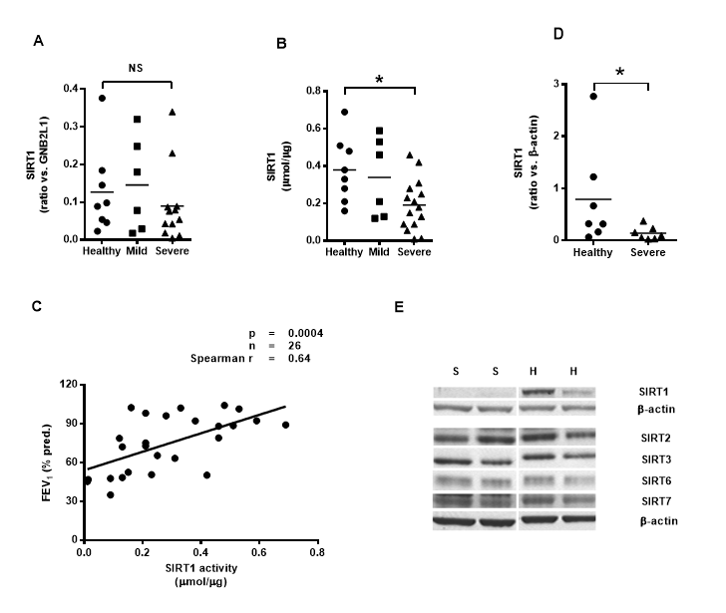

Figure 2
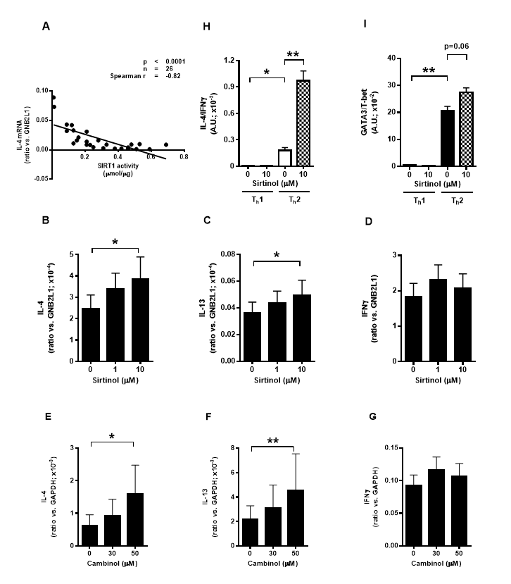

Figure 3
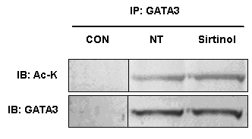

Supplementary Material

Supplementary Methods

Dot blot analysis.

PBMCs from healthy individuals were pre-treated with vehicle or sirtinol (10µM) for 20 minutes before being transferred to media containing immobilised anti-CD3 (5 µg/ml) and anti-CD28 (0.5 µg/ml) for 7 days. PBMCs were then transferred to fresh media for 48 hours after which they were stimulated with PMA (10 ng/ml) and ionomycin (0.5μM). After 24 hours, cell culture supernatants were removed and the Human cytokine array Panel A (R&D systems, Minneapolis, MN) was used to quantify the expression of 36 cytokines according to the manufacturers instructions.

Figure E1. Sirtuin protein expression in severe asthma. Protein expression was quantified by western blot (healthy individuals [7], severe asthmatics [8]). A, SIRT2. B, SIRT3. C, SIRT6. D, SIRT7. *=p<0.05.

Figure E2. The effect of sirtuin inhibition on cytokine and chemokine production. A, dot blot membrane; B, protein layout of dot-blot membrane; C, expression of T_{h}1 associated proteins; D, expression of T_{h}2 associated proteins. Error bars represent the SEM. [n=3]. * = p<0.05.

Figure E1

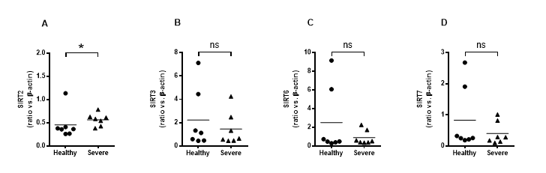

Figure E2
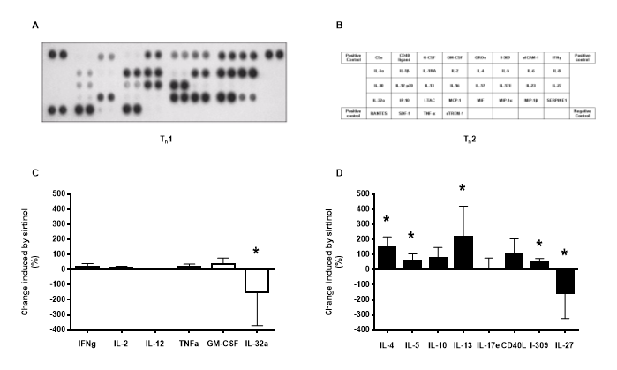

Table E1 Characterisation of subjects (all subjects were non-smokers), Cohort 1

 | Healthy Volunteers | Mild asthma | Severe asthma
N (M/F) | 8 (6/2) | 6 (3/3) | 16 (5/11)
Age (yrs) | 35.7 ± 1.7 | 41.5 ± 3.3 | 35.1 ± 2.6
FEV₁ (% predicted) | 96.4 ± 2.2 | 84.5 ± 4.6 * | 55.0 ± 3.4 † ***
Atopy | 1/10 | 6/6 | 7/16
OCS | N/A | 0/6 | 11/16
ICS | N/A | 0/6 | 14/16

N/A: not applicable
FEV₁: forced expiratory volume
OCS: oral corticosteroids
ICS: inhaled corticosteroids
* p<0.05 compared to healthy volunteers
† p<0.001 compared to mild asthma
*** p<0.0001 compared to healthy volunteers

Table E2 Characterisation of subjects (all subjects were non-smokers), Cohort 2
 | Healthy Volunteers | Severe asthma
N (M/F) | 7 (1/6) | 7 (3/4)
Age (yrs) | 54.6 ± 2.6 | 45.7 ± 5.3
FEV₁ (% predicted) | 90.7 ± 3.45 | 76 ± 5.64 *
FEV₁/FVC | 0.80 ± 0.02 | 0.68 ± 0.03 *
Atopy | 1/8 | 7/7
OCS | N/A | 6/7
ICS: FP  BDP | N/A  N/A | 6/7  1/7

N/A: not applicable
FEV₁: forced expiratory volume
FVC: forced vital capacity
OCS: oral corticosteroids
ICS: inhaled corticosteroids
FP: fluticasone propionate
BDP: beclomethasone dipropionate
* p<0.05 compared to healthy volunteers

