***Supplementary Information-***

***SI1 An overview of ecosystem services categories***

Ecosystem services are often classified into four groups namely supporting, regulating, provisioning and cultural services as used by the Millennium Ecosystem Assessment (MA) (MillenniumEcosystemAssessment, 2005). Recently the Common International Classification of Ecosystem Services (CICES) (Haines-Young & Potschin, 2012) has been developed to support work on environmental accounting within the European Union and the United Nations Statistical Division (European Commission. et al., 2014; European Commission. et al., 2013). A major difference between the MA and CICES classification is that the latter omits supporting services (e.g. nutrient cycling) that are taken as intermediate steps in the delivery of final services (Haines-Young & Potschin, 2012). Examples of key ecosystem services and the classes that they fall within are provided in Table S1.

Within the main text we consider synthetic measures of two ecosystem services indicators which underpin the provision of a range of services. In the first case study soil quality (used as a term that captures features such as carbon, soil structure, microbial community etc.) is considered due to the strong link between this and services such as climate and hazard regulation (see (Holland et al., 2015)). In the second case study biodiversity is considered given its central role in underpinning other ecosystem services (Mace et al., 2012).

**Table S1: Example of ecosystem services and broad categorisation based on the UK National Ecosystem Assessment (UKNEA, 2011).** Supporting services can be considered as underpinning the other three categories and so may not be considered in separately in assessments.

|  |  |  |  |
| --- | --- | --- | --- |
| **Provisioning ES** | **Regulating ES** | **Supporting ES** | **Cultural ES** |
| Crops | Climate | Primary production | Environmental Settings |
| Livestock | Disease and pest | Water cycling | Wild species diversity |
| Fish | Water purification | Soil formation |  |
| Trees and standing vegetation | Air purification | Nutrient cycling |  |
| Peat | Soil purification |  |  |
| Water Supply | Pollination |  |  |
| Wild species diversity | Hazard regulation |  |  |
|  | Noise regulation |  |  |

***SI2 UK livestock overview and case study assumptions***

The livestock sector is a complex system. The total population is dominated by cattle, sheep, lamb, pig and poultry in the UK; share of goats, farmed deer and horses are negligible. According to the statistics (1985-2014), overall more than 70% of UK domestic supply of animal products is met by home-fed production. The UK cattle populations varied between 9.84 and 13.03 million heads between 1985 to 2014 (DEFRA, 2015a). This equates to 3.39-3.75 million beef and dairy breeding herds plus 0.77-0.92 million other above 2-year old female cattle (not breeding) and 2.87-3.09 million younger female herds (<2 years) as well as 2.74-3.03 million male cattle (Fig S1). For sheep about 31.1-44.6 million head partition into almost equally into breeding and non-breeding flocks (based on statistics from 1985-2014) (DEFRA, 2015d). Whereas pig population ranging between 4.4-8.1 million during 1985-2014 is dominated by fattening pig, accounting for 87.7%-89.6% of total population. During the period of 1985-2014, out of 121.9-181.8 million poultry population, table chicken i.e. broilers accounts for 51%-65%; remaining population include a small fraction of other poultry (1.9-18.5 million, e.g. ducks, geese, turkey) and 42.7-58.4 million fowls for laying and breeding where 76%-89% is hens and pullets raised for egg production purposes (DEFRA, 2015d),

The majority of ruminant livestock utilise grassland for much of the year. Typically, dairy and breeding cattle are housed for approximately 24 weeks over the winter period while sheep are housed on average for six weeks over the lambing period (Jerram et al., 2001). Whereas the demand for fodder fed i.e. composite animal feed in the UK is dominated by cattle (especially dairy cows), and poultry (Fig S2). Cereal and their by-products together with soya/oilseed rape cake and meal dominate the raw material supply for UK compound feed; cereal (especially wheat) accounts for approximately 40% of total animal compound feed and 60% of integrated poultry feed.

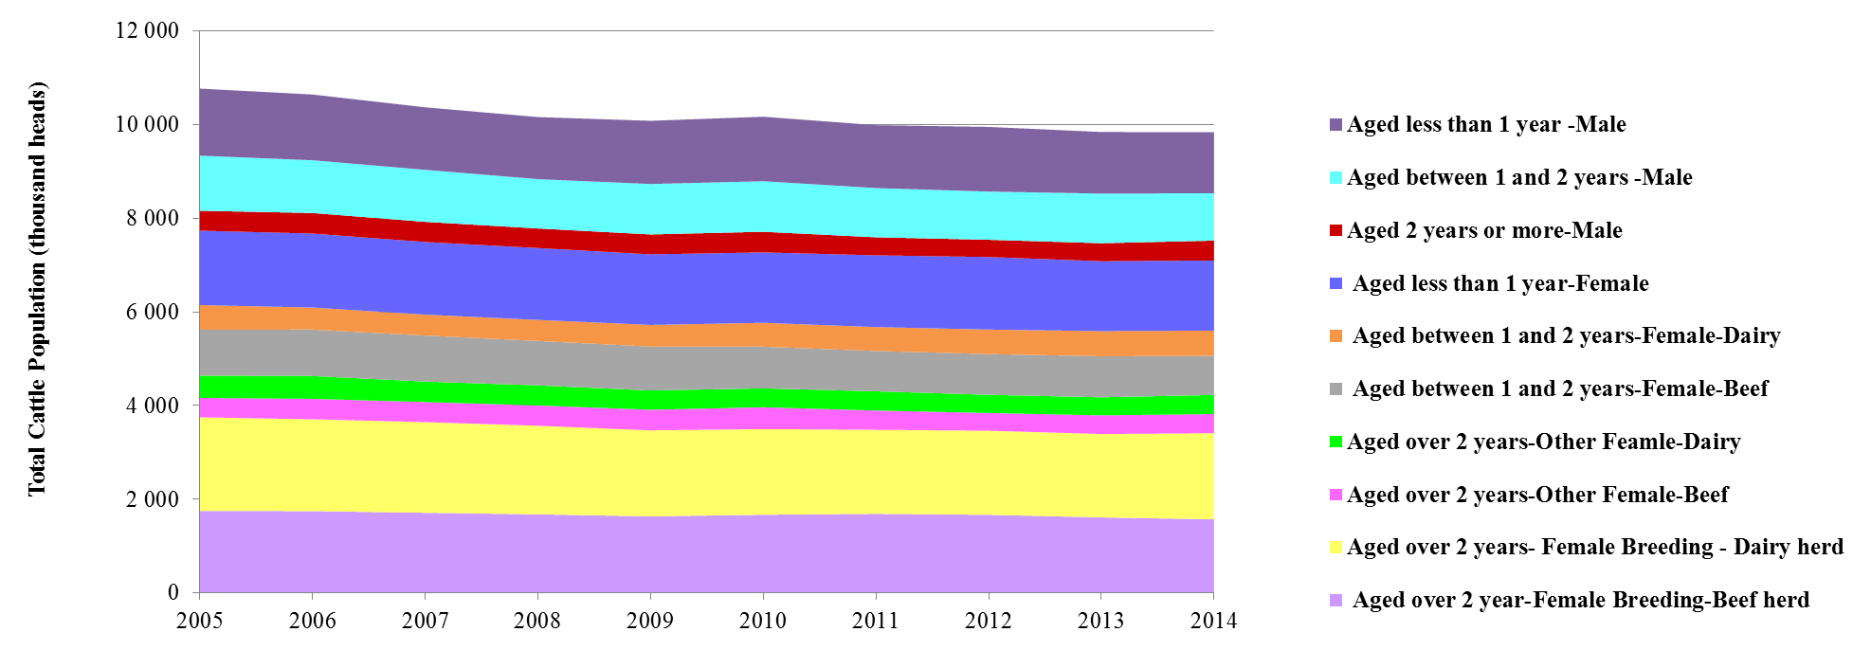

**Figure S1 Cattle population in the UK (DEFRA, 2015d)**

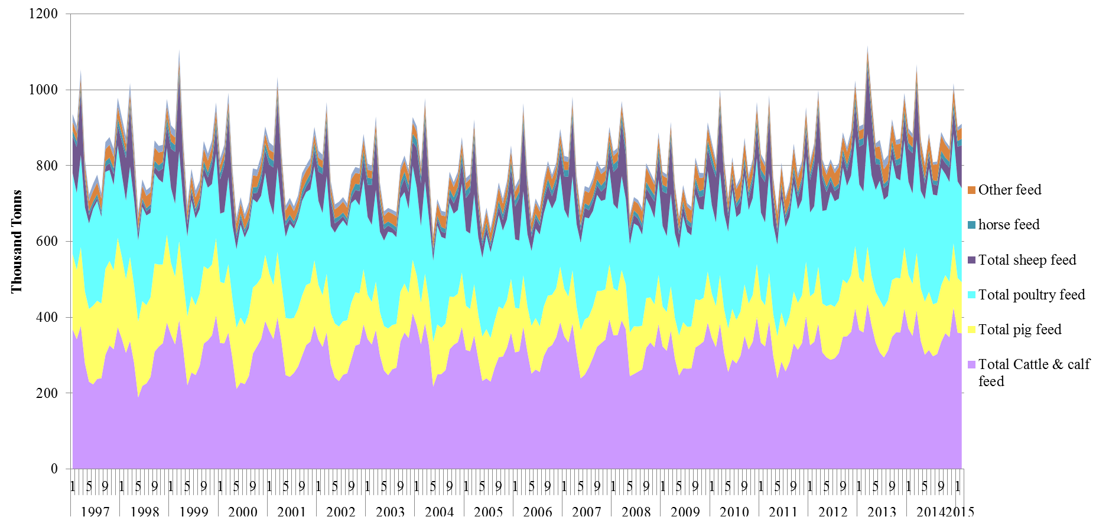

**A**

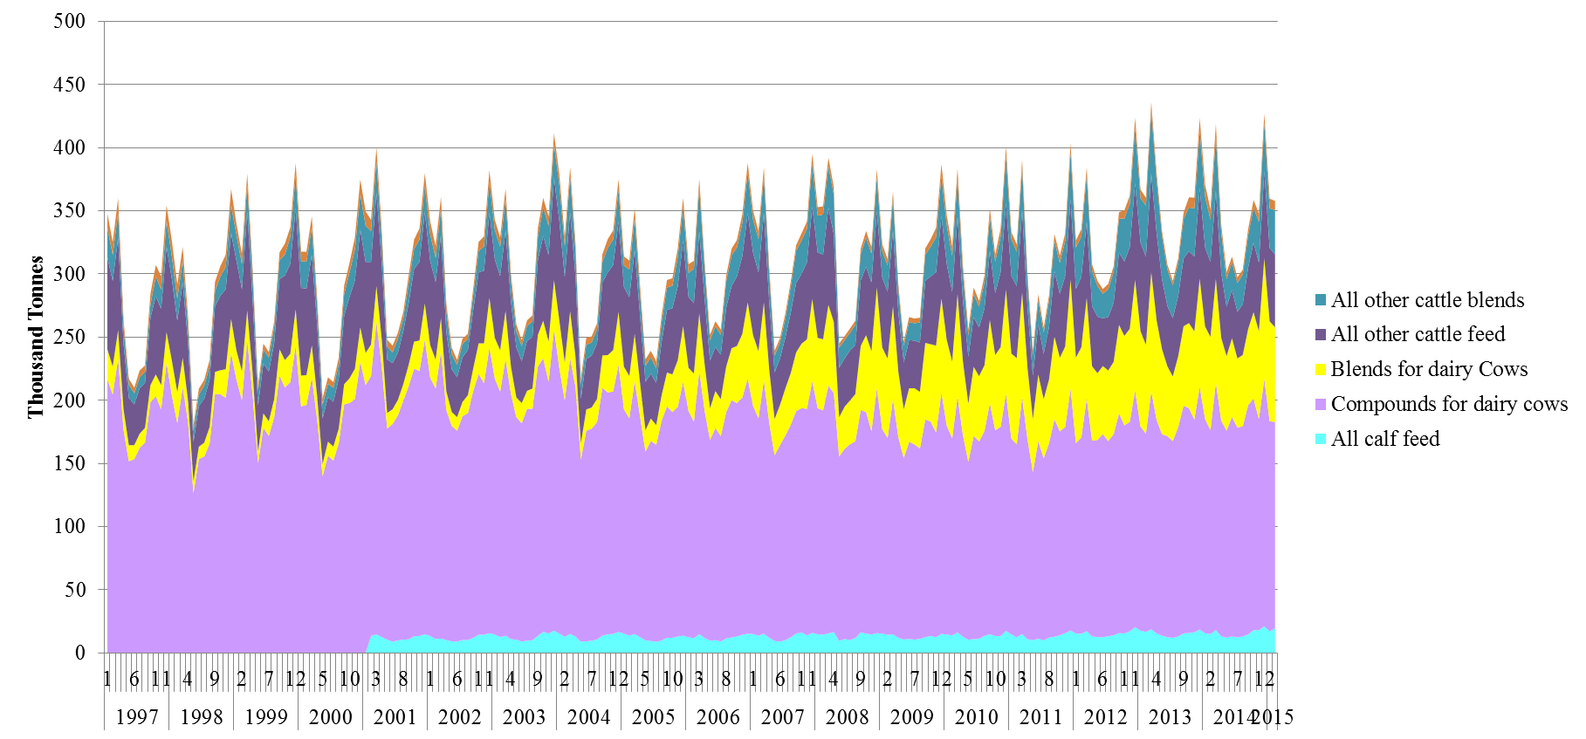

**B**

**Figure S2 Production of compound animal feed by livestock categories (A) and by cattle population (B) (Defra, 2015c)**

In the UK 100% of milk supply was met by domestic production. Total dairy population can be classified into three types - 1) cows at grass 2) composite category and 3) high-output cows (AHDB, 2014). Based on the average milk yield and dairy cattle population for each classification investigated in the DairyCo’s survey, the weighted average milk yield for the entire UK dairy system is estimated as 7472 L/LU/y, (close to the data reported in 2012 statistics 7477L/LU/y)(DEFRA, 2015a). Thus it is assumed that the proportion of three dairy farm classification in DairyCo’s Milkbench+ Evidence Report (AHDB, 2014) is representative of the UK dairy industry structure. The average housing period for UK dairy cattle population accounts for 50% of a year (AHDB, 2014, 2015; NaturalEngland, 2009); on average, the dairy consumption of compound & blends feed accounts for 27% of total UK processed feeding (8.8-10.7 million ton from 1997-2014) (Defra, 2015b).

All forage-fed livestock groups with different species and ages are converted to a consistent reference unit LU to estimate stocking rate. The derived stocking rates vary significantly with type of land quality, livestock type, temporal and spatial pattern of grazing regimes. For instance, in Wales regardless of age classes, stocking rate vary for beef (<0.1 to > 0.3 LU), dairy (<0.1 to >0.8 LU) and sheep (<0.2 to >0.8 LU/ha)(HCC, 2014). An overview of the average stocking rate linked to each land category is given below –

* Rotational grassland category - currently about 1.357 million hectare (~ 5% of the UK land area) are covered with such highly productive grass leys which can sustain the current herds in full lactation of beef fattening with stocking rate of 2.5 LU per hectare(NaturalEngland, 2009).
* Permanent grassland category - this comprises about 5.8 million hectares in the UK and is mainly allocated to younger cattle and high productivity sheep. The average stocking rate for this land category is assumed as 2 LU/ha (NaturalEngland, 2009).
* Rough grazing grassland areas fall into two groups of land, i.e. 1.2 million ha of “common rough grazing” and 3.9 million ha “sole right rough grazing” which are hills, heathland and moorlands (Statista, 2014). The stocking rates of these areas vary greatly between and within grassland categories, lowland (0.2 – 0.5 LU/ha) and upland (0.05 to 0.75 LU/ha). An average stocking rate of 0.25 LU/ha is assumed for this land category (Jerram et al., 2001).
* Woodland category - the primary aims of England and Scotland woodlands differ, the former prioritise nature conservation whereas the latter emphasize more on production. The average stocking rate (0.1 LU/ha) recommended for biodiversity grazing by cattle to meet nature conservation objective is adopted in this study (Armstrong et al., 2003).

***References***

AHDB. (2014). Dairy Statistics An Insider Guide 2014. In. Agriculture and Horticulture Development Board Diary.

AHDB. (2015). UK Yearbook 2015 Cattle. In. Agriculture and Horticulture Development Board Beef and Lamb.

Armstrong, H. M., Poulsom, L., Connolly, T., & Peace, A. (2003). A survey of cattle-grazed woodlands in Britain. In: UK Forest Research.

DEFRA. (2015a). Agriculture in the United Kingdom data sets. In: Department for Environment, Food & Rural Affairs.

Defra. (2015b). Animal Feed Production Statistics. In. Department for Environment, Food & Rural Affairs.

Defra. (2015c). Latest animal feed production statistics. In: Department for Environment, Food & Rural Affairs.

DEFRA. (2015d). Structure of the agricultural industry. In. Department for Environment, Food & Rural Affairs UK.

European Commission., Eurostat., United Nations., Food and Agriculture Organization of the United Nations., International Monetary Fund., Organisation for Economic Co-operation and Development., & Bank, W. (2014). System of Environmental-Economic Accounting 2012 Central Framework. In. New York; [Luxembourg]: UNO ; [Publications Office].

European Commission., Organisation for Economic Co-operation and Development., United Nations., & Bank., W. (2013). System of Environmental-Economic Accounting 2012. Experimental-Economic Accounting. In. White cover publication.

Haines-Young, R., & Potschin, M. (2012). CICES Version 4: Response to Consultation. In. Centre for Environmental Management, University of Nottingham.

HCC. (2014). Little Book of Meat Facts 2014. In. Hybu Cig Cymru.

Holland, R. A., Eigenbrod, F., Muggeridge, A., Brown, G., Clarke, D., & Taylor, G. (2015). A synthesis of the ecosystem services impact of second generation bioenergy crop production. Renewable and Sustainable Energy Reviews*,* 46, 30-40.

Jerram, R., Jefferson, R., & Backshall, J. (2001). Chapter 7 Meadows And Enclosed Pasture In The upland management handbook. Natural England

Mace, G. M., Norris, K., & Fitter, A. H. (2012). Biodiversity and ecosystem services: a multilayered relationship. Trends in Ecology & Evolution*,* 27, 19-26.

MillenniumEcosystemAssessment. (2005). Ecosystems and Human Well-being: Synthesis. In. Island Press, Washington, DC.

NaturalEngland. (2009). Environmental impacts of land management. In Natural England Research Report NERR030. Natural England.

Statista. (2014). Common rough grazing land area in the United Kingdom In.

UKNEA. (2011). UK National Ecosystem Assessment. In. UK National Ecosystem Assessment.