**Combined Cr and Mo Poisoning of (La,Sr)(Co,Fe)O3-δ**

**Solid Oxide Fuel Cell Cathodes at the Nanoscale**

Na Ni*, Stephen Skinner

Imperial College London, Exhibition road, SW7 2AZ London UK

* n.ni@imperial.ac.uk

Cr poisoning has been identified as a critical issue for solid oxide fuel cell (SOFC) cathodes degradation when metallic alloys are used for intermediate temperature SOFCs. In additon, Mo is also a common alloying element in ferritic stainless steel or Ni based alloys considered as interconnect materials and molybdenum trioxide is very volatile, raising concerns on Mo poisoning to the cathodes. In this work, the intrinsic reactivity of Cr with a porous (La0.6Sr0.4)0.95(Co0.2Fe0.8)O3-δ cathode (LSCF6428) with and without the presence of Mo was investigated by transmission electron microscopy (TEM) in order to reveal the nanoscale incorporation and evolution behavior of Cr and/or Mo in LSCF. Cr incorporation was identified with formation of Cr containing phases including chromium oxide and SrCrOx with sizes of as small as ~100 nm, suggesting that the poisoning can take effect with subtle changes at the very small scale. Co-poisoning of Mo with Cr significantly changes the pattern of Cr behaviour. CrCo2Fe3Ox spinel becomes the main reaction product in addition to chromium oxide as a result of Sr reacting preferentially with Mo to form SrMrO4. The LSCF grain boundary was found to be rich in Cr and deficient in Co. These results suggest that potential Mo poisoning effects should be considered when developing metallic interconnects containing Mo.

Keywords: Solid oxide fuel cells; cathodes; [Lanthanum strontium cobalt ferrite](https://en.wikipedia.org/wiki/Lanthanum_strontium_cobalt_ferrite) (LSCF); Cr poisoning; Transmission electron microscopy (TEM)

1. **Introduction**

(La,Sr)(Co,Fe)O3-δ (LSCF) perovskite oxides have been considered to be a promising cathode material for SOFCs operating in the intermediate temperature range due to their significantly higher electrochemical activity for the O2 reduction reaction and higher oxygen ion conductivity than the conventional (La,Sr)MnO3 (LSM) cathode [1, 2]. In practice, metallic materials have become a preferential choice for the interconnect due to their excellent physical and chemical properties. However the presence of chromium in all commonly used metallic alloys has been found to cause poisoning of the cathode under operating conditions leading to rapid electrochemical performance degradation of the cathodes including LSCF [3-5]. Apart from Cr, Mo is also a common alloying element in ferritic stainless steel or Ni based alloys considered as interconnect materials [6, 7]. Molybdenum trioxide is very volatile with a high vapor pressure of ~ 6x10-1 Pa at 600˚C [8]. It has been shown that the evaporation of Mo volatile species occurred in an Fe based alloy containing > 4 wt% Mo [6]. Therefore, potential Mo poisoning in LSCF cathodes as a result of Mo deposition via surface or gas phase diffusion should be considered.

Development of a poisoning tolerant cathode material for increased long-term durability of SOFCs relies on a fundamental understanding of the mechanism of the chromium deposition and poisoning of the cathode materials. So far, no study on the interaction of Mo with LSCF cathodes has been reported, and careful microstructural studies of SOFC cathodes poisoning, especially on the nanometer to atomic scale, are very limited. This however can give valuable information on the detailed process of interaction between the poisoning species and the cathode materials, providing an important insight for mechanistic understanding of poisoning. In this work, the intrinsic reactivity of Cr with a porous (La0.6Sr0.4)0.95(Co0.2Fe0.8)O3-δ cathode (LSCF6428) with and without the presence of Mo was investigated by transmission electron microscopy (TEM) in order to reveal the nanoscale incorporation and evolution behavior of Cr and/or Mo in LSCF.

1. **Experimental**

Symmetrical cells with LSCF6428 on a Ce0.9Gd0.1O2−x (CGO) electrolyte were prepared. CGO pellets with dimensions of 20 mm in diameter and 2 mm in thickness were obtained from CGO powder (99.9%, PiKem, Surrey, UK) by uniaxially pressing at 2MPa for 20s followed by isostatic pressing at 400 MPa for 30s. The samples were sintered at 1400°Cfor 5 hrs in air with a heating rate and a cooling rate of 5°C min−1. A LSCF6428 ink (Fuel Cell Materials, Lewis Center, OH) was screen-printed in symmetrical cell configuration on to both sides of the CGO electrolytes and sintered at 1000 °C for 2 h in air with heating rate and a cooling rate of 5°C min−1. The LSCF thickness was ~ 20 µm as determined by SEM from the cross sections of the samples. The strategy for Cr poisoning adopted in this work was impregnating the LSCF 6428 cathode with a Cr stock solution of 1.22 mol l-1, which was prepared by dissolving Cr(NO3)3.9H2O (99% purity, Sigma-Aldrich Co. LLC, Dorset, UK) in ethanol. The solution was dispensed into the electrode using a brush so as to fully wet the electrode in order to fill the pores and excess solution on the outer surface was removed using a swab. The impregnated sample was then heated at 900°C for 5 hours to allow for any rapid reaction between Cr and LSCF.

Mo contamination was introduced during the heat treatment process using the Mo containing heating element as the Mo source. Cr poisoned sample without Mo contamination were prepared by imbedding samples in LSCF6428 powder with the same nominal composition ((La0.60Sr0.40)0.95(Co0.20Fe0.80)O3-x, Fuel Cell Materials, Lewis Center, OH).

TEM analysis on the nanoscale structure and chemistry was carried out on a JEOL 2100F microscope equipped with an Oxford Instrument EDX detector and a Gatan Image Filter operated at 200 kV. EDX and electron energy loss spectroscopy (EELS) were performed in STEM mode. The STEM probe size used was ~1 nm. TEM foils were prepared from the LSCF porous layer by FIB milling using a Helios NanoLab 600 instrument (2–30 keV Ga+ incident beam energy with currents of 16 pA - 21nA). The specimens were polished at the last stage with first 5 and then 2 keV Ga+ in FIB to reduce the damage caused by the high energy Ga+ beam. To obtain TEM specimens from the porous sample with improved quality from the porous sample, the bulk sample was first infiltrated with a commercial embedding resin (Epon_812 substitute, MNA, DDSA and DMP, Sigma-Aldrich Co. LLC, Dorset, UK) in order to fill the pores so that a more homogenous thinning of the TEM specimen can be achieved.

1. **Results and Discussion**
   1. Cr poisoned sample

Figure 1 shows the annular dark field (ADF) image and a typical STEM-EDX elemental mapping of the sample poisoned by Cr. Co rich locations can be clearly seen. Further EDX and electron diffraction analysis reveals that these Co rich particles also contains Fe and O with a composition of ~ CoFeOx and adopt a CoFe2O4 spinel structure. An example of the particle with its indexed diffraction pattern is shown in Figure 2a. The CoFe2O4 phase was reported only for LSCF poisoned with Cr at cathodic polarization [9] and Co rich micron size phase was reported after annealing at 800°C for 96 hours [10]. Cr rich locations can be seen predominantly at the pores and surface of the LSCF grains. These regions were identified by EDX as either CrOx or SrCrOx. Compared to CrOx,SrCrOx particles have better defined morphology (arrowed in the map). Electron diffraction confirms that SrCrOx particles have a structure matching the monoclinic SrCrO4 (Figure 2b). These two main phases have been reported previously [9-11], but the grain sizes observed here are mostly ~100-200 nm and up to ~500 nm, much smaller than those found in other studies.

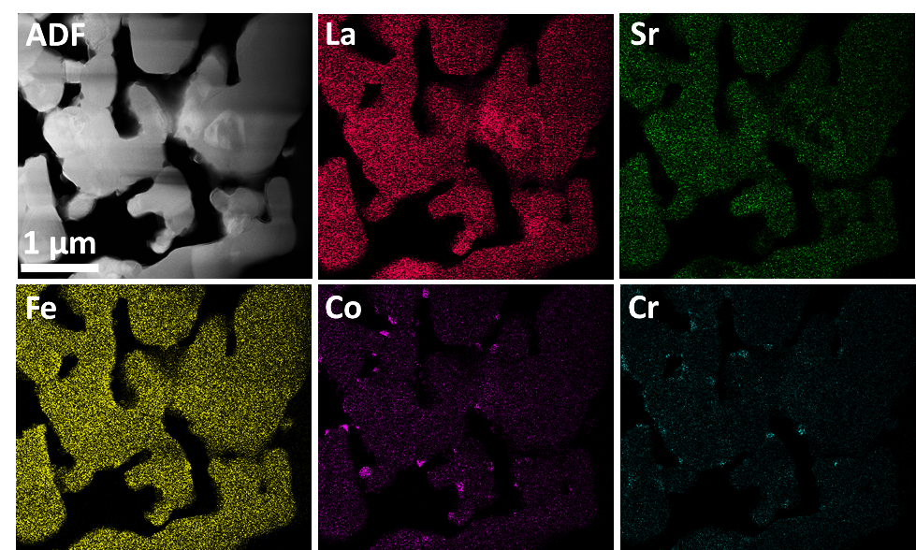

Figure 1 A typical STEM-EDX mapping of the Cr poisoned LSCF sample.

 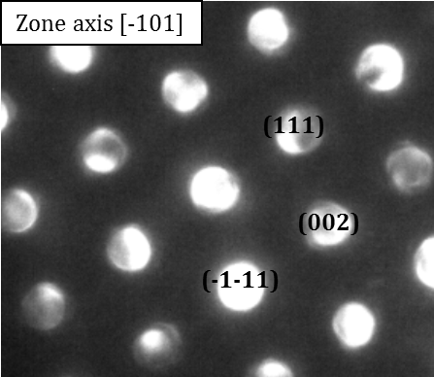

**(a)**

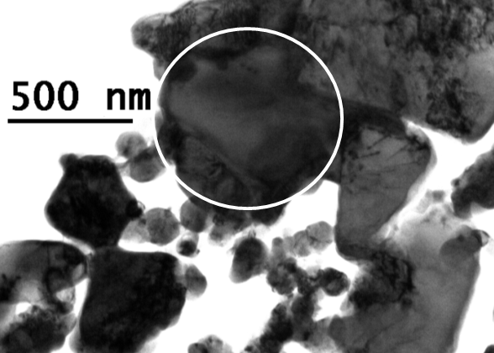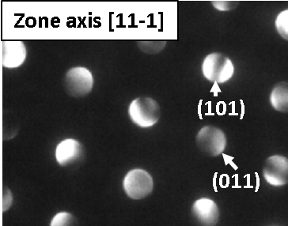

**(b)**

Figure 2 (a) Bright field image of a CoFeOx grain with indexed micro-diffraction pattern confirming the spinel structure. (b) Bright field image of a big SrCrOx grain with indexed micro-diffraction pattern confirming the monoclinic structure.

* 1. Cr poisoned sample with Mo co-contamination

Figure 3 shows the STEM-EDX mapping of the Cr poisoned sample with the presence of Mo contamination. The presence of Mo was found to significantly alter the Cr poisoning behavior in LSCF. Sr presence is predominantly associated with Mo in the form of SrMoOx (indicated by the solid circle in Figure 3), suggesting higher reactivity of Sr with Mo than with Cr. A degradation of the material conductivity can be expected with the formation of this SrMoOx phase as SrMoO4 is non-conductive with a conductivity of ~ 9x10-5 S cm-1 at 800˚C [12], similar to the SrCrO4 phase resulting from Cr poisoning. In addition to chromium oxide, Cr distribution is seen to strongly correlate with Co in the elemental maps (some are indicated by the dash circle in Figure 3) with Mo co-poisoning. Closer investigation with EDX and electron diffraction reveals these regions are also Fe rich with a composition of ~ CrCo2Fe3Ox spinel phase and a cubic structure reported for CoCr2Sb3O4 [13] (Figure 4). The spinel phase was found to form on the LSCF grain with a preferred orientation and the relationship was identified to be (11-1)spinel//(10-2)LSCF and <110>spinel//<010>LSCF. Cr segregation into the LSCF grain boundary is evident in the Mo contaminated sample and Co appears to be deficient at the same grain boundary (indicated by the arrows in Figure 3). The change of grain boundary chemistry has been shown to significantly influence the grain boundary conductivity in in electrolyte materials such as CGO and Cr segregation was found to decrease the conductivity by 2 orders of magnitude, likely due to the change of space charge region next to the grain boundary core [14]. Similar effect can happen for Cr segregation at LSCF grain boundaries. In addition, it is known that impurities segregated at grain boundaries can have profound effects on the core structure leading to different boundary “complexions” [15], resulting possible decrease in the intrinsic grain boundary conductivity of LSCF.

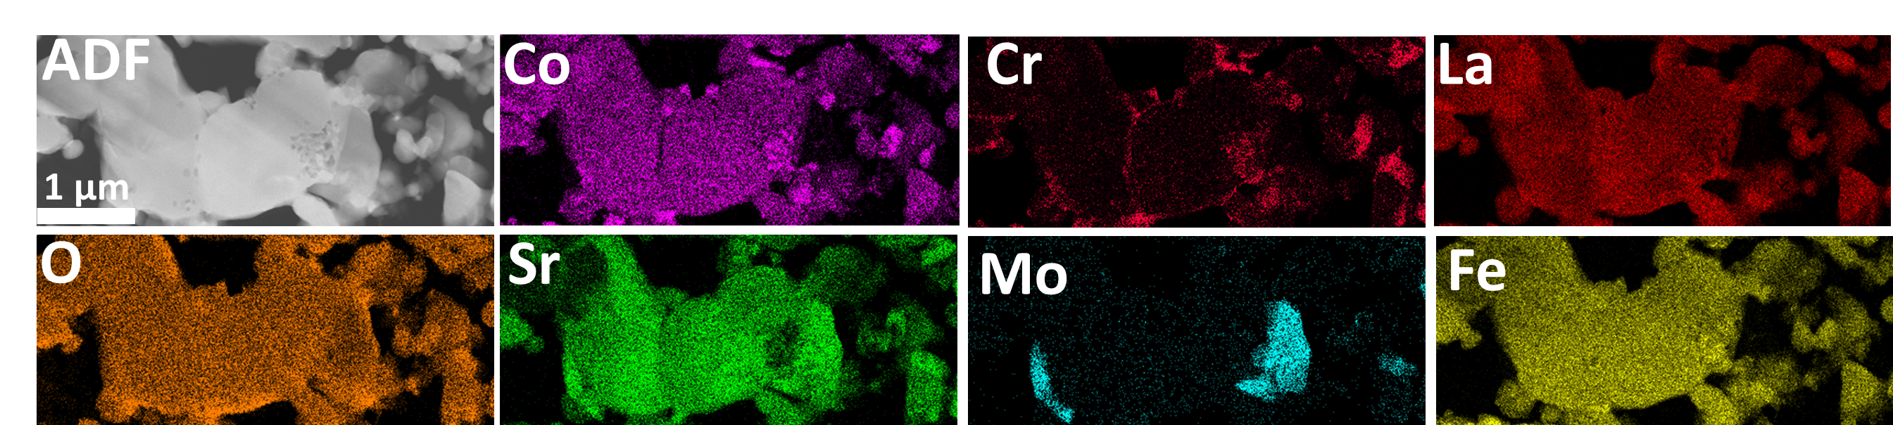

Figure 3 STEM-EDX mapping of Cr poisoned LSCF sample in the presence of Mo contamination.

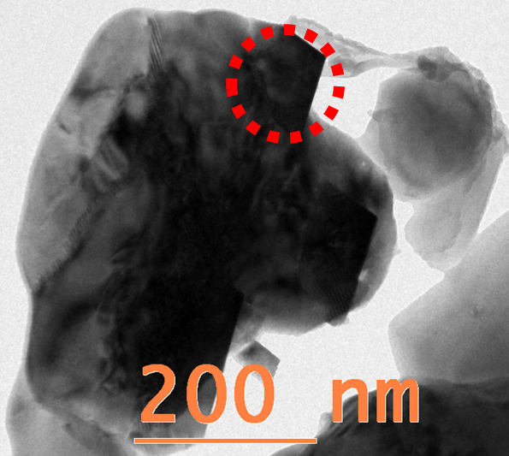 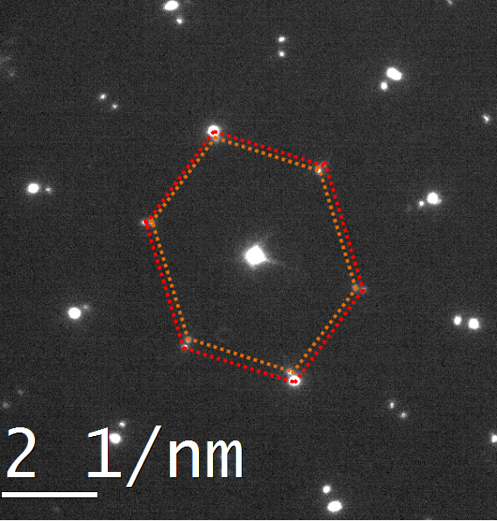 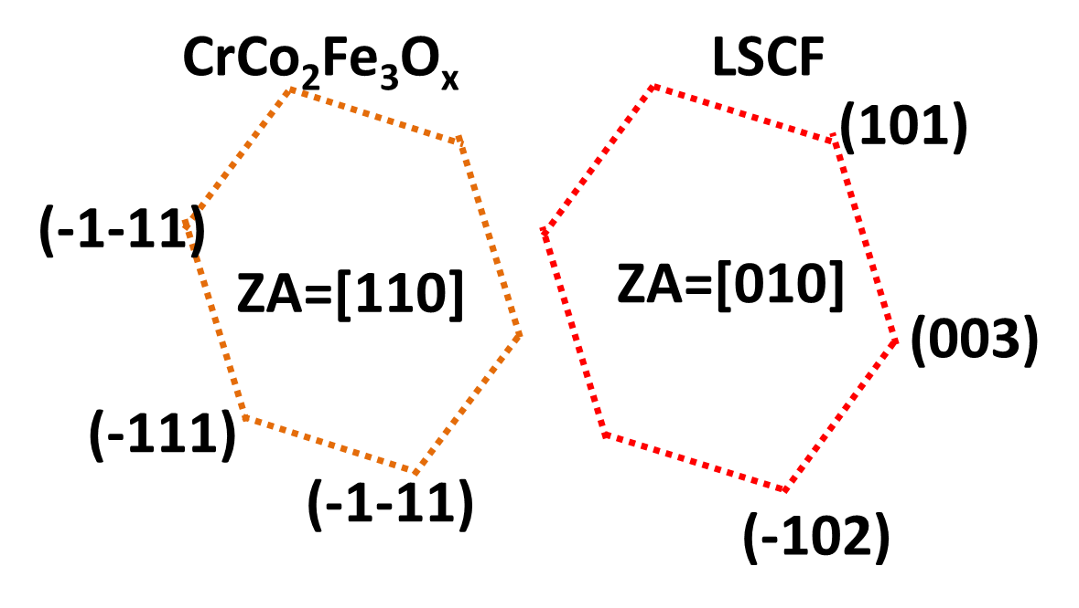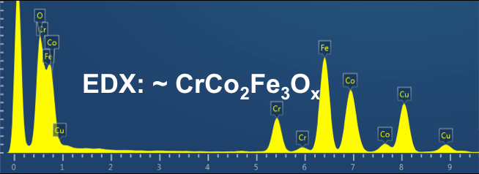

Figure 4 Bright field image of a typical CrCo2Fe3Ox grain (circled), EDX spectrum from the grain and indexed selected area electron diffracion pattern.

1. **Conclusions**

Cr poisoning was carried out by impregnating Cr(NO3)3.9H2O solution into porous LSCF6428 cathodes followed by heat treatment at 900°C for 5 hours. A co-poisoning with Mo was also investigated. The poisoning mechanisms were studied by investigating the intrinsic reactivity of Cr species with the LSCF cathode at naonometre scale using a combination of multiple TEM analyses. Cr incorporation was identified at the nanometer level with formation of Cr containing phases including chromium oxide and SrCrOx with sizes of as small as ~100 nm, different from the micron sizes particles observed in previous studies. This suggests that the poisoning can take effect with subtle changes at the very small scale. Co-poisoning of Mo in addition to Cr significantly changes the pattern of Cr behaviour. CrCo2Fe3Ox spinel becomes the main reaction product in addition to chromium oxide as a result of Sr reacting preferentially with Mo to form SrMrO4. The grain boundary was found to be rich in Cr and deficient in Co. These results suggest that potential poisoning effect of Mo should be considered when developing metallic interconnects containing Mo.

**Acknowledgements**

NN would like to acknowledge the Imperial College London Junior Research Fellowship for funding this work.

**References**

[1] S.P. Jiang, *Solid State Ionics* **146** (2002) (1–2) 1.

[2] A. Esquirol, N.P. Brandon, J.A. Kilner, M. Mogensen, *J. Electrochem. Soc.* **151** (2004) (11) A1847.

[3] M.C. Tucker, H. Kurokawa, C.P. Jacobson, L.C. De Jonghe, S.J. Visco, *J. Power Sources* **160** (2006) (1) 130.

[4] S.P. Jiang, X.B. Chen, *Int. J. Hydrog. Energy* **39** (2014) (1) 505.

[5] S.N. Lee, A. Atkinson, J.A. Kilner, *J. Electrochem. Soc.* **160** (2013) (6) F629.

[6] D.W. Yun, H.S. Seo, J.H. Jun, J.M. Lee, K.Y. Kim, *Int. J. Hydrog. Energy* **37** (2012) (13) 10328.

[7] J. Wu, X. Liu, *Journal of Materials Science & Technology* **26** (2010) (4) 293.

[8] E.A. Gulbransen, K.F. Andrew, F.A. Brassart, *J. Electrochem. Soc.* **110** (1963) (3) 242.

[9] Do-Hyung Cho, Haruo Kishimoto, Katsuhiko Yamaji, Manuel E. Brito, Katherine Develos- Bagarinao, Mina Nishi, Taro Shimonosono, Fangfang Wang, Harumi Yokokawa, T. Horita, *ECS Transactions* **57** (2013) (1) 1865.

[10] L. Zhao, J. Drennan, C. Kong, S. Amarasinghe, S.P. Jiang, *ECS Transactions* **57** (2013) (1) 599.

[11] E. Konysheva, H. Penkalla, E. Wessel, J. Mertens, U. Seeling, L. Singheiser, K. Hilpert, *J. Electrochem. Soc.* **153** (2006) (4) A765.

[12] J.D. Bobić, M.M. Vijatović Petrović, J. Banys, B.D. Stojanović, *Ceramics International* **39** (2013) (7) 8049.

[13] P. Garcia Casado, I. Rasines, *Polyhedron* **5** (1986) 787.

[14] S. Taub, K.S. , Hans-Dieter Wiemhöfer, Na Ni, John A. Kilner, A. Atkinson, *Acta Mater.* **Under review** (2015).

[15] P.R. Cantwell, M. Tang, S.J. Dillon, J. Luo, G.S. Rohrer, M.P. Harmer, *Acta Mater.* **62** (2014) (0) 1.

**Figure captions:**

Figure 1 A typical STEM-EDX mapping of the Cr poisoned LSCF sample.

Figure 2 (a) Bright field image of a CoFeOx grain with indexed micro-diffraction pattern confirming the spinel structure. (b) Bright field image of a big SrCrOx grain with indexed micro-diffraction pattern confirming the monoclinic structure.

Figure 3 STEM-EDX mapping of Cr poisoned LSCF sample in the presence of Mo contamination.

Figure 4 Bright field image of a typical CrCo2Fe3Ox grain (circled), EDX spectrum from the grain and indexed selected area electron diffracion pattern.