Supplementary Information

**Correlation of local structure and diffusion pathways in the modulated anisotropic oxide ion conductor CeNbO4.25**

Stevin S. Pramana,a Tom Baikie,b* Tao An,c Matthew G. Tucker,d,e Ji Wu,a Martin K. Schreyer,f Fengxia Wei,g Ryan D. Bayliss,a† Christian L. Kloc,c Timothy J. White,c Andrew P. Horsfield,a and Stephen J. Skinner.a*

a Department of Materials, Imperial College London, Exhibition Road, London, SW7 2AZ, United Kingdom

b Energy Research Institute @ NTU (ERI@N), Research Technoplaza, Nanyang Technological University, Nanyang Drive, Singapore

c Division of Materials Science and Engineering, Nanyang Technological University, Singapore

d ISIS Facility, Rutherford Appleton Laboratory, Didcot OX11 0QX, United Kingdom

e Diamond Light Source, Chilton, Oxfordshire, OX11 0DE, United Kingdom

f Institute of Chemical and Engineering Sciences, 1 Pesek Road, Jurong Island, Singapore

g Institute of Materials Research and Engineering, 3 Research Link, Singapore

*e-mail: tbaikie@ntu.edu.sg, s.skinner@imperial.ac.uk

† Present address: Department of Chemistry, University of Illinois at Chicago, 845 W. Taylor Street (MC 111), Chicago, Illinois, 60607, USA

Table S1: Refinement details for the single crystal X-ray diffraction of CeNbO4.25.

|  |  |
| --- | --- |
| Crystal size | 0.1 x 0.1 x 0.1 mm |
| Crystal system | Monoclinic |
| Space group | *P*121*/c*1 (no. 14) |
| Temperature | 298 K |
| Unit cell dimensions |  |
| *a* (Å) | 14.3732(8) |
| *b* (Å) | 22.7921(12) |
| *c* (Å) | 11.8319(6) |
| ** (°) | 105.071(2) |
| *V* (Å3) | 3742.8(3) |
| *Z* | 48 |
| Density (g cm-3) | 6.3233 |
| ❍ (cm-1) | 17.903 |
| Radiation | Mo K (0.71069 Å) |
| Collection limits (,°) | 1.47-32.63 |
| Data measured | 67054 |
| Unique reflections | 13566 |
| Reflections with *I* ≥ 3*(I)* | 8604 |
| R | 0.0431 |
| Rw | 0.0945 |
| GOF | 1.79 |
| D residual (e Å-3) |  |
| + | 4.99 |
| - | -3.93 |

Table S2: Refined atomic positions and anisotropic displacement parameters for CeNbO4.25 derived from single crystal X-ray diffraction.

|  |  |  |  |  |
| --- | --- | --- | --- | --- |
| S.G. | *a* = 14.3732(8) Å | *c* = 11.8319(6) Å |  |  |
| *P*121*/c*1 | *b =* 22.7921(12) Å | *β* = 105.071(2)° |  |  |
| **Site** | ***x*** | ***y*** | ***z*** | ***UIso*** |
| **Ce4+(1)** | 0.57897(4) | 0.19103(2) | 0.08329(4) | 0.00732(15) |
| **Ce4+(2)** | 0.00782(3) | 0.56366(2) | 0.21997(5) | 0.00842(14) |
| **Ce4+(3)** | 0.24153(4) | 0.18156(2) | 0.72620(5) | 0.00808(15) |
| **Ce4+(4)** | 0.67083(3) | 0.06018(2) | 0.92400(5) | 0.00721(13) |
| **Ce4+(5)** | 0.07968(4) | 0.18110(2) | 0.10306(5) | 0.00779(14) |
| **Ce4+(6)** | 0.74938(4) | 0.30950(2) | 0.26208(5) | 0.00748(15) |
| **Ce3+(1)** | 0.33392(4) | 0.44052(2) | 0.07097(5) | 0.00745(14) |
| **Ce3+(2)** | 0.92610(4) | 0.19046(2) | 0.43663(5) | 0.00776(15) |
| **Ce3+(3)** | 0.39763(4) | 0.30954(2) | 0.90636(5) | 0.00781(15) |
| **Ce3+(4)** | 0.84596(3) | 0.43614(2) | 0.09445(5) | 0.00809(14) |
| **Ce3+(5)** | 0.51183(3) | 0.93980(2) | 0.74621(4) | 0.00751(14) |
| **Ce3+(6)** | 0.16660(4) | 0.05622(2) | 0.89253(5) | 0.00934(15) |
| **Nb(1)** | 0.16341(6) | 0.30235(3) | 0.91470(7) | 0.0064(2) |
| **Nb(2)** | 0.82815(6) | 0.17678(4) | 0.09658(7) | 0.0076(2) |
| **Nb(3)** | 0.42018(6) | 0.07134(4) | 0.91516(7) | 0.0073(2) |
| **Nb(4)** | 0.31457(6) | 0.18351(3) | 0.05436(7) | 0.0070(2) |
| **Nb(5)** | 0.25436(5) | 0.41821(4) | 0.73843(7) | 0.0076(2) |
| **Nb(6)** | 0.73833(6) | 0.07987(3) | 0.25887(7) | 0.0070(2) |
| **Nb(7)** | 0.91119(6) | 0.57879(4) | 0.91624(7) | 0.0080(2) |
| **Nb(8)** | 0.92051(5) | 0.06947(4) | 0.92922(7) | 0.0082(2) |
| **Nb(9)** | 0.58893(5) | 0.42170(4) | 0.08694(7) | 0.0066(2) |
| **Nb(10)** | 0.49847(6) | 0.32395(3) | 0.24911(7) | 0.0071(2) |
| **Nb(11)** | 0.66191(6) | 0.32133(3) | 0.92317(7) | 0.0067(2) |
| **Nb(12)** | 0.00900(6) | 0.18917(3) | 0.77826(7) | 0.0072(2) |
| **O(1)** | 0.7286(4) | 0.6599(3) | 0.9799(5) | 0.0115(19) |
| **O(2)** | 0.1396(5) | 0.4670(3) | 0.9847(6) | 0.016(2) |
| **O(3)** | 0.8206(4) | 0.0275(3) | 0.9770(5) | 0.0105(19) |
| **O(4)** | 0.0349(4) | 0.5841(3) | 0.0474(5) | 0.0110(19) |
| **O(5)** | 0.4280(4) | 0.2245(3) | 0.0487(6) | 0.012(2) |
| **O(6)** | 0.4327(4) | 0.7300(3) | 0.0534(5) | 0.0104(19) |
| **O(7)** | 0.1043(4) | 0.3380(3) | 0.0468(5) | 0.0110(19) |
| **O(8)** | 0.6827(4) | 0.4708(3) | 0.0617(5) | 0.0109(19) |
| **O(9)** | 0.4841(4) | 0.1011(3) | 0.0615(5) | 0.013(2) |
| **O(10)** | 0.2207(4) | 0.8550(3) | 0.0568(5) | 0.011(2) |
| **O(11)** | 0.9339(4) | 0.7591(3) | 0.0650(5) | 0.0091(19) |
| **O(12)** | 0.6671(4) | 0.9844(3) | 0.0660(5) | 0.0101(19) |
| **O(13)** | 0.1967(4) | 0.1169(3) | 0.0759(5) | 0.013(2) |
| **O(14)** | 0.4481(4) | 0.6115(3) | 0.0673(5) | 0.011(2) |
| **O(15)** | 0.9254(4) | 0.2234(3) | 0.0746(5) | 0.011(2) |
| **O(16)** | 0.7068(4) | 0.3510(3) | 0.0838(5) | 0.012(2) |
| **O(17)** | 0.2254(4) | 0.6130(3) | 0.0880(5) | 0.0105(19) |
| **O(18)** | 0.6952(4) | 0.8697(3) | 0.0771(5) | 0.011(2) |
| **O(19)** | 0.9894(5) | 0.8642(3) | 0.0847(6) | 0.015(2) |
| **O(20)** | 0.4412(5) | 0.8517(3) | 0.0943(6) | 0.014(2) |
| **O(21)** | 0.4714(4) | 0.3579(3) | 0.0962(5) | 0.0104(19) |
| **O(22)** | 0.2468(4) | 0.7305(3) | 0.1016(5) | 0.0100(19) |
| **O(23)** | 0.9578(5) | 0.1063(3) | 0.0948(6) | 0.015(2) |
| **O(24)** | 0.6962(4) | 0.1118(3) | 0.1001(5) | 0.0096(19) |
| **O(25)** | 0.2271(4) | 0.2345(3) | 0.1018(6) | 0.012(2) |
| **O(26)** | 0.5010(4) | 0.4758(3) | 0.1130(5) | 0.0117(19) |
| **O(27)** | 0.7431(4) | 0.7610(3) | 0.1046(5) | 0.0101(19) |
| **O(28)** | 0.7326(4) | 0.2293(3) | 0.1212(5) | 0.0111(19) |
| **O(29)** | 0.6458(4) | 0.5861(3) | 0.1202(5) | 0.0080(18) |
| **O(30)** | 0.9971(4) | 0.9828(3) | 0.1088(6) | 0.015(2) |
| **O(31)** | 0.4814(4) | 0.9751(3) | 0.1182(6) | 0.012(2) |
| **O(32)** | 0.9337(4) | 0.3439(3) | 0.1367(5) | 0.0111(19) |
| **O(33)** | 0.0161(4) | 0.4643(3) | 0.1685(5) | 0.0108(19) |
| **O(34)** | 0.3277(5) | 0.0237(3) | 0.1796(6) | 0.014(2) |
| **O(35)** | 0.9477(4) | 0.6533(3) | 0.1822(5) | 0.0100(19) |
| **O(36)** | 0.2191(4) | 0.4184(3) | 0.1849(6) | 0.015(2) |
| **O(37)** | 0.3745(4) | 0.1460(3) | 0.1990(5) | 0.0104(19) |
| **O(38)** | 0.3477(4) | 0.5258(3) | 0.2094(5) | 0.012(2) |
| **O(39)** | 0.5943(4) | 0.2719(3) | 0.2203(5) | 0.0107(19) |
| **O(40)** | 0.1096(4) | 0.7721(3) | 0.2035(5) | 0.012(2) |
| **O(41)** | 0.7856(4) | 0.6621(3) | 0.2146(5) | 0.012(2) |
| **O(42)** | 0.1593(4) | 0.9065(3) | 0.2159(5) | 0.013(2) |
| **O(43)** | 0.0937(4) | 0.2560(3) | 0.2283(5) | 0.011(2) |
| **O(44)** | 0.3825(4) | 0.6470(3) | 0.2384(5) | 0.0101(19) |
| **O(45)** | 0.6030(4) | 0.8896(3) | 0.2360(6) | 0.012(2) |
| **O(46)** | 0.5980(4) | 0.7742(3) | 0.2357(6) | 0.012(2) |
| **O(47)** | 0.8589(4) | 0.1423(3) | 0.2472(5) | 0.0105(19) |
| **O(48)** | 0.8483(4) | 0.5426(3) | 0.2360(6) | 0.013(2) |
| **O(49)** | 0.8851(5) | 0.8634(3) | 0.2271(6) | 0.022(2) |
| **O(50)** | 0.6331(4) | 0.3911(3) | 0.2472(5) | 0.011(2) |
| **O(51)** | 0.8339(4) | 0.0304(3) | 0.2359(5) | 0.0095(19) |

|  |  |  |  |  |  |  |
| --- | --- | --- | --- | --- | --- | --- |
|  | ***U*11** | ***U*22** | ***U*33** | ***U*12** | ***U*13** | ***U*23** |
| **Ce4+(1)** | 0.0081(2) | 0.0056(2) | 0.0084(3) | -0.00007(17) | 0.00249(19) | -0.00001(18) |
| **Ce4+(2)** | 0.0081(2) | 0.0053(2) | 0.0120(3) | 0.00089(18) | 0.00288(18) | -0.00035(19) |
| **Ce4+(3)** | 0.0093(2) | 0.0054(2) | 0.0097(3) | -0.00092(17) | 0.00289(19) | 0.00044(19) |
| **Ce4+(4)** | 0.0081(2) | 0.0053(2) | 0.0082(2) | -0.00004(18) | 0.00215(17) | -0.00006(18) |
| **Ce4+(5)** | 0.0074(2) | 0.0057(2) | 0.0105(3) | 0.00021(17) | 0.00268(18) | -0.00050(18) |
| **Ce4+(6)** | 0.0077(2) | 0.0058(2) | 0.0089(3) | 0.00088(17) | 0.00209(19) | 0.00024(18) |
| **Ce3+(1)** | 0.0086(2) | 0.0056(2) | 0.0087(2) | -0.00068(18) | 0.00319(17) | -0.00007(18) |
| **Ce3+(2)** | 0.0084(2) | 0.0061(2) | 0.0088(2) | 0.00032(17) | 0.00231(19) | 0.00024(18) |
| **Ce3+(3)** | 0.0088(2) | 0.0055(2) | 0.0097(3) | 0.00072(17) | 0.00350(19) | 0.00003(18) |
| **Ce3+(4)** | 0.0080(2) | 0.0061(2) | 0.0103(3) | 0.00011(18) | 0.00254(19) | 0.00058(19) |
| **Ce3+(5)** | 0.0085(2) | 0.0059(2) | 0.0086(2) | -0.00010(18) | 0.00296(18) | -0.00034(18) |
| **Ce3+(6)** | 0.0105(2) | 0.0057(2) | 0.0120(3) | -0.00033(18) | 0.00310(19) | 0.00140(18) |
| **Nb(1)** | 0.0066(3) | 0.0047(3) | 0.0086(4) | -0.0003(3) | 0.0030(3) | -0.0003(3) |
| **Nb(2)** | 0.0074(3) | 0.0085(3) | 0.0072(4) | -0.0001(3) | 0.0023(3) | 0.0010(3) |
| **Nb(3)** | 0.0083(3) | 0.0073(4) | 0.0069(4) | 0.0010(3) | 0.0031(3) | 0.0001(3) |
| **Nb(4)** | 0.0074(3) | 0.0060(3) | 0.0083(4) | 0.0002(3) | 0.0033(3) | -0.0002(3) |
| **Nb(5)** | 0.0073(3) | 0.0069(4) | 0.0087(4) | -0.0013(3) | 0.0024(3) | 0.0009(3) |
| **Nb(6)** | 0.0074(3) | 0.0063(4) | 0.0081(4) | 0.0001(3) | 0.0034(3) | 0.0003(3) |
| **Nb(7)** | 0.0081(3) | 0.0059(4) | 0.0101(4) | 0.0014(3) | 0.0025(3) | -0.0014(3) |
| **Nb(8)** | 0.0082(3) | 0.0086(4) | 0.0085(4) | -0.0017(3) | 0.0036(3) | -0.0006(3) |
| **Nb(9)** | 0.0077(3) | 0.0060(4) | 0.0068(4) | -0.0002(3) | 0.0029(3) | 0.0000(3) |
| **Nb(10)** | 0.0076(3) | 0.0064(3) | 0.0081(4) | 0.0001(3) | 0.0036(3) | 0.0000(3) |
| **Nb(11)** | 0.0069(3) | 0.0057(3) | 0.0084(4) | -0.0001(3) | 0.0034(3) | -0.0003(3) |
| **Nb(12)** | 0.0069(3) | 0.0063(3) | 0.0092(4) | -0.0005(3) | 0.0033(3) | -0.0011(3) |
| **O(1)** | 0.012(3) | 0.011(3) | 0.013(3) | -0.001(2) | 0.005(3) | -0.002(2) |
| **O(2)** | 0.022(3) | 0.011(3) | 0.020(4) | -0.001(3) | 0.012(3) | 0.005(3) |
| **O(3)** | 0.011(3) | 0.011(3) | 0.012(3) | 0.001(2) | 0.006(2) | 0.005(2) |
| **O(4)** | 0.009(3) | 0.010(3) | 0.011(3) | -0.003(2) | -0.002(2) | -0.001(2) |
| **O(5)** | 0.011(3) | 0.005(3) | 0.018(4) | -0.001(2) | 0.002(3) | 0.001(2) |
| **O(6)** | 0.013(3) | 0.007(3) | 0.010(3) | 0.000(2) | 0.000(3) | 0.000(2) |
| **O(7)** | 0.014(3) | 0.009(3) | 0.009(3) | -0.001(2) | 0.001(2) | -0.006(2) |
| **O(8)** | 0.012(3) | 0.008(3) | 0.014(3) | -0.001(2) | 0.006(3) | -0.004(2) |
| **O(9)** | 0.011(3) | 0.014(3) | 0.013(3) | 0.002(3) | 0.004(3) | -0.001(3) |
| **O(10)** | 0.013(3) | 0.010(3) | 0.011(3) | -0.003(2) | 0.004(3) | 0.000(2) |
| **O(11)** | 0.011(3) | 0.006(3) | 0.011(3) | -0.001(2) | 0.003(2) | -0.002(2) |
| **O(12)** | 0.011(3) | 0.010(3) | 0.010(3) | 0.001(2) | 0.003(2) | 0.002(2) |
| **O(13)** | 0.016(3) | 0.012(3) | 0.012(3) | 0.000(3) | 0.005(3) | -0.001(3) |
| **O(14)** | 0.014(3) | 0.010(3) | 0.012(3) | 0.002(2) | 0.007(3) | 0.000(2) |
| **O(15)** | 0.011(3) | 0.011(3) | 0.014(3) | 0.000(2) | 0.007(3) | 0.001(3) |
| **O(16)** | 0.014(3) | 0.007(3) | 0.014(3) | 0.000(2) | 0.005(3) | 0.000(2) |
| **O(17)** | 0.014(3) | 0.011(3) | 0.007(3) | -0.005(2) | 0.004(2) | 0.000(2) |
| **O(18)** | 0.012(3) | 0.011(3) | 0.012(3) | 0.003(2) | 0.005(3) | -0.003(2) |
| **O(19)** | 0.025(4) | 0.009(3) | 0.010(3) | -0.006(3) | 0.003(3) | 0.003(2) |
| **O(20)** | 0.021(3) | 0.009(3) | 0.014(3) | 0.005(3) | 0.005(3) | 0.000(3) |
| **O(21)** | 0.009(3) | 0.012(3) | 0.010(3) | 0.000(2) | 0.001(2) | 0.001(2) |
| **O(22)** | 0.009(3) | 0.006(3) | 0.016(3) | 0.004(2) | 0.005(3) | -0.001(2) |
| **O(23)** | 0.019(3) | 0.012(3) | 0.013(4) | -0.003(3) | 0.006(3) | -0.001(3) |
| **O(24)** | 0.011(3) | 0.010(3) | 0.007(3) | 0.003(2) | 0.002(2) | -0.001(2) |
| **O(25)** | 0.013(3) | 0.010(3) | 0.015(3) | -0.003(2) | 0.007(3) | -0.001(3) |
| **O(26)** | 0.012(3) | 0.008(3) | 0.015(3) | 0.003(2) | 0.002(3) | 0.004(2) |
| **O(27)** | 0.006(3) | 0.011(3) | 0.013(3) | 0.001(2) | 0.001(2) | -0.006(2) |
| **O(28)** | 0.013(3) | 0.007(3) | 0.013(3) | -0.002(2) | 0.004(3) | -0.001(2) |
| **O(29)** | 0.008(3) | 0.009(3) | 0.006(3) | -0.002(2) | 0.000(2) | -0.001(2) |
| **O(30)** | 0.011(3) | 0.016(3) | 0.020(4) | 0.000(3) | 0.005(3) | -0.002(3) |
| **O(31)** | 0.013(3) | 0.009(3) | 0.015(3) | -0.003(2) | 0.005(3) | 0.001(3) |
| **O(32)** | 0.017(3) | 0.007(3) | 0.008(3) | 0.003(2) | 0.002(3) | -0.001(2) |
| **O(33)** | 0.017(3) | 0.009(3) | 0.007(3) | -0.002(2) | 0.003(2) | 0.001(2) |
| **O(34)** | 0.019(3) | 0.009(3) | 0.014(3) | 0.000(3) | 0.005(3) | -0.007(3) |
| **O(35)** | 0.010(3) | 0.009(3) | 0.012(3) | 0.003(2) | 0.004(2) | 0.002(2) |
| **O(36)** | 0.015(3) | 0.011(3) | 0.015(3) | -0.002(3) | 0.000(3) | -0.004(3) |
| **O(37)** | 0.011(3) | 0.010(3) | 0.012(3) | 0.003(2) | 0.005(2) | 0.004(2) |
| **O(38)** | 0.014(3) | 0.010(3) | 0.013(3) | 0.002(2) | 0.004(3) | 0.000(2) |
| **O(39)** | 0.010(3) | 0.005(3) | 0.016(3) | 0.000(2) | 0.002(3) | 0.001(2) |
| **O(40)** | 0.015(3) | 0.010(3) | 0.015(3) | 0.000(2) | 0.008(3) | -0.005(3) |
| **O(41)** | 0.015(3) | 0.008(3) | 0.015(3) | -0.001(2) | 0.008(3) | 0.005(2) |
| **O(42)** | 0.015(3) | 0.013(3) | 0.011(3) | 0.003(3) | 0.006(3) | -0.002(3) |
| **O(43)** | 0.010(3) | 0.010(3) | 0.014(3) | -0.001(2) | 0.004(3) | -0.004(3) |
| **O(44)** | 0.011(3) | 0.012(3) | 0.007(3) | 0.000(2) | 0.003(2) | 0.000(2) |
| **O(45)** | 0.011(3) | 0.014(3) | 0.013(3) | -0.006(2) | 0.006(3) | -0.001(3) |
| **O(46)** | 0.012(3) | 0.009(3) | 0.015(3) | -0.001(2) | 0.005(3) | 0.001(3) |
| **O(47)** | 0.009(3) | 0.009(3) | 0.014(3) | 0.002(2) | 0.006(3) | -0.001(2) |
| **O(48)** | 0.014(3) | 0.010(3) | 0.017(3) | 0.001(2) | 0.007(3) | 0.000(3) |
| **O(49)** | 0.021(4) | 0.015(4) | 0.037(5) | 0.009(3) | 0.019(3) | 0.017(3) |
| **O(50)** | 0.015(3) | 0.006(3) | 0.012(3) | 0.002(2) | 0.005(3) | 0.001(2) |
| **O(51)** | 0.010(3) | 0.009(3) | 0.011(3) | 0.000(2) | 0.005(2) | -0.003(2) |

Table S3: Selected bond lengths and bond valence sums for CeNbO4..25 (for bond lengths < 3 Å).

|  |  |  |  |
| --- | --- | --- | --- |
| **Ce4+(1) Polyhedron** | **Distance (Å)** | **Ce4+(2) Polyhedron** | **Distance (Å)** |
| Ce4+(1) – O(5) | 2.235(6) | Ce4+(2) – O(2) | 2.859(6) |
| Ce4+(1) – O(6) | 2.396(6) | Ce4+(2) – O(4) | 2.225(7) |
| Ce4+(1) – O(9) | 2.439(6) | Ce4+(2) – O(23) | 2.330(6) |
| Ce4+(1) – O(20) | 2.265(7) | Ce4+(2) – O(30) | 2.753(7) |
| Ce4+(1) – O(24) | 2.442(6) | Ce4+(2) – O(33) | 2.355(6) |
| Ce4+(1) – O(28) | 2.307(6) | Ce4+(2) – O(35) | 2.218(6) |
| Ce4+(1) – O(39) | 2.427(6) | Ce4+(2) – O(47) | 2.578(6) |
| Ce4+(1) – O(44) | 2.271(6) | Ce4+(2) – O(48) | 2.398(7) |
|  |  | Ce4+(2) – O(51) | 2.325(6) |
| **BVS** | 4.08(2) | **BVS** | 3.94(2) |
| **Ce4+(3) Polyhedron** | **Distance (Å)** | **Ce4+(4) Polyhedron** | **Distance (Å)** |
| Ce4+(3) – O(1) | 2.631(7) | Ce4+(4) – O(3) | 2.208(6) |
| Ce4+(3) – O(7) | 2.533(5) | Ce4+(4) – O(10) | 2.457(6) |
| Ce4+(3) – O(18) | 2.551(6) | Ce4+(4) – O(12) | 2.419(6) |
| Ce4+(3) – O(25) | 2.390(6) | Ce4+(4) – O(20) | 2.549(7) |
| Ce4+(3) – O(27) | 2.353(6) | Ce4+(4) – O(24) | 2.338(6) |
| Ce4+(3) – O(36) | 2.334(6) | Ce4+(4) – O(31) | 2.262(6) |
| Ce4+(3) – O(43) | 2.562(6) | Ce4+(4) – O(34) | 2.273(6) |
| Ce4+(3) – O(45) | 2.703(6) | Ce4+(4) – O(50) | 2.304(6) |
| Ce4+(3) – O(46) | 2.450(6) |  |  |
| Ce4+(3) – O(49) | 2.278(8) |  |  |
| **BVS** | 3.72(2) | **BVS** | 4.11(2) |
| **Ce4+(5) Polyhedron** | **Distance (Å)** | **Ce4+(6) Polyhedron** | **Distance (Å)** |
| Ce4+(5) – O(11) | 2.376(6) | Ce4+(6) – O(10) | 2.319(6) |
| Ce4+(3) – O(13) | 2.313(7) | Ce4+(6) – O(16) | 2.246(6) |
| Ce4+(5) – O(15) | 2.361(6) | Ce4+(6) – O(22) | 2.409(6) |
| Ce4+(5) – O(19) | 2.416(6) | Ce4+(6) – O(28) | 2.443(6) |
| Ce4+(5) – O(23) | 2.428(7) | Ce4+(6) – O(39) | 2.318(6) |
| Ce4+(5) – O(25) | 2.448(7) | Ce4+(6) – O(40) | 2.137(6) |
| Ce4+(5) – O(35) | 2.744(7) | Ce4+(6) – O(42) | 2.550(6) |
| Ce4+(5) – O(41) | 2.534(6) | Ce4+(6) – O(50) | 2.476(6) |
| Ce4+(5) – O(43) | 2.236(6) |  |  |
| **BVS** | 3.83(2) | **BVS** | 4.06(3) |
| **Ce3+(1) Polyhedron** | **Distance (Å)** | **Ce3+(2) Polyhedron** | **Distance (Å)** |
| Ce3+(1) – O(1) | 2.475(6) | Ce3+(2) – O(4) | 2.485(6) |
| Ce3+(1) – O(2) | 2.780(6) | Ce3+(2) – O(7) | 2.635(6) |
| Ce3+(1) – O(8) | 2.532(6) | Ce3+(2) – O(11) | 2.553(6) |
| Ce3+(1) – O(21) | 2.689(6) | Ce3+(2) – O(15) | 2.555(6) |
| Ce3+(1) – O(26) | 2.458(6) | Ce3+(2) – O(17) | 2.759(6) |
| Ce3+(1) – O(29) | 2.431(6) | Ce3+(2) – O(22) | 2.574(6) |
| Ce3+(1) – O(36) | 2.440(7) | Ce3+(2) – O(32) | 2.468(6) |
| Ce3+(1) – O(38) | 2.516(6) | Ce3+(2) – O(35) | 2.705(7) |
| Ce3+(1) – O(45) | 2.512(6) | Ce3+(2) – O(40) | 2.457(6) |
|  |  | Ce3+(2) – O(47) | 2.457(6) |
| **BVS** | 2.801(16) | **BVS** | 2.870(15) |
| **Ce3+(3) Polyhedron** | **Distance (Å)** | **Ce3+(4) Polyhedron** | **Distance (Å)** |
| Ce3+(3) – O(1) | 2.618(7) | Ce3+(4) – O(2) | 2.427(7) |
| Ce3+(3) – O(5) | 2.530(6) | Ce3+(4) – O(4) | 2.731(7) |
| Ce3+(3) – O(6) | 2.527(6) | Ce3+(4) – O(8) | 2.409(6) |
| Ce3+(3) – O(14) | 2.810(6) | Ce3+(4) – O(16) | 2.766(6) |
| Ce3+(3) – O(21) | 2.480(6) | Ce3+(4) – O(17) | 2.411(6) |
| Ce3+(3) – O(27) | 2.562(6) | Ce3+(4) – O(32) | 2.436(6) |
| Ce3+(3) – O(29) | 2.459(6) | Ce3+(4) – O(33) | 2.459(6) |
| Ce3+(3) – O(37) | 2.595(6) | Ce3+(4) – O(42) | 2.363(7) |
| Ce3+(3) – O(41) | 2.728(6) | Ce3+(4) – O(48) | 2.943(6) |
| Ce3+(3) – O(46) | 2.554(6) |  |  |
| **BVS** | 2.710(15) | **BVS** | 2.919(18) |
| **Ce3+(5) Polyhedron** | **Distance (Å)** | **Ce3+(6) Polyhedron** | **Distance (Å)** |
| Ce3+(5) – O(9) | 2.445(7) | Ce3+(6) – O(3) | 2.432(6) |
| Ce3+(5) – O(14) | 2.383(6) | Ce3+(6) – O(12) | 2.491(6) |
| Ce3+(5) – O(26) | 2.466(6) | Ce3+(6) – O(13) | 2.514(6) |
| Ce3+(5) – O(29) | 2.788(6) | Ce3+(6) – O(18) | 2.560(6) |
| Ce3+(5) – O(31) | 2.502(6) | Ce3+(6) – O(19) | 2.950(7) |
| Ce3+(5) – O(34) | 2.394(6) | Ce3+(6) – O(30) | 2.512(7) |
| Ce3+(5) – O(37) | 2.522(6) | Ce3+(6) – O(33) | 2.990(5) |
| Ce3+(5) – O(38) | 2.415(6) | Ce3+(6) – O(36) | 2.811(7) |
| Ce3+(5) – O(44) | 2.699(6) | Ce3+(6) – O(49) | 2.316(7) |
|  |  | Ce3+(6) – O(51) | 2.490(6) |
| **BVS** | 3.036(18) | **BVS** | 2.863(17) |
| **Nb(1) Polyhedron** | **Distance (Å)** | **Nb(2) Polyhedron** | **Distance (Å)** |
| Nb(1) – O(1) | 1.923(6) | Nb(2) – O(10) | 1.910(6) |
| Nb(1) – O(7) | 2.125(7) | Nb(2) – O(15) | 1.827(7) |
| Nb(1) – O(11) | 2.038(6) | Nb(2) – O(23) | 2.464(7) |
| Nb(1) – O(25) | 2.660(6) | Nb(2) – O(24) | 2.414(6) |
| Nb(1) – O(27) | 2.026(6) | Nb(2) – O(28) | 1.901(7) |
| Nb(1) – O(35) | 1.984(6) | Nb(2) – O(47) | 1.892(6) |
| Nb(1) – O(41) | 2.029(7) |  |  |
| Nb(1) – O(43) | 2.547(6) |  |  |
| **BVS** | 4.90(3) | **BVS** | 4.88(4) |
| **Nb(3) Polyhedron** | **Distance (Å)** | **Nb(4) Polyhedron** | **Distance (Å)** |
| Nb(3) – O(9) | 1.863(6) | Nb(4) – O(5) | 1.896(6) |
| Nb(3) – O(12) | 1.840(6) | Nb(4) – O(13) | 2.337(7) |
| Nb(3) – O(18) | 2.156(6) | Nb(4) – O(18) | 1.948(6) |
| Nb(3) – O(20) | 2.679(7) | Nb(4) – O(25) | 1.901(7) |
| Nb(3) – O(31) | 1.889(7) | Nb(4) – O(27) | 2.238(6) |
| Nb(3) – O(45) | 1.947(6) | Nb(4) – O(37) | 1.906(6) |
| **BVS** | 5.03(4) | **BVS** | 4.78(4) |
| **Nb(5) Polyhedron** | **Distance (Å)** | **Nb(6) Polyhedron** | **Distance (Å)** |
| Nb(5) – O(13) | 2.049(6) | Nb(6) – O(17) | 1.907(6) |
| Nb(5) – O(29) | 1.903(5) | Nb(6) – O(24) | 1.958(6) |
| Nb(5) – O(34) | 1.932(7) | Nb(6) – O(38) | 1.853(7) |
| Nb(5) – O(37) | 2.401(7) | Nb(6) – O(44) | 2.321(6) |
| Nb(5) – O(41) | 2.038(6) | Nb(6) – O(47) | 2.274(6) |
| Nb(5) – O(48) | 1.816(7) | Nb(6) – O(51) | 1.851(6) |
| **BVS** | 4.99(4) | **BVS** | 5.01(4) |
| **Nb(7) Polyhedron** | **Distance (Å)** | **Nb(8) Polyhedron** | **Distance (Å)** |
| Nb(7) – O(2) | 1.855(7) | Nb(8) – O(3) | 1.928(7) |
| Nb(7) – O(4) | 2.036(5) | Nb(8) – O(10) | 2.699(6) |
| Nb(7) – O(7) | 1.973(6) | Nb(8) – O(19) | 2.025(7) |
| Nb(7) – O(33) | 1.900(7) | Nb(8) – O(23) | 2.070(6) |
| Nb(7) – O(36) | 1.943(6) | Nb(8) – O(30) | 2.901(6) |
| Nb(7) – O(49) | 2.539(7) | Nb(8) – O(30) | 1.816(7) |
|  |  | Nb(8) – O(42) | 1.881(6) |
| **BVS** | 4.92(4) | **BVS** | 4.97(4) |
| **Nb(9) Polyhedron** | **Distance (Å)** | **Nb(10) Polyhedron** | **Distance (Å)** |
| Nb(9) – O(8) | 1.835(6) | Nb(10) – O(20) | 1.936(6) |
| Nb(9) – O(14) | 1.918(6) | Nb(10) – O(21) | 1.913(6) |
| Nb(9) – O(16) | 2.346(6) | Nb(10) – O(39) | 1.913(6) |
| Nb(9) – O(21) | 2.252(6) | Nb(10) – O(45) | 2.129(7) |
| Nb(9) – O(26) | 1.848(6) | Nb(10) – O(46) | 1.836(6) |
| Nb(9) – O(50) | 1.964(6) | Nb(10) – O(50) | 2.473(6) |
| **BVS** | 5.03(4) | **BVS** | 4.99(4) |
| **Nb(11) Polyhedron** | **Distance (Å)** | **Nb(12) Polyhedron** | **Distance (Å)** |
| Nb(11) – O(6) | 1.869(6) | Nb(12) – O(11) | 2.170(6) |
| Nb(11) – O(14) | 2.225(6) | Nb(12) – O(19) | 2.023(7) |
| Nb(11) – O(16) | 1.961(6) | Nb(12) – O(32) | 1.898(6) |
| Nb(11) – O(17) | 2.233(6) | Nb(12) – O(40) | 1.981(7) |
| Nb(11) – O(22) | 1.845(6) | Nb(12) – O(43) | 1.941(7) |
| Nb(11) – O(44) | 1.987(6) | Nb(12) – O(49) | 1.952(7) |
| **BVS** | 4.92(4) | **BVS** | 4.99(4) |

R0 values used for the bond valence summations Ce4+ – O = 2.09; Nb5+ – O = 1.916

Table S4: Buckingham pair potential parameters for relevant ion pairs.

|  |  |  |  |  |
| --- | --- | --- | --- | --- |
| Interaction | *Aij* (eV) | *ρij* (Å) | *Cij* (eV Å6) | Reference |
| O2- - O2- | 9547.96 | 0.2072 | 32.0 | 1 |
| Ce3+ - O2- | 2010.18 | 0.3449 | 23.11 | 2 |
| Ce4+ - O2- | 1809.68 | 0.3547 | 20.40 | 3 |
| Nb5+ - O2- | 1036.63 | 0.3900 | 0.0 | 4 |

Table S5: Experimental and calculated lattice parameters for CeNbO4 and CeNbO4.25.

|  |  |  |  |  |
| --- | --- | --- | --- | --- |
|  |  | Experimental | Calculated | Difference |
| CeNbO4 | *a* (Å) | 7.261 | 7.690 | 5.91% |
|  | *b* (Å) | 11.403 | 11.171 | -2.04% |
|  | *c* (Å) | 5.162 | 5.438 | 5.34% |
|  | ** ° | 130.53 | 135.01 | 3.43% |
|  |  |  |  |  |
| CeNbO4.25 | *a* (Å) | 14.373 | 14.977 | 4.20% |
|  | *b* (Å) | 22.792 | 22.462 | -1.45% |
|  | *c* (Å) | 11.832 | 11.954 | 1.03% |
|  | ** ° | 105.07 | 106.69 | 1.54% |



Figure S1: Optical photograph of the oxidized CeNbO4.25 heat treated in air at 873K for 96h.



Figure S2: Crystal structure of CeNbO4.25 and CeNbO45 projected along principal [100], [010], [001] and [101] axes extracted from single crystal X-ray diffraction data clearly showing the difference of oxygen positions with relatively similar arrangement of cations. The coordination bond length of cation – oxygen used in this schematic is 3 Å. Transformation was applied for CeNbO4 to yield the same orientation as the oxidized CeNbO4.25 structure for comparison. Ce3+ and Ce4+ are drawn as yellow and blue balls, respectively with Nb in green and oxygen in red with the unit cell represented by black line.



Figure S3: Comparison between NbOx polyhedra (NbO6 (green), NbO7 (purple), NbO8 (orange) and O (red) in (a) CeNbO4.25 where the interstitial oxygen distort the polyhedra slab in the *xz-* crystallographic plane and (b) suggested interstitial oxygen (black) by Thompson *et al.*,6 which is located in the vacant metal site 4*b* in the distorted superstructure of fluorite-type7,8 with the shortest distance to the nearest oxygen to 2.19 Å and Ce of 2.59 Å.



Figure S4: Rietveld plot of (a) synchrotron powder X-ray diffraction and (b) neutron powder data of CeNbO4.25 showing a good fit using crystallographic information file extracted from the single crystal XRD data. The observed and calculated intensity data are shown by blue dots and red solid line, respectively. Differences between observed and calculated intensities are plotted beneath with the vertical markers indicate the Bragg reflections.



Figure S5: Pair distribution function analysis of CeNbO4 powders – (a) Bragg profile, (b) total correlation function G(r); while (c) Bragg profile and (d) G(r) of PDF analysis of CeNbO4.25. (e) partial O-O pair correlation function gO-O(r)

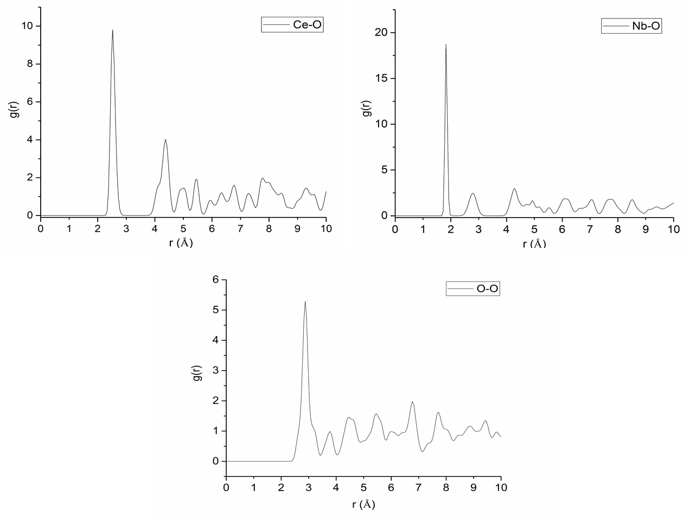

**Figure S6 Pair distribution function analysis of CeNbO4 phase from MD Simulations highlighting the Ce-O, Nb-O and O-O correlations.**

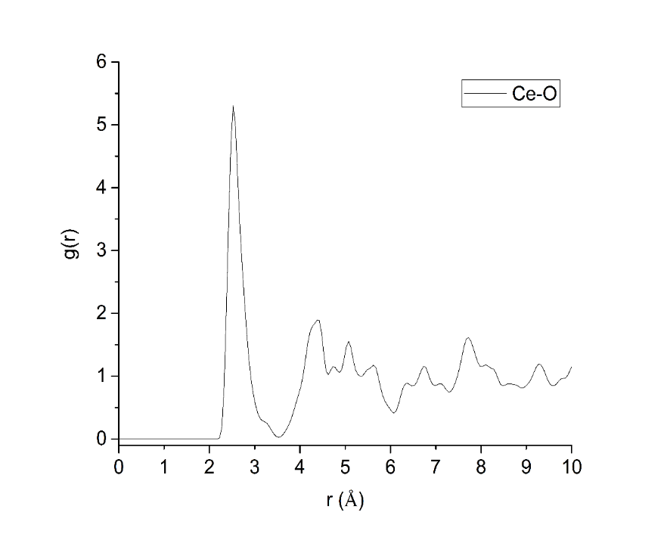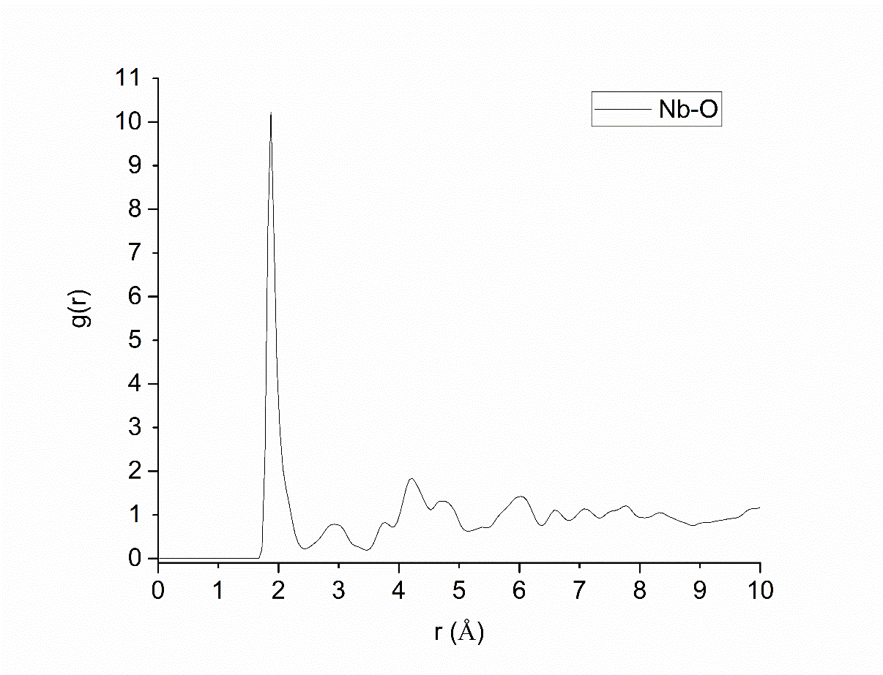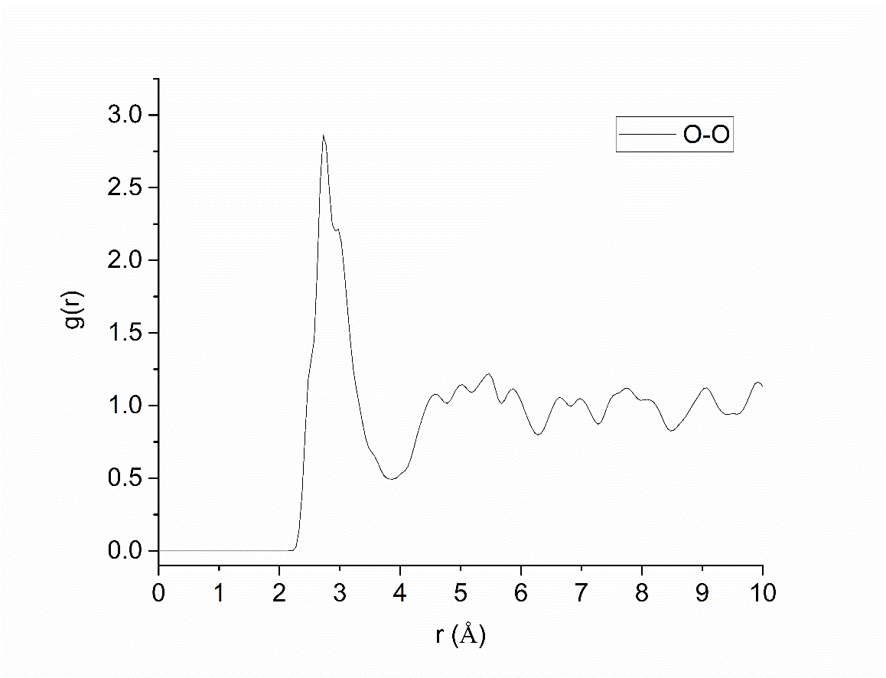

**Fig S7 - Pair distribution function analysis of CeNbO4.25 phase from MD Simulations highlighting the Ce-O, Nb-O and O-O correlations.**

**REFERENCES**

(1) Chroneos, A.; Parfitt, D.; Kilner, J. A.; Grimes, R. W. *J. Mater. Chem.* **2010**, *20*, 266.

(2) Minervini, L.; Zacate, M. O.; Grimes, R. W. *Solid State Ionics* **1999**, *116*, 339.

(3) Vyas, S.; Grimes, R. W.; Gay, D. H.; Rohl, A. L. *Journal of the Chemical Society, Faraday Transactions* **1998**, *94*, 427.

(4) Sepliarsky, M.; Asthagiri, A.; Phillpot, S. R.; Stachiotti, M. G.; Migoni, R. L. *Current Opinion in Solid State and Materials Science* **2005**, *9*, 107.

(5) Bayliss, R. D.; Pramana, S. S.; An, T.; Wei, F.; Kloc, C. L.; White, A. J. P.; Skinner, S. J.; White, T. J.; Baikie, T. *J. Solid State Chem.* **2013**, *204*, 291.

(6) Thompson, J. G.; Withers, R. L.; Brink, F. J. *J. Solid State Chem.* **1999**, *143*, 122.

(7) Hahn, T.; Looijenga-Vos, A. In *International Table for Crystallography*; Hahn, T., Ed.; Springer: Heidelberg, 2006; Vol. A.

(8) Swanson, H. E.; Tatge, E. *Standard X-ray diffraction powder patterns*, National Bureau of Standards, Washington, D.C., USA, 1953.