**Supporting Information**

**Dinuclear Zinc Salen Catalysts for the Ring Opening Copolymerization of Epoxides and**

**Carbon Dioxide or Anhydrides**

Arnaud Thevenon, Jennifer A. Garden, Andrew J. P. White and Charlotte K. Williams*

Department of Chemistry, Imperial College London, London, SW7 2AZ, United Kingdom

**Figure S1**: 1H NMR spectrum of **L1aH** (CDCl3, 298 K) 4

**Figure S2**: 13C NMR spectrum of **L1aH** (CDCl3, 298 K) 4

**Figure S3**: 1H NMR spectrum of **L1bH** (CDCl3, 298 K) 5

**Figure S4**: 13C NMR spectrum of **L1bH** (CDCl3, 298 K) 5

**Figure S5**: 1H NMR spectrum of **L2aH** (CDCl3, 298 K) 6

**Figure S6**: 13C NMR spectrum of **L2aH** (CDCl3, 298 K) 6

**Figure S7**: 1H NMR spectrum of **L2bH** (CDCl3, 298 K) 7

**Figure S8**: 13C NMR spectrum of **L2bH** (CDCl3, 298 K) 7

**Figure S9**: Molecular structure of **L1aZn2(OAc)2** 8

**Figure S10**: ChemDraw representation of **L1aZn2(OAc)2.(H2O)** 1 8

**Figure S11**: 1H NMR spectrum of **L1aZn2(OAc)2**(CDCl3, 298 K) 9

**Figure S12**: 13C NMR spectrum of **L1aZn2(OAc)2** (CDCl3, 298 K) 9

**Figure S13**: 1H NMR spectrum of **L2aZn2(OAc)2**(CDCl3, 298 K) 10

**Figure S14:** 13C NMR spectrum of **L2aZn2(OAc)2** (CDCl3, 298 K) 10

**Figure S15**: 1H NMR spectrum of **L1bZn2(OAc)2** (d5-pyr, 298 K) 11

**Figure S16**: 13C NMR spectrum of **L1bZn2(OAc)2** (d5-pyr, 298 K) 11

**Figure S17**: DOSY spectrum of **L2aZn2(OAc)2**(CDCl3, 298 K) 12

**Figure S18**: DOSY spectrum of **L1bZn2(OAc)2** (d5-pyr, 298 K). 12

**Figure S19**: 1H NMR of **L2aZn2(OAc)2** at 0 h (top) and after 16 h at 80oC (bottom) (d8-THF, 298 K) 13

**Figure S20**: 1H NMR spectrum obtained from reaction of **L2bH** with 2 equivalents of Zn(OAc)2 (C6D6, 298 K) 13

**Figure S21**: 1H NMR spectrum obtained from reaction of **L2bH** with 2 equivalents of Zn(OAc)2 (d5-pyr, 298 K). 14

**Figure S22**: MALDI-ToF spectrum of the product mixture obtained from the reaction of **L2bH** with 2 equivalents of Zn(OAc)2. 14

**Figure S23**: DOSY spectrum of the product mixture obtained from the reaction of **L2bH** with 2 equivalents of Zn(OAc) (C6D6, 298 K) 15

**Figure S24**: Molecular structure of **(L2b)2Zn2.THF** 15

**Figure S25**: Molecular structure of one (**A**) of the two independent *Ci*-symmetric complexes present in the crystal of **(L2b)2Zn2-MeOH**. 16

**Figure S26**: Molecular structure of one (**B**) of the two independent *Ci*-symmetric complexes present in the crystal of **(L2b)2Zn2-MeOH** 17

**Figure S27**: 1H NMR spectrum of **(L2b)2Zn2** (d8-THF, 298 K) 17

**Figure S28**: 13C NMR spectrum of **(L2b)2Zn2** (d8-THF, 298 K) 18

**Figure S29**: DOSY spectrum of **(L2b)2Zn2** (d8-THF, 298 K). 18

**Figure S30**: 1H NMR spectrum of **L2bZn2Et2** (C6D6, 298 K) 19

**Figure S31**: 13C NMR spectrum of **L2bZn2Et2** (C6D6, 298 K) 19

**Figure S32**: DOSY spectrum of **L2bZn2Et2** (C6D6, 298 K) 20

**Figure S33**: Molecular structure of **L2bZn3(OAc)4** 20

**Figure S34**: 1H NMR spectrum of **L2bZn3(OAc)4** (C6D6, 298 K) 21

**Figure S35**: 13C NMR spectrum of **L2bZn3(OAc)4** (C6D6, 298 K) 21

**Figure S36**: DOSY spectrum in C6D6 of **L2bZn3(OAc)4** (C6D6, 298 K). 22

**Figure S37**: 1H NMR spectrum of **L2bZn3(OAc)4** at 0 h (top) and after 16 h at 80oC (bottom) (d8-THF, 298 K) 22

**Figure S38**: 1H NMR spectrum in C6D6 of **(L2b)2Zn3(OAc)2**. 23

**Figure S39**: DOSY spectrum in C6D6 of **(L2b)2Zn3(OAc)2** at 298 K. 23

**Figure S40**: Molecular structure of **(L2b)2Zn3(OAc)2** 24

**Figure S41**: Overlaid 1H NMR spectra of the **L2bZn2(OAc)2** mixture, **L2bZn3(OAc)4** and **(L2b)2Zn3(OAc)2** (C6D6, 298 K). 24

**Figure S42**: Overlaid 1H NMR spectra of **(L2b)2Zn2** and the product isolated from the CO2/CHO polymerization reaction using **L2bZn2(OAc)2** catalyst (CDCl3, 298 K). 25

**Figure S43**: Stack of 1H NMR spectra after 2 h and 18 h of reaction (CDCl3, 298 K) 25

**Figure S44**: DOSY spectrum of the crude poly(ester-co-carbonate) (CDCl3, 298K). 26

**Figure S45**: 13C NMR spectrum of the block poly(ester-co-carbonate). 26

DOSY NMR Spectroscopy 27

Calibration plots 27

**Table S1**: Diffusion coefficients of standards in d5-pyridine solution compared to their molecular weight. 27

**Graph S1**: LogD vs LogMW representation from the 1H DOSY NMR data obtained for the standards HMDSH, Zn(HMDS)2, BDIH and (BDI)Zn(HMDS) in d5-pyridine solvent. 28

**Table S2**: Diffusion coefficients of standards in d8-toluene solution compared to their molecular weight. 28

**Graph S2**: LogD vs LogMW representation from the 1H DOSY NMR data obtained for the standards HMDSH, Zn(HMDS)2 and (BDI)Zn(HMDS) in d8-toluene solvent. 28

**Table S3**: Diffusion coefficients of standards in d8-THF solution compared to their molecular weight. 29

**Graph S3**: LogD vs LogMW representation from the 1H DOSY NMR data obtained for the standards HMDSH, Zn(HMDS)2 and BDIH in d8-THF solvent. 29

Crystallographic data 29

**Table S4**. Crystallographic Data for compounds **(L1a)Zn2(OAc)2**, **(L2b)2Zn2-THF**, **(L2b)2Zn2-MeOH**, **(L2b)Zn3(OAc)4** and **(L2b)Zn3Cl2**. 30

References: 31

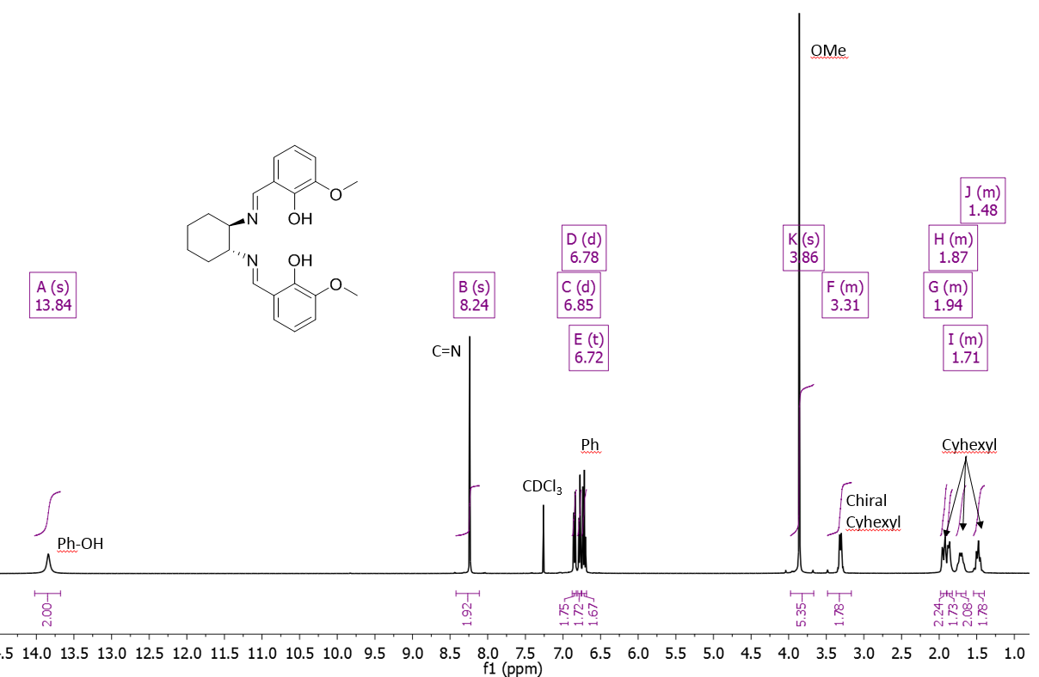

### **Figure S1**: 1H NMR spectrum of **L1aH** (CDCl3, 298 K)

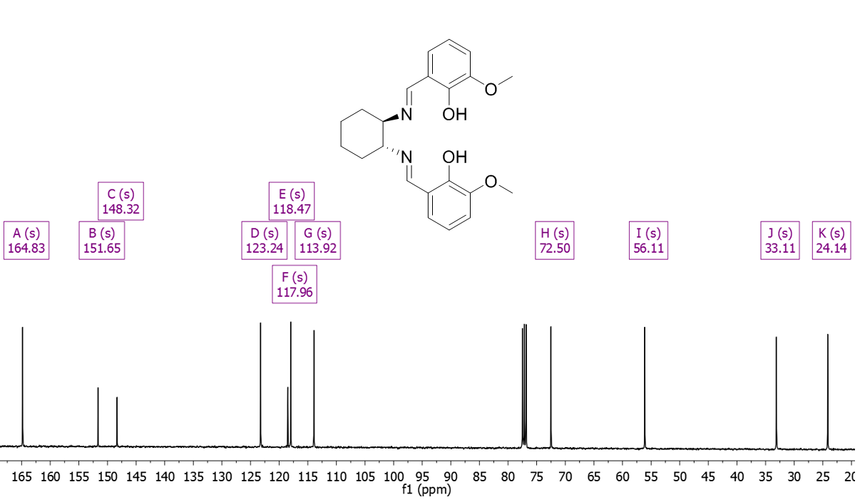

### **Figure S2**: 13C NMR spectrum of **L1aH** (CDCl3, 298 K)

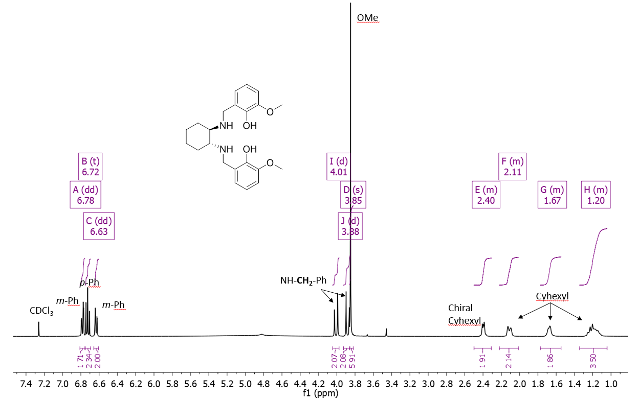

### **Figure S3**: 1H NMR spectrum of **L1bH** (CDCl3, 298 K)

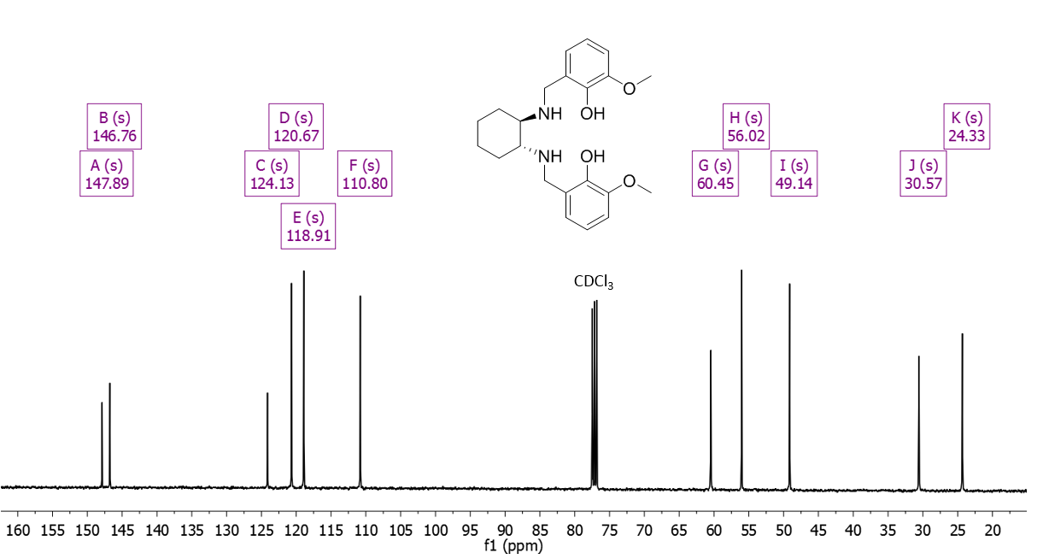

### **Figure S4**: 13C NMR spectrum of **L1bH** (CDCl3, 298 K)

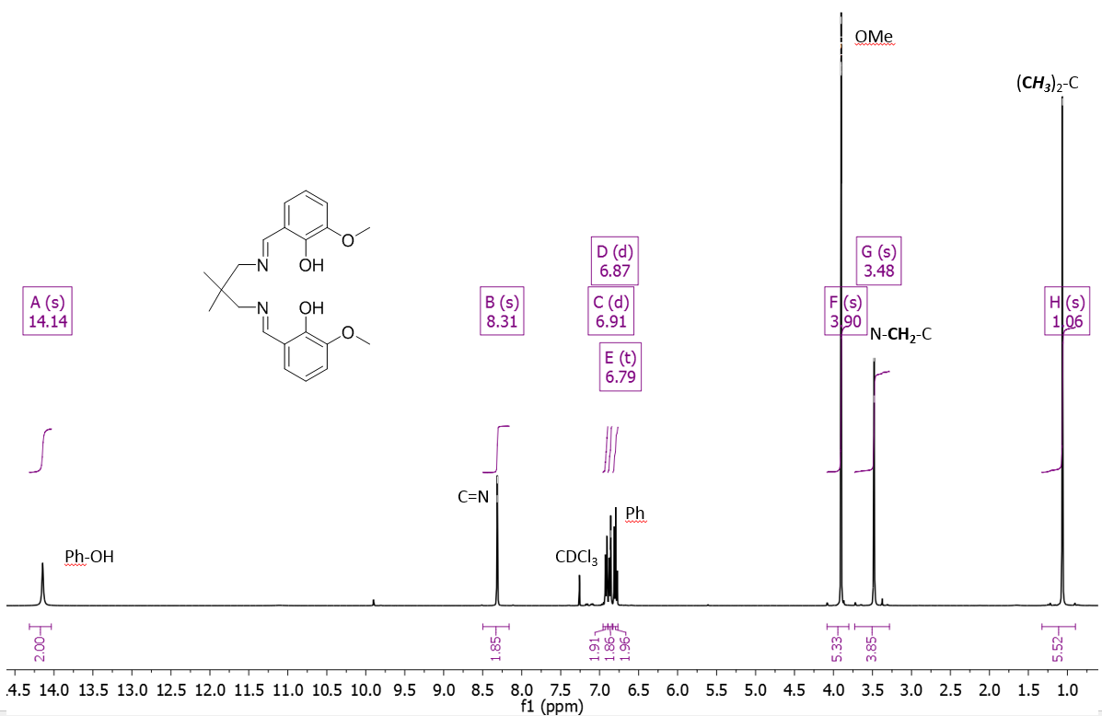

### **Figure S5**: 1H NMR spectrum of **L2aH** (CDCl3, 298 K)

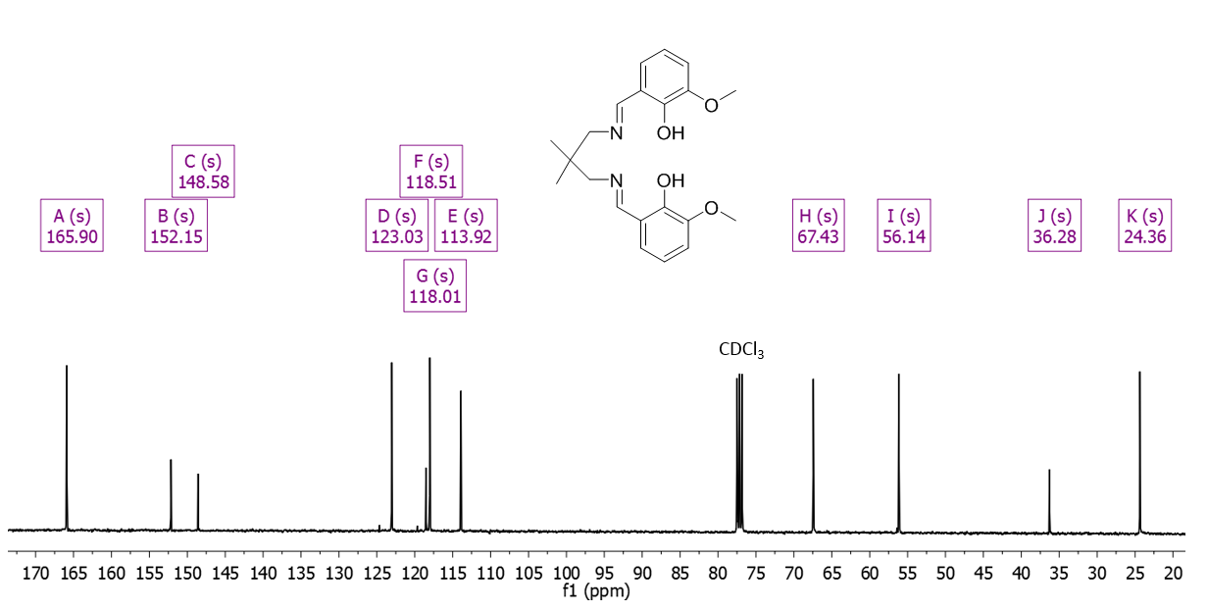

### **Figure S6**: 13C NMR spectrum of **L2aH** (CDCl3, 298 K)

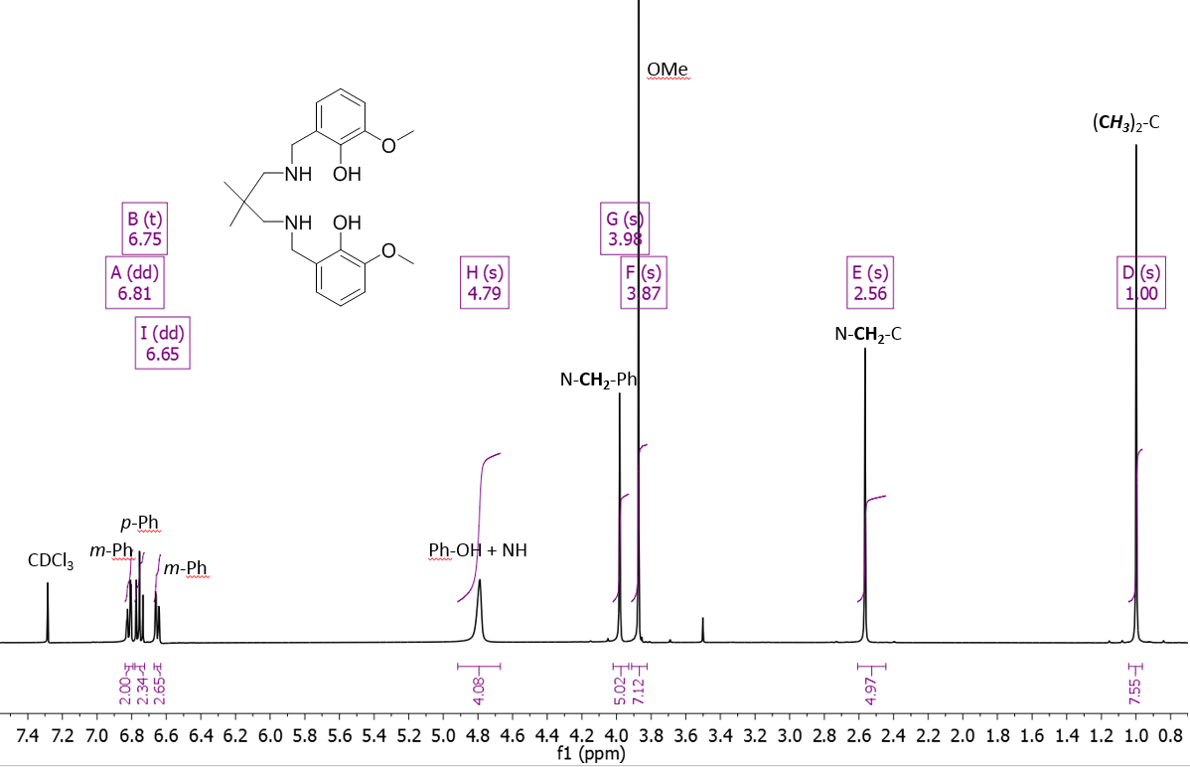

### **Figure S7**: 1H NMR spectrum of **L2bH** (CDCl3, 298 K)

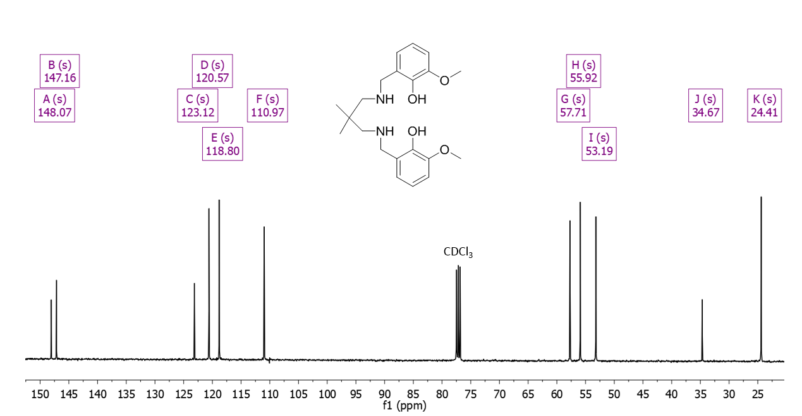

### **Figure S8**: 13C NMR spectrum of **L2bH** (CDCl3, 298 K)

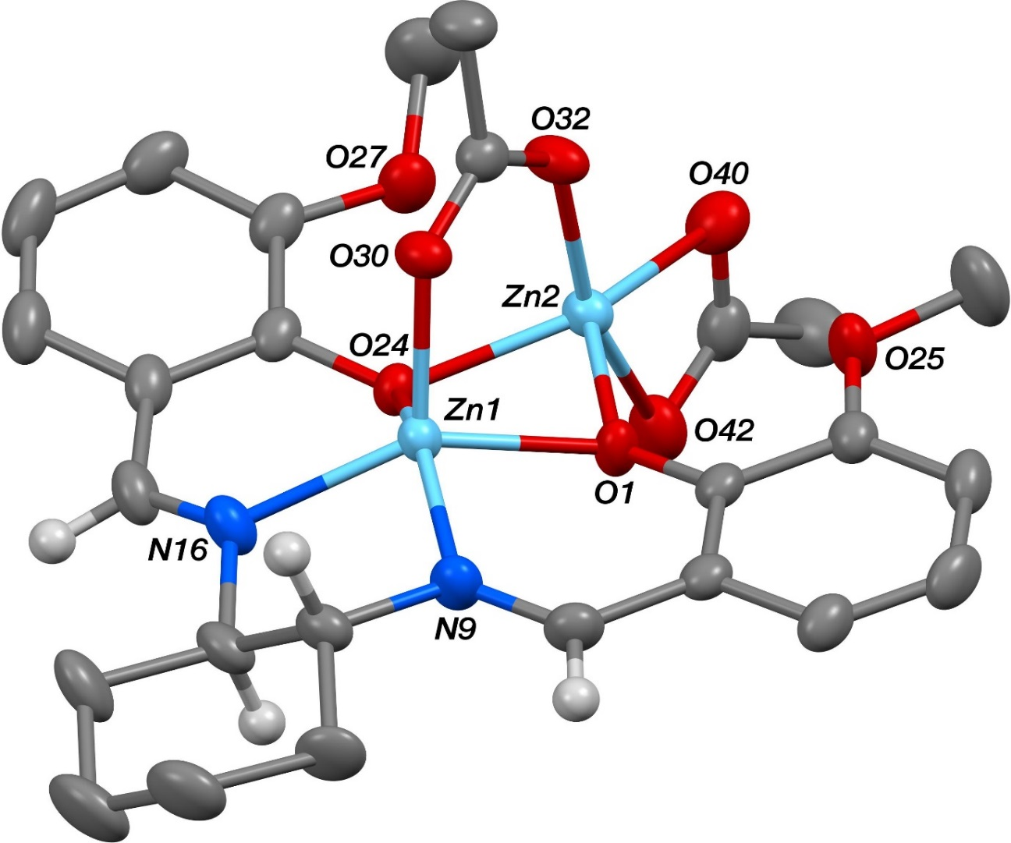

### **Figure S9**: Molecular structure of **L1aZn2(OAc)2**, with thermal ellipsoids at the 50% probability level and hydrogen atoms, one dichloromethane molecule and minor disordered components omitted for clarity.

The cyclohexyl unit bound to N9 and N16 in the structure of **(L1a)Zn2(OAc)2** was found to be disordered. Two orientations were identified of *ca*. 82 and 18% occupancy, their geometries were optimised, the thermal parameters of adjacent atoms were restrained to be similar, and only the non-hydrogen atoms of the major occupancy orientation were refined anisotropically (those of the minor occupancy orientation were refined isotropically).



### **Figure S10**: ChemDraw representation of literature complex **L1aZn2(OAc)2.(H2O)**.1

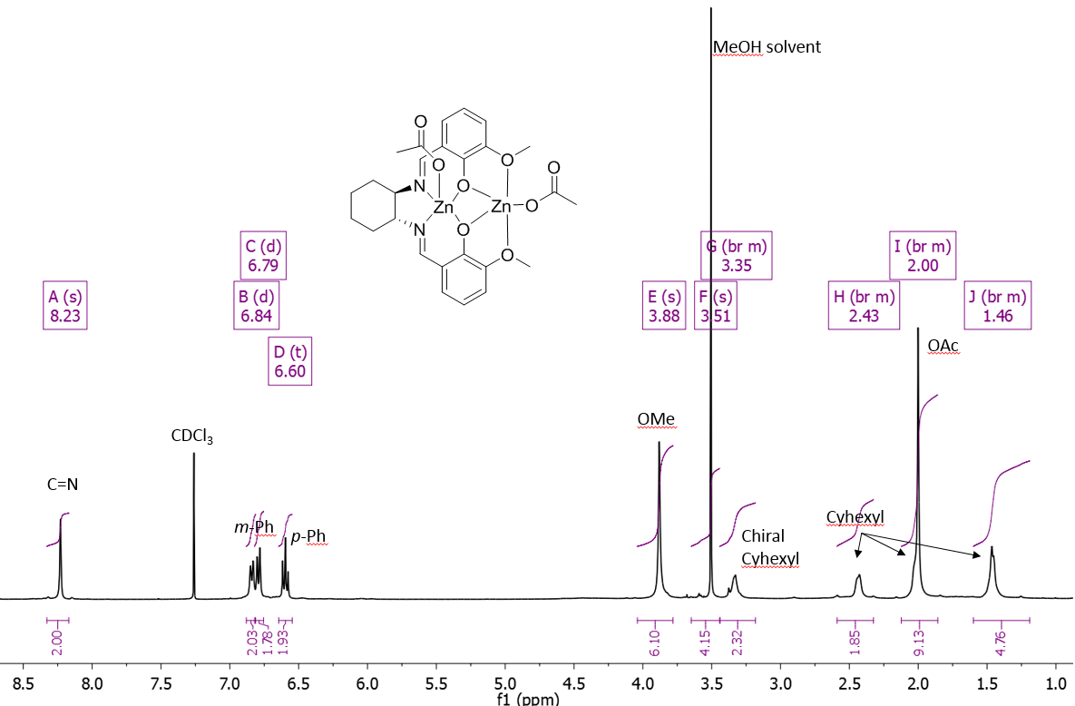

### **Figure S11**: 1H NMR spectrum of **L1aZn2(OAc)2**(CDCl3, 298 K)

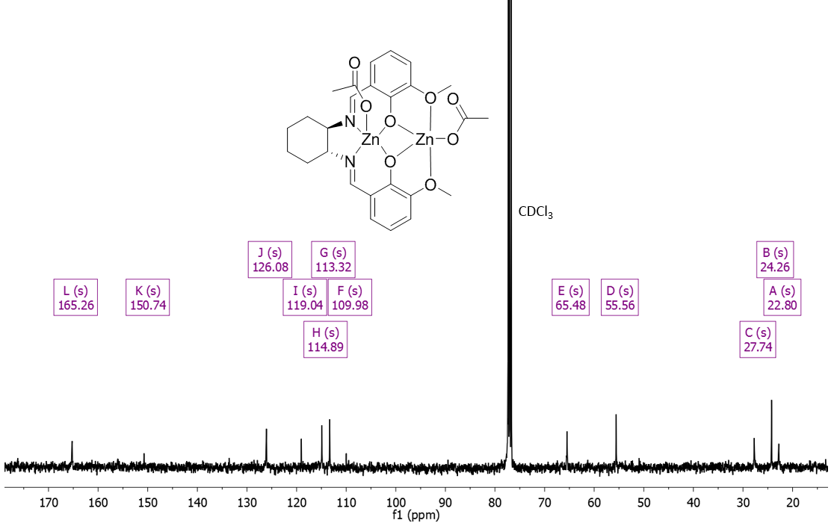

### **Figure S12**: 13C NMR spectrum of **L1aZn2(OAc)2**(CDCl3, 298 K)

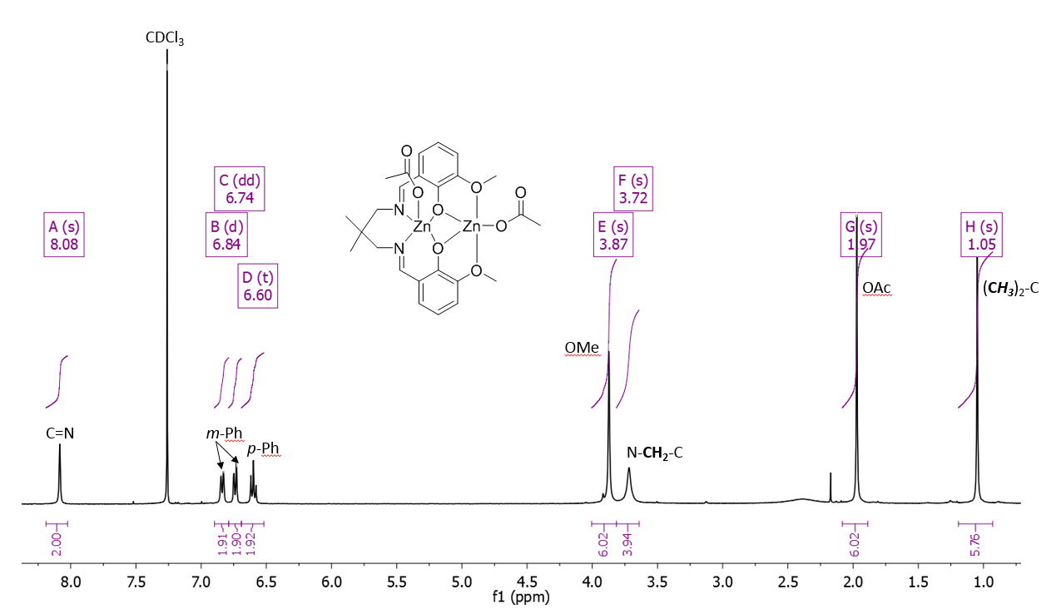

### **Figure S13**: 1H NMR spectrum of **L2aZn2(OAc)2**(CDCl3, 298 K)

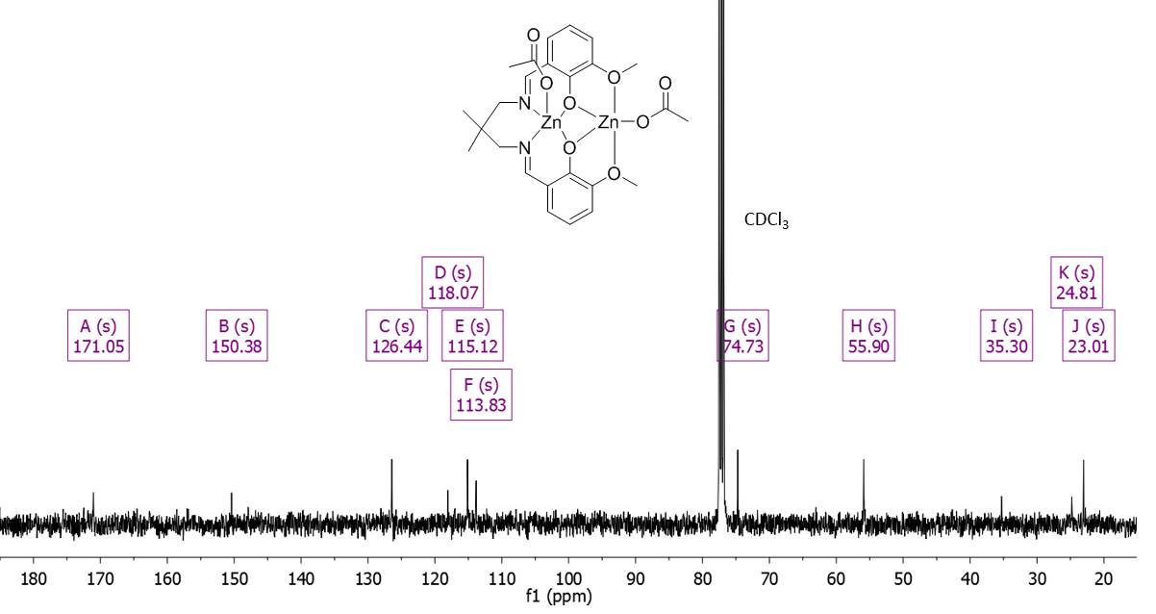

### **Figure S14**: 13C NMR spectrum of **L2aZn2(OAc)2** (CDCl3, 298 K)

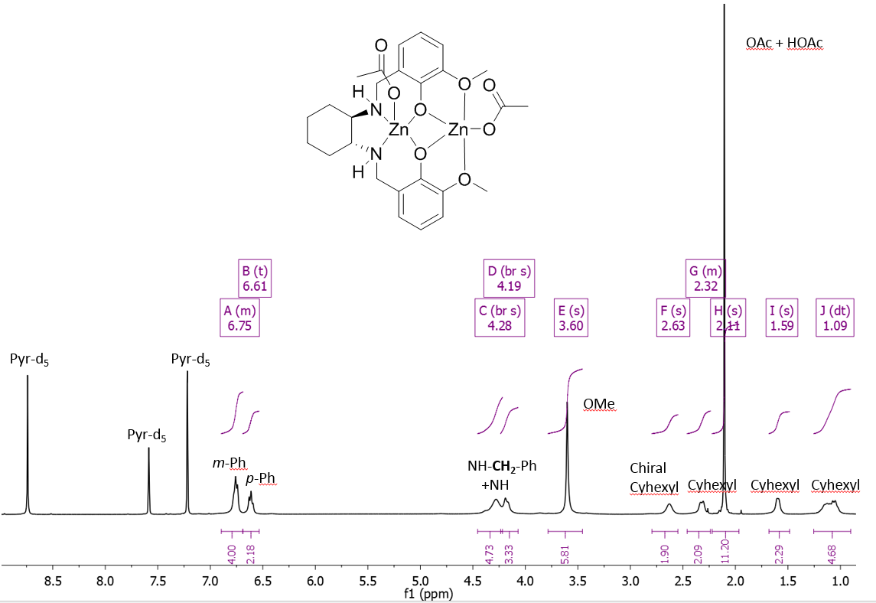

### **Figure S15**: 1H NMR spectrum of **L1bZn2(OAc)2** (d5-pyr, 298 K)

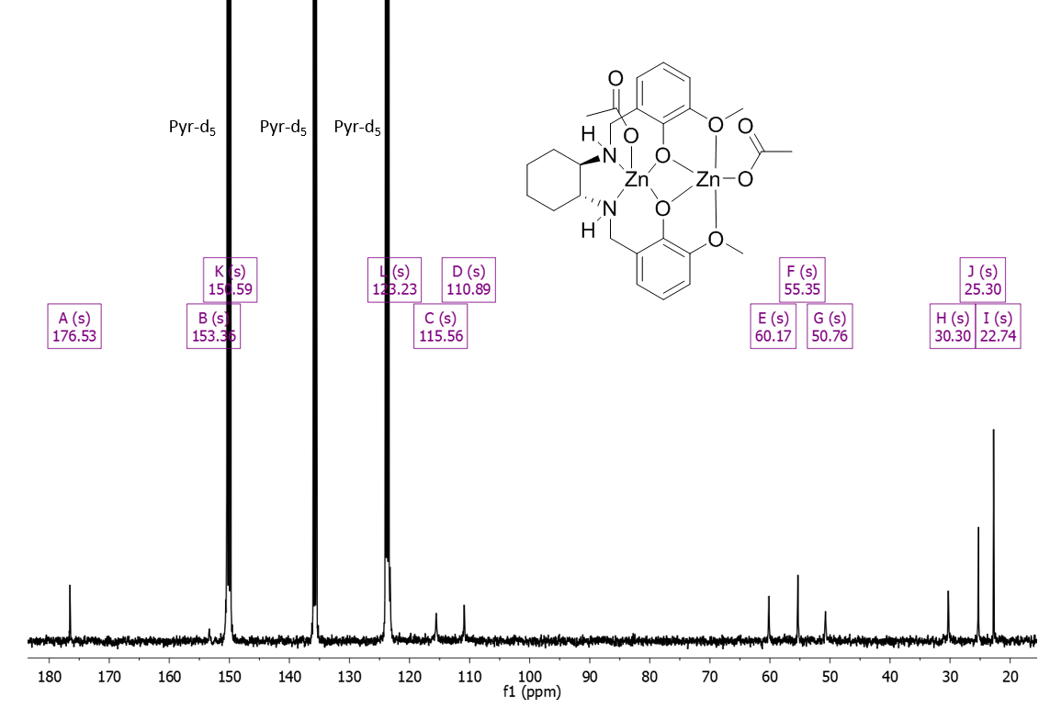

### **Figure S16**: 13C NMR spectrum of **L1bZn2(OAc)2** (d5-pyr, 298 K)

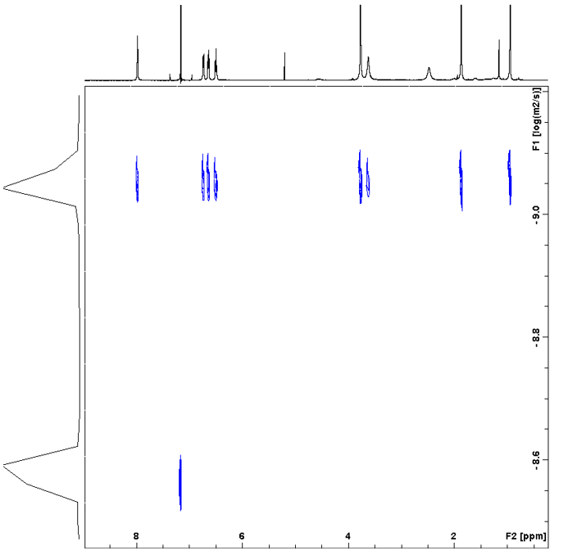

### **Figure S17**: DOSY spectrum of **L2aZn2(OAc)2**(CDCl3, 298 K)

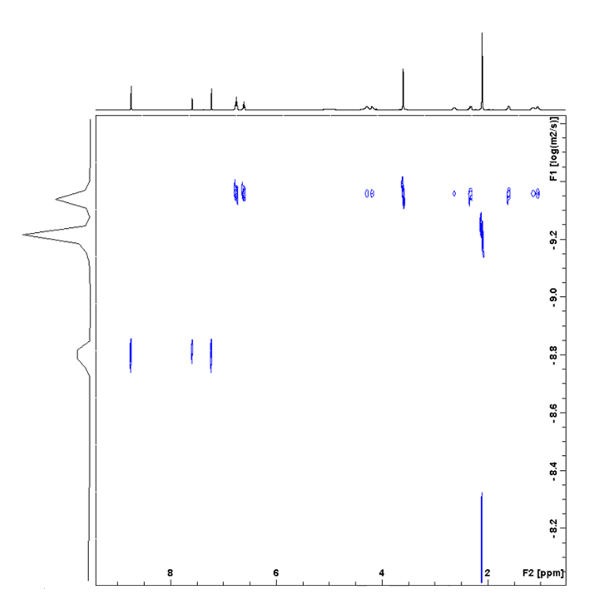

### **Figure S18**: DOSY spectrum of **L1bZn2(OAc)2** (d5-pyr, 298 K). The acetate signal lies at a lower logD value (-9.235 x 10-10 m2/s) than the other complex resonances (-9.358 x 10-10 m2/s). This is attributed to residual acetic acid exchanging with the acetate group.

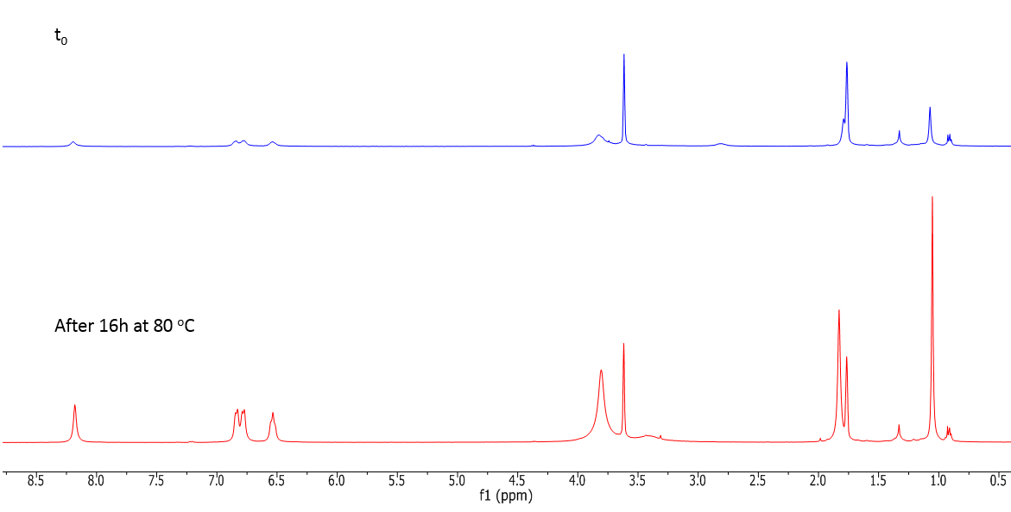

### **Figure S19**: 1H NMR of **L2aZn2(OAc)2** at 0 h (top) and after 16 h at 80oC (bottom) (d8-THF, 298 K). Difference in intensity between the top and the bottom spectrum are from the difference of solubility of **L2aZn2(OAc)2** in d8-THF at 298 K before and after heating for 16h at 80 oC.

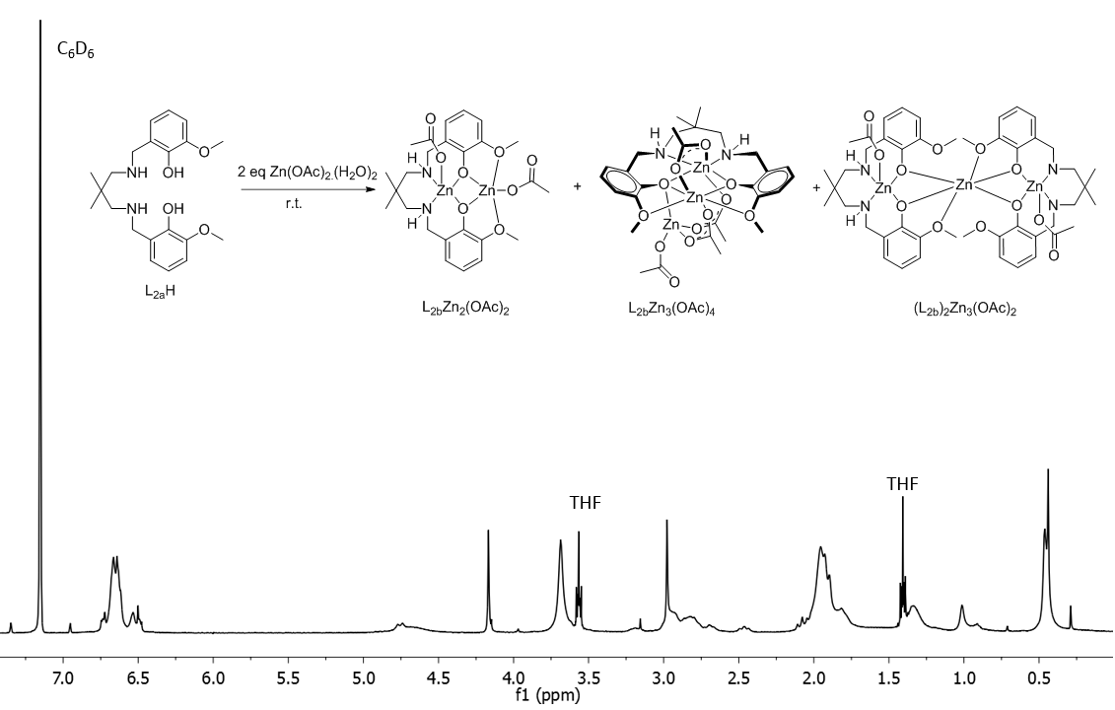

### **Figure S20**: 1H NMR spectrum of the product mixture obtained from the reaction of **L2bH** with 2 equivalents of Zn(OAc)2 (C6D6, 298 K)

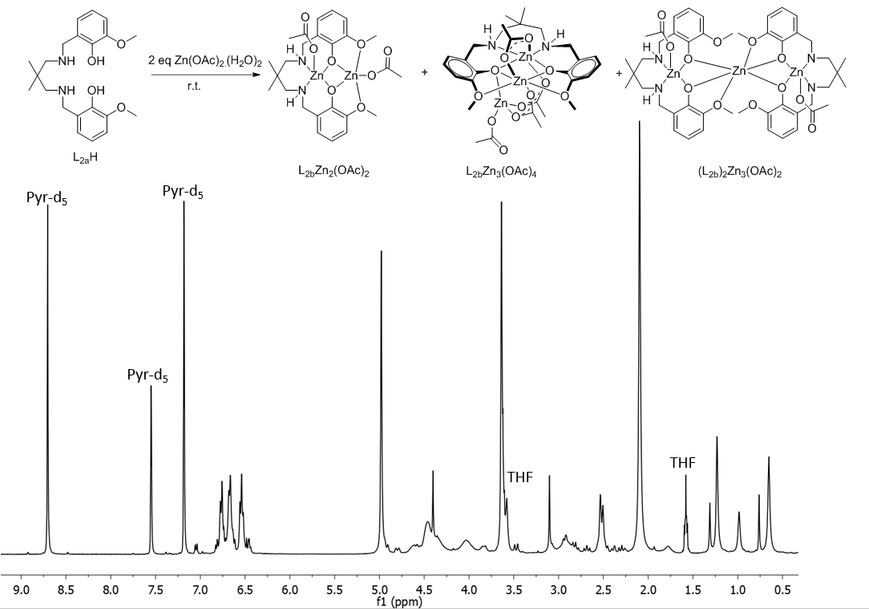

### **Figure S21**: 1H NMR spectrum of the product mixture obtained from the reaction of **L2bH** with 2 equivalents of Zn(OAc)2 (d5-pyr, 298 K).

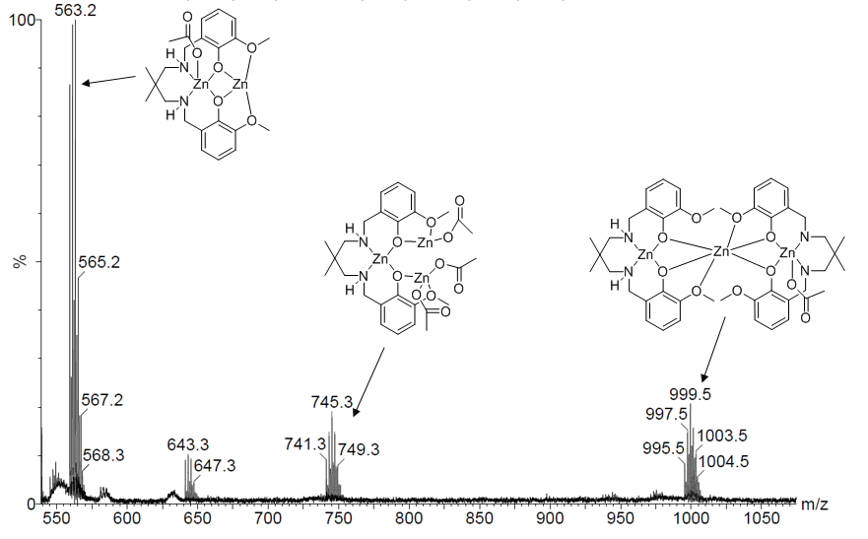

### **Figure S22**: MALDI-ToF spectrum of the product mixture obtained from the reaction of **L2bH** with 2 equivalents of Zn(OAc)2.

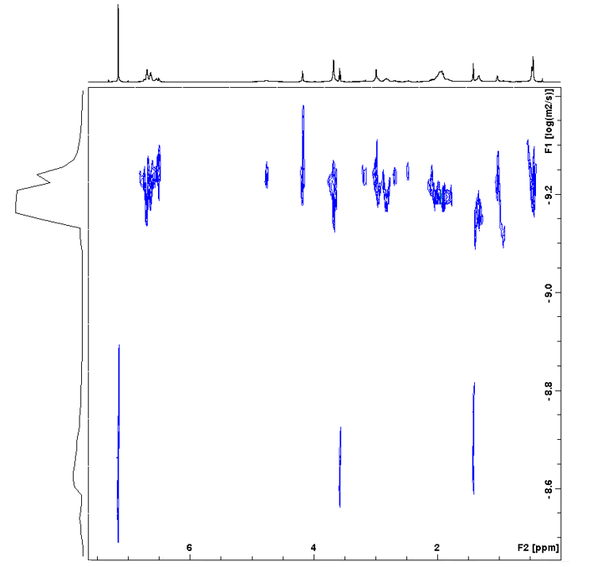

### **Figure S23**: DOSY spectrum of the product mixture obtained from the reaction of **L2bH** with 2 equivalents of Zn(OAc)2 (C6D6, 298 K)

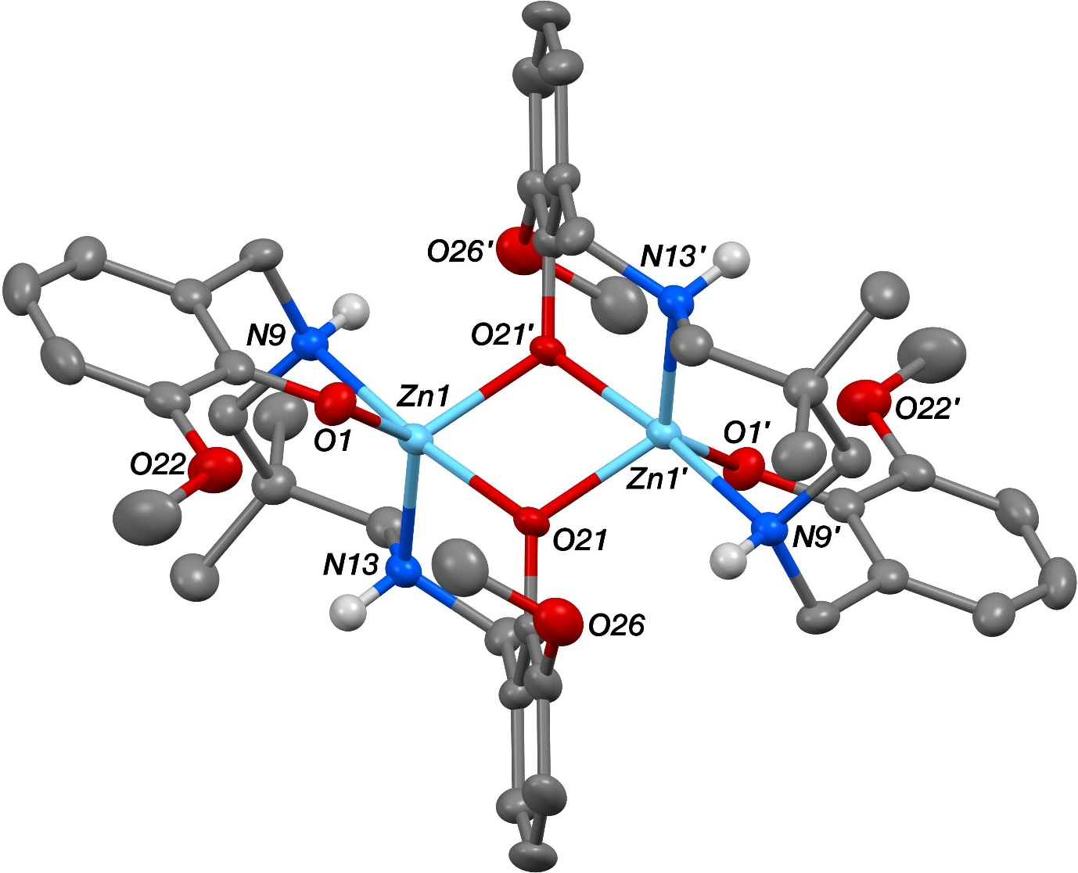

### **Figure S24**: Molecular structure of **(L2b)2Zn2-THF** with thermal displacement ellipsoids at the 50% probability level and hydrogen atoms as well as three THF molecules are omitted for clarity.

The structure of **(L2b)2Zn2-THF** showed the complex to sit across a centre of symmetry at the middle of the Zn2O2 ring. The N9 and N13 N–H hydrogen atoms were located from Δ*F* maps and refined freely subject to an N–H distance constraint of 0.90 Å. The O50-based included THF solvent molecule was found to be disordered. Two orientations were identified of *ca*. 80 and 20% occupancy, their geometries were optimised, the thermal parameters of adjacent atoms were restrained to be similar, and only the non-hydrogen atoms of the major occupancy orientation were refined anisotropically (those of the minor occupancy orientation were refined isotropically).

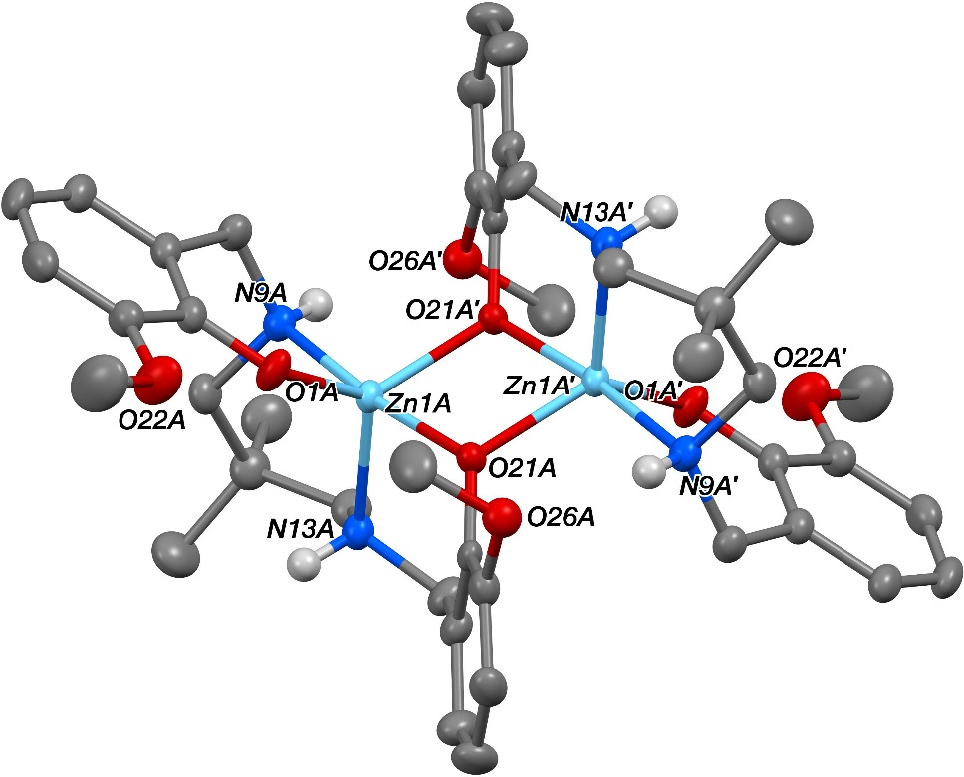

### **Figure S25**: The structure of one (**A**) of the two independent *Ci*-symmetric complexes present in the crystal of **(L2b)2Zn2-MeOH** with thermal displacement ellipsoids at the 50% probability level. Hydrogen atoms as well as one methanol molecule are omitted for clarity.

The structure of **(L2b)2Zn2-MeOH** showed the presence of two crystallographically independent complexes (**A** and **B**) both of which sit across centres of symmetry at the middle of the respective Zn2O2 rings. The four N–H and two O–H hydrogen atoms were all located from Δ*F* maps and refined freely subject to an X–H distance constraint of 0.90 Å. Though crystallographically very distinct from its THF counterpart, the two *Ci*-symmetric independent complexes present in the structure of **(L2b)2Zn2-MeOH** both have very similar conformations to that seen for the sole *Ci*-symmetric independent complex present in **(L2b)2Zn2-THF** (*cf*. Figs. S24).

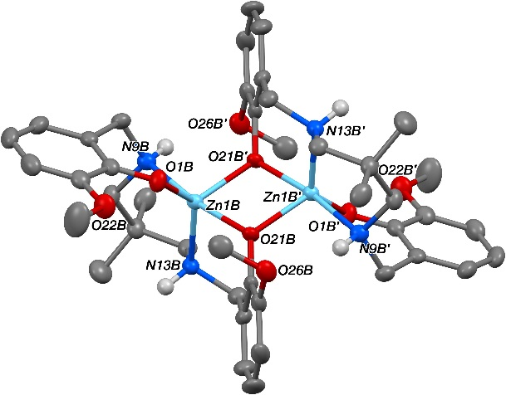

### **Figure S26**: The structure of one (**B**) of the two independent *Ci*-symmetric complexes present in the crystal of **(L2b)2Zn2-MeOH** with thermal displacement ellipsoids at the 50% probability level. Hydrogen atoms and one methanol molecule are omitted for clarity.

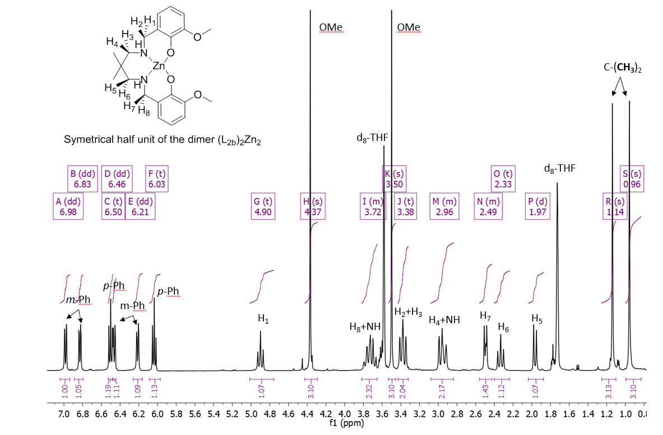

### **Figure S27**: 1H NMR spectrum of **(L2b)2Zn2** (d8-THF, 298 K)

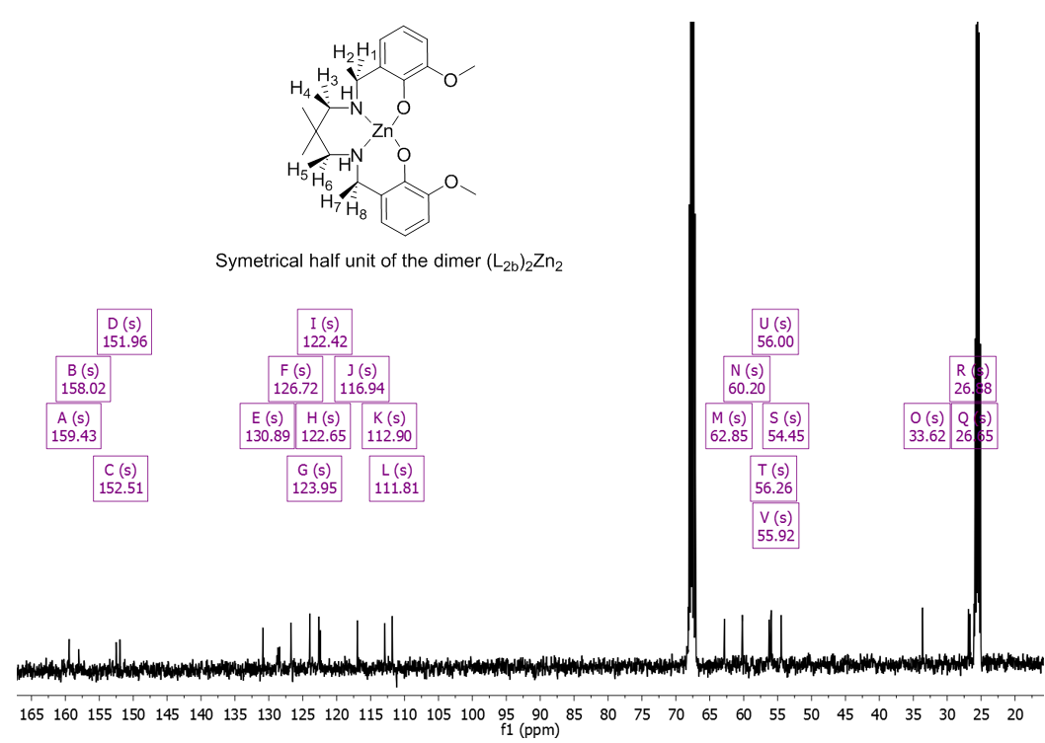

### **Figure S28**: 13C NMR spectrum of **(L2b)2Zn2** (d8-THF, 298 K)

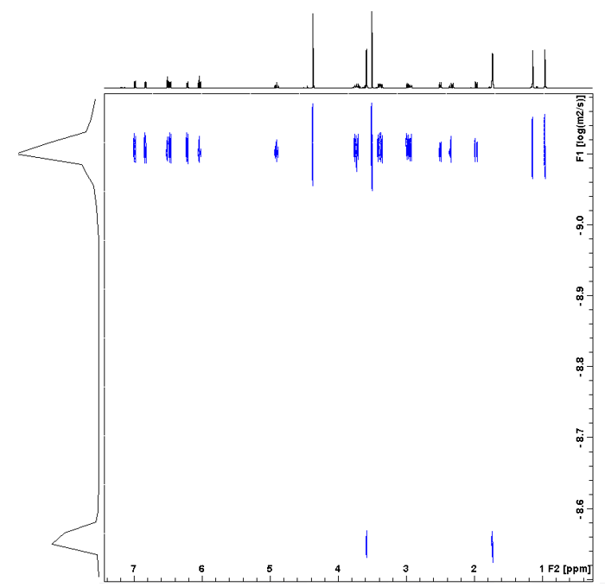

### **Figure S29**: DOSY spectrum of **(L2b)2Zn2** (d8-THF, 298 K)

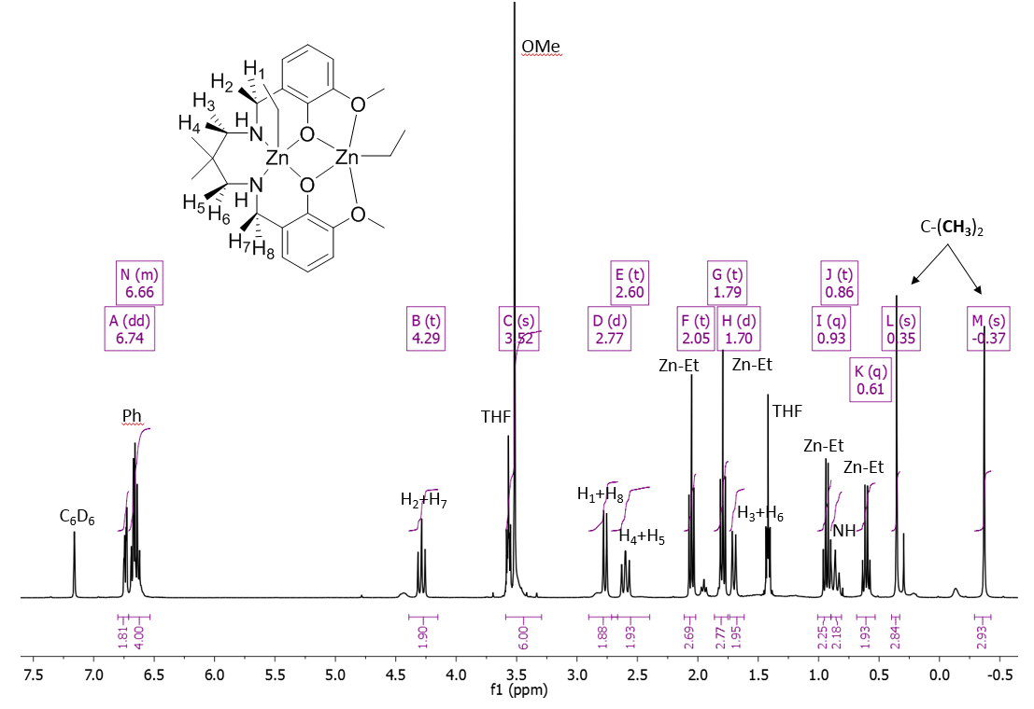

### **Figure S30**: 1H NMR spectrum of **L2bZn2Et2** (C6D6, 298 K)

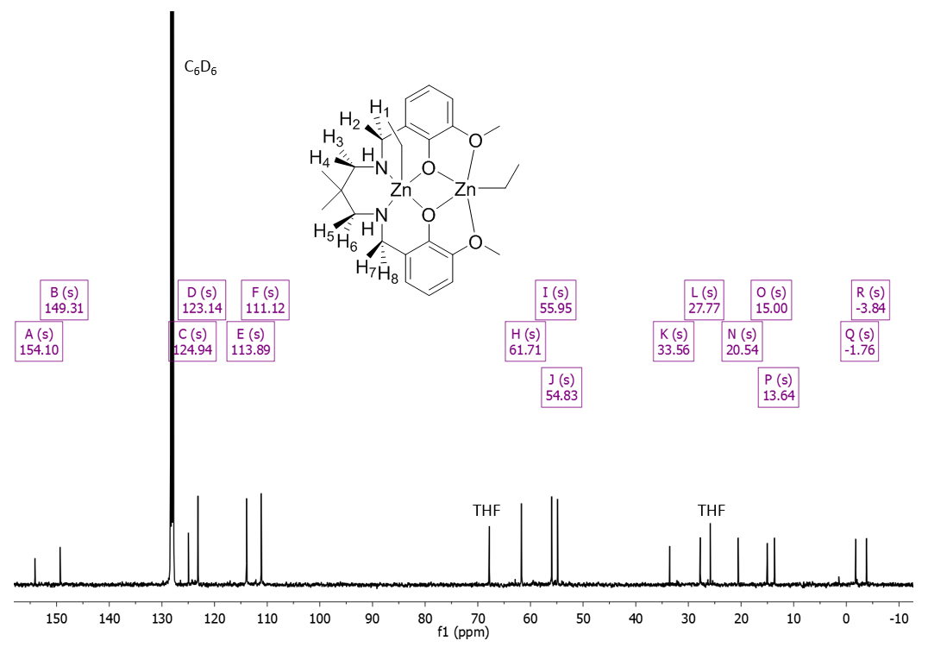

### **Figure S31**: 13C NMR spectrum of **L2bZn2Et2** (C6D6, 298 K)

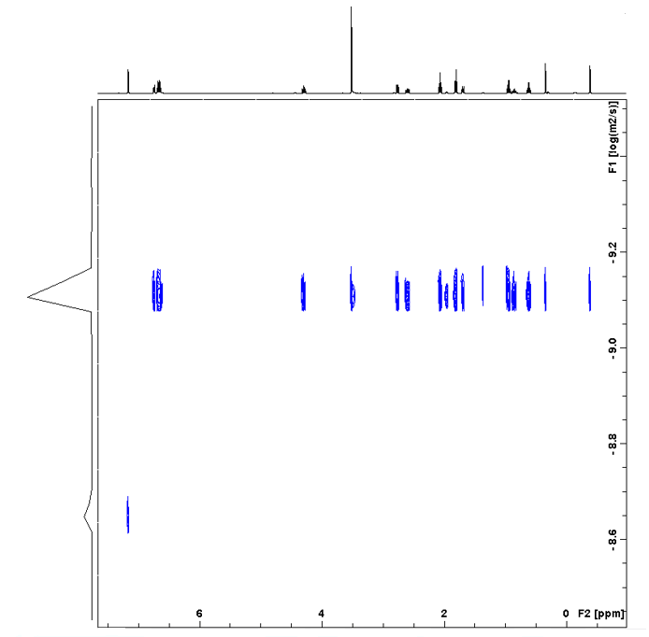

### **Figure S32**: DOSY spectrum of **L2bZn2Et2** (C6D6, 298 K)

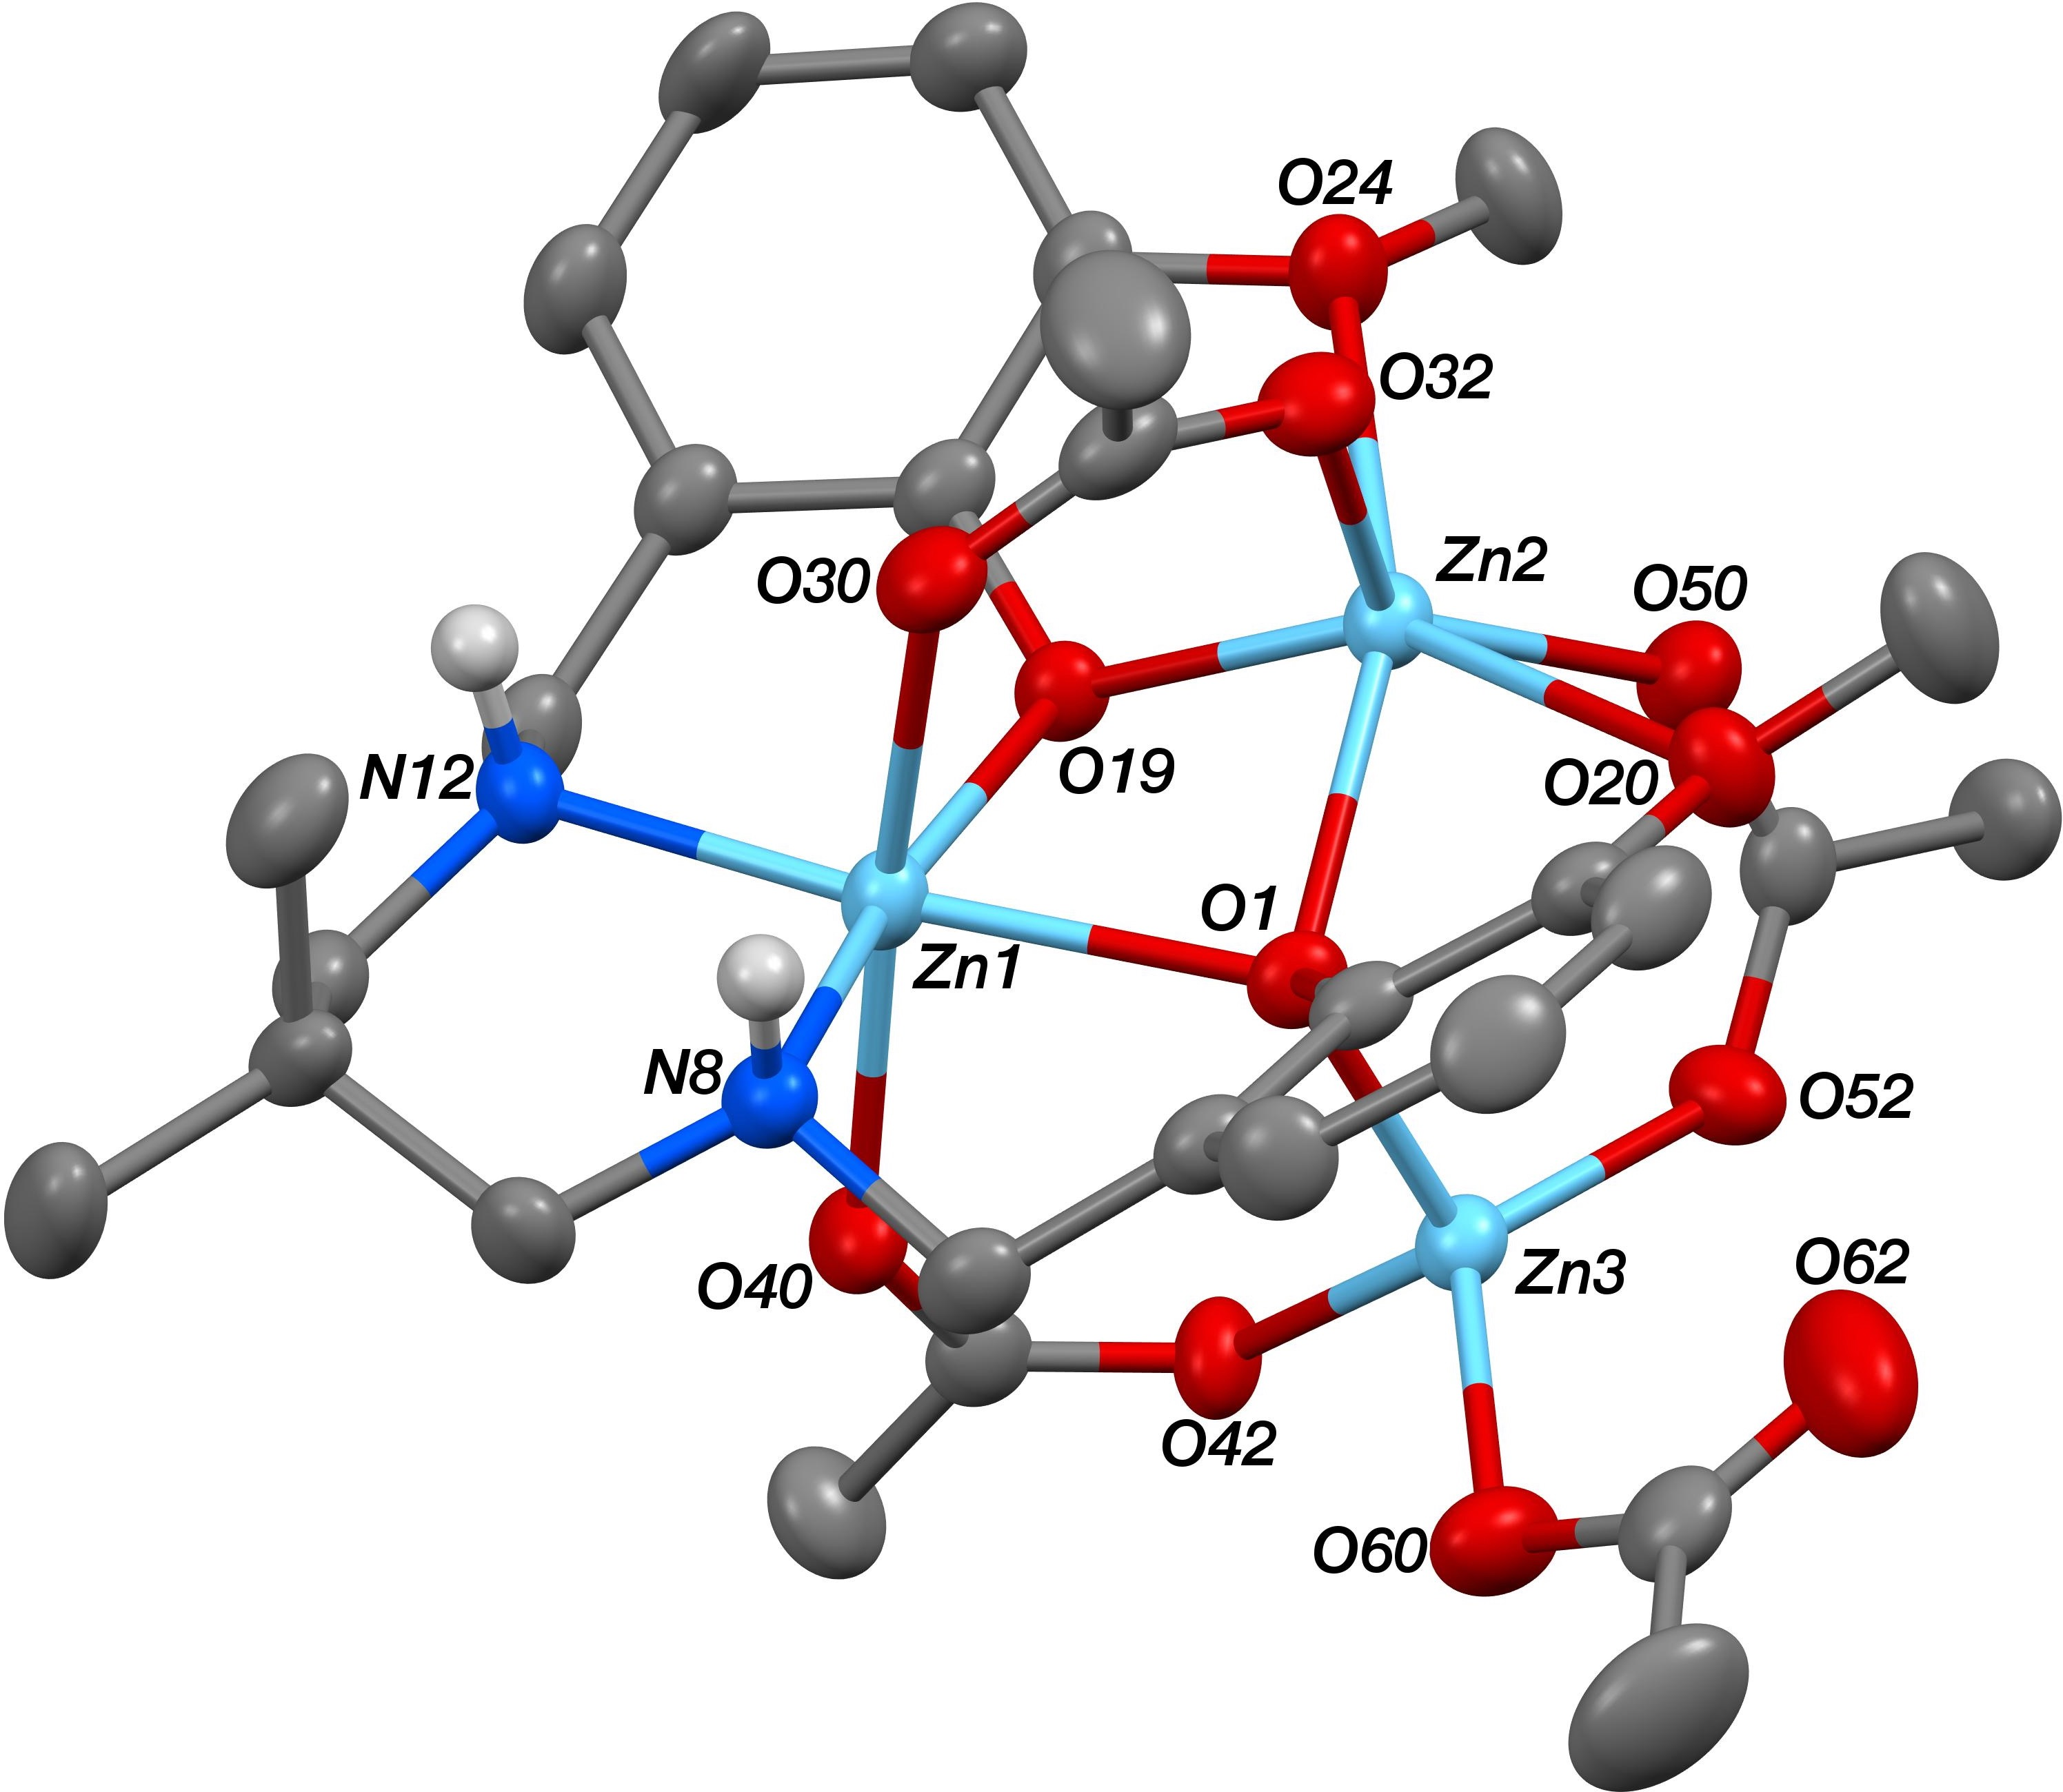

### **Figure S33**: Molecular structure of **L2bZn3(OAc)4** with thermal displacement ellipsoids at the 50% probability level. Hydrogen atoms are omitted for clarity.

The N8 and N12 N–H hydrogen atoms in the structure of **(L2b)Zn3(OAc)4** could not be located from Δ*F* maps and so were added in idealised positions, though they were then refined freely subject to an N–H distance constraint of 0.90 Å.

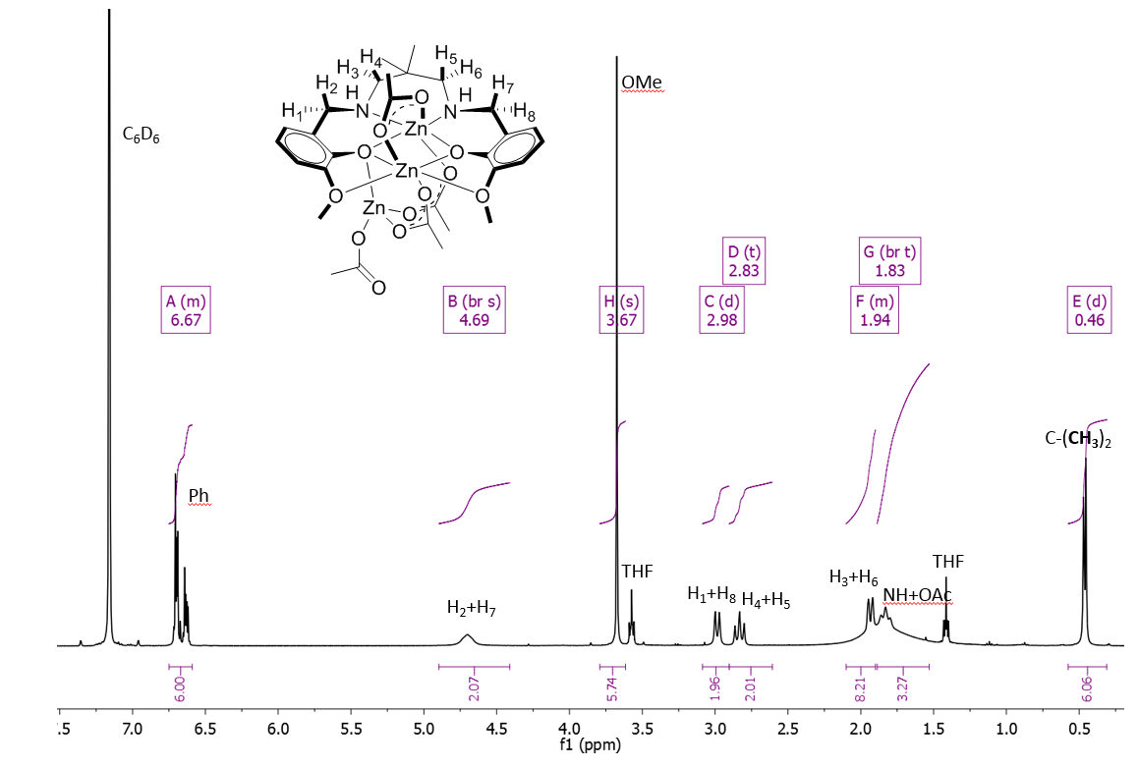

### **Figure S34**: 1H NMR spectrum of **L2bZn3(OAc)4**(C6D6, 298 K)

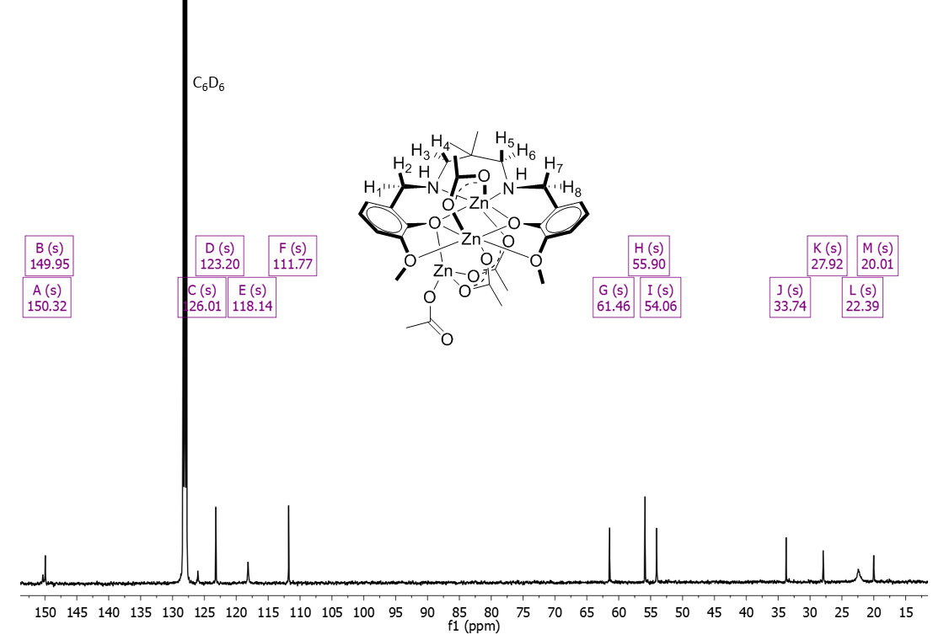

### **Figure S35**: 13C NMR spectrum of **L2bZn3(OAc)4** (C6D6, 298 K)

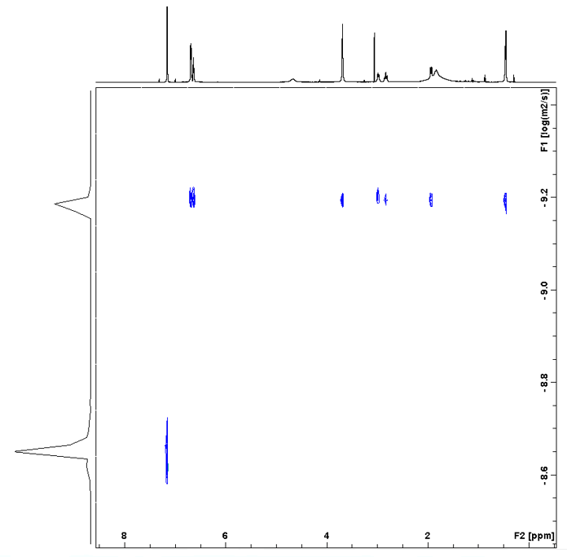

### **Figure S36**: DOSY spectrum in C6D6 of **L2bZn3(OAc)4** (C6D6, 298 K).

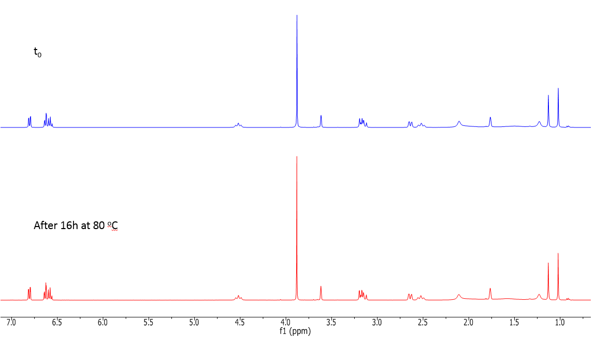

### **Figure S37**: 1H NMR spectrum of **L2bZn3(OAc)4** at 0 h (top) and after 16 h at 80oC (bottom) (d8-THF, 298 K)

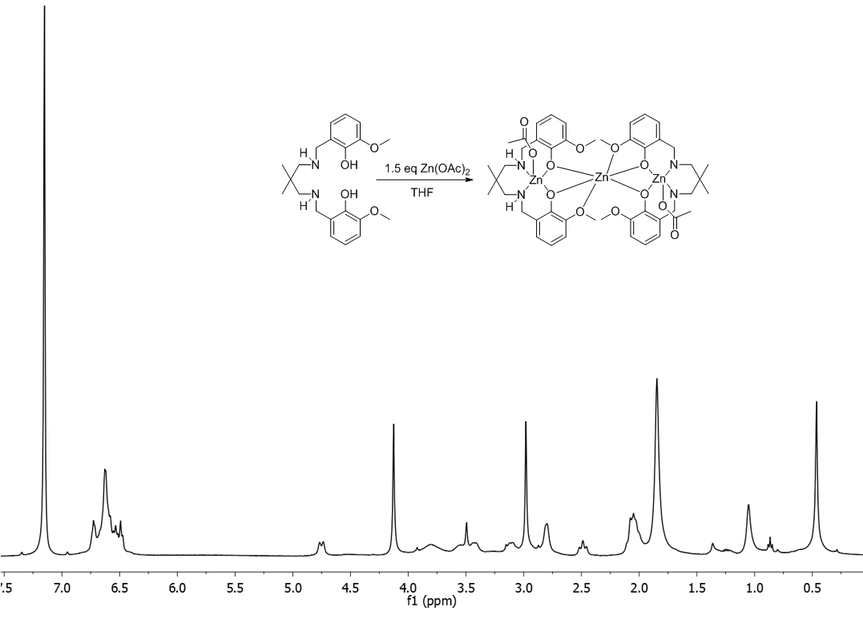

### **Figure S38**: 1H NMR spectrum in C6D6 at 298K of the product of the reaction of L2bH with Zn(OAc)2, assigned as **(L2b)2Zn3(OAc)2**.

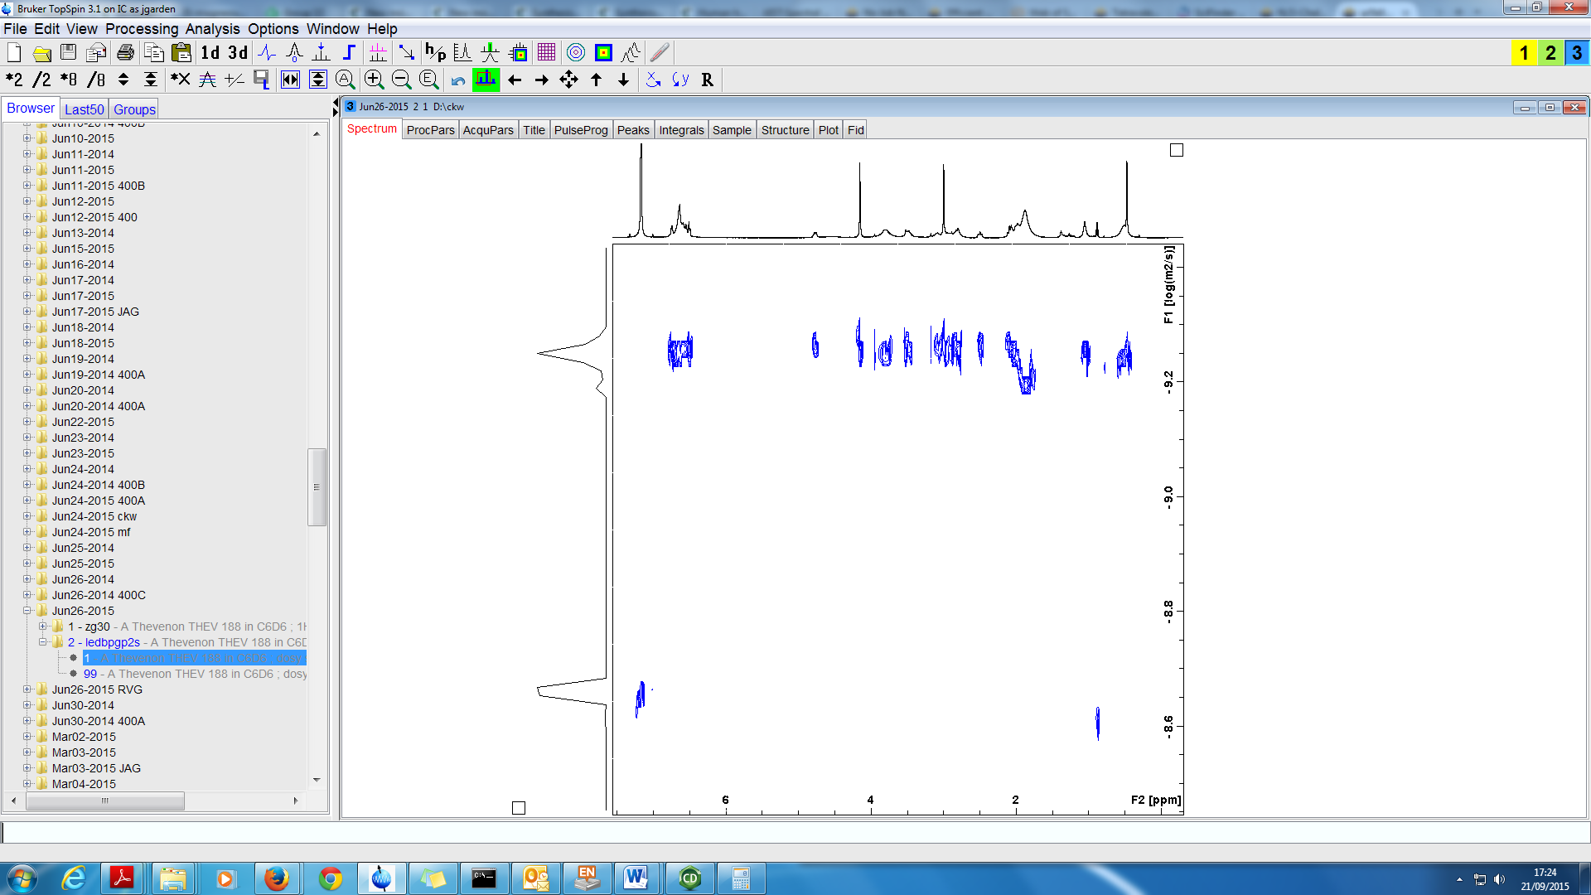

### **Figure S39**: DOSY spectrum in C6D6 of **(L2b)2Zn3(OAc)2** at 298 K. The acetate peaks lie at a different logD value (-9.196 x 10-10 m2/s) to those of the complex (-9.253 x 10-10 m2/s). This is attributed to residual acetic acid exchanging with the acetate co-ligands.

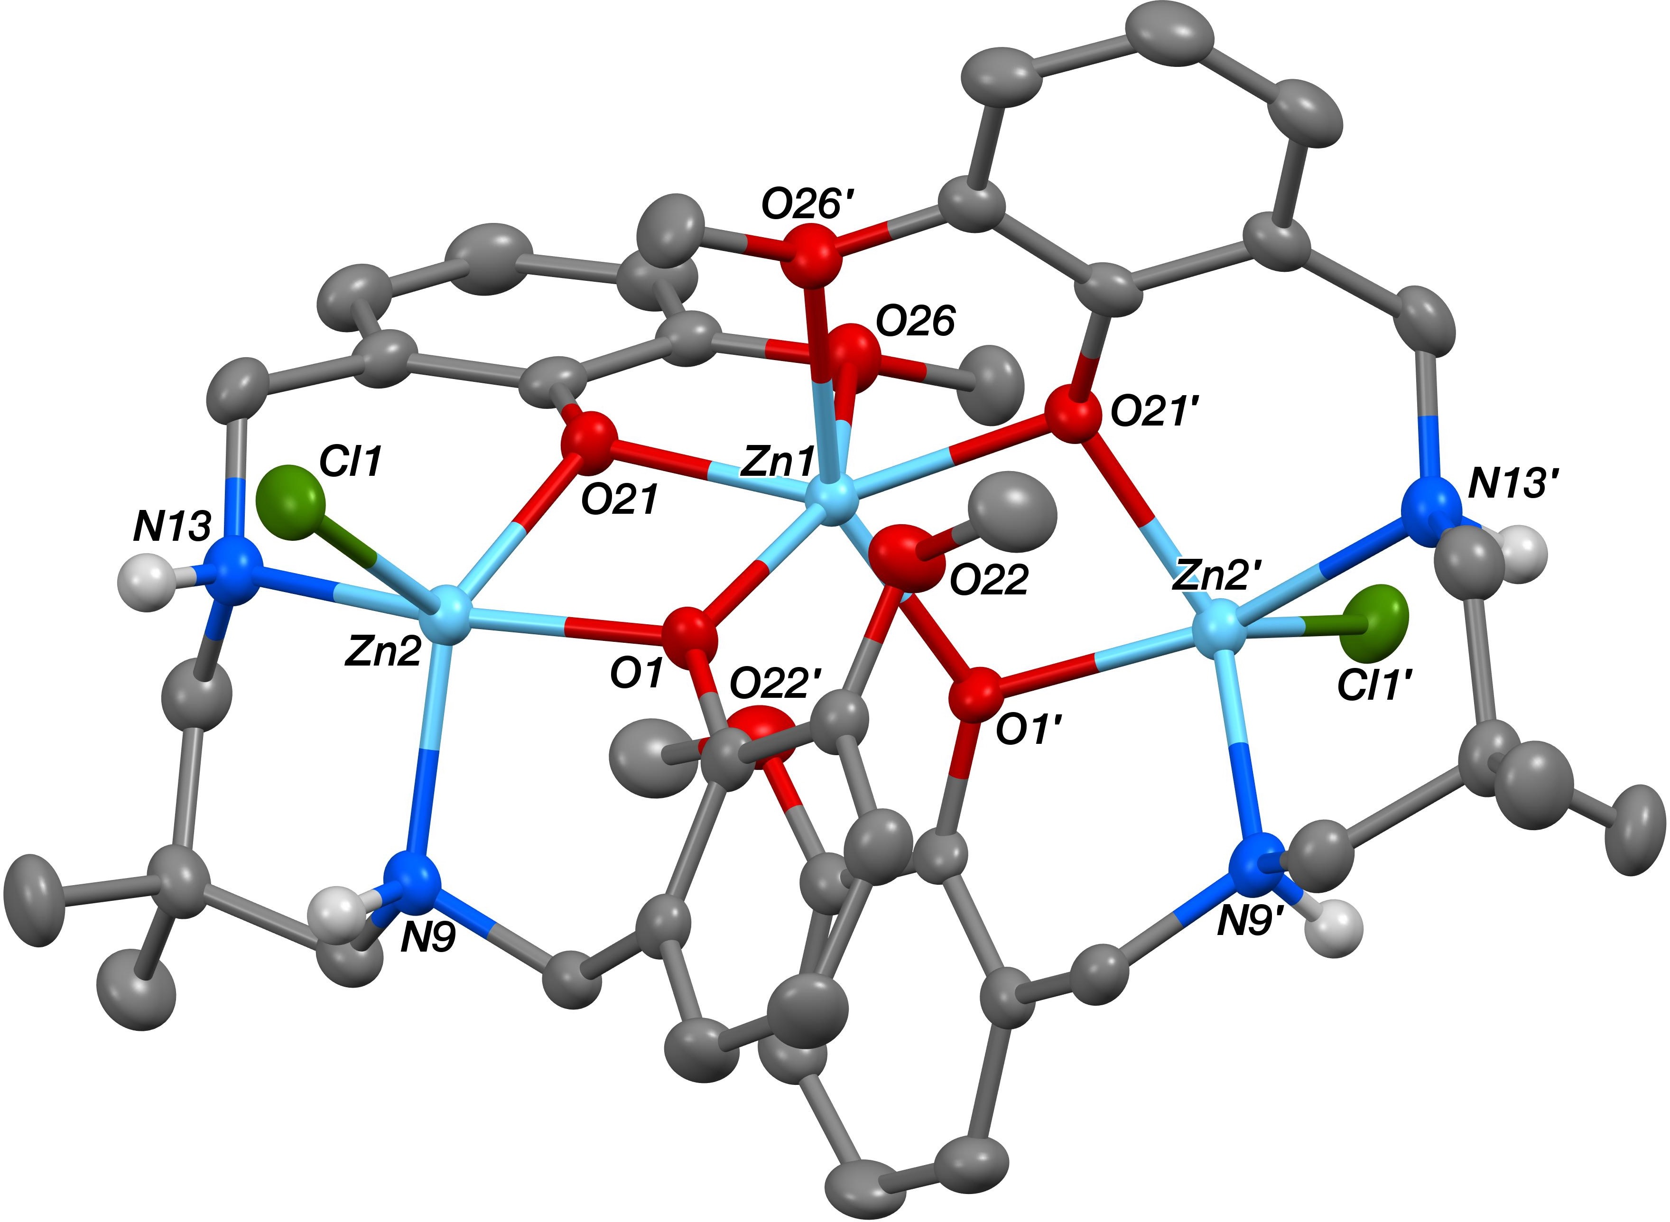

### **Figure S40**: Molecular structure of **(L2b)2Zn3(OAc)2** with thermal displacement ellipsoids at the 50% probability level and hydrogen atoms omitted for clarity.

The structure of **(L2b)Zn3Cl2** showed the complex to sit across a *C*2 axis that passes through Zn1 and bisects the O26···O26A vector. The N9 and N13 N–H hydrogen atoms were located from Δ*F* maps and refined freely subject to an N–H distance constraint of 0.90 Å. The O30- and O40-based included THF solvent molecules were found to be disordered, and in each case two orientations were identified, of *ca*. 65:35 and 52:48% occupancy respectively. The geometries of all four orientations were optimised, the thermal parameters of adjacent atoms were restrained to be similar, and only the non-hydrogen atoms of the major occupancy orientations were refined anisotropically (those of the minor occupancy orientations were refined isotropically).

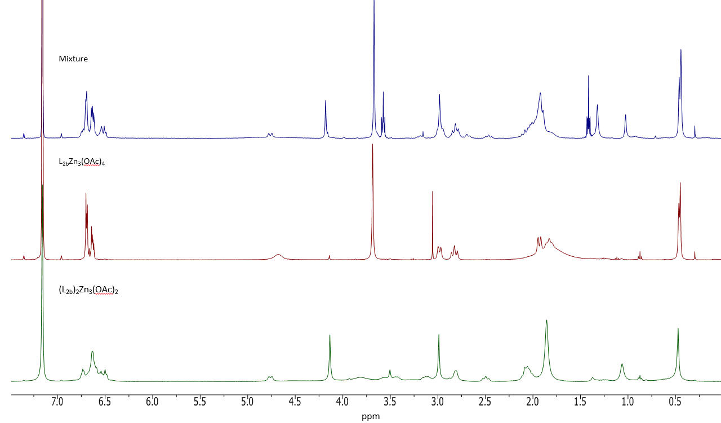

### **Figure S41**: Overlaid 1H NMR spectra of the **L2bZn2(OAc)**2 mixture (top), **L2bZn3(OAc)4**(middle) and **(L2b)2Zn3(OAc)2** (bottom) (C6D6, 298 K).

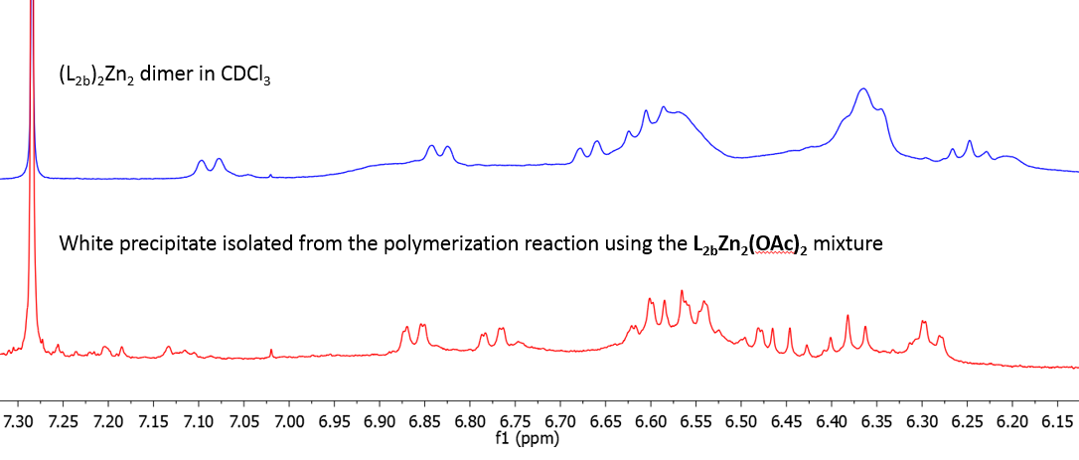

### **Figure S42**: Overlaid 1H NMR spectra of **(L2b)2Zn2** (top) and the product isolated from the CO2/CHO polymerization reaction using the **L2bZn2(OAc)2** catalyst at 1 bar of CO2 after 2 days at 80oC (bottom) (CDCl3, 298 K).

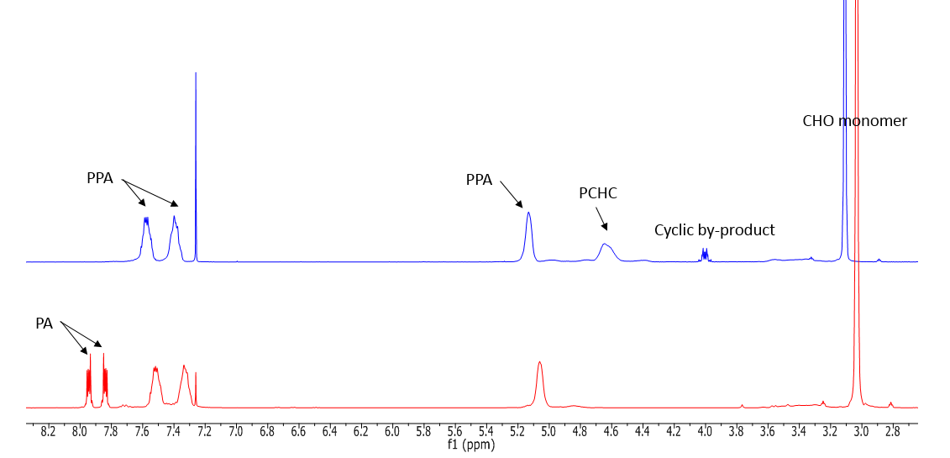

### **Figure S43**: Overlaid 1H NMR spectra of the terpolymerization of PA/CHO/CO2 using **L2aZn2(OAC)2** after 2 h of reaction (bottom) and 18 h of reaction (top) (CDCl3, 298 K)

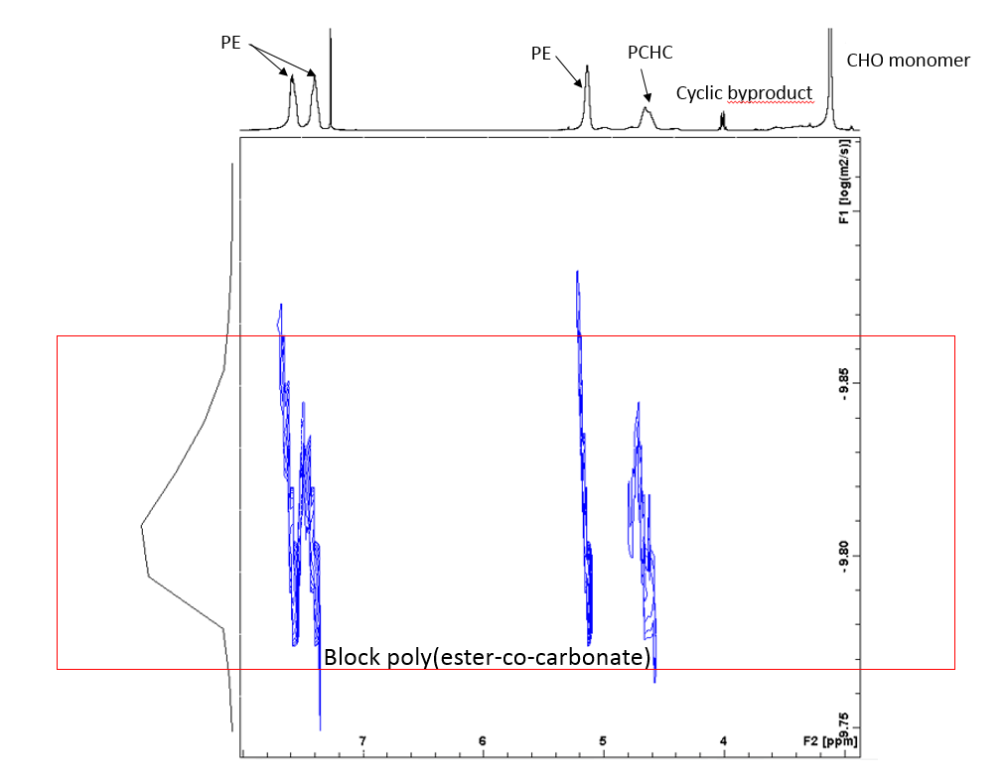

### **Figure S44**: DOSY spectrum of the crude poly(ester-co-carbonate) (CDCl3, 298K).

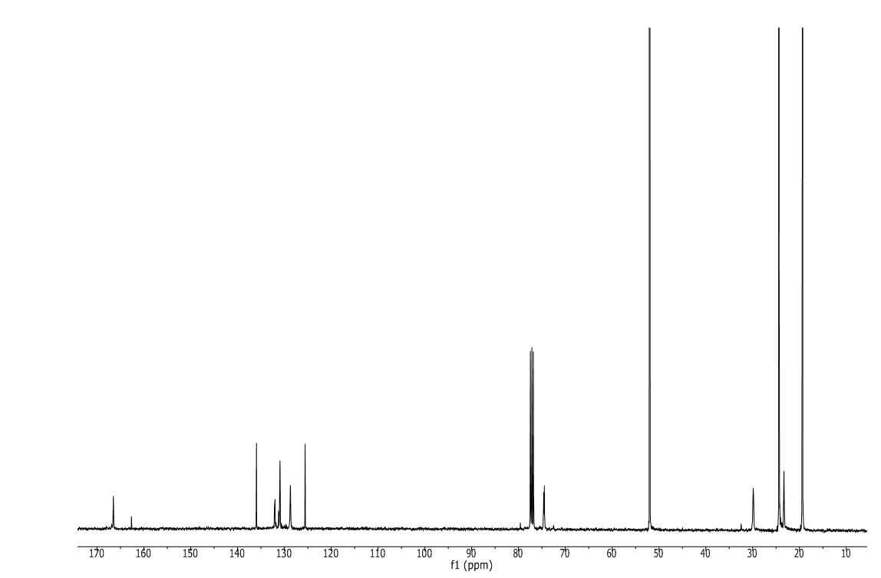

### **Figure S45**: 13C NMR spectrum of the block poly(ester-co-carbonate).

# DOSY NMR Spectroscopy

The Diffusion-Ordered Spectroscopy (DOSY) NMR experiments were performed at 298 K on a Bruker 500 AVANCE III HD NMR spectrometer operating at a frequency of 500.13 MHz for proton resonance under TopSpin (version 3.2, Bruker Biospin, Karlsruhe) and equipped with a z-gradient bbfo/5mm tuneable “SmartProbe”TM probe and a GRASP II gradient spectroscopy accessory providing a maximum gradient output of 53.5 G/cm (5.35G/cmA).

Diffusion ordered NMR data was acquired using the Bruker pulse program ledbpgp2s with a spectral width of 5500Hz (centred on 4.5 ppm) and 32768 data points. A relaxation delay of 12 s was employed along with a diffusion time (large delta) of 100 ms and a longitudinal eddy current delay (LED) of 5 ms. Bipolar gradients pulses (little delta/2) of 2.2 ms and homospoil gradient pulses of 0.6 ms were used. The gradient strengths of the 2 homospoil pulses were -17.13% and -13.17%. 32 experiments were collected with the bipolar gradient strength, initially at 2% (1st experiment), linearly increased to 95% (32nd experiment). All gradient pulses were smooth-square shaped (SMSQ10.100) and after each application a recovery delay of 200 µs used. The experiment was run with 24 scans per increment, employing one stimulated echo with two spoiling gradients.

DOSY plots were generated by using the DOSY processing module of TopSpin. Parameters were optimized empirically to find the best quality of data for presentation purposes. Diffusion coefficients were calculated by fitting intensity data to the Stejskal-Tanner expression.

## Calibration plots

A calibration plot was formed through DOSY analysis of a range of standards spanning the molecular weight range of 161.4 to 643.4 g mol‑1 [hexamethyldisilazane (HMDSH), 161.4; Zn(HMDS)2, 386.2; β-diketiminate ligand HC(C(Me)N-2,6-iPr2C6H3)2, (BDIH), 418.7; (BDI)Zn(HMDS), 643.4 g mol‑1, Table S1]. From the diffusion coefficients of the external standards, linear calibration graphs were obtained by plotting logD vs logMW (Graph S1). Following DOSY analysis of the product, the diffusion coefficient obtained for the signals corresponding to the productallowed an estimate of the MW of the species present in solution.

### **Table S1**: Diffusion coefficients of standards in d5-pyridine solution compared to their molecular weight.

|  |  |  |  |
| --- | --- | --- | --- |
| **Compound** | **LogD** | **MW**  **(g mol-1)** | **LogMW** |
| d5-pyridine | -8.831 | 84.1 | 1.9250 |
| HMDSH | -8.975 | 161.4 | 2.2079 |
| Zn(HMDS)2 | -9.203 | 386.2 | 2.5868 |
| BDIH | -9.247 | 418.7 | 2.6219 |
| (BDI)Zn(HMDS) | -9.298 | 643.4 | 2.8085 |

### **Graph S1**: LogD vs LogMW representation from the 1H DOSY NMR data obtained for the standards HMDSH, Zn(HMDS)2, BDIH and (BDI)Zn(HMDS) in d5-pyridine solvent.

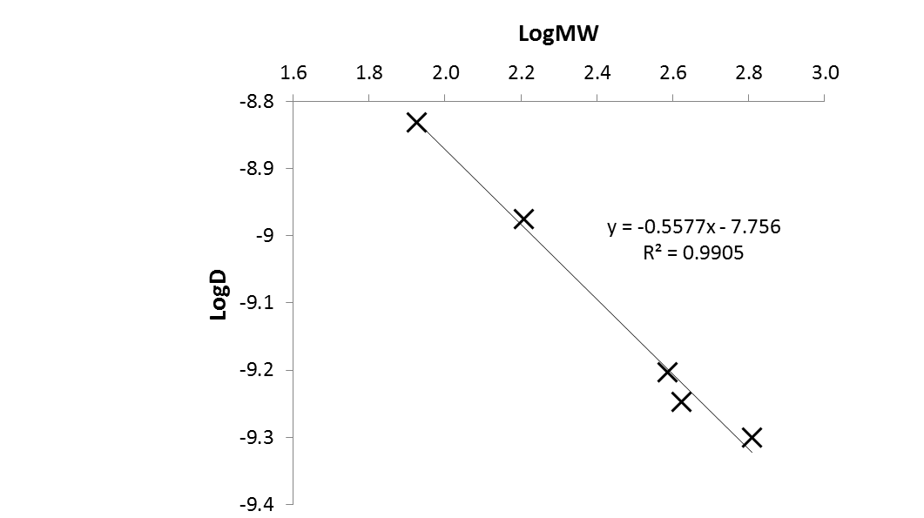

### **Table S2**: Diffusion coefficients of standards in d8-toluene solution compared to their molecular weight.

|  |  |  |  |
| --- | --- | --- | --- |
| **Compound** | **LogD** | **MW**  **(g mol-1)** | **LogMW** |
| d8-toluene | -8.702 | 100.2 | 2.0008 |
| HMDSH | -8.850 | 161.4 | 2.2079 |
| Zn(HMDS)2 | -9.039 | 386.2 | 2.5868 |
| (BDI)Zn(HMDS) | -9.182 | 643.4 | 2.8085 |

### **Graph S2**: LogD vs LogMW representation from the 1H DOSY NMR data obtained for the standards HMDSH, Zn(HMDS)2 and (BDI)Zn(HMDS) in d8-toluene solvent.

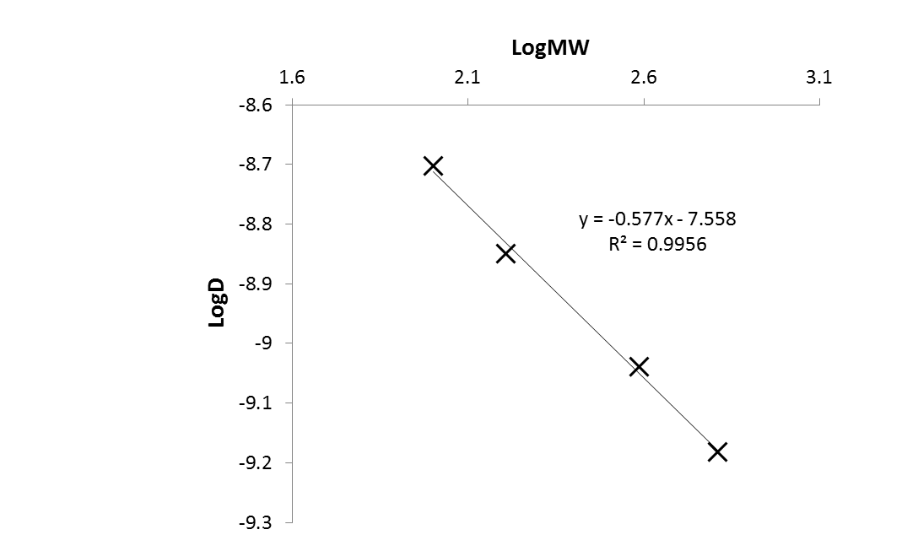

### **Table S3**: Diffusion coefficients of standards in d8-THF solution compared to their molecular weight.

|  |  |  |  |
| --- | --- | --- | --- |
| **Compound** | **LogD** | **MW**  **(g mol-1)** | **LogMW** |
| d8-THF | -8.568 | 80.2 | 1.9040 |
| HMDSH | -8.763 | 161.4 | 2.2079 |
| Zn(HMDS)2 | -8.943 | 386.2 | 2.5868 |
| BDIH | -8.990 | 418.7 | 2.6219 |

### **Graph S3**: LogD vs LogMW representation from the 1H DOSY NMR data obtained for the standards HMDSH, Zn(HMDS)2 and BDIH in d8-THF solvent.

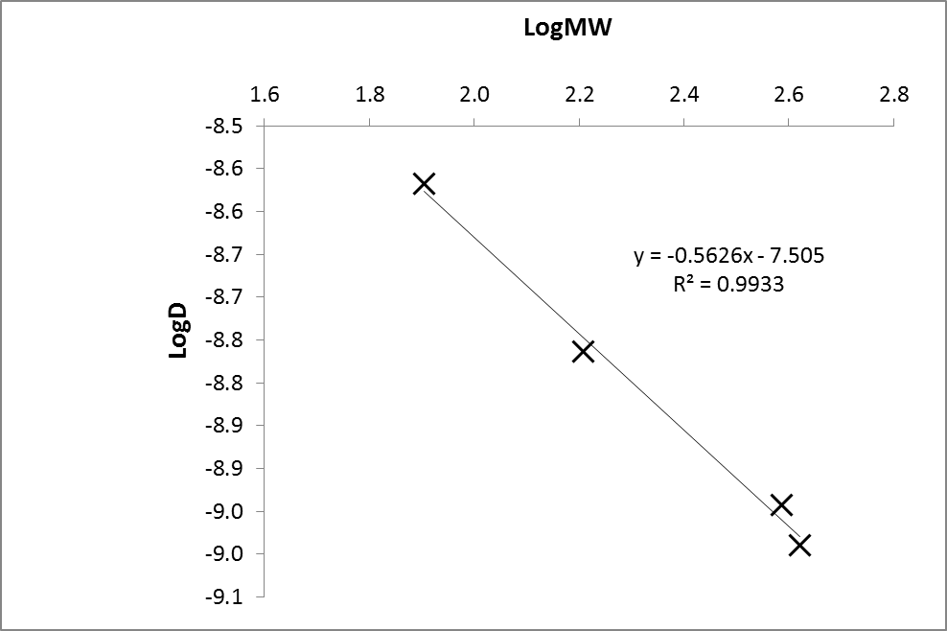

# Crystallographic data:

### **Table S4**: Crystallographic Data for compounds **(L1a)Zn2(OAc)2, (L2b)2Zn2-THF**, **(L2b)2Zn2-MeOH**, **(L2b)Zn3(OAc)4** and **(L2b)Zn3Cl2**.

|  |  |  |  |  |  |  |
| --- | --- | --- | --- | --- | --- | --- |
| Data | **(L1a)Zn2(OAc)2** | **(L2b)2Zn2-THF** | **(L2b)2Zn2-MeOH** | | **(L2b)Zn3(OAc)4** | **(L2b)Zn3Cl2** |
| chemical formula | C26H30N2O8Zn2 | C42H56N4O8Zn2 | C42H56N4O8Zn2 | C29H40N2O12Zn3 | | C42H56Cl2N4O8Zn3 |
| Solvent | CH2Cl2 | 6(C4H8O) | 2(CH4O) | — | | 4(C4H8O) |
| Fw | 714.18 | 1308.27 | 939.73 | 804.74 | | 1300.33 |
| *T* (°C) | –100 | –100 | –100 | –70 | | –100 |
| space group | *P*-1 (no. 2) | *P*-1 (no. 2) | *P*-1 (no. 2) | *Pbca* (no. 61) | | *C*2/*c* (no. 15) |
| *a* (Å) | 8.2671(3) | 11.0206(4) | 11.3488(4) | 18.7381(11) | | 17.2730(5) |
| *b* (Å) | 12.7351(8) | 12.7927(5) | 14.2169(5) | 18.6958(6) | | 20.0374(5) |
| *c* (Å) | 14.1980(6) | 13.4261(6) | 15.4784(4) | 18.9958(6) | | 19.2903(6) |
| α (deg) | 89.017(4) | 108.871(4) | 95.168(3) | 90 | | 90 |
| β (deg) | 87.860(3) | 108.312(4) | 100.165(3) | 90 | | 114.880(4) |
| γ (deg) | 79.825(4) | 92.889(3) | 111.371(3) | 90 | | 90 |
| *V* (Å3) | 1470.18(13) | 1675.87(13) | 2256.46(13) | 6654.7(5) | | 6056.8(3) |
| *Z* | 2 | 1 [c] | 2 [d] | 8 | | 4 |
| ρcalcd (g cm–3) | 1.613 | 1.296 | 1.383 | 1.606 | | 1.426 |
| λ (Å) | 0.71073 | 0.71073 | 0.71073 | 0.71073 | | 0.71073 |
| μ (mm–1) | 1.864 | 0.780 | 1.123 | 2.208 | | 1.329 |
| *R*1(obs) [a] | 0.0379 | 0.0462 | 0.0400 | 0.0531 | | 0.0358 |
| *wR*2(all) [b] | 0.0905 | 0.1149 | 0.1053 | 0.1102 | | 0.0852 |

[a] *R*1 = Σ||*F*o| – |*F*c||/Σ|*F*o|. [b] *wR*2 = {Σ[*w*(*F*o2 – *F*c2)2] / Σ[*w*(*F*o2)2]}s1/2; *w*–1 = σ2(*F*o2) + (*aP*)2 + *bP*. [c] The molecule has crystallographic *Ci* symmetry. [d] There are two independent *Ci* symmetric molecules.

Table S4 provides a summary of the crystallographic data for compounds **(L1a)Zn2(OAc)2**, **(L2b)2Zn2-THF**, **(L2b)2Zn2-MeOH**, **(L2b)Zn3(OAc)4** and **(L2b)Zn3Cl2**. Data were collected using an Agilent Xcalibur PX 3E diffractometer, and the structures were refined using the SHELXTL and SHELX-2013 program systems.2 CCDC 1420956 to 1420960.

# References:

(1) Li-ying Wu, D.-d. F., Xing-qiang Lu and Rong Lu *Chin. J. Polym. Sci.* **2014**, *32*, 768.

(2) (a) SHELXTL, Bruker AXS, Madison, WI; (b) SHELX-2013, http://shelx.uni-ac.gwdg.de/SHELX/index.php