Correlative Light-Ion Microscopy for Biological Applications
Sergio Bertazzo, Thomas von Erlach, Silvia Goldoni, Pelin L Çandarlıoğlu and Molly M Stevens*
Received (in XXX, XXX) Xth XXXXXXXXX 20XX, Accepted Xth XXXXXXXXX 20XX
DOI: 10.1039/b000000x

Here we report a new technique, Correlative Light-Ion Microscopy (CLIM), to correlate SEM-like micrographs with fluorescence images. This technique presents significant advantages over conventional methods in enabling topographical and biochemical information to be correlated with nanoscale resolution without destroying the fluorescence signal. We demonstrate the utility of CLIM for a variety of investigations of cell substrate interactions validating its potential to become a routine procedure in biomedical research.
Epifluorescence microscopy is one of the most widely used techniques in cell biology, providing a simple means to obtain spatial information about proteins. However, the information gained is typically limited in resolution by the wavelength of the light used and restricted to the proteins targeted. On the other hand, Scanning Electron Microscopy (SEM) offers much higher magnification and can easily provide three-dimensional visual information of all superficial components present on samples. For this reason, SEM has been increasingly applied to the study of cells and their interaction with biomaterials.¹ Notwithstanding its several advantages, electron microscopy typically cannot yield information on the biochemical nature of a sample. Hence, epifluorescence and electron microscopy are two ideally complementary methods and developing approaches to use both on the same sample would impact greatly on all fields of cell biology.
In spite of the highly desired combination of fluorescence and SEM to study biological specimens, to date several factors have prevented their simultaneous use. Firstly, samples for SEM need to be dried and coated with a conductive layer, whereas samples for fluorescence microscopy are typically retained in a hydrated state. Secondly, the fluorescence signal is extremely delicate and is destroyed by the high-energy electron beam used for SEM. Due to these mutually exclusive requirements, the way researchers currently obtain a fluorescence and a SEM image of the same region of a specimen is by recording a fluorescence image first, and a SEM image afterwards.²⁻⁴ Correlating the same microscopic region of a specimen by SEM and fluorescence is time-consuming and, in the absence of landmarks visible with both techniques, sometimes impossible. Whilst several attempts have been made to correlate light and electron microscopy,^{2, 5-8} these approaches do not allow one to reverse back to fluorescence imaging following electron microscopy, since electron imaging destroys the fluorescent signal. The possibility of re-examining samples with either microscopy technique would give users considerable advantages over traditional methods.
Here we report the combination of Scanning Ion Microscopy (SIM) and fluorescence imaging to obtain topographical and biochemical information from the same area of the sample at nanoscale resolution, without destroying the fluorescence signal. SIM, unlike the electron beam used in SEM, uses a gallium beam to extract secondary electrons from a surface and yet generates an electron micrograph. We demonstrate here that the gallium beam can be used with fluorescent probes without loss of fluorescence (probably because gallium ions have low penetration into the surface of the sample^{9, 10}), a characteristic never shown before. As additional an advantage, SIM allows etching of the sample (a feature that is commonly used in sample preparation for Transmission Electron Microscopy (TEM))¹¹ at nanoscale resolution, creating selective branding and easy identification of the area of interest.
The method presented here does not require any steps in addition to the standard sample preparation and handling procedures for conventional SIM and fluorescence microscopy. Following immuno-staining, samples were dehydrated in a graded series of ethanol dilutions (25, 50, 70, 90 and 100%, 5 min each), immersed in HMDS for 5 min and then dried at room temperature. The immersion in HMDS guarantees that ultra-structural features of the cell are not altered during the drying process.¹² Finally, samples were imaged by fluorescence microscopy (Supplementary Fig. 1) to confirm that the fluorescence signal was still intact. Samples were coated with 5 nm of chromium and then introduced into a SIM (Helios NanoLa 50 series Dual Beam microscope). The equipment was operated as usual, and the first step was to obtain an overview of the sample to find an area of interest for detailed analysis using the ion beam. The region chosen was then branded by milling with the gallium beam (Fig. 1a). The branding enabled localisation of this area with an optical microscope and facilitated switching back and forth between the two imaging techniques (Fig. 1b). The fluorescence signal proved to be stable to several cycles of fluorescence and ion micrographs. The same sample already imaged by SIM and fluorescence microscopy was re-introduced in the FIB microscope so that a second region, this time within cells, could be branded (Fig. 1c). After this procedure, a new fluorescence micrograph was successfully obtained showing preservation of vinculin and actin fibres even at sub-micron distances from the branding (Fig. 1d, e).
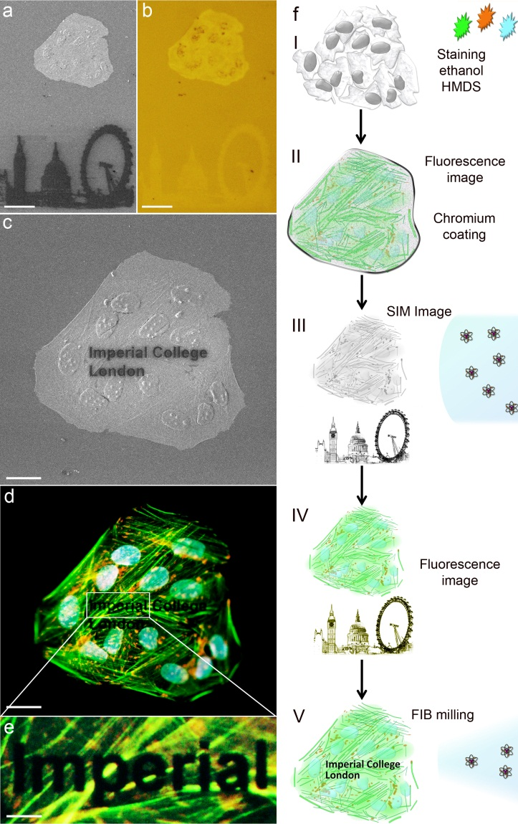
Figure 1: SIM and fluorescence micrographs showing that ion milling with a gallium beam does not alter the fluorescence signal. (a) SIM image with a section of the London skyline branded through ion milling below Saos-2 osteosarcoma cells grown on glass, processed for fluorescence, dried and coated with chromium (I, II and III in the scheme). Scale bar = 50 µm. (b) Corresponding bright field image of the same region shown in a, previously imaged by SIM (IV in the scheme). Scale bar = 50 µm. (c) SIM micrograph of the same cells presented in a and b after additional textual branding on the cells (V in the scheme). Scale bar = 25 µm. (d) Fluorescence micrograph corresponding to panel c. Cells were stained for vinculin (red), actin (green) and nuclei (blue) (V in the scheme). Scale bar = 25 µm. (e) Higher magnification of the branding on cells showing that there is no damage to the fluorescence signal in the vicinity of the milled region. Scale bar = 5 µm. (f) Scheme of the steps taken to obtain SIM and fluorescence micrographs of the same region within a sample. (I) Staining and drying, (II) chromium coating, (III) ion branding and electron image acquisition, (IV) fluorescence image acquisition and (V) ion branding and fluorescence image acquisition.

For comparison with the ion beam, the effect of a conventional electron beam on the fluorescence signal was investigated. Two grooves were milled side by side on the same sample using the ion beam and subsequently imaged using either the electron beam or the ion beam respectively (Supplementary Fig. 2 and 3). The fluorescence signal suffered considerable bleaching by the electron beam (Fig. 2a, 1) whereas the region imaged by the ion beam (Fig. 2a, 2) appeared intact.
This approach is likely to find applications across the fields of cell biology and biomaterials and could play role in the investigation of the cell-material interaction. We used a popular cell biology platform, single cells grown on a micropatterned surface,^{13, 14} as a successful an application example (Fig. 2b, c). In addition, we tested the method on a 3D biomaterial scaffold designed for musculoskeletal tissue engineering and images of the polymer microfibers (Fig. 2d, e) highlight the spatial correlation between cells and the 3D environment. Moreover, the identification of the imaged cells was extremely time-efficient, since the branding function on the SIM for simple landmarks does not require more than 2 min.
Finally, we tested the possibility to correlate Light-Ion Microscopy with Total Internal Reflection Fluorescence (TIRF) microscopy, in order to obtain correlation of SIM and fluorescence micrographs at the sub-micro scale. Dehydrated and chromium-coated samples presented image quality similar to that of samples prepared by standard protocols for TIRF microscopy. SIM/TIRF correlation images of a migrating fibroblast (Fig. 2f, g) enabled the visualization of vinculin organized in large focal adhesion complexes opposite the mobile cell edge, indicating that the cell is in an intermediate step of migration, where one of its sides is still stably adhered to the substrate. As mentioned earlier, with SIM it is possible to create fiducial marks at the nanoscale (Supplementary Fig. 4) and these therefore allow us to correlate SIM and TIRF images at the nanoscale.
Moreover, it is worth noting that TIRF microscopy can be used in combination with super-high resolution microscopy¹⁵, which could push the scale of correlation even further, to single molecule identification and correlation.
Conclusions
We believe that being able to repeatedly obtain images of the same sample by fluorescence and ion microscopy and to correlate SIM and TIRF micrographs at the submicron and nanoscale (Supplementary Fig. 4) can considerably contribute to the field of biological imaging. Given the simplicity, robustness and efficiency of this new approach, together with the fact that SIM microscopes are becoming more and more common in universities and other research centres, there is a strong likelihood that the technique presented here will rapidly become a routine procedure in biomedical laboratories.

Experimental
Cell Culture
Human foreskin fibroblasts (hFFs), Saos-2 osteosarcoma and MC3T3-E1 clone 4 pre-osteoblast cell lines (all from ATCC) were used for this study under standard cell culture conditions (37ºC, 5% CO₂). DMEM, RPMI 1640 and α-MEM media were used, respectively, with 10% (v/v) fetal bovine serum (all from Gibco®, Invitrogen). RPMI was supplemented with 1% (v/v) L-glutamine (Invitrogen). 0.25% (v/v) Trypsin-EDTA solution (Invitrogen) was used to detach cells.
Immuno-fluorescence Staining and Imaging
Cells grown on glass, micro-patterns on polystyrene or PLLA scaffolds were immuno-stained using standard procedures.
Briefly, cells were fixed with 4% (v/v) formalin in dH2O (Sigma) for 15 min at room temperature, washed with PBS, permeabilised with 0.25% (v/v) Triton-X-100/PBS for 2 min, Figure 2: Effect of electron and ion beam irradiation on fluorescence signal and the application of SIM imaging to relevant biological samples. (a) Comparison of ion and electron beam scanning effect on fluorescent signal. Saos-2 cells were cultured on glass, stained for vinculin (red), actin (green) and nuclei (blue), dried and coated with chromium. Two regions were branded by ion milling. These areas were then imaged with either an electron beam (1) or an ion beam (2). Subsequently, both regions were visualised by fluorescence microscopy, demonstrating that the ion-irradiated region was unchanged whereas the electron-irradiated region was significantly altered. (b and c) SIM image and correspondent fluorescence micrograph of a fibroblast cultured onto a triangular micro-patterned surface on polystyrene. Cells were stained for tubulin (red), actin (green) and nuclei (blue). (d and e) SIM and fluorescence micrographs of the same MC3T3-E1 pre-osteoblast cells cultured on electrospun poly-lactic acid (PLLA) micro-fibres. Cells were stained for actin (red) and nuclei (blue). (f and g) Correlative SIM/TIRF micrograph of a migrating human fibroblast stained for vinculin (red). The zoomed in area shows that features down to around 200 nm can be correlated.

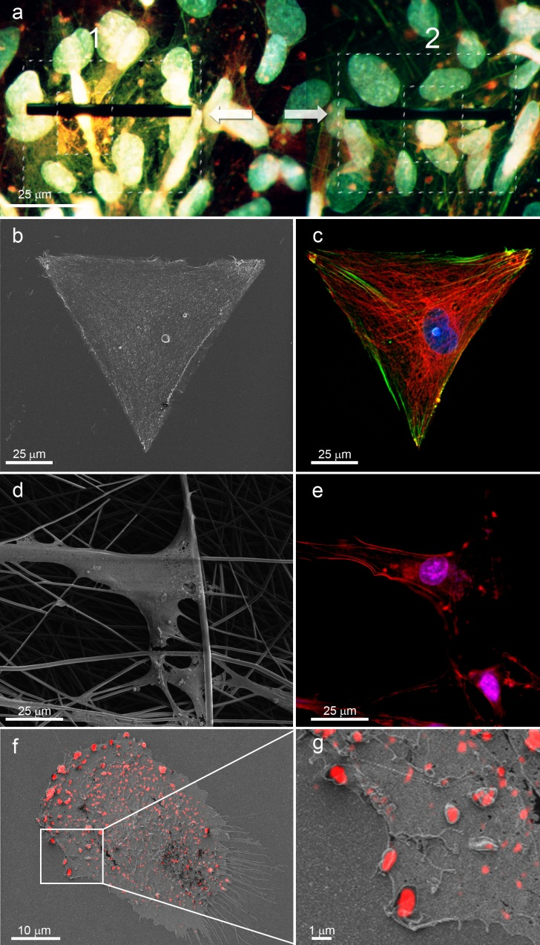
washed with PBS, permeabilised with 0.25% (v/v) Triton-X-100/PBS for 2 min, washed with PBS and then blocked with 4% (w/v) bovine serum albumin in PBS. Primary and secondary antibodies were incubated in blocking buffer for 1h at room temperature. Alexa Fluor®488 and Alexa Fluor®568 phalloidin (1:300 dilution) were incubated for 30 min and DAPI (4',6-diamidino-2-phenylindole) for 5 min at the end of the procedure (all from Molecular Probes, Invitrogen). Primary antibodies used were mouse anti-vinculin (abcam; 1:100) and anti-tubulin (Millipore; 1:100). Secondary antibody used was anti-mouse Alexa Fluor®568 (Molecular Probes, Invitrogen; 1:300). It is important to note that the fluorescence signal from all samples analysed did not present any noticeable variation in intensity over periods longer than two weeks. An Olympus BX51 upright was used to image fluorescence.
TIRF microscopy only illuminates fluorophores located approximately 100nm into the cell, that is several folds higher than the stack resolution of a conventional confocal microscope. Due to the minimized background, the signal-to-noise ratio of TIRF is higher compared to traditional epifluorescence or confocal microscopy, making it a uniquely suitable and extremely powerful microscopy technique for the study of biological processes at or near the plasma membrane.¹⁶
For TIRF microscopy, a non-commercial microscope with a 75 mW Diode Pumped Solid State Laser (Jive-75 TEMoo) at 561nm, an Alpha Plan Fluar Objective (100x/1.45 W), and a high-sensitivity back-illuminated EM-CCD camera (Hamamatsu C9100-13) was used.
SIM and SEM
Samples were secured to a SIM aluminium sample holder with carbon tape and silver paint applied to area immediately surrounding the sample (to maximise conductivity) then coated with 5 nm of chromium in a sputter coater (Quorum Technologies model K575X). Gold and carbon coating have been tested as alternatives with similar results (not presented here).
Following the coating procedure, samples were introduced into an Ion Microscope (FEI FIB200-SIMS or a SEM/Focused Ion Beam Helios NanoLa 50 series Dual Beam) with gallium beam operated at 30 KV and 28 pA current. SEM micrographs were obtained using electron beam at 5 KV and 0.17 nA current. For the milling procedure, the gallium beam was operated at 30 KV and 93 pA.
Materials Preparation
Micro-contact printing- Stamps were made by replica casting polydimethylsiloxane (PDMS, Sylgard 184; Dow Corning, Midland, MI) against a silicon master made by photolithography. PDMS pre-polymer was poured over the silicon master and cured at 60°C overnight. The elastomeric stamp bearing the negative pattern of the master was peeled off and stored dry in a closed well plate at room temperature. Stamps were sonicated for 30 min in ethanol, rinsed three times with distilled water, blown dry under nitrogen, oxidized in air plasma for 1 min (200 mtorr) (Plasma Prep 5, Gala Instruments) and used for contact printing immediately.
To allow adsorption of proteins, plasma-activated stamps were immersed for 1h in an aqueous solution of human fibronectin (50µg/mL, Sigma). Stamps were rinsed thoroughly with deionized water, blown dry under nitrogen, and placed in conformal contact with the substrate (non-treated polystyrene multi-dish, Nunclon Surface) for 60s before being peeled off. Subsequently, substrates were immersed in 0.1% (w/v) Pluronic F127 (Sigma) in phosphate-buffered saline (PBS) for 1h, and carefully rinsed with water without allowing the surface to dry. hFFs were seeded in serum-free medium immediately after the micro- contact printing procedure. After 2h cell adhesion, medium was replaced with serum-containing medium. After 24h cells were treated for immuno-fluorescence.
PLLA scaffolds electrospinning- Poly (L-lactide) was purchased from PURAC Biochem (The Netherlands). 3D fibrous scaffolds of PLLA were produced by electrospinning. Briefly, 8% (w/v) PLLA polymer was dissolved in HFIP and solutions were pumped through a syringe fitted with a 27G½ needle (Becton Dickinson, USA). The polymer solution was electrospun from a distance of 12 cm between the needle and aluminium collecting plate with an applied voltage of 7 kV and a flow rate of 1 ml h-1 for 40 min. Scaffolds were collected on glass cover slips and placed under vacuum for 24 h prior to use. Non-cytotoxic surgical silicone glue (Bluestar Silicones, Factor2 Inc., AZ, USA) was applied at the edges of the glass cover slips to immobilize the electrospun scaffolds. MC3T3-E1 cells were seeded in serum-free medium and after 2h cell adhesion, serum-containing medium was added. After 3 days in culture cells were treated for immuno-fluorescence.

ACKNOWLEDGMENT: We thank Nicolas Schaeffer for drawing the scheme shown in Fig. 1f, Yixiang Dong for electrospinning PLLA scaffolds, the Facility for Imaging by Light Microscopy (FILM) at Imperial College London for help and advice, Hans Markus Textor and Fabian Anderegg (ETH Zurich) for providing silicon masters for micro-contact printing. MMS thanks the EPSRC Challenging Engineering grant and ERC grant Naturale for support.
Notes and references
Department of Materials, Department of Bioengineering and Institute of Biomedical Engineering, Imperial College London, London, SW7 2AZ, UK. Fax: +44 (0) 207 5946757; Tel: +44 (0) 207 5946804; E-mail: m.stevens@imperial.ac.uk

† Electronic Supplementary Information (ESI) available: [details of any supplementary information available should be included here]. See DOI: 10.1039/b000000x/

1 M. Schliwa, Nat. Rev. Mol. Cell. Biol. 2002, 3, 291.
2 T. M. Svitkina, G. G. Borisy, Molecular Motors and the Cytoskeleton, Pt B, Elsevier 1998, 298, 570.
3 A. B. Verkhovsky, O. Y. Chaga, S. Schaub, T. M. Svitkina, J.-J. Meister, G. G. Borisy, Mol. Biol. Cell 2003, 14, 4667.
4 D. R. Larson, M. C. Johnson, W. W. Webb, V. M. Vogt, Proc. Natl. Acad. Sci. USA 2005, 102, 15453.
5 D. Evanko, Nat. Meth. 2011, 8, 448.
6 S. Watanabe, A. Punge, G. Hollopeter, K. I. Willig, R. J. Hobson, M. W. Davis, S. W. Hell, E. M. Jorgensen, Nat. Meth. 2011, 8, 80.
7 C. van Rijnsoever, V. Oorschot, J. Klumperman, Nat. Meth. 2008, 5, 973.
8 D. Bishop, I. Nikic, M. Brinkoetter, S. Knecht, S. Potz, M. Kerschensteiner, T. Misgeld, Nat. Meth. 2011, 8,, 568.
9 J. Mayer, L. A. Giannuzzi, T. Kamino, J. Michael, MRS Bull. 2007, 32, 400.
10 L. A. Gianuzzi, F. A. Stevie Introduction to Focused Ion Beams, New York, Springer 2005.
11 M. Marko, C. Hsieh, R. Schalek, J. Frank, C. Mannella, Nat. Meth. 2007, 4, 215.
12 F. Braet, R. De Zanger, E. J. Wisse, Microsc. 1997, 186, 84.
13 C. S. Chen, M. Mrksich, S. Huang, G. M. Whitesides, D. E. Ingber, Science 1997, 276, 1425.
14 R. Singhvi, A. Kumar, G. P. Lopez, G. N. Stephanopoulos, D. I. Wang, G. M. Whitesides, D. E. Ingber, Science 1994, 264, 696.
15 H. Shroff, C. G. Galbraith, J. A. Galbraith, H. White, J. Gillette, S. Olenych, M. W. Davidson, E. Betzig, Proc. Natl. Acad. Sci. USA 2007, 104, 20308.
16 A. L. Mattheyses, S. M. Simon and J. Z. Rappoport, J. Cell. Sci., 2010, 123, 3621.

