**Supplementary Information**

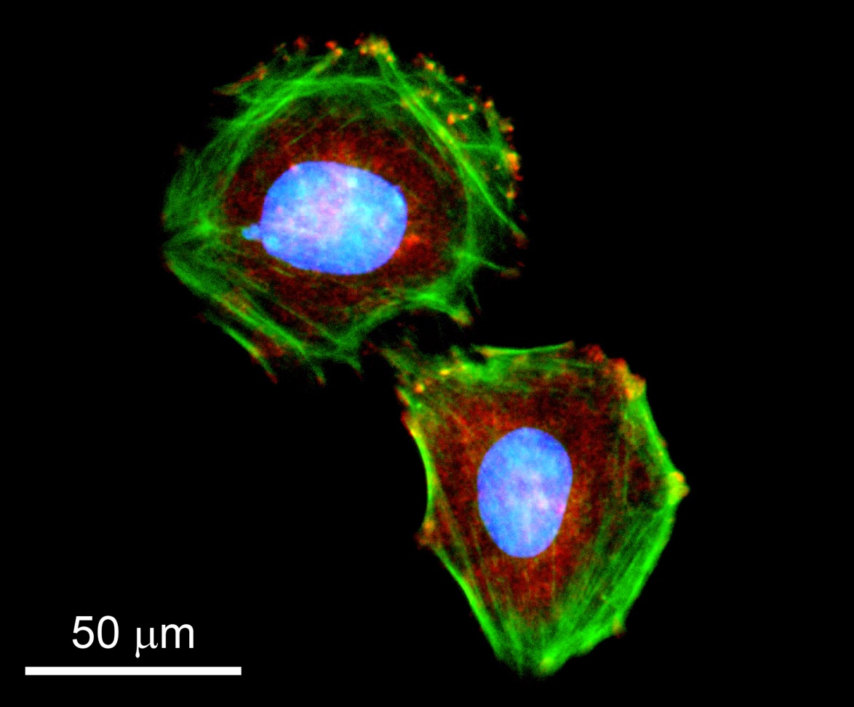

**Supplementary Figure 1:** Fluorescence micrograph of Saos-2 osteosarcoma cells grown on glass for seven days and subjected to immuno-fluorescence for vinculin (red), staining for actin (phalloidin, green) and nuclei (DAPI, blue). Samples shown here were dried through a series of graded ethanol then immersed in HDMS and finally air dried.

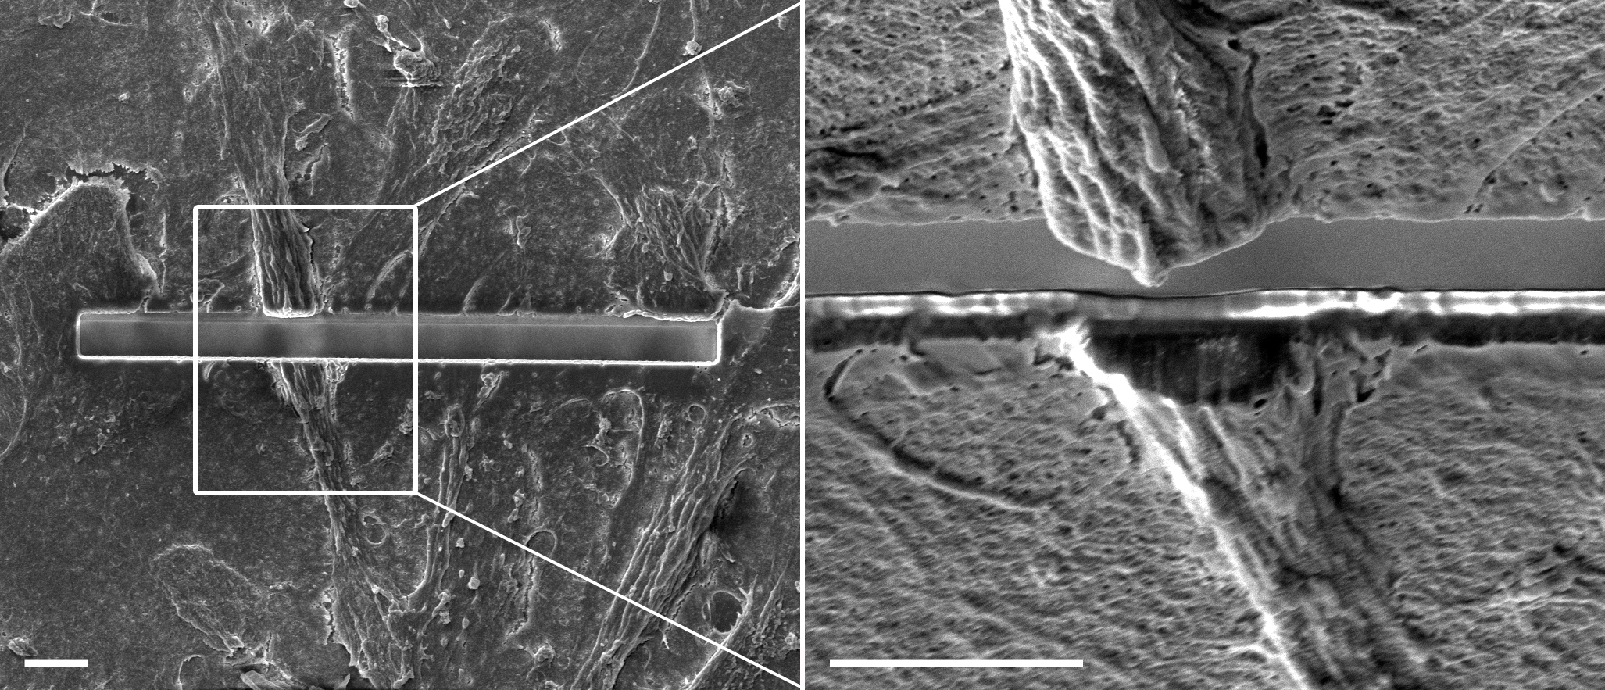

**Supplementary Figure 2:** SEM micrograph of sample shown in Fig. 2a (1) of main text. Saos-2 cells were cultured on glass. Region shown was branded by ion milling and imaged with electron beam. Subsequently, the same region was visualised by fluorescence microscopy. Note how clearly the cell nucleus can be seen through the milling (right panel). Scale bar = 5 µm

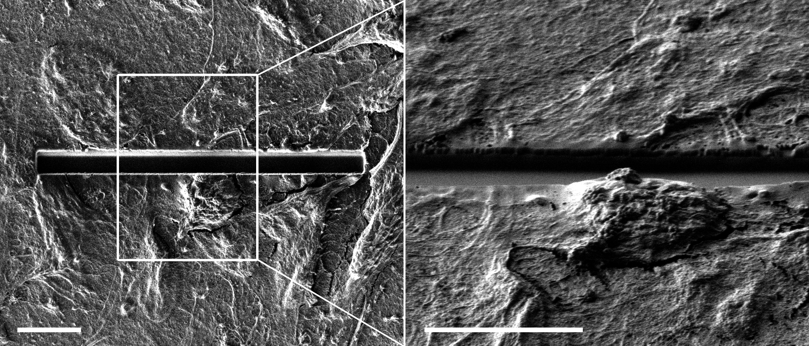

**Supplementary Figure 3:** SIM micrograph of sample shown in Fig. 2a (2) of main text. Saos-2 cells were cultured on glass. Saos-2 cells were cultured on glass. Region shown was branded by ion milling and imaged with gallium ion beam. Subsequently, the same region was visualised by fluorescence microscopy. Scale bar = 5 µm

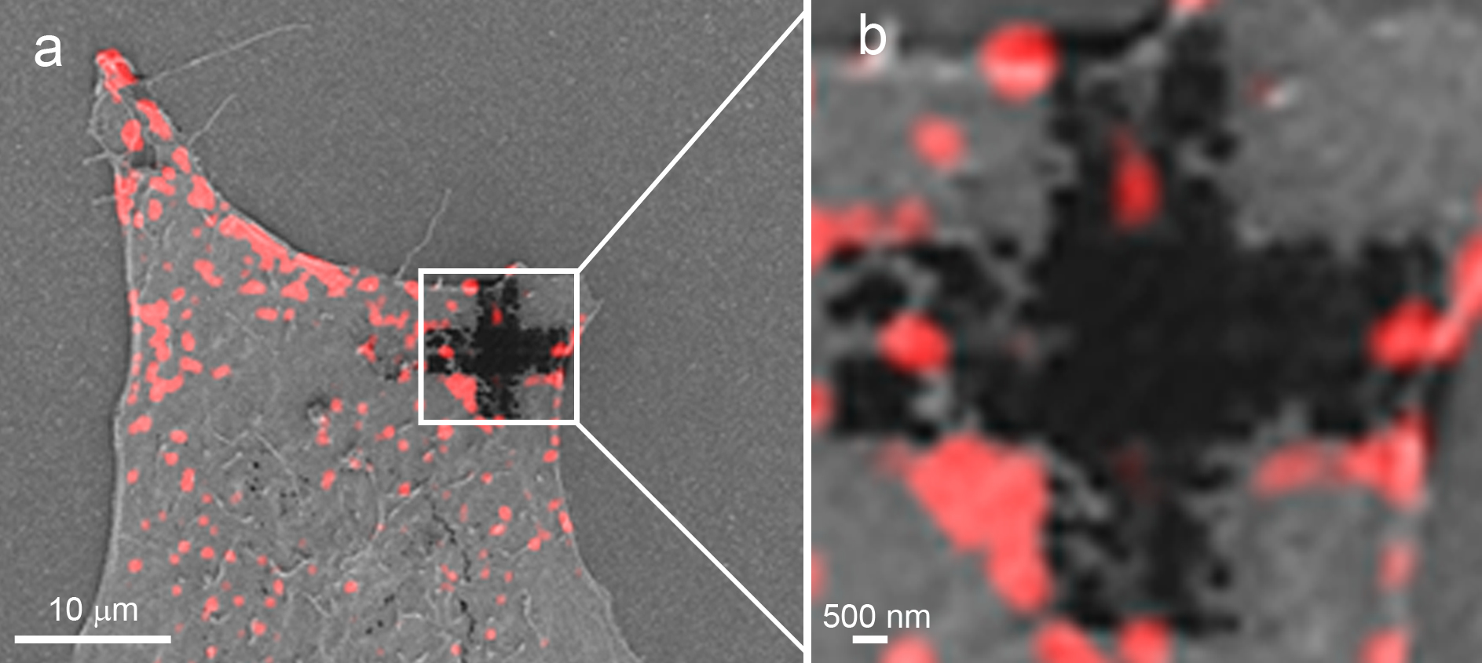

**Supplementary Figure 4:** Correlated SIM/TIRF micrograph. (**a**) Adherent fibroblast stained for vinculin (red) and branded with a fiducial mark by FIB. (**b**) Zoom in on the branded cell area showing intact fluorescence signal notably between the parallel lines of the marks.