Epitaxial Growth of Mixed Conducting Layered Ruddlesden-Popper La_{n+1}Ni_{n}O_{3n+1} (n = 1, 2 and 3) Phases by Pulsed Laser Deposition

Kuan-Ting Wu, Yeong-Ah Soh, Stephen J Skinner*

Department of Materials, Imperial College London, Exhibition Road, London SW7 2AZ, United Kingdom

*Corresponding Author: Email – s.skinner@imperial.ac.uk, Tel - +44(0)20 7594 6782, Fax - +44(0)20 7594 6757

Keywords: A. Layered compounds, A. Thin Films, B. Laser Deposition, C. X-ray Diffraction C. Atomic Force Microscopy,

Abstract
Layered Ruddlesden-Popper phases of composition La_{n+1}Ni_{n}O_{3n+1} (n = 1, 2 and 3) have been epitaxially grown on SrTiO₃ (001) or NdGaO₃ (110) single crystal substrates by using the pulsed laser deposition technique. X-ray diffraction analyses (θ/2θ, rocking curves, and φ-scans) and atomic force microscopy confirms the high-quality growth of the series of films with low surface roughness values (less than 1 nm). In particular, epitaxial growth of the higher order phases (n = 2 and 3) of lanthanum nickelate have been demonstrated for the first time.

1. Introduction
Layered Ruddlesden-Popper (RP) oxides, generally formulated A_{n+1}B_{n}O_{3n+1} (typically n = 1, 2 and 3), are the subject of considerable interest due to their various chemical and physical properties, covering magnetoresistance, superconductivity, multiferroics, oxidation catalysis, proton and mixed ionic-electronic conduction [1-4], exploited in widespread technological applications. The potential applications for these oxides are in a variety of electrochemical devices such as gas sensors, [5, 6] oxygen permeation membranes, [7, 8] solid oxide electrolyser cells [9, 10] and intermediate temperature solid oxide fuel cells (IT-SOFCs) [11].
La_{n+1}Ni_{n}O_{3n+1} phases (n = 1, 2 and 3) have recently attracted significant attention as emerging alternatives to conventional perovskites for use as promising cathode materials for the next generation of IT-SOFCs. [12-14] These layered compounds are typically mixed ionic-electronic conductors (MIEC), composed of n consecutive LaNiO₃ perovskite blocks, alternating with LaO rock-salt blocks (see Figure 1). Of interest has been the series of compounds displaying diverse defect chemistry in bulk, allowing non-stoichiometric defect structures (hypo- and hyper-stoichiometry) with typical formulae La₂NiO_{4+δ}, La₃Ni₂O_{7-δ} and La₄Ni₃O_{10-δ}. Based on the variable oxygen content, two possible crystallographic structures (tetragonal or orthorhombic) have been reported for La_{n+1}Ni_{n}O_{3n+1} (n = 1, 2 and 3) [15] . For potential application as a cathode operating at intermediate temperatures (500~700°C), previous research has demonstrated that La₂NiO_{4+δ} (n = 1) materials are predominantly electronic conductors with very promising ionic conductivity (σ_{i} = ~10⁻² Scm⁻¹)[16] and acceptable electronic conductivity (σ_{e} = ~100 Scm⁻¹), compared to conventional cathode materials [17, 18]. In addition, long-term stability and compatibility of La₂NiO_{4+δ} with lanthanum gallate based (LSGM) electrolytes has been evaluated by Amow et al[13, 14] who found that a Ni²⁺/Ni³⁺ impurity phase formed when La₂NiO_{4+δ} was heated at 900°C for two weeks in air. Thus, La₂NiO_{4+δ} phases are not ideally suited for practical utilization for IT-SOFCs.
Apart from La₂NiO_{4+δ}, higher order RP phases, La₃Ni₂O_{7-δ} (n = 2) and La₄Ni₃O_{10-δ} (n = 3), are of interest for use as SOFC cathodes owing to their superior electrical conductivity, and good chemical and thermomechanical stability in operation at intermediate temperatures (500~700ºC) [14]. However, to enable measurement of intrinsic ionic and electronic transport properties, the greatest challenge is to synthesize dense, continuous polycrystalline or ideally epitaxial specimens of La₃Ni₂O_{7-δ} and La₄Ni₃O_{10-δ}; only 50~60% of their theoretical density has been achieved by traditional ceramic processes (e.g. solid state and sol-gel methods). In this work, growth of model systems on single crystal substrates was conducted by the pulsed laser deposition (PLD) technique in order to obtain high-quality specimens of these compounds.

2. Experimental Section
Synthesis of Targets: PLD targets of La₂NiO_{4+δ} (25 mm in diameter), La₃Ni₂O_{7-δ} and La₄Ni₃O_{10-δ} (13 mm in diameter) with >90%, ~50%, ~50% of theoretical density, respectively, were prepared by the modified Pechini method[19] with stoichiometric amounts of mixed La(NO₃)₃/Ni(NO₃)₂ solutions. According to the approach of Fontaine et al.[20, 21] and Amow et al.[13, 14], a 1:1 molar ratio of citric acid (CA) and polyethylene glycol was adopted and the ratios of CA to nickel metal were held at 3:1 for La₂NiO_{4+δ}, 9:2 for La₃Ni₂O_{7-δ} and 9:3 for La₄Ni₃O_{10-δ}. These targets were verified as single phase compounds via X-ray powder diffraction (XRD). Their cation stoichiometry was confirmed with inductively coupled plasma – atomic emission spectrometry (ICP-AES) and energy-dispersive X-ray spectroscopy (EDX).
Film Growth Procedure: The c-axis oriented epitaxial films of RP-type La_{n+1}Ni_{n}O_{3n+1} (n = 1, 2 and 3) were grown using a Neocera PLD system utilizing KrF excimer laser (λ=248 nm, Lambda Physik COMPex 201). The laser power density was adjusted to 0.5 Jcm⁻² and its repetition rate was 8 Hz. The working distance between the substrate and the target was 50 mm. The oxygen pressure in the vacuum chamber was maintained at 250 mTorr and the substrate temperature was kept at 700-780°C during depositions. These thin-films were deposited on well oriented SrTiO₃ (001) or NdGaO₃ (110) single crystal substrates (Crystal GmbH, Berlin, Germany), noted as STO and NGO respectively, with a dimension of 5×5×0.5 mm, which were selected due to their low lattice mismatch with the ab-plane of perovskite blocks (i.e. LaNiO₃).
Film Characterization: The crystal structure and orientation of the films were characterised by high-resolution X-ray diffraction (PANalytical X'Pert Pro MRD), utilizing Cu Kα radiation (λ = 1.5418 Å), Ge monochromator, X'Celerator detector for high-speed data collection, and 4-angle (2θ, ω, φ and Ψ scan axes) goniometer. Out-of-plane parameters of the films were determined from θ/2θ scans. All 2θ peak positions and d-spacings of every (00L) reflection for each compound were carefully fitted by the Lorentz method. The systematic error was estimated to be 0.031±0.012% from the substrate peak position. Surface roughness of the films was characterized by atomic force microscopy (AFM) (Bruker Dimension 3100). All measurements were carried out in contact mode at ambient atmosphere and room temperature. Film thickness was measured by profilometry (Dektak 150 Surface Profiler) over masked areas.

3. Results and Discussion
Film-substrate preferential orientation is shown in Table I. The data for the n = 1, 2 and 3 compounds with orthorhombic structures were selected as standard references for the calculation of mean lattice mismatch. We consider the room-temperature orthorhombic La₂NiO_{4.25}, La₃Ni₂O₇ and La₄Ni₃O₁₀ [22-24] with their lattice parameters as displayed in Table I. The crystal structure of the STO substrate is cubic with a lattice constant of 3.9050 Å (JCPDF: 35-734); that of NGO is orthorhombic with a=5.4310, b=5.4990, and c=7.7100 Å (JCPDF: 21-0972), possessing pseudo-cubic in-plane parameters of 3.8644 and 3.8550 Å for the (110) plane. The mean lattice mismatch (f) was calculated by using the formula f = [(a_{s}-a_{p})/a_{p}]×100% where a_{s} represents the lattice parameter of the substrates; i.e. a_{s} = 3.9050 for STO (001), and 3.8597 Å for NGO (110), which originate from the average of the pseudo-cubic in-plane parameters of 3.8644 and 3.8550 Å for the NGO (110) plane. The term a_{p} represents the pseudo-cubic lattice parameters of the RP phases (n = 1, 2 and 3), defined as a_{p} = 3.8606, 3.8331 and 3.8467 Å, respectively. Based on the a and b lattice parameters of the orthorhombic structures in Table I, c-axis oriented epitaxial films are expected to grow in 45° geometrically rotated alignment on the basal planes of STO (001) and NGO (110) substrates, as illustrated in Figure 2.

3.1 Crystallographic Analysis and Film Quality
An initial deposition of the La₂NiO_{4+δ} (n = 1) phase, which has been widely studied, [25-31] was undertaken to determine the appropriate deposition conditions and substrate for RP film growth. Successful deposition of high quality c-axis oriented La₂NiO_{4+δ} epitaxial films on both STO (001) and NGO (110) substrates was achieved. Figure 3 (a) shows the θ/2θ XRD scans for epitaxial c-axis oriented La₂NiO_{4+δ} films deposited on STO (001) at a substrate temperature of 780°C. All the peaks can be assigned to the (00L) reflections of the parent phase. In comparison, La₂NiO_{4+δ} films grown on NGO (110) substrates at a lower substrate temperature of 750°C (a rather low average mismatch of -0.02% (compressive stress)) show significantly sharper and narrower peaks for all (00L) reflections (Figure 3 (b)). Similar to the La₂NiO_{4+δ} epitaxial films deposited via pulsed injection metal organic chemical vapor deposition [28] it is apparent that in this work single phase epitaxial films were produced. The θ/2θ scans in this scattering configuration, however, only indicate that the films all have a single orientation normal to the film planes.
In order to further ascertain the epitaxial quality of the films, rocking curve measurements were conducted and the full width at half maximum (FWHM) of the (004) peak for the films grown on STO was determined to be 0.55° (Figure 4 (a)). The n=1 films deposited on NGO display a significant improvement of FWHM to 0.11° (Figure 4 (b)), indicating their excellent crystallinity and out-of-plane alignment. The other essential parameters to prove the quality of films are surface morphology and roughness. Figure 5 (a) and (b) show 1×1µm atomic force microscopy (AFM) images with ~3.0 nm and ~1.8 nm root-mean-square (RMS) values of roughness for La₂NiO_{4+δ} films on STO and NGO substrates, respectively. The AFM image of La₂NiO_{4+δ} films grown on NGO displays improved surface morphology compared to the films on STO. This is perhaps expected because of the smaller lattice mismatch (only -0.02%) of La₂NiO_{4+δ} with NGO substrates. As a result of the superior n = 1 film quality and the superior lattice match according to calculation, we decided to use NGO (110) as substrates for the deposition of all higher-order La_{n+1}Ni_{n}O_{3n+1} phases (n = 2 and 3), possessing the smaller lattice mismatch with NGO (Table I).
As discussed earlier, our aim was to grow La₃Ni₂O_{7-δ} (n = 2) and La₄Ni₃O_{10-δ} (n = 3) dense, continuous polycrystalline or ideally epitaxial films. The growth of the single-phase c-axis oriented La₃Ni₂O_{7-δ} and La₄Ni₃O_{10-δ} epitaxial films has been achieved with the correct cation stoichiometry on NGO (110) as shown in Figure 3 (c) and (d) where only (00L) type reflections of the n = 2 and 3 films are clearly present. Moreover, rocking curve measurements confirmed the high quality of n = 2 and 3 epitaxial films with FWHM of ~0.18° for the (0010) and ~0.15° for the (0014) reflection of the n = 2 and 3 films, respectively (Figure 4 (c) and (d)). Surface morphology and roughness determined through 1×1µm AFM images further confirmed the high quality of La₃Ni₂O_{7-δ} and La₄Ni₃O_{10-δ} epitaxial films with ~0.2 nm RMS values of roughness for both films as can be seen in Figure 5 (c) and (d).

3.2 Limitation of Identifying Film Crystal Structures
We considered the possibility of identifying our films with the two different crystal structures that exist in bulk: tetragonal vs. orthorhombic. However, there are several limitations involved in the structural investigation: the nature of the lanthanum nickelates, the resolution of the utilized XRD equipment, and the crystallinity of the films. Firstly, the a and b parameters of the orthorhombic systems have no significant difference (see Table I), which indicates the difficulty in distinguishing interplanar distances (d-spacings) along the a and b axes. Additionally, the resolution of the utilized XRD equipment may pose a limit in identifying the structures of the deposited La₂NiO_{4+δ}, La₃Ni₂O_{7-δ} or La₄Ni₃O_{10-δ} films. To determine the instrumental contribution to the peak width we determined the resolution of the diffractometer from the width of the single crystal substrate peaks (~0.04-0.10°).
To investigate the phase deposited we considered two reflections, (101) and (111), selected from the tetragonal and orthorhombic crystal structures of La₂NiO_{4+δ}. The FWHM in 2θ of the (101) and (111) reflections from the XRD results are ~0.35° and ~0.40°, respectively which were determined when Ψ was fixed at 73.05° and 73.09° for (101) and (111) respectively. The peak widths are much broader than the theoretical 2θ difference (~0.01°) of the (101) and (111) reflections for bulk tetragonal and orthorhombic crystal structures. Although, at higher-index planes, the 2θ difference between the tetragonal and orthorhombic structures may increase, the difference is still limited to ~0.5°, making the distinction between tetragonal and orthorhombic structures impossible. It is therefore likely that the peak width is largely attributed to the crystallinity of the film, which leads to no distinguishable difference between the tetragonal and orthorhombic structures in the diffraction patterns. Throughout the rest of the article, we therefore adopt the orthorhombic notation.

3.3 Film Orientation Characterization
Further characterization through phi(φ) scans of in-plane orientation between film and substrate is necessary to confirm the epitaxial growth. A series of analyses of the orientation relationship are carried out as follows. For La₂NiO_{4+δ} films, the (111) reflection was selected for φ-scan characterization since it yields high intensity and there are no reflections from the substrates close to the 2θ and Ψ(psi) azimuths for this reflection. According to the symmetry of an orthorhombic structure with a large difference in a and b lattice parameters, a φ-scan pattern displaying two peaks at intervals of every 180° is expected. However, in Figure 6 (a) and (b), four peaks were observed in the φ-scans of (111) reflections from La₂NiO_{4+δ} with four-fold symmetry at intervals of every 90°, which precisely fit with the φ-scan patterns of (101) and (200) reflections from STO and NGO substrates, respectively. The reason for showing four-fold symmetry is due to the small difference in a and b lattice parameters, the width of the diffraction peaks, and the low resolution of the utilized XRD equipment, as previously discussed. The orientation relationships between La₂NiO_{4+δ} and the substrates do correspond to the expected geometry as shown in Figure 2. The φ-scan characterization of La₃Ni₂O_{7-δ} and La₄Ni₃O_{10-δ} also verified the basal plane orientation between films and substrates. Figure 6 (c) and (d) show four-fold symmetry of both films rotated by 45° in comparison with the four peaks from NGO substrates. Hence, these provide firm evidence of epitaxial growth.

3.4 Out-of-Plane Parameter Characterization
A series of detailed analyses of the out-of-plane (c-axis) parameters from θ/2θ XRD patterns of n = 1, 2 and 3 films were carried out to compare with the expected c-axis parameters in bulk. Using the Lorentz method, we carefully fitted the 2θ peak positions and d-spacings of every (00L) reflection for each compound. After calculation, the fitted c-axis parameters were plotted as a function of index of (00L) reflections in comparison with the expected parameters from standard orthorhombic and tetragonal bulk references. Figure 7 demonstrates the fitted c-axis parameters of La₂NiO_{4+δ} films grown on STO and NGO. Although the c-axis parameter of the (006) reflection from the film on STO has a large deviation from that of other reflections due to the splitting of the (006) peak, the rest of the parameters are well fitted with the references from bulk material. Average c-axis parameters of 12.656±0.034 Å and 12.721±0.009 Å were determined for the films grown on STO and NGO respectively. The values reasonably indicate that a compression in the out-of-plane direction can be caused by the in-plane tensile strain (lattice mismatch +1.15%) for films deposited on STO, which contribute to a slight decrease in the c-axis parameter. Conversely, a slight increase in the c lattice parameter can be due to the compressive strain (-0.02%) for films deposited on NGO. Besides lattice strain, the c-axis lattice parameters of films can differ from the bulk values due to non-stoichiometric oxygen content (δ). It is known that the higher the oxygen content, the larger the c-axis parameter in bulk specimens. [32] However, it is quite challenging to measure the oxygen content of thin-film specimens via typically thermo-gravimetric methods because of the small mass of thin films, and therefore we are not able to comment on the role of oxygen content on the lattice parameters of our films.
The same analyses of c-axis parameter were applied to La₃Ni₂O_{7-δ} and La₄Ni₃O_{10-δ} epitaxial films as seen in Figure 8 (a) and (b), respectively. The c-parameters were determined to be 20.29±0.20 Å and 27.80±0.56 Å for La₃Ni₂O_{7-δ} and La₄Ni₃O_{10-δ} films, respectively, in agreement with the corresponding standard references. Considering a wide range of oxygen stoichiometry of the La₃Ni₂O_{7-δ} compounds which has been reported in the range of 7.00 ~ 6.35, [33] orthorhombic and tetragonal crystal structures were selected as reference. As shown in Figure 8 (a), the average c-axis parameter (20.29±0.20 Å) is located between the expected c-axis parameters of the two crystal structures. The result firmly indicates the evidence of the growth of La₃Ni₂O_{7-δ} films. The intermediate value of c parameter, being between the bulk values, may be attributed to two effects: lattice strain or oxygen content. In the case of strain, the in-plane tensile strain (+0.70%) on the La₃Ni₂O_{7-δ} lattice can cause an out-of-plane compression, which might lead to a slight decrease in the c-axis parameter; however, variable oxygen stoichiometry in the films could also be associated with variation of the c-axis parameter. As mentioned earlier, determining the oxygen content is challenging in thin-film materials, and therefore the origin of the intermediate value of the c-axis parameter cannot be clearly assigned to either lattice strain or oxygen content. For the La₄Ni₃O_{10-δ} films, due to only orthorhombic crystal structures typically present in bulk, we only selected an orthorhombic crystal structure as reference. Again, comparing with the expected parameter from the bulk, a small decrease in the c-axis lattice parameter could be caused by the tensile strain (+0.34%), which yields a reasonable value of 27.80±0.56 Å as can be seen in Figure 8 (b).

4. Conclusion
In summary, this work highlights that high quality c-axis oriented layered RP-type epitaxial films of La_{n+1}Ni_{n}O_{3n+1} (n = 1, 2 and 3) were successfully grown on STO (100) and NGO (110) single crystal substrates using the PLD technique. In particular, epitaxial growth by PLD of the higher order phases (n = 2 and 3) of lanthanum nickelate has been demonstrated for the first time.
In further works, high-resolution transmission electron microscopy will be conducted to assess the quality of the films as well as to determine the atomic microstructure. Such high quality epitaxial films will be tested for electronic and ionic conductivity via DC Van der Pauw method and isotopic labelling. Further investigations of anisotropic properties by tracer experiments will be performed to examine the oxygen isotopic exchange and distribution via the isotope exchange depth profile method with secondary ion mass spectrometry.
In addition to high-temperature electrochemical studies, our growth of high-quality single crystal epitaxial films of La₃Ni₂O_{7-δ} and La₄Ni₃O_{10-δ} opens up the opportunity to investigate their anisotropic transport and magnetic properties at low temperatures in comparison with bulk materials [34-37]. Building the layered structures in epitaxy may also allow their functional properties to be enhanced, but potentially also totally new phenomena to be induced. These properties are primarily associated with the stoichiometry of oxygen, rotations and tilts of the oxygen octahedra, and delocalization of the p-type electronic charge carriers. Therefore, controlling the oxygen content and strain of these epitaxial films may be crucial to the tuning of the functional properties.

Acknowledgments
The authors gratefully acknowledge the assistance of Dr. Peter K Petrov and Dr. Bin Zou (Imperial College London) for thin-film depositions, the assistance of Mr. Richard Sweeney (Imperial College London), Dr. Richard Thorogate (University College London) for X-ray Diffraction measurements and Atomic Force Microscopy analyses, respectively, and useful discussions with Prof. John Kilner, Dr. Monica Burriel, Dr. Laura Bovo, and Mr. Russell Woolley. We gratefully acknowledge the use of the ICSD (Inorganic Crystal Structure Database), provided by the CDS (Chemical Database Service), Daresbury Laboratory, UK.

References

[1] I. Sharma, D. Singh, Bull. Mater. Sci. 1998, 21, 363.
[2] J. B. Goodenough, Rep. Prog. Phys. 2004, 67, 1915.
[3] P. Ghosez, J.-M. Triscone, Nat. Mater. 2011, 10, 269.
[4] A. Aguadero, L. Fawcett, S. Taub, R. Woolley, K.-T. Wu, N. Xu, J. Kilner, S. Skinner, J. Mater. Sci. 2012, 47, 3925.
[5] S. J. Lee, J. A. Park, J. Moon, T. H. Zyung, US Patent US 2010/0155691 A1, 2010.
[6] E. S. Raj, K. F. E. Pratt, S. J. Skinner, I. P. Parkin, J. A. Kilner, Chem. Mater. 2006, 18, 3351.
[7] Advanced membrane science and technology for sustainable energy and environmental applications, Woodhead Publishing, Cambridge, UK, 2011, Eds: A. Basile, S. P. Nunes.
[8] Solid State Electrochemistry II: Electrodes, Interfaces and Ceramic Membranes, Vol. 2, Wiley-VCH, Germany, 2011, Ed.: V. V. Kharton.
[9] T. Ogier, F. Chauveau, J.-M. Bassat, F. Mauvy, J.-C. Grenier, J. Mougin, M. Petitjean, ECS Trans. 2011, 35, 1817.
[10] F. Chauveau, J. Mougin, J. M. Bassat, F. Mauvy, J. C. Grenier, J. Power Sources 2010, 195, 744.
[11] A. Tarancon, M. Burriel, J. Santiso, S. J. Skinner, J. A. Kilner, J. Mater. Chem. 2010, 20, 3799.
[12] S. Takahashi, S. Nishimoto, M. Matsuda, M. Miyake, J. Am. Ceram. Soc. 2010, 93, 2329.
[13] G. Amow, S. J. Skinner, J. Solid State Electr. 2006, 10, 538.
[14] G. Amow, I. J. Davidson, S. J. Skinner, Solid State Ionics 2006, 177, 1205.
[15] M. Greenblatt, Curr. Opin. Solid St. M. 1997, 2, 174.
[16] J. M. Bassat, P. Odier, A. Villesuzanne, C. Marin, M. Pouchard, Solid State Ionics 2004, 167, 341.
[17] E. V. Tsipis, V. V. Kharton, J. Solid State Electr. 2008, 12, 1367.
[18] C. Sun, R. Hui, J. Roller, J. Solid State Electr. 2010, 14, 1125.
[19] M. Pechini, US Patent 3,330,697, 1967.
[20] M. L. Fontaine, C. Laberty-Robert, M. Verelst, J. Pielaszeck, P. Lenormand, F. Ansart, P. Tailhades, Mater. Res. Bull. 2006, 41, 1747.
[21] M. L. Fontaine, C. Laberty-Robert, A. Barnabe, F. Ansart, P. Tailhades, Ceram. Int. 2004, 30, 2087.
[22] A. Aguadero, J. A. Alonso, M. J. Martinez-Lope, M. T. Fernandez-Diaz, M. J. Escudero, L. Daza, J. Mater. Chem. 2006, 16, 3402.
[23] C. D. Ling, D. N. Argyriou, G. Wu, J. J. Neumeier, J. Solid State Chem. 2000, 152, 517.
[24] Z. Zhang, M. Greenblatt, J. Solid State Chem. 1995, 117, 236.
[25] S. Shinomori, M. Kawasaki, Y. Tokura, Appl. Phys. Lett. 2002, 80, 574.
[26] G. T. Kim, S. Y. Wang, A. J. Jacobson, Z. Yuan, C. L. Chen, J. Mater. Chem. 2007, 17, 1316.
[27] G. Kim, S. Wang, A. J. Jacobson, C. L. Chen, Solid State Ionics 2006, 177, 1461.
[28] G. Garcia, M. Burriel, N. Bonanos, J. Santiso, J. Electrochem. Soc. 2008, 155, P28.
[29] V. Faucheux, S. Pignard, M. Audier, J. Cryst. Growth 2005, 275, e947.
[30] V. Faucheux, S. Pignard, M. Audier, J. Solid State Chem. 2004, 177, 4616.
[31] D. Telesca, B. O. Wells, B. Sinkovic, Surf. Sci. 2012, 606, 865.
[32] M. Burriel, J. Santiso, M. D. Rossell, G. Van Tendeloo, A. Figueras, G. Garcia, J. Phys. Chem. C 2008, 112, 10982.
[33] Z. Zhang, M. Greenblatt, J. B. Goodenough, J. Solid State Chem. 1994, 108, 402.
[34] K. Sreedhar, M. Mcelfresh, D. Perry, D. Kim, P. Metcalf, J. M. Honig, J. Solid State Chem. 1994, 110, 208.
[35] G. Wu, J. J. Neumeier, M. F. Hundley, Phys. Rev. B 2001, 63, 245120.
[36] M. M. Cruz, M. D. Carvalho, A. Wattiaux, J. M. Bassat, A. Casaca, G. Bonfait, F. M. A. Costa, M. Godinho, Physica B 2000, 284, 1477.
[37] Y. Kobayashi, S. Taniguchi, M. Kasai, M. Sato, T. Nishioka, M. Kontani, J. Phys. Soc. Jpn. 1996, 65, 3978.
[38] E. A. Kiselev, N. V. Proskurnina, V. I. Voronin, V. A. Cherepanov, Inorg. Mater. 2007, 43, 167.
[39] V. V. Poltavets, K. A. Lokshin, T. Egami, M. Greenblatt, Mater. Res. Bull. 2006, 41, 955.

List of Figures

Figure 1. Schematic crystal structures of the n = 1, 2 and 3 members of the Ruddlesden–Popper (RP) type La_{n+1}Ni_{n}O_{3n+1} are shown. The denotation of n represents the number of stacked octahedral layers separated by a rock salt LaO layer. NiO₆ octahedra and La atoms are shown schematically.

Figure 2. A schematic diagram of the basal arrangement of film-substrate orientation with the relevant lattice parameters a_{p} = 3.8606, 3.8331 and 3.8467 Å for La₂NiO_{4.25}, La₃Ni₂O₇ and La₄Ni₃O₁₀, respectively. Purple and yellow squares represent the basal planes of STO (001) and NGO (110) unit cells, respectively; blue, green and pink squares represent those of lanthanum nickelates.

Figure 3. θ/2θ XRD patterns of c-axis oriented La₂NiO_{4-δ}, La₃Ni₂O_{7-δ} and La₄Ni₃O_{10-δ} phases grown on STO (001) at 780°C (a) and on NGO (110) single crystal substrates at 750°C (b), 750°C (c) and 700°C (d). The STO and NGO substrate peaks are indicated by star (*) and solid circles (•), respectively. The c-axis oriented film peaks are indexed by (00L). Film thickness determined by Dektak 150 Surface Profiler is shown as an insert in top right of each pattern.

Figure 4. X-ray rocking curves of the c-axis oriented La_{n+1}Ni_{n}O_{3n+1} (n = 1, 2 and 3) films: (a) (004) reflection of 82 nm thick La₂NiO_{4-δ} film on SrTiO₃, (b) (004) reflection of 128 nm thick La₂NiO_{4-δ} film on NdGaO₃, (c) (0010) reflection of 41 nm thick La₃Ni₂O_{7-δ} film on NdGaO₃, and (d) (0014) reflection of 51 nm thick La₄Ni₃O_{10-δ} film on NdGaO₃.

Figure 5. AFM images of the c-axis oriented La_{n+1}Ni_{n}O_{3n+1} (n = 1, 2 and 3) films (a) 82 nm thick La₂NiO_{4-δ} film on SrTiO₃, (b) 128 nm thick La₂NiO_{4-δ} film on NdGaO₃, (c) 41 nm thick La₃Ni₂O_{7-δ} film on NdGaO₃, and (d) 51 nm thick La₄Ni₃O_{10-δ} film on NdGaO₃. Image size: 1 μm × 1 μm, depth scale: (a) and (b) 20 nm, (c) and (d) 2 nm from dark brown to white.

Figure 6. Phi(φ)-scan patterns for the c-axis oriented La_{n+1}Ni_{n}O_{3n+1} (n = 1, 2 and 3) films: {111} reflections registered at 2θ=24.093°, Ψ=73.09° for La₂NiO_{4-δ} films on SrTiO₃ and NdGaO₃ substrates shown in (a) and (b) respectively, {206} reflections registered at 2θ=42.702°, Ψ=51.74° for La₃Ni₂O_{7-δ} film on NdGaO₃ substrate shown in (c), and {208} reflections registered at 2θ=42.702°, Ψ=51.74° for La₄Ni₃O_{10-δ} film on NdGaO₃ substrate shown in (d).
Figure 7. c-axis lattice parameter as function of (00L) planes for La₂NiO_{4+δ} films grown on STO (001) and NGO (110). The La₂NiO_{4+δ} film on STO is represented by solid circle (●); the film on NGO is represented by solid triangle (▲) with five units of the standard deviation errors from each individual fitted (00L) peak. The measured averages of c-axis parameters are labelled in the diagram. The analyses were based on the compared relationship of measured c-axis lattice parameters of each (00L) plane from the films with the values for the selected standard crystal structures of bulk materials.[22, 38] The results show the c-axis parameters are influenced by strain from different substrates.

Figure 8. c-axis lattice parameter as function of (00L) planes for (a) La₃Ni₂O_{7-δ} and (b) La₄Ni₃O_{10-δ} films grown on NGO (110). The analyses were based on the same method as the discussion in Figure 7. Four clear peaks from each compound were refined by the Lorentz method. All errors are within the data points to a level of five standard deviations. The reference values as standard correspond to solid and dashed lines in the diagrams.[23, 24, 39] The measured averages of c-axis parameters are labelled by green and pink solid lines.

Phase | n | Crystal System | Lattice Parameters (Å) |  |  | [Ref.] | Lattice Mismatch
Phase | n | Crystal System | a | b | c | [Ref.] | STO (001) | NGO (110)
La₂NiO_{4.25} | 1 | Orthorhombic  (FMMM) | 5.4563 | 5.4630 | 12.7049 | [22] | +1.15% | -0.02%
La₃Ni₂O₇ | 2 | Orthorhombic  (AMAM) | 5.3928 | 5.4486 | 20.5185 | [23] | +1.88% | +0.69%
La₄Ni₃O₁₀ | 3 | Orthorhombic  (FMMM) | 5.4150 | 5.4650 | 27.9590 | [24] | +1.52% | +0.34%

Table I. Summary of crystal structures, space groups, lattice parameters and mean lattice mismatch with STO (001) and NGO (110) substrates for the layered RP-type La_{n+1}Ni_{n}O_{3n+1} (n = 1, 2 and 3) compounds based on ICSD (Inorganic Crystal Structure Database) data.

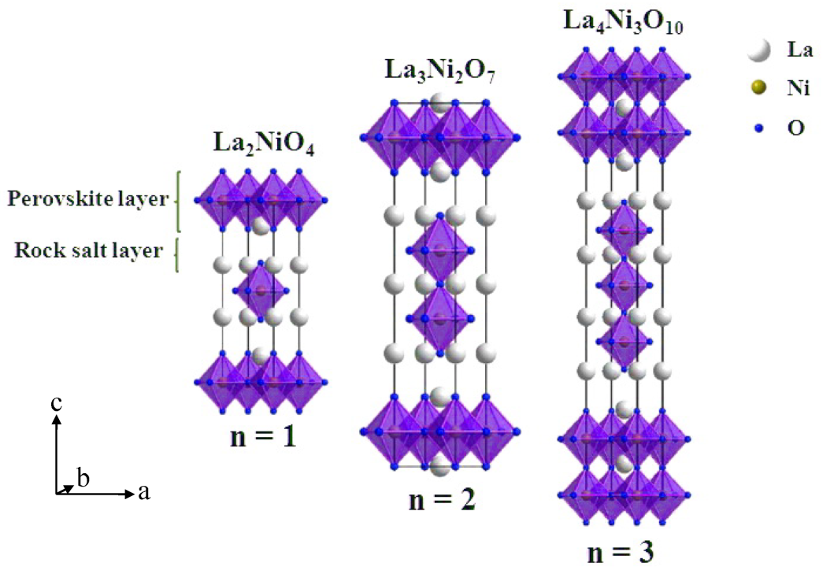
Figure 1. Schematic crystal structures of the n = 1, 2 and 3 members of the Ruddlesden–Popper (RP) type La_{n+1}Ni_{n}O_{3n+1} are shown. The denotation of n represents the number of stacked octahedral layers separated by a rock salt LaO layer. NiO₆ octahedra and La atoms are shown schematically.

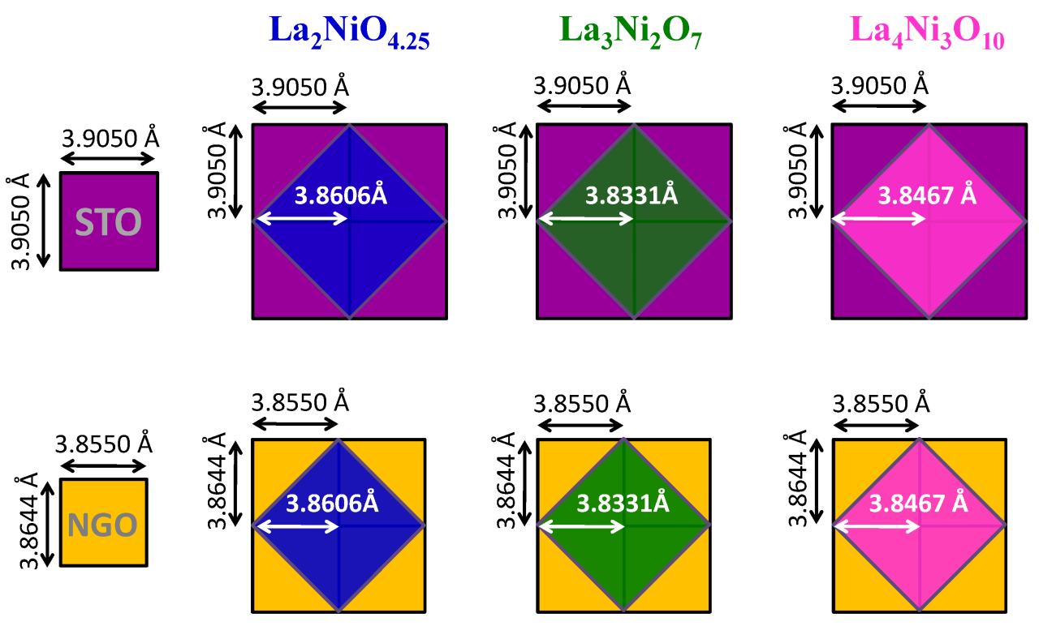
Figure 2. A schematic diagram of the basal arrangement of film-substrate orientation with the relevant lattice parameters a_{p} = 3.8606, 3.8331 and 3.8467 Å for La₂NiO_{4.25}, La₃Ni₂O₇ and La₄Ni₃O₁₀, respectively. Purple and yellow squares represent the basal planes of STO (001) and NGO (110) unit cells, respectively; blue, green and pink squares represent those of lanthanum nickelates.

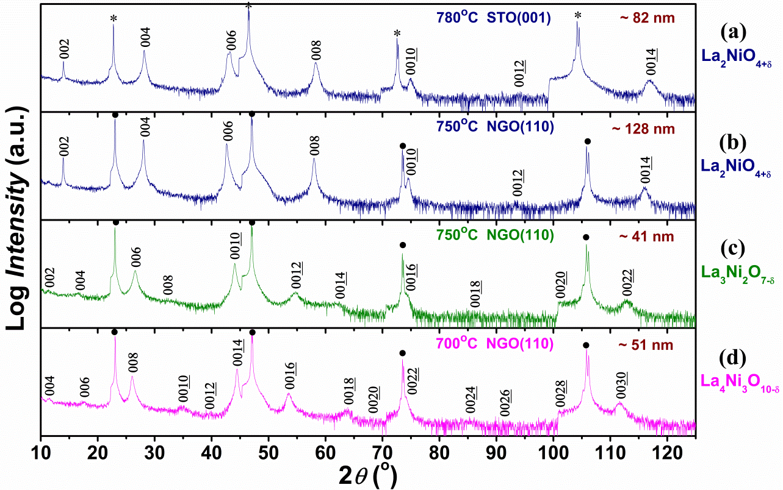
Figure 3. θ/2θ XRD patterns of c-axis oriented La₂NiO_{4-δ}, La₃Ni₂O_{7-δ} and La₄Ni₃O_{10-δ} phases grown on STO (001) at 780°C (a) and on NGO (110) single crystal substrates at 750°C (b), 750°C (c) and 700°C (d). The STO and NGO substrate peaks are indicated by star (*) and solid circles (•), respectively. The c-axis oriented film peaks are indexed by (00L). Film thickness determined by Dektak 150 Surface Profiler is shown as an insert in top right of each pattern.

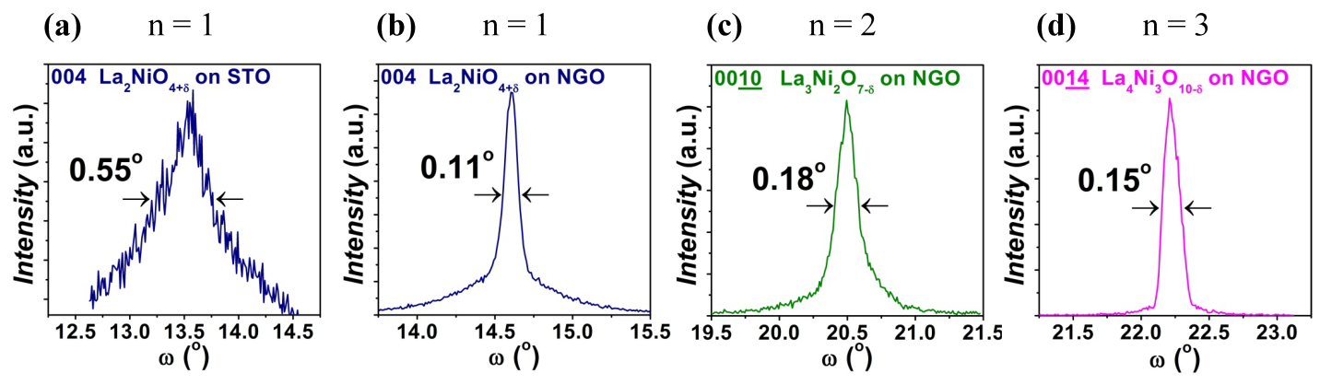
Figure 4. X-ray rocking curves of the c-axis oriented La_{n+1}Ni_{n}O_{3n+1} (n = 1, 2 and 3) films: (a) (004) reflection of 82 nm thick La₂NiO_{4-δ} film on SrTiO₃, (b) (004) reflection of 128 nm thick La₂NiO_{4-δ} film on NdGaO₃, (c) (0010) reflection of 41 nm thick La₃Ni₂O_{7-δ} film on NdGaO₃, and (d) (0014) reflection of 51 nm thick La₄Ni₃O_{10-δ} film on NdGaO₃.

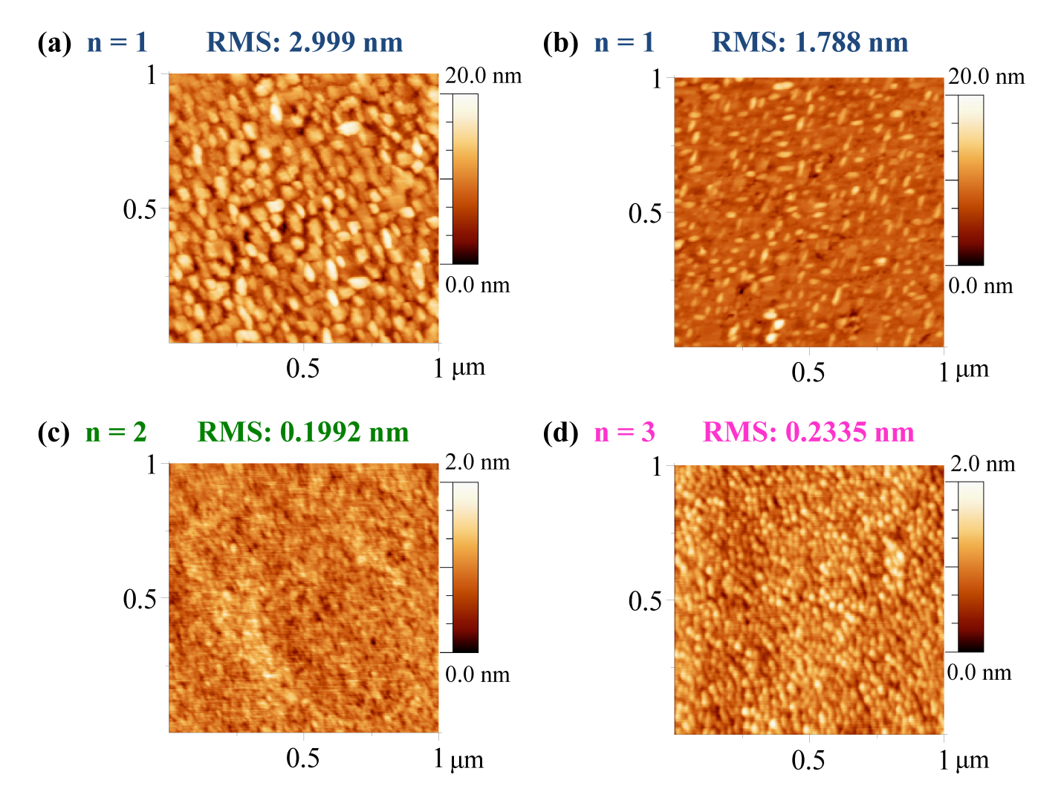
Figure 5. AFM images of the c-axis oriented La_{n+1}Ni_{n}O_{3n+1} (n = 1, 2 and 3) films (a) 82 nm thick La₂NiO_{4-δ} film on SrTiO₃, (b) 128 nm thick La₂NiO_{4-δ} film on NdGaO₃, (c) 41 nm thick La₃Ni₂O_{7-δ} film on NdGaO₃, and (d) 51 nm thick La₄Ni₃O_{10-δ} film on NdGaO₃. Image size: 1 μm × 1 μm, depth scale: (a) and (b) 20 nm, (c) and (d) 2 nm from dark brown to white.

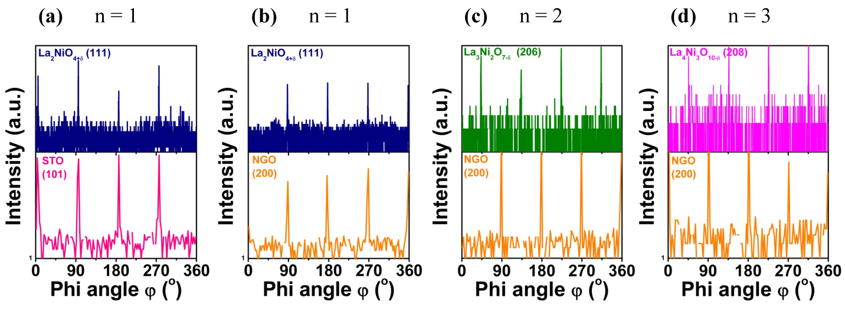
Figure 6. Phi(φ)-scan patterns for the c-axis oriented La_{n+1}Ni_{n}O_{3n+1} (n = 1, 2 and 3) films: {111} reflections registered at 2θ=24.093°, Ψ=73.09° for La₂NiO_{4-δ} films on SrTiO₃ and NdGaO₃ substrates shown in (a) and (b) respectively, {206} reflections registered at 2θ=42.702°, Ψ=51.74° for La₃Ni₂O_{7-δ} film on NdGaO₃ substrate shown in (c), and {208} reflections registered at 2θ=42.702°, Ψ=51.74° for La₄Ni₃O_{10-δ} film on NdGaO₃ substrate shown in (d).

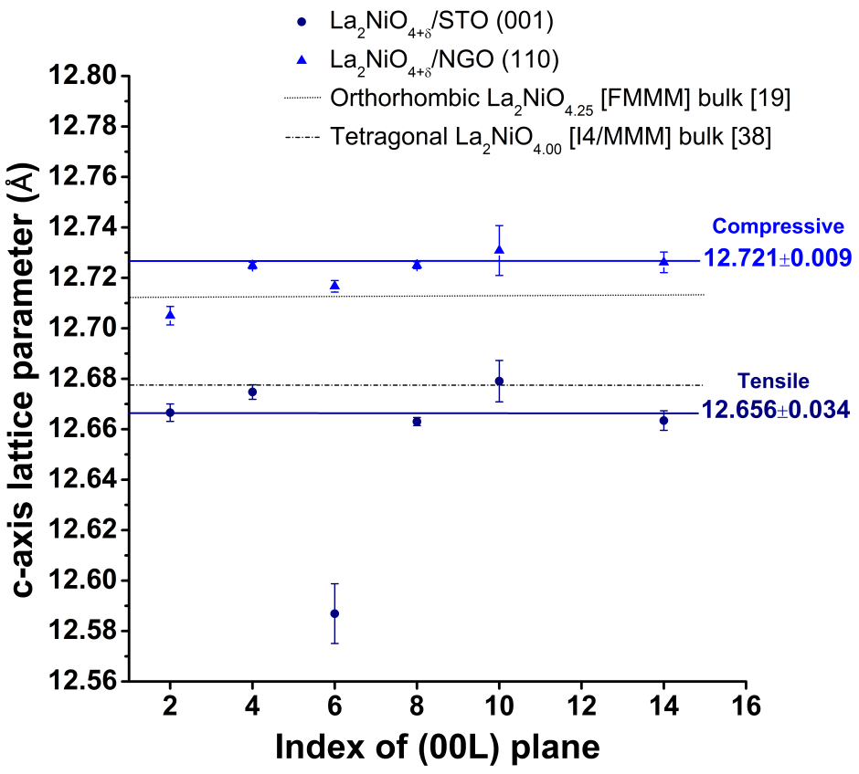
Figure 7. c-axis lattice parameter as function of (00L) planes for La₂NiO_{4+δ} films grown on STO (001) and NGO (110). The La₂NiO_{4+δ} film on STO is represented by solid circle (●); the film on NGO is represented by solid triangle (▲) with five units of the standard deviation errors from each individual fitted (00L) peak. The measured averages of c-axis parameters are labelled in the diagram. The analyses were based on the compared relationship of measured c-axis lattice parameters of each (00L) plane from the films with the values for the selected standard crystal structures of bulk materials.[22, 38] The results show the c-axis parameters are influenced by strain from different substrates.

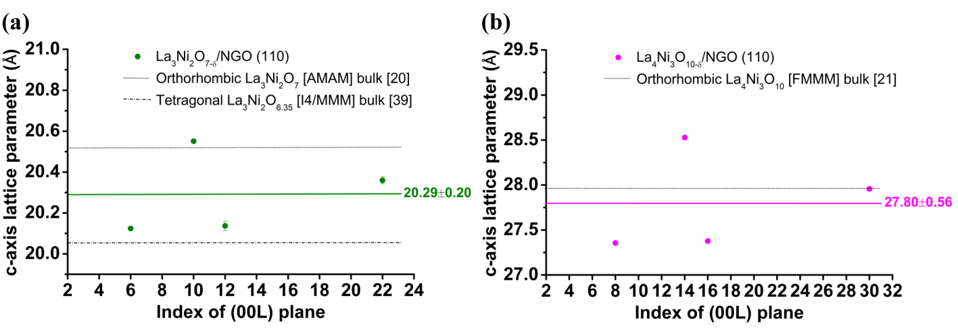
Figure 8. c-axis lattice parameter as function of (00L) planes for (a) La₃Ni₂O_{7-δ} and (b) La₄Ni₃O_{10-δ} films grown on NGO (110). The analyses were based on the same method as the discussion in Figure 7. Four clear peaks from each compound were refined by the Lorentz method. All errors are within the data points to a level of five standard deviations. The reference values as standard correspond to solid and dashed lines in the diagrams.[23, 24, 39] The measured averages of c-axis parameters are labelled by green and pink solid lines.

