Alkyl chain extension as a route to novel thieno[3,2-*b*]thiophene flanked diketopyrrolopyrrole polymers for use in organic solar cells and field effect transistors

Iain Meager,*,a Raja Shahid Ashraf,a Stephan Rossbauer,b Hugo Bronstein,c Jenny E. Donaghey,a Jonathan Marshall,a Bob C. Schroeder,a Martin Heeney,a Thomas D. Anthopoulos,b and Iain McCullocha

*a* Department of Chemistry and Centre for Plastic Electronics, Imperial College London, SW7 2AZ, U.K.

*b* Department of Physics and Centre for Plastic Electronics, Imperial College London, SW7 2AZ, U.K.

*c*Department of Chemistry, University College London, WC1H 0AJT, U.K.

**ABSTRACT**

The synthesis and characterisation of four new donor-acceptor type semiconducting polymers based on the electron-deficient diketopyrrolopyrrole unit for use in photovoltaic devices is reported. The extended 2-decyl-1-tetradecyl alkyl chain (C10C12) is utilised to provide a valuable route towards enhanced solubility. The resultant soluble DPP polymers were synthesized in high polymer molecular weights with a larger range of accessible co-monomer units. Bulk heterojunction solar cells containing these polymers show promising device performance with efficiencies around 4%. Organic thing film transistor devices with high ambipolar hole mobilities of > 0.1 cm2 V-1 s-1 are also reported.

**INTRODUCTION**

Conjugated polymers have the potential for use in next generation organic electronic devices such as renewable, cheap, solution processable solar cells and organic field effect transistors (OFET). Since their discovery the field has rapidly progressed; organic transistor mobilities are beginning to rival that of their inorganic counterparts and polymer/fullerene bulk heterojunction (BHJ) solar cell power conversion efficiencies (PCE) in excess of 8% have now been reported.[1-3] Of the wide range of semiconducting polymers developed, donor–acceptor (D-A) type polymers which utilise molecular orbital hybridisation as a means towards band gap (Eg) engineering have emerged as a promising class of materials. The electron deficient nature of the diketopyrrolopyrrole (DPP) core makes it an excellent choice for D-A type polymers and there has been a large amount of research into these materials. As such, DPP based polymers consistently deliver impressive device performances.[4] Bulk heterojunction organic solar cells containing DPP have now surpassed efficiencies (PCE) of 7% and organic field effect transistor (OFET) mobilities have been reported in excess of 1 cm2 V-1 s-1.[5-9] The fused DPP unit enforces a high degree of planarity whilst strong interchain π-π interactions facilitate charge transport. When designing novel donor materials it is important to consider the energetic contributions from different units along the polymer backbone as well as the nature of the solubilising alkyl chains. The former consideration has been well studied across a huge variety of different chemical structures whilst the latter can often be overlooked. Alkyl chains are crucial for polymer solubility and processability, their size and spacing being a key factor to consider during synthesis.[10, 11] With a longer alkyl chain solubility is generally improved, however this can come at the detriment of other factors such as packing, blend morphology and fullerene miscibility.[12] In addition to length, branched vs. linear alkyl chain nature has also been studied as well as more specific considerations such as the position of the branching point relative to the polymer backbone.[13-15] We previously reported a thieno[3,2-*b*]thiophene based DPP co-polymer with 2-octyl-1-dodecyl (C8C10) chains at the lactam nitrogens. Copolymerisation with thiophene shows PCE values of 5.4% in solar cell devices and hole mobilities of 1.95 cm2 V-1 S-1 in OFET devices.[16] Despite the good device performance, the processability and variety of copolymers accessible from this unit are limited by the intrinsic polymer solubility in organic solvents. We were aiming to improve polymer solubility, molecular weights and variety of accessible

\\ic.ac.uk\homes\im311\PhD\Polymers\C10C12structures.tif

Figure 1. Chemical structures of **P1**, **P2**, **P3** and **P4**.

comonomer units by increasing the length of the branched alkyl groups on the DPP unit to contain 2-decyl-1-tetradecyl (C10C12) alkyl groups with four extra carbon atoms in each chain compared to the C8C10 analogue. The synthesis of the novel C10C12DPPTT monomer is analogous to our previous report, through iodination of the commercially available 2-decyl-1-dodecanol we synthesised the 2-octyl-1-dodecyl iodide. This was attached to the DPP unit by deprotonation of the lactam nitrogen. Subsequent bromination afforded the target DPP monomer. Due to its significantly enhanced solubility, previously unreported co-polymers were prepared. Thiophene (**P1**) and thieno[3,2-*b*]thiophene (**P2**) were chosen as comonomers in order to achieve highly planar structures that would prove beneficial for charge transport. benzo[*c*][1,2,5]thiadiazole (**P3**) and benzene (**P4**) were chosen as co-monomers as they have shown excellent transistor ambipolarity in DPP-BT containing polymers, and promising solar cell efficiencies in DPP-P polymers.[17, 18] Polymerisation of the thieno(3,2-*b*)thiophene based DPP with these monomer units has previously not been possible due to the solubility of the resultant polymers in common organic solvents. **P1** and **P2** were prepared using palladium catalysed Stille polymerizations in high molecular weights using microwave irradiation. **P3**, **P4** were synthesised using palladium catalysed Suzuki coupling conditions with conventional heating, full details of which are reported in the experimental section. Following polymerisation, the polymers were precipitated into methanol, catalytic materials and lower molecular weight oligomers were then removed from the polymeric mixture by Soxhlet extraction with acetone and hexane. The resultant polymers were soluble in chlorinated solvents such as chloroform and chlorobenzene. In our initial publication with C8C10 alkyl chains it was not possible to obtain narrow polydispersities due to the low solubility of the oligomeric residue in solvents used for Soxhlet extraction. Utilizing the novel C10C12 chains lower polydispersities (PDI) were achievable demonstrating the improved processability of the materials.

**EXPERIMENTAL**

**General** All reagents and solvents were purchased from Sigma Aldrich, VWR, Apollo Scientific or TCI and were used without any further purification. Dry solvents for anhydrous reactions were purchased from Sigma Aldrich. All reactions were carried out under an inert argon atmosphere unless otherwise stated. 1H NMR and 13C NMR spectra were recorded on a BRUKER 400 spectrometer in CDCl3 solution at 298 K unless otherwise stated. Number-average (*M*n) and weight-average (*M*w) molecular weights were determined with an Agilent Technologies 1200 series GPC in chlorobenzene at 80°C, using two PL mixed B columns in series, and calibrated against narrow weight average dispersity (Dw < 1.10) polystyrene standards. UV-Vis absorption spectra were recorded on a UV-1601 Shimadzu UV-Vis spectrometer. Column chromatography was carried out on silica gel (for flash chromatography, VWR). Microwave experiments were performed in a Biotage initiator v.2.3. Photo Electron Spectroscopy in Air (PESA) measurements were recorded with a Riken Keiki AC-2 PESA spectrometer with a power setting of 5 nW and a power number of 0.5. 3,6-di(thieno[3,2-*b*]thiophen-2-yl)pyrrole[3,4-*c*]pyrrole-1,4(2*H*,5*H*)-dione (DPP), 2-decyl-1-tetradecyl iodide and comonomer units were synthesised according to previous literature.[19-22]

**Monomer synthesis**

**2,5-bis(2-decy-1-tetradecyl)-3,6-di(thieno[3,2-*b*]thiophen-2-yl)pyrrole[3,4-*c*]pyrrole-1,4(2*H*,5*H*)-dione**2-decyl-1-tetradecyl iodide (18.75 g, 40.36 mmol, 3.33 equiv.) was added to a solution of 3,6-di(thieno[3,2-*b*]thiophen-2-yl)pyrrole[3,4-*c*]pyrrole-1,4(2*H*,5*H*)-dione (5.00 g, 12.12 mmol, 1 equiv.), potassium carbonate (5.58 g, 40.36 mmol, 3.33 equiv.) and 18-crown-6 (~40 mg) in dimethylformamide (150 mL). The solution was heated with stirring at 120°C for 18h and subsequently cooled to room temperature. Solvent was removed by rotary evaporation to afford the crude product which was purified by column chromatography (3 : 1, hexanes : chloroform) to afford the title compound as a dark purple solid (4.61 g, 4.24 mmol, 35%). 1H NMR (400 MHz, CDCl3): δ 9.32 (d, 2H, ArH), 7.63 (d, J = 5.2 Hz, 2H, ArH), 7.35 (d, J = 5.1 Hz, 2H, ArH), 4.10 (d, J = 7.8 Hz, 4H, NCH2), 2.06 – 1.98 (m, 2H, NCH2CH(R)2), 1.40 – 1.20 (m, 80H, CH2), 0.92 – 0.86 (m, 12H, CH3). 13C NMR (100 MHz, CDCl3): δ 140.6, 140.3, 132.0, 131.2, 127.6, 119.3, 108.4, 46.6, 37.9, 32.0, 31.2, 30.1, 29.7, 29.7, 29.6, 29.4, 26.2, 22.7, 14.1. *m/z* calculated for C66H104N2O2S4 (M+) 1084.7, 1085.7, 1086.7, 1086.7, found 1084.8, 1085.8, 1086.8, 1087.8

**3,6-bis(2-bromothieno[3,2-b]thiophen-5-yl)-2,5-bis(2-decyl-1-tetradecyl)pyrrolo[3,4-c]pyrrole-1,4(2H,5H)-dione** To a stirring solution of 2,5-bis(2-dodecyl-1-tetradecyl)-3,6-di(thieno[3,2-*b*]thiophen-2-yl)pyrrole[3,4-*c*]pyrrole-1,4(2*H*,5*H*)-dione (2.00 g, 1.84 mmol, 1 equiv.) in chloroform (50 mL) was added a solution of bromine (0.59 g, 3.68 mmol, 2 equiv.) in chloroform (5 mL) dropwise. The solution was refluxed for 2 hours and then cooled to 0°C before quenching with sat. Na2S2O3 (aq) (50 mL). The organic layer was separated, dried over MgSO4 and concentrated by rotary evaporation to afford the crude product which was purified by column chromatography using (3 : 1, hexanes : chloroform) to give the title compound as a dark purple/blue solid (1.56 g, 1.25 mmol, 68%).1H NMR (400 MHz, CDCl3): δ 9.24 (s, 2H, ArH), 7.35 (s, 2H, ArH), 4.07 (d, J = 7.7 Hz, 4H, NCH2), 1.57 (s, 2H, NCH2CH(CH2R)2,), 1.35–1.15 (m, 80H, CH2), 0.91-0.87 (m, 12H, CH3). 13C NMR (100 MHz, CDCl3): δ 161.5, 142.0, 140.4, 140.2, 130.5, 126.8, 122.1, 119.0, 108.4, 46.6, 37.9, 32.0, 31.2, 30.1, 29.8, 29.7, 29.7, 29.6, 29.4, 26.3, 22.7, 14.2. *m/z* calculated for C66H102Br2N2O2S4 (M+) 1242.5, 1243.5, 1240.5,1244.5, found 1242.6, 1243. 6, 1244. 6.

**Polymer synthesis**

**P1**. **C10C12DPPTT-T** To a microwave vial was added 3,6-bis(2-bromothieno[3,2-*b*]thiophen-5-yl)-2,5-bis(2-dodecyl-1-tetradecyl)pyrrolo[3,4-*c*]pyrrole-1,4(2*H*,5*H*)-dione (0.24 g, 0.19 mmol, 1 equiv.) and 2,5-bis(trimethylstannyl)thiophene (0.08 g, 0.19 mmol, 1 equiv.) in chlorobenzene (1.7 mL). The solution was degassed before the addition of Pd2(dba)3 (4 mg) and P(*o*Tol)3 (5 mg). Following further degassing the microwave vial was sealed and the reaction mixture was heated in a microwave in successive intervals of 5 minutes at 100°C, 5 minutes at 140°C, 5 minutes at 160°C, 10 minutes at 180°C and finally 20 minutes at 200°C . After cooling to room temperature the reaction mixture was poured into vigorously stirring methanol and the resulting polymeric precipitate was filtered. The polymeric precipitate was purified by Soxhlet extraction first in acetone (24h), hexane (24h), chloroform (24h) and finally chlorobenzene (24h). The chlorobenzene fraction was concentrated by rotary evaporation, suspended in methanol and filtered to afford the desired polymer **C10C12DPPTT-T** (92 mg, 42%) as a dark green solid. GPC (chlorobenzene): *M*n = 148 kDa, *M*w = 385 kDa, PDI = 2.6.

**P2. C10C12DPPTT-TT**To a microwave vial was added 3,6-bis(2-bromothieno[3,2-*b*]thiophen-5-yl)-2,5-bis(2-dodecyl-1-tetradecyl)pyrrolo[3,4-*c*]pyrrole-1,4(2*H*,5*H*)-dione (0.19 g, 0.15 mmol, 1 equiv.) and 2,5-bis(trimethylstannyl)thieno[3,2-*b*]thiophene (0.07 g, 0.15 mmol, 1 equiv.) in chlorobenzene (1.7 mL). The solution was degassed before the addition of Pd2(dba)3 (4 mg) and P(*o*Tol)3 (5 mg). Following further degassing the vial was sealed and the reaction mixture was heated in a microwave in successive intervals of 5 minutes at 100°C, 5 minutes at 140°C, 5 minutes at 160°C, 10 minutes at 180°C and finally 20 minutes at 200°C. After cooling to room temperature the reaction mixture was poured into vigorously stirring methanol and the polymeric precipitate was filtered. The filtrate was purified by Soxhlet extraction first in acetone (24h), hexane (24h), chloroform (24h) and finally chlorobenzene (24h). The chlorobenzene fraction was concentrated by rotary evaporation, suspended in methanol and filtered to afford the desired polymer **C10C12DPPTT-TT** (105 mg, 61 %) as a dark green solid. GPC (chlorobenzene): *M*n = 100 kDa, *M*w = 280 kDa, PDI = 2.8.

**P3. C10C12DPPTT-BT** To a microwave vial was added 3,6-bis(2-bromothieno[3,2-*b*]thiophen-5-yl)-2,5-bis(2-dodecyl-1-tetradecyl)pyrrolo[3,4-*c*]pyrrole-1,4(2*H*,5*H*)-dione (0.18 g, 0.14 mmol, 1 equiv.) and 4,7-bis(4,4,5,5-tetramethyl-1,3,2-dioxabrolan-2-yl)benzothiadiazole (0.06g, 0.14 mmol, 1 equiv.) followed by a thoroughly degassed solution of Aliquat 336 (2 drops) in toluene (6 mL). The solution mixture was further degassed with stirring for 30 minutes. Pd2(PPh3)4 (15 mg) and the solution was again degassed for a futher 30 minutes. 2M K2CO3(aq) (2 mL) was added and the microwave vial was sealed and heated with vigorous stirring at 120°C for 3 days. After cooling to room temperature the reaction mixture was poured into vigorously stirring methanol and the resulting polymeric precipitate was filtered. The filtrate was purified by Soxhlet extraction first in acetone (24h), hexane (24h), chloroform (24h) and finally chlorobenzene (24h) to afford the title polymer **C10C12DPPTT-BT** (45 mg, 26 %) as a dark green/blue solid. GPC (chlorobenzene): *M*n = 50 kDa, *M*w = 78 kDa, PDI = 1.5.

**P4. C10C12DPPTT-P** To a microwave vial was added 3,6-bis(2-bromothieno[3,2-*b*]thiophen-5-yl)-2,5-bis(2-dodecyl-1-tetradecyl)pyrrolo[3,4-*c*]pyrrole-1,4(2*H*,5*H*)-dione (0.17 g, 0.14 mmol, 1 equiv.) and 1,4-di-(4,4,5,5-tetramethyl-1,3-dioxaboralane)-benzene (0.046 mg, 0.139 mmol, 1 equiv.) followed by a thoroughly degassed solution of Aliquat 336 (2 drops) in toluene (6 mL). The solution was further degassed with stirring for half an hour before the addition of Pd2(dba)3 (10 mg) and PPh3 (7 mg) followed by degassing for a further 30 minutes. K3PO4 (221 mg) in water (0.5 mL) was added and the vial was sealed and heated for 3 days at 120°C with vigorous stirring. After cooling to room temperature the reaction mixture was poured into vigorously stirring methanol and the resulting polymeric precipitate was filtered. The filtrate was purified by Soxhlet extraction first in acetone (24h), hexane (24h), chloroform (24h) and finally chlorobenzene (24h). The chlorobenzene fraction was concentrated by rotary evaporation, suspended in methanol and filtered to afford the desired polymer **C10C12DPPTT-P** (68 mg, 42 %) as a dark green solid. GPC (chlorobenzene): *M*n = 23 kDa, *M*w = 42 kDa, PDI = 1.8.

**Transistor Fabrication details**

**Top gate devices**: All film preparation steps were carried out under inert atmosphere. 2 x 2cm glass slides were cleaned in a DECON90 deionized (DI)-Water solution in an ultrasonic bath twice for 10 min and then rinsed with DI-Water. To help with the adhesion of the gold on the glass substrate, 5 nm of aluminium were evaporated prior to the evaporation of 25 nm of Gold. Polymeric chlorobenzene solution and substrates were heated to processing temperature followed by spincoating for 10 s at 500 rpm followed by 30-60s at 2000 rpm. The films were then dried at 100°C for 5 min. A perfluorinated polymer (commercial name CYTOP from Ashani Glass) was used as gate dielectric and applied via spincoating for 60s at 2000rpm and cured at 100°C for 90 min. 50 nm aluminum was evaporated on top of the dielectric as a gate electrode.

**Table 1.** Processing parameters for top gate / bottom contact devices.

|  |  |  |  |
| --- | --- | --- | --- |
| Polymer | Processing Temperature (°C) | Concentration (mg/mL) | Spin coating |
| **P1** | 150 | 5 | 2000 rpm 30s |
| **P2** | 100 | 10 | 500 rpm 10s,  2000 rpm 20s |
| **P3** | 100 | 20 | 500 rpm 10s,  2000 rpm 20s |
| **P4** | 100 | 10 | 2000 rpm 30s |

**Bottom gate devices:** Photolithographicly pre-patterned bottom gate bottom contact (200 nm SiO2 over Si+) substrates with gold electrodes were used. Substrates were cleaned in an ultrasonic bath (acetone 10 min and isopropanol 10 min).The devices were spun from same solution concentrations and processing parameters as described for top gate devices.

**RESULTS & DISCUSION**

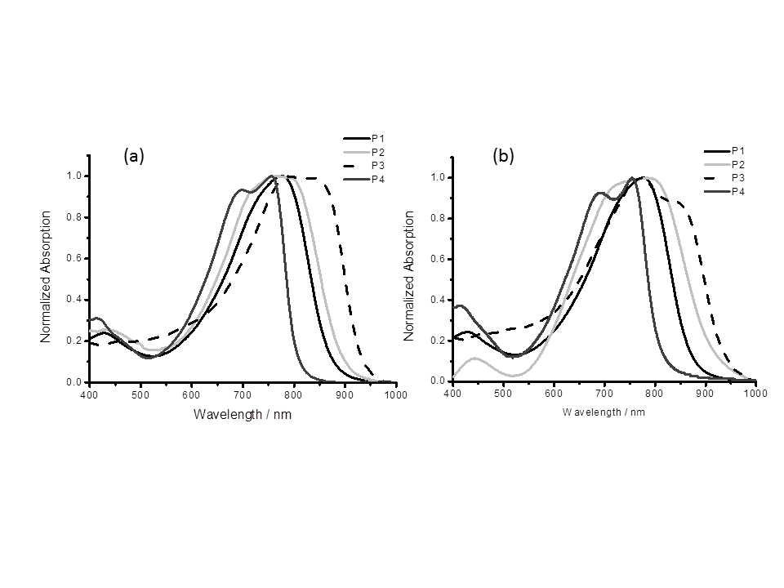

**Figure 2**.Normalized UV-Vis absorption spectra at 25 °C of polymers **P1**, **P2**, **P3** and **P4** in (a) chlorobenzene solution and (b) solid state.

**Table 2**. Properties of polymers **P1**, **P2**, **P3** and **P4**

|  |  |  |  |  |  |  |  |  |
| --- | --- | --- | --- | --- | --- | --- | --- | --- |
| Polymer | *M*n (kDa)*a* | *M*w (kDa)*a* | PDI*a* | *λmax* (nm) | | HOMO (eV)*d* | LUMO (eV)*d* | Band gap (eV) |
| Film*b* | Solution |
| **P1** | 148 | 385 | 2.6 | 787 | 779 | -5.2 | -3.8 | 1.4 |
| **P2** | 100 | 280 | 2.8 | 783 | 771 | -5.0 | -3.7 | 1.3 |
| **P3** | 50 | 78 | 1.6 | 774 | 796 | -5.1 | -3.8 | 1.3 |
| **P4** | 23 | 42 | 1.8 | 755 | 755 | -5.1 | -3.6 | 1.5 |

[*a*] Average molecular weight in number (*M*n), in weight (*M*w) and weight average dispersity PDI (*M*w/*M*n) as determined by GPC. [*b*] Spin-coated from 5 mg / mL chlorobenzene solution. [*c*] Measured in dilute chlorobenzene solution. [*d*] The HOMO energy was measured by PESA and the LUMO energy was estimated by adding the absorption onset to the HOMO.

All the polymers have a low band gap with absorption maxima between 750-800 nm. For **P1** the absorption maxima in solution is 779 nm whilst in the solid state (thin film) it has a slightly more red-shifted value of 787 nm, the single broad maximas observed are almost identical in solution and solid state to the C8C10 analogue. Replacing the thiophene in **P1** with thienothiophene in **P2** results in a slightly broader and red-shifted absorption in solution and solid state. Whilst the solution and solid state absorption maxima are similar for both **P1** and **P2**, in solid state the onset of the absorption of **P2** can be seen to be red-shifted relative to **P1**. This is potentially due to increased aggregation in the solid state due to the inclusion of the extra fused ring of the thieno[3,2-*b*]thiophene comonomer. **P3** displays a red-shifted absorption with maxima at 796 nm and 774 nm in solution and solid state respectively. Interestingly when copolymerized with benzene in **P4** there is no observable red-shift in going from solution to solid state with both spectra showing absorption maxima of 755 nm. The phenyl comonomer results in a significantly wider band gap, as has been observed previously in similar polymers, due to the twist of the phenyl ring resulting in a loss of conjugation.18 Both in solution and solid state UV-Vis spectra of **P1** and **P2** containing thiophene and thienothiophene

\\ic.ac.uk\homes\im311\PhD\Polymers\C10C12homolumo.tif

**Figure 3**. Frontier molecular orbital energy levels as predicted by UV-Vis/PESA and DFT/TDDFT calculation with a 6-31g* basis set.

respectively show a single broad absorption whilst **P3** and **P4** show bimodal absorptions, likely as a result of vibronic coupling. These vibronic structures are more pronounced in the solid state than in solution which could be a result of aggregation occurring in the thin film. Absorption maxima show different trends in solution and the solid state. In solution **P4** shows the lowest absorption maxima (755 nm) matching it’s significantly wider band gap whilst **P3** has the narrowest band gap and shows the most red-shifted maxima (796 nm) however in the solid state the **P3** absorption maxima is at a lower wavelength than both **P1** and **P2**. The frontier molecular orbitals were determined using photoelectron spectroscopy in air (PESA) and the absorption onsets from the UV-Vis spectra. These orbital energies are compared to the predicted energies using DFT/TDDFT with a 6-31g* basis set as shown in Figure 3. Due to the calculations being performed on trimeric units in a vacuum there are noticeable discrepancies between the UV-Vis/PESA and DFT/TDDFT values. This is as a result of the calculations not accounting for polymers reaching their effective conjugation length and not including the various interactions between polymer chains which occur outside of a vacuum. However the general trend predicted by these calculations matches the trend obtained experimentally. These experimentally observed and computationally calculated frontier molecular orbital energies can be correlated to the respective comonomer unit, polymer planarity and HOMO/LUMO distribution. As shown in Figure 4 **P1** and **P2** have planar backbones with HOMO and LUMO levels that are delocalized relatively evenly along the backbone. The HOMO level of **P2** is raised (-5.0 eV) relative to that of **P1** (-5.2 eV) due to the thienothiophene comonomer unit a stronger electron donor than the single thiophene. It can also be seen that the additional fused thiophene ring in **P2** results in a polymer backbone that is significantly more linear than the thiophene analogue **P1**. **P3** and **P4** have similar HOMO energies, however the LUMO of **P3** can be seen to be lowered (-3.8 eV) as a result of the LUMO being distributed onto the electron poor benzo[*c*][1,2,5]thiadiazole BT comonomer unit. The HOMO does not extend into the heterocyclic BT component and therefore is not significantly affected. The polymer retains its planarity implying no loss of conjugation. **P4** has a raised LUMO (-3.6 eV) and a wider band gap (1.5 eV), as a result of twisting of the polymer backbone breaking the conjugation that arises from the steric clash between protons on the adjacent thiophene and phenyl rings. The HOMO remains uninfluenced by this effect and is remarkably similar to that of **P1** which is surprising as previous literature has shown that incorporation of a phenyl ring into DPP polymers has a tendency to lower the polymer HOMO.[18]

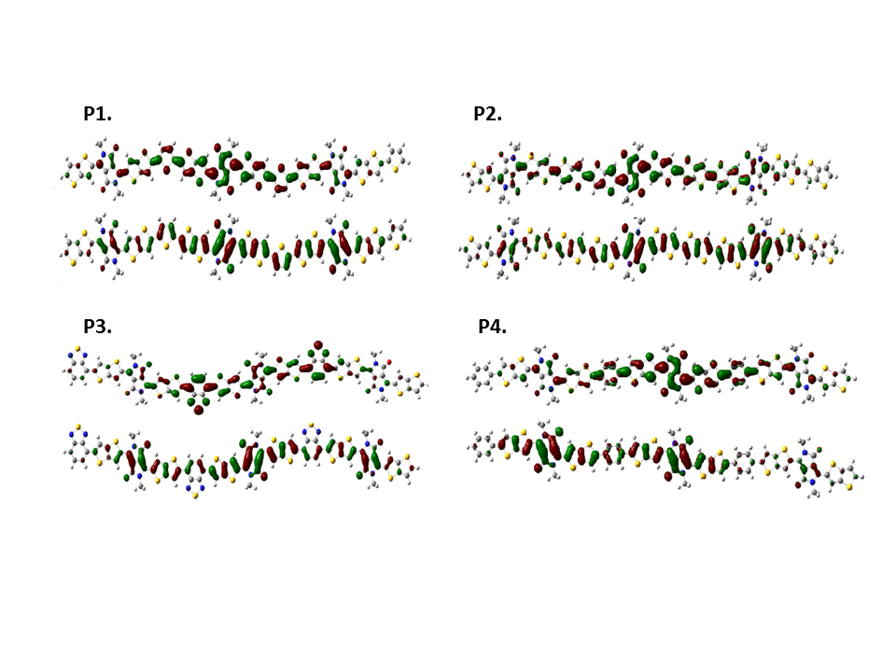

**Figure 4.** Frontier molecular orbital distribution of **P1**, **P2**, **P3** and **P4** calculated using DFT/TDDFT with a 6-31g* basis set, HOMO and LUMO levels are shown below and above respectively for each polymer.

**SOLAR CELLS**

Solar cells were fabricated using **P1**, **P2**, **P3** & **P4** as the donor material in the active layers by spin coating of a 1 : 2 polymer / PC[71]BM mixture from chloroform : *o*-dichlorobenzene (ODCB) (4 :1). The external quantum efficiency (EQE) corrected current density vs voltage (*J-V*) curve of all four polymers and AFM images of the polymer / fullerene blends are shown in Figure 5. The individual device data for each polymer are shown in Table 3. The best performing devices are achieved using **P1**, with a good short circuit current (*J*sc) of 14.7 mA cm-2, open circuit voltage (*V*oc) of 0.62 V and a fill factor (FF) of 0.53 resulting in an EQE corrected PCE of 4.1 %. The AFM image of the **P1** / fullerene blend is significantly different to that of **P2, P3** and **P4**, interestingly it is **P1** that appears to have the coarsest morphology. Changing the comonomer unit from thiophene to thienothiophene gives an increased quinoidal contribution and a band gap reduction from 1.4 eV to 1.3 eV leading to an improved *J*sc of 16.52 mA cm-2. The raised HOMO results in a significantly reduced *V*oc of 0.48 V with the fill factor showing only a small change to a value of 0.50, and an overall EQE corrected PCE of 3.8 %.

\\ic.ac.uk\homes\im311\PhD\Polymers\C10C12JVAFM.tif

**Figure 5.** EQE corrected *J-V* curve for polymers **P1**, **P2**, **P3** and **P4** and AFM images of polymer / fullerene blends of **P1**, **P2, P3** and **P4**.

**Table 3**. Solar cell device characteristics for polymers **P1**, **P2**, **P3** and **P4**.

|  |  |  |  |  |
| --- | --- | --- | --- | --- |
| Polymer | *Jsc* (mA cm-2)*a* | *Voc* (V) | FF | PCE (%) |
| **P1** | 12.6 | 0.62 | 0.53 | 4.1 |
| **P2** | 15.7 | 0.48 | 0.50 | 3.8 |
| **P3** | 2.9 | 0.68 | 0.55 | 1.1 |
| **P4** | 11.7 | 0.61 | 0.57 | 4.0 |

[*a*]EQE corrected

When compared to the higher performing **P1** polymer, the AFM of **P2** and **P4** show far less coarse morphologies whilst still retaining observable domain size. The AFM image of **P3** with the benzothiadiazole repeat unit is noticeably different to the other higher performing polymers. It shows very finely dispersed polymer/fullerene domains, it is likely that this morphology does not create favourable percolation pathways and is the reason for **P3** showing a significantly lower *J*sc of the four polymers (2.9 mA cm-2), fill factor of 0.55 and *V*oc of 0.68 V resulting in a PCE of 1.1 %. The higher lying LUMO and wider band gap in **P4** resulting from the twist introduced by the phenyl ring gives a *J*sc reduction to 11.7 mA cm-2, a good Voc (0.61) and FF (0.57) results in a high PCE of 4.04 %. All four polymers are found to be very stable with degradation temperatures of above 300°C as shown in TGA and DSC analysis with no observable phase transitions seen; further details are included in the supporting information (SI).

**FIELD EFFECT TRANSISTORS**

**Table 4**. Transistor properties of polymers **P1**, **P2**, **P3** and **P4** in top gate / bottom contact and bottom gate / bottom contact devices.

|  |  |  |  |  |  |  |
| --- | --- | --- | --- | --- | --- | --- |
| Polymer | Top gate / bottom contact | | | | Bottom gate / bottom contact | |
| Effective hole mobility (cm2 / V s) | On–off ratio holes | Effective electron mobility (cm2 / V s) | On-off ratio electrons | Effective hole mobility (cm2 / V s) | On-off ratio holes |
| **P1** | 0.33 | 1 x 104 | 0.12 | 1 x 103 | 0.45 | 1 x 104 |
| **P2** | 1.1 x 10-2 | 1 x 102 | 9 x 10-3 | - | 9 x 10-2 | 1 x 104 |
| **P3** | 3.7 x 10-2 | 1 x 103 | 0.15 | 1 x 102 | 3 x 10-3 | 10 |
| **P4** | 8.0 x 10-3 | 1 x 102 | 5 x 10-3 | - | 6 x 10-2 | 1 x 103 |

Top gate/bottom contact and bottom gate/bottom contact thin film OFETs with gold source/drain electrodes were used to evaluate the charge transport characteristics of **P1**-**P4**. In top gate/bottom contact devices **P1** shows good ambipolar mobilities > 0.1 cm2 V-1 s-1 with a high hole mobility of 0.33 cm2 V-1 s-1 and an electron mobility of 0.12 cm2 V-1 s-1. Both **P3** and **P4** show good electron mobilities of 0.15 cm2 V-1 s-1 with this same device configuration. In bottom gate/bottom contact devices, **P1** again shows good hole mobility giving a high value of 0.45 cm2 V-1 s-1. These mobilities are however slightly lower than those previously obtained with the shorter branched alkyl chain. Surprisingly **P2** has significantly lower hole and electron mobility, and poor device characteristics. We attribute this to the poor processability of the material from which it was difficult to obtain a good film. **P3** demonstrates fairly low hole mobility of 3.7 x 10-2 but very promising electron mobility of 0.15 cm2 V-1 s-1. It is believed that the electron deficient nature of the BT unit lowers the LUMO to allow for electron injection whilst the planar structure allows for efficient charge transfer to take place through interchain hopping. The mobility of **P4** is lower due to the phenyl rings disrupting the coplanarity, which results in inefficient charge transport. All four polymers **P1**, **P2**, **P3** and **P4** polymers have similar AFM images of the pristine film (Figure 5); with the **P4** film being slightly coarser than **P3**. These results were all obtained with as-spun devices and it has been seen that thermal annealing typically increases the mobility of DPP type polymers in thin film transistors devices.[23] Further investigations into the optimization of these devices by thermal annealing are underway.

**C:\PhD\Polymers\AFM\C10C12AFMtransistors.tif**

**Figure 5.** AFM images of polymers **P1**, **P2**, **P3** and **P4**.

**CONCLUSIONS**

The design, synthesis and characterisation of four novel DPP based polymers is demonstrated, through use of the larger 2-decyl-1-tetradecyl alkyl chains we demonstrate a valuable tool towards the synthesis of solution processable DPP polymers. An improved range of copolymers were be synthesized in high molecular weights and narrow polydispersities. When used as the donor material in polymer : fullerene bulk heterojunction solar cells efficiencies up to 4% and thin film transistor devices with promising ambipolar mobilities as high as 0.45 cm2 V-1 s-1 are demonstrated.

**ASSOCIATED CONTENT**

Polymer DSC, Polymer TGA, Polymer EQE spectra, OFET transfer curves for polymer OFET top gate / bottom and bottom gate / bottom contact devices.

**AUTHOR INFORMATION**

**Corresponding Author**

i.meager11@imperial.ac.uk

Author Contributions

The manuscript was written through contributions of all authors. All authors have given approval to the final version of the manuscript. The authors declare no competing financial interests.

Funding Sources

This research has been carried out primarily with funding from The Leventis Foundation and FP7 X10D project no. 287818, with support from the Centre for Plastic Electronics at Imperial College London, CDT Project number EP/G037515/1

**ACKNOWLEDGMENT**

We are grateful to Scott E. Watkins (CSIRO Materials Science and Engineering, Victoria, Australia) for his contribution to the polymer energy levels determination by UV-PESA measurements

**REFERENCES**

(1) Li, J.; Zhao, Y.; Tan, H. S.; Guo, Y.; Di, C.-A.; Yu, G.; Liu, Y.; Lin, M.; Lim, S. H.; Zhou, Y.; Su. H.; Ong, B. S. *Sci. Rep.* **2012**, *2*.

(2) Chen, H.; Guo, Y.; Yu, G.; Zhao, Y.; Zhang, J.; Gao, D.; Liu, H.; Liu, Y. *Adv. Mater.* **2012**, *24*, 4618-4622.

(3) He, Z.; Zhong, C.; Su, S.; Xu, M.; Wu, H.; Cao, Y. *Nature Photon*. **2012**, *6*, 591-595.

(4) Nielsen, C. B.; Turbiez, M.; McCulloch, I. *Adv. Mater*. **2012**, 25, 1859-1880.

(5) Ha, J. S.; Kim, K. H.; Choi, D. H. *J. Am. Chem. Soc.* **2011**, *133*, 10364-10367.

(6) Yuen, J. D.; Fan, J.; Seifter, J.; Lim, B.; Hufschmid R.; Heeger, A. J.; Wudl, F. *J. Am. Chem. Soc.* **2011**, *133*, 20799-20807.

(7) Yang, L. Q.; Zhou, H. X.; You, W. *J. Phys. Chem. C.* **2010**, *114*, 16793-16800.

(8) Zhang, F.; Hu, Y.; Schuettfort, T.; Di, C.-A.; Gao, X.; McNeill, C. R.; Thomsen, L.; Mannsfeld, S. C. B.; Yuan, W.; Sirringhaus, H.; Zhu, D. *J. Am. Chem. Soc* **2013**, *135*, 2338-2349.

(9) Bronstein, H.; Leem, D. S.; Hamilton, R.; Woebkenberg, P.; King, S.; Zhang, W.; Ashraf, R. S.; Heeney, M.; Anthopoulos, T. D.; de Mello, J.; McCulloch, I. *Macromolecules* **2011**, *44*, 6649-6652.

(10) Sonar, P.; Singh, S. P.; Li, Y.; Soh, M. S.; Dodabalapur, A. *Adv. Mater.* **2010**,5409-5413.

(11) Linshoeft, J.; Heinrich, A. C. J.; Segler, S. A. W.; Gates, P. J.; Staubitz, A. *Org Lett.* **2012**, *14*, 5644-5647.

(12) Lei, T.; Dou, J.-H.; Pei, J. *Adv. Mater.* **2012**, *24*, 6457-6461.

(13) Chen, D.; Zhao, Y.; Zhong, C.; Gao, S.; Yu, G.; Liu, Y.; Qin, J. *J. Mat. Chem.* **2012**, *22*, 14639-14644.

(14) Li, W.; Furlan, A.; Hendriks, K. H.; Wienk, M. M.; Janssen, R. A. J.; *J. Am Chem. Soc.* **2013**, 5529-5532.

(15) Chen, Z., Lee, M. J.; Ashraf, R. S.; Gu, Y.; Albert-Seifried, S.; Nielson, M. M.; Schroeder, B.; Anthopoulos, T. D.; Heeney, M.; McCulloch, I.; Sirringhaus, H*.* *Adv.* *Mater*. **2012**, *24*, p. 647-652.

(16) Bronstein, H.; Chen, Z.; Ashraf, R. S.; Zhang, W.; Du, J.; Durrant, J. R.; Tuladhar, P. S.; Song, K.; Watkins, S. E.; Geerts, Y.; Wienk, M. M.; Janssen, R. A. J.; Anthopoulos, T. D.; Sirringhaus, H.; Heeney, M.; McCulloch, I. *J*. *Am. Chem. Soc*. **2011**, *133*, p. 3272-3275.

(17) Wienk, M. M.; Turbiez, M.; Gilot, J.; Janssen, R. A. J. *Adv. Mater.* **2008**, *20*, p. 2556-2560.

(18) Bijleveld, J. C., Gevaerts, V. S.; Di Nuzzo, D.; Turbiez, M.; Mathijssen, S. G. J.; de Leeuw, D. M.; Wienk, M. M.; Janssen, R. A. J.; *Adv*. *Mater.* **2010**, *22*, p. 242-246.

(19) Mayer, A. C.; Toney, M. F.; Scully, S. R.; Rivnay, J.; Brabec, C. J.; Scharber, M.; Koppe, M.; Heeney, M.; McCulloch, I.; McGehee, M. D. et al., *Adv. Funct. Mater.* **2009**, *19*, p. 1173-1179.

(20) Dou, L.; Gao, J.; Richard, E.; You, J.; Chen, C.-C.; Cha, K. C.; He,Y.; Li, G.; Yang, Y. *J. Am. Chem. Soc.* **2012**, *134*, p. 10071-10079.

(21) Kleeberg, C.; Dang, L.; Lin, Z.; Marder, T. B. *Angew. Chem. Int. Ed.* **2009**, *48*, p. 5350-5354.

(22) Piliego, C.; Holcombe, T. W.; Douglas, J. D.; Woo, C. H.; Beaujuge, P. M.; Frechet, J. M. J.; *J. Am. Chem. Soc.* **2010**, *132*,: p. 7595-7597.

(23) Lemasson, F.; Berton, N.; Tittmann, J.; Hennrich, F.; Kappes, M. M.; Mayor, M. *Macromolecules*, **2011**, *45*, p. 713-722.

For ‘Table of contents use only’

Alkyl chain extension as a route to novel thieno[3,2-*b*]thiophene flanked diketopyrrolopyrrole polymers for use in organic solar cells and field effect transistors

Iain Meager,*,*a* Raja Shahid Ashraf,*a* Stephan Rossbauer,*b* Hugo Bronstein,*c* Jenny E. Donaghey,*a* Jonathan Marshall,*a* Bob C. Schroeder,*a* Martin Heeney,*a*Thomas D. Anthopoulos,*b* and Iain McCulloch*a*

*a* Department of Chemistry and Centre for Plastic Electronics, Imperial College London, SW7 2AZ, U.K.

*b* Department of Physics and Centre for Plastic Electronics, Imperial College London, SW7 2AZ, U.K.

*c*Department of Chemistry, University College London, WC1H 0AJT, U.K.

\\ic.ac.uk\homes\im311\PhD\Polymers\C10C12TOC.tif