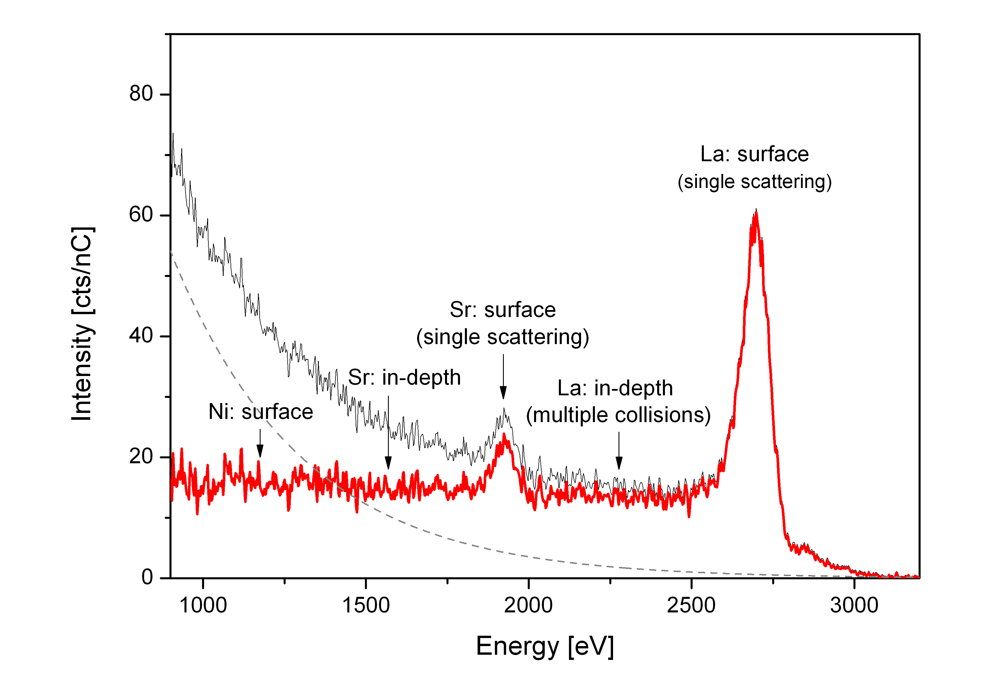

Fig. 1 22Ne LEIS energy spectrum for the (001) face of the heat-treated La1.67Sr0.33NiO4+δ single crystal. Original data (grey line), background (dashed line) and obtained corrected spectrum (red line).

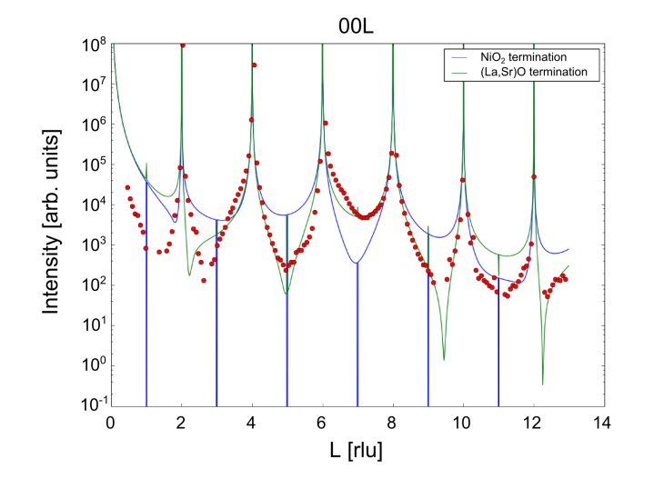

Figure 2 Crystal truncation rod scattering as measured along the 00L direction in air at 450 ºC. Red dots indicate the raw data and solid lines the model CTR patterns for NiO2 (blue) or (La,Sr)O (green) terminations.

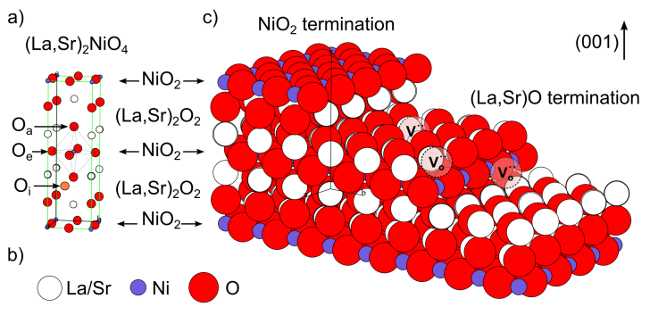

Figure 3. a) Representation of the (La,Sr)2NiO4 structure, consisting of a stacking sequence of (La,Sr)2O2 bilayers and NiO2 monolayers along the *c*-axis. The position of an oxygen interstitial in the (La,Sr)2O2 layer of the structurehas been marked (orange atom) together with the positions of the apical (Oa) and equatorial oxygen (Oe) atoms. b) Colour code for the Ni (purple), La/Sr (white) and O (red) atoms. c) 3D view of the crystal highlighting the two possible ideal terminations for the (001) face (top surface), a step edge and possible oxygen vacancy positions (marked as $V_{O}^{∙∙}$).

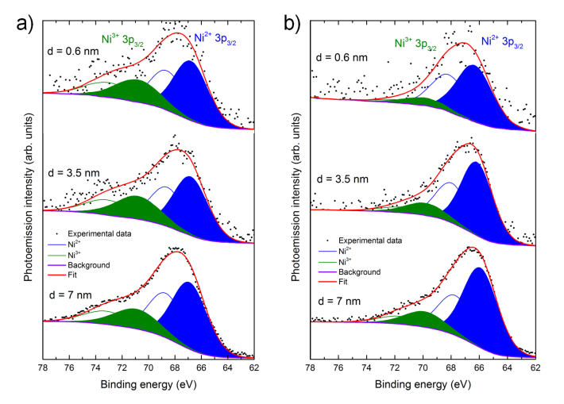

Figure 4. Angle-resolved experimental and deconvoluted Ni 3*p* XPS data for the (001) face of the La1.67Sr0.33NiO4+δ single crystal a) before and b) after heat treatment. The spectra correspond to three different surface regions 0.6, 3.5 and 7 nm. The contributions from Ni2+ and Ni3+ are marked in blue and green respectively. The full peaks correspond to the 3*p*3/2 lines and the empty curves to the 3*p*1/2 lines. The envelope of both components is shown in red.