**Decoupling Framework for Large-Scale Energy Systems Simultaneously Addressing Carbon Emissions and Energy Flow Relationships through Sector Units: A Case Study on Uncertainty in China's Carbon Emission Targets**

Chenxi Lia,b , Nilay Shahb,*, Zheng Lia, Pei Liua,*

aState Key Lab of Power Systems, Department of Energy and Power Engineering, Tsinghua-BP Clean Energy Centre, Tsinghua University, Beijing, 100084, China

bDepartment of Chemical Engineering, Imperial College London, SW7 2AZ, United Kingdom

*Corresponding author.

E-mail addresses: licx21@mails.tsinghua.edu.cn (C. Li), n.shah@imperial.ac.uk (N. Shah), lz-dte@tsinghua.edu.cn (Z. Li)，liu_pei@tsinghua.edu.cn (P. Liu).

**Highlights:**

* Large-scale energy systems are dismantled with sectors as the smallest unit.
* The CO2 and power supply and demand relationships between sectors are preserved.
* The long-term carbon emission target curve is only characterized by two parameters.
* The impact of uncertainty on China's emission target curve has been evaluated.
* Delaying reduction and high carbon budgets are not conducive to achieving net zero.

**Abstract****:** The energy system requires meticulous planning to achieve low-carbon development goals cost-effectively. However, optimizing large-scale energy systems with high spatial-temporal resolution and a rich variety of technologies has always been a challenge due to limited computational resources. Therefore, this study proposes a soft-linkage framework to deconstruct large-scale energy system optimization models based on sectors. Carbon emissions control between sectors is facilitated through the pre-allocation of carbon quotas. Prioritizing end-use sector planning and utilizing end-use sector power demand as input for power sector planning ensures supply-demand balance. Using China's energy system as a case study, the impact of uncertainty on emission reduction targets is analyzed. A long-term emission target curve is only described by the total carbon budget and its temporal distribution. Results show that delaying carbon reduction offers no cost or sustainability advantage, while excessively high carbon budgets raise national natural gas demand, threatening energy security.

**Keywords:** decoupling; sector-based energy system; duel relationship of CO2 and electricity; emission target curve; uncertainty; carbon budget and its temporal distribution

1. Introduction

The normal operation of energy systems is a necessary condition for ensuring normal human life and production. However, it currently leads to extremely high CO2 emissions, causing grave climate change (Baker et al., 2018). Therefore, it is necessary to achieve carbon reduction in the energy system as soon as possible, which requires reasonable advance planning, otherwise it may lead to high costs due to the enormous cost differences among various transition pathways (Sahin et al., 2024), and even make the energy system unable to operate normally (Peters et al., 2024).

Common energy system plans are typically achieved through simulation or optimization (Debnath & Mourshed, 2018). Emission reduction simulation models usually deploy specific low-carbon technologies in a bottom-up method to obtain predicted carbon emissions. Kumar and Madlener utilized the LEAP model to assess the CO2 reduction potential through several scenarios (Kumar & Madlener, 2016). Karatayev, Gaduš and Lisiakiewicz simulated a national power system by EnergyPLAN at an accuracy of 8760 hours per year to create a secure and low-carbon power system for the Slovak Republic (Karatayev et al., 2023). Nassar et al. employed a System Dynamics model to explore the potential policies for the promotion of the decarbonization of Brazil’s freight transport (Nassar et al., 2023). Although these bottom-up models are able to portray the details of the energy system in a high time or spatial resolution, which is crucial for energy systems with a high proportion of renewable energy, it is difficult to reach the total carbon emission limitation strictly unless massive scenario simulations are conducted. The mismatch between the CO2 emissions planned for the total amount and the emissions controlled for the total amount is susceptible to causing the inability to achieve emissions reduction targets or unaffordable high costs (Misconel et al., 2022). Optimization models are operative tools for planners to formulate decarbonization pathways, achieving total emissions control by directly constraining total carbon emissions. Niño et al. assessed the decarbonization pathway of Colombia with yearly and single-noded spatial resolution, including 169 technologies involved in more than five sectors, by using OSeMOSYS (Plazas-Niño et al., 2023). Coppens et al. carried out scenario analysis with the TIMES model for the energy system of Wallonia with single-noded spatial resolution and 24 timeslices in a year (Coppens et al., 2022). The resolution of some other studies using optimization models for energy system planning, including spatiotemporal resolution and the number of techniques included, are listed in Table 1. It can be found that due to limited computing resources, global optimization planning of energy systems with as many details as possible is almost unrealistic.

Table 1 The scope and resolution of previous studies about energy system optimization planning

|  |  |  |  |  |  |
| --- | --- | --- | --- | --- | --- |
| Study | Planning length | Scope | Spatial resolution | Temporal resolution | Number of technologies |
| (Saeid Atabaki et al., 2023) | 35 years | Power+  Transport | Single-noded | 36 time steps | 15 |
| (Mc Guire et al., 2023) | 32 years | Building | Single-noded | 40 time steps | 1188 |
| (Zhu et al., 2022) | 40 years | The Whole Society | 9 regions | 5 years | Technology-rich |
| (Hoettecke et al., 2022) | 30 years | Power+  Heating | Single- noded | Hourly | 18 |
| (Aryanpur et al., 2022) | 32 years | Transport | 26 regions | 40 time steps | More than 100 |
| (Verástegui et al., 2021) | 25 years | Power | 20 regions | Hourly (6 representative day) | 12 |
| (Martínez-Quintana et al., 2021) | 30 years | Power | 7 regions | 10 time steps | 14 |
| (Haghi et al., 2020) | 31 years | Power+  Heating | Single- noded | Hourly | 17 |
| (Godínez-Zamora et al., 2020) | 35 years | Power+  Transport | Single- noded | Yearly | More than 200 |
| (Bohra & Shah, 2020) | 30 years | The Whole Society | Single- noded | 6 time steps | 28 |

However, for future energy systems with a high proportion of renewable energy, high-resolution planning is essential. Renewable energy relies heavily on local natural conditions (Joshi et al., 2021) and has strong volatility (Ren et al., 2023), so only a relatively high spatiotemporal resolution can distinguish its differences from ordinary fossil fuels in more detail. In addition, the technology choices of the end-user sector in a low-carbon society directly determine their energy needs and are transmitted to the energy conversion sector, such as the transport (Hoehne et al., 2023) and steel sectors (Lei et al., 2023) in hydrogen and electricity choices. Therefore, more ens-user technology options are also necessary.

One possible way to achieve tractable energy system optimization models with high spatiotemporal resolution and multiple technological choices is to split the global optimization model into sectors as the most basic unit. This is because the connections among sectors are much simpler than the connections between technical options within sectors. Secondly, there have been numerous optimization planning models based on sectoral modeling in previous studies. However, simply adding up the research results of models planned based on sectors may not be adequate to ensure internal connections within the energy system sectors (Energy Foundation China, 2020; Huo et al., 2021; ICCSD, 2021; T. Li, 2021; Ou & Yuan, 2022; Y. Zhang et al., 2022). The power supply and demand balance between the energy conversion sector and the energy demand sector, namely the power sector and the end-use sectors, is difficult to ensure. It is also difficult to meet the requirements of total carbon emissions control among various energy consumption sectors.

Therefore, this study proposes a framework for splitting energy systems based on sectors, the long-term multi-sector carbon mitigation pathway planning framework with priority to carbon quota allocation (LOMUS-QUAF framework), which is used to plan the long-term transition pathway of the energy system while ensuring the electricity supply and demand balance and controlling total carbon emissions. Due to the optimization of the model being based on sectors, it can incorporate more technology types and higher spatiotemporal resolution within limited computing resources. Soft linkage is used for connection among sectors, which has been confirmed to expand the scalability of optimization planning models (Curty et al., 2023; Mimica et al., 2022). The electricity supply and demand balance between the end-use sectors and the power sector can be ensured through a computation sequence, while the total control of carbon dioxide emissions can be managed by introducing carbon quota allocations among all sectors before the optimization of every single sector.

The LOMUS-QUAF framework is used to explore the impact of uncertainty in transition goals on energy system transition through multi-scenario analysis. Although multiple uncertainties exist in the transition of energy systems, such as the outputs of wind and solar (Bhavsar et al., 2023), the costs of decarbonization technologies or fuels (Duan & Caldeira, 2024) and the appearance of disruptive events (Heuberger et al., 2018), there are insufficient studies that discuss the uncertainty of transition goals, to the best of our knowledge. Although most countries or regions consider carbon neutrality as their ultimate transition goal, it is uncertain how to transit from current emissions to net zero emissions, whether to reduce emissions uniformly, slowly first, or quickly first (Victoria et al., 2020). Meanwhile, achieving net zero emissions with different carbon budgets will also have a significant impact on the low-carbon transition pathway (Pye et al., 2017). Different emission reduction target curves may have significant differences in the path, including costs and emission reduction technology configurations (S. Zhang & Chen, 2022), so it is worth discussing. Meanwhile, although fuzzy programming (Cai et al., 2018), stochastic programming (Z. Guan et al., 2023), robust optimization (Abdin et al., 2022) and interval optimization (Kaffash et al., 2021) et al. are all mature uncertainty analysis methods applied to energy systems, they all belong to pre-analysis methods, and their applicability to uncertainty discussions with transition goals is limited. Therefore, this study uses multi-scenario analysis as a post-uncertainty analysis method. China is being used as a case study, not only because it is currently the largest carbon-emitting country, but also because China's transition goals are not clear. It only claims the latest carbon peak year and expected carbon neutrality year, and it is unclear how to shift from current carbon emissions to achieving this goal.

The novelty of this work can be summarized as three points. Firstly, this paper takes sectors as the basic unit to decouple the optimization modeling of large-scale energy systems and proposes a generic decoupling framework. The allocation of carbon quotas is introduced into the framework, and the calculation sequence of end-use first, then the energy conversion sector, ensures the control of total carbon emissions among sectors and the balance of electricity supply and demand. In addition, in order to analyze the impact of uncertainty in the long-term carbon emission target curve on transition, this study describes the carbon emission target curve composed of uncertain parameters of multi-year carbon emission targets using only two variables: total carbon budget and temporal distribution of carbon budget, representing the height and shape of the curve, respectively. Thirdly, this study explores China's energy system emission reduction paths under different transition target curves and analyzes their impact on China's low-carbon transition, providing possible insights for decision-makers to choose potential transition goals and paths.

This paper is organized as follows: Section 1 introduces the background of this study. Section 2 describes the proposed framework in detail. Section 3 provides the basic scenario settings for this study. Section 4 presents and discusses the results, and Section 6 summarizes the conclusion of this research.

2. Methodology

Major energy-consuming and carbon-emitting sectors include both end-use sectors and the power sector. Decoupling the energy system by sector requires ensuring that the coupling relationship between different sectors is still satisfied. In this framework, particular attention is given to the coupling relationship of electricity and carbon emissions. The reduction of emissions in end-use sectors is mainly achieved through technologies such as electrification or the use of energy products produced from electricity. Consequently, the electricity interconnection of electricity between end-use and power supply sectors becomes pivotal in low-carbon energy systems. In addition, the sum of carbon emissions from various departments should be constrained by the target carbon emissions. This aggregate figure serves as the direct objective in the pursuit of curbing carbon emissions. The interrelation between other energy sources and products among different sectors is intentionally excluded for the sake of simplification. Electricity is generated from the power sector and supplied to the end-use sector. Therefore, the supply and demand balance of electricity between the power sector and end-use sectors should be ensured. Besides, all the sectors cannot avoid emitting CO2 emissions by utilising fossil fuels. The sum of carbon emission limits for all sectors should be the carbon emission limit for the entire system. Based on the two coupling relationships described above, we propose the long-term multi-sector carbon mitigation pathway planning framework with priority to carbon quota allocation (LOMUS-QUAF framework).

The LOMUS-QUAF framework aims to find a possible cost-effective decarbonization solution for the whole society, including both demand-side and supply-side, under specific carbon emissions targets with high time and spatial resolution, as well as rich technology types. Four major energy-consuming sectors, transport (C. Li et al., 2022), building (heating included) (C. Li, Liu, et al., 2023), industry (only steel and cement production included) and power (C. Li, Tian, Chen, et al., 2023), are planned by superstructure optimization models, respectively, whose structure can be simplified as Figures 1(a-d). The technologies included, the specific spatio-temporal resolution and the detailed mathematical description for each sectoral optimization model and the framework are provided in the Supplementary material. Due to the complex structure of other energy consumption sectors, while their energy consumption only accounts for a relatively small proportion of total social consumption, predictions are made through future economic development, energy intensity prediction, and other macroscopic parameters. The types of primary energy consumed considered in the LOMUS-QUAF framework include coal, oil (gas, diesel, kerosene), natural gas, nuclear, and renewable energy (wind, solar, biomass, hydro).

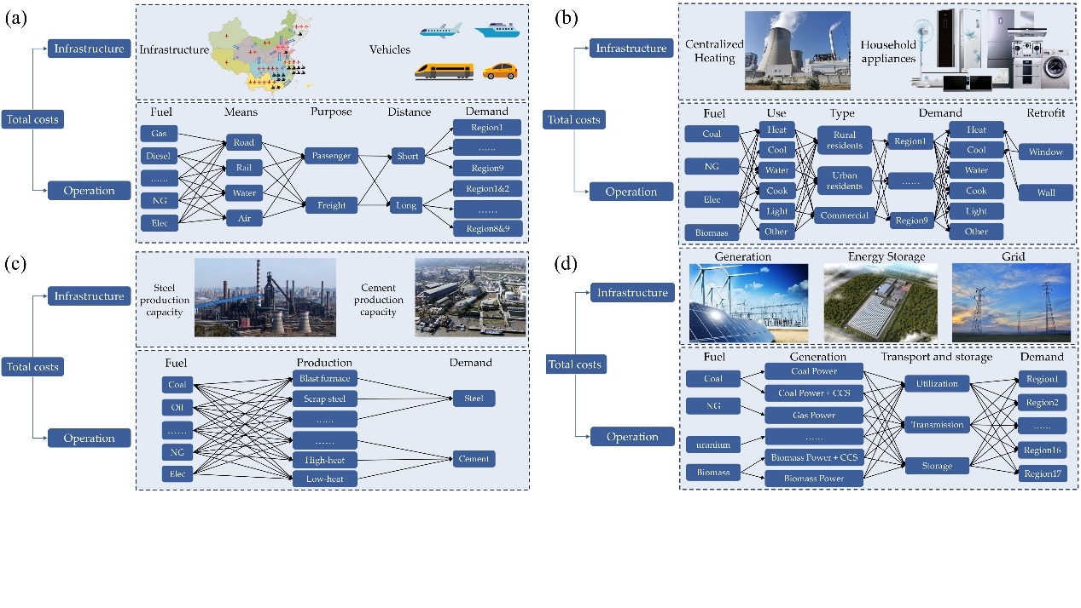

Figure 1 The structure of four major energy-consuming sectors (a) Transport (b) Building (c) Industry (d) Power

The structure of the LOMUS-QUAF framework is shown in Figure 2, where the data flow in the framework is also depicted. Starting from the end-use demand forecasting, which can be either counted privately or obtained from the existing result from authoritative institutions under specific contexts, showing the broad applicability of this framework. The total national carbon emissions target should be allocated to each sector before the low-carbon planning for them. Although there are many ways to allocate carbon quotas, the mechanism of quota allocation is not the focus of this study. Therefore, we only apply the most basic cumulative historical emission allocation mechanism in this framework. Through the allocation of carbon quotas and optimization of various sub-sectors, the coupling relationship of carbon emissions between departments is preserved. Due to the fact that energy consumption in the other sector has already been determined through predictions, the CO2 emissions of it is also fixed, calculated by its forecast energy consumption through emission factors. Therefore, the actual sector that participated in the allocation only includes building, industry, transport and power, and the total carbon quota of these four sectors is the difference between the total national target and the predicted emissions of the other sectors. The allocation mechanism can be set to a single allocation or include reassignment. After obtaining the allocation quota, the four chief energy consumers plan the lowest cost transition pathway while meeting future demand and carbon emission requirements, wherein the total electricity demand derives from the forecast and optimization results from end-use sectors. Consequently, the supply and demand balance of electricity is ensured in the LOMUS-QUAF framework. Due to the existence of cogeneration technology, the planning and operation of the power sector and building sector are interrelated. Therefore, after optimization by the power sector, the building sector is supposed to replan based on the new results related to coal-fired power units. By implementing the LOMUS-QUAFIM framework, not only can the quota allocation be obtained, but also the planning pathway of each sector.

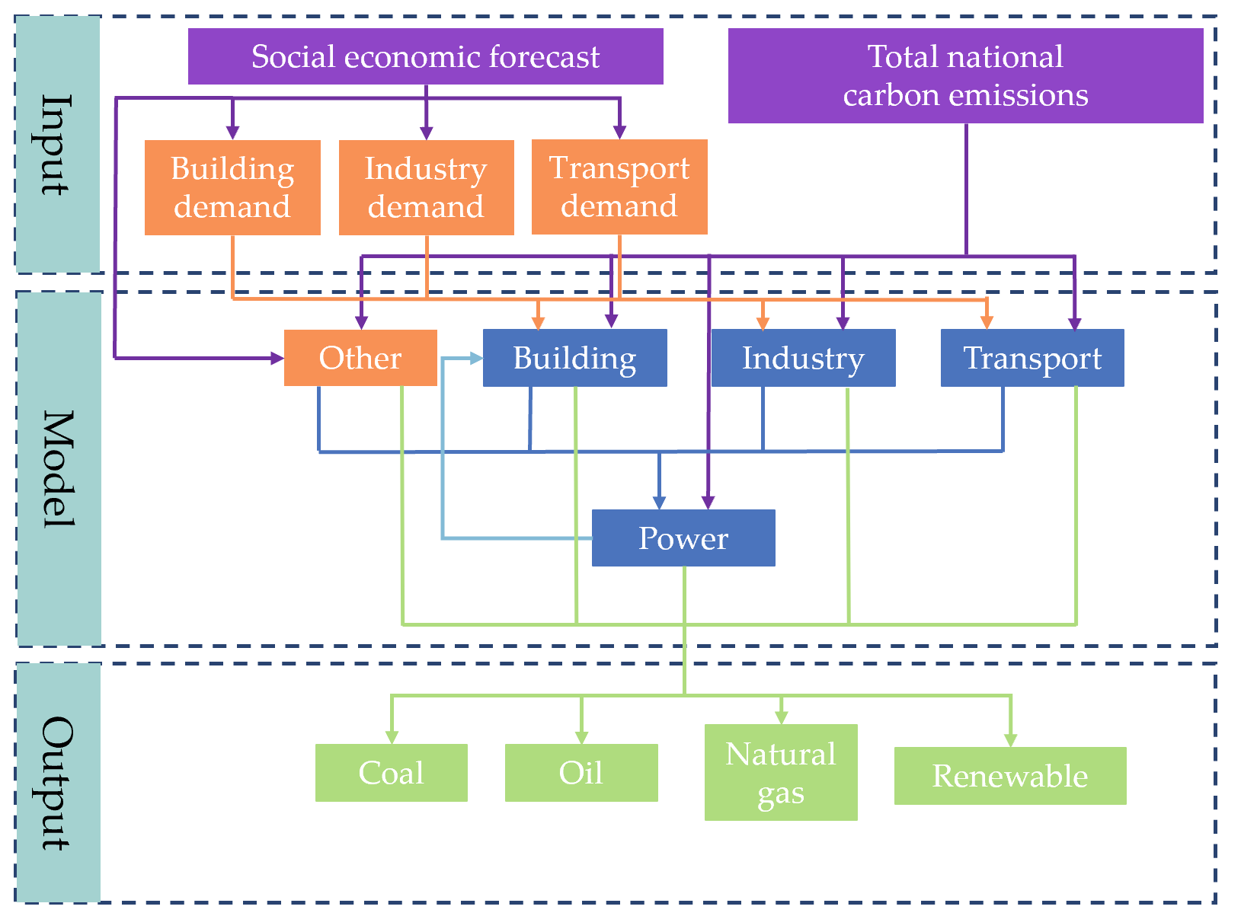

Figure 2 The structure and data flow of the LOMUS-QUAF framework

Soft-linking is implemented among sub-models, ensuring the most basic and vital relationships between each sub-model. Meanwhile, independent computing can ensure high temporal and spatial resolution, as well as a wide variety of technologies, even when using business laptops.

**3. Case study and scenario settings**

As the biggest emitter around the world, China, which has only announced key points for its carbon mitigation goal without providing how it can transition from its current emissions to achieving its net zero emissions target, is set as the case for the proposed LOMUS-QUAF framework. The planning period for this study is from 2024 to 2060. implemented using the CPLEX solver on the GAMS platform, using a laptop equipped with an i7-10750H CPU and 16GB of memory. Due to the long planning period, high spatiotemporal resolution and rich variety of technologies involved in the problem, as well as the presence of a large number of integer variables, global optimization cannot be achieved on the same device. However, using the proposed framework, this large-scale optimization problem can be decomposed, and a solution can be obtained within a maximum of one day (including iteration time, and the specific solution time is related to model input and constraints).

The LOMUS-QUAF framework will be applied to discuss how China's energy system will shift from its current structure to a net zero emission in 2060 and achieve a carbon peak by 2030 in this study. At the same time, it is useful to explore the impact of different target emission curves on the transition of China's energy system, and whether there are corresponding laws. However, for a carbon emission curve with 37 points and only two constraints, the workload of point-by-point uncertainty analysis is large. Therefore, it is necessary to use as few parameters as possible to describe the uncertainty of the curve.

Inspired by previous studies related to scenario analysis, we quantitatively and qualitatively characterize a long-term target emissions curve with two parameters: the time series distribution of the carbon budget and the total carbon budget. The time series distribution can describe the shape of a curve, and the amount of total carbon budget can evaluate the height of a curve. Accordingly, we set up the following possible transition target curves for the analysis of this study, as listed in Table 2 and shown in Figure 3(a-b). All of the scenario settings can satisfy the demand for carbon peaking before 2030 and reaching carbon neutrality in 2060 when nature-based solutions are also considered. In all scenarios, only four optimization sectors participated in the allocation of carbon quotas, and their transition pathway changed with different scenario designs, while the predicted results of the other sector are assumed to be unique. When using the cumulative historical emissions method for quota allocation, 10 years are selected as the cumulative duration, and historical emissions are determined based on the CEADs dataset as well as previous studies (Y. Guan et al., 2021; Shan et al., 2018; Shan et al., 2020; Shan et al., 2016; Xu et al., 2024) and China Statistical Yearbooks. According to a study by the Energy Foundation, it is believed that China's remaining total CO2 budget for 2016-2050 is 150-260 Gt (Energy Foundation China, 2020). Roughly estimated, China emitted approximately 10 billion tonnes of CO2 annually from 2016 to 2023, with an average annual emission of 2 billion tonnes from 2051 to 2060. Considering China's annual natural carbon sink of approximately 1.5 billion tonnes (Technology Foreign Affairs Office, 2021), the total carbon budget range for 2024 to 2060 is estimated to be between 143.5 and 255.5 Gt. Meanwhile, due to the net zero emissions of all greenhouse gases in 2060, according to reports from the World Resources Institute (Yao et al., 2016) and estimates from the Energy Foundation, China's non-CO2 greenhouse gas emissions in 2060 are estimated to be approximately 762 million tonnes. Assuming that the natural carbon sink remained at 1.5 billion tonnes in 2060, then the national CO2 emissions in 2060 are set at 829 million tonnes to achieve net zero emissions for the whole society.

Table 2 The cap of CO2 emissions in each scenario (Gt)

|  |  |  |  |  |  |
| --- | --- | --- | --- | --- | --- |
|  | 2030 | 2040 | 2050 | 2060 | Total budget |
| s0 (s-255) | 12.04 | 8.18 | 3.20 | 0.83 | 255.56 |
| s1 | 11.04 | 7.66 | 4.27 | 0.83 | 255.52 |
| s2 | 12.04 | 8.03 | 3.03 | 0.83 | 255.56 |
| s3 | 12.04 | 10.17 | 1.50 | 0.83 | 255.50 |
| s4 | 9.65 | 6.65 | 6.15 | 0.83 | 255.54 |
| s-245 | 12.04 | 7.69 | 3.00 | 0.83 | 245.58 |
| s-235 | 11.81 | 7.21 | 2.81 | 0.83 | 235.56 |
| s-225 | 11.06 | 6.78 | 2.64 | 0.83 | 225.56 |
| s-215 | 10.73 | 6.32 | 2.43 | 0.83 | 215.56 |
| s-205 | 10.73 | 5.72 | 2.19 | 0.83 | 205.53 |
| s-195 | 10.73 | 4.84 | 1.85 | 0.83 | 195.53 |

*The scenarios s0, s1, s2, s3, and s4 are set to analyze the impact of the time series distribution of the carbon budget on the transition pathway. Therefore, their total carbon budget is designed the same. The scenarios s-255, s-245, s-235, s-225, s-215, s-205, and s-195 are set to analyze the impact of the total carbon budget on the transition pathway. Therefore the shape of their carbon emission cap curve is designed as similar as possible. When the total budget is less than 185 Gt, there is no solution under the same assumptions as other scenarios.

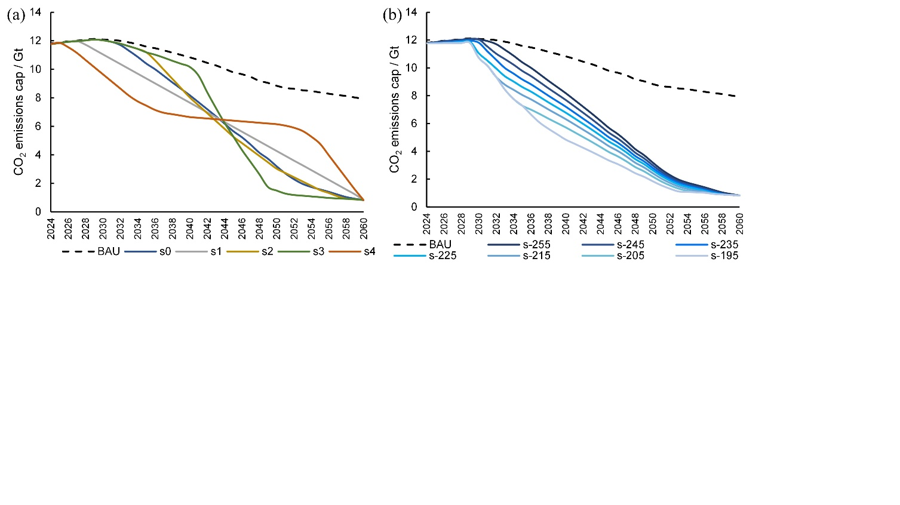

Figure 3 Scenario settings. BAU represents the total emissions of society without carbon emission targets. (a) Scenario settings of the time series distribution of the carbon budget (b) Scenario settings of the total carbon budget

The future end-use demand of different sectors can be found in the Supplementary material and the economic parameters of the technologies considered are according to our previous research (C. Li et al., 2022; C. Li, Liu, et al., 2023; C. Li, Tian, Chen, et al., 2023; C. Li, Tian, Yang, et al., 2023).

4. Results and discussions

4.1. The impact of the time series distribution of the carbon budget on the transition pathway

In order to have a comprehensive understanding of the energy transition path from the current energy system structure to a net-zero emission energy system—it is crucial to grasp the changes in total national energy consumption and its structure. Figure 4 illustrates these changes, while Table 3 provides a detailed breakdown of the results. It is important to emphasize that all results presented in this study are calculated using the electrothermal equivalent method.



Figure 4 The total national energy consumption in scenarios s0~s4

Table 3 The national energy consumption in scenarios s0~s4 in 2030 and 2060 (million tces)

|  |  |  |  |  |  |  |
| --- | --- | --- | --- | --- | --- | --- |
|  |  | s0 | s1 | s2 | s3 | s4 |
| 2030 | Coal | 3191 | 3026 | 3187 | 3168 | 2626 |
| Oil | 993 | 981 | 990 | 977 | 937 |
| Gas | 571 | 517 | 575 | 601 | 453 |
| Renewable | 684 | 778 | 686 | 692 | 1022 |
| 2060 | Coal | 499 | 572 | 523 | 873 | 817 |
| Oil | 564 | 564 | 564 | 563 | 564 |
| Gas | 165 | 167 | 165 | 165 | 167 |
| Renewable | 2597 | 2558 | 2615 | 2473 | 2468 |

Results indicate that when the emission reduction rate is excessively high—reflected in a steep slope of the carbon emission limit curve over time—coal consumption will be greatly affected. Implementing strict emission reduction requirements in the early stages, such as s1 and s4, mainly requires a rapid decline in national coal consumption. In 2030, the coal consumption in the s1 and s4 scenarios will be 4.9% and 17.5% lower than the average consumption in the other three scenarios respectively. Conversely, enforcing stringent emission reduction requirements during the mid-to-late period is anticipated to profoundly influence coal consumption post-commercialization of carbon capture technology on a large scale (after 2040). Coal consumption is expected to surge significantly because coal-fired power generation, coupled with carbon capture technology, can deliver stable and clean electricity. By 2060, coal consumption in scenarios s3 and s4 is estimated to be 64.3% and 53.6% higher, respectively, than the average consumption in the other three scenarios. Disparities in coal consumption also translate into variations in the consumption of other energy sources, particularly renewable energy. In 2060, the ratios of renewable energy consumption to total national energy consumption in s0, s1 and s2 scenarios are 67.9%, 66.2% and 67.6% respectively, while those in s3 and s4 are only 60.7% and 61.4%. In addition, in the s4 scenario, its premature emission reductions and the carbon emission plateau period from 2035 to 2055 will cause a significant increase in natural gas consumption, which can also be clearly observed in Figure 4.

Further, we observe the differences in end-use energy demand and power generation structure in different carbon emission time series distributions, as shown in Figure 5(a-b) and Figure 6. End-use hydrogen energy is considered to come from the electrolysis of water, and the ratio of producing 1kg of hydrogen with 45kWh of electricity is converted into electricity consumption (C. Li, Tian, Yang, et al., 2023). Since there are not many direct application scenarios of renewable energy in end-use sectors, and its proportion does not exceed 6% of end-use energy consumption, this article does not conduct a separate analysis and discussion of renewable consumption in the end-use sector. Results show that unless emissions are reduced prematurely, such as in the s4 scenario, changes in end-use coal consumption will not make much difference. Moreover, different carbon budget timing distributions will have a greater impact on end-use natural gas and electricity consumption. Delaying emissions reductions could result in an increase in peak end-use natural gas demand. Compared with the s0 scenario, the peak natural gas demand in the s3 scenario increases by 15.4%. In addition, an excessively fast emission reduction rate after 2040 is not conducive to the reduction of terminal natural gas demand, because it may cause over-reliance on natural gas in the heating and transport sectors, such as the s1 and s4 scenarios. In addition, the results show that the energy consumption demand of the end-use sector in 2060 has little difference among various carbon emission scenarios, with the electricity demand of about 20PWh, which may imply that the energy consumption structure of the end-use sector when carbon neutral in 2060 has carbon budget timing irrelevance.

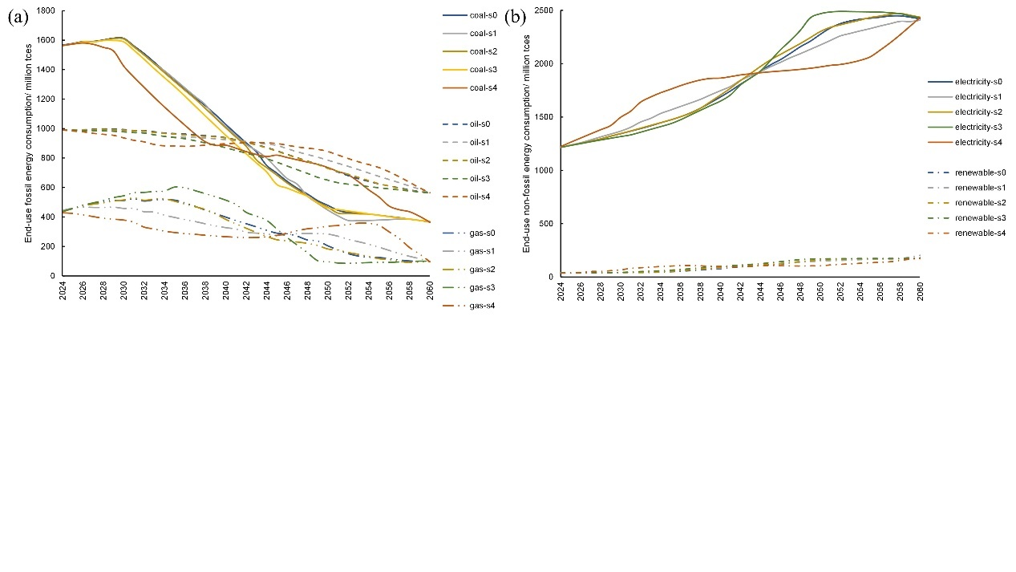

Figure 5 End-use energy consumption in scenarios s0~s4 (a) Fossil energy consumption (b) Non-fossil energy consumption

Additionally, it is found that the the shape of the end-use power demand curve and the national total carbon emission cap constraint curve are complementary. Therefore, we hypothesise that the national power demand curve, *PD(t)*, and the total carbon emission cap constraint curve, *CAP(t)*, have a positive correlation, that is, *corr(PD(t),-CAP(t))>0*. Therefore, we conducted a correlation analysis between the electricity demand curve and the total carbon emission cap constraint curve for the five scenarios. Results show that the average value of *corr(PD(t),-CAP(t))* of the five curves is 0.9945, indicating a high positive correlation. This brings inspiration to other optimization planning studies that only consider the power system with the goal of low-carbon development: Although the total power demand curve in similar studies is not entirely derived from the optimization results of end-use sectors, it is necessary to ensure as much as possible during planning There is a positive correlation between *PD(t)* and *-CAP(t)* to improve the meaningfulness of scenario design during research.



Figure 6 The generation mix in scenarios s0~s4. The technology types: subcritical coal-fired power generation (without or with carbon capture, SPC or SPCC), supercritical coal-fired power (without or with carbon capture, UPC or UPCC), natural gas combined cycle power (NGCC), nuclear power (NU), hydropower (HD), onshore wind power (WD), offshore wind power (WDOFF), centralized photovoltaic (PV), decentralized photovoltaic (PVDIS) and biomass power (without or with carbon capture, BE or BECCS).

The results concerning the power generation structure highlight a critical imperative: irrespective of the emission reduction method employed, it is essential to phase out lower-efficiency coal power units by no later than 2050. Failure to do so risks impeding the power system's ability to meet expected carbon reduction requirements. Moreover, excessively rapid emission reductions in the short term may lead to a surge in coal-fired power generation within the power sector. For instance, only the s3 scenario requires power supply from SPCC units, and the proportion of coal-fired power generation in the s4 scenario will be much higher than that of s0~s3 from 2050. Compared with the s0~s2 scenarios, the proportion of coal-fired power generation in the s3 and s4 scenarios are 5 and 6 percentage points higher respectively. This is also the reason why coal consumption in these two scenarios is high in 2060 among the national total energy consumption. The goal of the low-carbon transition of the energy system is not only to reduce carbon emissions, but also to reduce the consumption of fossil energy as much as possible, because the development model of continuing large consumption of fossil energy is unsustainable. Therefore, judging from the perspective of sustainability alone, reducing carbon emissions too quickly in the short term is not necessarily a wise way to transition.

Given that China’s energy infrastructure is dominated by coal and has a short average service life, achieving carbon neutrality in less than 40 years will inevitably lead to the early decommissioning of a large number of coal-related assets. Based on the calculation results, we compiled the amount of early decommission and the average number of years of early decommissioning of coal-fired power plants and coal-fired heat boilers, as listed in Table 4. The early decommissioning of coal-fired assets will lead to the closure of related factories and cause unemployment among workers, thus raising the issue of injustice in the energy transition (Xie et al., 2023). Therefore, from the perspective of transition justice, s1 and s0 may be more appropriate for carbon reduction transition.

Table 4 The profile of early decommission coal-based infrastructure

|  |  |  |  |  |  |
| --- | --- | --- | --- | --- | --- |
|  | s0 | s1 | s2 | s3 | s4 |
| Generation units (GW) | 115 | 138 | 122 | 130 | 403 |
| Average years of units | 2.56 | 2.52 | 2.64 | 1.58 | 5.38 |
| Heat boilers (GW) | 386 | 238 | 14206 | 4476 | 1910 |
| Average years of boilers | 2.96 | 2.18 | 1.00 | 1.96 | 1.00 |

In addition, the study also analyzed the costs under different budget timing distribution curves, as illustrated in Figure 7. The results show that unless significant emission reductions are started too early, the difference in emission reduction costs for a total of 37 years from 2024 to 2060 will not be too high and will basically be within 150 trillion yuan. This is in line with existing similar studies (Chen et al., 2020). In addition, we found that delaying emission reductions does not necessarily lead to a decrease in costs, and starting emission reductions in advance does not necessarily lead to an increase in costs. For example, in scenario s1, where emissions are reduced evenly starting in 2027, the cost is about 20 trillion less compared to s0, s2, and s4. Therefore, from a cost perspective alone, uniform emission reduction may be a better choice.



Figure 7 The total transition costs in scenarios s0~s4

The selection of the emission reduction target curve typically involves consideration of multiple criteria rather than relying on a single standard. Therefore, this study undertakes an analysis of the advantages and disadvantages of five carbon budget time series distribution curves. To facilitate this analysis, a three-dimensional radar chart is constructed, encompassing sustainability, justice, and economy based on national fossil consumption in 2060, coal-based infrastructure decommissioning, and associated costs, as depicted in Figure 8. Upon comparison, our findings indicate that the overall performance of scenarios s0 and s1 stands out favorably.



Figure 8 Comprehensive performance radar chart for scenarios s0~s4

4.2. The impact of the total carbon budget on the transition pathway

Based on the results of the comprehensive assessment in Section 4.1, we select the s0 curve to analyze the impact of the total carbon budget. The national energy consumption and related proportions under different carbon budgets are shown in Figure 8(a~d) and Table 5 below. Overall, a reduction in the carbon budget will lead to a decrease in the national consumption of coal, oil, and natural gas and an increase in the consumption of renewable energy. This shows that the reduction of the total carbon budget is beneficial to the reduction of fossil energy imports.

Table 5 Energy consumption structure under different carbon budgets

|  |  |  |  |  |  |  |  |  |
| --- | --- | --- | --- | --- | --- | --- | --- | --- |
|  |  | s-255 | s-245 | s-235 | s-225 | s-215 | s-205 | s-195 |
| 2030 | Coal | 60.2% | 60.3% | 60.2% | 58.1% | 56.9% | 56.3% | 55.9% |
| Renewable | 12.9% | 13.3% | 13.5% | 15.8% | 17.3% | 18.3% | 18.0% |
| 2060 | Coal | 13.2% | 13.1% | 12.7% | 12.3% | 12.4% | 13.1% | 13.5% |
| Renewable | 68.6% | 68.6% | 69.0% | 69.5% | 69.3% | 68.8% | 68.5% |

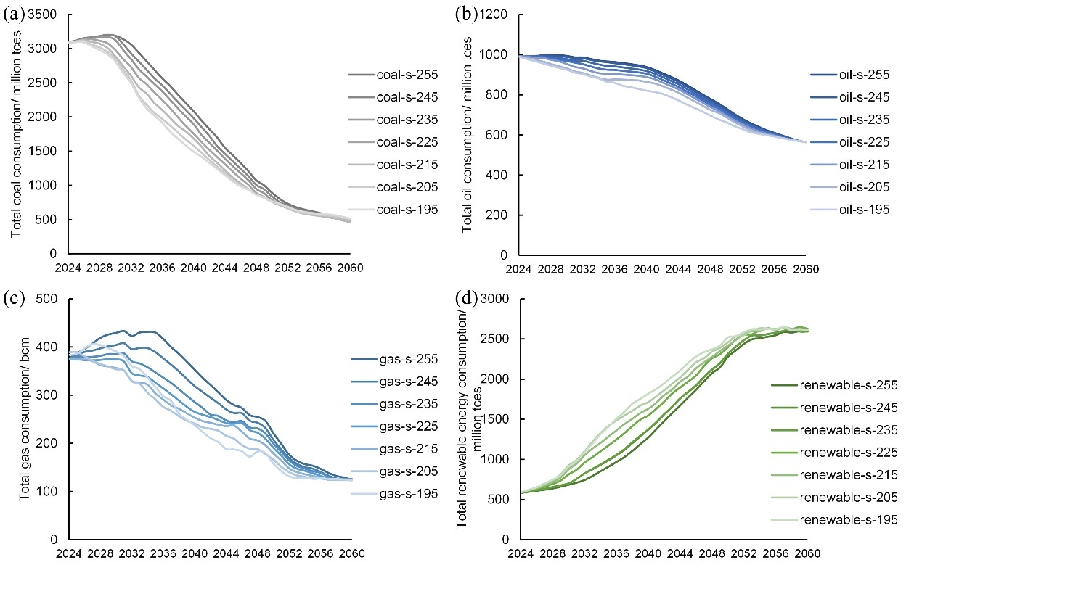

Figure 9 The total energy consumption in scenarios s-255~s-195. (a) Coal (b) Oil (c) Gas (d) Renewable energy

Furthermore, the proportion of oil and natural gas imports resulting from the low-carbon transition is calculated based on public data. In 2022, China's national oil consumption stood at 968 million tces, while natural gas consumption was 454 million tces. At that time, the oil import rate was approximately 75%, and the natural gas import rate was about 45%. The transition towards a low-carbon energy system aimed at achieving carbon neutrality across society is expected to lead to a continual decline in oil imports. By 2060, the import rate is projected to be only 57%. However, the low-carbon transition may entail a surge in natural gas consumption by 2035. Assuming domestic production cannot sustain expansion, a higher carbon budget could result in the national natural gas import rate peaking at 56%, marking an 11-percentage-point increase from the 2022 level. This trajectory would further heighten China's reliance on foreign energy sources. Nonetheless, this scenario is anticipated to improve once natural gas consumption reaches its zenith. Beyond 2050, the country is projected to attain near self-sufficiency in natural gas.

However, as the carbon budget is further reduced, there may be a slight rebound in natural gas consumption. This can be attributed to overly aggressive emission reduction targets, which compel buildings to rely more on gas boilers to meet heating needs. In scenario s-255, approximately 23.1% of the country's heating demand in 2030 is satisfied by natural gas boilers. As carbon emission requirements become increasingly stringent, this ratio decreases to 22.9% in scenario s-225. However, as emission requirements become even more stringent, this ratio gradually increases. When the total carbon budget is only 195 billion tonnes, this ratio reaches 27.3%, resulting in a significant surge in demand for natural gas for heating, thereby influencing the total national demand.

In addition, upon achieving carbon neutrality in 2060, the national energy consumption across various types under different carbon budgets remains largely consistent. This suggests that when determining the carbon budget time series distribution, the energy consumption in 2060 may not be significantly impacted by the total carbon budget. By this time, the national average coal consumption stands at 488 million tces, the average oil consumption at 564 million tces, the average natural gas consumption at 124 bcm, and the average renewable consumption at 260.8 tces.

Finally, attention should be paid to the cost changes and their patterns caused by different carbon budgets. Figure 10 illustrates the costs and their components under seven carbon budget scenarios. As expected, as the total carbon budget decreases—indicating increased carbon emissions requirements—the total transition costs gradually escalate. This trend suggests a certain degree of reliability in our results. Furthermore, this study explores the quantitative relationship between carbon budgets and costs. When the total carbon dioxide emission budget from 2024 to 2060 is reduced from 255 billion tonnes to 195 billion tonnes, the total national transition cost increases from 146.43 trillion yuan to 306.93 trillion yuan, an increase of more than 100%. In addition, through fitting, we believe that there is a quadratic power relationship between carbon budget and transition costs, rather than a linear relationship. The correlation coefficient is 0.9947. The selection of the transition curve cannot rely solely on economic costs, but also needs to consider other factors, such as whether the available stable sources of natural gas imports can support high import volumes. Therefore, although more relaxed emission reduction requirements can significantly reduce the cost of transition, it is not necessarily the ideal transition path.



Figure 10 The total transition costs in scenarios s-255~s-195

6. Conclusion and Policy Implications

Adopting sectors as the foundational unit of planning and prioritizing carbon quota allocation, while ensuring the matching relationship between power supply and demand in the energy system through calculation sequence, this study applies soft linkage on the basis of retaining the total carbon emission constraints and power supply relationships, and the splitting and solving of the long-term planning model of the energy system with high spatiotemporal accuracy and technological richness are achieved. The case of China’s energy system emission reduction from 2024 to 2060 proves the feasibility of the above method. Furthermore, the study employs a multi-scenario approach to quantitatively analyze the impact of uncertainty in China's carbon emission reduction curve on transition, encompassing considerations of energy structure and economy. By utilizing the time series distribution of the carbon budget and the total carbon budget to depict the shape and magnitude of the carbon emission reduction curve, the study effectively reduces the complexity of uncertainty analysis. The key findings are outlined below:

When the total carbon budget remains consistent, varying emission reduction rates across different periods significantly affect the sustainability, equity, and economics of energy system development. For China, a scenario featuring a "rapid decline in emissions" post-2040 leads to a relatively higher national coal consumption in the carbon-neutral period. Compared with a scenario where the emission reduction rate is more gradual, its coal consumption may increase by more than 50%, indirectly resulting in a decrease of about 7 percentage points in the proportion of renewable energy consumption. Additionally, improper timing distribution of carbon budgets may prompt premature retirements of coal-based energy infrastructure, consequently exacerbating social issues like unemployment. In addition, the total transition cost across the country varies under different carbon budget time series distributions, and the difference can be up to nearly 100 trillion yuan. For China, no carbon budget time series distribution can provide the best performance in all aspects. Therefore, in actual planning and decision-making, various factors need to be comprehensively considered to determine the appropriate carbon emission time series distribution.

Secondly, consistent time series distribution of the carbon budget exerts an influence on energy consumption and costs. Generally speaking, the reduction of the total carbon budget leads to a reduction in the consumption of coal, oil, and natural gas and an increase in renewable consumption. This shows that for China, a country that relies heavily on imported natural gas and oil, a lower carbon budget is conducive to energy independence. When the total carbon budget is 255 billion tons of carbon budget, the import rate of natural gas in the peak year may be 56%, an increase of 11 percentage points compared with 2022. However, it is essential to note two caveats: a carbon budget that is too low may spur an abnormal surge in natural gas demand, primarily driven by increased demand for natural gas in building heating. Additionally, the national energy consumption structure in 2060 appears independent of the total carbon budget. Moreover, the relationship between the carbon budget and the total transformation cost exhibits a nonlinear correlation with quadratic power, as per calculation results.

In light of the aforementioned findings, the study advocates for comprehensive consideration of multiple factors when determining the carbon emission target curve to chart the most suitable transition path.

Declaration of competing interest

The authors declare that they have no known competing financial interests or personal relationships that could have appeared to influence the work reported in this paper.

CRediT authorship contribution statement

Chenxi Li: Writing – original draft, Methodology.

Nilay Shah: Writing– review & editing.

Zheng Li: Conceptualization, Supervision.

Pei Liu: Writing– review & editing.

Acknowledgements

The authors gratefully acknowledge the support by the National Key Research and Development Program of China (2023YFC3807201), the Phase IV Collaboration between BP and Tsinghua University and the Ph.D. Short-term Visiting Scholar Fund of Tsinghua University.

References

Abdin, A. F., Caunhye, A., Zio, E., & Cardin, M.-A. (2022). Optimizing generation expansion planning with operational uncertainty: A multistage adaptive robust approach. Applied Energy*,* 306, 118032.

Aryanpur, V., Balyk, O., Daly, H., Ó Gallachóir, B., & Glynn, J. (2022). Decarbonisation of passenger light-duty vehicles using spatially resolved TIMES-Ireland Model. Applied Energy*,* 316, 119078.

Baker, H. S., Millar, R. J., Karoly, D. J., Beyerle, U., Guillod, B. P., Mitchell, D., Shiogama, H., Sparrow, S., Woollings, T., & Allen, M. R. (2018). Higher CO2 concentrations increase extreme event risk in a 1.5 °C world. Nature Climate Change*,* 8, 604-608.

Bhavsar, S., Pitchumani, R., Ortega-Vazquez, M. A., & Costilla-Enriquez, N. (2023). A hybrid data-driven and model-based approach for computationally efficient stochastic unit commitment and economic dispatch under wind and solar uncertainty. International Journal of Electrical Power & Energy Systems*,* 151, 109144.

Bohra, M., & Shah, N. (2020). Optimizing Qatar’s energy system for a post-carbon future. Energy Transitions*,* 4, 11-29.

Cai, M., Huang, G., Chen, J., Li, Y., & Fan, Y. (2018). A generalized fuzzy chance-constrained energy systems planning model for Guangzhou, China. Energy*,* 165, 191-204.

Chen, B., Lu, Y., Liu, G., Thomas, P., Ming, T. K., Rune, J., & Fan, L. (2020). China Climate Pathway Report. In. China: Boston Consulting Group.

Coppens, L., Gargiulo, M., Orsini, M., & Arnould, N. (2022). Achieving −55% GHG emissions in 2030 in Wallonia, Belgium: Insights from the TIMES-Wal energy system model. Energy Policy*,* 164, 112871.

Curty, M. G., Borges, C. L. T., Saboia, C. H. M., Lisboa, M. L. V., & Berizzi, A. (2023). A soft-linking approach to include hourly scheduling of intermittent resources into hydrothermal generation expansion planning. Renewable and Sustainable Energy Reviews*,* 188, 113838.

Debnath, K. B., & Mourshed, M. (2018). Challenges and gaps for energy planning models in the developing-world context. Nature Energy*,* 3, 172-184.

Duan, L., & Caldeira, K. (2024). Implications of uncertainty in technology cost projections for least-cost decarbonized electricity systems. iScience*,* 27, 108685.

Energy Foundation China. (2020). China’s New Growth Pathway: From the 14th Five-Year Plan to Carbon Neutrality. In. Beijing, China: Energy Foundation China.

Godínez-Zamora, G., Victor-Gallardo, L., Angulo-Paniagua, J., Ramos, E., Howells, M., Usher, W., De León, F., Meza, A., & Quirós-Tortós, J. (2020). Decarbonising the transport and energy sectors: Technical feasibility and socioeconomic impacts in Costa Rica. Energy Strategy Reviews*,* 32, 100573.

Guan, Y., Shan, Y., Huang, Q., Chen, H., Wang, D., & Hubacek, K. (2021). Assessment to China's Recent Emission Pattern Shifts. Earth's Future*,* 9.

Guan, Z., Lu, C., Li, Y., & Wang, J. (2023). Chance-constrained optimization of hybrid solar combined cooling, heating and power system considering energetic, economic, environmental, and flexible performances. Renewable Energy*,* 212, 908-920.

Haghi, E., Qadrdan, M., Wu, J., Jenkins, N., Fowler, M., & Raahemifar, K. (2020). An iterative approach for optimal decarbonization of electricity and heat supply systems in the Great Britain. Energy*,* 201, 117611.

Heuberger, C. F., Staffell, I., Shah, N., & Mac Dowell, N. (2018). Impact of myopic decision-making and disruptive events in power systems planning. Nature Energy*,* 3, 634-640.

Hoehne, C., Muratori, M., Jadun, P., Bush, B., Yip, A., Ledna, C., Vimmerstedt, L., Podkaminer, K., & Ma, O. (2023). Exploring decarbonization pathways for USA passenger and freight mobility. Nature Communications*,* 14, 6913.

Hoettecke, L., Schuetz, T., Thiem, S., & Niessen, S. (2022). Technology pathways for industrial cogeneration systems: Optimal investment planning considering long-term trends. Applied Energy*,* 324, 119675.

Huo, T., Xu, L., Feng, W., Cai, W., & Liu, B. (2021). Dynamic scenario simulations of carbon emission peak in China's city-scale urban residential building sector through 2050. Energy Policy*,* 159, 112612.

ICCSD. (2021). A deep conprehension on carbon neutrality: China's Action Roadmap for Low Carbon Development from 2020 to 2050. Beijing: CITIC Publishing Group.

Joshi, S., Mittal, S., Holloway, P., Shukla, P. R., Ó Gallachóir, B., & Glynn, J. (2021). High resolution global spatiotemporal assessment of rooftop solar photovoltaics potential for renewable electricity generation. Nature Communications*,* 12, 5738.

Kaffash, M., Ceusters, G., & Deconinck, G. (2021). Interval Optimization to Schedule a Multi-Energy System with Data-Driven PV Uncertainty Representation. In Energies (Vol. 14).

Karatayev, M., Gaduš, J., & Lisiakiewicz, R. (2023). Creating pathways toward secure and climate neutral energy system through EnergyPLAN scenario model: The case of Slovak Republic. Energy Reports*,* 10, 2525-2536.

Kumar, S., & Madlener, R. (2016). CO2 emission reduction potential assessment using renewable energy in India. Energy*,* 97, 273-282.

Lei, T., Wang, D., Yu, X., Ma, S., Zhao, W., Cui, C., Meng, J., Tao, S., & Guan, D. (2023). Global iron and steel plant CO2 emissions and carbon-neutrality pathways. Nature*,* 622, 514-520.

Li, C., Liu, P., & Li, Z. (2022). A Long-Term Decarbonisation Modelling and Optimisation Approach for Transport Sector Planning Considering Modal Shift and Infrastructure Construction: A Case Study of China. In Processes (Vol. 10).

Li, C., Liu, P., & Li, Z. (2023). Modelling building’s life-cycle decarbonization in China: A multi-level and multi-region optimization approach. In A. C. Kokossis, M. C. Georgiadis & E. Pistikopoulos (Eds.), Computer Aided Chemical Engineering (Vol. 52, pp. 25-31): Elsevier.

Li, C., Tian, G., Chen, C., Liu, P., & Li, Z. (2023). A long-term or a short-term decision when planning the decarbonisation transition pathway of power systems? A case study of China. Energy for Sustainable Development*,* 76, 101264.

Li, C., Tian, G., Yang, Y., Liu, P., & Li, Z. (2023). Long-term multi-sector low-carbon transition pathway planning based on modified-grandfathering emission allocation method: A case study of China. Journal of Cleaner Production*,* 415, 137774.

Li, T. (2021). The low-carbon transition pathway of energy supply systems in China based on infrastructure planning*.* Tsinghua University, Beijing.

Martínez-Quintana, M. A., Martín-del-Campo, C., & Cruz-Mendoza, G. (2021). A power optimization model for the long-term planning scenarios: Case study of Mexico's power system decarbonization. Canadian Journal of Chemical Engineering*,* 99, 884-897.

Mc Guire, J., Rogan, F., Balyk, O., Mac Uidhir, T., Gaur, A., & Daly, H. (2023). Developing decarbonisation pathways in changing TIMES for Irish homes. Energy Strategy Reviews*,* 47, 101086.

Mimica, M., Dominković, D. F., Kirinčić, V., & Krajačić, G. (2022). Soft-linking of improved spatiotemporal capacity expansion model with a power flow analysis for increased integration of renewable energy sources into interconnected archipelago. Applied Energy*,* 305, 117855.

Misconel, S., Prina, M. G., Hobbie, H., Möst, D., & Sparber, W. (2022). Model-based step-wise marginal CO2 abatement cost curves to determine least-cost decarbonization pathways for sector-coupled energy systems. Journal of Cleaner Production*,* 368, 133173.

Nassar, R. F., Ghisolfi, V., Annema, J. A., van Binsbergen, A., & Tavasszy, L. A. (2023). A system dynamics model for analyzing modal shift policies towards decarbonization in freight transportation. Research in Transportation Business & Management*,* 48, 100966.

Ou, X. M., & Yuan, Z. Y. (2022). Development Paths for China's Transport Sector under the Carbon Neutrality Goal. Chinese Journal of Urban and Environmental Studies*,* 10, 16.

Peters, R., Berlekamp, J., Kabiri, C., Kaplin, B. A., Tockner, K., & Zarfl, C. (2024). Sustainable pathways towards universal renewable electricity access in Africa. Nature Reviews Earth & Environment*,* 5, 137-151.

Plazas-Niño, F. A., Yeganyan, R., Cannone, C., Howells, M., & Quirós-Tortós, J. (2023). Informing sustainable energy policy in developing countries: An assessment of decarbonization pathways in Colombia using open energy system optimization modelling. Energy Strategy Reviews*,* 50, 101226.

Pye, S., Li, F. G. N., Price, J., & Fais, B. (2017). Achieving net-zero emissions through the reframing of UK national targets in the post-Paris Agreement era. Nature Energy*,* 2, 17024.

Ren, G., Wang, W., Wan, J., Hong, F., & Yang, K. (2023). A novel metric for assessing wind and solar power complementarity based on three different fluctuation states and corresponding fluctuation amplitudes. Energy Conversion and Management*,* 278, 116721.

Saeid Atabaki, M., Bagheri, M., & Aryanpur, V. (2023). Exploring the role of electrification and modal shift in decarbonizing the road passenger transport in British Columbia. Sustainable Energy Technologies and Assessments*,* 56, 103070.

Sahin, H., Solomon, A. A., Aghahosseini, A., & Breyer, C. (2024). Systemwide energy return on investment in a sustainable transition towards net zero power systems. Nature Communications*,* 15, 208.

Shan, Y., Guan, D., Zheng, H., Ou, J., Li, Y., Meng, J., Mi, Z., Liu, Z., & Zhang, Q. (2018). China CO2 emission accounts 1997–2015. Scientific Data*,* 5, 170201.

Shan, Y., Huang, Q., Guan, D., & Hubacek, K. (2020). China CO2 emission accounts 2016–2017. Scientific Data*,* 7, 54.

Shan, Y., Liu, J., Liu, Z., Xu, X., Shao, S., Wang, P., & Guan, D. (2016). New provincial CO2 emission inventories in China based on apparent energy consumption data and updated emission factors. Applied Energy*,* 184, 742-750.

Technology Foreign Affairs Office. (2021). Analysis of China's Forest Carbon Neutrality Capacity Based on Full Caliber Carbon Sink Monitoring. In.

Verástegui, F., Lorca, Á., Olivares, D., & Negrete-Pincetic, M. (2021). Optimization-based analysis of decarbonization pathways and flexibility requirements in highly renewable power systems. Energy*,* 234, 121242.

Victoria, M., Zhu, K., Brown, T., Andresen, G. B., & Greiner, M. (2020). Early decarbonisation of the European energy system pays off. Nature Communications*,* 11, 6223.

Xie, J. J., Martin, M., Rogelj, J., & Staffell, I. (2023). Distributional labour challenges and opportunities for decarbonizing the US power system. Nature Climate Change*,* 13, 1203-1212.

Xu, J., Guan, Y., Oldfield, J., Guan, D., & Shan, Y. (2024). China carbon emission accounts 2020-2021. Applied Energy*,* 360, 122837.

Yao, B., Katherine, R., Zhu, J., Kristin, I., Song, R., & Thomas, D. (2016). Opportunities to enhance non-carbon dioxide greenhouse gas mitigation in China. In. Washington, USA: World Resources Institute.

Zhang, S., & Chen, W. (2022). Assessing the energy transition in China towards carbon neutrality with a probabilistic framework. Nature Communications*,* 13, 87.

Zhang, Y., Zhang, X., & Lan, L. (2022). Robust optimization-based dynamic power generation mix evolution under the carbon-neutral target. Resources, Conservation and Recycling*,* 178, 106103.

Zhu, Q., Leibowicz, B. D., Busby, J. W., Shidore, S., Adelman, D. E., & Olmstead, S. M. (2022). Enhancing policy realism in energy system optimization models: Politically feasible decarbonization pathways for the United States. Energy Policy*,* 161, 112754.