Bioactive glass-based organic/inorganic hybrids: an analysis of the current trends in polymer design and selection

Lukas Gritsch1,2*, Cédric Bossard1, Edouard Jallot1, Julian R. Jones3 and Jonathan Lao1

# Affiliations

1 Université Clermont Auvergne, CNRS/IN2P3, Laboratoire de Physique de Clermont, 4 Avenue Blaise Pascal, 63178 Aubière (Clermont-Ferrand), France

2 Technogym S.p.A., via Calcinaro 2861, 47521 Cesena (FC), Italy

3 Department of Materials, Imperial College London, South Kensington Campus, London, SW7 2AZ, UK

**\* Corresponding author**

Lukas Gritsch, PhD

[lukas.gritsch@clermont.in2p3.fr](mailto:lukas.gritsch@clermont.in2p3.fr)

# Abstract

Bioactive glass-based organic/inorganic hybrids are a family of materials holding great promise in the biomedical field. Developed from bioactive glasses following recent advances in sol-gel and polymer chemistry, they can overcome many limitations of traditional composites typically used in bone repair and orthopedics. Thanks to their unique molecular structure, hybrids are often characterized by synergistic properties that go beyond a mere combination of their two components; it is possible to synthesize materials with a wide variety of mechanical and biological properties. The polymeric component, in particular, can be tailored to prepare tough, load-bearing materials, or rubber-like elastomers. It can also be a key factor in the determination of a wide range of interesting biological properties. In addition, polymers can also be used within hybrids as carriers for therapeutic ions (although this is normally the role of silica). This review offers a brief look into the history of hybrids, from the discovery of bioactive glasses to the latest developments, with particular emphasis on polymer design and chemistry. First the benefits and limitations of hybrids will be discussed and compared with alternative approaches (for instance, nanocomposites). Then, key advances in the field will be presented focusing on the polymeric component: its chemistry, its physicochemical and biological advantages, its drawbacks, and selected applications. Comprehensive tables summarizing all the polymers used to date to fabricate sol-gel hybrids for biomedical applications are also provided, to offer a handbook to discover all the available candidates for hybrid synthesis. In addition to current trends, open challenges and possible avenues of future development are proposed.

# Table of Contents

1. Introduction 4

2. Hybrids and nanocomposites 6

3. The inorganic component: silicates and sol-gel bioactive glasses 9

4. The organic component: state of the art in the use of polymers in hybrids 10

4.1. List of synthetic polymers used and relevant examples 13

Aliphatic poly-(α-hydroxy acids) 13

Poly(ethylene oxide) and poly(ethylene glycol) 19

Organosilicon polymers 23

Methylacrylate-based strategies 21

4.2. List of natural polymers used and relevant examples 25

Polysaccharides 26

Polypeptides 32

Polymers obtained through bacterial synthesis 32

5. Concluding remarks 37

# 1. Introduction

More than five decades ago Professor Larry Hench and his collaborators started working on bioactive glasses (BGs), a new class of surface reactive materials that would quickly establish itself as crucial in the biomaterials field. BGs are inorganic materials that can react with the physiological environment forming a strong bond to bone and other living tissues. They typically consist of an amorphous network of silicon, boron and/or phosphorus atoms, bridged with oxygens. To date, the most widely used BGs for biomedical applications are silicate-based networks incorporating sodium, calcium and phosphorus for better processing and biological properties1. Many of them are slight variations of the first composition developed, the well-known 45S5 Bioglass®: 45 SiO2, 24.5 Na2O, 24.5 CaO and 6 wt% P2O5. Countless formulations have been studied over the years, particularly in the direction of incorporating biologically active ions (e.g. fluorine, magnesium, strontium, iron, silver, copper or zinc)2 to increase material functionality, for instance adding antibacterial activity or other therapeutic effects (osteogenic, angiogenic). Most notably, BGs the ability to interact with organic tissues (bone and cartilage in particular) and bond with it, a property usually named bioreactivity or bioactivity. Bonding with host tissue is based on the precipitation of calcium-deficient carbonated apatite (hydroxycarbonate apatite, HCA) on the surface of the biomaterial following the release of calcium and phosphate from it3. Bonding occurs because the glass does not trigger fibrous encapsulation, instead collagen fibrils interact with the HCA layer and integrate with it. Clinically, Bioglass®-based medical devices have been FDA approved for use mainly as bone filler for bone and periodontal regeneration, and dental active repair agent (Novamin®). The latter is arguably the biggest commercial success of the material4,5. Several products (e.g., BonAlive®, Novabone®, GlassBone®) are available for clinical use. In a typical application, they are mixed with a blood to create a paste that can simultaneously fill bone/dental defects while providing the beneficial bioactive effect of BGs. Particulate bone fillers are easy to process and to use, they are versatile and can adapt to the shape of the defect. In vivo and clinical trials showed that they can offer significant improvement in regeneration compared to competing bioceramic particles6, sometimes performing almost as well as autograft, the current gold standard. However, decellularized bone matrix (DBM) is still the market-leader7 and synthetic alternatives such as porous HA particles are more commonly used than bioactive glasses5. This is partly due to the lack of processability of BGs and their tendency to undergo crystallization during sintering1. Uncontrolled crystallization can be detrimental: it can alter the physical, mechanical and degradation properties of the construct making it unreliable (e.g., uneven degradation/ion release, unpredictable failure)8,9. To be competitive on the market, new BG-based devices should also share load with host tissue. The brittle nature of bioactive glass-ceramics can be overcome in clinical practice using fixation devices together with synthetic bone grafts; the former provides the necessary mechanical stability, the latter bioactivity and regenerative potential. However, a stiff fixator can shield load from the regenerative tissue. Another well-known issue of BGs is their tendency to increase alkalinity in the environment surrounding an implant. The same release of ions (mainly Na+ and Ca2+) responsible for the bioactivity of BGs is causing a significant increase in pH upon implantation (or immersion in simulated body fluid). This problematic was recently tackled in a review paper10. Variations in pH depend on the specific formulation considered: more reactive formulations dissolve faster, are more bioactive and cause a higher change in pH but could cause cytotoxicity if they degrade too fast.

Researchers are working to develop materials that preserve the beneficial properties of BGs while improving their mechanical properties. The strategy for increasing toughness of a glass has conventionally been the composite approach: combining a particulate or fibrous inorganic phase with a biodegradable (often polymeric) matrix. Some examples of commercially available composites with BG include inorganic-based composites such as Vitoss BA (BG and tricalcium phosphates) or OssiMend11 (a combination of BG, carbonate apatite and collagen) and, more recently, polyester-based composites (e.g., PLLA/BG composites, Noraker)12. The acidic degradation of bioresorbable polyesters, could theoretically be coupled with the basic degradation of BGs, reaching a balance between the two, thus avoiding the alkali-based cytotoxicity of BGs and the problems with low pH typical of polyesters (i.e., autocatalysis). However, getting that balance right is challenging and the property has not been definitively proven to date13,14. The addition of a filler to a polymeric matrix is often linked to a significant increase in mechanical properties, especially in compression15–18. There are however limits to a conventional composite approach, including poor interface properties (due to the physicochemical differences between the phases) and difficulties in obtaining a homogeneous filler dispersion, resulting in masking of the glass bioactivity by the polymer. Matching the degradation of the two components is also complex, making it hard to investigate and predict the long-term behavior of composite medical devices. Overall, conventional composites are often considered materials with high sample variability, challenging scalability and reduced mechanical reliability upon degradation. All these disadvantages arise from the same key processing weakness of conventional composites: limited control over the composite micro-structure and its homogeneity.

Overcoming these limitations with traditional melt-quench bioactive glasses has been proven complex due to the intrinsic limits of the processing technique, but in 1991 a novel approach for the synthesis of BGs based on sol-gel chemistry was proposed19. The sol-gel technique offers the chance to synthesize glasses at low temperature from a solution of their precursors, opening up to a plethora of new opportunities, especially in terms of fabrication techniques and drug delivery applications. With sol-gel based processing methods, diverse types of porous scaffolds, coatings and complex structures can be formed20. There are two main paths of development: nanocomposites and hybrids. Sol-gel BG can be formed into nanoparticles and nanofibers. Nanoparticles can then be mixed with polymers to obtain nanocomposites. On the other hand, the mild synthesis conditions of sol-gel glasses allow for the mixing of the glass solution with polymers to create hybrids, a process that would not be possible with melt-derived glasses. Although different in structure, both represent a significant leap forward towards the design of materials that can more closely mimic the highly hierarchical structure of bone: a nanocomposite of inorganics (hydroxyapatite) dispersed in, and bonded to, a fibrous collagen matrix. Both nanocomposites and hybrids tend to achieve a similar goal using opposite approaches, top-down and bottom-up respectively. There are countless possibilities available in terms of bioactive glass composition and processing, composite fabrication, polymer chemistries, interface treatments and post-processing. In particular, the identification of ideal polymers is complex: these polymers might not have even been synthesized yet. So far research has focused more on the inorganic component of these materials, investigating and understanding the role of BG compositions and processing techniques. However, the choice and manipulation of the polymer are equally powerful tools to design a composite or hybrid material with properties that significantly outclass its components, especially in terms of biological response.

The main goal of this communication is to focus on what polymers have been chosen to synthesize hybrids for bone repair and regeneration. A summary of all the most relevant polymers used as organic phase will be presented, highlighting for each one its chemistry, its physical and biological advantages and synergies with the inorganic phase in order to identify why it is a good candidate for the specific application. The aim is to offer the reader a comprehensive handbook to know, at a glance, what polymers were already used in hybrids, the ones that were not and, for both, the reasons why. Past trends and promising future developments in hybrid polymer science will be described.

# 2. Hybrids and nanocomposites

It is important to begin with a clear definition of what organic/inorganic hybrids are, distinguishing them from nanocomposites. BG-based hybrids and nanocomposites are sometimes confused due to their structural similarities (Figure 1).

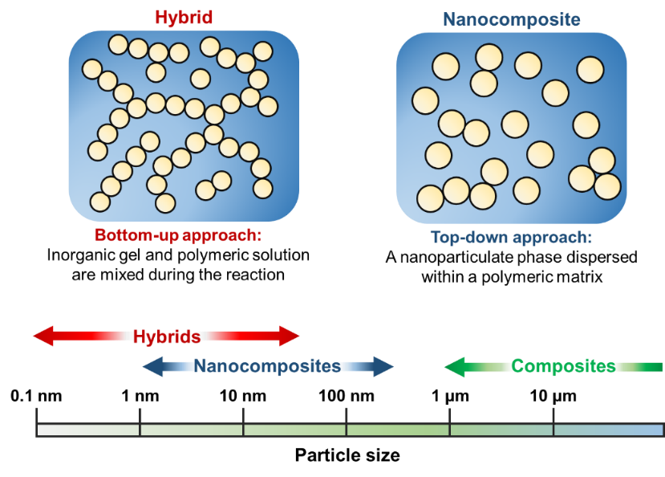

**Figure 1:** Schematic illustrating the typical differences between hybrids and nanocomposites in terms of structure, fabrication approach and particle size.

Developed by combining the traditional composite approach with novel techniques in inorganic particle and fiber fabrication, nanocomposites can be considered a top-down approach18. They represent the natural evolution of polymer/BG composites, using finer scale fillers that can be prepared by sol-gel chemistry and other cutting-edge techniques21.Comparing properties of nanoparticles to microparticles, when used alone, the smaller granulometry of the nanoparticles can lead to increased surface area reacting with the surrounding host and, as a result, to enhanced ion release, protein adsorption and bioactivity. Data show that a reduction in particle size contributes to more accurate mimicking of the physiological structure of bone22,23. Very recently, for instance, Rocton *et al.*22 compared the bioactivity of quaternary traditional melt quenched BG microparticles (D50 = 60 µm, formulation 46 SiO2, 24 CaO, 6 P2O5 and 24 mol% Na2O) with a ternary nano-sized BG synthesized via sol-gel (D50 = 110 nm, 55 SiO2, 40 CaO, and 5 mol% P2O5). By exclusively varying synthesis method, a 70-fold increase in surface area could be obtained. This in turn accelerated the formation of HCA in simulated body fluid (SBF), which occurred in only 3 days, way faster compared to the typical 14 days of melt-quench BG.

Similarly, the superior properties of nanosized BGs (nBGs) were confirmed when the glasses were embedded in polymeric matrices. When combined with poly(3-hydroxybutyrate), a polyester of bacterial origin, the finer granulometry of nBGs not only improved the mechanical (from 0.8 GPa to 1.2-1.6 GPa, depending on filler content) and structural performance of the composite, but it also introduced a more hierarchical topography at the nanoscale, leading to stronger bioactivity, higher wettability and surface protein adsorption23. All these characteristics are known to be beneficial for cell response upon implantation, as several studies confirmed24,25. Furthermore, these improvements could open new avenues of research. It is the case for composite core-shell nanofibers and injectable systems, whose development was made easier by the facile fabrication of nanofillers with finer granulometry using sol-gel methods26,27. Overall, the advantage of nanocomposites over traditional composites seems beyond doubt. However, they can still be subject to the intrinsic drawbacks of the composite approach: poor interface properties and inhomogeneous dispersion of the filler in the matrix. They still are composed by two distinct phases and this could sometimes lead to insufficient or unreliable properties at the microscale. In addition, there is a significant regulatory concern associated with the use of nanotechnologies28. Strategies to overcome these limitations by improving the filler/matrix interface with covalent bonding are under investigation29–31, but there is also another way: organic/inorganic (O/I) hybrids with organic and inorganic networks mixed at the molecular level. This characteristic gives them the ability to act as a single phase above nanoscale. They are obtained via a bottom-up approach involving sol-gel chemistry and are usually classified in five classes according to the synthesis route, type of phase interactions and macromolecular structure (Figure 2).

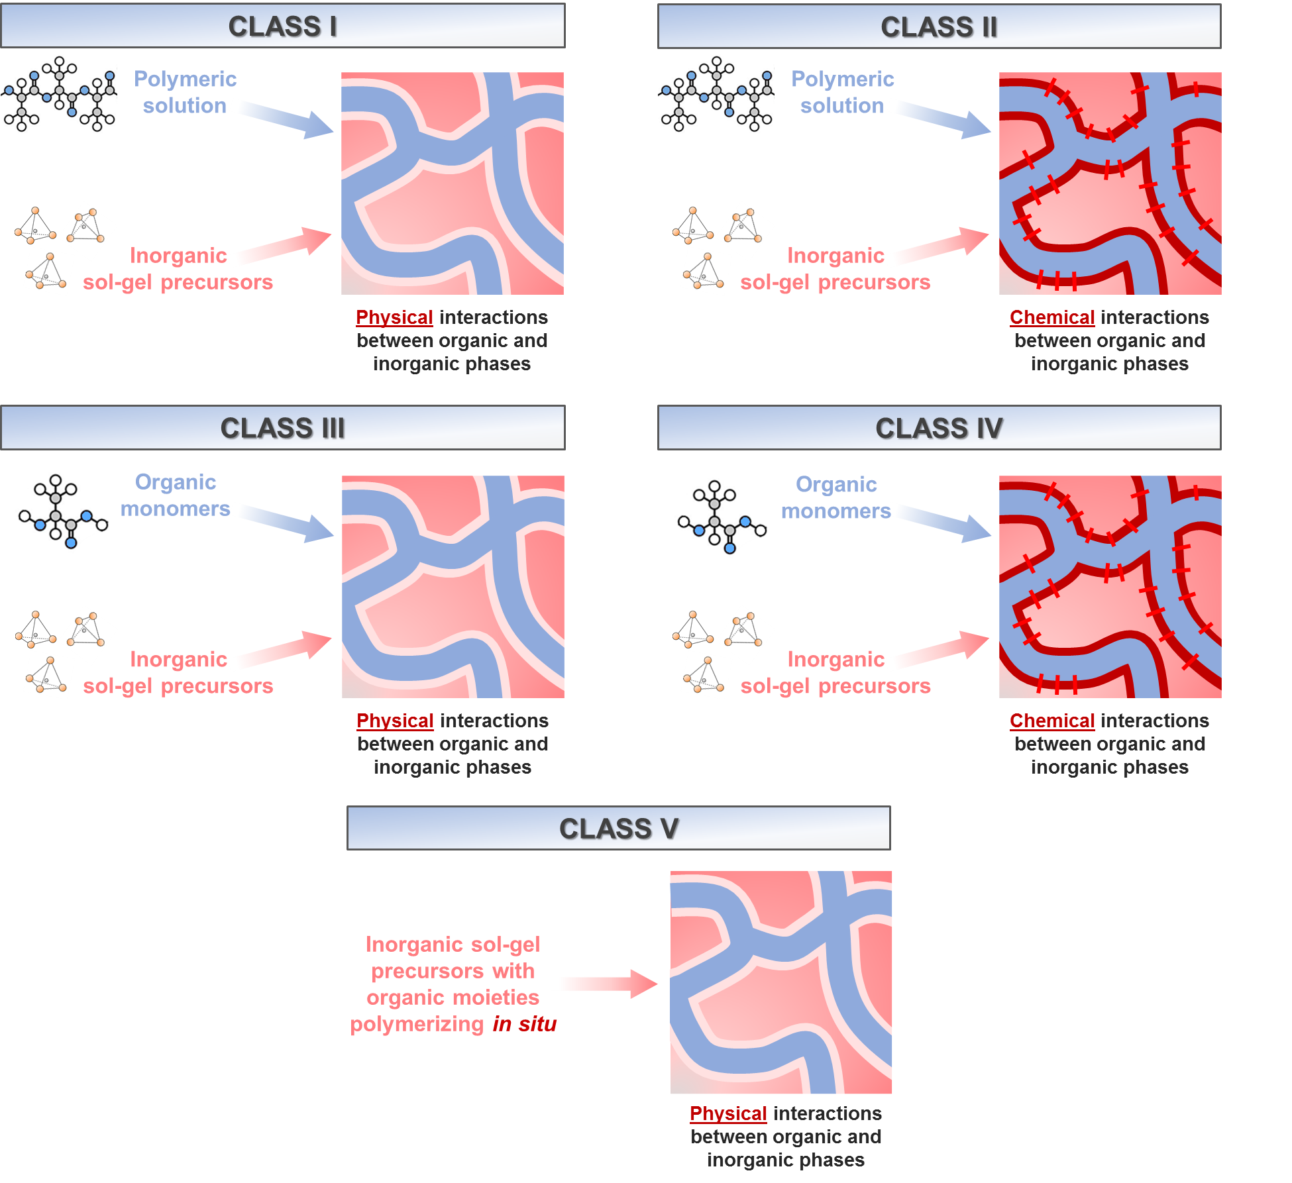

**Figure 2:** O/I hybrids can be divided in five major classes depending on (i) the type of precursors used in the synthesis and (ii) the nature of the interaction between the organic and inorganic phase in the final material.

Class I and class II hybrids are obtained by polymerizing an inorganic macromolecule (most commonly a network of silicate nanoparticles) in presence of a solubilized organic polymer. Hybrids with weak intermolecular interactions between the organic and inorganic components (molecular entanglement, hydrogen bonding and/or van der Waals forces) belong to class I, while class II are hybrids in which the organic and inorganic chains are covalently bonded. This covalent bonding is for example achieved through previous functionalization of the polymer with inorganic residues, which in turn can react with the inorganic network32. Class III hybrids are prepared via the simultaneous polymerization of both the organic (from monomers) and inorganic (from sol-gel precursors) components in a one-pot synthesis, resulting in a structure similar to class I hybrids (i.e., with weak interactions). Class IV hybrids are similarly obtained via one-pot processing but have strong bonds between the two phases. Finally, class V is a variation of class III in which the silicate precursors are designed so that during the sol-gel process they liberate organic moieties that can react and polymerize to form an organic matrix.

O/I hybrids and nanocomposites are produced through two opposite synthesis approaches, each presenting their advantages and limitations and leading to small structural variations that actually make a significant change in properties. The main benefit of O/I hybrids over nanocomposites lies in the sol-gel process, as the colloidal nature of the sol naturally translates into a homogeneous distribution of inorganic particles throughout the hybrid. These particles are typically few nanometers wide, while those prepared for composites are hardly smaller than 30 nm. Furthermore, in O/I hybrids, the inorganic particles can be assembled into rings and chains that entangle with the polymer, thus resulting in an interpenetration of the organic and inorganic components at a molecular level. As such, the main difference from nanocomposites is that no phase heterogeneity can be identified at the nanoscale and above. A major advantage arises from the fine-scale interactions between the organic and inorganic chains, which results in great tailorability of the mechanical properties and degradation rate, especially in class II or class IV hybrids. A key characteristic of hybrids is that their properties are not merely related to the chemical nature of each constituting material. Careful understanding and application of soft matter and sol–gel chemistries combined can modify the hybrid nanostructure and degree of organization, finally resulting in a unique set of properties that relies on the synergistic effects between components more than on the components themselves5. Thanks to the relatively mild synthesis conditions, hybrids are also often considered as promising drug delivery carriers33. In addition, since the polymer is mixed with the inorganic sol at an early stage, hybrids can be formed using various processing techniques (e.g., sol-gel foaming, electrospinning), without the intrinsic difficulties introduced by binders. This allows for the direct fabrication of scaffolds with complex porous geometries. Porosity control and drug delivery are very strong assets for the development of next generation biomedical products, as proven by the rich patent literature protecting the IP of several hybrid systems worldwide. The controlled delivery of osteostimulative agents such as citric acid34, fisetin35 or strontium36 seems to be the main focus of the industrial interest regarding hybrids. A wide variety of processes to prepare hybrids all based on ring opening polymerization are also protected37. The possibilities are many, but with them also the challenges: the synthesis of hybrids is a very delicate and complex process that requires meticulous tuning, as numerous variables contribute to the final properties of the material. From a sol-gel point of view, the polymer must be soluble in the solvent system used for the synthesis and it must withstand the pH conditions during the reaction. The synthesis of a suitable inorganic phase also presents several challenges, as discussed below.

# 3. The inorganic component: silicates and sol-gel bioactive glasses

In a typical process, the sol-gel synthesis of a bioactive glass is initiated using a silicate precursor (usually tetraethyl orthosilicate, TEOS). By means of acidic catalysis, TEOS moieties hydrolyze to silicic acid and polymerize into nanoparticles that progressively coalesce and crosslink to form a gel. Class I and class II O/I hybrids can be prepared by adding the polymer during this condensation process, before the complete gelation of the system. In this way, the polymer chains can entangle and interlock with the forming silicate network structure. Mixing halfway through gelation is also convenient as the two parts have matching viscosities and will form a stable mixture without significant phase separation. Due to the very different chemical natures of the organic and inorganic components, hybrids have the tendency to separate during synthesis if the reagents and the solvent systems are not optimally compatible. In any case, if processing optimization is not enough, a thoughtful polymer choice and design can further help reduce this risk (e.g. functionalized polymers with increased solubility in the solvent38). The control of pH is also of key importance throughout the process. A change in pH can strongly affect the fabrication of O/I hybrids in several ways, acting on both the polymer and the forming silica network. The sol-gel process is highly influenced by the acidity or alkalinity of the reaction pot: the kinetics of gelation are pH-dependent, with gelation time increasing with pH. Ideally, sufficient working time is required before complete gelation (i.e., if a silicate gel sets too fast it cannot be mixed adequately with the polymeric solution). However, the hybrid should also gel completely within a useful and scalable timeframe. Synthesis pH should be also carefully monitored since strong acidity/alkalinity could be detrimental to the polymer and to other biomolecules introduced into the reaction pot (i.e., for drug delivery), causing their degradation. This creates a trade-off between the minimization of pH to achieve slower gelation and longer handling time, and optimization of pH for the safety of organic moieties and for quicker processing. When choosing polymers for an O/I hybrid, pH is a complex variable to calibrate and it might determine which candidates might be more or less suitable for the purpose.

Currently, an even greater challenge in hybrid research for the development of bioactive materials is the incorporation of ions into the material network. Since pure silicate network are usually considered not sufficiently bioactive (release of silica species alone is not osteogenic39), the use of bioactive glasses as inorganic component is more sought after due to the ability of BGs to incorporate numerous different biologically active elements within their network. The goal is therefore to use complex BG formulations for the synthesis of hybrids to ultimately enhance the biological performance of the final materials. Due to the complex nature of the chemistry involved, however, the incorporation of metallic ions into the silicate network has been challenging so far. Most of the BGs currently used for the synthesis of hybrids are binary systems containing silicon and calcium, while many studies still rely on pure silicate as inorganic phase. The difficulty to incorporate more elements lies in the processing: usually, after the sol-gel synthesis of BGs, a heat treatment (~ 600 °C) is used to stabilize the glass and to decompose metal salts, allowing the subsequent diffusion of metallic ions within the silicate network40,41. The polymers used in hybrids could not withstand such a treatment, so most hybrid systems are aged and dried below 100 °C. As a consequence, metals cannot enter the network and remain in their primary form (salts or oxides for most of them), loosely interacting with the material42. Such an unstable system is not suitable for the synthesis of complex formulations, as all the ions present in the system would tend to precipitate or form secondary phases41. As a consequence, most BGs considered for hybrid synthesis are binary (or rarely ternary) formulations to minimize this effect. Regarding calcium, the quest for ideal calcium sources is still open: from the original syntheses using CaCl2, research in the past decade moved to the use of organic salts of calcium (e.g., methoxyethoxide and ethoxide), leading to more homogeneous incorporation. However, the use of alkoxides is still limited due to their instability (quick hydrolysis in the presence of humidity) and their limited availability: it can be very difficult to find high purity precursors and suppliers are sparse. This works against most scaffold fabrication techniques, which require a significant transitory step between solution and gelation (see for instance, sol-gel electrospinning43). Recently, calcium hydroxide and calcium oxide were also proposed as a promising alternative source thanks to ideal and reproducible gelation time (~ 1-2 h) and reliable low-temperature synthesis of the sols41. In spite of these promising steps forward, having to avoid the usual heat treatment for sol-gel BGs remains an important limitation for the incorporation of ions with therapeutic interest. Efforts are made to find novel routes to stably include calcium in the material with promising results, such as curing or the development of borophosphosilicate formulations. These strategies exploit the inorganic phase as calcium carrier. Alternatively, the polymer phase could be also used. Chelation, for instance, is the ability of certain molecules to coordinate with metal ions to create a stable complex. The incorporation of polymers that can chelate calcium ions is currently under development44–48. It could be an effective strategy to circumvent this issue, obtaining bioactive hybrids that deliver complex ion profiles in a control fashion.

O/I hybrids are a highly promising family of materials with still many open challenges up ahead. As we introduced in this section, to reach these ambitious objectives it is important to tailor and balance several variables and parameters of the two hybrid components, the inorganic as well as the organic. In particular, when reviewing the current literature on the topic, it becomes clear that choosing and/or synthesizing a polymer that meets the applicative requirement is one of the main tasks related to the biomedical use of O/I hybrids. Smart design of the polymer chemistry of hybrids could be an effective strategy within reach to reduce their drawbacks and make them more competitive clinically and commercially, especially when compared to nanocomposites.

# 4. The organic component: state of the art in the use of polymers in hybrids

Polymers used in biomedical applications are generally divided according to their origin into synthetic or natural. The origin of the material is also often associated with trends in behavior, properties, advantages and disadvantages (Table 1). Generally, synthetic polymers, principally saturated and unsaturated polyesters, are preferable for their reproducibility and precise control over reactive side groups and mechanical behavior. However, polyesters are highly hydrophobic (inconvenient for applications in contact with cells), with less functional residues and biologically inert. Natural polymers are sought for their ability to mimic the structure, water content and sometimes even the chemical composition of the extracellular matrix (ECM). They tend to be more biologically active (i.e., can elicit specific responses from cells) than synthetic materials. For instance, dissolution products from gelatin were proven to be able to improve cell response49. In addition, their richness in reactive side groups, such as carboxylic groups. allows for chemical grafting (e.g., functionalization with silanol groups to bond to the silica network in class II hybrids) compared to most synthetic polymers. Being naturally sourced, these polymers can sometimes have limitation in terms of reproducibility and scalability. High batch-to-batch variability remains one of the key drawbacks for the widespread use of many natural polymers as biomaterials.

Early syntheses of O/I hybrids focused on the fabrication of class I hybrids incorporating poly(vinyl alcohol) (PVA)50–53, chosen for its water solubility and biocompatibility. A water solution containing PVA (16 kDa) was introduced to the sol (also water-based) before its gelation. Several organic-to-inorganic ratios were tested. Sol compositions with various silicate (SiO2), calcium oxide (CaO) and phosphate (P2O5) contents were also investigated. The protocol was then applied to sol-gel foam processing to give porous hybrid scaffolds for bone tissue engineering53. The results obtained with this system were promising: the hybrid approach improved the strain to failure compared to BG scaffolds while correctly stimulating the osteogenic differentiation of mesenchymal stem cells (MSCs), tissue mineralization and osteoid formation50. The incorporation of cobalt in the formulation to increase angiogenic performance was also explored53. Unfortunately, due to the high solubility of PVA in water and the weak interactions between organic and inorganic phases, the properties of the material were not durable. As dissolution tests revealed, the polymer was rapidly lost upon contact with water, determining a significant decrease in mechanical properties and overall integrity of the scaffolds50. These results highlighted the need to further investigate and engineer the interaction between the two phases and fostered the focus of research on class II hybrids. When designing class II hybrids, specific polymers that contain ‒Si(OR)3 alkoxysilane groups have to be employed in order to obtain a covalent bonding between the organic and inorganic components. These groups can be intrinsically present in the chosen polymer: a typical example is polydimethoxysilane (PDMS), an organosilicon polymer that can be directly added to a silica sol to prepare an organic/inorganic covalent network. Alternatively, if silane groups are not already available, they can be added using a suitable coupling agent (e.g. glycidoxypropyltrimethoxysilane, GPTMS). In this case, natural polymers were considered to be the best candidate for coupling thanks to the higher occurrence of reactive side groups compared to synthetic polymers: especially, Gabrielli *et al.*54 demonstrated that coupling occurs through the nucleophilic attack on the GPTMS epoxy ring by amine and/or carboxylic acid groups from the polymers, while thiols and hydroxyl groups were ineffective. In the decade of 2005-2015, research was very active on the development of class II hybrids based on natural polymers, in particular on collagen55, gelatin56, chitosan57 and γ-PGA58. In parallel, a smaller body of work focused on class I hybrids using more stable and longer chain polymers, especially polycaprolactone (PCL), with promising results59. More recently (2015-2020), more refined strategies involving polymer chemistry paved the way to an increase in the use of synthetic polymers over natural ones. This approach avoids the high batch-to-batch variability of natural polymers, offering superior control and reproducibility over the synthesis process, which in turn translates into a more precise set of desired properties in the hybrid material and in the final device.

**Table 1:** Advantages and disadvantages of the main classes of polymers used for the synthesis of O/I hybrids

|  |  |  |  |  |
| --- | --- | --- | --- | --- |
|  | **Polymer group** | **Advantages** | **Disadvantages** | **Ref.** |
| Synthetic polymers | Polyvinyl alcohol | Water soluble  Biocompatible | Instability in water | 5,51 |
| Poly-(α-hydroxy acids) | Widespread use as biomaterials  Bioresorbable within months/years  Easy processing  Fine mechanical tailoring | Functional groups only at chain ends  Hydrophobic and insoluble | 60,61 |
| Polyethylene oxides | Many molecular configurations available (e.g., linear, branched)  Fine tailoring of the mechanical properties | Unable to trigger apatite formation even when combined in hybrids (low degradation rate) | 62,63 |
| Polymethacrylates | Higher density of reactive groups (for better class II effectiveness)  Chemically versatile | Non-biodegradable  Limited biological properties | 63,64 |
| Organosilicon polymers | Unique synergy between polymers and SiO2 thanks to siloxanes  Easy processing (class II)  Chemically versatile  Non-cytotoxic | Non-biodegradable | 63 |
| Natural polymers | Polypeptides (*collagens, silk proteins*) | Surface functionality similar to tissue components | Hard to solubilize  Limited reproducibility  Low O/I ratio | 65,66 |
| Denatured polypeptides (e.g., *gelatin*) | Soluble  Increased processability (compared to collagen)  Outstanding biocompatibility  Rich in reactive functional groups for class II synthesis | Excessive dissolution rate resulting in anisotropic swelling (class I)  Uneven degradation between organic and inorganic phase (class I) | 49,67,68 |
| Polysaccharides (*chitosans, alginates*) | Relevant biological properties (e.g., mucoadhesion, cell encapsulation, antibacterial activity)  Chemically versatile, available with various molecular configurations  Outstanding biocompatibility | High batch-to-batch variability  Limited mechanical properties | 69,70 |
| Bacterial polymers (e.g., polyhydroxybutyrate) | Natural synthesis, but with fine control over the properties of the final material  Wide range of polymers that can be produced by bacteria  Versatile mechanical properties  Similar to bioresorbable polyesters | Complex scale up of synthesis  Few reactive groups (chain-end)  Extraction is complex and requires the use of harmful solvents | 71 |

## 4.1. Synthetic polymers

### Aliphatic poly(α-hydroxy acids)

A class I hybrid produced with biodegradable poly(L-lactic acid) (PLLA)72 with Mw of 260 kDa was combined with a binary SiO2-CaO inorganic network using chloroform as solvent and calcium methoxyethoxide (CME) as calcium source. The sol-gel synthesis was performed in ethanol. The hybrid sol was then used to fabricate electrospun mats with a submicrometric fiber network. Compared to the native polymer, the hybrid material showed increased hydrophilicity and induced apatite formation upon immersion in SBF after 12 hours. In addition, PLLA/SiO2-CaO hybrids exhibited a twofold increase in tensile strength compared to a PLLA control. The increase in hydrophilicity is a particularly relevant feature of this system, as the application of PLLA is often hindered by its strong hydrophobicity. Polylactide-based systems, although promising, are also rarely used because of their processing limitations associated with the low solubility of the polymer in typical solvents used for sol-gel chemistry. For these reasons, researchers prefer to use polycaprolactone (PCL) as synthetic polyester for class I hybrids. PCL is an aliphatic polyester with slow degradation kinetics and better solubility, which eases the design of the solvent system to match sol-gel and polymer dissolution. Due to its convenient solubility (for a polyester), PCL-based hybrids were synthesized using several similar protocols. Generally, the sol-gel synthesis is performed in water or ethanol, and the polymer (usually 80 kDa, but other MW were also explored) is dissolved in various solvents, including Methyl Ethyl Ketone (MEK)43,59, chloroform73,74 and Tetrahydrofuran (THF)75. PCL/silica hybrids were synthesized both as monoliths and scaffolds for tissue engineering. Thanks to their relatively simple preparation and ideal mechanical properties as bone fillers, class I PCL/BG hybrids are adequate for scaffold fabrication. Several fabrication techniques were used, including electrospinning and sacrificial template microsphere sintering. Allo *et al.*43, for instance, used 80 kDa PCL dissolved in MEK to prepare class I hybrids with glass composition of mol% 70 SiO2, 26 CaO, and 4 P2O5 and up to 60% polymer (w/w). The hybrid solution was then successfully electrospun to fabricate fiber mats intended for bone tissue engineering. To increase reproducibility, the viscosity of the electrospinning solution was carefully monitored and standardized. Key results confirmed that hybrids following this procedure were homogeneous, amorphous and thermally stable up to circa 200 °C. The organic and inorganic components were well interpenetrated, with molecular interactions occurring in the form of H-bonds, resulting in improved mechanical properties. In addition, hydroxyapatite (HA) formation occurred on the hybrids already after 6 hours from first immersion in SBF and it was found to increase as PCL content decreased59. In a follow-up study76, the biological performance of PCL/bioactive glass hybrids fibrous scaffolds was also investigated. Generally, the behavior of mammalian cells (murine osteoblast-like MC3T3-E1) underlined good cell growth and proliferation for all materials, comparable to the ones of a positive control. Only the possible occurrence of minor PCL-dependent cytotoxic effects was reported. Nevertheless, the hybrids can be considered biocompatible. The characterization of targeted bone-associated gene expression confirmed these results, as the expression of alkaline phosphatase (ALP), osteopontin (OPN), bone sialoprotein (BSP), and osteocalcin (OCN) were all significantly higher on the hybrid fibrous scaffolds (p < 0.001) than on a PCL control, suggesting that hybrid PCL/BG fibrous scaffolds may provide a favorable microenvironment to accelerate in vitro bone formation. A similar hybrid material75 (80 kDa PCL and SiO2-CaO bioactive glass) was used to prepare bone scaffolds with a different microstructure, trying to mimic and improve the properties of commercial bovine-derived bone grafts. THF was used as solvent for the polymer, while the sol-gel process was carried out in ethanol. Compared to previous studies43, other Ca sources were explored, moving from traditional CaCl2 to calcium hydroxide, calcium ethoxide and calcium methoxyethoxide, resulting in improved calcium incorporation41,75. A joint approach combining microsphere sintering, hybrid infiltration and porogen leaching was proposed. The material showed similar properties to the ones described above: rapid bioactivity, increased toughness and flexibility. Its fabrication into scaffolds was confirmed viable, with ideal topography and morphology for bone tissue engineering. Interestingly, apatite formation in SBF was not limited to the surface of the constructs, as it generally occurs: by means of particle-induced X-ray emission (PIXE) chemical mapping it was possible to observe the deposition of calcium phosphates in the bulk of the hybrid (Figure 3), a phenomenon that led to better resorption compared to sole surface deposition77.

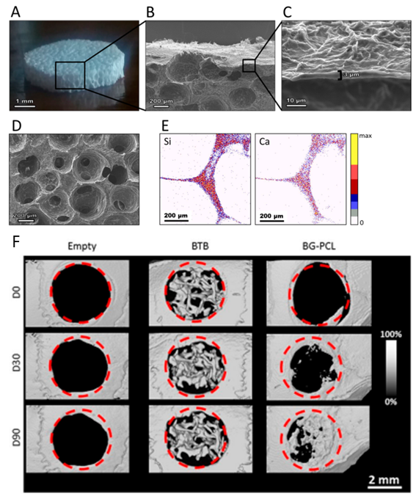

**Figure 3:** (A) Porous PCL/BG hybrids prepared by a combination of microsphere sintering, hybrid infiltration and porogen leaching. The panels show (B-D) several SEM views, (E) PIXE elemental mapping and µCT results. Figure adapted from reference 78 with permission of ACS Publications.

This unique behavior was attributed to the superior homogeneity of calcium incorporation using this protocol, as already reported also for similarly prepared BG-gelatin hybrids56,75. The porous constructs were biologically tested both in vitro and in vivo and benchmarked against a commercial purified bovine xenograft (Lubboc®, OST Laboratoires) with very promising results78. The adhesion and differentiation of primary osteoblasts harvested from rat calvaria were significantly promoted in vitro, as confirmed by an increase in ALP enzymatic activity and by the upregulation of RUNX2. Compared to a commercial bovine-bone product, the hybrid scaffolds showed improved adhesive potential, measured by an increase of the ratio between phosphorylated and non-phosphorylated focal adhesion kinases (pFAK/FAK). Higher phosphorylation of FAK indicates higher activation of focal adhesions and therefore higher cell adhesion. The mechanism by which PCL/BG hybrids promote this cell behavior are still under investigation. In vitro results were further corroborated by in vivo testing using a mouse critical size defect model: hybrid scaffolds were characterized by a significantly superior regenerative potential compared to their commercial competitor (Lubboc®). After 3 months of implantation, histological data confirmed ongoing vessel sprouting, mineralization and bone remodeling, supported by ALP activity promotion. This tissue growth was confirmed to be a physiological-like and well-orchestrated phenomenon, with novel deposition of mineralized collagen by osteoblasts and osteoclastic resorption pits. Remarkable micro-computed tomography (µCT) measurements of in vivo implantation showed doubled bone ingrowth compared to the commercial xenograft (Figure 3), suggesting that hybrid scaffolds could considerably outperform current products. Owing to this outstanding performance, the approach was also patented, focusing in particular on the ability of the process to control scaffold porosity79. In addition, these hybrids are synthesized with a relatively simple class I method. For medical device development, this characteristic is greatly valuable: it can potentially reduce industrialization risks, in particular related to regulatory affairs, scaling-up and reproducibility limits.

Aliphatic polyesters are also popular synthetic polymers for the synthesis of class II hybrids. Trials using aminolyzed polylactic acid (PLA) and GPTMS as coupling agent are reported80, although in this case, probably due to the high hydrophobicity of the polyester, the two components were combined using a two-step method: first the polymer was processed into porous membranes, and then the inorganic phase was grafted onto it by aminolyzation, GPTMS functionalization and finally silica sol-gel synthesis. This results in a PLA/SiO2 material that should be described as a silanized membrane rather than a proper hybrid. Once again, PLA shows limitations due to its solubility. For this reason, PCL established itself as a more promising candidate. A series of studies by Tian and coauthors81–84 examined the use of low MW variants of this polymer as possible components of class II silica/PCL hybrids and investigated how processing variable would affect the final properties of the materials. Several PCL precursors were used, including hydroxyl end-capped linear PCL (Mn = 2-4 kDa), vinyl end-capped three-arm star-shaped PCL (Mn = 12 kDa), and hydroxyl pendent groups containing PCL (Mn = 14.5 kDa, 5.0 mol% OH groups), PCL diol (Mn = 1250 g/mol) and PCL triol (Mn = 900 g/mol). The presence of reactive end groups permits the derivatization with 3-(triethoxysilyl) propyl isocyanate (ICPTES), a coupling agent that makes PCL reactive during the sol-gel process, effectively creating covalent bonding between the organic and inorganic phases. The synthesis is performed in a THF/ethanol solvent system. No calcium source was considered in these studies, as the research was not aiming to the treatment of bone defects. Generally, hybrids synthesized with this method are monophasic, transparent, amorphous materials with increased thermal stability compared to PCL. The polymer was successfully incorporated into the inorganic network, with which it interacted both by covalent and H-bonds. The incorporation was found to be dependent on several variables, including the polymer content, MW and number of functional groups per chain, all of which evidenced that the final properties of the material are mostly related to the number of available reactive triethoxysilane groups. Around the same period, Rhee *et al.*85,86 developed a similar system (triethoxysilane end-capped PCL) and investigated its suitability as bioresorbable biomaterial for bone tissue engineering. They added a calcium source (calcium nitrate Ca(NO3)2) to enhance the bioactivity of the system. The MW of PCL is also different (6700 g/mol). The resulting material showed remarkable mechanical properties, approaching the values characteristic for cancellous bone, and degraded in vitro at a similar rate to the one of PCL86. In addition, apatite formation assays performed in vitro by immersion in SBF confirmed that the addition of calcium can significantly increase the bioactivity of the material, whose surface was completely covered by newly formed crystals after only 9 hours. The correct composition of these formation was verified by SEM imaging and XRD spectroscopy and presented the characteristic shape and XRD peaks of apatite. The authors suggest that un-reacted silanols and soluble calcium salt acted as nucleation sites and accelerator, respectively85. Fostered by the promising results obtained by these studies, more investigations into PCL hybrids with increasingly refined properties were carried out in the past two decades.

In recent years, for instance, more refined inorganic compositions including a significant borate fraction included for its therapeutic effect were proposed87. A non-aqueous sol-gel procedure performed in acetone was developed to prepare novel class II hybrids combining a borophosphosilicate glass composed of mol% 91 SiO2, 5 B2O3 and 4 P2O5 (BPSG) with a triethoxysilane end-capped PCL that was functionalized using GPTMS in presence of trimethyl borate as catalyzer. An array of analyses (FTIR, TGA, XRD and solid state 29Si CP-MAS NMR) confirmed successful fabrication of a uniform hybrid with a well-developed organic/inorganic network, which remained amorphous and transparent up to 60 wt% in polymer fraction. The network was characterized by a dominance of T3 conformations (Tn networks are equivalent to Qn networks, but with one C atom connected to the Si), indicating a well-interconnected structure in which silicon atoms are covalently bond to four bridging atoms, three oxygens and one carbon provided by the functionalized PCL. The dominance of T3 over T4 is due to the absence of any high temperature thermal treatment. Most remarkably, the first investigations into this hybrid showed that BPSG are a possible alternative to Ca-containing glasses to trigger the deposition of physiological-like crystalline hydroxyapatite in vitro with a routine SBF incubation test. According to the authors, this was the first time that calcium-free O/I hybrids incorporating B2O3 were reported and, furthermore, were demonstrated to be bioactive. To our knowledge, BPSG is indeed the only sol-gel inorganic component for hybrids that abandons the SiO2-CaO-P2O5 triad. The exploration of new compositions not only gave successful results in terms of bioactivity: BPSG/PCL hybrids were shown to possess superior mechanical and degradation properties compared to conventional composites prepared using the same organic and inorganic components (i.e., inorganic particles and polymer matrix). This was probably due to (i) the successful formation of covalent bonding between the two phases and (ii) the molecular scale at which the components are mixed, hybrids exhibited more reproducible and higher compressive strength, modulus and toughness compared to composites. The degradation of hybrids was also easier to tailor and control. It was characterized by slow surface erosion, while composites rapidly cracked and lost weight upon immersion in PBS88. In view of its application as bone tissue engineering scaffolds, the processability of BPSG/PCL into porous constructs by solvent-free particulate leaching was confirmed. Compression molding was performed in presence of a porogen (NaCl). The salt was then leached to leave an interconnected porous scaffold with tailorable porosity (44 – 60%). The cytocompatibility of the hybrid scaffolds was confirmed using a MC3T3-E1 murine osteoblastic cell line88. Cell behavior in contact with the constructs and osteogenicity due to boron release was then investigated using stem cells (MSCs)89. Cells successfully attached, proliferated and infiltrated for about 1 mm in the construct. Spreading and focal adhesion formation were excellent. Boron release from scaffolds with 2 mol% B2O3 was correlated with a significant upregulation of ALP and OCN, suggesting differentiation toward the osteoblastic phenotype and ongoing mineralization. Interestingly, hybrids with 5 mol% B2O3, although previously not cytotoxic, had a negative effect on cell differentiation. The authors claim this is possibly a consequence of excessive local release of boron above its cytotoxicity threshold, a shortcoming that might not occur in vivo, where mass transfer is highly superior to the one occurring for in vitro static culture. Further studies perhaps using more refined in vitro culture models (e.g. cocultures, bioreactors) might shed light on the complex matter of boron release and help to better identify the ideal doping of bioactive glass to obtain the desired therapeutic effect, as it was recently reported for copper and its angiogenic potential90. One of the main limits to the use of PCL as organic component of class II hybrids is, as it is for most aliphatic polyesters, its lack of reactive sidechains. This effectively limits the possible bonding sites between the organic and inorganic phases. Chain-end functionalization can only go so far.

Sang *et al.*91 offered a possible solution to the problem by developing a novel copolymer of caprolactone and GPTMS. One-pot ring opening polymerization (ROP) of poly(CL-co-GPTMS) was performed at 110 °C using benzyl alcohol as initiator and stannous octoate as catalyzer (Figure 4). Various CL/GPTMS ratios were investigated, ranging from 10:2 to 200:2.

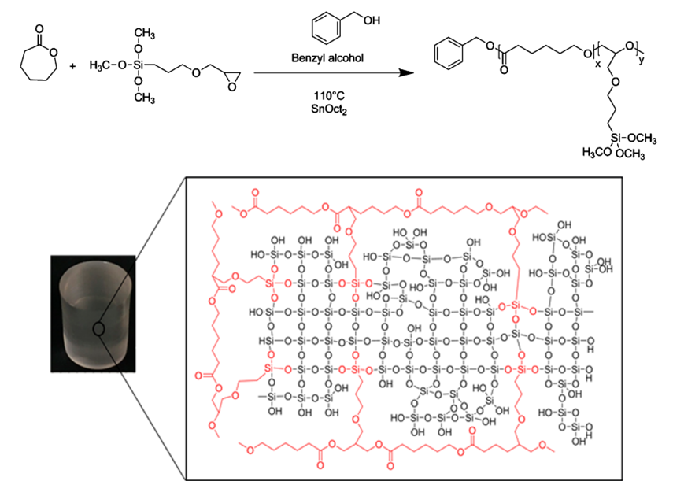

**Figure 4:** Scheme showing the ring opening polymerization of caprolactone and (3-glycidyloxypropyl) trimethoxysilane monomer, forming a poly(CL-co-GPTMS) random copolymer (top). Typical sample and structure of the final materials are also shown (bottom). Figure adapted from reference 91 with permission of ACS Publications.

This leads to a polymer with side trimethoxysilane groups that can hydrolyze during the sol-gel process, leaving silanol groups that can act as starting sites for the polycondensation of the silica network. The use of this novel copolymer offered the possibility to finely tailor the mechanical properties of the final material by independently tuning the organic-to-inorganic and CL/GPTMS ratios. The result is a transparent, amorphous and homogeneous material with a remarkably linear elastic mechanical behavior characterized by high strength, satisfactory strain to failure and no significant hysteresis when subject to cyclic load. The authors claim that this novel approach to the fabrication of PCL-based hybrids is more efficient compared to previously described PCL functionalization. In addition, a preliminary ISO10993-compliant biological evaluation of poly(CL-co-GPTMS)/SiO2 hybrids did not highlight significant cytotoxicity and showed good adhesion of MC3T3-E1 preosteoblasts.

These recent studies highlight how a smart chemical reaction between the organic and inorganic component of a hybrid can open up to novel materials with unique properties, in particular in terms of mechanical behavior. However, research also showed how a conventional class II approach (i.e., a three-component synthesis comprising a polymer, a sol-gel silicate network and a coupling agent) is limited by the availability of reactive groups and by the miscibility of the polymer phase in the sol-gel pot. A further step forward to overcome the issue is the development of class IV hybrids, in which both the organic and inorganic network are formed in situ at the same time and covalent bonds form between the networks. This approach results in greater homogeneity and interpenetration of the two networks. However, it is intrinsically more complex, requiring more careful processing control. When the variables are correctly controlled, this approach can result in the fabrication of hybrid materials with properties that go beyond the simple combination of its components. Interestingly, one of the most successful and remarkable examples of this approach is a case of serendipity92. While developing a protocol for the synthesis of class II PCL/SiO2 hybrids in THF, the unexpected polymerization of the solvent, initiated by the coupling agent (GPTMS), led to the formation of a poly(caprolactone-co-tetrahydrofuran) copolymer and, ultimately, to the fabrication of a novel SiO2/PTHF/PCL-diCOOH hybrid exhibiting unique elastomeric behavior (so-called “Bouncing Bioglass”) with autonomous self-healing properties. The hybrid is synthesized following a three-pot reaction that results in a material described by the authors as a combination of class II and class IV. First, carboxylic acid end-capped PCL (PCL-diCOOH) was obtained through TEMPO oxidation of a low MW (Mn = 530 g/mol) PCL diol precursor. The reaction was performed in THF. The PCL-diCOOH was then grafted with GPTMS using boron trifluoride diethyletherate (BF3Oet2) as epoxide ring activator (Lewis’s acid). During this step, the activated epoxide ring of the coupling agent also acts as an initiator for the polymerization of THF into PTHF, a linear polyether obtained by cationic ring opening polymerization (CROP) at room temperature and pressure (RTP conditions). This unique synthesis protocol is patent protected37. Results obtained by 1H-NMR show that this polymerization occurs only in presence of BF3Oet2 and GPTMS, while PCL-diCOOH is not necessary. The authors propose a possible mechanism of reaction involving first the ring opening of the epoxide and then, as a consequence, the opening of the THF ring and its polymerization into PTHF. The final structure is a combination of PCL and PTHF chains within a SiO2 network, with multiple interactions between components, including covalent bonds, hydrogen bonding, London forces and dipole-dipole interactions (Figure 5).

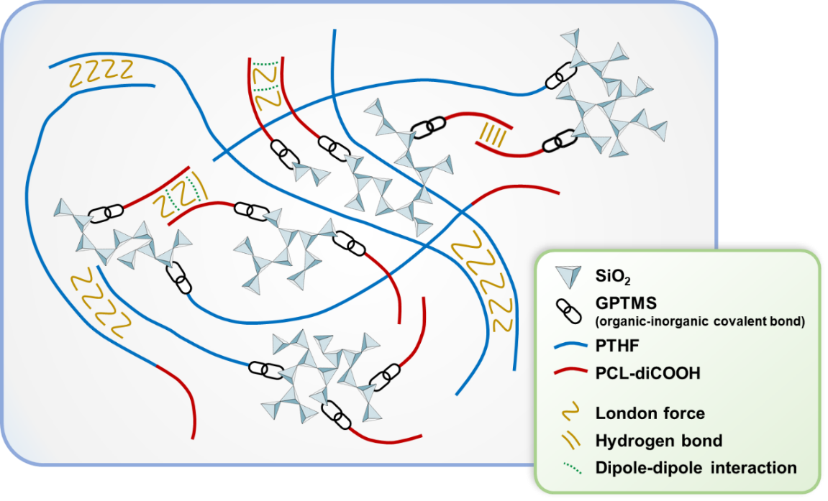

**Figure 5:** Schematic representation of the SiO2/PTHF/PCL-diCOOH hybrid, modified from Tallia et al. 92, highlighting the hypothesized GPTMS-mediated covalent bonding between inorganic and organic phases as well as the other interactions between polymer chains.

This complex interlaced structure is thought to be responsible for the elastomeric, self-healing properties of this hybrid. In particular, the bouncy elastomeric behavior is probably related to the in situ formation of PTHF chains which act as soft segments within the network. The organic component has also a key role in self-healing: the complex network of weak intermolecular forces between the organic components can rearrange itself after a damage, thanks also to the elastomeric nature of PTHF, which helps chain rearrangements and accommodates healing. H-bonds are thought to be the major interaction responsible for the healing, however London forces and dipole-dipole interactions probably have a significant role, too.

By reason of its behavior, the authors investigated the application of the material for the regeneration of cartilage, a tissue with unique mechanical behavior and lacking intrinsic regenerative potential. Thanks to a sufficiently wide sol-gel transition period, the gelling hybrid (inorganic-to-organic ratio 80:20) was 3D printed via Direct Ink Writing to produce woodpile scaffolds and their potential in cartilage regeneration was tested against an ATDC5 chondrogenic cell line. The results are encouraging. Besides evidence of satisfactory cell adhesion, viability and proliferation, several markers related to cartilage formation were promoted. The biological characterization showed increased expression of collagen type II, cartilage-specific proteoglycan core protein (CSPCP, or aggrecan) and SOX9. Collagen type II production was accompanied by negligible quantities of type I and type X, varieties of the protein that are associated with the formation of fibrous or osseous tissues, respectively. These findings show that hybrids, thanks to their properties halfway between polymers and bioactive glass, could find application not only as bone substitutes, but also in cartilage regeneration. They might indeed offer a solution to the regeneration of one of the most challenging tissues of the human body.

### Poly(ethylene oxide) and poly(ethylene glycol)

An alternative synthetic polymer that appears promising as organic component of hybrids is poly(ethylene oxide) (PEO), also known as poly(ethylene glycol) (PEG) when the MW is lower than 100 kDa. PEOs are particularly interesting and versatile polymers for biomedical applications thanks to their relatively low cost and their availability in a variety of molecular configurations (linear or branched) across a broad range of MW, from less than a few hundred kDa to several million. Similar to PCL, PEOs can be end-capped using desired moieties that act as bond sites for the polymerization of a silicate network during sol-gel. The potential of this family of polymers was first explored by Messori *et al.*93 in a study investigating class II PEO/silicate hybrids as coating materials to prevent the leaching of plasticizer from PVC-based medical devices (e.g. gloves, fluid bags, tubes, catheters and dialysis equipment). PEO-based O/I hybrid coatings were also proposed as a possible strategy to improve the oxygen barrier properties of PLA films for food packaging applications without hindering their transparency94. More recently, the combination of sol-gel silica and PEO/PEG in tissue engineering was also proposed and characterized95. Hendrikx *et al.*96, for instance, developed an interesting indirect FDM-based technique to prepare porous scaffolds from class II hybrid sols (ICPTES as coupling agent). Several candidate materials were used: five linear PEGs with different molecular weights ranging from 200 to 8000 Da (all MW are given as numeral average Mn) and six PEG-derived branched oligomers, namely four trimethylolpropane ethoxylates (TMPEO) with Mn from 170 to 1014 and two pentaerythritol ethoxylates (PETEO) with Mn 270 and 797. The fabrication approach consists of the 3D printing of a sacrificial PCL woodpile and its infiltration with the hybrid sol. Once the hybrid is set, the PCL template can be leached. The correct choice of solvent is key: PEO comes in handy as it is usually soluble in the ethanol used for the sol-gel process, but insoluble in the organic solvent used for the leaching of PCL (i.e., tetrahydrofuran). This technique, although rather elaborate, leads to scaffolds with tailorable mechanical properties for cancellous bone regeneration (Figure 6).

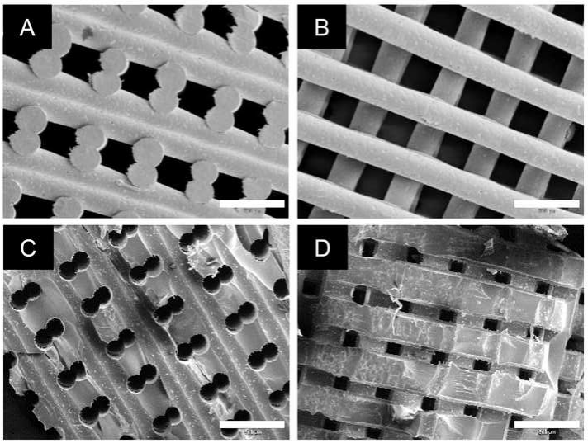

**Figure 6:** SEM images of the templates (A-B) and final scaffolds (C-D) obtained by Hendrikx et al. by indirect rapid prototyping of a class II PEG/silicate hybrid show. Figure adapted from reference 96 with permission of Elsevier.

In particular, the mechanical behavior can be controlled by varying the type of organic component: generally speaking, branched polymers lead to a 50% increased compressive strength compared to linear PEG of comparable MW. Moreover, the lower the molecular weight of the chosen organic crosslinkers the higher the mechanical properties of the final hybrid scaffold. Results also confirmed the satisfactory adhesion and proliferation of Saos-2 cells on the scaffolds, with results comparable to a PCL control. Further control over the mechanical properties (e.g. increased stiffness) and biodegradability of this family of PEO-based hybrids can be achieved via the introduction of enantio-pure oligolactides (LA) in the organic precursors, as investigated by Kascholke *et al.*97 on a range of LA/branched-PEO hybrids. Given that the inorganic component is 100% SiO2, the main drawback of these biomaterials in bone tissue engineering was their low bioactivity, compared to PCL-based hybrids96,97. The authors tried to tackle this limitation in a follow-up publication98 by adding CaCl2 as calcium source. Unfortunately, the PCL leaching process caused also a significant and unwanted calcium loss. When immersed in SBF, the presence of calcium in the sol-gel glass seems to increase the bioactivity of the final scaffolds, as observed by SEM and EDX, however results do not appear fully reproducible and further optimization is needed. An alternative approach to calcium incorporation into PEO-based O/I hybrids consists in the use of calcium methoxyethoxide as calcium source99. CME was combined with low molecular weight PEG300 and PEG600 polymeric precursors and APTES as coupling agent. Generally, PEO-based hybrids hold great promise thanks to their versatile synthesis and the possibility to finely tune the properties of the final material. If a lack of biomineralization is unavoidable, as the authors point out, such not-bioactive formulations would still be of great interest to target non-mineralized tissues that nevertheless demand for precisely adjusted mechanical properties, such as cartilage or tendon97.

### Methylacrylate-based strategies

When performed in the sol, the in situ reaction of coupling agents with polymers is known to not achieve completion, leaving possibly harmful by-products that are hard to remove. Having more reactive groups could help shift the balance of the reaction and reduce by-products. Methacrylate-based polymers were investigated as a promising candidate to overcome this limitation. In fact, they can be synthesized including coupling sites for the silica network within the polymeric backbone. This in turn results in better integration of the bridging moieties (e.g., alkoxysilanes) and a more tailorable design in which crosslinking degree and MW can be controlled independently. However, the strong chemical advantages of methacrylate-based systems come with the significant drawback of not being biodegradable due to the non-degradable C-C bond in their backbone. Small molecules can excreted via the kidneys if their MW is less than ~30 kg/mol, as they would pass through the pores of the glomeruli100,101. Hybrids made with MW higher than this cannot be considered as biodegradable. Random copolymers were successfully synthesized from various methacrylate precursors, including 3-(trimethoxysilyl)propyl methacrylate (TMSPMA)102, methyl methacrylate (MMA)103, 2-hydroxyethylmethacrylate (HEMA)104,105 and n-butyl methacrylate (BMA)103. The already polymerized material, polymethyl methacrylate (PMMA), was also used102,106. When a calcium salt (CaCl2 or Ca(NO3)2) was added, bioactivity was significantly promoted, regardless of the precursor monomers102,104,105. The results of mechanical testing report values of Young’s modulus as high as 4 ± 0.2 GPa for a poly(TMSPMA/MMA)/SiO2-Ca(NO3)2102. Recently, the addition of strontium to a HEMA-based hybrid based was also explored for its osteogenic potential. Interestingly, triethoxyvinylsilane, TEVS, was used as network former instead of more common TEOS107. Although encouraging, the results of these studies suffered severe data scattering and lacked reproducibility. Other authors suggested that an issue might lie within unassessed significant variations in polymer chemistry (e.g., polymer molecular weight, molecular structure of the final network) affecting the organic/inorganic interaction and interpenetration ultimately resulting in widely varying degradation, bioactive and mechanical properties. In an attempt to further deepen the understanding of this drawback and eventually control it, Maçon *et al.*108 addressed the issue following a triple approach: they developed a novel data manipulation technique elaborating the output data of acoustic atomic force microscopy (AC-AFM) and solid state nuclear magnetic resonance (SS-NMR) in order to understand the relation between hybrid network structure and macroscopic mechanical properties, elasticity in particular. In parallel, they developed a methacrylate-based class II hybrid to use as a test model for their characterization protocols (Figure 7), a high crosslinking density polyTMSPMA/SiO2 class II hybrid (the high crosslinking density is due to the fact that each monomer of TMSPMA has an alkoxysilane residue, the theoretical crosslinking degree of polyTMSPMA is 100%)64. Finally, they investigated the role of polydispersity in determining the material properties by directly comparing the performance of similar class II hybrids in which the organic phase is polymerized by either telomerization or reversible addition–fragmentation chain-transfer (RAFT), resulting in products with similar MW but very different polydispersity (PD) (i.e., higher for telomerization, lower for RAFT). The outcome of these studies is greatly insightful. PolyTMSPMA/SiO2 hybrids are transparent, mesoporous and cytocompatible. The high crosslinking density leads to a significant shift in mechanical behavior, from brittle to ductile, without excessive shrinking or crack formation. Most remarkably, the material shows signs of improved apatite forming ability compared to pure silica, even without the addition of a calcium source64. In parallel, the elaboration of the outputs coming from AC-AFM and SS-NMR allowed the authors to propose a new mechanism of gelation. They suggest that the volumetric density of bridging oxygen bonds (Si-O-Si), measurable via SS-NMR, is a key parameter to identify the structure/property relationships in silicate hybrids. Specifically, the addition of polyTMSPMA was directly linked with variation in elasticity: the polymer acts as spacer, lowering the density of bridging oxygen bonds and, ultimately, increasing chain mobility. More polymeric phase was also correlated to accelerated gelation kinetics. Interestingly, the mechanical behavior of this system is independent from variations in the molecular weight of the polymer and can be controlled by solely tailoring the organic/inorganic ratio. This is probably a consequence of the very high crosslinking density. Regarding the gelation kinetics, they can be controlled lowering the crosslinking degree by alternating TMSPMA and MMA monomers in the polymer backbone, as investigated by other authors109. Regarding the comparison of polymerization techniques, the PD was found to have a significant effect on the properties of high crosslinking density hybrids. It was observed that while gelation is driven by the higher fraction of the molecular distribution, the mechanical and chemical durability properties were not affected. In particular, the gelation of RAFT-based hybrids was significantly slower than that of of telomerization-based hybrids. Being able to carefully tailor a longer gelation time could be of great interest for the application of O/I hybrid sols in conjunction with scaffold fabrication techniques that require uniform rheological properties through the process (e.g., electrospinning, additive manufacturing).

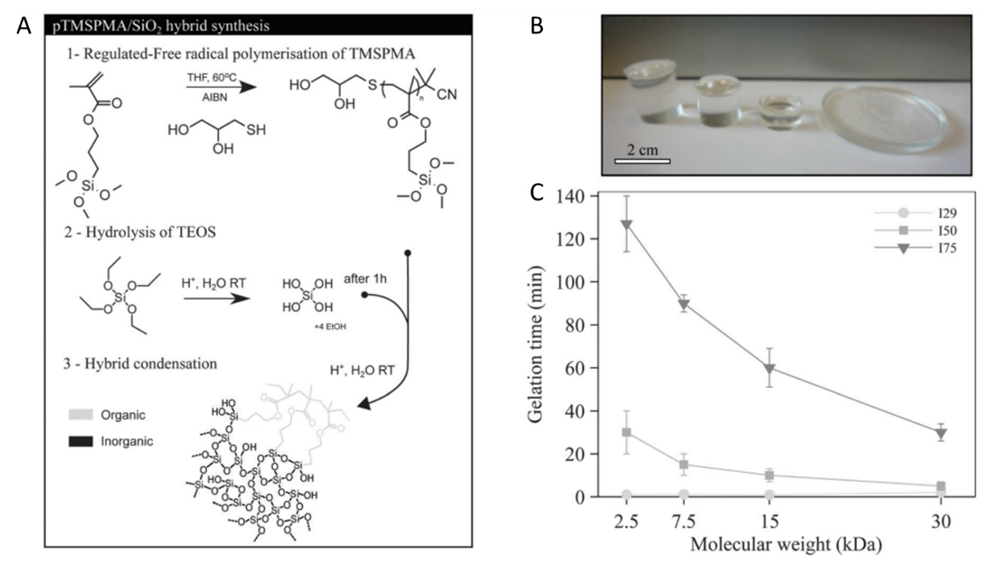

**Figure 7:** (A) Free radical polymerisation of TMSPMA and hybrid synthesis. (B) Photograph of pTMSPMA/SiO2 hybrids after drying and (C) time taken by the different sols to gel as a function of the molecular weight of pTMSPMA. Figure adapted from reference 108 under Creative Commons License..

All the methacrylate-based hybrids discussed so far were made with polymers of linear architecture. The possibility of synthesizing multibranched polymethacrylates was also studied, confirming the high versatility and potential of this material platform. Randomly branched and star-shaped copolymers of TMSPMA and MMA were prepare using RAFT polymerization. Branched polymers were one-pot synthesized at 70°C, while star-shaped ones underwent a two steps process with re-dissolution in toluene. With this procedure it is possible to prepare well-defined organic precursor and achieve a better tailoring of their properties, thanks to the fine and accurate approach to polymer chemistry. Specifically, architecture can have a significant effect on the mechanical behavior of the final system, maintaining the compressive strength of sol-gel glass while significantly increasing both the toughness modulus and the Young’s modulus (9.6 and 4.5 fold, respectively in the case of star copolymer-SiO2 hybrids). At the same time, variations in polymer chemistry did not affect the cytocompatibility of the hybrids, as verified by culturing an osteoblast precursor cell line (MC3T3-E1). Fostered by these findings, Chung *et al.*110 proposed a further optimization of the randomly branched and star poly(TMSPMA-co-MMA)/SiO2 hybrids. In spite of the promising results obtained with methacrylate-based hybrids, few studies focused on overcoming their lack of biodegradability. For this reason, the introduction of disulphide-based dimethacrylate (DSDMA) as enzymatically biodegradable branching agent was investigated. Hybrids were prepared as discussed above but adding DSDM to the polymerization pot. The authors suggest that an enzymatically degradable system might be superior to a hydrolytically degradable ones as the former offers a more refined control over degradation kinetics111. These MM-based biodegradable hybrids were compared in terms of mechanical and biological performance to similar non-biodegradable ones and no significant difference was observed. These remarkable results might represent a turning-point for the application of MM-based hybrids within the human body and could pave the way for their forthcoming application in tissue engineering and regenerative medicine.

### Organosilicon polymers

In parallel to methylacrylate-based strategies discussed above, another approach to avoid the use of coupling agents and still be able to crosslink the polymer to the silicate network is to use polymers that intrinsically contain reactive residues. Polydimethylsiloxane (PDMS) and SiO2 have a strong synergy that started being exploited more than twenty years ago to develop class II hybrids. Initial trials focused on pure silica hybrids112, soon moving to the incorporation of calcium to increase the bioactivity. Because of its limitation in terms of biodegradability and overall biological performance (i.e. PDMS is non-toxic, but very bioinert), research on PDMS-based hybrids focused on the incorporation of multiple elements, such as calcium113–119, strontium119, zirconium120 and titanium115,117,120. Interestingly, it was discovered that a high organic-to-inorganic ratio could hinder calcium incorporation and therefore decrease the bioactivity of the final material118. Titanium and zirconium were added to the system in an attempt to change its mechanical properties and topography. In particular, titanium was chosen to investigate the possible enhancement of bioactivity due to the exposure of Ti-OH groups on the surface of the materials. In addition, authors reported that by carefully adapting the synthesis protocol, titanium can affect the condensation of the silicate network and result in different surface morphologies117. The engineering of titanium incorporation was recently studied by Almeida *et al.*117 for the preparation of a PDMS-SiO2-TiO2-CaO hybrid. In particular, the investigation focused on how changing the protocol for the chelation of the titanium precursor (Ti-isopropoxide) could have an effect on the properties of the final material. Ti-isopropoxide was either (i) used directly or (ii) mixed with isopropanol before adding it into the synthesis pot. The amounts of precursors and solvents were always left unvaried. Remarkably, the slight variation of procedure led to deeply different structures, microstructures and surface wettability. Samples prepared with the first procedure show relatively lower hydrophilicity (contact angle ~ 125°, Wenzel wetting regime) and a rougher surface topography. These distinctive characteristics influenced the results of the biological characterization (Figure 8). Although both materials were found to be cytocompatible and supported the adhesion and proliferation of an MG63 cell line, rougher, less hydrophilic samples determined a significant increase in ALP activity, indicating that samples produced with the first procedure might have a synergetic combination of surface roughness and wettability that can promote osteogenic differentiation117. These findings were applied in a follow-up study where a portion of calcium was substituted with strontium119, an element known for its beneficial therapeutic effect on osteoblasts. The addition of strontium compacts the microstructure and smoothen the hybrid surface. More importantly the strontium release, well-tailored to be over its therapeutic level but under the cytotoxicity threshold, was proved to improve the osteoblastic response, resulting in a faster overexpression of ALP, especially after 5 days of culture. For longer cultures strontium-containing hybrids are comparable to PDMS-SiO2-TiO2-CaO ones.

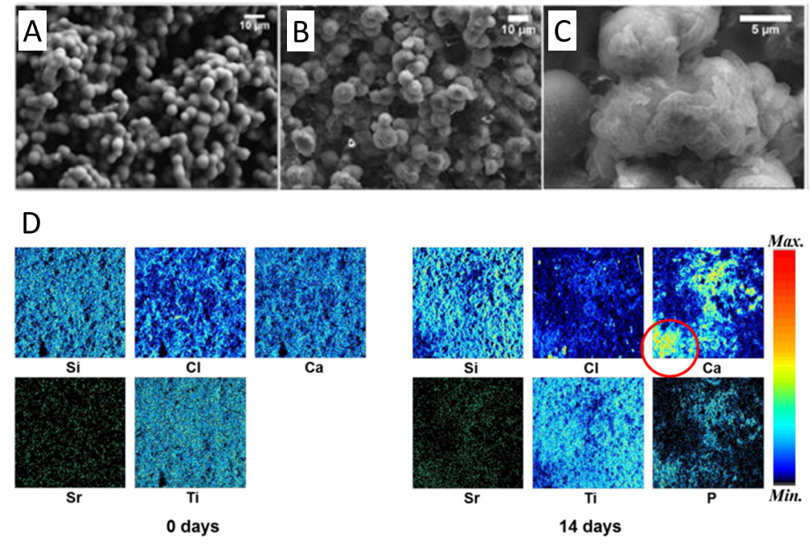

**Figure 8:** SEM micrographs (A-C) showing the change in morphology of PDMS-SiO2-TiO2-CaO hybrids upon immersion in SBF. PIXE mapping results (D) confirm that after 14 a significant deposition of calcium phosphates (i.e., bioactivity) occurred. Figure adapted from reference 119 with permission of Elsevier.

**Table 2:** Summary of synthetic polymers used to prepare O/I hybrids, their respective class and synthesis conditions.

|  |  |  |  |  |  |  |  |  |
| --- | --- | --- | --- | --- | --- | --- | --- | --- |
| **Organic phase** | **Polymer characteristics** | **Inorganic phase** | **Hybrid class** | **Calcium source (if applicable)** | **Inorganic phase (sol-gel) solvent** | **Organic phase solvent** | **Coupling agent (if applicable)** | **Refs.** |
| PVA | 16 kDa | SiO2 - CaO | I | CaCl2 | Water | Water 80°C | - | 51 |
| PLA | 260 kDa | SiO2 - CaO | I | CME | Ethanol | Chloroform | - | 72 |
| PCL | 14 kDa | SiO2 | I | - | Ethanol | Chloroform | - | 121 |
| 80 kDa | SiO2 - CaO - P2O5 | I | CaCl2 | Water | MEK 35°C | - | 18,43,59 |
| SiO2 - CaO | I | CE | Ethanol | THF | - | 75,78 |
| PHB+PCL | 437 kDa48-90 kDa | SiO2 - CaO - P2O5 | I | CaCl2 | Ethanol | Chloroform + DMF | - | 73,74,122 |
| PCL diol | 2000 g/mol | SiO2 | II | - | THF + Ethanol | THF | ICPTES | 81–84 |
| 3000 g/mol | SiO2 - B2O3 - P2O5 | II | - | Acetone | Acetone | GPTMS | 87–89 |
| 6700 g/mol | SiO2 - CaO | II | Ca(NO3)2 | Ethanol | THF | ICPTES | 85,86 |
| poly(CL-co-GPTMS) | 4-20 kDa | SiO2 | II | - | water | THF | - | 91 |
| poly(CL-co-THF) | 530 g/mol | SiO2 | II/IV | - | water | THF | GPTMS | 92 |
| PEG | 600 g/mol | SiO2 | II | - | directly in polymer solution | Ethanol | ICPTES | 93 |
| 300, 600 g/mol | SiO2 - CaO | II | CME | directly in polymer solution | Ethanol | APTES | 99 |
| PEO derivatives | 170 - 8000 g/mol | SiO2 | II | - | ethanol 55°C | - | ICPTES | 96,98 |
| poly(EO-co-LA) | 1000 - 3000 g/mol | SiO2 | II | - | ethanol 55°C | - | ICPTES | 97 |
| PTMSPMA | 2.5 - 30 kDa | SiO2 | II | - | water | Ethanol | - | 108 |
| PMMA-co-PTMSPMA | 10 - 60 kDa | SiO2 | II | - | water | THF | - | 103,110 |
| PDMS | 550 g/mol | CaO - SrO - TiO2 (+ SiO2 from polymer) | II | Ca(CH3COO)2 | water + isopropanol | - | - | 117,119 |
| polymer of HEMA/TEVS | - | CaO - P2O5 (+ SiO2 from polymer) | IV | CaCl2 | directly in polymer solution | ethanol | - | 107 |

## *4.2. Natural polymers*

### Polypeptides

Due to their main structural role in most connective tissues, collagens are obvious candidates for a wide range of biomedical applications. In particular, since one aim of O/I hybrids design is to mimic the natural structure of bone, researchers explored the combination of type I collagen with silicates and bioactive glasses as an approach leading to the development of materials with a close resemblance to physiological bone tissue5,55. Collagen has a complex hierarchical supramolecular structure based on triple helix fibrils determining unique mechanical properties123, significantly superior to other natural polymers. They are usually described using the so-called “stacking model” originally described by Hodge and Petruska124. In addition, collagen is characterized by its ability to nucleate mineralization125,126 while also being remodeled by enzymes involved in physiological bone regeneration mechanisms5. Furthermore, synergistic effects between collagen and silica naturally occur in deep sea siliceous sponge species (*Monorhaphididae*)127. The fibrillary structure of collagen is able to act as template for silica self-assembly, which in turns results in the mineralization of the polymeric matrix (Figure 9). This phenomenon is referred to as biosilicification and, in nature, is responsible for the formation of complex and remarkably tough multilayer nanostructures that caught the attention of biomaterials research.

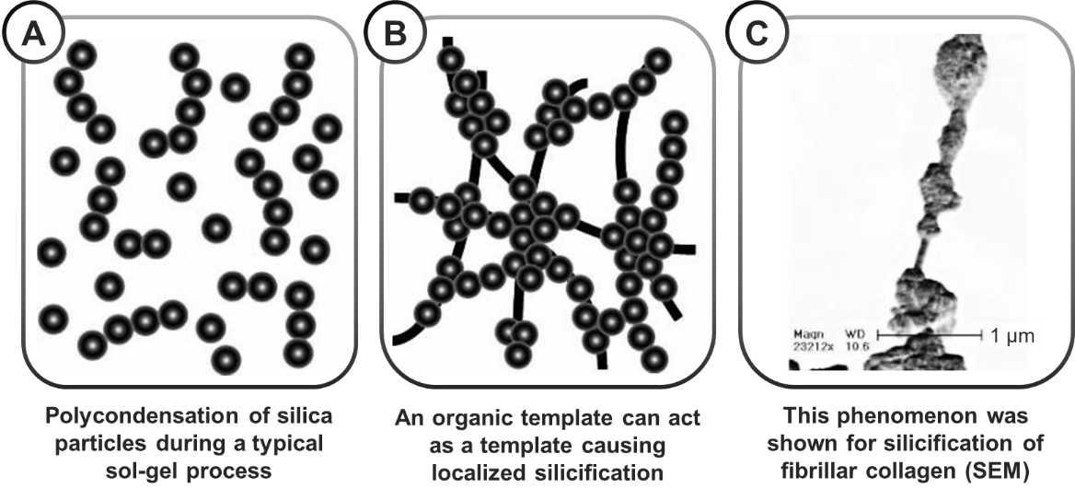

**Figure 9:** In biosilicification, the normal polycondensation of silica (A) can be tailored using an organic template (B). In panel (C) a typical structure of silica condensing on tropocollagen fibrils is shown (inverted SEM). Figure adapted from reference 128 with permission of John Wiley & Sons, Inc.

Using the sol-gel hybrid approach to synthetically mimic biosilicification and produce bio-inspired collagen-silica hybrid seems a promising and feasible strategy to obtain hierarchical 3D structures that resembles bone tissue. However, due to its complex molecular structure, processing collagen is a complex matter. Its solubility is very low and it can be dissolved only in acetic acid at low concentration. Several studies showed that a stable suspension of regenerated collagen can be prepared from tropocollagen, the structural subunit of collagen fibrils consisting of three polypeptide strands arranged in an α-helix. Tropocollagen is first dialyzed to remove salts used during extraction, then allowed to self-assemble into fibrils, freeze-dried and resuspended in a Tris-HCl buffer. With this approach class I hybrids of regenerated collagen and silica were successfully produced using various precursors, including TEOS129–132, tetramethoxysilane (TMOS)126, potassium silicon tris-catecholate127 and sodium silicate127,133. The maximum polymer content that could be attained was nevertheless relatively low (~ 15-30%) compared to other hybrid materials. In a typical biosilicification synthesis process132, hydrolyzed TEOS and a buffered collagen suspension are vigorously mixed, resulting in spontaneous gelation. Gelation kinetics can be controlled by tailoring the organic-to-inorganic ratio and the concentration of collagen, probably as a consequence of electrostatic interactions between negatively charged silica and positively charged groups of collagen, mainly amines131,134. The combination of hybrid synthesis and a composite approach was also investigated, blending collagen-silica hybrids with particulate bioinorganics (e.g. α-tricalcium phosphates129, hydroxyapatite135). Class I collagen-silica hybrids are homogeneous, bioactive134 and biocompatible (using human MSCs128 and also in vivo in rats132,135). In addition, the relative amount of collagen has significant impact on their mechanical properties126: the introduction of the biopolymer into the inorganic matrix determines significant increases in compressive modulus, ultimate strength and strain at fracture.

Compared to other polymers used for hybrid synthesis, the chosen inorganic precursor used in synthetic biosilicification has higher impact on the final structure obtained. Due to the highly hierarchical self-assembly of collagen and silica, changing the precursors can be the determining factor between obtaining a nanofibrillar tropocollagen dispersion in a silica matrix or silica-coated collagen macrofibers127. An in-depth investigation into the role of silica precursors on the final structure of bio-inspired collagen-silica hybrids was conducted by Eglin *et al.*127, who observed that all studied silicates (i.e. silicon alkoxides, silicon catecholates and silica nanoparticles) can only be added in limited amounts to collagen before they hinder the self-assembly properties of the polymer. In fact, collagen-silica hybrid fabrication could be successfully prepared only using regenerated tropocollagen with a low self-assembly degree. The limited amount of silica that can be used, coupled with the limited solubility and processability of collagen, presents a significant bottleneck for the successful application of this type of hybrid. For their limited processability and the disadvantages associated with bio-inspired biosilicification (e.g. low reproducibility, very limited organic-to-inorganic ratio), the use of collagen for hybrid synthesis has been often deemed unsuitable5.

The significant limitations of collagen can be overcome using gelatins, a family of hydrolyzed collagen derivatives that retain the biomimicry attractiveness of collagen and the presence of reactive functional groups, while being highly soluble in water. Class I136,137, but mostly class II gelatin-silica hybrids137–140, were successfully synthesized avoiding the limits of collagen biosilicification. The use of gelatin over collagen is a remarkably effective way to overcome the severely limited processability of native collagen. Gelatin-silica hybrids are scalable and can be manufactured into porous tissue engineering scaffolds using a wide variety of fabrication techniques, including sol-gel foaming68,139, freeze-drying68,139,141, electrospinning142,143, sacrificial template leaching56, solution blow spinning (SBS)138 and direct gel 3D printing143. As for other natural polymers, the synthesis of hybrids without the use of TEOS is also reported142. The strategy, however, has limited tailorability of the coupling degree, which cannot be controlled independently from gelatin content5. In a typical synthesis procedure, GPTMS is generally used as coupling agent and TEOS as silica precursor. Gelatin is dissolved in water, while the polycondensation of silica can be performed either in ethanol or in water. In a recent relevant study by Greenhalgh *et al.*138, the use of tert-butyl alcohol (TBA) was also suggested as a better solvent for freezing-based processing, such as lyophilization or cryo-SBS.

In class II hybrids, the congruent release of gelatin and silica following similar degradation rates indicated the successful synthesis of a hybrid. In addition, significant increases in the peaks of Tn species associated with increasing GPTMS:gelatin molar ratios also confirmed the presence of O/I covalent bonding68. Calcium nitrate (Ca(NO3)2) and calcium ethoxide (CE) were proposed as possible calcium sources. The use of calcium alkoxides such as CE is particularly promising and results in a more homogenous distribution of calcium inside the material56,137. This, in turn, leads to better apatite-forming ability throughout the whole bulk of the material and not just on its surface. Gelatin-silica hybrids have remarkable biological properties thanks to the optimal biocompatibility of gelatin and the osteostimulative ion release of the inorganic network. To date, the main drawbacks of this family of hybrids are (i) the difficulty to standardize their properties due to the intrinsic variability in composition, and as a consequence in properties, of gelatins5, and (ii) the limited reproducibility of their swelling/degradation properties as a consequence of the mismatch between the solubility of the organic and inorganic phases56.

### Polysaccharides

The investigation of polysaccharides as components of O/I hybrids focuses mostly on chitosan and to a lesser extent on alginate. One study also reports the use of starch104. As mentioned in previous sections, natural polymers are convenient due to their close resemblance to the ECM, high water content for optimal cytocompatibility and abundance of reactive side residues. Chitosan is no exception. The main strategy adopted when preparing chitosan O/I hybrids is to covalently bond the polysaccharide (rich in –NH2 and –OH moieties) to the inorganic component (i.e., class II). Only few studies explored the preparation of freeze-dried tissue engineering scaffolds based on class I chitosan hybrids144,145. Although this straight-forward approach results in constructs with satisfactory morphology (pore size = 20-300 μm, interconnected porosity = 97 %), the mechanical properties and cytocompatibility of class I chitosan hybrids is often unsatisfactory, probably due to phase separation and presence of residual reagents, respectively. In addition, class I chitosan hybrids tend to suffer from loss of mechanical stability and permselectivity (i.e., anisotropic preferential permeation) as a consequence of low homogeneity and uneven swelling between the organic and inorganic phases146. These findings pushed research to develop hybrids with covalent bonding between the silicate network and the polysaccharide. In particular, when grafting silanes on chitosan, GPTMS is the coupling agent of choice. The mechanism of coupling was extensively studied by Connell and collaborators147, to shed light over the several hypotheses existing at the time. NMR investigations proved that acid catalyzed covalent bonding between primary amines of chitosan (often expressed by the degree of deacetylation, DDA) and epoxides occurs. Variations in pH did not change the reaction yield or the amount of by-product, but it has an impact on the mechanical properties, especially for high organic content (65%). High amounts of organic component can disrupt the silica network and speed up dissolution rate. Given the central role of primary amines in constituting the bond, tailoring the DDA of chitosan to engineer specific hybrid properties could be an interesting development into the research on chitosan hybrids. However, to date, we did not find any report specifically exploring this property. Research investigated instead the role of another key characteristic of chitosan: molecular weight, exploring the potential of both low MW (~ 50-150 kDa)57,146–150 and high MW (> 200 kDa)148,151–153 chitosans. Generally, low MW is preferred for *in situ* approaches based on the sol-gel synthesis of a glass network in presence of chitosan. High MW chitosan on the other hand was used to prepare flexible hydrogels with an inorganic component. Although strictly speaking not a hybrid, the material produced with this approach show very interesting properties worth mentioning. The presence of GPTMS grafted on the polymer, if properly tailored, can modulate the mechanical properties of the hydrogel while improving cell adhesion, proliferation and differentiation of osteoblasts153. Remarkably, GPTMS induces the mineralization of the cell layer when compared to a non-bioactive chitosan control. This property can be further enhanced by the addition of a calcium source (CaCl2) during the synthesis of these hydrogels152. In addition, a follow-up study contributed to a better understanding of the physical and biological role of GPTMS. There seems to be an optimal level of GPTMS grafting at which both short (adhesion) and long term (proliferation, ALP activity) cell behaviors are positively influenced (Figure 10). Above 0.5:1 GPTMS-to-chitosan molar ratio the coupling agent started inhibiting cell growth. When below this threshold, increasing amounts of GPTMS were correlated with better cell attachment and improved ALP activity. The authors suggest that these cell behaviors are probably due to increased hydrogel stiffness and the release of osteogenic silicates151.

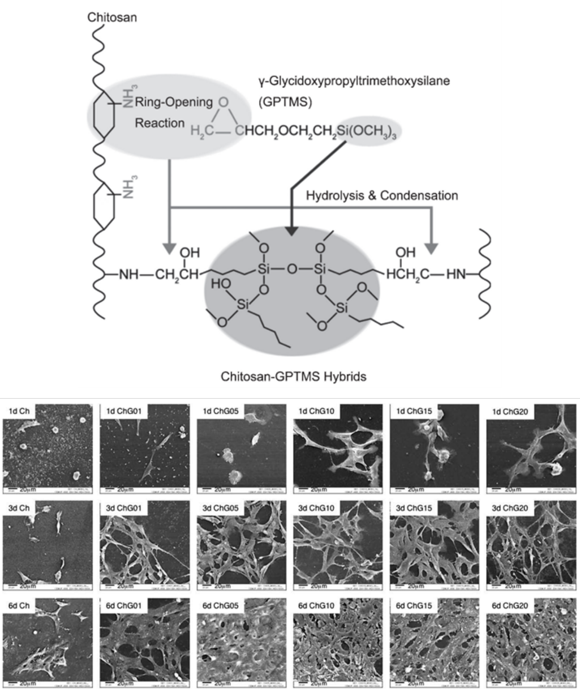

**Figure 10:** Reaction scheme of the synthesis of class II chitosan/silicate hybrids (top) and their effect on the culture of MG63 osteoblasts at 1, 3 and 6 days. Note how increasing amounts of inorganic component greatly enhances the adhesion of cells on the material. Figure adapted from reference 153 with permission of Elsevier.

For the *in situ* formation of a sol-gel silica network in presence of chitosan, lower MW products are generally used. Similarly to other class II hybrid syntheses, chitosan-GPTMS is first prepared by mixing the two precursors in acidic water. The low pH is necessary both to catalyze the nucleophilic reaction of GPTMS with chitosan and to protonate the polymer, making it soluble in water. If the pH is not low enough (> 5), chitosan does not completely dissolve. On the other hand, if the pH is too low, the epoxy rings spontaneously open and form diols, impeding the grafting entirely. In particular, for GPTMS in water the formation of diols is pH-dependent (a variation in pH alters the equilibrium), while in presence of chitosan is not the equilibrium that is affected by the pH, but rather the reaction kinetics147. Although the mechanism varies in presence of chitosan, the results is still that higher absolute amounts of diol are produced the lower the pH. To overcome the issue, Wang *et al.*149 propose to use a pH of 4 as optimal compromise between reactivity and solubility. Once GPTMS-chitosan is prepared, it can be mixed with previously hydrolyzed silicate precursor (usually TEOS) and left to gel and age for a few days. Further processing can be performed, including air drying to produce films154, as well as supercritical CO2 drying150 or freeze-drying149 for porous scaffolds. Authors seem to agree that the main advantage of class II chitosan-based hybrid resides in their enhanced mechanical properties. Although not particularly tough, the hybrid synthesis process results in a rubber-like material with high elongation at break, as recently reported by Reyes-Peces *et al.*150. The elastomeric behavior depends on the GPTMS grafting density and it is completely absent in class I chitosan hybrids, characterized by higher elastic modulus (11.2 MPa) and significantly lower maximum strain values (12.2%), the typical mechanical behavior of chitosan. This case study is a good example of how the preparation of class II hybrids, differently from class I, offers the possibility to design materials with properties that radically differ from the ones of the original components. These unique characteristics are particularly notable for hybrids with high organic content (e.g., 60:40 O/I ratio) and could come in handy during surgery, simplifying the implantation thanks to their ability to be squeezed into place and quickly recover their shape without deteriorating the mechanical properties. Coupling this behavior with a clever choice of fabrication technique could offer a promising solution to complex osteochondral tissue engineering problems. The highly anisotropic morphology of freeze-dried scaffolds, for instance, was identified as an attractive candidate for the regeneration of sub-articular cartilage. Thanks to their ability to form complexes with divalent cations, chitosan hybrids are particularly interesting as a possible solution155 to the problem of calcium incorporation41.

The synthesis of class II alginate-based hybrids is another viable route for the synthesis of O/I hybrids with a natural polysaccharide as organic component156,157. Similarly to chitosan, the interest in alginate stems from its ability to crosslink into a hydrogel in presence of calcium ions. As previously discussed, the incorporation of calcium into the silica network of hybrids cannot be performed as it requires temperatures higher than 400°C. The exploitation of polymers with chelating properties has been considered as a possible alternative to circumvent this obstacle and improve the bioactivity of hybrids. Studies on alginate grafted with 3-aminopropyltriethoxysilane (APTES) and crosslinked with CaCl2 have indeed confirmed how the presence of both siloxanes and calcium can significantly increase the apatite formation of the bare polysaccharide in vitro157, as well as in a rat tibia in vivo model156. Most remarkably, data showed that the presence of calcium alone does not result in bioactivity since silanol groups (Si-OH) are the moieties providing nucleation sites for the deposition to begin157. Encouraged by these findings, research focused on the synthesis of alginate-silica hybrids incorporating calcium within the polymer matrix. The synthesis normally occurs in water. Similarly to chitosan, GPTMS was proposed as coupling agent and an in-depth investigation of the mechanisms and homogeneity of reaction was reported by Vueva *et al.*158 using NMR, FTIR and ToF-SIMS. The epoxide ring of GPTMS bonds to the carboxylic acid groups of alginate forming an ester bond. However, as discussed for chitosan, GPTMS tends to form diols. This competing reaction was found to be predominant over the GPTMS hydrolysis/condensation, keeping the yield of the grafting reaction low. In addition, ToF-SIMS analysis showed that silicon ions are heterogeneously distributed within the hybrid, possibly as a consequence of poor integration of GPTMS in the silica network formed from TEOS. That is, in acidic conditions and once hydrolyzed, GPTMS tends to condense and form -Si-O-Si- bonds with itself. In agreement with similar studies conducted on chitosan147, the results suggest that two separate silicate networks coexist (one from TEOS, the other from GPTMS) and that GPTMS is more acting as a crosslinker for alginate than as nucleation site for the silica network. The results of the degradation and bioactivity study seems to support this hypothesis, too: higher GPTMS content was associated with higher silica release rate in SBF, possibly because the poor co-condensation between GPTMS and TEOS determined higher density of TEOS with Si-OH, more accessible to the attack of water. Research to date indicates that high-yield alginate hybrid synthesis remains a complex goal. Possible routes for improvements are the use of alginate derivatives and/or the exploration into other coupling agents, one being ATPES. In spite of this challenge, alginate still remains a very promising material especially for biomaterial processing in direct contact with cells (e.g., bio-inks). In this context, class I hybrids, with their less aggressive conditions, could offer a more viable alternative. A successful application of this concept was recently proposed by Oh *et al.*159, who investigated the potential of combining alginate and pre-polymerized hydrated silica (TMOS in water as precursor) into class I alginate/silicate cell-laden hydrogels (Figure 11).

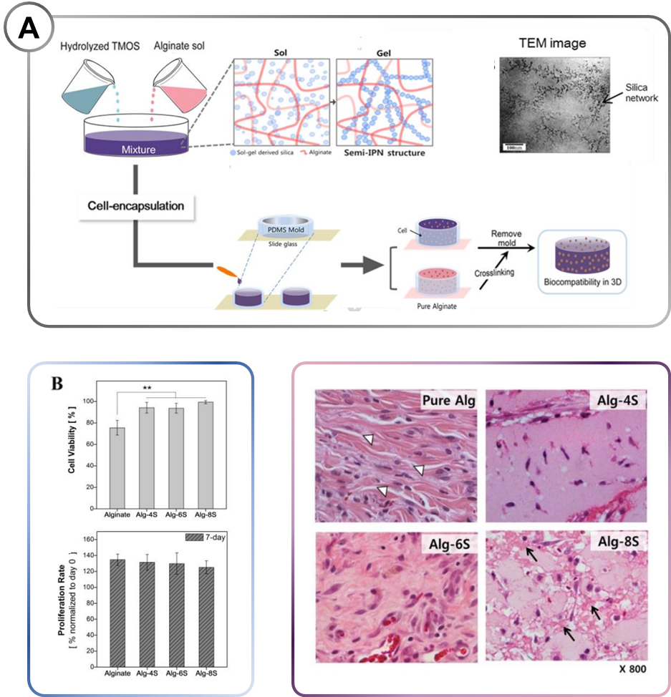

**Figure 11:** Alginate/silica hybrid hydrogel prepared for cell encapsulation by Oh et al.159 (A) Schematic diagram illustrating the experimental procedure and the structure of the resulting hydrogel, including a TEM image (top right). (B) Cell viability and proliferation, measured by MTS after 3h and 7d from encapsulation, respectively (**, p < 0.01). (C) Hematoxylin/eosin-stained cross-section of cell-encapsulating hydrogels implanted subcutaneously in rats. The images show healthy elongated cells, collagen fibrils formation (white arrow heads) and macrophages (black arrows). Figure adapted from reference 159 with permission of John Wiley & Sons, Inc.

Thanks to the presence of the silicate network, this approach not only led to gelation at room temperature without the addition of additional crosslinkers (e.g., CaCl2), but was also responsible for significant improvements in the properties of alginate as cell carrier. In particular, hybrid gels were more resilient to degradation and mechanically tougher (higher compressive strength and modulus with comparable strain at break). The presence of silica significantly improves cell adhesion and proliferation when using a 2D model. These results were confirmed first using a 3D *in vitro* model of encapsulation of 3T3 cells, followed by the *in vivo* implantation of gels with encapsulated MSCs in five weeks old Sprague–Dawley rats (MSCs isolated from the same species)160. Most importantly, the in vivo study highlighted the higher biostability of the hybrid gels compared to the alginate control, indicating that this approach can provide cells with a better substrate for longer-term growth. Cell-laden materials could be an innovative application of O/I hybrids in tissue engineering. Future work should be encouraged, especially looking into other encapsulation polymers, other cell types and, most importantly, the addition of other biologically relevant ions.

### Polymers obtained by bacterial synthesis

As previously discussed, the problem of calcium incorporation is a key challenge for the development of successful O/I hybrids. Due to the toxicity of nitrates, CaNO3 should be avoided and other routes of calcium incorporation should be investigated. While a significant body of work investigates the use of other calcium sources (e.g. CaCl2, calcium alkoxides) to incorporate the ion in the inorganic network, the possibility of using the polymer phase as a carrier is also under scrutiny, as already reported for chitosan and its ability to form complexes with calcium (i.e., chelate) and other divalent ions46. A similar approach was attempted using another polymer of natural origin, poly (γ-glutamic acid) (γ-PGA), a biopolymer produced by bacterial synthesis and known for its calcium chelating ability45. Chelation properties were associated with an ability to promote mineralization: some reports have indeed suggested that sequences of glutamic acid found at the end of collagen fibrils can nucleate the deposition of HCA161. Class II γ-PGA O/I hybrids are generally based on GPTMS as coupling agent. They are known for their remarkable mechanical properties and their good calcium incorporation. Their regulatory approval and scale-up, however, are potential barriers to the market. Since γ-PGA is produced by fermentation, concerns could raise regarding its reproducibility and reliability, especially in terms of MW and racemic structure5. Generally, class II γ-PGA O/I hybrids have been developed following three main approaches: (i) free acid form of γ-PGA combined with a silicate network, (ii) salt forms of γ-PGA with ions of interest (e.g., calcium, strontium) combined with a silicate network or (iii) salt forms of γ-PGA with ions grafted with GPTMS, but without silicate self-assembly (i.e., the only source of silicate is the coupling agent).

Free acid form γ-PGA functionalized with GPTMS and combined with a silicate network were proposed as biomaterials for bone and cartilage tissue engineering58,162 and as injectable pH-responsive biosensors163. The functionalization of the raw polymer is usually performed in DMSO to properly dissolve the free acid form of γ-PGA, insoluble in water in absence of cations. Simultaneously, the use of DMSO as solvent avoids side reactions between GPTMS and water164. Since γ-PGA is rich in carboxylic acid side groups, the hypothesis is that acid-catalyzed ring opening of the epoxy by DMSO occurs165, followed by nucleophilic attack and formation of an ester bond. After coupling and before mixing with the silica sol, a calcium source can be added to the organic network. However, this incorporation process must include a moisture-assisted drying step for the successful chelation of calcium by γ-PGA162. One of the possible ways to optimize the calcium incorporation is exploring more efficient calcium sources. For instance, CaCl2 was successfully replaced with calcium methoxyethoxide (CME) in a class II hybrid prepared from the free acid form of γ-PGA functionalized with GPTMS in DMSO44. The use of CME results in significantly lower gelation time, better incorporation and reduced network connectivity. The latter, in particular, decreases because of calcium acting as network modifier when introduced as CME. Most remarkably, using CME as precursor for class II γ-PGA hybrids can lead to compressive strength similar to 70S30C bioactive glass stabilized at 700°C, with a two-fold increase in modulus compared to hybrids synthesized with CaCl2-based protocols44.

Alternatively, calcium (or other ions) can be incorporated into γ-PGA synthesizing its salt form. Calcium γ-polyglutamate (γCaPGA) can be used as organic phase44,48,166–168, avoiding DMSO altogether and directly mixing the salt form of the polymer in a water-based inorganic sol. However, the amount of calcium that can be incorporated with this method is low and the ions tend to associate with the carboxylic acid groups of γ-PGA, reducing the number of sites available for GPTMS coupling. Moreover, GPTMS coupling performed in water has lower yield due to the occurrence of competing diol formation164. In spite of these drawbacks, the results obtained with this method are encouraging. Class II O/I hybrids with 40 wt.% γCaPGA can successfully and homogeneously incorporate calcium and silicates, resulting in the fast formation of HCA within 1 week of incubation in SBF. They present competitive mechanical properties, with high compressive strength (~500 MPa) and strain at failure (>26%), that can be tailor by varying the MW of the polymer48 and the GPTMS: γ-PGA ratio44, among other factors. The competitive mechanical properties are retained also after processing into scaffold: a similar protocol was used to prepare and electrospin a silicate and sodium γ-PGA hybrid that showed a significant improvement in tensile strength and elongation at break compared to a polymeric control167. The release of silicate and ECM-like fibrillary network were also associated with the promotion of cell proliferation and differentiation toward a desirable osteoblastic phenotype. Electrospun mats of γ-PGA hybrids containing calcium166,169 and strontium168 were also successfully prepared (Figure 12).

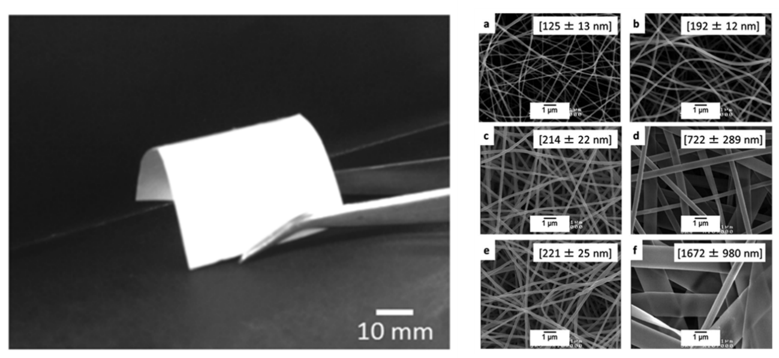

**Figure 12:** Hybrid γ-PGA-based fiber mats fabricated by electrospinning. Macroscopic appearance (left) and SEM micrographs showing the fibrous micro- and nanotopography. Figure adapted from reference 166 under Creative Commons License.

Contrary to previously described examples, these hybrids do not contain a self-assembled silica network and their only silicate source is the coupling agent (usually GPTMS, although APTES is also reported169). Nevertheless, investigations into their therapeutic potential confirmed that the release of biologically active ions have a beneficial effect on cells. Silicate and calcium released from γSr/CaPGA hybrids promoted mineralization, resulting in the formation of a superficial apatite-like layer after only 3 days, while strontium release was associated with higher proliferation and increased ALP activity, indicating the early onset of osteogenic differentiation168.

Poly(3-hydroxybutyrate) (PHB) is another biopolymer obtained by bacterial synthesis and used for the preparation of O/I hybrids. It belongs to a group of naturally occurring polyesters called polyhydroxyalkanoates (PHAs). PHAs are well-known in biomaterials science for their tailorable mechanical behavior, their competitive degradation properties and their bioactivity. However, compared to γ-PGA, the application of PHAs in hybrids is still at an earlier stage of development. To date, their main use is in combination with PCL for the direct electrospinning of hybrid sols33,73,74,122. PHB and PCL are usually blended at a 7:3 ratio. They are then combined with various sol-gel derived inorganics, including pure silica33,73,122, binary (S70C30)122 and ternary (S58)74 bioactive glasses. CaCl2 and TEP were used as calcium and phosphate sources, respectively. The possibility to use this material as a drug delivery carrier was also explored using the antibiotic levofloxacin as a model drug33. The electrospinning process has been proven robust and reproducible up to an organic-to-inorganic ratio of 50:50 and it is an effective way to combine the high stiffness of PHB, the flexibility of PCL and the osteostimulative properties bioactive glass122. Interestingly, the bioactivity of hybrids was not superior to the one of PCL and PHB alone. The addition of bioactive glass, either binary or ternary, was not sufficient to significantly promote the mineralization of these fiber scaffolds in SBF. No increase in bioactivity compared to a polymeric control was observed for either binary or ternary glasses. The authors suggest that this uncommon result could be due to inadequate surface chemistry. The hypothesis, supported by related research142,170, is that the solvent system used to prepare the sol-gel glass plays a role in determining the overall bioactivity of the system, possibly by coordinating the self-assembly of the silica network and, as a consequence, the availability of nucleation sites for apatite deposition122. Nonetheless, the biological properties of PHB/PCL/silica hybrids are encouraging. In vitro testing performed using an MG-63 cell line confirmed the biocompatibility of this technology, regardless of the formulation used (no difference in cell viability at 24 hours). Cell proliferation, osteoblast differentiation and mineralization were improved on hybrid fiber mats compared to a tissue culture polystyrene (TCPS) control. The release of biologically active ions (i.e., silicates, calcium, phosphates) determined a remarkable increase in ALP activity and mineralization in PHB/PCL/S58 hybrid scaffolds with an organic-to-inorganic ratio of 5:1. A minor increase was also assessed for polymeric electrospun substrates. This highlights the promoting role that topography has on cells, in parallel with material chemistry. In particular, cell adhesion and proliferation were significantly improved by the nanotopography introduced by electrospinning, both in polymeric and hybrid mats. This is a well-known benefit of choosing a complex and hierarchical 3D topography over a simpler 2D culture substrate21 and highlights the importance of synergistically pairing biologically active materials with a well-engineered scaffold design.

**Table 3:** Summary of synthetic polymers used to prepare O/I hybrids, their respective class and synthesis conditions.

|  |  |  |  |  |  |  |  |  |
| --- | --- | --- | --- | --- | --- | --- | --- | --- |
| **Organic phase** | **Polymer characteristics** | **Inorganic phase** | **Hybrid class** | **Calcium source (if applicable)** | **Inorganic phase (sol-gel) solvent** | **Organic phase solvent** | **Coupling agent (if applicable)** | **Refs.** |
| Gelatin | Porcine type A | SiO2 | II | - | water | acidic water | GPTMS | 68,139 |
| - | SiO2 (coupling agent) – CaO | II | Ca(NO3)2 | directly in polymer solution | formic acid | GPTMS | 142 |
| - | SiO2 (coupling agent) | II | - | directly in polymer solution | acidic water | GPTMS | 141 |
| Type B | SiO2 - CaO | II | CE | ethanol | water | GPTES | 56,137 |
| Chitosan | Low MW: 50-190 kDa DDA > 75% | SiO2 | II | - | water | acidic water | GPTMS | 57 |
| High MW: 310-375 kDa  DDA > 75% | SiO2 (coupling agent) | II | - | directly in polymer solution | acidic water | GPTMS | 148,151–153,155 |
| 50-150 kDa | SiO2 | II | - | water | acidic water | GPTMS | 147,149 |
| Chitosan/PVA | Chitosan: High MW, DDA > 75% | SiO2 - CaO - P2O5 | I | Ca(NO3)2 | water | acidic water | - | 145 |
| Alginate | M/G ratio = 2.4 | SiO2 (coupling agent) – CaO | II | CaCl2 | directly in polymer solution | water | APTES | 157 |
| Calcium alginate | - | SiO2 - Ca2+ | II | in polymer | water | acidic water | GPTMS | 158 |
| γ-PGA | - | SiO2 - CaO | II | CaCl2 | water | DMSO 80°C | GPTMS | 58,162 |
| - | SiO2 - CaO | II | CME | water | DMSO 80°C | GPTMS | 44 |
| 800-1200 kDa | SiO2 (coupling agent) | II | CaCl2 | directly in polymer solution | water | APTES | 169 |
| Calcium γ-PGA | 30-120 kDa | SiO2 - Ca2+ | II | in polymer | water | acidic water | GPTMS | 48 |
| 200-500 kDa | SiO2 (coupling agent) - Ca2+ | II | in polymer | directly in polymer solution | acidic water | GPTMS | 166 |
| Strontium/Calcium γ-PGA | 1500-2500 kDa | SiO2 (coupling agent) - Ca2+ - Sr2+ | II | in polymer | - | water | GPTMS | 168 |

# 5. Summary and outlook

Following the discovery of bioactive glasses and the progress in sol-gel chemistry started in the ‘70s, organic/inorganic hybrids emerged as a promising class of biomaterials with unique structure and mechanical properties. In the field of biomaterials, they were originally developed to overcome weaknesses of the composites used in orthopedics and bone tissue engineering. With sol-gel-based hybrid synthesis, an inorganic network, usually silicate, can be combined with polymers using a bottom-up approach, blending them at a supramolecular level. The absence of an organic/inorganic interface typical of composites avoids the great majority of complications normally associated with interfacial defects, voids and degradation mismatch. Thanks to Direct Ink Writing, it has been possible to achieve porous scaffolds with satisfactory mechanical properties to mimic bone. Compared to composites, hybrids tend to have more homogeneous and predictable degradation, more tailorable and reproducible mechanical properties and a reduced risk of catastrophic mechanical failure. The organic phase can play a key role in the determination of these properties. A clever choice of polymer and synthesis chemistry will highly influence the mechanical behavior of the hybrid, leading to tough structural materials, rubber-like elastomers and even self-healing properties. In addition, thanks to the soft chemistry approach of hybrid synthesis, biologically active molecules that would be otherwise degraded by thermal treatments can be loaded within the organic/inorganic network offering advantages compared to other drug loading techniques (e.g., absorption). O/I hybrids were even confirmed as suitable carriers for drug delivery systems and cell encapsulation devices.

Using different polymers can have a significant impact on the outcome for each application. In this review, both natural and synthetic polymers were discussed, with their respective advantages and disadvantages. While natural polymers are usually sought for their higher ability to mimic natural tissues, their high water content and biocompatibility, synthetic polymers offer more reproducibility and superior control over the chemistry route. The target tissue of hybrids also shifted over the years, with more authors proposing the application of hybrids for the regeneration of cartilage and osteochondral tissues.

We anticipate that in the coming years research will continue focusing on investigating new synthesis approaches to achieve a finer tuning of the properties of the hybrid material. In particular, there seems to be a general trend toward the preference of class II hybrids owing to the unique sets of properties that can be obtained as a consequence of the covalent bond between the organic and inorganic phase. Investigations into new combinations of sol-gel bioactive glasses with natural polymers unexplored to date should be also considered. A notable example are silk proteins: fibroin and sericin. Similarly to collagen, these proteins seems to have an intrinsic biomineralization potential due to their unique self-assembly. This peculiar property could make them promising candidates as organic phases of O/I hybrids in the near future.

Increasing and optimizing the biological complexity of hybrids by adding active agents is also a hot topic in the field. Generally, the goal can be reached following two major strategies: (i) loading drugs such as antibiotics, phytotherapeutics or osteostimulative agents during the synthesis of the material and (ii) study more complex inorganic formulations that include therapeutic metal ions that can be released over time in vivo. The two approaches can be also implemented at the same time, a feature that makes hybrids a promising way to develop implantable materials with well-tailored, multifaceted beneficial effects. Given the encouraging results and promising opportunities explored so far, O/I hybrids are expected to remain a key subject in biomaterials sciences, fostering the discovery of new combinations of polymer and inorganic phases and new synthesis routes, hopefully ultimately leading to their routine clinical application.

# References

1 F. Baino, S. Hamzehlou and S. Kargozar, *J. Funct. Biomater.*, 2018, **9**, 25.

2 V. Mouriño, J. P. Cattalini and a. R. Boccaccini, *J. R. Soc. Interface*, 2012, **9**, 401–419.

3 C. Ohtsuki, T. Kokubo and T. Yamamuro, *J. Non. Cryst. Solids*, 1992, **143**, 84–92.

4 L. L. Hench, *J. Mater. Sci. Mater. Med.*, 2006, **17**, 967–78.

5 J. R. Jones, *Acta Biomater.*, 2013, **9**, 4457–4486.

6 H. Oonishi, L. L. Hench, J. Wilson, F. Sugihara, E. Tsuji, M. Matsuura, S. Kin, T. Yamamoto and S. Mizokawa, 2000, 4–13.

7 F. D. Smith, *AORN J.*, 2012, **95**, 239–254.

8 A. R. Boccaccini, Q. Chen, L. Lefebvre, L. Gremillard and J. Chevalier, *Faraday Discuss.*, 2007, **136**, 27.

9 Q. Nawaz, A. de Pablos‐Martín, J. Martins de Souza e Silva, K. Hurle, A. T. C. Jaimes, D. S. Brauer and A. R. Boccaccini, *J. Am. Ceram. Soc.*, 2020, **103**, 4234–4247.

10 F. E. Ciraldo, E. Boccardi, V. Melli, F. Westhauser and A. R. Boccaccini, *Acta Biomater.*, 2018, **75**, 3–10.

11 S. A. Ferreira, G. Young, J. R. Jones and S. Rankin, *Mater. Sci. Eng. C*, 2021, **118**, 111393.

12 X. Lacambra-Andreu, N. Dergham, M. Magallanes-Perdomo, S. Meille, J. Chevalier, J.-M. Chenal, A. Maazouz and K. Lamnawar, *Polymers (Basel).*, 2021, **13**, 2991.

13 L. Gritsch, G. Conoscenti, V. La Carrubba, P. Nooeaid and A. R. Boccaccini, *Mater. Sci. Eng. C*, 2019, **94**, 1083–1101.

14 L. Gritsch, C. Lovell, W. H. Goldmann and A. R. Boccaccini, *J. Mater. Sci. Mater. Med.*, 2018, **29**, 18.

15 K. Rezwan, Q. Z. Chen, J. J. Blaker and A. R. Boccaccini, *Biomaterials*, 2006, **27**, 3413–3431.

16 P. Gentile, M. Mattioli-Belmonte, V. Chiono, C. Ferretti, F. Baino, C. Tonda-Turo, C. Vitale-Brovarone, I. Pashkuleva, R. L. Reis and G. Ciardelli, *J. Biomed. Mater. Res. Part A*, 2012, **100A**, 2654–2667.

17 F. Baino, S. Fiorilli and C. Vitale-Brovarone, *Bioengineering*, 2017, **4**, 1–18.

18 B. A. Allo, D. O. Costa, S. J. Dixon, K. Mequanint and A. S. Rizkalla, *J. Funct. Biomater.*, 2012, **3**, 432–463.

19 R. Li, A. E. Clark and L. L. Hench, *J. Appl. Biomater.*, 1991, **2**, 231–239.

20 M. Shi, J. Chang and C. Wu, 2016, pp. 147–181.

21 L. Gritsch, D. Meng and A. R. Boccaccini, in *Biomedical Composites*, Elsevier, 2017, pp. 501–542.

22 N. Rocton, H. Oudadesse, S. Mosbahi, L. Bunetel, P. Pellen-Mussi and B. Lefeuvre, *IOP Conf. Ser. Mater. Sci. Eng.*, 2019, **628**, 012005.

23 S. K. Misra, D. Mohn, T. J. Brunner, W. J. Stark, S. E. Philip, I. Roy, V. Salih, J. C. Knowles and A. R. Boccaccini, *Biomaterials*, 2008, **29**, 1750–1761.

24 Y. Arima and H. Iwata, *Biomaterials*, 2007, **28**, 3074–3082.

25 E. Ngandu Mpoyi, M. Cantini, P. M. Reynolds, N. Gadegaard, M. J. Dalby and M. Salmerón-Sánchez, *ACS Nano*, 2016, **10**, 6638–6647.

26 C. Wu, W. Fan, M. Gelinsky, Y. Xiao, J. Chang, T. Friis and G. Cuniberti, *J. R. Soc. Interface*, 2011, **8**, 1804–1814.

27 M. Qiu, D. Chen, C. Shen, J. Shen, H. Zhao and Y. He, *RSC Adv.*, 2017, **7**, 23671–23679.

28 E. Alpaslan and T. J. Webster, *Int. J. Nanomedicine*, 2014, **9**, 7–12.

29 J. Qi, T. Zhang, J. Xiao, Q. Zhang and C. Xiong, *New J. Chem.*, 2020, **44**, 19227–19237.

30 A. Liu, Z. Hong, X. Zhuang, X. Chen, Y. Cui, Y. Liu and X. Jing, *Acta Biomater.*, 2008, **4**, 1005–1015.

31 O. Oral, L. V. Lassila, O. Kumbuloglu and P. K. Vallittu, *Dent. Mater.*, 2014, **30**, 570–577.

32 B. M. Novak, *Adv. Mater.*, 1993, **5**, 422–433.

33 Y. Ding, W. Li, A. Correia, Y. Yang, K. Zheng, D. Liu, D. W. Schubert, A. R. Boccaccini, H. A. Santos and J. A. Roether, *ACS Appl. Mater. Interfaces*, 2018, **10**, 14540–14548.

34 CN108653821B, 2017.

35 US20220008619A1, 2018.

36 EP2178805B1, 2007.

37 WO2017168168A1, 2016.

38 V. K. Mouryaa, N. N. Inamdara and A. Tiwari, *Adv. Mater. Lett.*, 2010, **1**, 11–33.

39 I. D. Xynos, A. J. Edgar, L. D. K. Buttery, L. L. Hench and J. M. Polak, *J. Biomed. Mater. Res.*, 2001, **55**, 151–157.

40 F. E. Ciraldo, L. Liverani, L. Gritsch, W. H. Goldmann and A. R. Boccaccini, *Materials (Basel).*, 2018, **11**, 692.

41 C. Bossard, H. Granel, É. Jallot, V. Montouillout, F. Fayon, J. Soulié, C. Drouet, Y. Wittrant and J. Lao, *ACS Biomater. Sci. Eng.*, 2019, **5**, 5906–5915.

42 S. Lin, C. Ionescu, K. J. Pike, M. E. Smith and J. R. Jones, *J. Mater. Chem.*, 2009, **19**, 1276–1282.

43 B. A. Allo, A. S. Rizkalla and K. Mequanint, *Langmuir*, 2010, **26**, 18340–18348.

44 G. Poologasundarampillai, B. Yu, O. Tsigkou, D. Wang, F. Romer, V. Bhakhri, F. Giuliani, M. M. Stevens, D. S. McPhail, M. E. Smith, J. V. Hanna and J. R. Jones, *Chem. - A Eur. J.*, 2014, **20**, 8149–8160.

45 T. Tsujimoto, *J. Microbiol. Biotechnol.*, 2010, **20**, 1436–1439.

46 Y. Qin, *J. Appl. Polym. Sci.*, 1993, **49**, 727–731.

47 E. Guibal, T. Vincent and R. Navarro, *J. Mater. Sci.*, 2014, **49**, 5505–5518.

48 E. M. Valliant, F. Romer, D. Wang, D. S. McPhail, M. E. Smith, J. V. Hanna and J. R. Jones, *Acta Biomater.*, 2013, **9**, 7662–7671.

49 A. B. Bello, D. Kim, D. Kim, H. Park and S.-H. Lee, *Tissue Eng. Part B Rev.*, 2020, **26**, 164–180.

50 V. S. Gomide, A. Zonari, N. M. Ocarino, A. M. Goes, R. Serakides and M. M. Pereira, *Biomed. Mater.*, 2012, **7**, 015004.

51 M. M. Pereira, J. R. Jones, R. L. Orefice and L. L. Hench, *J. Mater. Sci. Mater. Med.*, 2005, **16**, 1045–1050.

52 A. P. V. Pereira, W. L. Vasconcelos and R. L. Oréfice, *J. Non. Cryst. Solids*, 2000, **273**, 180–185.

53 A. G. S. de Laia, B. R. Barrioni, T. M. Valverde, A. M. de Goes, M. A. de Sá and M. de M. Pereira, *J. Mater. Sci.*, 2020, **55**, 8710–8727.

54 L. Gabrielli, L. Connell, L. Russo, J. Jiménez-Barbero, F. Nicotra, L. Cipolla and J. R. Jones, *RSC Adv.*, 2014, **4**, 1841–1848.

55 B. Sarker, S. Lyer, A. Arkudas and A. R. Boccaccini, *Nanotechnol. Rev.*, 2013, **2**, 427–447.

56 J. Lao, X. Dieudonné, F. Fayon, V. Montouillout and E. Jallot, *J. Mater. Chem. B*, 2016, **4**, 2486–2497.

57 S. Trujillo, E. Pérez-Román, A. Kyritsis, J. L. Gómez Ribelles and C. Pandis, *J. Polym. Sci. Part B Polym. Phys.*, 2015, **53**, 1391–1400.

58 G. Poologasundarampillai, C. Ionescu, O. Tsigkou, M. Murugesan, R. G. Hill, M. M. Stevens, J. V. Hanna, M. E. Smith and J. R. Jones, *J. Mater. Chem.*, 2010, **20**, 8952.

59 B. A. Allo, A. S. Rizkalla and K. Mequanint, *ACS Appl. Mater. Interfaces*, 2012, **4**, 3148–3156.

60 M. Vert, S. M. Li, G. Spenlehauer and P. Guerin, *J. Mater. Sci. Mater. Med.*, 1992, **3**, 432–446.

61 S. Li, in *Science and Principles of Biodegradable and Bioresorbable Medical Polymers: Materials and Properties*, Woodhead Publishing, 2017, pp. 37–78.

62 J. Herzberger, K. Niederer, H. Pohlit, J. Seiwert, M. Worm, F. R. Wurm and H. Frey, *Chem. Rev.*, 2016, **116**, 2170–2243.

63 E. M. Saffer, G. N. Tew and S. R. Bhatia, *Curr. Med. Chem.*, 2011, **18**, 5676–5686.

64 A. L. B. Maçon, S. Li, J. J. Chung, A. Nommeots-Nomm, A. K. Solanki, M. M. Stevens and J. R. Jones, *J. Mater. Chem. B*, 2016, **4**, 6032–6042.

65 M. C. Gómez-Guillén, B. Giménez, M. E. López-Caballero and M. P. Montero, *Food Hydrocoll.*, 2011, **25**, 1813–1827.

66 Y. Qi, H. Wang, K. Wei, Y. Yang, R. Y. Zheng, I. S. Kim and K. Q. Zhang, *Int. J. Mol. Sci.*, , DOI:10.3390/ijms18030237.

67 D. Liu, M. Nikoo, G. Boran, P. Zhou and J. M. Regenstein, *Annu. Rev. Food Sci. Technol.*, 2015, **6**, 527–557.

68 O. Mahony, O. Tsigkou, C. Ionescu, C. Minelli, L. Ling, R. Hanly, M. E. Smith, M. M. Stevens and J. R. Jones, *Adv. Funct. Mater.*, 2010, **20**, 3835–3845.

69 K. Sun and Z. H. Li, *Express Polym. Lett.*, 2011, **5**, 342–361.

70 J. Venkatesan, I. Bhatnagar, P. Manivasagan, K.-H. Kang and S.-K. Kim, *Int. J. Biol. Macromol.*, 2015, **72**, 269–281.

71 A. P. Bonartsev, V. L. Myshkina, D. A. Nikolaeva, E. K. Furina and T. A. Makhina, 2007, 295–307.

72 G. Poologasundarampillai, B. Yu, J. R. Jones and T. Kasuga, *Soft Matter*, 2011, **7**, 10241.

73 Y. Ding, Q. Yao, W. Li, D. W. Schubert, A. R. Boccaccini and J. A. Roether, *Colloids Surfaces B Biointerfaces*, 2015, **136**, 93–98.

74 Y. Ding, W. Li, T. Müller, D. W. Schubert, A. R. Boccaccini, Q. Yao and J. A. Roether, *ACS Appl. Mater. Interfaces*, 2016, **8**, 17098–17108.

75 C. Bossard, H. Granel, Y. Wittrant, É. Jallot, J. Lao, C. Vial and H. Tiainen, *Biomed. Glas.*, 2018, **4**, 108–122.

76 B. A. Allo, S. Lin, K. Mequanint and A. S. Rizkalla, *ACS Appl. Mater. Interfaces*, 2013, **5**, 7574–7583.

77 H. Granel, C. Bossard, L. Nucke, F. Wauquier, G. Y. Rochefort, J. Guicheux, E. Jallot, J. Lao and Y. Wittrant, *Adv. Healthc. Mater.*, 2019, **8**, 1801542.

78 H. Granel, C. Bossard, A.-M. Collignon, F. Wauquier, J. Lesieur, G. Y. Rochefort, E. Jallot, J. Lao and Y. Wittrant, *ACS Appl. Bio Mater.*, 2019, **2**, acsabm.9b00407.

79 US10149920B2, 2014.

80 C. Pandis, S. Trujillo, J. Matos, S. Madeira, J. Ródenas-Rochina, S. Kripotou, A. Kyritsis, J. F. Mano and J. L. Gómez Ribelles, *Macromol. Biosci.*, 2015, **15**, 262–274.

81 D. Tian, S. Blacher and R. Jerome, *Polymer (Guildf).*, 1999, **40**, 951–957.

82 D. Tian, S. Blacher, J.-P. Pirard and R. Jérôme, *Langmuir*, 1998, **14**, 1905–1910.

83 D. Tian, S. Blacher, P. Dubois and R. Jérôme, *Polymer (Guildf).*, 1998, **39**, 855–864.

84 D. Tian, P. Dubois and R. Jérôme, *J. Polym. Sci. Part A Polym. Chem.*, 1997, **35**, 2295–2309.

85 S.-H. Rhee, Y.-K. Lee, B.-S. Lim, J. J. Yoo and H. J. Kim, *Biomacromolecules*, 2004, **5**, 1575–1579.

86 S.-H. Rhee, J.-Y. Choi and H.-M. Kim, *Biomaterials*, 2002, **23**, 4915–4921.

87 D. Mondal, A. S. Rizkalla and K. Mequanint, *RSC Adv.*, 2016, **6**, 92824–92832.

88 D. Mondal, S. J. Dixon, K. Mequanint and A. S. Rizkalla, *J. Mech. Behav. Biomed. Mater.*, 2017, **75**, 180–189.

89 D. Mondal, S. Lin, A. S. Rizkalla and K. Mequanint, *J. Mech. Behav. Biomed. Mater.*, 2019, **92**, 162–171.

90 S. N. Rath, A. Brandl, D. Hiller, A. Hoppe, U. Gbureck, R. E. Horch, A. R. Boccaccini and U. Kneser, *PLoS One*, 2014, **9**, e113319.

91 T. Sang, S. Li, H.-K. Ting, M. M. Stevens, C. R. Becer and J. R. Jones, *Chem. Mater.*, 2018, **30**, 3743–3751.

92 F. Tallia, L. Russo, S. Li, A. L. H. Orrin, X. Shi, S. Chen, J. A. M. Steele, S. Meille, J. Chevalier, P. D. Lee, M. M. Stevens, L. Cipolla and J. R. Jones, *Mater. Horizons*, 2018, **5**, 849–860.

93 M. Messori, M. Toselli, F. Pilati, E. Fabbri, P. Fabbri, L. Pasquali and S. Nannarone, *Polymer (Guildf).*, 2004, **45**, 805–813.

94 M. Iotti, P. Fabbri, M. Messori, F. Pilati and P. Fava, *J. Polym. Environ.*, 2009, **17**, 10–19.

95 L. Russo, L. Gabrielli, E. M. Valliant, F. Nicotra, J. Jiménez-Barbero, L. Cipolla and J. R. Jones, *Mater. Chem. Phys.*, 2013, **140**, 168–175.

96 S. Hendrikx, C. Kascholke, T. Flath, D. Schumann, M. Gressenbuch, F. P. Schulze, M. C. Hacker and M. Schulz-Siegmund, *Acta Biomater.*, 2016, **35**, 318–329.

97 C. Kascholke, S. Hendrikx, T. Flath, D. Kuzmenka, H.-M. Dörfler, D. Schumann, M. Gressenbuch, F. P. Schulze, M. Schulz-Siegmund and M. C. Hacker, *Acta Biomater.*, 2017, **63**, 336–349.

98 S. Hendrikx, D. Kuzmenka, R. Köferstein, T. Flath, H. Uhlig, D. Enke, F. P. Schulze, M. C. Hacker and M. Schulz-Siegmund, *J. Sol-Gel Sci. Technol.*, 2017, **83**, 143–154.

99 A. Li, H. Shen, H. Ren, C. Wang, D. Wu, R. A. Martin and D. Qiu, *J. Mater. Chem. B*, 2015, **3**, 1379–1390.

100 M. E. Fox, F. C. Szoka and J. M. J. Fréchet, *Acc. Chem. Res.*, 2009, **42**, 1141–1151.

101 Y. Takakura, R. I. Mahato and M. Hashida, *Adv. Drug Deliv. Rev.*, 1998, **34**, 93–108.

102 R. Ravarian, X. Zhong, M. Barbeck, S. Ghanaati, C. J. Kirkpatrick, C. M. Murphy, A. Schindeler, W. Chrzanowski and F. Dehghani, *ACS Nano*, 2013, **7**, 8469–8483.

103 J. J. Chung, B. S. T. Sum, S. Li, M. M. Stevens, T. K. Georgiou and J. R. Jones, *Macromol. Rapid Commun.*, 2017, **38**, 1700168.

104 C. Ohtsuki, T. Miyazaki, M. Kamitakahara and M. Tanihara, *J. Eur. Ceram. Soc.*, 2007, **27**, 1527–1533.

105 T. Miyazaki, M. Imamura, E. Ishida, M. Ashizuka and C. Ohtsuki, *J. Mater. Sci. Mater. Med.*, 2009, **20**, 157–161.

106 S.-H. Rhee, M.-H. Hwang, H.-J. Si and J.-Y. Choi, *Biomaterials*, 2003, **24**, 901–906.

107 Ł. John, M. Podgórska, J.-M. Nedelec, Ł. Cwynar-Zając and P. Dzięgiel, *Mater. Sci. Eng. C*, 2016, **68**, 117–127.

108 A. L. B. Maçon, S. J. Page, J. J. Chung, N. Amdursky, M. M. Stevens, J. V. M. Weaver, J. V. Hanna and J. R. Jones, *Phys. Chem. Chem. Phys.*, 2015, **17**, 29124–29133.

109 T.-Y. Tsai, N. Bunekar, M. H. Chang, W.-K. Wang and S. Onda, *Int. J. Mech. Ind. Aerosp. Sci.*, , DOI:10.5281/zenodo.1340589.

110 J. J. Chung, Y. Fujita, S. Li, M. M. Stevens, T. Kasuga, T. K. Georgiou and J. R. Jones, *Acta Biomater.*, 2017, **54**, 411–418.

111 A. Li Volsi, F. Tallia, H. Iqbal, T. K. Georgiou and J. R. Jones, *Mater. Adv.*, 2020, **1**, 3189–3199.

112 K. Tsuru, C. Ohtsuki, A. Osaka, T. Iwamoto and J. D. Mackenzie, *J. Mater. Sci. Mater. Med.*, 1997, **8**, 157–161.

113 M. Kamitakahara, M. Kawashita, N. Miyata, T. Kokubo and T. Nakamura, *J. Mater. Sci. Mater. Med.*, 2002, **13**, 1015–1020.

114 M. Kamitakahara, M. Kawashita, N. Miyata, T. Kokubo and T. Nakamura, *J. Sol-Gel Sci. Technol.*, 2001, **21**, 75–81.

115 Q. Chen, F. Miyaji, T. Kokubo and T. Nakamura, *Biomaterials*, 1999, **20**, 1127–1132.

116 K. Tsuru, Y. Aburatani, T. Yabuta, S. Hayakawa, C. Ohtsuki and A. Osaka, *J. Sol-Gel Sci. Technol.*, 2001, **21**, 89–96.

117 J. C. Almeida, A. Wacha, P. S. Gomes, M. H. R. Fernandes, M. H. V. Fernandes and I. M. M. Salvado, *Mater. Sci. Eng. C*, 2016, **64**, 74–86.

118 A. J. Salinas, J. M. Merino, F. Babonneau, F. J. Gil and M. Vallet-Regí, *J. Biomed. Mater. Res. Part B Appl. Biomater.*, 2007, **81B**, 274–282.

119 J. C. Almeida, A. Wacha, P. S. Gomes, L. C. Alves, M. H. V. Fernandes, I. M. M. Salvado and M. H. R. Fernandes, *Mater. Sci. Eng. C*, 2016, **62**, 429–438.

120 J. C. Almeida, A. Wacha, A. Bóta, L. Almásy, M. H. Vaz Fernandes, F. M. A. Margaça and I. M. Miranda Salvado, *Polymer (Guildf).*, 2015, **72**, 40–51.

121 M. Catauro, D. Verardi, D. Melisi, F. Belotti and P. Mustarelli, *J. Appl. Biomater. Biomech.*, 2010, **8**, 42–51.

122 Y. Ding, J. A. Roether, A. R. Boccaccini and D. W. Schubert, *Eur. Polym. J.*, 2014, **55**, 222–234.

123 M. P. E. Wenger, L. Bozec, M. A. Horton and P. Mesquida, *Biophys. J.*, 2007, **93**, 1255–1263.

124 A. J. Hodge and J. A. Petruska, *Asp. Protein Struct.*, 1963, 289–300.

125 H. Ehrlich, S. Heinemann, C. Heinemann, P. Simon, V. V. Bazhenov, N. P. Shapkin, R. Born, K. R. Tabachnick, T. Hanke and H. Worch, *J. Nanomater.*, 2008, **2008**, 1–8.

126 S. Heinemann, H. Ehrlich, C. Knieb and T. Hanke, *Int. J. Mater. Res.*, 2007, **98**, 603–608.

127 D. Eglin, K. L. Shafran, J. Livage, T. Coradin and C. C. Perry, *J. Mater. Chem.*, 2006, **16**, 4220–4230.

128 S. Heinemann, C. Heinemann, H. Ehrlich, M. Meyer, H. Baltzer, H. Worch and T. Hanke, *Adv. Eng. Mater.*, 2007, **9**, 1061–1068.

129 S. Heinemann, C. Heinemann, R. Bernhardt, A. Reinstorf, B. Nies, M. Meyer, H. Worch and T. Hanke, *Acta Biomater.*, 2009, **5**, 1979–1990.

130 M. F. Desimone, C. Hélary, I. B. Rietveld, I. Bataille, G. Mosser, M.-M. Giraud-Guille, J. Livage and T. Coradin, *Acta Biomater.*, 2010, **6**, 3998–4004.

131 S. Heinemann, T. Coradin, H. Worch, H. P. Wiesmann and T. Hanke, *Compos. Sci. Technol.*, 2011, **71**, 1873–1880.

132 V. Alt, D. V. Kögelmaier, K. S. Lips, V. Witt, S. Pacholke, C. Heiss, M. Kampschulte, S. Heinemann, T. Hanke, R. Schnettler and A. C. Langheinrich, *Acta Biomater.*, 2011, **7**, 3773–3779.

133 M. F. Desimone, C. Hélary, S. Quignard, I. B. Rietveld, I. Bataille, G. J. Copello, G. Mosser, M.-M. Giraud-Guille, J. Livage, A. Meddahi-Pellé and T. Coradin, *ACS Appl. Mater. Interfaces*, 2011, **3**, 3831–3838.

134 I. Brasack, H. Böttcher and U. Hempel, *J. Sol-Gel Sci. Technol.*, 2000, **19**, 479–482.

135 S. Heinemann, C. Heinemann, S. Wenisch, V. Alt, H. Worch and T. Hanke, *Acta Biomater.*, 2013, **9**, 4878–4888.

136 B. Lei, K.-H. Shin, D.-Y. Noh, I.-H. Jo, Y.-H. Koh, W.-Y. Choi and H.-E. Kim, *J. Mater. Chem.*, 2012, **22**, 14133.

137 X. Dieudonné, V. Montouillout, É. Jallot, F. Fayon and J. Lao, *Chem. Commun.*, 2014, **50**, 8701.

138 R. D. Greenhalgh, W. S. Ambler, S. J. Quinn, E. S. Medeiros, M. Anderson, B. Gore, A. Menner, A. Bismarck, X. Li, N. Tirelli and J. J. Blaker, *J. Mater. Sci.*, 2017, **52**, 9066–9081.

139 O. Mahony, S. Yue, C. Turdean-Ionescu, J. V. Hanna, M. E. Smith, P. D. Lee and J. R. Jones, *J. Sol-Gel Sci. Technol.*, 2014, **69**, 288–298.

140 L. Ren, K. Tsuru, S. Hayakawa and A. Osaka, *Biomaterials*, 2002, **23**, 4765–4773.

141 L. Ren, K. Tsuru, S. Hayakawa and A. Osaka, *J. Non. Cryst. Solids*, 2001, **285**, 116–122.

142 L. Ren, J. Wang, F.-Y. Yang, L. Wang, D. Wang, T.-X. Wang and M.-M. Tian, *Mater. Sci. Eng. C*, 2010, **30**, 437–444.

143 M. Nelson, S. Li, S. J. Page, X. Shi, P. D. Lee, M. M. Stevens, J. V. Hanna and J. R. Jones, *Mater. Sci. Eng. C*, 2021, **123**, 111964.

144 E. M. F. Lemos, S. M. Carvalho, P. S. O. Patrício, C. L. Donnici and M. M. Pereira, *J. Nanomater.*, 2015, **2015**, 1–8.

145 A. R. P. da Silva, T. L. Macedo, D. J. Coletta, S. Feldman and M. de M. Pereira, *Matéria (Rio Janeiro)*, 2016, **21**, 964–973.

146 J. G. Varghese, R. S. Karuppannan and M. Y. Kariduraganavar, *J. Chem. Eng. Data*, 2010, **55**, 2084–2092.

147 L. S. Connell, F. Romer, M. Suárez, E. M. Valliant, Z. Zhang, P. D. Lee, M. E. Smith, J. V. Hanna and J. R. Jones, *J. Mater. Chem. B*, 2014, **2**, 668–680.

148 Y. Shirosaki, T. Okayama, K. Tsuru, S. Hayakawa and A. Osaka, *Chem. Eng. J.*, 2008, **137**, 122–128.

149 D. Wang, F. Romer, L. Connell, C. Walter, E. Saiz, S. Yue, P. D. Lee, D. S. McPhail, J. V. Hanna and J. R. Jones, *J. Mater. Chem. B*, 2015, **3**, 7560–7576.

150 M. V. Reyes-Peces, A. Pérez-Moreno, D. M. De-los-Santos, M. del M. Mesa-Díaz, G. Pinaglia-Tobaruela, J. I. Vilches-Pérez, R. Fernández-Montesinos, M. Salido, N. de la Rosa-Fox and M. Piñero, *Polymers (Basel).*, 2020, **12**, 2723.

151 Y. Shirosaki, M. Hirai, S. Hayakawa, E. Fujii, M. A. Lopes, J. D. Santos and A. Osaka, *J. Biomed. Mater. Res. Part A*, 2015, **103**, 289–299.

152 Y. Shirosaki, K. Okamoto, S. Hayakawa, A. Osaka and T. Asano, *Biomed Res. Int.*, 2015, **2015**, 1–6.

153 Y. Shirosaki, K. Tsuru, S. Hayakawa, A. Osaka, M. Lopes, J. Santos, M. Costa and M. Fernandes, *Acta Biomater.*, 2009, **5**, 346–355.

154 Y.-L. Liu, Y.-H. Su and J.-Y. Lai, *Polymer (Guildf).*, 2004, **45**, 6831–6837.

155 Y. Shirosaki, K. Tsuru, S. Hayakawa, A. Osaka, M. A. Lopes, J. D. Santos and M. H. Fernandes, *Biomaterials*, 2005, **26**, 485–493.

156 C. Ohtsuki, K. Hosoya, T. Kawai, M. Kamitakahara, S. Ogata, T. Miyazaki and M. Tanihara, *Key Eng. Mater.*, 2005, **284**–**286**, 779–782.

157 K. Hosoya, C. Ohtsuki, T. Kawai, M. Kamitakahara, S. Ogata, T. Miyazaki and M. Tanihara, *J. Biomed. Mater. Res.*, 2004, **71A**, 596–601.

158 Y. Vueva, L. S. Connell, S. Chayanun, D. Wang, D. S. McPhail, F. Romer, J. V. Hanna and J. R. Jones, *Appl. Mater. Today*, 2018, **11**, 1–12.

159 J.-S. Oh, J.-S. Park, C.-M. Han and E.-J. Lee, *Mater. Sci. Eng. C*, 2017, **78**, 796–805.

160 S.-A. Oh, S.-H. Kim, J.-E. Won, J.-J. Kim, U. S. Shin and H.-W. Kim, *J. Tissue Eng.*, 2010, **1**, 475260.

161 G. K. Hunter and H. A. Goldberg, *Biochem. J.*, 1994, **302**, 175–179.

162 G. Poologasundarampillai, B. Yu, O. Tsigkou, E. Valliant, S. Yue, P. D. Lee, R. W. Hamilton, M. M. Stevens, T. Kasuga and J. R. Jones, *Soft Matter*, 2012, **8**, 4822.

163 Q. Gao, C. Zhang, M. Wang, Y. Wu, C. Gao and P. Zhu, *Polymer (Guildf).*, 2020, **197**, 122489.

164 L. S. Connell, L. Gabrielli, O. Mahony, L. Russo, L. Cipolla and J. R. Jones, *Polym. Chem.*, 2017, **8**, 1095–1103.

165 S. Antoniotti, S. Antonczak and J. Golebiowski, *Theor. Chem. Acc.*, , DOI:10.1007/s00214-004-0579-y.

166 A. Obata, S. Ito, N. Iwanaga, T. Mizuno, J. R. Jones and T. Kasuga, *RSC Adv.*, 2014, **4**, 52491–52499.

167 C. Gao, S. Ito, A. Obata, T. Mizuno, J. R. Jones and T. Kasuga, *Polymer (Guildf).*, 2016, **91**, 106–117.

168 C. Gao, K. Zhao, Y. Wu, Q. Gao and P. Zhu, *RSC Adv.*, 2018, **8**, 25745–25753.

169 M.-Y. Koh, C. Ohtsuki and T. Miyazaki, *J. Biomater. Appl.*, 2011, **25**, 581–594.

170 S.-B. Cho, K. Nakanishi, T. Kokubo, N. Soga, C. Ohtsuki and T. Nakamura, *J. Biomed. Mater. Res.*, 1996, **33**, 145–151.