Supporting Information for
Effect of W and Mo co-substituting on conductivity and structure of LaNbO₄
Yidong Han ^{a§}, Siqi Li ^{b§}, Stephen Skinner ª*
ª Department of Materials, Imperial College London, SW7 2AZ, London, United Kingdom
^{b} Department of Chemistry, Technical University of Munich, Garching 85748, Munich, Germany
* s.skinner@imperial.ac.uk
§ Yidong Han and Siqi Li both contributed equally to this work
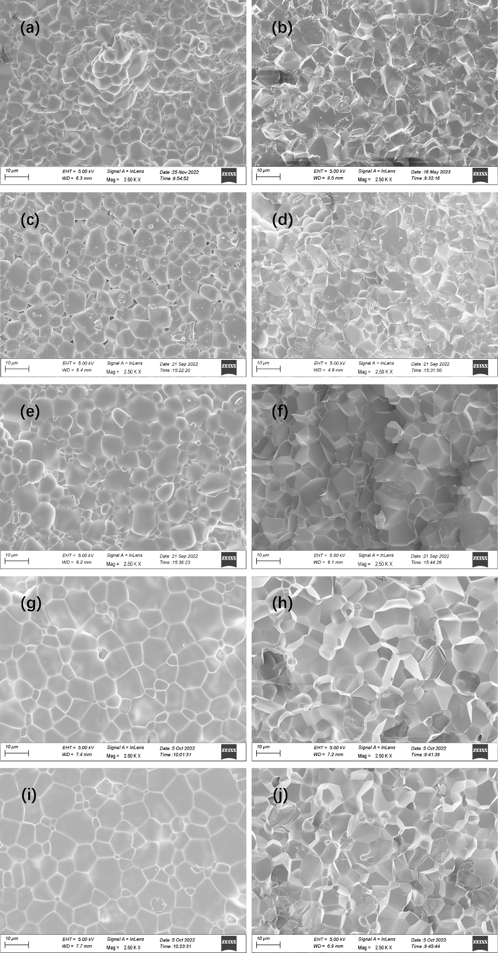
Figure S1. Microstructure obtained from the surface (left column) and cross section (right column) of (a), (b) LNMo₂₀; (c),(d) LNW₄Mo₁₆; (e),(f) LNW₁₀Mo₁₀; (g), (h) LNW₁₆Mo₄; (i), (j) LNW₁₈Mo₂.
Figure S2. XRD patterns of LNW₂Mo₁₈ recorded around 600 °C. The satellite reflections of the modulated structure are marked by the arrows.
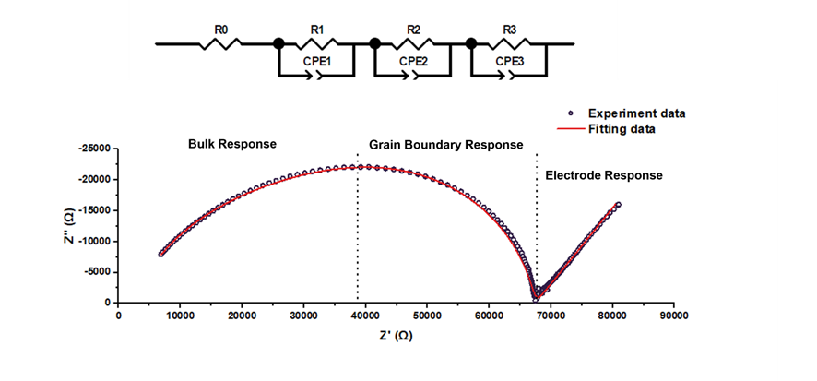
Figure S3. Impedance spectrum of LNMo₂₀ measured at 500 °C. The hollow circles represent the experimental data, and the red line represents the fitting results using the model in the inset.
Figure S4. Conductivities and unit cell volumes of LaNb_{0.8}W_{x}Mo_{0.2-x}O_{4.1} series at around 650 °C, error bars are smaller than the symbols.

Table S1. Refined structural parameters of all samples from Rietveld refinements against XRD data collected at 25 °C.
 | LNMo₂₀ | LNW₂Mo₁₈ | LNW₄Mo₁₆ | LNW₁₀Mo₁₀ | LNW₁₆Mo₄ | LNW₁₈Mo₂ | LNW₂₀
Space group | I 1 2/a 1 | I 1 2/a 1 | I 4₁/a | I 4₁/a | I 4₁/a | I 4₁/a | I 4₁/a
a (Å) | 5.4001(8) | 5.3995(5) | 5.3487(5) | 5.3402(4) | 5.3348(9) | 5.3352(3) | 5.3361(4)
b (Å) | 5.3071(3) | 5.3082(5) | - | - | - | - | -
c (Å) | 11.6460(7) | 11.6455(2) | 11.6647(3) | 11.6881(9) | 11.6973(3) | 11.6943(8) | 11.6897(8)
β (°) | 91.269(1) | 91.182(2) | - | - | - | - | -
V (Å³) | 333.682(9) | 333.711(2) | 333.712(1) | 333.317(2) | 332.904(2) | 332.873(6) | 332.856(9)
R_{wp} (%) | 6.75 | 6.77 | 7.32 | 9.06 | 7.55 | 7.30 | 10.75
χ² | 7.16 | 4.85 | 5.16 | 4.35 | 4.96 | 4.60 | 7.24

Table S2. Refined structural parameters of all samples from Rietveld refinements against XRD data collected at 850 °C.
 | LNMo₂₀ | LNW₂Mo₁₈ | LNW₄Mo₁₆ | LNW₁₀Mo₁₀ | LNW₁₆Mo₄ | LNW₁₈Mo₂ | LNW₂₀
Space group | I 4₁/a | I 4₁/a | I 4₁/a | I 4₁/a | I 4₁/a | I 4₁/a | I 4₁/a
a (Å) | 5.4028(2) | 5.4014(4) | 5.3984(3) | 5.3865(3) | 5.3788(3) | 5.3787(5) | 5.3809(6)
c (Å) | 11.7685(4) | 11.7742(6) | 11.7887(4) | 11.8061(4) | 11.8190(5) | 11.8142(6) | 11.8088(9)
V (Å³) | 343.526(4) | 343.516(8) | 343.552(8) | 342.544(1) | 341.946(6) | 341.798(9) | 341.914(8)
R_{wp} (%) | 5.25 | 8.10 | 6.28 | 6.02 | 7.45 | 8.41 | 10.64
χ² | 5.40 | 5.98 | 4.63 | 4.13 | 5.04 | 5.50 | 7.56

Table S3. Refined structural parameters of all samples from Rietveld refinements against XRD data collected at 650 °C.
 | LNMo₂₀ | LNW₂Mo₁₈ | LNW₄Mo₁₆ | LNW₁₀Mo₁₀ | LNW₁₆Mo₄ | LNW₁₈Mo₂ | LNW₂₀
Space group | I 4₁/a | I 4₁/a | I 4₁/a | I 4₁/a | I 4₁/a | I 4₁/a | I 4₁/a
a (Å) | 5.3882(3) | 5.3883(3) | 5.3841(3) | 5.3722(3) | 5.3658(3) | 5.3672(3) | 5.3679(5)
c (Å) | 11.7385(1) | 11.7416(5) | 11.7577(5) | 11.7776(5) | 11.7877(5) | 11.7857(6) | 11.7792(8)
V (Å³) | 340.796(4) | 340.911(5) | 340.839(5) | 339.912(8) | 339.391(7) | 339.505(2) | 339.407(2)
R_{wp} (%) | 5.44 | 6.26 | 6.72 | 6.12 | 7.62 | 7.46 | 10.64
χ² | 5.63 | 4.64 | 4.91 | 4.19 | 5.17 | 4.88 | 7.36

