**Supporting Information**

**Double positively charged polyamide nanofiltration membrane with PEI/Zr4+ for Cr3+ and** **trimethoprim removal**

Jinqiang Wang 1,2,4, Zhaoyang Su 1, Nigel J. D. Graham 3, Hongkai Liu 1, Kai Sun 4, Wenzheng Yu 1*

1 Key Laboratory of Drinking Water Science and Technology, Research Centre for Eco-Environmental Sciences, Chinese Academy of Sciences, Beijing, China, 100086

2 Center for Environment and Health in Water Source Area of South-to-North Water Diversion, School of Public Health, Hubei University of Medicine, Shiyan, China, 442000

3 Department of Civil and Environmental Engineering, Imperial College London, South Kensington Campus, London SW7 2AZ, UK

4 State Key Laboratory of Urban Water Resource and Environment, School of Environment, Harbin Institute of Technology, Harbin, China, 150001

[wangjinqiangkgs@outlook.com](mailto:wangjinqiangkgs@outlook.com); wangjinqiang@hbmu.edu.cn; [zysu@rcees.ac.cn](mailto:zysu@rcees.ac.cn); [n.graham@imperial.ac.uk](mailto:n.graham@imperial.ac.uk); [liuliu9900@163.com](mailto:liuliu9900@163.com); [ksun@hit.edu.cn](mailto:ksun@hit.edu.cn); [wzyu@rcees.ac.cn](mailto:wzyu@rcees.ac.cn)

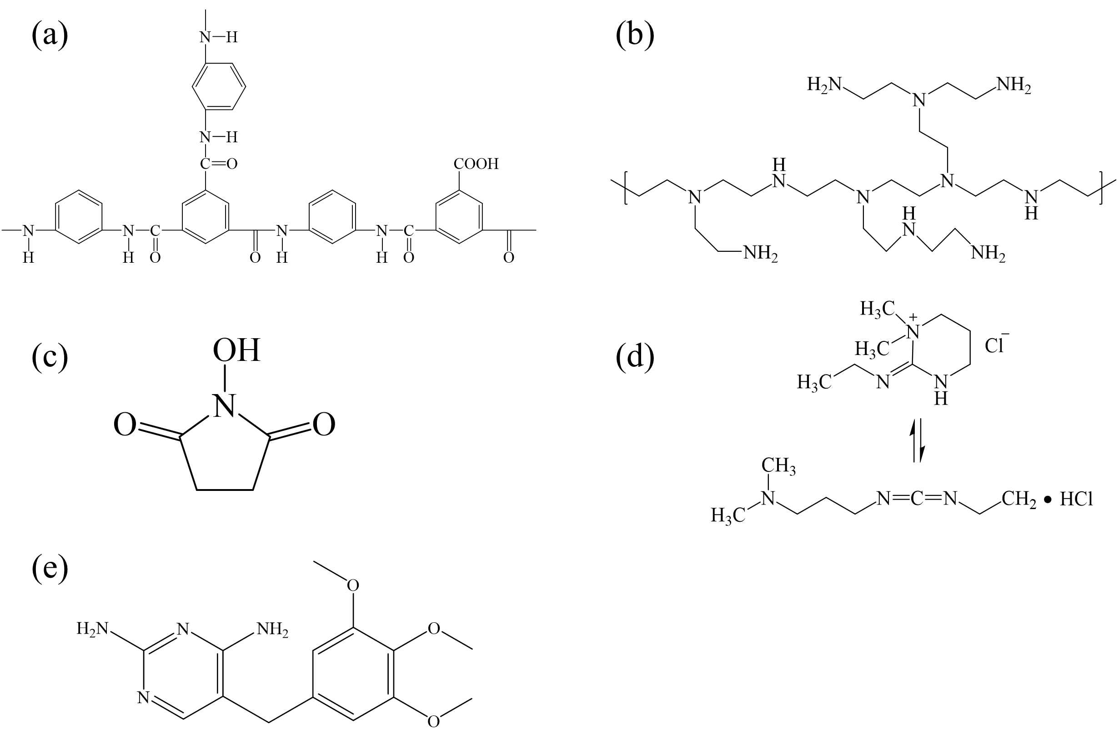

**Figure S1.** Molecular structures of (a) polyamide layer, (b) hyperbranced PEI, (c)NHS, (d) EDC and (e) trimethoprim.

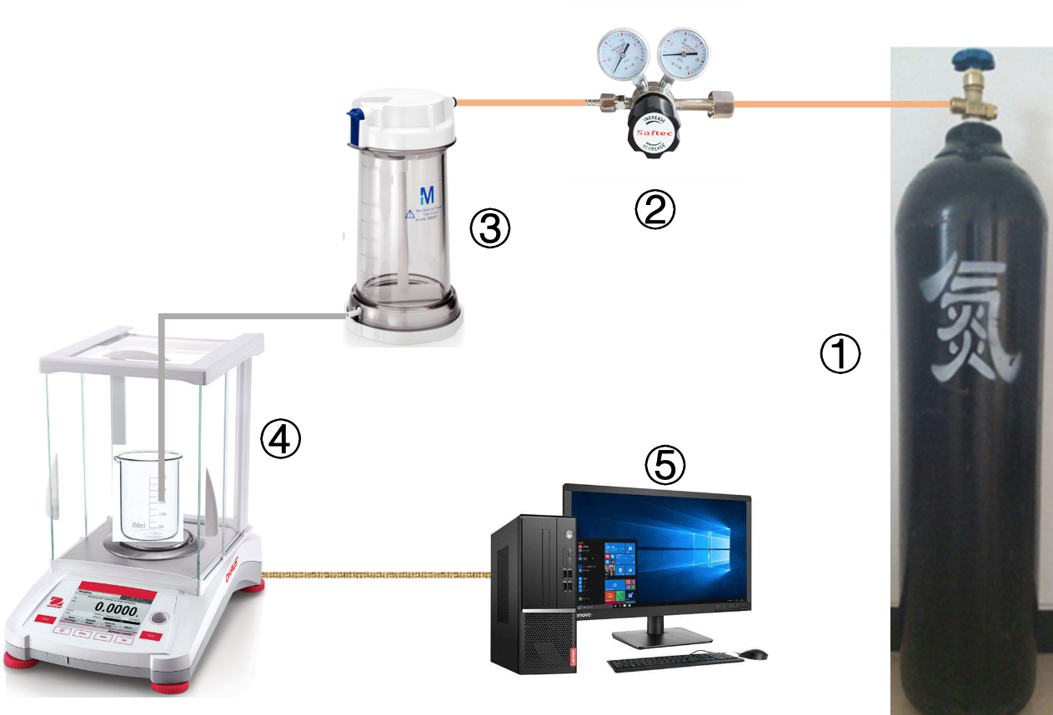**Figure S2.** The real installation of “dead-end” nanofiltration system: ① nitrogen gas cylinder; ② relief value; ③ ultrafiltration cup; ④ electronic balance; ⑤ computer (recording one data per second).

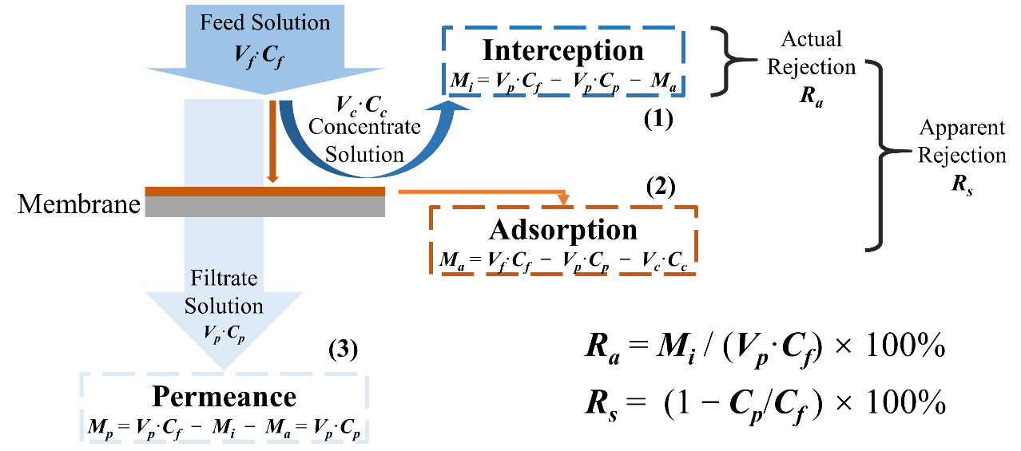

**Figure S3.** The solute in the feed solution is divided into three parts during the filtration process: (1) interception in the concentrate solution (***Mi***, mg); (2) adsorption on the surface of the NF membrane (***Ma***, mg); (3) permeance in the filtrate solution (***Mp***, mg). ***Vf***, ***Vp*** and ***Vc*** are the volume (L) of the feed solution, filtrate solution and concentrate solution, respectively; ***Cf***, ***Cp*** and ***Cc*** are the concentration (mg/L) of the feed solution, filtrate solution and concentrate solution, respectively.

**Table S1** The contents of C, N and O elements and the ratio of elements on the surface of PA, PEI-PA and PEI/Zr4+-PA NF membranes.

|  |  |  |  |  |  |  |  |
| --- | --- | --- | --- | --- | --- | --- | --- |
|  | **Content of Elements (%)** | | | | **Ratio of Elements** | | |
| **C1s** | **N1s** | **O1s** | **Zr3d** | **O/N** | **C/O** | **C/N** |
| **PA** | **69.51** | **9.39** | **20.07** | **0.06** | **2.14** | **3.46** | **7.40** |
| **PEI-PA** | **70.2** | **15.89** | **13.26** | **0.02** | **0.83** | **5.29** | **4.42** |
| **PEI/Zr4+-PA** | **69.7** | **16.98** | **13.13** | **0.19** | **0.77** | **5.31** | **4.10** |