**Double positively charged polyamide nanofiltration membrane with PEI/Zr4+ for Cr3+ and** **trimethoprim removal**

Jinqiang Wang 1,2,4, Zhaoyang Su 1, Nigel J. D. Graham 3, Hongkai Liu 1, Kai Sun 4, Wenzheng Yu 1*

1 Key Laboratory of Drinking Water Science and Technology, Research Centre for Eco-Environmental Sciences, Chinese Academy of Sciences, Beijing, China, 100086

2 Center for Environment and Health in Water Source Area of South-to-North Water Diversion, School of Public Health, Hubei University of Medicine, Shiyan, China, 442000

3 Department of Civil and Environmental Engineering, Imperial College London, South Kensington Campus, London SW7 2AZ, UK

4 State Key Laboratory of Urban Water Resource and Environment, School of Environment, Harbin Institute of Technology, Harbin, China, 150001

[wangjinqiangkgs@outlook.com](mailto:wangjinqiangkgs@outlook.com); wangjinqiang@hbmu.edu.cn; [zysu@rcees.ac.cn](mailto:zysu@rcees.ac.cn); [n.graham@imperial.ac.uk](mailto:n.graham@imperial.ac.uk); [liuliu9900@163.com](mailto:liuliu9900@163.com); [ksun@hit.edu.cn](mailto:ksun@hit.edu.cn); [wzyu@rcees.ac.cn](mailto:wzyu@rcees.ac.cn)

**Abstract**

This paper focuses on the functionalization of double positively charged polyethylenimine (PEI)/Zr4+-polyamide (PA) nanofiltration (NF) membrane by connecting Zr4+ with positively charged PEI-PA NF membrane surface. In particular, the properties of prepared PEI/Zr4+-PA NF membrane, performance on removing aquatic contaminants (Cr3+ and trimethoprim), and its antifouling ability were evaluated in detail. In this regard, zirconium acetate was successfully adopted as the zirconium source for stable membrane surface charge control. Zr4+ loading increased the hydrophilicity of the PEI-PA NF membrane, improved permeate flux, and enhanced the removal behavior of PEI/Zr4+-PA NF membrane especially when exposed to Cr3+ and trimethoprim at high concentrations. Furthermore, effectiveness of PEI/Zr4+-PA NF membrane was not affected by high filtering degree, filtration cycle, and negatively charged macromolecules, such as bovine serum albumin (BSA). Also, antifouling ability of PEI/Zr4+-PA NF membrane could be further improved by continuously loading Zr4+.

**Keywords:** Polyethylenimine; Zirconium tetravalent ion (Zr4+); Nanofiltration; Membrane fouling; Chromium trivalent ion (Cr3+); Trimethoprim

**1. Introduction**

NF is a kind of pressure-driven separation technique between reverse osmosis and ultrafiltration [1-5]. Due to its low energy consumption and high water flux, NF has a broad application prospect in the precise separation of small molecular substances (200‒1000 Da) [6-8]. In general, in addition to electromigration, the separation mechanism of NF membranes depends on the size-sieving and Donnan exclusion effects [9-14]. When nanochannel diameter of NF membrane is larger than molecular size of the solute in feed, an electrostatic-repulsion force between charged membrane wall and charged solute plays a dominant role in separation process [15, 16]. Therefore, in the past decades, charged NF membranes have become one of the most attractive and competitive choices for separating small molecules [17-20].

Until now, the majority of commercial NF membranes on the market are rich in carboxyl groups with negative charge [21-23], fabricated via interfacial polymerization, i.e. active layer formation on the surface of NF membranes. As one of the most important NF membranes, PA NF membrane is effective in removing negatively-charged macromolecules and multivalent anions [12, 24-26]. In this way, this negatively-charged property limits its application in water softening and removal of positively-charged contaminants (e.g. cationic dyes, heavy metal ions and antibiotics) [27]. Consequently, to develop positively-charged NF membranes is highly desired.

PEI, a kind of high molecular polymer with abundant reactive amine groups, has been widely used as a modifier with positive charge [28-32]. Especially, PEI has been successfully adopted for preparing positively-charged functionalized NF membrane [33-36] or changing the charge of commercial NF membrane to the positive [37-39]. Of course, heavy metal ions, a group of substances with plentiful positive charge, are easily chelated by amine group of PEI. For example, PEI and heavy metal ions (such as Ag+, Fe3+, Co2+ and Zn2+) were employed for preparing chelation-induced active layer on the surface of hydrolyzed polyacrylonitrile (PAN) membrane, showing excellent dye desalination performance [40-44]. Heavy metal ions can not only occupy the chelating site of PEI, which is expected to prevent the adsorption of PEI to other substances and thus reduce the membrane fouling, but also increase permeate flux of membrane owing to the hydrophilia of metal ions. Therefore, the chelation of PEI with heavy metal ions, namely as chelation-induced self-assembly, has gradually become a promising technique.

A tetravalent cation, Zr4+ is also an excellent positive charge modifier [45, 46]. Here, the aim of this work is to prepare a double positively-charged PA NF membrane by grafting with PEI and Zr4+ in sequence. Specifically, PEI was firstly grafted onto the surface of negatively-charged PA NF membrane by amide reaction. Then Zr4+ was chelated by PEI when the PEI-PA NF membrane was immersed into the Zr4+-containing solution. We selected Cr3+ and trimethoprim (TMP) as two representative pollutants of heavy metal ions and positively charged antibiotics separately. The potential of additional Zr4+ loading is also expected to have an ability to further improve the rejection performance of positively-charged PA NF membrane on some positively-charged contaminants, to increase permeate flux, and to reduce membrane fouling.

**2. Experimental**

**2.1. Chemicals**

Commercial aromatic polyamide nanofiltration (PA NF) membranes (Beijing Separate Equipment Co., Ltd, China) were used as this experimental study of membranes. Hyperbranched polyethylenimine (PEI, Mw = 70,000 g/mol, 50 w.t. %, Aladdin, Shanghai, China) were used as the modifying agents. N-Hydroxysuccinimide (NHS, 98 w.t. %, Aladdin, Shanghai, China) and N-(3-Dimethylaminopropyl)-N'-ethylcarbodiimide hydrochloride (EDC, 98 w.t. %, Aladdin, Shanghai, China) were used as the carboxyl activators. Chromium (III) nitrate nonahydrate (Cr(NO3)3·9 H2O，AR) and trimethoprim (AR) were purchased from Aladdin (Shanghai, China). Zirconium (IV) tetrachloride (ZrCl4, 98 w.t. %, OKA, Beijing, China) and zirconium (IV) acetate (Zr(CH3COOH)4, 15.0 ~ 16.0 w.t. %, Alladin, Shanghai, China) were used as two selective sources of zirconium ions. Bovine serum albumin (BSA, 98 w.t. %) and TMP (98 w.t. %) were purchased from sigma-aldrich (USA). All chemicals were used as received without further purification unless otherwise specified. The molecular structures of the polyamide layer, PEI, NHS, EDC and trimethoprim were shown in Figure S1.

**2.2. Membrane fabrication**

All the PA NF membranes were immersed in the pure water at least two days to remove the residual protective agents. Although the membranes used in this paper were commercial NF membranes, it could be not guaranteed that each part of the membrane was uniform. The pure water flux of each membrane with a diameter of 7.6 cm need to be test and the NF membranes with similar pure water flux were placed in one group for the filtration experiment. The NF membranes grouped according to the pure water flux were modified in two steps to form a double positive-functional membrane.

Firstly, the PEI modification of PA NF membranes in our previous work were as follows [15]. The PA NF membranes were dipped in 30 mL mix water solution of 0.45 g EDC and 0.09 g NHS for 1 hour at room temperature. Then the carboxyl-activated PA NF membranes were washed with DI water at least three times and immersed the 1 w.t. % PEI water solution for 4 hours at room temperature. The activated carboxyl on the PA NF membrane surface could be easily reacted with amino in the PEI molecule and the positive charged PA NF membrane (named as PEI-PA NF membrane) was obtained.

Secondly, the PEI-PA membrane were immersed in the Zr4+ water solution for 20 min at room temperature. The modification procedure of double positive-functionalized PA NF membrane (named as PEI/Zr4+-PA NF membrane) was shown in Figure 1. It was also worth mentioning that the zirconium (IV) tetrachloride hydrolyzed to produce large amounts of hydrogen chloride and the ZrCl4 water solution needed to boil for an hour in order to remove the hydrogen chloride before loading Zr4+ on the surface of PEI-PA NF membrane.

**2.3. Characterization**

The surface elements analysis of membranes was detected by X-ray photoelectron spectroscopy (XPS) (ESCALAB 250 Xi, Thermo Fisher, UK) and the water contact angles (WCAs) of the membranes were performed by a contact angle goniometer (OCA 15 EC, Dataphysics, Germany). The zeta potentials of liquid samples were measured with a Zetasizer Nano analyzer (ZS 90, Malvern, UK) and the surface zeta potentials of solid membranes were measured with a surface zeta potential analyzer (Sur Pass 3, Anton Paar, Austria). The fourier transform infrared spectra (FTIR) were measured by the FTIR spectroscopy (NICOLET 8700, Thermal, USA, with the ATR accessory) after the membrane samples had been dried in the drying oven at 35℃. The trimethoprim concentrations were detected and analyzed by the UV-vis analyzer (UV-2600, Shimadzu, Japan). The concentrations of heavy metal ions were analyzed by inductively coupled plasma-optical emission spectroscopy (ICP-OES) (Optima 8300, Perkinelmer, USA).

**2.4. NF performance**

A lab-scale “dead-end” flow cell (8500, Millipore, USA) was used for determining the water flux of membranes (***J***, L·m−2·h−1·MPa−1) and the rejections (***Rs***, %) of heavy metal ions and trimethoprim. The effective diameter of membranes in the flow cell was 7.8 cm and all the filtration experiments were carried out at room temperature under 0.4 MPa unless otherwise specified. An electronic balance (AX523ZH, Ohaus, USA) was used for recording the mass of flow continuously. All sections of the “dead-end” filtration system was shown in Figure S2.

The flux of pure water and feed solution (***J***, L·m−2·h−1·MPa−1) were determined by using Eq. (1) [47]:

***J*** = ***V***/ (***A*** · ***t*** · ***P***) (1)

where ***V*** represents the volume of permeate (L), ***A*** is the effective membrane area (m2), ***t*** is the permeation time (h) and ***P*** is the applied pressure (MPa). All the densities of pure water, feed solution, filtrate solution and concentrate solution were assumed to be 1 g/mL in all cases.

The feed solution rejection (***Rs***, %) was calculated by using Eq. (2) [48]:

***Rs*** = (1 – ***Cp***/***Cf*** ) × 100 % (2)

where ***Cp*** and ***Cf*** represent the concentrations (mg/L) of filtrate solution and feed solution, respectively.

In a previous study [15], the ***Rs*** was referred to as the apparent rejection. Correspondingly, we also define a parameter of ***Ra*** (%) as the actual rejection. The ***Rs*** and ***Ra*** are explained in detail as follows:

During the filtration process, the solute in the feed solution is divided into three part (Figure S3). The first part of solute can pass through the nanofiltration membrane into the filtrate; the second part of solute can be adsorbed on the surface of nanofiltration membrane by physical or chemical adsorption; and the third part of solute will be rejected by the charge repulsion on the membrane or by the size effect of nanochannel in the membrane and will remain in the concentrate. These three parts of the solute in this study are respectively referred to as the permeance (***Mp***, mg), adsorption (***Ma***, mg) and interception (***Mi***, mg). The ***Ma***, ***Mi*** and ***Mp*** were calculated by using the Eqs. (3) ~ (5), respectively [15].

***Ma***=***Vf***·***Cf***－***Vp***·***Cp***－***Vc***·***Cc*** (3)

***Mi***=***Vp***·***Cf***－***Vp***·***Cp***－***Ma*** (4)

***Mp***=***Vp***·***Cf***－***Mi***－***Ma***=***Vp***·***Cp*** (5)

where ***Vf***, ***Vp***, ***Vc***represent the volume (L) of total feed solution, permeate solution and concentrated solution; ***Cf***, ***Cp***, ***Cc*** represent the solute concentration (mg/L) of the feed, permeate and concentrated solutions, respectively. As the mode of filtration was ‘dead-end’, the volume ratio of permeate and concentrate was 1:1 unless otherwise specified. In addition, the densities of pure water and all solute solutions were assumed to be 1 g/mL in all cases.

The sum of ***Ma*** and ***Mi*** can reflect all the ability of the nanofiltration to reject the solutes in the feed liquid. Hence, the ratio of the sum of ***Ma*** and ***Mi*** to the original solute content in the filtrate is the rejection of the nanofiltration membrane to the solute, namely the apparent rejection (***Rs***, %). While the ***Mi*** can only reflect the ability of the nanofiltration membrane to reject solutes by its own nanachannel size effect and surface charge force. The ratio of the ***Mi*** to the original solute content in the filtrate is the rejection of nanofiltration membrane to the solute without considering its adsorption on solute, namely as the actual rejection (***Ra***, %). The value of ***Ra*** can represent the ability of nanofiltration membrane to reject solute by electrostatic repulsion. The ***Rs*** and ***Ra*** were calculated by Eq. (6) and Eq. (7), respectively and the relevant data meanings in Eq. (6) and Eq. (7) has been shown above[15].

***Rs***=(***Mi***+***Ma***)/(***Vp***·***Cf***)×100 %

=(***Vp***·***Cf***－***Vp***·***Cp***)/(***Vp***·***Cf***)×100 %

=(1–***Cp***/***Cf***)×100 % (6)

***Ra***=***Mi***/(***Vp***·***Cf***)×100 % (7)

**2.5. The effect of BSA on the NF membrane performance**

In previous study [15], 5 mg/L humic acid (HA) solution was used as a simulation solution of negatively charged substances in water to study the effect of negatively charged substances on the rejection performance of positively charged PEI-PA NF membrane on positively charged copper (II) ions . In this study, 5 mg/L bovis serum albumin (BSA) substituted for HA was used as a simulation solution of negative charge substances in water. The initial PA NF membrane, PEI-PA NF membrane and PEI/Zr4+-PA NF membrane were used to filter 5 mg/L Cr3+ feed solution by three different methods, respectively. The effects of negatively charged substance of BSA on the Cr3+ rejection of three kinds of membranes were measured. The three filter methods were as follows: (1) the three kinds of NF membranes filtrated the 5 mg/L BSA solution before filtrating 5 mg/L Cr3+ solution (marked as "BSA*Cr"); (2) the three kinds of NF membranes filtrated only 5 mg/L of Cr3+ (marked as "Cr"); (3) the three kinds of NF membranes filtrated a mixture solution of 5 mg/L Cr3+ and 5 mg/L BSA (marked as "BSA+Cr").

**3. Results and discussion**

**3.1. Characterization of PEI/Zr4+-PA NF membranes**

A schematic diagram of PEI/Zr4+ double positively charged functionalization modification of PA NF (polyamide nanofiltration) membrane was shown in Figure 1. The PA NF membrane was divided into two sections of substrate and PA active layer. The substrate supported the membrane, and made the PA NF membrane had a certain mechanical strength. There were abundant nanoscale water channels in the PA active layer, which were used for screening and rejecting the solute. Moreover, there were plentiful carboxyl groups on the surface of the PA active layer, which could ionize into negatively charged carboxyl groups in the water environment so that the PA active layer was rich in a large number of negative charges. After the carboxyl groups on the surface of the PA active layer were activated by EDC/NHS, the amine groups in PEI molecules were easy to undergo the amide reaction of dehydration condensation with the carboxyl groups. The amine groups of PEI and the carboxyl groups of PA were consumed at the same time, which reduced the content of negative charge on the surface of PA NF membrane. In addition, the excess amine groups in PEI molecule were positively charged at a neutral pH value. The combined action of these two factors transformed the negative charge on the surface of PA NF membrane into positive charge. Then, the PEI-modified PA NF membrane was placed in Zr4+ solution. The Zr4+ ions would be loaded on the surface of PEI-PA NF membrane in three ways shown in the Figure 1. One was that the Zr4+ ions bind to the positive charged amino groups through coordination bonds. The other was that the Zr4+ ions were absorbed on the negative charged carboxyl through electrostatic attraction. And the third way was the result of both coordination bonds and electrostatic attraction. The second loaded Zr4+ increased the thickness of the positive charge functional layer on the surface of PA NF membrane. The increase of the thickness of the positive charge functional layer contributed to improve the rejection performance of PA NF membrane for positively charged contaminant.

In order to obtain the changes of surface chemical composition of PA NF membrane before and after modification, XPS test was necessary and the XPS results were shown in Figure 2. The Figure 2 (a) presented the total XPS spectra of PA, PEI-PA and PEI/Zr4+-PA NF membrane, and the peak of Zr3d for PEI/Zr4+-PA NF membrane at 180 ~ 185 eV was clearly obvious. The Figure 2 (b) was the magnified figure of peak of Zr3d at the range of 170 ~ 190 eV. The content and ration of elements on the surface of three kinds of NF membranes were list in the Table S1. The contents of C, N and O elements on the PA NF membrane were 69.51 %, 9.39 % and 20.07 %, respectively. After modified with PEI, the content of N element increased from 9.39 % to 15.89 % because of the enrich N elements in the PEI molecules. Correspondingly, the O/N and C/N ratios decreased from 2.14 and 7.40 to 0.83 and 4.42. And the PEI molecules lacked of O elements but was rich in C element, so the C/O ratio increased from 3.46 to 5.29. When the Zr4+ was secondary loaded on the surface of PEI-PA NF membrane, there was no significant change in either the content of C, N and O elements or the O/N, C/O and C/N ratios of elements, but the content of Zr element increased to 0.19 %. The peak of Zr3d and the content of Zr element indicated that the Zr4+ was successfully loaded on the surface of PEI-PA NF membrane.

In the process of loading PEI and Zr4+ on the surface of PA NF membrane, there was always only one kind of N element (N-C) on the surface of PA NF membrane, so only peak separation fitting processing was carried out for the peak positions of C element and O element. The relevant results were shown in Figure 2 (c) ~ (e) (C element) and Figure 2 (f) ~ (h) (O element), respectively. The peak of C1s could be separated into three peeks of 287.2 eV, 285.5 eV and 284.4 eV, which were assigned to C=O, C-N and C-C. The peak of O1s could be separated into two peeks of 531.9 eV and 530.5 eV, which were assigned to O-H and O=C. The contents of C=O, C-N, C-C, O-H and O=C were list in the Table 1. Before modification with PEI, the contents of C=O, C-N, C-C, O-H and O=C on the surface of PA NF membrane were 16.27 %, 23.12 %, 60.61 %, 55.67 % and 44.43 %, respectively. When the PA NF membrane was modified with PEI, the amine groups in the PEI molecule would undergo an amide reaction with the carboxyl group on the surface of PA NF membrane. In this process, abundant of C-N was produced and O-H was rapidly consumed by the amide reaction. Therefore, the C-N of PEI-PA NF membrane increased from 23.12 % to 36.74 %, and the O-H of PEI-PA NF membrane decreased sharply from 55.67 % to 18.34 %. After loaded with Zr4+, the content of O-H on the surface of PEI/Zr4+-PA NF membrane increased from 18.34 % to 20.91 %, which might be attributed to the zirconium source of zirconium acetate containing plentiful O-H.

In this article, zirconium acetate and zirconium chloride were selected as two zirconium sources of Zr4+. Both of the two zirconium ion solutions need to be boiled before use to remove other acidic substances generated by hydrolysis of Zr4+. After the two kinds of Zr4+ were loaded on the PEI-PA NF membranes, the PEI/Zr4+-PA NF membranes were washed with pure water and placed in the ultrafiltration cup to continue filtering the pure water and removing the residual Zr4+ left in the nanochannel of the PEI/Zr4+-PA NF membranes until no Zr4+ could be detected in the filtrate. The zeta potentials on the surface of the two PEI/Zr4+-PA NF membranes were then measured and compared with the results of the initial PA NF membrane and the PEI-PA NF membrane, as shown in Figure 3 (a). It could be seen from the figure that the surface zeta potentials of the initial PA NF membrane and PEI-PA NF membrane were - 54 mV and + 30.16 mV, respectively. After the zirconium acetate was reloaded onto the surface of PEI-PA membrane, the surface zeta potential of the PEI/Zr4+-PA membrane was + 28.11 mV, which was only a slightly lower than that of the PEI-PA NF membrane. However, the surface zeta potential of the PEI/Zr4+-PA NF membrane decreased significantly after the secondary loading of zirconium chloride to the surface of PEI-PA NF membrane and reached + 16.89 mV. The reasons for this might be that: (1) The two zirconium sources contain acetate ions and chloride ions, respectively. The acetate ions and chloride ions could be loaded onto the surface of the PEI-PA NF membrane together with the Zr4+. These two negatively charged groups surrounded the zirconium ions, forming a double electric layer with positive and negative charges. The side of the double electric layer near the water phase was abundant of negatively charged acetate ions and chloride ions, which made the measured zeta potentials decreased. At the same time, the hydrophilicity of chloride ions was much greater than that of acetate ions. The chloride ions tended to be much closer to the water phase side than acetate ions, which made the zeta potential on the surface of PEI/Zr4+-PA NF membrane by use of zirconium chloride decreased more greatly. (2) Zirconium acetate and zirconium chloride could undergo hydrolysis, and the pH value of the solution after hydrolysis of zirconium chloride was lower than that of zirconium acetate. The lower pH value made the adsorbed PEI molecules on the surface of PA NF membrane by physical adsorption more positively charged, which increased the repulsive force between PEI molecules and contributed the PEI molecules much more easily washed away by water, thus reducing the positive charge on the surface of PA NF membrane modified with PEI and Zr4+. In conclusion, zirconium acetate was a better source of Zr4+ than zirconium chloride, and subsequent experiments in this research would use zirconium acetate as the source of Zr4+. It was worth mentioning that the acetate ions in zirconium acetate also had a strong chelating ability to heavy metal ions. In the filtration solution of heavy metal ions, the rejection performance of PEI/Zr4+-PA NF membrane for heavy metal ions might be enhanced due to the "capture" ability of acetate ions for heavy metal ions.

The hydrophilicity of membrane is one of the most important properties of NF membranes. Figure 3 (b) showed the dynamic water contact angles of four kinds of NF membranes within 180 seconds. The four NF membranes were the initial PA NF membrane ("PA"), the PA NF membrane modified with PEI 70,000 ("PEI-PA"), the PA NF membrane modified with PEI and Zr4+ ("PEI/Zr4+-PA") and the PA NF membrane exposed only to zirconium ions ("Zr4+-PA"). The water contact angles at the initial moment of "PA" NF membrane was about 38°. With time increasing, the water contact angles decreased gradually, and the water contact angle decreased quickly in the initial stage and slowly in the later stage. The results indicated that the surface of "PA" NF membrane was well hydrophilic and the water droplets could spread quickly on the membrane surface. After modified with PEI 70,000, although PEI with high molecular weight also contained hydrophilic amine group, most of its molecular chain structure was hydrophobic carbon chain, and the PEI with high molecular weight covered the water channel in the NF membrane, which hindered the speed of water molecules entering the water channel. Therefore, the initial water contact angles of "PEI-PA" NF membrane was relatively large and reached about 60°, and the water contact angles decreased slowly. When PEI and Zr4+ were loaded on the surface of PA NF membrane at the same time, as mentioned above, PEI 70,000 captured zirconium ions and zirconium ions were hydrophilic. Therefore, compared with "PEI-PA" NF membrane, the water contact angles of "PEI/Zr4+-PA" NF membrane was about 40° at the initial moment and decreased to a greater extent. The downward trend was fast in the early period and slow in the later period. The dynamic water contact angles of "Zr4+-PA" NF membrane was identical with that of "PEI/Zr4+-PA" NF membrane, which indicated that the carboxyl group on the surface of PA NF membrane could also capture zirconium ions. However, the spatial position of the acetate ions around the zirconium ion was in the form of the carboxyl groups pointing towards the zirconium ion and the methyl groups pointing outwards, in other words, the closest to the water phase was the hydrophobic methyl group. Therefore, compared with "PA" NF membrane, the dynamic contact angles of "Zr4+-PA" NF membrane increased slightly.

In order to more accurately understand the influence of PEI/Zr4+ double modification on the pure water flux of PA NF membrane, twelve PA NF membranes were specially selected as the research objects, as shown in Figure 3 (c). Before the experiment, the pure water flux of twelve initial PA NF membranes was measured. The PA NF membranes were arranged in order of pure water flux from large to small and were numbered "01" to "12". The twelve PA NF membranes were divided into three groups according to the pure water flux. The first membrane in each group was modified with nothing as a blank control sample, the second membrane in each group was only modified with PEI 70,000. The third and fourth membranes in each group were modified with PEI and Zr4+ at the same time. Then the pure water flux of each membrane before and after modification was tested. As could be seen from Figure 2 (c), the maximum and minimum pure water flux of the twelve initial PA NF membranes were 88.5 L/(m2·h·MPa) and 81.2 L/(m2·h·MPa). Even for the same batch and the same large group, the maximum pure water flux of the initial PA NF membrane was about 9.0 % higher than the minimum value. Because the difference of water flux between the initial PA NF membranes could be so large, all the experiments in this research needed to test the initial pure water flux of each PA NF membrane, and grouped several PA NF membranes whose pure water flux were close to each other into a group, so as to reduce the systematic error in the experiments as much as possible. The maximum and minimum values of pure water flux were 66.3 L/(m2·h·MPa) and 62.6 L/(m2·h·MPa) after PEI modification on nine of twelve PA NF membranes. Compared with the initial PA NF membrane, the decreased percentages of pure water flux of nine PEI-PA NF membranes were 19 % ~ 28 %. The main reason for the decrease of pure water flux was that the macromolecules of PEI covered the surface of PA NF membranes and reduced the effective pore size of water channel. Another possible reason for the decrease of pure water flux was that the thickness of functional layer of PA NF membrane was theoretically increased after modified with PEI. Six of the nine PEI-PA NF membranes were loaded with Zr4+, and the maximum and minimum values of pure water flux were 75.6 L/(m2·h·MPa) and 71.6 L/(m2·h·MPa). Compared with PEI-PA NF membranes, the increased percentages of pure water flux of six PEI/Zr4+-PA NF membranes were 12 % ~ 15 %. The main reason for the increase of pure water flux was that after loading Zr4+, not only Zr4+ increased the hydrophilicity on the surface of PA NF membranes, but also the acidic Zr4+ solution cleaned PEI deposited on the surface of PA NF membranes, which reduced the degree of blocking of PA NF membranes water channel by PEI. In conclusion, the continuous loading of zirconium acetate on the surface of PEI-PA NF membrane was helpful to improve the pure water flux of positively charged functionalization PA NF membrane.

The Figure 3 (d) showed the FTIR spectra of PA, PEI-PA, Zr4+-PA and PEI/Zr4+-PA NF membranes. The peak of 1680 cm-1 was attributed to the amide group and the 3500 cm-1 was attributed to the N-H or O-H. It could be seen from the Figure 2 (d) that no matter what process the surface of PA NF membrane had undergone, there was no significant difference between the two peaks of 1680 cm-1 and 3500 cm-1. The FTIR results were identical to those of previous studies [15] and showed the contents of PEI and Zr4+ loaded on the surface of PA NF membrane were extremely low, which could not be detected by FTIR.

**3.2. Rejection performance for Cr3+**

Figure 4 (a) ~ (c) and (d) ~ (e) showed the removal results of 1 mg/L Cr3+ and 10 mg/L Cr3+ by the initial PA NF membrane, PEI-PA NF membrane and the PEI/Zr4+-PA NF membrane, respectively. By comparing the Figure 4 (a) and (d), when the concentration of feed solution was relatively low (1 mg/L), the Cr3+ concentrations in the filtrate by filtering with PA, PEI-PA and PEI/Zr4+-PA NF membranes gradually decreased, while the Cr3+ concentration in concentrate by filtering with PEI-PA NF membrane was the largest. When the concentration of feed solution was relatively high (10 mg/L), the Cr3+ concentration in filtrate also showed a downward trend. Different from filtering the low concentration feed solution, the Cr3+ concentration in filtrate by filtering with initial PA NF membrane was much higher than that of by filtering with the latter two kinds of PA NF membranes modified with PEI and PEI/Zr4+, while the Cr3+ concentrations in the concentrate showed a gradually increasing trend. The Cr3+ rejections calculated based on filtrate and concentrate concentrations were shown in Figure 4 (b) and (e). It could be seen from the two figures that the initial PA NF membrane also had a higher apparent rejection (~ 75 %) for low concentration of Cr3+ feed solution, and the PA NF membranes modified with PEI and PEI/Zr4+ had a certain improvement in apparent rejection for low concentration of Cr3+ feed solution. However, the initial PA NF membrane had a low apparent rejection for high concentration of Cr3+ feed solution, which only reached about 40 %. The PA NF membrane modified with PEI and PEI/Zr4+ had a significant increase in the apparent rejection for high concentration of Cr3+ feed solution, and the apparent rejection of Cr3+ reached the level of filtering the low concentration feed solution. These results indicated that the initial PA NF membrane had a low ability to remove high concentration of Cr3+, while the PA NF membranes modified with PEI and PEI/Zr4+ had a high ability to remove low and high concentration of Cr3+, and the secondary load of Zr4+ could continue to improve the performance of PA NF membrane to intercept high concentration of Cr3+.

For the filtration results of feed solution with different concentrations, another noteworthy phenomenon was that the actual rejection of PEI-PA NF membrane for low concentration Cr3+ was the highest and reached about 70 %. While the actual rejection of PEI/Zr4+-PA membrane for high concentration of Cr3+ was the highest and reached about 84 %, which was only slightly lower than the apparent rejection of 88 %. The differences in the actual rejections of the three kinds of PA NF membranes for the feed solutions with different concentrations of Cr3+ could be analyzed from the three directions of Cr3+, as shown in Figure 4 (c) and (e). When the concentration of feed solution was low, both the carboxyl on the surface of the initial PA NF membrane and the acetate ions around the zirconium ions had strong chelating ability to Cr3+, and the PEI molecules had a weak ability to adsorb Cr3+ due to its own positive charged amine groups and the speed of saturated adsorption might be slower. Therefore, the adsorption proportion of Cr3+ on the surface of PEI-PA NF membrane was relatively low and the higher rejection of PEI-PA NF membrane for Cr3+ was due to its positive repulsive force for Cr3+ and water channel aperture, which made the actual rejection of PEI-PA NF membrane to low concentration of Cr3+ feed solution was the highest. For the high concentration of Cr3+ feed solution, as the filtration process gone on, the concentration of Cr3+ in the concentrate became higher and higher, and the content of Cr3+ on the surface of three kinds of PA NF membranes rapidly exceeded the Cr3+ adsorption capacity of carboxyl and acetate ions (that was, the surface of all the three kinds of PA NF membrane could quickly reach the maximum adsorption capacity to Cr3+). Therefore, the excessive Cr3+ either passed through the NF membrane or was rejected by the NF membranes. The water channel aperture of the initial PA NF membrane was larger and lacked of rejection performance for Cr3+. Much more Cr3+ penetrated the PA NF membrane and went into the filtrate. However, the PEI and PEI/Zr4+ modification could enhance the surface positive charged performance of PA NF membrane and reduce the effective pore size of water channel, which improved the Cr3+ rejection ability. Therefore, much more Cr3+ was rejected and remained in the concentrate. As mentioned above, the PEI content on the surface of PEI/Zr4+-PA NF membrane was lower than that of unloaded Zr4+, and the reduction of PEI content meant that the adsorption capacity of high-concentration Cr3+ was also reduced. The adsorption capacity and permeance of Cr3+ decreased at the same time, corresponding to the increase of Cr3+ rejection, that was, the PEI-PA and PEI/Zr4+-PA membranes for high concentration of Cr3+ had the highest actual rejection.

Figure 5 showed the dynamic water contact angles of the three kinds of PA NF membranes after filtration of pure water, low and high concentration of Cr3+. It could be seen that no matter whether PA NF membrane was modified or not, the dynamic water contact angles after the filtration of Cr3+ varied from 30° to 40°, and the dynamic water contact angles for the filtration of high concentration Cr3+ was slightly lower than that for the filtration of low concentration Cr3+. This was because the surface of three kinds of PA NF membranes could absorb the hydrophilic Cr3+, and the Cr3+ had a great influence on the dynamic water contact angles, so that the water contact angles on the surface of PA NF membranes were determined by the hydrophilic Cr3+. When high concentration of Cr3+ was filtered, more content of Cr3+ was adsorbed and deposited on the surface of PA NF membranes, so the measured dynamic water contact angles were lower than that of filtering the low concentration of Cr3+.

Figure 6 showed the effect of filtrate volume percentage on the rejection of Cr3+ with different concentrations by PEI/Zr4+-PA NF membrane. The feed solution concentrations in Figure 6 (a) ~ (c) and (d) ~ (f) were 1 mg/L and 10 mg/L, respectively. By comparing Figure 6 (a) and (d), it could be seen that for both low and high concentration of feed solutions, the concentration of filtrate increased slightly with the increase of the filtrate volume percentage, and the concentration of concentrate also increased with the increase of the filtrate volume percentage, and the increase of concentrate concentration was far greater than that of filtrate concentration. Figure 6 (b) showed that when the feed solution concentration was low (1 mg/L), the apparent rejections of Cr3+ for all filtrate volume percentages were about 90 %, with almost no difference; the actual rejections of Cr3+ for all filtrate volume percentages were also greater than 60 %. Although the actual rejections of Cr3+ fluctuated, the overall trend was relatively stable. The results in Figure 6 (e) were slightly different from those in Figure 6 (b). When the feed solution concentration was high (10 mg/L), the apparent rejection of Cr3+ gradually decreased from 88 % to 75 % with the increase of the filtrate volume percentage, and the actual rejection of Cr3+ also presented a downward trend on the whole, from the maximum value of 84 % to 57 %. Three locations of Cr3+ were analyzed, and the results were shown in Figure 6 (c) and (f). When the feed solution concentration was low, with the gradual increase of filtration degree, all the percentages of adsorbed Cr3+, intercepted Cr3+ and permeated Cr3+ were relatively stable, which made both the apparent rejection and actual rejection of Cr3+ remained stable. However, when the feed solution concentration was high, it could be seen that the percentage of adsorbed Cr3+ and permeated Cr3+ presented an increasing trend on the whole, so that the percentage of intercepted Cr3+ decreased with the increase of filtration degree, and then the actual rejection of Cr3+ decreased on the whole. The above results could be explained as follows: the concentration of Cr3+ in the concentrate did not exceed the adsorption capacity and rejection ability of the PEI/Zr4+-PA NF membrane for Cr3+, even though the filtration degree of the low concentration of feed solution was large, so that the apparent and actual rejection of Cr3+ could remain at a high and stable level. When feed liquid concentration was higher, the concentration of enriched Cr3+ in the concentrate increased rapidly with the increase of filtration degree. The resulting concentration polarization effect of Cr3+ gradually made the Cr3+ overcome the positive repulsive force on the surface of the modified PA NF membranes and entered into the filtrate, eventually making the apparent rejection and the actual rejection of Cr3+ decline trends as a whole. In conclusion, even if the filtration degree of feed solution was up to 90 %, there was still no significant decline in the Cr3+ rejection performance of PEI/Zr4+-PA NF membrane. This result was of great significance in practical application.

The effect of multiple and repeated filtration on the Cr3+ rejection performance was also an important research content of the PA NF membrane modified by PEI/Zr4+ double positive charge functionalization. Figure 7 was the result of repeated filtration of feed solution by PEI/Zr4+-PA membrane for ten cycles. The feed solution concentration of (a) ~ (c) was 1 mg/L, and the feed solution concentration of (d) ~ (f) was 10 mg/L. The treatment method of "∞" sample in the Figure 7 was as follows: PEI/Zr4+-PA NF membrane was immersed in a high concentration of Cr3+ solution (5 g/L). After the Cr3+ was adsorbed and saturated by the membrane, the PEI/Zr4+-PA NF membrane was washed with pure water and then was placed in a ultrafiltration cup to filter pure water with continuous cleaning until the concentration of Cr3+ detected in the filtrate was below 0.01 mg/L. As could be seen from Figure 7 (a) ~ (c), when the feed solution concentration was low (1 mg/L), the apparent rejection of PEI/Zr4+-PA NF membrane for Cr3+ was relatively stable, which kept at the level of 90 % all the time, and did not decrease with the increase of filtration times. However, the actual rejection of Cr3+ increased gradually from ~ 40 % to ~ 70 % with the increase of filtration times. This was because with the increasing of filtration cycles, the adsorbed Cr3+ on the surface of PEI/Zr4+-PA NF membrane gradually saturated, and backwashing with a short period of time could not completely washed away the adsorbed Cr3+, the percentage of adsorbed Cr3+ gradually reduced, which made a contribution to the improvement of percentage of intercepted Cr3+ due to the electrostatic repulsion and water channel, resulting in the increasing actual rejection of Cr3+. The results of the "∞" sample for the filtration of Cr3+ were almost similar to the results of the first filtration of Cr3+, indicating that the PEI/Zr4+-PA NF membrane after repeated use could be restored to the initial state after a long time of pure water cleaning, so as to achieve the purpose of reuse of the PEI/Zr4+-PA NF membrane. Figure 7 (d) ~ (e) were the results of multiple filtration of Cr3+ by PEI/Zr4+-PA NF membrane when the concentration of feed solution was 10 mg/L. It could be seen that when the concentration of feed solution increased by ten times, the apparent rejection of Cr3+ was relatively stable, while the actual rejection of Cr3+ fluctuated and there was no significant change for the actual rejection of Cr3+ in the overall. At this time, there was no significant difference between the "∞" sample and the results of the first filtration. These above results indicated that the PEI/Zr4+-PA NF membrane also had a relatively stable reusable performance when it was exposed to high concentration of Cr3+ feed solution.

**3.3. The effect of BSA on the rejection performance of Cr3+**

As could be seen from Figure 8, when the PA NF membrane was modified with nothing, no matter which filter method was adopted, the rejection of PA NF membrane for Cr3+ was all lower than 30 %, indicating that PA NF membrane could not effectively intercept the Cr3+.

When PEI was modified on the surface of PA NF membrane, the filtrate concentrations of PEI-PA NF membrane were all low and only slightly increased with the order of the three filter methods, but the concentrate concentrations gradually increased in the order of the three filter methods. The corresponding results were that the apparent rejection of PEI-PA NF membrane for Cr3+ was about 90 %, and the actual rejection gradually increased with the order of the three filter methods. When the "BSA*Cr" filter method was used, BSA was first intercepted by PEI-PA NF membrane, and a large amount of BSA was adsorbed on the surface of PEI-PA NF membrane. When Cr3+ feed solution was filtered again, both BSA and PEI on the surface of PEI-PA NF membrane could adsorb Cr3+. When "Cr" filter method was used, only the PEI on the surface of PEI-PA NF membrane could adsorb Cr3+. When "BSA+Cr" filter method was adopted, Cr3+ would bind to BSA in advance, which not only reduced the negative charge of BSA, but also occupied the binding site of Cr3+ and PEI, so that neither Cr3+ nor BSA could be effectively adsorbed by PEI on the surface of PEI-PA NF membrane. However, the permeance proportions of Cr3+ of the three filter methods were similar, so the proportion of intercepted Cr3+ of "Cr" filter method was higher than that of "BSA*Cr" and lower than that of "BSA+Cr". This made the Cr3+ actual rejection of "Cr" higher than that of "BSA*Cr" and lower than that of "BSA+Cr". These results indicated that the negatively charged substance of BSA could only affect the actual rejection of PEI-PA NF membrane for Cr3+, but could not affect the apparent rejection of PEI-PA NF membrane for Cr3+.

For the PEI/Zr4+-PA NF membrane, there was no difference between the apparent rejection and the actual rejection of Cr3+. The apparent rejection of PEI/Zr4+-PA NF membrane for Cr3+ was slightly higher than that of PEI-PA NF membrane, and the actual rejection of PEI/Zr4+-PA NF membrane was higher than that of PEI-PA NF membrane. When the zirconium acetate was secondary loaded onto the surface of PEI-PA NF membrane, the zirconium ions of zirconium acetate could bind with PEI, and the acetate ions were toward the side of the concentrate solution. Therefore, when "BSA*Cr" filter method was used, the content of BSA attached to the surface of the PEI/Zr4+-PA NF membrane was less due to the action of negatively charged acetate ions, and the PEI, which binded with zirconium ions, lost the binding site to Cr3+, and the adsorbed Cr3+ proportion did not increase. When the "Cr" filter method was used, there was not enough site for PEI to bind to Cr3+ on the surface of PEI/Zr4+-PA NF membrane, so that the adsorbed Cr3+ proportion was not high. Similarly, when "BSA+Cr" filter method was adopted, the BSA could absorbed Cr3+ first, and the combination of BSA and Cr3+ could not be deposited on the surface of PEI/Zr4+-PA NF membrane. Therefore, the adsorbed Cr3+ proportion on the surface of PEI/Zr4+-PA NF membrane was not high. It could be seen from Figure 8 that the Cr3+ permeance proportions of the three filter methods were almost the same, so the Cr3+ rejections were relatively high, and the difference was not significant. In summary, the PEI/Zr4+-PA NF membrane had a high and similar Cr3+ actual rejection when the three filter methods were adopted, which indicated that negatively charged substances in water (such as BSA) could not have any adverse effect on the rejection performance of PEI/Zr4+-PA NF membrane for Cr3+.

**3.4. Rejection performance for trimethoprim**

In addition to heavy metal ions, positively charged contaminants in water also included positively charged organics, such as TMP of positively charged antibiotics. Figure 9 showed the rejection performance of 1mg/L and 10mg/L TMP by PA, PEI-PA and PEI/Zr4+-PA NF membranes. The Figure 9 (a) and (d) were the UV-vis spectra of TMP with concentrations of 0 ~ 2 mg/L and 0 ~ 20 mg/L, respectively. The peak of UV-vis at 272 nm was the characteristic absorption peak of TMP. The peak intensity at 272 nm was linearly fitted with the concentrations of TMP, and the standard curves of TMP detection was obtained and inserted into the Figure 9 (a) and (b). Three kinds of PA NF membranes were then used to filtrate 1 mg/L and 10 mg/L TMP feed solutions, respectively. The UV-vis spectra of all filtrates, concentrates, and feed solutions were shown in Figure 9 (b) and (d). The inserted figures in Figure 9 (b) and (d) were the magnified images at the wave length range of 260 nm ~ 360 nm. Finally, the TMP concentrations in all the filtrates, concentrates and feed solutions were calculated according to the TMP standard curve and UV-vis spectra peak intensity at 272 nm of TMP, and then the rejections of the three kinds of PA NF membranes for TMP at different concentrations were obtained. The results were shown in Figure 9 (c) and (e).

It could be seen from the Figure 9 (c) that after the three kinds of PA NF membranes filtered the low concentration (1 mg/L) of TMP feed solution, the TMP concentrations in the filtrates were similar and about 0.573 mg/L, 0.572mg/L and 0.516mg/L respectively, while the TMP concentrations in the concentrates showed a slight increase trend with the two modifications of PEI and PEI/Zr4+ on the surface of PA NF membrane and were about 1.385 mg/L, 1.425 mg/L and 1.52 mg/L, respectively. After calculation, the rejection of the PA, PEI-PA and PEI/Zr4+-PA NF membranes for low concentration (1 mg/L) TMP were not high, and were about 40.37 %, 40.47 % and 46.31 %, respectively. The results indicated that the rejection of PEI-PA NF membrane for 1 mg/L TMP was almost not improved, while the rejection of PEI/Zr4+-PA NF membrane for 1 mg/L TMP was only slightly improved by about 6 %. The Figure 9 (e) were the results of filtration of high concentration (10 mg/L) TMP feed solution by three kinds of PA NF membranes. The TMP concentrations in the filtrates decreased obviously, and were about 5.475 mg/L, 4.121 mg/L and 3.389 mg/L, respectively. While the TMP concentrations in the concentrations also increased significantly, and were about 14.789 mg/L, 16.562 mg/L and 17.233 mg/L, respectively. The corresponding rejections of TMP (10 mg/L) were 46.30 %, 59.59 % and 66.76 %, respectively. It could be seen that for the feed solution with high concentration (10 mg/L) of TMP, the rejections of both PEI-PA and PEI/Zr4+-PA NF membranes for TMP were significantly improved compared with the blank PA NF membrane, which increased by about 13 % and 20 %, respectively. Through the above data analysis, it could be seen that the increased percentage of rejection of PEI/Zr4+-PA NF membrane for the high concentration (10 mg/L) of TMP was nearly three times higher than that of for the low concentration (1 mg/L) of TMP. The reasons for this result might be that the high concentration (10 mg/L) of TMP solution had more positive charge inside and higher positively electric potential, so the repulsion force on the surface of the positively charged PA NF membrane to the TMP was larger, which leaded to a higher rejection of the high concentration (10 mg/L) of TMP.

Figure 10 showed the dynamic water contact angles of the PA, PEI-PA and PEI/Zr4+-PA membranes after filtrating pure water, 1 mg/L TMP solution and 10 mg/L TMP solution, respectively. When the PA NF membrane filtered two different TMP solutions, the negative charged carboxyl group on the surface of PA NF membrane attracted the positive charged TMP and caused the amino groups of TMP molecule to point to the surface of the membrane and the methoxy groups to point to the concentrate. The outermost part of the membrane was the hydrophobic methoxy group of TMP, which made the dynamic contact angles increased greatly and reached the range of 40° ~ 50°. However, the results of PEI-PA and PEI/Zr4+-PA NF membranes were just the opposite. This was because the surface of these two membranes were positively charged and repelled the TMP so that the methoxy groups of TMP faced the surface of the membranes and the positively charged amine groups of TMP faced the concentrates. The hydrophilic amine groups of TMP were near the outermost layer of the membrane. Therefore, the dynamic contact angles on the surface of PEI-PA and PEI/Zr4+-PA NF membranes after filtration of two kinds of TMP solutions were both low and within the range of 30° ~ 40°.

**3.5. The anti-fouling performance of the PEI/Zr4+-PA NF membrane**

As in previous study [15], this study also used 5 mg/L humic acid (HA) as the simulated solution of pollutants in water. The PA, PEI-PA and PEI/Zr4+-PA NF membranes were used to filter 60 mL of HA solution, respectively. Each membrane filtered the HA solution for three times (i.e., three cycles). In addition, a backwashing process was inserted in each of the two filtration processes of HA. The pure water of backwashing was 15 mL, and the operating pressure of backwashing was 0.1 MPa. The continuous flux changes in all the processes of HA filtration were recorded and calculated, and the fluxes were normalized (***J/J0***). The results were shown in Figure 11.

The normalized flux (***J/J0***) of PA NF membrane decreased from 1.0 to 0.92 in the first filtration cycle, and increased to 0.96 after the first backwash. In the second cycle, the ***J/J0*** of PA NF membrane decreased to 0.89 and recovered to 0.95 after the second backwash. In the third filtration cycle, the ***J/J0*** of the PA NF membrane decreased to 0.91. In contrast, the normalized flux (***J/J0***) of PEI-PA NF membrane decreased sharply from 1.0 to 0.66 in the first filtration cycle. In the subsequent two filtration cycles, although the ***J/J0*** of PEI-PA NF membrane recovered to some extent, the ***J/J0*** of PEI-PA NF membrane decreased to 0.66 after filtration of 60 mL HA solution. For PEI/Zr4+-PA NF membrane, ***J/J0*** decreased from 1.0 to 0.70 in the first filtration cycle, and recovered to some degree in the two subsequent filtration cycles. After filtration of 60 mL HA solution, ***J/J0*** also decreased to 0.70 in both cycles. These results indicated that there was a maximum limit for the fouling degree of both PEI-PA and PEI/Zr4+-PA NF membranes by HA, and the fouling degree of the former was greater than that of the latter. The results showed that the secondary loading of Zr4+ could not only increase the rejection performance of positively charged PA NF membrane for Cr3+, but also reduce the fouling degree of positively charged PA NF membrane, which was helpful to improve the practical application ability of positively charged PA NF membrane to remove Cr3+.

**4. Conclusions**

Zr4+, provided by zirconium acetate, was loaded on the surface of PA NF membrane with PEI 70,000, and thus double positively charged PA (denoted as "PEI/Zr4+-PA") NF membranes were successfully obtained. Filtration performance of these PEI/Zr4+-PA NF membranes were evaluated when treating Cr3+ and trimethoprim as model aqueous contaminants, and their anti-fouling capabilities and recoverability were also investigated. Some specific conclusions are as follows:

(1) PEI 70,000 firstly changed surface charge of virgin PA NF membranes, from the negative to positive. Compared with zirconium chloride, zirconium acetate was selected as a Zr4+ source for additional loading due to its charge stability, without a significant influence on surface charge of PEI-PA membranes.

(2) Secondary loading of Zr4+ could improve water flux of the prepared PEI/Zr4+-PA NF membranes, supported by the decrease of water contact angle of PEI/Zr4+-PA NF membranes, comparing with PEI-PA membranes.

(3) Apparent rejection of PEI-PA NF membrane to Cr3+ (more than 90 %) could be further improved by secondary loading of Zr4+ in the presence of both low and high Cr3+ concentrations respectively.

(4) Retention rate of NF feed, filtration cycle, and coexisting substances (e.g., BSA) in water exerted a limited effect on Cr3+ removal efficiency by PEI/Zr4+-PA NF membranes.

(5) TMP removal efficiency was significantly improved by PEI/Zr4+-PA NF membranes when TMP was at a high concentration (10 mg/L); however, little improvement was observed when TMP was at a low concentration (1 mg/L).

(6) Secondary loading of Zr4+ could reduce PEI/Zr4+-PA NF membrane fouling caused by HA, and thus improve its anti-fouling ability.

For future studies, it is suggested that the rejection of the double positively charged functionalization of PEI/Zr4+-PA NF membrane to mixed heavy metal ions can be evaluated. In addition, the removal effect of PEI/Zr4+-PA NF membrane on positively charged organic matter has a great potential for improvement.

**References**

[1] J. Jawad, A.H. Hawari, S. Javaid Zaidi, Artificial neural network modeling of wastewater treatment and desalination using membrane processes: A review, Chem. Eng. J. 419 (2021) 129540.

[2] Y. Yu, S. Lee, K. Hong, S. Hong, Evaluation of membrane fouling potential by multiple membrane array system (MMAS): Measurements and applications, J. Membr. Sci. 362 (2010) 279-288.

[3] D.L. Zhao, T.-S. Chung, Applications of carbon quantum dots (CQDs) in membrane technologies: A review, Water Res. 147 (2018) 43-49.

[4] J. Gao, S.-P. Sun, W.-P. Zhu, T.-S. Chung, Polyethyleneimine (PEI) cross-linked P84 nanofiltration (NF) hollow fiber membranes for Pb2+ removal, J. Membr. Sci. 452 (2014) 300-310.

[5] K.Y. Wang, Q. Yang, T.-S. Chung, R. Rajagopalan, Enhanced forward osmosis from chemically modified polybenzimidazole (PBI) nanofiltration hollow fiber membranes with a thin wall, ChEnS 64 (2009) 1577-1584.

[6] D.L. Oatley, L. Llenas, R. Pérez, P.M. Williams, X. Martínez-Lladó, M. Rovira, Review of the dielectric properties of nanofiltration membranes and verification of the single oriented layer approximation, Adv. Colloid Interface Sci. 173 (2012) 1-11.

[7] A.W. Mohammad, Y.H. Teow, W.L. Ang, Y.T. Chung, D.L. Oatley-Radcliffe, N. Hilal, Nanofiltration membranes review: Recent advances and future prospects, Desalination 356 (2015) 226-254.

[8] J. Luo, Y. Wan, Effects of pH and salt on nanofiltration—a critical review, J. Membr. Sci. 438 (2013) 18-28.

[9] I.I. Ryzhkov, A.V. Minakov, Theoretical study of electrolyte transport in nanofiltration membranes with constant surface potential/charge density, J. Membr. Sci. 520 (2016) 515-528.

[10] A. Yaroshchuk, M.L. Bruening, E. Zholkovskiy, Modelling nanofiltration of electrolyte solutions, Adv. Colloid Interface Sci. 268 (2019) 39-63.

[11] S. Lee, E.Y. Choi, C.K. Kim, Fabrication and Properties of Nanofiltration Membranes Assembled with Chitosan on Poly(Ether Sulfone) Membranes Surface-Functionalized with Acyl Chloride Groups, Ind. Eng. Chem. Res. 58 (2019) 6679-6686.

[12] R. Epsztein, E. Shaulsky, N. Dizge, D.M. Warsinger, M. Elimelech, Role of Ionic Charge Density in Donnan Exclusion of Monovalent Anions by Nanofiltration, Environ. Sci. Technol. 52 (2018) 4108-4116.

[13] Y. Zhao, X. Tong, Y. Chen, Fit-for-Purpose Design of Nanofiltration Membranes for Simultaneous Nutrient Recovery and Micropollutant Removal, Environ. Sci. Technol. 55 (2021) 3352-3361.

[14] C.-H. Tu, Y.-Y. Fang, J. Zhu, B. Van der Bruggen, X.-L. Wang, Free Energies of the Ion Equilibrium Partition of KCl into Nanofiltration Membranes Based on Transmembrane Electrical Potential and Rejection, Langmuir 27 (2011) 10274-10281.

[15] J. Wang, W. Yu, N.J.D. Graham, L. Jiang, Evaluation of a novel polyamide-polyethylenimine nanofiltration membrane for wastewater treatment: Removal of Cu2+ ions, Chemical Engineering Journal 392 (2020) 123769.

[16] C. Zhao, X. Yu, X. Da, M. Qiu, X. Chen, Y. Fan, Fabrication of a charged PDA/PEI/Al2O3 composite nanofiltration membrane for desalination at high temperatures, Sep. Purif. Technol. 263 (2021) 118388.

[17] D. Xu, X. Zhu, X. Luo, Y. Guo, Y. Liu, L. Yang, X. Tang, G. Li, H. Liang, MXene Nanosheet Templated Nanofiltration Membranes toward Ultrahigh Water Transport, Environ. Sci. Technol. 55 (2021) 1270-1278.

[18] S. Liu, X. Tong, Y. Chen, J. Crittenden, Forward Solute Transport in Forward Osmosis Using a Freestanding Graphene Oxide Membrane, Environ. Sci. Technol. 55 (2021) 6290-6298.

[19] X. Wei, S. Wang, Y. Shi, H. Xiang, J. Chen, Application of Positively Charged Composite Hollow-Fiber Nanofiltration Membranes for Dye Purification, Ind. Eng. Chem. Res. 53 (2014) 14036-14045.

[20] X. Cheng, Y. Zhang, S. Shao, C. Lai, D. Wu, J. Xu, X. Luo, D. Xu, H. Liang, X. Zhu, Highly permeable positively charged nanofiltration membranes with multilayer structures for multiple heavy metal removals, Desalination 548 (2023) 116266.

[21] B.-M. Jun, H.K. Lee, Y.-N. Kwon, Acid-catalyzed hydrolysis of semi-aromatic polyamide NF membrane and its application to water softening and antibiotics enrichment, Chem. Eng. J. 332 (2018) 419-430.

[22] P. Ge, Z. Lin, J. Yang, C. Hu, Q. Liu, Q. Zhang, Polyethylenimine grafted hollow fiber membranes for fast dye separation, Journal of Membrane Science 672 (2023) 121428.

[23] W. Lai, L. Liu, J. Bai, L. Xiao, Y. Jiao, Y. Yang, L. Shan, S. Luo, Highly permeable benzene-trisulfonyl chloride-based polysulfonamide membranes fabricated by interfacial polymerization for acid-resistant nanofiltration, Chemical Engineering Journal 460 (2023) 141708.

[24] T. Shintani, K. Akamatsu, S. Hamada, K. Nakagawa, H. Matsuyama, T. Yoshioka, Preparation of monoamine-incorporated polyamide nanofiltration membranes by interfacial polymerization for efficient separation of divalent anions from divalent cations, Sep. Purif. Technol. 239 (2020) 116530.

[25] R. Epsztein, W. Cheng, E. Shaulsky, N. Dizge, M. Elimelech, Elucidating the mechanisms underlying the difference between chloride and nitrate rejection in nanofiltration, J. Membr. Sci. 548 (2018) 694-701.

[26] S. Bandini, Modelling the mechanism of charge formation in NF membranes: Theory and application, J. Membr. Sci. 264 (2005) 75-86.

[27] C.-E. Lin, L.-F. Fang, S.-Y. Du, Z.-K. Yao, B.-K. Zhu, A novel positively charged nanofiltration membrane formed via simultaneous cross-linking/quaternization of poly(m-phenylene isophthalamide)/polyethyleneimine blend membrane, Sep. Purif. Technol. 212 (2019) 101-109.

[28] J. Cheng, S. Feng, S. Han, X. Zhang, Y. Chen, X. Zhou, R. Wang, X. Li, H. Hu, J. Zhang, Facile Assembly of Cost-Effective and Locally Applicable or Injectable Nanohemostats for Hemorrhage Control, ACS Nano 10 (2016) 9957-9973.

[29] K. Na, S. Kim, K. Park, K. Kim, D.G. Woo, I.C. Kwon, H.-M. Chung, K.-H. Park, Heparin/Poly(l-lysine) Nanoparticle-Coated Polymeric Microspheres for Stem-Cell Therapy, J. Am. Chem. Soc. 129 (2007) 5788-5789.

[30] L. Bui, S. Abbou, E. Ibarboure, N. Guidolin, C. Staedel, J.-J. Toulmé, S. Lecommandoux, C. Schatz, Encapsidation of RNA–Polyelectrolyte Complexes with Amphiphilic Block Copolymers: Toward a New Self-Assembly Route, J. Am. Chem. Soc. 134 (2012) 20189-20196.

[31] Z. Bao, C. Hou, Z. Shen, H. Sun, G. Zhang, Z. Luo, Z. Dai, C. Wang, X. Chen, L. Li, Y. Yin, Y. Shen, X. Li, Negatively Charged Nanosheets Significantly Enhance the Energy-Storage Capability of Polymer-Based Nanocomposites, Adv. Mater. 32 (2020) 1907227.

[32] X. Cao, J. Chen, S. Wen, C. Peng, M. Shen, X. Shi, Effect of surface charge of polyethyleneimine-modified multiwalled carbon nanotubes on the improvement of polymerase chain reaction, Nanoscale 3 (2011) 1741-1747.

[33] X.-Y. Gong, Z.-H. Huang, H. Zhang, W.-L. Liu, X.-H. Ma, Z.-L. Xu, C.Y. Tang, Novel high-flux positively charged composite membrane incorporating titanium-based MOFs for heavy metal removal, Chem. Eng. J. 398 (2020) 125706.

[34] X. Cheng, Y. Qin, Y. Ye, X. Chen, K. Wang, Y. Zhang, A. Figoli, E. Drioli, Finely tailored pore structure of polyamide nanofiltration membranes for highly-efficient application in water treatment, Chem. Eng. J. 417 (2021) 127976.

[35] W.-J. Yang, D.-D. Shao, Z. Zhou, Q.-C. Xia, J. Chen, X.-L. Cao, T. Zheng, S.-P. Sun, Carbon quantum dots (CQDs) nanofiltration membranes towards efficient biogas slurry valorization, Chem. Eng. J. 385 (2020) 123993.

[36] V.N. Francis, J.Y. Chong, G. Yang, L. Che, R. Wang, Robust polyamide-PTFE hollow fibre membranes for harsh organic solvent nanofiltration, Chemical Engineering Journal 452 (2023) 139333.

[37] A. Metecan, A. Cihanoğlu, S. Alsoy Altinkaya, A positively charged loose nanofiltration membrane fabricated through complexing of alginate and polyethyleneimine with metal ions on the polyamideimide support for dye desalination, Chem. Eng. J. 416 (2021) 128946.

[38] Q. Li, Z. Liao, X. Fang, D. Wang, J. Xie, X. Sun, L. Wang, J. Li, Tannic acid-polyethyleneimine crosslinked loose nanofiltration membrane for dye/salt mixture separation, J. Membr. Sci. 584 (2019) 324-332.

[39] Z. Zhang, X. Xiao, Y. Zhou, L. Huang, Y. Wang, Q. Rong, Z. Han, H. Qu, Z. Zhu, S. Xu, J. Tang, J. Chen, Bioinspired Graphene Oxide Membranes with pH-Responsive Nanochannels for High-Performance Nanofiltration, ACS Nano (2021).

[40] S. Liu, Z. Wang, M. Ban, P. Song, X. Song, B. Khan, Chelation–assisted in situ self-assembly route to prepare the loose PAN–based nanocomposite membrane for dye desalination, J. Membr. Sci. 566 (2018) 168-180.

[41] P. Li, Z. Wang, L. Yang, S. Zhao, P. Song, B. Khan, A novel loose-NF membrane based on the phosphorylation and cross-linking of polyethyleneimine layer on porous PAN UF membranes, J. Membr. Sci. 555 (2018) 56-68.

[42] S. Zhao, H. Zhu, Z. Wang, P. Song, M. Ban, X. Song, A loose hybrid nanofiltration membrane fabricated via chelating-assisted in-situ growth of Co/Ni LDHs for dye wastewater treatment, Chem. Eng. J. 353 (2018) 460-471.

[43] L. Yang, Z. Wang, J. Zhang, Highly permeable zeolite imidazolate framework composite membranes fabricated via a chelation-assisted interfacial reaction, Journal of Materials Chemistry A 5 (2017) 15342-15355.

[44] Q. Shi, N. Zhang, D. Wang, J. Zhang, Y. Li, Z. Wang, Polyethylenimine-mica nanosheets/cellulose nanofibers stacked loose nanofiltration membrane for effective dye/salt separation, Desalination 551 (2023) 116410.

[45] S. Zhang, A. Bao, T. Sun, E. Wang, J. Wang, PEI/Zr4+-coated nanopore for selective and sensitive detection of ATP in combination with single-walled carbon nanotubes, Biosensors Bioelectron. 63 (2015) 287-293.

[46] S. Zhang, T. Sun, J. Wang, Biomimetic phosphate assay based on nanopores obtained by immobilization of zirconium(IV) on a film of polyethyleneimine, Microchimica Acta 182 (2015) 1387-1393.

[47] H. Sun, X. Yang, Y. Zhang, X. Cheng, Y. Xu, Y. Bai, L. Shao, Segregation-induced in situ hydrophilic modification of poly (vinylidene fluoride) ultrafiltration membranes via sticky poly (ethylene glycol) blending, J. Membr. Sci. 563 (2018) 22-30.

[48] J. Gao, S.-P. Sun, W.-P. Zhu, T.-S. Chung, Chelating polymer modified P84 nanofiltration (NF) hollow fiber membranes for high efficient heavy metal removal, Water Res. 63 (2014) 252-261.

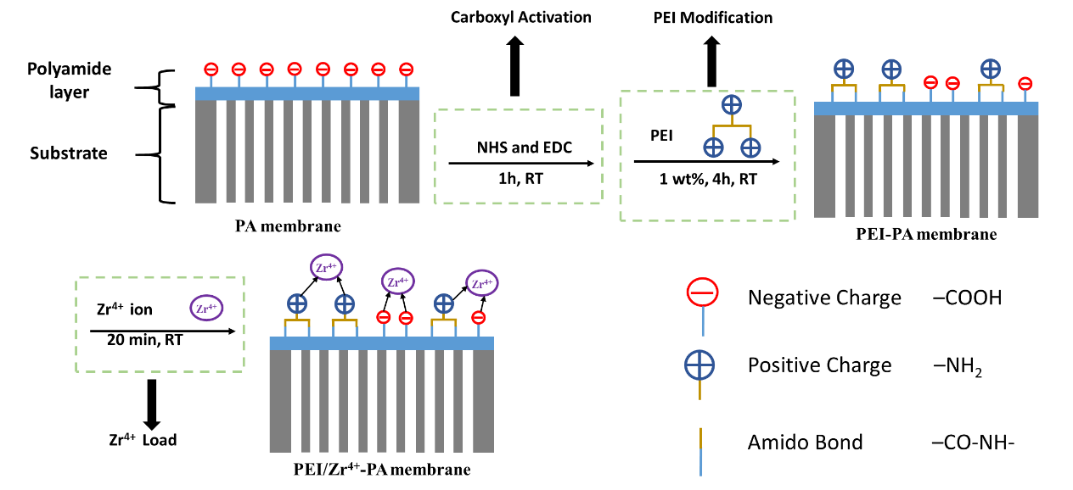

**Figure 1.** Schematic diagram of double positively charged PA NF membrane modification with PEI/Zr4+.

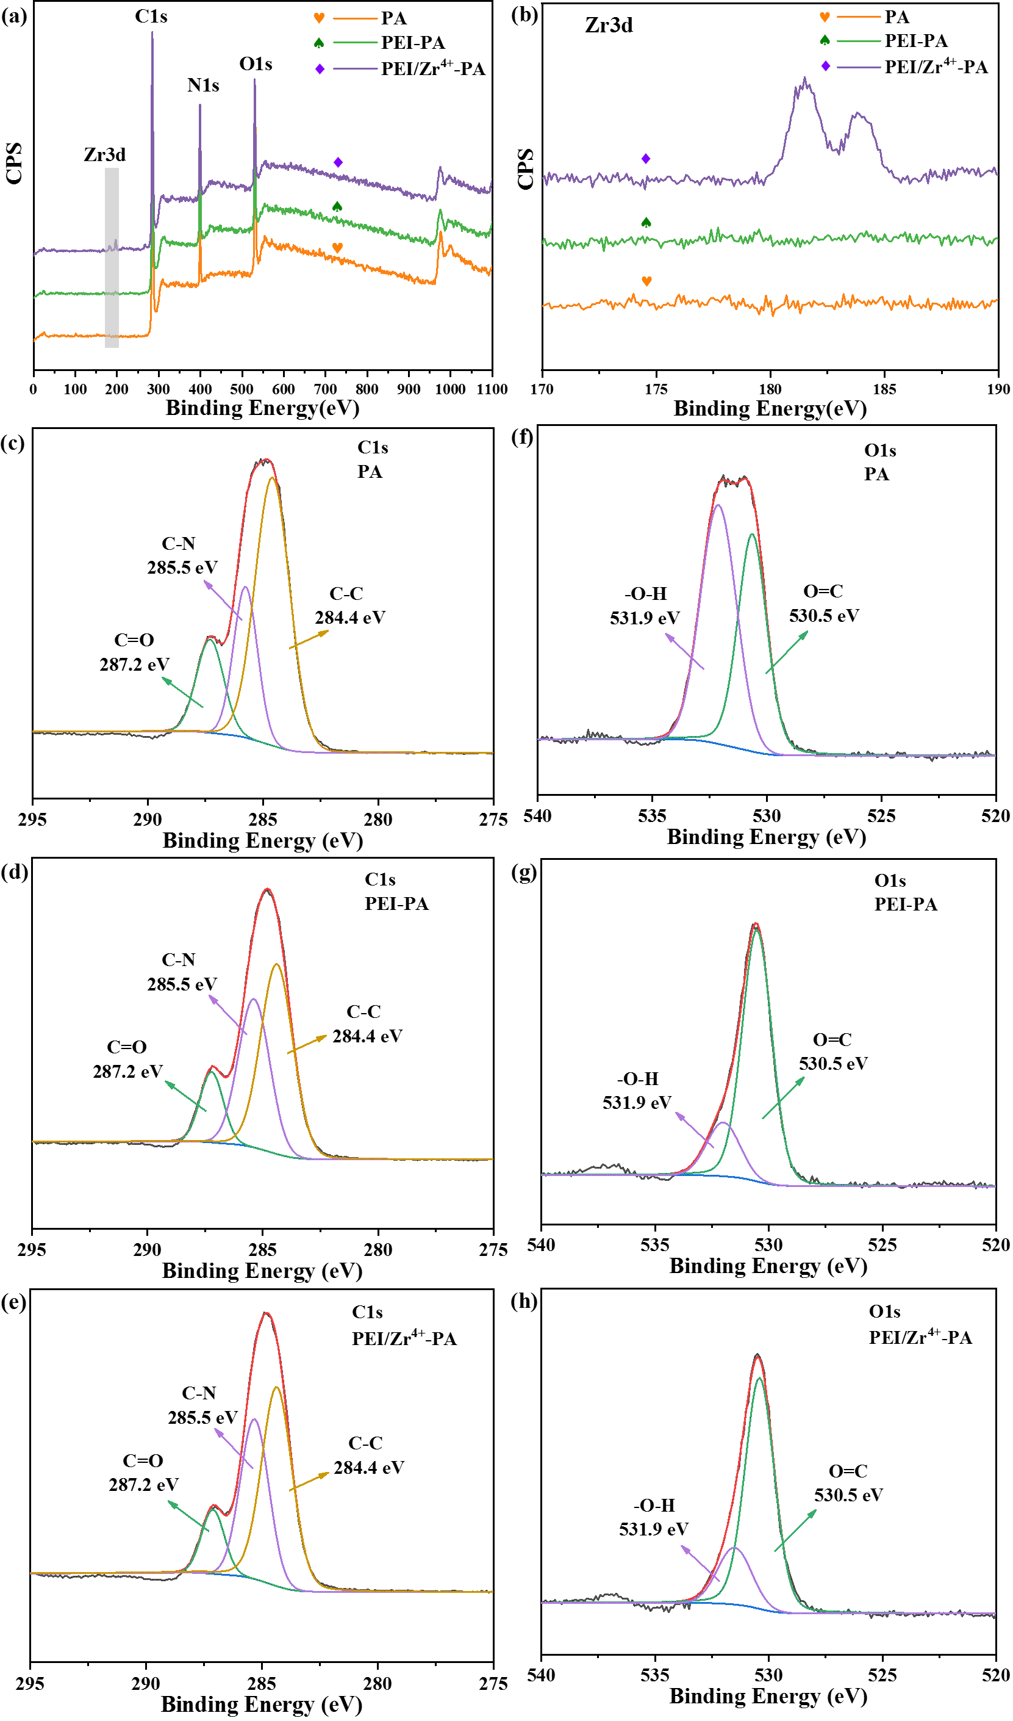

**Figure 2.** XPS spectra of PA, PEI-PA and PEI/Zr4+-PA NF membranes: (a) XPS spectra and (b) their Zr3d peaks; the C1s of XPS spectra of (c) PA, (d) PEI-PA, and (e) PEI/Zr4+-PA NF membranes; the O1s of XPS spectra of (f) PA, (g) PEI-PA, and (h) PEI/Zr4+-PA NF membranes.

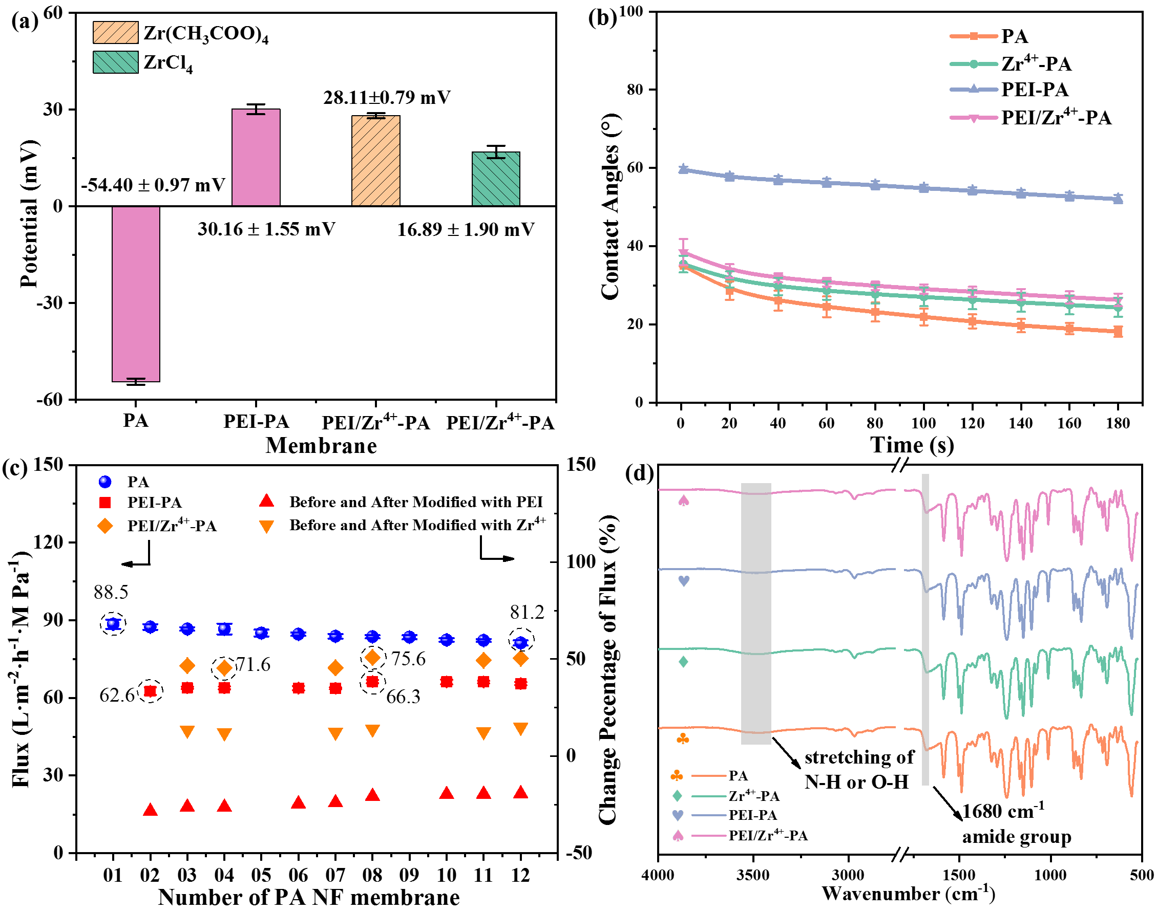

**Figure 3.** Characterization of the prepared PA, PEI-PA, Zr4+-PA, and PEI/Zr4+-PA NF membranes: (a) solid surface zeta potentials, (b) dynamic water contact angles, (c) pure water flux, and (d) FTIR spectra. The “Zr4+-PA” means that PA NF membrane was only treated with Zr4+, without PEI.

**Table 1** The contents of C1s and O1s components on the surface of PA, PEI-PA and PEI/Zr4+-PA NF membranes.

|  |  |  |  |  |  |
| --- | --- | --- | --- | --- | --- |
|  | **C1s (%)** | | | **O1s (%)** | |
| **C=O**  **287.2 eV** | **C-N**  **285.5 eV** | **C-C**  **284.4 eV** | **O-H**  **531.9 eV** | **O=C**  **530.5 eV** |
| **PA** | 16.27 | 23.12 | 60.61 | 55.67 | 44.33 |
| **PEI-PA** | 12.96 | 36.74 | 50.30 | 18.34 | 81.66 |
| **PEI/Zr4+-PA** | 11.67 | 36.48 | 51.85 | 20.91 | 79.09 |

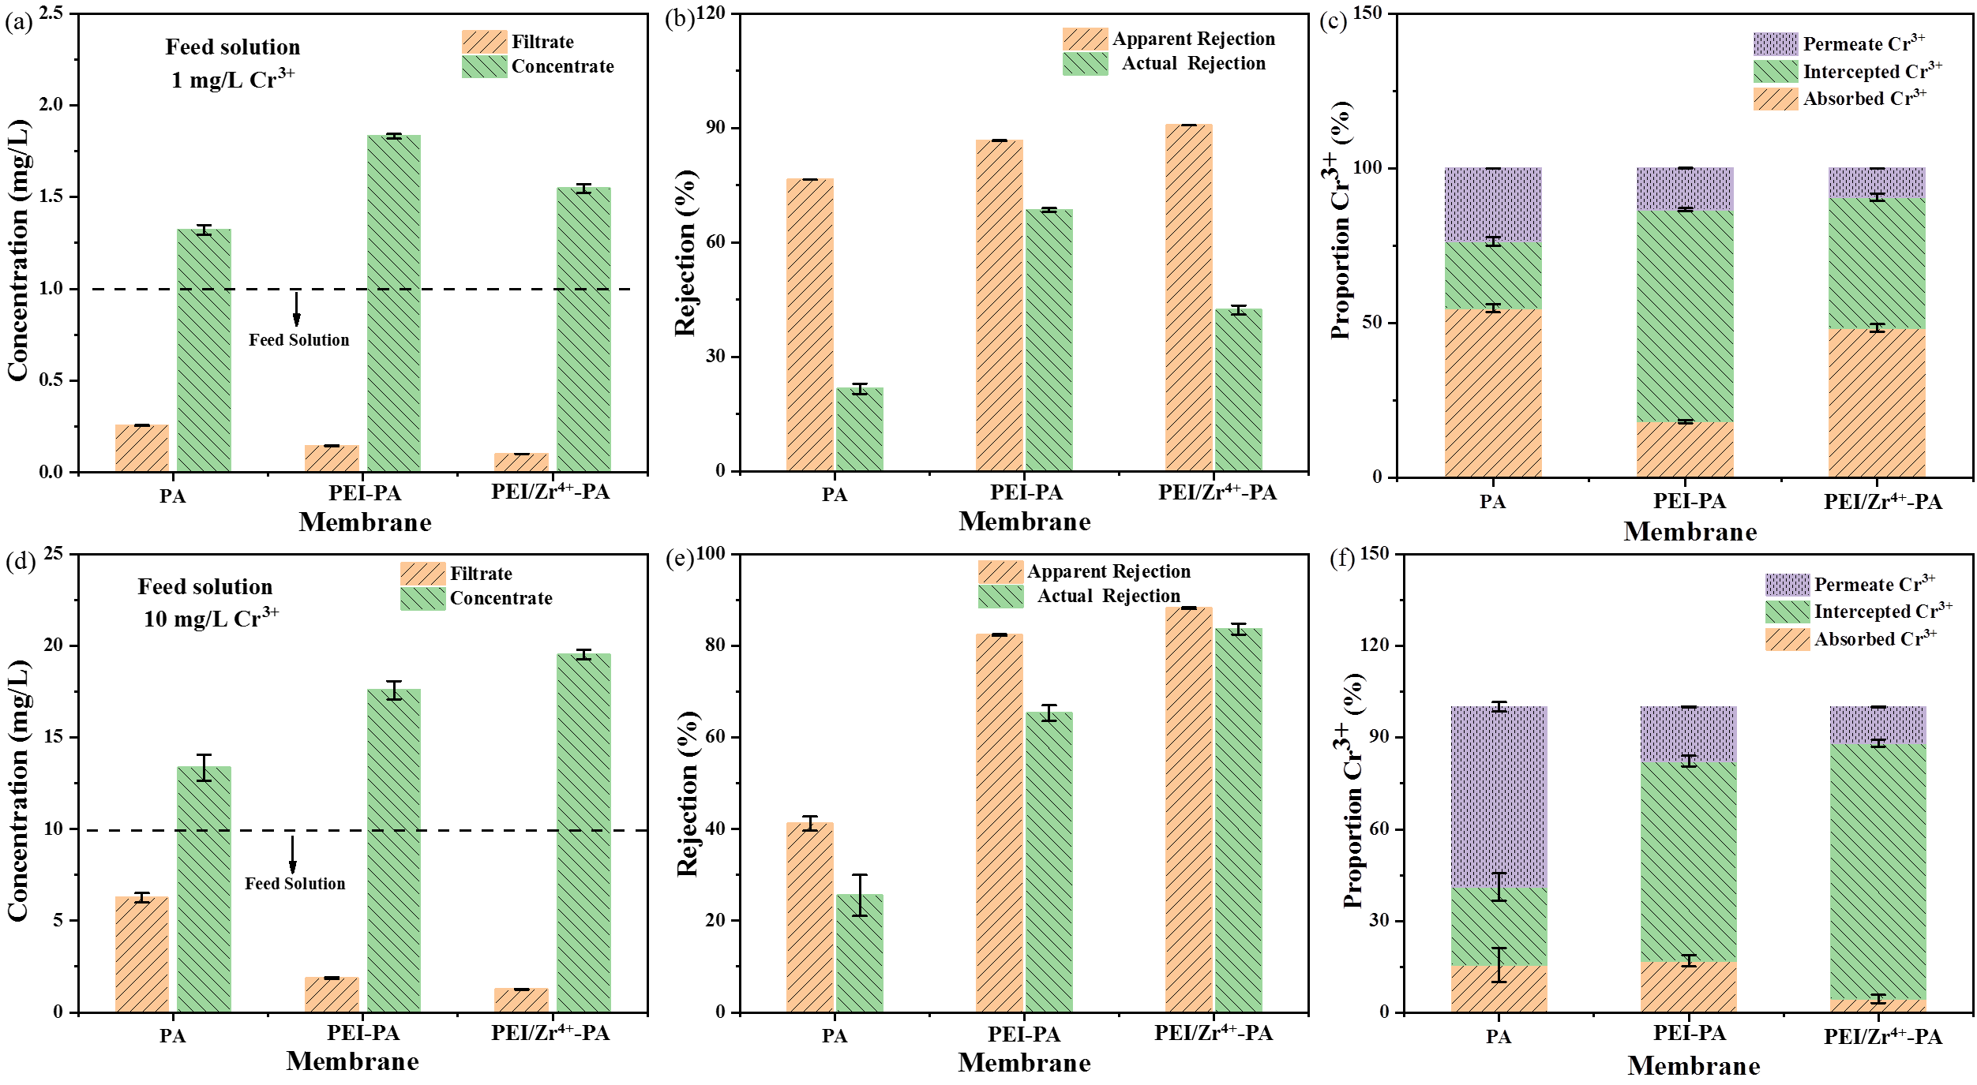

**Figure 4.** Cr3+ rejection performance of PA, PEI-PA, and PEI/Zr4+-PA NF membranes. (a) and (d) Cr3+ concentrations of filtrates and concentrates; (b) and (e) apparent and actual rejection; (c) and (f) the proportion of Cr3+ adsorbed, intercepted and in permeate. (a) ~ (c) the concentration of feed solutions was 1 mg/L; (d) ~ (f) the concentration of feed solutions was 10 mg/L.



**Figure 5.** Dynamic water contact angles of the PA, PEI-PA and PEI/Zr4+-PA membranes after filtrating pure water, 1 mg/L and 10 mg/L Cr3+ solutions, respectively.

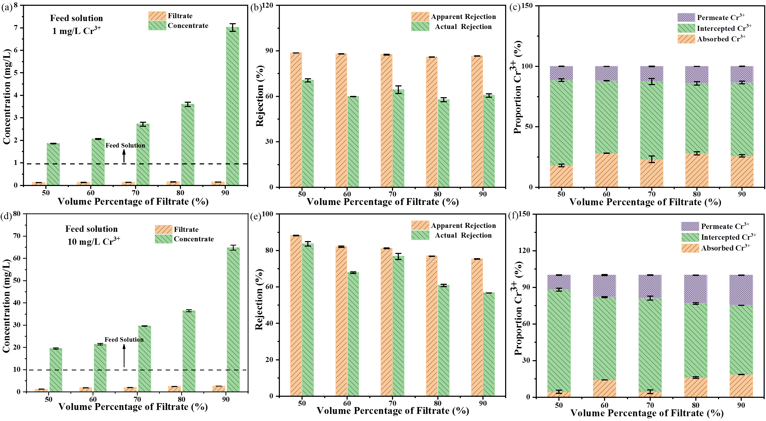

**Figure 6.** Effects of filtrate volume on PEI/Zr4+-PA NF membranes performance for Cr3+ rejection: (a) and (d) Cr3+ concentrations of filtrates and concentrates; (b) and (e) apparent and actual rejection; (c) and (f) the proportion of Cr3+ adsorbed, intercepted and in permeate. (a) ~ (c) the concentration of feed solutions was 1 mg/L; (d) ~ (f) the concentration of feed solutions was 10 mg/L.

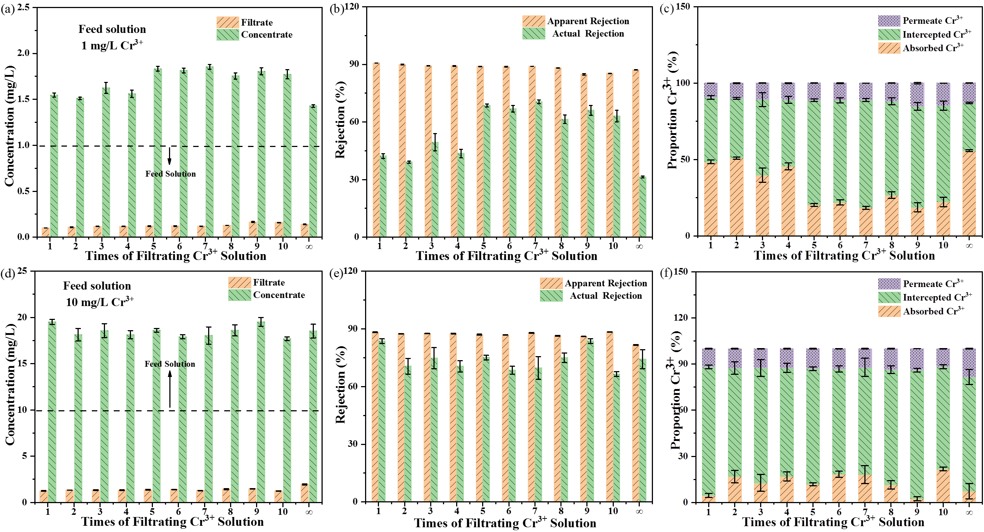

**Figure 7.** Influence of filtration cycle on PEI/Zr4+-PA NF membranes performance for Cr3+ rejection. (a) and (d) Cr3+ concentrations of filtrates and concentrates; (b) and (e) apparent and actual rejection; (c) and (f) the proportion of Cr3+ adsorbed, intercepted and in permeate. (a) ~ (c) the concentration of feed solutions was 1 mg/L; (d) ~ (f) the concentration of feed solutions was 10 mg/L. Each PEI/Zr4+-PA membrane was flushed with 30 mL pure water before the next filtration cycle. The symbol “∞” means that before filtering Cr3+ solutions, the PEI/Zr4+-PA membranes were immersed in high concentration (5 g/L) Cr3+ solution overnight and then rinsed using pure water until Cr3+ concentrations in the filtrates were lower than 0.01 mg/L, respectively.

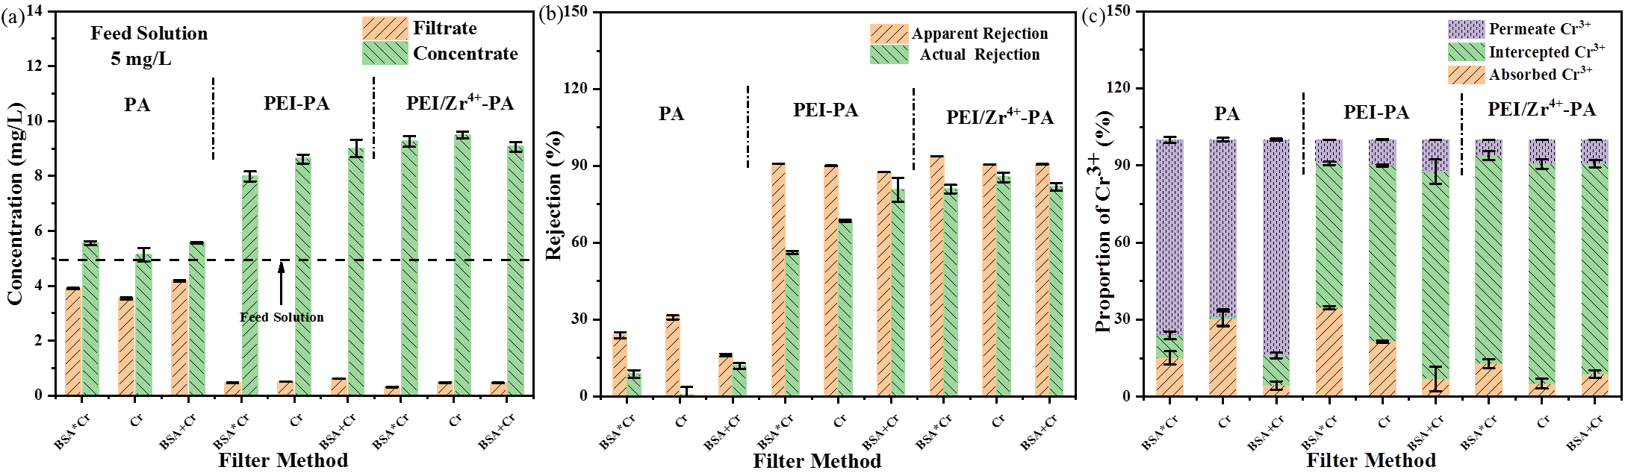

**Figure 8.** Effects of BSA on apparent rejection performance of PA, PEI-PA, and PEI/Zr4+-PA NF membranes for Cr3+ removal by different filter methods. (a) Cr3+ concentrations in filtrates and concentrates; (b) apparent rejection rate of Cr3+; (c) proportions of Cr3+ adsorbed, intercepted, and in permeate. The filter methods of “BSA*Cr”, “Cr” and “BSA+Cr” were as follows: “BSA*Cr” means the NF membrane initially filtered with BSA solution and then filtered with Cr3+ solution; “Cr” means filtration of Cr3+ solution only; “BSA+Cr” means filtration of a solution containing BSA and Cr3+. All the concentrations of BSA solutions, Cr3+ feed solutions, and solutions of BSA and Cr3+ were 5 mg/L, respectively.

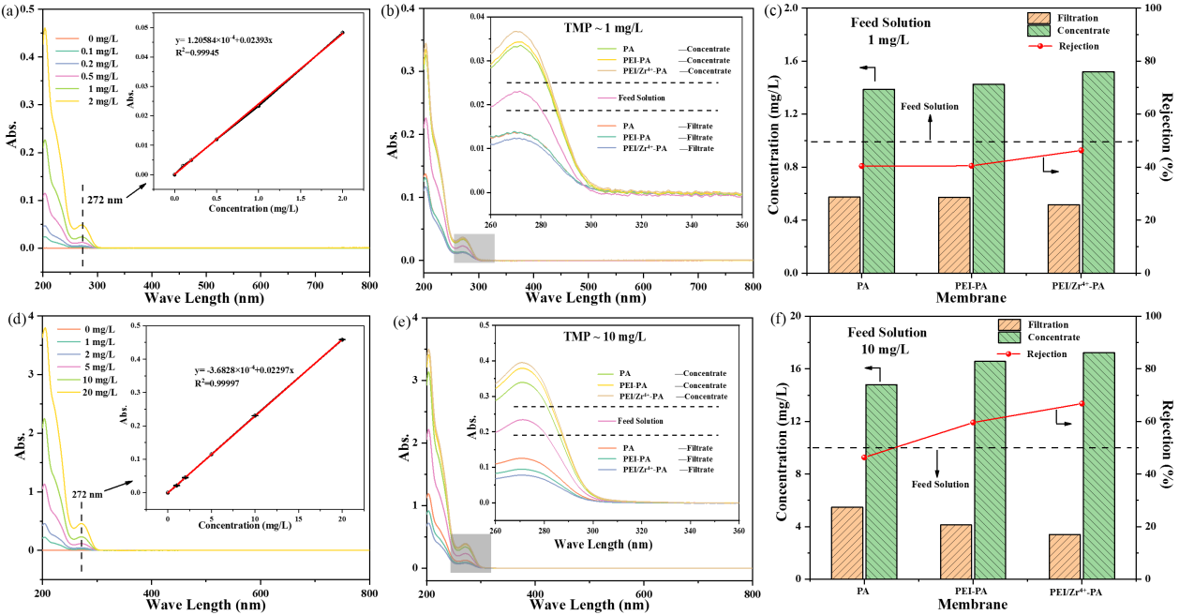

**Figure 9.** Apparent rejection performance of the PA, PEI-PA, and PEI/Zr4+-PA NF membranes for trimethoprim. UV-vis spectra of trimethoprim with concentrations of (a) 0 ‒ 2 mg/L and (d) 0 ‒ 20 mg/L (the inserted figures were the standard curves of trimethoprim at 272 nm); (b) and (e) UV-vis spectra of trimethoprim in filtrates, concentrates and feed solutions (the inserted figures were the magnified images at a wave length range of 260 nm ‒ 360 nm); (c) and (f) trimethoprim concentrations in filtrates and concentrates, and its removal efficiency. (b) and (c) the concentration of feed solutions was 1 mg/L; (e) and (f) the concentration of feed solutions was 10 mg/L.



**Figure 10.** Dynamic water contact angles of the PA, PEI-PA and PEI/Zr4+-PA membranes after filtrating pure water, 1 mg/L and 10 mg/L TMP solutions, respectively.



**Figure 11.** Effects of BSA (5 mg/L) on flux recovery of PA, PEI-PA, and PEI/Zr4+-PA NF membranes.