Chapter 17

Large scale production of membrane proteins in Pichia pastoris: the production of G protein-coupled receptors as a case study

Shweta Singh¹, Adrien Gras¹, Cedric Fiez-Vandal^{2*}, Magdalena Martinez¹, Renaud Wagner² and Bernadette Byrne^{1†}

¹Division of Molecular Biosciences, Imperial College London, Exhibition Road, London, SW7 2AZ
²Ecole Supérieure de Biotechnologie de Strasbourg – Centre National de la Recherche Scientifique, Département Récepteurs et Protéines Membranaires, 67412 Illkirch, France

†To whom correspondence should be addressed:
Dr Bernadette Byrne
Division of Molecular Biosciences
Imperial College London
Exhibition Road
London
SW7 2AZ
E-mail: b.byrne@imperial.ac.uk
Tel: + 44 (0) 20 7594 3004
Fax: + 44 (0) 20 7594 3022

Abstract
One of the major advantages of using Pichia pastoris is that it is readily adapted to large scale culture in bioreactors. Bioreactors allow precise regulation of cell growth parameters increasing both yields and reproducibility of the culture. P. pastoris cultures grow to very high cell densities which helps minimize culture volume and facilitate downstream processing of the sample. Here we provide protocols for the large-scale production of the human adenosine A_{2A} receptor (A_{2A}R) and provide some details of how bioreactor cultures can be used for optimisation of expression of the human dopamine D2 receptor (D2DR).

Key words: large-scale expression, bioreactor, control of culture parameters, methanol probe, large scale membrane preparations, receptor

1. Introduction
One of the key advantages of using Pichia pastoris is that it is readily adapted to large-scale culture in bioreactors (1, 2). Bioreactors allow precise regulation of the aeration, pH and addition of carbon source, which allows the cultures to grow to high cell densities. This in turn can be used to maximise yields of the target protein. P. pastoris cultures are able to grow to much higher cell densities than the other popular yeast expression host, Saccharomyces cerevisae. This is because at high cell densities, S. cerevisae switches to fermentative growth producing ethanol as a by-product. This quickly reaches toxic levels which limits further cell growth and recombinant protein production. In contrast, Pichia pastoris is a relatively poor fermentor, preferring respiratory growth. It can therefore be grown to very high cell densitites (an OD₅₉₅ of 500 has been reported, 2) in controlled bioreactor environments without the toxic side effects of ethanol production. This means it is possible to use much lower culture volumes for P. pastoris making expression cheaper as well as facilitating downstream processing.

There are a number of standard protocols available for the production of proteins in P. pastoris using bioreactors (3, 4, 5), many of which have been developed to deal with the specific challenges of growing high cell density cultures. However, optimisation of these standard protocols is usually necessary for specific targets. One particular issue is the osmotic stress induced during high cell density culturing, known to be responsible for adaptive cell response mechanisms such as changes in membrane lipid content (6). These changes may be disadvantageous during membrane protein production and hence medium cell density culturing approaches may be more suitable. For example in high cell density fermentations, we observed lowered specific activity for some recombinant G protein-coupled receptors (GPCRs) as well as altered receptor behavior in solubilization assays. Therefore although it is possible to produce very high P. pastoris cell density cultures (up to OD₆₀₀ = 500), we typically use medium cell density protocols (OD₆₀₀ = 80-100; 3).

Another concern is proteolytic degradation of the target protein, as the high stress environment of the bioreactor increases the likelihood of cell death leading to release of intracellular proteases. Our protocols therefore use a temperature-limited fed batch technique (3) which was specifically developed to reduce proteolysis during recombinant protein production. However, previous work in our laboratories has also revealed the proteolytic degradation of some, but not all, receptor constructs when expressed in bioreactors (7). In contrast, the same constructs are not subject to degradation in the much lower cell density cultures grown in shake flasks. This clearly illustrates the fact that specific optimization is required for individual protein targets. For example, in one case it was necessary to express an alternative construct in order to obtain protein which was sufficiently stable for further studies (7).

A further important parameter that requires optimization is the amount of methanol added for induction. It has been shown that very high levels of methanol can have cytotoxic effects which reduce cell viability and thus yield of the target protein (8). Methanol sensors, which detect the level of unmetabolized methanol, have been key to reducing these cytotoxic effects and optimizing the production of the target protein.

The large-scale production of membrane proteins in P. pastoris also presents challenges post-induction, which are related to the structure of the yeast cell envelope (9). The cell envelope is comprised of 1) the plasma membrane which surrounds the cytosol and is the location for a wide range of integral membrane proteins with diverse roles in cellular function, 2) the periplasm, external to the plasma membrane but internal to the cell wall and the location of a number of secreted enzymes with important roles in hydrolysis of substrates prior to transport across the plasma membrane and 3) the cell wall, formed from a thick layer of mainly polysaccharides with a small amount of chitin. The consequence of this complex cell envelope structure to researchers producing recombinant proteins in yeast is that specialized, and often expensive, pieces of equipment are required for efficient cell lysis of large volumes of cell pellet. Such equipment must provide large mechanical forces in order to break open the cell walls. Continuous flow cell disrupters which work by forcing cells through a small nozzle at very high pressures (Constant Systems, Figure 1) are a popular means of processing large volumes of yeast cell culture. Bead-beaters relying on crushing and cracking of the cells with glass beads in a sealed system are also used. In both cases it is important to perform the cell lysis at a low temperature in order to minimize proteolytic degradation of the target protein. In addition, it is possible to use enzymes to lyse cells (10), however the effects of such enzymes on the target protein must be carefully assessed.

Below we give a protocol for the large scale production of the GPCR, adenosine A_{2A} receptor (A_{2A}R), using a bioreactor. In addition we supply a protocol for large-scale membrane preparation using a continuous flow cell disruptor. We also provide some comments on optimizing receptor yield in bioreactor cultures using the human dopamine D2 receptor (D2DR) as the target protein.

2. Materials

Medium preparation for large scale bioreactor cultures
- Geneticin should be made as a stock solution at 100 mg mL⁻¹ and filter-sterilized through a 0.2 μm syringe filter.
- YPD agar: 1% (w/v) yeast extract, 2% (w/v) peptone, 2% (w/v) dextrose, 2% (w/v) agar supplemented with either 0.1 or 0.25 mg mL⁻¹ geneticin. Autoclave 450 mL water containing 5 g yeast extract, 10 g peptone and 10 g agar. Add 50 mL filter-sterilized 20% dextrose to the medium once it has cooled to 60°C.
- MGY medium: Add 100 mL autoclaved 1 M potassium phosphate buffer pH 6 to 700 mL autoclaved deionised (DI) water. Add 100 mL filter-sterilized 10× yeast nitrogen base without amino acids (to give a final concentration of 1.34% w/v), 100 mL filter-sterilized 10× glycerol solution (to give a final concentration of 1% w/v), followed by 2 mL filter-sterilized 500× biotin (to give a final concentration of 0.02% w/v).
- FM22 medium: 0.5% (w/v) ammonium sulphate, 0.1% (w/v) calcium sulphate, 1.43% (w/v) potassium sulphate, 1.17% (w/v) magnesium sulphate and 2% (w/v) glycerol. If a significant amount of foaming is observed 250 μL L⁻¹ of antifoam can be added to the medium before autoclaving. This solution can be autoclaved within the bioreactor vessel. Prepare 3 L of this solution.
- Potassium phosphate solution: 1 L 4.3% (w/v) monobasic potassium phosphate, autoclaved separately to prevent precipitation. Add this to the bioreactor following autoclaving to give a final volume of 4 L.
- PMT4 trace elements solution: 0.2% (w/v) copper sulphate, 0.008% (w/v) sodium iodide, 0.3% (w/v) manganese sulphate, 0.02% (w/v) sodium molybdate, 0.002% (w/v) boric acid, 0.05% (w/v) calcium sulphate, 0.05% (w/v) cobalt chloride, 0.7% (w/v) zinc chloride, 2.2% (w/v) iron sulphate and 1mL L⁻¹ concentrated sulphuric acid. This solution should be stored in the dark at 4°C.
- Biotin solution: filter sterilize a 2% solution. To increase the shelf-life of the PMT4 solution, add biotin just prior to use to a final concentration of 0.02%.
- Glycerol feed solution: 50% (w/v) glycerol autoclaved prior to use.
- Methanol feed solution: add 4 mL L⁻¹ PMT4 solution to 400 mL 100% methanol.
- Histidine solution: filter sterilize a 100× solution of 4% (w/v) histidine.
- Ammonia solution: 28% ammonia solution (purchased as a 0.880 gcm⁻³ solution from VWR) used to control the pH of the culture.
- Antifoam solution: autoclave 100 mL of antifoam solution.

2.2 Large scale membrane preparation
- Breaking buffer: 50 mM HEPES pH 7.4, 100 mM NaCl, 10% (w/v) glycerol, 2 mM EDTA supplemented with protease inhibitor tablets (Roche; add 1 tablet per 100 mL buffer).
- Membrane buffer: 50 mM HEPES pH 7.4, 100 mM NaCl, 10% (w/v) glycerol.

3. Methods

3.1 Starter culture
- Select single P. pastoris colonies containing the plasmid of interest on separate YPD agar plates supplemented with 0.01% or 0.25% geneticin (see Note 1).
- Use a single colony to inoculate a 150 mL MGY medium.
- Grow the culture at 30 ºC with aeration for 18-22 h to an OD₆₀₀ 10-15.

3.2 Preparation of the bioreactor
This section describes a medium density P. pastoris cultivation in a 5 L bioreactor vessel (4 L working volume) operated by an ADI 1010 bio-controller connected to a PC running BioExpert software (all from Applikon Biotechnology; see Figure 2 and Note 2).

Day 1:
- Add 4 L autoclaved FM22 medium to the bioreactor vessel. Add 100 mL glycerol feed solution to a feed bottle. Connect the glycerol and antifoam (antifoam A emulsion, Sigma) feed bottles to the bioreactor using silicon tubing. Connect the empty methanol bottle using solvent-impermeable Tygon® tubing, but connect C-Flex® for the section used by the peristaltic pump (both from Masterflex). Ensure that all venting filters are protected using cotton wool and aluminium foil secured with autoclave tape. Clamp all lines except the bioreactor exhaust. Autoclave on a liquid cycle.

Day 2:
- Connect the ammonia feed bottle using Tygon® and C-Flex® tubing and add 200 mL methanol feed solution to the empty feed bottle.
- Begin equilibration of the bioreactor by setting the temperature and dO₂ control to 30°C and 35%, respectively. Add 1 mL PMT4 solution per 1 L medium at this point. Once the temperature and dO₂ have equilibrated, set the pH control to 5.0.
- Centrifuge the MGY starter culture and resuspend the cells in 10 mL fresh MGY medium. Inoculate the bioreactor vessel with sufficient cell suspension to obtain a starting OD₆₀₀ of 0.25.
- Incubate the culture for 18-20 h. During this growth phase, the cells consume all the glycerol. Glycerol depletion is marked by a sharp rise in dO₂ levels (Figure 3).

Day 3:
- Once the glycerol is fully depleted, begin the glycerol fed-batch phase by feeding 50% glycerol at 10 mL L⁻¹ h⁻¹ with a peristaltic pump. Continue the feed until the OD₆₀₀ reaches 80-100 (3-4 h).
- Turn off the glycerol feed. A further sharp rise in dO₂ levels should be observed at this point (Figure 3). Add sterile histidine to a final concentration of 0.04% and sterile DMSO to a final concentration of 2.5%. Allow for minor temperature changes to stabilize then lower the temperature control to 22°C.
- Once the temperature has stabilized, begin the methanol induction phase (18-21 h) by adding 0.1% (v/v) methanol feed solution to the vessel. Allow 2-3 min for the methanol sensor (Raven Biotech) reading (mV) to stabilize and set the methanol control to this value. The internal feedback system of the methanol sensor enables the on/off control of the 101U/R peristaltic pump (Watson Marlow) to maintain a steady concentration of 0.1% methanol in the vessel. Allow approximately 1 h for the culture to adapt to methanol metabolism. The dO₂ levels should drop to 35% during this period.
- Add another 0.1% (v/v) methanol aliquot to the vessel and set the methanol control at 0.2% as described in step 8. Repeat this step until methanol is set at 0.4%. Samples should be taken at multiple time points and frozen at -80°C for further analysis of the yield profile. In the case of recombinant A_{2A}R, the culture was usually induced for 18 h after which a reduction in recovery of functional receptor was observed.

Day 4:
- Turn off the methanol feed and allow dO₂ to rise to approximately 80% before harvesting cells. This allows depletion of the methanol present in the vessel. This typically takes about 30 min.
- Spin down the cells at 3000 × g and store the pellet at -80°C or proceed directly to membrane preparation (see Notes 3 and 4).

3.3 Large scale membrane preparation.
1. All steps are carried out at 4°C. Resuspend the cells in ice-cold cell breakage buffer.
2. Stir the sample gently for 15 min.
2. Pass the suspension through a continuous cell disruptor (Constant systems; Figure 1) at 39 kpsi. To allow efficient cell breakage, the suspension is usually passed two or three times through the disruptor.
3. Remove cell debris by centrifuging samples at 5000 × g for 20 min.
4. Isolate the membranes by centrifuging the supernatant at 170,000 × g for 1h using a 45 Ti rotor in an Ultra XP ultracentrifuge (Beckman Coulter).
5. Resuspend the membranes in 400 mL membrane buffer (50 mM Tris pH 8, 120 mM NaCl, 20% glycerol, 300 nM ZM241385 (Tocris), protease inhibitors (Roche)) using a cell homogeniser (Dounce). Use immediately for solubilisation and purification of the receptor or store at -80°C until further use (see Note 5).

3.4 Optimisation of expression yields in a bioreactor
- Prepare a starter culture and bioreactor as described above (sections 3.1 and 3.2).
- Grow the cultures as described above.
- Induce expression at 30°C for 18 h.
- For optimization of D2R yields, we supplemented the culture medium with 5% DMSO, 0.04% histidine and 10 μM metocloprimide (specific D2R antagonist).
- Induce expression at a range of different temperatures (e.g. 20, 18 and 16°C). Figure 4 gives an example of the different yields which can be obtained by altering the culture conditions (see Note 6).

4. Notes
- It is useful to screen the colonies using both concentrations of geneticin. Those colonies that contain a higher copy number of the expression plasmid integrated into the genome will grow on higher concentrations of geneticin. However there is no clear relationship between higher copy number and higher expression levels. Therefore it is probably useful to carry out expression screening on colonies containing both high and low copy numbers.
- The 5 L bioreactor equipment typically used in our laboratory was obtained from Applikon Biotechnology; however comparable yields can be achieved using the BioFlo 3000 system from New Brunswick Scientific.
- Since 350 g cells can be typically obtained from a bioreactor culture, it is usually best to freeze the cells in batches. These can then be processed separately.
- It is useful to prepare a small (5 mL) aliquot of culture to test for production of the target protein either by Western blot or functional analysis before processing the sample further.
- It is possible to freeze membranes containing the GPCR prior to further analysis or purification, but this can reduce functional yield. In most cases it is preferable to prepare membranes immediately prior to use.
- Although optimization of yields in a bioreactor is possible, it may also be quicker to assess the effects of different conditions in shake flasks.

6. Acknowledgments
This research was funded by the MepNet consortium, the Biothechnology and Biological Research Council and GlaxoSmithKline.

6. References
1. Cereghino GPL, Cereghino JL, Ilgen C, Cregg JM (2002) Production of recombinant proteins in fermenter cultures of the yeast Pichia pastoris. Curr Opin Biotechnol 13: 329-332.
2. Cereghino GPL, Cregg JM (2000) Heterologous protein expression in the methylotrophic yeast Pichia pastoris. FEMS Microbiology Reviews 24: 45-66.
3. Jahic M, Wallberg F, Bollok M, Garcia P, Enfors S-O. (2003) Temperature limited fed-batch technique for control of proteolysis in Pichia pastoris biorector cultures. Microb. Cell Fact 2: 6-17.
4. Charoenrat T, Ketudat-Cairns M, Stendahl-Andersen H, Jahic M, Enfors S-O, (2005) Oxygen-limited fed-batch process: an alternative control for Pichia pastoris recombinant protein processes. Bioprocess Biosyst Eng 27: 399-406.
5. Jahic M, Veide A, Charoenrat T, Teeri T, Enfors S-O. (2006) Process technology for production and recovery of heterologous proteins with Pichia pastoris. Biotechnol Prog 22: 1465-73.
6. Mattanovich D, Gasser B, Hohenblum H, Sauer M (2004) Stress in recombinant protein producing yeasts. J Biotechnol 113:121-35.
7. Singh S, Gras A, Fiez-Vandal C, Ruprecht J, Rana R, Martinez M, Strange PG, Wagner R, Byrne B (2008) Large-scale functional expression of WT and truncated human adenosine A2A receptor in Pichia pastoris bioreactor cultures. Microb. Cell Fact. 7: 28-38.
8. Zhang W, Smith LA, Plantz BA, Schlegel VL, Meagher MM (2002) Design of methanol feed control in Pichia pastoris fermentations based upon a growth model. Biotechnol Prog 18:1392-9.
9. Northcoate DH, Warne RW (1952) The chemical composition and structure of the yeast cell wall. Biophys J 51: 232–236.2
10. Salazar O, Asenjo JA (2007) Enzymatic lysis of microbial cells. Biotechnol Lett 29: 985-94.

Figure legends
Figure 1: A schematic diagram of the continuous cell disruptor system used for preparation of cell membranes. Within the detailed inset, the black arrows show the flow of the cell suspension prior to cell lysis. The cells are forced through a nozzle at high pressure and then hit a target at high speed. Both processes contribute to efficient cell lysis. The cell lysate, showed by the open arrows is then collected from the outlet.

Figure 2: Schematic of the bioreactor set-up. From left to right; methanol sensor and pump, bioreactor vessel and controller units. The bioreactor contains pH, dO₂, methanol and temperature probes and a stirrer inserted into the vessel. These are all connected to the controller unit which allows monitoring and control of the different parameters during the grow-up. The pH is maintained at 5 by the addition of acid or base into the cell culture as required while the dissolved O₂ is maintained to a minimum level of 40% by regulating the airflow. The vessel contains an external jacket connected to the condenser required to maintain the temperature of the culture. During the fed-batch phase glycerol is introduced into the system at a regular flow rate through a pump. The pump is then connected to the methanol sensor during the induction phase to regulate the amount of methanol added. The vessel also has inlets to add phosphate buffer, additives and inoculum to the media during the grow up and an outlet to harvest the cells after the grow-up.

Figure 3: A) A schematic representation of the different parameters monitored and controlled during production of A_{2A}R in a bioreactor. B) A graphical representation of the changes in dO₂ during the course of a culture producing wild-type A_{2A}R. The key culture phases are indicated.

Figure 4: Optimisation of functional yields of DRD2 in a bioreactor. Induction at 30 °C for 18 h, yielded a functional yield of 2 pmol mg⁻¹ membrane protein. Supplementing the culture medium with 5% DMSO, 0.04% histidine and 10 mM metoclopramide (a receptor-specific antagonist) and inducing at 30 °C for 18 h gave an increased functional yield of 4 pmol mg⁻¹ membrane protein. Further optimization of the yield was achieved by reducing the induction temperature. Inducing at 20°C increased the functional yield to about 6 pmol mg⁻¹ membrane protein, with a similar result obtained for induction at 16°C. The highest yield was obtained when the culture was induced at 18°C to give 16 pmol mg⁻¹ membrane protein. These optimized conditions yielded an 8-fold higher yield than the original induction conditions.

Figure 1
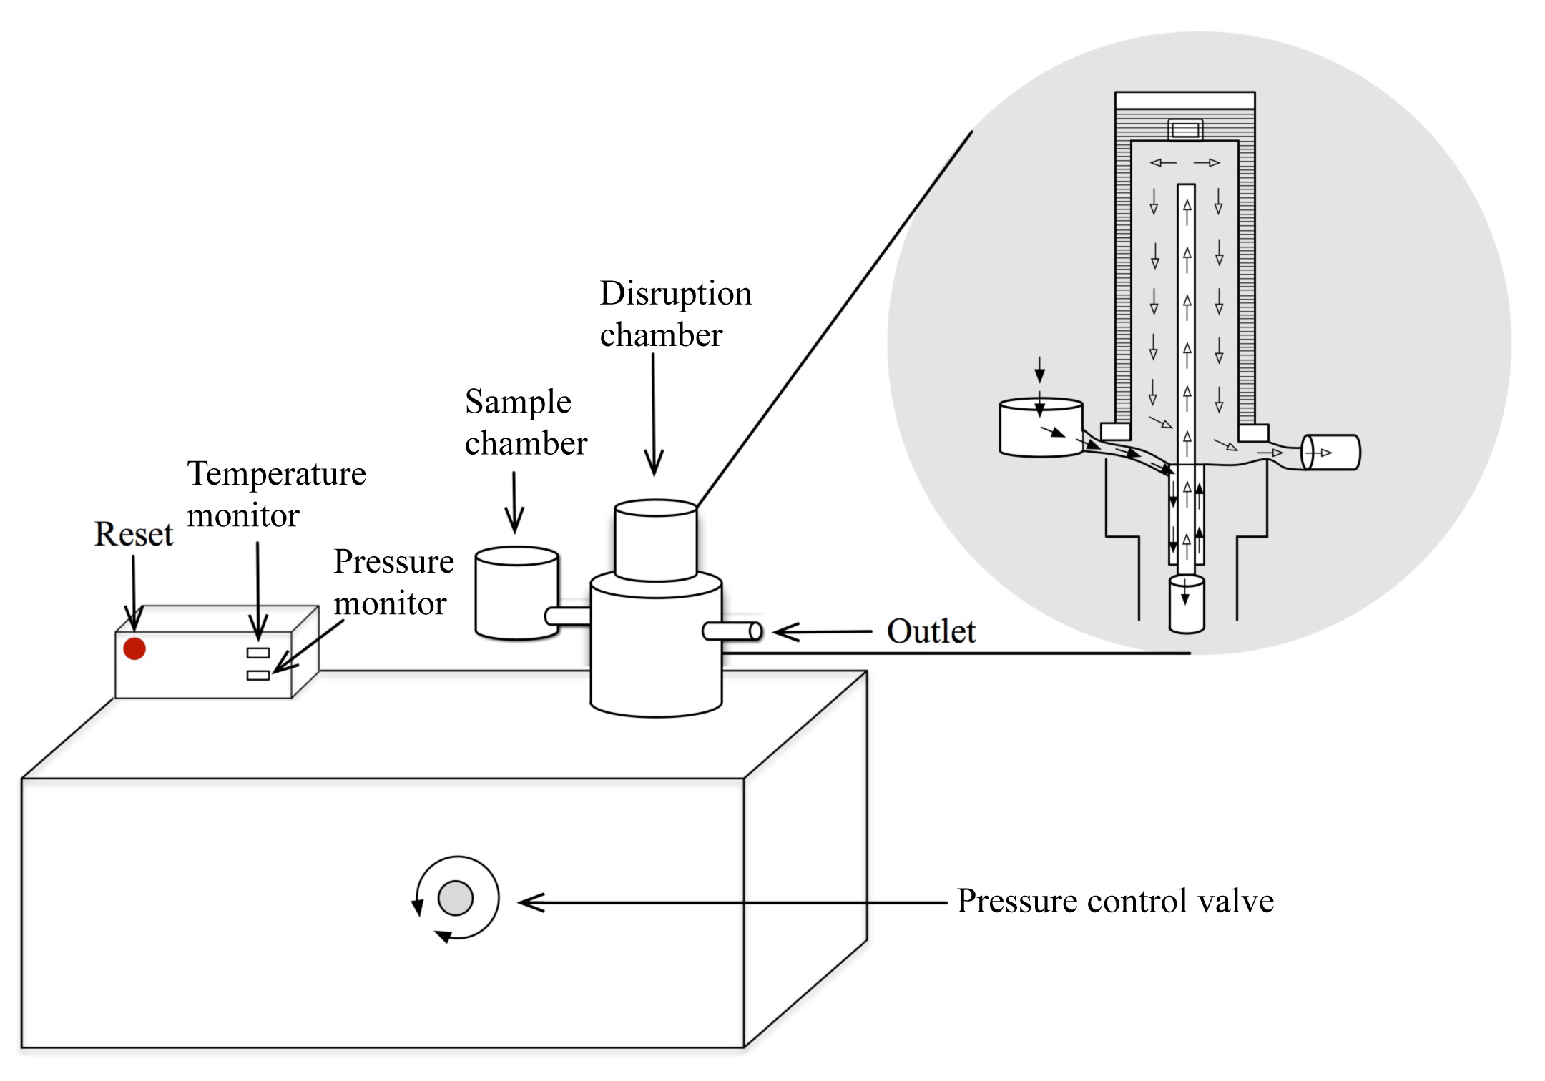

Figure 2
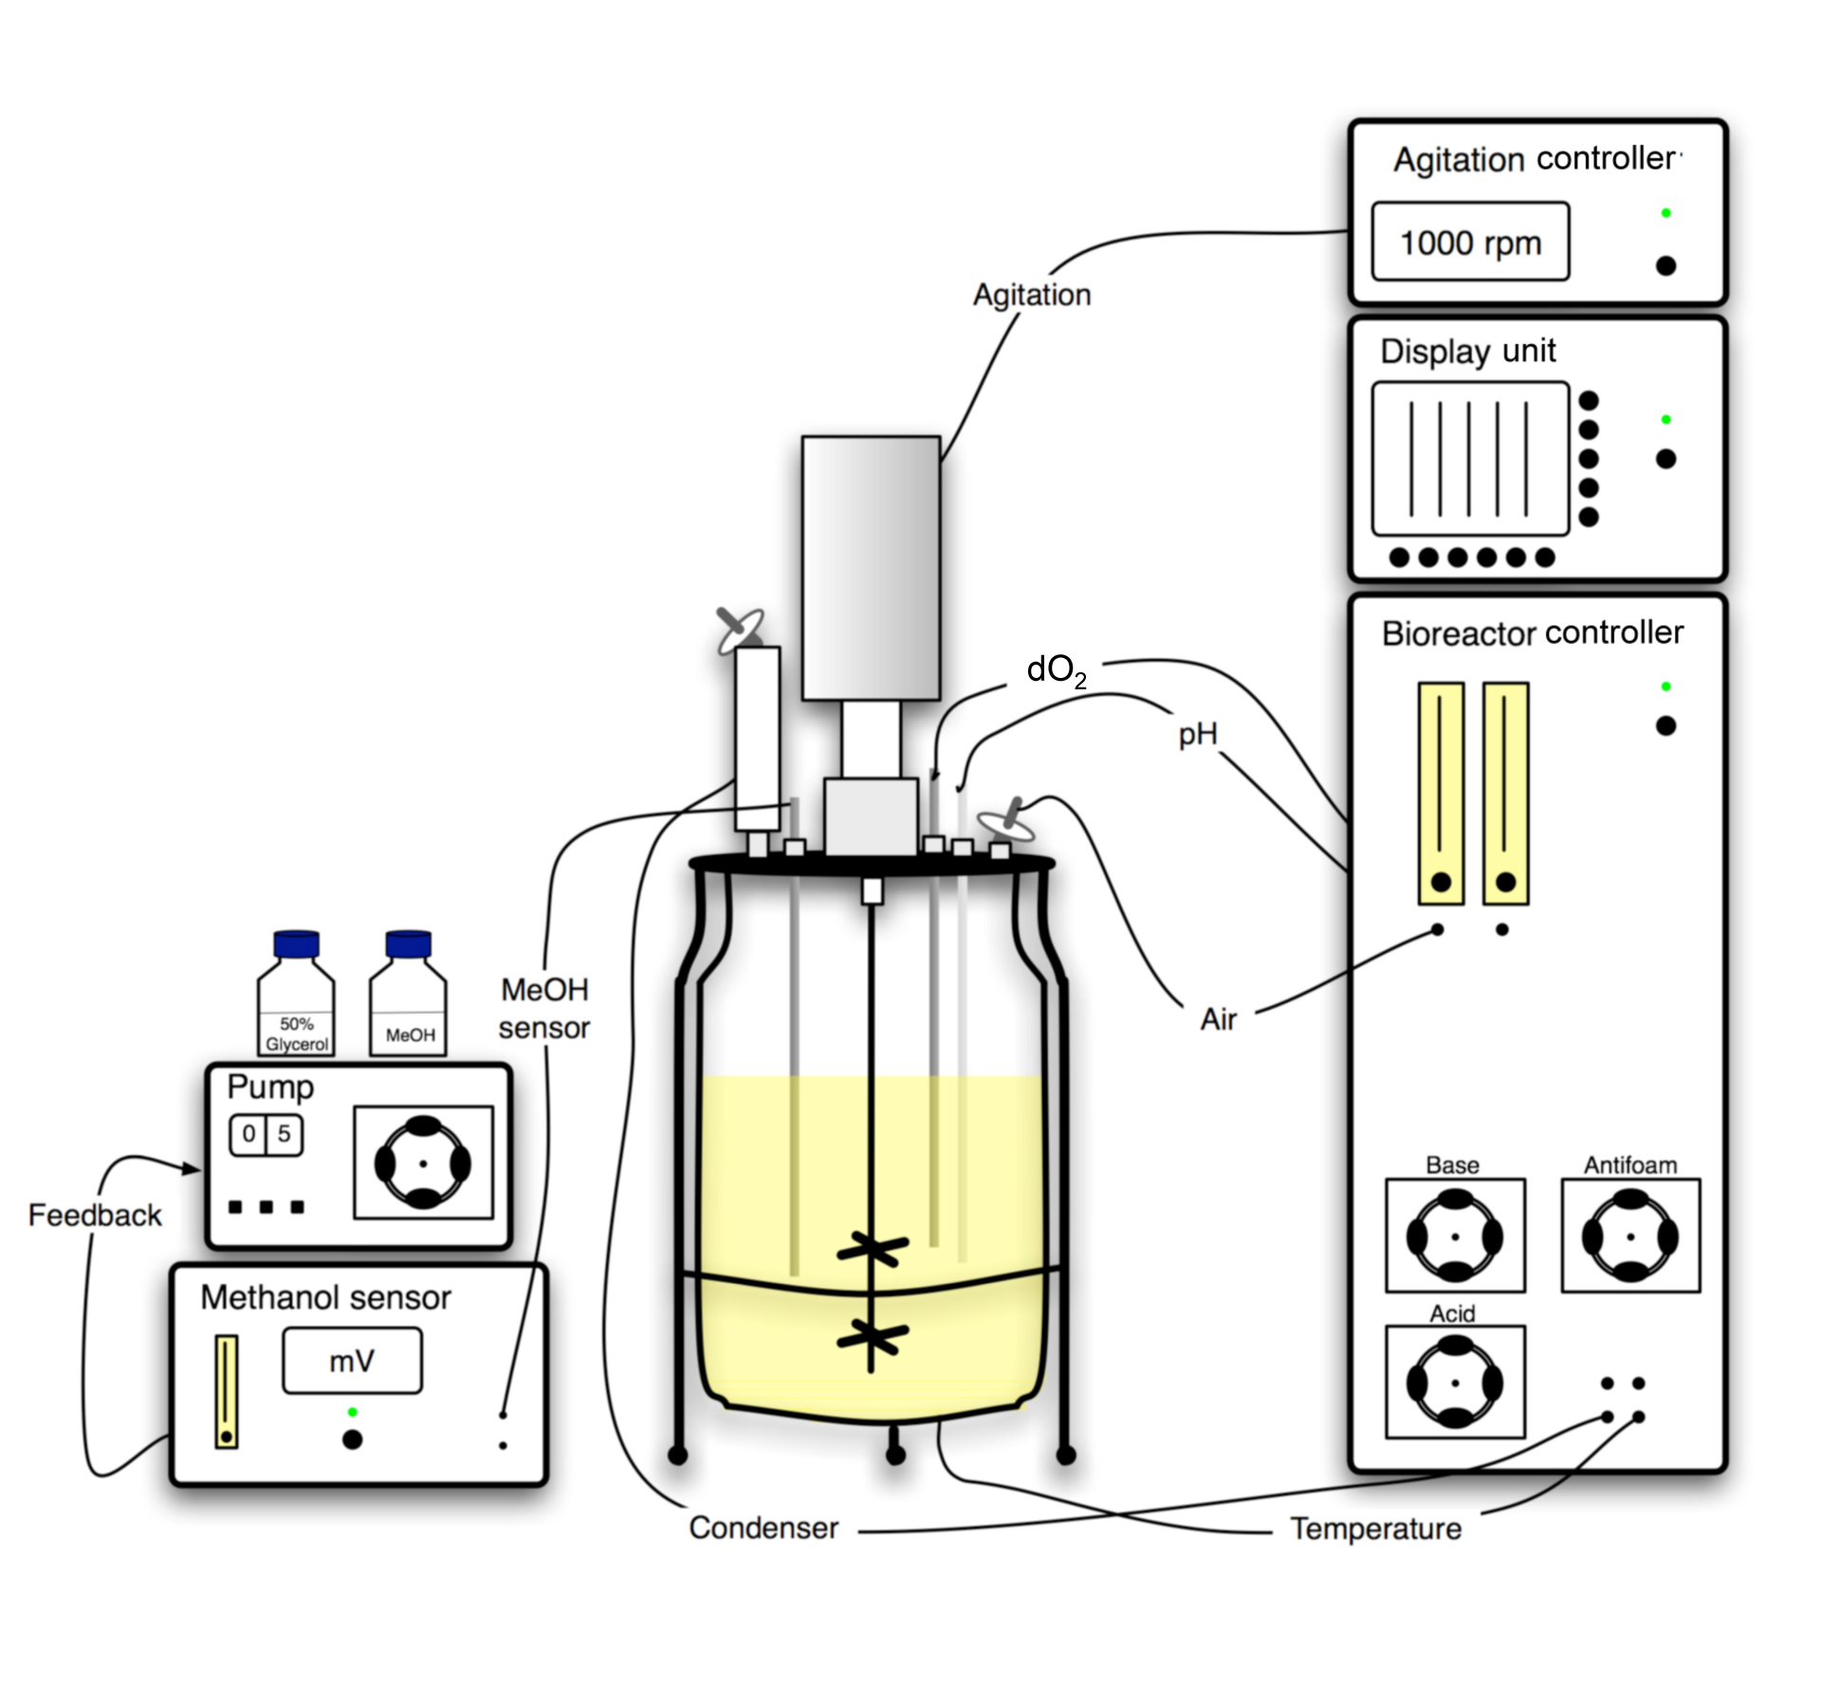

Figure 3
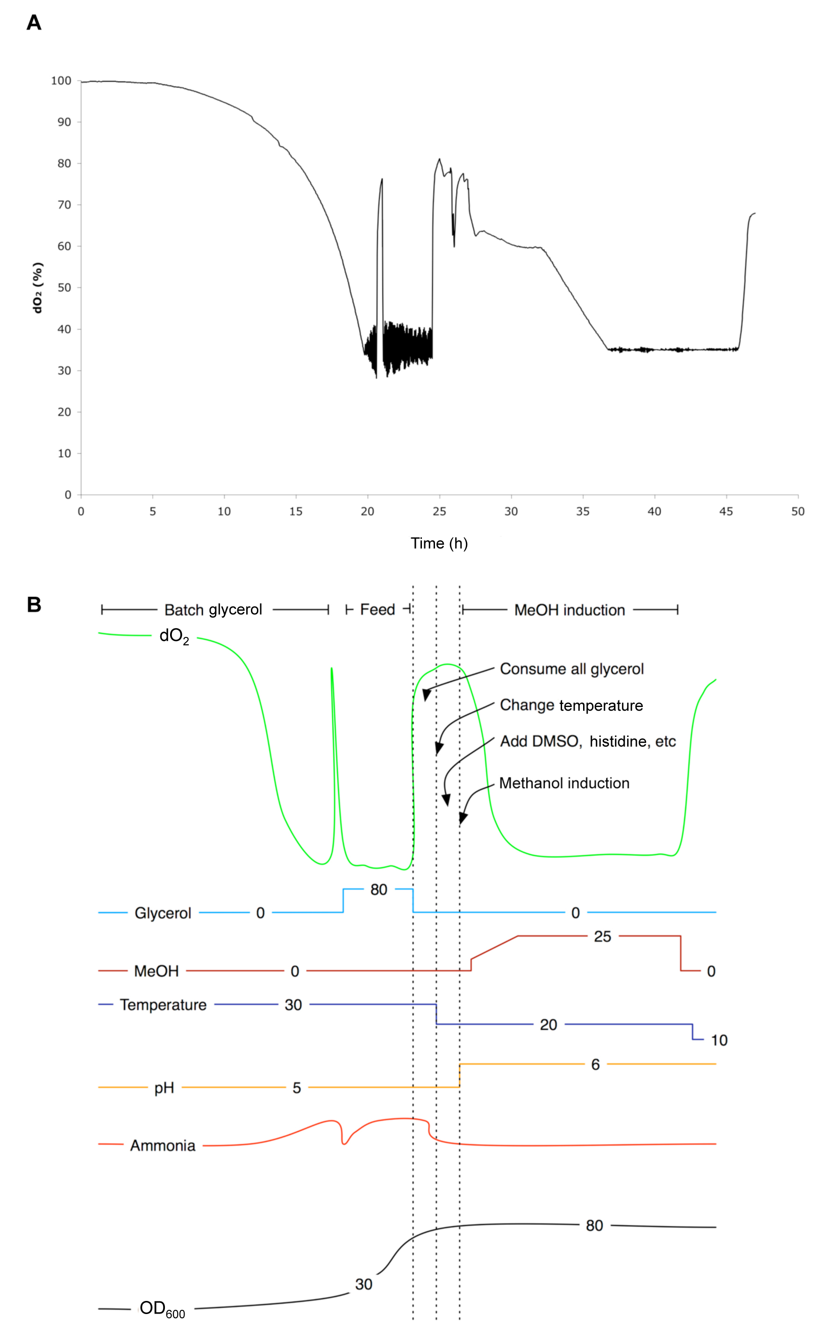
Figure 4
