**A ten-year observational study of the use, acceptability and effectiveness of Long-Acting Paliperidone Palmitate – implications for clinical decision making**

Running Title: Ten-year observational study of Long Acting Paliperidone Palmitate

Sofia Pappa1,2, Joshua Barnett1,3, Katy Mason1,4

West London NHS Trust, London, United Kingdom1

Department of Brain Sciences, Faculty of Medicine, Imperial College, London, United Kingdom2

North East London NHS Foundation Trust, London, United Kingdom3,

Lancashire and South Cumbria NHS Foundation Trust, Lancashire, United Kingdom4

Corresponding author: Dr Sofia Pappa, [sofia.pappa@westlondon.nhs.uk](mailto:sofia.pappa@westlondon.nhs.uk) or [s.pappa@imperial.ac.uk](mailto:s.pappa@imperial.ac.uk)

Avenue House, Recovery Team East, West London NHS Trust, 43-47 Avenue Road, London, W3 8NJ, United Kingdom

ORCiD ID

Sofia Pappa: 0000-0002-6303-1547

Joshua Barnett: 0000-0001-8182-0745

Katy Mason: 0000-0003-2150-3419

**Abstract**

**Background:**  Long-acting injectable antipsychotics (LAIs) have been shown to improve adherence and relapse in the treatment of schizophrenia and psychotic disorders, though longitudinal data on treatment outcomes are limited.

**Objectives:** To establish the long-term acceptability and effectiveness of Paliperidone Palimitate once-monthly (PP1M)

**Methods:** This independent 10-year mirror image study was carried out in a large urban mental health provider. The study evaluated the retention and hospitalization rates five years following initiation of PP1M in a naturalistic patient cohort of all adult patients who were newly initiated on PP1M between 2011-2015. Electronic records were used to compare the frequency and length of hospital admissions in the five years before and after introduction of PP1M. Switching and discontinuation rates and reasons were also recorded with a separate analysis of patients who continued and discontinued PP1M during the study period.

**Results:** A total of 167 patients were included in the study (70% with schizophrenia, 30% with other diagnoses). Discontinuation rates were 24%, 15%, 17%, 5% and 8% in years 1 to 5; poor tolerability was the most common cause for stopping PP1M. Demographic and clinical factors such as age, sex, diagnosis and care setting did not discriminate between continuers and discontinuers. The group that completed 5 years on PP1M (46%) showed an overall reduction of 72% in the mean number and 68% in the mean length of admissions compared to the 5-year period before initiation, with more than half of the patients requiring no admission at all during this period of time (median=0). On the contrary, discontinuers demonstrated worse outcomes in overall bed occupancy than continuers. Findings were overall similar across the total cohort and schizophrenia only group.

**Conclusions:** Our study has one of the longest duration of follow up of a patient population treated with LAIs confirming sustained improvements for patients who continued treatment for up to five years with implicit implications for cost effectiveness. Study findings may facilitate shared decision making in this area overcoming some of the common barriers for use.

**Key Points**:

This 10-year mirror-image observational study reassures the long-term acceptability and effectiveness of Paliperidone Palmitate once-monthly (PP1M) with almost half of the patient population continuing treatment at five years.

Persistence with PP1M was associated with a significant reduction in both number and length of hospital admissions in the five years after compared to the five years before PP1M initiation.

Conversely, patients who discontinued treatment demonstrated considerably worse hospitalisation rates indicating that treatment adherence effectively improves disease burden.

# 1.0 Introduction

Schizophrenia is a chronic and severe mental disorder affecting 1% of the population [1]. It typically develops in early life [2] and is associated with substantially increased healthcare and wider societal costs [3,4] and if left untreated relapse is often inevitable [5].

Antipsychotics are the mainstay in the pharmacologic treatment of schizophrenia and psychotic disorders [6] providing symptomatic relief and relapse prevention [7]. However, non-adherence with treatment is common and strongly associated with an increased risk of relapse, hospitalization and suicide attempts [8,9]. Long-acting injectable antipsychotics (LAIs) have long been a viable alternative to oral medication [10] and have been shown to improve adherence [11,12] and reduce health costs [13] as well as relapse risk and mortality [14,15].

The newer atypical LAIs have offered additional benefits of improved tolerability and practical advantages pertaining to dosing, frequency and site of administration; they may, for example, better mitigate against partial adherence with the use of longer acting formulations [16]. In fact, emerging evidence supports the notion that less frequent administration of LAIs may improve patient outcomes by improving the actual level of adherence and avoiding treatment gaps [17]. Apart from the evidence deriving from Randomised Control Trials (RCTs), a number of naturalistic mirror image and cohort studies have also demonstrated ‘real world’ effectiveness of LAIs given that the pragmatic management of schizophrenia is far more complex in routine clinical settings, often including patients with dual diagnosis, other psychiatric and physical comorbidities and/or issues with polypharmacy, limited insight, lack of capacity or poor engagement [18].

However, LAIs are often used as continuous - and often lifelong - maintenance treatment and gathering information about the long-term effects remains important but is presently limited. Therefore, the main aim of this study was to establish the long-term clinical outcomes such as hospitalisation rates and treatment discontinuation of Paliperidone Palmitate once-monthly (PP1M), one of the most commonly used second-generation LAI [19,20].

# 2.0 Methods

This independent, naturalistic, mirror image study is part of the wider West London LAI project and took place between 2011-2021 in West London National Health Service (NHS) Trust; a large, urban mental health provider. It was approved by the department for audit and naturalistic research (project number 1295); as such ethics approval and individual written informed patient consent were not required.

This study has a five year pre-PP1M initiation and a five year post-PP1M initiation observation period. The study cohort was formed of all eligible consecutive patients who were initiated on PP1M between 2011-2015 allowing for 5-year post initiation follow up of all patients. Eligibility criteria were as follows: 1) adult patients (>18 years) 2) with any diagnoses 3) newly commenced on PP1M in this time period and 4) full hospitalisation records covering the study period. PP1M initiation was subject to independent clinical prescribing decision and standard of care was unaffected. Exclusion criteria included: 1) patients who were initiated during a forensic or rehabilitation admission as they have typically longer admissions 2) in the event of death and 3) patients with incomplete data during the study period either because they had not been registered as being treated in our trust five years prior to starting PP1M, or because they had moved out of the area and/or were transferred from the trust in the five years following PP1M initiation (‘lost to follow up’), as we were unable to establish continuation of treatment and collect their full hospitalisation data.

The electronic clinical records system provided demographical and clinical information, on primary diagnosis (using International Classification of Diseases 10th revision coding), concurrent substance misuse, number and length of hospital admissions, antipsychotic used immediately prior to PP1M, reason for switching medication as well as discontinuation rates and reasons. For those patients who completed a minimum of 5 years of PP1M treatment (continuers) and for those who discontinued during this period of time (discontinuers), the number of hospital admissions and bed days before and after initiation of PP1M were compared using a mirror image design over a 10-year period, as also previously described [21].

## 2.1 Statistical Analysis

Descriptive statistics were used to summarize demographical, diagnostic and other clinical information. Means and standard deviations (SD) or ranges were calculated for continuous data and frequencies and percentages were calculated for categorical data. Hospital stay length was calculated using an online date difference calculator. Number and length of inpatient admissions were compared in a within-patient-analysis. Shapiro–Wilks W test revealed that this data was not normally distributed, thus Wilcoxon signed-rank test for paired data was used to compare for admission rates and bed days before and after PP1M initiation. The data were analysed using the Statistical Package for Social Sciences (SPSS) for Windows and p values of less than 0.05 were used to determine statistical significance. In addition to the total cohort, the subgroup with a diagnosis of schizophrenia was also analysed and presented separately as this is the formally licenced diagnosis for treatment with PP1M in the United Kingdom although, in real world clinical practice, off licence prescribing is common. In addition, we wanted to allow for comparisons with other relevant studies where they commonly report on patients with schizophrenia.

# 3.0 Results

A total of 197 patients were registered for treatment with PP1M during the study period, of these 167 patients met eligibility criteria and were included in the study. A total of 117 (70%) had a primary diagnosis of schizophrenia and the remaining 50 (30%) had schizoaffective disorder, bipolar affective disorder or other diagnosis. The demographic and clinical characteristics of the total cohort and the schizophrenia only group are summarised in Table 1.

3.1 Discontinuation rates and reasons

Of the total patient cohort, 24% (40/167) discontinued in the first year, 15% (19/127) in second, 17.6% (19/108) in the third, 5.6% (5/89) the fourth and 8.3% (7/84) in year 5 and the continuation rates were 76%, 64.7%, 53.3%, 50.3% and 46.1% respectively (table 2). In the schizophrenia group (n=117), the discontinuation rates over the 5 years were 21% (24/117), 14% (13/93) and 19% (15/80), 6% (4/65) and 7% (4/61) respectively. Thus, 79.5% continued for 1 year, 68.4% for 2 years, 55.6% for 3 years, 52.1% for 4 years and 48.7% for the full 5 years (table 2). In total, 77 patients completed 5 years on PP1M; of these, 57 patients had a primary diagnosis of schizophrenia (Table 2).

The main reasons for discontinuation (Table 3) included poor tolerability, ineffectiveness of the medication and poor medication adherence. Notably, PP1M was discontinued due to ineffectiveness in 17% (20/117) of patients with schizophrenia, but in only 8% (4/50) in patients with other diagnoses. Poor tolerability led to discontinuation in 17% (20/117) of patients with schizophrenia, but in the other diagnoses group this figure reached 26% (13/50). Tolerability was only recorded if it caused discontinuation. Out of the 33 patients who discontinued due to tolerability issues 4/33 (12%) were due to extra-pyramidal side effects, 1/33 (3%) weight gain, 3/33 (9%) hyperprolactinaemia, 3/33 (9%) sedation, 1/33 (3%) sexual dysfunction, 17/33 (52%) were in the “other” category when there was a combination of side effects, and in 4/33 (12%) the tolerability issue was unknown or not clearly recorded.

A multivariate logistic analysis was used to calculate whether there were significant differences in demographic and clinical characteristics between the group of patients who continued on PP1M for 5 years versus those who discontinued as outlined in table 4 and post hoc corrections were completed accordingly; the main predictor of continuation was switching from an oral or depot formulation of risperidone. Oral paliperidone is rarely prescribed in the UK, initially due to the favourable costs of Risperidone [21] which continued to be preferred, thus it was not used in our patient population.

## 3.2 Hospitalisation rates

In the patients who continued with PP1M for 5 years (n=77), the mean number of admissions decreased from 1.84 (SD 2.3) per patient in the 5 years prior to PP1M initiation to 0.51 (SD 1.2) in the 5 years after initiation (Figures 1 & 2) and the median number of admissions fell from 1 to 0 (P<0.000, Wilcoxon signed-rank test). Similarly, the mean length of admission fell from 102.3 (SD 145.7) days in the 5 years pre-PP1M initiation to 32.7 (SD 77.4) days in the 5 years post-PP1M initiation (Figures 3&4) while the median length of admission fell from 49 days to 0 days in the same period (P<0.000, Wilcoxon signed-rank test).

The schizophrenia patient group who completed 5 years of PPM1 (n=57) also demonstrated statistically significant reductions in number (Figures 1&2) and length (Figures 3&4) of admissions. In the 5 years pre-PP1M initiation to the 5 years post-treatment, the mean number of admissions decreased from 1.72 (Standard Deviation [SD] 2.3) to 0.61 (SD, 1.2) (P<0.001, Wilcoxon signed-rank test) while the mean length decreased from 103.04 days (SD 156.7) to 28.61 (SD 63.0) days (P<0.001, Wilcoxon signed-rank test).

There was no significant improvement in hospitalisation rates in the group of discontinuers (n=90) as shown in figures 2&4 both for the total cohort and for the patients with schizophrenia. There was only a modest reduction in the mean number of admissions; 2.04 (SD 1.8) to 1.47 (SD 1.8) in the all patient group and 1.71 (SD 1.5) to 1.41 (SD 1.7) in the schizophrenia patient group. In terms of the mean length of admissions there was increase in duration of hospital stay in the five years after compared to the five years pre-PPM1 initiation; 97.16 (SD 113.1) to 131.31 (SD 127.9) days in the all patient group and 82.59 (89.9) to 112.46 (113.9) in the schizophrenia patient group.

# 4.0 Discussion

Our study has one of the longest duration of follow up of a naturalistic cohort treated with a LAI antipsychotic medication. The introduction of PP1M was associated with high continuation and low hospitalisation rates, which were sustained into the fifth year of treatment: almost half of patients were still continuing on PP1M at 5 years after initiation and more than half had no hospital admission during follow-up. This was not the case for the group of discontinuers who performed worse than the continuers.

## 4.1 Bed Usage

This 10-year mirror-image study demonstrated a considerable reduction in both duration and frequency of hospital admissions; this change was sustained over a 5-year period following the initiation of PP1M (figures 1 & 3). Patients who continued treatment for 5 years (n=77) demonstrated an overall reduction of 72.3% in the mean number of admissions and 68% in the mean length of admissions compared to the 5-year period before initiation while more than half of the patients did have no admission during this period of time.

Previous naturalistic studies recorded a similar trend regarding hospitalisation rates though the majority had relatively short follow up periods of one year [23-25] and only two other studies reporting on two and three years’ treatment outcomes [26,27]. Overall, results compared more favourably in this study and are well sustained into the 4th and 5th year with minimal need for hospital use in this patient population. A large Scandinavian population-based cohort study and a follow up period of 20 years demonstrated that clozapine and LAIs and particularly PP1M carried the lowest risk of psychiatric re-hospitalization compared to oral antipsychotics. [27]

The majority of the past naturalistic studies did not report separately according to diagnosis but here the schizophrenia patient group showed similar improvements to the whole group. It is noteworthy, that both number and length of admissions were increasing and greatest in the year immediately prior to PP1M initiation in both the whole and schizophrenia group (figures 1 & 3). This observation is consistent with other studies examining the usage of PP1M [21,26] as well as Aripiprazole LAI [29], which is another commonly used, second-generation antipsychotic. Similarly, another study comparing the effects of first- and second-generation LAIs on hospitalisation rates showed that PP1M was prescribed more regularly in patients with longer and more frequent hospital admissions in the year directly preceding initiation than other LAIs [30]. This pattern of use indicates that LAIs are often being initiated after prolonged clinical deterioration despite recent evidence of the benefits of early LAI use [31] and that many barriers to their use remain, including stigma and perceived coercion [32-35].

Whether RCTs or naturalistic in design, studies rarely tend to follow up the group of patients after they drop out or discontinue an intervention. Nevertheless, in their four-year mirror image study, Taylor et al [26] showed that patients that discontinued PP1M did significantly worse regarding both number and length of hospitalisations than the patients that continued treatment which is akin to our own findings providing further evidence of the benefits of continued treatment with PP1M.

Evidently, the above findings have significant implications with regards to the economic burden of hospitalisations on health services while providing further support for the potential role of PP1M in particular and LAIs in general to enhance stability and recovery.

## 4.2 Treatment Continuation

Treatment continuation provide a marker of effectiveness, tolerability and patient preference [21]. Retention rates compared favourably in this study at 76%, 64.7%, 53.3%, 50.3% and 46.1% for years 1 to 5 respectively indicating a trend for stabilisation with patients less likely to discontinue treatment with PP1M after the third year (Table 3).

As mentioned above, , this is the only study to report on 5-year follow-up continuation data in a naturalistic cohort treated with LAIs, so comparable data in similar cohorts is only available in studies with a shorter follow up. Two mirror-image studies with relatively long observation periods, involving the first 225 and the second 98 patients, demonstrated PP1M retention figures of 65% at 1 year and 38% at 2 years [26], and 85%, 60% and 47% over 3 years respectively [27]. In contrast, a prospective cohort study that included 211 patients on Risperidone LAI showed that less than 25% completed 2 years and only 16% 3 years of treatment [36]. Another mirror-image study of 84 inpatients commenced on Haloperidol reported that only a third of patients remained on treatment at one year [37]. In comparison, newer LAIs appear to perform better possibly due to less frequent administration, alternative injections sites and improved tolerability. In a recent pre-post intervention study of 140 patients Pantall et al. [38] described continuation rates of 70% for PP1M and 62% for Aripiprazole LAI in the first year of treatment; these rates were 66% and 63% respectively at two years in the mirror image study of 109 patients on by Mason et al. including 109 patients treated with Aripiprazole LAI and 173 with PP1M [29].

Furthermore, in two randomised clinical trials of patients with schizophrenia the completion rate in a head-to-head comparison between risperidone LAI and oral antipsychotics over a period of 12 months was 64% in 88 patients [39] in one study and only 40% in 376 patients with first episode of psychosis in the other study [40]. Similarly, two well-known large scale studies the European First Episode Schizophrenia Trial (EUFEST) and Clinical Antipsychotic Trial of Intervention Effectiveness (CATIE) comparing various antipsychotics also reported high discontinuation rates (42% in 498 patients with schizophrenia, schizoaffective or schizophreniform disorder over a period of 12 months and 74% in 1493 chronic schizophrenia patients over 18 months respectively) [41,42].

As also previously observed [43], switching from either oral or long-acting preparations of risperidone were associated with higher levels of continuation (Table 3). There were no other significant differences between continuers and discontinuers at 5 years both in terms of demographic (age, sex, ethnicity) and other clinical factors (comorbid substance misuse, total previous admissions, care setting initiation). Of marginal significance, those who switched to PP1M due to ineffectiveness of previous treatments were more likely to discontinue treatment, while those who switched to PP1M for the convenience of 1-monthly administrations (versus shorter dosing intervals) were more likely to continue for 5 years.

Poor tolerability was the most common reason to cease treatment (19.8%), followed by ineffectiveness (13.8%) and poor adherence (13.2%) (Table 3). Similarly, the above mentioned study by Mace et al [37] recorded as the most frequent discontinuation reasons poor tolerability (25%), patient refusal (20%) and ineffectiveness (18%). Additionally, a study comparing long-acting and oral risperidone in patients with early psychosis found that the discontinuation rate was double due to adverse effects (21 vs. 10%) and also higher due to lack of efficacy for the oral versus the long-acting formulation [31].

# 5.0 Strengths and limitations

This study was designed and conducted independently, without any external funding or support in order to minimise potential bias. The five-year follow up period and ten-year mirror image design and a relatively large initial sample size are the other main strengths of the study with good retention rates further increasing the validity of the results. Furthermore, the schizophrenia group was reported on separately providing additional insights of everyday clinical use and impact of PP1M regarding its main treatment indication.

Whilst a mirror image design is advantageous in examining “real world” clinical outcomes especially in this patient group, the open, observational nature of the study and the lack of a control group comes with implicit limitations. Thus socioeconomic variables, advancing age of patients and time-related factors (e.g. hospitalisation criteria and changes in clinical practice) could not be accounted for. The main reason PP1M was selected for this study is that it is available for a longer period of time thus allowing the collection of data with a longer duration of follow-up. On the downside, the generalisability of findings may be further hampered by the study design. Additionally, the quality of the records may have been variable and disease severity could not be assessed formally with the use of a validated rating scale although, number and length of admissions may act as a proxy measurement as baseline severity of illness has been shown to be one of the correlates of inpatient stay [44]. In this study adverse effects were only reported if they led to discontinuation of the medication and thus will not provide complete information about the frequency of side effects, particularly those which may be more tolerable. Finally, patients were excluded from the study if there were no complete records during the duration of the study; this was usually if they moved out of the area, thus the length of follow up does increase the number of excluded patients.

# 6.0 Conclusion

The results of this 10-year naturalistic study suggest that patients have good persistence with PP1M with almost half of all patients continuing with treatment at 5 years. Furthermore, bed usage was reduced by two thirds compared to the 5 years before drug initiation among continuers. This was not the case for discontinuers who showed higher hospitalisation rates. Findings may facilitate the collaborative process and help overcome common barriers, such as negative perceptions and stigma in the use of long-acting antipsychotic treatments.

# 7.0 Declarations

**Author contribution**

SP was responsible for the study concept and design. SP, JB and KM were responsible for data extraction and statistical analysis. SP, JB and KM were responsible for drafting the manuscript. All authors were responsible for critical revision of the manuscript and have read and approved the final submitted manuscript, and agree to be accountable for the work.

**Conflicts of interest**

SP has received honoraria as a consultant or speaker from Janssen, Recordati, Sunovion and CNX Therapeutics and an investigator-led research grant from Recordati. JB and KM have nothing to declare.

**Funding**

The authors received no financial support for the research, authorship, and/or publication of this article.

**Ethics Approval**: Approval was obtained by the department for audit and naturalistic research (project number 1295), West London NHS Trust, UK

**Consent to Participate**: All identifiable personal information was removed for privacy protection, thus the requirement for informed consent was waived.

**Consent to publication**: Not applicable

**Data availability**: Data is available on contact with the authors but is not published in any publically available data set.

**Code availability**: not applicable

# 8.0 References

1. James SL. Global, regional, and national incidence, prevalence, and years lived with disability for 354 diseases and injuries for 195 countries and territories, 1990–2017: a systematic analysis for the Global Burden of Disease Study 2017. The Lancet. 2018; <https://doi.org/10.1016/S0140-6736(18)32279-7>
2. Immonen J, Jääskeläinen E, Korpela H, Miettunen J. Age at onset and the outcomes of schizophrenia: A systematic review and meta-analysis. Early Interv Psychiatry. 2017;11(6):453-460. doi:10.1111/eip.12412
3. Chong HY, Teoh SL, Wu DB, Kotirum S, Chiou CF, Chaiyakunapruk N. Global economic burden of schizophrenia: a systematic review. Neuropsychiatr Dis Treat. 2016;12:357-373. Published 2016 Feb 16. doi:10.2147/NDT.S96649
4. Ride J, Kasteridis P, Gutacker N, Aragon MJ, Jacobs R. Healthcare Costs for People with Serious Mental Illness in England: An Analysis of Costs Across Primary Care, Hospital Care, and Specialist Mental Healthcare. Appl Health Econ Health Policy. 2020;18(2):177-188. doi:10.1007/s40258-019-00530-2
5. Correll CU, Rubio JM, Kane JM. What is the risk-benefit ratio of long-term antipsychotic treatment in people with schizophrenia? World Psychiatry. 2018 Jun;17(2):149-160. doi: 10.1002/wps.20516.
6. Patel KR, Cherian J, Gohil K, Atkinson D. Schizophrenia: overview and treatment options. *P T*. 2014;39(9):638-645.
7. Gaebel W, Stricker J, Hasan A, Falkai P, McIntyre JS, Kerst A. The revised DGPPN and APA schizophrenia guidelines: Guideline quality and recommendations for long-term antipsychotic treatment. Schizophr Res. 2021 Mar;229:137-139. doi: 10.1016/j.schres.2020.11.011. Epub 2020 Nov 15. PMID: 33203610.
8. Novick D, Haro JM, Suarez D, Perez V, Dittmann RW, Haddad PM. Predictors and clinical consequences of non-adherence with antipsychotic medication in the outpatient treatment of schizophrenia. Psychiatry Research. 2010; <https://doi.org/10.1016/j.psychres.2009.05.004>.
9. Emsley R, Chiliza B, Asmal L, Harvey BH. The nature of relapse in schizophrenia. BMC Psychiatry. 2013 Feb 8;13:50. doi: 10.1186/1471-244X-13-50.
10. Crismon L, Argo TR, Buckley PF. Schizophrenia. In: DiPiro JT, Talbert RL, Yee GC, et al., editors. Pharmacotherapy: A Pathophysiologic Approach*.* 9th ed. New York, New York: McGraw-Hill; 2014. pp. 1019–1046.
11. Haddad PM, Brain C, Scott J. Nonadherence with antipsychotic medication in schizophrenia: challenges and management strategies. Patient Relat Outcome Meas. 2014; doi: 10.2147/PROM.S42735.
12. Park SC, Choi MY, Choi J, Park E, Tchoe HJ, Suh JK et al. Comparative Efficacy and Safety of Long-acting Injectable and Oral Second-generation Antipsychotics for the Treatment of Schizophrenia: A Systematic Review and Meta-analysis. Clin Psychopharmacol Neurosci. 2018; doi: 10.9758/cpn.2018.16.4.361.
13. Valsecchi P, Barlati S, Garozzo A, Deste G, Nibbio G, Turrina C et al. Paliperidone palmitate in short- and long-term treatment of schizophrenia. Riv Psichiatr. 2019; doi: [10.1708/3281.32542](http://dx.doi.org/10.1708/3281.32542)
14. Correll CU, Lauriello J. Using Long-Acting Injectable Antipsychotics to Enhance the Potential for Recovery in Schizophrenia. J Clin Psychiatry. 2020; doi: 10.4088/JCP.MS19053AH5C.
15. Biagi E, Capuzzi E, Colmegna F, Mascarini A, Brambilla G, Ornaghi A et al. Long-Acting Injectable Antipsychotics in Schizophrenia: Literature Review and Practical Perspective, with a Focus on Aripiprazole Once-Monthly. Adv Ther. 2017; doi: 10.1007/s12325-017-0507-x.
16. Pappa S, Mason K, Howard E. Long-term effects of paliperidone palmitate on hospital stay and treatment continuation. Int Clin Psychopharmacol. 2019; doi: 10.1097/YIC.0000000000000285.
17. García-Carmona J, Barnett J, Campos-Navarro MP, Mason K, Valdivia-Muñoz F, Pappa S. Comparative effectiveness of long-acting injectable antipsychotics in a large naturalistic cohort across two European centres: Findings from the long-acting injectable antipsychotics collaborative (LAICO) study. Neuroscience Applied. 2022;1; doi.org/10.1016/j.nsa.2022.100111
18. Kishimoto J. Long-acting injectable versus oral antipsychotics in schizophrenia: a systematic review and meta-analysis. J Clin Psychiatry. 2013;74:957–65.
19. Joint Formulary Committee. Paliperidone. In: British National Formulary (online). BMJ Group and pharmaceutical Press <https://bnf.nice.org.uk/drug/paliperidone>. Accessed 20 February 2022
20. Alphs L, Benson C, Cheshire-Kinney K, Lindenmayer JP, Mao L, Rodriguez SC et al. Real-world outcomes of paliperidone palmitate compared to daily oral antipsychotic therapy in schizophrenia: a randomized, open-label, review board-blinded 15-month study. J Clin Psychiatry. 2015; doi: 10.4088/JCP.14m09584.
21. Pappa S, Mason K. Partial compliance with long-acting paliperidone palmitate and impact on hospitalization: a 6-year mirror-image study. Ther Adv Psychopharmacol. 2020; doi: 10.1177/2045125320924789.
22. Luther K, Fung GM, Khorassani F. Cost Comparison of Atypical Antipsychotics: Paliperidone ER and Risperidone. Hosp Pharm. 2019 Dec;54(6):389-392. doi: 10.1177/0018578718809269. Epub 2018 Nov 4. PMID: 31762487; PMCID: PMC6852033
23. Bressington D, Stock J, Hulbert S, MacInnes D. A retrospective observational study of the effectiveness of paliperidone palmitate on acute inpatient hospitalization rates. Int Clin Psychopharmacol. 2015;30:230–236.
24. Deslandes PN, Ward EH, Norris K, Sewell RD. Effectiveness of paliperidone long-acting injection in clinical practice. Ther Adv Psychopharmacol. 2018;8:139–145.
25. Whale R, Pereira M, Cuthbert S, Fialho R. Effectiveness and predictors of continuation of paliperidone palmitate long-acting injection treatment: a 12-month naturalistic cohort study. J Clin Psychopharmacol. 2015;35:591–595.
26. Taylor DM, Sparshatt A, O’Hagan M, Dzahini O. Effect of paliperidone palmitate on hospitalisation in a naturalistic cohort - a four-year mirror image study. Eur Psychiatry. 2016;37:43–48.
27. Nikolić N, Page N, Akram A, Khan M. The impact of paliperidone palmitate long-acting injection on hospital admissions in a mental health setting. Int Clin Psychopharmacol. 2017;32:95–102.
28. Taipale H, Mehtälä J, Tanskanen A, Tiihonen J. Comparative effectiveness of antipsychotic drugs for rehospitalization in schizophrenia-a Nationwide study with 20-year follow-up. Schizophr Bull. 2018; doi.org/10.1093/schbul/sbx176
29. Mason K, Barnett J, Pappa S. Effectiveness of 2-year treatment with aripiprazole long-acting injectable and comparison with paliperidone palmitate. Ther Adv Psychopharmacol. 2021; doi: 10.1177/20451253211029490.
30. Patel R, Chesney E, Taylor M, Taylor D, McGuire P. Is paliperidone palmitate more effective than other long-acting injectable antipsychotics? Psychol Med. 2018;48:1616–1623.
31. Subotnik KL, Casaus LR, Ventura J, Luo JS, Hellemann GS, Gretchen-Doorly D, Marder S, et al. Long-Acting Injectable Risperidone for Relapse Prevention and Control of Breakthrough Symptoms After a Recent First Episode of Schizophrenia. A Randomized Clinical Trial. JAMA Psychiatry. 2015; doi: 10.1001/jamapsychiatry.2015.0270.
32. Stahl SM. Long-acting injectable antipsychotics: shall the last be first? CNS Spectr. 2014;19:3–5.
33. Samalin L, Garnier M, Auclair C, Llorca PM. Clinical Decision-Making in the Treatment of Schizophrenia: Focus on Long-Acting Injectable Antipsychotics. Int J Mol Sci. 2016; doi: 10.3390/ijms17111935.
34. Pappa S, Barnett J, Gomme S, Iliopoulou A, Moore I, Whitaker M et al. Shared and Supported Decision Making in Medication in a Mental Health Setting: How Far Have We Come? Community Ment Health J. 2021; doi: 10.1007/s10597-021-00780-2.
35. Kane JM, McEvoy JP, Correll CU, Llorca PM. Controversies Surrounding the Use of Long-Acting Injectable Antipsychotic Medications for the Treatment of Patients with Schizophrenia. CNS Drugs. 2021; doi: 10.1007/s40263-021-00861-6.
36. Taylor DM, Fischetti C, Sparshatt A, Thomas A, Bishara D, Cornelius V. Risperidone long-acting injection: a prospective 3-year analysis of its use in clinical practice. J Clin Psychiatry. 2009;70:196–200.
37. Mace S, Dzahini O, O’Hagan M, Taylor D. Haloperidol decanoate long-acting injection (HDLAI): results of a 1-year mirror-image study. Ther Adv Psychopharmacol. 2018;8:241–249.
38. Pantall SA, Pilsbury J, Gan L, Brownell L. A two-year mirror-image study of the effect of treatment with paliperidone and aripiprazole long-acting injections on need for inpatient care and home treatment intervention. BJPsych Open. 2021; doi: 10.1192/bjo.2021.745.
39. Subotnik KL, Casaus LR, Ventura J et al. Longacting injectable risperidone for relapse prevention and control of breakthrough symptoms after a recent first episode of schizophrenia. A randomized clinical trial. *JAMA Psychiatry* 2015;72(8):822–9
40. Schreiner A, Aadamsoo K, Altamura AC. Paliperidone palmitate versus oral antipsychotics in recently diagnosed schizophrenia. *Schizophr Res* 2015;169(1–3):393–9
41. Kahn RS, Fleischhacker WW, Boter H et al. Effectiveness of antipsychotic drugs in first-episode schizophrenia and schizophreniform disorder: an open randomised clinical trial. *Lancet* 2008;371:1085–97
42. Lieberman JA, Stroup TS, McEvoy JP et at. Effectiveness of Antipsychotic Drugs in Patients with Chronic Schizophrenia. *N Engl J Med* 2005;353(12):1209-23
43. Attard A, Olofinjana O, Cornelius V, Curtis V, Taylor D. Paliperidone palmitate long-acting injection–prospective year-long follow-up of use in clinical practice. Acta Psychiatr Scand. 2014;130:46–51.
44. Olfson M, Ascher-Svanum H, Faries DE, Marcus SC. Predicting psychiatric hospital admission among adults with schizophrenia. *Psychiatr Serv.* 2011 Oct;62(10):1138-45

**Table 1** Demographical and clinical characteristics for the all patient group, schizophrenia group and those with other diagnosesa.

|  |  |  |  |
| --- | --- | --- | --- |
| Characteristics | All patient group  n= 167 (%) | Schizophrenia  n= 117 (%) | Other diagnoses  n= 50 (%) |
| Sex  Male  Female | 110 (65.9)  57 (34.1) | 76 (65.0)  41 (35.0) | 34 (68)  16 (32) |
| Age  Mean (SD), range | 46.4 (15.9), 21-97 | 46.67 (14.67), 21-75 | 45.7 (18.73), 22-97 |
| Ethnicity  White  Black  Other | 65 (38.9)  54 (32.3)  48 (28.8) | 47 (40.2)  41 (35.0)  29 (25.8) | 18 (36.0)  13 (26.0)  19 (38.0) |
| Primary diagnosis  Schizophrenia  Schizoaffective disorder  Bipolar affective disorder  Other | 117 (70.1)  19 (11.4)  12 (7.1)  19 (11.4) | 117 (100) | 19 (38.0)  12 (24.0)  19 (38.0) |
| Comorbid substance misuse  Yes  No | 31 (18.6)  136 (81.4) | 21 (17.9)  96 (82.1) | 10 (20.0)  40 (80.0) |
| Care Setting  Inpatient  Outpatient | 70 (41.9)  97 (58.1) | 46 (39.3)  71 (60.7) | 24 (48.0)  26 (52.0) |
| No. previous admissions  Mean (SD), range | 3.81 (4.32) 0-31 | 3.54 (3.7) 0-23 | 4.4 (5.47) 0-31 |
| Antipsychotic switched from  Oral Risperidone  Oral other  LAI Risperidone  Depot/LAI Other | 34 (20.4)  48 (28.7)  42 (25.1)  43 (25.8) | 20 (17.1)  27 (23.1)  33 (28.2)  37 (31.6) | 14 (28.0)  21 (42.0)  9 (18.0)  6 (12.0) |
| Reason for switching from previous medication  Poor adherence  Poor tolerability  Ineffectiveness  Patient preference/choice  Other | 71 (42.5)  29 (17.4)  21 (13.9)  24 (14.4)  22 (13.2) | 49 (41.8)  22 (18.8)  16 (13.7)  18 (15.4)  12 (10.3) | 22 (44.0)  7 (14.0)  5 (10.0)  6 (12.0)  10 (20.0) |

LAI Long Acting Injectable, SD Standard Deviation

1. Data is presented as a table showing demographical and clinical characteristics according to diagnosis.

**Table 2** Continuation rates according to diagnostic groupb

|  |  |  |  |  |  |
| --- | --- | --- | --- | --- | --- |
| Diagnosis | Year 1 | Year 2 | Year 3 | Year 4 | Year 5 |
| All patient group | 76% (127/167) | 65% (108/167) | 53%  (89/167) | 50%  (84/167) | 46%  (77/167) |
| Schizophrenia group | 80%  (93/117) | 68%  (80/117) | 56%  (65/117) | 52%  (61/117) | 49%  (57/117) |

1. Data is presented as a table showing continuation rates for each year of treatment according to diagnostic group

**Table 3** Discontinuation reasons for all patients, schizophrenia patients, patients with other diagnosesc

|  |  |  |  |
| --- | --- | --- | --- |
| **Discontinuation Reasons** | **All patients**  **n= 167** | **Schizophrenia patients n= 117** | **Other diagnoses patients**  **n= 50** |
| **Poor tolerability** | 33/167 (20%) | 20/117 (17%) | 13/50 (26%) |
| **Ineffectiveness** | 23/167 (14%) | 20/117 (17%) | 4/50 (8%) |
| **Poor adherence** | 22/167 (13%) | 14/117 (12%) | 8/50 (16%) |
| **Other** | 12/167 (7%) | 6/117(5%) | 5/50 (10%) |

1. Data is presented as a table showing reasons for discontinuing PP1M according to diagnostic group

## **Table 4** Demographical and clinical characteristics of patients who continued PP1M for 5 years vs patients who discontinuedd

|  |  |  |  |  |
| --- | --- | --- | --- | --- |
| Characteristics | Continued on PP1M  n= 77 (%) | Discontinued PP1M  n= 90 (%) | X 2 (df)e | P value |
| Sex  Male  Female | 53 (68.8)  24 (21.2) | 57 (63.3)  33 (36.7) | 0.56 (1) | 0.45 |
| Age  Mean (SD), range | 48.5 (14.14), 21-74 | 49.67 (14.3), 25-67 |  |  |
| Ethnicity  White  Black  Other | 28 (36.4)  26 (33.8)  23 (29.8) | 37 (41.1)  28 (31.1)  25 (27.8) | 0.39 (2) | 0.82 |
| Primary diagnosis  Schizophrenia  Schizoaffective disorder  Bipolar affective disorder  Other | 57 (74.0)  9 (11.7)  3 (3.9)  8 (10.4) | 60 (66.7)  10 (11.1)  9 (10.0)  11 (12.2) | 2.61 (3) | 0.46 |
| Comorbid substance misuse  Yes  No | 17 (22.1)  60 (77.9) | 14 (15.6)  76 (84.4) | 1.17 (1) | 0.28 |
| Care Setting  Inpatient  Outpatient | 32 (41.6)  45 (58.4) | 38 (42.2)  52 (57.8) | 0.01 (1) | 0.93 |
| No. previous Admissions  Mean, range | 3.66, 0-23 | 3.49, 0-11 |  |  |
| Antipsychotic switched from  Oral/LAI Risperidone  Oral/LAI Other | 43 (55.8)  34 (44.2) | 33 (46.7)  57 (63.3) | 6.15 (1) | **0.01\*** |
| Antipsychotic switched from  Oral risperidone  Oral other  LAI risperidone  Depot/LAI other | 19 (24.7)  19 (24.7)  24 (31.2)  15 (19.4) | 15 (16.7)  29 (32.2)  18 (20.0)  28 (31.1) | 6.37 (3) | 0.09 |
| Oral  Depot/LAI | 38 (49.4)  39 (50.6) | 44 (48.9)  46 (51.1) | 3.4 (1) | 0.06 |
| Reasons for switching  Ineffective  Adherence  Tolerability  Convenience  Other | 5 (6.5)  33 (42.9)  11 (14.3)  16 (20.8)  12 (15.5) | 16 (17.8)  38 (42.2)  18 (20.0)  8 (8.9)  10 (11.1) | 9.7 (4) | **0.05\*** |

LAI Long Acting Injectable, PP1M Paliperidone Palimitate once-monthly, SD Standard Deviation

*denotes statistically significant at p=0.05 level

d. Data is presented as a table showing demographical and clinical characteristics of patients according to those who continued and discontinued

e. Chi Squared calculation with degrees of freedom (df)

## **Fig 1** Mean number of admissions per year in all patient group (n= 77) and schizophrenia group (n= 57) in the 5 years pre and post PP1M initiation

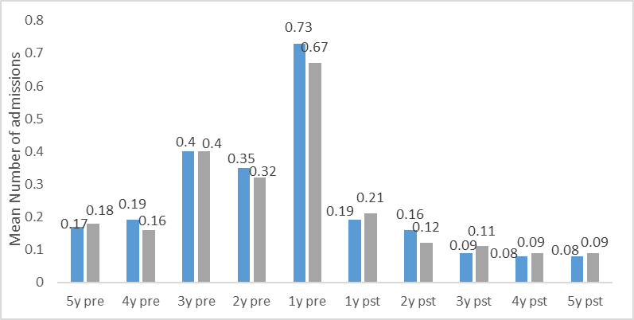

**Fig 2** Total mean number admissions in 5 years pre and post PP1M initiation

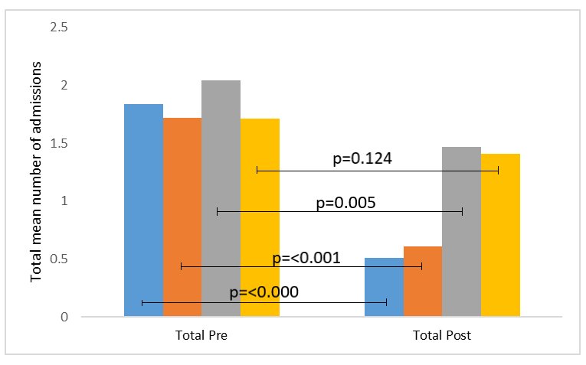

## **Fig 3** Mean length of admissions per year in all patient group (n= 77) and schizophrenia group (n= 57) in the 5 years pre and post PP1M initiation

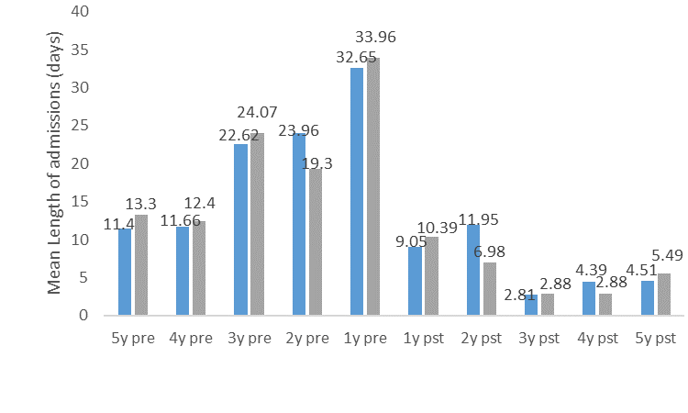

**Fig 4** Total mean length of admissions in 5 years pre and post PP1M initiation

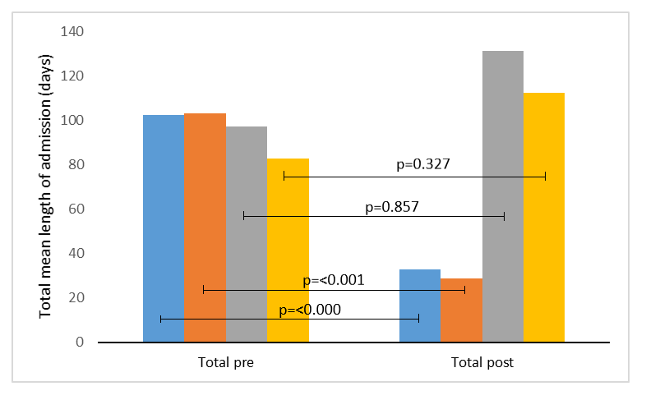

Figure captions

**Fig 1** Mean number of admissions per year in all patient group (n= 77) and schizophrenia group (n= 57) in the 5 years pre and post PP1M initiation[1][2]

The all patient group are represented in blue and the schizophrenia group in grey.

**Fig 2** Total mean number admissions in 5 years pre and post PP1M initiation in all patient group (n= 77) and schizophrenia group (n= 57)e

The all patient group who continued are represented in blue and those who discontinued are represented in grey. The schizophrenia group who continued are represented in orange, and those who discontinued are represented in yellow.

**Fig 3** Mean length of admissions per year in all patient group (n= 77) and schizophrenia group (n= 57) in the 5 years pre and post PP1M initiation[3][4]

The all patient group are represented in blue and the schizophrenia group in grey.

**Fig 4** Total mean length of admissions in 5 years pre and post PP1M initiation in all patient group (n=77) and schizophrenia group (n=57)[5]

The all patient group who continued are represented in blue and those who discontinued are represented in grey. The schizophrenia group who continued are represented in orange, and those who discontinued are represented in yellow.

1. Bar chart representing the mean number of admissions in both the all patient group and the schizophrenia group in each of the five years pre and post administration of PP1M
2. pst=post y=years

   eBar chart representing the total mean number of admissions in the five years pre and post initiation of PP1M in the all patient group, and schizophrenia groups, both separated according to those who continued and those who discontinued.
3. Bar chart representing the mean length of admissions in both the all patient group and the schizophrenia group in each of the five years pre and post administration of PP1M
4. pst=post y=years

   I Bar chart representing the total mean length of admissions in the five years pre and post initiation of PP1M in the all patient group, and schizophrenia groups, both separated according to those who continued and those who discontinued.
5. Bar chart representing the total mean number of admissions in the five years pre and post initiation of PP1M in the all patient group, and schizophrenia groups, both separated according to those who continued and those who discontinued.